Supplemental Materials

Voting behavior verification
We verified voting status for a subset of these participants from 2020 and 2022 who provided their repermanent address (N = 223) where they were registered to vote. We were able to find voter history data for roughly three-quarters of this subset (N = 169). We compared self-reported voting behavior against records for registered voters using an online interface for checking individual voter records based on public voting history data (didmyfriendsvote.org). Importantly, we could only validate self-reported voting behavior in those who were registered to vote. Voting records could not be verified for N = 54 due to either no records existing or there being multiple conflicting records. Overall, self-reported voting and public records matched for 86.4% of these participants (N = 169). Of those that reported voting (N = 145), we found congruence in voter records for 87.6% (N = 127). A small subset of registered voters (N = 24) reported not voting, for whom 91.7% of records matched (N = 22). We did not attempt to verify voting for the 2024 election as records were not available in all states when this manuscript was drafted.

Demographics per sample
Demographics for each sample separately is reported in Table S1.

Table S1
Demographics per sample
Variable | 2020 general  N = 316 | 2020 student  N = 191 | 2021 student  N = 146 | 2022 general1  N = 256 | 2022 general2  N = 707 | 2022 student1  N = 137 | 2022 student2  N = 219 | 2024 student1  N = 329 | 2024 student2  N = 179
Gender
Genderqueer / Genderfluid | 0 (0%) | 0 (0%) | 0 (0%) | 0 (0%) | 2 (0.3%) | 0 (0%) | 1 (0.5%) | 2 (0.6%) | 1 (0.6%)
Man | 183 (58%) | 67 (35%) | 65 (45%) | 126 (49%) | 350 (50%) | 43 (31%) | 64 (29%) | 70 (21%) | 62 (35%)
Non-binary / third gender | 0 (0%) | 0 (0%) | 5 (3.4%) | 2 (0.8%) | 13 (1.8%) | 1 (0.7%) | 3 (1.4%) | 2 (0.6%) | 0 (0%)
Woman | 132 (42%) | 124 (65%) | 75 (51%) | 122 (48%) | 336 (48%) | 91 (66%) | 147 (67%) | 250 (76%) | 112 (63%)
Age | 39 (12) | 20 (2) | 20 (1) | 39 (14) | 40 (14) | 20 (1) | 20 (1) | 22 (5) | 20 (1)
Race
American Indian or Alaskan Native | 2 (0.6%) | 0 (0%) | 0 (0%) | 4 (1.6%) | 3 (0.4%) | 2 (1.5%) | 1 (0.5%) | 0 (0%) | 0 (0%)
Asian (East Asian, South Asian, and/or Southeast Asian) | 14 (4.4%) | 43 (23%) | 35 (24%) | 29 (11%) | 47 (6.7%) | 42 (31%) | 65 (30%) | 100 (30%) | 58 (32%)
Black or African American | 37 (12%) | 19 (9.9%) | 16 (11%) | 19 (7.4%) | 58 (8.2%) | 9 (6.6%) | 20 (9.1%) | 27 (8.2%) | 14 (7.8%)
Middle Eastern or North African | 0 (0%) | 0 (0%) | 0 (0%) | 0 (0%) | 0 (0%) | 0 (0%) | 0 (0%) | 3 (0.9%) | 2 (1.1%)
Native Hawaiian or Other Pacific Islander | 0 (0%) | 0 (0%) | 0 (0%) | 0 (0%) | 2 (0.3%) | 0 (0%) | 0 (0%) | 0 (0%) | 0 (0%)
White | 255 (81%) | 116 (61%) | 74 (51%) | 182 (71%) | 544 (77%) | 74 (54%) | 104 (47%) | 162 (49%) | 83 (46%)
More than one race or race not listed | 7 (2.2%) | 11 (5.8%) | 13 (8.9%) | 18 (7.0%) | 39 (5.5%) | 6 (4.4%) | 16 (7.3%) | 26 (7.9%) | 11 (6.1%)
Prefer not to say | 1 (0.3%) | 2 (1.0%) | 8 (5.5%) | 4 (1.6%) | 11 (1.6%) | 4 (2.9%) | 12 (5.5%) | 11 (3.3%) | 11 (6.1%)
Hispanic/Latinx
No | 279 (88%) | 170 (89%) | 125 (86%) | 230 (90%) | 635 (90%) | 122 (89%) | 201 (92%) | 281 (86%) | 152 (86%)
Yes | 37 (12%) | 21 (11%) | 17 (12%) | 26 (10%) | 69 (9.8%) | 15 (11%) | 18 (8.2%) | 43 (13%) | 23 (13%)
Subjective social status (10-pt scale)* | 5.79 (1.93) | 7.30 (1.74) | - | 4.92 (1.84) | 4.86 (1.76) | 7.34 (1.58) | 7.13 (1.86) | 6.68 (1.72) | 7.01 (1.74)
Political party identification* | 3.81 (2.50) | 2.66 (1.74) | - | 2.93 (1.85) | 2.95 (1.87) | 2.62 (1.72) | 2.46 (1.51) | - | -
Note. *Indicates the statistic is mean (SD). All other statistics are N (%).

Key variables per sample
Means and standard errors of the mean for each variable included in the study as a function of sample are reported in Figures S1-S2.

Figure S1
Mean and SEM for key predictor variables per study
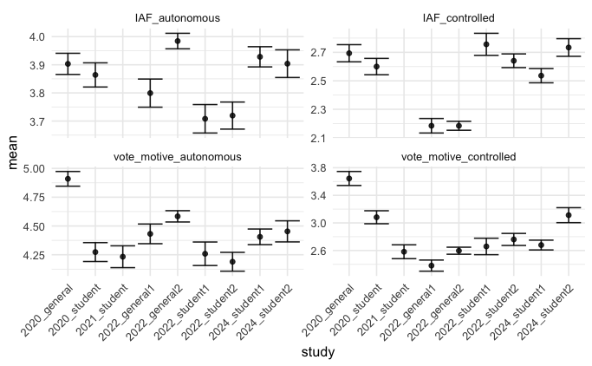

Figure S2
Mean and SEM for key outcome variables per study
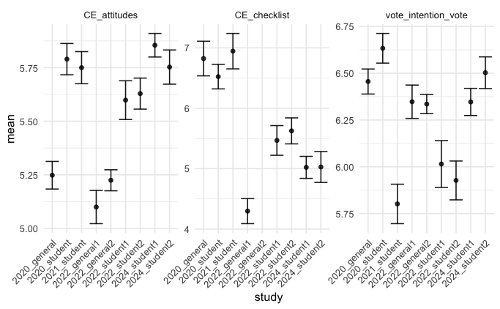

Sensitivity analyses: Models including control variables
As a robustness test of our hypothesized relationships, we included age, gender, race, ethnicity, subjective socioeconomic status (10-pt scale), and strength of political party affiliation. All variables were correlated with at least one dependent variable (r > 0.1, p < 0.5). The variance inflation factor for all models is < 2. Coefficients for our main variables of interest (motivation to vote, autonomous and controlled functioning) are not qualitatively different in these models than in those reported in the main results. Caution should be used when considering the relationship between outcomes and categorical variables (e.g. race/ethnicity, gender) that contain categories with few individuals as this study was not designed or powered to test these relationships.

Table S2

Models for autonomous and controlled motivation to vote

DV | N | Marginal R2 / Conditional R2 | Predictors | Estimate | CI | Statistic | p | df
Voting intentions | 1390 | 0.25 / 0.28 | Intercept | 0.07 | -0.16 – 0.29 | 0.60 | 0.550 | 46.39
Voting intentions | 1390 | 0.25 / 0.28 | MV-A | 0.41 | 0.37 – 0.46 | 19.16 | <0.001 | 1372.17
Voting intentions | 1390 | 0.25 / 0.28 | MV-C | -0.12 | -0.16 – -0.08 | 5.71 | <0.001 | 1369.51
Voting intentions | 1390 | 0.25 / 0.28 | Political party affiliation | -0.03 | -0.05 – -0.01 | 3.31 | 0.001 | 1376.00
Voting intentions | 1390 | 0.25 / 0.28 | Gender [Woman] | 0.03 | -0.04 – 0.11 | 0.88 | 0.379 | 1366.81
Voting intentions | 1390 | 0.25 / 0.28 | Gender [Non-binary /  third gender] | 0.14 | -0.29 – 0.57 | 0.64 | 0.519 | 1372.44
Voting intentions | 1390 | 0.25 / 0.28 | Gender [Genderqueer /  Genderfluid] | 0.24 | -0.76 – 1.23 | 0.46 | 0.642 | 1371.19
Voting intentions | 1390 | 0.25 / 0.28 | Age | 0.00 | 0.00 – 0.01 | 2.87 | 0.004 | 674.63
Voting intentions | 1390 | 0.25 / 0.28 | Race/ethnicity [Black or  African American] | -0.14 | -0.28 – -0.00 | 1.99 | 0.047 | 1371.58
Voting intentions | 1390 | 0.25 / 0.28 | Race/ethnicity [Asian  (East Asian, South Asian,  and/or Southeast Asian)] | -0.20 | -0.33 – -0.08 | 3.30 | 0.001 | 1374.28
Voting intentions | 1390 | 0.25 / 0.28 | Race/ethnicity [American  Indian or Alaskan Native] | 0.21 | -0.29 – 0.71 | 0.82 | 0.415 | 1372.28
Voting intentions | 1390 | 0.25 / 0.28 | Race/ethnicity [More than  one race or race not  listed] | -0.12 | -0.30 – 0.06 | 1.32 | 0.189 | 1373.73
Voting intentions | 1390 | 0.25 / 0.28 | Hispanic/Latinx [Yes] | -0.12 | -0.26 – 0.01 | 1.79 | 0.074 | 1372.27
Voting intentions | 1390 | 0.25 / 0.28 | Subjective socioeconomic status | 0.00 | -0.02 – 0.03 | 0.43 | 0.670 | 1040.67
Voting behavior* | 298 | 0.43 / 0.57 | Intercept | 0.05 | 0.00 – 34.05 | 0.91 | 0.365 | -
Voting behavior* | 298 | 0.43 / 0.57 | MV-A | 1.90 | 1.30 – 2.77 | 3.29 | 0.001 | -
Voting behavior* | 298 | 0.43 / 0.57 | MV-C | 0.89 | 0.60 – 1.32 | 0.59 | 0.554 | -
Voting behavior* | 298 | 0.43 / 0.57 | Political party affiliation | 0.58 | 0.46 – 0.74 | 4.45 | <0.001 | -
Voting behavior* | 298 | 0.43 / 0.57 | Gender [Woman] | 0.58 | 0.26 – 1.26 | 1.38 | 0.166 | -
Voting behavior* | 298 | 0.43 / 0.57 | Gender [Non-binary /  third gender] | 0.00 | - | 0.07 | 0.948 | -
Voting behavior* | 298 | 0.43 / 0.57 | Age | 1.29 | 0.93 – 1.78 | 1.53 | 0.126 | -
Voting behavior* | 298 | 0.43 / 0.57 | Race/ethnicity [Black or  African American] | 0.58 | 0.16 – 2.18 | 0.80 | 0.422 | -
Voting behavior* | 298 | 0.43 / 0.57 | Race/ethnicity [Asian  (East Asian, South Asian,  and/or Southeast Asian)] | 0.45 | 0.21 – 0.99 | 1.99 | 0.047 | -
Voting behavior* | 298 | 0.43 / 0.57 | Race/ethnicity [American  Indian or Alaskan Native] | 0.00 | - | 0.04 | 0.968 | -
Voting behavior* | 298 | 0.43 / 0.57 | Race/ethnicity [More than  one race or race not  listed] | 0.32 | 0.05 – 2.20 | 1.16 | 0.248 | -
Voting behavior* | 298 | 0.43 / 0.57 | Hispanic/Latinx [Yes] | 0.75 | 0.18 – 3.12 | 0.40 | 0.689 | -
Voting behavior* | 298 | 0.43 / 0.57 | Subjective socioeconomic status | 1.29 | 1.05 – 1.60 | 2.38 | 0.017 | -
Civic duty | 1390 | 0.24 / 0.30 | Intercept | -0.41 | -0.74 – -0.07 | 2.54 | 0.021 | 17.60
Civic duty | 1390 | 0.24 / 0.30 | MV-A | 0.45 | 0.40 – 0.50 | 17.25 | <0.001 | 1371.18
Civic duty | 1390 | 0.24 / 0.30 | MV-C | 0.02 | -0.03 – 0.07 | 0.87 | 0.387 | 1376.00
Civic duty | 1390 | 0.24 / 0.30 | Political party affiliation | -0.05 | -0.07 – -0.03 | 4.14 | <0.001 | 1374.33
Civic duty | 1390 | 0.24 / 0.30 | Gender [Woman] | 0.18 | 0.08 – 0.27 | 3.70 | <0.001 | 1375.77
Civic duty | 1390 | 0.24 / 0.30 | Gender [Non-binary /  third gender] | -0.05 | -0.57 – 0.47 | 0.19 | 0.852 | 1371.28
Civic duty | 1390 | 0.24 / 0.30 | Gender [Genderqueer /  Genderfluid] | 0.32 | -0.88 – 1.52 | 0.52 | 0.602 | 1370.60
Civic duty | 1390 | 0.24 / 0.30 | Age | 0.00 | -0.00 – 0.01 | 1.57 | 0.117 | 1103.32
Civic duty | 1390 | 0.24 / 0.30 | Race/ethnicity [Black or  African American] | 0.14 | -0.03 – 0.30 | 1.65 | 0.100 | 1370.83
Civic duty | 1390 | 0.24 / 0.30 | Race/ethnicity [Asian  (East Asian, South Asian,  and/or Southeast Asian)] | -0.08 | -0.23 – 0.07 | 1.05 | 0.293 | 1375.81
Civic duty | 1390 | 0.24 / 0.30 | Race/ethnicity [American  Indian or Alaskan Native] | 0.24 | -0.37 – 0.84 | 0.77 | 0.439 | 1371.19
Civic duty | 1390 | 0.24 / 0.30 | Race/ethnicity [More than  one race or race not  listed] | 0.20 | -0.02 – 0.42 | 1.79 | 0.074 | 1372.04
Civic duty | 1390 | 0.24 / 0.30 | Hispanic/Latinx [Yes] | 0.11 | -0.06 – 0.28 | 1.30 | 0.192 | 1371.23
Civic duty | 1390 | 0.24 / 0.30 | Subjective socioeconomic status | 0.06 | 0.03 – 0.08 | 4.23 | <0.001 | 1285.52
Civic behavior | 816 | 0.26 / 0.27 | Intercept | -0.80 | -1.13 – -0.46 | 4.70 | <0.001 | 356.92
Civic behavior | 816 | 0.26 / 0.27 | MV-A | 0.24 | 0.18 – 0.31 | 6.95 | <0.001 | 802.36
Civic behavior | 816 | 0.26 / 0.27 | MV-C | 0.22 | 0.15 – 0.28 | 6.61 | <0.001 | 652.25
Civic behavior | 816 | 0.26 / 0.27 | Political party affiliation | -0.03 | -0.06 – 0.00 | 1.96 | 0.05 | 796.03
Civic behavior | 816 | 0.26 / 0.27 | Gender [Woman] | 0.10 | -0.03 – 0.22 | 1.53 | 0.126 | 751.12
Civic behavior | 816 | 0.26 / 0.27 | Gender [Non-binary /  third gender] | -0.14 | -1.14 – 0.86 | 0.28 | 0.781 | 802.99
Civic behavior | 816 | 0.26 / 0.27 | Age | 0.00 | -0.01 – 0.01 | 0.07 | 0.948 | 71.45
Civic behavior | 816 | 0.26 / 0.27 | Race/ethnicity [Black or  African American] | 0.06 | -0.16 – 0.28 | 0.53 | 0.596 | 800.87
Civic behavior | 816 | 0.26 / 0.27 | Race/ethnicity [Asian  (East Asian, South Asian,  and/or Southeast Asian)] | -0.17 | -0.34 – -0.00 | 1.98 | 0.048 | 795.65
Civic behavior | 816 | 0.26 / 0.27 | Race/ethnicity [American  Indian or Alaskan Native] | -0.27 | -0.98 – 0.44 | 0.75 | 0.454 | 801.66
Civic behavior | 816 | 0.26 / 0.27 | Race/ethnicity [More than  one race or race not  listed] | 0.09 | -0.21 – 0.39 | 0.58 | 0.562 | 801.47
Civic behavior | 816 | 0.26 / 0.27 | Hispanic/Latinx [Yes] | 0.14 | -0.07 – 0.36 | 1.28 | 0.200 | 801.15
Civic behavior | 816 | 0.26 / 0.27 | Subjective socioeconomic status | 0.14 | 0.10 – 0.17 | 7.97 | <0.001 | 476.17
Civic behavior | 563 | 0.18 / 0.24 | Intercept | -0.40 | -0.81 – 0.02 | 1.96 | 0.060 | 29.31
Civic behavior | 563 | 0.18 / 0.24 | MV-A | 0.20 | 0.13 – 0.26 | 5.69 | <0.001 | 546.91
Civic behavior | 563 | 0.18 / 0.24 | MV-C | 0.02 | -0.06 – 0.09 | 0.43 | 0.668 | 548.63
Civic behavior | 563 | 0.18 / 0.24 | Political party affiliation | -0.09 | -0.12 – -0.05 | 4.59 | <0.001 | 546.85
Civic behavior | 563 | 0.18 / 0.24 | Gender [Woman] | 0.25 | 0.12 – 0.38 | 3.78 | <0.001 | 549.84
Civic behavior | 563 | 0.18 / 0.24 | Gender [Non-binary /  third gender] | -0.01 | -0.85 – 0.84 | 0.01 | 0.990 | 547.55
Civic behavior | 563 | 0.18 / 0.24 | Age | 0.01 | -0.00 – 0.01 | 1.66 | 0.098 | 189.12
Civic behavior | 563 | 0.18 / 0.24 | Race/ethnicity [Black or  African American] | -0.22 | -0.47 – 0.02 | 1.81 | 0.071 | 547.24
Civic behavior | 563 | 0.18 / 0.24 | Race/ethnicity [Asian  (East Asian, South Asian,  and/or Southeast Asian)] | -0.25 | -0.40 – -0.09 | 3.08 | 0.002 | 549.71
Civic behavior | 563 | 0.18 / 0.24 | Race/ethnicity [American  Indian or Alaskan Native] | -0.39 | -1.12 – 0.34 | 1.04 | 0.300 | 547.06
Civic behavior | 563 | 0.18 / 0.24 | Race/ethnicity [More than  one race or race not  listed] | 0.04 | -0.23 – 0.31 | 0.29 | 0.770 | 547.58
Civic behavior | 563 | 0.18 / 0.24 | Hispanic/Latinx [Yes] | -0.11 | -0.33 – 0.12 | 0.93 | 0.353 | 547.11
Civic behavior | 563 | 0.18 / 0.24 | Subjective socioeconomic status | 0.06 | 0.02 – 0.10 | 3.26 | 0.001 | 453.81
Note. MV = vote motivations; A = autonomous; C = controlled. Main effects that are statistically significant at p < .05 are bolded. *Estimates are odds ratios and statistics are Z-values. In all other models, estimates are standardized regression coefficients and statistics are t-values. †Model excluding the 2020 general sample. In logistic models of voting behavior, confidence intervals for some levels of gender and race variables are unstable (upper bounds labeled as “-”) due to perfect prediction.

Table S3

Models for autonomous and controlled functioning
DV | N | Marginal R2 / Conditional R2 | Predictors | Estimate | CI | Statistic | p | df
Voting intentions | 1417 | 0.10 / 0.11 | Intercept | -0.06 | -0.32 – 0.19 | 0.50 | 0.615 | 114.13
Voting intentions | 1417 | 0.10 / 0.11 | IAF-A | 0.20 | 0.16 – 0.25 | 8.20 | <0.001 | 1401.43
Voting intentions | 1417 | 0.10 / 0.11 | IAF-C | -0.02 | -0.07 – 0.03 | 0.87 | 0.383 | 1393.79
Voting intentions | 1417 | 0.10 / 0.11 | Political party affiliation | -0.06 | -0.09 – -0.04 | 5.07 | <0.001 | 1401.82
Voting intentions | 1417 | 0.10 / 0.11 | Gender [Woman] | 0.05 | -0.05 – 0.14 | 0.94 | 0.350 | 1372.58
Voting intentions | 1417 | 0.10 / 0.11 | Gender [Non-binary /  third gender] | 0.26 | -0.26 – 0.79 | 0.98 | 0.326 | 1400.81
Voting intentions | 1417 | 0.10 / 0.11 | Gender [Genderqueer /  Genderfluid] | -0.10 | -1.33 – 1.14 | 0.15 | 0.878 | 1398.31
Voting intentions | 1417 | 0.10 / 0.11 | Age | 0.01 | 0.00 – 0.01 | 2.64 | 0.009 | 324.80
Voting intentions | 1417 | 0.10 / 0.11 | Race/ethnicity [Black or  African American] | -0.12 | -0.29 – 0.04 | 1.44 | 0.151 | 1399.69
Voting intentions | 1417 | 0.10 / 0.11 | Race/ethnicity [Asian  (East Asian, South Asian,  and/or Southeast Asian)] | -0.26 | -0.41 – -0.11 | 3.43 | 0.001 | 1386.38
Voting intentions | 1417 | 0.10 / 0.11 | Race/ethnicity [American  Indian or Alaskan Native] | 0.47 | -0.11 – 1.05 | 1.59 | 0.113 | 1401.10
Voting intentions | 1417 | 0.10 / 0.11 | Race/ethnicity [More than  one race or race not  listed] | -0.16 | -0.38 – 0.07 | 1.37 | 0.170 | 1402.48
Voting intentions | 1417 | 0.10 / 0.11 | Hispanic/Latinx [Yes] | -0.21 | -0.38 – -0.05 | 2.52 | 0.012 | 1399.35
Voting intentions | 1417 | 0.10 / 0.11 | Subjective socioeconomic status | 0.03 | 0.01 – 0.06 | 2.46 | 0.014 | 720.86
Voting behavior* | 318 | 0.34 / 0.45 | Intercept | 0.13 | 0.00 – 47.00 | 0.68 | 0.495 | -
Voting behavior* | 318 | 0.34 / 0.45 | IAF-A | 1.28 | 0.90 – 1.82 | 1.35 | 0.177 | -
Voting behavior* | 318 | 0.34 / 0.45 | IAF-C | 0.84 | 0.58 – 1.23 | 0.88 | 0.378 | -
Voting behavior* | 318 | 0.34 / 0.45 | Political party affiliation | 0.56 | 0.45 – 0.69 | 5.25 | <0.001 | -
Voting behavior* | 318 | 0.34 / 0.45 | Gender [Woman] | 0.76 | 0.38 – 1.53 | 0.76 | 0.448 | -
Voting behavior* | 318 | 0.34 / 0.45 | Gender [Non-binary /  third gender] | 0.16 | 0.01 – 3.16 | 1.20 | 0.229 | -
Voting behavior* | 318 | 0.34 / 0.45 | Age | 1.24 | 0.93 – 1.66 | 1.47 | 0.141 | -
Voting behavior* | 318 | 0.34 / 0.45 | Race/ethnicity [Black or  African American] | 0.48 | 0.15 – 1.59 | 1.20 | 0.232 | -
Voting behavior* | 318 | 0.34 / 0.45 | Race/ethnicity [Asian  (East Asian, South Asian,  and/or Southeast Asian)] | 0.33 | 0.16 – 0.68 | 3.03 | 0.002 | -
Voting behavior* | 318 | 0.34 / 0.45 | Race/ethnicity [American  Indian or Alaskan Native] | 0.00 | 0.00 – Inf | 0.01 | 0.993 | -
Voting behavior* | 318 | 0.34 / 0.45 | Race/ethnicity [More than  one race or race not  listed] | 0.36 | 0.06 – 2.13 | 1.12 | 0.261 | -
Voting behavior* | 318 | 0.34 / 0.45 | Hispanic/Latinx [Yes] | 0.47 | 0.14 – 1.56 | 1.23 | 0.219 | -
Voting behavior* | 318 | 0.34 / 0.45 | Subjective socioeconomic status | 1.23 | 1.01 – 1.49 | 2.06 | 0.040 | -
Civic duty | 1417 | 0.23 / 0.26 | Intercept | -0.45 | -0.73 – -0.16 | 3.17 | 0.003 | 36.37
Civic duty | 1417 | 0.23 / 0.26 | IAF-A | 0.41 | 0.36 – 0.46 | 16.53 | <0.001 | 1399.27
Civic duty | 1417 | 0.23 / 0.26 | IAF-C | 0.12 | 0.07 – 0.17 | 4.59 | <0.001 | 1402.98
Civic duty | 1417 | 0.23 / 0.26 | Political party affiliation | -0.07 | -0.10 – -0.05 | 6.09 | <0.001 | 1402.43
Civic duty | 1417 | 0.23 / 0.26 | Gender [Woman] | 0.18 | 0.08 – 0.27 | 3.70 | <0.001 | 1397.41
Civic duty | 1417 | 0.23 / 0.26 | Gender [Non-binary /  third gender] | 0.08 | -0.45 – 0.61 | 0.30 | 0.761 | 1398.95
Civic duty | 1417 | 0.23 / 0.26 | Gender [Genderqueer /  Genderfluid] | -0.44 | -1.67 – 0.79 | 0.70 | 0.486 | 1397.21
Civic duty | 1417 | 0.23 / 0.26 | Age | 0.00 | -0.00 – 0.01 | 1.20 | 0.232 | 669.83
Civic duty | 1417 | 0.23 / 0.26 | Race/ethnicity [Black or  African American] | 0.17 | 0.00 – 0.34 | 1.98 | 0.047 | 1398.14
Civic duty | 1417 | 0.23 / 0.26 | Race/ethnicity [Asian  (East Asian, South Asian,  and/or Southeast Asian)] | -0.10 | -0.25 – 0.05 | 1.35 | 0.176 | 1401.09
Civic duty | 1417 | 0.23 / 0.26 | Race/ethnicity [American  Indian or Alaskan Native] | 0.39 | -0.20 – 0.97 | 1.30 | 0.193 | 1399.10
Civic duty | 1417 | 0.23 / 0.26 | Race/ethnicity [More than  one race or race not  listed] | 0.13 | -0.09 – 0.35 | 1.14 | 0.256 | 1400.26
Civic duty | 1417 | 0.23 / 0.26 | Hispanic/Latinx [Yes] | 0.03 | -0.14 – 0.20 | 0.34 | 0.734 | 1398.00
Civic duty | 1417 | 0.23 / 0.26 | Subjective socioeconomic status | 0.08 | 0.05 – 0.10 | 5.83 | <0.001 | 1076.09
Civic behavior | 853 | 0.21 / 0.23 | Intercept | -1.01 | -1.37 – -0.65 | 5.58 | <0.001 | 99.62
Civic behavior | 853 | 0.21 / 0.23 | IAF-A | 0.09 | 0.02 – 0.15 | 2.58 | 0.010 | 838.49
Civic behavior | 853 | 0.21 / 0.23 | IAF-C | 0.25 | 0.18 – 0.32 | 7.45 | <0.001 | 835.88
Civic behavior | 853 | 0.21 / 0.23 | Political party affiliation | -0.04 | -0.08 – -0.01 | 2.84 | 0.005 | 839.83
Civic behavior | 853 | 0.21 / 0.23 | Gender [Woman] | 0.15 | 0.03 – 0.28 | 2.38 | 0.017 | 826.79
Civic behavior | 853 | 0.21 / 0.23 | Gender [Non-binary /  third gender] | -0.02 | -0.92 – 0.88 | 0.04 | 0.965 | 838.37
Civic behavior | 853 | 0.21 / 0.23 | Age | 0.00 | -0.00 – 0.01 | 0.89 | 0.376 | 161.82
Civic behavior | 853 | 0.21 / 0.23 | Race/ethnicity [Black or  African American] | 0.13 | -0.10 – 0.35 | 1.12 | 0.265 | 837.15
Civic behavior | 853 | 0.21 / 0.23 | Race/ethnicity [Asian  (East Asian, South Asian,  and/or Southeast Asian)] | -0.26 | -0.43 – -0.09 | 2.97 | 0.003 | 836.11
Civic behavior | 853 | 0.21 / 0.23 | Race/ethnicity [American  Indian or Alaskan Native] | -0.13 | -0.80 – 0.55 | 0.36 | 0.716 | 837.73
Civic behavior | 853 | 0.21 / 0.23 | Race/ethnicity [More than  one race or race not  listed] | 0.16 | -0.15 – 0.46 | 1.01 | 0.315 | 839.37
Civic behavior | 853 | 0.21 / 0.23 | Hispanic/Latinx [Yes] | 0.07 | -0.15 – 0.28 | 0.60 | 0.547 | 836.62
Civic behavior | 853 | 0.21 / 0.23 | Subjective socioeconomic status | 0.15 | 0.12 – 0.19 | 8.82 | <0.001 | 667.79
Civic behavior | 593 | 0.15 / 0.20 | Intercept | -0.42 | -0.83 – -0.02 | 2.11 | 0.041 | 36.58
Civic behavior | 593 | 0.15 / 0.20 | IAF-A | 0.07 | 0.00 – 0.13 | 2.04 | 0.042 | 577.52
Civic behavior | 593 | 0.15 / 0.20 | IAF-C | 0.02 | -0.05 – 0.09 | 0.54 | 0.589 | 576.99
Civic behavior | 593 | 0.15 / 0.20 | Political party affiliation | -0.11 | -0.14 – -0.07 | 5.99 | <0.001 | 577.18
Civic behavior | 593 | 0.15 / 0.20 | Gender [Woman] | 0.27 | 0.14 – 0.40 | 4.17 | <0.001 | 579.53
Civic behavior | 593 | 0.15 / 0.20 | Gender [Non-binary /  third gender] | -0.06 | -0.81 – 0.69 | 0.16 | 0.873 | 577.64
Civic behavior | 593 | 0.15 / 0.20 | Age | 0.01 | -0.00 – 0.01 | 1.70 | 0.091 | 162.22
Civic behavior | 593 | 0.15 / 0.20 | Race/ethnicity [Black or  African American] | -0.18 | -0.42 – 0.06 | 1.47 | 0.142 | 577.58
Civic behavior | 593 | 0.15 / 0.20 | Race/ethnicity [Asian  (East Asian, South Asian,  and/or Southeast Asian)] | -0.28 | -0.44 – -0.13 | 3.55 | <0.001 | 579.89
Civic behavior | 593 | 0.15 / 0.20 | Race/ethnicity [American  Indian or Alaskan Native] | -0.30 | -0.97 – 0.37 | 0.89 | 0.375 | 577.42
Civic behavior | 593 | 0.15 / 0.20 | Race/ethnicity [More than  one race or race not  listed] | 0.06 | -0.22 – 0.34 | 0.43 | 0.671 | 577.69
Civic behavior | 593 | 0.15 / 0.20 | Hispanic/Latinx [Yes] | -0.11 | -0.33 – 0.11 | 0.98 | 0.326 | 577.06
Civic behavior | 593 | 0.15 / 0.20 | Subjective socioeconomic status | 0.07 | 0.03 – 0.10 | 3.65 | <0.001 | 446.05
Note. IAF = Index of autonomous functioning; A = autonomous; C = controlled. Main effects that are statistically significant at p < .05 are bolded. *Estimates are odds ratios and statistics are Z-values. In all other models, estimates are standardized regression coefficients and statistics are t-values. †Model excluding the 2020 general sample. In logistic models of voting behavior, confidence intervals for some levels of gender and race variables are unstable (upper bounds labeled as “-”) due to perfect prediction.

Sensitivity analyses: Leave-one-sample-out analyses
We conducted exploratory robustness tests for all primary analyses using a leave-one-sample-out approach. For each main analysis (Hypotheses 1-8), we conducted the same statistical tests while iteratively leaving out one sample. Coefficients for autonomous and controlled motivations in each leave-one-out model are visualized in Figure S3, and coefficients for autonomous and controlled functioning in each leave-one-out model are shown in Figure S4. Full model details per each model, labeled per the sample left out, are included in Table S5 for motivations to vote and S6 for autonomous and controlled functioning.

Autonomous and controlled motivations to vote – leave one sample out models:

Figure S3
Leave-one-sample-out coefficient estimates for autonomous and controlled motivation to vote
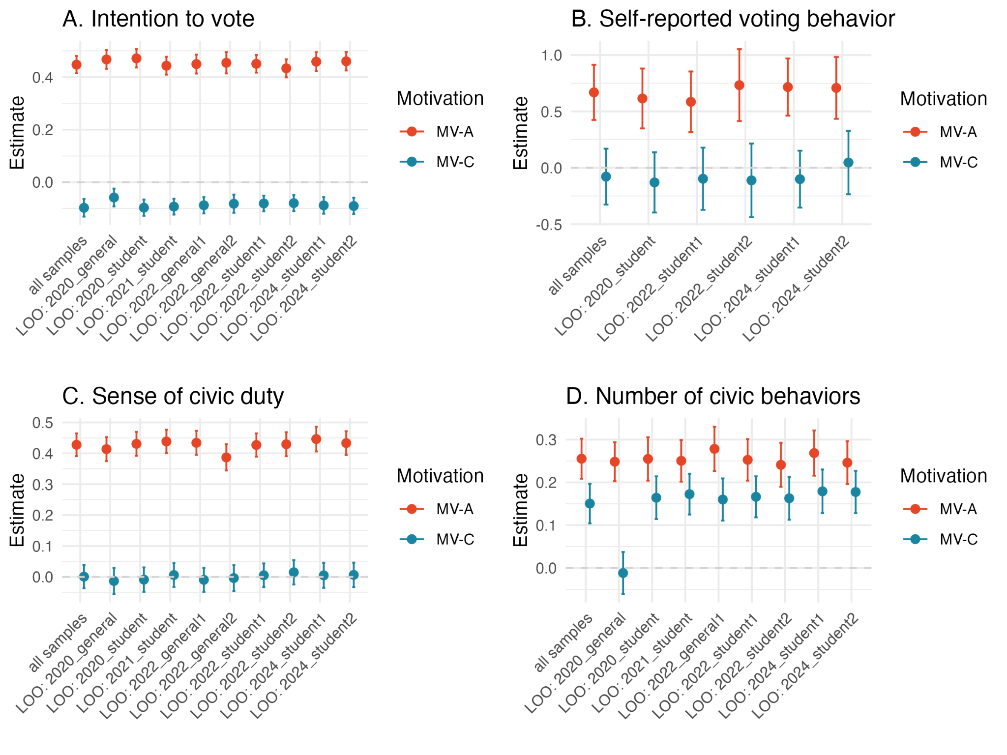

Table S4
Leave-one-sample out analyses with autonomous and controlled motivation to vote

DV | Sample excluded | N | Marginal R2 / Conditional R2 | Predictors | Estimate | CI | Statistic | p | df
Voting intentions | 2020_student | 2215 | 0.24 / 0.27 | Intercept | 4.49 | 4.26 – 4.72 | 39.97 | <0.001 | 22.32
 |  |  |  | MV-A | 0.47 | 0.44 – 0.51 | 26.41 | <0.001 | 411.77
 |  |  |  | MV-C | -0.10 | -0.13 – -0.07 | 6.11 | <0.001 | 232.30
Voting intentions | 2020_general | 2095 | 0.23 / 0.29 | Intercept | 4.45 | 4.15 – 4.74 | 34.56 | <0.001 | 8.40
 |  |  |  | MV-A | 0.47 | 0.43 – 0.50 | 25.53 | <0.001 | 400.72
 |  |  |  | MV-C | -0.06 | -0.09 – -0.02 | 3.37 | 0.001 | 291.04
Voting intentions | 2021_student | 2258 | 0.22 / 0.25 | Intercept | 4.71 | 4.49 – 4.94 | 43.74 | <0.001 | 29.89
 |  |  |  | MV-A | 0.44 | 0.41 – 0.48 | 25.48 | <0.001 | 411.19
 |  |  |  | MV-C | -0.09 | -0.12 – -0.06 | 6.05 | <0.001 | 227.77
Voting intentions | 2022_general1 | 2156 | 0.21 / 0.27 | Intercept | 4.60 | 4.30 – 4.89 | 35.53 | <0.001 | 8.12
 |  |  |  | MV-A | 0.45 | 0.41 – 0.49 | 24.48 | <0.001 | 436.05
 |  |  |  | MV-C | -0.09 | -0.12 – -0.06 | 5.50 | <0.001 | 225.21
Voting intentions | 2022_general2 | 1713 | 0.21 / 0.27 | Intercept | 4.57 | 4.26 – 4.88 | 33.36 | <0.001 | 9.24
 |  |  |  | MV-A | 0.45 | 0.41 – 0.49 | 21.99 | <0.001 | 726.49
 |  |  |  | MV-C | -0.08 | -0.12 – -0.05 | 4.62 | <0.001 | 355.33
Voting intentions | 2022_student1 | 2297 | 0.22 / 0.28 | Intercept | 4.62 | 4.34 – 4.89 | 37.87 | <0.001 | 9.20
 |  |  |  | MV-A | 0.45 | 0.42 – 0.48 | 26.24 | <0.001 | 408.25
 |  |  |  | MV-C | -0.08 | -0.11 – -0.05 | 5.30 | <0.001 | 230.10
Voting intentions | 2022_student2 | 2189 | 0.21 / 0.27 | Intercept | 4.69 | 4.41 – 4.97 | 38.16 | <0.001 | 9.51
 |  |  |  | MV-A | 0.43 | 0.40 – 0.47 | 24.70 | <0.001 | 483.29
 |  |  |  | MV-C | -0.08 | -0.11 – -0.05 | 5.14 | <0.001 | 265.56
Voting intentions | 2024_student1 | 2083 | 0.22 / 0.28 | Intercept | 4.56 | 4.26 – 4.86 | 35.33 | <0.001 | 7.77
 |  |  |  | MV-A | 0.46 | 0.42 – 0.49 | 24.91 | <0.001 | 484.07
 |  |  |  | MV-C | -0.09 | -0.12 – -0.06 | 5.46 | <0.001 | 259.96
Voting intentions | 2024_student2 | 2226 | 0.22 / 0.28 | Intercept | 4.55 | 4.26 – 4.84 | 36.37 | <0.001 | 8.57
 |  |  |  | MV-A | 0.46 | 0.42 – 0.50 | 25.72 | <0.001 | 422.90
 |  |  |  | MV-C | -0.09 | -0.12 – -0.06 | 5.68 | <0.001 | 241.21
Voting behavior* | 2020_student | 370 | 0.08 / 0.22 | Intercept | 4.00 | 1.75 – 9.15 | 3.29 | 0.001 | -
 |  |  |  | MV-A | 1.85 | 1.42 – 2.41 | 4.54 | <0.001 | -
 |  |  |  | MV-C | 0.88 | 0.67 – 1.15 | 0.95 | 0.341 | -
Voting behavior* | 2022_student1 | 447 | 0.07 / 0.21 | Intercept | 7.14 | 3.16 – 16.09 | 4.74 | <0.001 | -
 |  |  |  | MV-A | 1.79 | 1.37 – 2.35 | 4.26 | <0.001 | -
 |  |  |  | MV-C | 0.91 | 0.69 – 1.20 | 0.69 | 0.490 | -
Voting behavior* | 2022_student2 | 378 | 0.10 / 0.28 | Intercept | 7.17 | 2.69 – 19.09 | 3.94 | <0.001 | -
 |  |  |  | MV-A | 2.08 | 1.51 – 2.86 | 4.51 | <0.001 | -
 |  |  |  | MV-C | 0.89 | 0.65 – 1.24 | 0.67 | 0.504 | -
Voting behavior* | 2024_student1 | 495 | 0.10 / 0.26 | Intercept | 4.50 | 1.87 – 10.83 | 3.35 | 0.001 | -
 |  |  |  | MV-A | 2.05 | 1.59 – 2.64 | 5.54 | <0.001 | -
 |  |  |  | MV-C | 0.90 | 0.70 – 1.16 | 0.78 | 0.435 | -
Voting behavior* | 2024_student2 | 446 | 0.09 / 0.30 | Intercept | 5.40 | 1.90 – 15.35 | 3.16 | 0.002 | -
 |  |  |  | MV-A | 2.03 | 1.54 – 2.67 | 5.06 | <0.001 | -
 |  |  |  | MV-C | 1.05 | 0.79 – 1.39 | 0.33 | 0.744 | -
Civic duty | 2020_student | 2212 | 0.18 / 0.26 | Intercept | 0.08 | -0.16 – 0.32 | 0.78 | 0.459 | 7.95
 |  |  |  | MV-A | 0.43 | 0.39 – 0.47 | 21.82 | <0.001 | 2112.51
 |  |  |  | MV-C | -0.01 | -0.05 – 0.03 | 0.43 | 0.665 | 2091.87
Civic duty | 2020_general | 2092 | 0.17 / 0.23 | Intercept | 0.16 | -0.04 – 0.36 | 1.76 | 0.105 | 11.31
 |  |  |  | MV-A | 0.41 | 0.37 – 0.45 | 20.82 | <0.001 | 2223.86
 |  |  |  | MV-C | -0.01 | -0.06 – 0.03 | 0.61 | 0.542 | 2837.54
Civic duty | 2021_student | 2255 | 0.19 / 0.27 | Intercept | 0.08 | -0.16 – 0.33 | 0.80 | 0.448 | 7.54
 |  |  |  | MV-A | 0.44 | 0.40 – 0.48 | 22.59 | <0.001 | 2026.81
 |  |  |  | MV-C | 0.01 | -0.03 – 0.04 | 0.31 | 0.756 | 1970.31
Civic duty | 2022_general1 | 2153 | 0.18 / 0.25 | Intercept | 0.16 | -0.06 – 0.37 | 1.62 | 0.137 | 9.69
 |  |  |  | MV-A | 0.43 | 0.40 – 0.47 | 21.85 | <0.001 | 2420.44
 |  |  |  | MV-C | -0.01 | -0.05 – 0.03 | 0.48 | 0.633 | 2194.29
Civic duty | 2022_general2 | 1713 | 0.16 / 0.24 | Intercept | 0.15 | -0.06 – 0.36 | 1.57 | 0.149 | 9.90
 |  |  |  | MV-A | 0.39 | 0.34 – 0.43 | 17.85 | <0.001 | 4376.00
 |  |  |  | MV-C | 0.00 | -0.05 – 0.04 | 0.18 | 0.860 | 3748.66
Civic duty | 2022_student1 | 2294 | 0.18 / 0.27 | Intercept | 0.09 | -0.16 – 0.34 | 0.87 | 0.411 | 7.14
 |  |  |  | MV-A | 0.43 | 0.39 – 0.46 | 22.24 | <0.001 | 1988.94
 |  |  |  | MV-C | 0.01 | -0.03 – 0.04 | 0.27 | 0.790 | 1968.34
Civic duty | 2022_student2 | 2186 | 0.18 / 0.27 | Intercept | 0.09 | -0.16 – 0.34 | 0.87 | 0.415 | 7.10
 |  |  |  | MV-A | 0.43 | 0.39 – 0.47 | 21.67 | <0.001 | 2262.09
 |  |  |  | MV-C | 0.02 | -0.02 – 0.05 | 0.74 | 0.456 | 2183.20
Civic duty | 2024_student1 | 2080 | 0.19 / 0.27 | Intercept | 0.08 | -0.16 – 0.31 | 0.75 | 0.475 | 8.02
 |  |  |  | MV-A | 0.45 | 0.41 – 0.49 | 21.80 | <0.001 | 2440.01
 |  |  |  | MV-C | 0.01 | -0.04 – 0.05 | 0.25 | 0.806 | 2301.05
Civic duty | 2024_student2 | 2223 | 0.19 / 0.27 | Intercept | 0.09 | -0.16 – 0.34 | 0.87 | 0.413 | 7.08
 |  |  |  | MV-A | 0.43 | 0.39 – 0.47 | 22.04 | <0.001 | 2215.90
 |  |  |  | MV-C | 0.01 | -0.03 – 0.05 | 0.32 | 0.747 | 2218.91
Civic behavior | 2020_student | 1524 | 0.11 / 0.16 | Intercept | 0.01 | -0.21 – 0.23 | 0.13 | 0.903 | 5.56
 |  |  |  | MV-A | 0.25 | 0.20 – 0.31 | 9.84 | <0.001 | 1399.40
 |  |  |  | MV-C | 0.16 | 0.11 – 0.21 | 6.44 | <0.001 | 1381.14
Civic behavior | 2020_general | 1404 | 0.07 / 0.15 | Intercept | 0.02 | -0.24 – 0.27 | 0.16 | 0.878 | 4.44
 |  |  |  | MV-A | 0.25 | 0.20 – 0.29 | 10.66 | <0.001 | 2137.91
 |  |  |  | MV-C | -0.01 | -0.06 – 0.04 | 0.47 | 0.638 | 3033.84
Civic behavior | 2021_student | 1567 | 0.12 / 0.15 | Intercept | -0.01 | -0.18 – 0.15 | 0.17 | 0.868 | 9.38
 |  |  |  | MV-A | 0.25 | 0.20 – 0.30 | 10.09 | <0.001 | 1400.65
 |  |  |  | MV-C | 0.17 | 0.12 – 0.22 | 7.11 | <0.001 | 1352.20
Civic behavior | 2022_general1 | 1465 | 0.12 / 0.16 | Intercept | 0.09 | -0.09 – 0.27 | 1.13 | 0.291 | 7.90
 |  |  |  | MV-A | 0.28 | 0.23 – 0.33 | 10.52 | <0.001 | 1692.95
 |  |  |  | MV-C | 0.16 | 0.11 – 0.21 | 6.37 | <0.001 | 1452.43
Civic behavior | 2022_student1 | 1606 | 0.11 / 0.17 | Intercept | 0.04 | -0.21 – 0.29 | 0.43 | 0.686 | 4.48
 |  |  |  | MV-A | 0.25 | 0.20 – 0.30 | 10.19 | <0.001 | 1291.09
 |  |  |  | MV-C | 0.17 | 0.12 – 0.21 | 6.80 | <0.001 | 1283.19
Civic behavior | 2022_student2 | 1498 | 0.11 / 0.16 | Intercept | 0.04 | -0.22 – 0.29 | 0.37 | 0.725 | 4.52
 |  |  |  | MV-A | 0.24 | 0.19 – 0.29 | 9.19 | <0.001 | 1515.07
 |  |  |  | MV-C | 0.16 | 0.11 – 0.21 | 6.37 | <0.001 | 1434.82
Civic behavior | 2024_student1 | 1392 | 0.13 / 0.18 | Intercept | 0.06 | -0.17 – 0.30 | 0.70 | 0.513 | 5.16
 |  |  |  | MV-A | 0.27 | 0.22 – 0.32 | 9.94 | <0.001 | 1819.03
 |  |  |  | MV-C | 0.18 | 0.13 – 0.23 | 6.89 | <0.001 | 1643.70
Civic behavior | 2024_student2 | 1535 | 0.12 / 0.17 | Intercept | 0.07 | -0.14 – 0.29 | 0.84 | 0.431 | 6.00
 |  |  |  | MV-A | 0.25 | 0.20 – 0.30 | 9.63 | <0.001 | 1530.13
 |  |  |  | MV-C | 0.18 | 0.13 – 0.23 | 7.04 | <0.001 | 1531.68
Note. MV = vote motivations; A = autonomous; C = controlled. LOO sample indicates which sample is left out in each model iteration. Main effects that are statistically significant at p < .05 are bolded. *Estimates are odds ratios and statistics are Z-values. In all other models, estimates are standardized regression coefficients and statistics are t-values.

Autonomous and controlled functioning – leave one sample out models:

Figure S4
Leave-one-sample-out coefficient estimates for autonomous and controlled functioning
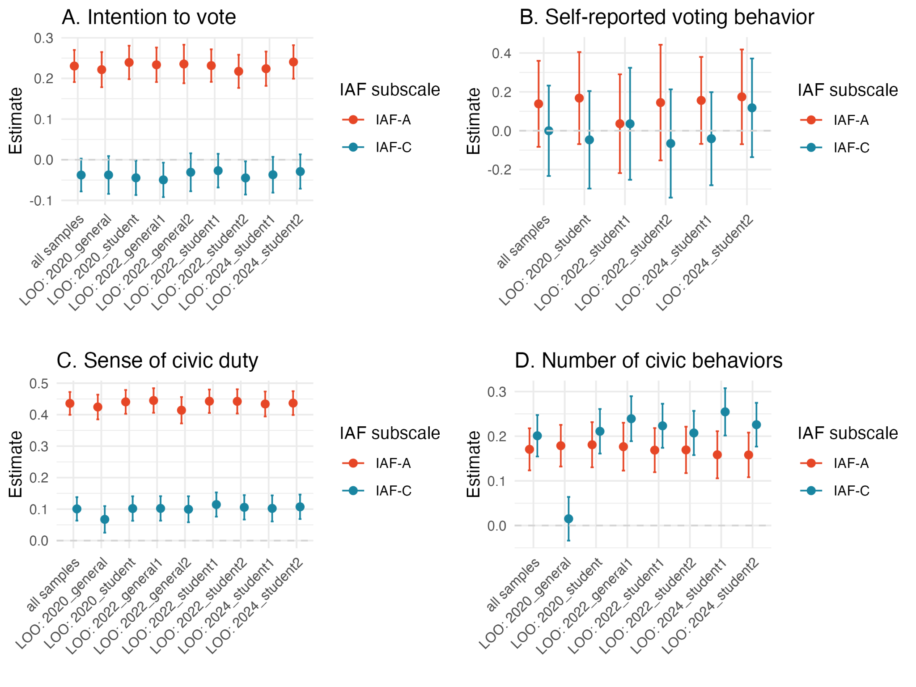

Table S5
Leave-one-sample out analyses with autonomous and controlled functioning
DV | Sample excluded | N | Marginal R2 / Conditional R2 | Predictors | Estimate | CI | Statistic | p | df
Voting intentions | 2020_student | 2121 | 0.06 / 0.08 | Intercept | 0.00 | -0.12 – 0.12 | 0.03 | 0.975 | 8.23
 |  |  |  | IAF-A | 0.24 | 0.20 – 0.28 | 11.39 | <0.001 | 2065.52
 |  |  |  | IAF-C | -0.04 | -0.09 – -0.00 | 2.06 | 0.039 | 2073.86
Voting intentions | 2020_general | 1996 | 0.05 / 0.07 | Intercept | 0.01 | -0.15 – 0.18 | 0.23 | 0.83 | 5.28
 |  |  |  | IAF-A | 0.22 | 0.18 – 0.26 | 10.04 | <0.001 | 2325.63
 |  |  |  | IAF-C | -0.04 | -0.08 – 0.01 | 1.58 | 0.114 | 2798.85
Voting intentions | 2022_general1 | 2056 | 0.06 / 0.08 | Intercept | 0.03 | -0.14 – 0.20 | 0.40 | 0.707 | 4.92
 |  |  |  | IAF-A | 0.23 | 0.19 – 0.28 | 10.78 | <0.001 | 2623.86
 |  |  |  | IAF-C | -0.05 | -0.09 – -0.01 | 2.29 | 0.022 | 2350.13
Voting intentions | 2022_general2 | 1627 | 0.06 / 0.08 | Intercept | 0.04 | -0.13 – 0.21 | 0.56 | 0.602 | 5.07
 |  |  |  | IAF-A | 0.24 | 0.19 – 0.28 | 9.74 | <0.001 | 4244.24
 |  |  |  | IAF-C | -0.03 | -0.08 – 0.02 | 1.30 | 0.195 | 3605.80
Voting intentions | 2022_student1 | 2175 | 0.06 / 0.08 | Intercept | 0.05 | -0.09 – 0.20 | 0.90 | 0.402 | 6.28
 |  |  |  | IAF-A | 0.23 | 0.19 – 0.27 | 11.34 | <0.001 | 2119.27
 |  |  |  | IAF-C | -0.03 | -0.07 – 0.01 | 1.27 | 0.204 | 2196.51
Voting intentions | 2022_student2 | 2093 | 0.05 / 0.07 | Intercept | 0.07 | -0.04 – 0.18 | 1.39 | 0.194 | 9.83
 |  |  |  | IAF-A | 0.22 | 0.18 – 0.26 | 10.46 | <0.001 | 2474.78
 |  |  |  | IAF-C | -0.04 | -0.09 – -0.00 | 2.15 | 0.032 | 2259.15
Voting intentions | 2024_student1 | 1983 | 0.05 / 0.08 | Intercept | 0.03 | -0.14 – 0.20 | 0.45 | 0.669 | 4.81
 |  |  |  | IAF-A | 0.22 | 0.18 – 0.27 | 10.40 | <0.001 | 2434.55
 |  |  |  | IAF-C | -0.04 | -0.08 – 0.01 | 1.64 | 0.100 | 2600.87
Voting intentions | 2024_student2 | 2133 | 0.06 / 0.08 | Intercept | 0.01 | -0.14 – 0.17 | 0.21 | 0.843 | 5.54
 |  |  |  | IAF-A | 0.24 | 0.20 – 0.28 | 11.43 | <0.001 | 2129.57
 |  |  |  | IAF-C | -0.03 | -0.07 – 0.01 | 1.35 | 0.178 | 2115.16
Voting behavior* | 2020_student | 397 | 0.01 / 0.13 | Intercept | 3.51 | 1.66 – 7.42 | 3.29 | 0.001 | -
 |  |  |  | IAF-A | 1.18 | 0.93 – 1.50 | 1.39 | 0.164 | -
 |  |  |  | IAF-C | 0.95 | 0.74 – 1.23 | 0.36 | 0.715 | -
Voting behavior* | 2022_student1 | 452 | 0.00 / 0.13 | Intercept | 5.57 | 2.61 – 11.89 | 4.44 | <0.001 | -
 |  |  |  | IAF-A | 1.04 | 0.80 – 1.34 | 0.28 | 0.781 | -
 |  |  |  | IAF-C | 1.04 | 0.78 – 1.38 | 0.24 | 0.808 | -
Voting behavior* | 2022_student2 | 405 | 0.01 / 0.15 | Intercept | 5.61 | 2.49 – 12.65 | 4.15 | <0.001 | -
 |  |  |  | IAF-A | 1.16 | 0.86 – 1.56 | 0.95 | 0.340 | -
 |  |  |  | IAF-C | 0.94 | 0.71 – 1.24 | 0.46 | 0.644 | -
Voting behavior* | 2024_student1 | 524 | 0.01 / 0.14 | Intercept | 3.65 | 1.73 – 7.70 | 3.41 | 0.001 | -
 |  |  |  | IAF-A | 1.17 | 0.93 – 1.46 | 1.37 | 0.172 | -
 |  |  |  | IAF-C | 0.96 | 0.76 – 1.22 | 0.34 | 0.737 | -
Voting behavior* | 2024_student2 | 474 | 0.01 / 0.20 | Intercept | 4.14 | 1.66 – 10.38 | 3.04 | 0.002 | -
 |  |  |  | IAF-A | 1.19 | 0.93 – 1.52 | 1.40 | 0.161 | -
 |  |  |  | IAF-C | 1.13 | 0.87 – 1.45 | 0.91 | 0.363 | -
Civic duty | 2020_student | 2120 | 0.19 / 0.25 | Intercept | 0.03 | -0.20 – 0.25 | 0.28 | 0.788 | 6.74
 |  |  |  | IAF-A | 0.44 | 0.40 – 0.48 | 22.84 | <0.001 | 2058.55
 |  |  |  | IAF-C | 0.10 | 0.06 – 0.14 | 5.13 | <0.001 | 2094.56
Civic duty | 2020_general | 1995 | 0.18 / 0.23 | Intercept | 0.10 | -0.12 – 0.32 | 1.08 | 0.315 | 7.22
 |  |  |  | IAF-A | 0.42 | 0.39 – 0.46 | 21.18 | <0.001 | 2400.73
 |  |  |  | IAF-C | 0.07 | 0.03 – 0.11 | 3.13 | 0.002 | 2917.27
Civic duty | 2022_general1 | 2055 | 0.19 / 0.25 | Intercept | 0.10 | -0.11 – 0.31 | 1.08 | 0.311 | 7.73
 |  |  |  | IAF-A | 0.45 | 0.41 – 0.48 | 22.39 | <0.001 | 2622.18
 |  |  |  | IAF-C | 0.10 | 0.06 – 0.14 | 5.15 | <0.001 | 2361.93
Civic duty | 2022_general2 | 1626 | 0.19 / 0.24 | Intercept | 0.10 | -0.10 – 0.30 | 1.15 | 0.283 | 8.49
 |  |  |  | IAF-A | 0.41 | 0.37 – 0.46 | 19.37 | <0.001 | 4722.46
 |  |  |  | IAF-C | 0.10 | 0.06 – 0.14 | 4.73 | <0.001 | 4036.01
Civic duty | 2022_student1 | 2174 | 0.20 / 0.26 | Intercept | 0.04 | -0.20 – 0.28 | 0.40 | 0.705 | 6.02
 |  |  |  | IAF-A | 0.44 | 0.41 – 0.48 | 23.37 | <0.001 | 2044.24
 |  |  |  | IAF-C | 0.11 | 0.08 – 0.15 | 5.83 | <0.001 | 2139.72
Civic duty | 2022_student2 | 2092 | 0.19 / 0.25 | Intercept | 0.03 | -0.20 – 0.27 | 0.35 | 0.739 | 6.22
 |  |  |  | IAF-A | 0.44 | 0.40 – 0.48 | 22.5 | <0.001 | 2254.61
 |  |  |  | IAF-C | 0.11 | 0.07 – 0.14 | 5.34 | <0.001 | 2092.36
Civic duty | 2024_student1 | 1983 | 0.19 / 0.24 | Intercept | 0.02 | -0.20 – 0.24 | 0.24 | 0.816 | 7.13
 |  |  |  | IAF-A | 0.43 | 0.39 – 0.47 | 21.46 | <0.001 | 2260.79
 |  |  |  | IAF-C | 0.10 | 0.06 – 0.14 | 4.84 | <0.001 | 2442.10
Civic duty | 2024_student2 | 2132 | 0.19 / 0.25 | Intercept | 0.04 | -0.20 – 0.28 | 0.38 | 0.718 | 6.06
 |  |  |  | IAF-A | 0.44 | 0.40 – 0.47 | 22.62 | <0.001 | 2125.71
 |  |  |  | IAF-C | 0.11 | 0.07 – 0.15 | 5.42 | <0.001 | 2128.86
Civic behavior | 2020_student | 1436 | 0.07 / 0.11 | Intercept | -0.09 | -0.29 – 0.11 | 1.12 | 0.303 | 6.20
 |  |  |  | IAF-A | 0.18 | 0.13 – 0.23 | 7.01 | <0.001 | 1320.19
 |  |  |  | IAF-C | 0.21 | 0.16 – 0.26 | 8.29 | <0.001 | 1355.5
Civic behavior | 2020_general | 1311 | 0.04 / 0.09 | Intercept | -0.08 | -0.28 – 0.12 | 0.93 | 0.386 | 6.07
 |  |  |  | IAF-A | 0.18 | 0.13 – 0.23 | 7.51 | <0.001 | 2495.11
 |  |  |  | IAF-C | 0.02 | -0.03 – 0.06 | 0.61 | 0.545 | 3262.98
Civic behavior | 2022_general1 | 1371 | 0.08 / 0.12 | Intercept | -0.02 | -0.22 – 0.19 | 0.22 | 0.835 | 5.92
 |  |  |  | IAF-A | 0.18 | 0.12 – 0.23 | 6.46 | <0.001 | 1859.86
 |  |  |  | IAF-C | 0.24 | 0.19 – 0.29 | 9.31 | <0.001 | 1568.80
Civic behavior | 2022_student1 | 1490 | 0.07 / 0.12 | Intercept | -0.05 | -0.31 – 0.21 | 0.52 | 0.632 | 4.00
 |  |  |  | IAF-A | 0.17 | 0.12 – 0.22 | 6.69 | <0.001 | 1285.17
 |  |  |  | IAF-C | 0.22 | 0.17 – 0.27 | 8.87 | <0.001 | 1378.71
Civic behavior | 2022_student2 | 1408 | 0.07 / 0.12 | Intercept | -0.06 | -0.32 – 0.21 | 0.60 | 0.580 | 3.94
 |  |  |  | IAF-A | 0.17 | 0.12 – 0.22 | 6.39 | <0.001 | 1524.73
 |  |  |  | IAF-C | 0.21 | 0.16 – 0.26 | 8.21 | <0.001 | 1360.28
Civic behavior | 2024_student1 | 1298 | 0.09 / 0.13 | Intercept | -0.03 | -0.26 – 0.20 | 0.38 | 0.723 | 4.94
 |  |  |  | IAF-A | 0.16 | 0.11 – 0.21 | 5.89 | <0.001 | 1690.16
 |  |  |  | IAF-C | 0.25 | 0.20 – 0.31 | 9.43 | <0.001 | 1853.45
Civic behavior | 2024_student2 | 1448 | 0.07 / 0.12 | Intercept | -0.02 | -0.25 – 0.20 | 0.27 | 0.797 | 5.12
 |  |  |  | IAF-A | 0.16 | 0.11 – 0.21 | 6.20 | <0.001 | 1443.04
 |  |  |  | IAF-C | 0.23 | 0.18 – 0.27 | 9.03 | <0.001 | 1445.00
Note. MV = vote motivations; A = autonomous; C = controlled. LOO sample indicates which sample is left out in each model iteration. Main effects that are statistically significant at p < .05 are bolded. *Estimates are odds ratios and statistics are Z-values. In all other models, estimates are standardized regression coefficients and statistics are t-values.

Exploratory analyses: Interactions between context-specific and trait level motivation
Given our evidence that both trait- and context-level autonomy relate to voting and civic engagement, that trait- and context-level autonomy are not redundant with each other, and that trait- and context-level autonomy can relate differently to key variables of interest, we also tested their interactions in an exploratory set of analyses. We found that with outcomes of voting intentions, voting behavior, and range of civic behaviors, autonomous motivations to vote and autonomous functioning share overlapping variance as evidenced by the weaker coefficients for autonomous functioning in the presence of the main effect of and interaction with autonomous motivation. The reduced magnitude of the coefficient for autonomous functioning suggests that context-specific motivations hold greater explanatory power when directionally aligned with trait-like autonomy. These variables were not redundant with each other as evidenced by their unique relationships (see Table 5 in main manuscript), and multicollinearity is not a problem in the complete model (all variance inflation factors < 2).
Considering potential interactions, we found no interaction in the combined model for sense of civic duty, and both autonomous motivation to vote and autonomous functioning remained significant positive indicators of civic duty. We found a significant interaction between autonomous functioning and motivation only for voting intentions, but not voting behavior, indicating that autonomous functioning yields less impact on voting intentions if context-specific autonomous motivations are also higher. Regarding civic behaviors, the significant main effects and interaction for controlled motivation and functioning are again driven by the inclusion of the 2020 general sample, which has a different pattern of civic behaviors reported than in our other samples. Excluding this sample, neither the main effects nor interaction for controlled functioning and motivation are statistically significant. In this version of the model, only the main effects but not the interaction of autonomous motivations to vote and autonomous functioning are significant in the predicted direction.

Table S6
Interactions between trait and context-level motivations, across all samples
DV | N | Marginal R² / Conditional R² | Variable | Estimate | CI | Statistic | p | df
Voting intentions | 2236 | 0.25 / 0.27 | Intercept | 0.13 | -0.01 – 0.27 | 2.28 | 0.057 | 6.81
Voting intentions | 2236 | 0.25 / 0.27 | IAF-C | -0.10 | -0.14 – -0.07 | 5.54 | <0.001 | 2227.87
Voting intentions | 2236 | 0.25 / 0.27 | IAF-A | 0.06 | 0.03 – 0.10 | 3.62 | <0.001 | 2225.37
Voting intentions | 2236 | 0.25 / 0.27 | MV-C | -0.04 | -0.08 – -0.00 | 2.09 | 0.037 | 2229.00
Voting intentions | 2236 | 0.25 / 0.27 | MV-A | 0.41 | 0.37 – 0.44 | 22.03 | <0.001 | 2227.70
Voting intentions | 2236 | 0.25 / 0.27 | IAF-C * MV-C | -0.02 | -0.05 – 0.00 | 1.62 | 0.106 | 2228.67
Voting intentions | 2236 | 0.25 / 0.27 | IAF-A * MV-A | -0.06 | -0.09 – -0.03 | 3.78 | <0.001 | 2223.70
Voting behavior* | 407 | 0.11 / 0.30 | Intercept | 4.07 | 1.31 – 12.61 | 2.43 | 0.015 | -
Voting behavior* | 407 | 0.11 / 0.30 | IAF-C | 1.03 | 0.75 – 1.40 | 0.16 | 0.870 | -
Voting behavior* | 407 | 0.11 / 0.30 | IAF-A | 0.97 | 0.70 – 1.36 | 0.16 | 0.872 | -
Voting behavior* | 407 | 0.11 / 0.30 | MV-C | 1.04 | 0.73 – 1.46 | 0.21 | 0.835 | -
Voting behavior* | 407 | 0.11 / 0.30 | MV-A | 2.22 | 1.63 – 3.01 | 5.08 | <0.001 | -
Voting behavior* | 407 | 0.11 / 0.30 | IAF-C * MV-C | 0.93 | 0.69 – 1.27 | 0.43 | 0.668 | -
Voting behavior* | 407 | 0.11 / 0.30 | IAF-A * MV-A | 1.04 | 0.78 – 1.39 | 0.26 | 0.798 | -
Civic duty | 2236 | 0.27 / 0.35 | Intercept | 0.10 | -0.14 – 0.33 | 0.97 | 0.363 | 7.16
Civic duty | 2236 | 0.27 / 0.35 | IAF-C | 0.04 | -0.00 – 0.08 | 1.91 | 0.056 | 2227.40
Civic duty | 2236 | 0.27 / 0.35 | IAF-A | 0.32 | 0.29 – 0.36 | 16.68 | <0.001 | 2223.54
Civic duty | 2236 | 0.27 / 0.35 | MV-C | 0.04 | -0.00 – 0.08 | 1.75 | 0.081 | 2226.35
Civic duty | 2236 | 0.27 / 0.35 | MV-A | 0.31 | 0.27 – 0.35 | 15.34 | <0.001 | 2224.72
Civic duty | 2236 | 0.27 / 0.35 | IAF-C * MV-C | -0.02 | -0.05 – 0.01 | 1.39 | 0.166 | 2226.87
Civic duty | 2236 | 0.27 / 0.35 | IAF-A * MV-A | -0.01 | -0.04 – 0.03 | 0.35 | 0.730 | 2222.86
Civic behavior | 1567 | 0.14 / 0.17 | Intercept | -0.04 | -0.21 – 0.14 | 0.54 | 0.611 | 6.34
Civic behavior | 1567 | 0.14 / 0.17 | IAF-C | 0.08 | 0.03 – 0.14 | 3.20 | 0.001 | 1559.95
Civic behavior | 1567 | 0.14 / 0.17 | IAF-A | 0.07 | 0.02 – 0.13 | 2.88 | 0.004 | 1557.50
Civic behavior | 1567 | 0.14 / 0.17 | MV-C | 0.11 | 0.06 – 0.16 | 3.94 | <0.001 | 1559.89
Civic behavior | 1567 | 0.14 / 0.17 | MV-A | 0.21 | 0.16 – 0.27 | 8.02 | <0.001 | 1559.25
Civic behavior | 1567 | 0.14 / 0.17 | IAF-C * MV-C | 0.07 | 0.03 – 0.11 | 3.68 | <0.001 | 1559.85
Civic behavior | 1567 | 0.14 / 0.17 | IAF-A * MV-A | -0.04 | -0.08 – 0.01 | 1.65 | 0.099 | 1555.80
Civic behavior† | 1258 | 0.09 / 0.14 | Intercept | -0.03 | -0.25 – 0.19 | 0.30 | 0.774 | 5.20
Civic behavior† | 1258 | 0.09 / 0.14 | IAF-C | -0.02 | -0.07 – 0.03 | 0.77 | 0.443 | 1250.54
Civic behavior† | 1258 | 0.09 / 0.14 | IAF-A | 0.10 | 0.05 – 0.15 | 3.75 | <0.001 | 1248.24
Civic behavior† | 1258 | 0.09 / 0.14 | MV-C | 0.03 | -0.03 – 0.09 | 1.05 | 0.293 | 1250.23
Civic behavior† | 1258 | 0.09 / 0.14 | MV-A | 0.20 | 0.15 – 0.25 | 7.85 | <0.001 | 1247.68
Civic behavior† | 1258 | 0.09 / 0.14 | IAF-C * MV-C | -0.02 | -0.07 – 0.02 | 0.96 | 0.338 | 1247.30
Civic behavior† | 1258 | 0.09 / 0.14 | IAF-A * MV-A | -0.02 | -0.06 – 0.03 | 0.83 | 0.408 | 1247.07
Note. IAF = Index of autonomous functioning; MV = vote motivations; A = autonomous; C = controlled. Main effects that are statistically significant at p < .05 are bolded. *Estimates are odds ratios and statistics are Z-values. In all other models, estimates are standardized regression coefficients and statistics are t-values. †Model excluding the 2020 general sample.

Civic engagement behaviors
The percentage of people who engaged in each civic behavior is visualized in Figure S5 across samples and in Figure S6 per sample. Note, the pattern of responses for civic engagement behaviors in the 2020 general sample was abnormal relative to other samples. All other samples show a more similar pattern of responses to those recorded in Zukin et al. (2006). The mean number of behaviors reported by participants per sample is also included in Table S8.

Figure S5
Civic behavior rates (%) across samples
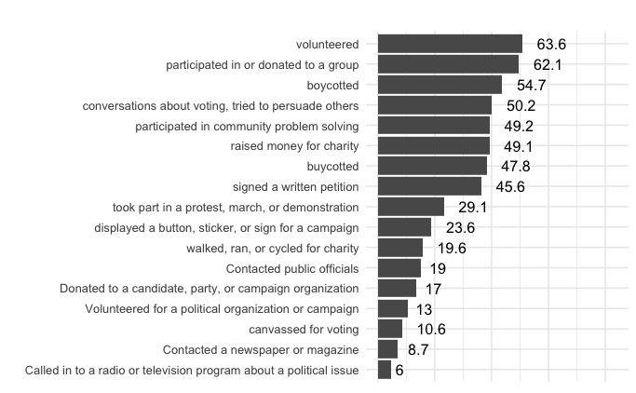

Table S7
Mean number of behaviors reported by respondents in each sample
Study | Mean # of behaviors
2020_general | 6.82
2020_student | 6.42
2021_student | 6.72
2022_general1 | 4.30
2022_student1 | 5.47
2022_student2 | 5.60
2024_student1 | 5.02
2024_student2 | 5.03

Figure S6
Civic behavior rates (%) per sample
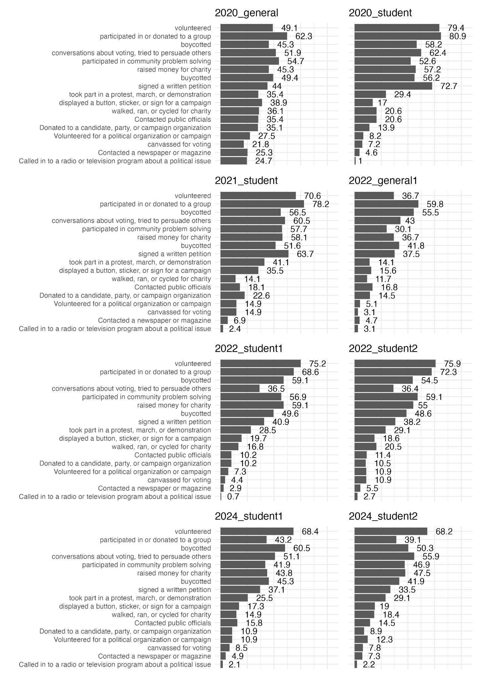

Combined intention to register and vote
In our preregistration, we stated that we would analyze intentions for voting-related behavior (Hypotheses 1 and 5), though we originally pre-registered that we would combine intentions to register to vote and intentions to vote as a single outcome variable. While our analyses in the main report deviate from the preregistration in that we do not include intentions to register, we include those analyses here for posterity. For both Hypothesis 1 and hypothesis 5, we found qualitatively similar results as compared to models with only intention to vote as the outcome variable. Model details are shown below in Table S9.

Table S8
Models for combined intention to register and vote
Model | N | Marginal R² / Conditional R² | Variable | Estimate | CI | Statistic | p | df
(H1) Voting intentions ~ MV | 2225 | 0.19 / 0.27 | Intercept | 0.03 | -0.37 – 0.44 | 0.20 | 0.844 | 6.82
(H1) Voting intentions ~ MV | 2225 | 0.19 / 0.27 | MV-A | 0.78 | 0.72 – 0.85 | 23.75 | <0.001 | 2218.04
(H1) Voting intentions ~ MV | 2225 | 0.19 / 0.27 | MV-C | -0.24 | -0.31 – -0.17 | 7.07 | <0.001 | 2221.22
(H5) Voting intentions  ~ IAF | 2132 | 0.06 / 0.08 | Intercept | 0.05 | -0.25 – 0.34 | 0.39 | 0.713 | 5.49
(H5) Voting intentions  ~ IAF | 2132 | 0.06 / 0.08 | IAF-A | 0.43 | 0.35 – 0.51 | 11.03 | <0.001 | 2128.46
(H5) Voting intentions  ~ IAF | 2132 | 0.06 / 0.08 | IAF-C | -0.09 | -0.17 – -0.01 | 2.30 | 0.021 | 2116.15
Note. MV = motivation to vote, IAF = Index of autonomous functioning (A = autonomous, C = controlled).

Exploratory analyses: Reasons for voting
We conducted exploratory analyses on the relationship between autonomous and controlled motivations to vote and participants’ reported reasons for voting in post-election follow-up surveys. For all participants who self-reported voting and provided at least one reason for voting (n = 415; see Methods; reasons included in Table S10 below), we used a logistic regression model per reason for voting (n = 18), predicting whether or not the reason was endorsed from autonomous and controlled motivations to vote (Table S11), and in separate models, by autonomous and controlled functioning (Table S12). We did not correct for multiple comparisons. Findings from these analyses are discussed in the Results section of the main manuscript.

Table S9
Reasons for not/voting included in post-election follow-up studies
Reasons for voting | Reasons for not voting
It is my civic duty | I change my location frequently
It's part of being an adult | I don't think my vote matters
To support my community | It's too much work
To support my family | I am too busy
To advocate for issues I care about | I don't know how
To make my voice heard | I don't think voting leads to societal change
To hold politicians accountable | I think the system is corrupt
To advance social justice | No one cares if i vote
To build a better world | I don't like the candidates
Because it's my right | I don't meet the necessary requirements to register  (e.g., having a permanent address or valid photo ID)
To participate in democracy | I don't care about politics
Because I care about the consequences of the election | *I don't know what's on the ballot
Because the election outcome will affect me financially | *I'm not qualified to make decisions about what's on  the ballot
To be a part of something bigger than myself
To express myself
Because there is a lot at stake in this election
Because others do not want me to vote
Because i am worried about my future
Note. Participants were asked either about their reasons for voting or their reasons for not voting based on their self-reported voting behavior. Participants chose as many reasons as were applicable for them. *Indicates item not included in 2020 samples.

Table S10
Reasons for voting and autonomous and controlled motivations to vote (N = 415)
DV (Reason) | Variable | Odds Ratio | CI | z | p
is civic duty | MV-A | 1.73 | 1.28 – 2.32 | 3.62 | <0.001
is civic duty | MV-C | 0.93 | 0.69 – 1.25 | 0.49 | 0.623
part of being adult | MV-A | 1.07 | 0.85 – 1.34 | 0.55 | 0.584
part of being adult | MV-C | 1.09 | 0.87 – 1.38 | 0.75 | 0.455
support my community | MV-A | 1.68 | 1.31 – 2.15 | 4.11 | <0.001
support my community | MV-C | 0.92 | 0.72 – 1.17 | 0.71 | 0.477
support my family | MV-A | 1.59 | 1.23 – 2.06 | 3.51 | <0.001
support my family | MV-C | 0.97 | 0.76 – 1.24 | 0.22 | 0.825
advocate for issues care about | MV-A | 2.48 | 1.84 – 3.34 | 5.99 | <0.001
advocate for issues care about | MV-C | 0.75 | 0.57 – 0.98 | 2.09 | 0.036
make voice heard | MV-A | 2.14 | 1.62 – 2.82 | 5.41 | <0.001
make voice heard | MV-C | 0.99 | 0.76 – 1.28 | 0.11 | 0.913
hold politicians accountable | MV-A | 1.74 | 1.37 – 2.22 | 4.47 | <0.001
hold politicians accountable | MV-C | 0.98 | 0.78 – 1.24 | 0.13 | 0.896
advance social justice | MV-A | 1.92 | 1.49 – 2.47 | 5.05 | <0.001
advance social justice | MV-C | 0.88 | 0.69 – 1.12 | 1.03 | 0.305
build better world | MV-A | 2.51 | 1.90 – 3.33 | 6.41 | <0.001
build better world | MV-C | 1.00 | 0.77 – 1.30 | 0.02 | 0.983
is my right | MV-A | 1.38 | 1.06 – 1.78 | 2.41 | 0.0159
is my right | MV-C | 1.00 | 0.77 – 1.30 | 0.00 | 0.999
participate in democracy | MV-A | 2.10 | 1.55 – 2.84 | 4.78 | <0.001
participate in democracy | MV-C | 0.99 | 0.74 – 1.34 | 0.06 | 0.955
care about election consequences | MV-A | 2.09 | 1.52 – 2.86 | 4.58 | <0.001
care about election consequences | MV-C | 0.72 | 0.53 – 0.98 | 2.11 | 0.0351
outcome affects me financially | MV-A | 1.18 | 0.91 – 1.54 | 1.23 | 0.219
outcome affects me financially | MV-C | 1.27 | 0.99 – 1.64 | 1.87 | 0.062
be part something bigger | MV-A | 1.85 | 1.45 – 2.36 | 4.95 | <0.001
be part something bigger | MV-C | 1.22 | 0.96 – 1.55 | 1.66 | 0.096
express myself | MV-A | 1.58 | 1.25 – 2.00 | 3.81 | <0.001
express myself | MV-C | 0.89 | 0.71 – 1.12 | 0.98 | 0.327
lot at stake this election | MV-A | 2.44 | 1.81 – 3.29 | 5.89 | <0.001
lot at stake this election | MV-C | 0.78 | 0.59 – 1.02 | 1.81 | 0.070
others dont want me to vote | MV-A | 1.03 | 0.70 – 1.51 | 0.14 | 0.885
others dont want me to vote | MV-C | 1.08 | 0.74 – 1.58 | 0.42 | 0.675
worried about my future | MV-A | 1.86 | 1.46 – 2.37 | 4.97 | <0.001
worried about my future | MV-C | 0.96 | 0.76 – 1.22 | 0.32 | 0.752

Table S11
Reasons for voting and autonomous and controlled functioning (N = 433)
DV (Reason) | Variable | Odds Ratio | CI | z | p
is civic duty | IAF-A | 1.25 | 0.94 – 1.66 | 1.52 | 0.128
is civic duty | IAF-C | 1.12 | 0.84 – 1.50 | 0.80 | 0.426
part of being adult | IAF-A | 1.02 | 0.81 – 1.28 | 0.17 | 0.867
part of being adult | IAF-C | 1.17 | 0.94 – 1.46 | 1.37 | 0.169
support my community | IAF-A | 1.28 | 1.01 – 1.62 | 2.08 | 0.038
support my community | IAF-C | 0.94 | 0.75 – 1.18 | 0.50 | 0.614
support my family | IAF-A | 1.33 | 1.04 – 1.71 | 2.26 | 0.024
support my family | IAF-C | 0.99 | 0.79 – 1.25 | 0.07 | 0.942
advocate for issues care about | IAF-A | 1.67 | 1.27 – 2.20 | 3.68 | <0.001
advocate for issues care about | IAF-C | 0.73 | 0.56 – 0.95 | 2.36 | 0.018
make voice heard | IAF-A | 1.18 | 0.92 – 1.51 | 1.31 | 0.190
make voice heard | IAF-C | 0.97 | 0.76 – 1.23 | 0.26 | 0.793
hold politicians accountable | IAF-A | 1.10 | 0.87 – 1.37 | 0.79 | 0.428
hold politicians accountable | IAF-C | 0.98 | 0.79 – 1.22 | 0.18 | 0.855
advance social justice | IAF-A | 1.23 | 0.97 – 1.55 | 1.72 | 0.085
advance social justice | IAF-C | 0.92 | 0.74 – 1.15 | 0.71 | 0.479
build better world | IAF-A | 1.37 | 1.07 – 1.74 | 2.51 | 0.012
build better world | IAF-C | 0.85 | 0.67 – 1.08 | 1.33 | 0.185
is my right | IAF-A | 1.10 | 0.85 – 1.43 | 0.76 | 0.448
is my right | IAF-C | 1.18 | 0.92 – 1.53 | 1.28 | 0.200
participate in democracy | IAF-A | 1.25 | 0.94 – 1.65 | 1.56 | 0.119
participate in democracy | IAF-C | 0.98 | 0.75 – 1.30 | 0.11 | 0.910
care about election consequences | IAF-A | 1.29 | 0.96 – 1.73 | 1.67 | 0.094
care about election consequences | IAF-C | 0.85 | 0.64 – 1.14 | 1.08 | 0.279
outcome affects me financially | IAF-A | 1.06 | 0.82 – 1.37 | 0.44 | 0.663
outcome affects me financially | IAF-C | 1.15 | 0.90 – 1.47 | 1.12 | 0.262
be part something bigger | IAF-A | 1.23 | 0.99 – 1.54 | 1.84 | 0.066
be part something bigger | IAF-C | 1.19 | 0.96 – 1.48 | 1.59 | 0.112
express myself | IAF-A | 1.25 | 1.00 – 1.56 | 1.92 | 0.055
express myself | IAF-C | 1.19 | 0.96 – 1.47 | 1.56 | 0.119
lot at stake this election | IAF-A | 1.27 | 0.98 – 1.65 | 1.78 | 0.076
lot at stake this election | IAF-C | 0.94 | 0.73 – 1.22 | 0.44 | 0.657
others dont want me to vote | IAF-A | 1.09 | 0.74 – 1.6 | 0.42 | 0.676
others dont want me to vote | IAF-C | 0.87 | 0.60 – 1.26 | 0.76 | 0.446
worried about my future | IAF-A | 1.47 | 1.17 – 1.85 | 3.27 | 0.001
worried about my future | IAF-C | 1.01 | 0.81 – 1.26 | 0.07 | 0.942

Exploratory analyses: Reasons for not voting
We also conducted exploratory analyses on the relationship between autonomous and controlled motivations to vote and participants’ reported reasons for not voting in post-election follow-up surveys. For all participants who self-reported not voting and provided at least one reason for not voting (see Methods; reasons included in Table S10), we used a logistic regression model per reason for not voting (n = 14), predicting whether or not the reason was endorsed from autonomous and controlled motivations to vote, and in separate models, by autonomous and controlled functioning. We did not correct for multiple comparisons.
We found that autonomous motivation to vote was negatively related to reason endorsement for several reasons (“the system is corrupt,” “it doesn’t lead to societal change,” “my vote doesn’t matter”, “I don’t care about politics,” and “it’s too much work”), and was not positively related to any reason endorsement. Controlled motivation to vote was not significantly related to any reason endorsement. Neither autonomous or controlled functioning were significantly related to any reason endorsement.

Table S12
Reasons for not voting and autonomous and controlled motivations to vote (N = 415)
DV (Reason) | Variable | Odds Ratio | CI | z | p
I change my location frequently | MV-A | 1.08 | 0.72 – 1.62 | 0.37 | 0.711
I change my location frequently | MV-C | 1.10 | 0.72 – 1.67 | 0.45 | 0.656
I don't think my vote matters | MV-A | 0.27 | 0.14 – 0.54 | 3.73 | <0.001
I don't think my vote matters | MV-C | 1.79 | 0.97 – 3.29 | 1.86 | 0.063
It's too much work | MV-A | 0.40 | 0.2 – 0.81 | 2.54 | 0.011
It's too much work | MV-C | 1.27 | 0.65 – 2.48 | 0.69 | 0.490
I am too busy | MV-A | 1.20 | 0.8 – 1.8 | 0.88 | 0.376
I am too busy | MV-C | 0.89 | 0.58 – 1.35 | 0.56 | 0.575
I don't know how | MV-A | 0.91 | 0.47 – 1.79 | 0.26 | 0.794
I don't know how | MV-C | 0.97 | 0.49 – 1.93 | 0.08 | 0.939
I don't think voting leads to societal change | MV-A | 0.33 | 0.13 – 0.79 | 2.47 | 0.013
I don't think voting leads to societal change | MV-C | 0.49 | 0.15 – 1.62 | 1.17 | 0.243
I think the system is corrupt | MV-A | 0.44 | 0.2 – 0.98 | 2.01 | 0.044
I think the system is corrupt | MV-C | 1.12 | 0.51 – 2.47 | 0.29 | 0.771
No one cares if i vote | MV-A | 0.74 | 0.28 – 1.96 | 0.61 | 0.545
No one cares if i vote | MV-C | 1.53 | 0.58 – 4.03 | 0.86 | 0.387
I don't like the candidates | MV-A | 1.10 | 0.68 – 1.78 | 0.37 | 0.709
I don't like the candidates | MV-C | 0.87 | 0.52 – 1.45 | 0.54 | 0.591
I don't meet the necessary requirements to register (e.g., having a permanent address or valid photo ID) | MV-A | 1.37 | 0.74 – 2.54 | 0.99 | 0.320
 | MV-C | 1.20 | 0.65 – 2.21 | 0.58 | 0.564
I don't care about politics | MV-A | 0.42 | 0.23 – 0.77 | 2.78 | 0.005
I don't care about politics | MV-C | 1.21 | 0.68 – 2.18 | 0.65 | 0.515
*I don't know what's on the ballot | MV-A | 0.61 | 0.32 – 1.19 | 1.45 | 0.148
*I don't know what's on the ballot | MV-C | 1.31 | 0.7 – 2.48 | 0.84 | 0.400
*I'm not qualified to make decisions about what's on the ballot | MV-A | 1.29 | 0.84 – 1.99 | 1.16 | 0.247
 | MV-C | 1.03 | 0.66 – 1.61 | 0.15 | 0.884
*Indicates item not included in 2020 samples.

Table S13
Reasons for not voting and autonomous and controlled functioning (N = 433)
DV (Reason) | Variable | Odds Ratio | CI | z | p
I change my location frequently | IAF-A | 0.90 | 0.62 – 1.29 | 0.58 | 0.564
I change my location frequently | IAF-C | 0.97 | 0.62 – 1.51 | 0.14 | 0.889
I don't think my vote matters | IAF-A | 1.03 | 0.66 – 1.6 | 0.12 | 0.904
I don't think my vote matters | IAF-C | 1.20 | 0.71 – 2.01 | 0.68 | 0.499
It's too much work | IAF-A | 0.89 | 0.52 – 1.53 | 0.42 | 0.675
It's too much work | IAF-C | 1.09 | 0.57 – 2.09 | 0.25 | 0.799
I am too busy | IAF-A | 0.92 | 0.64 – 1.34 | 0.42 | 0.675
I am too busy | IAF-C | 1.28 | 0.82 – 1.99 | 1.10 | 0.272
I don't know how | IAF-A | 1.02 | 0.58 – 1.79 | 0.06 | 0.950
I don't know how | IAF-C | 1.06 | 0.52 – 2.17 | 0.16 | 0.876
I don't think voting leads to societal change | IAF-A | 1.06 | 0.55 – 2.04 | 0.18 | 0.854
I don't think voting leads to societal change | IAF-C | 0.56 | 0.22 – 1.38 | 1.27 | 0.206
I think the system is corrupt | IAF-A | 1.34 | 0.69 – 2.62 | 0.87 | 0.385
I think the system is corrupt | IAF-C | 0.63 | 0.27 – 1.45 | 1.09 | 0.274
No one cares if i vote | IAF-A | 0.92 | 0.39 – 2.15 | 0.19 | 0.849
No one cares if i vote | IAF-C | 0.82 | 0.28 – 2.42 | 0.36 | 0.718
I don't like the candidates | IAF-A | 1.25 | 0.81 – 1.94 | 1.02 | 0.307
I don't like the candidates | IAF-C | 0.96 | 0.58 – 1.59 | 0.15 | 0.877
I don't meet the necessary requirements to register (e.g., having a permanent address or valid photo ID) | IAF-A | 0.61 | 0.33 – 1.12 | 1.59 | 0.111
 | IAF-C | 0.93 | 0.44 – 1.99 | 0.18 | 0.857
I don't care about politics | IAF-A | 0.63 | 0.39 – 1.01 | 1.93 | 0.054
I don't care about politics | IAF-C | 0.83 | 0.45 – 1.51 | 0.63 | 0.531
*I don't know what's on the ballot | IAF-A | 0.61 | 0.36 – 1.04 | 1.83 | 0.067
*I don't know what's on the ballot | IAF-C | 0.80 | 0.4 – 1.59 | 0.64 | 0.522
*I'm not qualified to make decisions about what's on the ballot | IAF-A | 0.97 | 0.66 – 1.42 | 0.17 | 0.868
 | IAF-C | 0.89 | 0.56 – 1.41 | 0.51 | 0.612
*Indicates item not included in 2020 samples.

Figure S7
Self-reported reasons for not voting as a function of autonomy
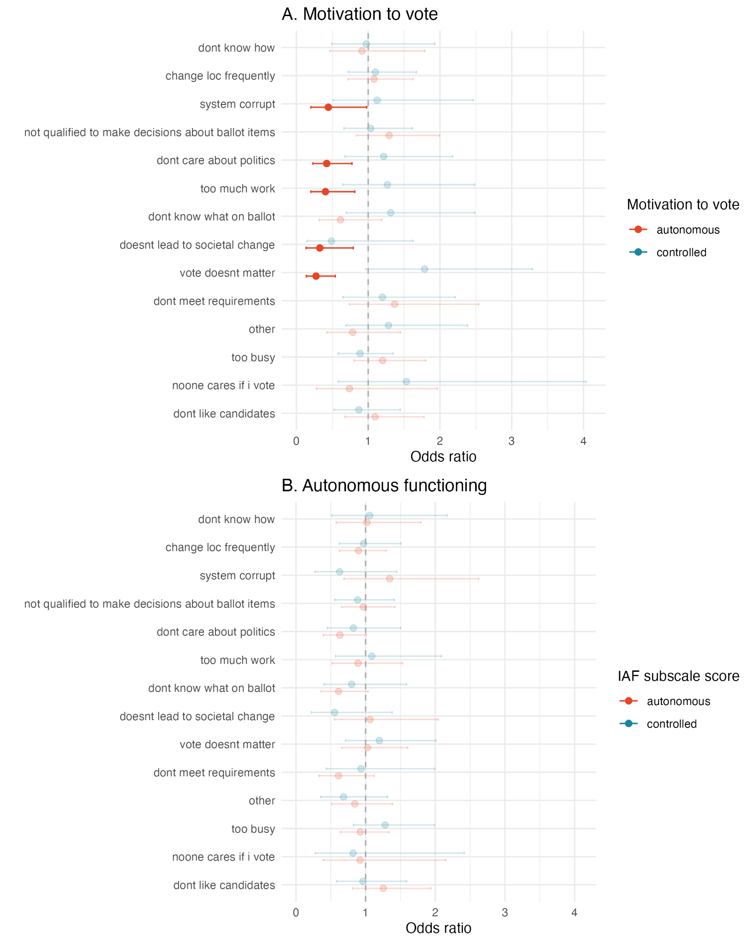
Note. Reasons for not voting as related to (A) Motivation to vote (n = 119); (B) Index of autonomous functioning (n = 130). Odds ratios and 95% CIs are plotted, with higher opacity for significant results. Dashed line indicates no effect (OR = 1).

Exploratory analyses: Causal pathways among voting motivation, intentions, and behavior
Data from all participants who completed measures of voting behavior were included in the same structural equation model. All variables were modeled as observed variables. The model was fit using the sem function from the lavaan package (Rosseel, 2012) in R and exhibited an excellent fit (CFI = 1.000, TLI = 1.000, RMSEA = 0.000). Parameter estimates were standardized and confidence intervals and p-values were bootstrapped (N iterations = 1000) using the standardizedSolution_boot function from the semboottools package (Yang & Cheung, 2026) in R. These statistics are reported in Table S15.
First, we found that autonomous motivation (a1 path: 𝛽 = 0.44, 95% CI [0.36, 0.52]) was positively associated with voting intentions, but controlled motivation was not (a2 path: 𝛽 = -0.03, 95% CI [-0.11, 0.05]). Second, voting intentions predicted subsequent behavior (b path: 𝛽 = 0.58, 95% CI [0.49, 0.66]). Third, there was an indirect effect of autonomous motivation on voting behavior through intentions (a1*b path: 𝛽 = 0.25, 95% CI [0.20, 0.32]), but no indirect effect on behavior for controlled motivation (a2*b path: 𝛽 = -0.02, 95% CI [-0.06, 0.03]).

Table S14
Structural equation model for voting motivation, intentions, and behavior, across all samples (N = 534)
Path | 𝛽 | CI | SE | z | p
a1: MV-A → Voting intention | 0.44 | 0.36 – 0.52 | 0.04 | 11.26 | <0.001
a2: MV-C → Voting intention | -0.03 | -0.11 – 0.05 | 0.04 | -0.73 | 0.440
b: Voting intention → Voting behavior | 0.58 | 0.49 – 0.66 | 0.04 | 13.97 | <0.001
a1*b: MV-A → Voting intention → Voting behavior | 0.25 | 0.20 – 0.32 | 0.03 | 8.57 | <0.001
a2*b: MV-C → Voting intention → Voting behavior | -0.02 | -0.06 – 0.03 | 0.02 | -0.73 | 0.440
c1’: MV-A → Voting behavior | -0.02 | -0.10 – 0.06 | 0.04 | -0.44 | 0.660
c2’: MV-C → Voting behavior | 0.02 | -0.06 – 0.10 | 0.04 | -0.41 | 0.642
c1: MV-A total (indirect + direct) effect | 0.24 | 0.14 – 0.32 | 0.04 | 5.34 | <0.001
c2: MV-C total (indirect + direct) effect | 0.00 | -0.09 – 0.09 | 0.05 | -0.01 | 0.988
Note. MV = motivation to vote (A = autonomous, C = controlled).

Exploratory analyses: expression of trait and state autonomy by age
As noted in the main manuscript, the voter turnout gap is even greater for young adults (Pew Research Center, 2023). Here, we explore the interaction between both trait and context-specific autonomy and age, across samples. Table S16 and Figure S8 show autonomous and controlled motivations and functioning as a function of age. As age increases, participants report both higher autonomous motivations to vote and higher autonomous functioning (MV-A: b = 0.10, 95% CI [0.07, 0.013]; IAF-A: b = 0.15, 95% CI [0.11, 0.18]), but lower controlled motivations to vote and lower controlled functioning (MV-C: b = -0.06, 95% CI [-0.09, -0.03]; IAF-C: b = -0.23, 95% CI [-0.26, -0.19]). These results are consistent autonomy development during emerging adulthood (Ratelle & Guay, 2023).
Table S17 shows model estimates for two of our primary outcomes, voting intentions and sense of civic duty, in a model including the interaction between age and motivation to vote, and a model including the interaction between age and autonomous and controlled functioning. These models are also visualized in Figures S8–S12. These models show that the level of autonomous motivation to vote is more strongly associated with voting intentions in younger adults, as compared to older adults (b = -0.03, 95% CI [-0.05, -0.003]), while there is no significant interaction between controlled motivations and age (b = -0.01, 95% CI = [-0.03, 0.02]). This pattern also holds in the relationship between voting intentions and autonomous (b = -0.03, 95% CI [-0.06, -0.002]) and controlled functioning (b = 0.03, 95% CI [-0.003, 0.06]). These findings indicate that support for autonomous motivations may be particularly relevant in younger adults, who have not yet formed a habit of voting.
We found a distinct pattern regarding sense of civic duty; autonomous motivations to vote (b = 0.044, 95% CI [0.016, 0.072]) have a stronger association with civic duty in older adults as compared to younger adults, which may reflect a developmental trajectory of internalizing civic duty across adulthood. There was no significant interaction between controlled motivations and age (b = 0.02, 95% CI [-0.01 – 0.05]) affecting civic duty. However, there was also no significant interaction between age and autonomous functioning as related to civic duty (b = 0.03, 95% CI [-0.001 – 0.06]), though there was a positive and significant interaction between age and controlled functioning (b = 0.04, 95% CI [0.01, 0.07]), suggesting that among older adults in our sample, controlled functioning is more associated with civic duty than among younger participants.

Table S15
Autonomous and controlled motivations and functioning by age
Outcome variable | N | Marginal R² / Conditional R² | Variable | Estimate | CI | Statistic | p | df
MV-A | 2329 | 0.02 / 0.02 | Intercept | -0.11 | -0.16 – -0.06 | -3.99 | <0.001 | 2327.00
MV-A | 2329 | 0.02 / 0.02 | age_s | 0.10 | 0.07 – 0.13 | 6.61 | <0.001 | 2327.00
MV-C | 2327 | 0.01 / 0.01 | Intercept | 0.08 | 0.02 – 0.13 | 2.83 | 0.005 | 2325.00
MV-C | 2327 | 0.01 / 0.01 | age_s | -0.06 | -0.09 – -0.03 | -3.97 | <0.001 | 2325.00
IAF-A | 2244 | 0.04 / 0.06 | Intercept | -0.18 | -0.30 – -0.05 | -3.23 | 0.012 | 8.08
IAF-A | 2244 | 0.04 / 0.06 | age_s | 0.15 | 0.11 – 0.18 | 7.71 | <0.001 | 384.27
IAF-C | 2244 | 0.10 / 0.13 | Intercept | 0.31 | 0.15 – 0.47 | 4.38 | 0.002 | 8.36
IAF-C | 2244 | 0.10 / 0.13 | age_s | -0.23 | -0.26 – -0.19 | -12.05 | <0.001 | 1017.97
Note. MV = motivation to vote, IAF = Index of autonomous functioning (A = autonomous, C = controlled). Models are simple linear regressions, collapsed across studies. Age (age_s) is scaled and centered at 18, such that a unit increase in age_s reflects a 10-year age difference from the youngest adults in our sample.

Figure S8
Autonomous and controlled motivations and autonomous and controlled functioning by age
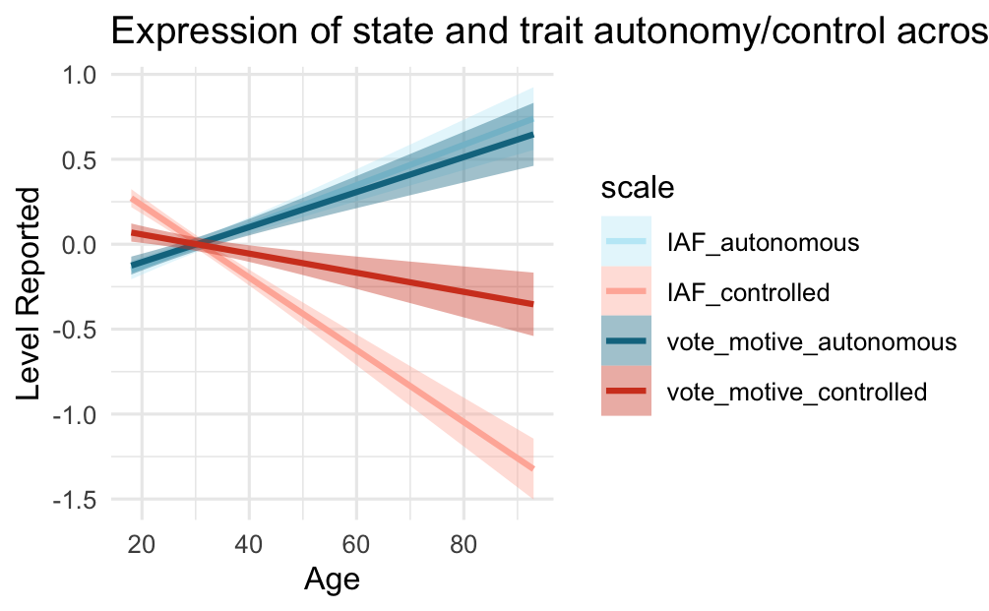
Note. Figure shows reported levels smoothed with simple linear regression. Motivation and IAF scales are standardized.

Table S16
Age interactions with trait and state autonomy in voting intentions and civic duty

DV | N | Marginal R² / Conditional R² | Variable | Estimate | CI | Statistic | p | df
Voting intentions | 2327 | 0.245 / 0.294 | Intercept | -0.012 | -0.173 – 0.149 | -0.167 | 0.871 | 8.380
Voting intentions | 2327 | 0.245 / 0.294 | MV-A | 0.477 | 0.433 – 0.521 | 21.228 | <0.001 | 2317.897
Voting intentions | 2327 | 0.245 / 0.294 | age_s | 0.074 | 0.042 – 0.107 | 4.501 | <0.001 | 1565.390
Voting intentions | 2327 | 0.245 / 0.294 | MV-C | -0.075 | -0.121 – -0.030 | -3.231 | 0.001 | 2319.155
Voting intentions | 2327 | 0.245 / 0.294 | MV-A*age_s | -0.028 | -0.053 – -0.003 | -2.220 | 0.027 | 2319.559
Voting intentions | 2327 | 0.245 / 0.294 | MV-C*age_s | -0.005 | -0.031 – 0.021 | -0.385 | 0.701 | 2319.537
Voting intentions | 2244 | 0.068 / 0.094 | Intercept | -0.040 | -0.187 – 0.106 | -0.636 | 0.543 | 7.990
Voting intentions | 2244 | 0.068 / 0.094 | IAF-A | 0.256 | 0.199 – 0.312 | 8.897 | <0.001 | 2236.460
Voting intentions | 2244 | 0.068 / 0.094 | age_s | 0.095 | 0.052 – 0.138 | 4.317 | <0.001 | 578.086
Voting intentions | 2244 | 0.068 / 0.094 | IAF-C | -0.052 | -0.109 – 0.005 | -1.803 | 0.071 | 2237.646
Voting intentions | 2244 | 0.068 / 0.094 | IAF-A*age_s | -0.033 | -0.064 – -0.002 | -2.117 | 0.034 | 2237.696
Voting intentions | 2244 | 0.068 / 0.094 | IAF-C*age_s | 0.029 | -0.003 – 0.061 | 1.797 | 0.073 | 2198.869
Civic duty | 2327 | 0.189 / 0.277 | Intercept | 0.089 | -0.148 – 0.326 | 0.865 | 0.412 | 8.119
Civic duty | 2327 | 0.189 / 0.277 | MV-A | 0.371 | 0.321 – 0.420 | 14.654 | <0.001 | 2316.111
Civic duty | 2327 | 0.189 / 0.277 | age_s | 0.019 | -0.017 – 0.056 | 1.039 | 0.299 | 2023.748
Civic duty | 2327 | 0.189 / 0.277 | MV-C | -0.026 | -0.078 – 0.025 | -0.995 | 0.320 | 2317.049
Civic duty | 2327 | 0.189 / 0.277 | MV-A*age_s | 0.044 | 0.016 – 0.072 | 3.104 | 0.002 | 2317.489
Civic duty | 2327 | 0.189 / 0.277 | MV-C*age_s | 0.023 | -0.006 – 0.052 | 1.529 | 0.126 | 2317.419
Civic duty | 2243 | 0.192 / 0.261 | Intercept | 0.047 | -0.185 – 0.280 | 0.480 | 0.645 | 7.151
Civic duty | 2243 | 0.192 / 0.261 | IAF-A | 0.404 | 0.352 – 0.456 | 15.179 | <0.001 | 2232.258
Civic duty | 2243 | 0.192 / 0.261 | age_s | 0.023 | -0.018 – 0.065 | 1.113 | 0.266 | 1718.614
Civic duty | 2243 | 0.192 / 0.261 | IAF-C | 0.068 | 0.016 – 0.121 | 2.549 | 0.011 | 2234.731
Civic duty | 2243 | 0.192 / 0.261 | IAF-A*age_s | 0.028 | -0.001 – 0.056 | 1.905 | 0.057 | 2234.743
Civic duty | 2243 | 0.192 / 0.261 | IAF-C*age_s | 0.036 | 0.006 – 0.065 | 2.381 | 0.017 | 2236.673
Note. IAF = Index of autonomous functioning; MV = vote motivations; A = autonomous; C = controlled. Main effects that are statistically significant at p < .05 are bolded. Estimates are standardized regression coefficients and statistics are t-values. Models include a random intercept per study sample. Age (age_s) is scaled and centered at 18, such that a unit increase in age_s reflects a 10-year age difference from the youngest adults in our sample.

Figure S9
Voting intentions by age and autonomous and controlled motivation
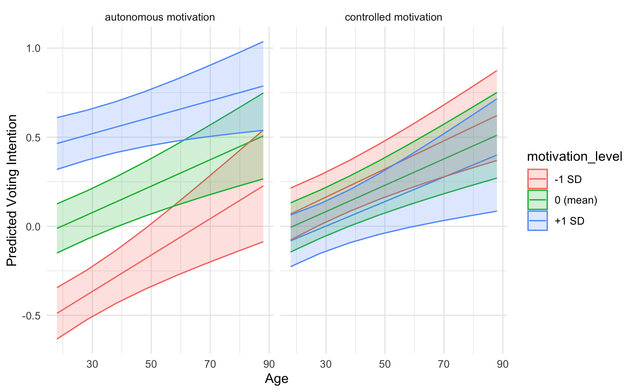

Figure S10
Sense of civic duty by age and autonomous and controlled motivation
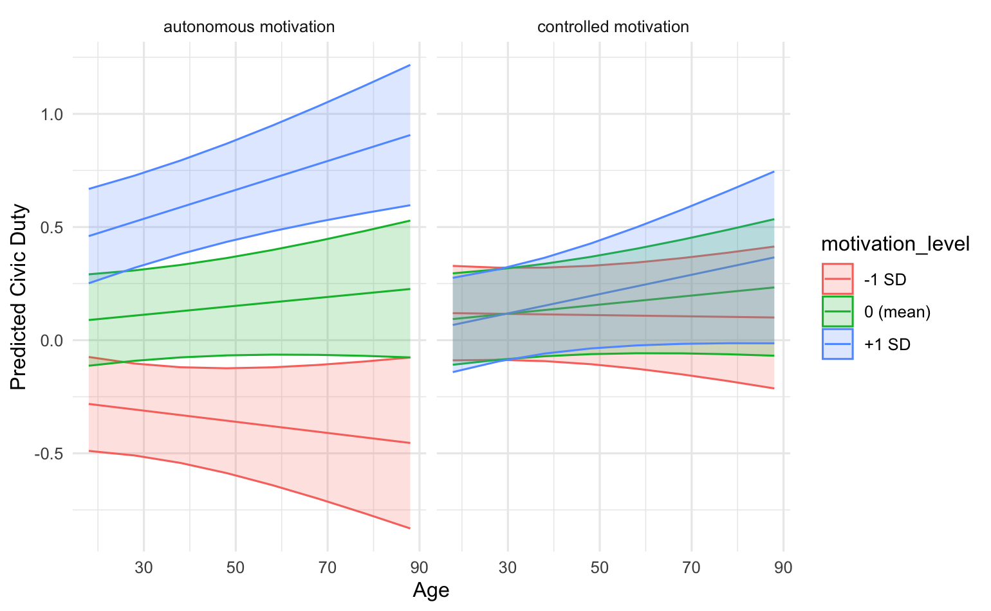

Figure S11
Voting intentions by age and autonomous and controlled functioning

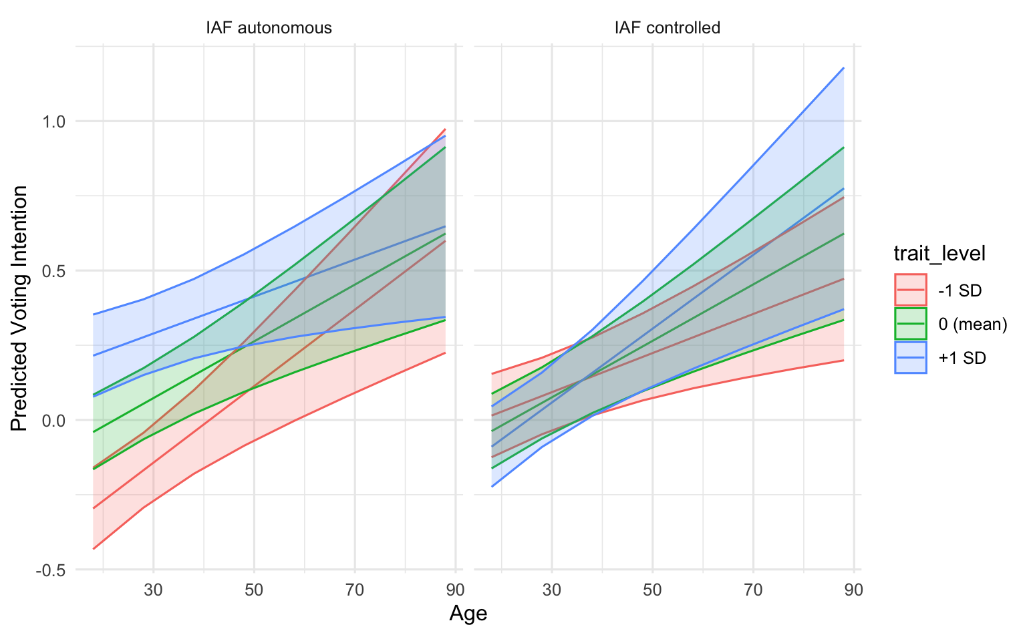

Figure S12
Sense of civic duty by age and autonomous and controlled motivation
