Fig S1: Distribution of environmental impact values on linear and log-transformed scales

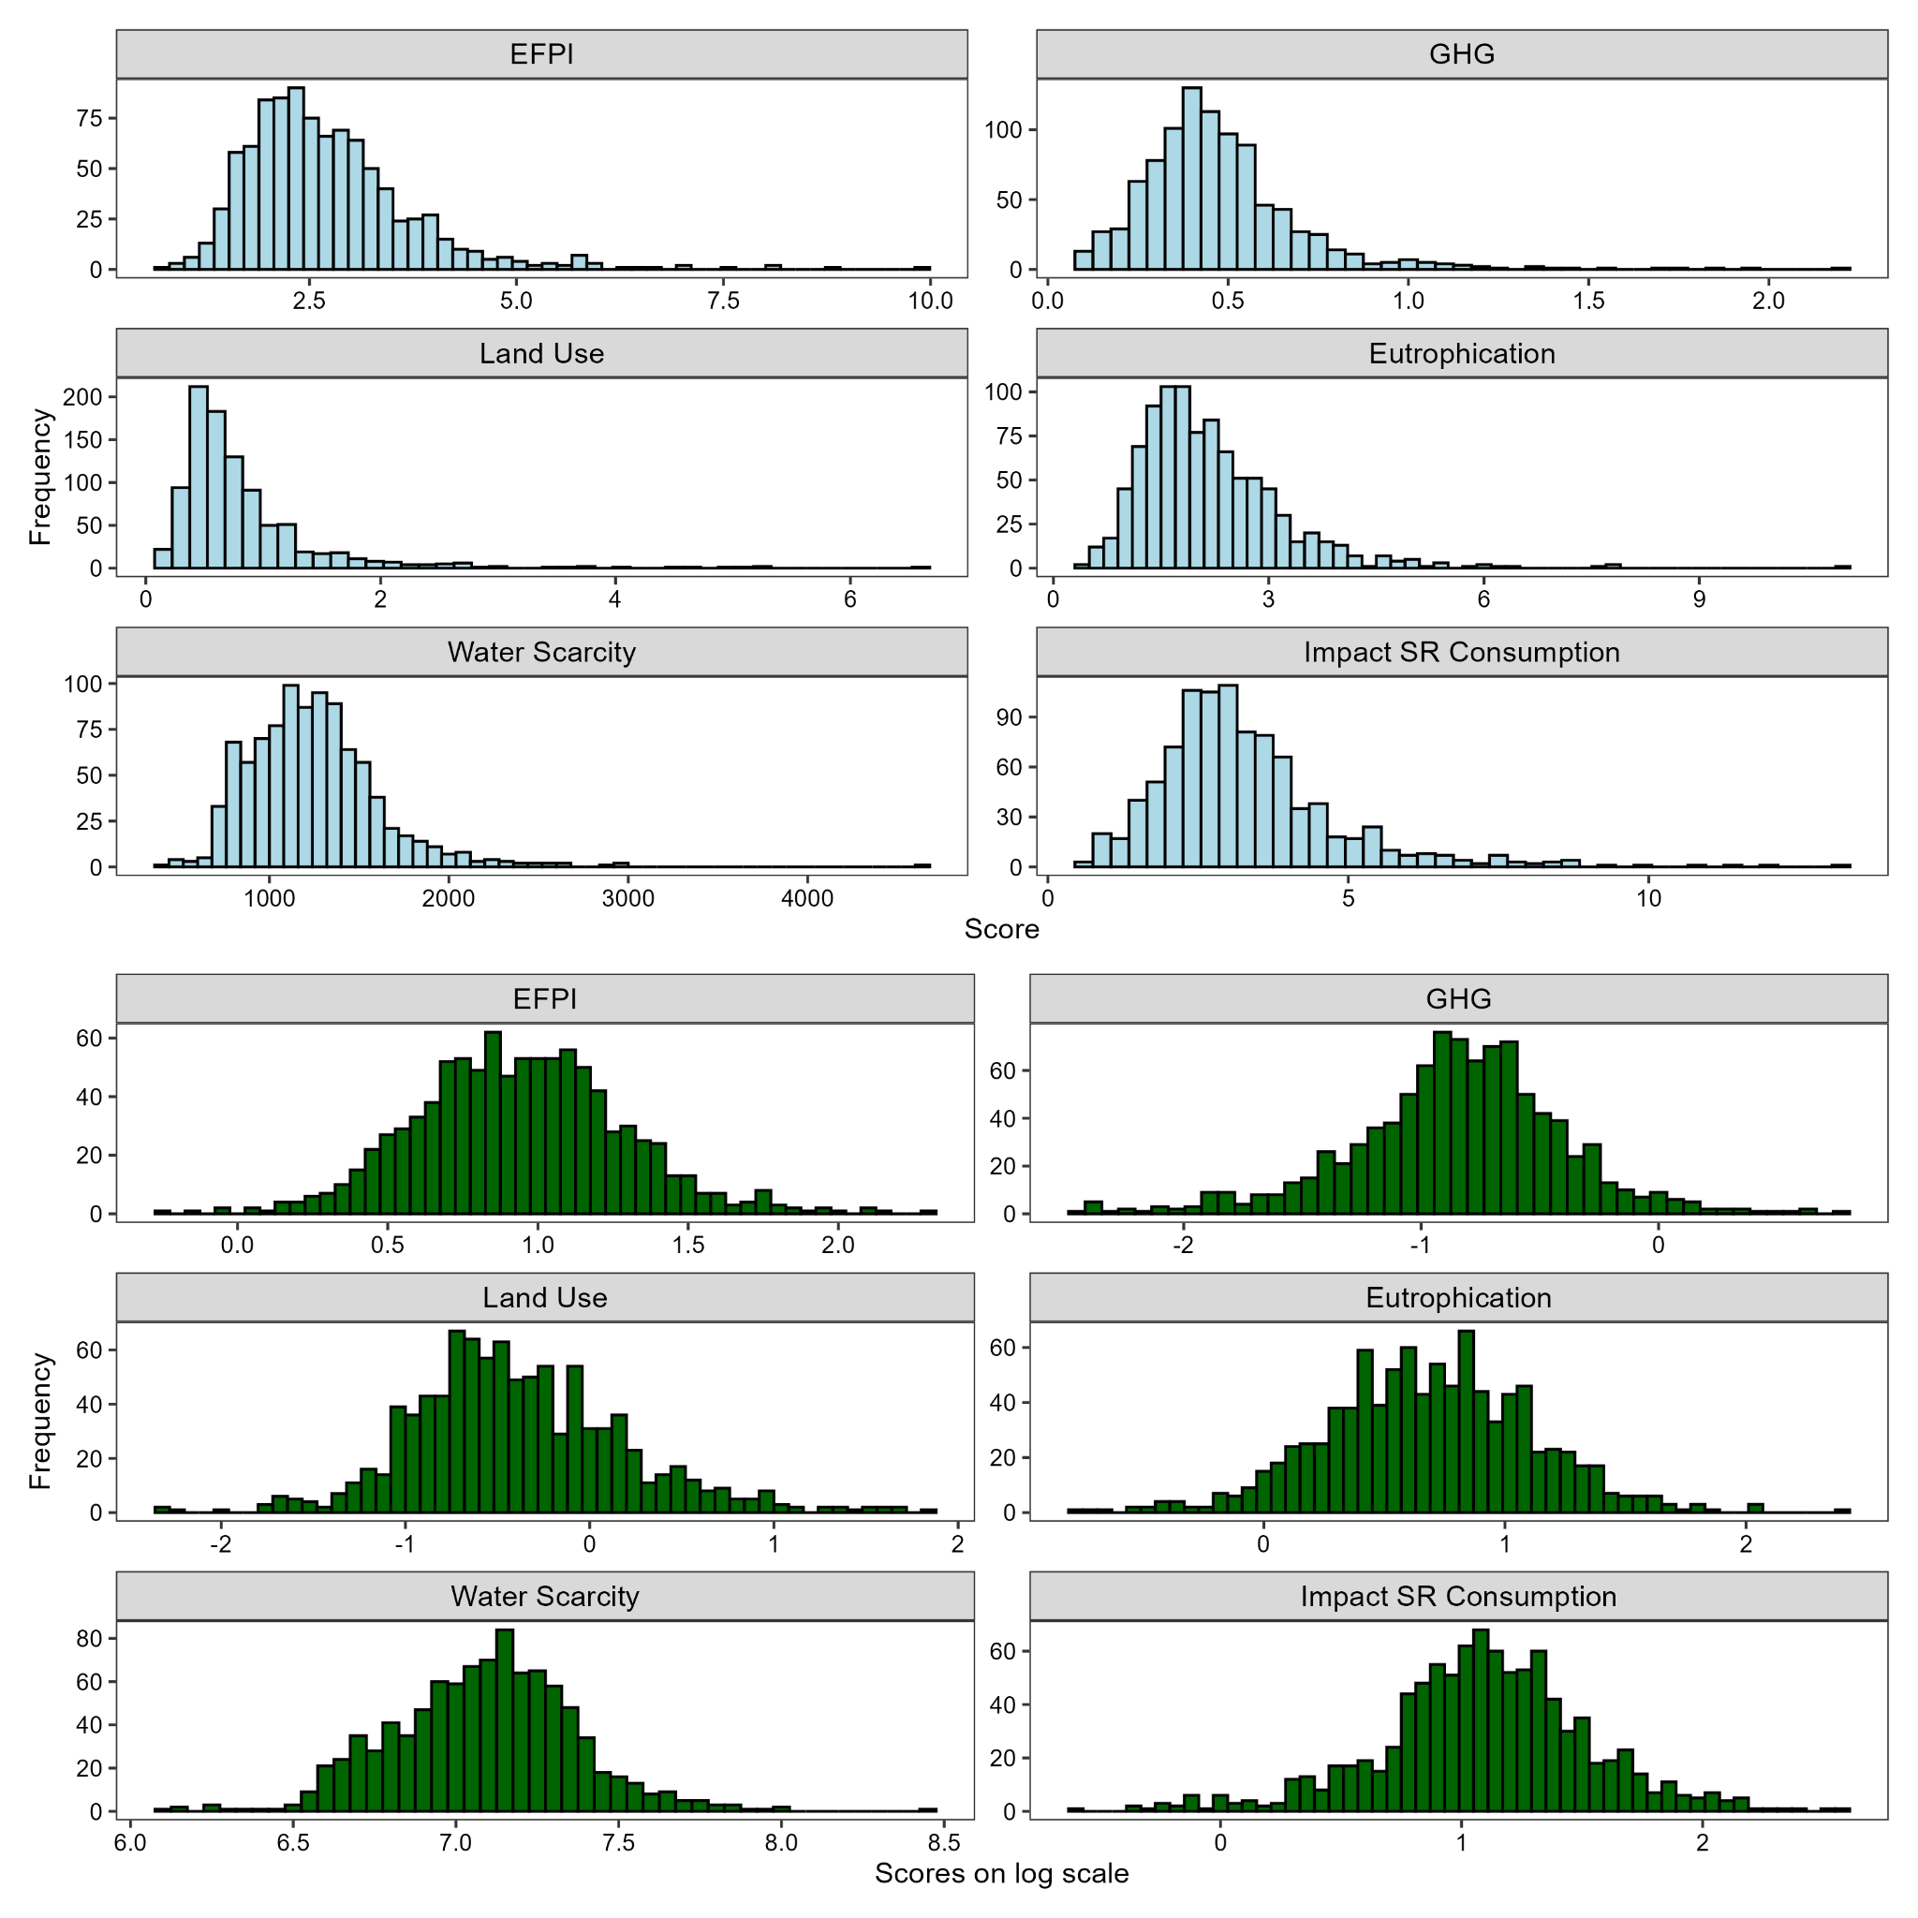

Fig S2: Distribution of food shopping perceived environmental impact scores
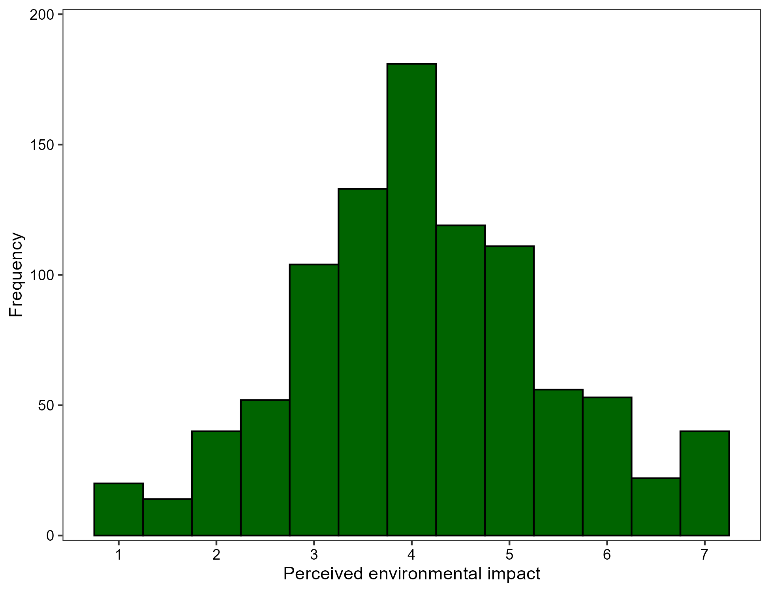

Table S1 Partial correlations between self-report measures and EFPI scores for regular shoppers
Self-report measure | EFPI
Perceived food shopping impact | .13***
Impact of self-reported dietary consumption | .31***
Omnivore (0) vs. Low-meat (1) | -.24***
Covariates: number of people shopped for, self-reported percentage of grocery shopping done at Tesco, and main household shopper status. Correlations remained significant when additionally controlling for total volume by purchase weight (perceived environmental impact, r_{p} = .11, p = .002; environmental impact of self-reported dietary consumption, r_{p} = .32, p < .001; omnivore vs. low-meat households, r_{p} = -.26, p < .001.
For the omnivore vs. low-meat diet measure, participants in omnivore-only households were coded as 0, and participants with at least one household member following a vegan, vegetarian, pescatarian, or flexitarian diet were coded as 1.
*** p <. 001
Table S2 Multiple linear regression coefficients and model statistics for high-level food group composition associations with EFPI and perceived environmental impact of food shopping
Variables | EFPI |  |  | Perceived env. impact
Variables | b | SE | p | b | SE | p
Shopped for =
2 | 0.01 | 0.02 | .721 | 0.01 | 0.11 | .892
3 | 0.00001 | 0.03 | .999 | -0.34 | 0.13 | .006
4 | -0.01 | 0.03 | .797 | -0.17 | 0.14 | .199
5+ | 0.04 | 0.04 | .392 | -0.32 | 0.20 | .112
Main shopper | -0.02 | 0.03 | .596 | -0.09 | 0.14 | .499
% Tesco | -0.0002 | 0.0004 | .604 | -0.01 | 0.002 | <.001
Total weight | 0.02 | 0.01 | .008 | 0.18 | 0.04 | <.001
Group ILR 1 | -0.08 | 0.01 | <.001 | -0.06 | 0.03 | .036
Group ILR 2 | -0.07 | 0.01 | <.001 | 0.01 | 0.04 | .754
Group ILR 3 | -0.04 | 0.01 | <.001 | -0.11 | 0.03 | .002
Group ILR 4 | -0.02 | 0.01 | .022 | 0.05 | 0.05 | .275
Model statistics
F | F(11, 904) = 36.84*** |  |  | F(11, 902) = 6.79***
R²_{adj} | .301 |  |  | .065
Group ILRs = isometric log-ratios representing high-level food group composition. Shopped for reference category = 1 person; main shopper reference category = do all or most of the shopping.
% Tesco = Self-reported percentage of grocery shopping done at Tesco. Total weight = food shopping purchase weight over 12-month period (log-transformed).
*** p < .001
Fig S3: High-level food group composition associations with standardised (z-scored) EFPI scores and perceived environmental impact of food shopping
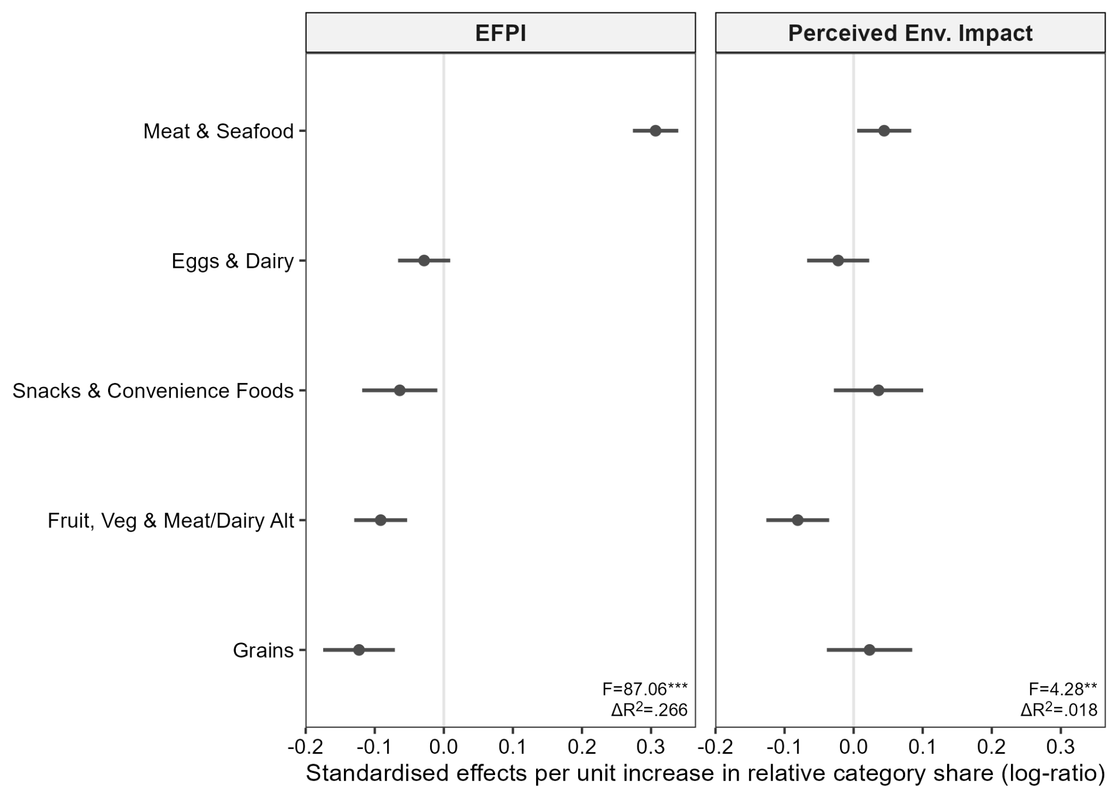
CLR coefficients with 95% confidence intervals, indicating the expected change in z-scored EFPI and perceived environmental impact scores associated with a one-unit increase in the natural log of a component relative to the geometric mean of the composition.
** p < .01 *** p < .001
Fig S4: Within-group composition associations with EFPI scores and perceived environmental impact of food shopping 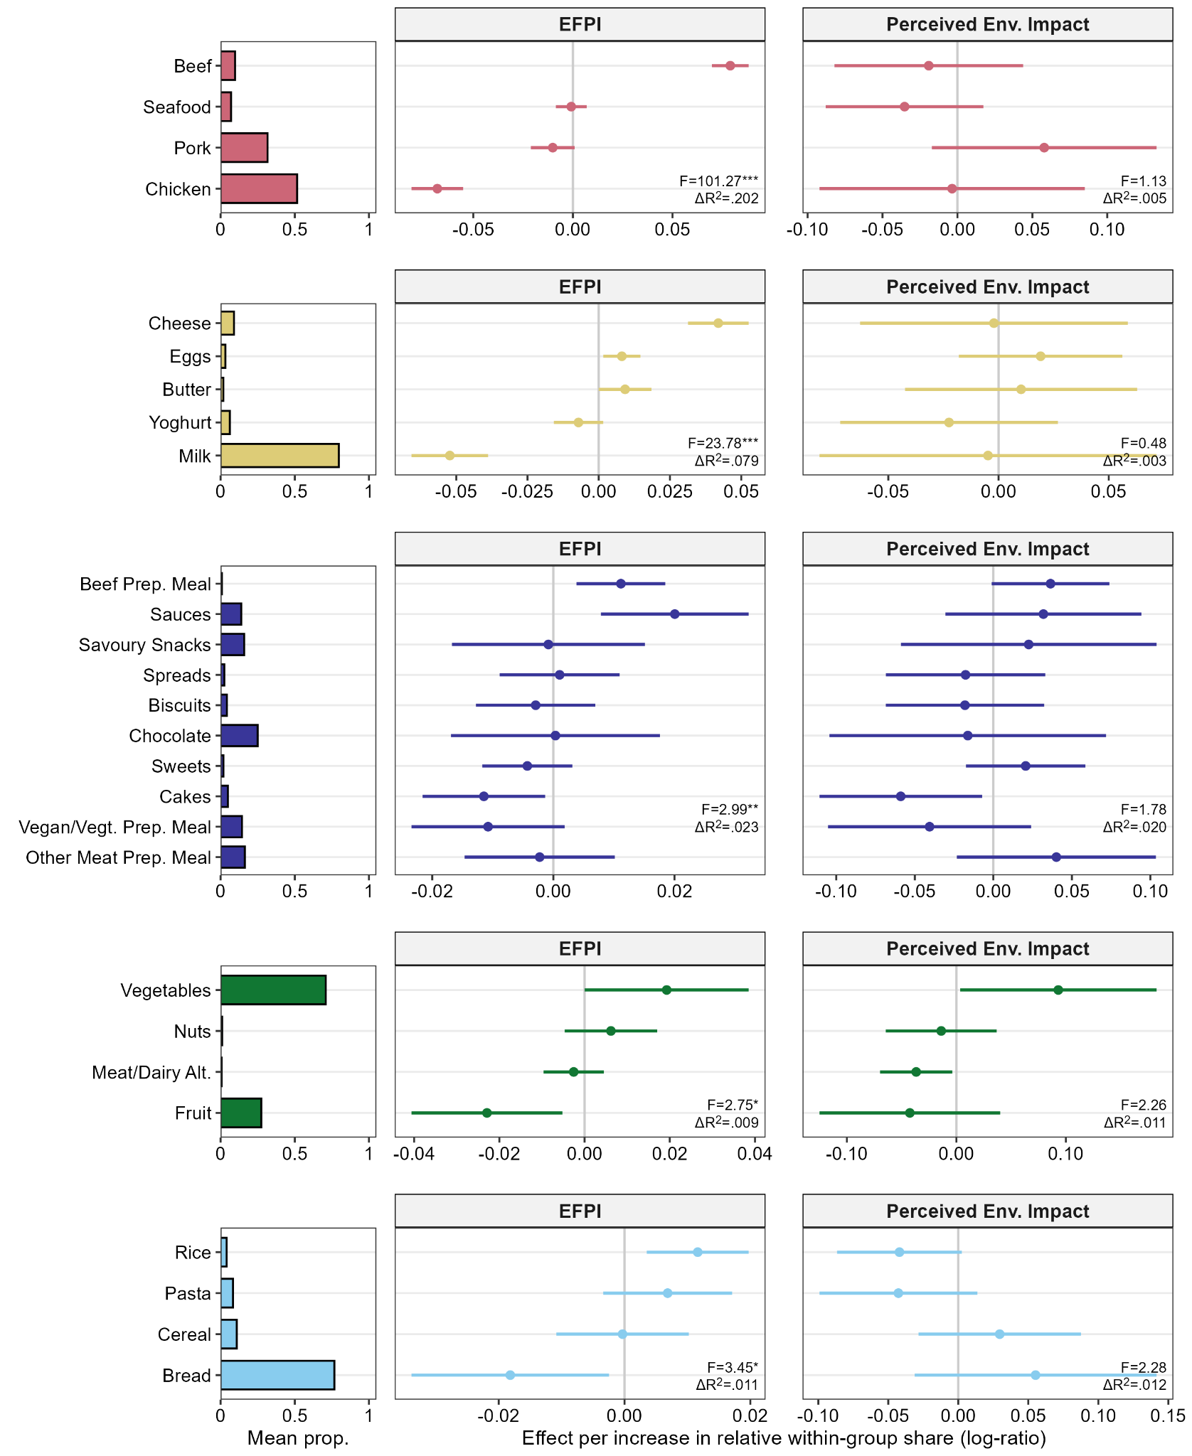
The left-hand panel shows mean within-group compositional shares. Panels to the right show CLR coefficients with 95% confidence intervals, indicating the expected change in the outcome associated with a one-unit increase in the natural log of a component relative to the geometric mean of the composition. Each plot relates to a separate multiple linear regression model. ILR regression coefficients are reported in Tables S3-S7.
* p < .05, ** p < .01, *** p < .001

Table S3 Multiple linear regression coefficients and model statistics for meat and seafood within-group composition associations with EFPI and perceived environmental impact of food shopping
Variables | EFPI |  |  | Perceived env. impact
Variables | b | SE | p | b | SE | p
Shopped for =
2 | -0.02 | 0.02 | .255 | -0.10 | 0.14 | .452
3 | -0.02 | 0.02 | .442 | -0.61 | 0.16 | <.001
4 | -0.01 | 0.02 | .654 | -0.49 | 0.17 | .004
5+ | -0.03 | 0.03 | .391 | -0.49 | 0.23 | .030
Main shopper | -0.003 | 0.02 | .895 | -0.07 | 0.17 | .696
% Tesco | -0.00001 | 0.003 | .982 | -0.01 | 0.002 | <.001
Total weight | -0.01 | 0.01 | .142 | 0.32 | 0.06 | <.001
Group ILR 1 | -0.19 | 0.01 | <.001 | -0.09 | 0.07 | .206
Group ILR 2 | -0.12 | 0.01 | <.001 | -0.11 | 0.10 | .244
Group ILR 3 | -0.11 | 0.01 | <.001 | -0.34 | 0.08 | <.001
Group ILR 4 | -0.06 | 0.01 | <.001 | 0.16 | 0.10 | .093
M&S ILR 1 | 0.04 | 0.01 | <.001 | 0.04 | 0.05 | .392
M&S ILR 2 | 0.03 | 0.01 | <.001 | -0.05 | 0.04 | .156
M&S ILR 3 | 0.09 | 0.01 | <.001 | -0.02 | 0.04 | .552
Model statistics
F | F(14, 560) = 67.43*** |  |  | F(14, 559) = 5.30***
R²_{adj} | .618 |  |  | .095
Subsample of participants (n = 575) who purchased at least three subcategories across beef (premium and standard beef combined), pork, chicken, seafood. Imputation of zero purchase values prior to compositional analysis = 8.0% of total values.
Group ILRs = isometric log-ratios representing high-level food group composition. M&S ILRs = meat and seafood isometric log-ratios representing within-group composition. Shopped for reference category = 1 person; main shopper reference category = do all or most of the shopping.
% Tesco = Self-reported percentage of grocery shopping done at Tesco. Total weight = food shopping purchase weight over 12-month period (log-transformed).
*** p < .001
Table S4 Multiple linear regression coefficients and model statistics for eggs and dairy within-group composition effects on EFPI scores, perceived food shopping impact, and impact of self-reported dietary consumption
Variables | EFPI |  |  | Perceived env. impact
Variables | b | SE | p | b | SE | p
Shopped for =
2 | -0.01 | 0.02 | .671 | -0.11 | 0.13 | .416
3 | -0.002 | 0.03 | .948 | -0.56 | 0.14 | <.001
4 | 0.01 | 0.03 | .683 | -0.41 | 0.16 | .013
5+ | 0.02 | 0.04 | .672 | -0.40 | 0.23 | .075
Main shopper | -0.01 | 0.03 | .690 | -0.10 | 0.16 | .508
% Tesco | 0.00002 | 0.0004 | .970 | -0.01 | 0.002 | <.001
Total weight | -0.01 | 0.01 | .234 | 0.25 | 0.06 | <.001
Group ILR 1 | -0.07 | 0.01 | <.001 | -0.07 | 0.06 | .235
Group ILR 2 | -0.11 | 0.01 | <.001 | -0.06 | 0.08 | .494
Group ILR 3 | -0.10 | 0.01 | <.001 | -0.20 | 0.07 | .005
Group ILR 4 | -0.07 | 0.02 | <.001 | 0.16 | 0.09 | .071
E&D ILR 1 | -0.07 | 0.01 | <.001 | -0.002 | 0.04 | .964
E&D ILR 2 | 0.01 | 0.01 | .045 | 0.01 | 0.03 | .738
E&D ILR 3 | -0.01 | 0.01 | .258 | -0.02 | 0.03 | .488
E&D ILR 4 | 0.01 | 0.004 | .015 | 0.02 | 0.02 | .314
Model statistics
F | F(15, 638) = 37.35*** |  |  | F(15, 636) = 4.51***
R²_{adj} | .455 |  |  | .075
Subsample of participants (n = 654) who purchased at least three subcategories across milk, cheese, butter, yoghurt, eggs. Imputation of zero purchase values = 13.6% of total.
Group ILRs = isometric log-ratios representing high-level food group composition. E&D ILRs = eggs and dairy isometric log-ratios representing within-group composition. Shopped for reference category = 1 person; main shopper reference category = do all or most of the shopping.
% Tesco = Self-reported percentage of grocery shopping done at Tesco. Total weight = food shopping purchase weight over 12-month period (log-transformed).
*** p < .001
Table S5 Multiple linear regression coefficients and model statistics for snacks & convenience food within-group composition associations with EFPI and perceived environmental impact of food shopping
Variables | EFPI |  |  | Perceived env. impact
Variables | b | SE | p | b | SE | p
Shopped for =
2 | 0.005 | 0.02 | .838 | -0.03 | 0.12 | .813
3 | 0.02 | 0.03 | .437 | -0.41 | 0.14 | .003
4 | 0.02 | 0.03 | .434 | -0.20 | 0.15 | .191
5+ | 0.01 | 0.04 | .834 | -0.40 | 0.21 | .058
Main shopper | 0.002 | 0.03 | .935 | -0.14 | 0.15 | .346
% Tesco | 0.0001 | 0.0004 | .816 | -0.01 | 0.002 | <.001
Total weight | -0.01 | 0.01 | .609 | 0.23 | 0.06 | <.001
Group ILR 1 | -0.10 | 0.01 | <.001 | 0.02 | 0.05 | .629
Group ILR 2 | -0.09 | 0.01 | <.001 | -0.05 | 0.07 | .461
Group ILR 3 | -0.07 | 0.01 | <.001 | -0.19 | 0.06 | .001
Group ILR 4 | -0.03 | 0.02 | .047 | 0.08 | 0.08 | .283
S&CF ILR 1 | -0.001 | 0.01 | .838 | -0.03 | 0.04 | .438
S&CF ILR 2 | -0.01 | 0.01 | .181 | -0.05 | 0.03 | .096
S&CF ILR 3 | 0.005 | 0.01 | .613 | 0.002 | 0.05 | .972
S&CF ILR 4 | -0.001 | 0.005 | .912 | 0.03 | 0.02 | .158
S&CF ILR 5 | 0.001 | 0.01 | .826 | 0.05 | 0.03 | .169
S&CF ILR 6 | 0.01 | 0.004 | <.001 | 0.04 | 0.02 | .091
S&CF ILR 7 | 0.02 | 0.01 | .002 | 0.03 | 0.03 | .424
S&CF ILR 8 | -0.0002 | 0.01 | .974 | -0.02 | 0.03 | .388
S&CF ILR 9 | -0.01 | 0.01 | .095 | -0.04 | 0.03 | .218
Model statistics
F | F(20, 706) = 22.37*** |  |  | F(20, 705) = 4.03***
R²_{adj} | .376 |  |  | .077
Subsample of participants (n = 727) who purchased at least six subcategories across savoury snacks, biscuits, cakes, chocolate, sweets, beef-based prepared meals, other meat/fish-based prepared meals, sauces, sweet spreads, vegetarian/vegan prepared meals (vegan and vegetarian prepared meals combined). Imputation of zero purchase values = 13.1% of total.
Group ILRs = isometric log-ratios representing high-level food group composition. S&CF ILRs = snacks and convenience food isometric log-ratios representing within-group composition. Shopped for reference category = 1 person; main shopper reference category = do all or most of the shopping.
% Tesco = Self-reported percentage of grocery shopping done at Tesco. Total weight = food shopping purchase weight over 12-month period (log-transformed).
*** p < .001
Table S6 Multiple linear regression coefficients and model statistics for fruit/veg & meat/dairy alternatives within-group composition associations with EFPI and perceived environmental impact of food shopping
Variables | EFPI |  |  | Perceived env. impact
Variables | b | SE | p | b | SE | p
Shopped for =
2 | -0.01 | 0.03 | .825 | -0.13 | 0.14 | .333
3 | 0.02 | 0.03 | .517 | -0.34 | 0.15 | .026
4 | 0.02 | 0.03 | .649 | -0.34 | 0.16 | .037
5+ | 0.01 | 0.05 | .895 | -0.47 | 0.24 | .048
Main shopper | -0.001 | 0.04 | .982 | -0.19 | 0.17 | .266
% Tesco | 0.001 | 0.001 | .123 | -0.01 | 0.002 | <.001
Total weight | -0.03 | 0.01 | .023 | 0.15 | 0.06 | .009
Group ILR 1 | -0.09 | 0.01 | <.001 | 0.04 | 0.05 | .430
Group ILR 2 | -0.08 | 0.02 | <.001 | -0.22 | 0.08 | .004
Group ILR 3 | -0.10 | 0.02 | <.001 | -0.29 | 0.07 | <.001
Group ILR 4 | -0.08 | 0.02 | <.001 | 0.20 | 0.08 | .018
F&V ILR 1 | 0.03 | 0.01 | .015 | 0.10 | 0.06 | .094
F&V ILR 2 | 0.01 | 0.01 | 374 | -0.03 | 0.03 | .352
F&V ILR 3 | -0.003 | 0.004 | .480 | -0.04 | 0.02 | .030
Model statistics
F | F(14, 528) = 26.92*** |  |  | F(14, 528) = 5.65***
R²_{adj} | .401 |  |  | .107
Subsample of participants (n = 543) who purchased at least three subcategories across vegetables, fruit, nuts (almond walnuts, macadamias and other nuts combined), meat/dairy alternatives (plant-based milks, meat alternatives, cheese alternatives combined). Imputation of zero purchase values = 14.4% of total.
Group ILRs = isometric log-ratios representing high-level food group composition. F&V ILRs = fruit, vegetables, and meat/dairy alternatives isometric log-ratios representing within-group composition. Shopped for reference category = 1 person; main shopper reference category = do all or most of the shopping.
% Tesco = Self-reported percentage of grocery shopping done at Tesco. Total weight = food shopping purchase weight over 12-month period (log-transformed).
*** p < .001

Table S7 Multiple linear regression coefficients and model statistics for grains within-group composition associations with EFPI and perceived environmental impact of food shopping
Variables | EFPI |  |  | Perceived env. impact
Variables | b | SE | p | b | SE | p
Shopped for =
2 | 0.003 | 0.03 | .918 | -0.02 | 0.15 | .887
3 | 0.02 | 0.03 | .575 | -0.53 | 0.16 | .001
4 | 0.01 | 0.03 | .733 | -0.39 | 0.18 | .033
5+ | 0.02 | 0.04 | .633 | -0.63 | 0.25 | .012
Main shopper | 0.02 | 0.03 | .622 | -0.28 | 0.19 | .130
% Tesco | -0.0001 | 0.0005 | .902 | -0.01 | 0.003 | <.001
Total weight | -0.01 | 0.01 | .578 | 0.27 | 0.07 | <.001
Group ILR 1 | -0.13 | 0.01 | <.001 | -0.06 | 0.07 | .366
Group ILR 2 | -0.09 | 0.02 | <.001 | -0.14 | 0.10 | .140
Group ILR 3 | -0.10 | 0.01 | <.001 | -0.23 | 0.08 | .004
Group ILR 4 | -0.03 | 0.02 | .181 | 0.29 | 0.10 | .006
Grains ILR 1 | 0.01 | 0.01 | .139 | -0.02 | 0.05 | .700
Grains ILR 2 | 0.02 | 0.01 | .001 | -0.07 | 0.03 | .019
Grains ILR 3 | 0.01 | 0.01 | .191 | -0.05 | 0.03 | .138
Model statistics
F | F(14, 511) = 28.03*** |  |  | F(14, 511) = 4.70***
R²_{adj} | .419 |  |  | .090
Subsample of participants (n = 526) who purchased at least three subcategories from bread, rice, pasta, cereal. Imputation of zero purchase values prior to compositional analysis = 9.8% of total values.
Group ILRs = isometric log-ratios representing high-level food group composition. Grains ILRs = isometric log-ratios representing within-group composition for grains.
Shopped for reference category = 1 person; main shopper reference category = do all or most of the shopping.
% Tesco = Self-reported percentage of grocery shopping done at Tesco. Total weight = food shopping purchase weight over 12-month period (log-transformed).
*** p < .001

Table S8 Multiple linear regression coefficients and model statistics for high-level food group composition associations with relative perceived impact of food categories
Variables | PEI Meat & Seafood |  |  | PEI Snacks/Ready Meals |  |  | PEI Eggs & Dairy |  |  | PEI Plant-Based
Variables | b | SE | p | b | SE | p | b | SE | p | b | SE | p
Shopped for =
2 | 0.18 | 0.07 | .010 | -0.07 | 0.07 | .354 | -0.12 | 0.07 | .068 | 0.01 | 0.07 | .938
3 | 0.14 | 0.08 | .078 | -0.22 | 0.08 | .005 | -0.03 | 0.07 | .692 | 0.11 | 0.08 | .148
4 | -0.13 | 0.08 | .118 | -0.06 | 0.09 | .496 | -0.06 | 0.08 | .421 | 0.25 | 0.08 | .003
5+ | 0.05 | 0.13 | .718 | -0.11 | 0.13 | .395 | 0.08 | 0.12 | .484 | -0.02 | 0.13 | .876
Main shopper | -0.07 | 0.09 | .408 | -0.04 | 0.09 | .627 | 0.12 | 0.08 | .125 | -0.01 | 0.09 | .898
% Tesco | -0.001 | 0.001 | .534 | -0.004 | 0.001 | <.001 | 0.002 | 0.001 | .086 | 0.003 | 0.001 | .016
Total weight | 0.04 | 0.02 | .046 | 0.06 | 0.02 | .006 | -0.02 | 0.02 | .448 | -0.09 | 0.02 | <.001
Group ILR 1 | 0.03 | 0.02 | .124 | -0.02 | 0.02 | .318 | -0.01 | 0.02 | .758 | -0.004 | 0.02 | .817
Group ILR 2 | -0.02 | 0.03 | .498 | 0.01 | 0.03 | .704 | 0.02 | 0.02 | .355 | -0.01 | 0.03 | .564
Group ILR 3 | 0.07 | 0.02 | <.001 | -0.04 | 0.02 | .049 | 0.02 | 0.02 | .241 | -0.06 | 0.02 | .011
Group ILR 4 | 0.08 | 0.03 | .006 | -0.05 | 0.03 | .075 | -0.01 | 0.03 | .652 | -0.01 | 0.03 | .616
Model statistics
F(11, 798) | 3.68*** |  |  | 3.41*** |  |  | 1.10 |  |  | 3.72***
R²_{adj} | .035 |  |  | .032 |  |  | .001 |  |  | .033
Results are from separate regression models for each dependent variable (n = 810 for all models).
Group ILRs = isometric log-ratios representing high-level food group composition.
Shopped for reference category = 1 person; main shopper reference category = do all or most of the shopping.
% Tesco = Self-reported percentage of grocery shopping done at Tesco. Total weight = food shopping purchase weight over 12-month period (log-transformed).
*** p < .001
Table S9 Multiple linear regression coefficients and model statistics for meat and seafood binary purchase indicator associations with relative perceived impact of beef, pork, chicken, and seafood.
Variables | PEI Beef |  |  | PEI Pork |  |  | PEI Chicken |  |  | PEI Seafood
Variables | b | SE | p | b | SE | p | b | SE | p | b | SE | p
Shopped for =
2 | 0.10 | 0.06 | .113 | -0.03 | 0.06 | .607 | -0.09 | 0.06 | .164 | 0.02 | 0.07 | .838
3 | 0.10 | 0.07 | .186 | -0.08 | 0.06 | .244 | 0.01 | 0.07 | .839 | -0.04 | 0.08 | .673
4 | -0.05 | 0.08 | .540 | -0.17 | 0.07 | .015 | 0.07 | 0.08 | .372 | 0.15 | 0.09 | .102
5+ | -0.05 | 0.12 | .681 | -0.08 | 0.10 | .439 | 0.03 | 0.11 | .816 | 0.10 | 0.13 | .454
Main shopper | 0.08 | 0.08 | .282 | -0.09 | 0.07 | .182 | 0.12 | 0.08 | .116 | -0.11 | 0.09 | .213
% Tesco | -0.002 | 0.001 | .032 | -0.002 | 0.001 | .026 | 0.003 | 0.001 | .008 | 0.002 | 0.001 | .197
Total weight | 0.04 | 0.03 | .150 | 0.06 | 0.02 | .022 | -0.08 | 0.03 | .006 | -0.02 | 0.03 | .498
Group ILR 1 | -0.03 | 0.02 | .224 | 0.01 | 0.02 | .695 | -0.004 | 0.02 | .859 | 0.02 | 0.02 | .367
Group ILR 2 | -0.02 | 0.03 | .490 | -0.01 | 0.02 | .791 | 0.01 | 0.02 | .708 | 0.01 | 0.03 | .631
Group ILR 3 | 0.01 | 0.02 | .549 | -0.01 | 0.02 | .473 | 0.02 | 0.02 | .403 | -0.02 | 0.02 | .497
Group ILR 4 | -0.04 | 0.03 | .211 | 0.01 | 0.03 | .673 | 0.05 | 0.03 | .068 | -0.03 | 0.03 | .428
Premium beef | -0.05 | 0.06 | .428 | 0.04 | 0.05 | .458 | 0.03 | 0.06 | .634 | -0.02 | 0.07 | .774
Standard beef | 0.02 | 0.06 | .795 | 0.002 | 0.06 | .968 | 0.06 | 0.06 | .329 | -0.08 | 0.07 | .278
Chicken | -0.10 | 0.09 | .244 | -0.06 | 0.08 | .413 | 0.06 | 0.09 | .524 | 0.11 | 0.10 | .275
Pork | -0.003 | 0.08 | .965 | -0.001 | 0.07 | .991 | 0.12 | 0.07 | .120 | -0.11 | 0.09 | .202
Seafood | -0.10 | 0.07 | .142 | -0.03 | 0.06 | .651 | 0.06 | 0.06 | .324 | 0.06 | 0.08 | .437
Lamb | 0.03 | 0.07 | 638 | -0.06 | 0.06 | .355 | -0.05 | 0.07 | .525 | 0.07 | 0.08 | .400
Turkey | 0.03 | 0.07 | .688 | 0.09 | 0.06 | .137 | -0.06 | 0.07 | .409 | -0.06 | 0.08 | .432
Model statistics
F(18, 789) | 1.33 |  |  | 1.36 |  |  | 1.74* |  |  | 0.92
R²_{adj} | .007 |  |  | .008 |  |  | .016 |  |  | -.002
Purchase indicator coefficients
ΔF | 0.64 |  |  | 0.65 |  |  | 0.87 |  |  | 0.96
ΔR² | .005 |  |  | .006 |  |  | .007 |  |  | .008
Results are from separate regression models for each dependent variable (n = 808 for each model).
Group ILRs = isometric log-ratios representing high-level food group composition.
Shopped for reference category = 1 person; main shopper reference category = do all or most of the shopping.
% Tesco = Self-reported percentage of grocery shopping done at Tesco. Total weight = food shopping purchase weight over 12-month period (log-transformed).
* p < .05

Table S10 Multiple linear regression coefficients and model statistics for meat and seafood within-group composition associations with relative perceived impact of beef, pork, chicken, and seafood.
Variables | PEI Beef |  |  | PEI Pork |  |  | PEI Chicken |  |  | PEI Seafood
Variables | b | SE | p | b | SE | p | b | SE | p | b | SE | p
Shopped for =
2 | 0.15 | 0.08 | .073 | 0.05 | 0.07 | .458 | -0.18 | 0.08 | .021 | -0.02 | 0.09 | .847
3 | 0.24 | 0.10 | .013 | -0.03 | 0.08 | .689 | -0.03 | 0.09 | .782 | -0.18 | 0.11 | .092
4 | 0.04 | 0.11 | .736 | -0.20 | 0.09 | .018 | 0.04 | 0.10 | .711 | 0.13 | 0.12 | .263
5+ | 0.08 | 0.15 | .562 | -0.05 | 0.12 | .688 | 0.02 | 0.14 | .869 | -0.06 | 0.16 | .718
Main shopper | 0.02 | 0.10 | .818 | -0.14 | 0.08 | .093 | 0.12 | 0.10 | .198 | -0.01 | 0.11 | .954
% Tesco | -0.002 | 0.001 | .137 | -0.002 | 0.001 | .143 | 0.002 | 0.001 | .165 | 0.002 | 0.002 | .219
Total weight | 0.003 | 0.03 | .908 | 0.07 | 0.02 | .003 | -0.03 | 0.03 | .174 | -0.03 | 0.03 | .249
Group ILR 1 | -0.01 | 0.02 | .785 | 0.02 | 0.02 | .258 | -0.04 | 0.02 | .093 | 0.02 | 0.03 | .404
Group ILR 2 | -0.02 | 0.03 | .587 | -0.01 | 0.02 | .725 | 0.01 | 0.03 | .797 | 0.02 | 0.03 | .599
Group ILR 3 | 0.01 | 0.03 | .672 | -0.004 | 0.02 | .862 | 0.03 | 0.03 | .183 | -0.04 | 0.03 | .170
Group ILR 4 | -0.03 | 0.04 | .503 | 0.02 | 0.03 | .500 | 0.05 | 0.04 | .156 | -0.05 | 0.04 | .275
M&S ILR 1 | -0.03 | 0.03 | .357 | -0.001 | 0.03 | .960 | 0.02 | 0.03 | .537 | 0.01 | 0.04 | .736
M&S ILR 2 | 0.004 | 0.02 | .868 | 0.05 | 0.02 | .006 | -0.01 | 0.02 | .798 | -0.05 | 0.02 | .052
M&S ILR 3 | -0.03 | 0.02 | .172 | 0.01 | 0.02 | .724 | 0.01 | 0.02 | .810 | 0.02 | 0.03 | .448
Model statistics
F(14, 494) | 1.24 |  |  | 2.16** |  |  | 1.66 |  |  | 1.41
R²_{adj} | .007 |  |  | .031 |  |  | .018 |  |  | .011
Subsample of participants (n = 510) who purchased at least three subcategories from beef (premium and standard beef combined), pork, chicken, seafood, and rated perceived impact of each meat/seafood type on the 1-7 scale. Results are from separate regression models for each dependent variable.
Group ILRs = isometric log-ratios representing high-level food group composition. M&S ILRs = meat and seafood isometric log-ratios representing within-group composition. Shopped for reference category = 1 person; main shopper reference category = do all or most of the shopping.
% Tesco = Self-reported percentage of grocery shopping done at Tesco. Total weight = food shopping purchase weight over 12-month period (log-transformed).
** p < .01
Fig S5. Associations between meat and seafood within-group compositional shares and environmental impact judgements
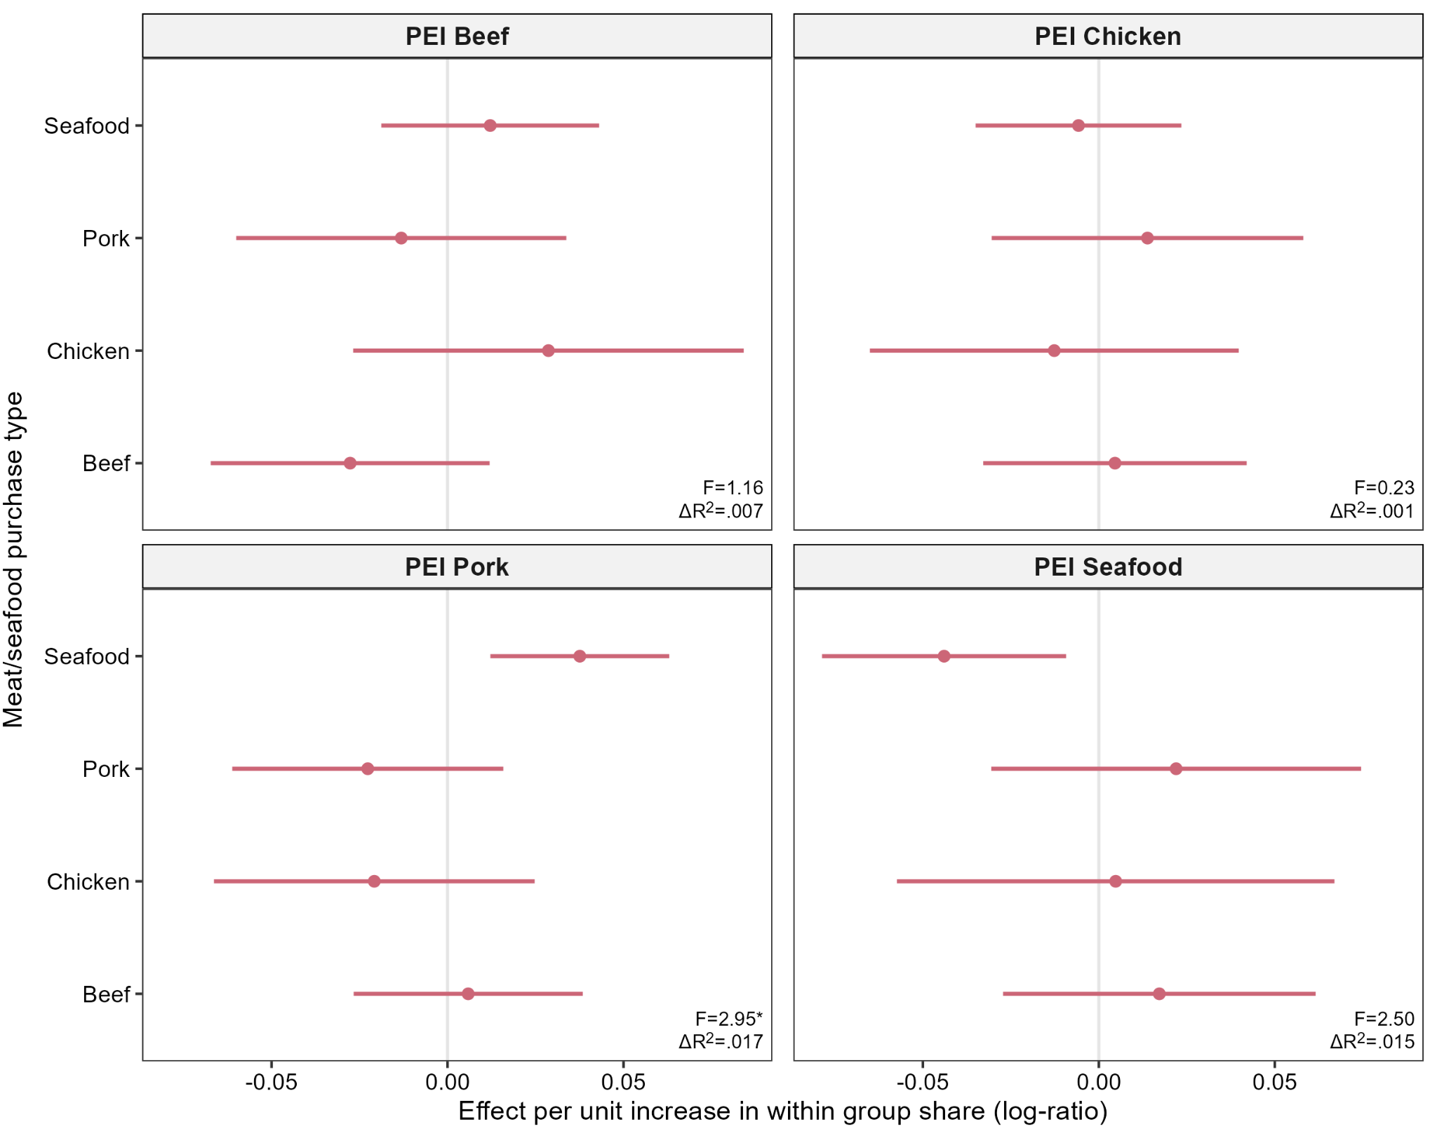
CLR coefficients with 95% confidence intervals, indicating the expected change in the corresponding category perceived impact measure associated with a one-unit increase in the natural log of a component relative to the geometric mean of the composition. PEI = perceived environmental impact. ILR regression coefficients are reported in Table S10.
* p < .05
Fig S6: Difference scores for beef vs. chicken and cheese/butter vs. milk perceived environmental impact ratings
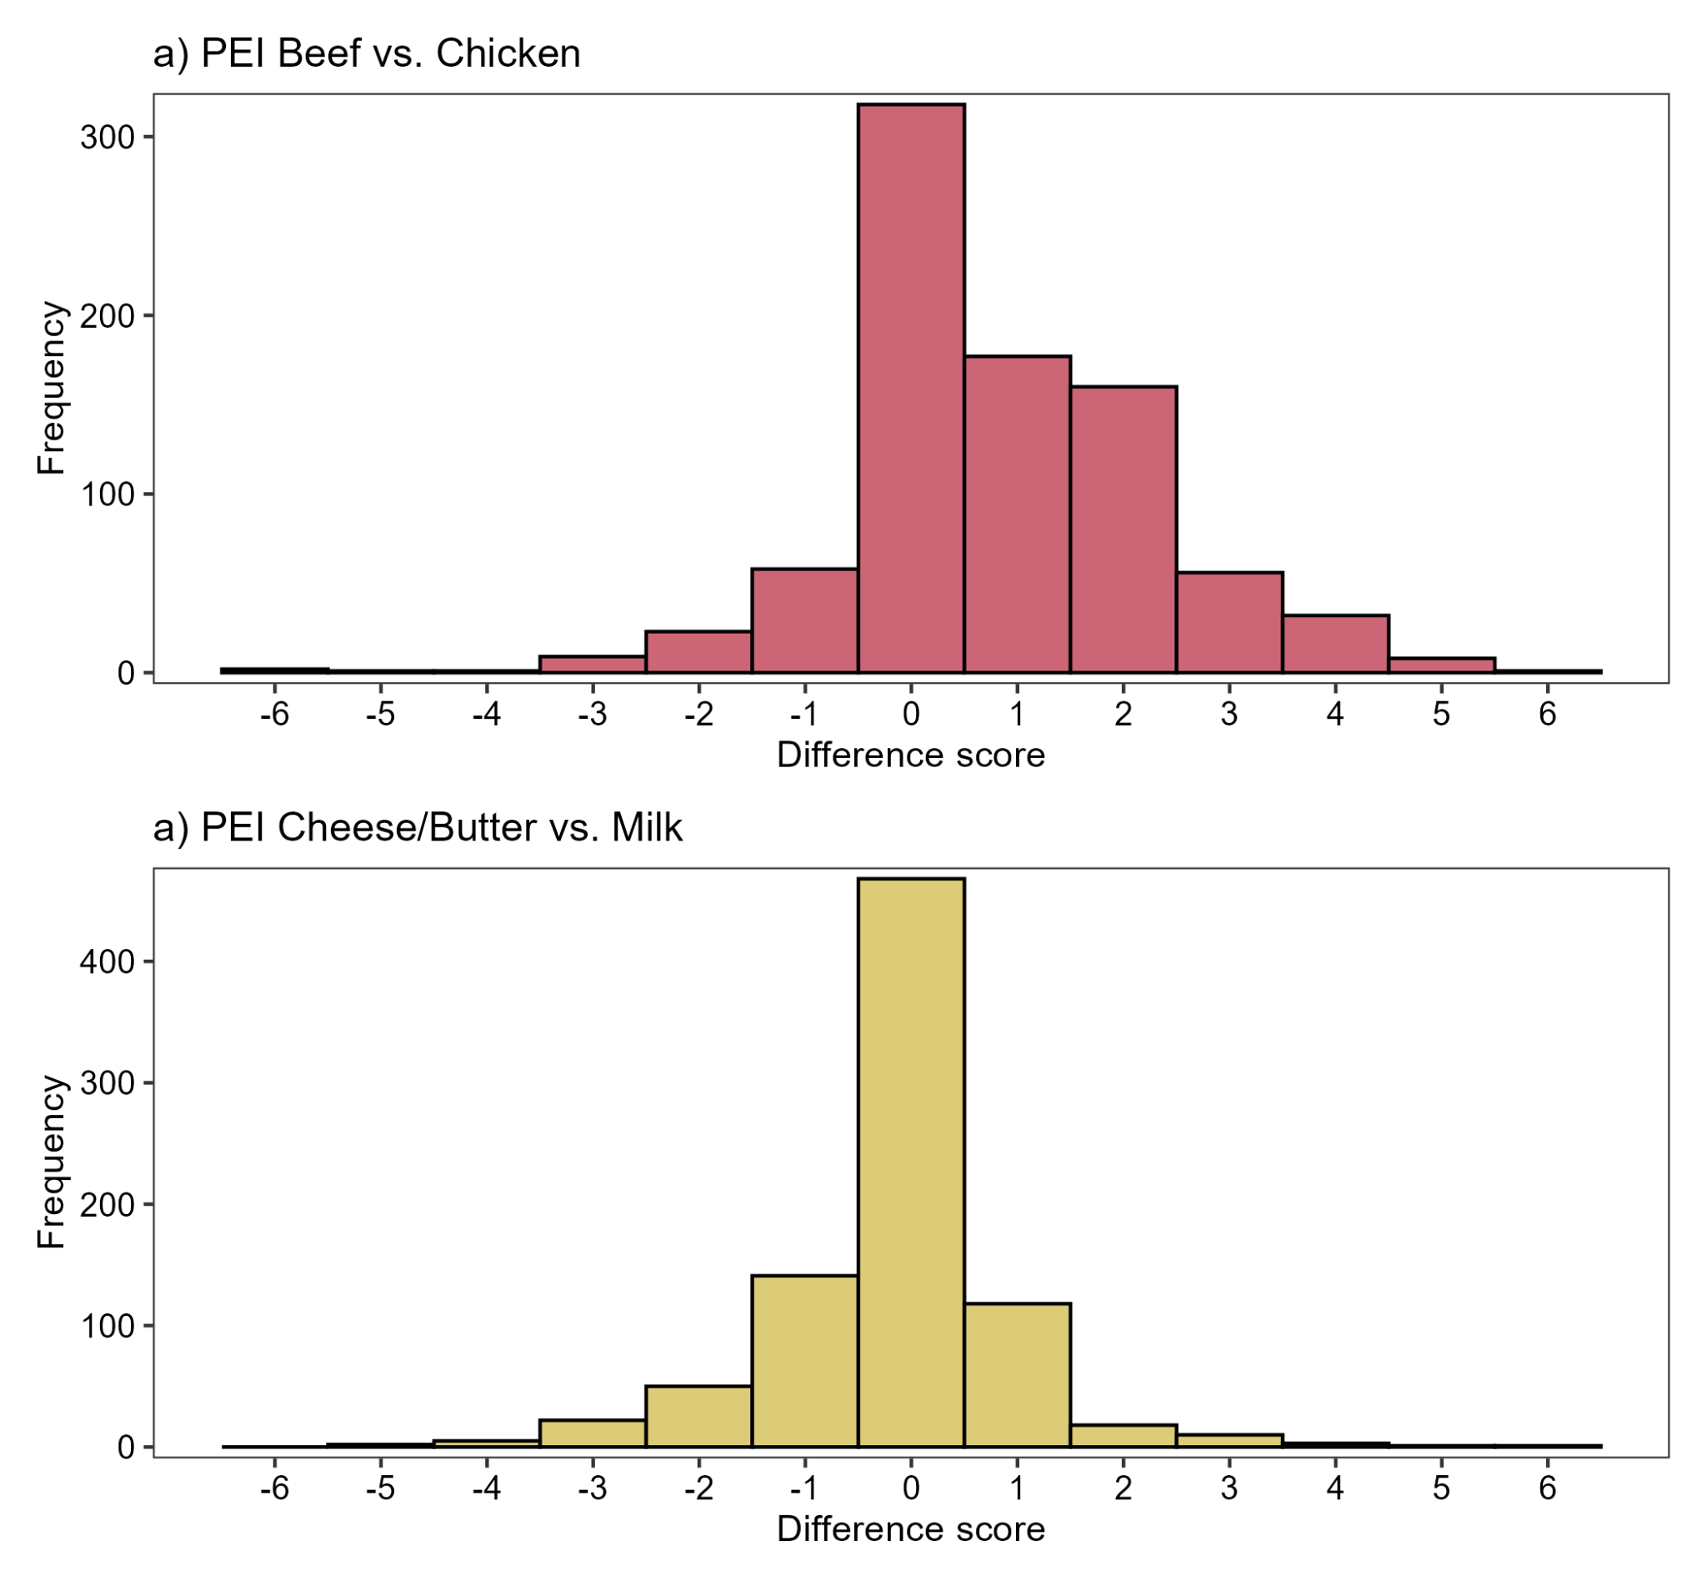
Higher scores indicate higher perceived environmental impact ratings for (a) beef compared to chicken and (b) cheese/butter compared to milk.
Table S11 Demographic characteristics
Measure | Frequency | Percent
Age
18-29 | 245 | 25.9%
30-39 | 227 | 24.0%
40-49 | 198 | 20.9%
50-59 | 182 | 19.2%
60-69 | 67 | 7.1%
70+ | 28 | 3.0%
Gender
Man | 431 | 45.5%
Woman | 507 | 53.5%
Other | 9 | 1.0%
Education
Secondary or below | 149 | 15.7%
Diploma/A-levels | 241 | 25.4%
Undergraduate | 334 | 35.3%
Postgraduate | 192 | 20.3%
Doctoral | 29 | 3.1%
Household income
Less than £20,000 | 139 | 14.7%
£20,000 - £29,999 | 171 | 18.1%
£30,000 - £39,999 | 159 | 16.8%
£40,000 - £49,999 | 124 | 13.1%
£50,000 - £59,999 | 106 | 11.2%
£60,000 - £69,999 | 73 | 7.7%
£70,000 - £79,999 | 59 | 6.2%
£80,000 + | 116 | 12.2%
Geographic region
North England | 231 | 24.4%
Mid-England | 237 | 25.0%
South England | 210 | 22.2%
Greater London | 118 | 12.5%
Wales | 53 | 5.6%
Scotland | 73 | 7.7%
Northern Ireland | 25 | 2.6%

Fig S7: Distribution of number of food items, total weight, and months with food purchases over the previous 12 months
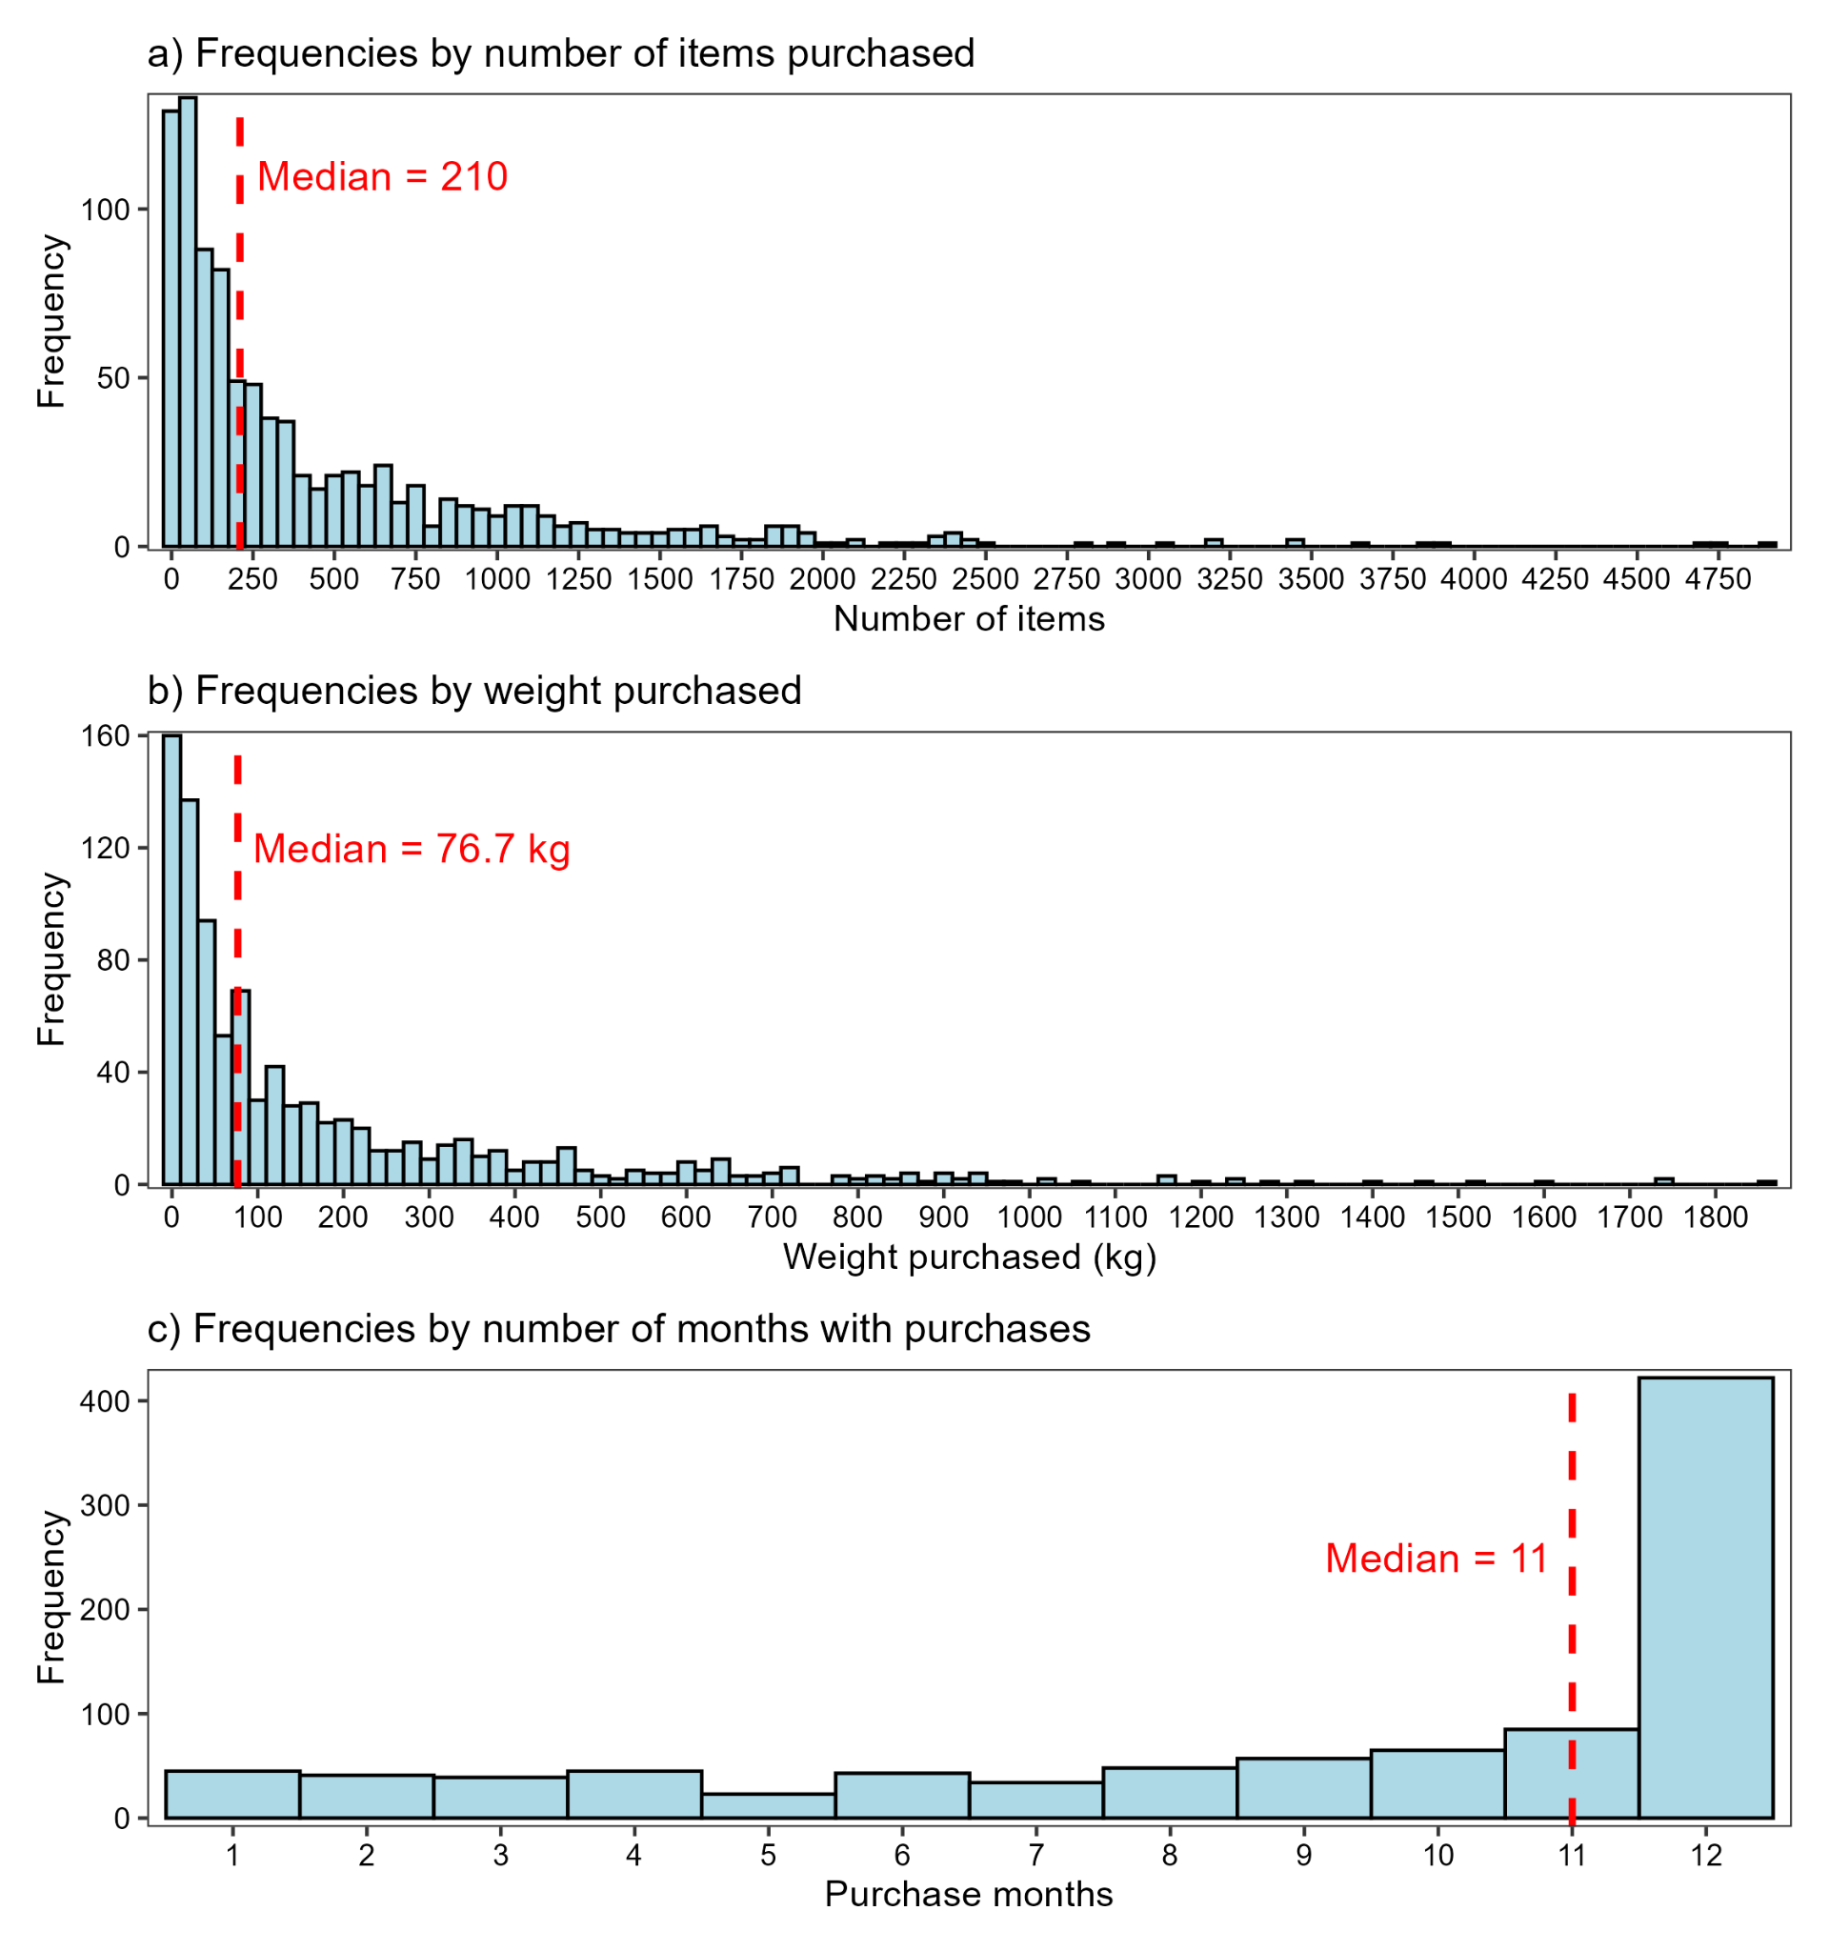

Fig S8: High-level food group compositions associations with total weight purchased
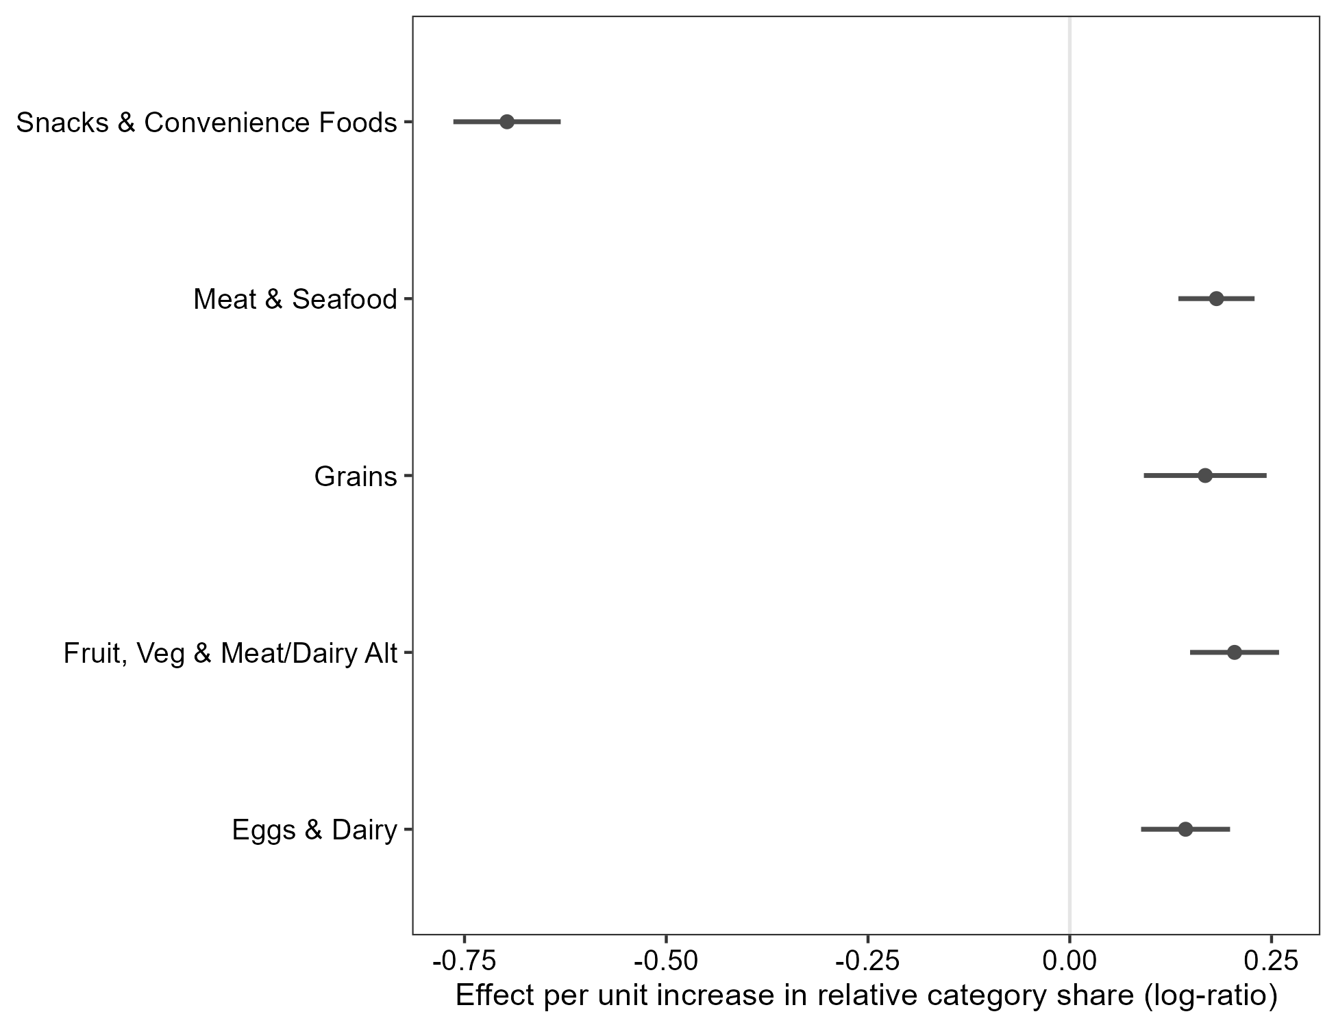
CLR coefficients with 95% confidence intervals, indicating the expected change in (log-transformed) total weight purchased associated with a one-unit increase in the natural log of a component relative to the geometric mean of the composition.

Table S12 Self-reported shopping behaviours and Clubcard use
Variable | Response | Frequency | %
Main shopper in household | Do all or most of grocery shopping | 842 | 88.9%
Main shopper in household | Responsibility shared equally | 105 | 11.1%
No. people shopping for | 1 | 313 | 33.1%
No. people shopping for | 2 | 277 | 29.3%
No. people shopping for | 3 | 171 | 18.1%
No. people shopping for | 4 | 137 | 14.5%
No. people shopping for | 5+ | 49 | 5.2%
Clubcard used by others in household | Always | 278 | 29.4%
Clubcard used by others in household | Usually | 127 | 13.4%
Clubcard used by others in household | Sometimes | 123 | 13.0%
Clubcard used by others in household | Never | 220 | 23.2%
Clubcard used by others in household | Don’t know | 8 | 0.8%
Clubcard used by others in household | Not applicable | 191 | 20.2%

