Small-molecule-mediated OGG1 inhibition attenuates pulmonary inflammation and lung fibrosis
L. Tanner¹*, A.B. Single¹, R.K.V Bhongir¹, M. Heusel², T. Mohanty², C.A.Q. Karlsson², C-M. Clausson³, C.K. Andersson⁴, R. M. Oommen⁵, J.S. Erjefält³, J. Malmström², O. Wallner⁵, T. Helleday^{5,6,7}, C. Kalderén^{5, 6}, A. Egesten¹

¹Respiratory Medicine & Allergology, Department of Clinical Sciences Lund, Lund University and Skåne University Hospital, SE-221 84 Lund, Sweden.
²Division of Infection Medicine, Department of Clinical Sciences, Lund University, SE-221 84 Lund, Sweden
³Division of Airway Inflammation, Department of Experimental Medical Sciences, Lund University, SE-221 84 Lund, Sweden
⁴Respiratory Cell Biology, Department of Experimental Medical Sciences Lund, Lund University, SE-221 84 Lund, Sweden
⁵Science for Life Laboratory, Department of Oncology-Pathology, Karolinska Institutet, SE-171 76 Stockholm, Sweden.
⁶Oxcia AB, Norrbackagatan 70C, SE-113 34 Stockholm
⁷ Weston Park Cancer Centre, Department of Oncology and Metabolism, University of Sheffield, Sheffield S10 2RX, UK.
*Corresponding author. Email: lloyd.tanner@med.lu.se.

Supplemental Figures
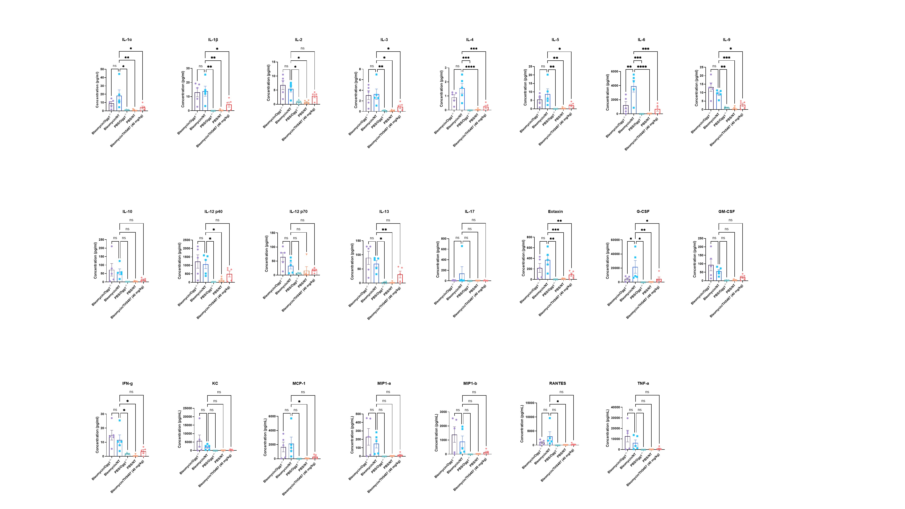
Supplementary Figure 1: Murine BALF cytokine levels from siRNA experiments. Cytokine values were compared to the vehicle/bleomycin group using a one-way ANOVA (*P<0.05; **P<0.01; ***P<0.005; *****P<0.001).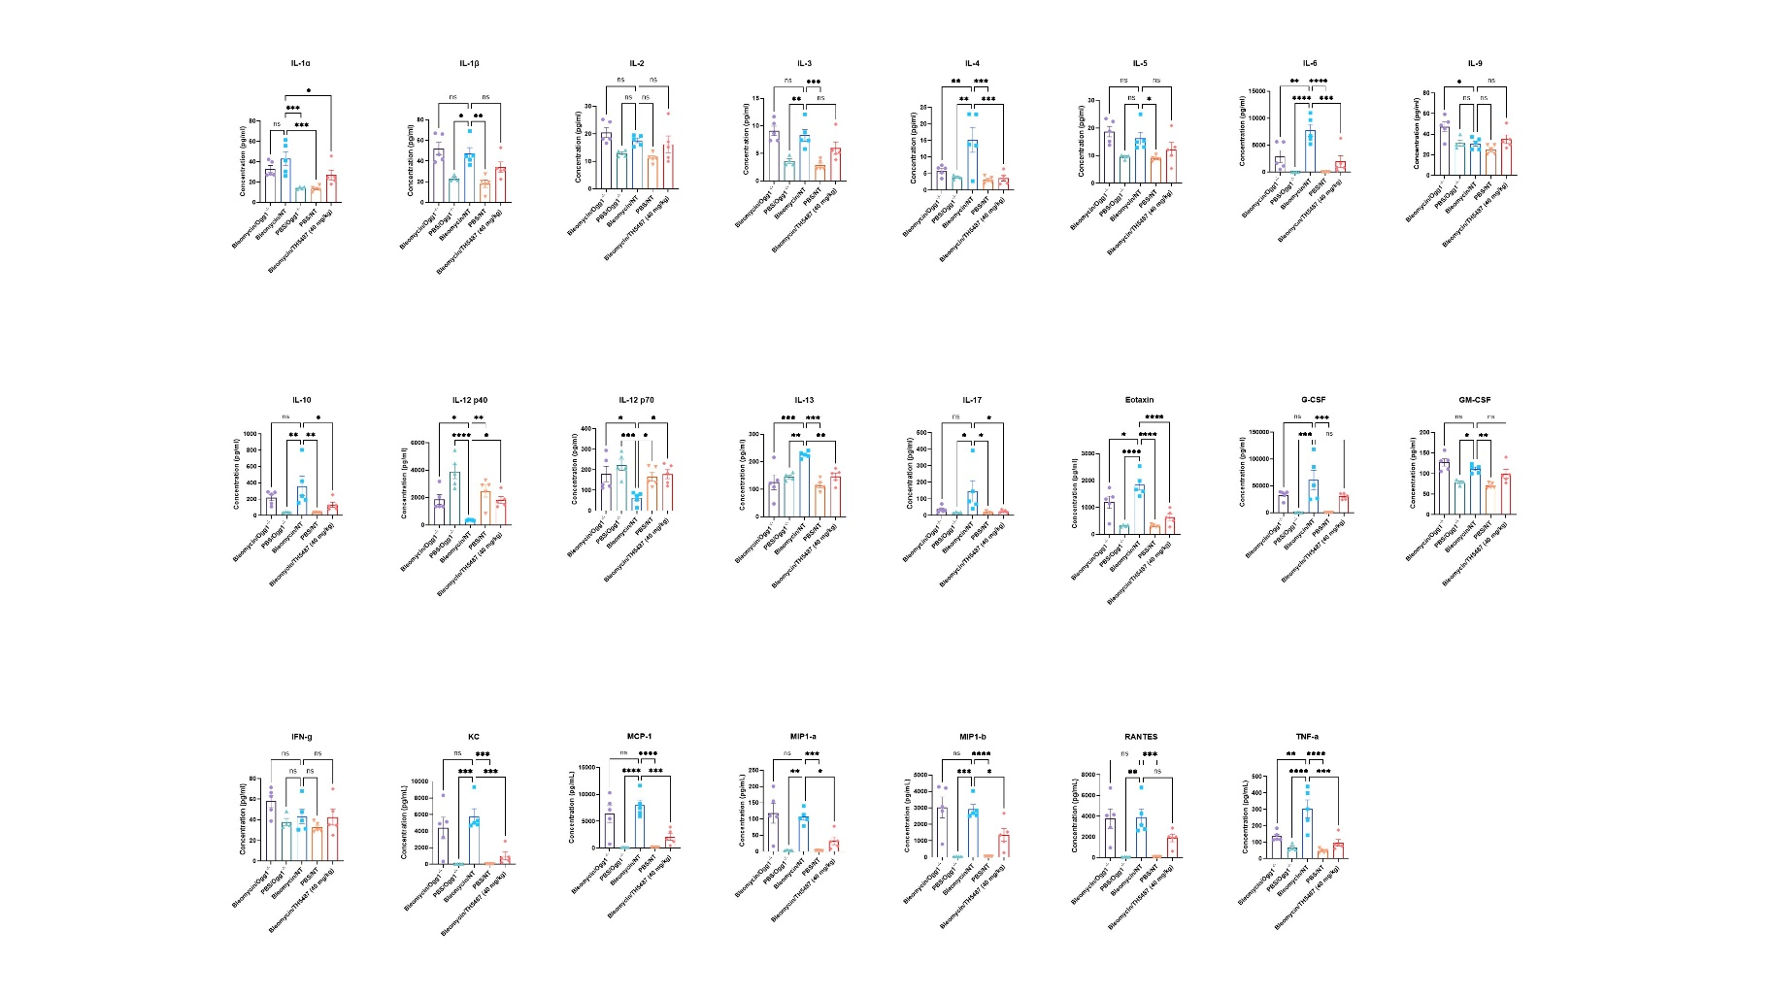 Supplementary Figure 2: Murine plasma cytokine levels from siRNA experiments. Cytokine values were compared to the vehicle/bleomycin group using a one-way ANOVA (*P<0.05; **P<0.01; ***P<0.005; *****P<0.001).
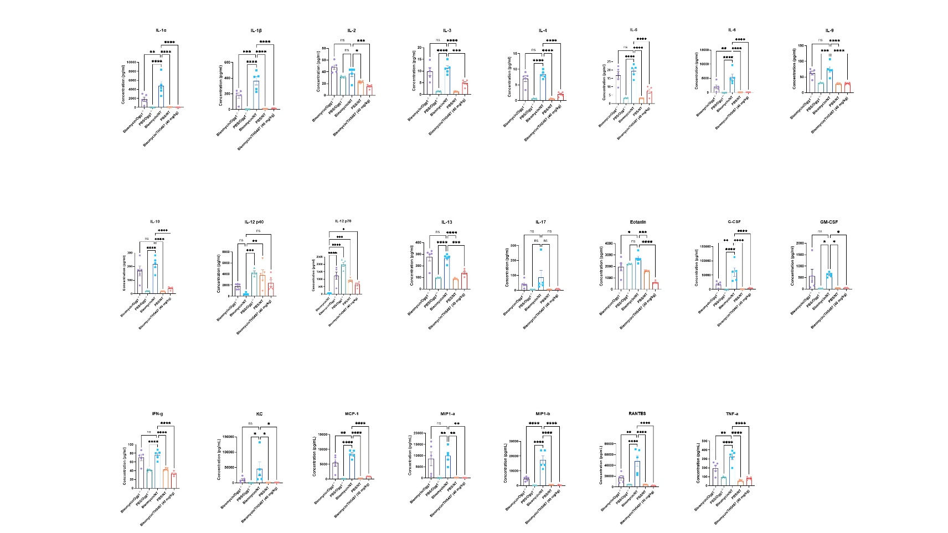
Supplementary Figure 3: Murine lung homogenate cytokine levels from siRNA experiments. Cytokine values were compared to the vehicle/bleomycin group using a one-way ANOVA (*P<0.05; **P<0.01; ***P<0.005; *****P<0.001).

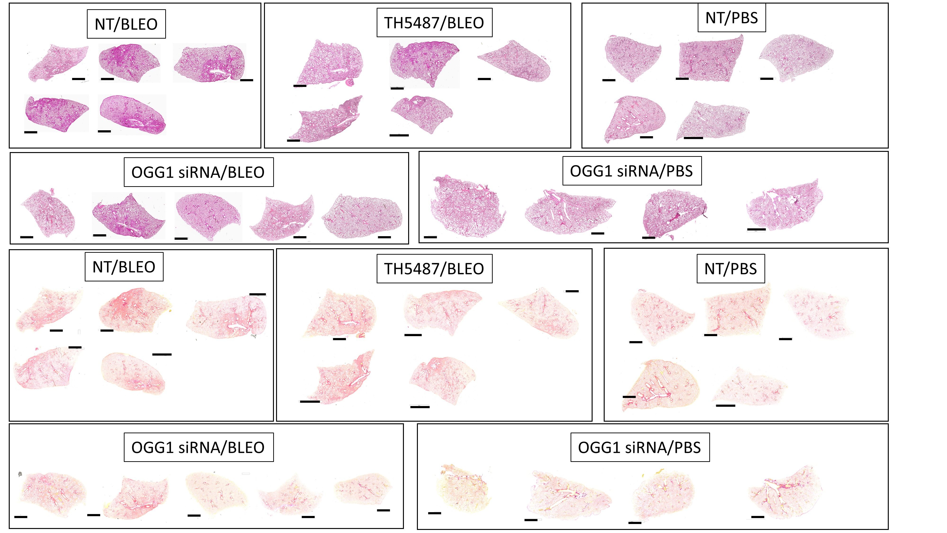Supplementary Figure 4: Whole lung scans of murine lungs from siRNA experiments following H&E and picrosirius red staining (scale bar=2 mm).

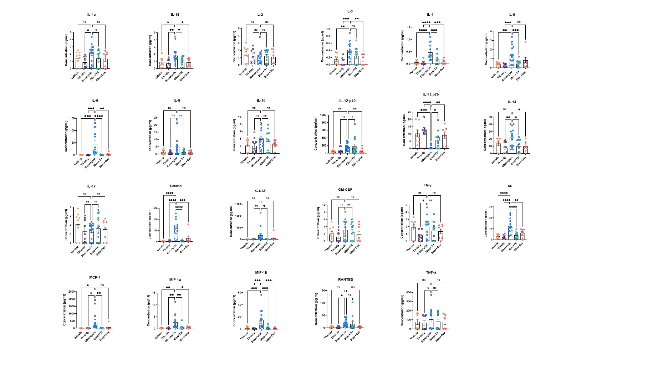
Supplementary Figure 5: Murine BALF cytokine levels. Cytokine values were compared to the vehicle/bleomycin group using a one-way ANOVA (*P<0.05; **P<0.01; ***P<0.005; *****P<0.001).
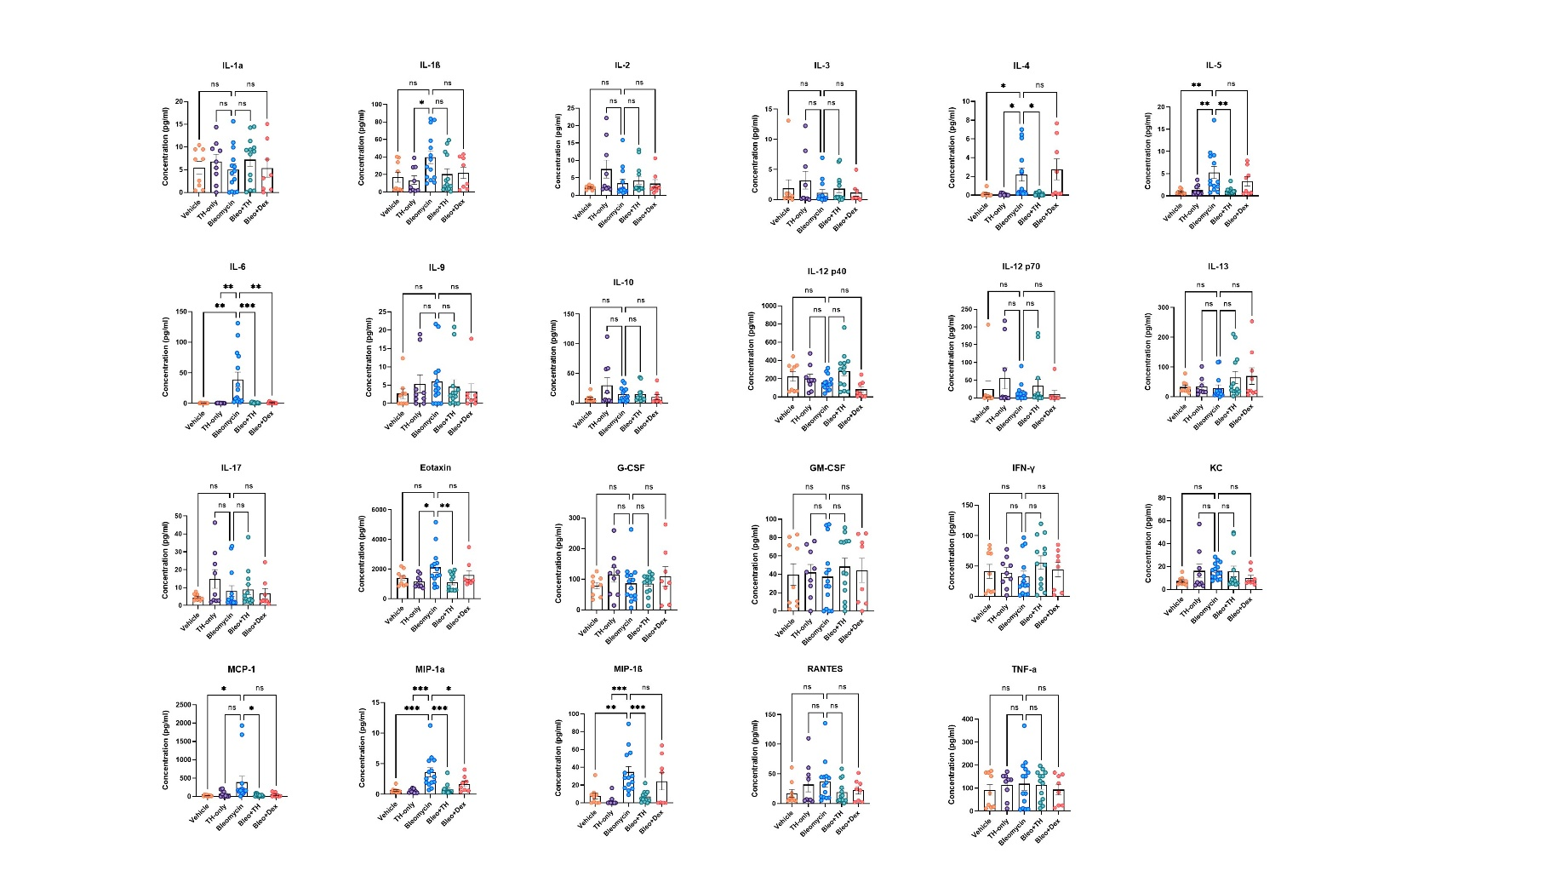
Supplementary Figure 6: Murine plasma cytokine levels. Cytokine values were compared to the vehicle/bleomycin group using a one-way ANOVA (*P<0.05; **P<0.01; ***P<0.005; *****P<0.001).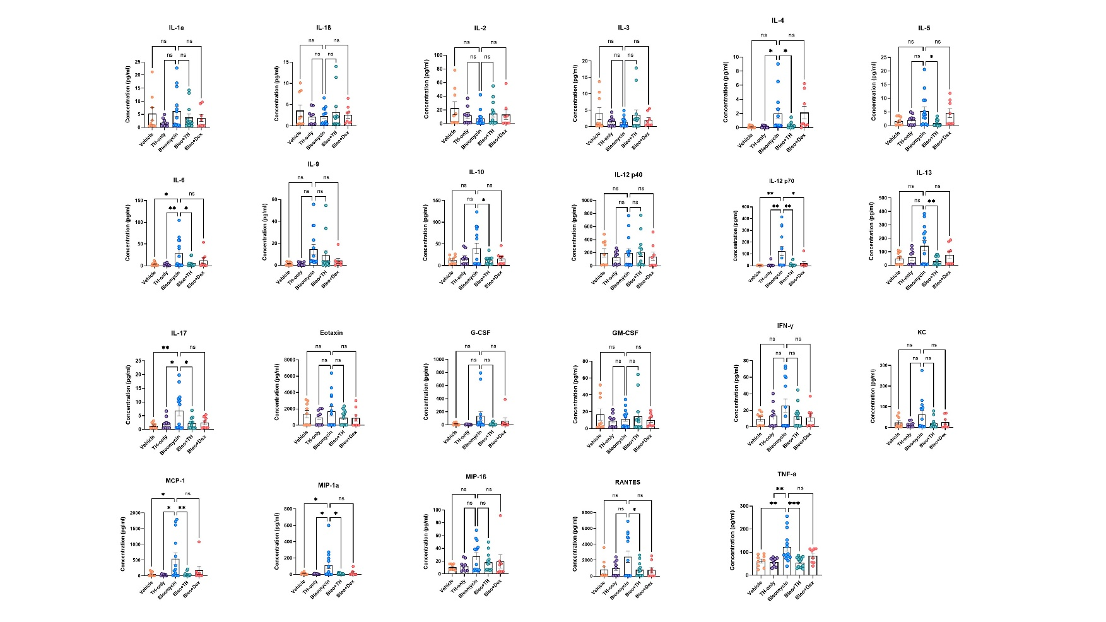
Supplementary Figure 7: Murine lung homogenate cytokine levels. Cytokine values were compared to the vehicle/bleomycin group using a one-way ANOVA (*P<0.05; **P<0.01; ***P<0.005; *****P<0.001).

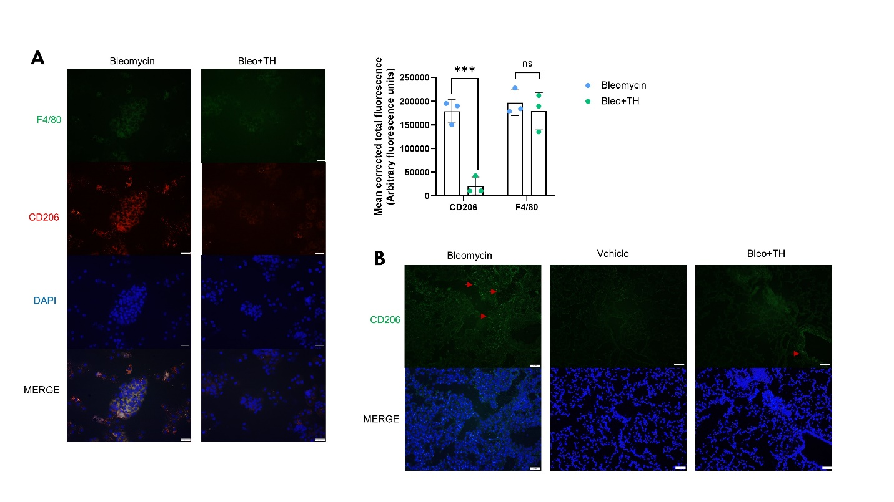
Supplementary Figure 8: Macrophage staining in (A) BALF and (B) lung sections. F4/80 and CD206 immunofluorescence staining, with quantification inset.

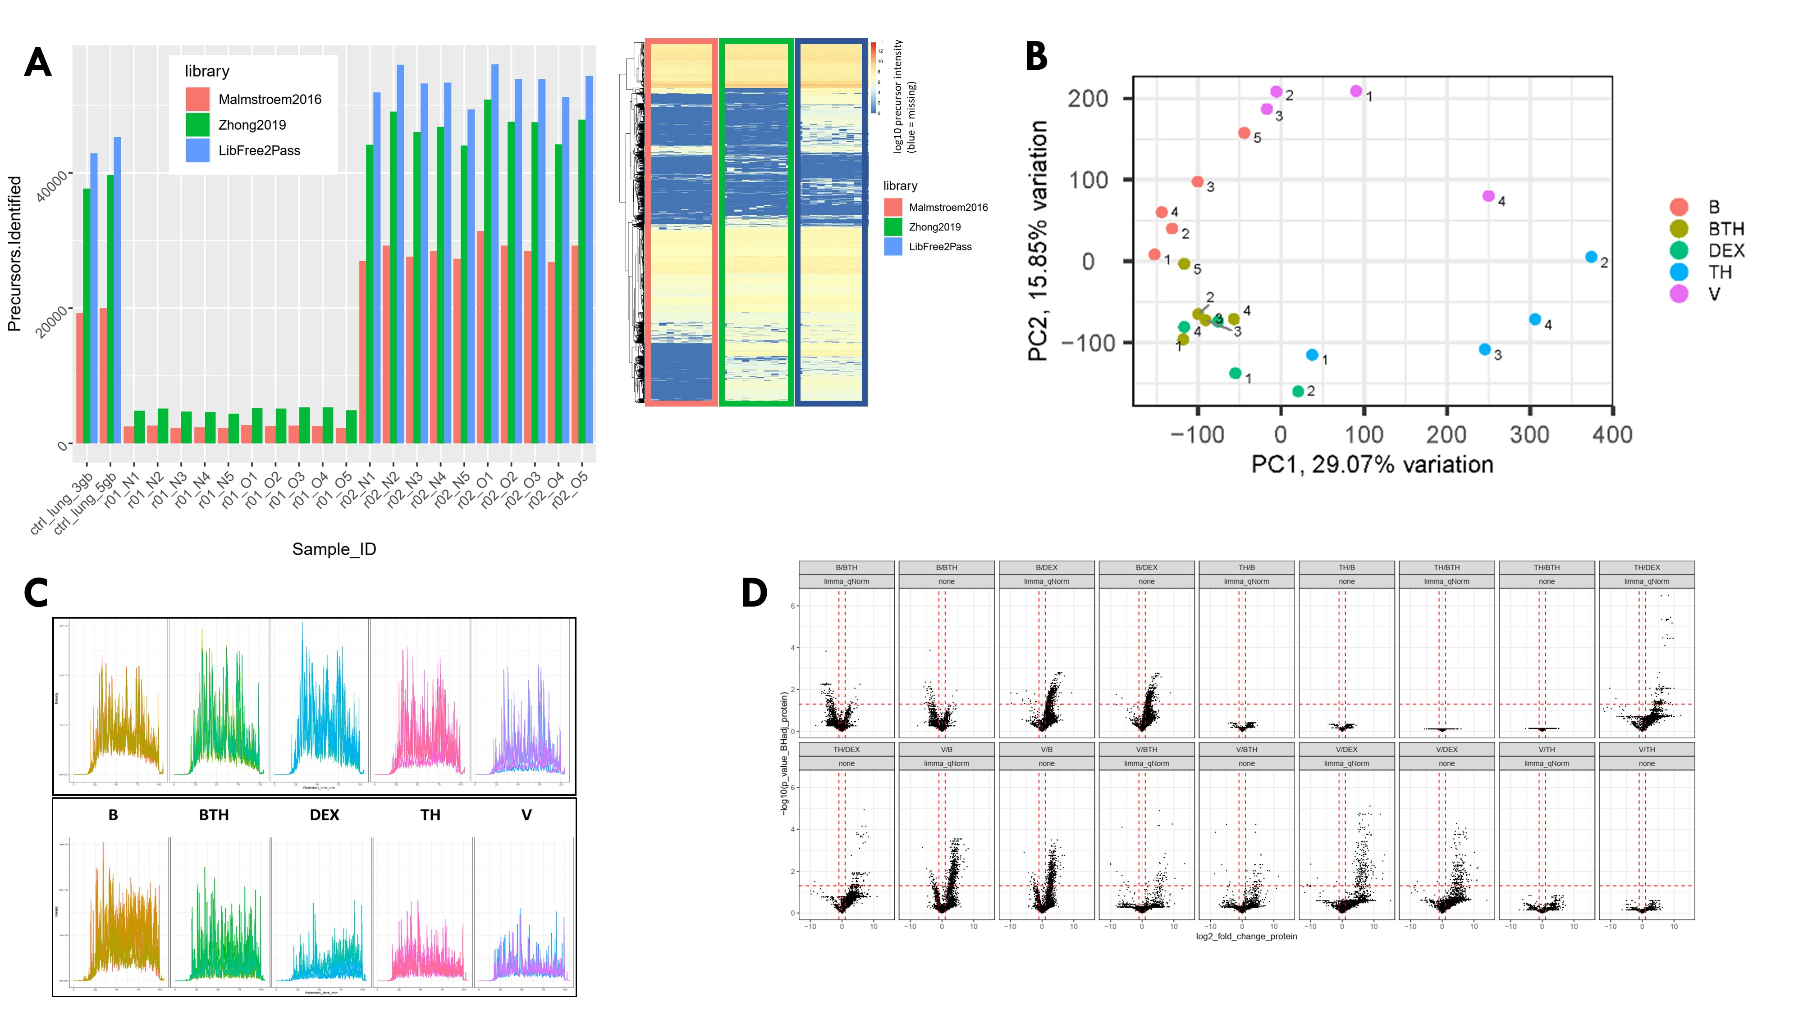
Supplementary Figure 9: Proteomic DIA analysis. (A) Increased precursor identifications where found using LibFree2Pass methodology in this study compared with prior-knowledge-based spectral library approaches (B) PCA plot showing treatment condition groupings. (C) Representative chromatograms, (D) Volcano plot displaying condition comparisons in the lung samples analyzed.
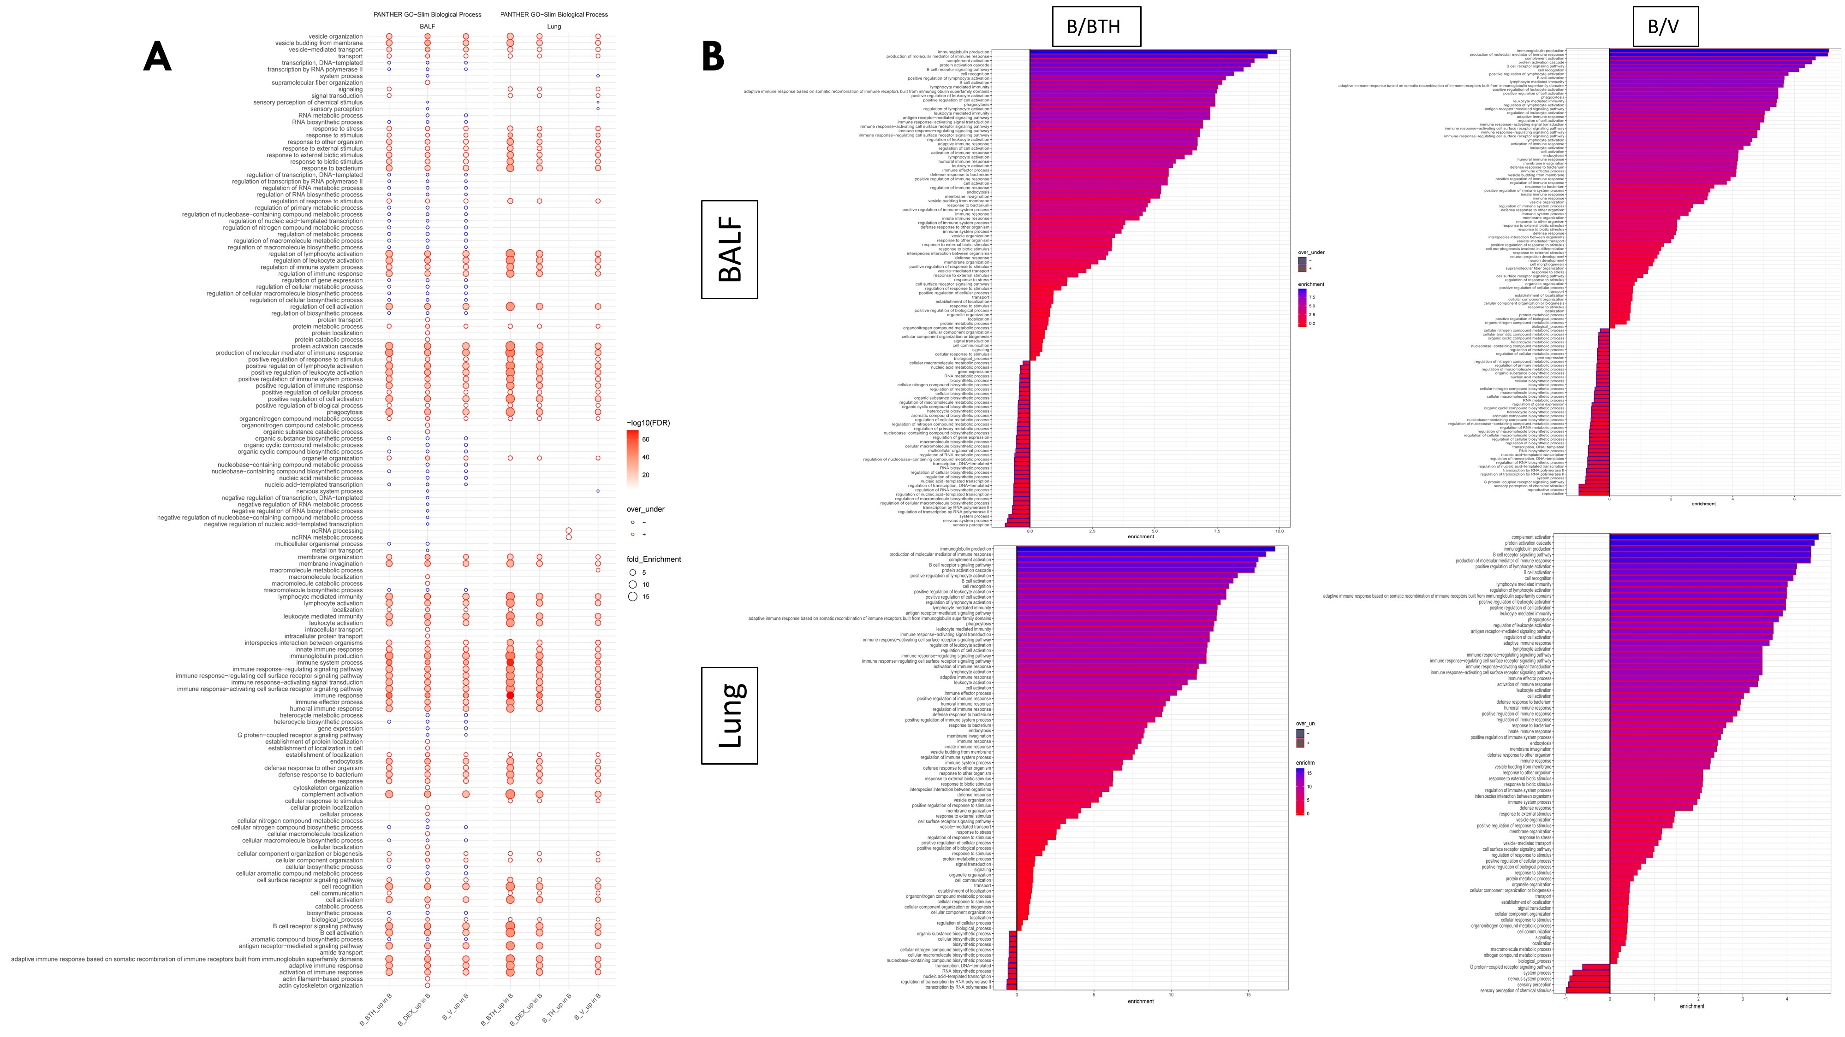
Supplementary Figure 10: PANTHER gene ontology (GO) biological process enrichment analysis from BALF and lung homogenate protein list IDs.
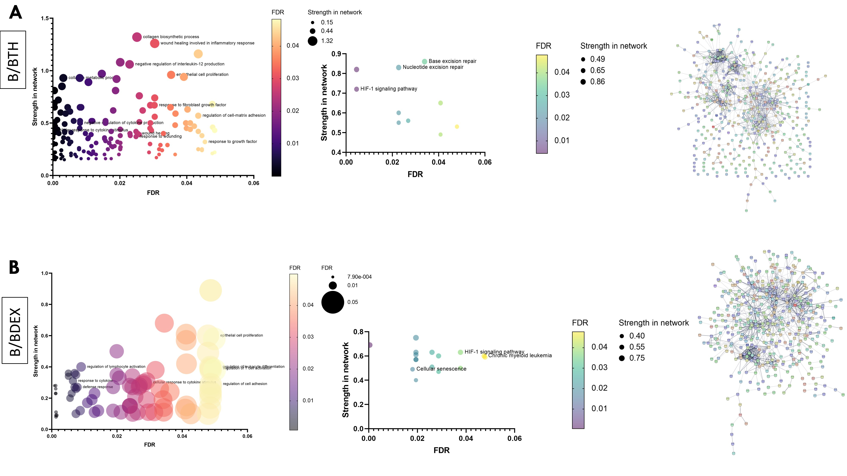
Supplementary Figure 11: STRINGDB GO terms from lung homogenate samples. (A) Bleomycin/Bleo/TH5487, (B) Bleomycin/dexamethasone treatment conditions; false discovery rate (FDR).

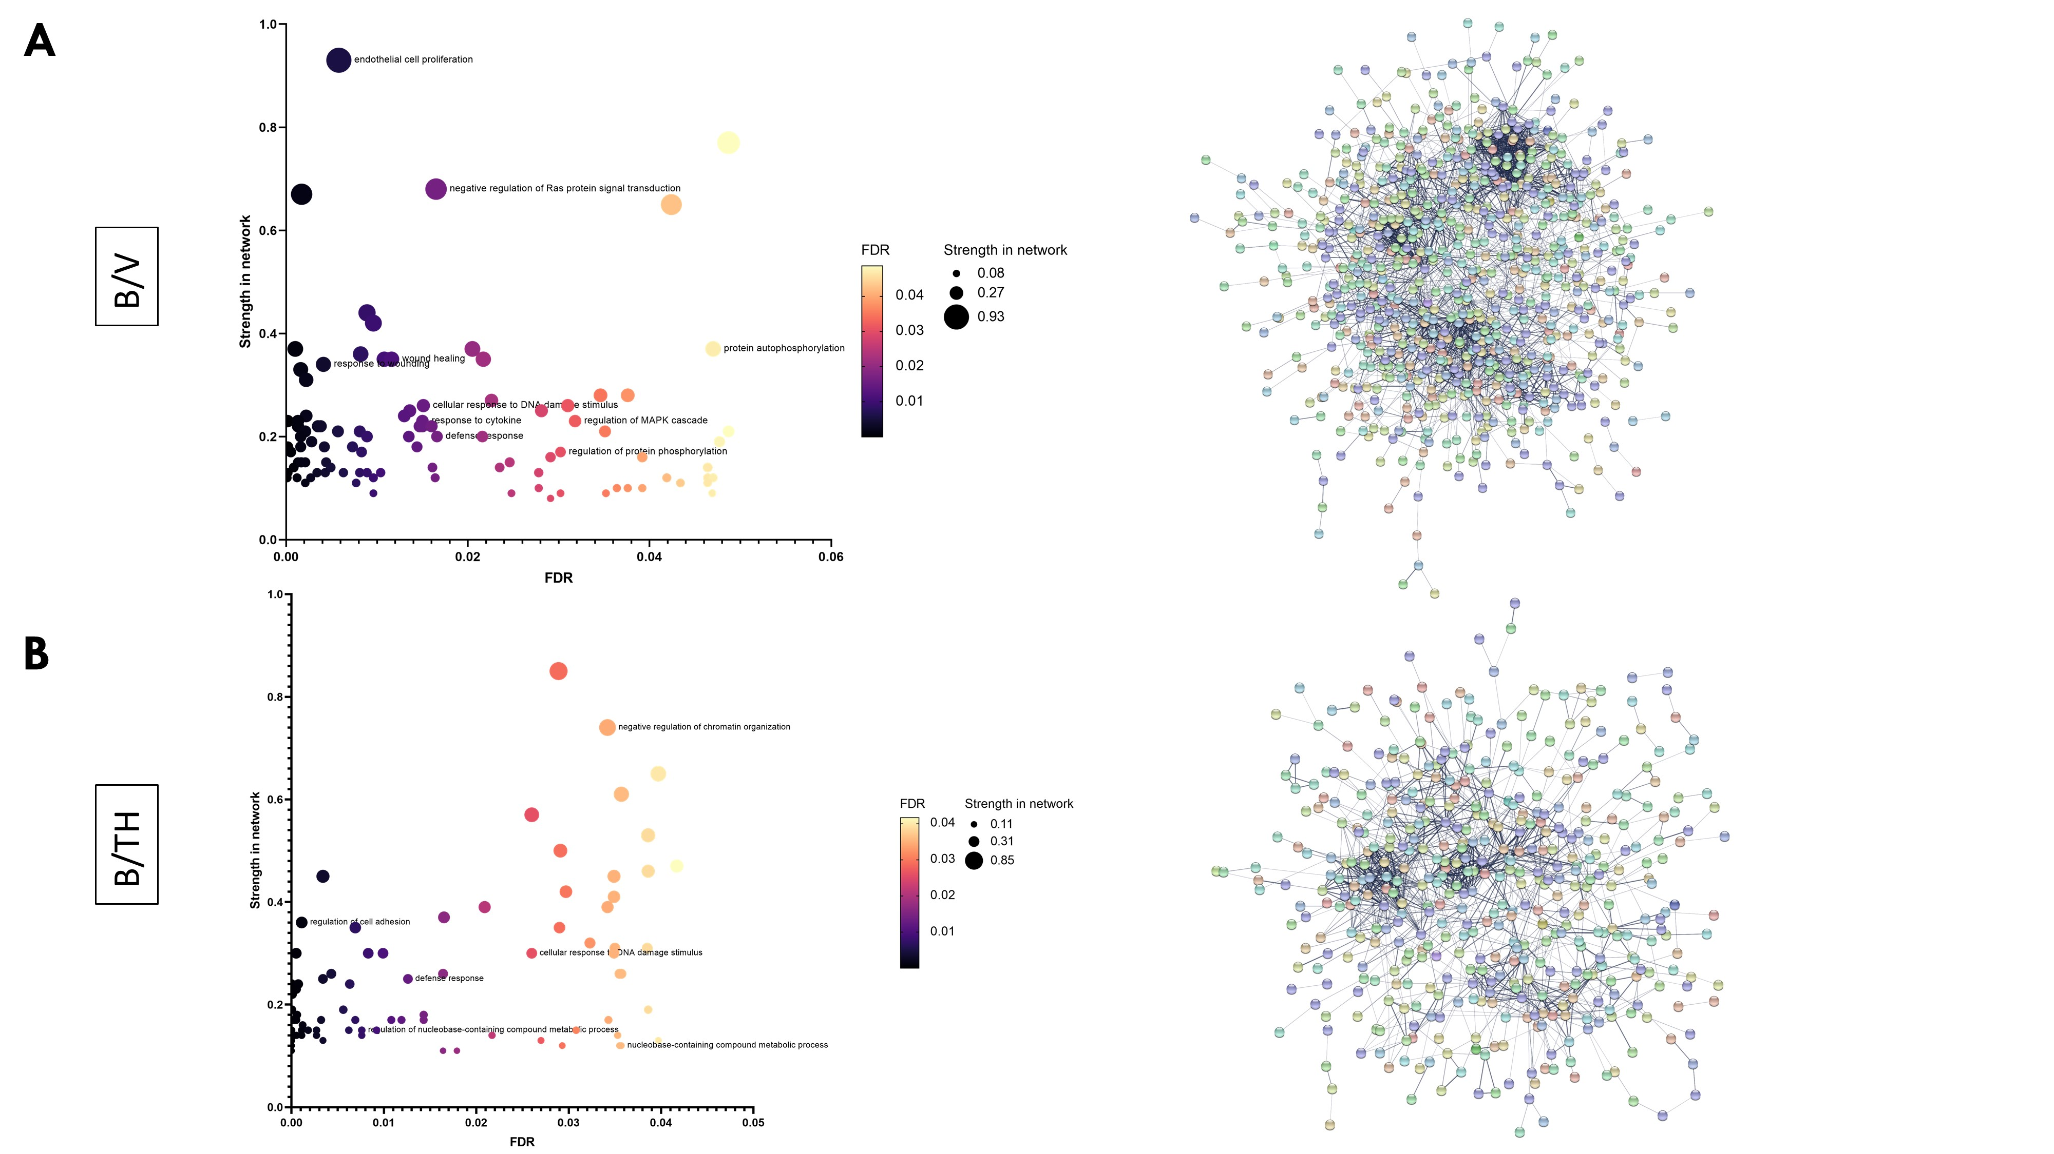
Supplementary Figure 12: STRINGDB GO terms from lung homogenate samples. (A) Bleomycin/vehicle, (B) Bleomycin/TH5487 treatment conditions; false discovery rate (FDR).

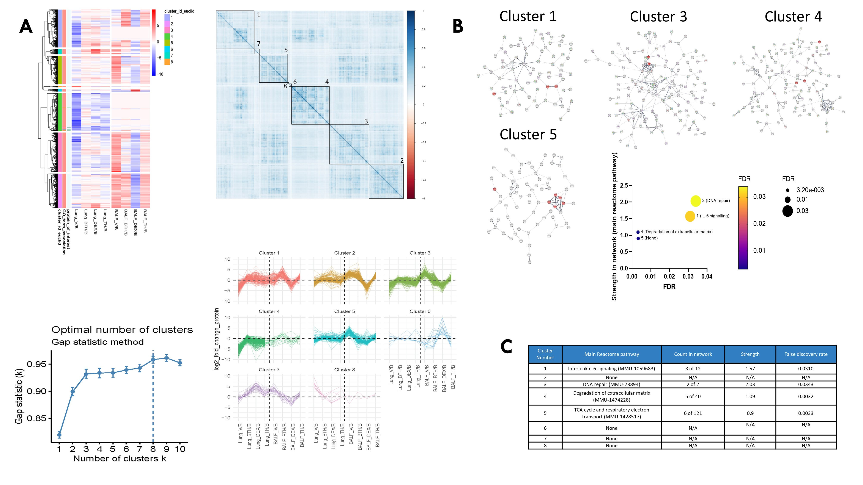
Supplementary Figure 13: STRINGDB GO terms from lung homogenate samples analyzed using cluster analysis.

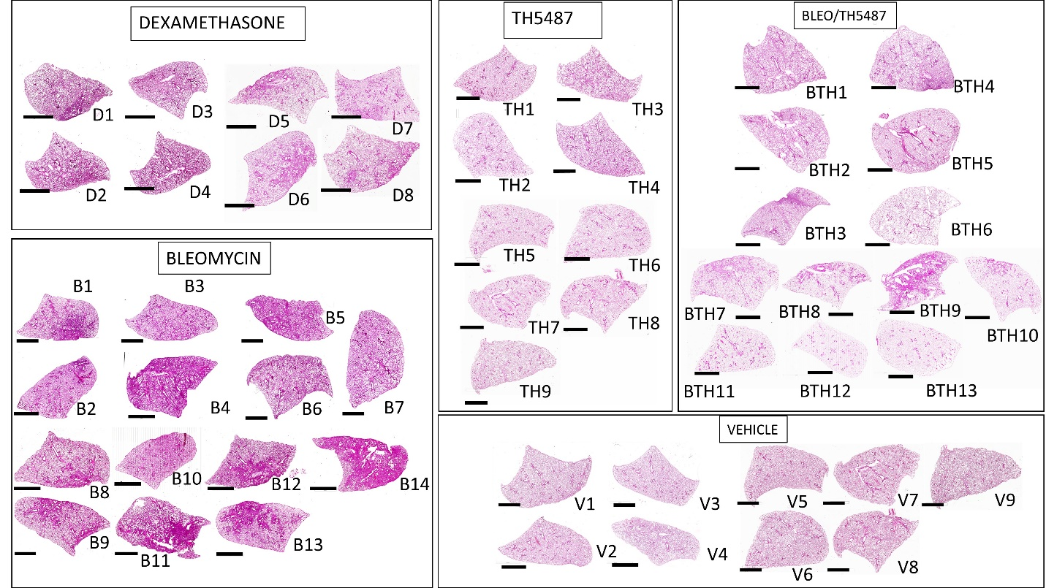
Supplementary Figure 14: Whole lung scans of murine lungs following H&E staining (scale bar=2 mm).

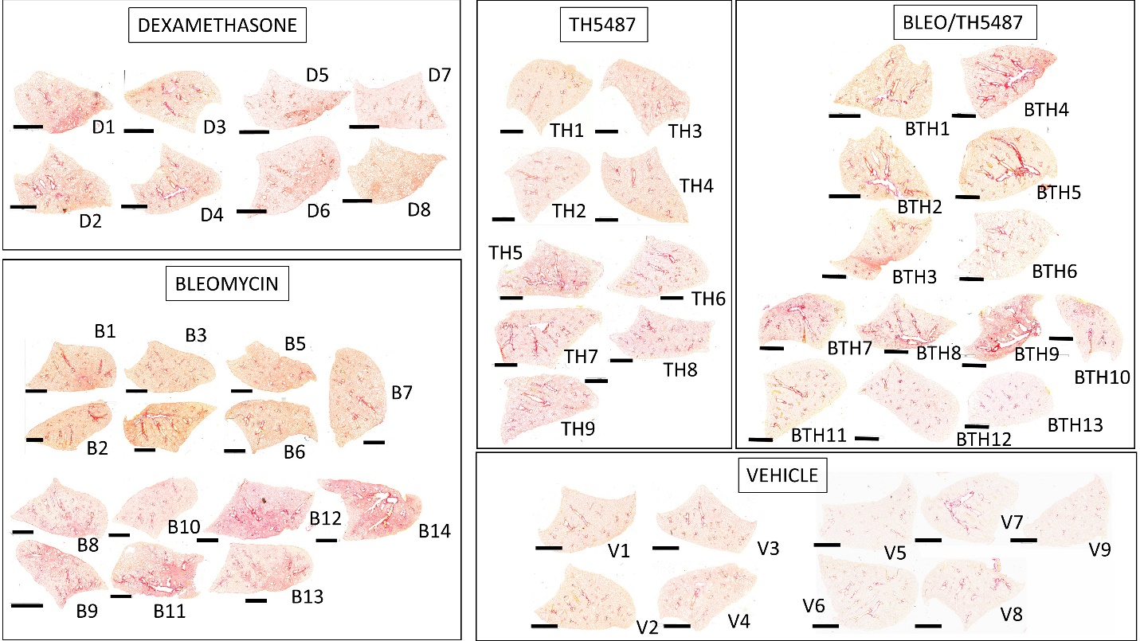
Supplementary Figure 15: Whole lung scans of murine lungs following picrosirius red staining (scale bar=2 mm).

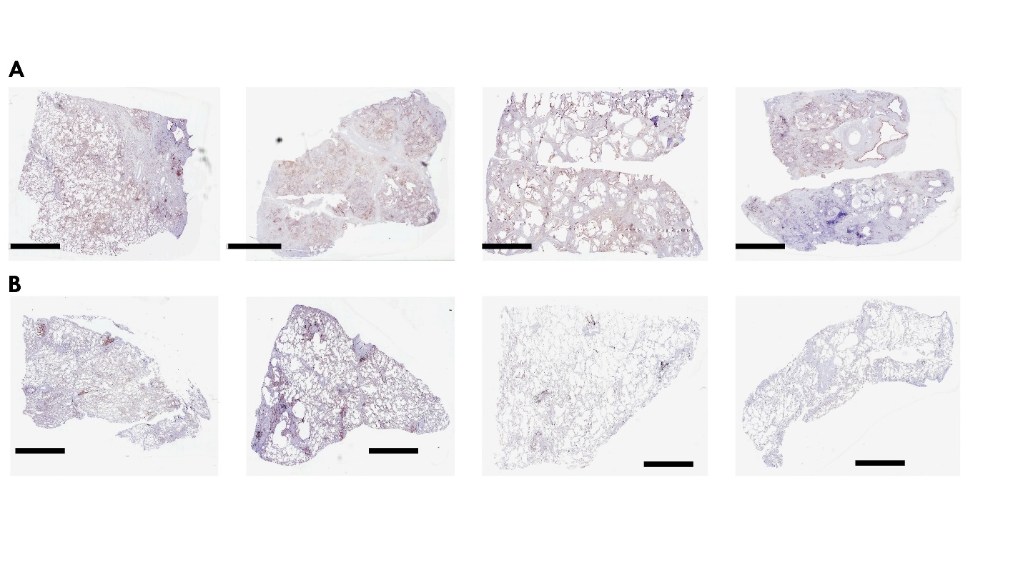
Supplementary Figure 16: Lung scans of human lung explants following immunostaining for OGG1 (scale bar=6 mm).

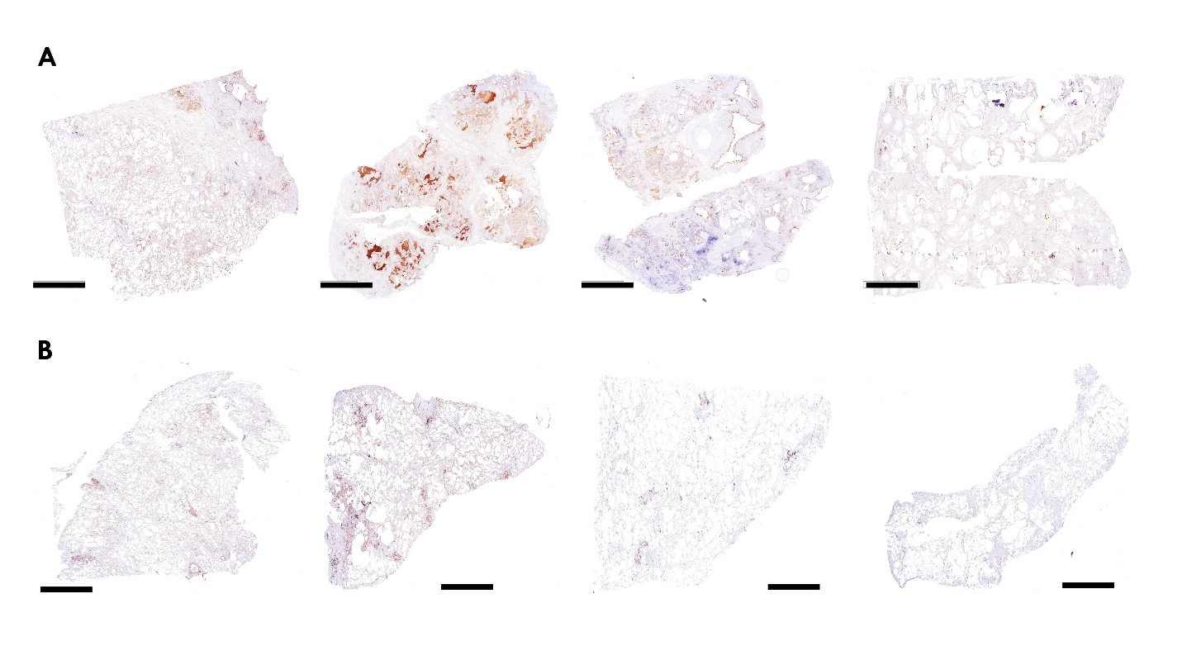
Supplementary Figure 17: Lung scans of human lung explants following immunostaining for SMAD7 (scale bar=6 mm).

