Circadian Regulation of miR-206-3p Impairs Nurr1-Dependent Dopaminergic Homeostasis and Promotes ADHD-Like Behaviors in Mice
Yun Wang^{1,3†} ,Linzi Wang^{2†}, Siyi Li^{1†},Xueyin Liao¹, Xin Ding ²*,Jian Huang¹*

¹ School of Basic Medical Sciences, Soochow University, Suzhou 215123, P. R. China.
² Soochow Key Laboratory of Prevention and Treatment of Child Brain Injury, Children’s Hospital of Soochow University, Suzhou 215123, P. R. China.
³ Department of Clinical Laboratory, The Affiliated Guangji Hospital of Soochow University, Suzhou 215137, P. R. China.
Y.W. ，L.W. and S.L. contributed equally to this study.
* Correspondence:
Jian Huang, Ph.D.,
Department of medical genetics, School of Basic Medical Sciences, Soochow University, Suzhou 215123, P. R. China.
Email: huangjian79@suda.edu.cn.
ORCID (JH): 0000-0003-0026-2513
Xin Ding, Ph.D.,
Soochow Key Laboratory of Prevention and Treatment of Child Brain Injury, Children’s Hospital of Soochow University, Suzhou 215123, P. R. China.
Email: dingxin@suda.edu.cn

Supplementary Figure
Supplementary Figure 1. Validation of AAV-mediated miR-206-3p overexpression in mouse brain.
(A) Immunofluorescence images showing AAV-mediated miR-206-3p overexpression after lateral ventricular injection. Green indicates GFP-positive viral expression, and red indicates nuclei. SN, substantia nigra. (B) qPCR validation of miR-206-3p overexpression in whole mouse brain. ****p<0.0001.
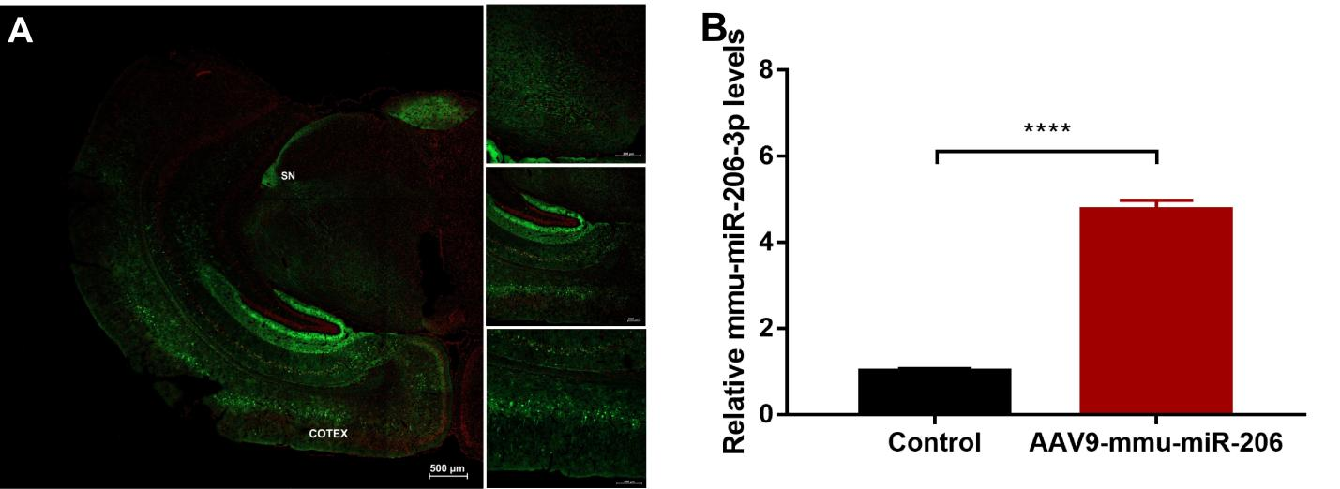

Supplementary Figure 2. Knockdown of miR-206-3p produces limited effects on open-field locomotor behavior under basal conditions.
(A, B) Representative open-field movement tracks from control and miR-206-3p-knockdown mice. (C-H) Quantification of total distance, average movement speed, central-area/total-path ratio, time spent moving in the central area, time spent moving in the outer ring, and rearing counts.
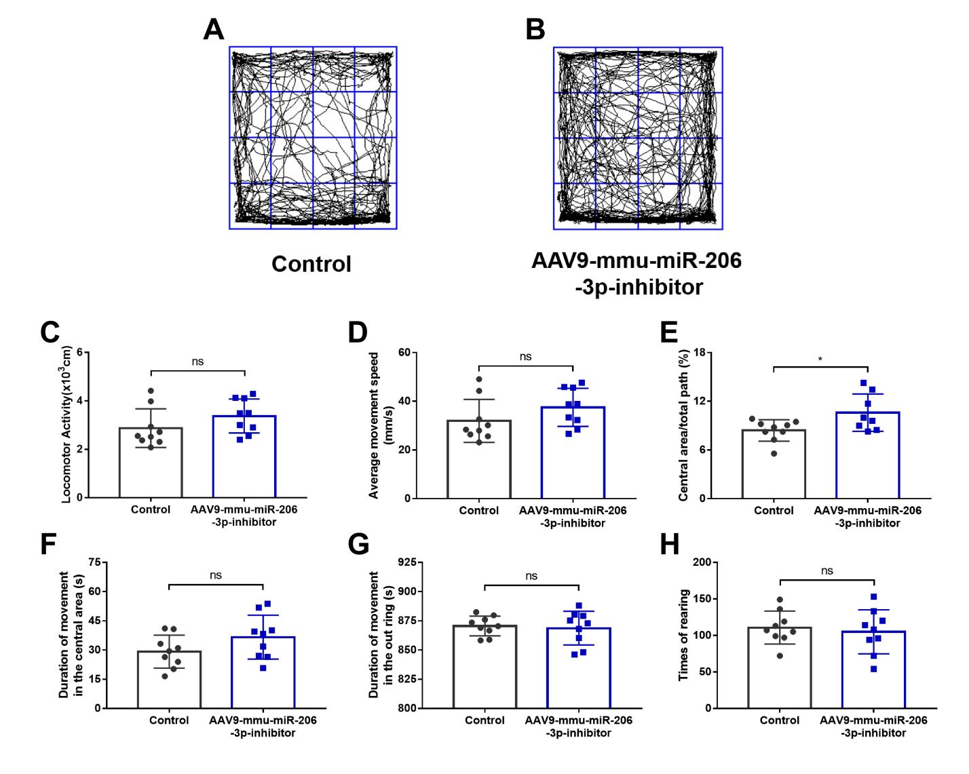

Supplementary Figure 3. Morris water maze analysis after miR-206-3p overexpression.
- Representative swimming paths in the Morris water maze. (B-D) Quantification of swimming distance, average speed, and escape latency during training. (E) Platform-crossing frequency after platform removal.

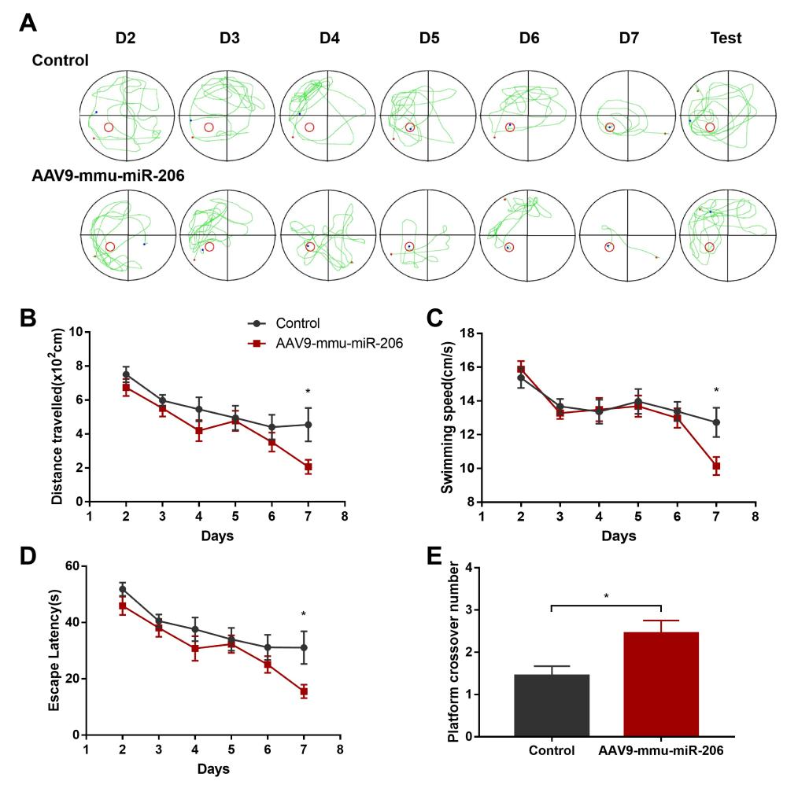

Supplementary Figure 4. Morris water maze analysis after miR-206-3p knockdown.
(A-D) Quantification of swimming distance, average speed, escape latency, and platform-crossing frequency in control and miR-206-3p-knockdown mice.
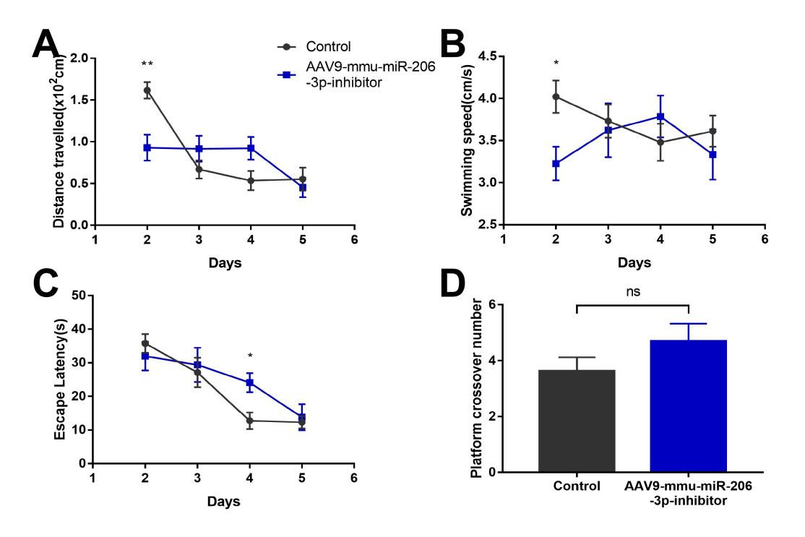

Supplementary Figure 5. Extended analysis of dopamine-related gene-expression changes.
(A-F) qPCR analysis of Dat1, Th, Vmat2, Drd1, Manf, and Lphn2 expression in mouse brain. These data complement the dopamine homeostasis results presented in Figure 7.

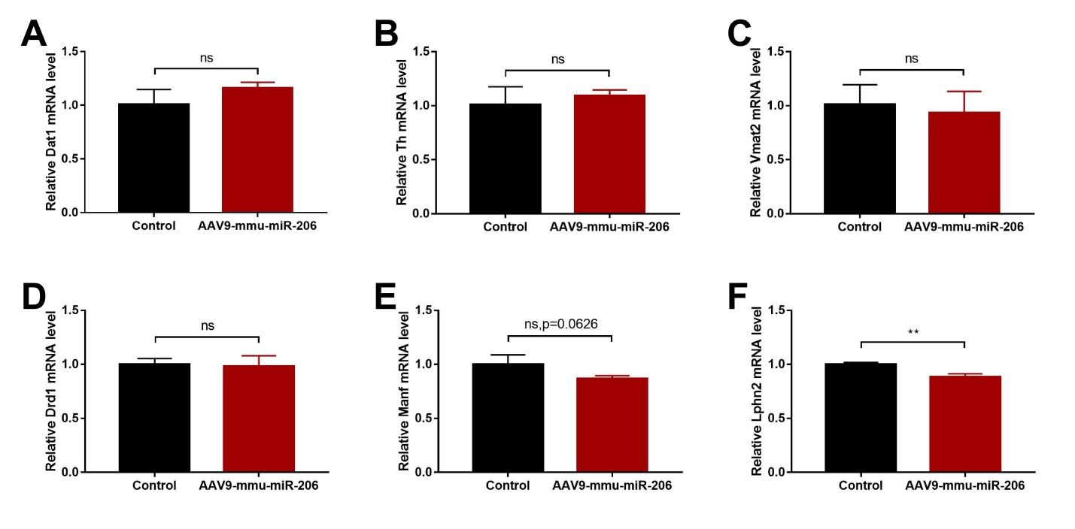

Supplementary Figure 6. Extended circadian gene-expression analysis.
(A-D) qPCR analysis of Bmal, Clock, Cry1, and Cry2 expression in mouse brain. (E-G) qPCR analysis of Per1, Per2, and Per3 expression. These data complement the main dopamine-related molecular analysis shown in Figure 7.
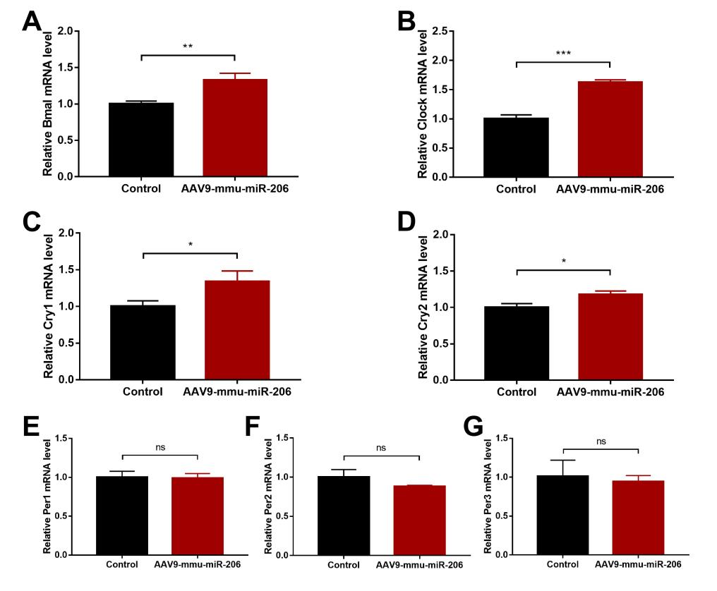

Supplementary Figure 7. RNA-seq enrichment analysis after miR-206-3p overexpression.
(A) Differentially expressed genes associated with biological rhythmic processes in the brains of miR-206-3p-overexpressing mice. (B, C) Gene Ontology enrichment analysis identifying downregulated genes related to tyrosine metabolism and upregulated genes associated with nervous system development and function.
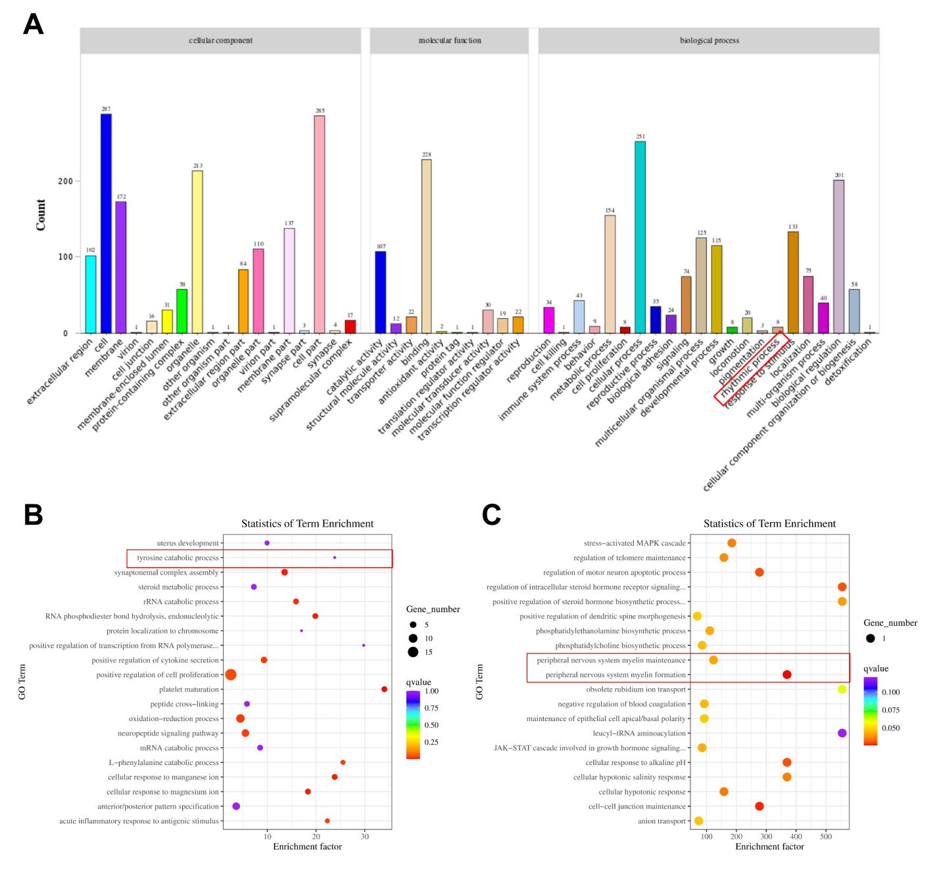

Supplementary table 1. q-PCR primers used in this study.
NAME | SEQUENCE
mVmat2-F | AGGGGACACCTCTTACGACC
mVmat2-R | CTGCCACTTTCGGGAACACA
mDat1-F | TTCATGGTTATTGCCGGGATG
mDat1-R | TGTAGAAGAAGCCCACGTAGAA
mDbh-F | GAGGCGGCTTCCATGTACG
mDbh-R | TCCAGGGGGATGTGGTAGG
mDrd1-F | GTGGGCGAATTCTTCCCTGA
mDrd1-R | GGGCAGAGTCTGTAGCATCC
mDrd2-F | CGGCCTACATAGCAACCCTG
mDrd2-R | TTTCTGCGGCTCATCGTCTT
mDrd4-F | GCCTGGAGAACCGAGACTATG
mDrd4-R | CGGCTGTGAAGTTTGGTGTG
mMaoa-F | GTGAATGTCAATGAGCGTCTAGT
mMaoa-R | TCAACAGGGATCTCTTTTCCCA
mMaob-F | AACAAAAGCGATGTGATCGTGG
mMaob-R | GCCCAACATAAGATCCTCCAAGG
mManf-F | TCTGGGACGATTTTACCAGGA
mManf-R | CTTGCTTCACGGCAAAACTTT
mLphn2-F | GCCTTACCATTCGGGTTAGTTAG
mLphn2-R | CGTAGTTCGCACTCTCGATCAT
mLphn3-F | AACGGCTCATCGAGGACAG
mLphn3-R | GCTCAATGGGGTAGCTCTCAC
mOtp-F | CAGGCTAGGTATGAAAGATGCC
mOtp-R | GAAGCAGGGGTAGAGCCCA
mBmal-F | ACAGTCAGATTGAAAAGAGGCG
mBmal-R | GCCATCCTTAGCACGGTGAG
mClock-F | CTTCCTGGTAACGCGAGAAAG
mClock-R | GTCGAATCTCACTAGCATCTGAC
mCry1-F | CACTGGTTCCGAAAGGGACTC
mCry1-R | CTGAAGCAAAAATCGCCACCT
mCry2-F | CACTGGTTCCGCAAAGGACTA
mCry2-R | CCACGGGTCGAGGATGTAGA
mPer1-F | GATGTGGGTGTCTTCTATGGC
mPer1-R | AGGACCTCCTCTGATTCGGC
mPer2-F | AAAGCTGACGCACACAAAGAA
mPer2-R | ACTCCTCATTAGCCTTCACCT
mPer3-F | TCAAGACGTGAGGGCGTTCTA
mPer3-R | CATTCATACTGCGAGGCTCTTT

