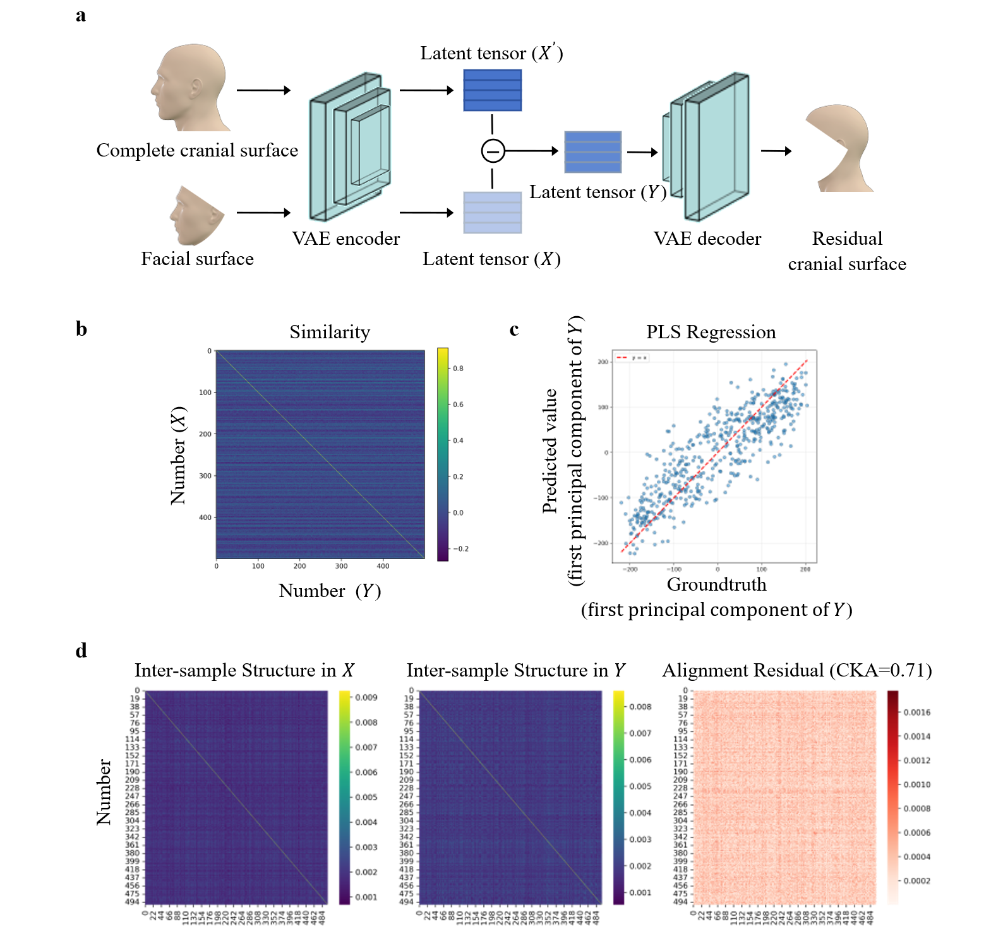
Fig. S1 | Face-to-scalp mapping. a. The VAE for extracting topological latent representations of the cranial surface. Subtract the facial surface latent tensor $X∈R^{32×4096}$ from the complete cranial surface latent tensor $X^{'}∈R^{32×4096}$ to obtain the residual cranial surface latent tensor $Y∈R^{32×4096}$. b. Cosine similarity between the latent tensors $X$ and $Y$, computed after flattening and reducing their dimensionality to 300 via principal component analysis (PCA). The average cosine similarity for paired samples is 0.75, while that for unpaired samples is -0.0053. The similarity between paired samples is significantly higher than that between un paired samples (p<0.0001). The p-value is obtained using t-test. (n=500) c. Cross-validation prediction results of the Partial Least Squares (PLS) regression. The model integrates PCA-based pre-reduction (to 300 dimensions) and PLS regression (with 50 components), with all prediction metrics evaluated via 5-fold cross-validation on unseen test sets. (n=500) d. Representational similarity analysis via Centered Kernel Alignment (CKA). The heatmaps display the normalized inter-sample similarity matrices for latent tensors $X$ (left) and $Y$ (middle), along with their absolute alignment residuals (right). The high global CKA score of 0.71 demonstrates a strong topological isomorphism between the two high-dimensional latent spaces, indicating that the relative geometric layout of the dataset is preserved across domains. (n=500)

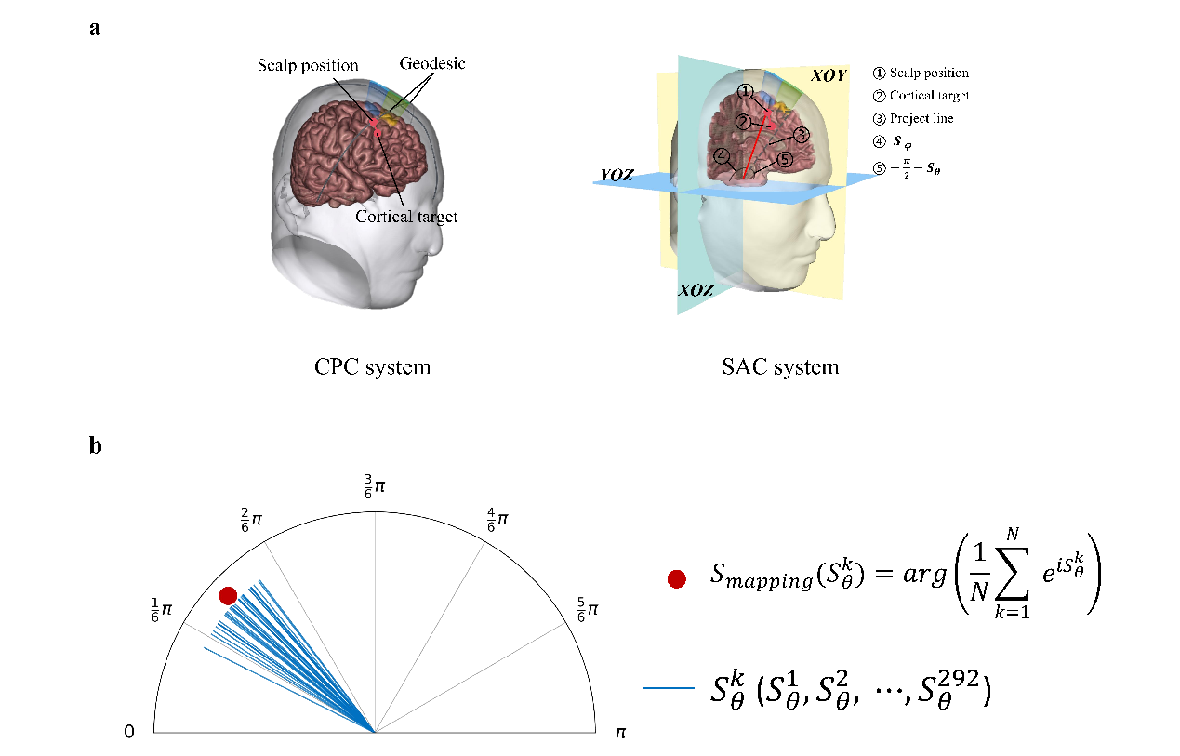
Fig. S2 | Cortex-to-scalp mapping. a. The CPC system employs scalp geodesics to construct a continuous cortex-to-scalp mapping coordinate system. Scalp position is represented by the proportion of two geodesic lines. A scalp angle coordinate (SAC) system to construct the cortex-to-scalp mapping, decoupling mapping errors from cranial surface reconstruction compared to scalp geodesics. The scalp position is defined by two angles $(S_{θ},S_{φ})$. The red line represents the connection between the scalp position and the origin. $S_{φ}$ is the angle between the red line and the z-axis, while $S_{θ}$ is the angle between the projection of the red line onto the XOY plane and the x-axis. b. Calculation method for cortex-to-scalp mapping. Taking any mapping $S_{θ} ([0,π])$ as an example, the blue line represents the phases of $S_{θ}^{k} (k=1,2,⋯,292)$, whilst the red dots represent the mean of these phases, which is the result of the mapping.

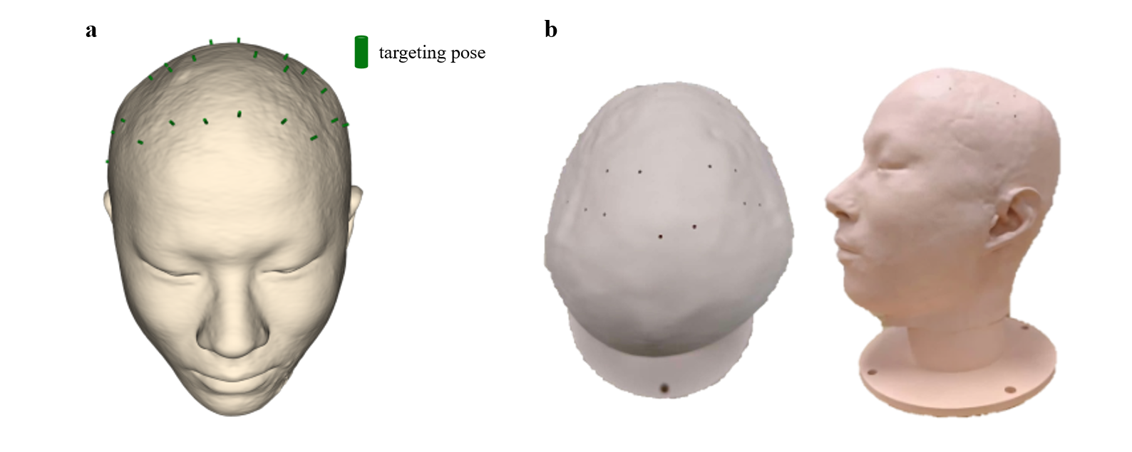
Fig. S3 | 3D-printed head model. a. The head model was obtained through MRI reconstruction. The green cylinder represents the pose of the target on the scalp. The scalp points were derived from an optimisation search using SimNIBS. The optimization aims to minimize the distance between the cortical target and the line of the scalp point normal. The MNI coordinates of the selected cortical targets are: M1 (x=-64, y=-9, z=32), (x=64, y=-6, z=33), (x=-5, y=-36, z=71), (x=6, y=-33, z=73), DLPFC (x=-44, y=38, z=34), (x=44, y=38, z=34), (x=-3, y=47, z=49), (x=9, y=49, z=47), PM (x=-28, y=-2, z=67), (x=27, y=-3, z=68). b. Using the cylinders described above, drill holes in the head model and 3D print it to produce a physical head model for testing.

