Dual-functional Nanocarrier for Improved Immunochemotherapy of Acute Myeloid Leukemia
Supplementary Figures

^{1,5}Zhuoya Wan, ^{2,3,5}Limei Wu, ¹Yiqing Mu, ¹Bei Zhang, ²Jing-Zhou Hou, ⁴Jingjing Sun, ^{2,3*}Wei Du, and ^{1*}Song Li

¹Center for Pharmacogenetics, Department of Pharmaceutical Sciences, University of Pittsburgh School of Pharmacy, Pittsburgh, PA.

²Division of Hematology and Oncology, University of Pittsburgh School of Medicine, Pittsburgh, PA.

³Genome Stability Program, UPMC Hillman Cancer Center, Pittsburgh, PA.

⁴Department of Pharmaceutical Sciences, College of Pharmacy, University of Nebraska Medical Center, Omaha, NE

⁵Equal contribution

*Corresponding authors: Song Li, MD, PhD
sol4@pitt.edu

OR

Wei Du, MD, PhD
duw@upmc.edu

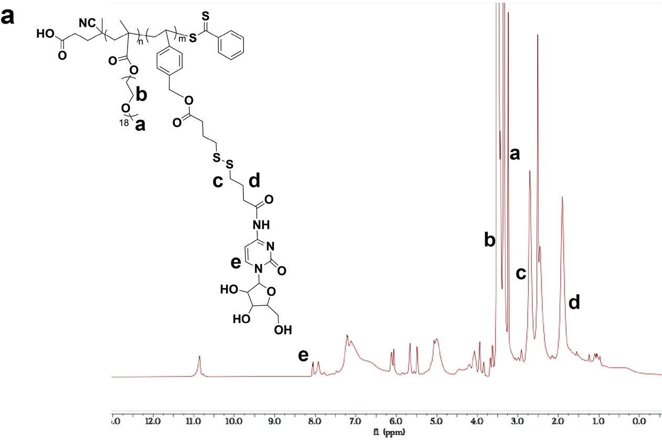

Supplementary Fig. 1 (a) ¹H-NMR result (in DMSO-d6) of PAraC.

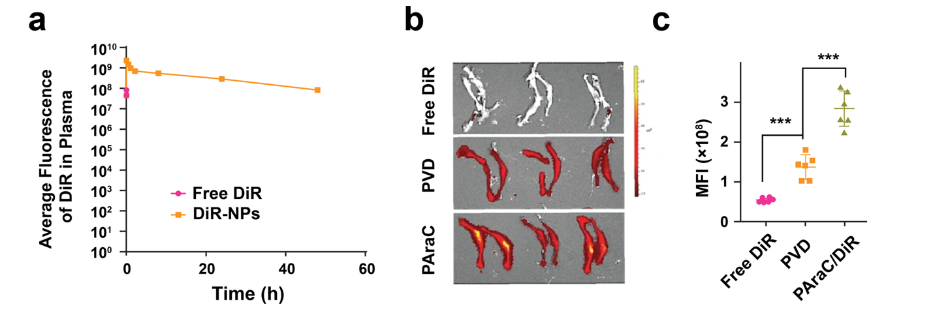
Supplementary Fig.2 Accumulation of PAraC NPs. (a) Free DiR and DiR-loaded PAraC nanoparticles were i.v. injected into mice. Mouse serum was taken from the mice at different time points, and the fluorescence intensity of the serum was measured. (b-c) Free DiR, DiR-loaded PAraC, or PVD nanoparticles were i.v. injected into mice (N=3). Twenty-four hours after injection, hind limb bones were taken out for fluorescence imaging and mean fluorescence intensity was quantified (Each dot represents one bone).

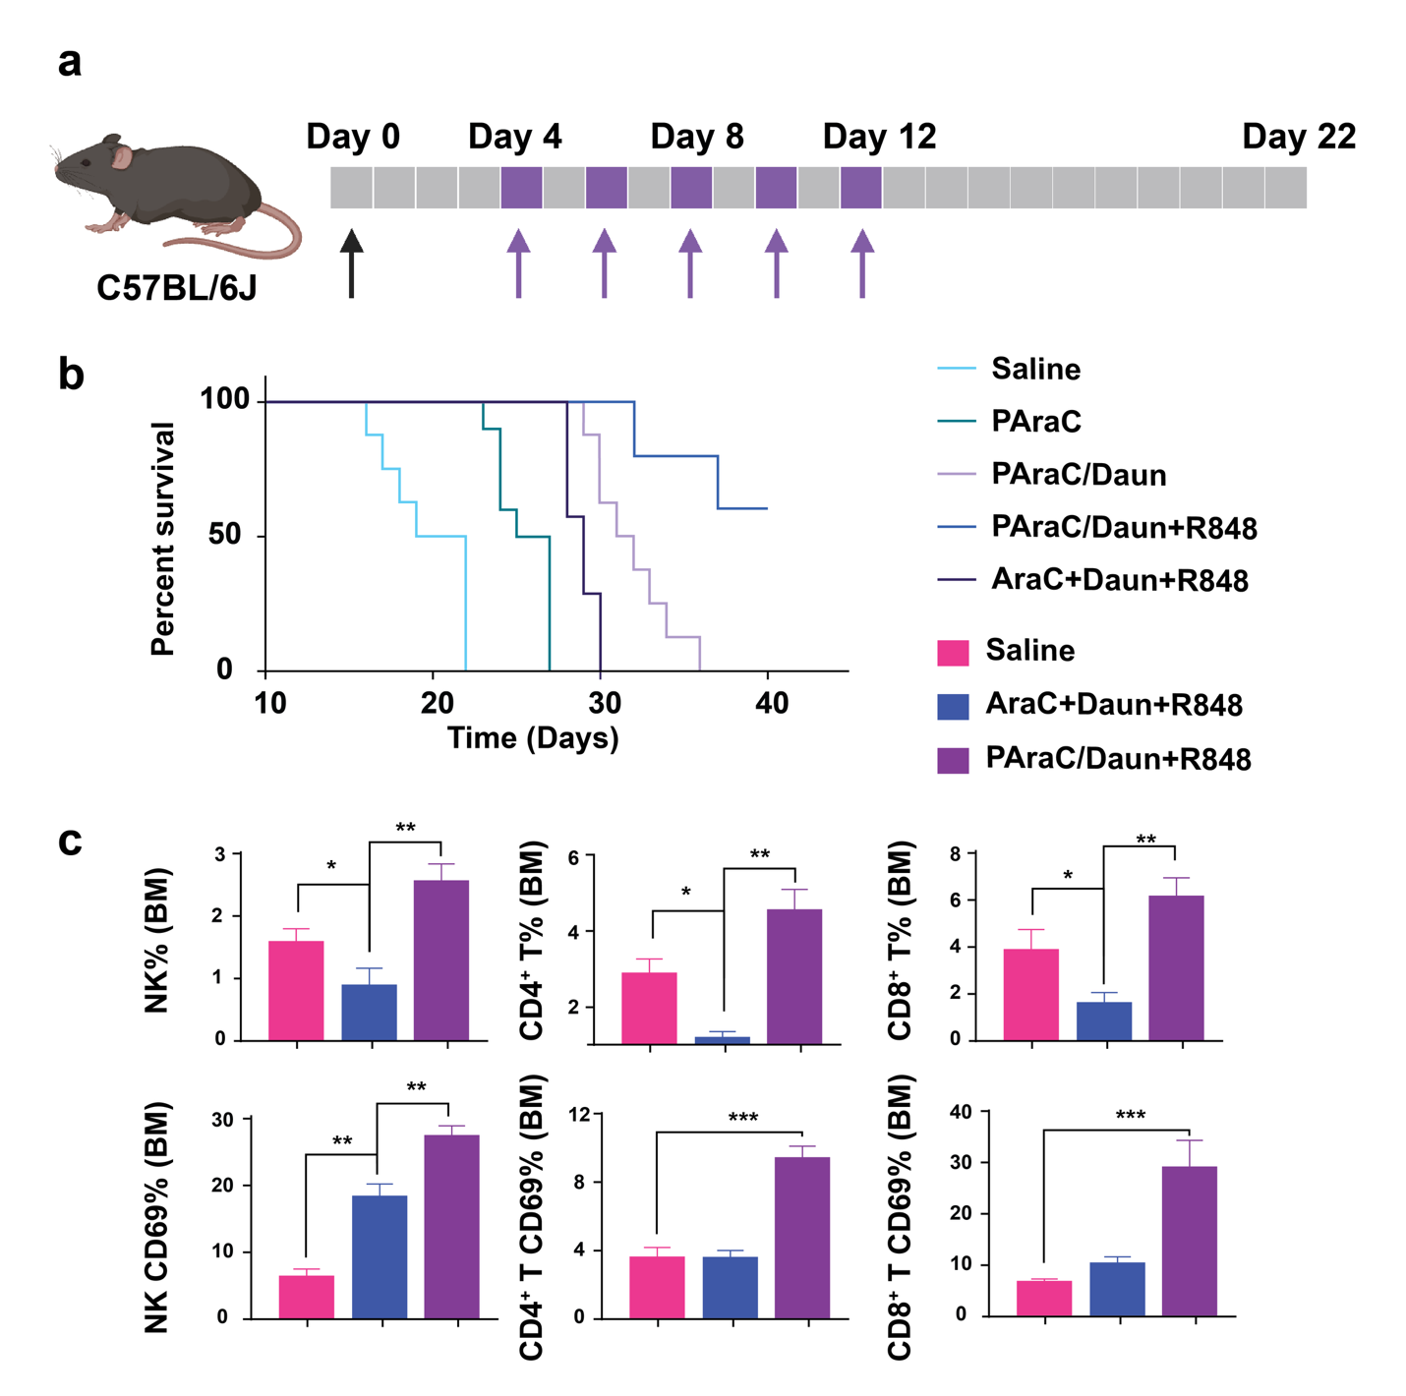
Supplementary Fig. 3 In vivo antitumor effect of PAraC NPs in the C1498 model (a) Workflow of C1498 murine AML model establishment and treatment. Created in BioRender. (b) Survival curve of AML mice in different treatment groups (N=8). (c) Twenty-two days after AML inoculation, mice from different treatment groups were sacrificed, and bone marrow was isolated for flow study. Numbers of total and activated NK cells, CD4⁺ T cells, and CD8⁺ T cells were measured by flow cytometry (N=3).

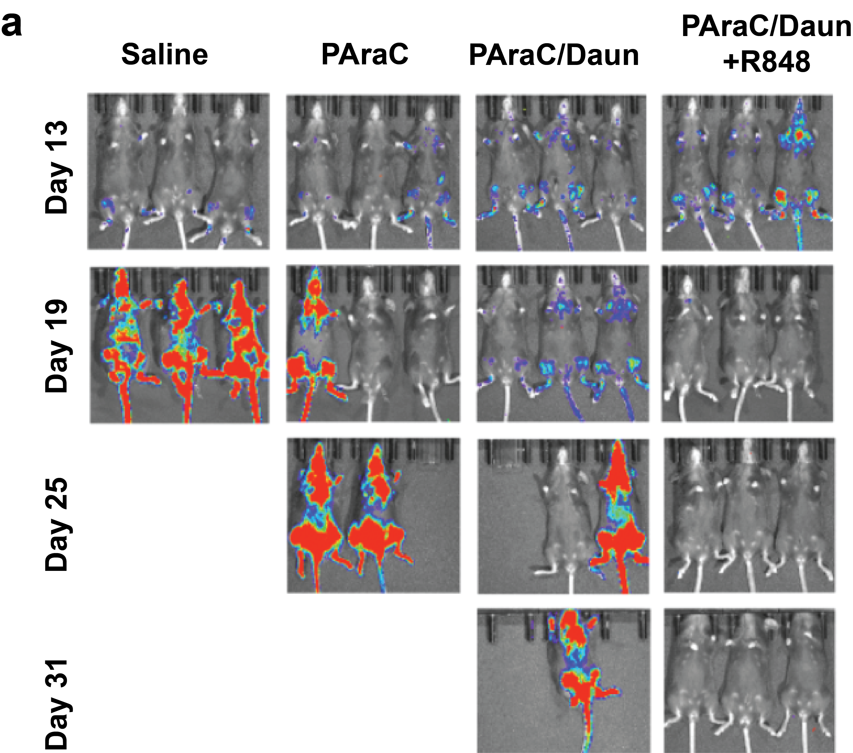
Supplementary Fig. 4 In vivo antitumor effect of PAraC NPs in murine ALL models (a) The murine ALL model was established by luciferase (Luc)-expressing p185⁺ Arf^{−/−} pre-B cells intravenously inoculated into C57Bl/6 mice. Progress of the ALL in different treatment groups was monitored by bioluminescence imaging on different days after inoculation (N=3).

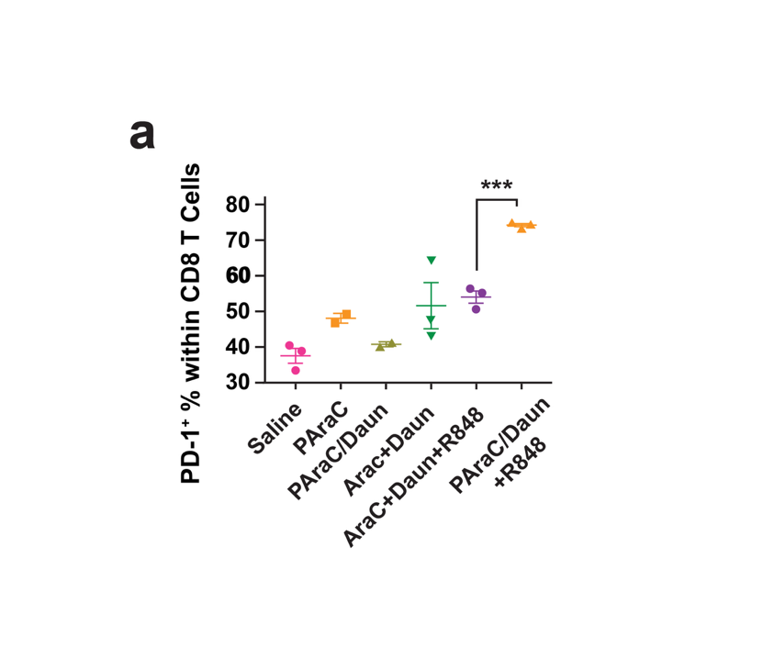

Supplementary Fig. 5 Upregulation of PD-1 in CD8 cells following different treatments. (a) Percentage of PD-1⁺ cells within CD8⁺ T cells after different treatments was measured by flow cytometry(N=3).

