Supplementary Materials
Tumor Perfusion Shows Substantial Hour-Scale Temporal and Spatial Dynamics in Superresolution Ultrasound Measurements
Alexandra Raab¹, Jasmin Baier¹, Céline Porte¹, Thomas Lisson², Palma Emese Inczeffy¹, Rahaf Mihyar¹, Andreas Schuppert³, Renée Michèle Girbig¹, Anne Rix¹, Susanne Koletnik¹, Jochen Maurer⁴, Stefanie Dencks², Georg Schmitz², Fabian Kiessling^{1*}
¹ Institute for Experimental Molecular Imaging, University Hospital RWTH Aachen, Aachen, Germany
² Chair for Medical Engineering, Faculty of Electrical Engineering and Information Technology, Ruhr University Bochum, Bochum, Germany
³ Institute of Computational Biomedicine, University Hospital RWTH Aachen, Aachen, Germany
⁴ Clinic for Gynecology and Obstetrics, University Hospital RWTH Aachen, Aachen, Germany
Email correspondence: fkiessling@ukaachen.de

Table S1 Daily score sheet for tumor-bearing mice. Alterations in body weight, general condition, spontaneous behavior, and clinical symptoms were monitored and scored using a predefined point-based grading system. No detectable alterations in physiological condition were assigned 0 points, whereas scores above 20 points indicated the highest severity level and defined the humane endpoint. In tumor-bearing mice, tumor growth and body condition were additionally documented and scored.
Parameters for healthy and tumor-bearing mice
Observation | Score
I Body weight  - No changes  - Change < 5%  - Weight reduction 5 – 10 %  - Weight reduction 11 – 19 %  - Weight reduction ≥ 20 % | 0  1  5  10  20
III General condition  - Shiny fur, clean body openings, clear and shiny eyes  - Defects of the fur, (increased or decreased body care)  - Dull fur, untidy, unclean body openings, cloudy eyes, increased muscle tonus  - Dirty fur, clotted and soggy body openings, unusual posture, dull eyes, high muscle tonus  - Cramps, paralysis (trunk muscles, extremities), conspicuous breathing problems, cold body | 0  1  5  10  20
IV Behavior  - Normal behavior (sleep, reaction to blowing and touching, curiosity, social contacts)  - Slight changes to normal behavior  - Unusual behavior, impaired motor function or hyper kinetics  - Self-isolation, lethargy, pronounced hyper kinetics or behavioral stereotypes, coordination disorders  - Pain sounds when seizing, self-amputation (auto aggression, autotomy), apathy, noticeable defensive reactions | 0  1  5  10  20
V Clinical symptoms  - Temperature and heart rate normal, mucosa well supplied with blood  - Slight change to the normal situation  - Change of body temperature from 1-2 °C, pulse + 30  - Change of the body temperature from > 2 °C, pulse + 50 | 0  1  5  20
Additional parameters for tumor-bearing mice
VI Body Conditioning Score  - Spine and pelvis not prominent (BC3)  - Spine prominent, segmentation of vertebral column evident, pelvis palpable (BC2)  Skeletal structure and vertebral column highly prominent, little or no subcutaneous fat (BC1) | 0  10  20
VII Orthotopic tumor growth  - Tumor ø > 5 mm to < 10 mm  - Tumor ø > 10 mm to < 15 mm  - Tumor ø > 15 mm or tumor size > 10% of body weight  - Neuronal effects (motion uncertainty, loss of sensitivity (no reaction to touch))  - Exulceration, invasive tumor growth, ascites or bleeding  - Highly enlarged spleen or lymph nodes (imaging)  - Soft stool  - Persistent diarrhea | 5  10  20  10  20  20  5  20
Assessment | Total score
- Degree of stress 0: no stress  - Degree of stress 1: low stress, continue to observe carefully  - Degree of stress 2: moderate stress, if necessary initiate veterinary case (analgesia)  - Degree of stress 3: high stress, remove animal form the study | 0  1 – 9  10 – 19  20
Humane end point | ≥ 15 for more than 48 hours

Table S2 Mixed-effects modelling of longitudinal microvascular parameters derived from ULM imaging. Linear mixed-effects models were applied to assess temporal changes in microvascular parameters and potential differences between tumor models (BCSC1 and MCF-7) across the individual timepoints (0h, 3h, 6h, 9h). For each parameter, the fixed effects included timepoint, tumor model, and their interaction (timepoint x tumor model). F-statistics with corresponding degrees of freedom (df) and p-values are reported for the time effect, model effect, and interaction term. Models were fitted using restricted maximum likelihood (REML) with a first-order autoregressive covariance structure (AR(1)) as described in the experimental section, to account for repeated measurements within individual mice. Columns “Temporal change?” and “Model differences?” summarize whether significant temporal effects or differences between tumor models were detected (p < 0.05). “Trend” indicates p-values between 0.05 and 0.1
Parameter | Time effect (F(df), p) | Model effect  (F(df), p) | Interaction Time x Model (F(df), p) | Temporal change? | Model differences?
Vessel coverage | 1.67 (3,13.52), 0.221 | 0.98 (1,8.36), 0.349 | 0.49 (3,13.52), 0.693 | No | No
Mean flow velocity | 2.57 (3,16.06), 0.090 | 0.51 (1,8.11), 0.494 | 0.16 (3,16.06), 0.921 | Trend | No
Mean track counts | 1.16 (3,15.92), 0.358 | 0.43 (1,8.37), 0.531 | 1.00 (3,15.92), 0.471 | No | No
Flow direction | 0.47 (3,9.53), 0.711 | 0.02 (1,7.71), 0.893 | 0.84 (3,9.53), 0.503 | No | No
Mean distance to closest track | 0.17 (3,13.88), 0.917 | 2.80 (1,8.47), 0.131 | 0.28 (3,13.88), 0.838 | No | Trend
Mean track length | 10.25 (3,15.31), <0.001 | 0.02 (1,8.34), 0.888 | 0.22 (3,15.31), 0.884 | Yes | No
Mean tortuosity (Sum of angles metric) | 2.71 (3,15.43), 0.081 | 1.59 (1,7.82), 0.244 | 0.42 (3,15.43), 0.742 | Trend | No
Mean track-wise velocity | 7.05 (3,13.63), 0.004 | 0.40 (1,8.18), 0.545 | 0.18 (3,13.63), 0.906 | Yes | No

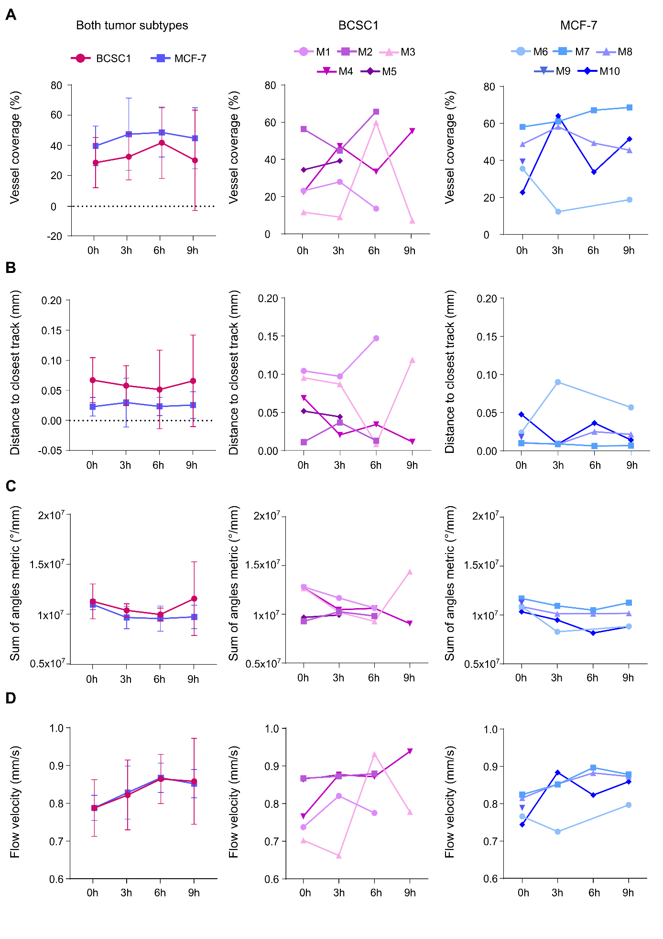
Fig. S1 Non-normalized vascular parameters show stable distributions across timepoints in both tumor models, but intra-tumoral variability. (A-D) Non-normalized values of the primary ULM-derived microvascular parameters quantified in BCSC1 and MCF-7 xenografts across the monitored timepoints (0h, 3h, 6, and 9h). For each parameter, the left graph shows the mean values ± SD for both tumor models, while the corresponding graphs on the right illustrate singular tumor profiles for the individual models over time. Parameters include (A) vessel coverage, (B) mean distance to closest track, (C) mean vessel tortuosity (sum of angles metric), and (D) mean microvascular flow velocity. Although individual tumors exhibit fluctuations between timepoints, no consistent temporal trends are observed across the animals. The letter “M” represents individual mice (1-10)

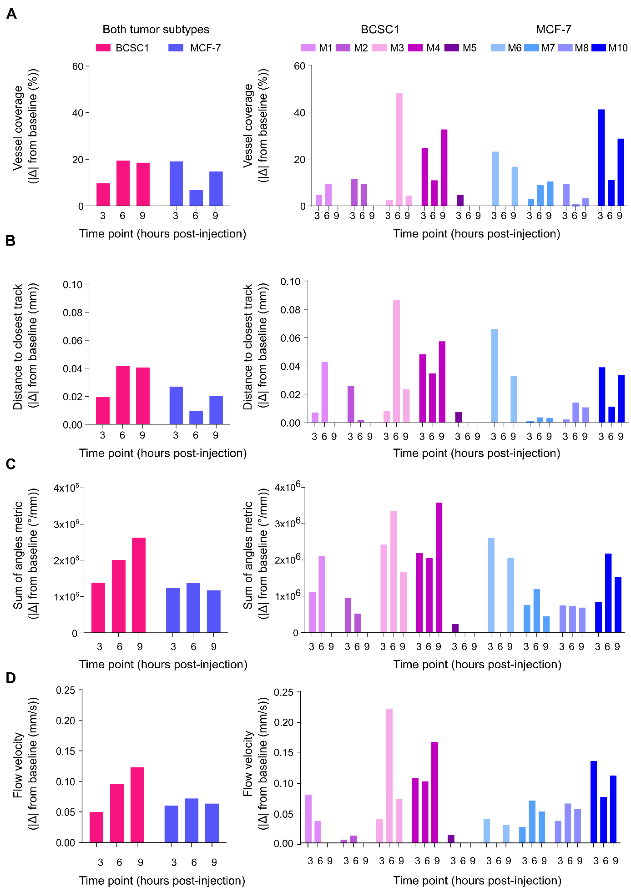Fig. S2 Absolute deviations from the baseline highlight intra-tumoral variability of microvascular patterns. Absolute changes relative to the baseline at 0h for the primary ULM-derived parameters in BCSC1 and MCF-7 tumors across the monitored timepoints. For each panel the left graph summarizes the magnitude of deviation from the baseline at the group level for the two tumor models, while the corresponding plots on the right illustrate the absolute deviations for individual tumors over time. Parameters include (A) vessel coverage, (B) mean distance to the closest track, (C) mean vessel tortuosity expressed as sum of angles metric, and (D) mean microvascular flow velocity. Although group-level changes remain limited, individual tumors reveal heterogeneous temporal changes between animals, highlighting pronounced intra-tumoral variability despite the absence of systematic trends across the tumor models. The letter “M” represents individual mice (1-10)
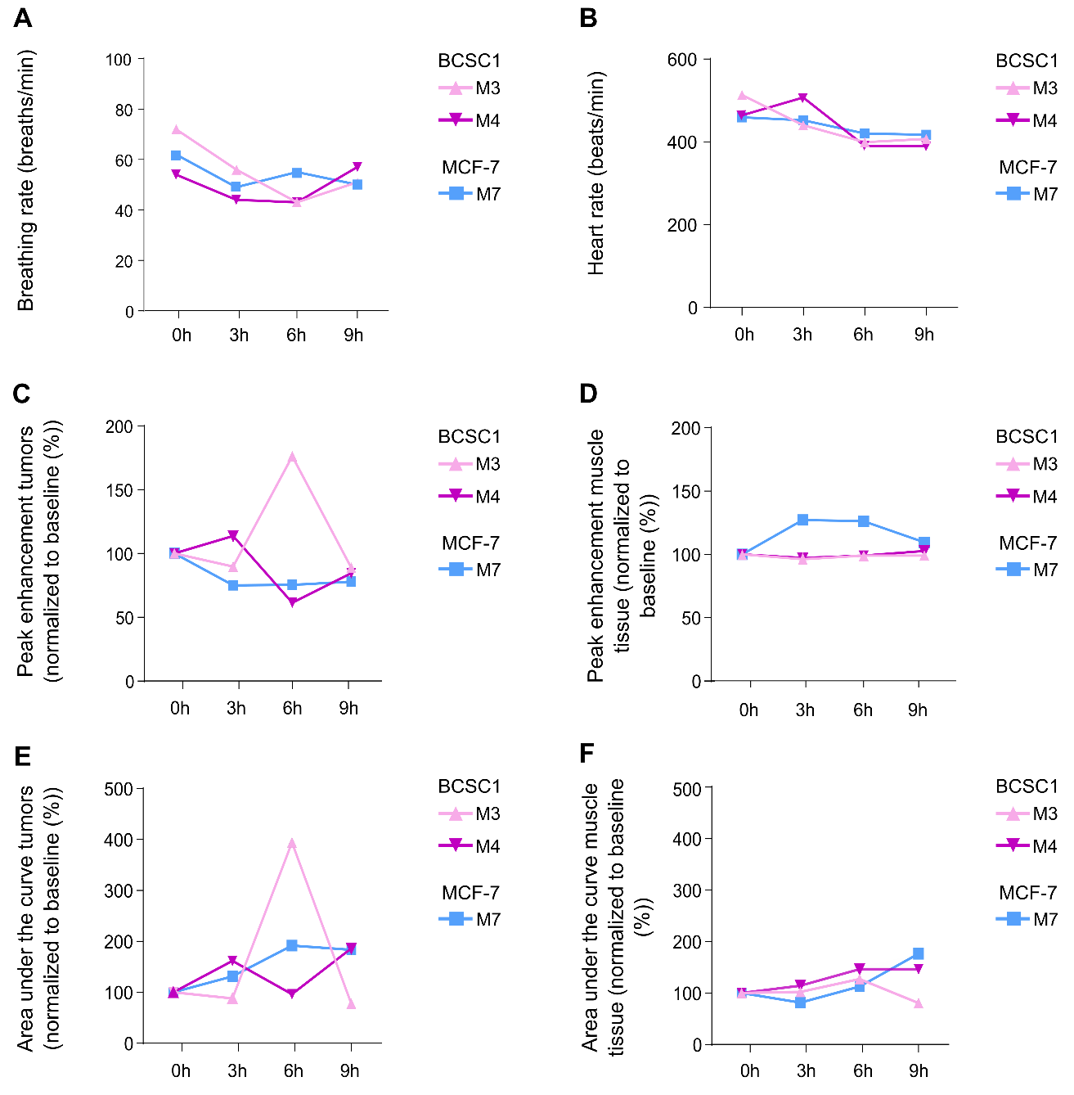
Fig. S3 Stable systemic physiological parameters and muscle perfusion confirm tumor-intrinsic origins of heterogeneous perfusion patterns. (A) Breathing rate (breaths/min) and (B) heart rate (beats/min) of three mice measured throughout the 9-hour imaging period under isoflurane anesthesia. Both parameters remained within a stable physiological range over time. (C-E) PE and AUC derived from CEUS measurements in tumor tissue (C,E) and muscle tissue (D,F), displayed as values normalize to baseline (0h = 100%). In contrast to tumors, muscle tissue perfusion remained largely stable across all imaging timepoints, showing only minor variability. Tumor tissue, on the other hand, exhibited pronounced temporal fluctuations in perfusion parameters. Importantly, any changes observed in the muscle tissue did not follow the magnitude or directional patterns seen in tumors. The markedly lower variability observed in muscle and the lack of matching temporal trends between muscle tissue and tumors reflect that observed perfusion dynamics predominantly reflect tumor-intrinsic microvascular processes, rather than systemic effects induced by prolonged anesthesia. The letter “M” represents individual mice (1-10)
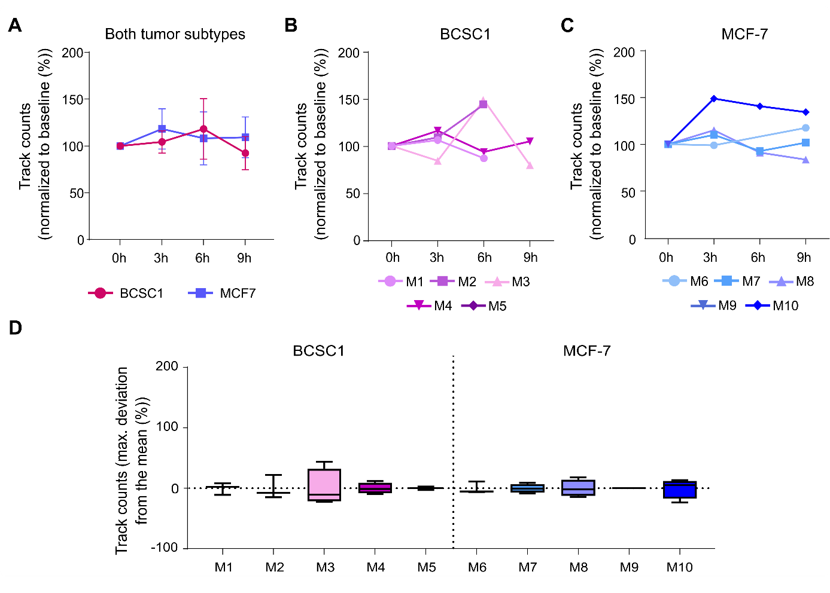
Fig. S4 MB track detection metric remains stable over time. (A-D) Mean MB track counts derived from ULM analysis across the same imaging timepoints. (A) Mean baseline-normalized track counts in BCSC1 and MCF-7 tumors (0 h = 100%). Data are shown as mean ± SD. (B,C) Individual tumor profiles for BCSC1 and MCF-7 xenografts. (D) Distribution of relative track count values across all monitored timepoints, presented as the maximum percentage deviation from the mean within each tumor. Box-and-whisker plots display the median as well as the interquartile range with the full range of the data. The letter “M” represents individual mice (1-10)

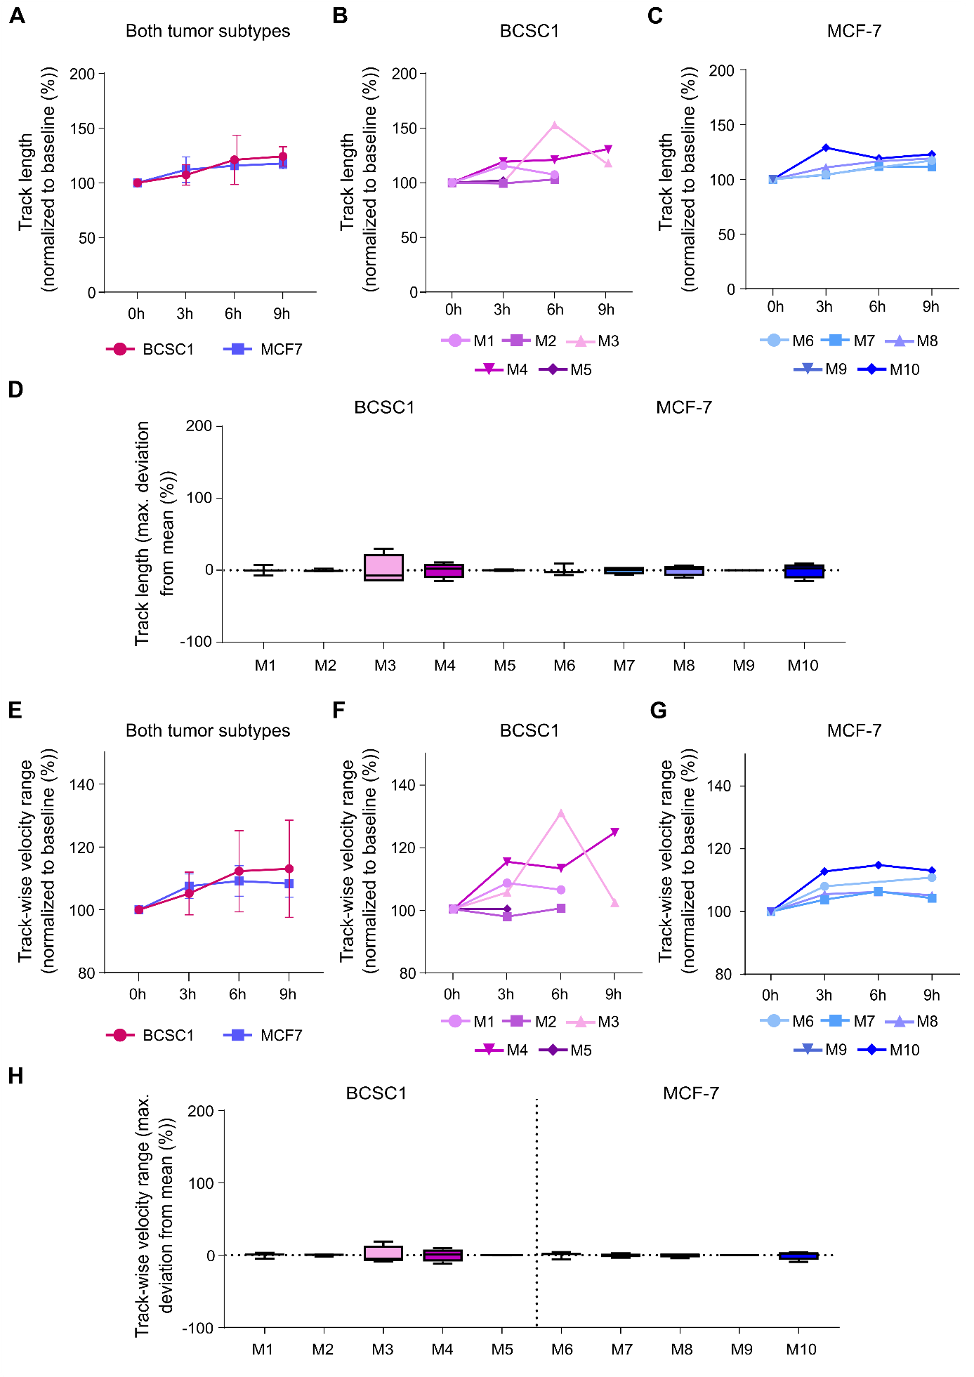

Fig. S5 Mean track length and mean track-wise velocity metrics exhibit high intratumoral heterogeneity without significant differences between tumor groups. (A-C) Mean track length derived from ULM analysis across the monitored timepoints. (A) Mean relative track length in BCSC1 and MCF-7 xenografts expressed as percentage change relative to the baseline (0h = 100%). Data as shown as mean ± SD. (B,C) Relative mean track length developments for individual tumors within each subgroup, showing changes over time for (B) BCSC1 and (C) MCF-7 tumors. (D) Distribution of track length variability across all timepoints, shown as maximum percentage deviation from the mean within each tumor over 9 hours. (E-H) Mean track-wise MB velocity over time. (E) Mean relative velocity derived from individual MB tracks in BCSC1 and MCF-7 xenografts. Values are displayed relative to the baseline (0h = 100%). Data are presented as mean ± SD. (F,G) Relative track-wise velocity development over time in (F) BCSC1 and (G) MCF-7 tumors. (H) Distribution of the intra-tumoral variability of track-wise velocity across all timepoints, expressed as the maximum percentage deviation from the mean. (D,H) Box-and-whisker plots display the median as well as the interquartile range with the full range of the data. The letter “M” represents individual mice (1-10)

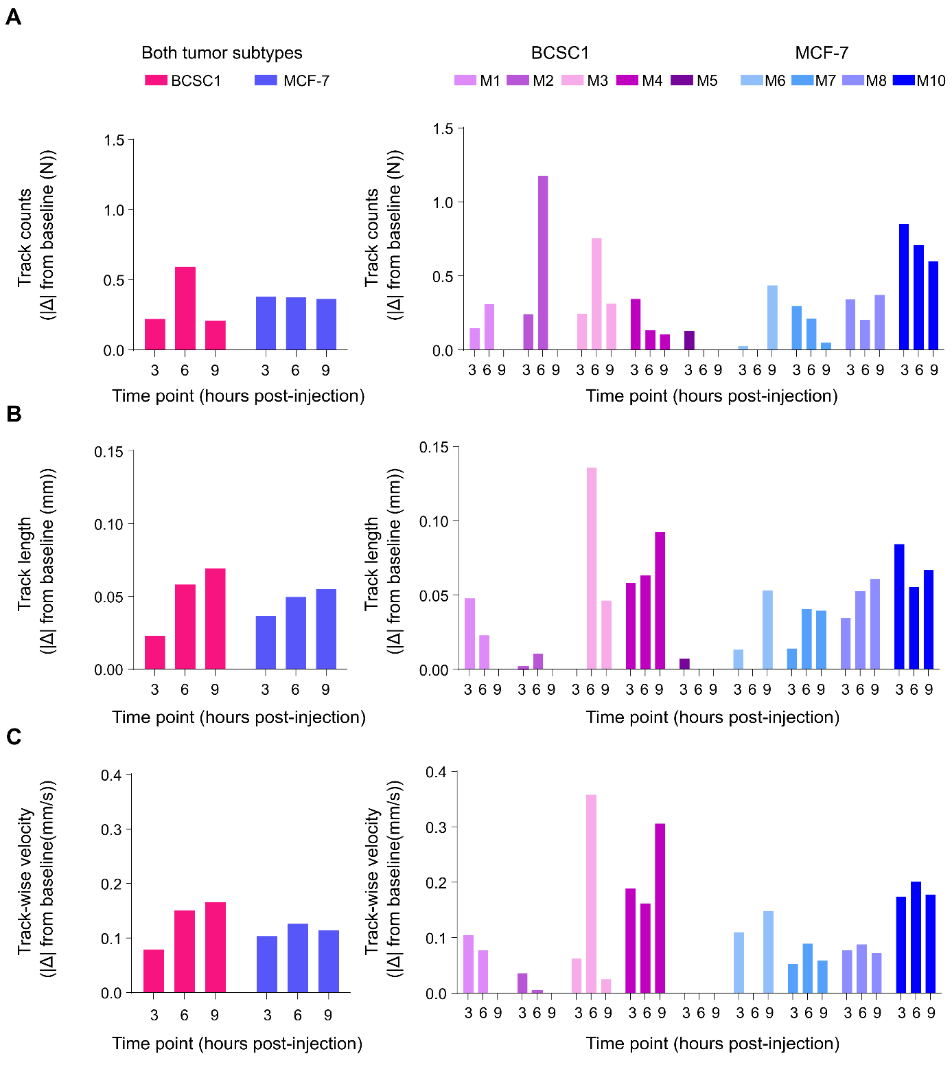

Fig. S6 Absolute deviations from the baseline reveal heterogeneous parameter-specific variability across individual tumors. (A-C) Absolute changes relative to the baseline (Δ from 0h) for selected microvascular parameters quantified by ULM across the monitored timepoints post-MB injection at 3h, 6h, and 9h for (A) mean track counts, (B) mean track length, and (C) mean track-wise velocity. Graphs on the left summarize average values for BCSC1 and MCF-7 xenografts, while graphs on the right show the absolute deviations for every individual tumor within each model. While the extent of deviation varied between tumors, no consistent or significant differences were observed in deviation magnitude between the two tumor models. The letter “M” represents individual mice (1-10)

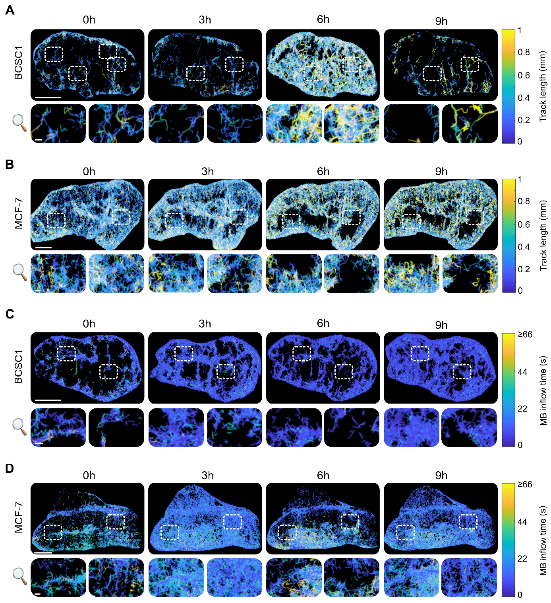
Fig. S7 Representative ULM-derived vascular maps illustrating the full spatial and local variability of MB track length and inflow time within the tumor microvasculature. (A,B) Representative track length maps derived from ULM analysis showing the spatial distribution of individual MB track lengths within the tumor vasculature of (A) BCSC1 and (B) MCF-7 xenografts. Colors indicate the length of reconstructed MB tracks across the vascular network. Dashed white boxes highlight representative regions of interest within the tumors. Enlarged views of the corresponding regions are shown below each map to illustrate the changes in local microvascular patterns. (C,D) Inflow time illustrating the spatial distribution of MB arrival times within the tumor vasculature of (C) BCSC1 and (D) MCF-7 xenografts. Colors represent the relative inflow times of detected MBs. Dashed white boxes indicate the according magnified regions below, to illustrate changes at a recurring tumor area. Scale bars of maps in the top rows: 2 mm. Scale bars of zoomed-in maps: 200 µm

