Supplementary
Supplement Figure S1. Overview of study design and parallel cross-sectional analyses in primary care and hospital cohorts
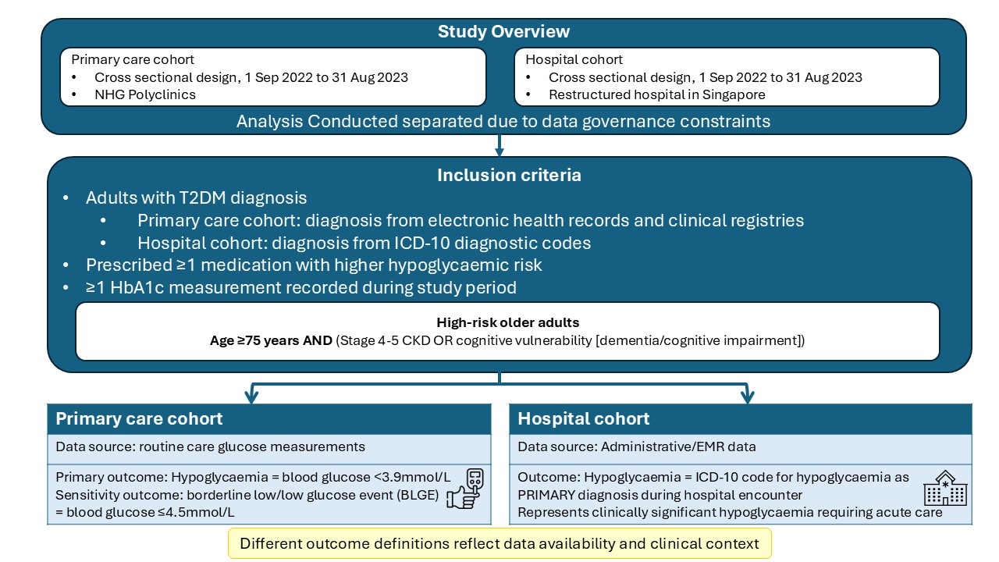
This figure illustrates the parallel cross‑sectional design of the study. Adults with type 2 diabetes prescribed medications with higher hypoglycaemia risk were identified independently within primary care and tertiary hospital settings during the study period (1 September 2022–31 August 2023). Due to data governance and infrastructure constraints, patient‑level linkage across settings was not feasible; analyses were therefore conducted separately within each setting using setting‑appropriate glucose safety signals, and findings represent parallel analyses rather than a unified longitudinal cohort.

Supplementary Table S2. Hypoglycaemia (<3.9mmol/L) rates by HbA1c categories across age groups in the primary care cohort
HbA1c category | Primary care cohort (N=38,957) |  |  | <65yo (n=16,659) |  |  | 65-<75yo (n=14,046) |  |  | 75-<85yo (n=6,795) |  |  | >/=85yo (n=1,457) |  |  | High-risk older adults (n=1,430)
HbA1c category | Total | n | % | Total | n | % | Total | n | % | Total | n | % | Total | n | % | Total | n | %
<6% | 1151 | 18 | 1.6 | 416 | 1 | 0.2 | 423 | 9 | 2.1 | 241 | 6 | 2.5 | 71 | 2 | 2.8 | 73 | 3 | 4.1
6–<6.5% | 3041 | 32 | 1.1 | 1096 | 3 | 0.3 | 1184 | 23 | 1.9 | 616 | 6 | 1.0 | 145 | 0 | 0.0 | 153 | 1 | 0.7
6.5–<7% | 6213 | 54 | 0.9 | 2362 | 9 | 0.4 | 2415 | 27 | 1.1 | 1187 | 17 | 1.4 | 249 | 1 | 0.4 | 247 | 4 | 1.6
7–<8% (ref) | 14521 | 112 | 0.8 | 5784 | 15 | 0.3 | 5600 | 72 | 1.3 | 2606 | 24 | 0.9 | 531 | 1 | 0.2 | 460 | 9 | 2.0
8-<8.5 | 4440 | 20 | 0.5 | 1938 | 0 | 0.0 | 1551 | 13 | 0.8 | 788 | 5 | 0.6 | 163 | 2 | 1.2 | 157 | 1 | 0.6
≥8.5% | 9591 | 42 | 0.4 | 5063 | 9 | 0.2 | 2873 | 20 | 0.7 | 1357 | 12 | 0.9 | 298 | 1 | 0.3 | 340 | 3 | 0.9
Total | 38957 | 278 | 0.7 | 16659 | 37 | 0.3 | 14046 | 164 | 1.2 | 6795 | 70 | 1.0 | 1457 | 7 | 0.5 | 1430 | 21 | 1.5

Supplementary Table S3. Borderline low/low glucose event (BLGE, ≤4.5mmol/L) rates by HbA1c categories across age groups in the primary care cohort
HbA1c category | Primary care cohort (N=38,957) |  |  | <65yo (n=16,659) |  |  | 65-<75yo (n=14,046) |  |  | 75-<85yo (n=6,795) |  |  | >/=85yo (n=1,457) |  |  | High-risk older adults (n=1,430)
HbA1c category | Total | n | % | Total | n | % | Total | n | % | Total | n | % | Total | n | % | Total | n | %
<6% | 1151 | 59 | 5.1 | 416 | 5 | 1.2 | 423 | 30 | 7.1 | 241 | 21 | 8.7 | 71 | 3 | 4.2 | 73 | 8 | 11.0
6–<6.5% | 3041 | 117 | 3.8 | 1096 | 12 | 1.1 | 1184 | 83 | 7.0 | 616 | 20 | 3.2 | 145 | 2 | 1.4 | 153 | 5 | 3.3
6.5–<7% | 6213 | 158 | 2.5 | 2362 | 25 | 1.1 | 2415 | 95 | 3.9 | 1187 | 35 | 2.9 | 249 | 3 | 1.2 | 247 | 7 | 2.8
7–<8% (ref) | 14521 | 307 | 2.1 | 5784 | 46 | 0.8 | 5600 | 189 | 3.4 | 2606 | 68 | 2.6 | 531 | 4 | 0.8 | 460 | 17 | 3.7
8-<8.5 | 4440 | 65 | 1.5 | 1938 | 4 | 0.2 | 1551 | 44 | 2.8 | 788 | 14 | 1.8 | 163 | 3 | 1.8 | 157 | 2 | 1.3
≥8.5% | 9591 | 120 | 1.3 | 5063 | 24 | 0.5 | 2873 | 61 | 2.1 | 1357 | 31 | 2.3 | 298 | 4 | 1.3 | 340 | 9 | 2.6
Total | 38957 | 826 | 2.1 | 16659 | 116 | 0.7 | 14046 | 502 | 3.6 | 6795 | 189 | 2.8 | 1457 | 19 | 1.3 | 1430 | 48 | 3.4

Supplementary Table S4. Hypoglycaemia rates by HbA1c categories across age groups in the tertiary hospital cohort
HbA1c category | Hospital cohort (N=6855) |  |  | <65yo (n=2732) |  |  | 65-<75yo (n=2029) |  |  | 75-<85yo (n=1508) |  |  | >/=85yo (n=586) |  |  | High-risk older adults (n=966)
HbA1c category | Total | n | % | Total | n | % | Total | n | % | Total | n | % | Total | n | % | Total | n | %
<6% | 352 | 49 | 13.9 | 112 | 13 | 11.6 | 108 | 20 | 18.5 | 82 | 4 | 4.9 | 50 | 12 | 24.0 | 80 | 14 | 17.5
6–<6.5% | 538 | 40 | 7.4 | 159 | 3 | 1.9 | 174 | 17 | 9.8 | 136 | 11 | 8.1 | 69 | 9 | 13.0 | 103 | 14 | 13.6
6.5–<7% | 886 | 43 | 4.9 | 277 | 7 | 2.5 | 279 | 11 | 3.9 | 236 | 19 | 8.1 | 94 | 6 | 6.4 | 160 | 16 | 10.0
7–<8% (ref) | 1964 | 123 | 6.3 | 662 | 20 | 3.0 | 626 | 43 | 6.9 | 488 | 44 | 9.0 | 188 | 16 | 8.5 | 287 | 31 | 10.8
8-<8.5 | 768 | 49 | 6.4 | 304 | 6 | 2.0 | 225 | 18 | 8.0 | 188 | 16 | 8.5 | 51 | 9 | 17.6 | 107 | 19 | 17.8
≥8.5% | 2347 | 94 | 4.0 | 1218 | 26 | 2.1 | 617 | 27 | 4.4 | 378 | 28 | 7.4 | 134 | 13 | 9.7 | 229 | 28 | 12.2
Total | 6855 | 398 | 5.8 | 2732 | 75 | 2.7 | 2029 | 136 | 6.7 | 1508 | 122 | 8.1 | 586 | 65 | 11.1 | 966 | 122 | 12.6

