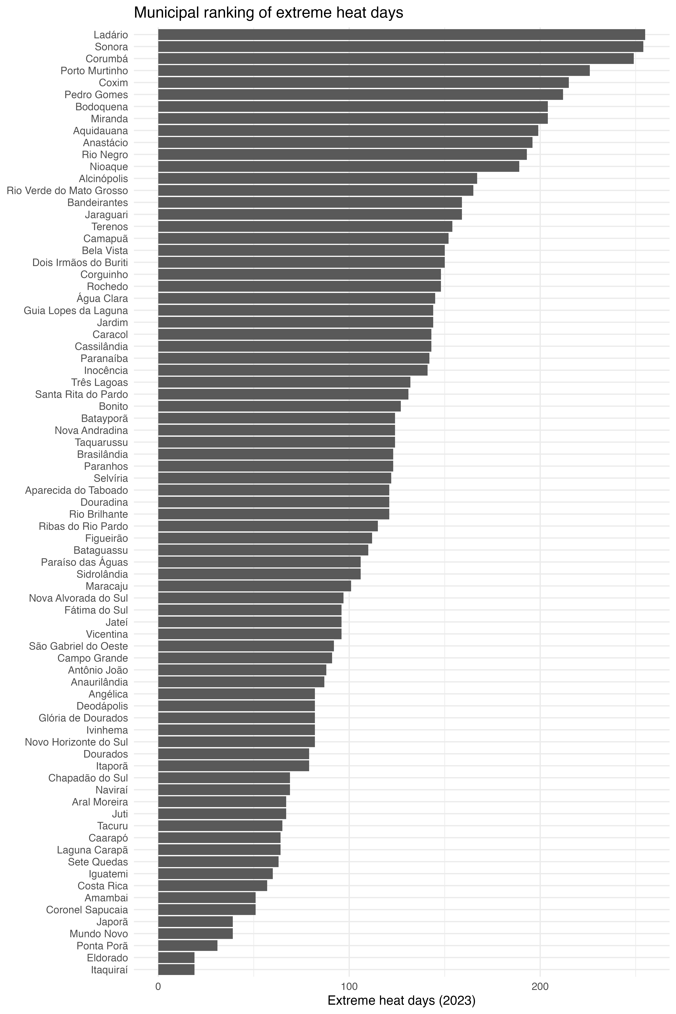
SM 1. Municipal ranking of extreme heat days recorded in 2023 across the municipalities of Mato Grosso do Sul, Central Brazil. Bars represent the total number of days classified as extreme heat events for each municipality, highlighting substantial spatial heterogeneity in annual heat exposure across the state.
SM 2. Multivariable linear regression model examining municipal predictors of extreme heat days in Mato Grosso do Sul, Central Brazil. Regression coefficients (Beta), standard errors (SE), and p-values are presented for log-transformed green cover per capita (green_log), Human Development Index (HDI), Gini index, and log-transformed population size (log_pop). Positive coefficients indicate greater expected numbers of extreme heat days with increasing predictor values.
Predictor | Beta | SE | p_value
green_log | 14.469 | 3.152 | 0
hdi | 257.93 | 147.605 | 85
gini | 115.476 | 93.207 | 219
log_pop | -9.427 | 6.967 | 0.18

SM 3. Adjusted associations between extreme heat days and municipal health outcomes in Mato Grosso do Sul, Central Brazil. Regression coefficients for extreme heat exposure (beta_heat) and corresponding p-values (p_heat) are presented for circulatory hospitalizations, circulatory mortality, respiratory mortality, and cancer mortality. Positive coefficients indicate higher outcome rates with increasing numbers of extreme heat days.
model | beta_heat | p_heat
Hospitalizations circulatory | -0.502 | 0.289
Mortality circulatory | 0.099 | 0.538
Mortality respiratory | 0.214 | 0.008
Mortality cancer | 0.025 | 0.773

SM 4. Principal Component Analysis (PCA) biplot of socioenvironmental gradients across municipalities of Mato Grosso do Sul, Central Brazil. PC1 (33.9%) represents the hot-dry exposure gradient, whereas PC2 (21.3%) represents the urban development gradient. Grey points correspond to municipalities, identified by numeric codes. Blue vectors indicate the direction and relative contribution of the original variables: extreme heat days (heat_days), municipal green cover per capita (green_log), precipitation (precip51), relative humidity (rh_mean), Human Development Index (hdi), Gini index (gini), and population size (log_pop). Longer vectors indicate stronger contributions to component structure, and angles between vectors reflect correlations among variables. Numbers represent municipalities.

