Defect rich copper oxide nanosheets for selective electrochemical conversion of CO₂ to multi-carbon products at high current density

Supplementary Methods
Methods
Chemicals.
Synthesis of CuO-st. CuO-st was prepared by a scalable one-pot wet-chemical synthesis method. Typically, 2.0 g CuCl₂ was dissolved into 2.0 L deionized water. Followed, 4.0 g KOH and 200 uL hydrazine hydrate were added into the solution successively. After being stirred at rt for 48 h, the mixture was filtered, washed with deionized water and EtOH, and dried, giving CuO-st as brown solid.
Synthesis of of Cu2O-pt. 2.0 g CuCl₂ was dissolved into 2.0 L deionized water. Followed, 4.0 g KOH and 500 uL hydrazine hydrate were added into the solution successively. After being stirred at rt for 23h, the mixture was filtered, washed with deionized water and EtOH, and dried, giving Cu₂O as yellow solid.
Synthesis of of Cu-pt. 2.0 g CuCl₂ was dissolved into 2.0 L deionized water. Followed, 4.0 g KOH and 2000 uL hydrazine hydrate were added into the solution successively. After being stirred at rt for 23h, the mixture was filtered, washed with deionized water and EtOH, and dried, giving Cu as deep red solid.
Evaluation of eCO₂RR performance
Catalyst (30.0 mg) and Nafion solution (50 uL, 5 wt %) were ultrasonically dispersed in ethanol (2.95 mL) to form the catalyst ink. A typical catalyst loading was ~0.5 mg/cm² for each electrode.
H-cell: Prior to the controlled potential electrolysis, the electrolyte of two compartments was saturated with CO₂ by bubbling CO₂ gas for 30 min. The pH of the CO₂ saturated 0.1 M KCl was calculated to be 3.8. The electrolyte in the cathodic compartment was stirred at a rate of 800 rpm.
Flow-cell：Catholyte and anolyte were performed at a constant flow rate of approximately 28 mL/min.
The potentials were measured against the Ag/AgCl electrode, and then converted to the reversible hydrogen electrode (RHE).
In potentiostatic electrolysis, the potentials were converted via the equation (with iR correction):
E (vs. RHE) = E (vs. Ag/AgCl) + 0.197 + pH × 0.0591 + iR (R: the solution resistance).
In galvanostatic electrolysis, the potentials were converted via the equation (without iR correction):
E (vs. RHE) = E (vs. Ag/AgCl) + 0.197 + pH × 0.0591
Typically, CO₂ gas was delivered at a rate of ~20 sccm, and routed directly into an on-line gas chromatograph (GC, FANWEI) equipped with FID and TCD detectors. CO, CH₄ and C₂H₄ were detected using a flame ionization detector (FID). H₂ gas was detected by a thermal conductivity detector (TCD). For quantifying the liquid products, 10 mmol L⁻¹ of DMSO in D₂O was used as the internal standard.
Faradaic efficiency:
$${FE}_{x}=\frac{Q_{x}}{Q_{total}}=\frac{tz_{x}Fv_{x}Gp_{0}}{RT_{0}Q_{total}}×100\%$$
Wherein, $Q_{x}$ is the charge for product (x) production, t is the sampling time (10 min), z_{x} is the number of electron required to form a molecule of product (x), $v_{x}$ is volume concentration of product (x) measured by GC, $Q_{total}$ is the total charge passed during the electrolysis of 10 min. F = 96485 C/mol, G = 20.00 sccm, P₀= 1.01×10⁵ Pa, R = 8.314 J mol^{–1} K^{–1}, T₀= 273.15 K.
Faradaic efficiencies of liquid products were calculated as below:
$${FE}_{x}=\frac{z_{x}Fn_{x}}{Q_{total}}×100\%$$
Wherein, z_{x} is the number of electron required to form a molecule of product (x), F = 96485 C/mol, $n_{x}$ is the quantity (mol) for products (x) production, $Q_{x}$ is the charge for product (x) production. $n_{x}$ was determined by ¹H NMR peak area.

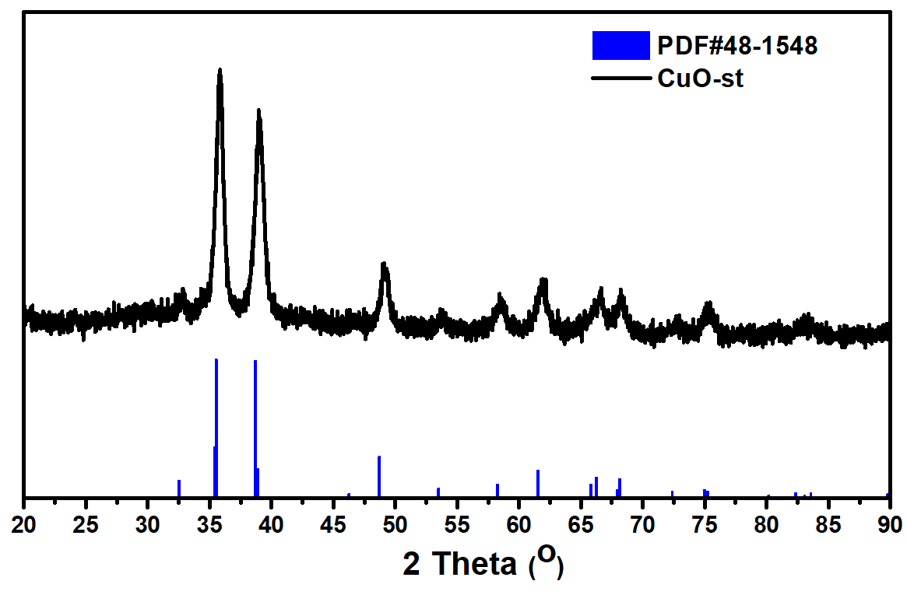
Supplementary Fig. 1 The XRD patterns of CuO-st.

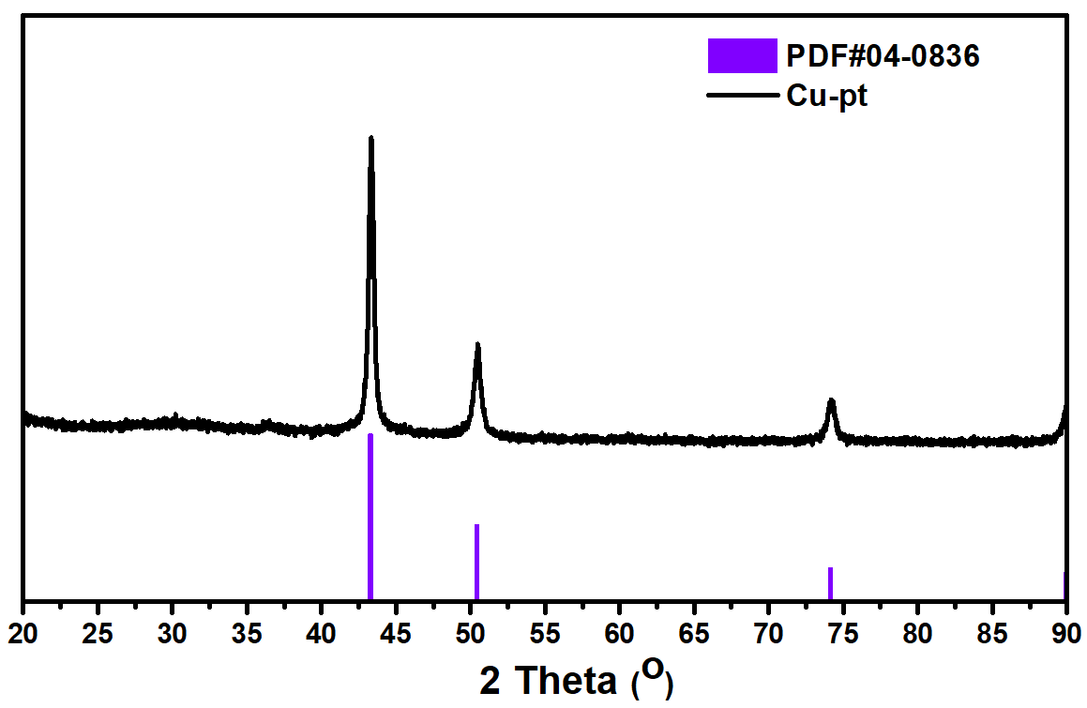
Supplementary Fig. 2 The XRD patterns of Cu-pt.

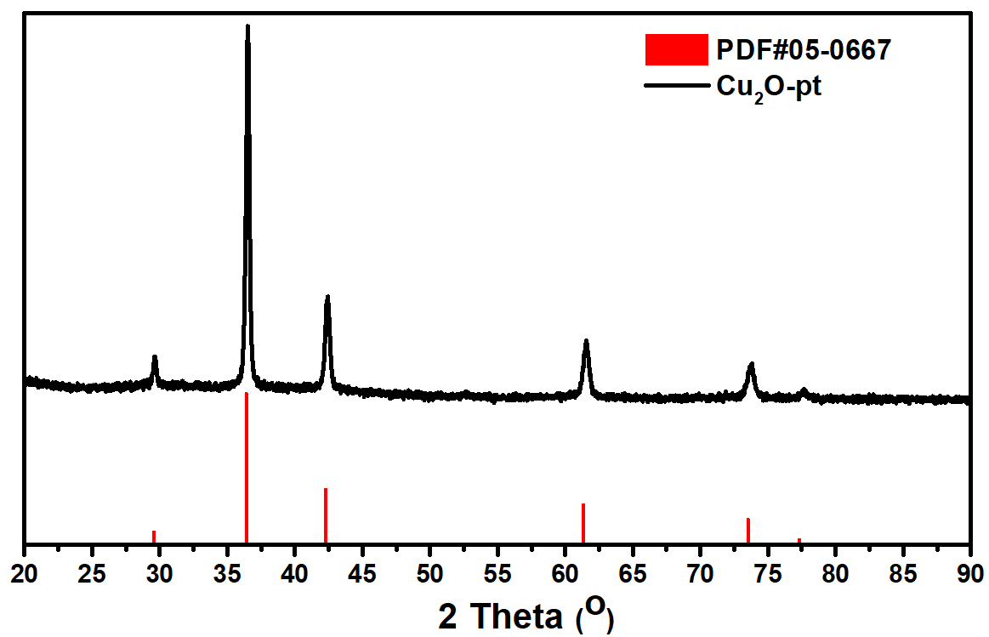
Supplementary Fig. 3 The XRD patterns of Cu₂O-pt.
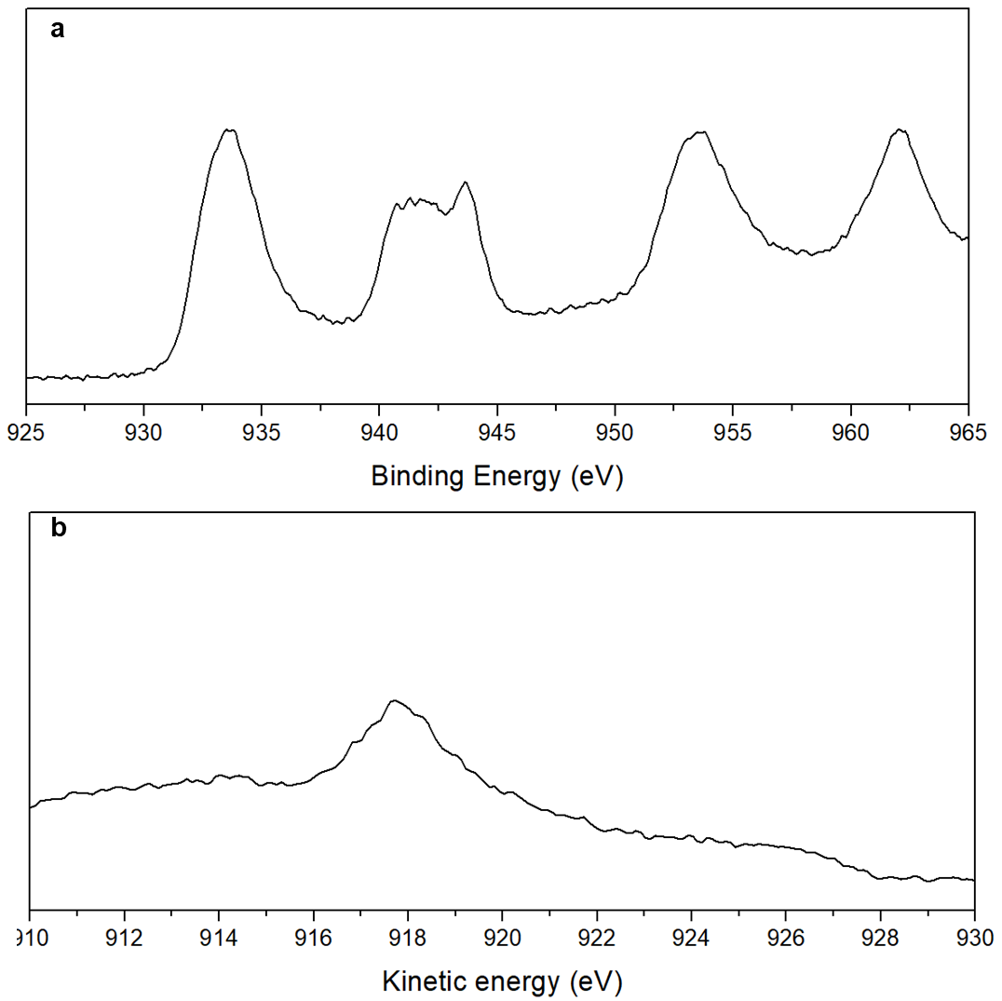
Supplementary Fig. 4 The XPS of CuO-st: (a) the Cu 2p3/2 and 2p1/2 regions, and (b) Cu LMM region.

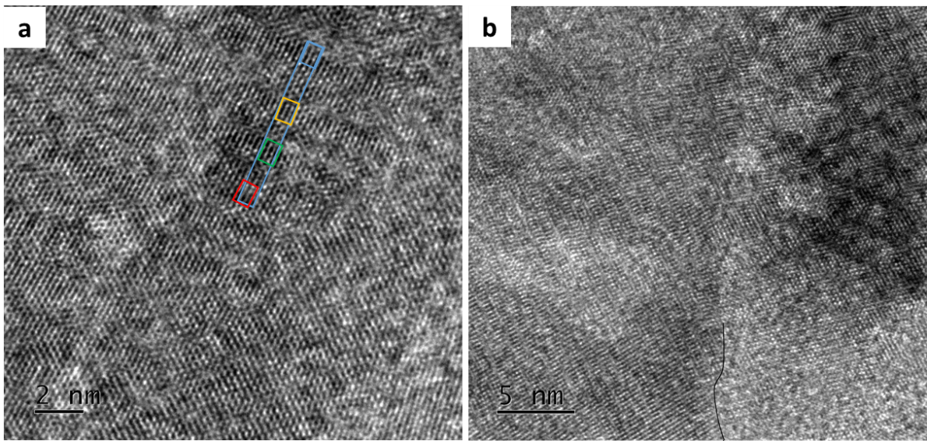
Supplementary Fig. 5 The HR-TEM images of CuO-st.

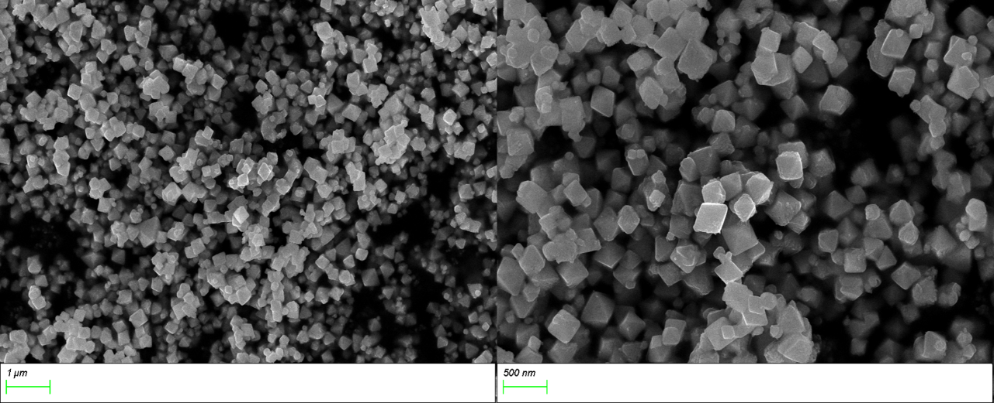
Supplementary Fig. 6 The SEM images of Cu₂O-pt.

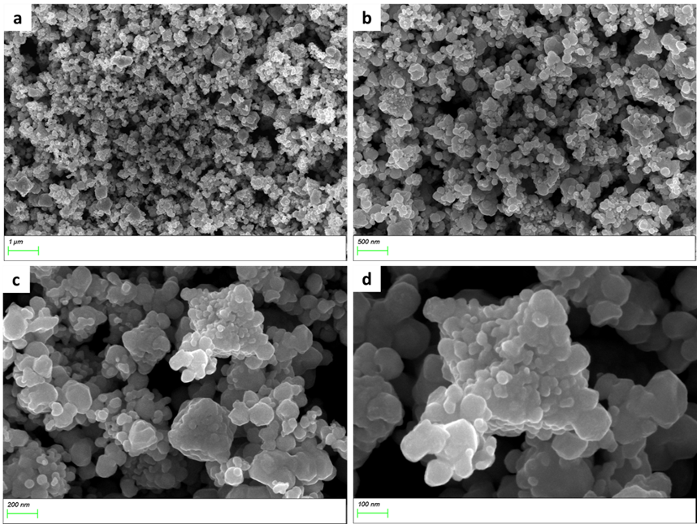
Supplementary Fig. 7 The SEM images of Cu-pt.

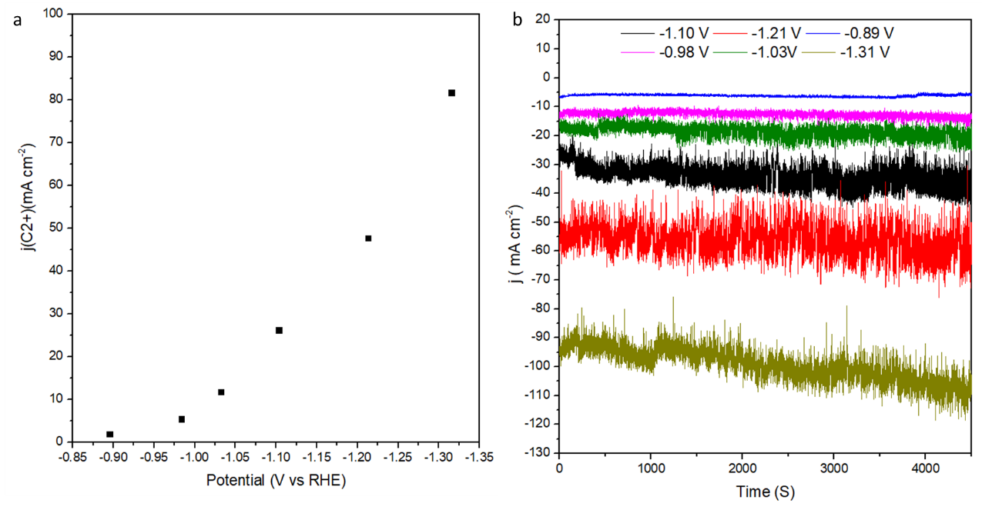
Supplementary Fig. 8 (a) the partial current of C₂₊ products and (b) the i-t curves of CuO-st in H-cell

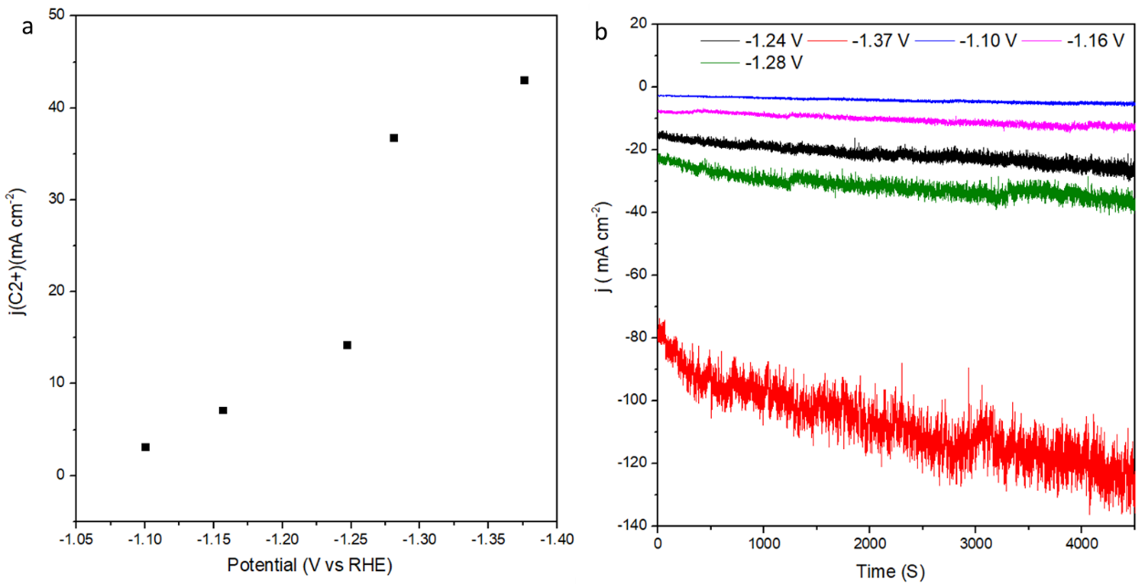
Supplementary Fig. 9 (a) the partial current of C₂₊ products and (b) the i-t curves of Cu₂O-pt in H-cell

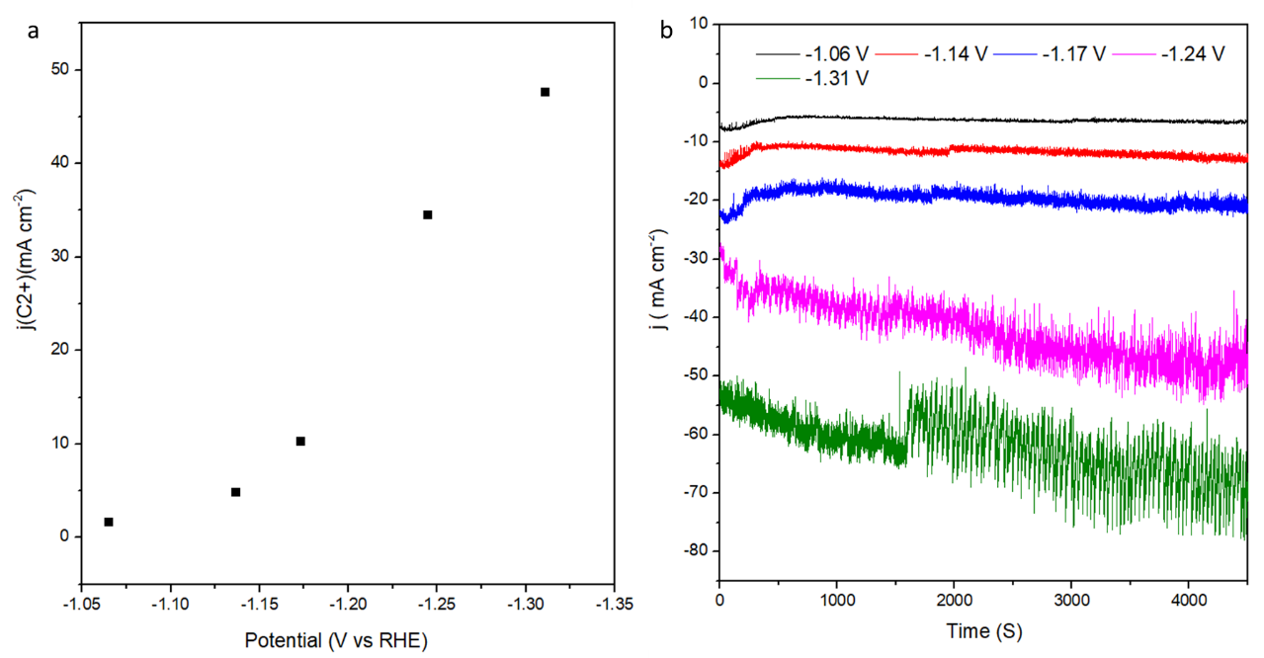

Supplementary Fig. 10 (a) the partial current of C₂₊ products and (b) the i-t curves of Cu-pt in H-cell

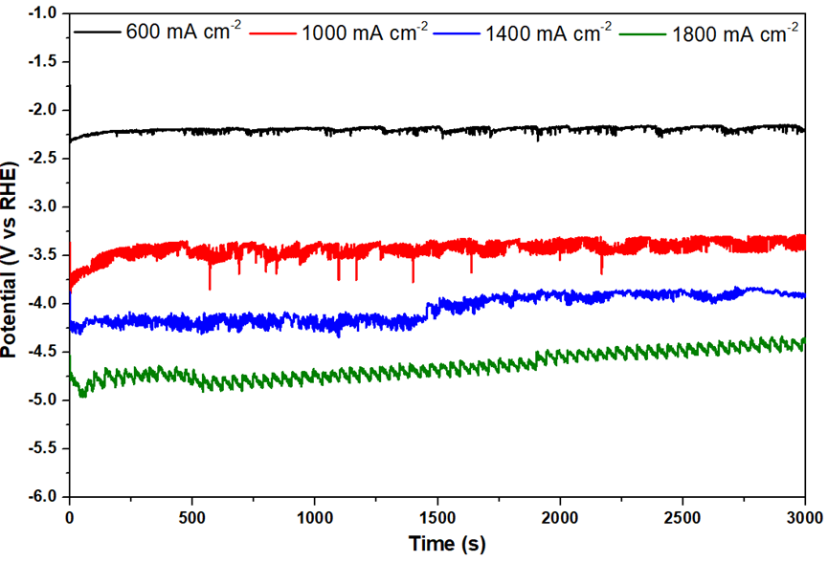
Supplementary Fig. 11 Potential curves (vs RHE, without iR correction) for CuO-st in flow cell over 3000 s of reaction at each given current density in 1 M KCl.

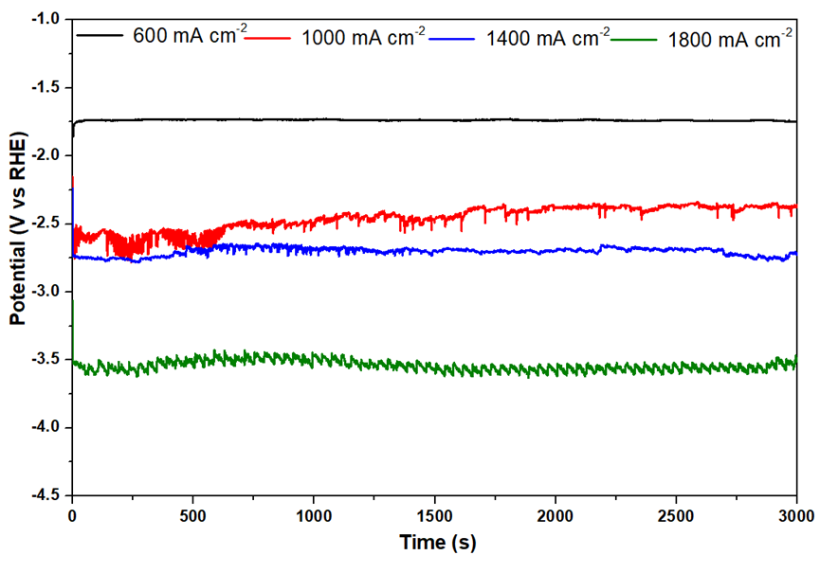
Supplementary Fig. 12 Potential curves (vs RHE, without iR correction) for CuO-st in flow cell over 3000 s of reaction at each given current density in 2 M KCl.

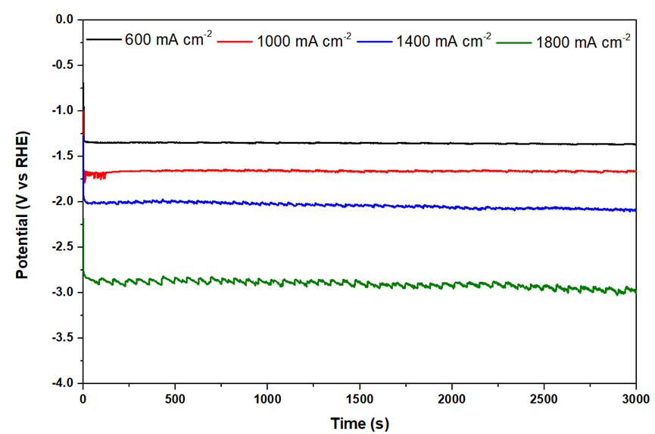
Supplementary Fig. 13 Potential curves (vs RHE, without iR correction) for CuO-st in flow cell over 3000 s of reaction at each given current density in Sa. KCl.

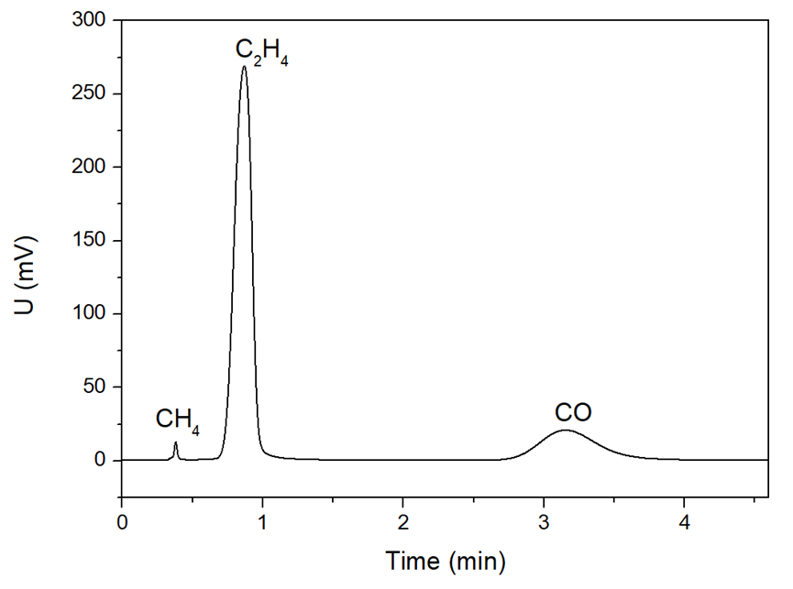
Supplementary Fig. 14 Representative FID spectrum of the gas products in Sa. KCl.

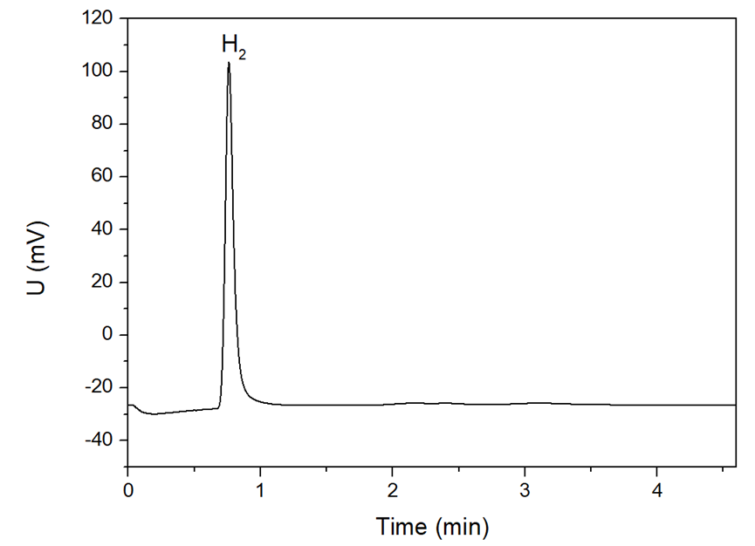
Supplementary Fig. 15 Representative TCD spectrum of the gas product in Sa. KCl.

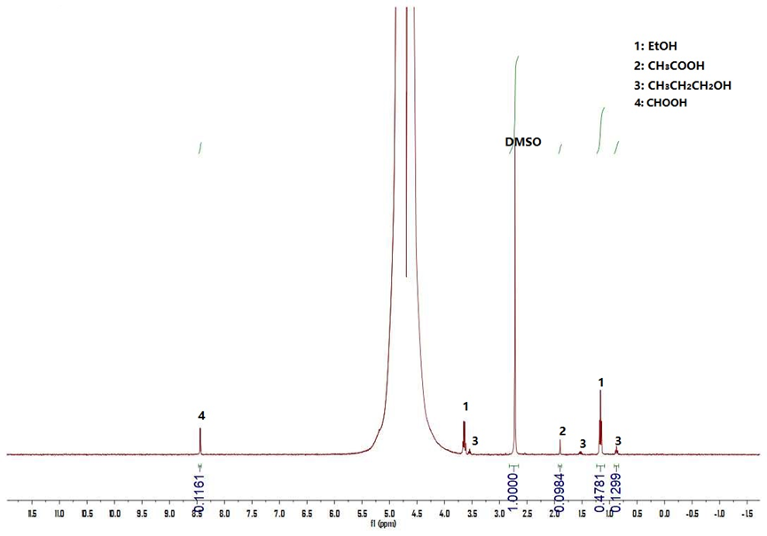
Supplementary Fig. 16 Representative nuclear magnetic resonance (NMR) spectra of the liquid products.

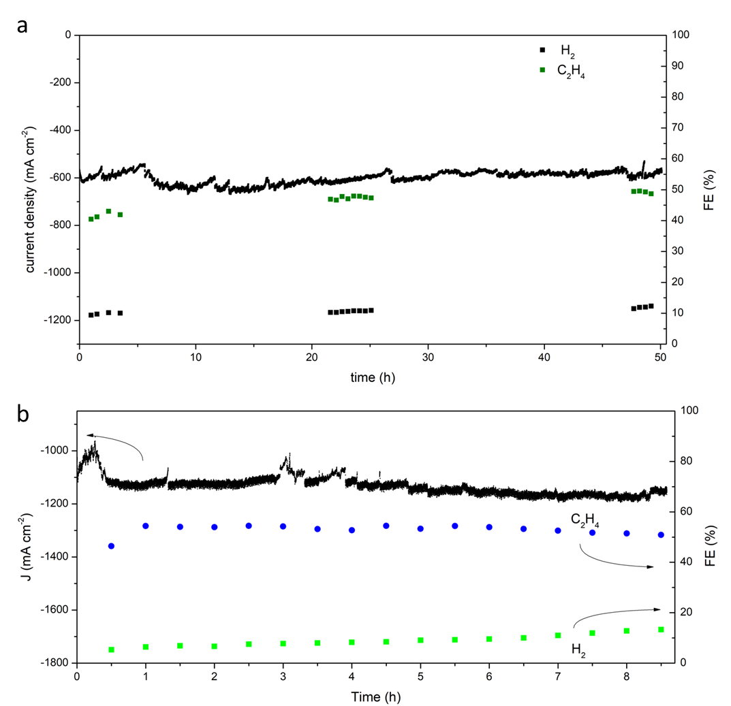
Supplementary Fig. 17 Stability tests of CuO-st in 1 M KCl: a) -0.98 V and b) at -1.29 V (vs RHE, with iR correction)

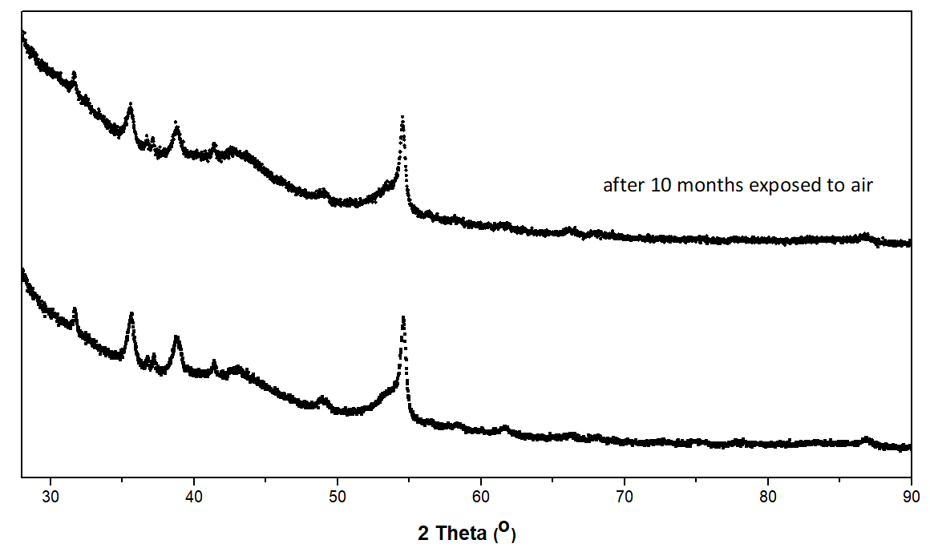

Supplementary Fig. 18 XRD of CuO-st

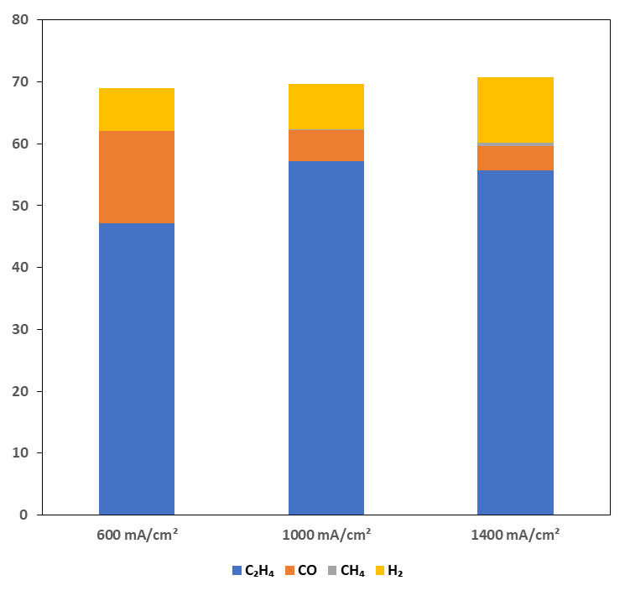
Supplementary Fig. 19 the eCO₂RR performance of the CuO-st exposed to air for more than 10 months in sa. KCl

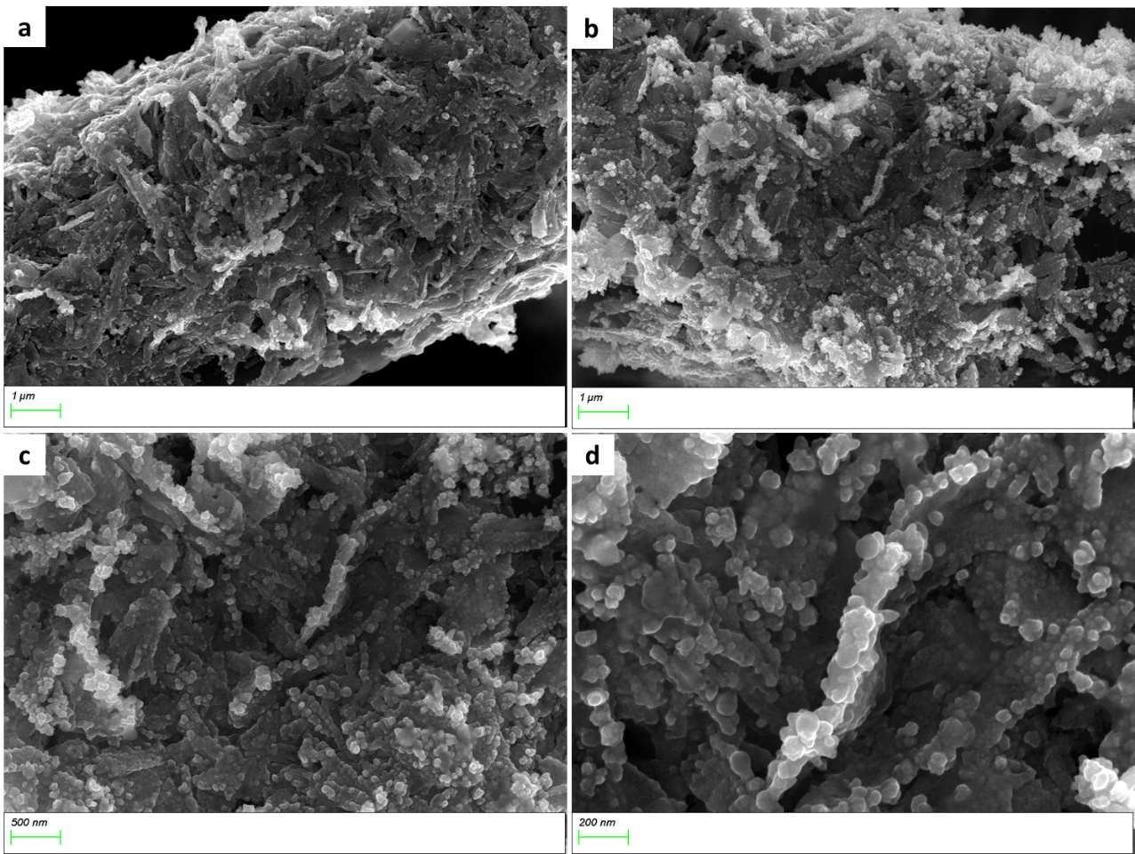
Supplementary Fig. 20 the SEM images of CuO-st after electrolyzing in 0.1 M KCl at -1.21 V (vs RHE) for 4500 s in H-cell

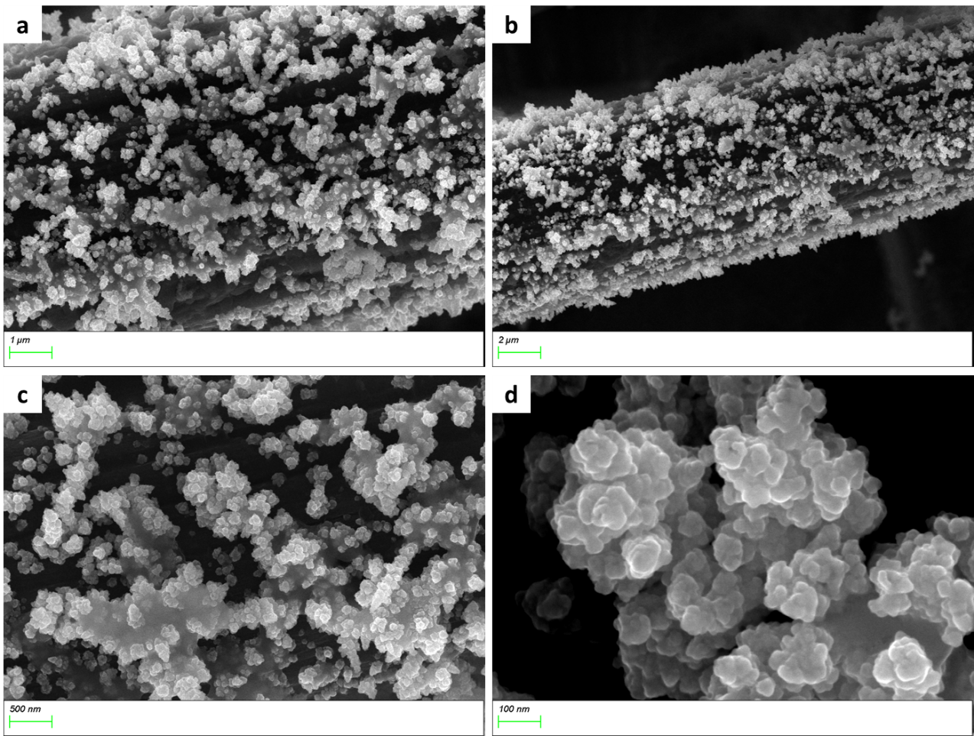
Supplementary Fig. 21 the SEM images of Cu₂O-pt after electrolyzing in 0.1 M KCl at -1.21 V (vs RHE) for 4500 s in H-cell

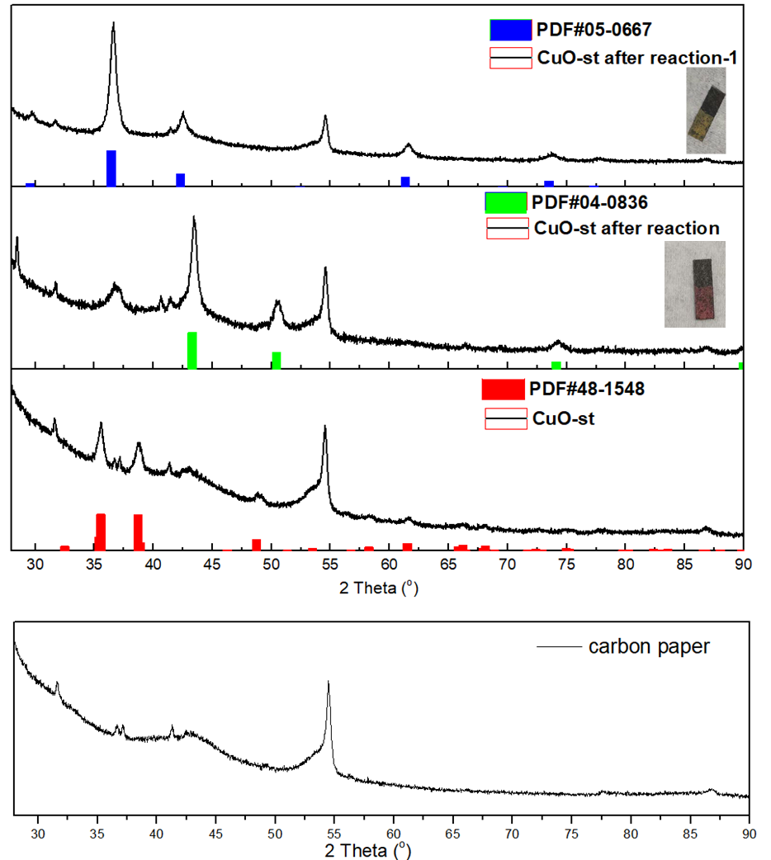
Supplementary Fig. 22 the XRD spectra of the electrodes

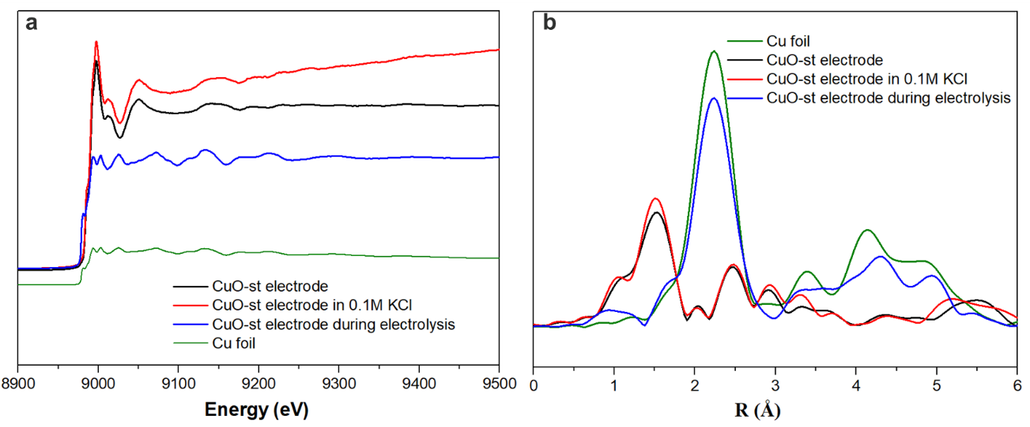

Supplementary Fig. 23 In situ x-ray absorption spectroscopy (XAS) study. The in situ data was recorded after a potential of −1.2 V (vs RHE) applied for 20 mins.

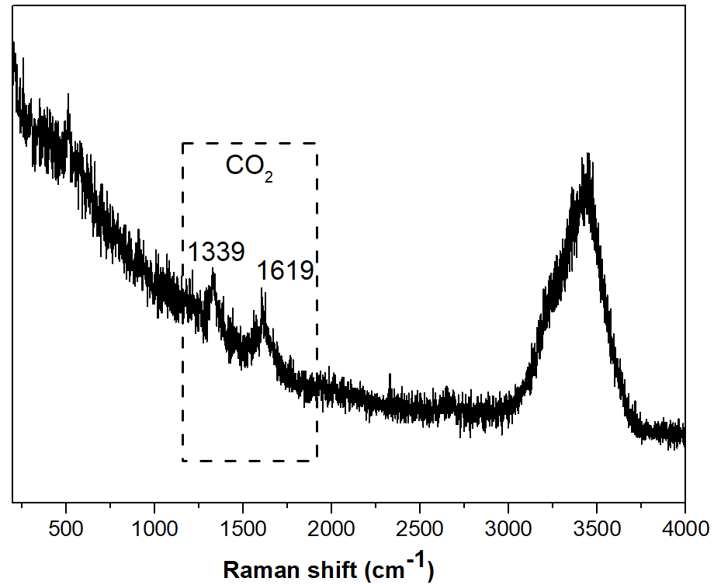

Supplementary Fig. 24 The Raman spectrum recorded at open circuit potential (OCP).

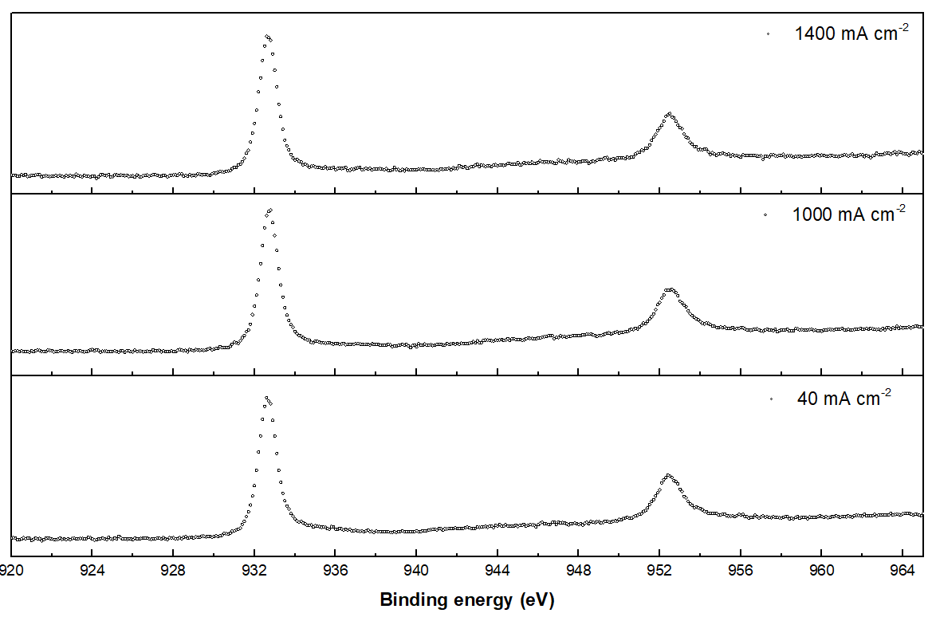
Supplementary Fig. 25 the Cu 2p of the quasi-in situ XPS

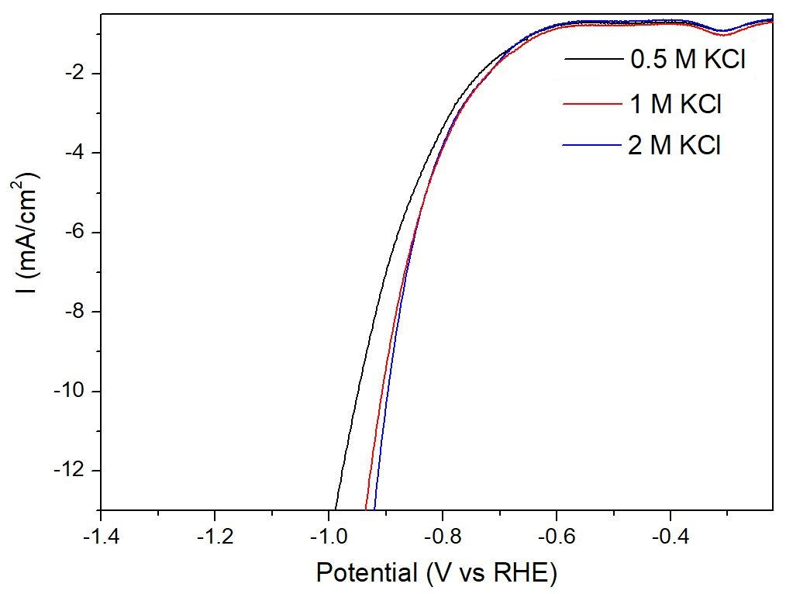
Supplementary Fig. 26 Linear sweep voltammetry (LSV) of CuO-st under Ar at a scan rate of 50 mV s⁻¹

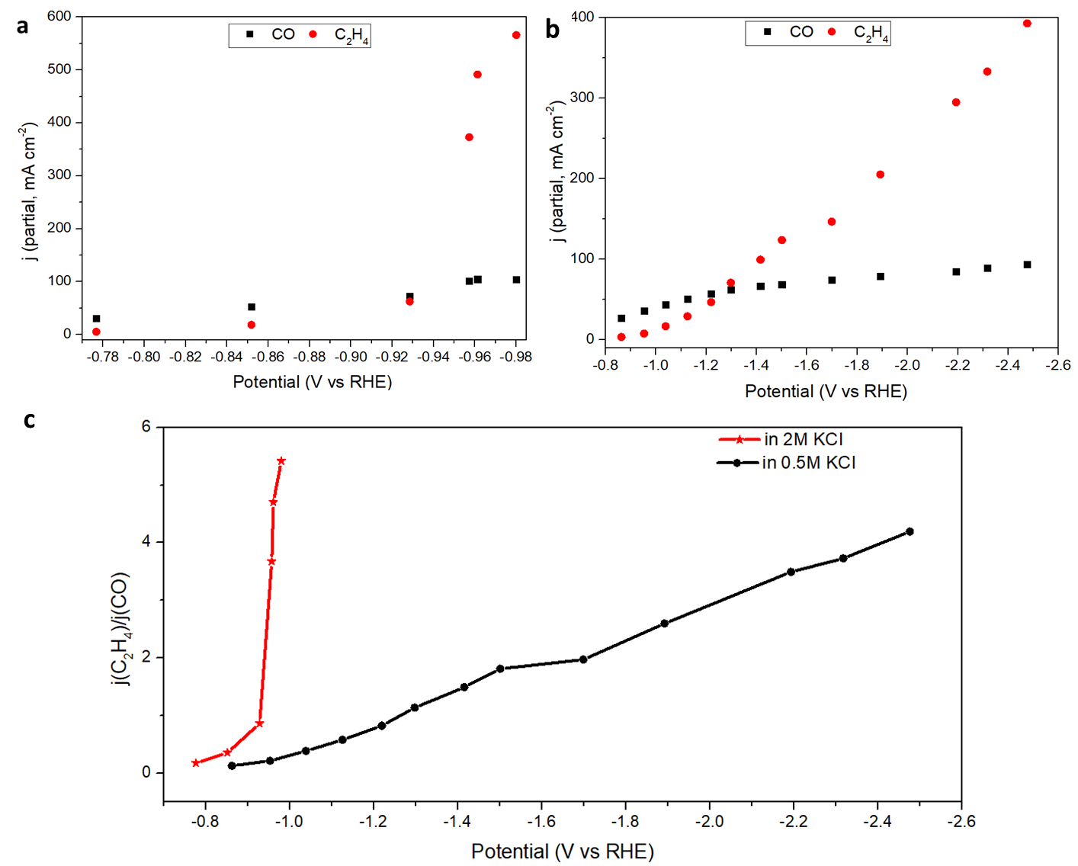

Supplementary Fig. 27 (a) The partial current (j) in 2 M KCl, (b) the partial current (j) in 0.5 M KCl, and (c) the j(C₂H₄)/j(CO) in 2 M KCl (red) and 0.5 M KCl (black). Note: 2 M KCl was used as the anodic electrolyte in the tests

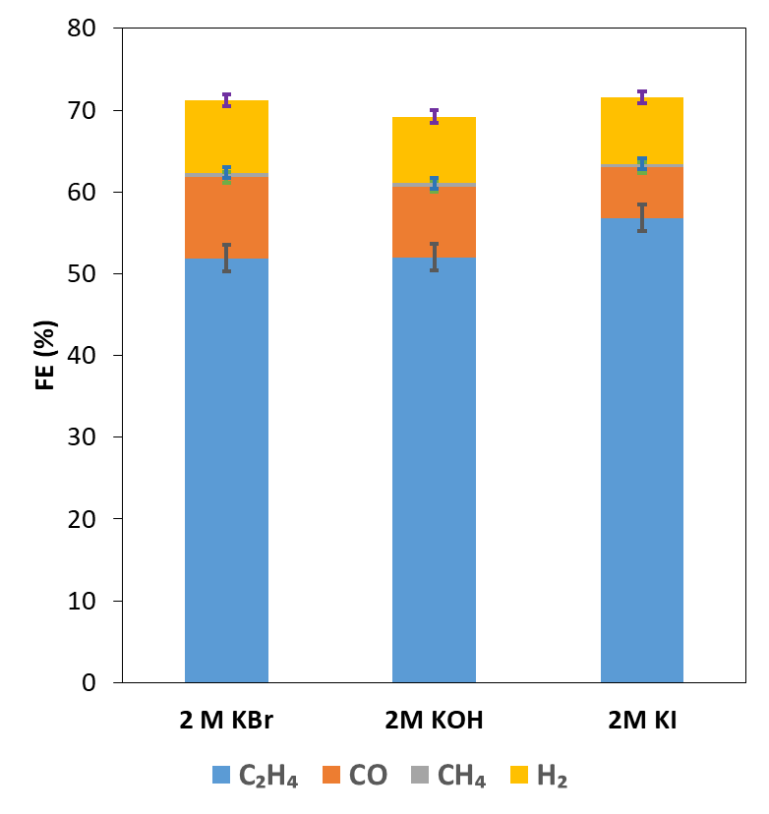
Supplementary Fig. 28 the eCO₂RR performance of CuO-st in 2M KBr, 2M KOH and 2M KI at the current density of 1 A cm⁻¹. Error bars represent the standard deviation from three independent measurements.

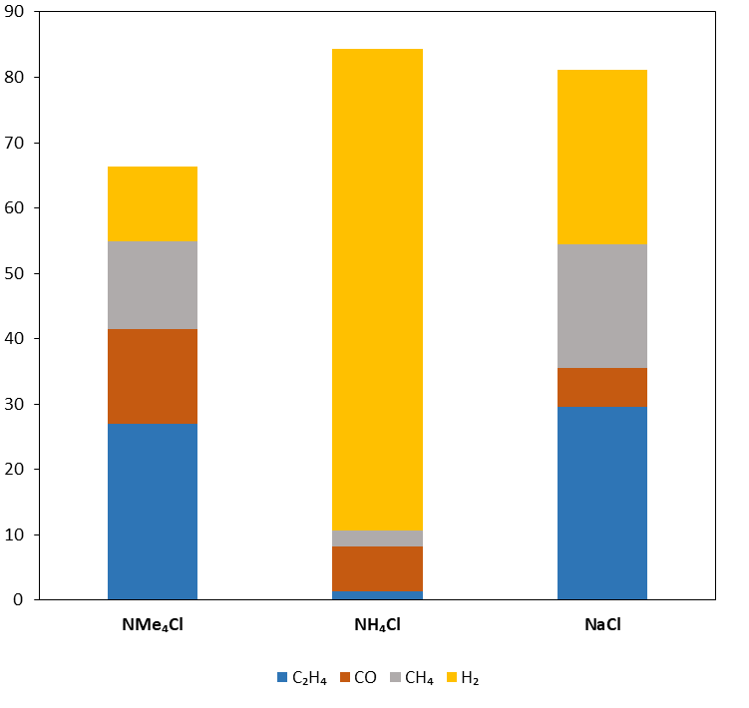
Supplementary Fig. 29 the eCO₂RR performance of CuO-st in 1M NMe₄Cl, 1M KOH and 1M NaCl at the current density of 600 mA cm⁻¹

Supplementary Table 1. The oxygen species in CuO-st obtained by XPS measurements

Oxygen species | Binding energy (eV) | Percentage (%)
lattice oxygen | 529.7 | 63.4
defective oxygen | 531.1 | 30.4
surface hydroxide or chemisorbed oxygen | 532.4 | 6.2

Supplementary Table 2. Summary of CO₂ reduction to C₂₊ products performance on different materials

Materials | Cell type | Electrolyte | FE (%) of C₂₊ | Current density (mA cm⁻²) |  | Reference
B-doped Cu | FLOW CELL | 1 M KOH | 79 |  | -200 | 1
nanoporous Cu | FLOW CELL | 1 M KOH | 68 |  | -653 | 2
Cu nanocubes | FLOW CELL | 1 M KHCO₃ | 59 |  | -300 | 3
Cu-CuI | FLOW CELL | 1 M KOH | 71 |  | -894 | 4
electrodeposited Cu | FLOW CELL | 2M KCl | 81 |  | -150 | 5
hierarchical Cu | FLOW CELL | 1 M KOH | 64 |  | -398 | 6
CuAg alloy | FLOW CELL | 1 M KOH | 85 |  | -300 | 7
electrodeposited copper | MEA | 3 M KOH | 90 |  | -120 | 8
N-modified Cu | FLOW CELL | 1 M KOH | 82 |  | -400 | 9
Cu-CO₂-60 | FLOW CELL | 7 M KOH | 90 |  | -578 | 10
F-Cu | FLOW CELL | 2.5 M KOH | 84 |  | -800 | 11
 |  | 0.75 M KOH | 80 |  | -1600 | 11
polyamine-incorporated Cu | FLOW CELL | 1 M KOH | 90 |  | -433 | 12
25-nm Cu | FLOW CELL | 10 M KOH | 83 |  | -275 | 13
 | FLOW CELL | 3.5 M KOH+ 5 M KI | 80 |  | -750 | 13
CuO-st | FLOW CELL | Sa. KCl | 86 |  | -1000 | This work
 |  |  | 81 |  | -1800 | This work

References

1. Song Y, et al. B-Cu-Zn gas diffusion electrodes for CO₂ electroreduction to C₂₊ products at high current densities. Angew. Chem. Int. Ed. 60, 9135-9141 (2021).
2. v JJ, Jouny M, Luc W, Zhu W, Zhu JJ, Jiao F. A highly porous copper electrocatalyst for carbon dioxide reduction. Adv. Mater. 30, e1803111 (2018).
3. Mçller T, et al. Electrocatalytic CO₂ reduction on CuO_{x} nanocubes: tracking the evolution of chemical state, geometric structure, and catalytic selectivity using operando spectroscopy. Angew. Chem. Int. Ed. 59, 17974-17983 (2020).
4. Li H, et al. High-rate CO₂ electroreduction to C₂₊ products over a copper-copper iodide catalyst. Angew. Chem. Int. Ed. 60, 14329-14333 (2021).
5. Zhang X, et al. Selective and high current CO₂ electro-reduction to multicarbon products in near-neutral KCl electrolytes. J. Am. Chem. Soc. 143, 3245-3255 (2021).
6. Niu ZZ, et al. Hierarchical copper with inherent hydrophobicity mitigates electrode flooding for high-rate CO₂ electroreduction to multicarbon products. J. Am. Chem. Soc. 143, 8011-8021 (2021).
7. Hoang TTH, et al. Nanoporous copper-silver alloys by additive-controlled electrodeposition for the selective electroreduction of CO₂ to ethylene and ethanol. J. Am. Chem. Soc. 140, 5791-5797 (2018).
8. Ozden A, et al. Cascade CO₂ electroreduction enables efficient carbonate-free production of ethylene. Joule 5, 706-719 (2021).
9. Kim JY, et al. Quasi-graphitic carbon shell-induced Cu confinement promotes electrocatalytic CO₂ reduction toward C₂₊ products. Nat. Commun. 12, 3765 (2021).
10. Wang Y, et al. Catalyst synthesis under CO₂ electroreduction favours faceting and promotes renewable fuels electrosynthesis. Nat. Catal. 3, 98-106 (2019).
11. Ma W, et al. Electrocatalytic reduction of CO₂ to ethylene and ethanol through hydrogen-assisted C–C coupling over fluorine-modified copper. Nat. Catal. 3, 478-487 (2020).
12. Chen X, et al. Electrochemical CO₂-to-ethylene conversion on polyamine-incorporated Cu electrodes. Nat. Catal. 4, 20-27 (2020).
13. Dinh C-T, et al. CO₂ electroreduction to ethylene via hydroxide-mediated copper catalysis at an abrupt interface. Science 360, 783 (2018).

