Supporting Materials for
“Unusual Melting Behavior of Nitrogen at Extreme Pressures from Large-Scale Machine-Learned Potential Simulations”
Jie Luo¹, Yuan Ma¹, Chennan Song¹, Yu Xie¹, Hanyu Liu^{1,2,3*}
1Key Laboratory of Material Simulation Methods and Software of Ministry of Education,
College of Physics, Jilin University, Changchun 130012, China
2State Key Laboratory of Superhard Materials, College of Physics, Jilin University, Changchun 130012, China
3International Center of Future Science, Jilin University, Changchun 130012, China

S1. Farthest Point Sampling
To reduce the cost of the subsequent SCAN meta-GGA relabeling, we used Farthest Point Sampling (FPS) to select about 1% of the configurations from the molecular dynamics trajectories as the training set.
We first tested this strategy on δ-N₂ at 80 GPa over 500–3000 K (with an interval of 500 K), which gives a full dataset of 120,000 configurations. We selected 1,200 configurations by FPS to train an MLP, and compared its accuracy on the full dataset with that of an MLP trained on all 120,000 configurations (Fig. S1). The RMSE values are listed in Table S1. The two models show comparable accuracy, which indicates that the FPS-reduced dataset well represents the full dataset.
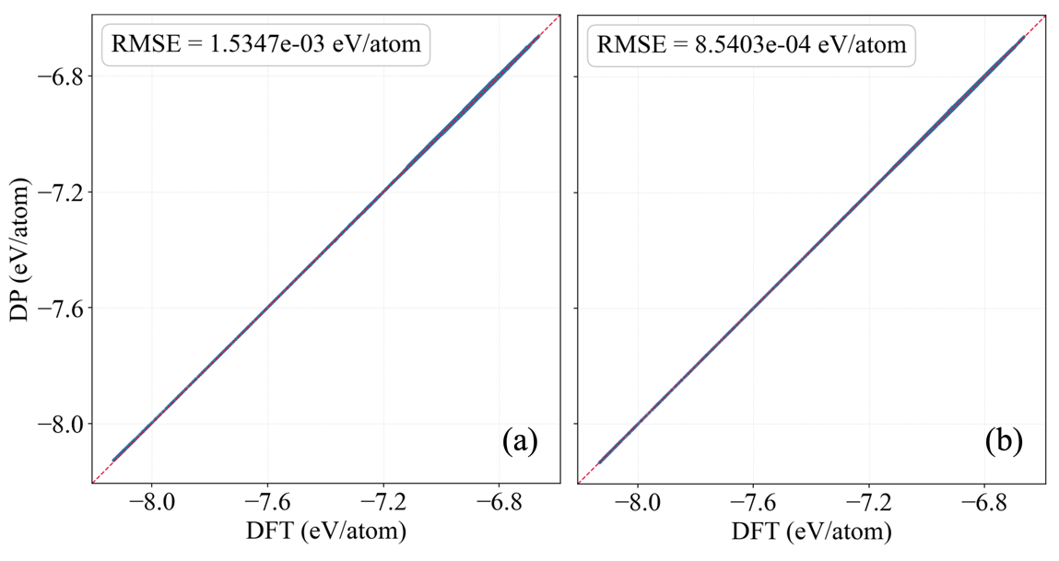
Fig. S1. Energy error of MLPs evaluated on the full dataset (120,000 configurations). (a) MLP trained on the reduced dataset (1,200 configurations). (b) MLP trained on the full dataset (120,000 configurations).
Training set | Energy  (meV/atom) | Forces  (meV/Å) | Virials  (meV/Å)
Reduced (1,200) | 1.53 | 86.32 | 8.08
Full (120,000) | 0.85 | 58.70 | 6.89
Table S1. RMSE of the two MLPs evaluated on the full dataset.
Based on this validation, we applied FPS to reduce the datasets of δ-N₂, ε-N₂, and cg-N over the full pressure range of 20–160 GPa. The reduced data were then relabeled using the SCAN meta-GGA functional. The resulting SCAN-MLP achieves RMSE values of 17.77 meV/atom for energy, 411.67 meV/Å for forces, and 20.62 meV/Å for virials.
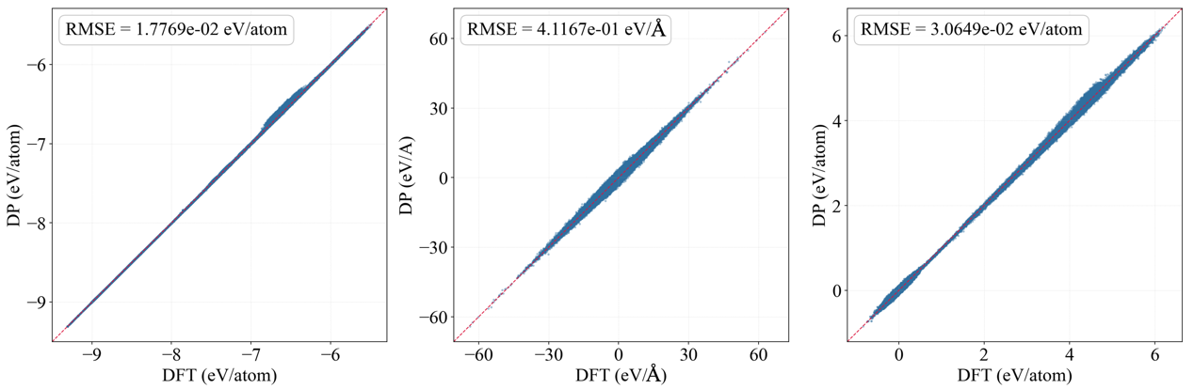
Fig. S2 Root-mean-square errors (RMSE) of the SCAN-MLP with respect to the SCAN DFT reference data, for energies, atomic forces, and virials.

S2. Frequence-dependent reflectivity
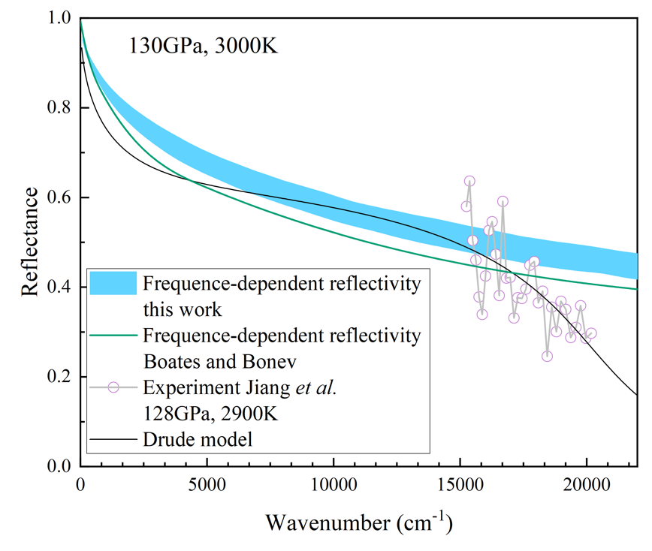
Fig. S3 Frequency-dependent reflectivity. Thick blue line: this work, with line width indicating the standard deviation across multiple configurations from the same MD trajectory. Green line: calculation by Boates and Bonev [36]. Purple open circles: experimental data from Jiang et al. [19]. Black line: Drude-model fit to the experimental data by Jiang et al.

S3. LLPT simulated with a 64-atom system
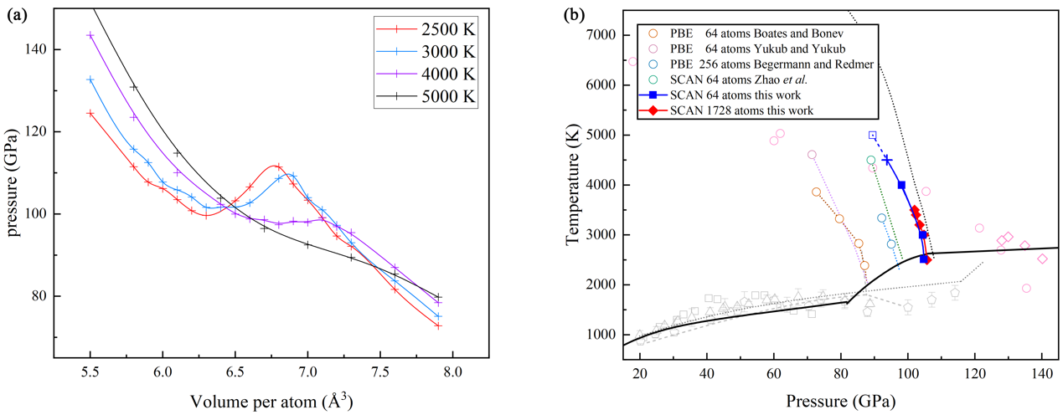
Fig. S4 LLPT simulated with a 64-atom system. (a) Isothermal P–V curves at different temperatures. (b) P–T phase diagram determined from the P–V results.

