Supplementary
List of variables and its sources
Variable Code | Full Name / Description | Source (Dataset) | Resolution | Category
bio1 | Annual Mean Temperature | WorldClim v2 | 1 km | Bioclimatic
bio2 | Mean Diurnal Range | WorldClim v2 | 1 km | Bioclimatic
bio3 | Isothermality | WorldClim v2 | 1 km | Bioclimatic
bio4 | Temperature Seasonality | WorldClim v2 | 1 km | Bioclimatic
bio5 | Max Temperature of Warmest Month | WorldClim v2 | 1 km | Bioclimatic
bio6 | Min Temperature of Coldest Month | WorldClim v2 | 1 km | Bioclimatic
bio7 | Temperature Annual Range | WorldClim v2 | 1 km | Bioclimatic
bio8 | Mean Temperature of Wettest Quarter | WorldClim v2 | 1 km | Bioclimatic
bio9 | Mean Temperature of Driest Quarter | WorldClim v2 | 1 km | Bioclimatic
bio10 | Mean Temperature of Warmest Quarter | WorldClim v2 | 1 km | Bioclimatic
bio11 | Mean Temperature of Coldest Quarter | WorldClim v2 | 1 km | Bioclimatic
bio12 | Annual Precipitation | WorldClim v2 | 1 km | Bioclimatic
bio13 | Precipitation of Wettest Month | WorldClim v2 | 1 km | Bioclimatic
bio14 | Precipitation of Driest Month | WorldClim v2 | 1 km | Bioclimatic
bio15 | Precipitation Seasonality | WorldClim v2 | 1 km | Bioclimatic
bio16 | Precipitation of Wettest Quarter | WorldClim v2 | 1 km | Bioclimatic
bio17 | Precipitation of Driest Quarter | WorldClim v2 | 1 km | Bioclimatic
bio18 | Precipitation of Warmest Quarter | WorldClim v2 | 1 km | Bioclimatic
bio19 | Precipitation of Coldest Quarter | WorldClim v2 | 1 km | Bioclimatic
aspect | Terrain Aspect | SRTM/Derived | 30 m | Topographic
canopy | Forest Canopy Cover | MODIS | 30 m – 1 km | Vegetation
D_PA | Distance to Protected Areas | Custom | 1 km | Conservation
D_Road | Distance to Roads | OpenStreetMap | 1 km | Anthropogenic
D_sett | Distance to Human Settlements | GHSL / Custom | 1 km | Anthropogenic
dsnow | Duration of Snow Cover | MODIS Snow | 500 m–1 km | Climate
elev | Elevation | SRTM | 30 m | Topographic
forest class | Forest Classification | ESA Land Cover / Custom | 100 m | Land Cover
forest cover | Forest Cover Fraction | MODIS | 250 m – 1km km | Land Cover
HMI | Human Modification Index | NASA SEDAC | 1 km | Anthropogenic
LPI | Landscape Pattern Index | Fragstats / Custom | 1 km | Landscape
ndvi | Normalized Difference Vegetation Index | MODIS | 250 m | Vegetation
NL | Nighttime Lights Intensity | VIIRS | 500 m–1 km | Anthropogenic
pop_den | Population Density | WorldPop | 1 km | Socio-environmental
TRI | Terrain Ruggedness Index | Derived from SRTM | 30 m | Topographic
VRM | Vector Ruggedness Measure | Derived from DEM | 30 m | Topographic
water bodies | Distance to Water Bodies | HydroSHEDS / OSM | 1 km | Hydrological

Variable selection
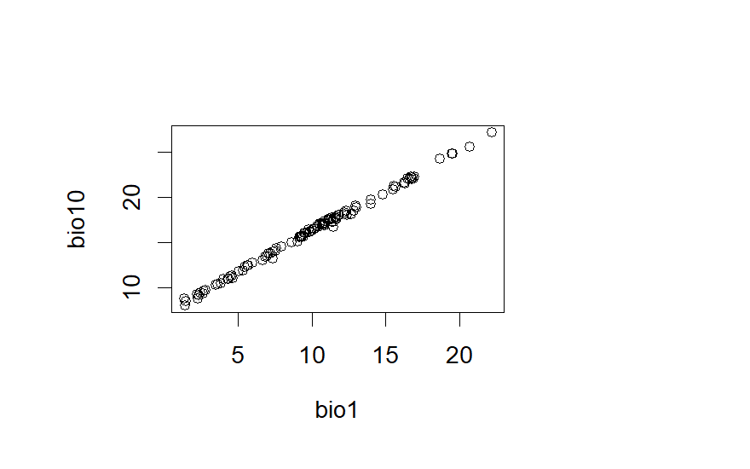
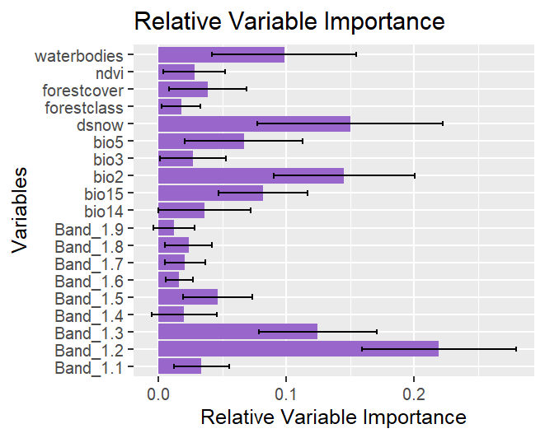Fig: 01 showing the results of variation impact factor

Fig 0.2: Showing the Distribution of Presence points against the variables.

Model performance and selection Table 02.
class : sdmModels
========================================================
number of species : 1
number of modelling methods : 6
names of modelling methods : gam, glm, mars, maxent, brt, rf
replicate. methods (data partitioning): subsampling, cross validation, bootstrap
number of replicates (each method) : 3
toral number of replicates per model: 21 (per species)
test percentage (in subsampling) : 30
------------------------------------------

model run success percentage (per species):
------------------------------------------
method btt
----------------------
gam : 100 %
glm : 100 %
mars : 100 %
maxent : 100 %
brt : 100 %
rf : 100 %

###################################################################
model Mean performance (per species), using test dataset (generated using partitioning):
-------------------------------------------------------------------------------

## species : btt
=========================

methods : AUC | COR | TSS | Deviance
-------------------------------------------------------------------------
gam : 0.87 | 0.6 | 0.65 | 2.12
glm : 0.89 | 0.61 | 0.66 | 0.49
mars : 0.88 | 0.61 | 0.66 | 0.57
maxent : 0.9 | 0.62 | 0.69 | 0.48
brt : 0.91 | 0.67 | 0.68 | 0.48
rf : 0.92 | 0.73 | 0.73 | 0.37

Best Fit model Details
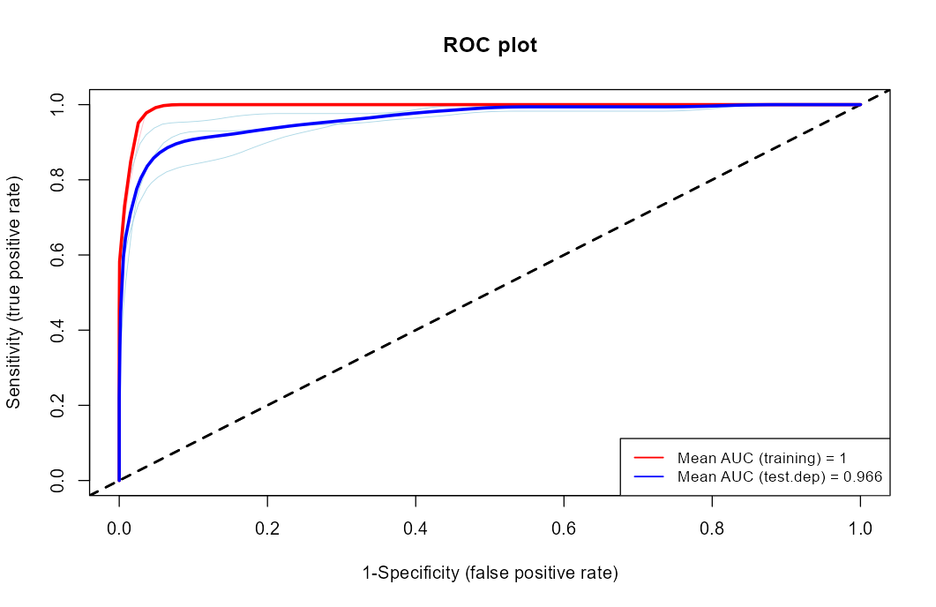
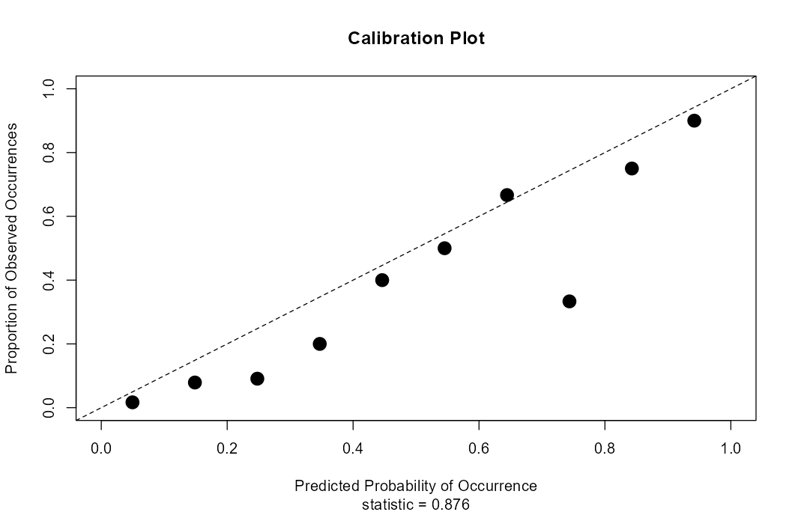

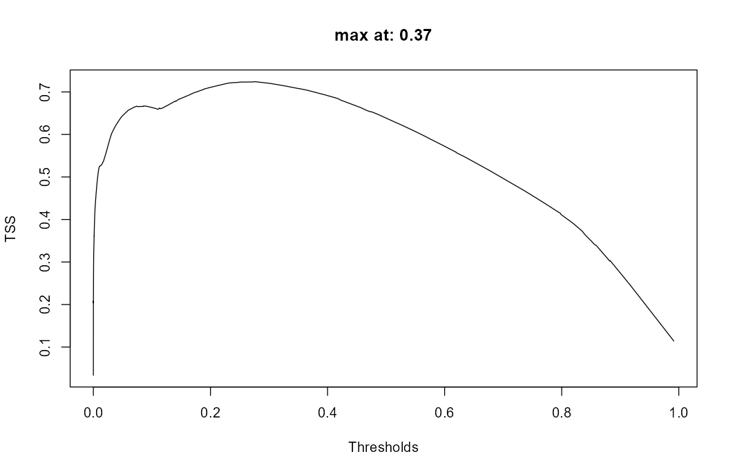

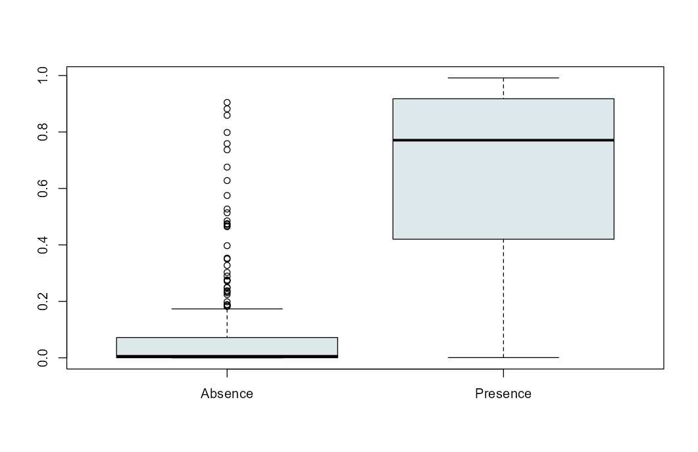
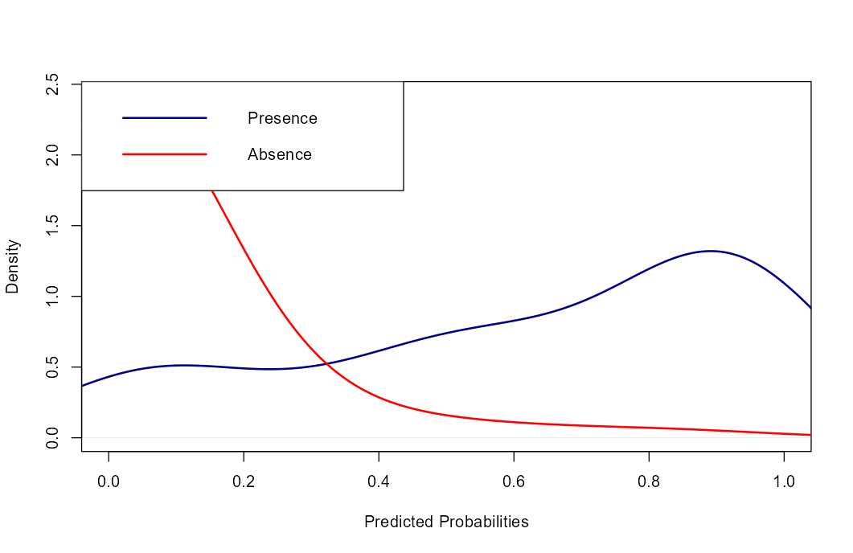

Model Evaluation Table 03:
Sl.no. | modelID | AUC | COR | Deviance | TSS | MCC | F1
1 | 126 | 0.985 | 0.873 | 0.200274 | 0.9385 | 0.9105 | 0.9195
2 | 121 | 0.968 | 0.781 | 0.291193 | 0.84 | 0.6136 | 0.619
3 | 117 | 0.965 | 0.822 | 0.268492 | 0.8069 | 0.7506 | 0.7797
4 | 75 | 0.961 | 0.722 | 0.410972 | 0.8309 | 0.6805 | 0.7042
5 | 124 | 0.96 | 0.827 | 0.288902 | 0.8871 | 0.8252 | 0.848
6 | 96 | 0.959 | 0.821 | 0.378495 | 0.8219 | 0.797 | 0.8214
7 | 76 | 0.955 | 0.687 | 0.422667 | 0.7839 | 0.6365 | 0.6667
8 | 118 | 0.954 | 0.794 | 0.303587 | 0.8169 | 0.7808 | 0.807
9 | 125 | 0.954 | 0.798 | 0.319837 | 0.7929 | 0.7595 | 0.7931
10 | 33 | 0.951 | 0.76 | 0.334149 | 0.7889 | 0.646 | 0.6761
11 | 105 | 0.95 | 0.69 | 0.424679 | 0.7885 | 0.5598 | 0.5674
12 | 100 | 0.949 | 0.703 | 0.434962 | 0.7715 | 0.549 | 0.5618
13 | 97 | 0.948 | 0.749 | 0.434962 | 0.7798 | 0.7562 | 0.7857
14 | 122 | 0.946 | 0.732 | 0.334495 | 0.7362 | 0.5932 | 0.6286
15 | 17 | 0.941 | 0.697 | 0.38249 | 0.7812 | 0.6889 | 0.7213
16 | 95 | 0.939 | 0.726 | 0.452266 | 0.7548 | 0.6847 | 0.7213
17 | 84 | 0.938 | 0.641 | 0.428802 | 0.773 | 0.5566 | 0.5693
18 | 80 | 0.936 | 0.664 | 0.447022 | 0.7596 | 0.5926 | 0.6216
19 | 13 | 0.935 | 0.722 | 0.365464 | 0.7389 | 0.5618 | 0.5926
20 | 34 | 0.934 | 0.684 | 0.378417 | 0.7228 | 0.6724 | 0.7119
21 | 101 | 0.934 | 0.696 | 0.45116 | 0.6962 | 0.5278 | 0.5641
22 | 38 | 0.933 | 0.666 | 0.383397 | 0.7496 | 0.5762 | 0.6053
23 | 123 | 0.933 | 0.714 | 0.363213 | 0.7646 | 0.6011 | 0.6301
24 | 64 | 0.932 | 0.667 | 0.460083 | 0.7302 | 0.5264 | 0.5507
25 | 79 | 0.932 | 0.651 | 0.446459 | 0.6965 | 0.4675 | 0.4808
26 | 106 | 0.932 | 0.74 | 0.353936 | 0.757 | 0.6305 | 0.6667
27 | 12 | 0.929 | 0.711 | 0.398594 | 0.7378 | 0.7155 | 0.75
28 | 1 | 0.927 | 0.699 | 0.402968 | 0.7482 | 0.6879 | 0.7253
29 | 16 | 0.927 | 0.624 | 0.807515 | 0.7046 | 0.5119 | 0.5412
30 | 14 | 0.924 | 0.697 | 0.39761 | 0.7348 | 0.6372 | 0.6769
31 | 55 | 0.923 | 0.687 | 0.393169 | 0.6657 | 0.5968 | 0.6452
32 | 103 | 0.922 | 0.709 | 0.483293 | 0.7632 | 0.6381 | 0.6803
33 | 58 | 0.921 | 0.639 | 0.629039 | 0.6896 | 0.4932 | 0.5227
34 | 120 | 0.92 | 0.724 | 0.377501 | 0.7519 | 0.6211 | 0.6571
35 | 63 | 0.919 | 0.678 | 0.39983 | 0.7921 | 0.6425 | 0.6667
36 | 85 | 0.918 | 0.739 | 0.441952 | 0.6928 | 0.637 | 0.6813
37 | 116 | 0.918 | 0.734 | 0.369464 | 0.7319 | 0.5847 | 0.6216
38 | 18 | 0.916 | 0.625 | 0.419104 | 0.7312 | 0.5842 | 0.6197
39 | 119 | 0.916 | 0.74 | 0.363242 | 0.7498 | 0.6722 | 0.7097
40 | 71 | 0.915 | 0.603 | 0.479085 | 0.7159 | 0.5081 | 0.5319
41 | 104 | 0.915 | 0.668 | 0.525231 | 0.6701 | 0.618 | 0.6721
42 | 82 | 0.914 | 0.689 | 0.4571 | 0.7272 | 0.6543 | 0.7023
43 | 83 | 0.914 | 0.666 | 0.45462 | 0.7109 | 0.6065 | 0.6569
44 | 107 | 0.914 | 0.666 | 0.404887 | 0.678 | 0.4903 | 0.5255
45 | 22 | 0.913 | 0.676 | 0.409612 | 0.6838 | 0.5803 | 0.6275
46 | 24 | 0.912 | 0.673 | 0.421344 | 0.7258 | 0.5355 | 0.5649
47 | 56 | 0.912 | 0.645 | 0.44285 | 0.7389 | 0.5618 | 0.5926
48 | 98 | 0.911 | 0.716 | 0.461416 | 0.7069 | 0.5445 | 0.5823
49 | 74 | 0.908 | 0.611 | 0.487428 | 0.6959 | 0.4859 | 0.5102
50 | 43 | 0.907 | 0.711 | 0.426652 | 0.7249 | 0.6319 | 0.6735
51 | 61 | 0.907 | 0.666 | 0.678197 | 0.7257 | 0.5931 | 0.6405
52 | 87 | 0.907 | 0.69 | 0.475048 | 0.6814 | 0.4943 | 0.5294
53 | 90 | 0.907 | 0.653 | 0.48867 | 0.6898 | 0.5511 | 0.5946
54 | 35 | 0.906 | 0.655 | 0.422801 | 0.7298 | 0.6263 | 0.6667
55 | 77 | 0.906 | 0.631 | 0.506272 | 0.7219 | 0.568 | 0.6053
56 | 25 | 0.904 | 0.636 | 0.440134 | 0.7128 | 0.6466 | 0.6885
57 | 81 | 0.904 | 0.552 | 0.539215 | 0.6981 | 0.4836 | 0.5053
58 | 99 | 0.904 | 0.653 | 0.497147 | 0.6869 | 0.5158 | 0.5542
59 | 108 | 0.904 | 0.725 | 0.385765 | 0.6794 | 0.6053 | 0.6526
60 | 66 | 0.902 | 0.64 | 0.473279 | 0.6924 | 0.4947 | 0.5248
61 | 60 | 0.899 | 0.573 | 0.48938 | 0.6612 | 0.4803 | 0.5176
62 | 59 | 0.897 | 0.661 | 0.440366 | 0.6827 | 0.541 | 0.5833
63 | 4 | 0.896 | 0.64 | 0.466834 | 0.6878 | 0.5902 | 0.6364
64 | 67 | 0.896 | 0.622 | 0.470289 | 0.6848 | 0.5429 | 0.5867
65 | 109 | 0.896 | 0.71 | 0.394701 | 0.7007 | 0.6898 | 0.7273
66 | 37 | 0.895 | 0.608 | 0.534231 | 0.6692 | 0.5595 | 0.6061
67 | 32 | 0.894 | 0.641 | 0.509376 | 0.6957 | 0.6747 | 0.7143
68 | 40 | 0.894 | 0.637 | 0.552456 | 0.685 | 0.5598 | 0.6144
69 | 115 | 0.894 | 0.684 | 0.408788 | 0.7148 | 0.5959 | 0.6377
70 | 92 | 0.893 | 0.616 | 0.507934 | 0.6519 | 0.4713 | 0.5111
71 | 78 | 0.892 | 0.604 | 0.505422 | 0.6387 | 0.5942 | 0.6441
72 | 102 | 0.892 | 0.58 | 0.513944 | 0.6827 | 0.541 | 0.5833
73 | 29 | 0.891 | 0.571 | 0.466117 | 0.6119 | 0.4272 | 0.4694
74 | 41 | 0.89 | 0.598 | 0.561958 | 0.6609 | 0.5408 | 0.5986
75 | 88 | 0.89 | 0.627 | 0.53146 | 0.5846 | 0.5943 | 0.6415
76 | 52 | 0.888 | 0.648 | 0.480895 | 0.7719 | 0.6624 | 0.697
77 | 57 | 0.888 | 0.636 | 0.589138 | 0.6669 | 0.4895 | 0.5287
78 | 65 | 0.888 | 0.571 | 0.515688 | 0.6238 | 0.4809 | 0.5333
79 | 69 | 0.888 | 0.657 | 0.467987 | 0.6628 | 0.5428 | 0.5915
80 | 86 | 0.886 | 0.581 | 0.530228 | 0.6291 | 0.4293 | 0.4625
81 | 62 | 0.884 | 0.598 | 0.6367 | 0.6029 | 0.4624 | 0.5269
82 | 111 | 0.884 | 0.694 | 0.417046 | 0.6807 | 0.6333 | 0.678
83 | 113 | 0.881 | 0.649 | 0.431593 | 0.6307 | 0.5258 | 0.5797
84 | 8 | 0.879 | 0.552 | 0.627694 | 0.5998 | 0.4295 | 0.4783
85 | 39 | 0.879 | 0.545 | 0.490992 | 0.6227 | 0.4549 | 0.5
86 | 53 | 0.879 | 0.595 | 0.509668 | 0.5928 | 0.44 | 0.4941
87 | 23 | 0.877 | 0.585 | 0.549896 | 0.6084 | 0.498 | 0.5556
88 | 42 | 0.875 | 0.56 | 0.449815 | 0.6032 | 0.4865 | 0.5357
89 | 44 | 0.872 | 0.572 | 0.633074 | 0.6107 | 0.5286 | 0.5859
90 | 27 | 0.87 | 0.616 | 0.480082 | 0.6187 | 0.5483 | 0.6032
91 | 94 | 0.87 | 0.632 | 0.499264 | 0.6628 | 0.5428 | 0.5915
92 | 54 | 0.869 | 0.715 | 0.955491 | 0.7198 | 0.6057 | 0.6471
93 | 70 | 0.868 | 0.558 | 0.523024 | 0.5928 | 0.44 | 0.4941
94 | 19 | 0.867 | 0.74 | 4.423653 | 0.7524 | 0.747 | 0.7826
95 | 73 | 0.867 | 0.611 | 0.52659 | 0.6528 | 0.5257 | 0.5753
96 | 45 | 0.866 | 0.586 | 0.618122 | 0.6614 | 0.4711 | 0.507
97 | 2 | 0.865 | 0.568 | 0.892356 | 0.6305 | 0.4904 | 0.5424
98 | 50 | 0.864 | 0.523 | 0.596147 | 0.6198 | 0.4526 | 0.5
99 | 28 | 0.863 | 0.526 | 0.53012 | 0.603 | 0.3941 | 0.416
100 | 49 | 0.863 | 0.574 | 0.524197 | 0.6078 | 0.4592 | 0.5122
101 | 36 | 0.861 | 0.591 | 0.50392 | 0.6557 | 0.5747 | 0.625
102 | 46 | 0.861 | 0.621 | 0.526237 | 0.6498 | 0.491 | 0.5366
103 | 110 | 0.86 | 0.643 | 0.473839 | 0.6287 | 0.5703 | 0.623
104 | 10 | 0.859 | 0.598 | 0.637323 | 0.6769 | 0.5024 | 0.5412
105 | 31 | 0.857 | 0.59 | 0.506012 | 0.5837 | 0.4822 | 0.5429
106 | 15 | 0.855 | 0.577 | 0.618721 | 0.5937 | 0.4996 | 0.5588
107 | 20 | 0.853 | 0.662 | 5.310073 | 0.7057 | 0.6715 | 0.7179
108 | 112 | 0.853 | 0.623 | 0.477416 | 0.5676 | 0.6341 | 0.6667
109 | 72 | 0.851 | 0.483 | 0.571894 | 0.5687 | 0.458 | 0.5205
110 | 30 | 0.849 | 0.451 | 0.704762 | 0.5898 | 0.4186 | 0.4681
111 | 91 | 0.849 | 0.618 | 0.519703 | 0.5546 | 0.516 | 0.5763
112 | 5 | 0.847 | 0.514 | 0.578033 | 0.5548 | 0.3832 | 0.4356
113 | 93 | 0.847 | 0.595 | 0.535223 | 0.5276 | 0.5116 | 0.5714
114 | 3 | 0.844 | 0.565 | 1.464792 | 0.6073 | 0.5222 | 0.58
115 | 114 | 0.841 | 0.608 | 0.499214 | 0.5446 | 0.4941 | 0.5574
116 | 6 | 0.839 | 0.572 | 0.849223 | 0.6017 | 0.5672 | 0.6207
117 | 26 | 0.838 | 0.506 | 0.577716 | 0.5396 | 0.4837 | 0.5484
118 | 9 | 0.837 | 0.475 | 0.870728 | 0.5357 | 0.3912 | 0.4545
119 | 68 | 0.836 | 0.488 | 0.571578 | 0.5146 | 0.4373 | 0.5075
120 | 48 | 0.833 | 0.61 | 0.548573 | 0.6348 | 0.4712 | 0.5176
121 | 89 | 0.827 | 0.55 | 0.553814 | 0.518 | 0.3354 | 0.3662
122 | 21 | 0.825 | 0.647 | 4.578279 | 0.6754 | 0.6617 | 0.6977
123 | 51 | 0.818 | 0.5 | 0.71172 | 0.5269 | 0.3501 | 0.4
124 | 47 | 0.795 | 0.423 | 0.746791 | 0.4737 | 0.3392 | 0.413
125 | 11 | 0.736 | 0.368 | 9.124507 | 0.4535 | 0.4535 | 0.5185
126 | 7 | 0.713 | 0.366 | 10.90353 | 0.4356 | 0.3738 | 0.4545

Model generation Table 04

Sl no. | Models generated
1 | id_1__sp_btt__m_gam__re_subs | id_2__sp_btt__m_gam__re_subs | id_3__sp_btt__m_gam__re_subs
4 | id_4__sp_btt__m_gam__re_cros | id_5__sp_btt__m_gam__re_cros | id_6__sp_btt__m_gam__re_cros
7 | id_7__sp_btt__m_gam__re_cros | id_8__sp_btt__m_gam__re_cros | id_9__sp_btt__m_gam__re_cros
10 | id_10__sp_btt__m_gam__re_cros | id_11__sp_btt__m_gam__re_cros | id_12__sp_btt__m_gam__re_cros
13 | id_13__sp_btt__m_gam__re_cros | id_14__sp_btt__m_gam__re_cros | id_15__sp_btt__m_gam__re_cros
16 | id_16__sp_btt__m_gam__re_cros | id_17__sp_btt__m_gam__re_cros | id_18__sp_btt__m_gam__re_cros
19 | id_19__sp_btt__m_gam__re_boot | id_20__sp_btt__m_gam__re_boot | id_21__sp_btt__m_gam__re_boot
22 | id_22__sp_btt__m_glm__re_subs | id_23__sp_btt__m_glm__re_subs | id_24__sp_btt__m_glm__re_subs
25 | id_25__sp_btt__m_glm__re_cros | id_26__sp_btt__m_glm__re_cros | id_27__sp_btt__m_glm__re_cros
28 | id_28__sp_btt__m_glm__re_cros | id_29__sp_btt__m_glm__re_cros | id_30__sp_btt__m_glm__re_cros
31 | id_31__sp_btt__m_glm__re_cros | id_32__sp_btt__m_glm__re_cros | id_33__sp_btt__m_glm__re_cros
34 | id_34__sp_btt__m_glm__re_cros | id_35__sp_btt__m_glm__re_cros | id_36__sp_btt__m_glm__re_cros
37 | id_37__sp_btt__m_glm__re_cros | id_38__sp_btt__m_glm__re_cros | id_39__sp_btt__m_glm__re_cros
40 | id_40__sp_btt__m_glm__re_boot | id_41__sp_btt__m_glm__re_boot | id_42__sp_btt__m_glm__re_boot
43 | id_43__sp_btt__m_mars__re_subs | id_44__sp_btt__m_mars__re_subs | id_45__sp_btt__m_mars__re_subs
46 | id_46__sp_btt__m_mars__re_cros | id_47__sp_btt__m_mars__re_cros | id_48__sp_btt__m_mars__re_cros
49 | id_49__sp_btt__m_mars__re_cros | id_50__sp_btt__m_mars__re_cros | id_51__sp_btt__m_mars__re_cros
52 | id_52__sp_btt__m_mars__re_cros | id_53__sp_btt__m_mars__re_cros | id_54__sp_btt__m_mars__re_cros
55 | id_55__sp_btt__m_mars__re_cros | id_56__sp_btt__m_mars__re_cros | id_57__sp_btt__m_mars__re_cros
58 | id_58__sp_btt__m_mars__re_cros | id_59__sp_btt__m_mars__re_cros | id_60__sp_btt__m_mars__re_cros
61 | id_61__sp_btt__m_mars__re_boot | id_62__sp_btt__m_mars__re_boot | id_63__sp_btt__m_mars__re_boot
64 | id_64__sp_btt__m_maxent__re_subs | id_65__sp_btt__m_maxent__re_subs | id_66__sp_btt__m_maxent__re_subs
67 | id_67__sp_btt__m_maxent__re_cros | id_68__sp_btt__m_maxent__re_cros | id_69__sp_btt__m_maxent__re_cros
70 | id_70__sp_btt__m_maxent__re_cros | id_71__sp_btt__m_maxent__re_cros | id_72__sp_btt__m_maxent__re_cros
73 | id_73__sp_btt__m_maxent__re_cros | id_74__sp_btt__m_maxent__re_cros | id_75__sp_btt__m_maxent__re_cros
76 | id_76__sp_btt__m_maxent__re_cros | id_77__sp_btt__m_maxent__re_cros | id_78__sp_btt__m_maxent__re_cros
79 | id_79__sp_btt__m_maxent__re_cros | id_80__sp_btt__m_maxent__re_cros | id_81__sp_btt__m_maxent__re_cros
82 | id_82__sp_btt__m_maxent__re_boot | id_83__sp_btt__m_maxent__re_boot | id_84__sp_btt__m_maxent__re_boot
85 | id_85__sp_btt__m_brt__re_subs | id_86__sp_btt__m_brt__re_subs | id_87__sp_btt__m_brt__re_subs
88 | id_88__sp_btt__m_brt__re_cros | id_89__sp_btt__m_brt__re_cros | id_90__sp_btt__m_brt__re_cros
91 | id_91__sp_btt__m_brt__re_cros | id_92__sp_btt__m_brt__re_cros | id_93__sp_btt__m_brt__re_cros
94 | id_94__sp_btt__m_brt__re_cros | id_95__sp_btt__m_brt__re_cros | id_96__sp_btt__m_brt__re_cros
97 | id_97__sp_btt__m_brt__re_cros | id_98__sp_btt__m_brt__re_cros | id_99__sp_btt__m_brt__re_cros
100 | id_100__sp_btt__m_brt__re_cros | id_101__sp_btt__m_brt__re_cros | id_102__sp_btt__m_brt__re_cros
103 | id_103__sp_btt__m_brt__re_boot | id_104__sp_btt__m_brt__re_boot | id_105__sp_btt__m_brt__re_boot
106 | id_106__sp_btt__m_rf__re_subs | id_107__sp_btt__m_rf__re_subs | id_108__sp_btt__m_rf__re_subs
109 | id_109__sp_btt__m_rf__re_cros | id_110__sp_btt__m_rf__re_cros | id_111__sp_btt__m_rf__re_cros
112 | id_112__sp_btt__m_rf__re_cros | id_113__sp_btt__m_rf__re_cros | id_114__sp_btt__m_rf__re_cros
115 | id_115__sp_btt__m_rf__re_cros | id_116__sp_btt__m_rf__re_cros | id_117__sp_btt__m_rf__re_cros
118 | id_118__sp_btt__m_rf__re_cros | id_119__sp_btt__m_rf__re_cros | id_120__sp_btt__m_rf__re_cros
121 | id_121__sp_btt__m_rf__re_cros | id_122__sp_btt__m_rf__re_cros | id_123__sp_btt__m_rf__re_cros
124 | id_124__sp_btt__m_rf__re_boot | id_125__sp_btt__m_rf__re_boot | id_126__sp_btt__m_rf__re_boot

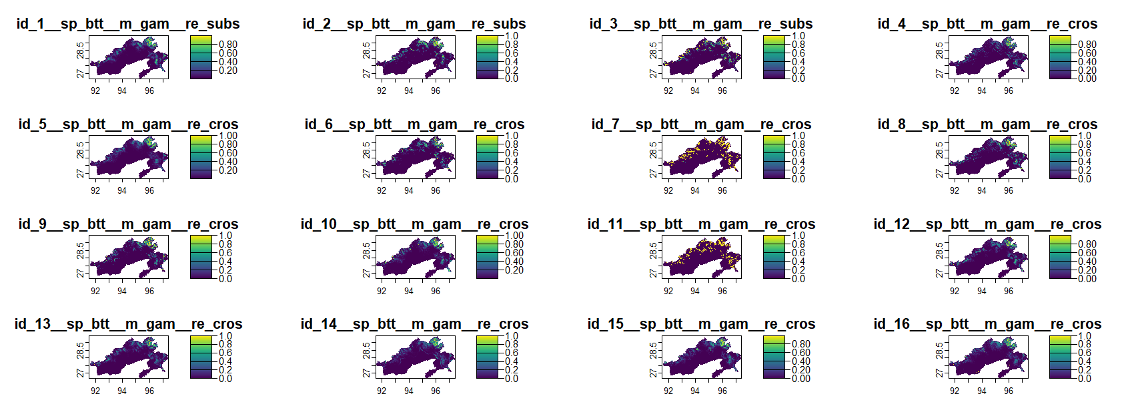

Future  Scenario | loss_  km² | gain_  km² | stable_  presence  _km² | stable_  absence  _km² | Loss  pct | Gain  pct | net_  change  pct | stable_  presence  pct | net_  change  km²
ssp126.2021 | 0.53 | 4.32 | 42.73 | 48.53 | 1.23 | 9.99 | 8.76 | 98.77 | 3.79
ssp245.2021 | 0.37 | 5.28 | 42.89 | 47.57 | 0.86 | 12.2 | 11.34 | 99.14 | 4.91
ssp370.2021 | 1.23 | 2.52 | 42.03 | 50.33 | 2.85 | 5.82 | 2.97 | 97.15 | 1.28
ssp585.2021 | 1.89 | 1.99 | 41.37 | 50.86 | 4.37 | 4.6 | 0.23 | 95.63 | 0.1
ssp126.2041 | 2.39 | 1.21 | 40.87 | 51.64 | 5.52 | 2.8 | -2.72 | 94.48 | -1.18
ssp245.2041 | 3.5 | 1.2 | 39.76 | 51.65 | 8.09 | 2.78 | -5.31 | 91.91 | -2.3
ssp370.2041 | 1.59 | 3.33 | 41.67 | 49.52 | 3.67 | 7.69 | 4.02 | 96.33 | 1.74
ssp585.2041 | 0.62 | 4.87 | 42.64 | 47.98 | 1.44 | 11.25 | 9.81 | 98.56 | 4.24
ssp126.2061 | 3.74 | 0.75 | 39.52 | 52.1 | 8.65 | 1.74 | -6.91 | 91.35 | -2.99
ssp245.2061 | 1.82 | 2.95 | 41.44 | 49.9 | 4.2 | 6.82 | 2.62 | 95.8 | 1.13
ssp370.2061 | 1.11 | 4.83 | 42.15 | 48.02 | 2.56 | 11.16 | 8.6 | 97.44 | 3.72
ssp585.2061 | 0.32 | 7.57 | 42.95 | 45.28 | 0.73 | 17.51 | 16.78 | 99.27 | 7.26
ssp126.2081 | 1.72 | 0.98 | 41.54 | 51.87 | 3.98 | 2.27 | -1.71 | 96.02 | -0.74
ssp245.2081 | 3.49 | 1.41 | 39.78 | 51.44 | 8.06 | 3.25 | -4.81 | 91.94 | -2.08
ssp370.2081 | 0.99 | 5.27 | 42.27 | 47.58 | 2.29 | 12.18 | 9.89 | 97.71 | 4.28
ssp585.2081 | 0.52 | 7.18 | 42.74 | 45.67 | 1.2 | 16.59 | 15.39 | 98.8 | 6.66
Table. 04: Habitat changes over the different ssp scenarios for different time period.

