Supplementary Materials

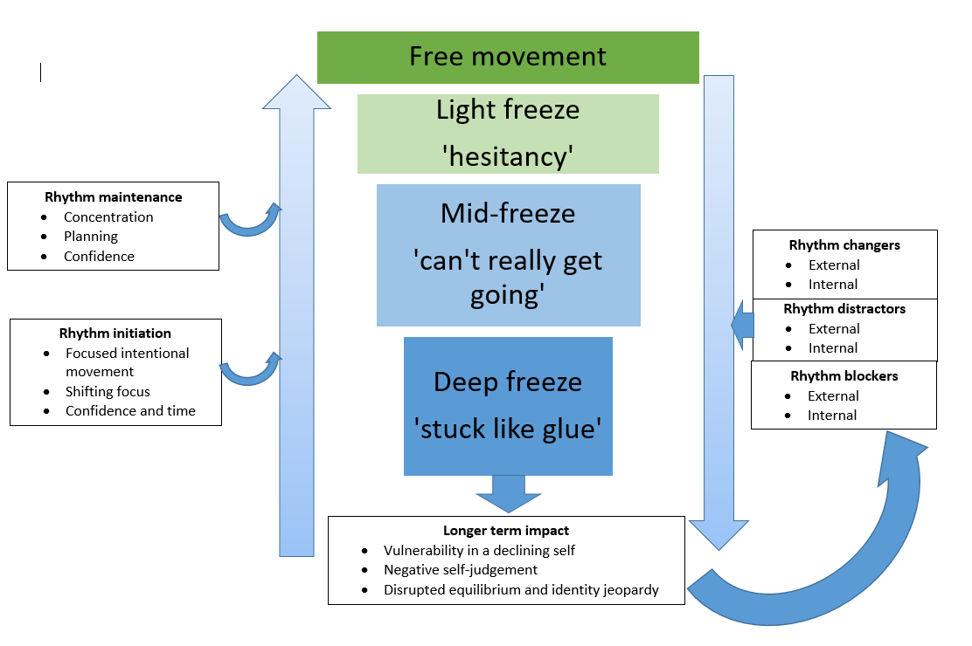 Supplementary materials A. Original conceptual model delivered from Phase 1.

Supplementary materials B. ‘The quartet’: a metaphor for the attempted maintenance, loss and regeneration of one’s sense of rhythm
This metaphor starts with the notion of automaticity; most quartets play without a conductor and must therefore anticipate the timings of their fellow players to ensure synchrony and an overall sense of rhythm. Next, the metaphor is expanded to highlight that different musicians represent key functions of brain regions: i) cognition: the conscious awareness of thoughts, feelings and decisions; ii) motor function: sending blueprints for movement to the muscles; iii) sensory function: integrating information from the various senses and forming perceptions and experiences of movement; and iv) emotional function: controlling the state of tension and arousal. When mid-way through playing a piece, musicians are already engaged in an ongoing rhythm, if one player makes an error in their timing, one of two scenarios can emerge. First, other players could start to follow the emergent errors thereby compromising the overall sense of rhythm in the group. Alternatively, the overall sense of rhythm within the group will be sufficient to maintain the beat, thereby allowing the errant player to correct their error(s) (i.e., update their predictions of the required temporal structure) and re-enter the main rhythm of the group (Rhythm Maintenance). This scenario represents cyclical gait where there are several potential sources of movement error caused by mistimed/placed movements, environmental changes (Rhythm Changers), as well as unhelpful thoughts and bodily sensations (Rhythm Distractors). Here, a central focus on maintaining an overall sense of rhythm between the ‘musicians’ is deemed critical. Translating this musical metaphor to gait initiation demonstrates the relative difficulty many people experience in establishing a new rhythm. Within a quartet there must be a prompt that specifies the onset of what will become the shared sense of rhythm. The concept of Rhythm Initiators reflects a requirement for an explicit temporal pattern to be generated before an attempt to execute the first step. In the quartet, uncertainty about when other players will start is likely to compromise any sense of rhythm experienced by a given player and is often countered by someone taking the lead and counting down. This sense of uncertainty received widespread support through our PPIE process (Figure 1) as it reflects both the unease of the situation and the efforts required to get all the necessary systems working together to solve, even if temporarily, the ‘puzzle of freezing’. Difficulties in aligning these systems are represented by Rhythm Blockers. In the quartet, these difficulties might necessitate the inclusion of a conductor. Rhythm Maintainers and initiators also provide a temporal structure to follow. When successful compensations are put in place and all parts work together in synchrony (temporal) and harmony (used here as a metaphor for spatial accuracy), there can be a sense of accomplishment and beauty; described by one individual with PD as a “magic moment of movement”. In music, this sense of rhythm is often known as ‘groove’ or being ‘locked in’. In broader contexts this is known as a ‘flow’ state reflecting an active engagement and enjoyment of one’s sense of rhythm. It is noteworthy that people who experience FOG described the necessity to achieve this sense of focussed engagement in order to successfully solve the puzzle of FOG and carry out these actions that would otherwise be routine.

