Coordination-Sphere Perturbations Partition Catalytic Bias Control in a Thermostable [FeFe]-Hydrogenase

Yuanming Wangª, Weisong Liu^{a,b}, Zepeng Kangª, Jiajun Liu^{a,b}, Jingxin Li^{c}, Lu Yu^{c}, Lingling Zhang^{a,b*}, Zhiguang Zhu^{a,b*}

ª State Key Laboratory of Engineering Biology for Low-carbon Manufacturing, Tianjin Institute of Industrial Biotechnology, 32 West 7th Avenue, Tianjin Airport Economic Area, Chinese Academy of Sciences, Tianjin, 300308, China
^{b} University of Chinese Academy of Sciences, 19A Yuquan Road, Shijingshan District, Beijing 100049, China
^{c} Anhui Key Laboratory of Low-Energy Quantum Materials and Devices, High Magnetic Field Laboratory, HFIPS, Chinese Academy of Sciences, Hefei, Anhui 230031, China

*Corresponding author. E-mail address: zhangll@tib.cas.cn, zhu_zg@tib.cas.cn

Figure S1. Amino acid alignment of TkHydA2 and AwHydA2. The similar residues are highlighted in red.

Figure S2. SDS-PAGE of TkHydA2 and AwHydA2.

Figure S3. H₂ oxidation (A, BV-mediated) and H₂ evolution (B, MV-mediated) activity of TkHydA2 at different temperatures.
Figure S4. H₂ evolution (black bar, MV-mediated) and H₂ oxidation (red bar, BV-mediated) activity of TkHydA2 and R20E at 50 ºC.

Figure S5. Comparison of the electrochemical behavior at the indicated pH values for wild type and the variants. A modified GC-WMCNTs electrode was used for hydrogenases. All the electrochemical experiments were performed at 25 ºC, rotation speed ω = 2500 rpm, scan rate ν = 10 mV s⁻¹, under 1 bar H₂.

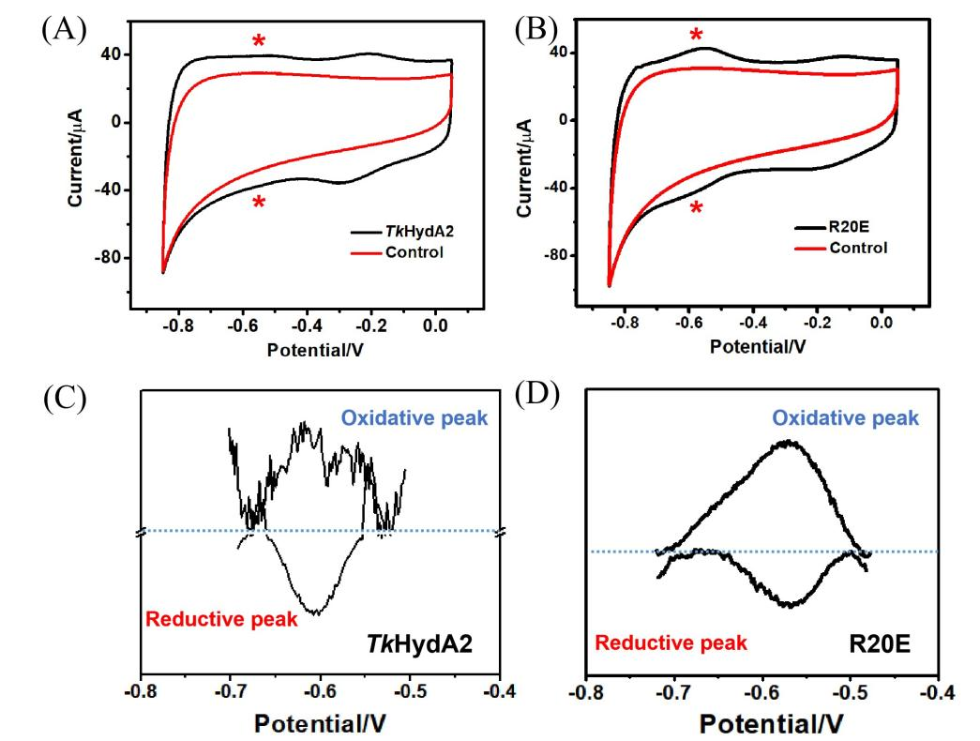
Figure S6. Comparison of cyclic voltammograms of modified ITO-CF electrode (Black lines) and unmodified ITO-CF electrode as the control experiments (Red lines) for TkHydA2 (A) and R20E (B). The asterisks denote the positions of the peaks. Other conditions: electrochemical experiments were performed at 25 ºC at a scan rate ν = 5 mV s⁻¹ under N₂ atmosphere, PBS buffer pH 7, 0.1 M NaCl. (C and D) The corresponding SWV curves of TkHydA2 (C) and R20E (D). PBS buffer pH 7, 0.1 M NaCl at N₂ atmosphere, 25 ºC, SWV frequency 1 Hz, amplitude 20 mV, step 2 mV. The non-turnover signals were analyzed after baseline correction.
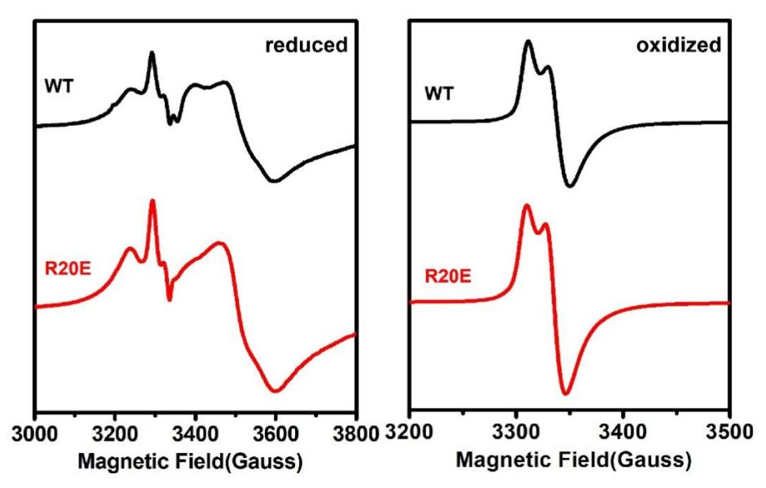
Figure S7. EPR spectroscopy of 5 mM dithionite-reduced TkHydA2 variant and wild type (left) and 5 mM ferricyanide-oxidized TkHydA2 variant R20E and wild type (right). X-band EPR spectra were collected at a frequency of 9.38 GHz, 1 mW microwave power, 15 K sample temperature (±0.2 K), a modulation frequency of 100 kHz, and a modulation amplitude of 5.0 G.

Figure S8. Electrocatalytic profiles of TkHydA2 and variants C55H Cyclic voltammograms at different pH values. Cyclic voltammograms were scanned between OCP and ± 0.2 V. Conditions: Rotation speed ω = 2500 rpm, scan rate ν = 10 mV s⁻¹, under 1 bar H₂. A modified GC-multiwalled carbon nanotube electrode was used for hydrogenases.

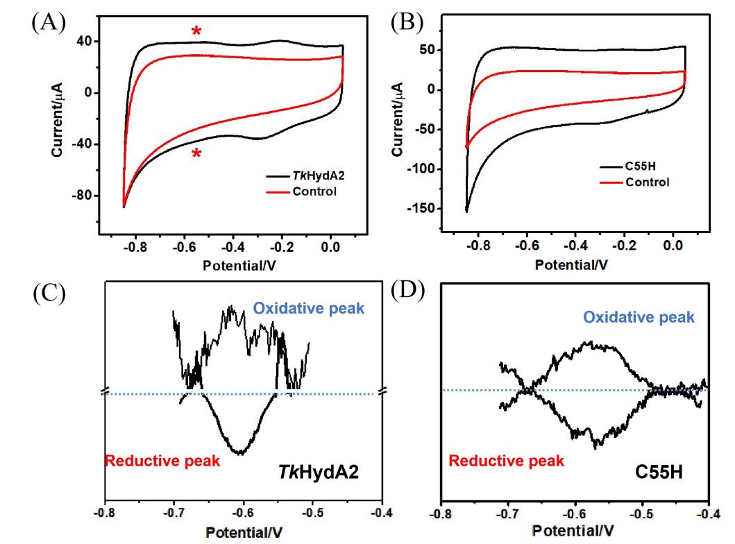
Figure S9. Comparison of cyclic voltammograms of modified ITO-CF electrode (Black lines) and unmodified ITO-CF electrode as the control experiments (Red lines) for TkHydA2 (A) and C55H (B). The asterisks denote the positions of the peaks and no distinct peaks were observed for C55H. Other conditions: electrochemical experiments were performed at 25 ºC at a scan rate ν = 5 mV s⁻¹ under N₂ atmosphere, PBS buffer pH 7, 0.1 M NaCl. (C and D) The corresponding SWV curves of TkHydA2 (C) and C55H (D). PBS buffer pH 7, 0.1 M NaCl at N₂ atmosphere, 25 ºC, SWV frequency 1 Hz, amplitude 20 mV, step 2 mV. The non-turnover signals were analyzed after baseline correction.

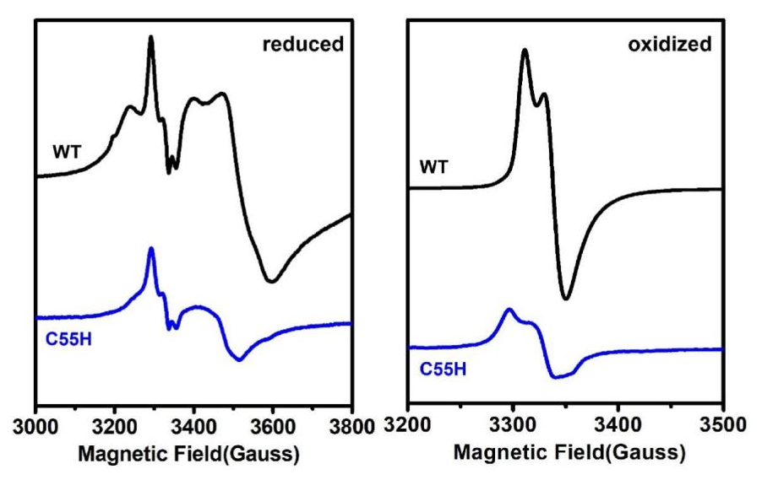
Figure S10. EPR spectroscopy of 5 mM dithionite-reduced TkHydA2 variant and wild type (left) and 5 mM ferricyanide-oxidized TkHydA2 variant C55H and wild type (right). X-band EPR spectra were collected at a frequency of 9.38 GHz, 1 mW microwave power, 15 K sample temperature (±0.2 K), a modulation frequency of 100 kHz, and a modulation amplitude of 5.0 G.

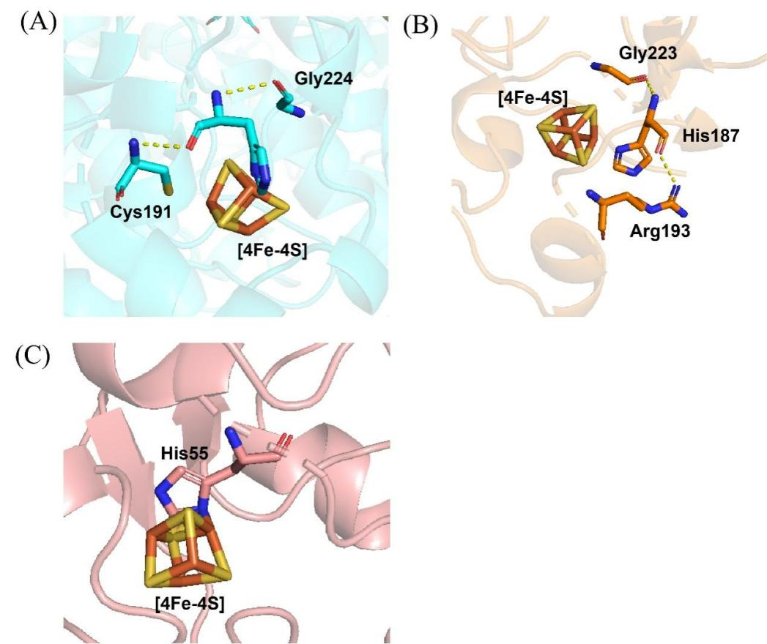
Figure S11. Comparison of the hydrogen-bond network around His residues in TkHydA2 variant C55H and those in [NiFe]-hydrogenases from Allochromatium vinosum (1H2A) (A) and D. vulgaris Miyazaki F (3MYR) (B).(C) TkHydA2 variant C55H.

Figure S12. Cyclic voltammograms of TkHydA2 (A) and the variants C55H (B) and R20E (C) obtained at different temperatures. Cyclic voltammograms were scanned between OCP and ± 0.2 V at pH 7.0. Conditions: Rotation speed ω = 2500 rpm, scan rate ν = 10 mV s⁻¹, under 1 bar H₂. A modified GC-multiwalled carbon nanotube electrode was used for hydrogenases. The data have been normalized to correct for film loss. Vertical dotted lines show the potentials at which the data were taken.
Figure S13. Eyring plots for H⁺ reduction and H₂ oxidation of TkHydA2 (A, B) and the variants C55H (C, D) and R20E (E, F) at different temperatures.

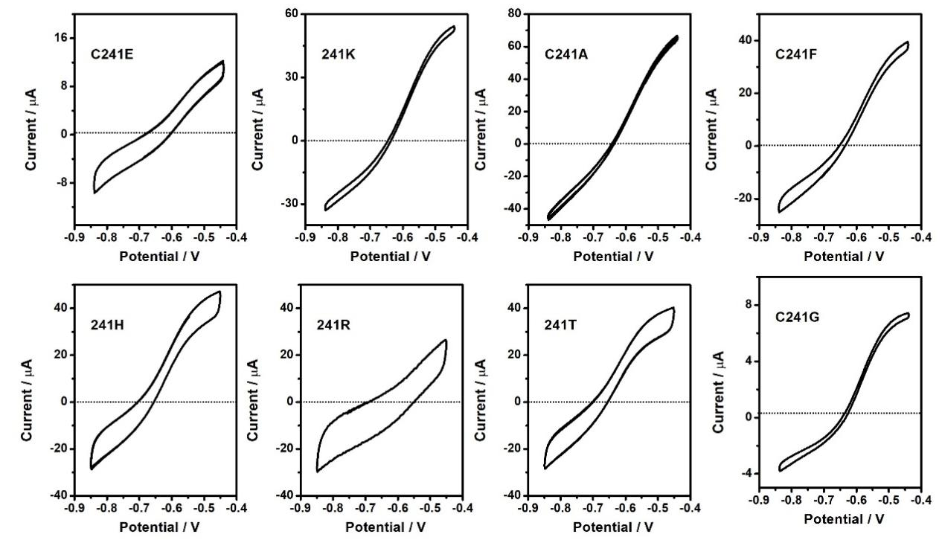
Figure S14. Electrocatalytic profiles of saturation mutagenesis at position C241. The bias of the variants shown above is consistent with that of the wild type. The variants not shown exhibit low enzymatic activity. Conditions: PBS pH 7.0, rotation speed ω = 2500 rpm, scan rate ν = 10 mV s⁻¹, under 100% H₂. A modified GC-multiwalled carbon nanotube electrode was used for hydrogenases.

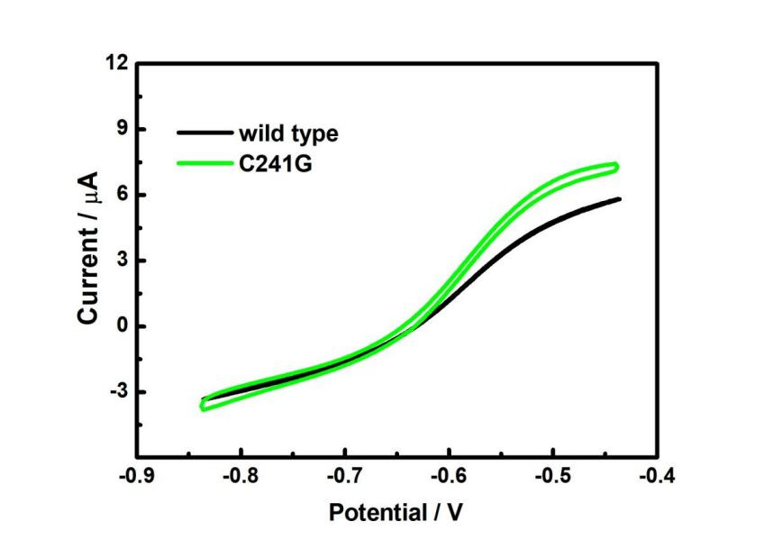
Figure S15. Cyclic voltammograms of TkHydA2 and the variants C241G. Cyclic voltammograms were scanned between OCP ± 0.2 V at a scan rate of 10 mV s⁻¹. Other conditions: 1 bar 100% H₂, PBS buffer pH 7.0 at 25 °C, with the rotating speed of ω = 2500 rpm. A modified GC-WMCNTs electrode was used for hydrogenases adsorption.

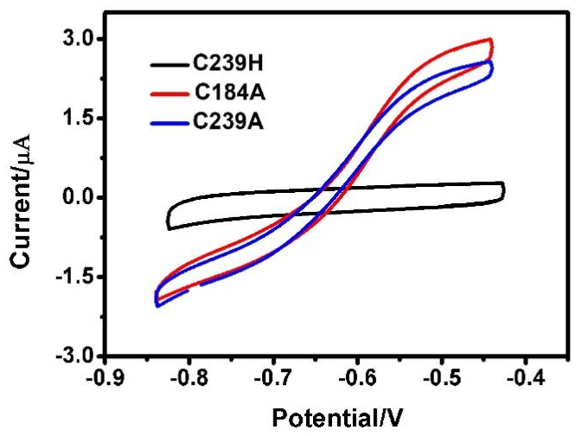
Figure S16. Electrocatalytic profiles of other variants at position C239 and C184. Cyclic voltammograms were scanned between OCP and ± 0.2 V. Conditions: pH 7.0, rotation speed ω = 2500 rpm, scan rate ν = 10 mV s⁻¹, under 1 bar H₂. A modified GC-multiwalled carbon nanotube electrode was used for hydrogenases. C184H had too low enzyme activity to display an electrocatalytic cycle.

Figure S17. Comparison of the electrochemical behavior at the indicated pH values for wild type (red line) and the variants C383H (black line). A modified GC-WMCNTs electrode was used for hydrogenases. All the electrochemical experiments were measured at 25 ºC, rotation speed ω = 2500 rpm, scan rate ν = 10 mV s⁻¹, under 100% H₂.

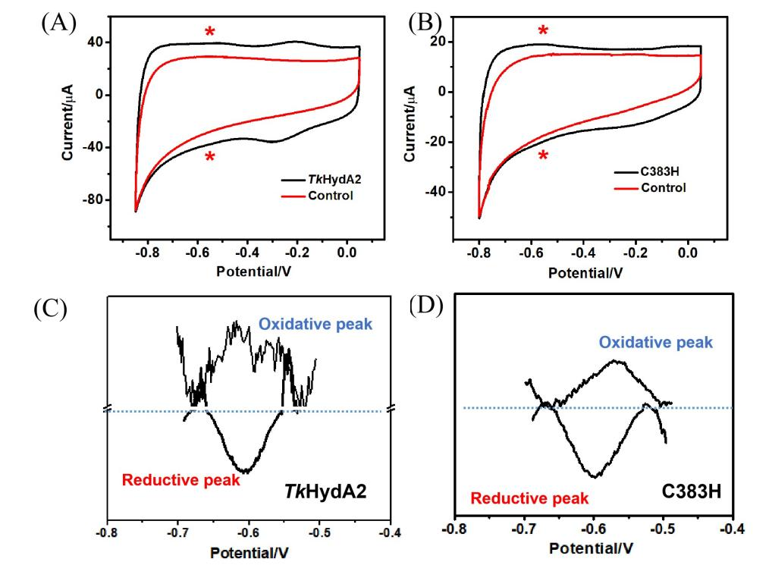
Figure S18. Comparison of cyclic voltammograms of modified ITO-CF electrode (Black lines) and unmodified ITO-CF electrode as the control experiments (Red lines) for TkHydA2 (A) and C383H (B). The asterisks denote the positions of the peaks. Other conditions: electrochemical experiments were performed at 25 ºC at a scan rate ν = 5 mV s⁻¹ under N₂ atmosphere, PBS buffer pH 7, 0.1 M NaCl. (C and D) The corresponding SWV curves of TkHydA2 (C) and C383H (D). PBS buffer pH 7, 0.1 M NaCl at N₂ atmosphere, 25 ºC, SWV frequency 1 Hz, amplitude 20 mV, step 2 mV. The non-turnover signals were analyzed after baseline correction.

Figure S19. Structure profiles of TkHydA2 edited using PyMOL.

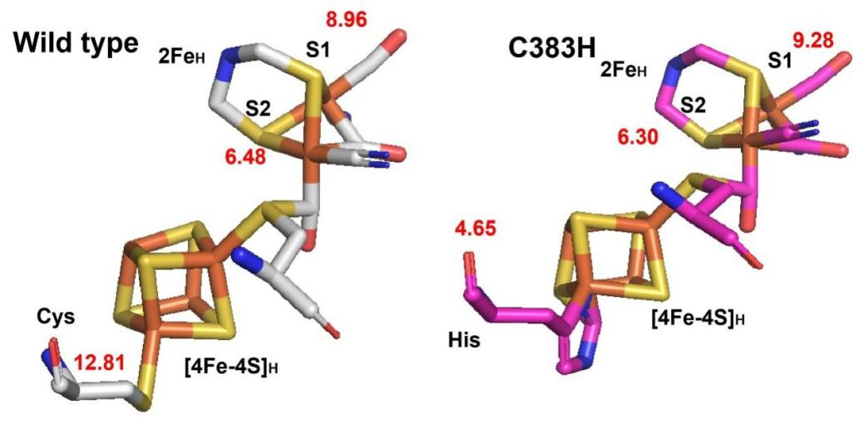
Figure S20. pKa values of TkHydA2 and variants C383H of active center, calculated by PDB2PQR. The sticks structures are visualized by PyMOL.
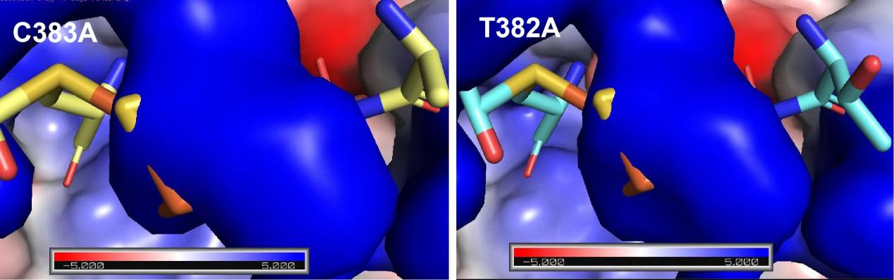
Figure S21. Electrostatic potential maps of C383A and T382A calculated by APBS Plugin in Pymol.

Table S1. Primers used in this work.
plasmids |  | Primers
pETDuet-6Xhis-TkHydA2 | TkHydA2-POE-IF | TTTAACTTTAAGAAGGAGATATACCATGAGCGCGAACAAAGCGATTATTA
pETDuet-6Xhis-TkHydA2 | TkHydA2-POE-IR | CCGATATCCAATTGAGATCTGCTTAgtgatgatgatgatgatgCACCTTTTTGCGCGGCGTATATTTGGTA
pETDuet-6Xhis-TkHydA2 | TkHydA2-POE-VF | TACCAAATATACGCCGCGCAAAAAGGTGcatcatcatcatcatcacTAAGCAGATCTCAATTGGATATCGG
pETDuet-6Xhis-TkHydA2 | TkHydA2-POE-VR | TAATAATCGCTTTGTTCGCGCTCATGGTATATCTCCTTCTTAAAGTTAAA
pETDuet-6Xhis-TkHydA2 Mutants | C15A-F | TTGATCAAGAACTGGCGACCGGCTGCCGCCGCTGCGCGGAAGTGTGCCCG
pETDuet-6Xhis-TkHydA2 Mutants | C18A-F | TTGATCAAGAACTGTGCACCGGCGCGCGCCGCTGCGCGGAAGTGTGCCCG
pETDuet-6Xhis-TkHydA2 Mutants | C21A-F | TTGATCAAGAACTGTGCACCGGCTGCCGCCGCGCGGCGGAAGTGTGCCCG
pETDuet-6Xhis-TkHydA2 Mutants | C55A-F | GATGTGCGGTCAGTGCGTGCAGAAAGCGAGCAGCTATGCGAGCTATTTTG
pETDuet-6Xhis-TkHydA2 Mutants | C184A-F | AGATCTGCCGATGTTTACGAGCTGCGCGCCGGCGTGGGTGAAATTTGCGG
pETDuet-6Xhis-TkHydA2 Mutants | C383A-F | TCTGCATTTTGTGGAAGTGATGACCTGCCCGGAAGGCTGCATTAGCGGCG
pETDuet-6Xhis-TkHydA2 Mutants | C383A-R | TCGCATTTGTTTTTTTTAATATCTT
pETDuet-6Xhis-TkHydA2 Mutants | T382A-F | TTTGTGGAAGTGATGGCGTGCCCGGAAGGCTGCATTAGCGGCGGTGGTCA
pETDuet-6Xhis-TkHydA2 Mutants | T382-R | ATGCAGATCGCATTTGTTTTTTTTA
pETDuet-6Xhis-TkHydA2 Mutants | R20A-F | TTGATCAAGAACTGTGCACCGGCTGCCGCGCGTGCGCGGAAGTGTGCCCG
pETDuet-6Xhis-TkHydA2 Mutants | 20A-R | TGTTAATAATCGCTTTGTTCGCGCT
pETDuet-6Xhis-TkHydA2 Mutants | C15H/C18H/C21H/C15A/C18A/C21A-R | TGTTAATAATCGCTTTGTTCGCGCT
pETDuet-6Xhis-TkHydA2 Mutants | C15H-F | TTGATCAAGAACTGCATACCGGCTGCCGCCGCTGCGCGGAAGTGTGCCCG
pETDuet-6Xhis-TkHydA2 Mutants | C18H-F | TTGATCAAGAACTGTGCACCGGCCATCGCCGCTGCGCGGAAGTGTGCCCG
pETDuet-6Xhis-TkHydA2 Mutants | C21H-F | TTGATCAAGAACTGTGCACCGGCTGCCGCCGCCATGCGGAAGTGTGCCCG
pETDuet-6Xhis-TkHydA2 Mutants | C55H-F | GATGTGCGGTCAGTGCGTGCAGAAACATAGCAGCTATGCGAGCTATTTTG
pETDuet-6Xhis-TkHydA2 Mutants | C55H-R | ACGCACACTTCGGTGTTAATTTTCT
pETDuet-6Xhis-TkHydA2 Mutants | C184H-F | AGATCTGCCGATGTTTACGAGCTGCCATCCGGCGTGGGTGAAATTTGCGG
pETDuet-6Xhis-TkHydA2 Mutants | C184H-R | TTGCCTTCTTTAATGCGTTTCACCA
pETDuet-6Xhis-TkHydA2 Mutants | C239H-F | AATTTTTAGCGTGAGCGTGATGCCGCATACCTGCAAGAGCTATGAGAGCG
pETDuet-6Xhis-TkHydA2 Mutants | C239H-R | TTCGCCGGATCCACGTTGTTAATTT
pETDuet-6Xhis-TkHydA2 Mutants | L14I-F | AACATTGATCAAGAAATTTGCACCGGCTGCCGCCGCTGCGCGGAAGTGTG
pETDuet-6Xhis-TkHydA2 Mutants | R20E-F | AACATTGATCAAGAACTGTGCACCGGCTGCCGCGAATGCGCGGAAGTGTG
pETDuet-6Xhis-TkHydA2 Mutants | L14I/R20E-R | AATAATCGCTTTGTTCGCGCTCATG
pETDuet-6Xhis-TkHydA2 Mutants | S56K-F | GGTCAGTGCGTGCAGAAATGCAGCAGCTATGCGAGCTATTTTGATGAAAG
pETDuet-6Xhis-TkHydA2 Mutants | S56K-R | GCACATCACGCACACTTCGGTGTTA

 | Enzyme activity(U mg⁻¹)
 | H₂+CO₂→HCOOH | HCOOH→H₂+CO₂
TkHDCR | 900 | 930
AwHDCR | 10 | 14
Table S2. CO₂ reduction and HCOOH oxidation of TkHDCR and Aw HDCR.

