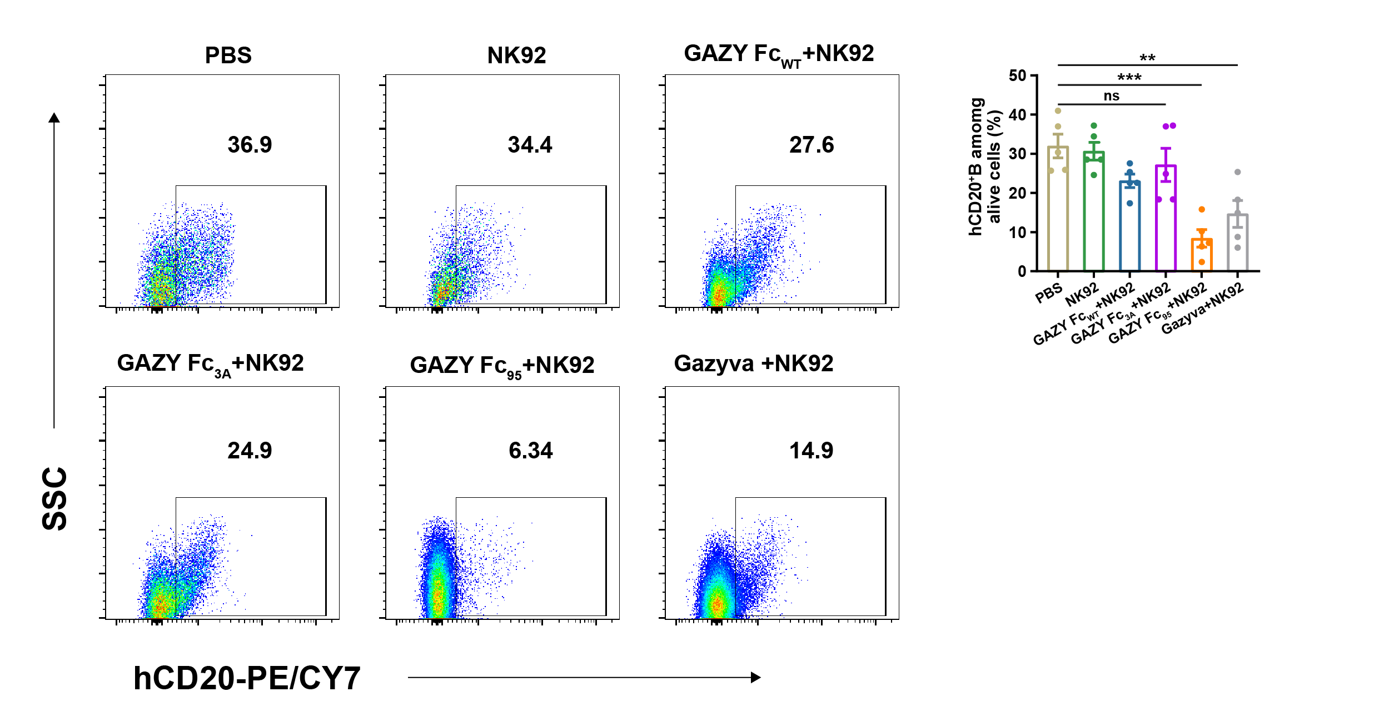
Extended data figure 1. Representative flow cytometry plots for human CD20⁺ B Raji cell profiling in the prropheral blood of mice corresponding to Figure 6C.
Groups include those treated with PBS, NK92, GAZY Fc_{WT}+NK92, GAZY Fc_{3A}+NK92, GAZY Fc₉₅+NK92 and Gazyva+NK92 . Data show the depletion of Raji cells (hCD20⁺) within the prropheral blood.

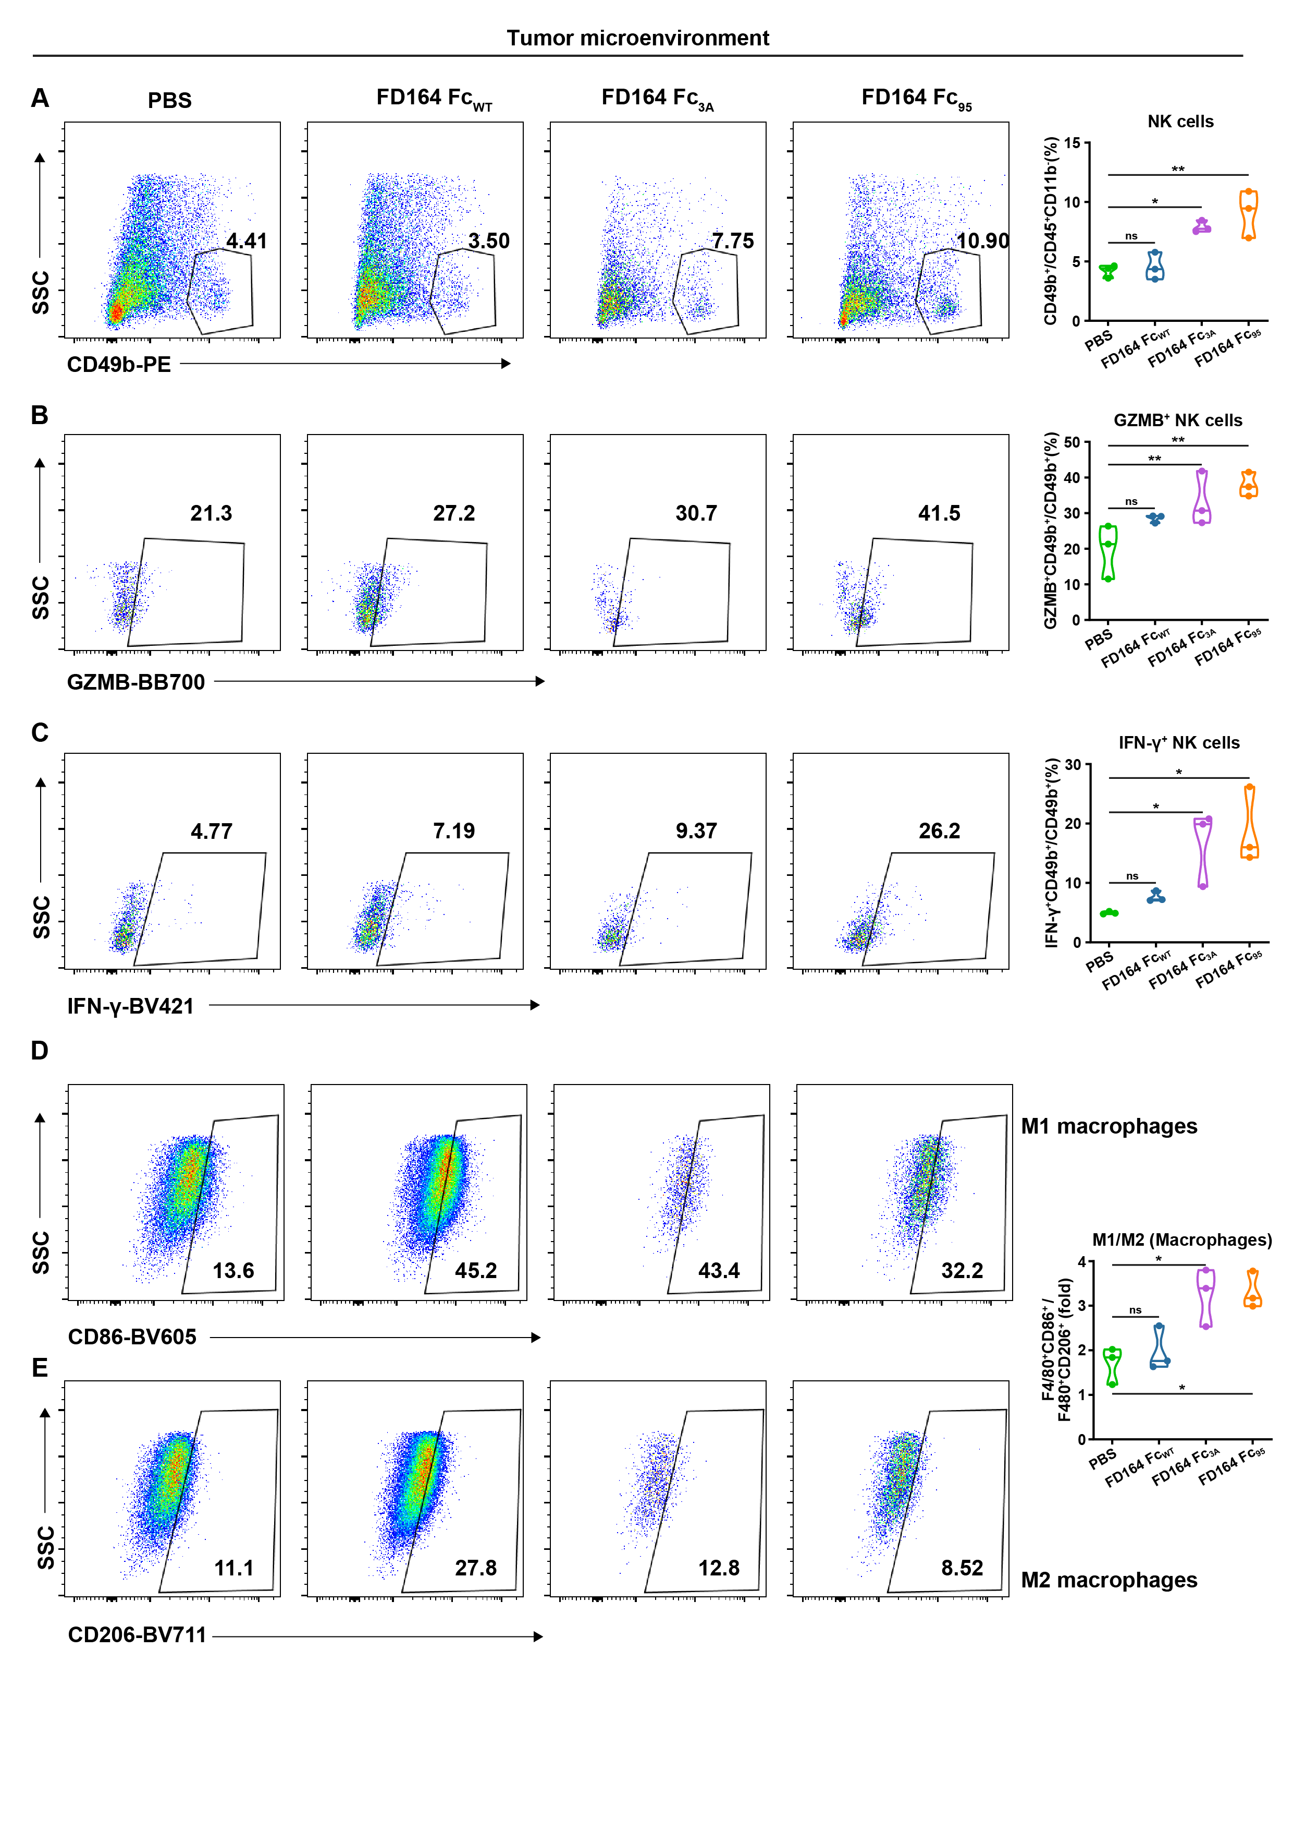
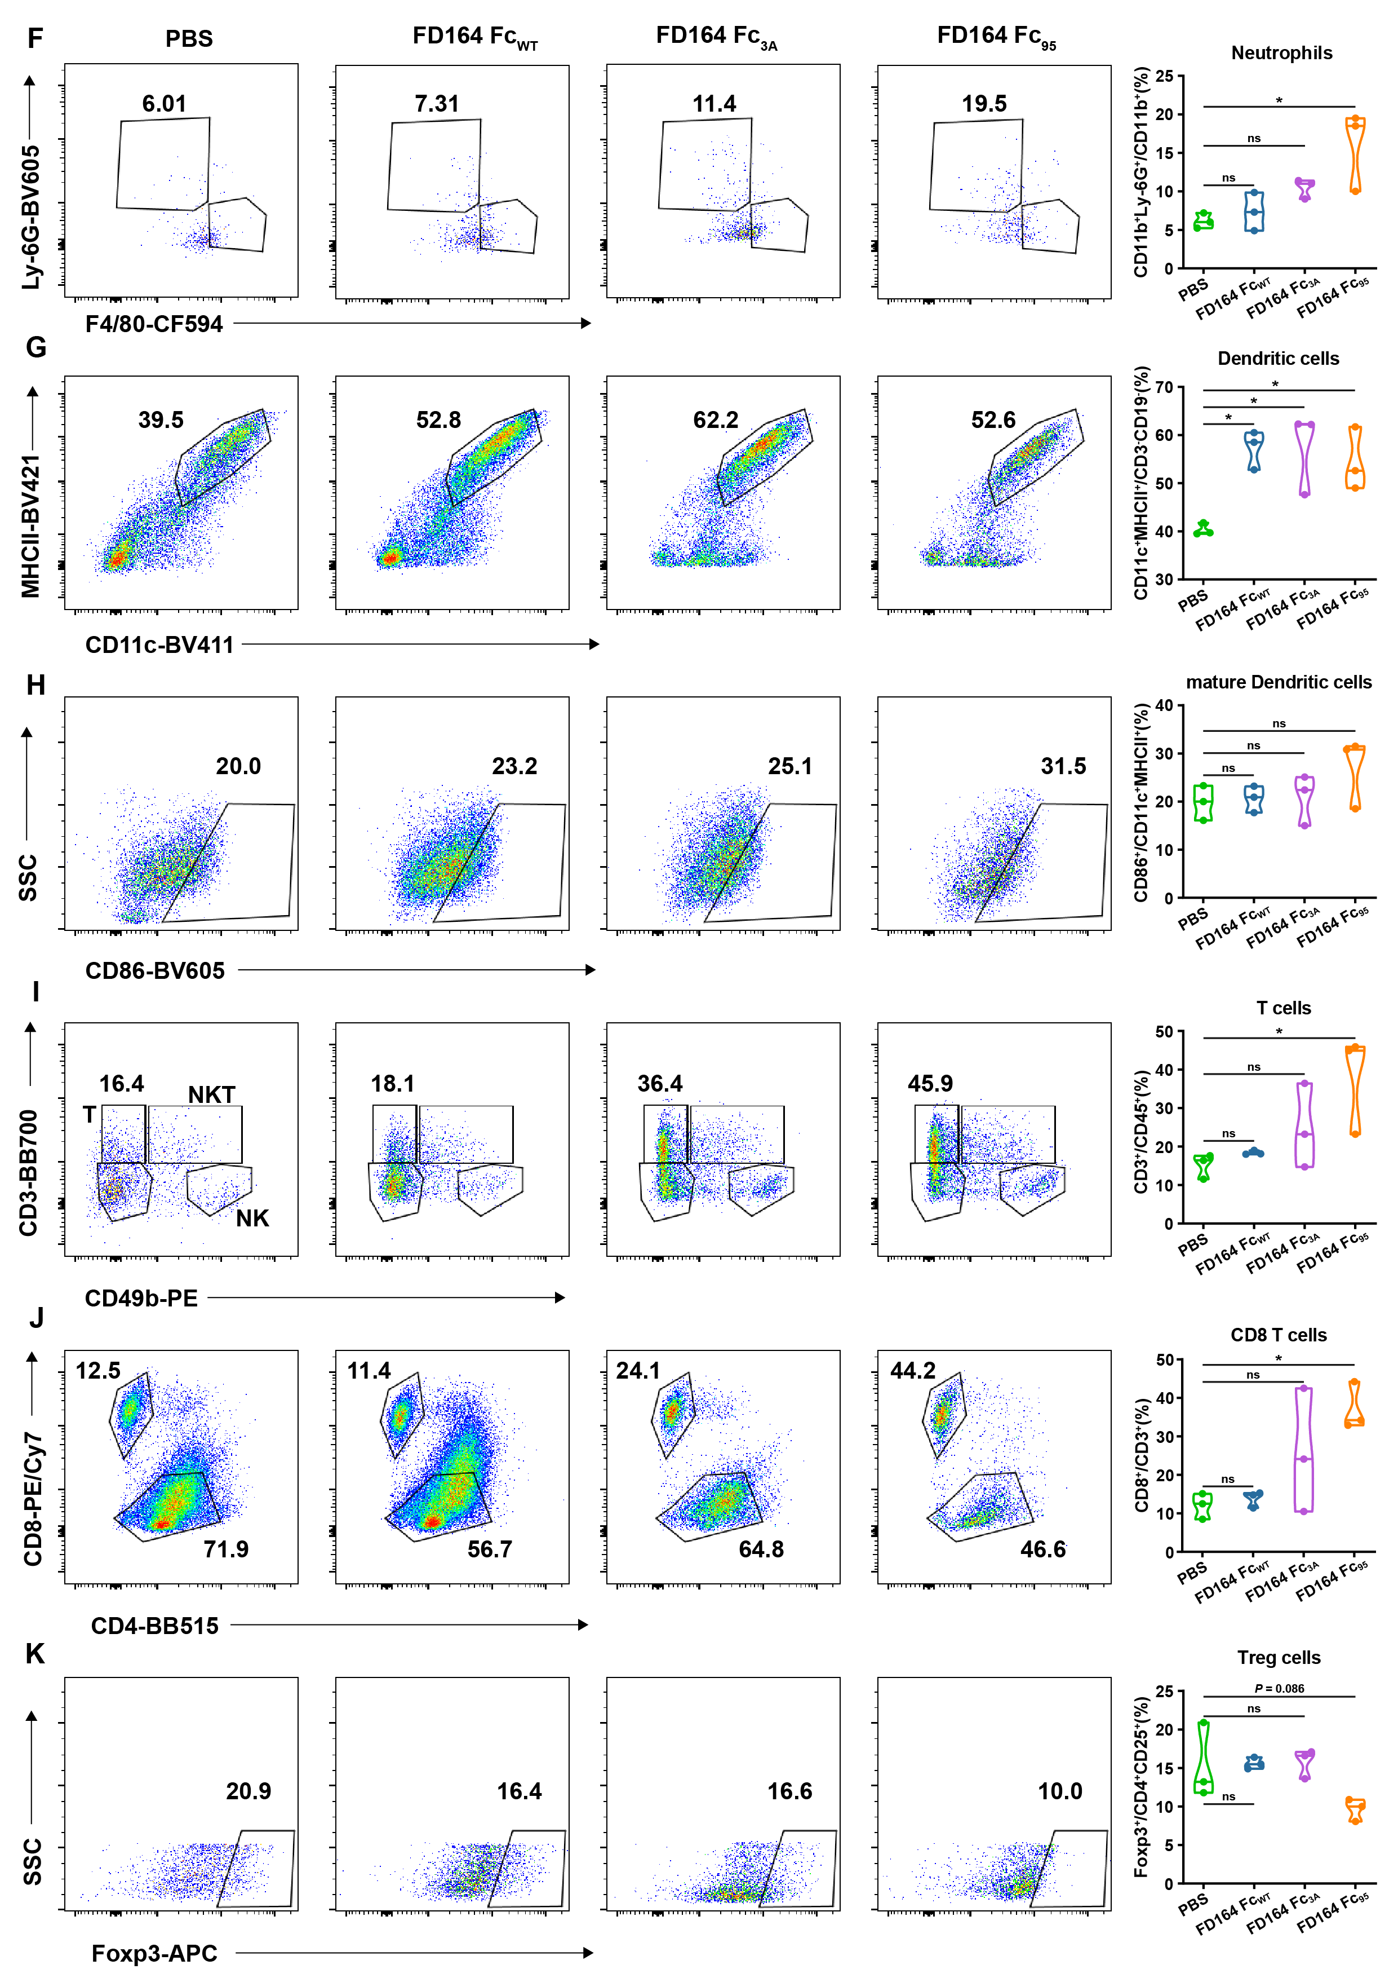
Extended data figure 2. Representative flow cytometry plots for immune cell profiling in the TME corresponding to Figure 7F.
Representative flow cytometry plots for NK cells (A), GAZM⁺NK cells (B), IFN-γ⁺NK cells (C), M1 macrophages (D), M2 macrophages (E), Neutrophils (F), Dendritic cells (G), Mature Dendritic cells (H), T cells (I), CD8 T cells (J), Treg cells (K) within the tumor microenvironment (TME).
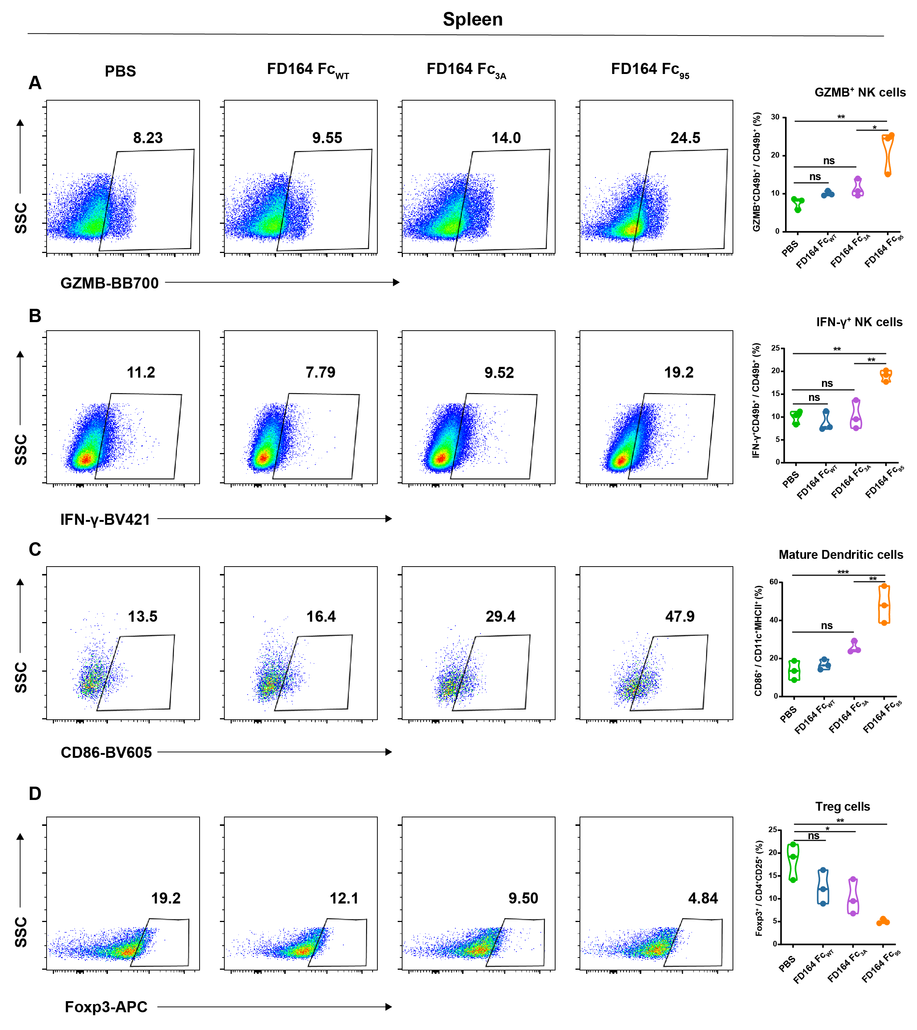
Extended data figure 3. Representative flow cytometry plots for immune cell profiling in the spleen corresponding to Figure S7O.
Representative flow cytometry plots for GAZM⁺NK cells (A), IFN-γ⁺NK cells (B), Mature Dendritic cells (C), Treg cells (D) in spleen. Non-significant groups are not shown.

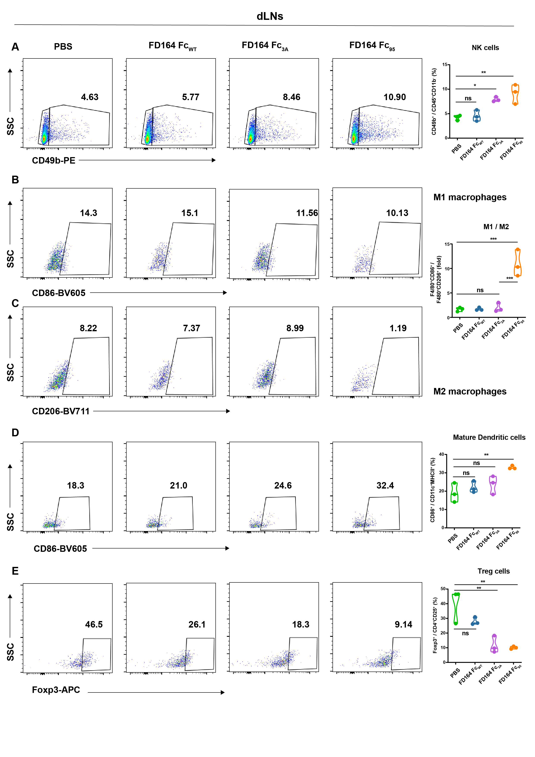
Extended data figure 4. Representative flow cytometry plots for immune cell profiling in the spleen corresponding to Figure S7P.
Representative flow cytometry plots for NK cells (A), M1 macrophages (B), M2 macrophages (C), Mature Dendritic cells (D), Treg cells (E) in dLNs. Non-significant groups are not shown.

