Tab.1 Primers for genetic markers of conjugate transfer of donor bacteria
Genes | Sequence（5ʹ-3ʹ） | Length（bp） | Tm（℃）
trbC | F：TAATACGACTCACTATAGGG | 999 | 60
trbC | R：TGCTAGTTATTGCTCAGCGG | 999 | 60
traF | F：TGCGAAACTGGCTGAACACTACG | 143 | 62
traF | R：TAATCACGCCATCCACGGAAACG | 143 | 62

Tab.2 Regulatory gene primers sequence
Genes | Sequence（5ʹ-3ʹ） | Length（bp） | Tm（℃）
GAPDH | F：GCTGAACGTGATCCGGCTAACC  R：CGTCAGTCAGGAACAGACCAGTTG | 85 | 60
lexA  recA | F：TTCAGGCGCTTAACGGTAACTTCG  R：GGATGGTGACTTGCTGGCAGTG  F：GCTGGACCCAATCTACGCAC  R：CCAGGGCGTCACAGATTTCC | 99  166 | 60  59
dpiA | F：AAGAGCCTGGTGTGCAACATACG  R：ATTCAAGATAACGCCTGGCAGTGG | 84 | 60
dpiB | F：TGCCGCCAGGACTGGATAGC  R：ATCACCACATCATCGCCTTCATCG | 142 | 61
rpoS | F：CTGGCGTTGCTGGACCTTATCG  R：ATCCACCAGGTTGCGTATGTTGAG | 110 | 60
Hu | F：AGTGGCCGAAGACGCTGATATTAG  R：CCGCCGCGATCTGGATGTTC | 194 | 60

Tab.3 The primers of resistance genes and plasmids in E. coli QALAK1-2
Genes | Sequence（5ʹ-3ʹ） | Tm（℃） | length（bp）
qnrA | F：TCAGCAAGAGGATTTCTCA | 52 | 627
qnrA | R：GGCAGCACTATTACTCCCA | 52 | 627
tetA | F：GCTACATCCTGCTTGCCTTC | 62 | 210
tetA | R：CATAGATCGCCGTGAAGAGG | 62 | 210
blaCTX-M-9G | F：GTGACAAAGAGAGTGCAACGG | 63 | 857
blaCTX-M-9G | R：ATGATTCTCGCCGCTGAAGCC | 63 | 857
fosA3 | F：GCGTCAAGCCTGGCATTT | 57.5 | 282
fosA3 | R：GCCGTCAGGGTCGAGAAA | 57.5 | 282
IncI2 | F：TTACAGTGCAAGCTAAGTGCAG | 55 | 615
IncI2 | R：GATTCACGGTCCCATATCGT | 55 | 615
IncFIB | F：GGAGTTCTGACACACGATTTTCTG | 60 | 702
IncFIB | R：CTCCCGTCGCTTCAGGGCATT | 60 | 702
GFP | F：TAATACGACTCACTATAGGG | 55 | 999
GFP | R：TGCTAGTTATTGCTCAGCGG | 55 | 999
mcr-1 | F：CGCATAATTTTTTATATCA | 53 | 1600
mcr-1 | R：AGTAGGCGTTTATTTGAT | 53 | 1600
oqxA | F：GATCAGTCAGTGGGATAGTTT | 51 | 670
oqxA | R：TACTCGGCGTTAACTGATTA | 51 | 670

Table 4 E. coli FTK conjugants resistance genes and plasmid identification primers
Genes | Sequence（5ʹ-3ʹ） | Tm（℃） | length（bp）
qnrB | F：GATCGTGAAAGCCAGAAAGG | 53 | 469
qnrB | R：ACGATGCCTGGTAGTTGTCC | 53 | 469
tetA | F：GCTACATCCTGCTTGCCTTC | 62 | 210
tetA | R：CATAGATCGCCGTGAAGAGG | 62 | 210
blaCTX-M-9G | F：GTGACAAAGAGAGTGCAACGG | 63 | 857
blaCTX-M-9G | R：ATGATTCTCGCCGCTGAAGCC | 63 | 857
fosA3 | F：GCGTCAAGCCTGGCATTT | 57.5 | 282
fosA3 | R：GCCGTCAGGGTCGAGAAA | 57.5 | 282
IncI2 | F：TTACAGTGCAAGCTAAGTGCAG | 55 | 615
IncI2 | R：GATTCACGGTCCCATATCGT | 55 | 615
IncHI2 | F：TTTCTCCTGAGTCACCTGTTAACAC | 60 | 644
IncHI2 | R：GGCTCACTACCGTTGTCATCCT | 60 | 644
IncY | F：AATTCAAACAACACTGTGCAGCCTG | 60 | 765
IncY | R：GCGAGAATGGACGATTACAAAACTTT | 60 | 765
mcr-1 | F：CGCATAATTTTTTATATCA | 53 | 1600
mcr-1 | R：AGTAGGCGTTTATTTGAT | 53 | 1600
oqxA | F：GATCAGTCAGTGGGATAGTTT | 51 | 670
oqxA | R：TACTCGGCGTTAACTGATTA | 51 | 670
oqxB | F：TTCTCCCCCGGCGGGAAGTAC  R: CTCGGCCATTTTGGCGCGTA | 65 | 512

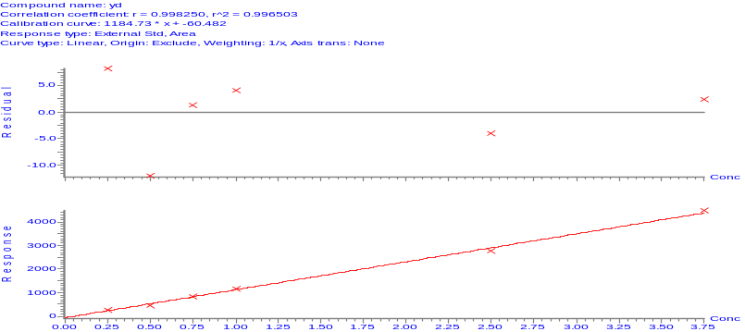
Fig.1 Indole standard curve
Concentration
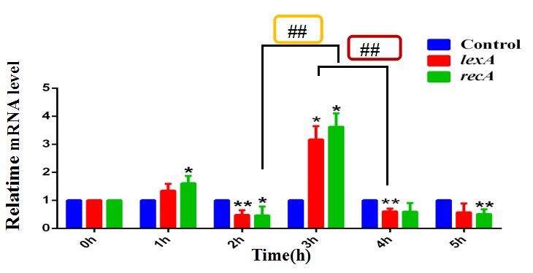
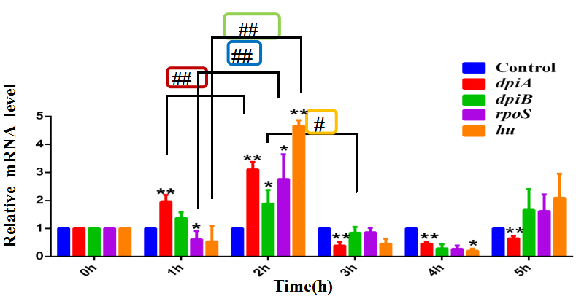
A
B
Note: A: In the RecA-dependent pathway, 0.01 μg/mL CTX induced 3h, vs control group, lexA、recA mRNA increased, 4h significantly decreased, and the SOS reaction was established. B: In the RecA-independent pathway, 0.01 μg/mL CTX induced later, vs control group, dpiA, dpiB, rpoS, and hu mRNA increased at 2h, and then gradually decreased from 3h-4h, SOS reaction was established. * vs control group (0h group), #group comparsion*/#P<0.05 **/##P<0.01.
Fig.2 Relative quantification of mRNA of SOS response regulatory genes in E. coli BL21

Tab.5 The primers of ibpA, acrEF, mtr
Genes | Sequence（5ʹ-3ʹ） | Tm /℃ | length（bp）
ibpA | F：TCAGCAAGAGGATTTCTCA | 61.5 | 98
ibpA | R：GGCAGCACTATTACTCCCA | 61.5 | 98
acrE | F：GCTACATCCTGCTTGCCTTC | 60 | 140
acrE | R：CATAGATCGCCGTGAAGAGG | 60 | 140
acrF | F：GTGACAAAGAGAGTGCAACGG | 62 | 129
acrF | R：ATGATTCTCGCCGCTGAAGCC | 62 | 129
mtr | F：ACCTTCGCAGAGATGTCACTAAACG | 59.6 | 85
mtr | R：TCAACCACACCACAAACGCTACC | 59.6 | 85
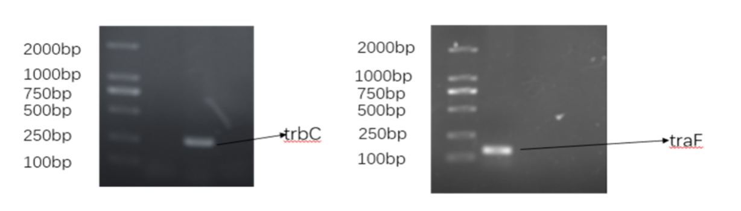
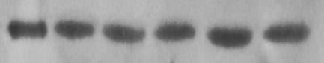
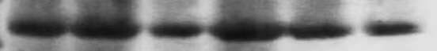
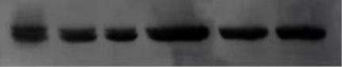
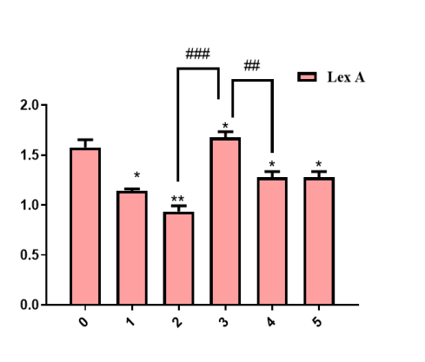
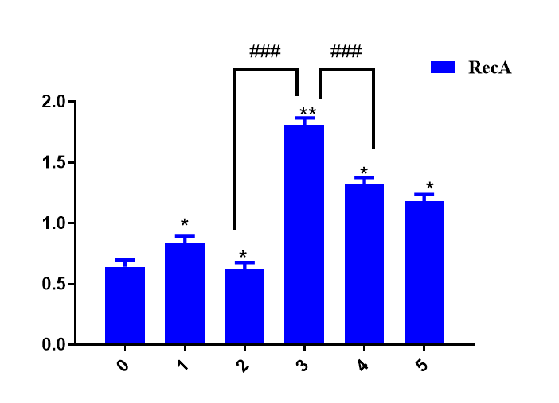
Note: A、B-Agarose electrophoresis of trbC and traF genes in E. coli QALAK1-2
C: Agarose electrophoresis diagram of E. coli QALAK1-2 resistance genes and plasmids
M:DL2000 Marker；1:mcr-1-1600bp；2:tetA-210bp；3:qnrA-627bp；4:IncI2-615bp；
5: bla_{CTX-M-9G} -857bp;6:fosA3-282bp;7:IncFIB-702bp
Fig.4 Agarose electrophoresis diagram of E. coli QALAK1-2 related gene

A
B
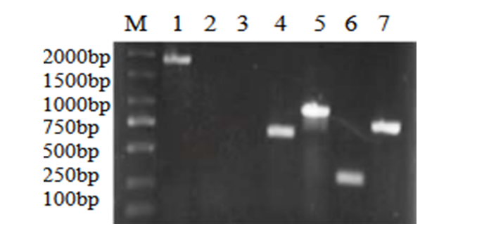
C
GAPDH

RecA

LexA

Con 1h 2h 3h 4h 5h

37kD

38kD

22kD
A
Time/h
Time/h
B
C
A: LexA, RecA SDS-PAGE electropherogram, GAPDH was internal reference, Control group: without drug (0 hour).
B: LexA gray value comparison chart, vs 0h, *P<0.05, **P<0.01; 4h vs3h, ##P<0.01; 2h vs 3h, ###P<0.001.
C: RecA gray value comparison Figure, vs 0h, *P<0.05, **P<0.01; 4h vs3h, ###P<0.001; 2h vs 3h,###P<0.001.
SOS response was established after 4h.
Fig.3 Expression of LexA and RecA protein in E. coli BL21 induced by 0.01μg / mL CTX
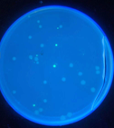
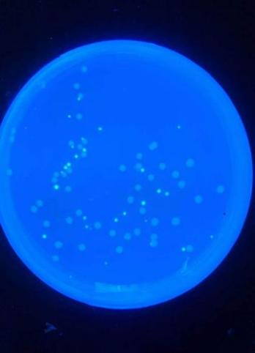
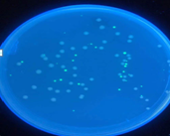
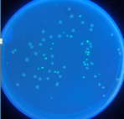
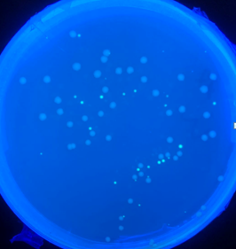
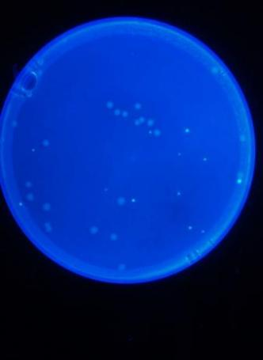
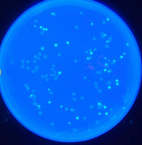
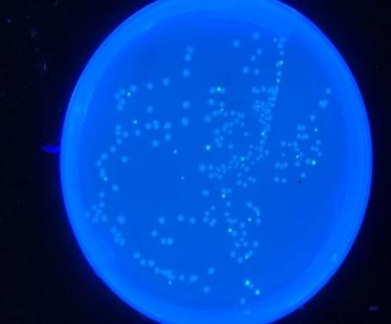
A: 1:1 10-12h uninduced B: 1:1 10~12h induce C:1:1 15~18h uninduced D:1:1 15~18h induce

E: 1:2 10~12h uninduced F: 1:2 10~12h induce G: 1:2 15~18h uninduced H: 1:2 15~18h induce

Green fluorescent colonies are conjugator colonies , ↓shown; white colonies are donor colonies; ABCD: recipient :donor to 1:1; EFGH: recipient :donor to 1:2
Fig.5 The conjugant colonies screening on LB plates

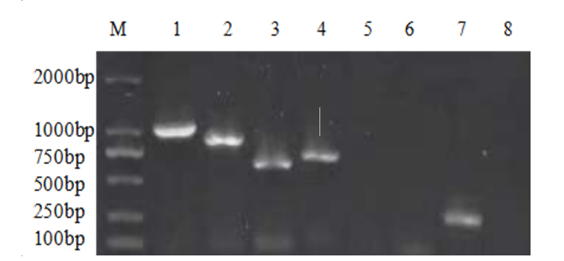
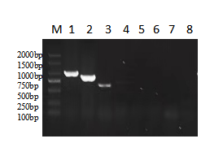
Left: Green fluorescent colonies derived from Fig.6 BCF: lane1-GFP (999bp), lane2-bla_{CTX-M-9G} (857bp), lane3-IncFIB (702bp).
Right: Green fluorescent colony from Fig6D, G&H: lane1-GFP (999bp); lane2-bla_{CTX-M-9G} (857bp), lane3-IncI2 (615bp), lane4-IncFIB (702bp), lane5-mcr-1 (1600bp), lane6-tetA(210bp); lane7-fosA3(282bp); 8: qnrA (627bp)
Fig.6 Identification of conjugates resistance genes and plasmids

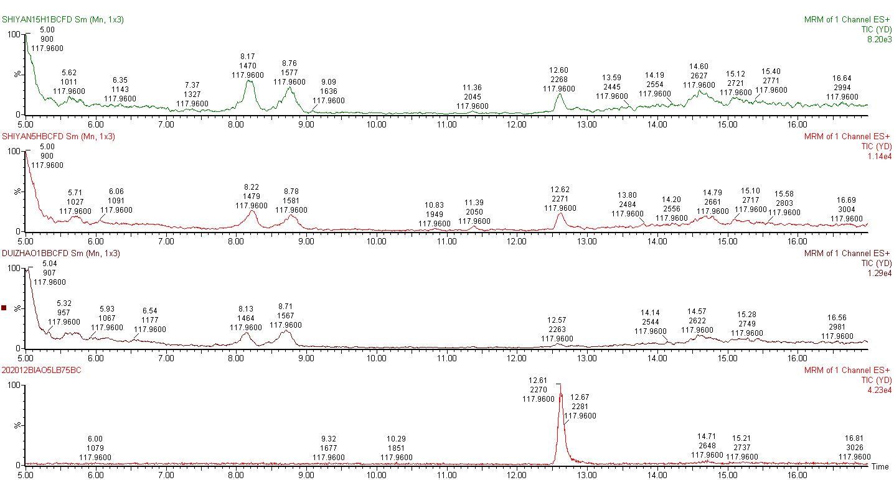
CTX 15h

CTX 5h

Control
(Without CTX)

Standard

Note: → the HPLC-MS ion current peak of indole
Fig.7 The total ion chromatogram for the determination of the indole concentration in the culture medium of the recipient bacteria BL21
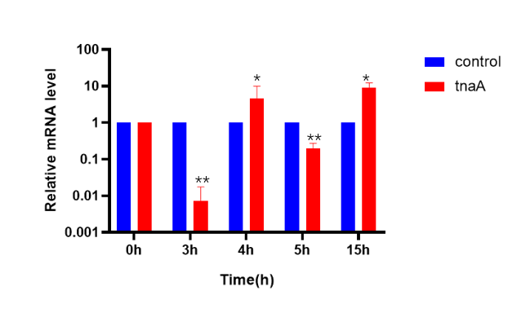
Note: vs control group(0h), *P<0.05;**P<0.01.
Fig.8 Reltive quantification of tnaA mRNA of BL21

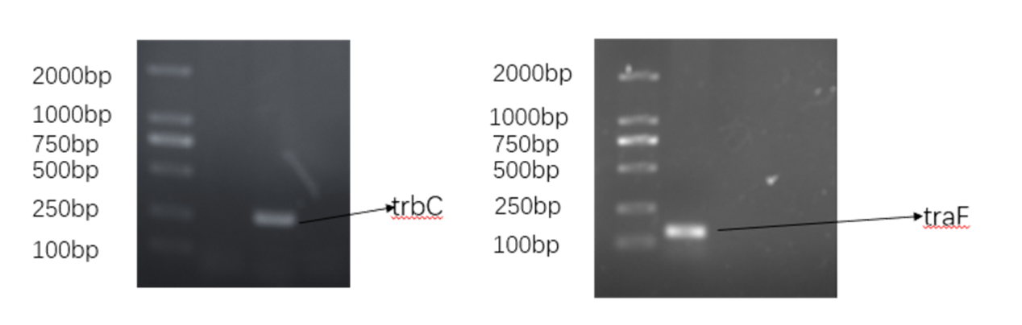
Fig.9 Agarose electrophoresis of trbC and traF genes in E. coli FTK

Tab.6 The reagents and manufacturers
Reagent name | Manufacturer
Kanamycin | Shanghai Shenggong Bioengineering Co., Ltd
Cefotaxime Sodium | Shanghai Shenggong Bioengineering Co., Ltd
Lysozyme | Shanghai Shenggong Bioengineering Co., Ltd
SanPrep column plasmid DNA small quantity extraction kit | Shanghai Shenggong Bioengineering Co., Ltd
Column bacterial genomic DNA Extraction Kit | Shanghai Shenggong Bioengineering Co., Ltd
Column bacteria gene total RNA extraction and Purification Kit | Shanghai Shenggong Bioengineering Co., Ltd
One step synthesis of premixed reagents for removing the first strand of genomic cDNA by Fastking | Beijing Tiangen Biochemical Technology Co., Ltd
Super real fluorescent quantitative premixed reagent | Beijing Tiangen Biochemical Technology Co., Ltd
Bacterial protein extraction kit | Shanghai Shenggong Bioengineering Co., Ltd
Rapid preparation kit for SDS-PAGE modified acrylamide gel | Shanghai Shenggong Bioengineering Co., Ltd
DAB reagent kit | Beijing solab biological Co., Ltd
4S green plus nucleic acid dye | Shanghai Shenggong Bioengineering Co., Ltd
DL2000 DNA Marker | Shanghai Shenggong Bioengineering Co., Ltd
LB broth medium | Qingdao Haibo biological Co., Ltd
LB solid medium | Qingdao Haibo biological Co., Ltd
MH broth (MHB) medium | Qingdao Haibo biological Co., Ltd
MH agar (MHA) medium | Qingdao Haibo biological Co., Ltd
2×Taq Master Mix | Shanghai Shenggong Bioengineering Co., Ltd
MH agar (MHA) medium | Beijing siliang long term Biotechnology Co., Ltd
Fluorescent quantitative PCR octet | Axygen company
Calcium chloride | Beijing Chemical Reagent Factory

Tab.7 Basic information of main instruments
Instrument name | Model | Manufacturer
Digital display blast drying oven | GZX-9070 MBE | Shanghai bosun Industrial Co., Ltd. medical equipment factory
TECAN microplate reader | 200 PRO | TECAN (Shanghai) Trading Co., Ltd
High speed table centrifuge | HH-S6 | Anke company
Ice maker | IMS-200 | Changshu Xueke Electric Appliance Co., Ltd
Electronic balance | JJ50 | Changshu Shuangjie testing instrument factory
Ultra-low temperature freezer | EDC-810 | Sanyo, Japan
Haier household microwave oven | TGL-16G | Qingdao Jiaonan Haier Microwave Products Co., Ltd
Gradient PCR instrument | MDF-U5086W | Dongsheng innovation
Horizontal electrophoresis apparatus | DW-25W388(9H) | Beijing Liuyi Instrument Factory
Gene amplification instrument | ETC811 | Suzhou Dongsheng Xingye Scientific Instrument Co., Ltd
Micro centrifuge | EW-6000 | Dongsheng innovation Biotechnology Co., Ltd
Real time PCR | Q2000 | Somerfield company
Digital constant temperature water bath | HH-2 | Changzhou huapuda Teaching Instrument Co., Ltd
Digital display electric heating incubator | HPX-9052 MBE | Shanghai bosun Industrial Co., Ltd. medical equipment factory
Chemiluminescence gel imaging system | ChemStudio | Jena analytical instruments AG
Temperature controlled shaker | JK-SI-98A | Shanghai Jingxue Scientific Instrument Co., Ltd
Digital display electric heating incubator | 303-4A | Shanghai Sunshine Experimental Instrument Co., Ltd
Thermo biosafety cabinet | 1384-2-A2 | Beijing CHENGMAO Xingye Technology Development Co., Ltd

Tab.8 MS operating conditions
Project | Mass spectrometry conditions | Carrier gas
Capillary electrochemistry | 2.5KV
Cone voltage | 30V
Extraction voltage | 3V
Source temperature | 150℃
Dissolved gas temperature | 350℃ | Nitrogen
Cone Gas Flow | 50L/h
Dissolved gas flow freqency | 600L/h | Nitrogen
Impact gas velocity | 0.18L/h | Nitrogen

Tab.9 Liquid phase conditions
Time | Current Speed | A% | B%
0 | 0.3 | 90 | 10
5 | 0.3 | 50 | 50
11 | 0.3 | 0 | 100
12 | 0.3 | 90 | 10
17 | 0.3 | 90 | 10
Note: A-0.1% formic acid, B-methan ol, flow freqency of 0.3mL/min.

