Supplementary Materials

Waste to Treasure: Catalytic Reduction of Triphenylphosphine Oxide with Pyrophosphonic Acid Waste

Tieqiao Chen,^{2,3}* Xin Wang,³ Xiaoxiang Xi,^{1,3} Jianqiu Zhang,³ Jing Xiao,⁴ and Li-Biao Han^{1,2,3}*

¹College of Chemistry & Chemical Engineering, Shaoxing University, Shaoxing 312000, China.
²School of Chemistry and Chemical Engineering, Hainan University, Haikou, 570228, China.
³Zhejiang Yangfan New Material Co., Ltd., Shangyu, Zhejiang Province, 312369, China.
⁴School of Chemistry and Chemical Engineering, Hunan University of Science and Technology, Xiangtan, 411201, China.
- mail: chentieqiao@hnu.edu.cn; hlb@shoufuchem.com

This PDF file includes:

General Information
Supplementary Text

Content

1. General Information 3
2. About the waste “H₃PO₃” 3
3. Comparison of reactivity of waste “H₃PO₃” with pure H₃PO₃ª 7
4. Screening on iodocompounds as catalystª 8
5. 100 g-scale reduction of Ph₃P(O). 9

- General Information
All reactions were carried out in oven dried glass tubes under nitrogen atmosphere. All materials were purchased and used without further purification. ³¹P NMR and ¹H NMR spectra were recorded on a Magritek Spinsolve NMR Ultra 80M (80 MHz for ¹H, 33 MHz for ³¹P NMR). ¹H NMR spectra were related to Me₄Si (0 ppm) as an internal standard. Chemical shifts for ³¹P NMR were related to 85% H₃PO₄ solution as an external standard (0 ppm). GC (FID) was recorded on the Agilent 8890 GC System, GC-MS detection was conducted on a Shimadzu GCMS-QP 2020 NX.
- About the waste “H₃PO₃”
It is a humic syrup. Samples from the factory appears pale yellow to dark brown depending on the manufacturing process (Fig. 1), with a bad smelling because of the remained trace acid and/or acyl chloride. Samples prepared from the laboratory is a colorless syrup. It may fog in the air due to the presence of little HCl.
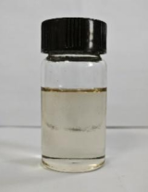
Fig. 1. The waste “H₃PO₃” from the factory.
As shown below, the ¹H NMR spectrum of the syrup (80 MHz) could not recognize organic residues (Fig. 2). Its extractant using CDCl₃ (600 MHz), however, did show the possible presence of trace organic chemicals which appeared between δ 0-3 ppm (Fig. 3).
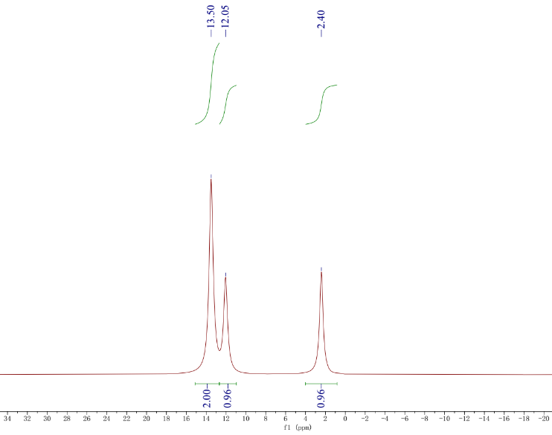
Fig. 2. ¹H NMR spectroscopy (80 MHz) of the neat “H₃PO₃” from the factory.

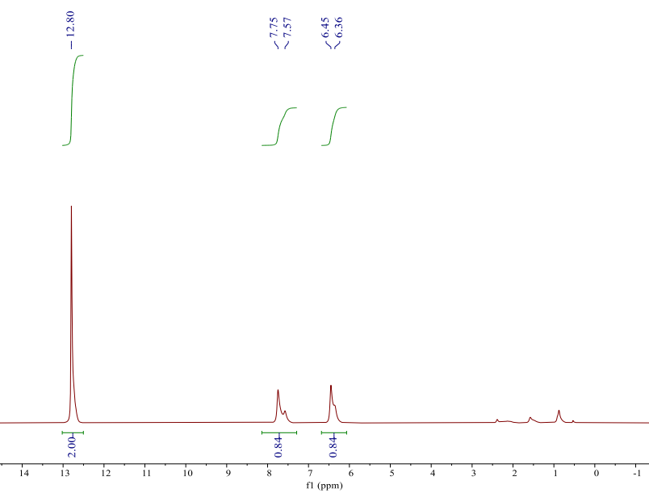
Fig. 3. ¹H NMR spectroscopy (600 MHz, CDCl₃) of the extractants of waste “H₃PO₃” from the factory.

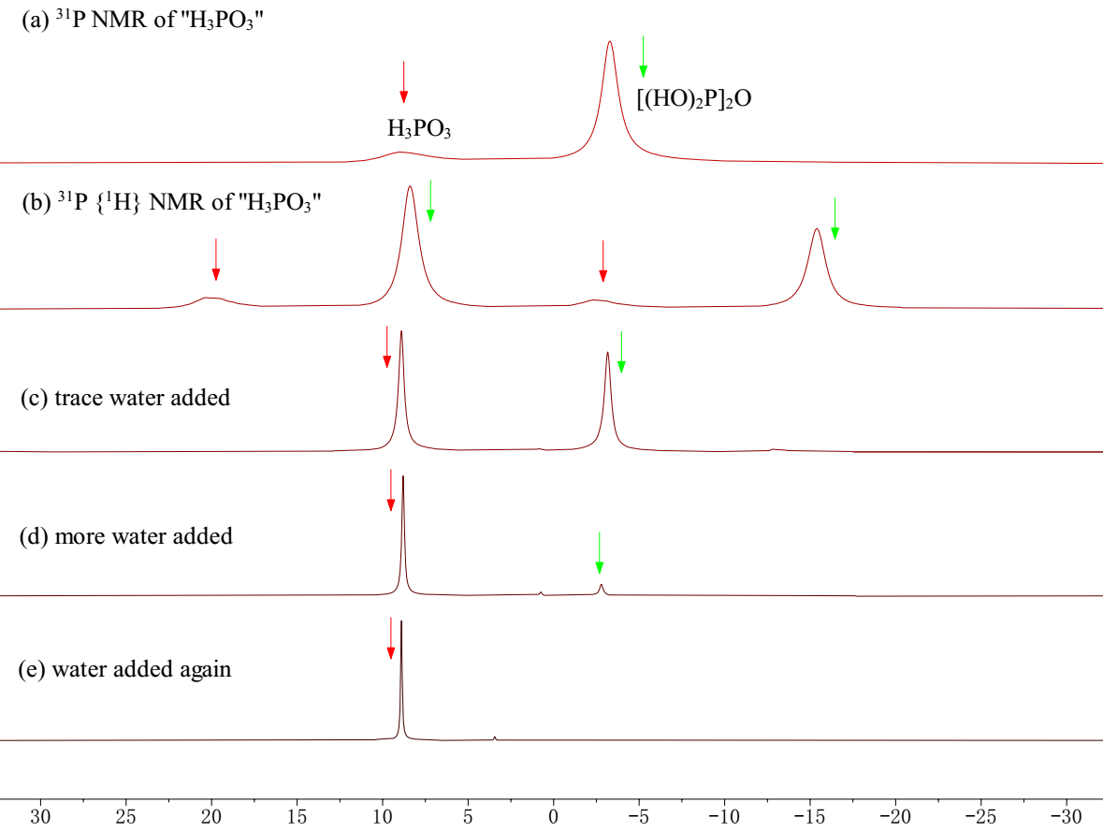
Fig. 4. ³¹P NMR spectra of the waste “H₃PO₃”
As shown in Fig. 4, the ³¹P NMR spectrum of the waste “H₃PO₃” obtained from the factory shows two signals at 6 ppm (J_{P-H} = 746.5 Hz) and -3 ppm (J_{P-H} = 785.4 Hz) in a ratio of ca. 30:70. The signal at 6 ppm is assigned to H₃PO₃. The signal at -3 ppm, as clearly indicated by ³¹P{1H} NMR, also contains a P(O)H group. When water was added, the signal at -3 ppm disappeared, leaving H₃PO₃ as the predominant phosphorus species. Therefore, the signal at -3 ppm was deduced to be pyrophosphonic acid [H(HO)P(O)]₂O. This assignment was further confirmed by comparison with an authentic sample of [H(HO)P(O)]₂O prepared separately. Thus, although, literatures described the generation of H₃PO₃ during the reaction of RCO₂H with PCl₃ (Fig. 5, eq 1), we assume that this conclusion was wrong. The reaction produced pyrophosphonic acid firstly that is then hydrolyzed by water to give H₃PO₃ (Fig. 5, eq 2).
Fig. 5. The generation path of H₃PO₃
A typical procedure for the preparation of the waste “H₃PO₃”: i-PrCO₂H (2.5 mol, 220.3 g) was added to a 500 mL flask under nitrogen. Then PCl₃ (1.0 mol, 137.3 g) was added dropwise. The mixture was then heated in an oil bath at 50 ºC for 2 h. The upper layer (i-PrC(O)Cl) was removed by decantation, leaving the waste “H₃PO₃” as a clear syrup (67.5 g) that contains 98% hypophosphonic acid and 2% H₃PO₃ as determined by ³¹P NMR.
As shown below, it seems that the ratio of i-PrCO₂H to PCl₃ does not affect the results a lot: with less or more i-PrCO₂H, hypophosphonic acid is always generated predominantly as determined by ³¹P NMR spectroscopy (Fig. 6).

equivs of i-PrCO₂H | equivs of PCl₃ | ratio of hypophosphonic acid to “H₃PO₃”
3.0 | 1.0 | 93/7
3.5 | 1.0 | 92/8
3.0 | 1.2 | 98/2

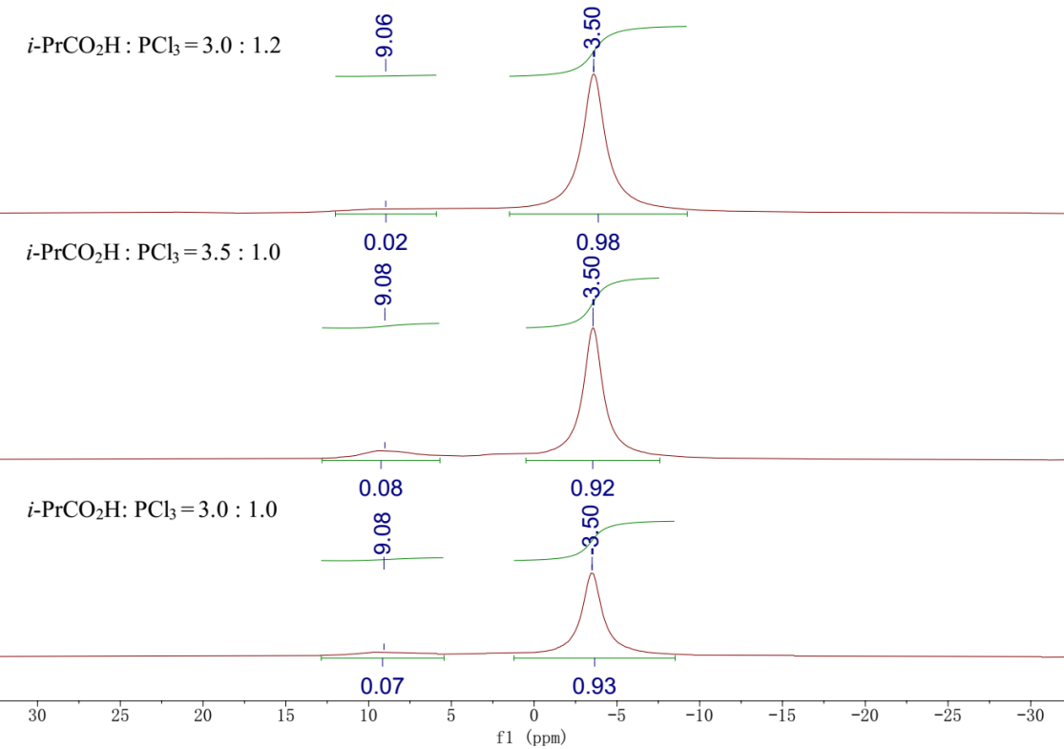
Fig. 6. ³¹P NMR spectroscopies of the waste “H₃PO₃” produced.

- Comparison of reactivity of waste “H₃PO₃” with pure H₃PO₃ª
Ph₃P(O) (1 mmol) and waste “H₃PO₃” (ca. 2.1 mmol based on P atom) were mixed in toluene (3 mL) and heated at 110 ºC for 5 h. GC yield using docecane as a standard. As described below, the waste “H₃PO₃” is a mixture of H₃PO₃ and pyrophosphonic acid with a ratio of 30 to 70 as estimated by ³¹P NMR. ^{b}In the absence of the I₂ catalyst. ^{c}5 mmol waste “H₃PO₃”. ^{d}10 mmol waste “H₃PO₃”.
A typical procedure taking entry 13 as an example: Ph₃P(O) (1.0 mmol, 278.2 mg), H₃PO₃ (2.1 mmol, 172.2 mg), P₂O₅ (0.2 mmol, 28.4 mg), and toluene (3 mL) were added to a 25 mL-Schlenk glass tube in a N₂-glove box, and then I₂ (0.02 mmol, 5.1 mg) was added under nitrogen. The glass tube was sealed and heated at 110 ℃ for 5 h. After cooling, water (1 mL) and n-C₁₂H₂₆ (internal standard, 75 mg) were added. The organic layer was analyzed by GC, and 11% yield of Ph₃P was obtained.

- Screening on iodocompounds as catalystª
ªPh₃P(O) (1 mmol) and waste “H₃PO₃” (ca. 2.1 mmol based on P atom) were mixed in toluene (3 mL) and heated for indicated time. GC yield using docecane as a standard. Toluene was used at 100 ºC, and p-xylene was used above 100 ºC. The waste “H₃PO₃” was obtained from the reaction of i-PrCO₂H with PCl₃ which contains ca. 95% [H(HO)P(O)]₂O and 5% H₃PO₃. ^{b}HI was in situ generated by the reaction of TMSI with water. ^{c}>99% pure pyrophosphonic acid prepared by the literature from PCl₃ and water was used.
A typical procedure taking entry 6 as an example: Ph₃P(O) (1.0 mmol, 278.2 mg), “H₃PO₃” (1.0 mmol, 146.0 mg), KI (0.02 mmol, 3.3 mg), and p-xylene (3 mL) were added to a 25mL-Schlenk glass tube in a N₂-glove box. The glass tube was sealed and heated at 150 ℃ for 16 h. After cooling, water (1 mL) and n-C₁₂H₂₆ (internal standard, 75 mg) were added. The organic layer was analyzed by GC, and 83% yield of Ph₃P was obtained.

- 100 g-scale reduction of Ph₃P(O).
Fig. 7. The reaction schemes of the reduction of Ph₃P(O) by “H₃PO₃” catalyzed by CH₂I₂.
Preparation of the waste "H₃PO₃" using an industrial process (Fig. 7a): i-PrCO₂H (2.5 mol, 220.3 g) was added to a 500 mL flask under nitrogen. Then PCl₃ (1.0 mol, 137.3 g) was added dropwise. The mixture was then heated in an oil bath at 50 ºC for 2 h. The upper layer (i-PrC(O)Cl) was removed by decantation, leaving the waste “H₃PO₃” as a clear syrup (67.5 g) that contains 98% hypophosphonic acid and 2% H₃PO₃ as determined by ³¹P NMR.
Reduction of Ph₃P(O) to Ph₃P with the waste "H₃PO₃" catalyzed by CH₂I₂ (Fig. 7b): Under nitrogen, Ph₃P(O) (100.0 g, 359.3 mmol), the waste “H₃PO₃” (104.9 g, 718.7 mmol), CH₂I₂ (1.9 g, 7.2 mmol) and p-xylene (0.58 L) were added to a 1 L flask equipped with a cooling condenser and a mechanic stirrer. The flask was put into an oil bath at 150 ℃ and heated for 16 h. After cooling to room temperature, water (100 mL) was added. And the organic layer was collected. The aqua phase was extracted with EtOAc (100 mL) twice, and the combined organic layer was washed with 100 mL H₂O. The organic solution was dried using MgSO₄, and the volatiles were roughly removed under a reduced pressure to get the crude Ph₃P (96.2 g). The crude Ph₃P was dissolved in 100 g EtOH at 70 ℃, and then slowly cooled to 0 ℃. The white precipitation was collected and dried under vacuum to obtain analytically pure Ph₃P (83.9 g, 89%), GC purity> 99 % (Fig. 8), mp. 79-81 ℃. It is also confirmed by NMR analysis (Fig.s 9 and 10).
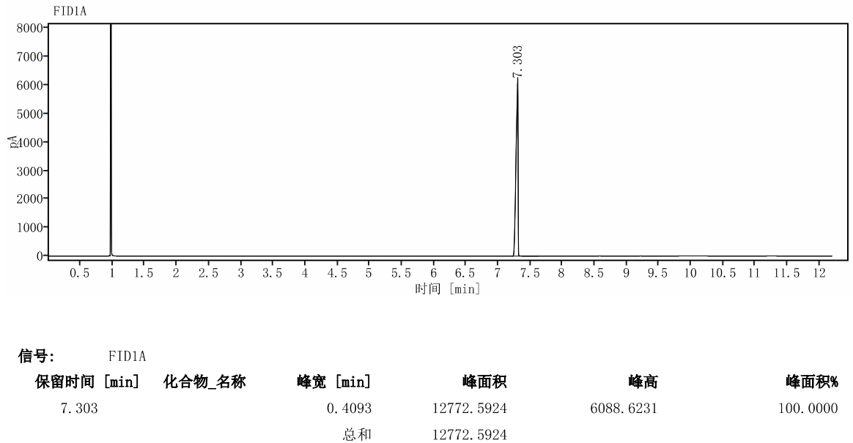
Fig. 8. GC (FID) analysis of the pure product Ph₃P

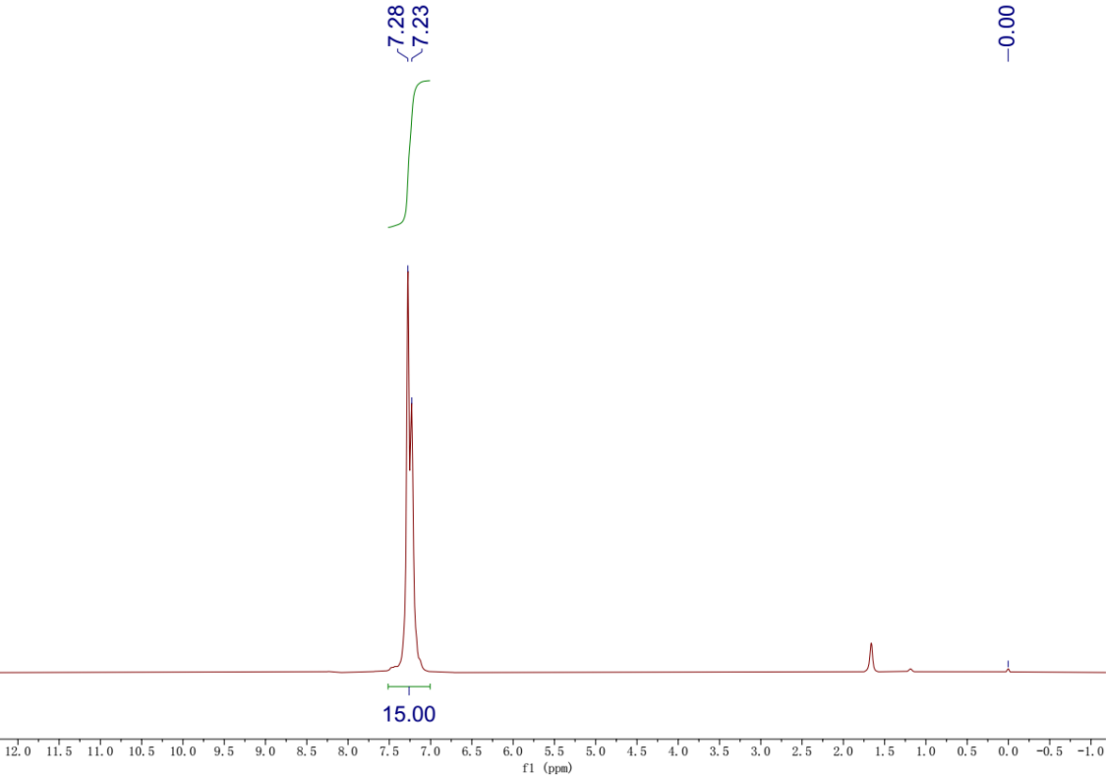
Fig. 9. ¹H NMR of Ph₃P（80 MHz, CDCl₃）

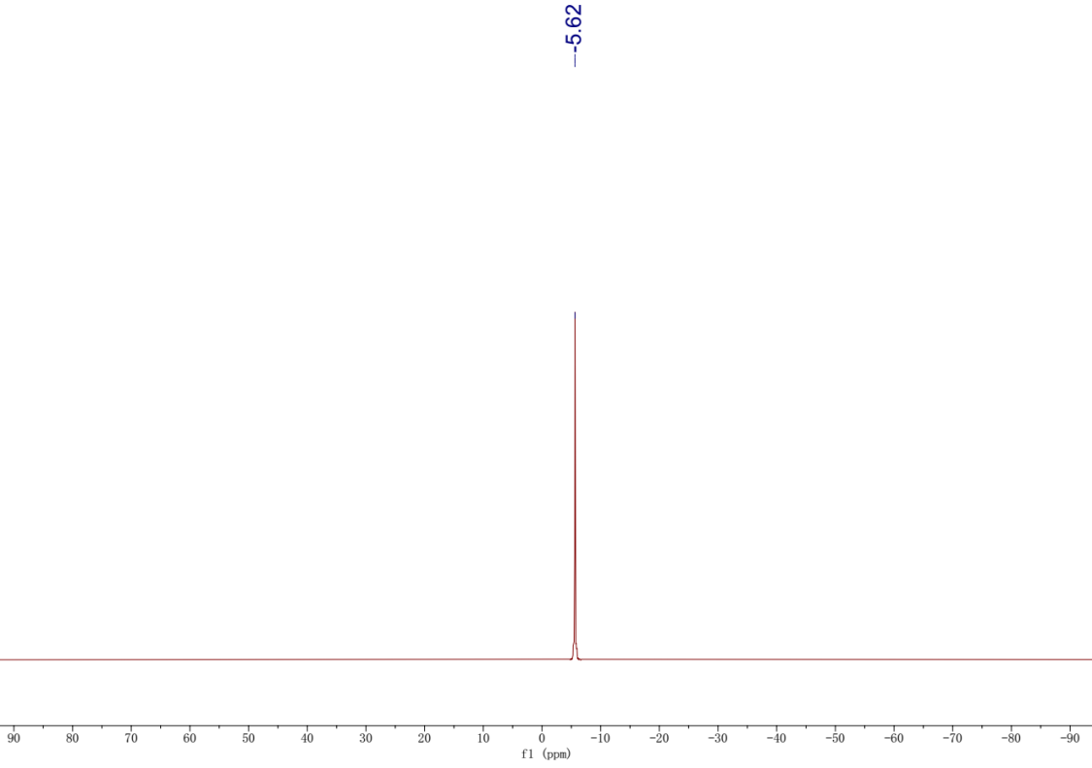
Fig. 10. ³¹P NMR of Ph₃P（33 MHz, CDCl₃）

