Supporting information
Direct and Diverse Synthesis of γ‑Amino Alcohols via Difunctionalization of Terminal Alkenes Using a Supported Cobalt Single‑Atom Catalyst
Wei Liu¹, Mingkai Liu²*，Hufengfeng Jiang, Pierre H. Dixneuf³, and Min Zhang¹*
¹Key Lab of Functional Molecular Engineering of Guangdong Province, School of Chemistry and Chemical Engineering, South China University of Technology, Guangzhou 510641, China.
²School of Chemistry and Chemical Engineering, Anhui University of Technology, Ma’anshan, Anhui, China.
³Univ. Rennes, CNRS, ISCR UMR 6226, 35000 Rennes, France
e-mail: liumingkai@ahut.edu.cn, minzhang@scut.edu.cn

Table of Contents
1. General Information S3
2. Procedure for the Preparation of Various Catalysts S4
2.1 Synthesis of Co₃O₄–phen/C. S4
2.2 Synthesis of Co-Nx/NC-900. S4
2.3 Synthesis of CoSA-N/NC. S4
2.4 Synthesis of SBA-15. S4
2.5 Synthesis of Co-N₄/HPC S4
3. Optimization of the reaction conditions S5
4. Characterization of Co-N₄/HPC S5
5. Experimental Procedure S7
5.1 The General Experimental Procedure for the Synthesis of C1 S7
5.2 Procedure for Catalyst Recycling. S7
5.3 Isolation of The Intermediate. S8
5.4 Conversion of The Intermediaten. S8
5.5 Poisoning Experiment S8
5.6 Acid etching of catalyst S9
5.7 Hot Filtration Experiment. S9
5.8 Verification of Hydroxy Source of the Products. S9
5.9 Formaldehyde-adsorption Experiments S9
6. Synthetic Utility S11
6.1 Gram-Scale Synthesis of γ-amino alcohol S11
6.2 Derivatization of γ-amino alcohols S11
6.3 Functionalization of Bioactive Molecules⁶ S12
6.4 Synthesis of phospholipase A2 inhibitor S13
7. Intermediate capture S15
8. References S18
9. Analytical Data of the Obtained Compounds S16
10. NMR Spectra of the Obtained Compounds S30

1. General Information
All chemicals were from commercial and used without further purification. Chemicals used in this work were purchased from the following vendors: nitroarenes (Energy Chemical, Bide Pharmatech Ltd., Accela ChemBio Co., Ltd., Macklin); styrene (Energy Chemical), 38% HCHO·H₂O, Cobalt chloride hexahydrate (CoCl₂·6H₂O, ≥99%) , tetraethyl orthosilicate (≥98 %), D-glutamic acid (≥98 %), P123, ethanol (≥99.7 %) and melamine (≥99%) were purchased from Shanghai Aladdin Biochemical Technology Co., Ltd. Hydrochloric acid (HCl, AR), and hydrofluoric acid (HF, ≥40%) were all purchased from Shanghai Chemical Reagent Company. All water used in the experiments was deionized water. All solvents were purchased from Greagent (Shanghai Titansci incorporated company) and used without further purification. All reactions were heated by metal sand bath (WATTCAS, LAB-500, https://www.wattcas.com.). Column chromatography was performed on silica gel (200-300 mesh). Reactions were monitored by using thin layer chromatography (TLC) (Qingdao Jivida silica gel reagent factory GF254).
All the obtained products were characterized by melting points (m.p.), ¹H-NMR, ¹³C-NMR, and mass spectra (MS), the NMR spectra of the known compounds were found to be identical with the ones reported in the literatures. Additionally, all the new compounds were further characterized by high resolution mass spectra (HRMS). Melting points were measured on an Electrothemal SGWX4 microscopy digital melting point apparatus and are uncorrected. Proton nuclear magnetic resonance (¹H-NMR) data were acquired on Bruker Avance400 (400 MHz), or Bruker Avance500 (500 MHz). Splitting patterns are designated as s, singlet; d, doublet; t, triplet; q, quartet; sept, septet; m, multiplet; br, broad; dt, doublet triplet. Proton decoupled Carbon-13 nuclear magnetic resonance (¹³C-NMR) data were acquired at 101 MHz on a Bruker Avance400 spectrometer, or at 125 MHz on a Bruker Avance500. Mass spectra were recorded on Trace DSQ GC/MS, High-resolution mass spectra (HRMS) were recorded on a JEOL JMS-600 spectrometer. TLC was performed using commercially prepared 100-400 mesh silica gel plates (GF254), and visualization was effected at 254 nm. Scanning electron microscopy (SEM) images were obtained from the ZEISS Sigma 500 electron microscope. Transmission electron microscope (TEM) images, high resolution TEM (HR-TEM), corresponding energy dispersive X-ray spectroscope (EDS) analysis were performed by applying a JEOL 2100 TEM (200 kV) instrument.Spherical-aberration-corrected HAADF-STEM images were obtained by using a Titan 80-300 scanning transmission electron microscope operated at an accelerating voltage of 300 kV, equipped with a probe spherical aberration corrector. X-ray diffraction (XRD) patterns were collected on a Bruker D2 Phaser using monochromatic Cu Kα radiation (λ = 1.54 Å). X-ray photoelectron spectroscopy (XPS) measurements were conducted on a PHI 5000 VersaProbe (ULVAC-PHI, Japan) system using a monochromatic Al Kα X-ray source (1,486.7 eV) with a beam diameter of 100 μm. The C1s peak has been fixed at the binding energy of 284.8 eV.The Brunauer-Emmett-Teller (BET) and Barrett-Joyner-Halenda (BJH) methods were used to calculate the specific surface area and pore volume and pore size distribution. X-ray absorption spectra (XAS) measurements were performed at BL14W1 beamline of Shanghai Synchrotron Radiation Facility (SSRF) operated at 3.5 GeV. The acquired XAFS data were processed according to the standard procedures using the ATHENA module of Demeter software packages.

2. Procedure for the Preparation of Various Catalysts

2.1 Synthesis of Co₃O₄–phen/C.¹ Cobalt(II) acetate tetrahydrate (126.8 mg, 0.5 mmol) and 1,10- phenanthroline (183.5 mg, 1.0 mmol) (Co:phenanthroline = 1:2 molar ratio) were stirred in ethanol (50 mL) for approximately 30 minutes at room temperature. Then, carbon powder (689.7 mg) (VULCAN® XC72R, Cabot Corporation Prod. Code XVC72R; CAS No. 1333-86-4) was added and the whole reaction mixture was refluxed for 4 hours. The reaction mixture was cooled to room temperature and the ethanol was removed in vacuo. The solid sample obtained was dried at 60 °C for 12 hours, after which it was grinded to a fine powder. Then, the grinded powder was transferred into a ceramic crucible and placed in the oven. The oven was evacuated to ca. 5 mbar and then flushed with argon. The oven was heated to 800 °C at the rate of 25 °C per minute, and held at 800 °C for 2 hours under argon atmosphere. After heating was switched off and the oven cooled back to room temperature to afford Co₃O₄–L₁/C porous carbon materials.

2.2 Synthesis of Co-Nx/NC-900.² At first, Co(NO₃)₂·6H₂O and Zn(NO₃)₂∙6H₂O with a Co²⁺/Zn²⁺ molar ratio of 1 : 20 was dissolved in 80 mL of methanol.[16] Another solution with 2- methylimidazole (3.70 g) and 80 mL methanol was added into the above solution and stirred at room temperature for 24 h. The total mole of (Zn + Co) was fixed at 5.65 mmol. The purply material was collected by centrifugation and washed with methanol for three times, dried under vacuum at 75 °C overnight. Then, the dried Co₁Zn₂₀-BMOF power (500 mg) was heated to 900 °C for 3 h with a heating rate of 5 °C /min under flowing argon, then cooled to room temperature naturally to afford Co-N_{x}/NC-900 porous carbon materials.

2.3 Synthesis of CoSA-N/NC.³ (Tetraphenylporphinato)cobalt (Co-TPP, 100 mg) and 1,10- phenanthroline (200 mg) were dissolved in dichloromethane (40 mL), and then carbon powder (1 g, VULCAN® XC72R, Cabot Corporation Prod. Code XVC72R; CAS No. 1333-86-4) was introduced and the resulting mixture and further stirred vigorously at room temperature for 30 min. After that, dichloromethane was removed under vacuum. The obtained solid sample was successively dried at 60 °C overnight, grinded to fine powder, and heated to 800 °C for 3 h at a heating rate of 2 °C/min under flowing argon, which afforded the Co_{SA}-N/NC porous carbon materials after cooling down to room temperature.

2.4 Synthesis of SBA-15.⁴ Mesoporous silica SBA-15 was synthesized following a modified procedure based on the method reported by Zhao et al. In a typical synthesis, 4.0 g of P123 was dissolved in a mixture of 105 mL deionized water and 20 mL concentrated hydrochloric acid under vigorous stirring. After complete dissolution, 9.1 mL of tetraethyl orthosilicate (TEOS) was added dropwise into the solution under continuous stirring. The mixture was then maintained at 40 °C under vigorous stirring for 12 h. Subsequently, the resulting white suspension was transferred into a 200 mL Teflon-lined autoclave and hydrothermally treated at 100 °C for 24 h. The solid product was collected, dried, and ground into a fine powder. Finally, the powder was calcined in a muffle furnace at 550 °C for 6 h to remove the polymer template, yielding white powdered mesoporous silica SBA-15.
2.5 Synthesis of Co-N₄/HPC. Typically, 200 mg of SBA-15, 300 mg of D-glutamic acid, and 300 mg of melamine were added into a mixed solvent composed of 50 mL ethanol and 50 mL deionized water. The mixture was vigorously stirred for 1 h. Subsequently, 2 mL of CoCl₂·6H₂O solution (0.2 M) was added into the mixture. The resulting mixture was continuously stirred at 60 °C to evaporate the solvent until a solid residue was obtained. The solid was then subjected to a two-step pyrolysis process under an Ar flow in a tube furnace: first heated to 600 °C at a ramp rate of 3 °C min⁻¹ and held for 60 min, followed by further heating to 900 °C at a rate of 2 °C min⁻¹ and maintained for 120 min. The carbonized product was treated with a 4 wt% HF aqueous solution for 24 h to remove the SBA-15 template. After centrifugation and repeated washing with deionized water, the collected precipitate was leached in 3 M HCl for 24 h to remove inactive cobalt species.
3. Optimization of the reaction conditions
Table S1. Optimization of Reaction Conditions
Entry | Catalyst | Additive | Solvent | T/ºC | Yield^{b}/%
1 | Co-N₄/HPC | pyridine | DMF | 80 | 57
2 | Co-N₄/HPC | DBU | DMF | 80 | 60
3 | Co-N₄/HPC | TBD | DMF | 80 | 62
4 | Co-N₄/HPC | TEA | DMF | 80 | 52
5 | Co-N₄/HPC | ^{t}BuOK | DMF | 80 | 48
6 | Co-N₄/HPC | CH₃COOH | DMF | 80 | trace
7 | Co-N₄/HPC | CF₃SO₃H | DMF | 80 | trace
8 | Co-N₄/HPC | Zn(OTf)₂ | DMF | 80 | 54
ªReaction conditions: nitrobenzene (0.3 mmol), HCHO (1 eq.), Co-N₄/HPC (10 mg), HCOOH (5 eq.), and DMF (2 mL), 80 °C, 36 h. ^{b}isolated yield.

4. Characterization of Co-N₄/HPC
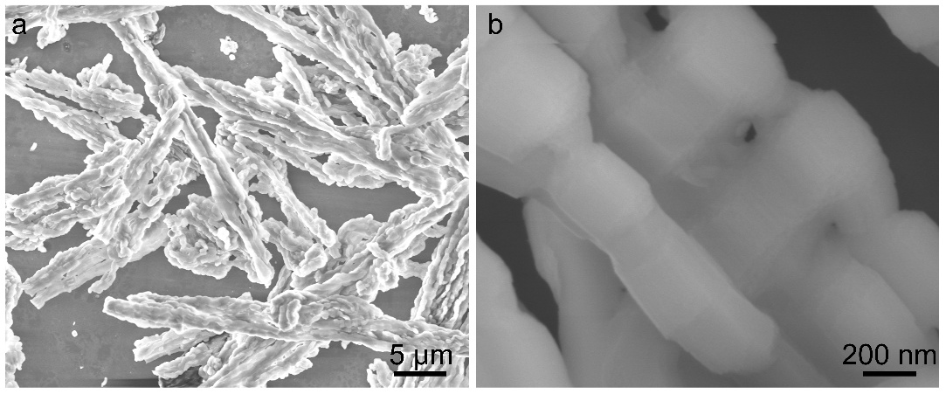
Figure S1. SEM images of SBA-15 template at (a) low and (b) high magnifications.
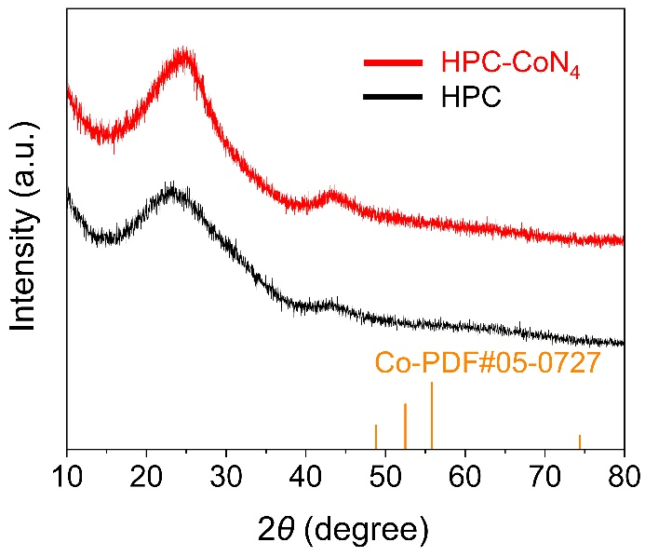
Figure S2. XRD patterns of HPC matrix and Co-N₄/HPC catalyst. 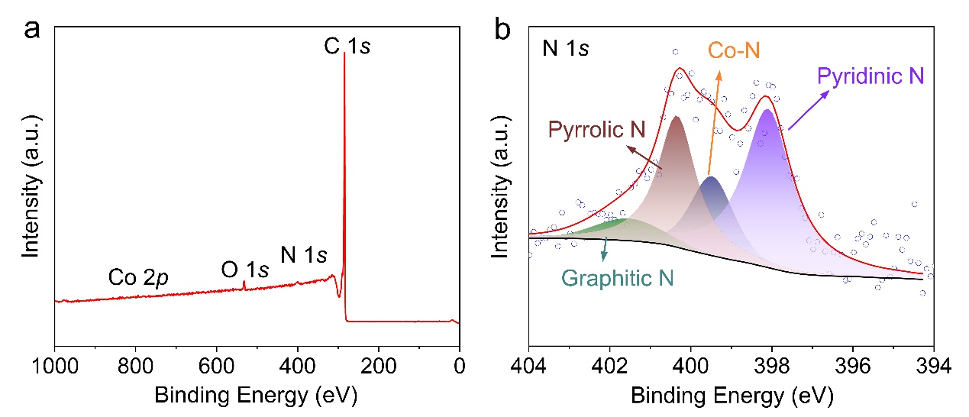
Figure S3. (a) XPS survey and (b) high-resolution N 1s spectra of Co-N₄/HPC catalyst.
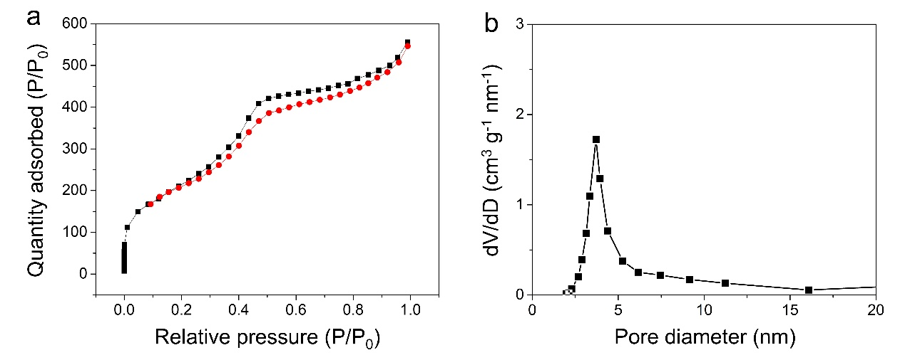
Figure S4. (a) N₂ adsorption/desorption isotherms and the (b) corresponding pore size distribution of Co-N₄/HPC catalyst.
Table 2. Structural parameters extracted from the Co K-edge for Co-N₄/HPC catalyst.
Sample | Scattering path | CN | R(Å) | σ²×10⁻³ (Å ²) | R factor
HPC-CoN₄ | Co-N | 3.9 | 1.93 | 0.88 | 0.006
5. Experimental Procedure

5.1 The General Experimental Procedure for the Synthesis of C1
Under nitrogen atmosphere, Co-N₄/HPC (10 mg), nitrobenzene A1 (31 µL, 0.3 mmol), HCHO(aq.), (19 µL, 0.25 mmol), styrene B1 (58 µL, 0.5 mmol), HCOOH (50 µL, 1.25 mmol), and DMF (2 mL) were added successively to a Schlenk tube (50 mL) equipped with a magnetic stirrer bar. The Schlenk tube was then closed and the resulting reaction mixture was heated at 80 °C for 36 h. After cooling to room temperature, the reaction mixture was poured into 20 mL of ethyl acetate and the organic layer was separated. The organic layer was washed with and brine, dried over Na₂SO₄ and concentrated. Finally, the residue was purified by TLC on silica gel to afford C1.

5.2 Procedure for Catalyst Recycling
Under nitrogen atmosphere, Co-N₄/HPC (10 mg), nitrobenzene A1 (31 µL, 0.3 mmol), HCHO(aq.), (19 µL, 0.25 mmol), styrene B1 (58 µL, 0.5 mmol), HCOOH (50 µL, 1.25 mmol), and DMF (2 mL) were added successively to a Schlenk tube (50 mL) equipped with a magnetic stirrer bar. The Schlenk tube was then closed and the resulting reaction mixture was heated at 80 °C for 36 h. After cooling to room temperature, the reaction mixture was poured into 20 mL of ethyl acetate and the organic layer was separated. The organic layer was washed with and brine, dried over Na₂SO₄ and concentrated. Finally, the residue was purified by TLC on silica gel to afford C1. The catalyst was isolated by centrifugation, washed with methanol for three times, then dried under vacuum at 80 °C for 12 h. The catalyst was then activated at 350 ºC and repeated five times. Similarly, the conditions of the half conversion are similar to those of the full conversion, except that the duration is reduced from 36 hours to 20 hours.
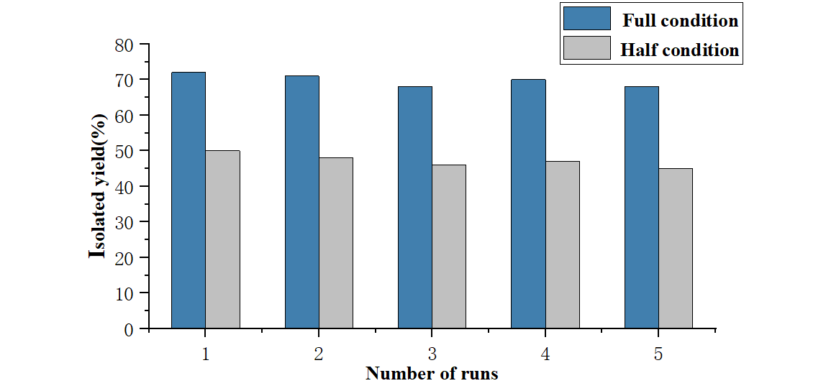
Figure S5. Catalyst Recycling
5.3 Isolation of The Intermediate
Under nitrogen atmosphere, Co-N₄/HPC (10 mg), nitrobenzene A1 (31 µL, 0.3 mmol), HCHO(aq.) (19 µL, 0.25 mmol), styrene B1 (58 µL, 0.5 mmol), HCOOH (50 µL, 1.25 mmol), and DMF (2 mL) were added successively to a Schlenk tube (50 mL) equipped with a magnetic stirrer bar. The Schlenk tube was then closed and the resulting reaction mixture was heated at 80 °C for 12 h. After cooling to room temperature, the reaction mixture was poured into 20 mL of ethyl acetate and the organic layer was separated. The organic layer was washed with and brine, dried over Na₂SO₄ and concentrated. Finally, the residue was purified by TLC on silica gel to afford int-4A1 (30% yield).
5.4 Conversion of The Intermediaten.
Under nitrogen atmosphere, Co-N₄/HPC (10 mg), int-4A1 (56.3 mg, 0.1 mmol) HCOOH (50 µL, 1.25 mmol), and DMF (2 mL) were added successively to a Schlenk tube (50 mL) equipped with a magnetic stirrer bar. The Schlenk tube was then closed and the resulting reaction mixture was heated at 80 °C for 36 h. After cooling to room temperature, the reaction mixture was poured into 20 mL of ethyl acetate and the organic layer was separated. The organic layer was washed with and brine, dried over Na₂SO₄ and concentrated. Finally, the residue was purified by TLC on silica gel to afford C1 (98% yield).
5.5 Poisoning Experiment
Under nitrogen atmosphere, Co-N₄/HPC (10 mg), nitrobenzene A1 (31 µL, 0.3 mmol), HCHO(aq.) (19 µL, 0.25 mmol), styrene B1 (58 µL, 0.5 mmol), HCOOH (50 µL, 1.25 mmol), KSCN(48.6mg, 0.5 mmol) and DMF (2 mL) were added successively to a Schlenk tube (50 mL) equipped with a magnetic stirrer bar. The Schlenk tube was then closed and the resulting reaction mixture was heated at 80 °C for 36 h. After cooling to room temperature, the reaction mixture was poured into 20 mL of ethyl acetate and the organic layer was separated. The organic layer was washed with and brine, dried over Na₂SO₄ and concentrated. Finally, the residue was purified by TLC on silica gel to afford C1.

5.6 Acid etching of the catalyst
The 10 mg Co-N₄/HPC was added to 50 ml 2M H₂SO₄ and stirred vigorously at 80℃ for 24h. After cooling to room temperature, the catalyst was centrifuged, washed with water three times, and dried under vacuum at 80 °C for 24 h to obtain the acid-etched catalyst. The acid-etched catalyst, when subjected to standard reaction conditions, afforded C1 in 72% yield.
5.7 Hot Filtration Experiment.
Co-N₄/HPC (10 mg) and DMF (2 mL) was added to an 10 mL vial and reaction for 30 min at 80 ºC, then the catalyst was filtrated away, nitrobenzene A1 (31 µL, 0.3 mmol), HCHO(aq.) (19 µL, 0.25 mmol), styrene B1 (58 µL, 0.5 mmol), HCOOH (50 µL, 1.25 mmol) was added in sequence to the vial and reacted for 36 h. After completion of the reaction, the mixture was concentrated in vacuum. It was not the discovery of the formation of the product C1.
5.8 Verification of Hydroxy Source of the Products.
Under nitrogen atmosphere, Co-N₄/HPC (10 mg), nitrobenzene A1 (31 µL, 0.3 mmol), HCHO(aq.) (19 µL, 0.25 mmol), styrene B1 (58 µL, 0.5 mmol), HCOOH (50 µL, 1.25 mmol), H₂¹⁸O(20 µl, 1mmol) and DMF (2 mL) were added successively to a Schlenk tube (50 mL) equipped with a magnetic stirrer bar. The Schlenk tube was then closed and the resulting reaction mixture was heated at 80 °C for 36 h. No ¹⁸O-labeled product was observed by HRMS.
5.9 Formaldehyde-adsorption Experiments
The formaldehyde concentrations in solution were detected by acetylacetone spectrophotometric method. The method is based on the reaction of formaldehyde with the acetylacetone and its read by a spectrophotometer. First, in a 10 mL glass beaker, CH₃COONH₄ (12.5 g) was dissolved in 5 mL distilled water at room temperature. Then, CH₃COOH (1.5 mL) and acetylacetone (0.125 mL) were added into the above solution and diluted to 50 mL to prepare the acetylacetone reagent. Secondly, four identical glass bottles to mark as A, B, C, D. The vial “A” was added HCHO(a.q.) (38 uL) and purified water (2 mL), heated to dissolve, then cooled to room temperature. The vial “B” was added acetylacetone (1 mL) and purified water (2 mL). The vial “C” was added HCHO(a.q.) (38 uL), and purified water (2 mL), heated to dissolve, then cooled to room temperature. Next, acetylacetone (1 mL) was added to get a yellow liquid. The vial “D” was added HCHO(a.q.) (38 uL), and purified water (2 mL), heated to dissolve, then cooled to room temperature.Next, acetylacetone (1 mL) and catalyst (10 mg) equipped with a magnetic stirrer bar under air for 1 h to get the colorless solution. Finally, the amount of adsorbed formaldehyde was determined by a spectrophotometer at 412 nm wavelength.
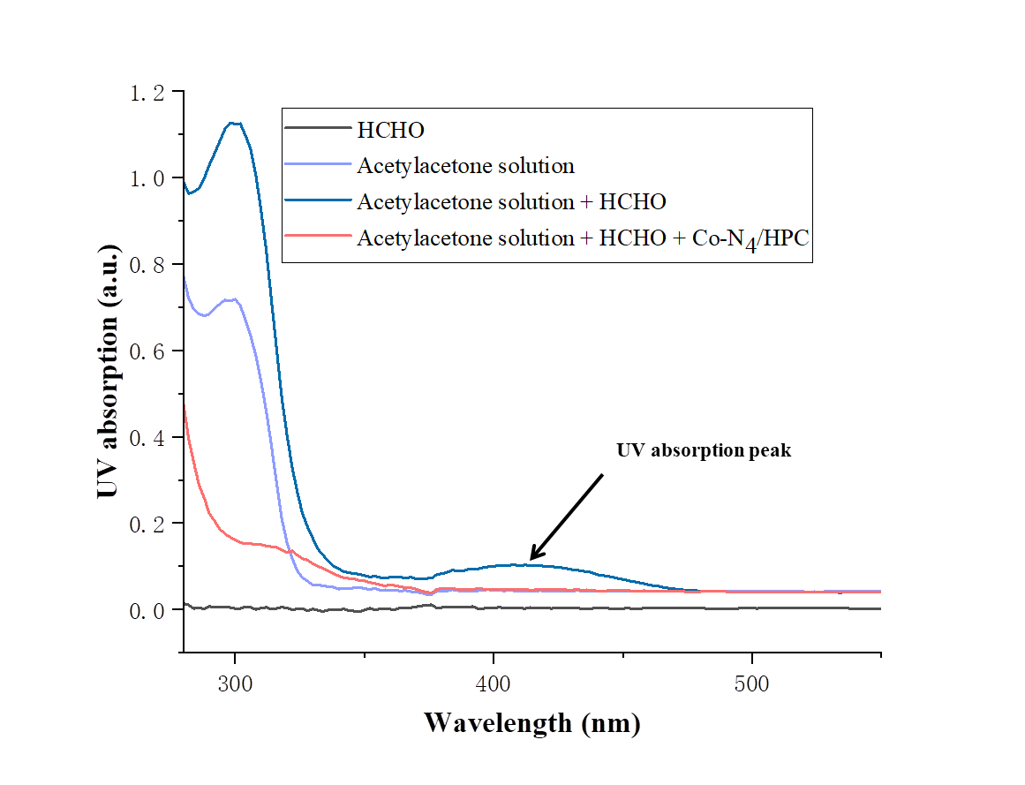
Figure S6. Formaldehyde-adsorption Experiment
6. Synthetic Utility
6.1 Gram-Scale Synthesis of γ-amino alcohol
Under nitrogen atmosphere, Co-N₄/HPC (250 mg), nitrobenzene A1 (766 µL, 7.5 mmol), HCHO(aq.), (475 µL, 6.25 mmol), styrene B1 (1450 µL, 12.5 mmol), HCOOH (1250 µL, 31.25 mmol), and DMF (50 mL) were added successively to a Schlenk tube (200 mL) equipped with a magnetic stirrer bar. The Schlenk tube was then closed and the resulting reaction mixture was heated at 80 °C for 36 h. After cooling to room temperature, the reaction mixture was poured into 50 mL of ethyl acetate and the organic layer was separated. The organic layer was washed with and brine, dried over Na₂SO₄ and concentrated, then separated by column chromatography. Afford the desired product C1 as the yellow solid (72% yield).
6.2 Derivatization of γ-amino alcohols
Under nitrogen atmosphere, the Schlenk tube was charged with C1 (22.7 mg, 0.10 mmol), dihalogenated alkane (1,8-diiodooctane) (73 mg, 0.2 mmol) and K₂CO₃ (151.8mg, 0.11 mmol), and MeCN (1 mL). The mixture was allowed to reflux at 90 °C in a metal bath for 28 h. After that, the reaction mixture was extracted with ethyl acetate, and the combined organic layer was dried over anhydrous Na₂SO₄, filtered and concentrated under vacuum. The crude product was purified by TLC to afford the desired product C50 as the yellow oil (40% yield). ¹H NMR (400 MHz, Chloroform-d) δ 7.38 – 7.27 (m, 5H), 7.22 (dd, J = 8.7, 7.3 Hz, 2H), 6.74 – 6.71 (m, 2H), 4.80 (dd, J = 7.2, 5.6 Hz, 1H), 3.43 (q, J = 6.8 Hz, 2H), 3.30 – 3.15 (m, 4H), 2.00 (q, J = 7.2 Hz, 2H), 1.82 (p, J = 7.0 Hz, 2H), 1.60 – 1.51 (m, 2H), 1.43 – 1.29 (m, 8H). ¹³C NMR (101 MHz, Chloroform-d) δ 148.3, 144.6, 129.3, 128.6, 127.7, 125.8, 116.6, 113.4, 73.2, 51.7, 48.5, 36.2, 33.5, 30.4, 29.3, 28.5, 27.1, 27.0, 7.4. HRMS (ESI): Calcd. for C23H31NO [M+H]⁺ : 338.2478; found: 338.2469.
The Schlenk tube was charged with C1 (22.7 mg, 0.1 mmol), HCHO (36% in H₂O,76 uL, 10.0 equiv., 1 mmol) and THF (1.5 mL). The mixture was stirred at room temperature for 6 h. The reaction was concentrated in vacuo. The residue was purified by preparative thin-layer chromatography using a mixture of petroleum ether and ethyl acetate (PE:EA = 20:1) as an eluent to afford the product C51 (91% yield). ¹H NMR (500 MHz, Chloroform-d) δ 7.43 – 7.31 (m, 7H), 7.25 – 7.18 (m, 2H), 6.99 (d, J = 6.7 Hz, 1H), 5.50 – 5.42 (m, 1H), 4.90 – 4.83 (m, 1H), 4.74 (d, 1H), 3.95 (d, 1H), 3.58 (t, J = 13.1 Hz, 1H), 2.09 – 1.97 (m, 1H), 1.68 (d, J = 13.6 Hz, 1H). ¹³C NMR (126 MHz, Chloroform-d) δ 149.0, 142.2, 142.2, 129.3, 129.3, 128.5, 127.8, 126.0, 120.7, 118.6, 81.6, 80.0, 50.2, 31.3. HRMS (ESI): Calcd. for C16H17NO [M+H]⁺ : 240.1383; found: 240.1385.
C1 (22.7 mg, 0.1 mmol) was dissolved in dichloromethane (2 mL) and cooled to −78 °C. Deoxofluor in toluene (1.1 mmol) was added in a single portion, the reaction was left stirring and allowed to warm to room temperature for 16 hours.⁵ The reaction mixture was poured into aqueous saturated NaHCO₃ (10 mL) and left until gas evolution stopped (safety: HF evolved). This was extracted with dichloromethane (3 × 10 mL), dried (Na₂SO₄) and filtered. Volatiles were removed in vacuo and the residue purified by column chromatography to give C52 as a colorless oil (28% yield). ¹H NMR (500 MHz, Chloroform-d) δ 7.40 – 7.33 (m, 5H), 7.18 (dd, J = 8.5, 7.3 Hz, 2H), 6.71 (t, J = 7.3 Hz, 1H), 6.61 (d, J = 7.9 Hz, 2H), 5.69 – 5.56 (m, 1H), 3.81 (s, 1H), 3.37 – 3.31 (m, 2H), 2.29 – 2.13 (m, 2H). ¹³C NMR (126 MHz, Chloroform-d) δ 148.0, 139.8, 129.3, 128.6, 128.5 (d, J = 2.5 Hz), 125.5 (d, J = 6.3 Hz), 117.5, 112.9, 93.1 (d, J = 170.1 Hz), 40.1, 36.9 (d, J = 22.7 Hz). ¹⁹F NMR (376 MHz, Chloroform-d) δ -176.18. HRMS (ESI): Calcd. for C15H16FN [M+H]⁺ : 230.1340; found: 230.1351.
The Schlenk tube was charged with C1 (22.7 mg, 0.1 mmol), Boc₂O (32.7 mg, 1.5 equiv., 0.15 mmol) and EtOH (0.5 mL). The mixture was stirred at room temperature for overnight. After that, the reaction mixture was extracted with ethyl acetate, and the combined organic layer was dried over anhydrous Na₂SO₄, filtered and concentrated under vacuum. The crude product was purified by TLC to afford the desired product C53 as the yellow oil (90% yield). ¹H NMR (500 MHz, Chloroform-d) δ 7.37 – 7.27 (m, 6H), 7.25 – 7.19 (m, 2H), 7.19 – 7.12 (m, 2H), 4.77 – 4.69 (m, 1H), 4.10 (s, 1H), 3.61 – 3.51 (m, 1H), 1.97 – 1.78 (m, 2H), 1.40 (s, 9H). ¹³C NMR (126 MHz, Chloroform-d) δ 155.8, 144.3, 142.2, 129.0, 128.4, 127.3, 127.2, 126.4, 125.7, 70.8, 46.9, 38.1, 28.3. HRMS (ESI): Calcd. for C20H25NO3 [M+Na]⁺ : 350.1727; found: 350.1734.
6.3 Functionalization of Bioactive Molecules⁶
To a stirred solution of 10 mmol carboxylic acid in l0 ml anhydrous CH₂Cl₂ is added 2 equivalent DMAP and 2 equivalent alcohol. DCC is added to the reaction mixture at 0 ºC , which is then stirred for 5min at 0°C and 3 h at 20°C. The solvent is removed by evaporation and the corresponding product is obtained by column chromatography. A53, A54, A56 are prepared by this method. C53, C54, C56 is obtained by the reaction of A53, A54, A56 under standard conditions.
White solid, m.p.:68.2 - 69.2 °C; ¹H NMR (400 MHz, Chloroform-d) δ 8.34 – 8.15 (m, 4H), 4.97 (td, J = 10.9, 4.4 Hz, 1H), 2.18 – 2.07 (m, 1H), 1.91 (td, J = 7.0, 2.7 Hz, 1H), 1.79 – 1.70 (m, 2H), 1.58 (ddt, J = 11.0, 7.7, 4.6 Hz, 2H), 1.19 – 1.08 (m, 2H), 0.98 – 0.89 (m, 7H), 0.79 (d, J = 7.0 Hz, 3H). ¹³C NMR (101 MHz, Chloroform-d) δ 164.2, 150.4, 136.2, 130.7, 123.5, 76.1, 47.2, 40.8, 34.2, 31.5, 26.6, 23.6, 22.0, 20.8, 16.5. HRMS (ESI): Calcd. for C17H23NO4 [M+H]⁺ : 306.1700; found: 306.1692.
White solid, m.p.:136.0 - 136.9 °C; ¹H NMR (400 MHz, Chloroform-d) δ 8.34 – 8.16 (m, 4H), 5.18 – 5.11 (m, 1H), 2.56 – 2.45 (m, 1H), 2.08 (m, 1H), 1.88 – 1.74 (m, 2H), 1.50 – 1.38 (m, 1H), 1.32 (m, 1H), 1.13 (m, 1H), 0.97 (s, 3H), 0.92 (m, 6H). ¹³C NMR (101 MHz, Chloroform-d) δ 164.9, 136.2, 130.6, 123.6, 81.8, 49.2, 48.0, 44.9, 36.9, 28.1, 27.4, 19.7, 18.9, 13.7. HRMS (ESI): Calcd. for C17H21NO4 [M+H]⁺ : 304.1543; found: 304.1539.
White solid, m.p.:254.3 - 255.3 °C; ¹H NMR (400 MHz, Chloroform-d) δ 8.28 (d, J = 8.8 Hz, 2H), 8.20 (d, J = 8.7 Hz, 2H), 5.43 (d, J = 4.4 Hz, 1H), 4.95 – 4.81 (m, 1H), 2.48 (d, J = 7.2 Hz, 2H), 2.05 – 1.76 (m, 6H), 1.64 – 1.39 (m, 8H), 1.39 – 1.30 (m, 3H), 1.26 – 1.19 (m, 2H), 1.16 – 1.10 (m, 3H), 1.08 – 0.97 (m, 7H), 0.92 (d, J = 6.5 Hz, 3H), 0.88 – 0.84 (m, 6H), 0.69 (s, 3H). ¹³C NMR (101 MHz, Chloroform-d) δ 150.4, 136.2, 130.7, 123.5, 123.2, 75.0, 56.7, 56.1, 50.0, 42.3, 39.7, 39.5, 38.1, 37.0, 36.6, 36.2, 35.8, 31.9, 31.9, 28.3, 28.0, 27.8, 24.3, 23.9, 22.9, 22.6, 21.1, 19.4, 18.7, 11.9. HRMS (ESI): Calcd. for C34H49NO4 [M+H]⁺ : 536.3734; found: 536.372.
6.4 Synthesis of phospholipase A2 inhibitor
Under nitrogen atmosphere, Co-N₄/HPC (10 mg), nitrobenzene A55 (766 µL, 0.3 mmol), HCHO(aq.), (19 µL, 0.25 mmol), styrene B30 (0.5 mmol), HCOOH (50 µL, 1.25 mmol), and DMF (2 mL) were added successively to a Schlenk tube (25 mL) equipped with a magnetic stirrer bar. The Schlenk tube was then closed and the resulting reaction mixture was heated at 80 °C for 36 h. After cooling to room temperature, the reaction mixture was poured into 50 mL of ethyl acetate and the organic layer was separated. The organic layer was washed with and brine, dried over Na₂SO₄ and concentrated, then separated by column chromatography. Afford the desired product C55 (53% yield). ¹H NMR (500 MHz, Chloroform-d) δ 7.38 – 7.30 (m, 2H), 7.09 – 6.96 (m, 4H), 6.59 (d, J = 8.0 Hz, 2H), 4.89 (dd, J = 7.5, 5.0 Hz, 1H), 3.27 (t, J = 6.3 Hz, 2H), 2.51 (t, J = 7.7 Hz, 2H), 2.05 – 1.97 (m, 2H), 1.62 – 1.51 (m, 2H), 1.41 – 1.31 (m, 2H), 0.92 (t, J = 7.3 Hz, 3H). ¹³C NMR (126 MHz, Chloroform-d) δ 162.2 (d, J = 247.0 Hz), 146.0, 140.2 (d, J = 2.5 Hz), 132.8, 129.2, 127.4 (d, J = 8.8 Hz), 115.3 (d, J = 21.4 Hz), 113.7, 73.3, 42.4, 38.4, 34.7, 34.0, 22.4, 14.0.¹⁹F NMR (376 MHz, Chloroform-d) δ -115.08.
Figure S7. Nitroarenes employed for the synthesis of γ-amino alcohol.

Figure S8. Alkenes employed for the synthesis of γ-amino alcohol.

7. Intermediate capture
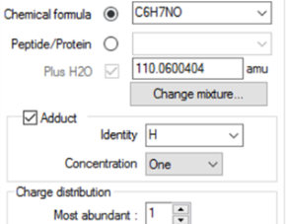
int-2A1
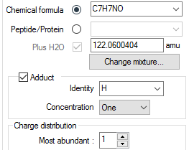
int-3A1
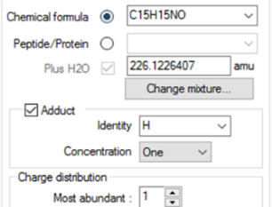
Int-4A1
Figure S9. HRMS of the int-2A1, int-3A1 and int-4A1 intermediates generated by interruption test of the model reaction at 1 hour
8. References
(1) Westerhaus, F. A.; Jagadeesh, R. V.; Wienhöfer, G.; Pohl, M.-M.; Radnik, J.; Surkus, A.-E.; Rabeah, J.; Junge, K.; Junge, H.; Nielsen, M.; Brückner, A.; Beller, M. Heterogenized Cobalt Oxide Catalysts for Nitroarene Reduction by Pyrolysis of Molecularly Defined Complexes. Nat. Chem. 2013, 5, 537–543.
(2) Sun, J.-L.; Ci, C.; Jiang, H.; Dixneuf, P. H.; Zhang, M. Utilizing Nitroarenes and HCHO to Directly Construct Functional N-Heterocycles by Supported Cobalt/Amino Acid Relay Catalysis. Angew. Chem. Int. Ed. 2023, 62, e202303007.
(3) Sun, J.-L.; Jiang, H.; Dixneuf, P. H.; Zhang, M. Reductive Coupling of Nitroarenes and HCHO for General Synthesis of Functional Ethane-1,2-Diamines by a Cobalt Single-Atom Catalyst. J. Am. Chem. Soc. 2023, 145, 17329–17336.
(4) Zhao, D.; Feng, J.; Huo, Q.; Melosh, N.; Fredrickson, G. H.; Chmelka, B. F.; Stucky, G. D. Triblock Copolymer Syntheses of Mesoporous Silica with Periodic 50 to 300 Angstrom Pores. Science 1998, 279, 548–552.
(5)Willcox, D. R.; Nichol, G. S.; Thomas, S. P. Borane-Catalyzed C(Sp3)–F Bond Arylation and Esterification Enabled by Transborylation. ACS Catal. 2021, 11, 3190–3197.
(6) Neises, B.; Steglich, W. Simple Method for the Esterification of Carboxylic Acids. Angew. Chem. Int. Ed. 1978, 17, 522–524.
9. Analytical Data of the Obtained Compounds
C1: 1-phenyl-3-(phenylamino)propan-1-ol
(Known compound, see: J. Wang, Y. Wang, D. Liu, W. Zhang, Adv. Synth. Catal. 2015, 357, 3262-3272). Yellow liquid (41.2 mg, 72% yield); TLC (petroleum ether: ethyl acetate = 3: 1); ¹H NMR (400 MHz, Chloroform-d): δ 7.40-7.29 (m, 5H), 7.20 (t, J = 8.0 Hz, 2H), 6.76 (t, J = 7.4 Hz, 1H), 6.64 (d, J = 7.6 Hz, 2H), 4.90-4.86 (m, 1H), 3.31-3.27 (m, 4H), 2.12-1.99 (m, 2H); ¹³C NMR (100 MHz, Chloroform-d): δ 148.3, 144.5, 129.4, 128.7, 127.8, 125.8, 118.0, 113.5, 73.7, 41.8, 38.3. HRMS (ESI): Calcd. for C15H17NO [M+H]⁺ : 228.1383; found: 228.1384.
C2: 1-phenyl-3-(p-tolylamino)propan-1-ol
White solid (33.2 mg, 55% yield), m.p.: 83.0 – 84.0 °C; TLC (petroleum ether: ethyl acetate = 3: 1); ¹H NMR (400 MHz, Chloroform-d) δ 7.44 – 7.32 (m, 4H), 7.34 – 7.27 (m, 1H), 7.04 – 6.96 (m, 2H), 6.63 – 6.53 (m, 2H), 4.90 (dd, J = 7.3, 5.3 Hz, 1H), 3.27 (t, J = 6.3 Hz, 2H), 2.25 (s, 3H), 2.10 – 2.01 (m, 2H). ¹³C NMR (126 MHz, Chloroform-d) δ 145.9, 144.5, 129.8, 128.6, 127.6, 127.3, 125.7, 113.7, 73.9, 42.3, 38.3, 20.4. HRMS (ESI): Calcd. for C16H19NO [M+H]⁺ : 242.1539; found: 242.1539.
C3: 1-phenyl-3-(m-tolylamino)propan-1-ol
Yellow solid (33.2 mg, 55% yield), m.p.: 44.8 – 45.3 °C; TLC (petroleum ether: ethyl acetate = 3: 1);¹H NMR (400 MHz, Chloroform-d) δ 7.40 – 7.28 (m, 5H), 7.13 – 7.06 (m, 1H), 6.59 (d, J = 7.4 Hz, 1H), 6.46 (d, J = 6.0 Hz, 2H), 4.88 (dd, J = 7.2, 5.4 Hz, 1H), 3.27 (t, J = 6.4 Hz, 2H), 2.30 (s, 3H), 2.09 – 2.00 (m, 2H). ¹³C NMR (101 MHz, Chloroform-d) δ 148.3, 144.5, 139.1, 129.2, 128.6, 127.7, 125.8, 118.8, 114.2, 110.6, 73.7, 41.8, 38.3, 21.7. HRMS (ESI): Calcd. for C16H19NO [M+H]⁺ : 242.1539; found: 242.1537.
C4: 1-phenyl-3-(o-tolylamino)propan-1-ol
Yellow liquid (32.0 mg, 53% yield); TLC (petroleum ether: ethyl acetate = 3: 1); ¹H NMR (400 MHz, Chloroform-d) δ 7.43 – 7.29 (m, 5H), 7.20 – 7.04 (m, 2H), 6.76 – 6.60 (m, 2H), 4.91 (dd, J = 7.6, 4.9 Hz, 1H), 3.33 (t, J = 6.4 Hz, 2H), 2.18 – 2.04 (m, 5H). ¹³C NMR (101 MHz, Chloroform-d) δ 146.3, 144.4, 130.1, 128.6, 127.8, 127.2, 125.8, 122.5, 117.3, 110.1, 74.0, 41.7, 38.1, 17.5. HRMS (ESI): Calcd. for C16H19NO [M+H]⁺ : 242.1539; found: 242.1536.
C5: 3-((4-ethylphenyl)amino)-1-henylpropan-1-ol
Yellow solid (35.2 mg, 55% yield), m.p.: 66.9 – 67.9 °C; TLC (petroleum ether: ethyl acetate = 3: 1); ¹H NMR (400 MHz, Chloroform-d) δ 7.40 – 7.25 (m, 5H), 7.07 – 6.99 (m, 2H), 6.65 – 6.51 (m, 2H), 4.90 (dd, J = 7.4, 5.2 Hz, 1H), 3.28 (t, J = 6.3 Hz, 2H), 2.56 (q, J = 7.6 Hz, 2H), 2.10 – 1.99 (m, 2H), 1.21 (t, J = 7.6 Hz, 3H). ¹³C NMR (126 MHz, Chloroform-d) δ 146.1, 144.5, 134.0, 128.6, 128.6, 127.6, 125.8, 113.7, 73.9, 42.3, 38.3, 28.0, 16.0. HRMS (ESI): Calcd. for C17H21NO [M+H]⁺ : 256.1696; found: 256.1696.
C6: 3-((4-fluorophenyl)amino)-1-phenylpropan-1-ol
Yellow liquid (33.9 mg, 55% yield); TLC (petroleum ether: ethyl acetate = 3: 1); ¹H NMR (400 MHz, Chloroform-d) δ 7.41 – 7.26 (m, 5H), 6.93 – 6.85 (m, 2H), 6.59 – 6.50 (m, 2H), 4.87 (dd, J = 7.6, 5.0 Hz, 1H), 3.22 (t, J = 6.4 Hz, 2H), 2.08 – 1.97 (m, 2H). ¹³C NMR (101 MHz, Chloroform-d) δ 157.3, 154.9, 144.6 (d, J = 2.2 Hz), 144.4, 128.6, 127.7, 125.7, 115.7 (d, J = 22.2 Hz), 114.3 (d, J = 7.3 Hz), 73.8, 42.5, 38.1. ¹⁹F NMR (376 MHz, Chloroform-d) δ -127.46. HRMS (ESI): Calcd. for C15H16FNO [M+H]⁺ : 246.1289; found: 246.1288.
C7: 3-((4-chlorophenyl)amino)-1-phenylpropan-1-ol
Yellow solid (42.7 mg, 65% yield), m.p.: 48.7– 49.7 °C; TLC (petroleum ether: ethyl acetate = 3: 1); ¹H NMR (400 MHz, Chloroform-d) δ 7.40 – 7.28 (m, 5H), 7.15 – 7.08 (m, 2H), 6.55 – 6.49 (m, 2H), 4.88 (dd, J = 7.8, 4.8 Hz, 1H), 3.24 (t, J = 6.5 Hz, 2H), 2.11 – 1.98 (m, 2H). ¹³C NMR (126 MHz, Chloroform-d) δ 146.8, 144.3, 129.1, 128.7, 127.8, 125.7, 122.2, 114.2, 73.7, 41.7, 38.0. Calcd. for C15H16ClNO [M+H]⁺ : 262.0993; found: 262.0993.
C8: 3-((4-bromophenyl)amino)-1-phenylpropan-1-ol
Yellow solid (58.0 mg, 76% yield), m.p.: 60.2 – 61.2 °C; TLC (petroleum ether: ethyl acetate = 3: 1); ¹H NMR (400 MHz, Chloroform-d) δ 7.31 – 7.24 (m, 4H), 7.24 – 7.19 (m, 1H), 7.16 – 7.13 (m, 2H), 6.39 – 6.35 (m, 2H), 4.77 (dd, J = 7.8, 4.8 Hz, 1H), 3.14 (t, J = 6.5 Hz, 2H), 1.99 – 1.91 (m, 2H). ¹³C NMR (126 MHz, Chloroform-d) δ 147.3, 144.3, 131.9, 128.7, 127.8, 125.7, 114.7, 109.3, 73.6, 41.5, 38.0. HRMS (ESI): Calcd. for C15H16BrNO [M+H]⁺ : 306.0488; found: 306.0486.
C9: 3-((3-iodophenyl)amino)-1-phenylpropan-1-ol
Yellow solid (68.0 mg, 77% yield), m.p.: 41.7 – 42.7 °C; TLC (petroleum ether: ethyl acetate = 3: 1); ¹H NMR (400 MHz, Chloroform-d) δ 7.39 – 7.27 (m, 5H), 7.02 (dt, J = 7.8, 1.3 Hz, 1H), 6.93 (t, J = 2.0 Hz, 1H), 6.86 (t, J = 7.9 Hz, 1H), 6.53 (ddd, J = 8.2, 2.3, 0.9 Hz, 1H), 4.85 (dd, J = 7.8, 4.9 Hz, 1H), 3.21 (t, J = 6.8 Hz, 2H), 2.06 – 1.94 (m, 2H). ¹³C NMR (126 MHz, Chloroform-d) δ 149.5, 144.2, 130.7, 128.7, 127.9, 126.3, 125.7, 121.5, 112.4, 95.4, 73.5, 41.2, 37.9. HRMS (ESI): Calcd. for C15H16INO [M+H]⁺ : 354.0349; found: 354.0346.
C10: 4-((3-hydroxy-3-phenylpropyl)amino)benzaldehyde
Yellow solid (52.3 mg, 82% yield), m.p.:80.1 – 81.7 °C; TLC (petroleum ether: ethyl acetate = 3: 1); ¹H NMR (400 MHz, Chloroform-d) δ 9.66 (s, 1H), 7.71 – 7.62 (m, 2H), 7.38 (d, J = 4.1 Hz, 5H), 6.58 (d, J = 8.7 Hz, 2H), 4.90 (dd, J = 7.8, 4.7 Hz, 1H), 3.44 – 3.29 (m, 2H), 2.18 – 2.01 (m, 2H). ¹³C NMR (126 MHz, Chloroform-d) δ 190.5, 153.6, 144.1, 132.5, 128.7, 127.9, 126.1, 125.7, 111.8, 73.3, 40.6, 37.7. HRMS (ESI): Calcd. for C16H17NO2 [M+H]⁺ : 256.1332; found: 256.1332.
C11: 4-((3-hydroxy-3-phenylpropyl)amino)benzonitrile
Yellow liquid (35.2 mg, 72% yield); TLC (petroleum ether: ethyl acetate = 3: 1); ¹H NMR (400 MHz, Chloroform-d) δ 7.42 – 7.27 (m, 7H), 6.55 – 6.48 (m, 2H), 4.86 (dd, J = 7.8, 4.7 Hz, 1H), 3.29 (t, J = 6.4 Hz, 2H), 2.11 – 1.99 (m, 2H). ¹³C NMR (126 MHz, Chloroform-d) δ 151.5, 144.1, 133.7, 128.7, 128.0, 125.7, 120.7, 112.2, 98.2, 73.4, 40.6, 37.6. Calcd. for C16H16N2O [M+H]⁺ : 253.1335; found: 253.1333.

C12: 3-((4-methoxyphenyl)amino)-1-phenylpropan-1-ol
Brown solid (16.0 mg, 25% yield), m.p.:50.6 – 51.2 °C; TLC (petroleum ether: ethyl acetate = 3: 1); ¹H NMR (400 MHz, Chloroform-d) δ 7.42 – 7.32 (m, 5H), 7.27 (t, J = 6.6 Hz, 1H), 6.96 (d, J = 7.6 Hz, 1H), 6.81 (d, J = 2.1 Hz, 1H), 6.75 (dd, J = 8.1, 2.4 Hz, 1H), 4.90 (dd, J = 7.8, 4.7 Hz, 1H), 3.31 (t, J = 6.2 Hz, 2H), 2.12 – 2.01 (m, 2H). ¹³C NMR (126 MHz, Chloroform-d) δ 152.7, 144.4, 142.2, 128.6, 127.6, 125.7, 115.2, 114.9, 55.8, 43.2, 38.2. HRMS (ESI): Calcd. for C16H19NO2 [M+H]⁺ : 258.1489; found: 258.1489.
C13: 1-phenyl-3-((3-(trifluoromethyl)phenyl)amino)propan-1-ol
Yellow liquid (52.4 mg, 71% yield); TLC (petroleum ether: ethyl acetate = 3: 1); ¹H NMR (400 MHz, Chloroform-d) δ 7.43 – 7.32 (m, 5H), 7.27 (t, J = 7.9 Hz, 1H), 6.97 (d, J = 7.6 Hz, 1H), 6.81 (d, J = 2.2 Hz, 1H), 6.75 (dd, J = 8.2, 2.4 Hz, 1H), 4.89 (dd, J = 7.8, 4.8 Hz, 1H), 3.30 (t, J = 6.7 Hz, 2H), 2.12 – 2.03 (m, 2H). ¹³C NMR (101 MHz, Chloroform-d) δ 148.5, 144.2, 131.5 (q, J = 31.3 Hz), 129.6, 128.7, 127.9, 125.7, 116.0, 113.8 (q, J = 3.8 Hz), 109.1 (q, J = 3.9 Hz), 73.6, 41.3, 37.9. ¹⁹F NMR (376 MHz, Chloroform-d) δ -62.74. HRMS (ESI): Calcd. for C16H16F3NO [M+H]⁺ : 296.1257; found: 296.1255.
C14: methyl 4-((3-hydroxy-3-phenylpropyl)amino)benzoate
White solid (52.1 mg, 73% yield), m.p.:96.3 – 97.3 °C; TLC (petroleum ether: ethyl acetate = 3: 1); ¹H NMR (400 MHz, Chloroform-d) δ 7.91 – 7.83 (m, 2H), 7.41 – 7.29 (m, 5H), 6.57 – 6.47 (m, 2H), 4.87 (dd, J = 7.8, 4.8 Hz, 1H), 3.84 (s, 3H), 3.32 (t, J = 7.2 Hz, 2H), 2.18 – 2.00 (m, 2H). ¹³C NMR (126 MHz, Chloroform-d) δ 167.5, 152.1, 144.2, 131.6, 128.7, 127.9, 125.7, 118.1, 111.5, 73.3, 51.6, 40.7, 37.8. HRMS (ESI): Calcd. for C17H19NO3 [M+H]⁺ : 286.1438; found: 286.1438.
C15: 1-(4-((3-hydroxy-3-phenylpropyl)amino)phenyl)ethan-1-one
Yellow solid (49.1 mg, 73% yield), m.p.:100.2 – 101.2 °C; TLC (petroleum ether: ethyl acetate = 3: 1); ¹H NMR (400 MHz, Chloroform-d) δ 7.39 – 7.30 (m, 5H), 7.29 – 7.24 (m, 2H), 7.19 (dd, J = 2.7, 1.5 Hz, 1H), 6.80 (ddd, J = 7.5, 2.6, 1.5 Hz, 1H), 4.89 (dd, J = 7.8, 4.9 Hz, 1H), 3.32 (t, J = 6.2 Hz, 2H), 2.56 (s, 3H), 2.10 – 1.98 (m, 2H). ¹³C NMR (101 MHz, Chloroform-d) δ 196.8, 152.5, 144.3, 130.9, 128.6, 127.8, 126.3, 125.7, 111.4, 73.1, 40.6, 37.8, 26.0. HRMS (ESI): Calcd. for C17H19NO2 [M+H]⁺ : 270.1489; found: 270.1487.

C16: 3-((4-(methylthio)phenyl)amino)-1-phenylpropan-1-ol
Yellow solid (33.5 mg, 49% yield), m.p.:45.7 – 46.7°C; TLC (petroleum ether: ethyl acetate = 3: 1); ¹H NMR (400 MHz, Chloroform-d) δ 7.39 – 7.27 (m, 5H), 7.24 – 7.18 (m, 2H), 6.58 – 6.53 (m, 2H), 4.86 (dd, J = 7.7, 4.9 Hz, 1H), 3.24 (t, J = 6.5 Hz, 2H), 2.41 (s, 3H), 2.07 – 2.00 (m, 2H). ¹³C NMR (101 MHz, Chloroform-d) δ 147.1, 144.4, 131.4, 128.6, 127.8, 125.7, 124.6, 113.8, 73.6, 41.6, 38.1, 19.1. HRMS (ESI): Calcd. for C16H19NOS [M+H]⁺ : 274.1260; found: 274.1259.
C17: 3-(naphthalen-1-ylamino)-1-phenylpropan-1-ol
Brown liquid (16.6 mg, 24% yield); TLC (petroleum ether: ethyl acetate = 3: 1); ¹H NMR (400 MHz, Chloroform-d) δ 7.81 (ddd, J = 9.3, 7.3, 2.2 Hz, 2H), 7.50 – 7.31 (m, 8H), 7.28 (s, 1H), 6.63 (d, J = 7.5 Hz, 1H), 5.02 (dd, J = 7.7, 4.6 Hz, 1H), 3.47 (t, J = 6.2 Hz, 2H), 2.33 – 2.17 (m, 2H). ¹³C NMR (101 MHz, Chloroform-d) δ 161.6, 146.6, 145.3, 144.4, 143.8, 128.6, 127.7, 125.7, 119.4, 118.6, 117.4, 116.5, 108.4, 73.3, 41.8, 37.9. HRMS (ESI): Calcd. for C19H19NO [M+H]⁺ : 278.1539; found: 278.1540.
C18: 3-((9H-fluoren-3-yl)amino)-1-phenylpropan-1-ol
White solid (26.8 mg, 34% yield), m.p.:131.4 – 132.4 °C; TLC (petroleum ether: ethyl acetate = 3: 1); ¹H NMR (400 MHz, Chloroform-d) δ 7.60 (dd, J = 20.1, 7.9 Hz, 2H), 7.46 (d, J = 7.5 Hz, 1H), 7.41 – 7.28 (m, 6H), 7.18 (m, 1H), 6.81 (d, J = 2.3 Hz, 1H), 6.65 (dd, J = 8.2, 2.3 Hz, 1H), 4.93 (dd, J = 7.6, 5.0 Hz, 1H), 3.81 (s, 2H), 3.35 (t, J = 6.4 Hz, 2H), 2.10 (tt, J = 6.5, 5.1 Hz, 2H). ¹³C NMR (101 MHz, Chloroform-d) δ 147.8, 145.2, 144.4, 142.3, 142.2, 128.6, 127.8, 126.6, 125.8, 124.9, 124.7, 120.6, 118.5, 112.5, 109.7, 42.0, 38.2, 37.0. HRMS (ESI): Calcd. for C22H21NO [M+H]⁺ : 316.1695; found: 316.1691.
C19: 3-([1,1'-biphenyl]-2-ylamino)-1-phenylpropan-1-ol
Yellow liquid (50.8 mg, 67% yield); TLC (petroleum ether: ethyl acetate = 3: 1); ¹H NMR (400 MHz, Chloroform-d) δ 7.51 – 7.44 (m, 4H), 7.41 – 7.27 (m, 7H), 7.14 (dd, J = 7.5, 1.7 Hz, 1H), 6.82 (td, J = 7.4, 1.2 Hz, 1H), 6.78 – 6.74 (m, 1H), 4.82 (dd, J = 7.9, 4.8 Hz, 1H), 3.28 (t, J = 6.6 Hz, 2H), 2.07 – 1.93 (m, 2H). ¹³C NMR (126 MHz, Chloroform-d) δ 145.1, 144.3, 139.5, 130.2, 129.4, 128.9, 128.7, 128.6, 128.1, 127.7, 127.3, 125.7, 117.3, 110.9, 73.4, 41.6, 38.2. HRMS (ESI): Calcd. for C21H21NO [M+H]⁺ : 304.1696; found: 304.1694.

C20: 6-((3-hydroxy-3-phenylpropyl)amino)-2H-chromen-2-one
Yellow solid (47.2 mg, 64% yield), m.p.:94.2 – 95.2 °C; TLC (petroleum ether: ethyl acetate = 2: 1); ¹H NMR (400 MHz, Chloroform-d) δ 7.56 (dd, J = 9.5, 2.1 Hz, 1H), 7.41 – 7.25 (m, 5H), 7.11 (d, J = 8.9 Hz, 1H), 6.79 (dd, J = 8.9, 2.8 Hz, 1H), 6.54 (d, J = 2.8 Hz, 1H), 6.33 (d, J = 9.4 Hz, 1H), 4.91 (dd, J = 7.8, 4.8 Hz, 1H), 3.28 (t, J = 6.4 Hz, 2H), 2.11 – 2.04 (m, 2H). ¹³C NMR (101 MHz, Chloroform-d) δ 161.6, 146.7, 145.3, 144.4, 143.7, 128.6, 127.7, 125.7, 119.4, 118.6, 117.4, 116.5, 108.4, 73.4, 41.8, 37.9. HRMS (ESI): Calcd. for C18H17NO3 [M+H]⁺ : 296.1281; found: 296.1282.
C21: 3-((5-bromopyridin-3-yl)amino)-1-phenylpropan-1-ol
Yellow solid (55.1 mg, 72% yield), m.p.:55.0 – 51.0 °C; TLC (petroleum ether: ethyl acetate = 2: 1); ¹H NMR (400 MHz, Chloroform-d) δ 7.95 (dd, J = 29.1, 1.6 Hz, 2H), 7.57 – 7.43 (m, 5H), 7.11 (s, 1H), 5.01 (dd, J = 7.7, 4.7 Hz, 1H), 3.35 (s, 2H), 2.20 (p, J = 6.6 Hz, 2H). ¹³C NMR (101 MHz, Chloroform-d) δ 145.5, 144.5, 138.2, 134.0, 128.6, 127.7, 125.7, 120.5, 73.0, 40.8, 37.6. HRMS (ESI): Calcd. for C14H15BrN2O [M+H]⁺ : 307.0441; found: 307.0437.
C22: 1-phenyl-3-(quinolin-6-ylamino)propan-1-ol
Yellow solid (21.0 mg, 30% yield), m.p.:87.5 – 88.5 °C; TLC (petroleum ether: ethyl acetate = 2: 1); ¹H NMR (400 MHz, DMSO-d₆) δ 8.46 (dd, J = 4.2, 1.6 Hz, 1H), 7.95 (d, J = 7.5 Hz, 1H), 7.70 (d, J = 9.1 Hz, 1H), 7.40 (d, J = 7.1 Hz, 2H), 7.33 (t, J = 7.6 Hz, 2H), 7.29 – 7.21 (m, 3H), 6.61 (d, J = 2.5 Hz, 1H), 6.24 (t, J = 5.2 Hz, 1H), 5.41 (d, J = 4.0 Hz, 1H), 4.79 – 4.72 (m, 1H), 3.25 – 3.10 (m, 2H), 1.95 (m, 2H). ¹³C NMR (101 MHz, DMSO-d₆) δ 147.5, 146.7, 145.3, 142.7, 133.6, 130.6, 129.8, 128.5, 127.2, 126.2, 122.2, 121.8, 101.3, 70.7, 40.4, 38.8. HRMS (ESI): Calcd. for C18H18N2O [M+H]⁺ : 279.1492; found: 279.1489.
C23: 3-(benzo[d][1,3]dioxol-5-ylamino)-1-phenylpropan-1-ol
Brown solid (21.0 mg, 31% yield), m.p.:50.4 – 51.4 °C; TLC (petroleum ether: ethyl acetate = 3: 1); ¹H NMR (400 MHz, Chloroform-d) δ 7.37 – 7.27 (m, 5H), 6.65 (d, J = 8.2 Hz, 1H), 6.26 (d, J = 2.3 Hz, 1H), 6.07 (dd, J = 8.3, 2.3 Hz, 1H), 5.85 (s, 2H), 4.89 (dd, J = 7.5, 5.1 Hz, 1H), 3.22 (t, J = 6.4 Hz, 2H), 2.05 – 2.00 (m, 2H). ¹³C NMR (101 MHz, Chloroform-d) δ 148.3, 144.4, 143.9, 140.0, 128.6, 127.7, 125.7, 108.6, 105.2, 100.6, 96.7, 73.9, 43.0, 38.1. HRMS (ESI): Calcd. for C16H17NO3 [M+H]⁺ : 272.1281; found: 272.1278.

C24: 3-((3-fluoro-4-methylphenyl)amino)-1-phenylpropan-1-ol
Yellow solid (40.8 mg, 63% yield), m.p.:98.2 – 99.2 °C; TLC (petroleum ether: ethyl acetate = 3: 1); ¹H NMR (400 MHz, Chloroform-d) δ 7.42 – 7.27 (m, 5H), 6.95 (t, J = 8.6 Hz, 1H), 6.34 – 6.26 (m, 2H), 4.85 (dd, J = 7.6, 5.0 Hz, 1H), 3.21 (t, J = 6.4 Hz, 2H), 2.17 (d, J = 1.3 Hz, 3H), 2.07 – 1.96 (m, 2H). ¹³C NMR (101 MHz, Chloroform-d) δ 163.3, 160.9, 148.0 (d, J = 5.1 Hz), 144.3, 131.7 (d, J = 7.1 Hz), 128.6, 127.8, 125.7, 113.1 (d, J = 18.2 Hz), 109.1 (d, J = 2.7 Hz), 100.0 (d, J = 26.3 Hz), 73.6, 41.8, 38.0, 13.7 (d, J = 3.2 Hz). HRMS (ESI): Calcd. for C16H18FNO [M+H]⁺ : 260.1445; found: 260.1442.
C25: 3-((3-bromo-4-methoxyphenyl)amino)-1-phenylpropan-1-ol
Yellow liquid (52.0 mg, 62% yield); TLC (petroleum ether: ethyl acetate = 3: 1); ¹H NMR (400 MHz, Chloroform-d) δ 7.39 – 7.27 (m, 5H), 6.85 (d, J = 2.8 Hz, 1H), 6.78 (d, J = 8.8 Hz, 1H), 6.54 (dd, J = 8.8, 2.8 Hz, 1H), 4.88 (dd, J = 7.5, 5.0 Hz, 1H), 3.81 (s, 3H), 3.21 (t, J = 6.4 Hz, 2H), 2.06 – 1.97 (m, 2H). ¹³C NMR (101 MHz, Chloroform-d) δ 148.6, 144.3, 143.4, 128.7, 127.8, 125.7, 118.4, 113.9, 113.4, 112.7, 73.8, 57.1, 42.5, 38.0. HRMS (ESI): Calcd. for C16H18BrNO2 [M+H]⁺ : 336.0594; found: 336.0590.
C26: (E)-1-phenyl-3-((4-styrylphenyl)amino)propan-1-ol
Yellow solid (41.9 mg, 51% yield), m.p.:112.3 – 113.5 °C; TLC (petroleum ether: ethyl acetate = 3: 1); ¹H NMR (400 MHz, Chloroform-d) δ 7.52 – 7.48 (m, 2H), 7.40 – 7.31 (m, 9H), 7.25 – 7.20 (m, 1H), 7.05 (d, J = 16.3 Hz, 1H), 6.93 (d, J = 16.4 Hz, 1H), 6.61 (d, J = 8.7 Hz, 2H), 4.89 (dd, J = 7.8, 4.9 Hz, 1H), 3.31 (t, J = 6.5 Hz, 2H), 2.07 (m, 2H). ¹³C NMR (101 MHz, Chloroform-d) δ 147.9, 144.3, 138.1, 128.8, 128.7, 128.6, 127.8, 127.8, 127.1, 126.8, 126.1, 125.7, 124.6, 113.3, 73.6, 41.6, 38.1. HRMS (ESI): Calcd. for C23H23NO [M+H]⁺ : 330.1852; found: 330.1849.
C27: 3-(phenylamino)-1-(p-tolyl)propan-1-ol
Yellow liquid (39.8 mg, 66% yield); TLC (petroleum ether: ethyl acetate = 3: 1); ¹H NMR (400 MHz, Chloroform-d) δ 7.30 – 7.27 (m, 2H), 7.25 – 7.18 (m, 4H), 6.79 – 6.73 (m, 1H), 6.69 – 6.63 (m, 2H), 4.87 (dd, J = 7.9, 4.8 Hz, 1H), 3.29 (t, J = 6.4 Hz, 2H), 2.39 (s, 3H), 2.13 – 2.04 (m, 2H). ¹³C NMR (101 MHz, Chloroform-d) δ 148.3, 141.5, 137.4, 129.3, 125.7, 117.7, 113.3, 73.5, 41.7, 38.2, 21.2. HRMS (ESI): Calcd. for C16H19NO [M+H]⁺ : 242.1539; found: 242.1538.

C28: 3-(phenylamino)-1-(m-tolyl)propan-1-ol
Yellow solid (38.0 mg, 63% yield), m.p.:62.1 – 63.5 °C; TLC (petroleum ether: ethyl acetate = 3: 1); ¹H NMR (400 MHz, Chloroform-d) δ 7.31 – 7.14 (m, 6H), 6.77 (m, 1H), 6.68 – 6.64 (m, 2H), 4.87 (dd, J = 7.8, 4.9 Hz, 1H), 3.31 (t, J = 6.4 Hz, 2H), 2.40 (s, 3H), 2.12 – 2.03 (m, 2H). ¹³C NMR (101 MHz, Chloroform-d) δ 148.3, 144.4, 139.1, 129.2, 128.6, 127.7, 125.8, 118.8, 114.2, 110.6, 73.7, 41.8, 38.3, 21.7. HRMS (ESI): Calcd. for C16H19NO [M+H]⁺ : 242.1539; found: 242.1539.
C29: 3-(phenylamino)-1-(o-tolyl)propan-1-ol
Yellow solid (41.6 mg, 69% yield), m.p.:63.5 – 64.7 °C; TLC (petroleum ether: ethyl acetate = 3: 1); ¹H NMR (400 MHz, Chloroform-d) δ 7.55 (d, J = 7.4 Hz, 1H), 7.23 (m, 5H), 6.77 (t, J = 7.3 Hz, 1H), 6.68 (d, J = 7.7 Hz, 2H), 5.15 (dd, J = 7.4, 4.8 Hz, 1H), 3.36 (td, J = 6.4, 1.8 Hz, 2H), 2.34 (s, 3H), 2.08 – 1.99 (m, 2H). ¹³C NMR (126 MHz, Chloroform-d) δ 148.3, 142.5, 134.2, 130.5, 129.3, 127.4, 126.4, 125.2, 117.8, 113.4, 70.1, 41.9, 37.0, 19.0. HRMS (ESI): Calcd. for C16H19NO [M+H]⁺ : 242.1539; found: 242.1538.
C30: 1-(4-fluorophenyl)-3-(phenylamino)propan-1-ol
White solid (43.5 mg, 71% yield), m.p.:64.3 – 65.2 °C; TLC (petroleum ether: ethyl acetate = 3: 1); ¹H NMR (400 MHz, Chloroform-d) δ 7.35 – 7.29 (m, 2H), 7.20 (td, J = 7.4, 1.9 Hz, 2H), 7.08 – 7.00 (m, 2H), 6.75 (t, J = 7.3 Hz, 1H), 6.66 – 6.60 (m, 2H), 4.86 (dd, J = 7.7, 4.9 Hz, 1H), 3.27 (t, J = 6.4 Hz, 2H), 2.05 – 1.97 (m, 2H). ¹³C NMR (126 MHz, Chloroform-d) δ 162.2 (d, J = 245.7 Hz), 148.2, 140.2 (d, J = 2.5 Hz), 129.3, 127.4 (d, J = 8.8 Hz), 118.0, 115.4 (d, J = 21.4 Hz), 113.4, 73.2, 41.8, 38.3. ¹⁹F NMR (376 MHz, Chloroform-d) δ -114.91. HRMS (ESI): Calcd. for C15H16FNO [M+H]⁺ : 246.1289; found: 246.1289.
C31: 1-(4-chlorophenyl)-3-(phenylamino)propan-1-ol
Yellow solid (45.7 mg, 70% yield), m.p.:63.7 – 64.5 °C; TLC (petroleum ether: ethyl acetate = 3: 1); ¹H NMR (400 MHz, Chloroform-d) δ 7.30 (q, J = 8.6 Hz, 4H), 7.23 – 7.15 (m, 2H), 6.76 (m, 1H), 6.66 – 6.61 (m, 2H), 4.86 (dd, J = 7.1, 5.5 Hz, 1H), 3.27 (td, J = 6.4, 1.5 Hz, 2H), 2.04 – 1.96 (m, 2H). ¹³C NMR (101 MHz, Chloroform-d) δ 148.1, 142.9, 133.3, 129.3, 128.7, 127.1, 118.1, 113.5, 73.1, 41.8, 38.2. HRMS (ESI): Calcd. for C15H16ClNO [M+H]⁺ : 262.0993; found: 262.0993.

C32: 1-(4-bromophenyl)-3-(phenylamino)propan-1-ol
White solid (54.9 mg, 72% yield), m.p.:64.5 – 65.7 °C; TLC (petroleum ether: ethyl acetate = 3: 1); ¹H NMR (400 MHz, Chloroform-d) δ 7.52 – 7.48 (m, 2H), 7.28 – 7.20 (m, 4H), 6.81 – 6.75 (m, 1H), 6.66 (m, 2H), 4.90 – 4.86 (m, 1H), 3.32 – 3.28 (m, 2H), 2.05 – 1.99 (m, 2H). ¹³C NMR (101 MHz, Chloroform-d) δ 148.1, 143.4, 131.6, 129.3, 127.5, 121.4, 118.1, 113.5, 73.1, 41.7, 38.2. HRMS (ESI): Calcd. for C15H16BrNO [M+H]⁺ : 306.0488; found: 306.0488.
C33: 3-(phenylamino)-1-(4-(trifluoromethyl)phenyl)propan-1-ol
Yellow solid (47.2 mg, 64% yield), m.p.:106.3 – 107.3 °C; TLC (petroleum ether: ethyl acetate = 3: 1); ¹H NMR (400 MHz, Chloroform-d) δ 7.61 (d, J = 8.1 Hz, 2H), 7.49 (d, J = 8.1 Hz, 2H), 7.20 (dd, J = 8.6, 7.3 Hz, 2H), 6.76 (s, 1H), 6.68 – 6.63 (m, 2H), 4.99 (t, J = 6.2 Hz, 1H), 3.32 (td, J = 6.4, 1.7 Hz, 2H), 2.07 – 2.02 (m, 2H). ¹³C NMR (126 MHz, Chloroform-d) δ 148.4, 148.0, 129.7 (q, J = 31.5 Hz), 129.4, 126.0, 125.5 (q, J = 3.7 Hz), 124.2 (q, J = 273.4 Hz), 73.1, 41.8, 38.2. ¹⁹F NMR (376 MHz, Chloroform-d) δ -62.37. HRMS (ESI): Calcd. for C16H16F3NO [M+H]⁺ : 296.1257; found: 296.1256.
C34: 4-(1-hydroxy-3-(phenylamino)propyl)benzaldehyde
Yellow liquid (28.1 mg, 44% yield); TLC (petroleum ether: ethyl acetate = 3: 1); ¹H NMR (400 MHz, Chloroform-d) δ 9.99 (s, 1H), 7.86 (d, J = 8.1 Hz, 2H), 7.53 (d, J = 8.1 Hz, 2H), 7.18 (d, J = 7.5 Hz, 2H), 6.76 (t, J = 7.3 Hz, 1H), 6.65 (d, J = 7.8 Hz, 2H), 4.99 (dd, J = 7.3, 5.1 Hz, 1H), 3.32 (m, 2H), 2.03 (m, 2H). ¹³C NMR (101 MHz, Chloroform-d) δ 192.0, 151.4, 148.0, 135.7, 130.1, 129.3, 126.3, 118.3, 113.6, 73.3, 41.8, 38.2. HRMS (ESI): Calcd. for C16H17NO2 [M+H]⁺ : 256.1332; found: 256.1328.
C35: 4-(1-hydroxy-3-(phenylamino)propyl)benzonitrile
Yellow solid (27.7 mg, 44% yield), m.p.:67.7 – 68.7 °C; TLC (petroleum ether: ethyl acetate = 3: 1); ¹H NMR (400 MHz, Chloroform-d) δ 7.61 (d, J = 8.3 Hz, 2H), 7.46 (d, J = 8.2 Hz, 2H), 7.23 – 7.16 (m, 2H), 6.77 (t, J = 7.3 Hz, 1H), 6.65 (d, J = 7.7 Hz, 2H), 4.96 (dd, J = 7.9, 4.5 Hz, 1H), 3.31 (td, J = 6.3, 2.2 Hz, 2H), 2.04 – 1.96 (m, 2H). ¹³C NMR (101 MHz, Chloroform-d) δ 149.9, 147.9, 132.4, 129.4, 126.4, 118.9, 118.4, 113.6, 111.1, 73.0, 41.8, 38.2. HRMS (ESI): Calcd. for C16H16N2O [M+H]⁺ : 253.1335; found: 253.1334.

C36: methyl 4-(1-hydroxy-3-(phenylamino)propyl)benzoate
Yellow solid (49.2 mg, 69% yield), m.p.:70.1 – 71.5 °C; TLC (petroleum ether: ethyl acetate = 3: 1); ¹H NMR (400 MHz, Chloroform-d) δ 7.99 (d, J = 8.3 Hz, 2H), 7.40 (d, J = 8.3 Hz, 2H), 7.22 – 7.15 (m, 2H), 6.74 (t, J = 7.3 Hz, 1H), 6.62 (d, J = 7.7 Hz, 2H), 4.91 (t, J = 6.2 Hz, 1H), 3.90 (s, 3H), 3.26 (td, J = 6.4, 1.8 Hz, 2H), 2.00 (q, J = 6.3 Hz, 2H). ¹³C NMR (101 MHz, Chloroform-d) δ 167.1, 149.8, 148.1, 129.9, 129.3, 129.2, 125.7, 118.0, 113.5, 73.1, 52.2, 41.6, 38.2. HRMS (ESI): Calcd. for C17H19NO3 [M+H]⁺ : 286.1438; found: 286.1434.
C37: 1-(naphthalen-2-yl)-3-(phenylamino)propan-1-ol
Yellow solid (57.5 mg, 83% yield), m.p.:82.5 – 83.7 °C; TLC (petroleum ether: ethyl acetate = 3: 1); ¹H NMR (400 MHz, Chloroform-d) δ 7.87 – 7.78 (m, 4H), 7.53 – 7.46 (m, 3H), 7.24 – 7.17 (m, 2H), 6.77 (t, J = 7.3 Hz, 1H), 6.64 (d, J = 7.7 Hz, 2H), 5.02 (dd, J = 7.2, 5.4 Hz, 1H), 3.30 (t, J = 6.4 Hz, 2H), 2.11 (td, J = 6.8, 6.3, 3.0 Hz, 2H). ¹³C NMR (101 MHz, Chloroform-d) δ 148.3, 141.8, 133.3, 133.0, 129.3, 128.4, 128.0, 127.8, 126.3, 126.0, 124.5, 124.0, 117.9, 113.4, 73.8, 41.8, 38.1. HRMS (ESI): Calcd. for C19H19NO [M+H]⁺ : 278.1539; found: 278.1538.
C38: 1-([1,1'-biphenyl]-4-yl)-3-(phenylamino)propan-1-ol
Yellow solid (56.1 mg, 74% yield), m.p.:109.4 – 110.3 °C; TLC (petroleum ether: ethyl acetate = 3: 1); ¹H NMR (400 MHz, Chloroform-d) δ 7.64 – 7.59 (m, 4H), 7.46 (td, J = 8.6, 6.8 Hz, 4H), 7.41 – 7.37 (m, 1H), 7.24 – 7.19 (m, 2H), 6.81 – 6.74 (m, 1H), 6.69 – 6.64 (m, 2H), 4.93 (dd, J = 7.6, 5.1 Hz, 1H), 3.32 (t, J = 6.4 Hz, 2H), 2.15 – 2.04 (m, 2H). ¹³C NMR (101 MHz, Chloroform-d) δ 148.3, 143.5, 140.8, 140.6, 129.3, 128.9, 127.4, 127.3, 127.1, 126.3, 117.9, 113.4, 73.4, 41.8, 38.2. HRMS (ESI): Calcd. for C21H21NO [M+H]⁺ : 304.1696; found: 304.1696.
C39: 3-(phenylamino)-1-(pyridin-2-yl)propan-1-ol
White solid (51.3 mg, 90% yield), m.p.:104.0 – 105.2 °C; TLC (petroleum ether: ethyl acetate = 2: 1); ¹H NMR (400 MHz, Chloroform-d) δ 8.55 (dt, J = 5.0, 1.4 Hz, 1H), 7.69 (dd, J = 7.7, 1.8 Hz, 1H), 7.33 (d, J = 7.8 Hz, 1H), 7.25 – 7.15 (m, 3H), 6.75 – 6.69 (m, 1H), 6.66 – 6.60 (m, 2H), 4.95 (dd, J = 8.4, 3.7 Hz, 1H), 3.43 – 3.26 (m, 2H), 2.19 (m, 1H), 1.99 (m, 1H). ¹³C NMR (101 MHz, Chloroform-d) δ 161.7, 148.3 (d, J = 6.8 Hz), 136.9, 129.2, 122.5, 120.2, 117.4, 113.0, 71.8, 41.0, 37.6. HRMS (ESI): Calcd. for C14H16NO2 [M+H]⁺ : 229.1335; found: 229.1336.
C40: 3-(phenylamino)-1-(thiophen-2-yl)propan-1-ol
Brown liquid (33.8 mg, 58% yield); TLC (petroleum ether: ethyl acetate = 3: 1); ¹H NMR (400 MHz, Chloroform-d) δ 7.30 – 7.28 (m, 1H), 7.24 – 7.19 (m, 2H), 7.03 – 6.98 (m, 2H), 6.76 (tt, J = 7.3, 1.1 Hz, 1H), 6.70 – 6.64 (m, 2H), 5.18 (t, J = 6.3 Hz, 1H), 3.36 (td, J = 6.3, 4.5 Hz, 2H), 2.19 (q, J = 6.4 Hz, 2H). ¹³C NMR (101 MHz, Chloroform-d) δ 148.4, 148.2, 129.3, 126.8, 124.7, 123.7, 118.0, 113.4, 69.4, 41.6, 38.5. HRMS (ESI): Calcd. for C13H15NOS [M+H]⁺ : 234.0947; found: 234.0945.
C41: 1-(4-methylthiazol-5-yl)-3-(phenylamino)propan-1-ol
Yellow liquid (36.0 mg, 58% yield), m.p.:80.1 – 81.7 °C; TLC (petroleum ether: ethyl acetate = 3: 1); ¹H NMR (400 MHz, Chloroform-d) δ 8.55 (s, 1H), 7.17 (dd, J = 8.6, 7.4 Hz, 2H), 6.76 – 6.71 (m, 1H), 6.65 – 6.59 (m, 2H), 5.16 (dd, J = 8.3, 4.6 Hz, 1H), 3.29 (m, 2H), 2.33 (s, 3H), 2.13 – 1.99 (m, 2H). ¹³C NMR (101 MHz, Chloroform-d) δ 150.9, 148.1, 147.9, 136.4, 129.3, 118.1, 113.4, 66.6, 41.6, 38.5, 15.2. HRMS (ESI): Calcd. for C13H16N2OS [M+H]⁺ : 249.1056; found: 249.1052.
C42: 1-phenyl-4-(phenylamino)butan-2-ol
Yellow solid (12.1 mg, 20% yield), m.p.:74.8 – 75.8 °C; TLC (petroleum ether: ethyl acetate = 3: 1); ¹H NMR (400 MHz, Chloroform-d) δ 7.37 – 7.17 (m, 7H), 6.80 – 6.72 (m, 1H), 6.70 – 6.63 (m, 2H), 4.05 (m, 1H), 3.38 – 3.26 (m, 2H), 2.86 – 2.73 (m, 2H), 1.94 – 1.73 (m, 2H). ¹³C NMR (101 MHz, Chloroform-d) δ 158.5, 148.2, 129.6, 129.3, 121.3, 117.7, 114.6, 113.2, 72.0, 69.3, 41.3, 32.4. HRMS (ESI): Calcd. for C16H19NO [M+H]⁺ : 242.1539; found: 242.1535.
C43: 1-(4-methoxyphenyl)-4-(phenylamino)butan-2-ol
Yellow solid (19.0 mg, 28% yield), m.p.:53.3 – 54.3 °C; TLC (petroleum ether: ethyl acetate = 3: 1); ¹H NMR (400 MHz, Chloroform-d) δ 7.21 – 7.14 (m, 4H), 6.87 (d, J = 8.6 Hz, 2H), 6.71 (d, J = 7.4 Hz, 1H), 6.64 (d, J = 7.7 Hz, 2H), 4.01 – 3.94 (m, 1H), 3.80 (s, 3H), 3.34 – 3.28 (m, 2H), 2.82 – 2.66 (m, 2H), 1.91 – 1.71 (m, 2H). ¹³C NMR (101 MHz, Chloroform-d) δ 158.4, 148.4, 130.4, 130.0, 129.3, 117.6, 114.1, 113.2, 72.2, 55.3, 43.5, 41.9, 35.7. HRMS (ESI): Calcd. for C17H21NO2 [M+H]⁺ : 272.1645; found: 272.1640.
C44: 1-phenoxy-4-(phenylamino)butan-2-ol
Yellow solid (29.9 mg, 44% yield), m.p.:83.7 – 84.7 °C; TLC (petroleum ether: ethyl acetate = 3: 1); ¹H NMR (400 MHz, Chloroform-d) δ 7.33 – 7.28 (m, 2H), 7.22 – 7.16 (m, 2H), 6.99 (t, J = 7.4 Hz, 1H), 6.92 (d, J = 7.9 Hz, 2H), 6.74 (t, J = 7.3 Hz, 1H), 6.66 (d, J = 7.7 Hz, 2H), 4.25 – 4.16 (m, 1H), 4.02 – 3.89 (m, 2H), 3.38 (m, 2H), 1.90 (m, 2H). ¹³C NMR (101 MHz, Chloroform-d) δ 158.5, 148.2, 129.6, 129.3, 121.3, 117.7, 114.6, 113.2, 72.0, 69.3, 41.3, 32.4. HRMS (ESI): Calcd. for C17H21NO2 [M+H]⁺ : 272.1645; found: 272.1646.
C45: 4-(1-hydroxy-3-(phenylamino)propyl)-1,3-dioxolan-2-one
Yellow liquid (37.3 mg, 63% yield); TLC (petroleum ether: ethyl acetate = 3: 1); ¹H NMR (400 MHz, Chloroform-d) δ 7.25 – 7.15 (m, 2H), 6.78 (t, J = 7.3 Hz, 1H), 6.67 (d, J = 7.7 Hz, 2H), 4.58 – 4.41 (m, 3H), 4.09 (m, 1H), 3.41 – 3.32 (m, 2H), 1.84 (m, 1H), 1.69 – 1.60 (m, 1H). ¹³C NMR (101 MHz, Chloroform-d) δ 155.5, 147.8, 129.4, 118.4, 113.6, 78.6, 69.5, 65.6, 41.1, 30.9. HRMS (ESI): Calcd. for C12H15NO4 [M+H]⁺ : 238.1074; found: 238.1071.
C46: ethyl 2-hydroxy-4-(phenylamino)butanoate
Yellow solid (17.3 mg, 31% yield), m.p.:148.2 – 148.9 °C; TLC (petroleum ether: ethyl acetate = 2: 1); ¹H NMR (400 MHz, Chloroform-d) δ 7.17 (t, J = 7.8 Hz, 2H), 6.71 (t, J = 7.3 Hz, 1H), 6.62 (d, J = 8.0 Hz, 2H), 4.31 (dd, J = 7.4, 4.0 Hz, 1H), 4.21 (m, 2H), 3.34 (t, J = 6.5 Hz, 2H), 2.13 – 1.97 (m, 2H), 1.24 (t, J = 7.2 Hz, 3H). ¹³C NMR (101 MHz, Chloroform-d) δ 175.1, 148.0, 129.3, 117.5, 112.8, 69.1, 61.9, 40.1, 33.3, 14.1. HRMS (ESI): Calcd. for C12H17NO3 [M+H]⁺ : 224.1281; found: 224.1276.
C47: 2-hydroxy-1-morpholino-4-(phenylamino)butan-1-one
Yellow solid (44.9 mg, 68% yield), m.p.:120.0 – 121.0 °C; TLC (petroleum ether: ethyl acetate = 2: 1); ¹H NMR (400 MHz, Chloroform-d) δ 7.22 – 7.10 (m, 2H), 6.69 (t, J = 7.3 Hz, 1H), 6.60 (d, J = 7.7 Hz, 2H), 4.45 (dd, J = 8.6, 2.7 Hz, 1H), 3.67 – 3.55 (m, 4H), 3.49 – 3.34 (m, 4H), 3.15 (m, 2H), 1.96 (m, 1H), 1.74 – 1.63 (m, 1H). ¹³C NMR (101 MHz, Chloroform-d) δ 173.1, 147.6, 129.4, 117.6, 112.9, 66.6, 66.2, 65.8, 45.2, 42.8, 39.6, 33.5. HRMS (ESI): Calcd. for C14H20N2O3 [M+H]⁺ : 265.1547; found: 265.1542.
C48: (E)-1-phenyl-5-(phenylamino)pent-1-en-3-ol
Yellow solid (32.9 mg, 52% yield), m.p.:120.1 – 121.4 °C; TLC (petroleum ether: ethyl acetate = 3: 1); ¹H NMR (400 MHz, Chloroform-d) δ 7.43 – 7.21 (m, 7H), 6.80 – 6.55 (m, 4H), 6.30 (dd, J = 15.9, 6.5 Hz, 1H), 4.56 – 4.48 (m, 1H), 3.35 (m, 2H), 2.03 – 1.92 (m, 2H). ¹³C NMR (101 MHz, Chloroform-d) δ 148.3, 136.6, 132.0, 130.4, 129.3, 128.7, 127.8, 126.6, 117.9, 113.4, 72.0, 41.4, 36.4. HRMS (ESI): Calcd. for C17H19NO [M+H]⁺ : 254.1539; found: 254.1535.
C49: 5-(phenylamino)pent-1-en-3-ol
Brown liquid (11.1 mg, 25% yield); TLC (petroleum ether: ethyl acetate = 3: 1); ¹H NMR (400 MHz, Chloroform-d) δ 7.18 (m, 2H), 6.79 – 6.60 (m, 3H), 6.02 – 5.80 (m, 1H), 5.28 (dt, J = 17.2, 1.4 Hz, 1H), 5.15 (dt, J = 10.4, 1.3 Hz, 1H), 4.42 – 4.28 (m, 1H), 3.40 – 3.13 (m, 2H), 1.96 – 1.79 (m, 2H). ¹³C NMR (101 MHz, Chloroform-d) δ 148.3, 140.7, 129.3, 117.8, 114.9, 113.3, 72.2, 41.3, 36.0. HRMS (ESI): Calcd. for C11H15NO [M+H]⁺ : 178.1226; found: 178.1223.
(1R,2S,5R)-2-isopropyl-5-methylcyclohexyl-4-((3-hydroxy-3-phenylpropyl)amino)benzoate(C51)
Yellow liquid (86.9 mg, 85% yield); TLC (petroleum ether: ethyl acetate = 3: 1); ¹H NMR (400 MHz, Chloroform-d) δ 7.85 (d, J = 8.8 Hz, 2H), 7.38 – 7.26 (m, 5H), 6.52 (d, J = 8.8 Hz, 2H), 4.86 (td, J = 11.0, 4.5 Hz, 2H), 3.29 (t, J = 6.9 Hz, 2H), 2.12 – 1.95 (m, 4H), 1.71 (m, 2H), 1.58 – 1.46 (m, 2H), 1.17 – 1.00 (m, 2H), 0.91 (m, 7H), 0.79 (m, 3H). ¹³C NMR (101 MHz, Chloroform-d) δ 166.6, 152.0, 144.3, 131.5, 128.7, 127.8, 125.7, 118.8, 111.5, 74.0, 73.3, 47.4, 41.2, 40.8, 37.9, 34.4, 31.5, 26.5, 23.7, 22.1, 20.8, 16.7. HRMS (ESI): Calcd. for C26H35NO3 [M+H]⁺ : 410.2690; found: 410.2683.
(1S,2R,4S)-1,7,7-trimethylbicyclo[2.2.1]heptan-2-yl-4-((3-hydroxy-3-phenylpropyl)amino)benzoate(C52)
White solid (78.4 mg, 77% yield), m.p.:152.7 – 153.7 °C; TLC (petroleum ether: ethyl acetate = 3: 1); ¹H NMR (400 MHz, Chloroform-d) δ 7.87 (d, J = 8.8 Hz, 2H), 7.37 – 7.28 (m, 5H), 6.53 (d, J = 8.8 Hz, 2H), 5.05 (dt, J = 9.9, 3.2 Hz, 1H), 4.85 (dd, J = 7.8, 4.9 Hz, 1H), 3.30 (t, J = 6.7 Hz, 2H), 2.48 – 2.38 (m, 1H), 2.14 (m, 1H), 2.07 – 2.00 (m, 2H), 1.79 (m, 1H), 1.71 (m, 1H), 1.45 – 1.34 (m, 1H), 1.32 – 1.26 (m, 1H), 1.09 (m, 1H), 0.95 (s, 3H), 0.91 (m, 6H). ¹³C NMR (101 MHz, Chloroform-d) δ 167.3, 152.1, 144.3, 131.5, 128.7, 127.8, 125.7, 118.8, 111.5, 79.7, 73.3, 49.1, 47.9, 45.0, 40.7, 37.9, 37.0, 28.1, 27.5, 19.8, 19.0, 13.7. HRMS (ESI): Calcd. for C26H33NO3 [M+H]⁺ : 408.2533; found: 408.2526.
(3S,8S,9S,10R,13R,14S,17R)-10,13-dimethyl-17-((R)-6-methylheptan-2-yl)-2,3,4,7,8,9,10,11,12,13,14,15,16,17-tetradecahydro-1H-cyclopenta[a]phenanthren-3-yl-4-((3-hydroxy-3-phenylpropyl)amino)benzoate(C53)
White solid (102.24 mg, 64% yield), m.p.:235.3 – 236.3 °C; TLC (petroleum ether: ethyl acetate = 3: 1); ¹H NMR (500 MHz, Chloroform-d) δ 7.87 – 7.82 (m, 2H), 7.40 – 7.27 (m, 5H), 6.56 – 6.48 (m, 2H), 5.40 (d, J = 5.3 Hz, 1H), 4.88 (dd, J = 8.0, 4.7 Hz, 1H), 4.80 (ddt, J = 11.9, 6.7, 3.6 Hz, 1H), 3.32 (td, J = 6.6, 1.8 Hz, 2H), 2.43 (m, 2H), 2.11 – 1.95 (m, 5H), 1.91 – 1.82 (m, 2H), 1.70 (dtd, J = 15.4, 12.2, 3.7 Hz, 2H), 1.59 – 1.45 (m, 6H), 1.41 – 1.32 (m, 3H), 1.31 – 1.07 (m, 9H), 1.06 (s, 3H), 1.04 – 0.97 (m, 3H), 0.92 (m, 3H), 0.87 (m, 6H), 0.69 (s, 3H). ¹³C NMR (126 MHz, Chloroform-d) δ 166.3, 151.9, 144.2, 140.0, 131.5, 128.7, 127.9, 125.7, 122.5, 119.0, 111.5, 73.7, 73.5, 56.7, 56.2, 50.1, 42.3, 40.8, 39.8, 39.5, 38.4, 37.9, 37.1, 36.7, 36.2, 35.8, 32.0, 31.9, 28.3, 28.0, 24.3, 23.9, 22.8, 22.6, 21.1, 19.4, 18.7, 11.9. HRMS (ESI): Calcd. for C43H61NO3 [M+H]⁺ : 640.4724; found: 640.4716.

10. NMR Spectra of the Obtained Compounds
¹H- NMR spectrum of C2
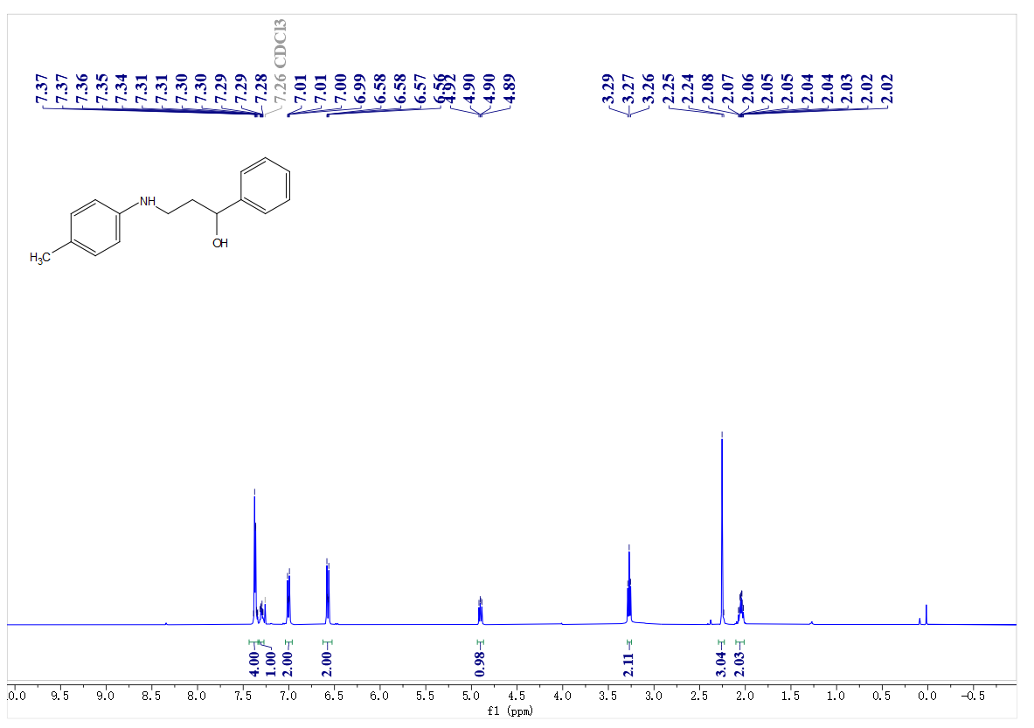
¹³C- NMR spectrum of C2
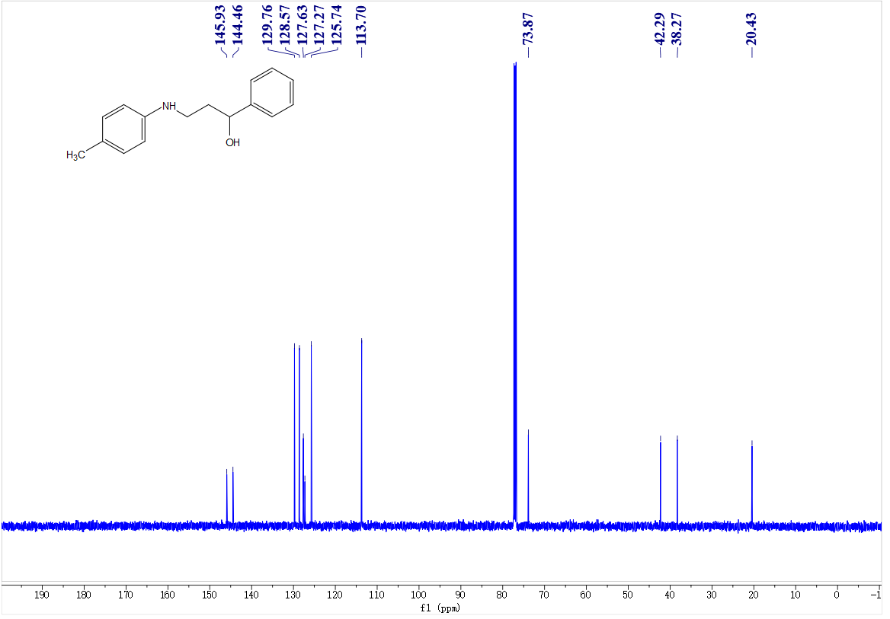

¹H- NMR spectrum of C3
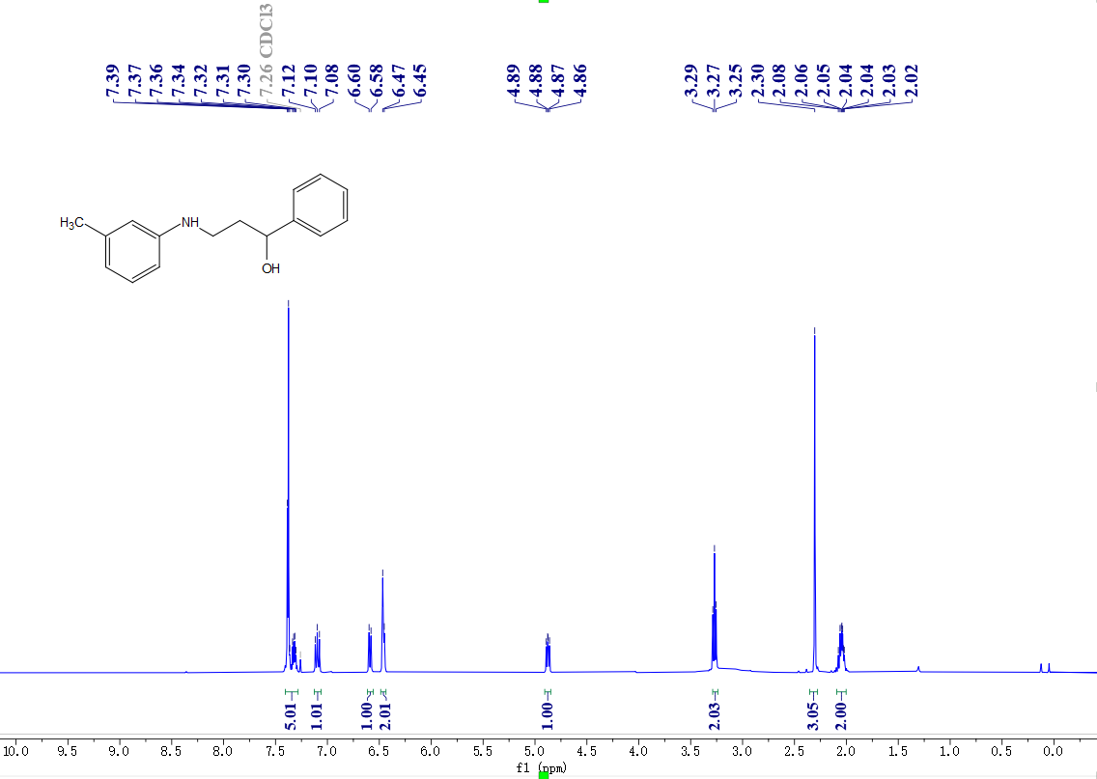
¹³C- NMR spectrum of C3
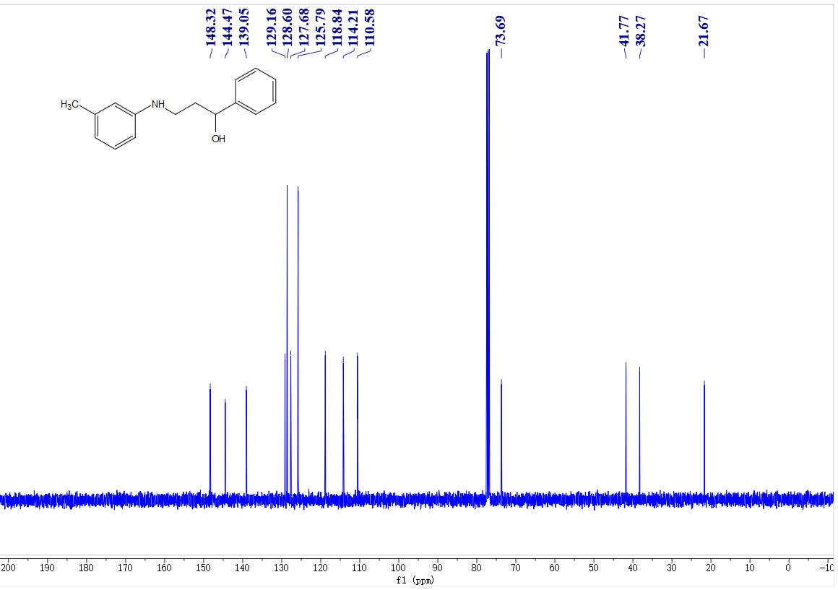

¹H- NMR spectrum of C4
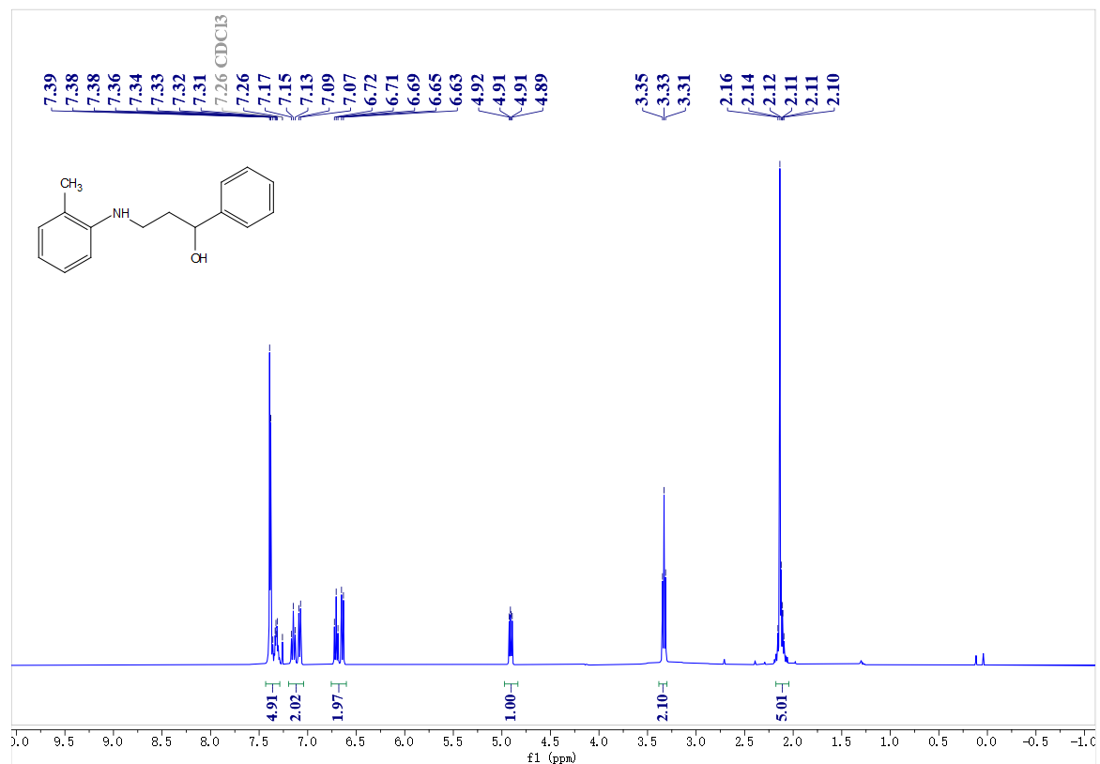
¹³C- NMR spectrum of C4
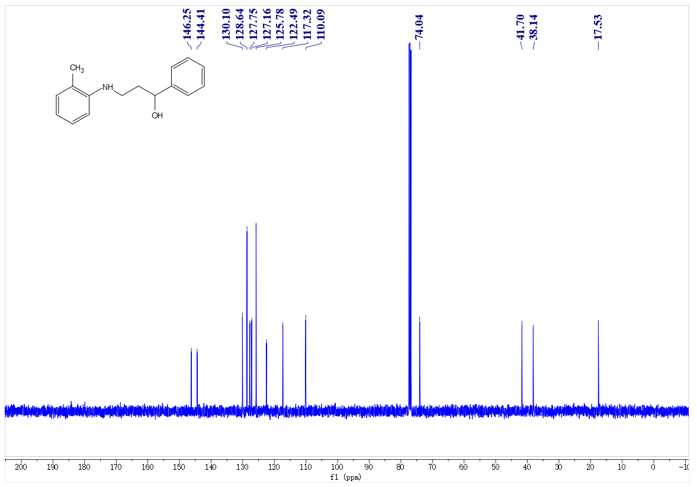

¹H- NMR spectrum of C5
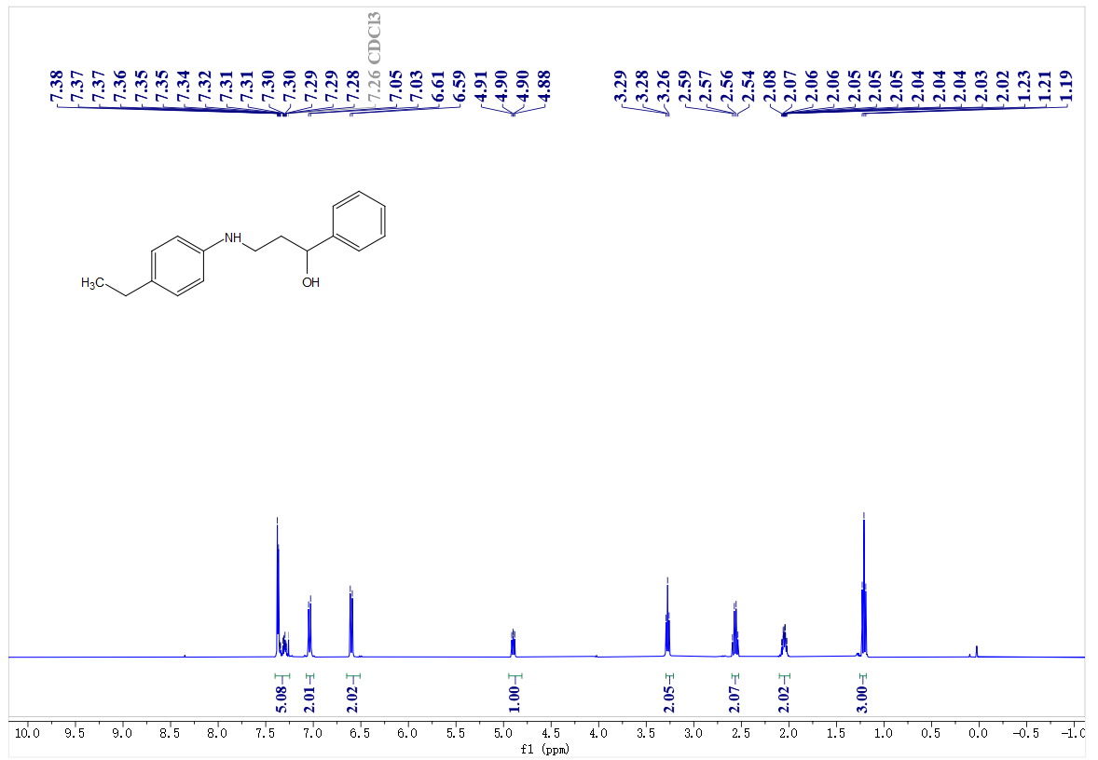
¹³C- NMR spectrum of C5
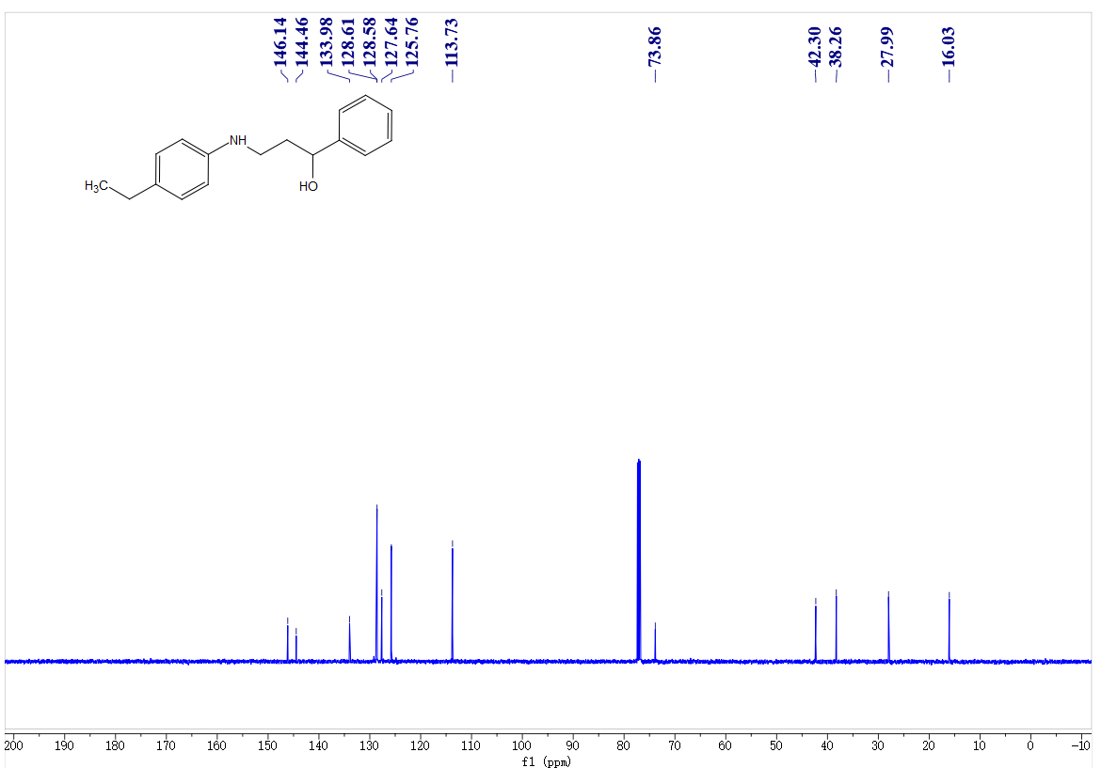

¹H- NMR spectrum of C6
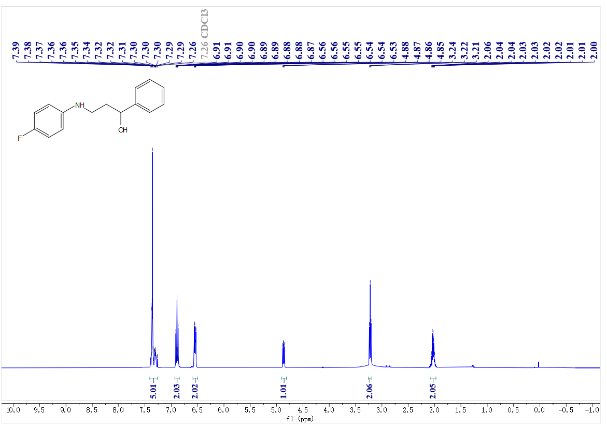
¹³C- NMR spectrum of C6
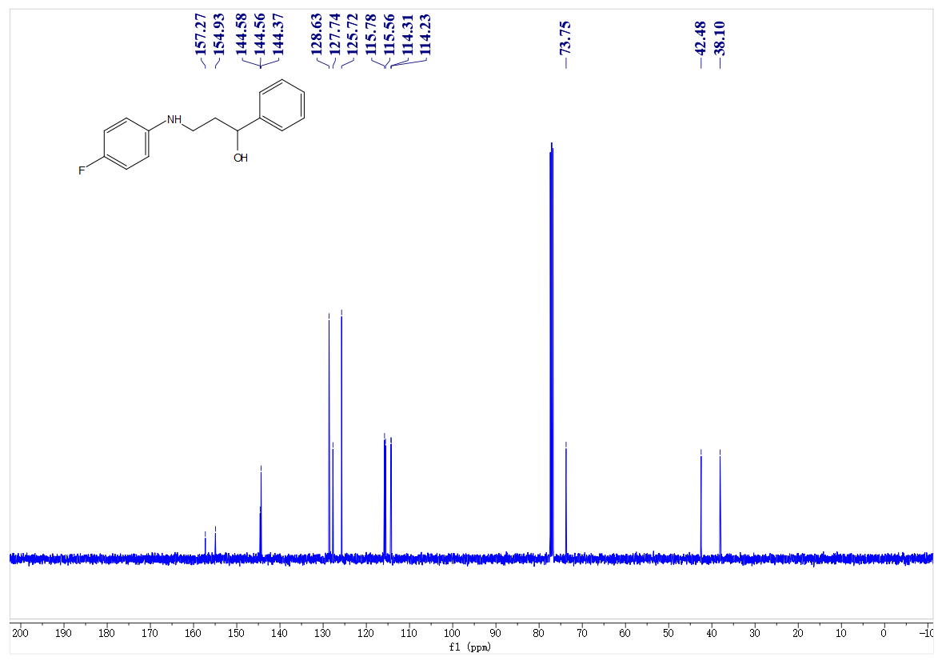
¹⁹F- NMR spectrum of C6
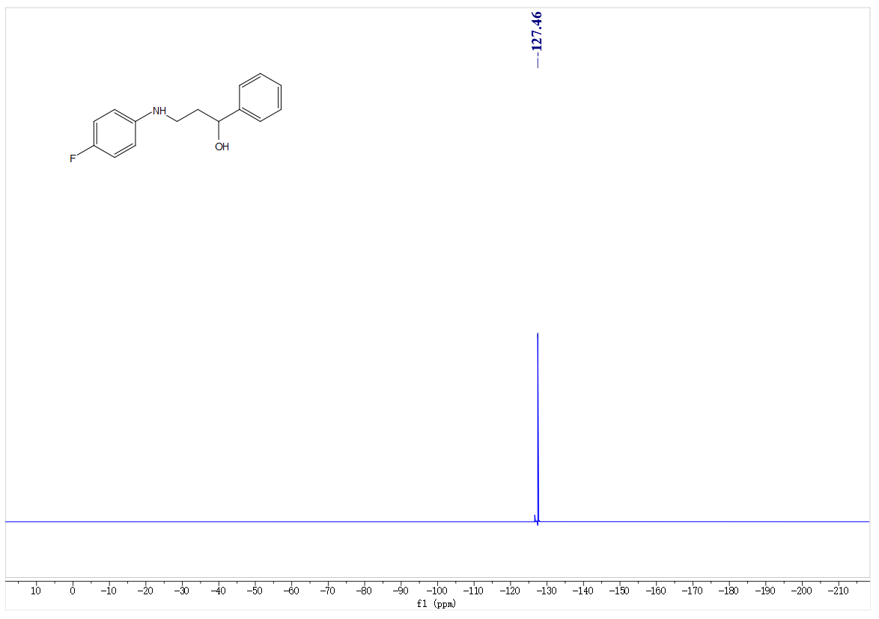
¹H- NMR spectrum of C7
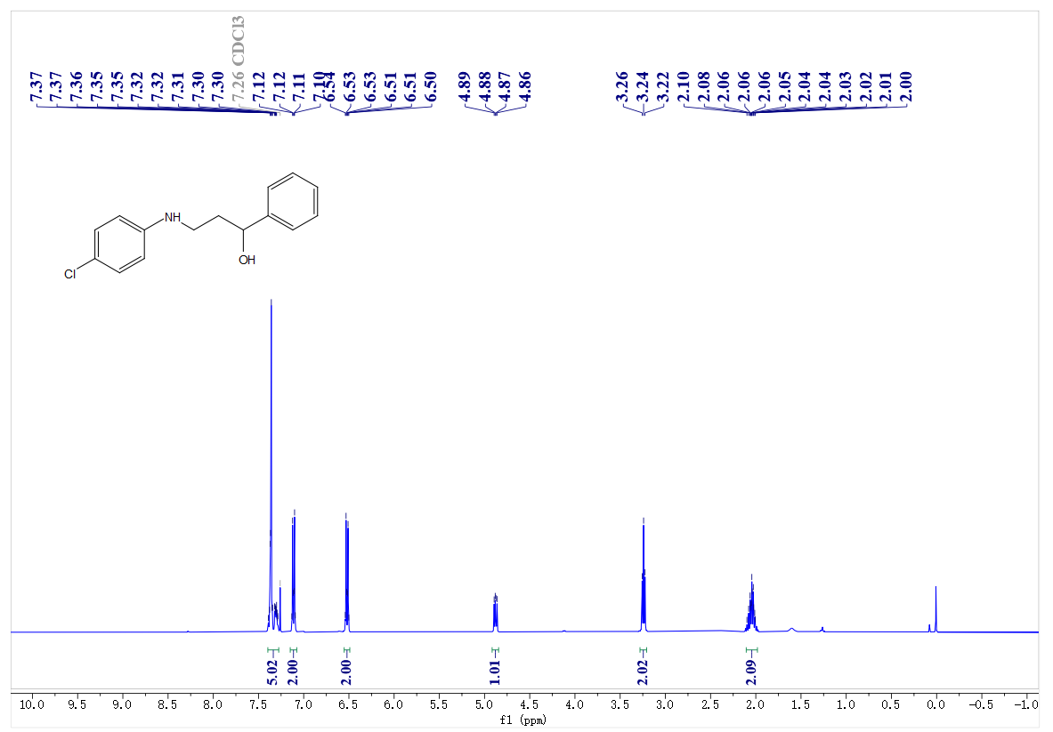

¹³C- NMR spectrum of C7
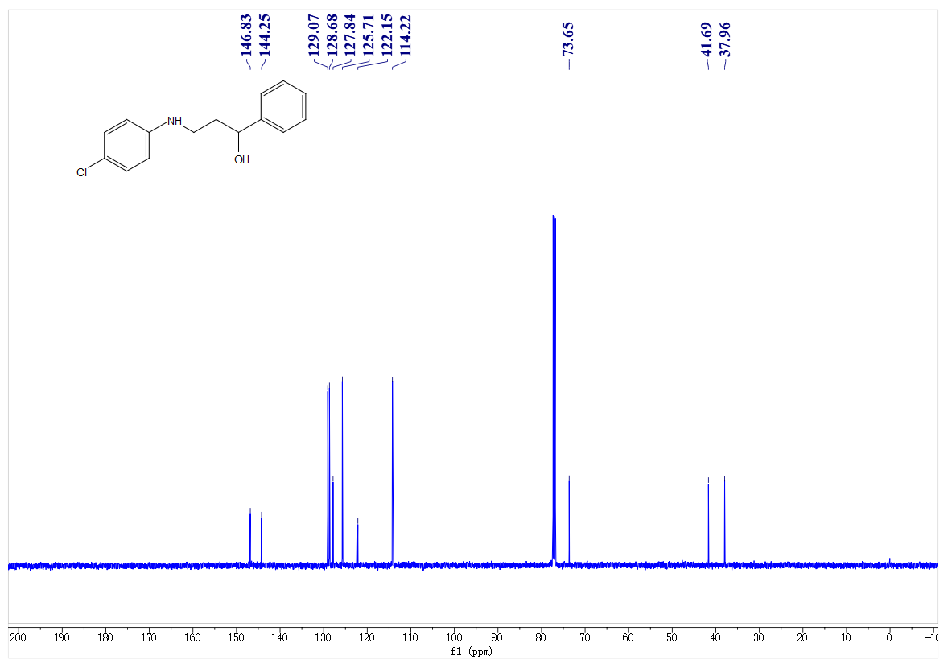
¹H- NMR spectrum of C8
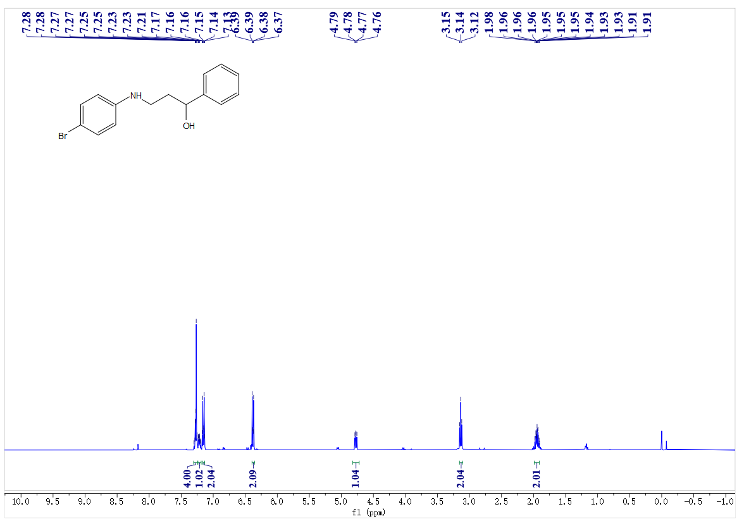
¹³C- NMR spectrum of C8
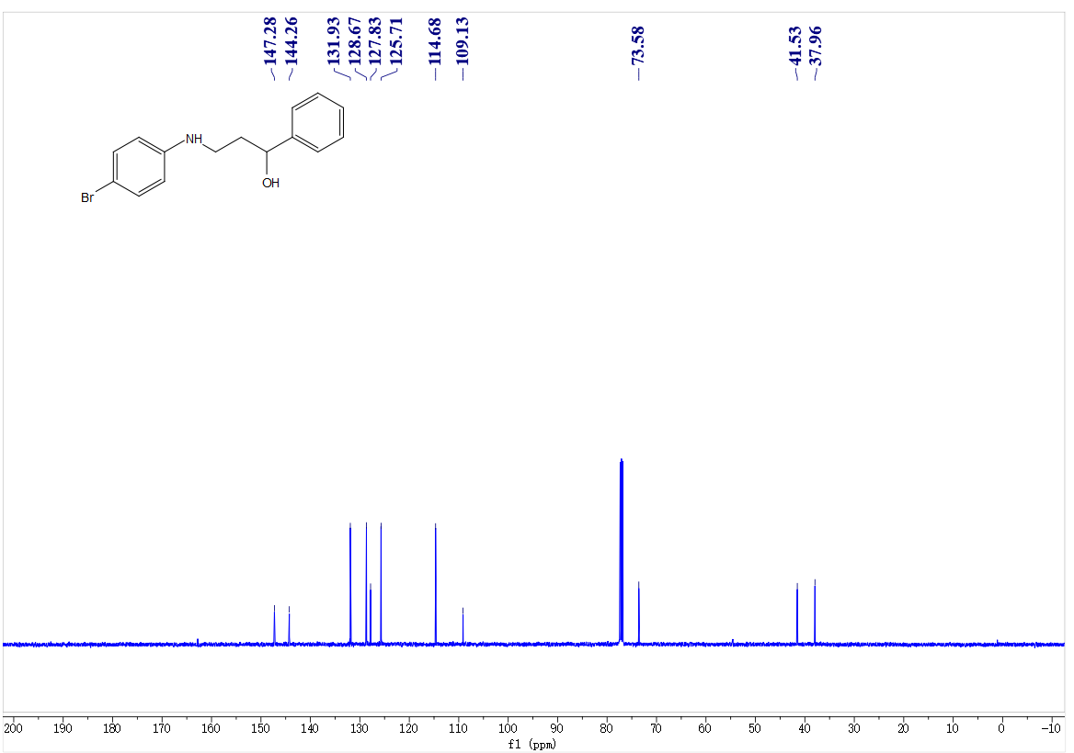
¹H- NMR spectrum of C9
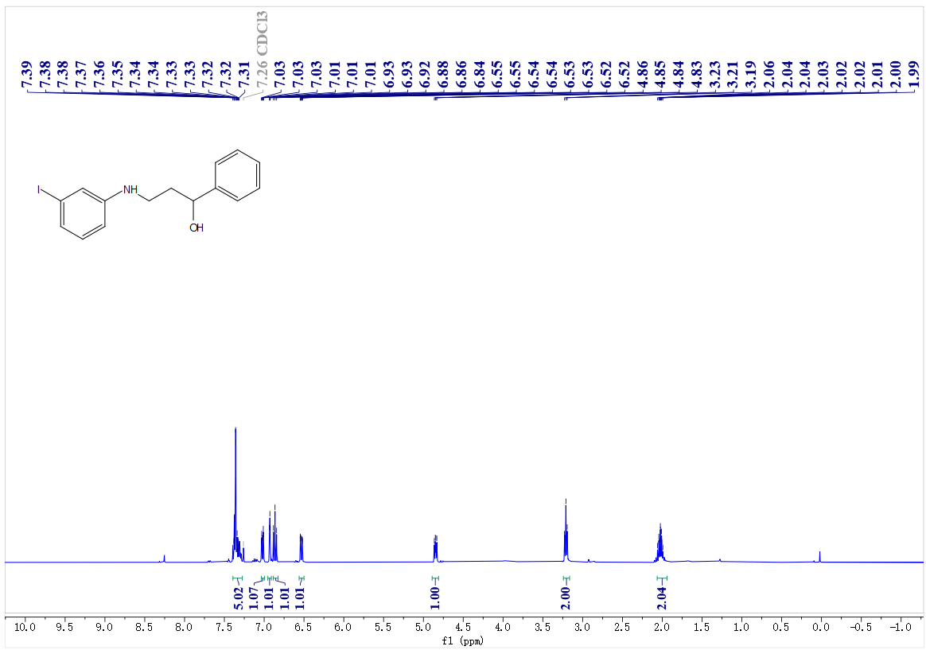
¹³C- NMR spectrum of C9
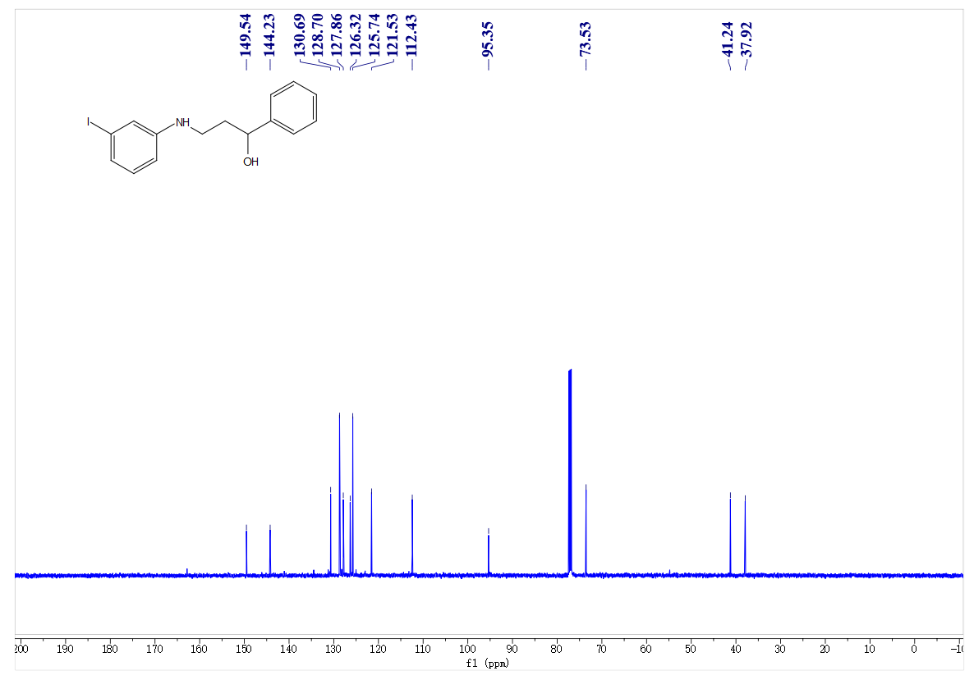
¹H- NMR spectrum of C10
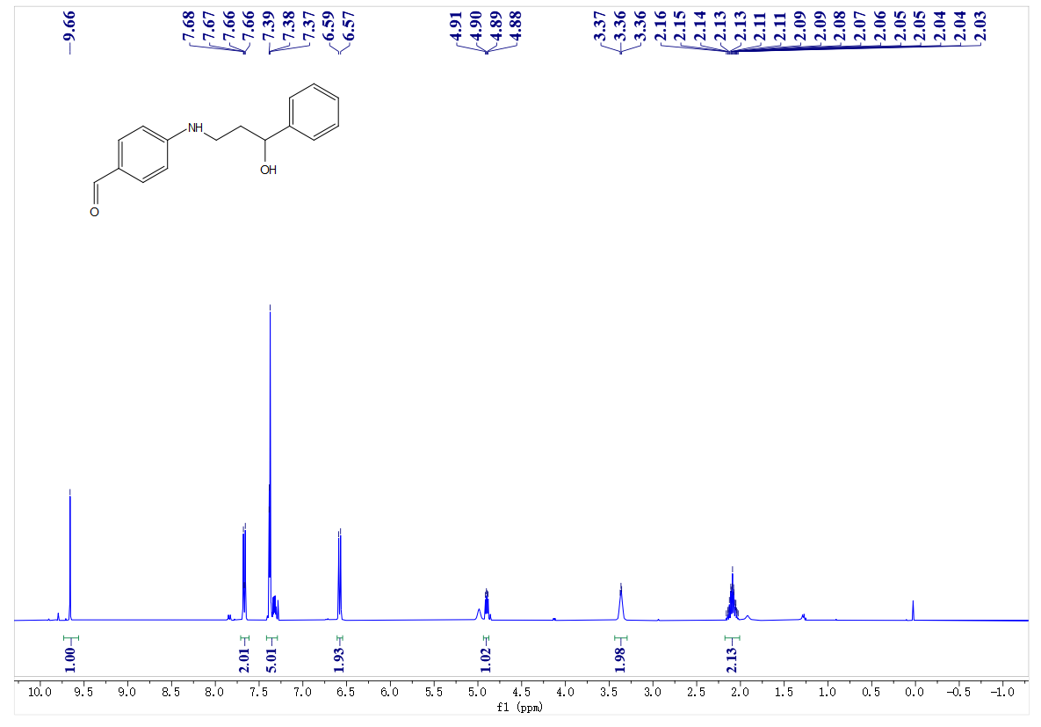
¹³C- NMR spectrum of C10

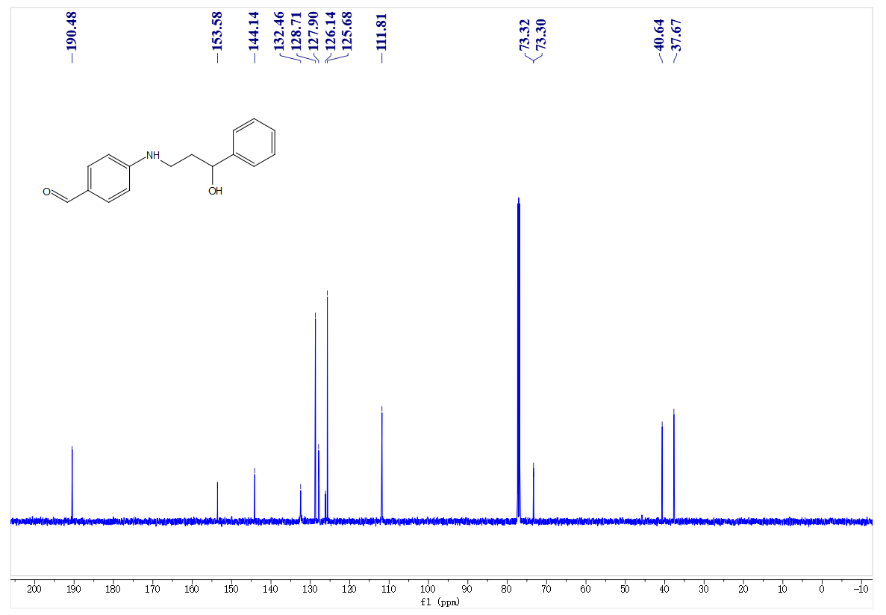
¹H- NMR spectrum of C11
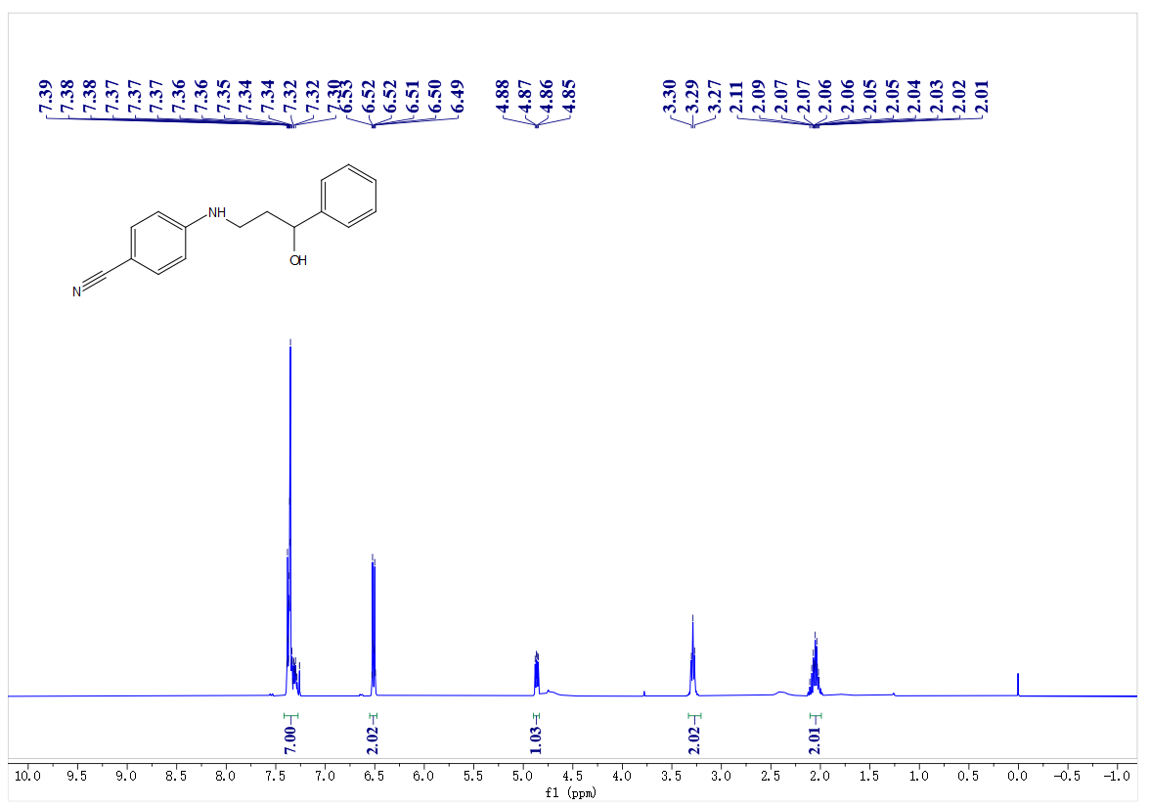
¹³C- NMR spectrum of C11
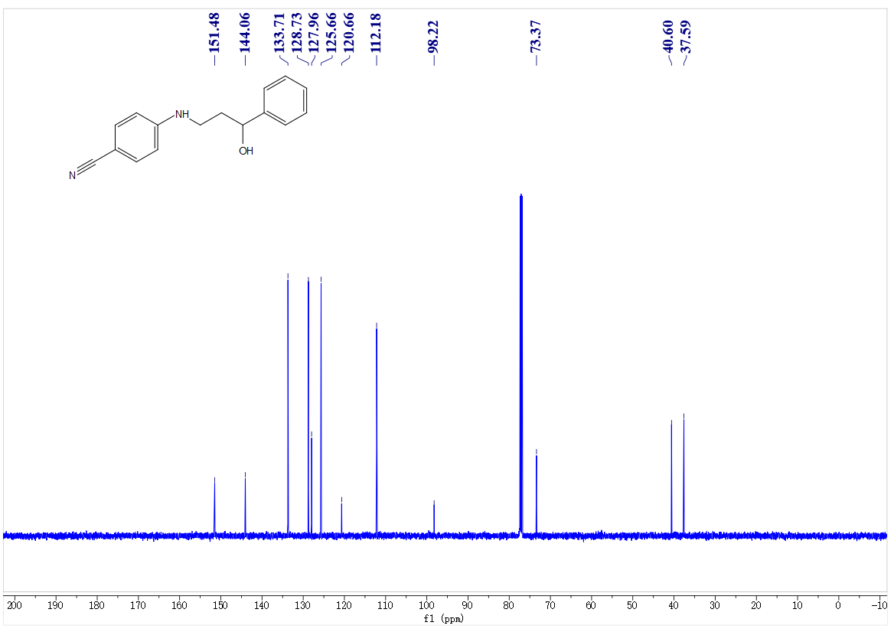
¹H- NMR spectrum of C12
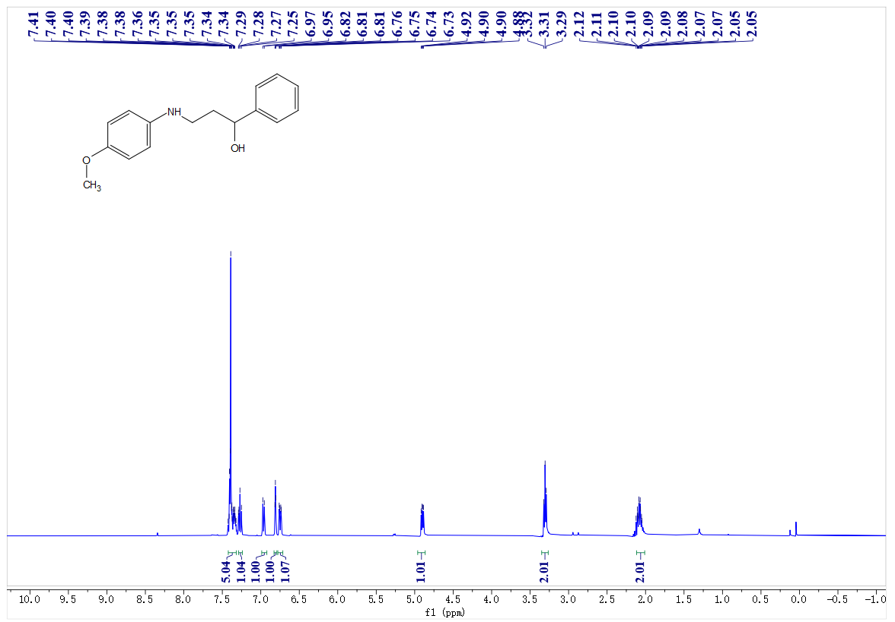
¹³C- NMR spectrum of C12
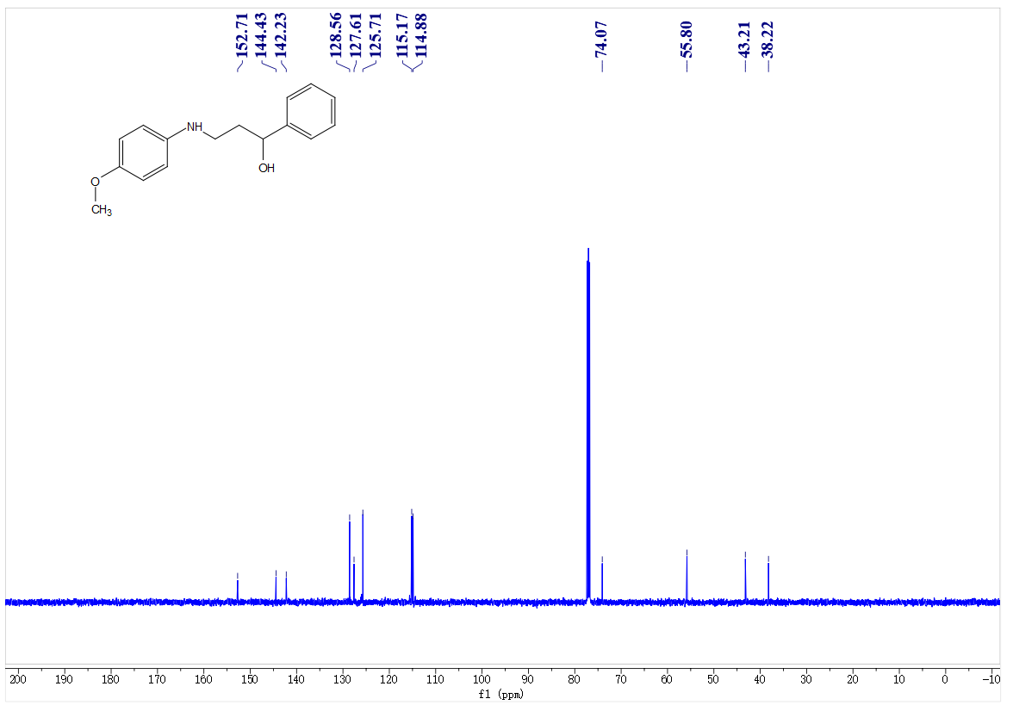
¹H- NMR spectrum of C13
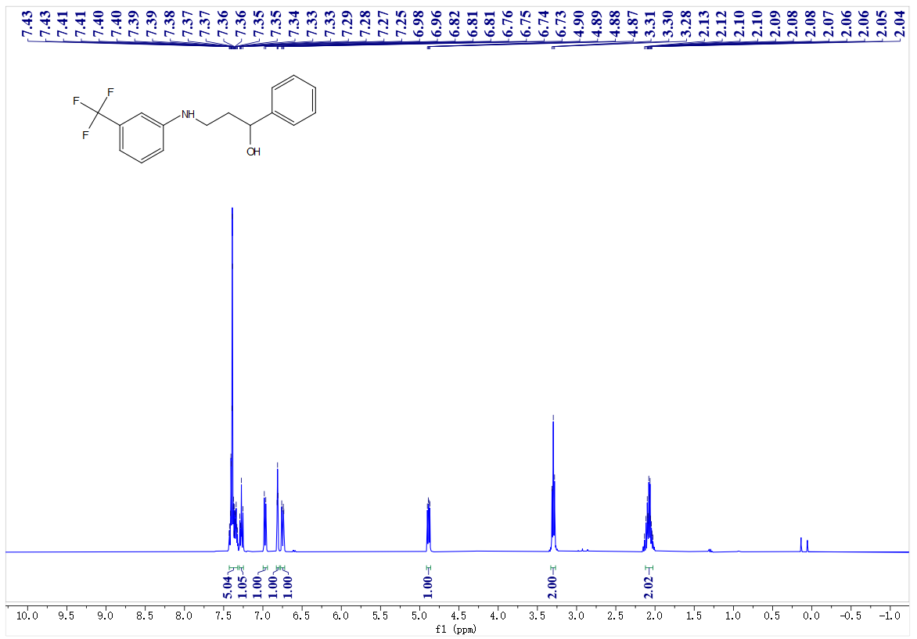
¹³C- NMR spectrum of C13
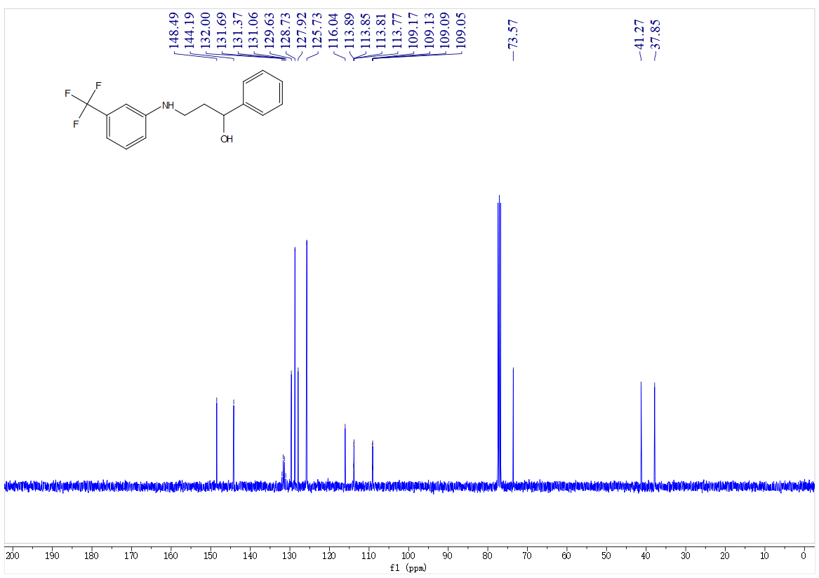
¹⁹F- NMR spectrum of C13
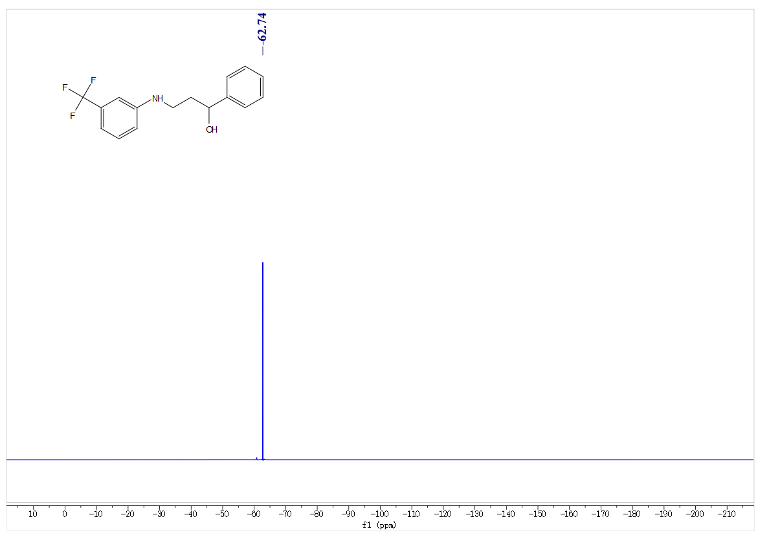
¹H- NMR spectrum of C14
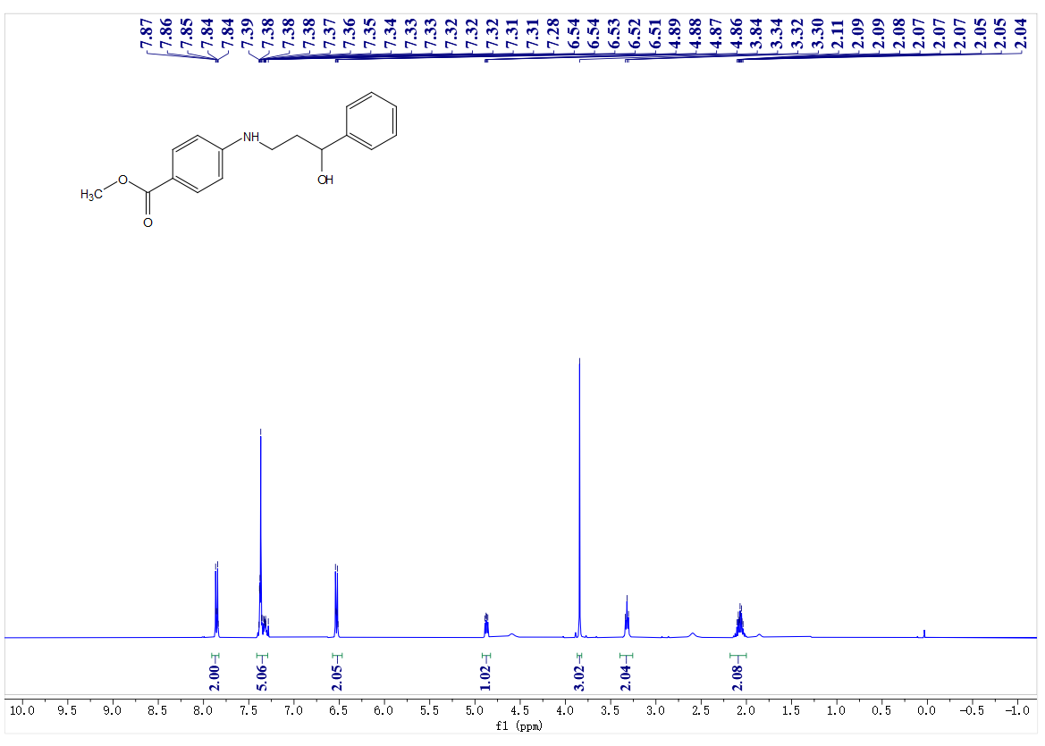
¹³C- NMR spectrum of C14
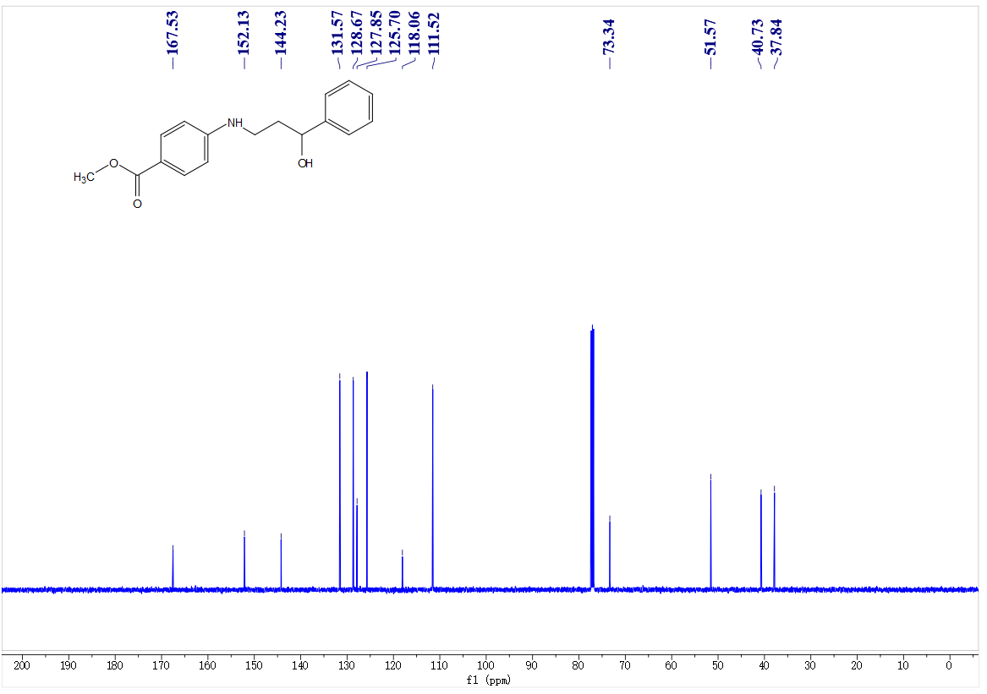
¹H- NMR spectrum of C15
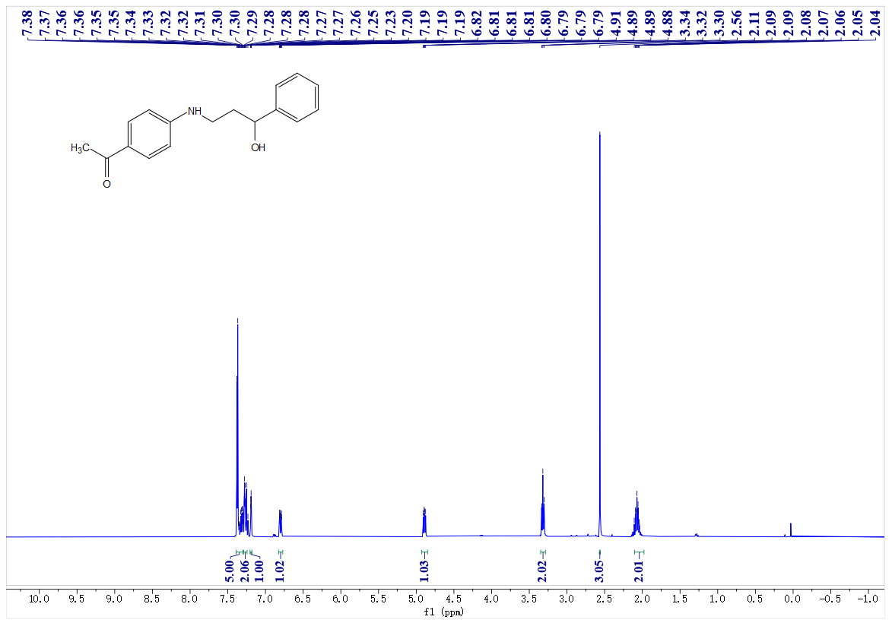
¹³C- NMR spectrum of C15
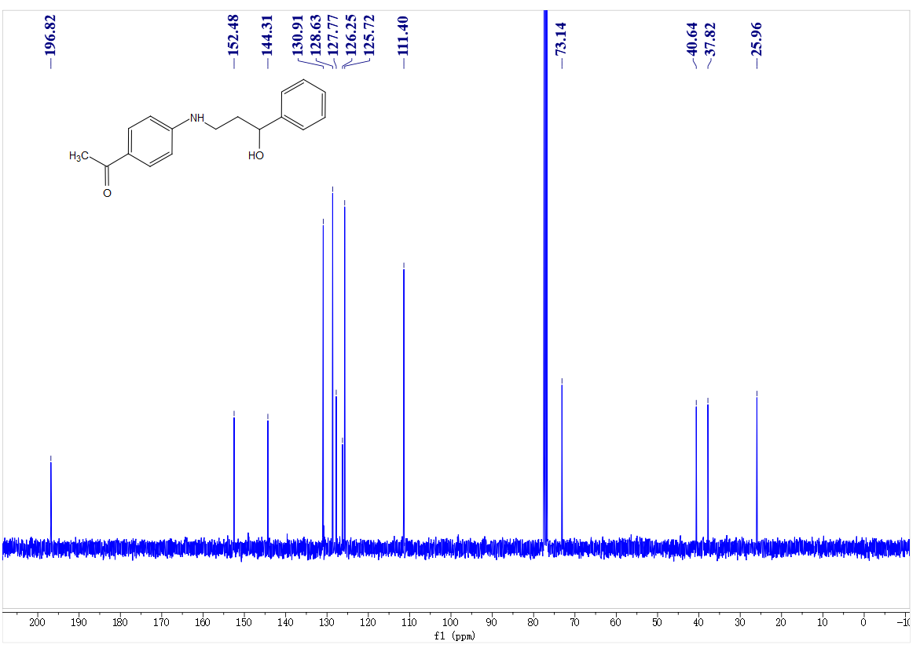
¹H- NMR spectrum of C16
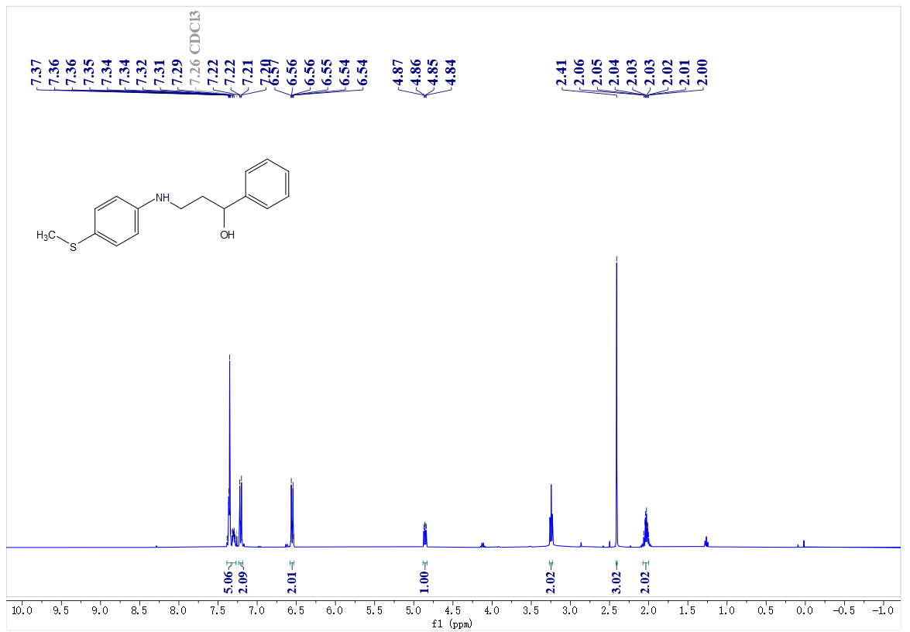
¹³C- NMR spectrum of C16

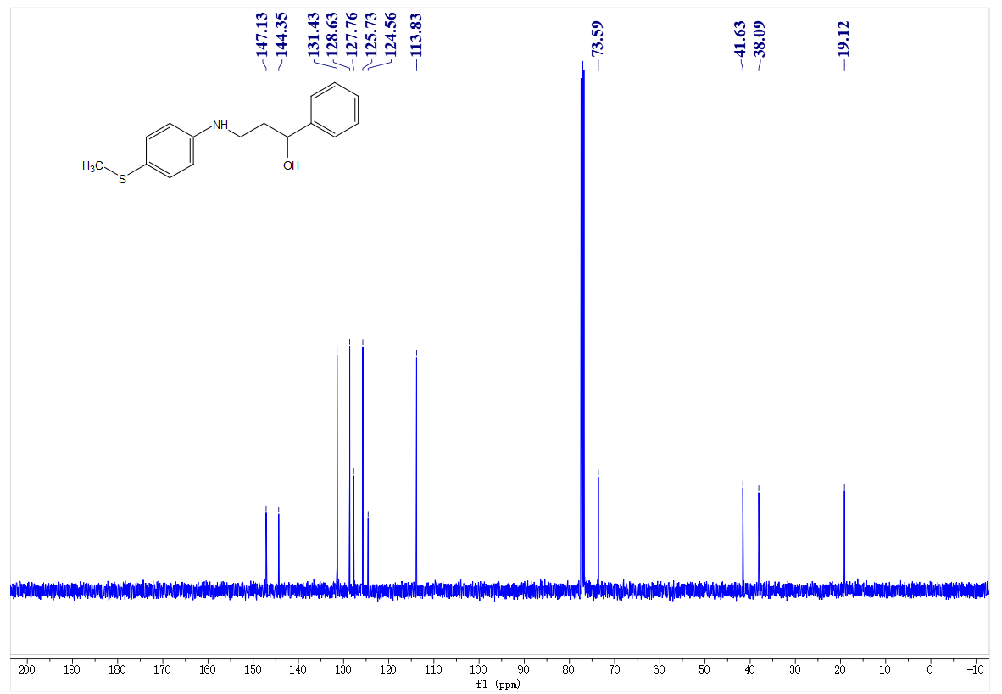
¹H- NMR spectrum of C17
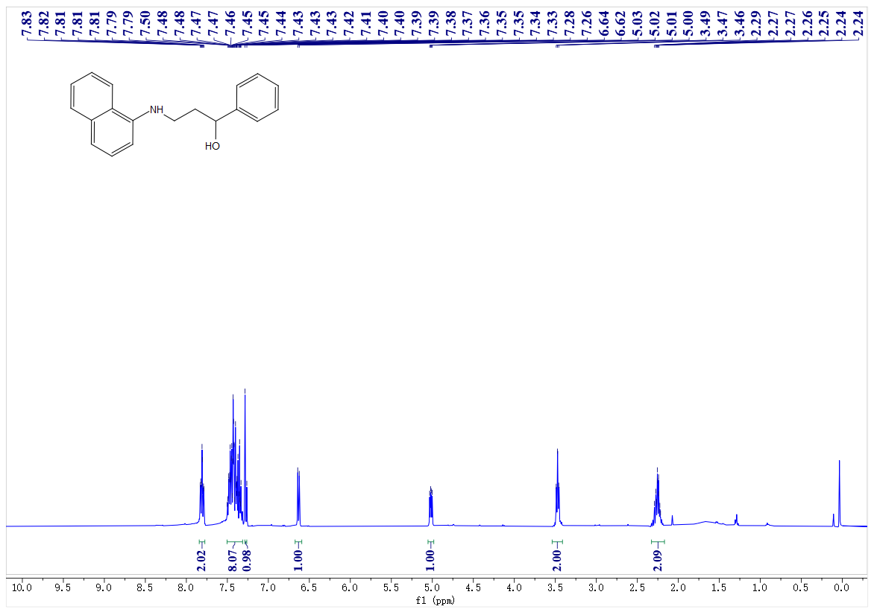
¹³C- NMR spectrum of C17
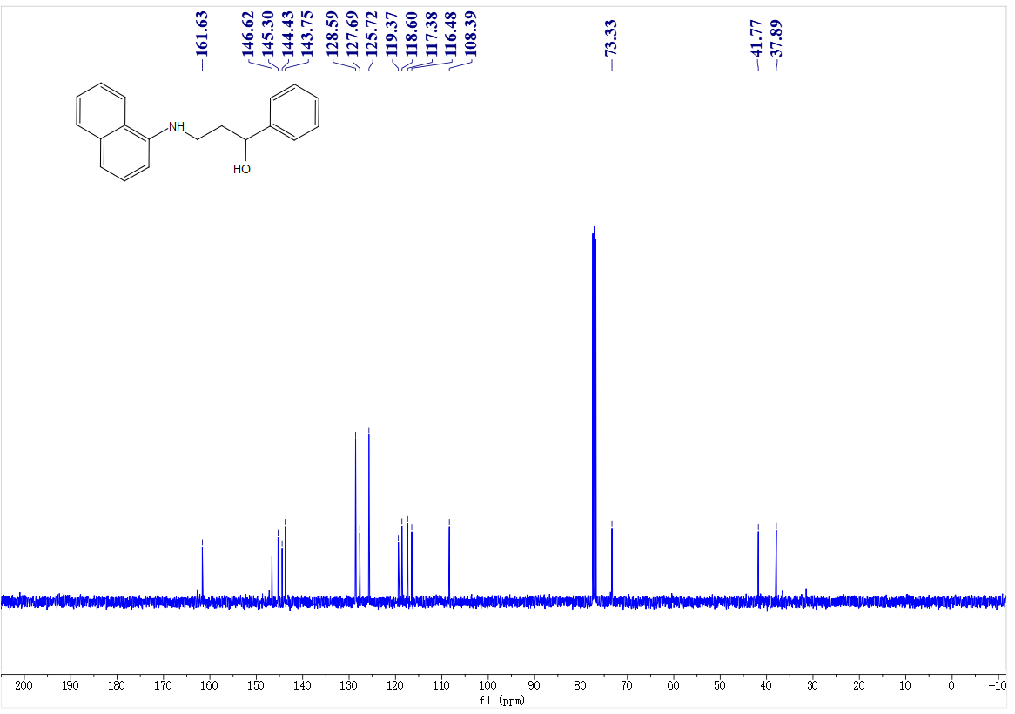
¹H- NMR spectrum of C18
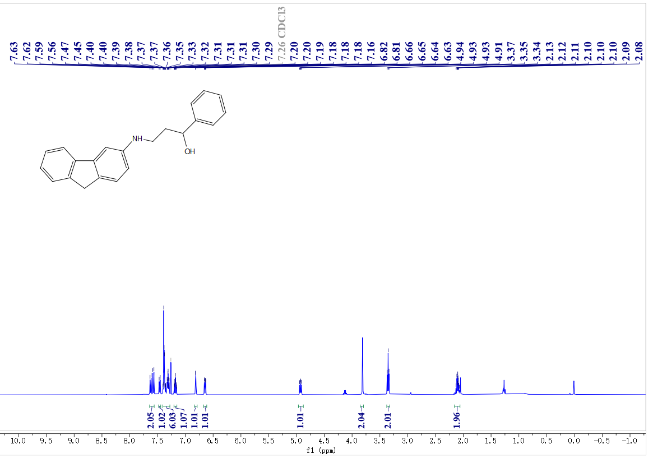
¹³C- NMR spectrum of C18
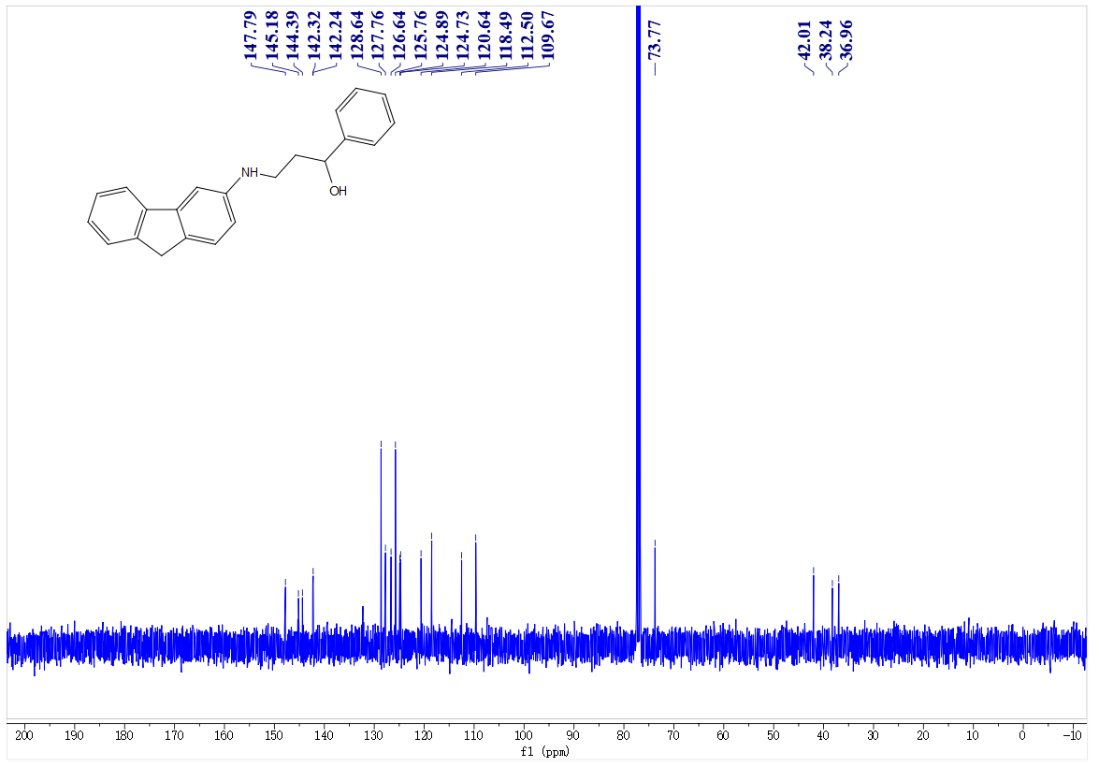
¹H- NMR spectrum of C19
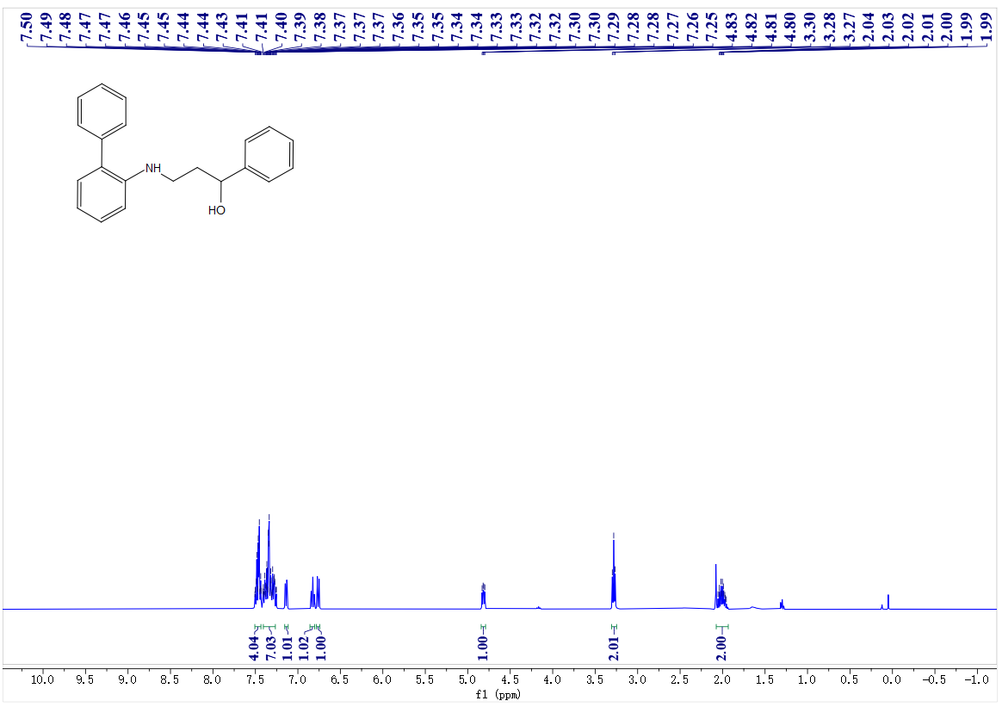
¹³C- NMR spectrum of C19
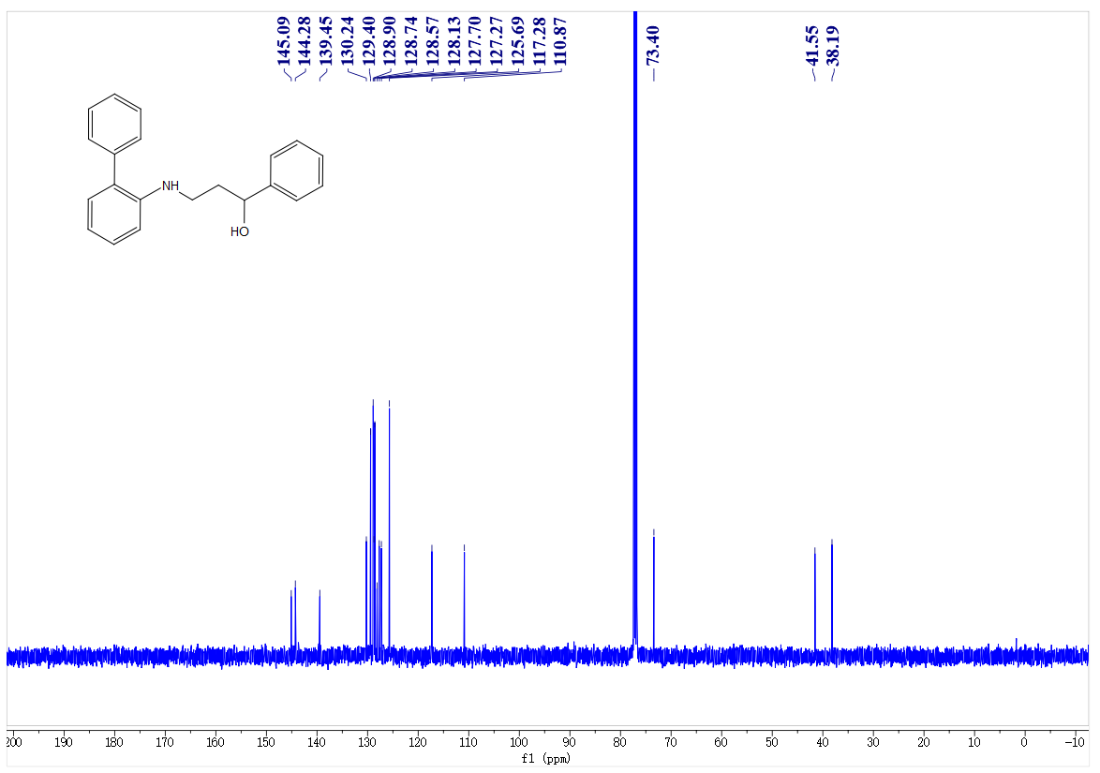
¹H- NMR spectrum of C20
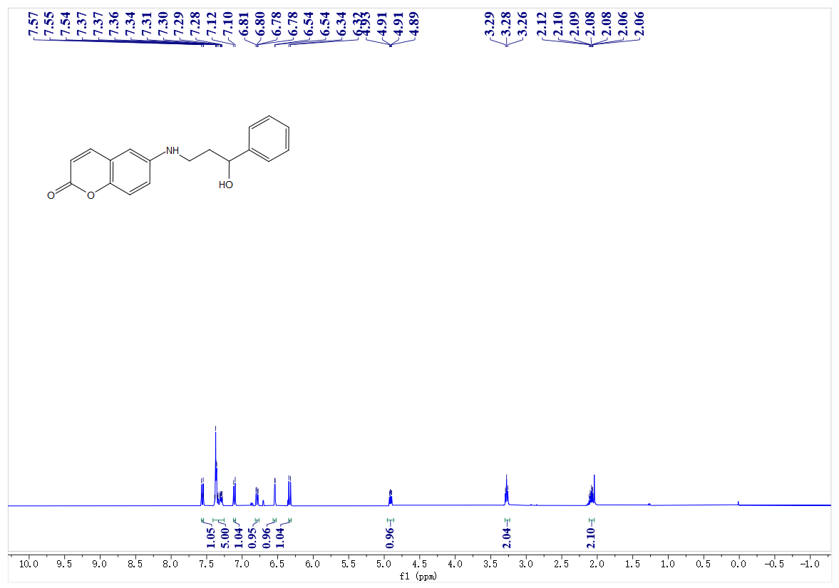
¹³C- NMR spectrum of C20
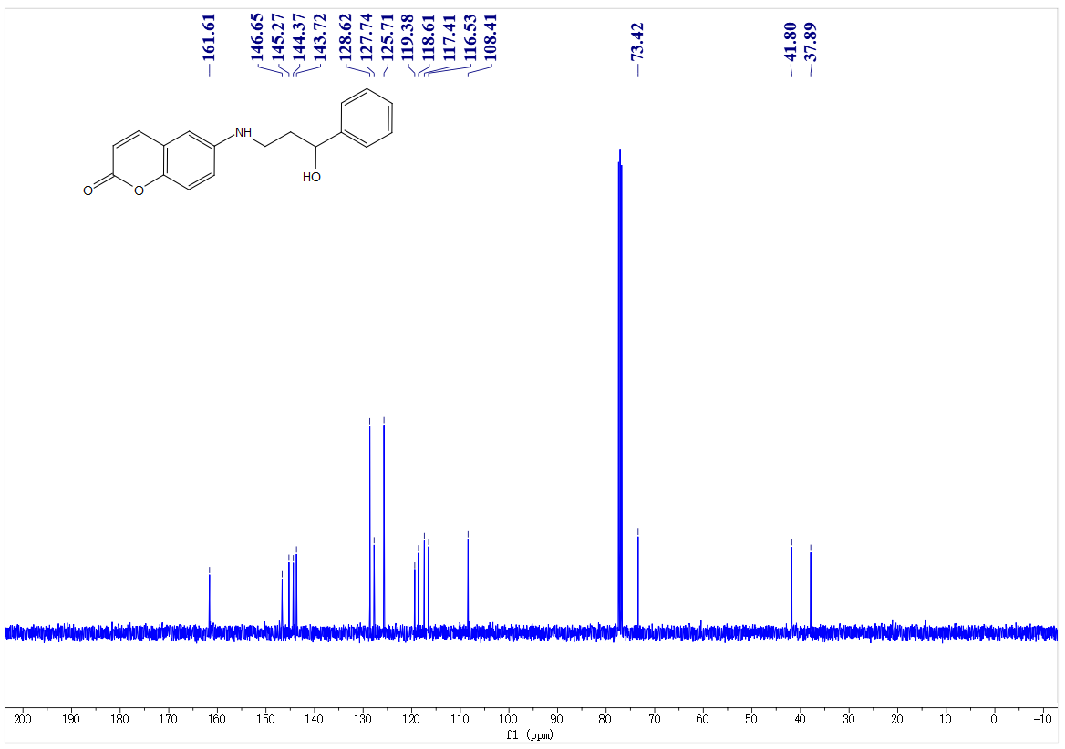
¹H- NMR spectrum of C21
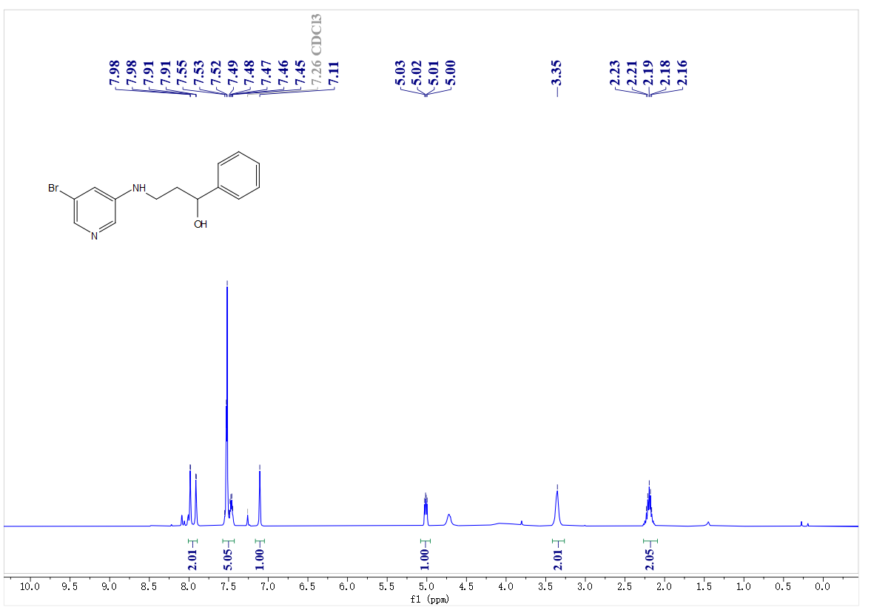
¹³C- NMR spectrum of C21
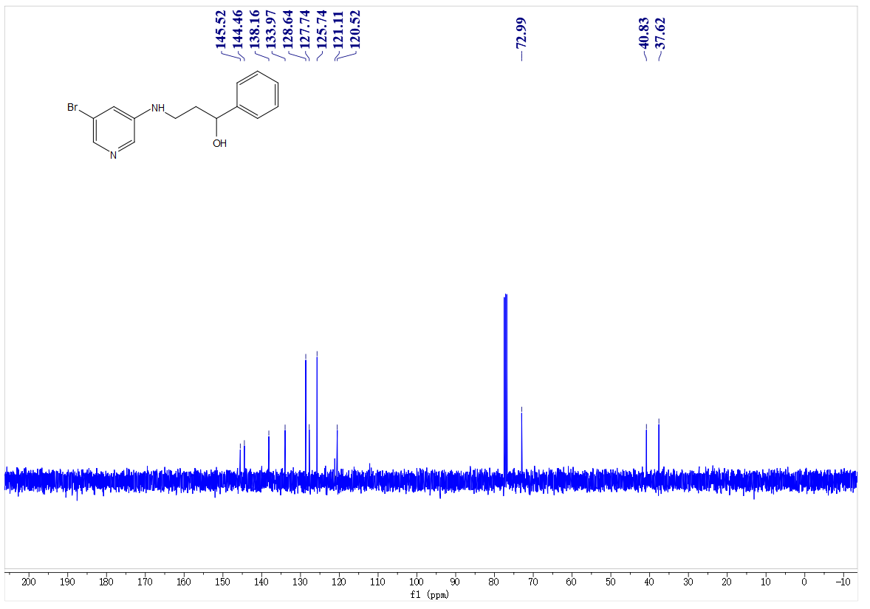
¹H- NMR spectrum of C22
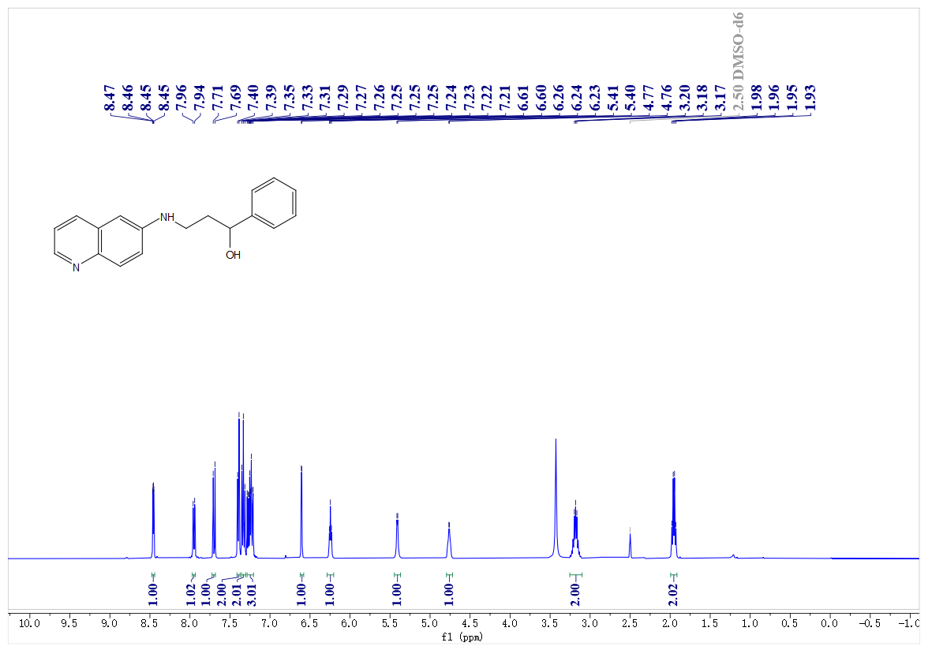
¹³C- NMR spectrum of C22
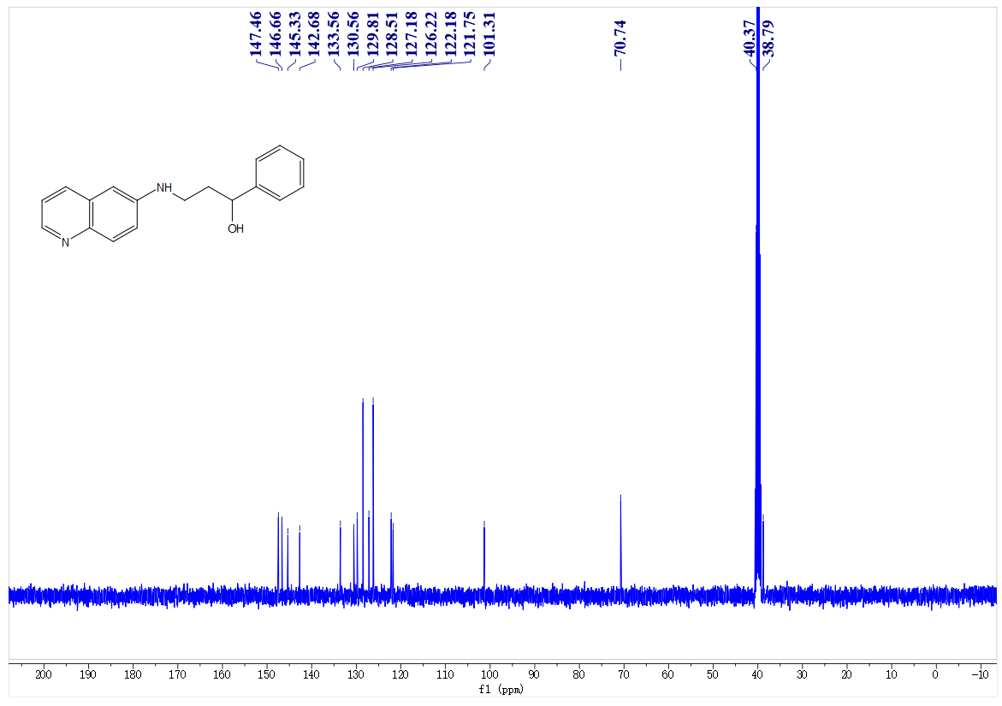
¹H- NMR spectrum of C23
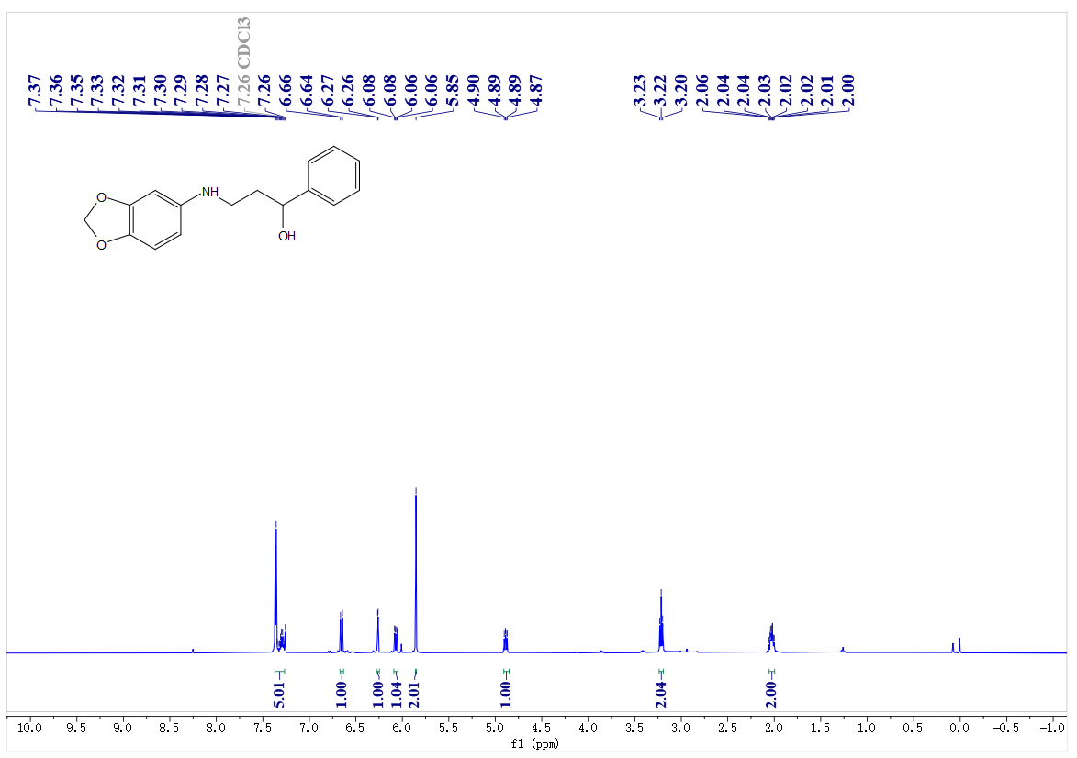
¹³C- NMR spectrum of C23
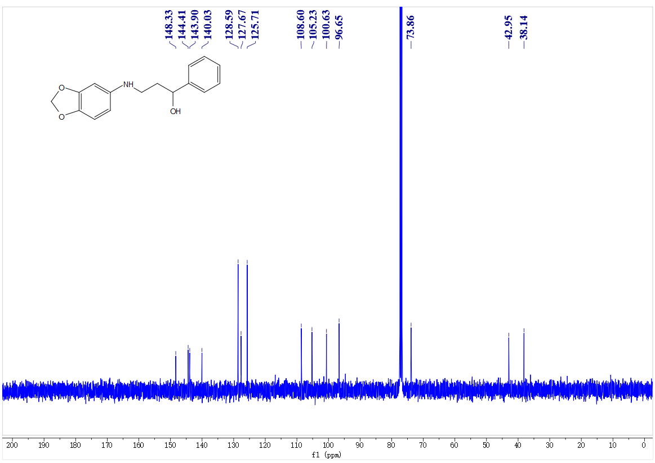
¹H- NMR spectrum of C24
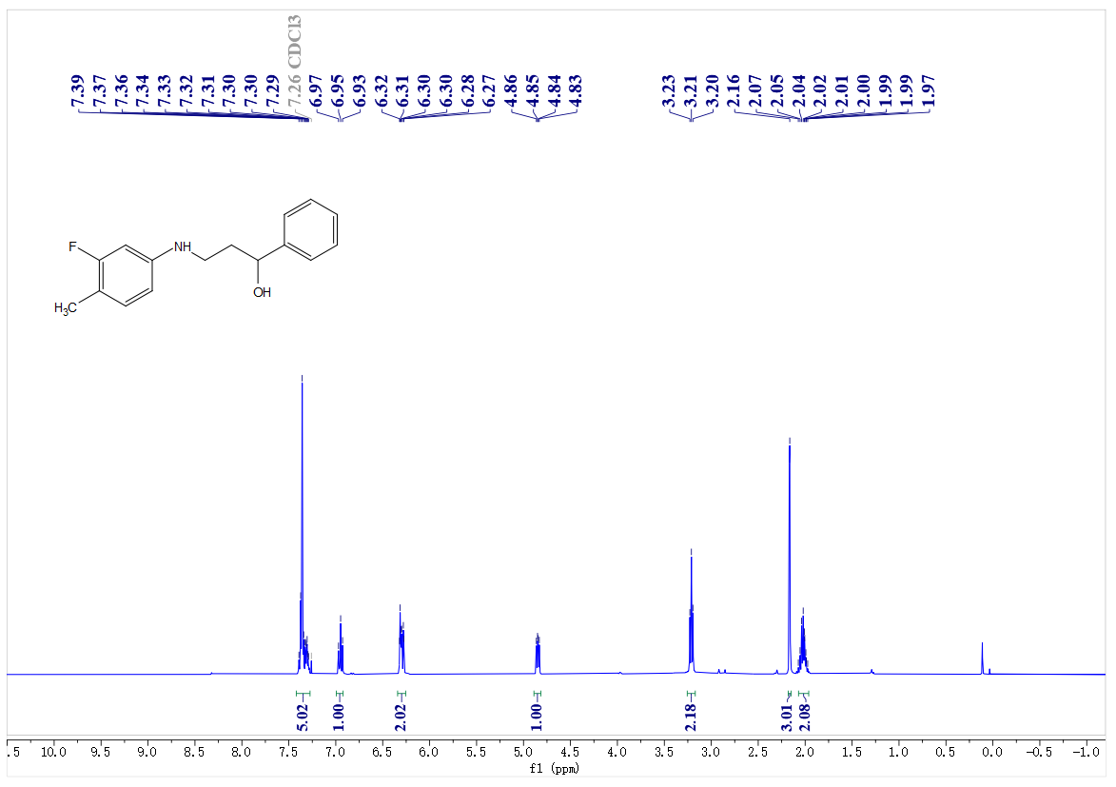
¹³C- NMR spectrum of C24
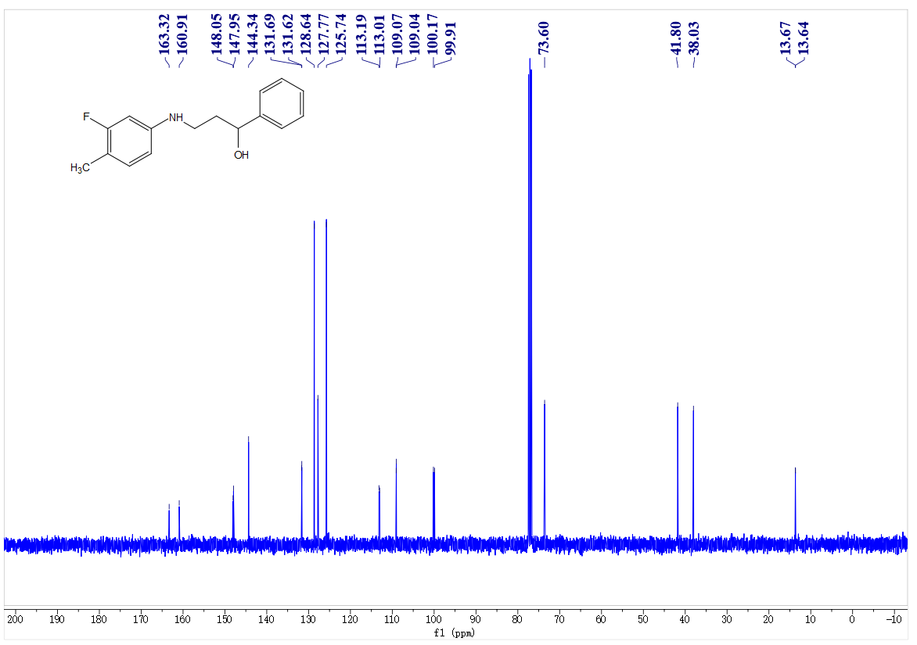
¹⁹F- NMR spectrum of C24
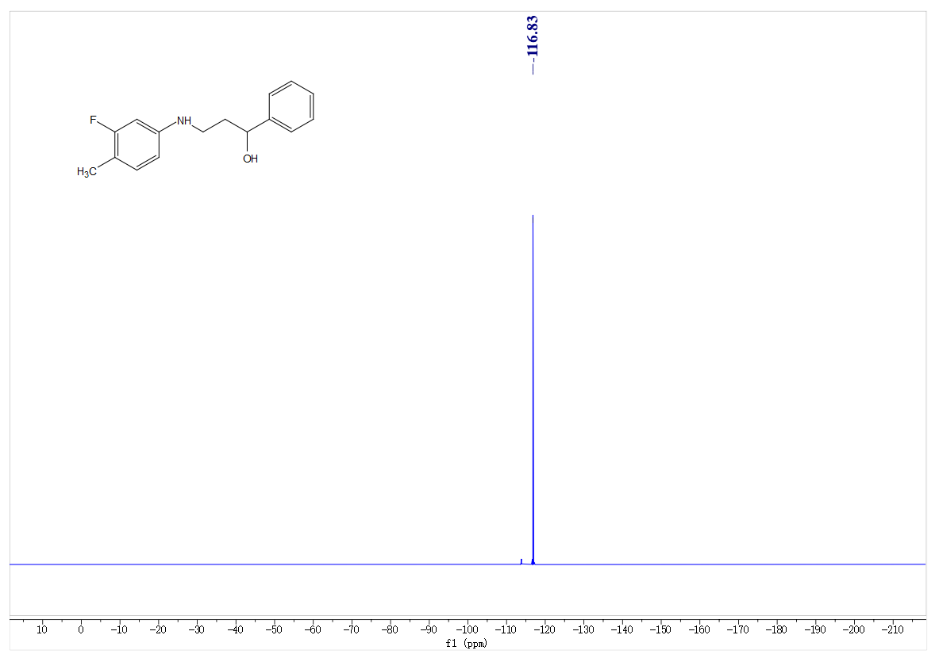
¹H- NMR spectrum of C25
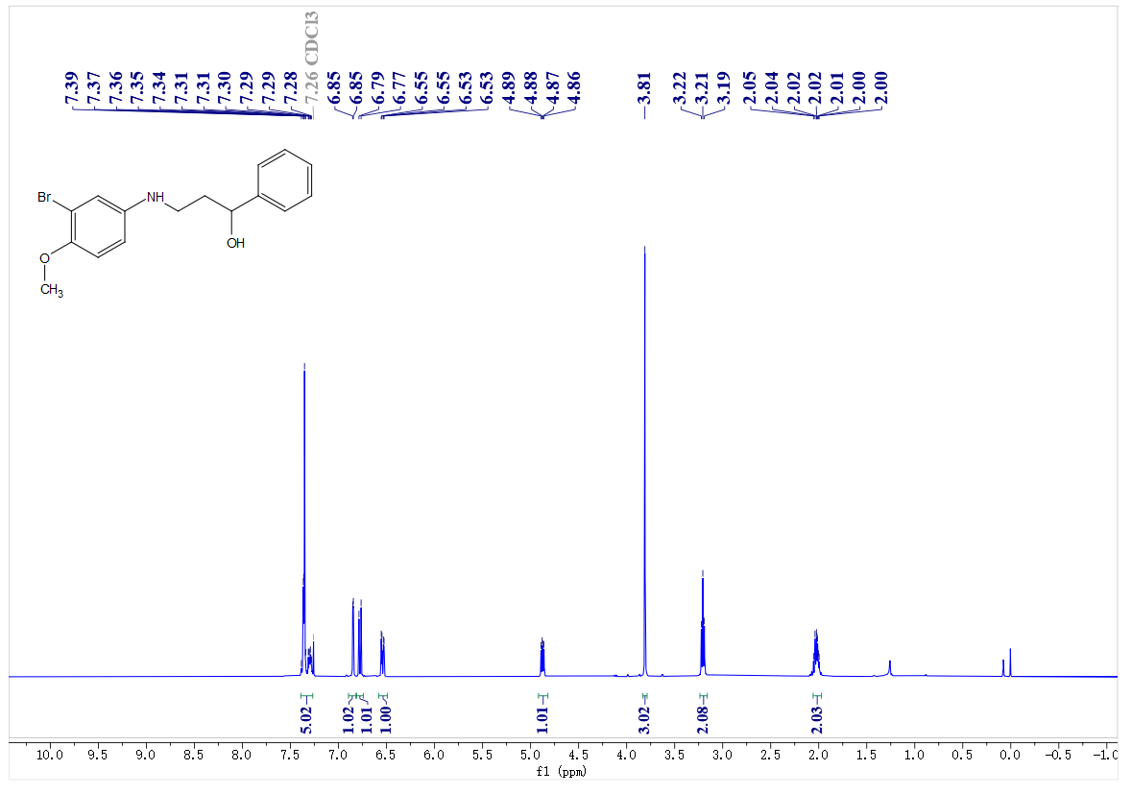
¹³C- NMR spectrum of C25
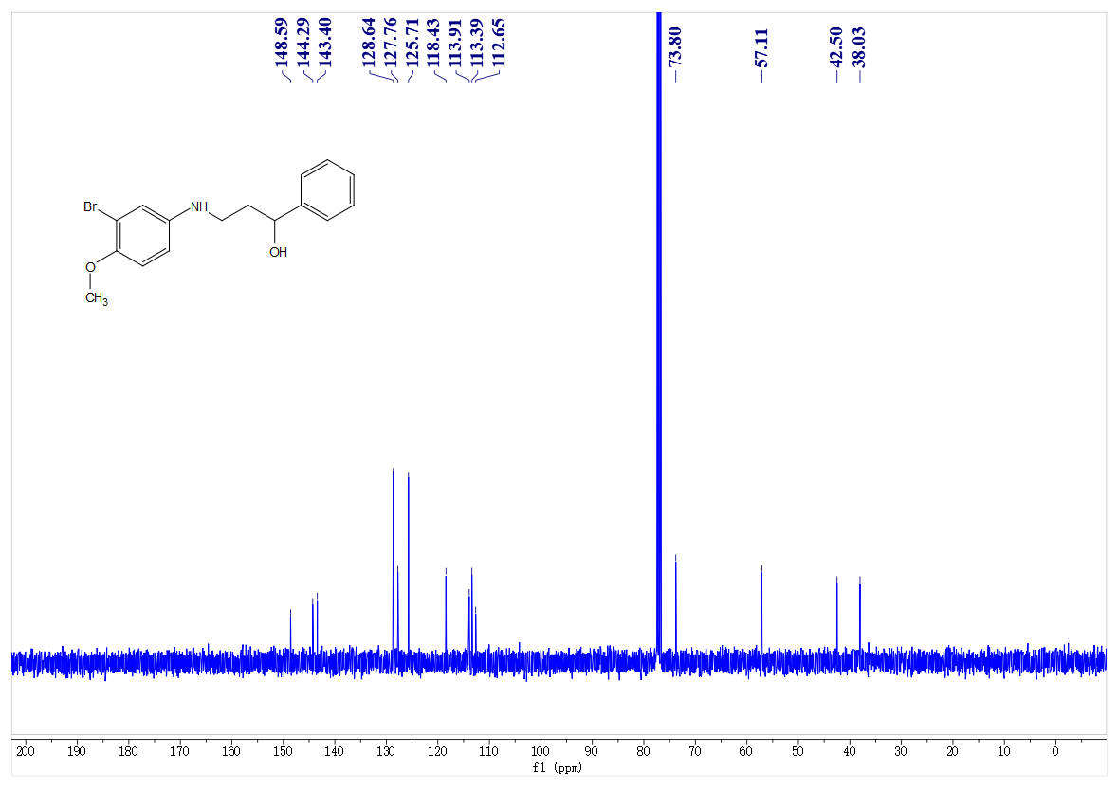
¹H- NMR spectrum of C26
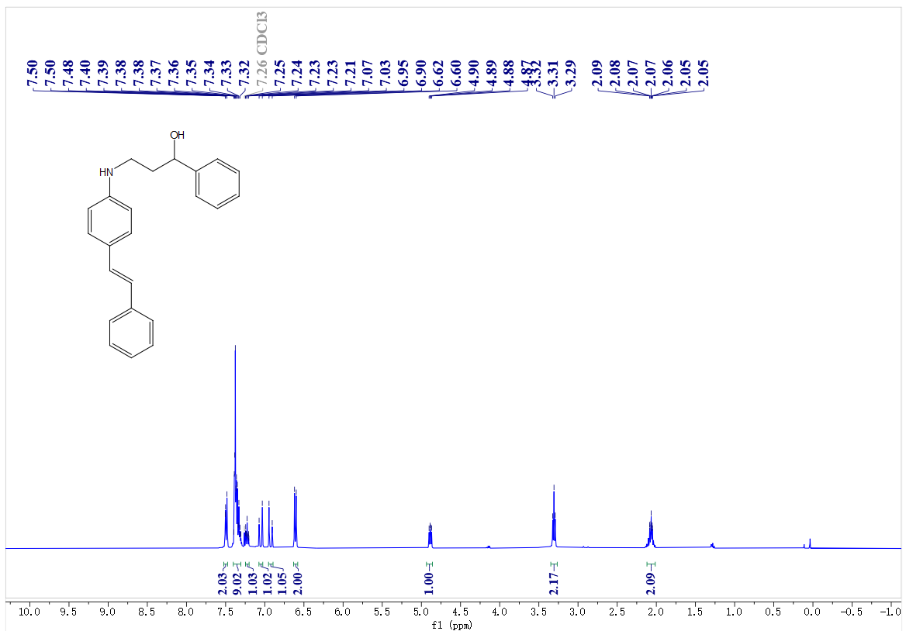
¹³C- NMR spectrum of C26
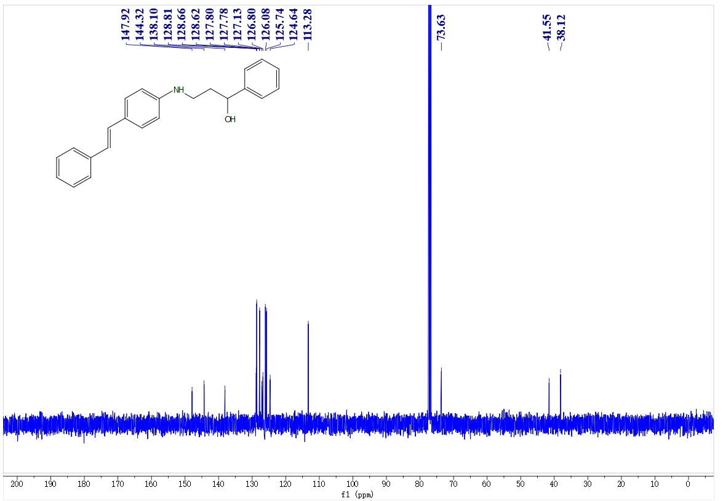
¹H- NMR spectrum of C27
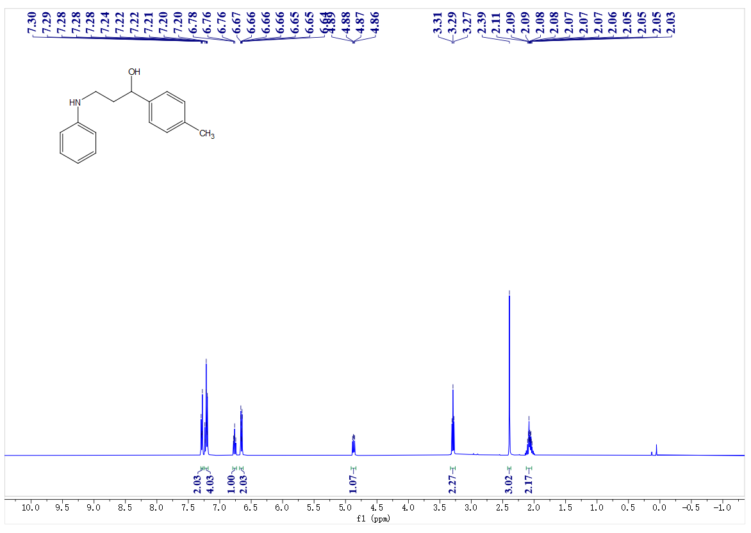
¹³C- NMR spectrum of C27
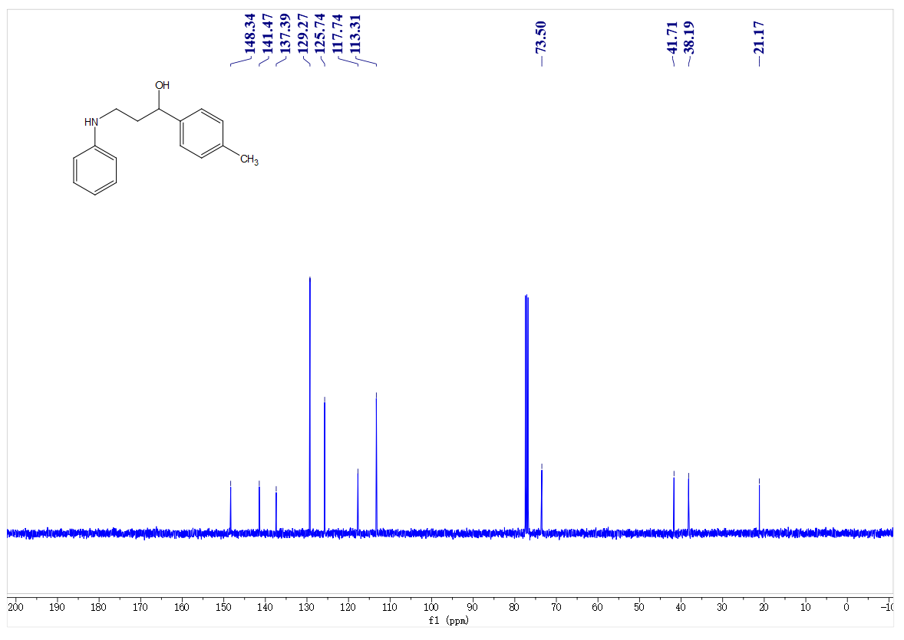
¹H- NMR spectrum of C28
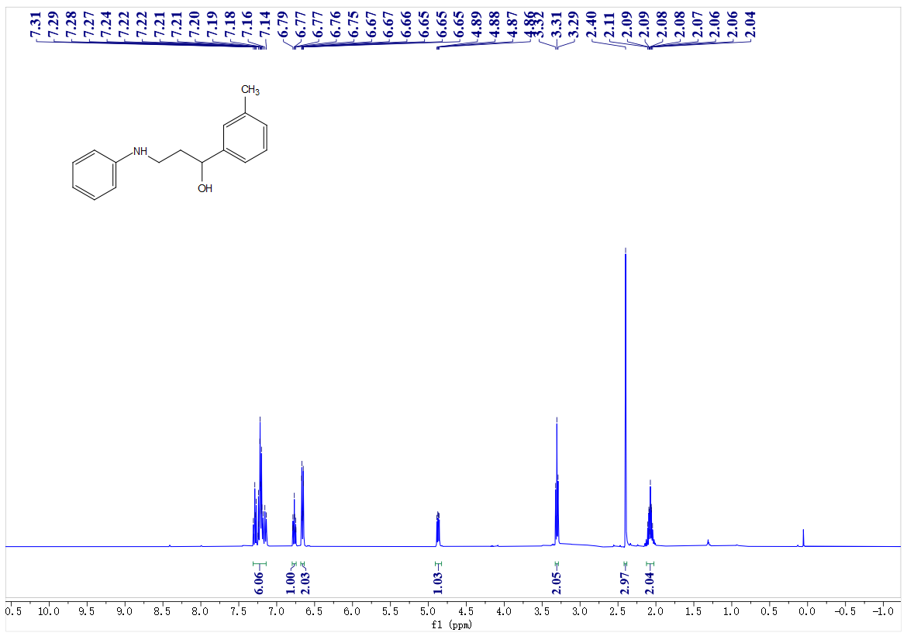
¹³C- NMR spectrum of C28
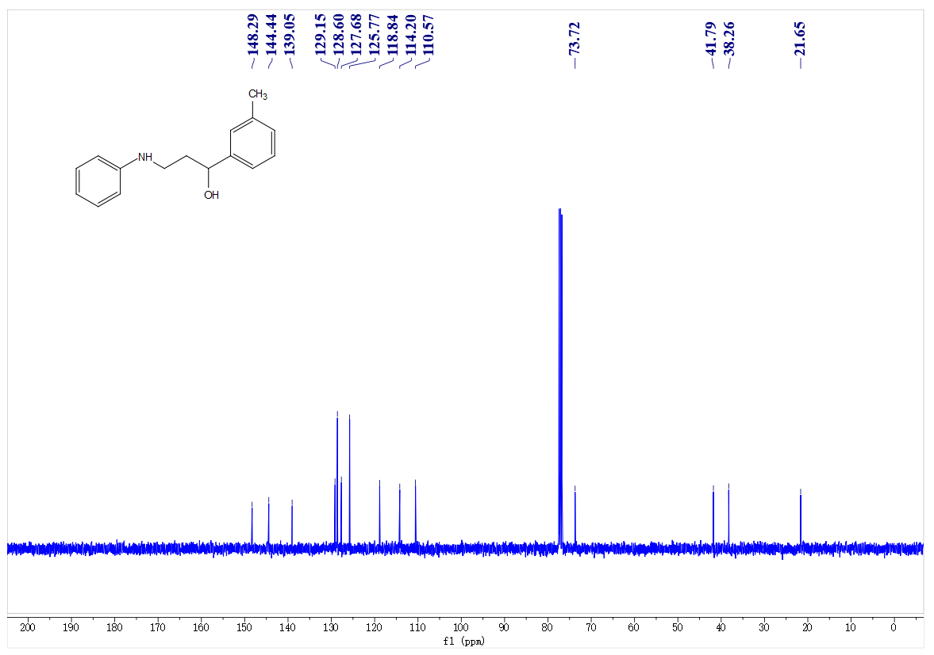
¹H- NMR spectrum of C29
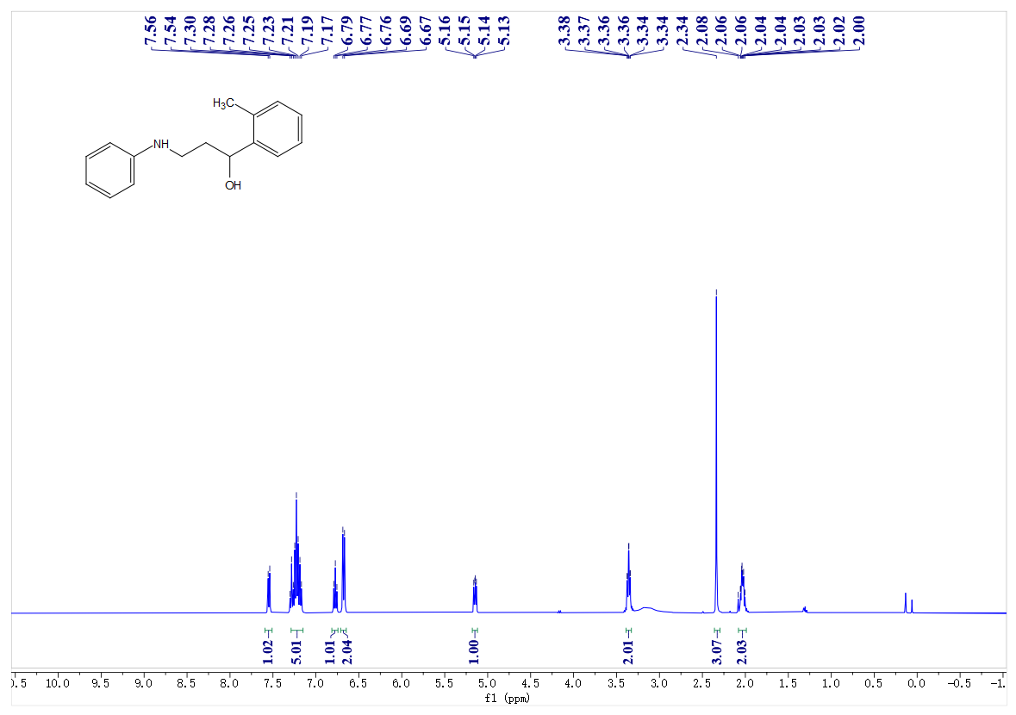
¹³C- NMR spectrum of C29
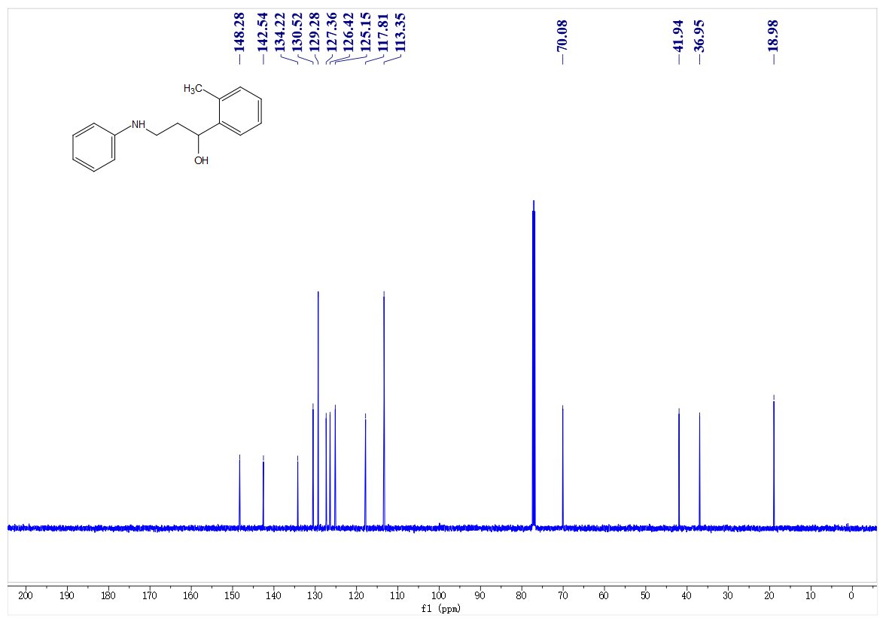
¹H- NMR spectrum of C30
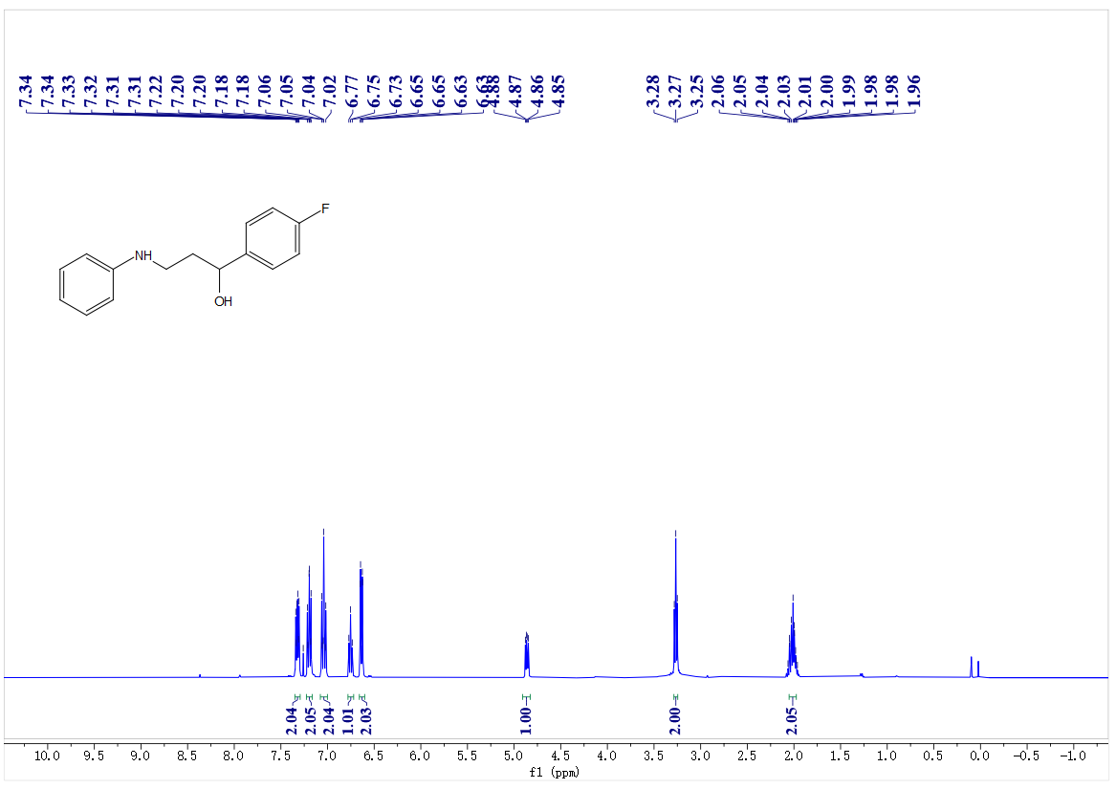
¹³C- NMR spectrum of C30
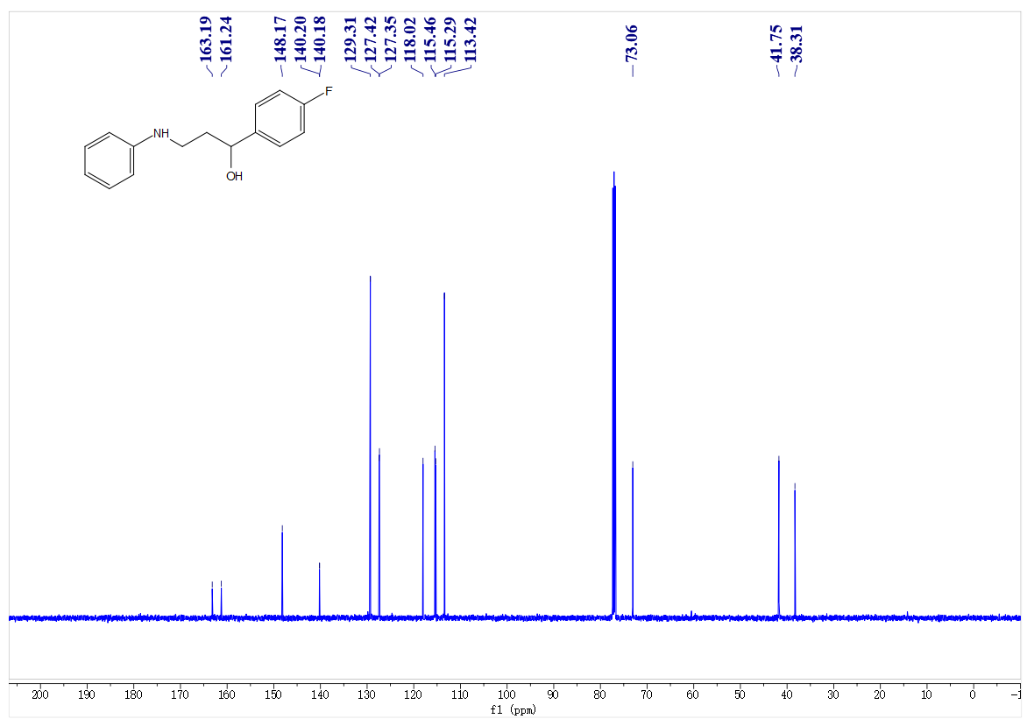
¹⁹F- NMR spectrum of C30
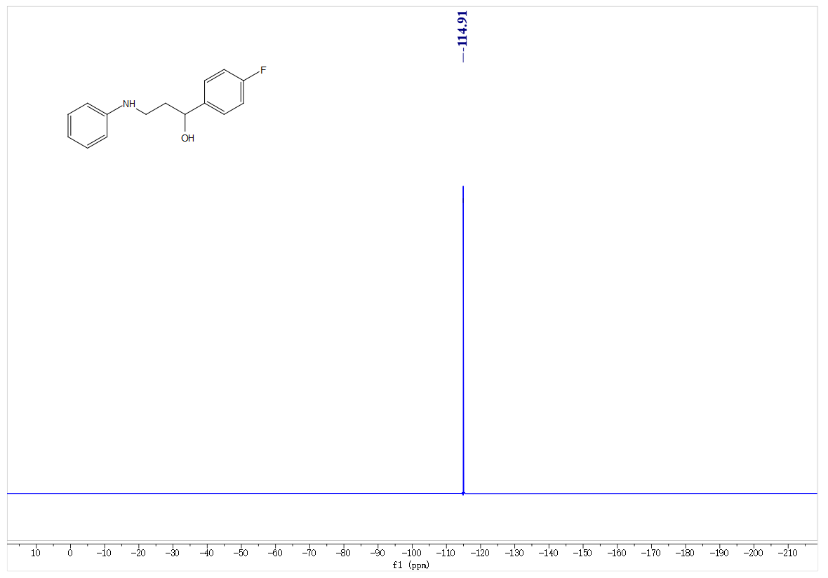
¹H- NMR spectrum of C31
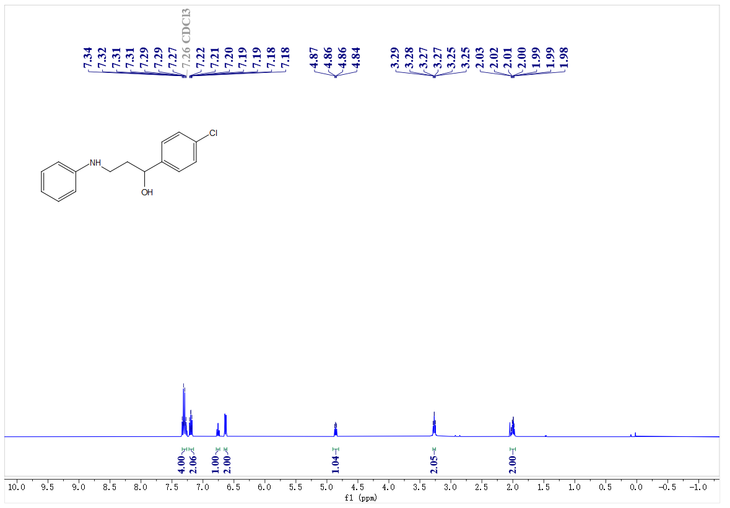
¹³C- NMR spectrum of C31
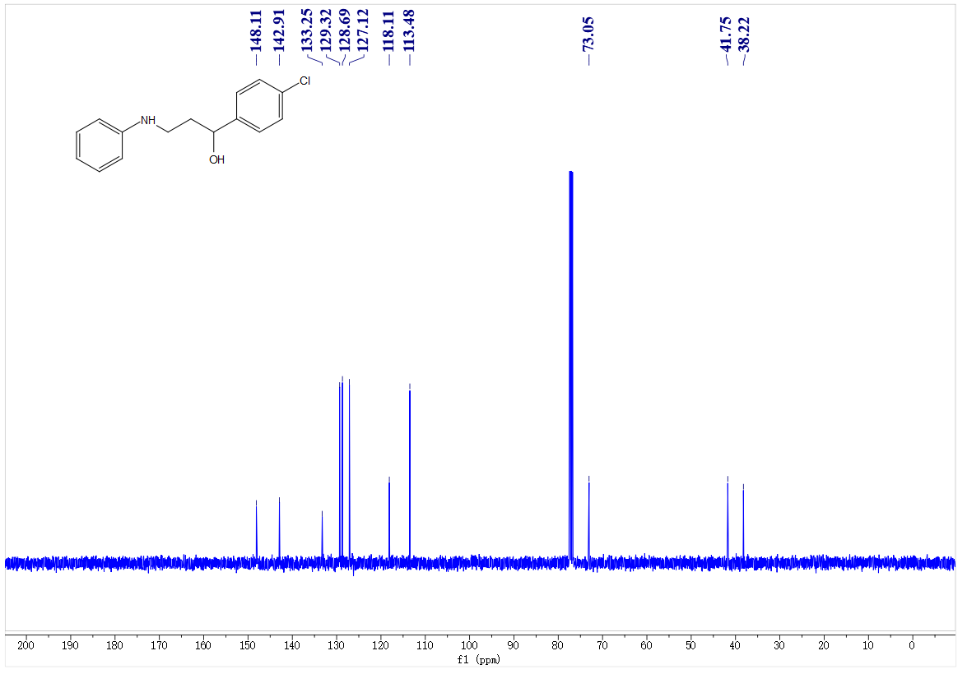
¹H- NMR spectrum of C32
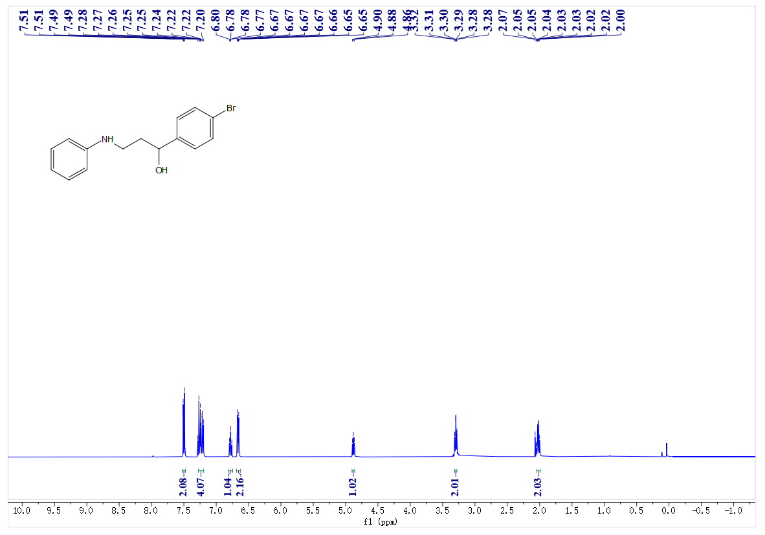
¹³C- NMR spectrum of C32
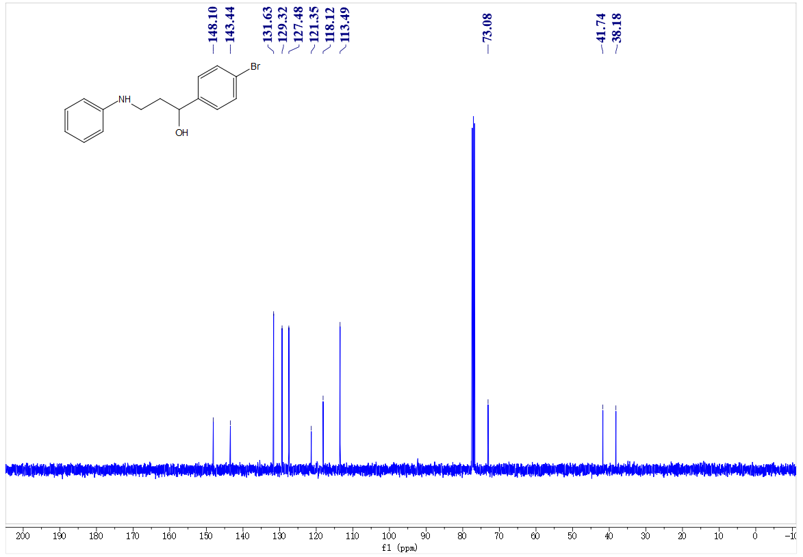
¹H- NMR spectrum of C33
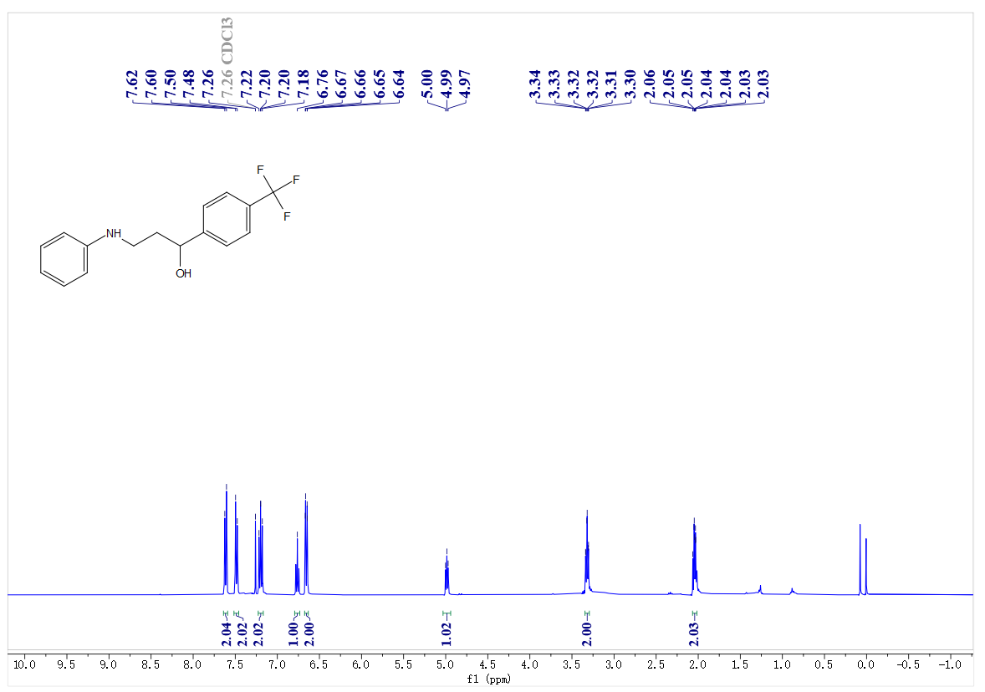
¹³C- NMR spectrum of C33
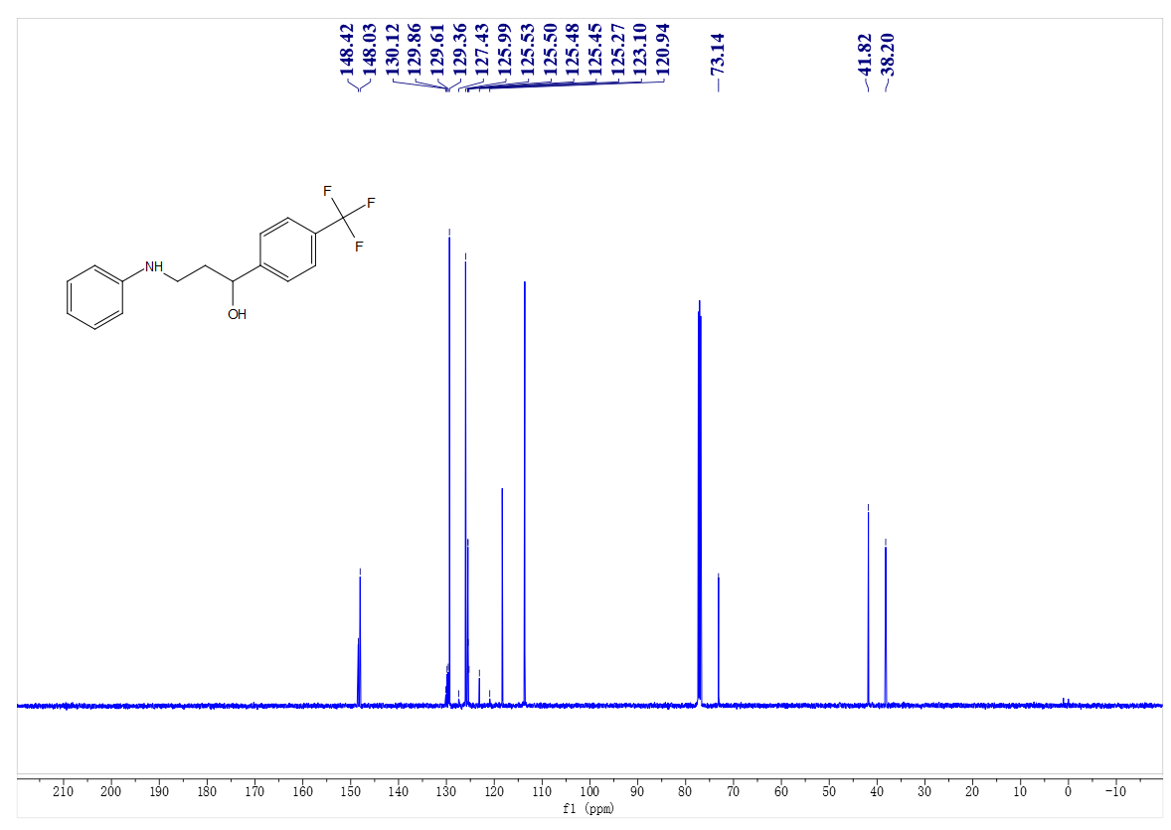
¹⁹F- NMR spectrum of C33
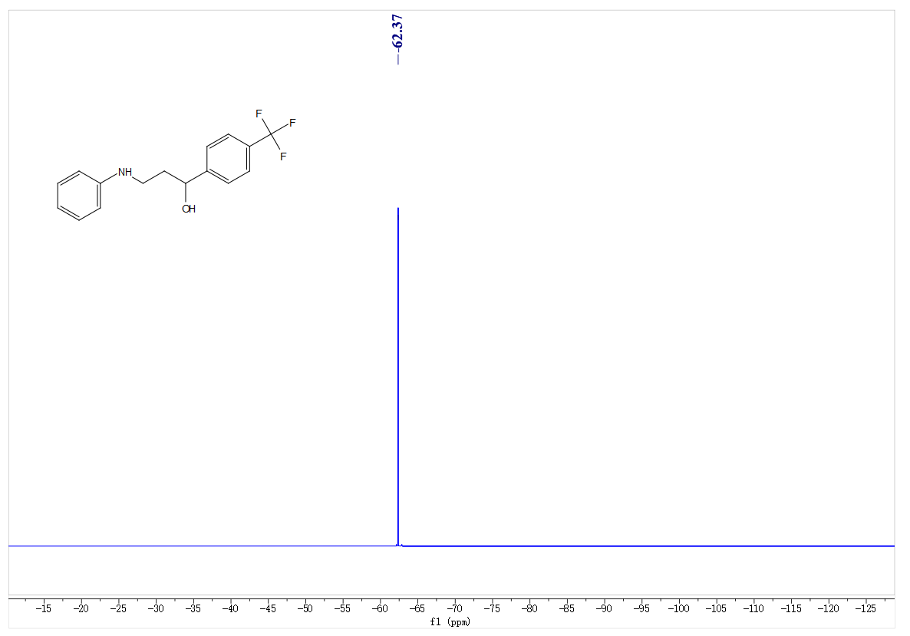
¹H- NMR spectrum of C34
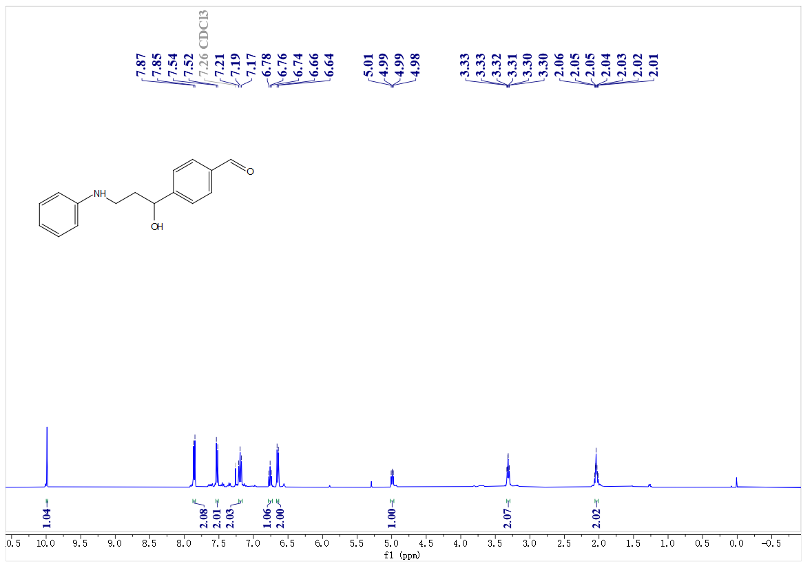
¹³C- NMR spectrum of C34
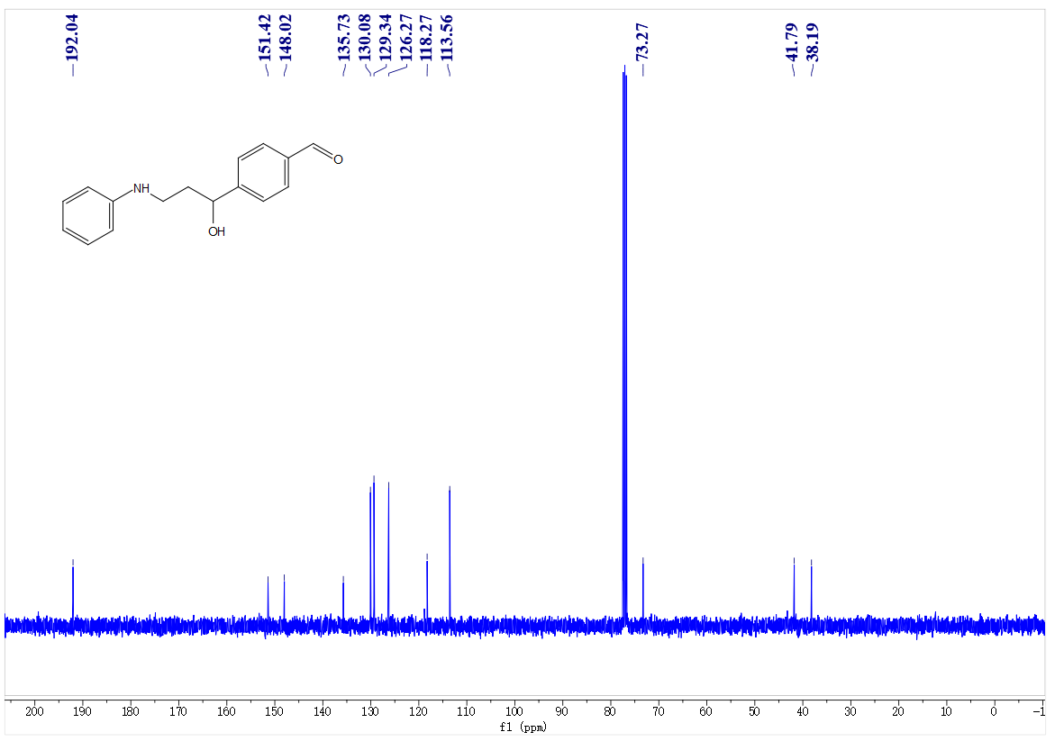
¹H- NMR spectrum of C35
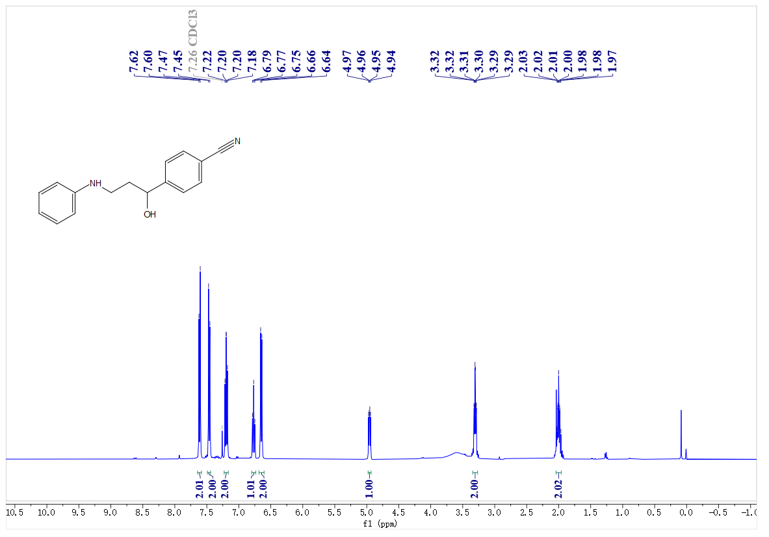
¹³C- NMR spectrum of C35
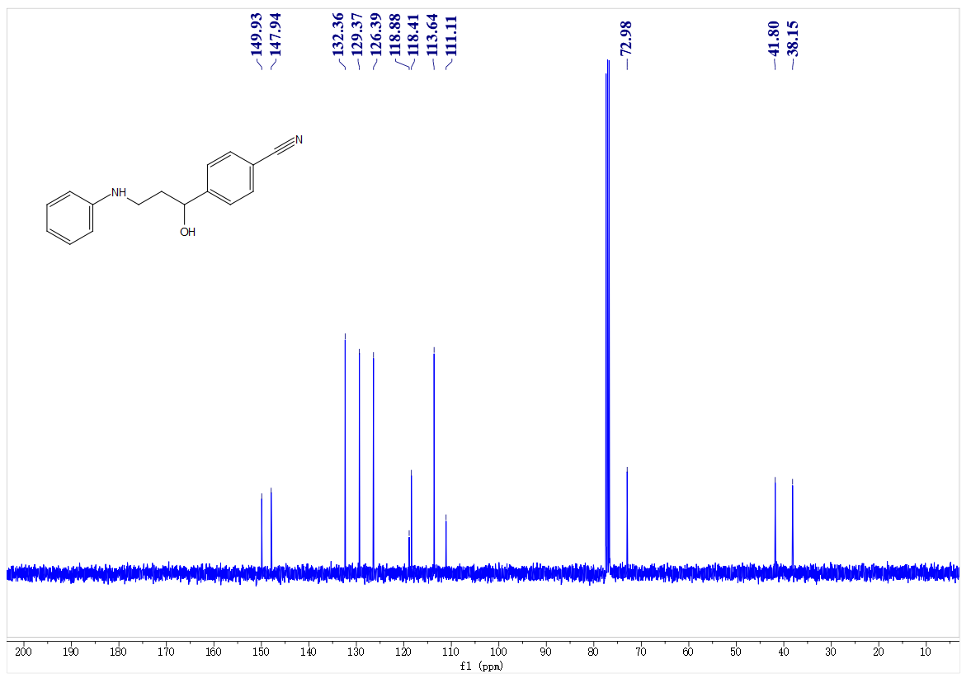
¹H- NMR spectrum of C36
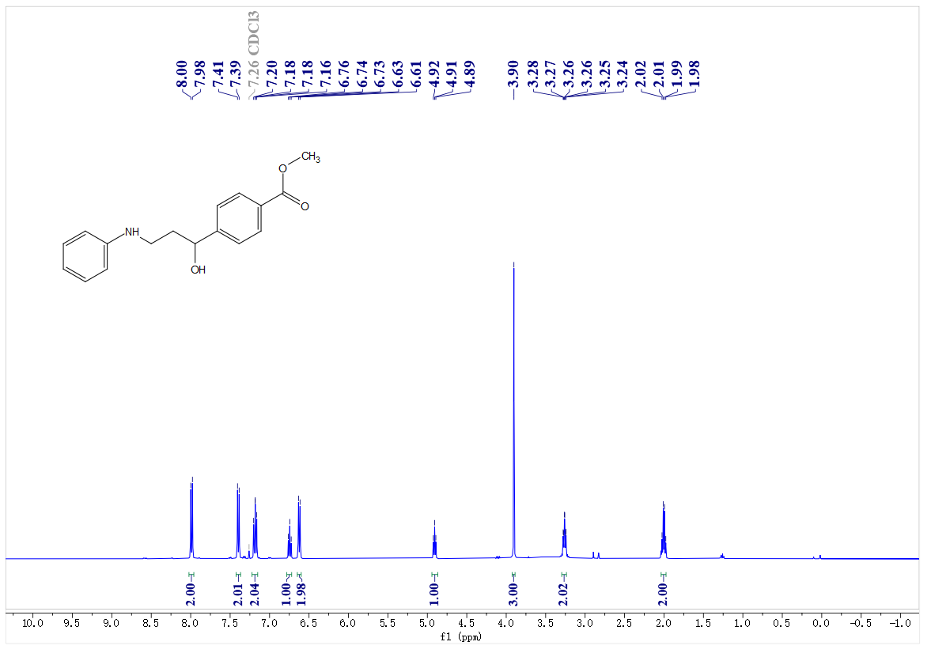
¹³C- NMR spectrum of C36
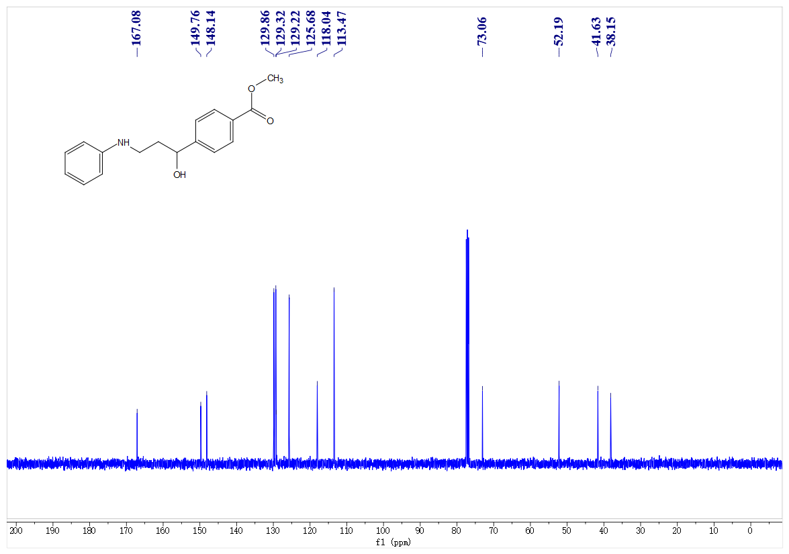
¹H- NMR spectrum of C37
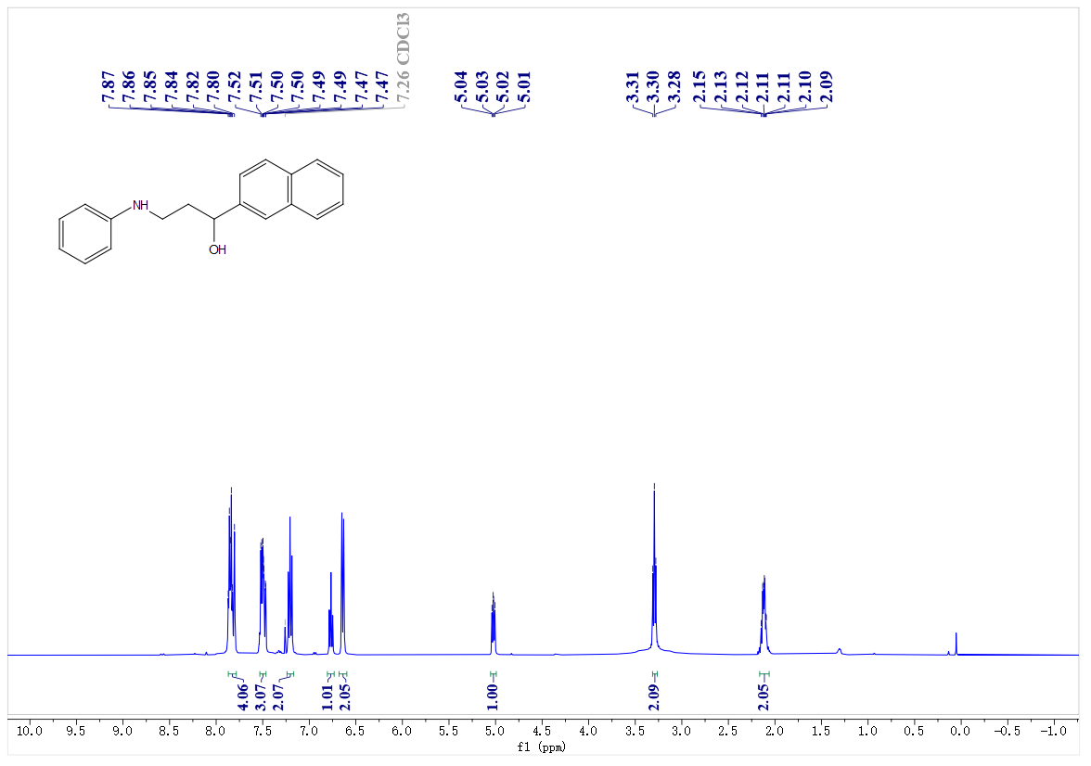
¹³C- NMR spectrum of C37
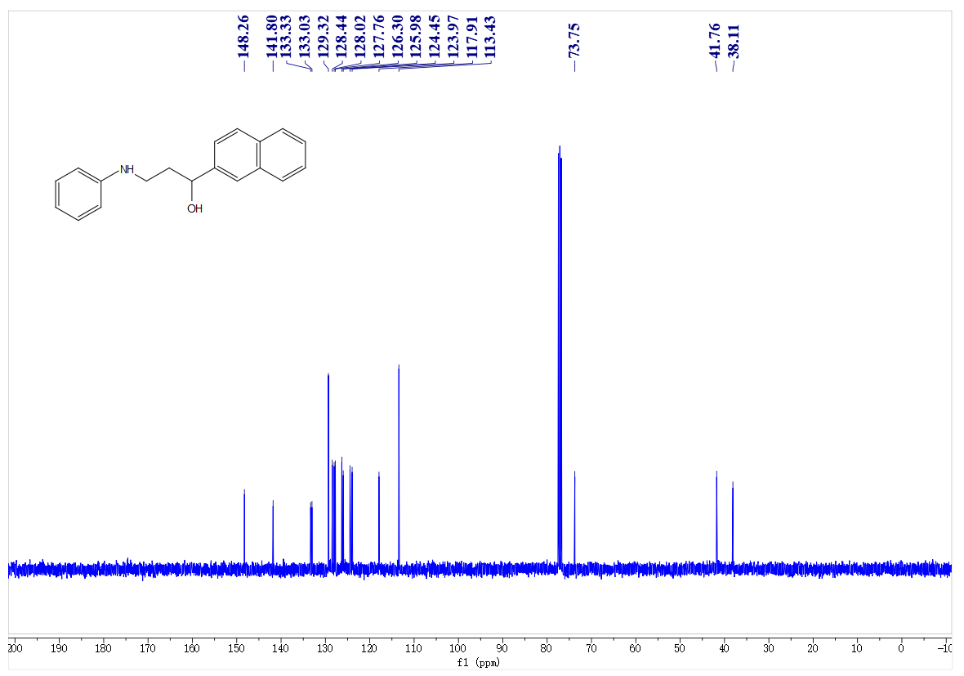
¹H- NMR spectrum of C38
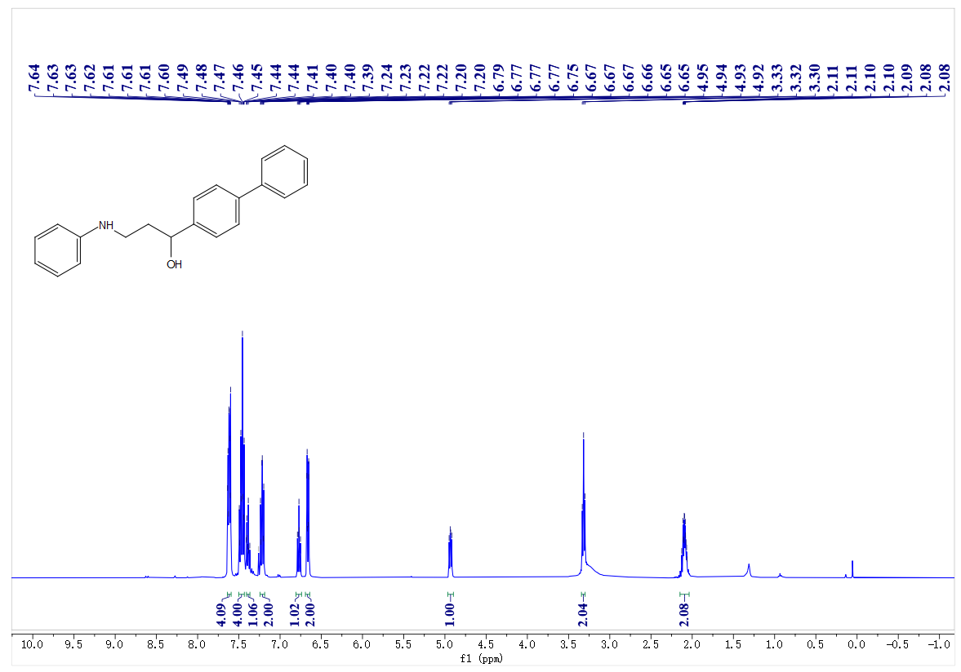
¹³C- NMR spectrum of C38
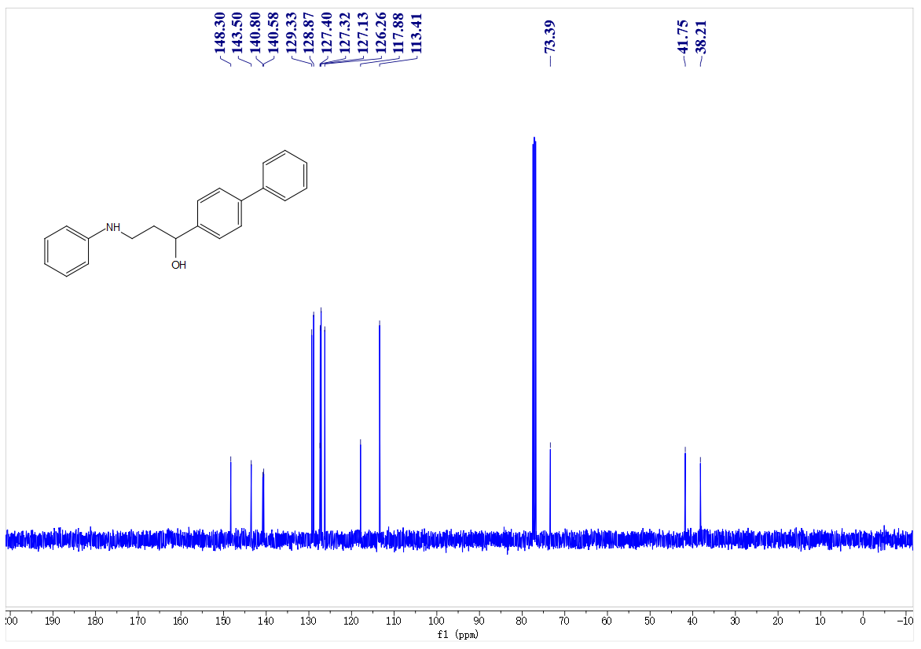
¹H- NMR spectrum of C39
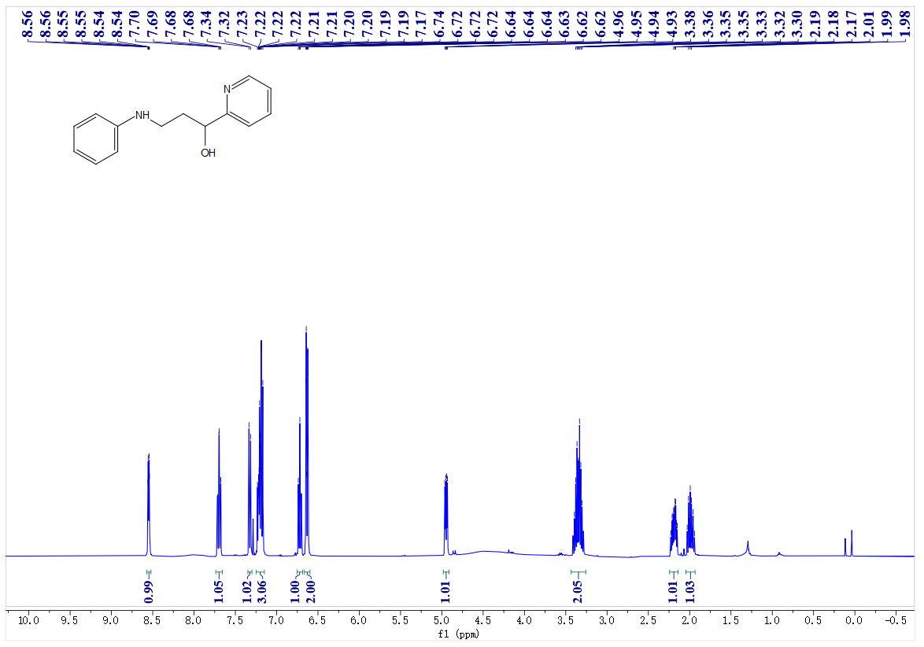
¹³C- NMR spectrum of C39
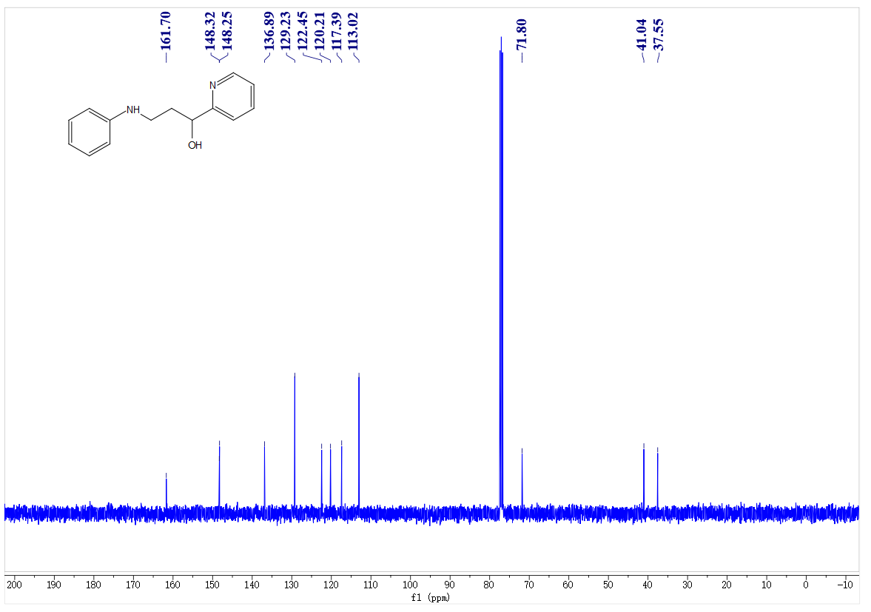
1H- NMR spectrum of C33
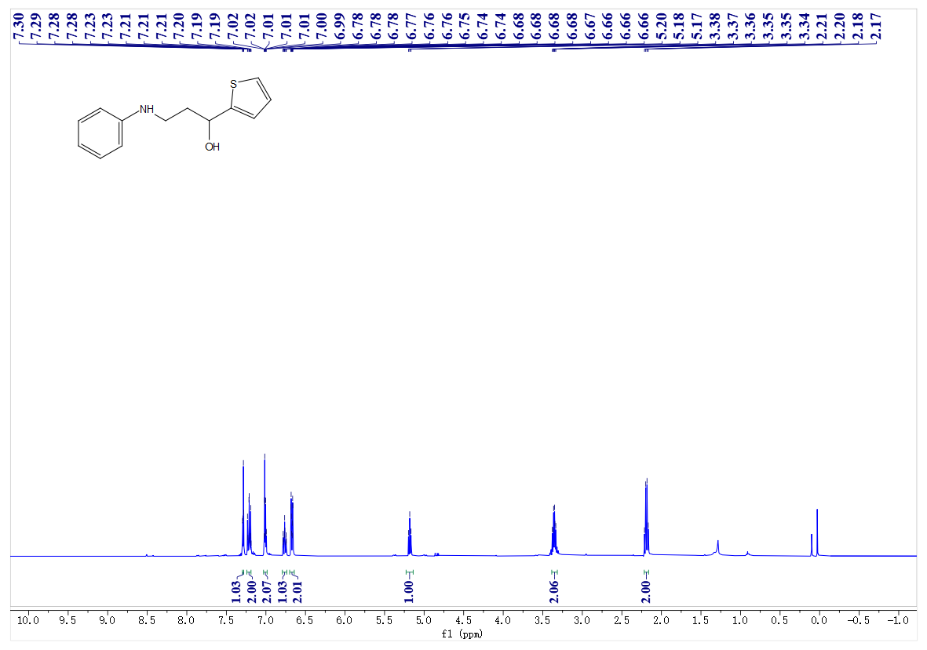
¹³C- NMR spectrum of C40
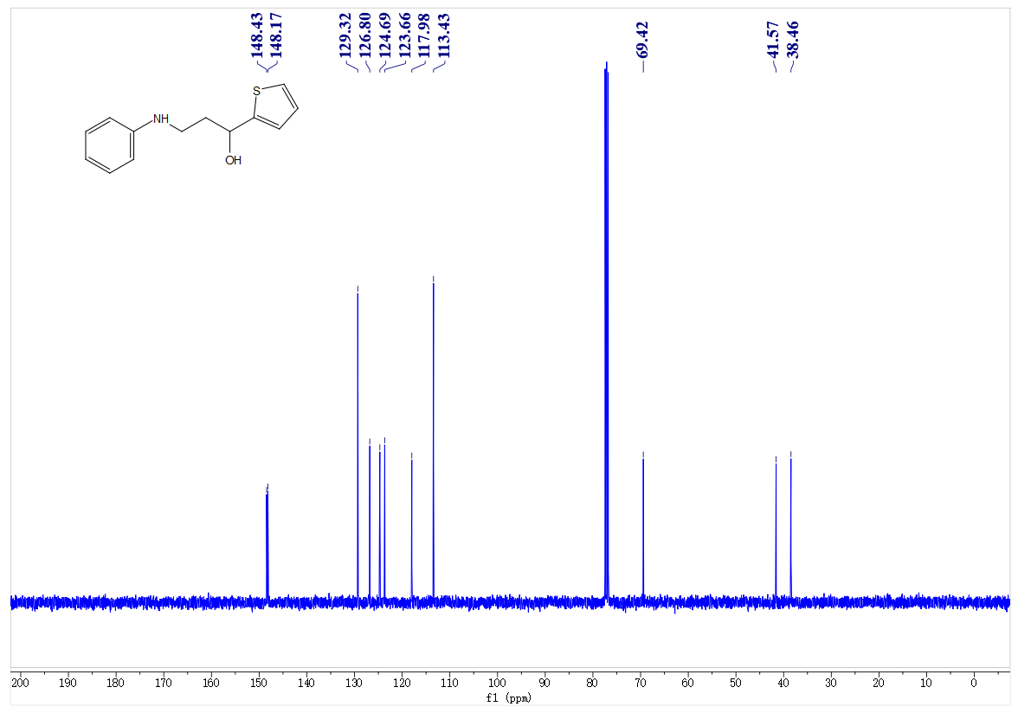
¹H- NMR spectrum of C41
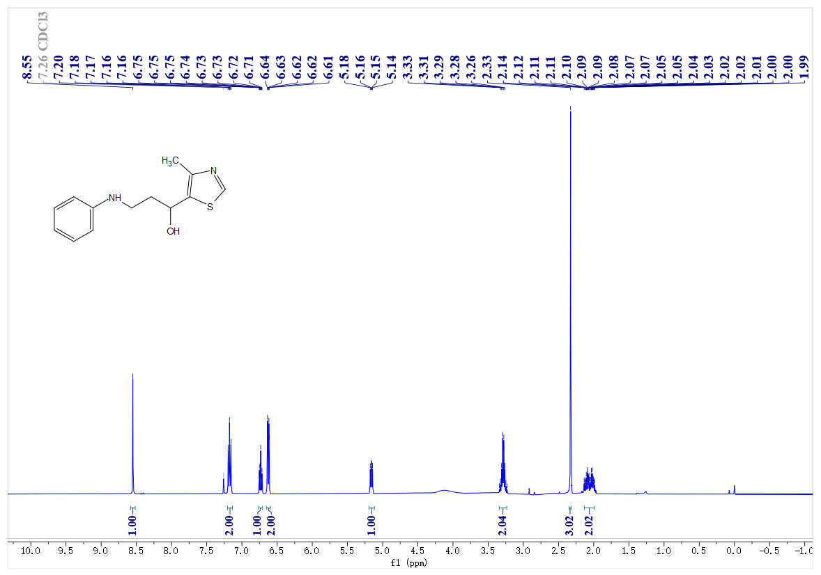
¹³C- NMR spectrum of C41
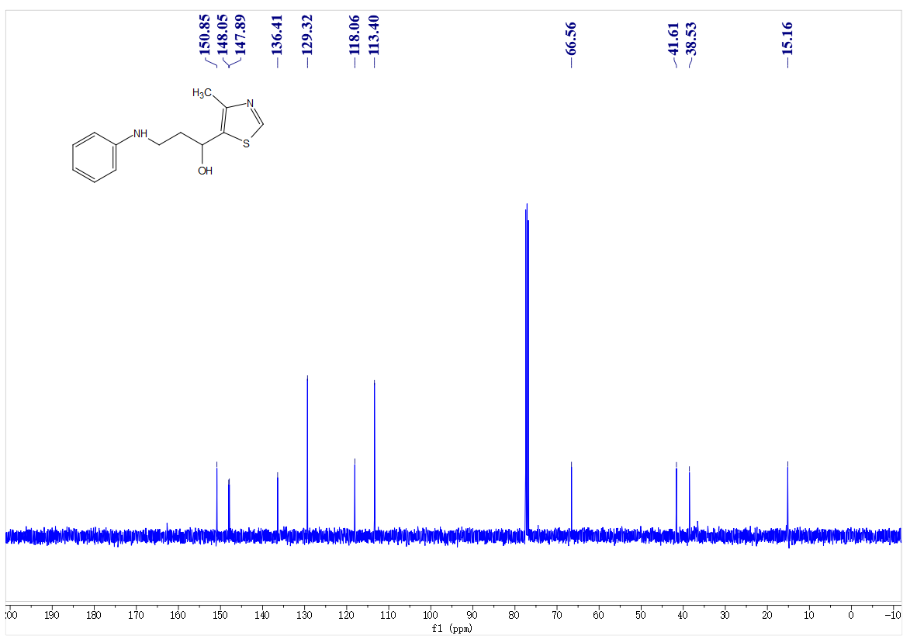
¹H- NMR spectrum of C42
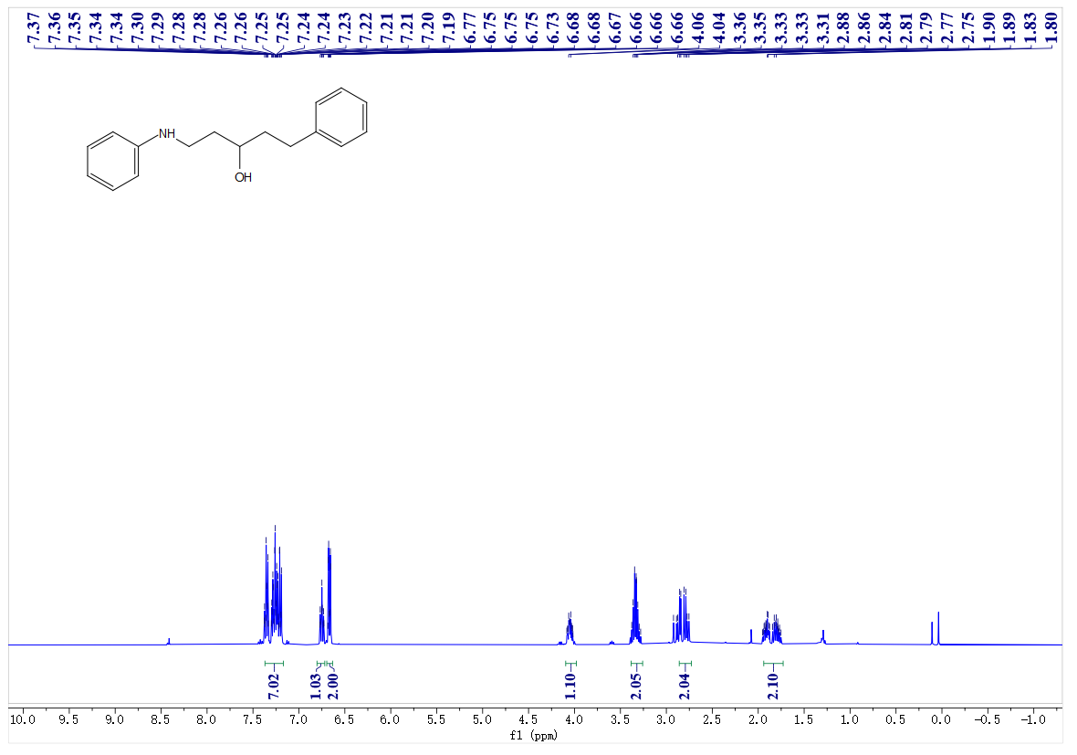
¹³C- NMR spectrum of C42
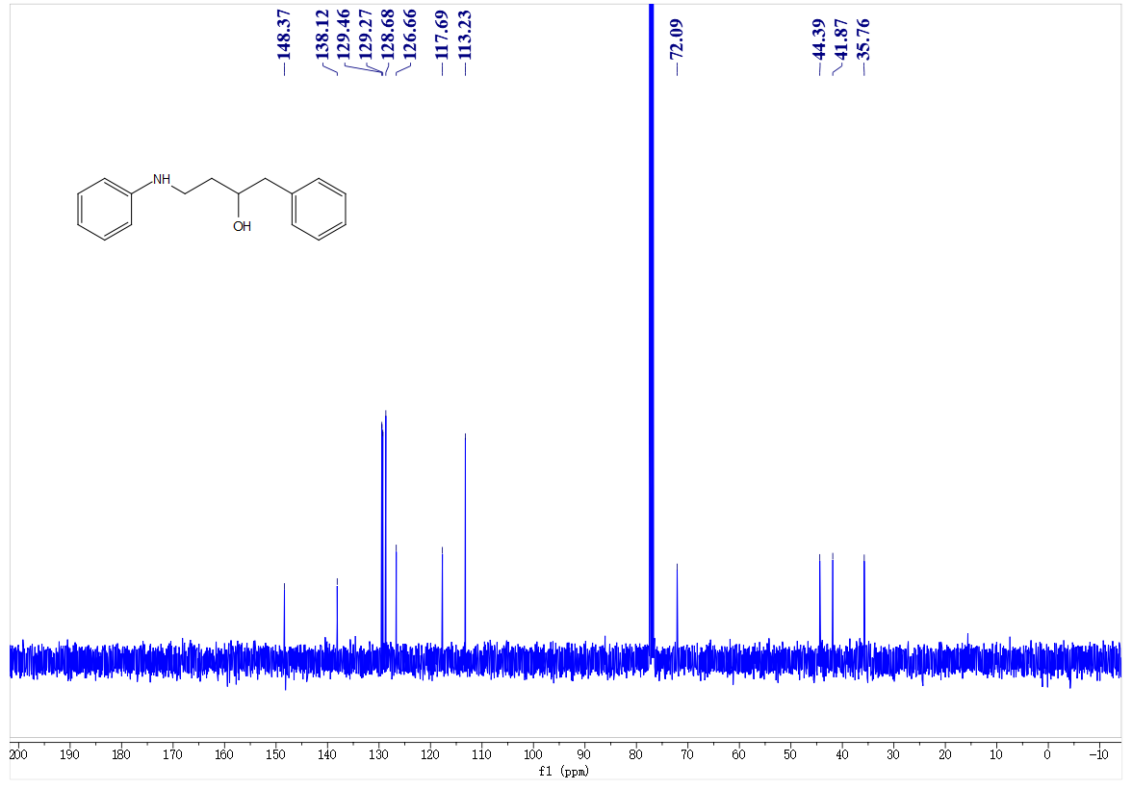
¹H- NMR spectrum of C43
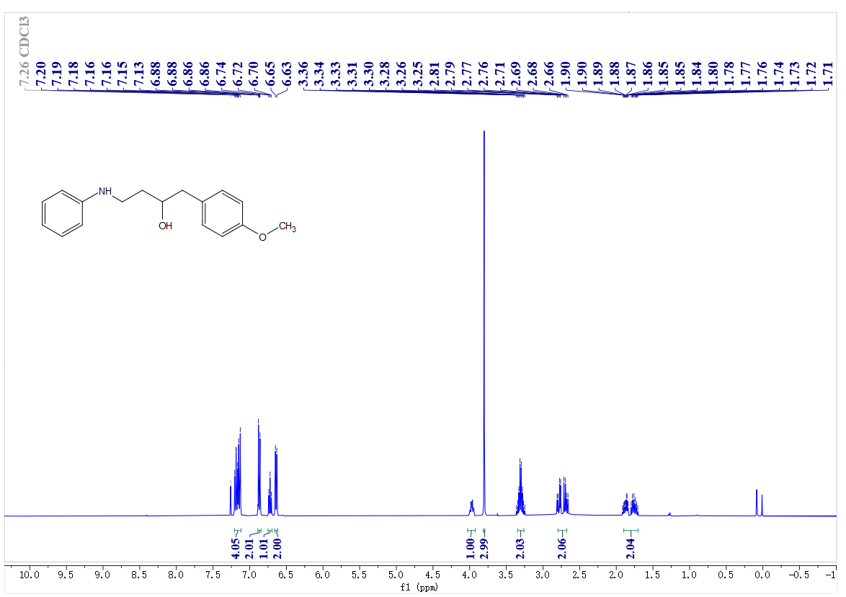
¹³C- NMR spectrum of C43
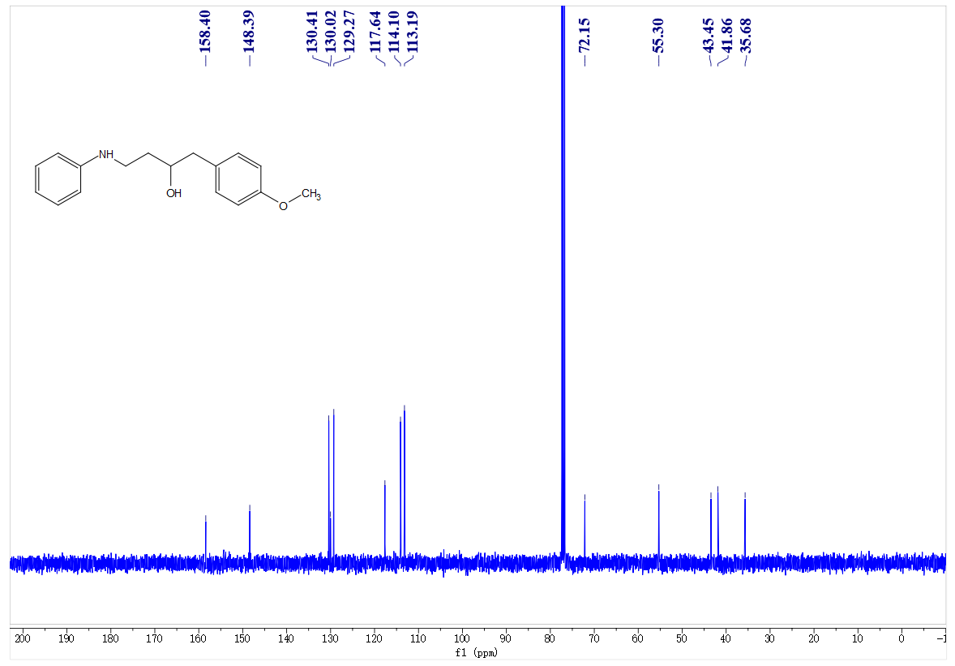
¹H- NMR spectrum of C44
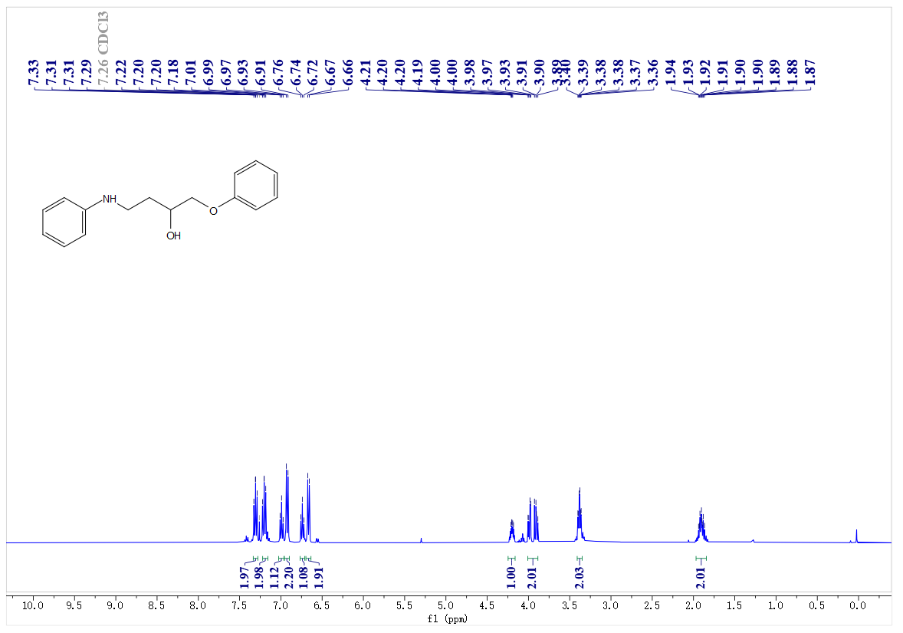
¹³C- NMR spectrum of C44
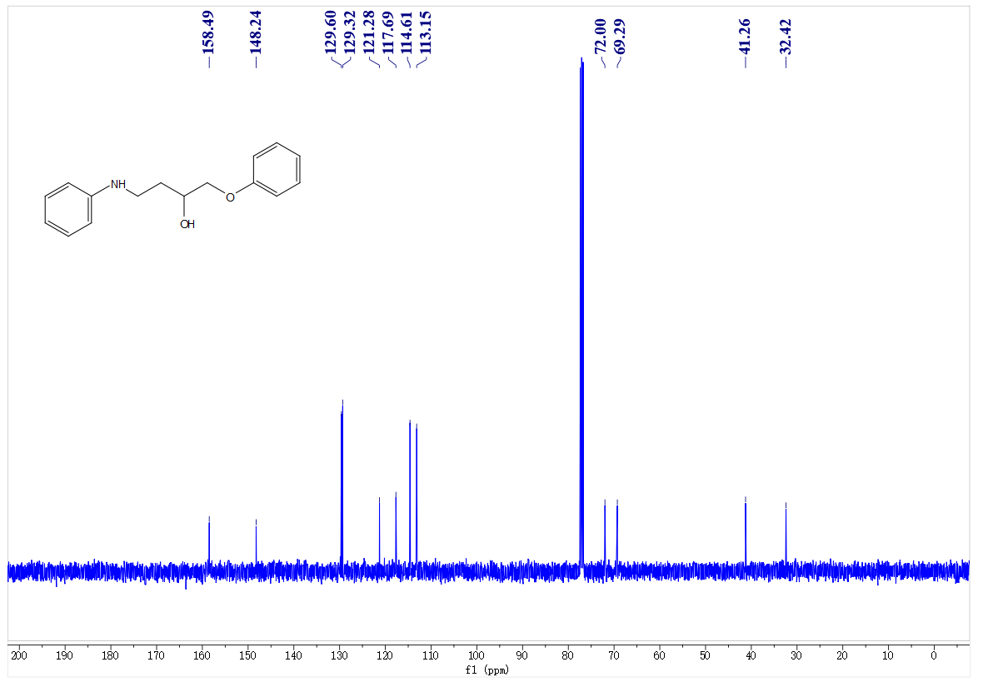
¹H- NMR spectrum of C45
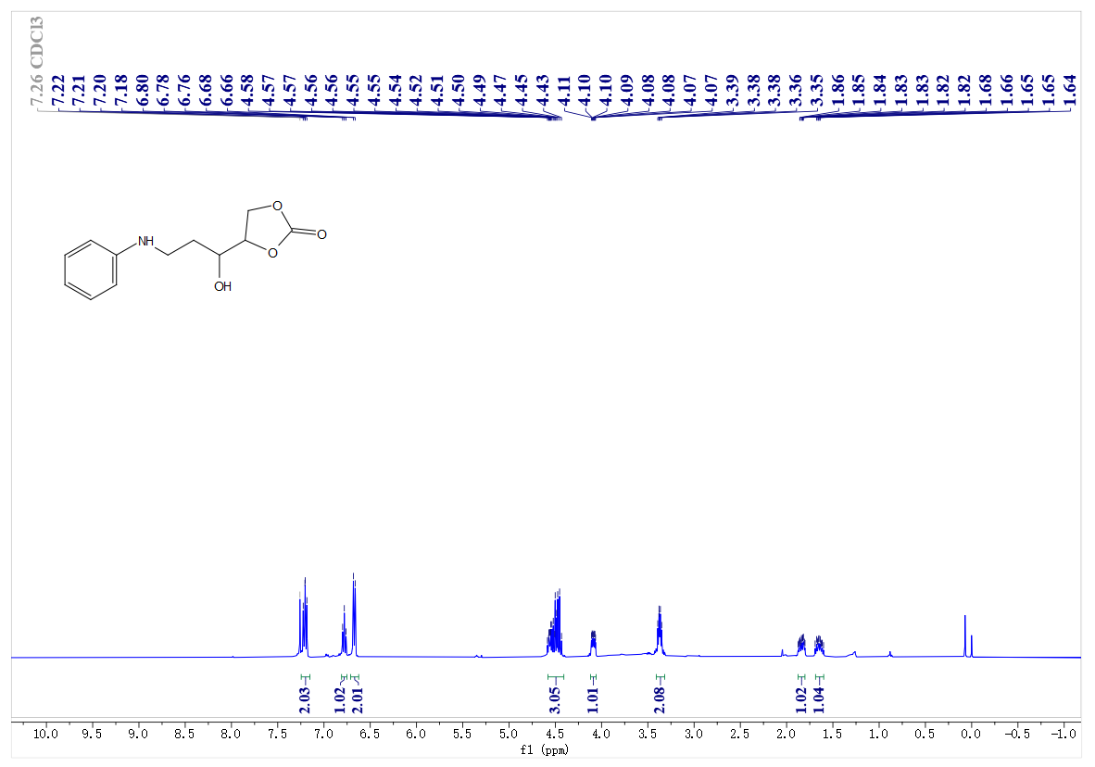
¹³C- NMR spectrum of C45
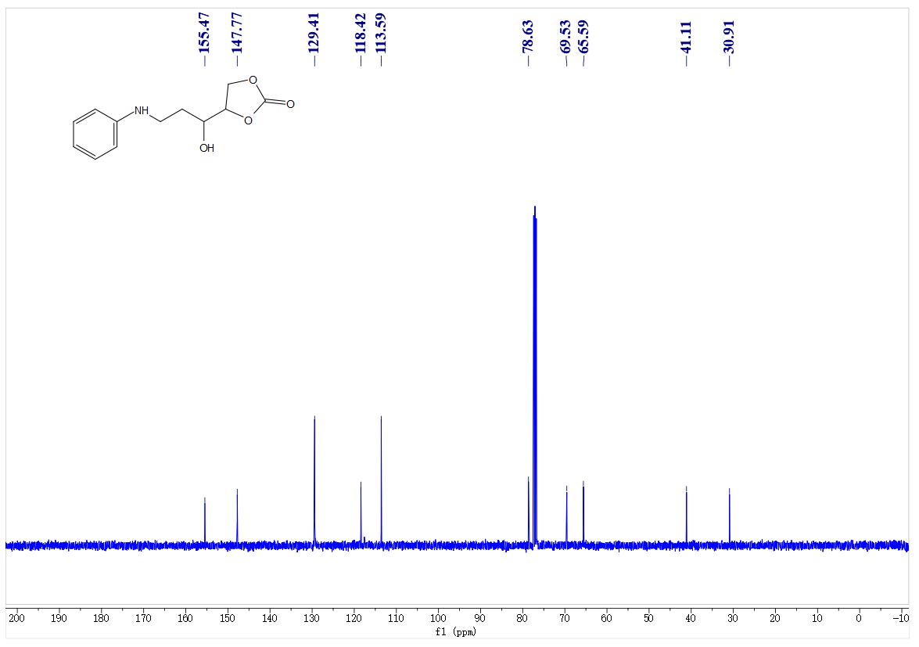
¹H- NMR spectrum of C46
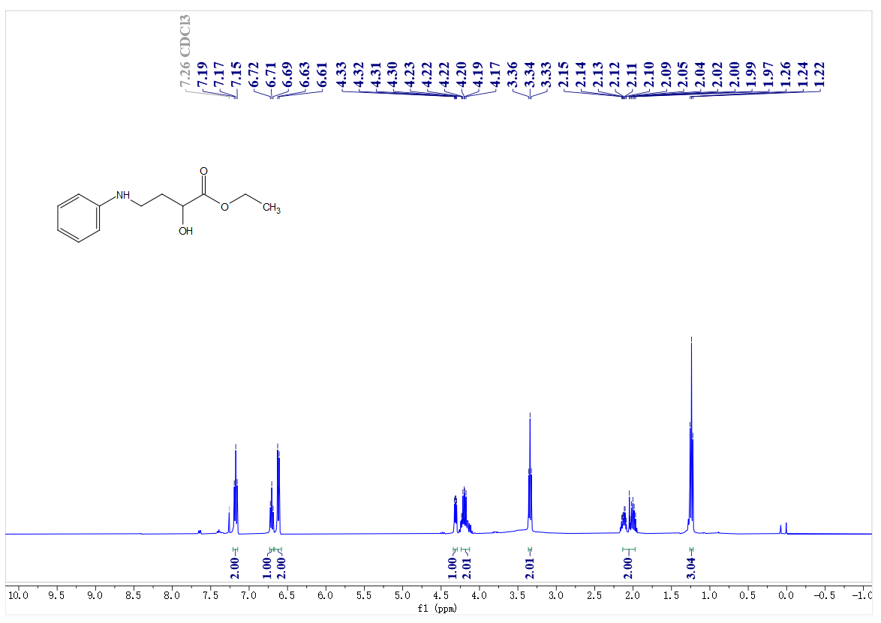
¹³C- NMR spectrum of C46
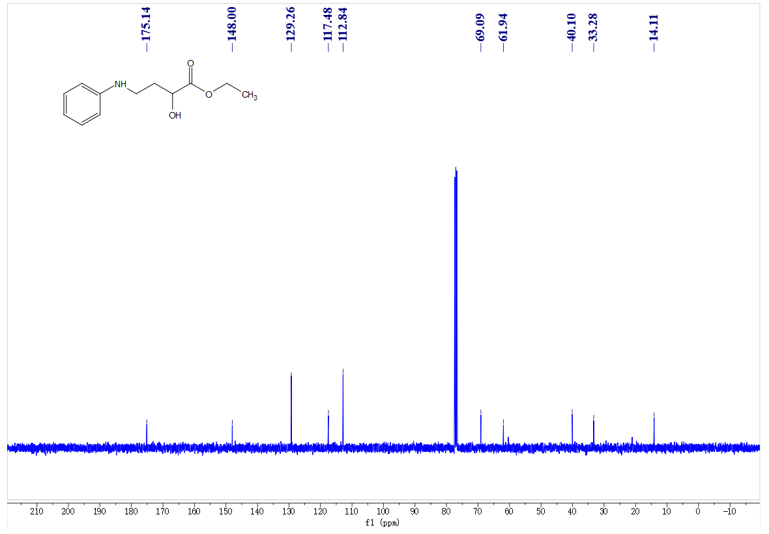
¹H- NMR spectrum of C47
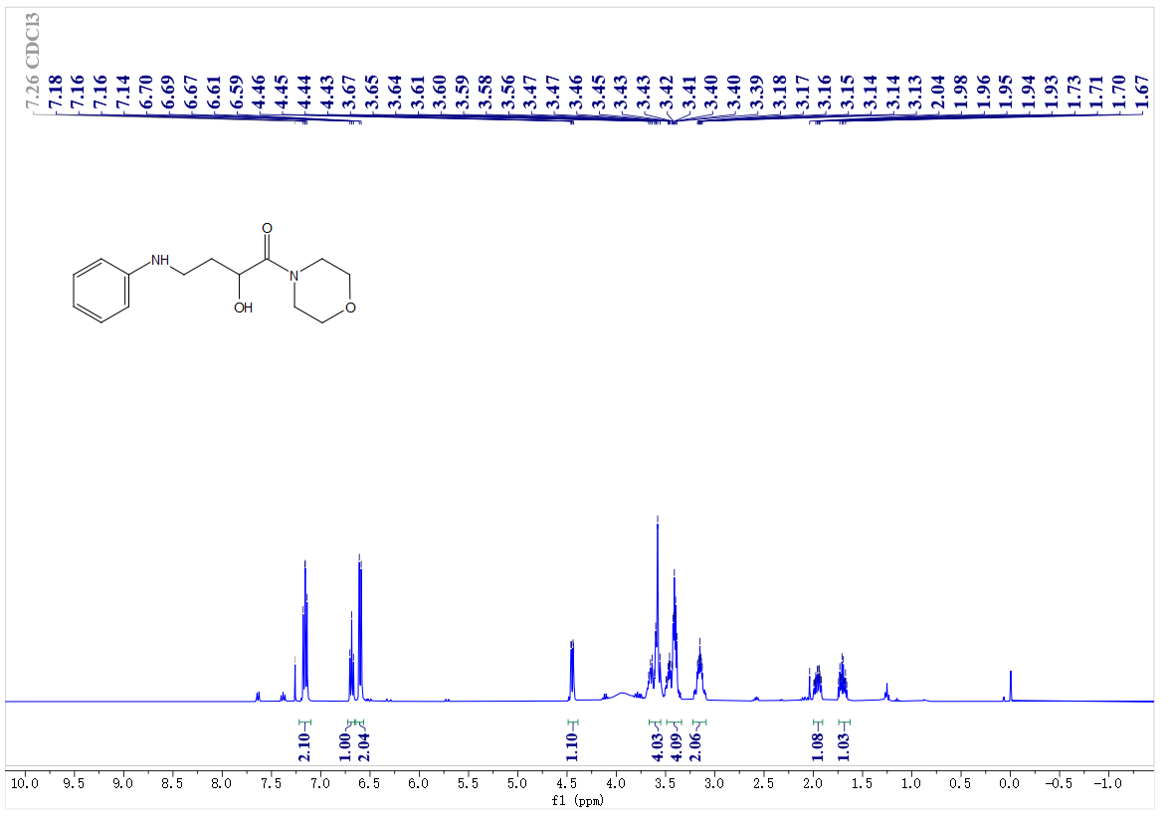
¹³C- NMR spectrum of C47
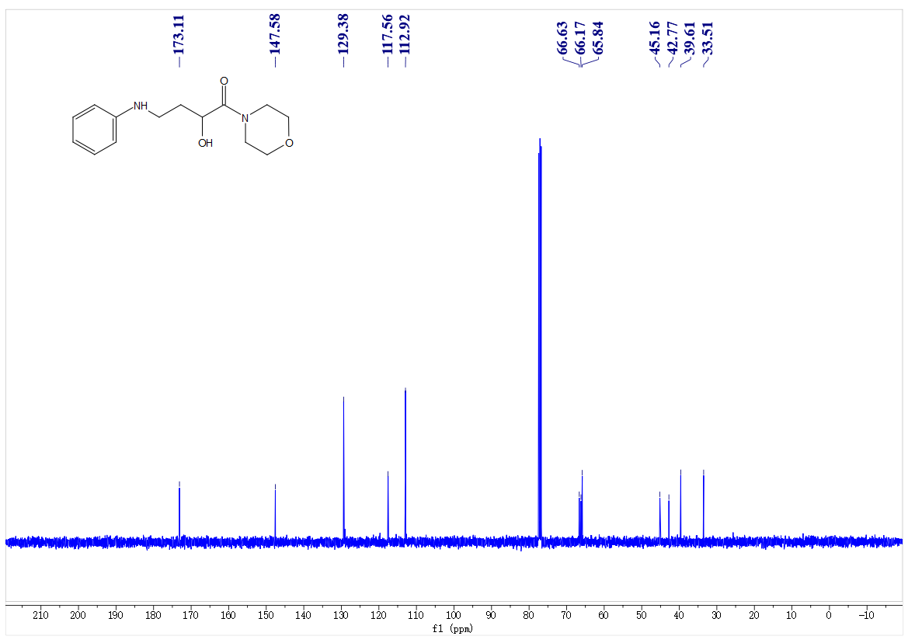
¹H- NMR spectrum of C48
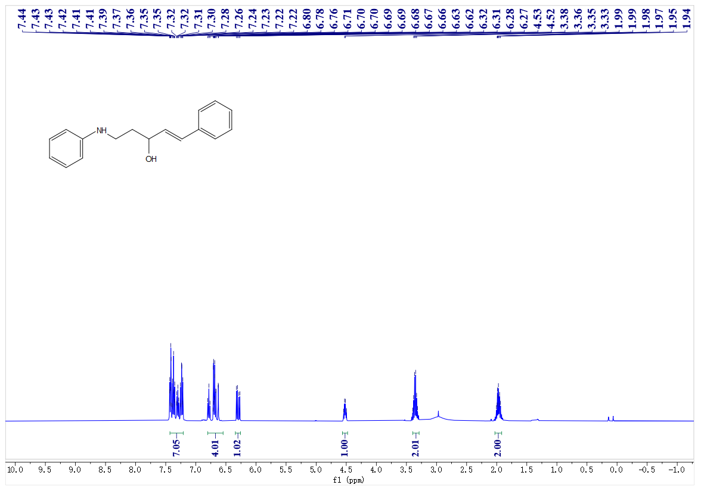
¹³C- NMR spectrum of C48
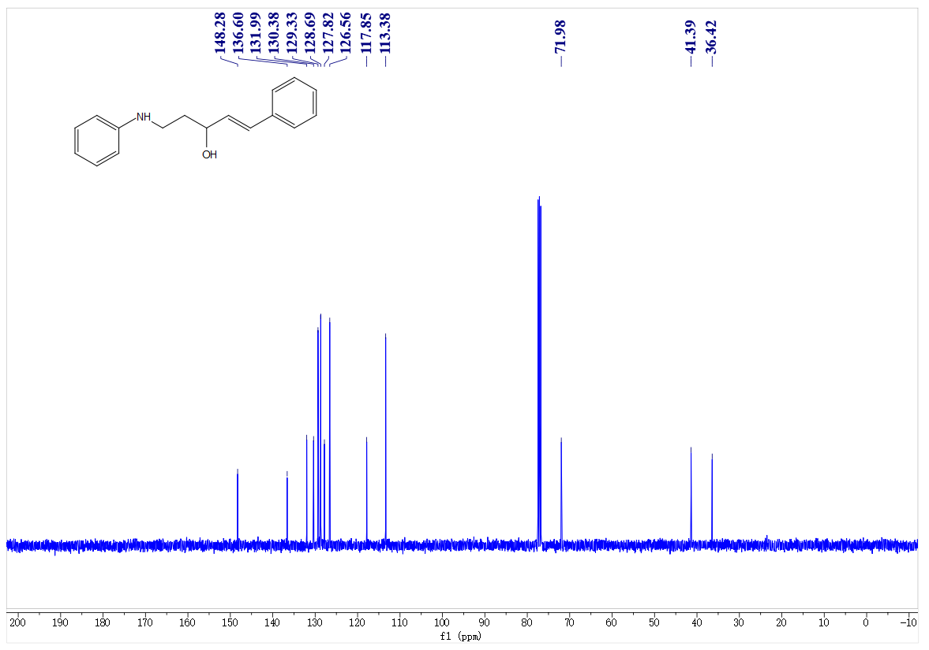
¹H- NMR spectrum of C49
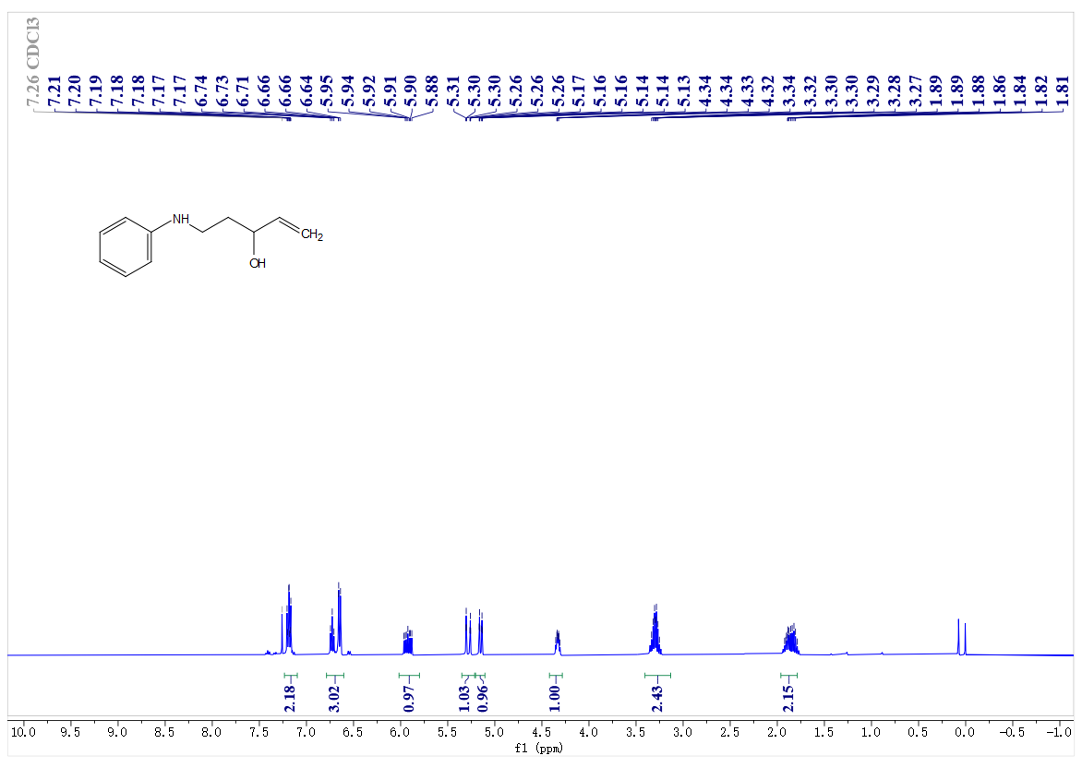
¹³C- NMR spectrum of C49
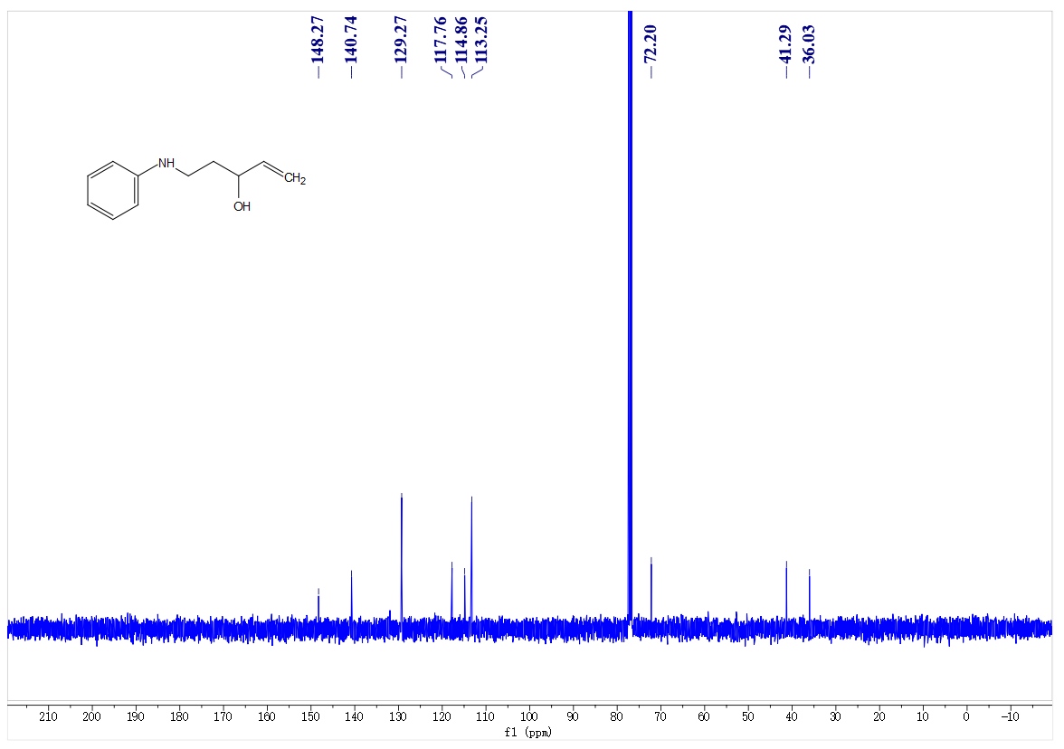
¹H- NMR spectrum of C50
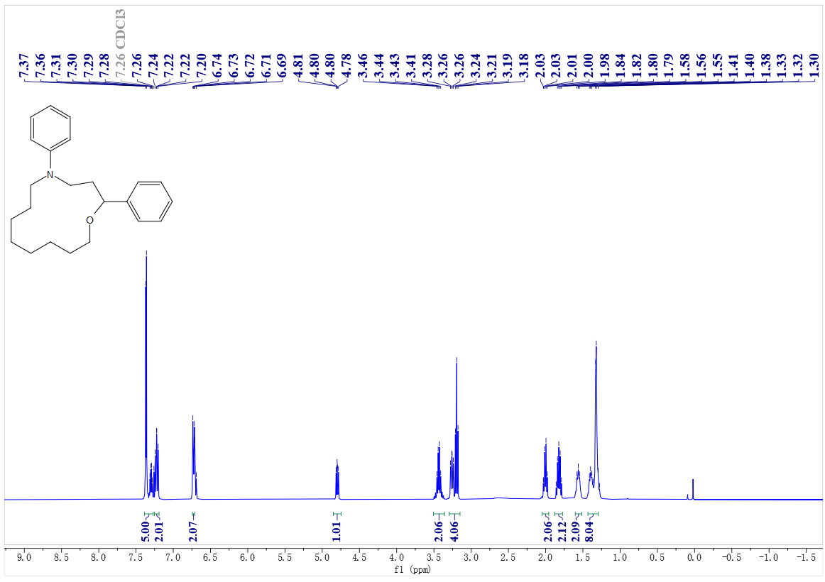
¹³C- NMR spectrum of C50
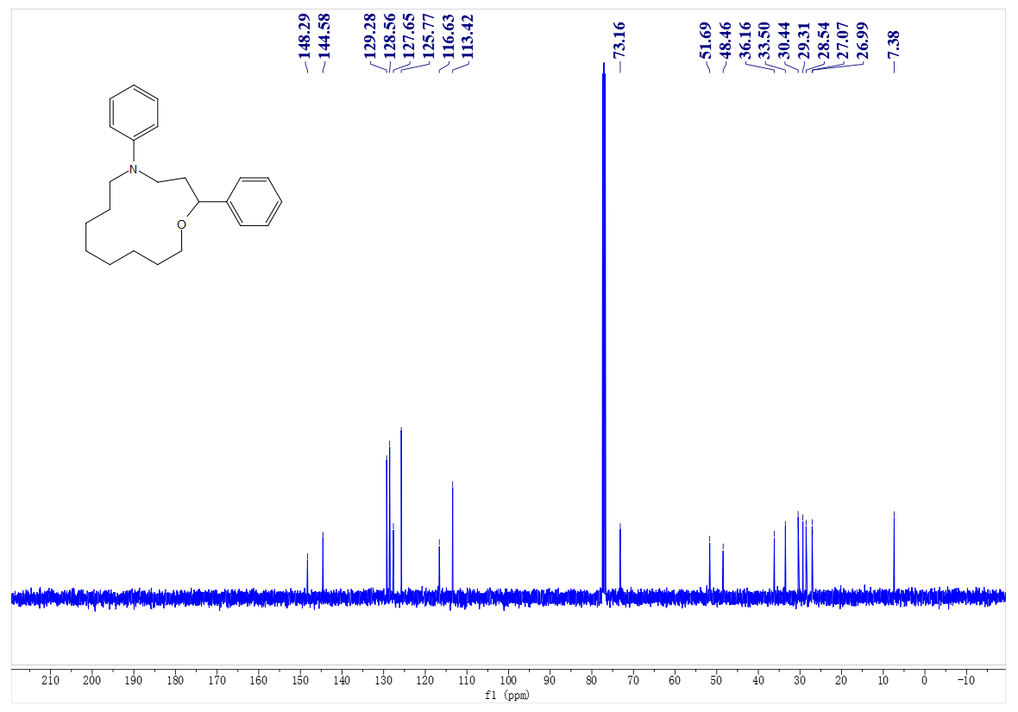
¹H- NMR spectrum of C51
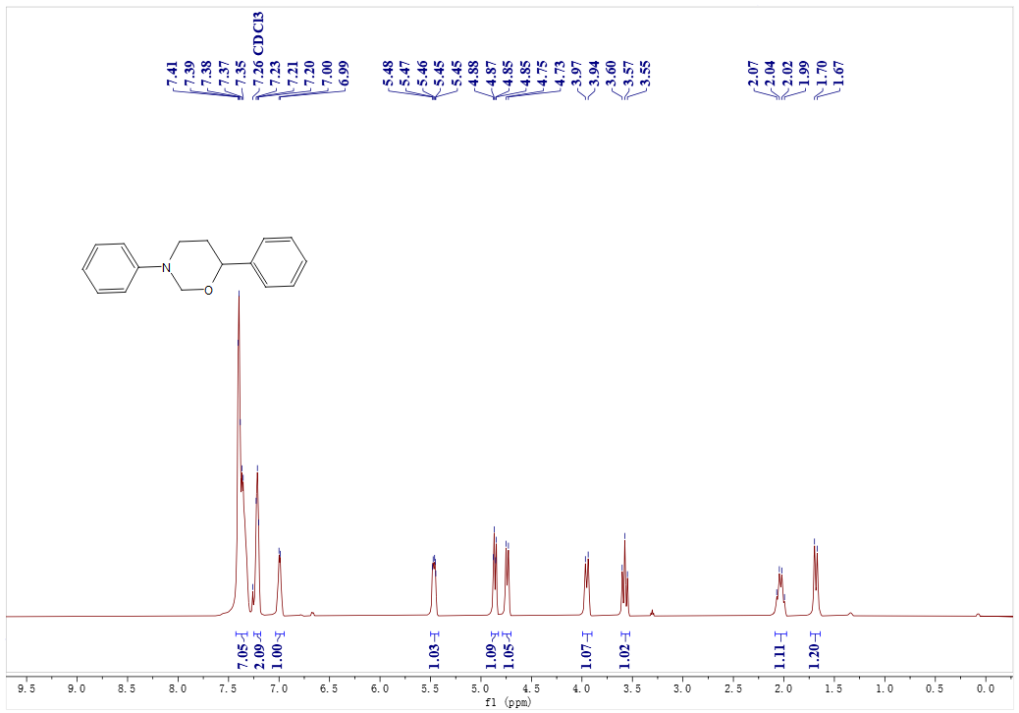
¹³C- NMR spectrum of C51
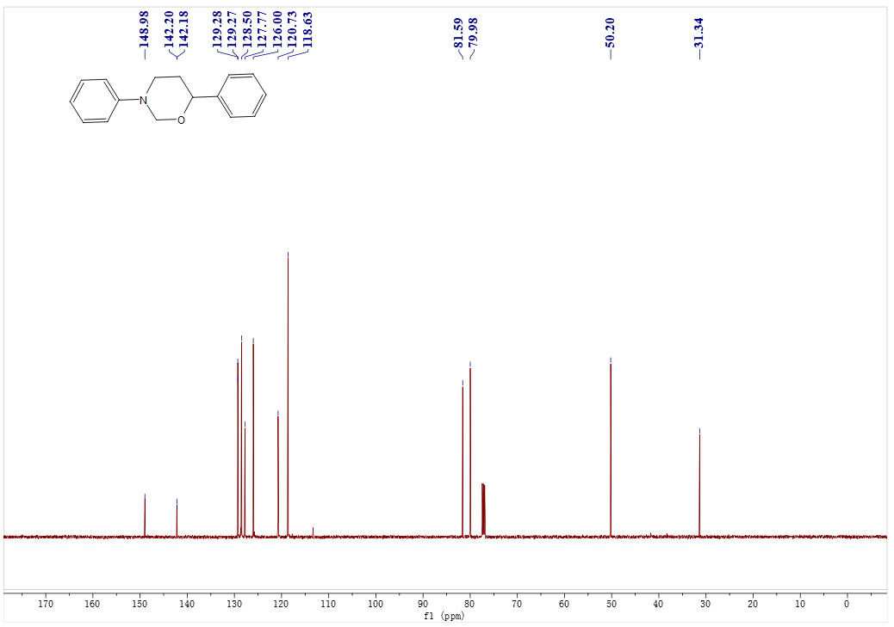
¹H- NMR spectrum of C52
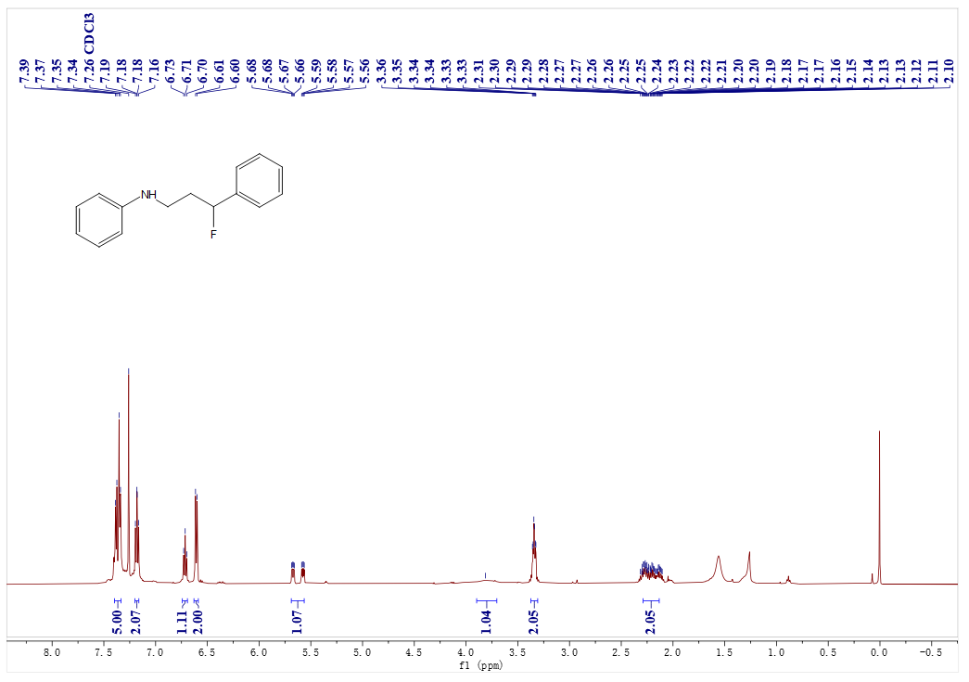
¹³C- NMR spectrum of C52
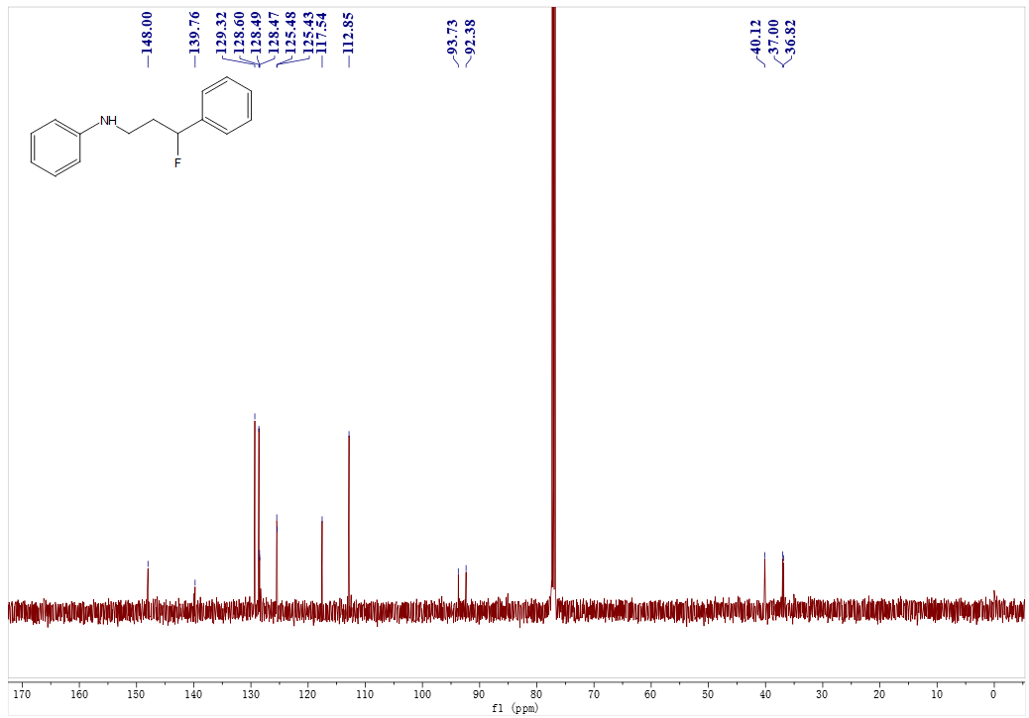
¹⁹F- NMR spectrum of C52
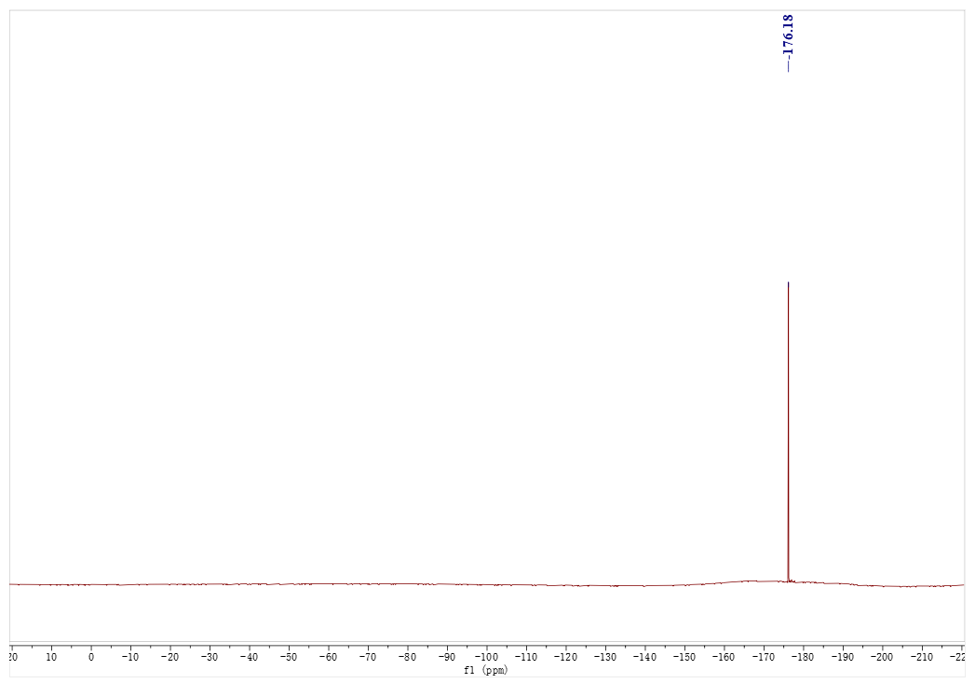
¹H- NMR spectrum of C53
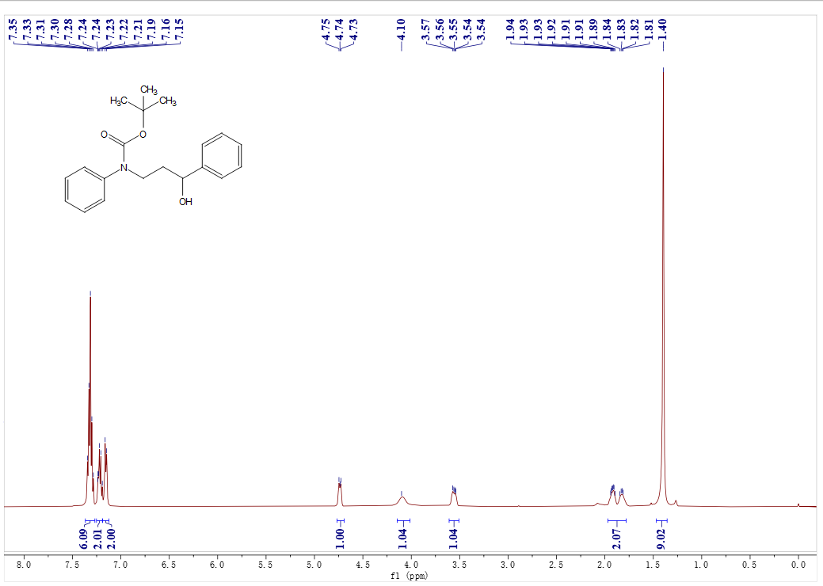
¹³C- NMR spectrum of C53
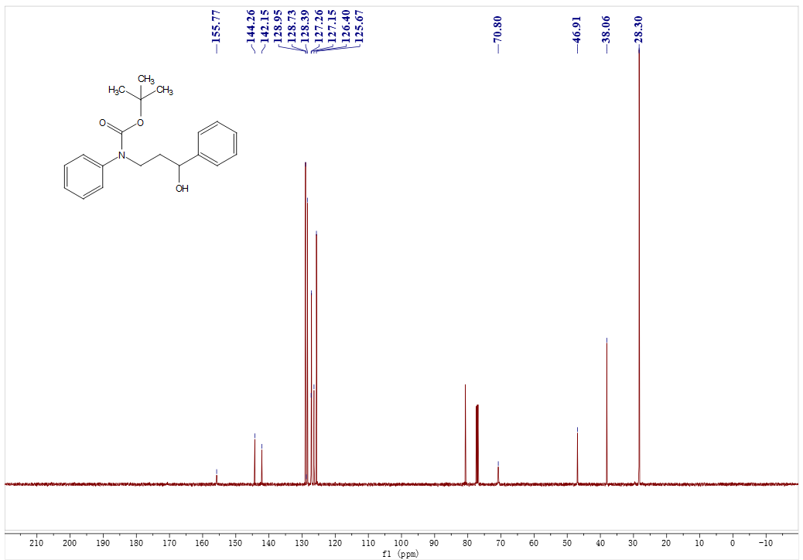

¹H- NMR spectrum of C53
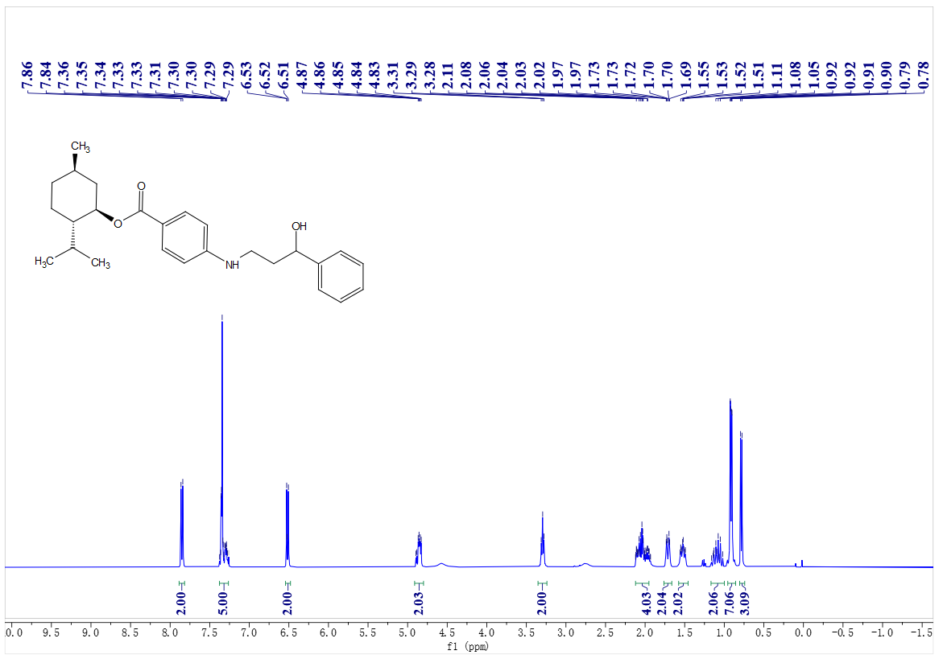
¹³C- NMR spectrum of C53
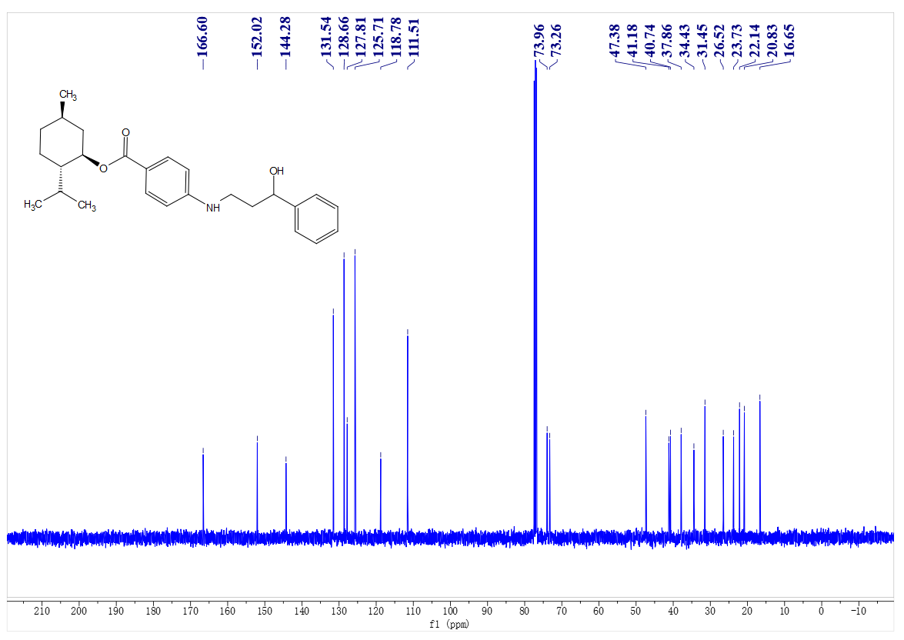¹H- NMR spectrum of C54
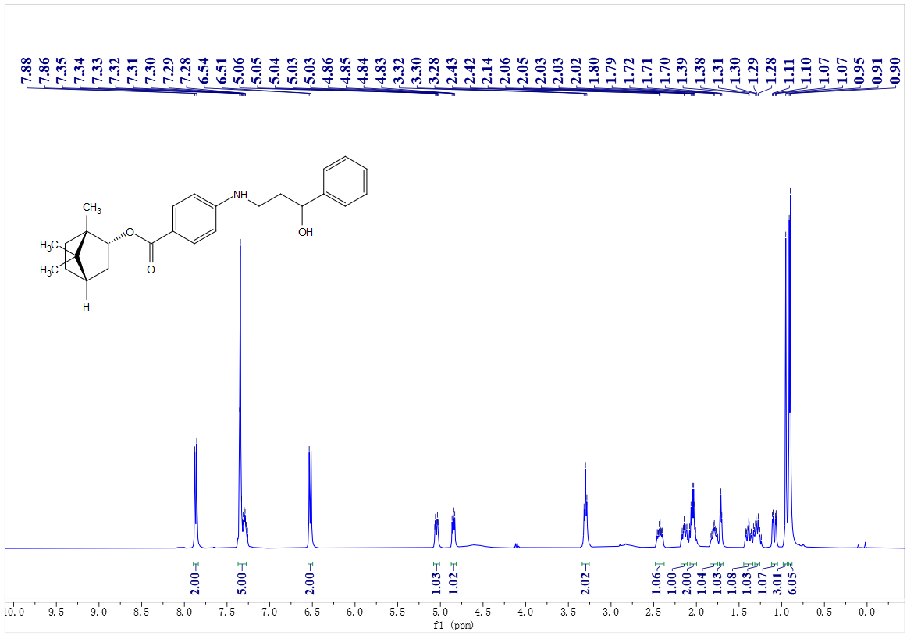
¹³C- NMR spectrum of C54
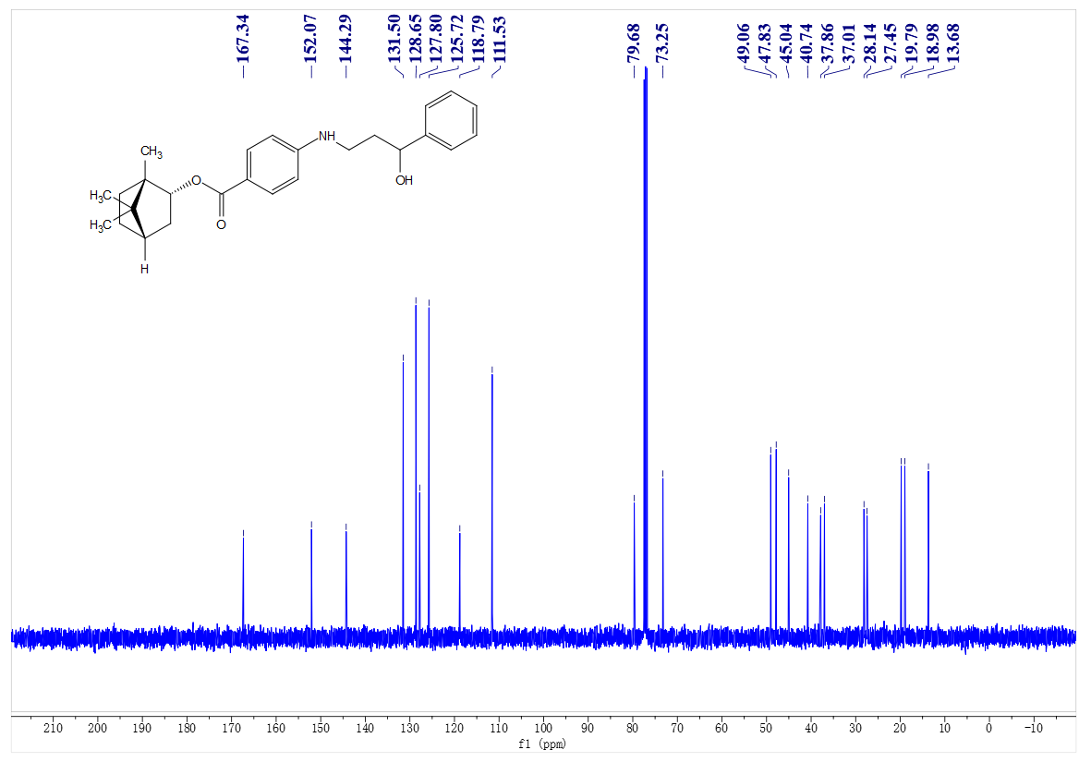
¹H- NMR spectrum of C55
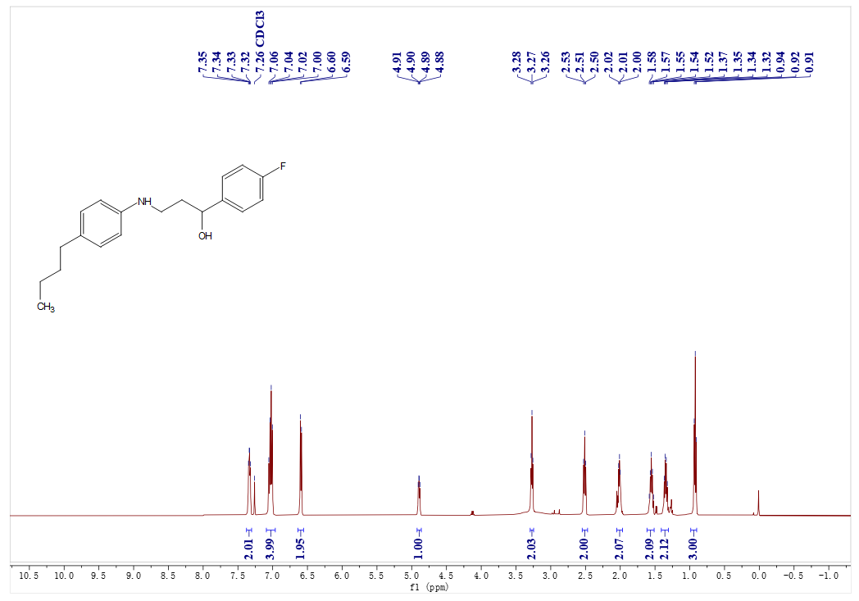
¹³C- NMR spectrum of C55
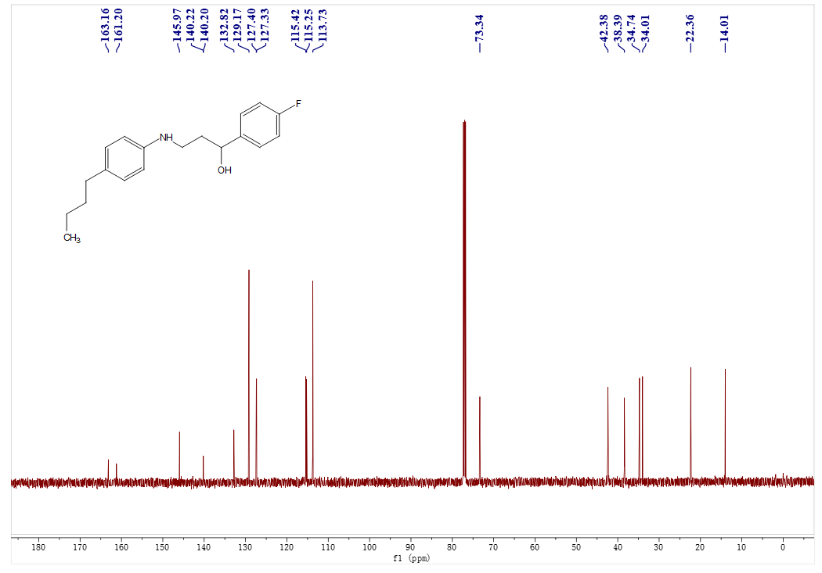
¹⁹F- NMR spectrum of C55
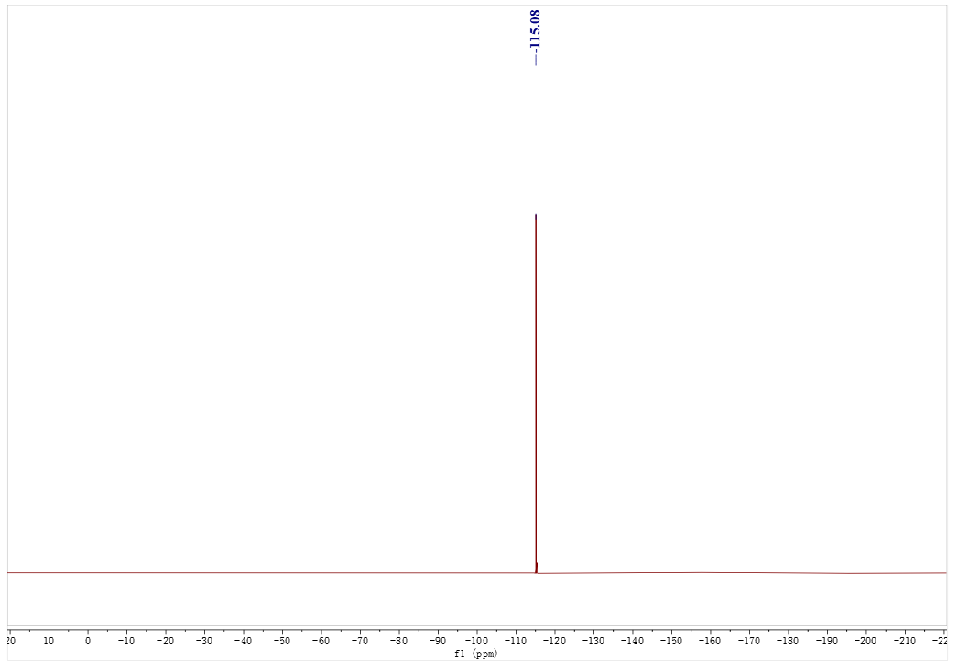
¹H- NMR spectrum of C56
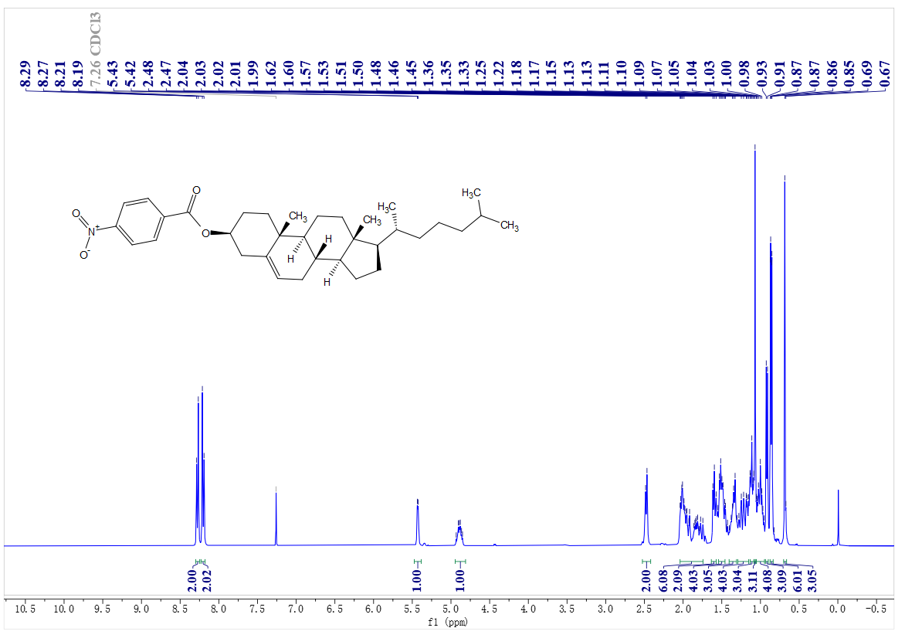
¹³C- NMR spectrum of C56
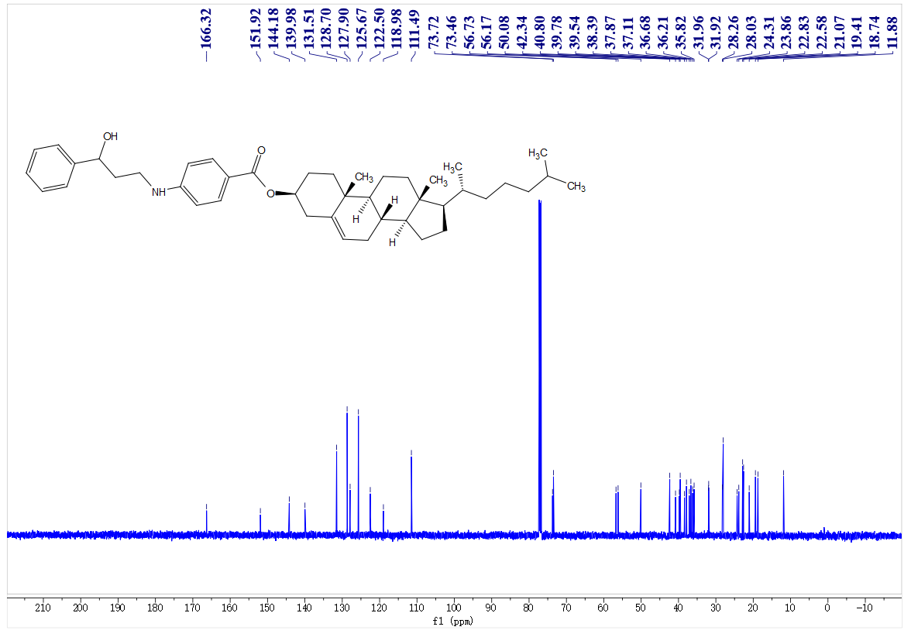
¹H- NMR spectrum of A53
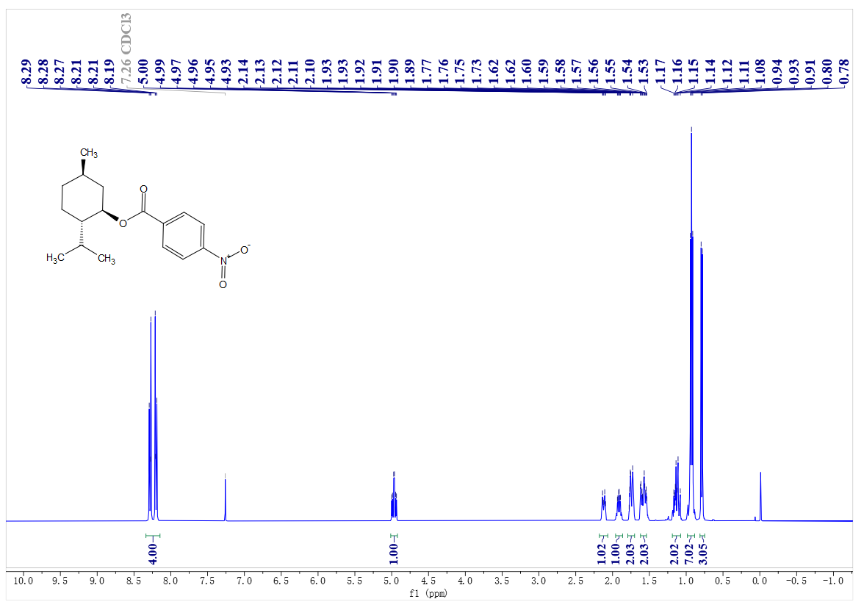
¹³C- NMR spectrum of A53
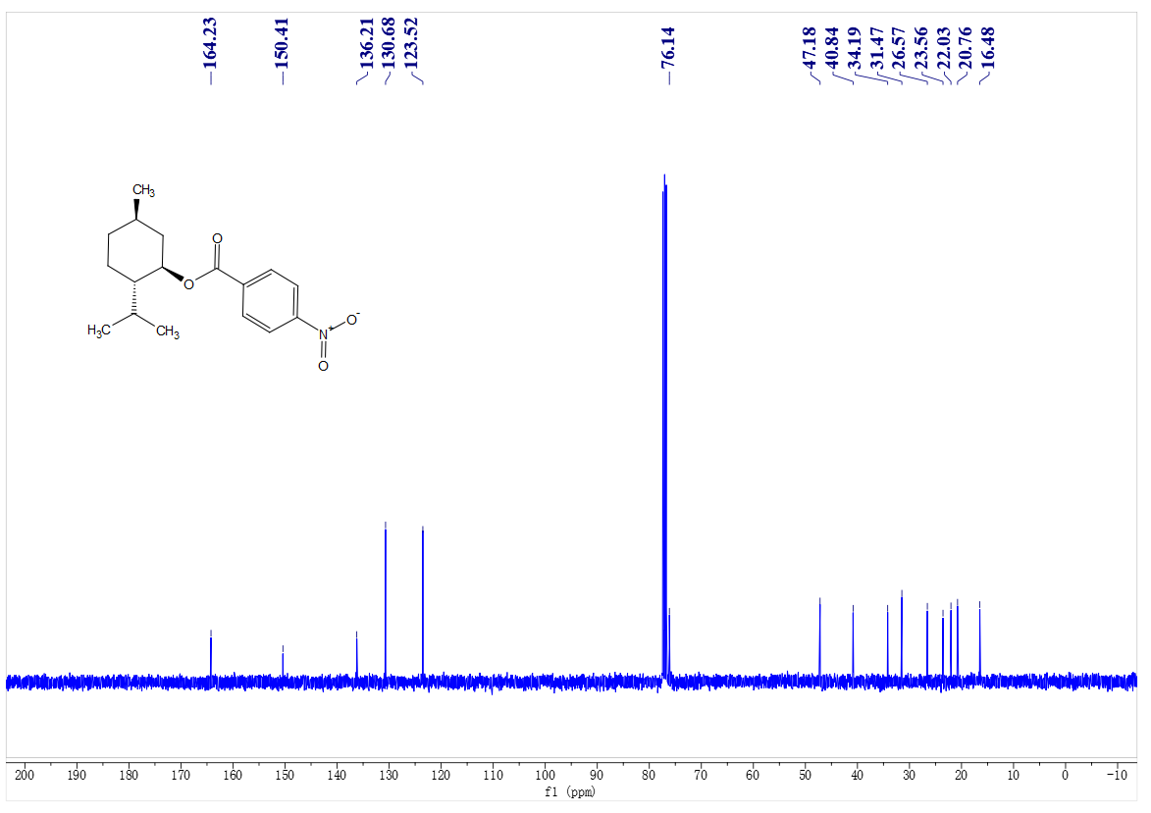
¹H- NMR spectrum of A54
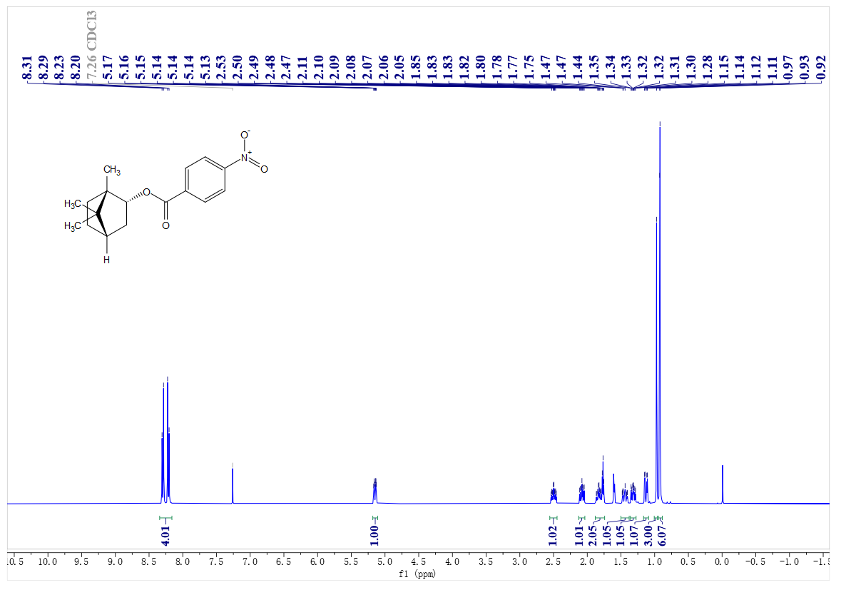
¹³C- NMR spectrum of A54
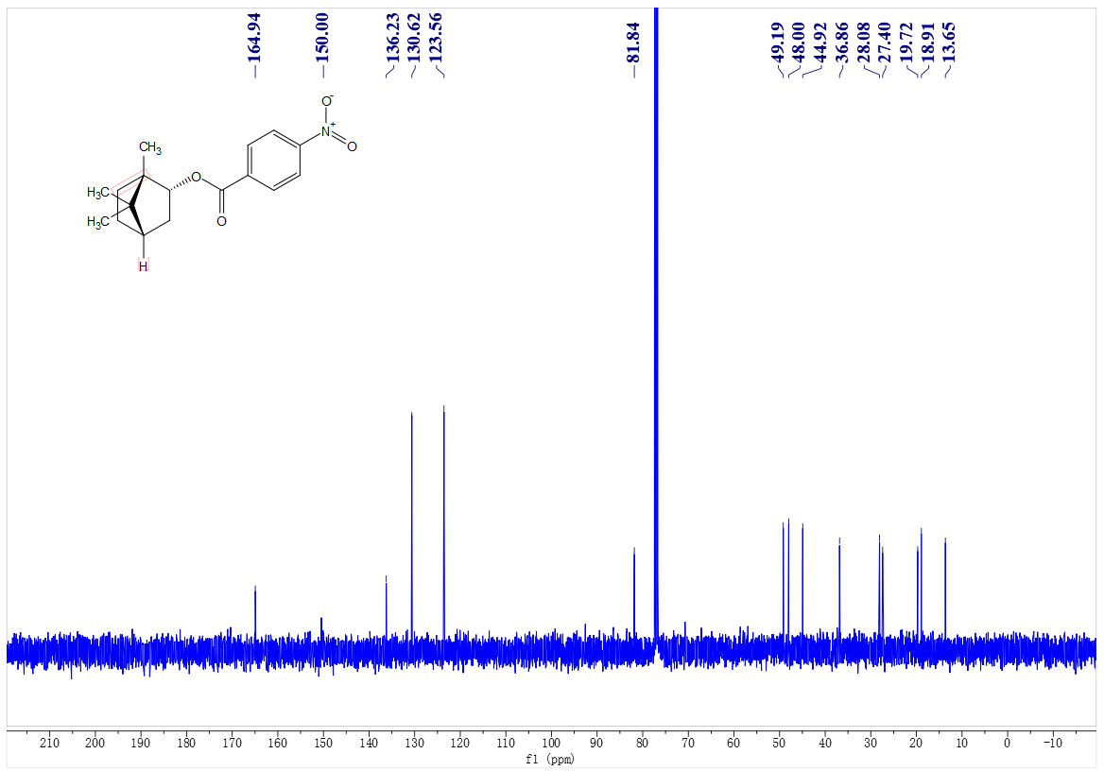
¹H- NMR spectrum of A56
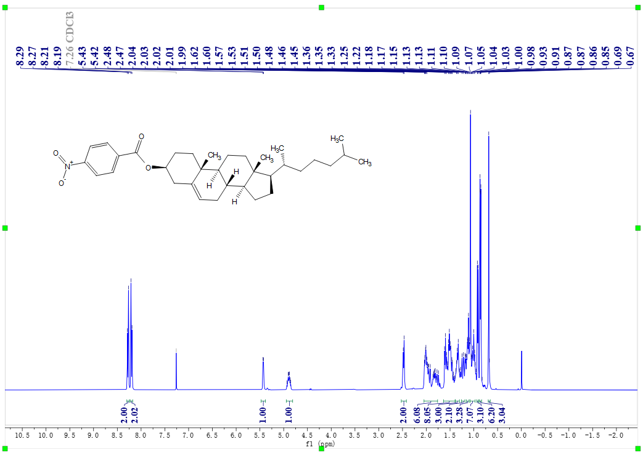
¹³C- NMR spectrum of A56
