Multimodal analysis reveals hydrolysis as a shared mechanism in magnetic tape degradation
Jack Harrison, Joyce James, Camelia N. Borca, Dominik Blatter, Richard L. Hess, David Hadzis, Kelly Pribble, Frédéric Ménétrier, Alain Dufaux, and Sebastian Gliga.
S1. Temperature-dependence of SSS signatures
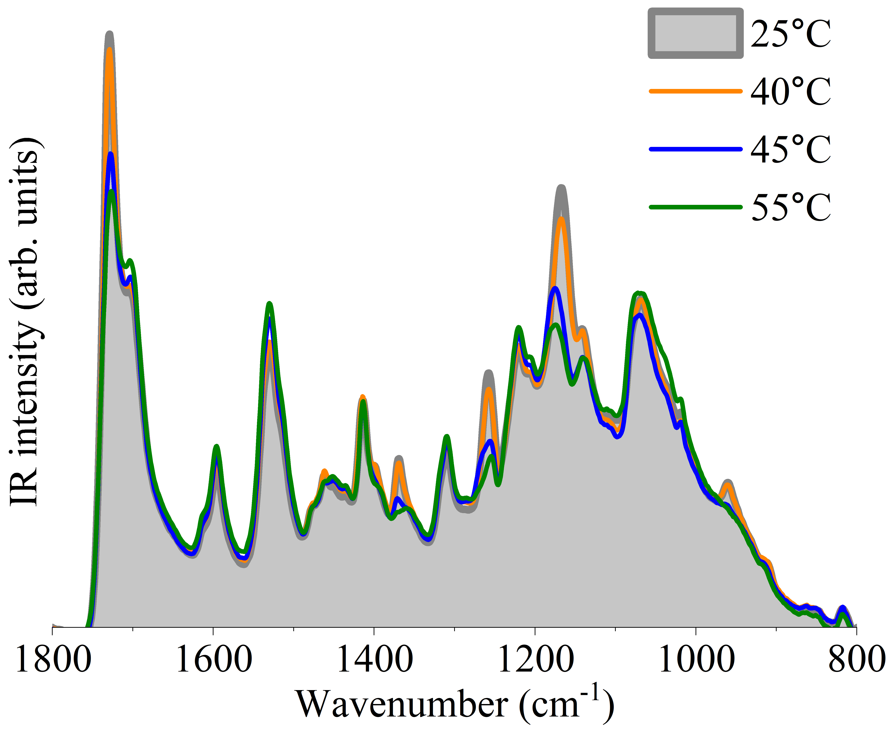
Figure S1: ATR-FTIR measurements from an untreated ¼” Ampex 406 tape as a function of temperature.
To demonstrate the temperature sensitivity of the baking process, we took a series of ATR-FTIR measurements on an untreated segment of the ¼” Ampex 406 tape with SSS at different temperatures using a custom Peltier heater (see section 2.2.3, main text). The background without a sample was initially measured at each temperature and found to be temperature independent. The heater voltage was slowly increased and the temperature read by the thermocouple was allowed to stabilise for one minute before each measurement. The results are shown in figure S1. Only minor changes are visible up until 40°C. From 45°C onwards, the IR signatures of hydrolysis significantly change, matching those of an undegraded tape. As shown in supplementary movie 1, the dark patches of binder residue on the surface disappear almost instantly upon crossing 46°C, with only minimal changes beyond this point. The movie corresponds to 10 minutes of measurement, demonstrating the rapidity of the healing process. It is the time required for the moisture to diffuse through the magnetic layers in the bulk of a tape pack that leads to the long baking times typically needed.

S2. Inhomogeneous degradation in 2” Ampex 456

0.5 mm
Figure S2: Optical microscopy image on the 2” Ampex 456 tape. The dark patches are the surface residue of binder hydrolysis.
The ATR-FTIR spectrometer with inbuilt optical microscope gives us the ability to inspect the sample surface before and after measurements. This is important for samples with inconsistent or patchy degradation, such as the 2” Ampex 456 tape as seen in figure S2. Indeed, the spectra from different regions can show large variations in the hydrolysis signatures, as seen in figure S3.
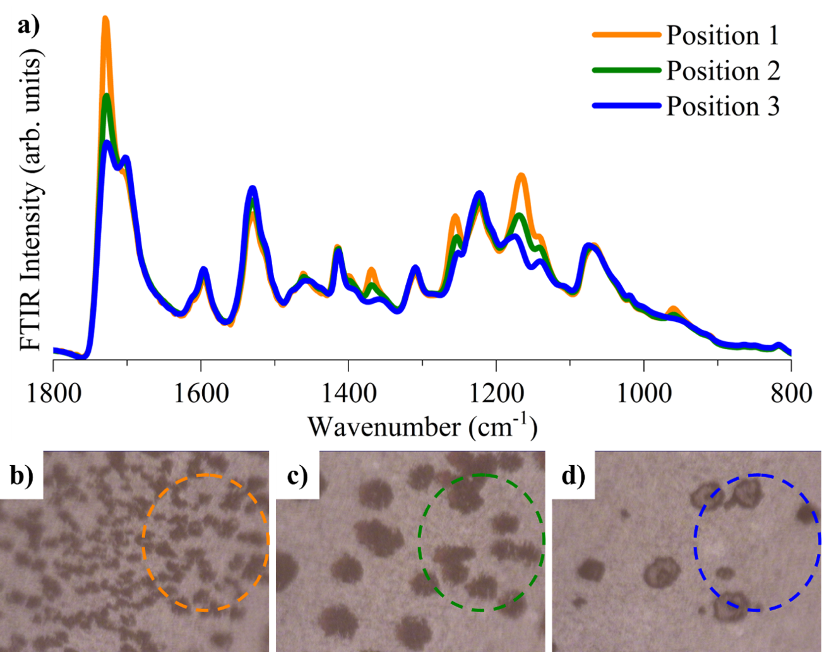
Figure S3: a) ATR-FTIR measurements at three different positions on an untreated segment of the 2” Ampex 456 tape. (b-d) corresponding optical microscopy images, with the coloured circles marking the measured regions.
S3. Hydrolysis of Pyral CJ87 tape back coat
To investigate the degradation of the Pyral tape, we also took ATR-FTIR spectra of the back coat, shown in figure S4. We observe a prominent peak at 1728 cm⁻¹ that matches the primary peak indicative of SSS observed across the degraded tapes studied here. This peak significantly weakens after the heat treatment. indicating that the back coat also hydrolyses – and heals during thermal treatment. The back coat is made of carbon black embedded in the same polymer binder as the oxide layer. We also note a clear peak at 1100 cm⁻¹, matching the additional peak shown in the ATR-FTIR spectra of the magnetic layer on this tape (black arrow in figure 5, main text) that is absent in the other studied tapes (figures 2, 4, and S7).
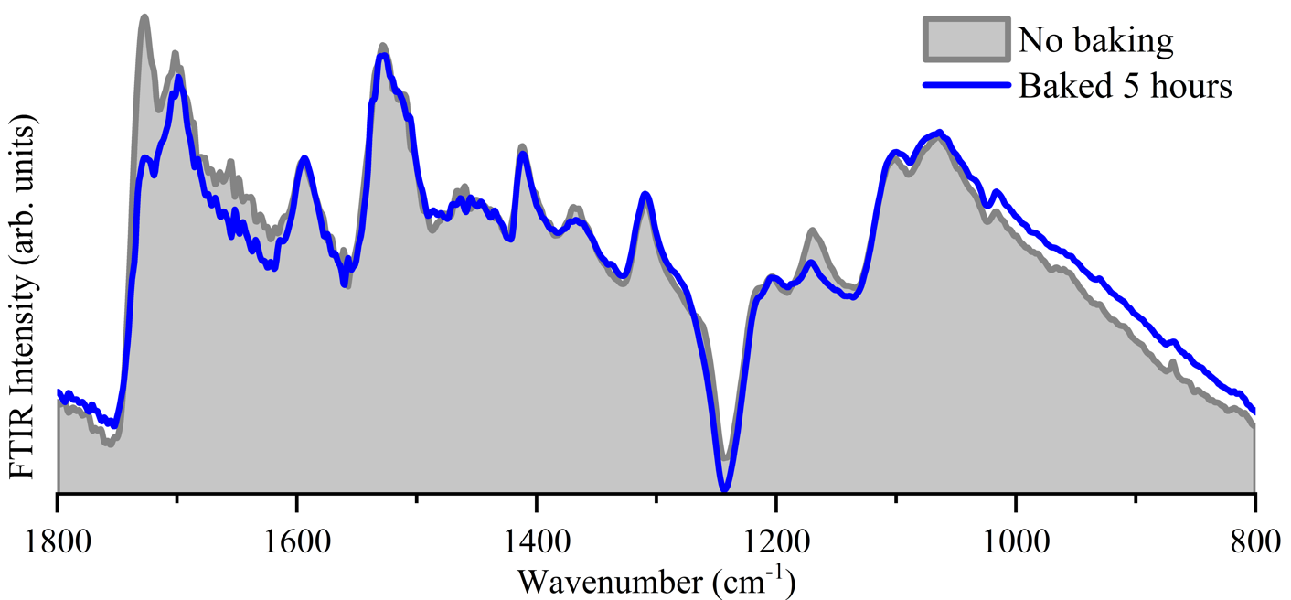
Figure S4: ATR-FTIR spectra of the back coat of Pyral CJ87 before heat treatment (grey) and after a 5 hour heat treatment at 55°C (blue). The peak marked by a black arrow in figure 5 (main text) that we attribute to the back coat is similarly marked here. The red arrow marks the primary peak indicative of binder hydrolysis.
S4. Chemical state of baked SSS tape segment after 18 months
It is commonly reported that tapes that undergo heat treatment re-degrade, becoming unplayable again within only a few weeks. To help understand this, we baked a segment of the ¼” Ampex 406 tape at 55°C for only 30 minutes, then measured its ATR-FTIR spectrum, showing that the chemical degradation had healed as expected (grey curve, figure S5). We then placed this underneath another segment of the same tape, sandwiched them between two glass slides, and placed them on a shelf in a temperature (23°C) and humidity (40% RH) controlled environment for 18 months. We remeasured the ATR-FTIR spectrum after 18 months and found no signs of re-degradation (blue curve, figure S5). Clearly, the behaviour of tapes packed onto reels is different to isolated segments, as the observed rapid re-degradation of tapes cannot be explained by chemistry alone, rather being connected to the environment within the pack.
Figure S5: ATR-FTIR spectra of a ¼” Ampex 406 segment immediately after a 30 minute heat treatment at 55°C (grey), and after being stored under standard laboratory conditions for 18 months (blue).
S5. Analysis of SONY PR150 tape degradation
Figure S6: ATR-FTIR spectra from SONY PR150 in the initial untreated state (grey) and after a 5 hour heat treatment at 55°C (blue).
We investigated a SONY PR150 tape as an example of tape with a different form of degradation but still categorised as SBS. This tape squeals during playback, is not back coated, and is observed to have a soft magnetic layer [11]. ATR-FTIR spectroscopy reveals a chemical structure that is different to the other tapes investigated in this work (figure S6), signifying a different binder formulation. Due to its different chemistry, the peaks associated with binder hydrolysis are not easily identified and, furthermore, there is no equivalent reduction in any particular peak intensities after heat treatment. This aligns with the authors’ experience that baking does not restore these tapes to a playable state. In a previous study, it was found that this binder has a reduced glass transition temperature compared to normal tapes and cold playback has been found to be a successful strategy to enable playback. This is a clear case of SBS where binder hydrolysis is not the main contributor to the degradation issues.
S6. IR spectroscopy of back coats of the ¼” and 2” Ampex tapes
We measured the back coat of the ¼” Ampex 406 tape and 2” Ampex 456 tape, both with SSS of different severity, both before and after heat treatment. We observe no signatures of binder hydrolysis on the back coats of either tape and no changes to the spectra after the heat treatment. This means that back coat hydrolysis does not contribute to the degradation phenomena observed on these tapes, in stark contrast to the Pyral CJ87 tape where hydrolysis of the back coat is crucial (see section S3).
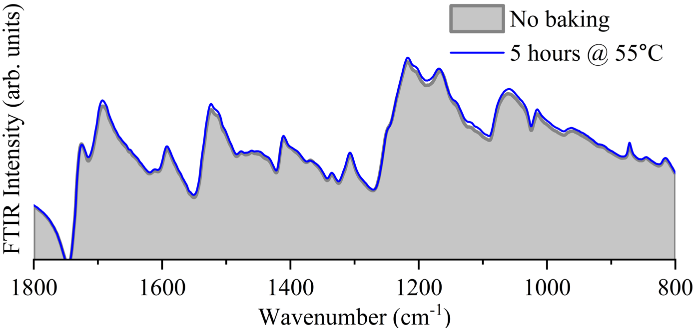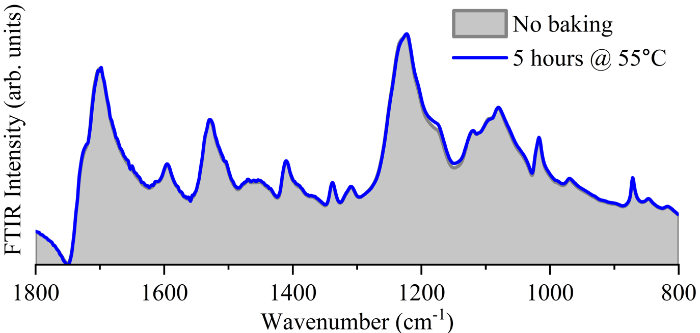
Figure S7: ATR-FTIR spectra from ¼” Ampex 406 (top) and 2” Ampex 456 (bottom) in the initial untreated state (grey) and after a 5 hour heat treatment at 55°C (blue).

