Supplementary Methods S1. Detailed diagnostic criteria for postoperative MACE components

All-cause death
All-cause death was defined as death from any cause occurring after surgery and before hospital discharge. When the exact cause of death could not be reliably determined from retrospective medical records, postoperative all-cause death before discharge was included as a component of the composite outcome.

Myocardial injury or myocardial infarction
Postoperative myocardial injury was defined as a postoperative cardiac troponin value above the 99th percentile upper reference limit with a rise or fall pattern^{[1-2]}. For patients with preoperative troponin already above the 99th percentile upper reference limit, postoperative myocardial injury required a further postoperative increase of at least 20% from the preoperative value, together with clinical documentation suggesting acute myocardial injury. Myocardial infarction required evidence of acute myocardial injury together with clinical evidence of acute myocardial ischemia, such as ischemic symptoms, new ischemic electrocardiographic changes, new pathological Q waves, imaging evidence of new loss of viable myocardium or new regional wall motion abnormality, or angiographic evidence of coronary thrombosis^{[1]}.

New-onset or worsening heart failure
Heart failure-related postoperative MACE was defined as new-onset or worsening heart failure after surgery. Worsening heart failure required compatible symptoms or signs, such as new or aggravated dyspnea, pulmonary rales, peripheral edema, hypoxemia, or pulmonary congestion, together with objective supporting evidence, such as elevated or rising NT-proBNP, radiographic pulmonary congestion, echocardiographic evidence of cardiac dysfunction, or physician diagnosis, and treatment escalation such as initiation or intensification of diuretic therapy, oxygen or ventilatory support, vasodilator or inotrope therapy, ICU monitoring, or other urgent management^{[3]}. Isolated NT-proBNP elevation without compatible symptoms, signs, objective clinical deterioration, or treatment escalation was not considered an outcome event.

Severe arrhythmia requiring clinical intervention
Severe arrhythmia was defined as new-onset or aggravated postoperative arrhythmia requiring clinical intervention, including antiarrhythmic medication, electrical cardioversion, pacemaker implantation, ICU monitoring, or other urgent management^{[4-5]}. For patients with pre-existing atrial fibrillation or flutter, progressive arrhythmia required sustained ventricular rate >120 beats/min, an increase of at least 20 beats/min from the preoperative baseline, hemodynamic instability, myocardial ischemia, heart failure aggravation, or escalation of rate-control, rhythm-control, monitoring, or cardiology-directed management. Chronic arrhythmia or conduction abnormality without postoperative deterioration or management escalation was not counted as an outcome event.

Ischemic stroke or intracerebral hemorrhage
Stroke was defined as a new focal neurological deficit occurring after surgery and before discharge with clinical or imaging evidence of ischemic stroke or intracerebral hemorrhage^{[6-7]}. Previous stroke without new postoperative neurological deficits was not counted as an outcome event.

Cardiogenic shock or hemodynamic collapse
Cardiogenic shock or hemodynamic collapse was defined as postoperative circulatory failure considered primarily cardiac in origin, with persistent systolic blood pressure <90 mmHg or mean arterial pressure <65 mmHg and requiring vasoactive or inotropic support, ICU admission, mechanical circulatory support, or urgent cardiovascular management. Hemodynamic instability clearly attributable to hypovolemia, acute blood loss, sepsis, anesthesia-related vasodilation, pulmonary embolism, or other non-cardiac causes was not counted as cardiogenic shock-related MACE.

Supplementary Table S1. Univariable logistic regression analysis of candidate predictors in the development cohort.
Variable | OR | 95% CI | P value
Age | 1.91 | 1.55-2.37 | <0.001
Sex | 1.31 | 0.88-1.95 | 0.184
Hypertension | 1.15 | 0.79-1.69 | 0.47
Diabetes mellitus | 1.68 | 1.08-2.61 | 0.021
Coronary artery disease | 2.52 | 1.40-4.55 | 0.002
Chronic heart failure | 4.63 | 2.85-7.51 | <0.001
History of stroke | 1.88 | 1.15-3.06 | 0.011
COPD | 3.45 | 1.27-9.38 | 0.015
Cardiac troponin I | 1.28 | 1.08-1.52 | 0.005
Serum myoglobin | 1.23 | 1.01-1.49 | 0.036
Creatine kinase-MB | 1.17 | 0.99-1.38 | 0.059
Creatine kinase | 1.11 | 0.95-1.29 | 0.21
Lactate dehydrogenase | 1.22 | 1.02-1.45 | 0.028
Albumin | 0.68 | 0.56-0.82 | <0.001
Total protein | 0.81 | 0.67-0.98 | 0.034
Globulin | 1.05 | 0.88-1.27 | 0.573
C-reactive protein | 1.15 | 0.96-1.38 | 0.118
Erythrocyte sedimentation rate | 1.25 | 1.05-1.49 | 0.012
White blood cell count | 1.05 | 0.87-1.26 | 0.645
Absolute neutrophil count | 1.06 | 0.88-1.28 | 0.513
Absolute monocyte count | 1.13 | 0.95-1.36 | 0.173
Absolute eosinophil count | 1.09 | 0.93-1.29 | 0.299
Absolute basophil count | 0.96 | 0.79-1.18 | 0.71
Red blood cell count | 0.7 | 0.58-0.85 | <0.001
Hemoglobin | 0.7 | 0.58-0.84 | <0.001
Hematocrit | 0.7 | 0.58-0.85 | <0.001
Mean corpuscular volume | 1.06 | 0.87-1.29 | 0.558
Mean corpuscular hemoglobin | 1.01 | 0.83-1.22 | 0.948
Mean corpuscular hemoglobin concentration | 0.85 | 0.71-1.02 | 0.079
Platelet count | 0.81 | 0.66-1.01 | 0.056
Plateletcrit | 0.83 | 0.67-1.02 | 0.077
Platelet distribution width | 0.95 | 0.80-1.13 | 0.585
Thrombin time | 1.01 | 0.85-1.20 | 0.909
Prothrombin time | 1.18 | 0.99-1.41 | 0.071
Prothrombin activity | 0.89 | 0.73-1.08 | 0.233
International normalized ratio | 1.18 | 0.99-1.41 | 0.069
Activated partial thromboplastin time | 1.04 | 0.87-1.26 | 0.656
Fibrinogen | 1.01 | 0.83-1.22 | 0.935
D-dimer | 0.91 | 0.74-1.12 | 0.396
Plasmin-alpha2-plasmin inhibitor complex | 0.87 | 0.70-1.09 | 0.227
Serum Potassium | 1.38 | 1.15-1.67 | <0.001
Serum Sodium | 0.84 | 0.70-1.00 | 0.052
Chloride | 0.87 | 0.72-1.04 | 0.134
Magnesium | 0.9 | 0.74-1.09 | 0.27
Triglycerides | 1.11 | 0.94-1.31 | 0.236
Triglyceride-glucose index | 1.15 | 0.95-1.38 | 0.144
Baseline ECG abnormality,n (%) | 3.01 | 2.02-4.48 | <0.001
Time from admission to surgery | 1.15 | 0.97-1.36 | 0.112

Values are presented as odds ratios (ORs), 95% confidence intervals (CIs), and P values. ORs for continuous variables are reported per 1-SD increase; ORs for binary variables compare 1 vs 0. Univariable logistic regression was used to evaluate the association between each candidate predictor and postoperative in-hospital MACE in the development cohort. Continuous variables were analyzed according to the scale used in the univariable model, and binary variables were coded as 0 or 1. MACE, major adverse cardiovascular events; OR, odds ratio; CI, confidence interval; COPD, chronic obstructive pulmonary disease; CK-MB, creatine kinase-MB; ECG, electrocardiography.
Supplementary Figure S1. LASSO coefficient profiles and cross-validation performance for auxiliary variable selection.
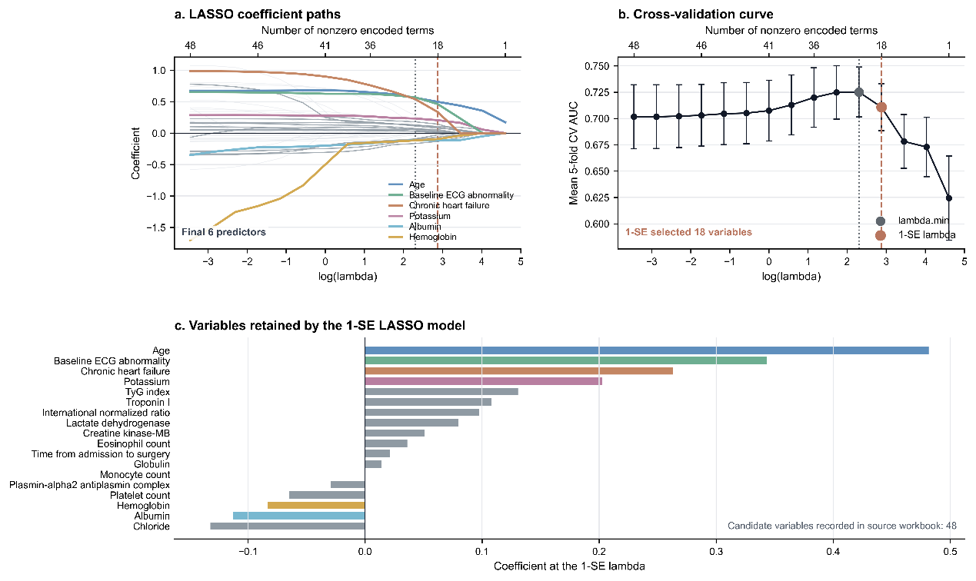
Figure S1. LASSO regression was used as an auxiliary approach for variable selection among candidate preoperative variables.
a. Coefficient paths of candidate encoded terms across different values of log(lambda). The vertical dotted line indicates the lambda value with the best cross-validated performance, and the vertical dashed line indicates the 1-SE lambda. The highlighted lines represent the six predictors retained for the final model.
b. Five-fold cross-validation curve showing the mean AUC across different lambda values. Error bars indicate variability across cross-validation folds. The 1-SE rule selected 18 nonzero encoded terms.
c. Coefficients of variables retained at the 1-SE lambda. Continuous variables were standardized before LASSO fitting; therefore, coefficients are presented on the standardized scale.
LASSO coefficients were used primarily to support variable selection and assess coefficient direction rather than to provide formal effect-size estimates.

Supplementary Table S2. Components of postoperative in-hospital MACE in the external validation cohort
Values are presented as n (%). Percentages were calculated among patients with postoperative in-hospital MACE in the external validation cohort. Individual MACE components were not mutually exclusive; therefore, a patient could contribute to more than one component but was counted only once for the primary composite outcome. MACE, major adverse cardiovascular events.
Postoperative MACE component | External validation cohort (n = 33)
All-cause death | 3 (9.1)
Myocardial injury / myocardial infarction | 7 (21.2)
Heart failure-related event | 20 (60.6)
Severe arrhythmia requiring clinical intervention | 8 (24.2)
Ischemic stroke / intracerebral hemorrhage | 2 (6.1)
Cardiogenic shock / hemodynamic collapse | 3 (9.1)

Supplementary Table S3. Performance of the final Platt-calibrated logistic regression model in the internal test set and external validation cohort
Metric | Internal test set | External validation cohort
N / events | 234 / 31 | 168 / 33
AUC | 0.814 | 0.760
95% CI | 0.748-0.876 | 0.657-0.849
PR-AUC | 0.343 | 0.462
Brier score | 0.102 | 0.141
Fixed threshold | 0.147 | 0.147
Sensitivity | 0.710 | 0.788
Specificity | 0.754 | 0.630
PPV | 0.306 | 0.342
NPV | 0.944 | 0.924
TN | 153 | 85
FP | 50 | 50
FN | 9 | 7
TP | 22 | 26
Accuracy | 0.748 | 0.661
F1 score | 0.427 | 0.477
Calibration intercept | 0.609 | 1.101
Calibration slope | 1.366 | 1.517
O/E ratio | 1.006 | 1.253
Values are presented as estimates unless otherwise indicated. Threshold-dependent metrics were calculated using the fixed threshold derived from the internal calibration set. O/E ratio was calculated as the number of observed events divided by the sum of predicted probabilities. PPV, positive predictive value; NPV, negative predictive value; TN, true negative; FP, false positive; FN, false negative; TP, true positive; O/E, observed-to-expected; AUC, area under the receiver operating characteristic curve; PR-AUC, area under the precision-recall curve.

Supplementary Table S4. Distribution of final model predictors in the external validation cohort
Values are presented as median (interquartile range) for continuous variables and number (percentage) for categorical variables. Values are based on observed data before imputation. Missing values were imputed as described in the Methods. ECG, electrocardiogram.
Predictor | External validation cohort  (n = 168) | Missing, n (%)
Age, years | 85.0 (78.8–89.0) | 0
Baseline ECG abnormality | 60 (35.7) | 0
Chronic heart failure | 16 (9.5) | 0
Potassium, mmol/L | 3.88 (3.56–4.21) | 2 (1.2)
Albumin, g/L | 34.5 (32.1–37.0) | 3 (1.8)
Hemoglobin, g/L | 110.0 (100.8–126.0) | 2 (1.2)

Supplementary Table S5. Final model coefficients and calibration parameters
Item | Value
Original logistic regression intercept | -3.8079
Age coefficient | 0.0502
Baseline ECG abnormality coefficient | 0.7607
Chronic heart failure coefficient | 1.2270
Potassium coefficient | 0.4821
Albumin coefficient | -0.0506
Hemoglobin coefficient | -0.0061
Platt calibration intercept | -2.0146
Platt calibration slope | 0.7832
Median used for potassium imputation | 3.8
Median used for albumin imputation | 35.4
Median used for hemoglobin imputation | 114
Values are the coefficients of the original logistic regression model before Platt calibration and the parameters used for probability calibration. Age, serum potassium, albumin, and hemoglobin were entered as continuous variables using their original clinical units. Baseline ECG abnormality and chronic heart failure were coded as binary variables, with 1 indicating presence and 0 indicating absence. Missing values in continuous predictors were imputed using the medians estimated from the development cohort. The Platt calibration intercept and slope were applied to the original model output to obtain the final calibrated predicted probability. ECG, electrocardiography.

Supplementary Figure S2. Global and individual-level SHAP explanations of the final model.
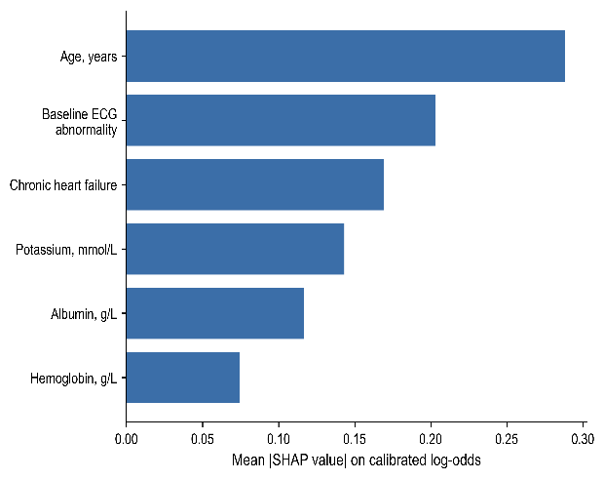
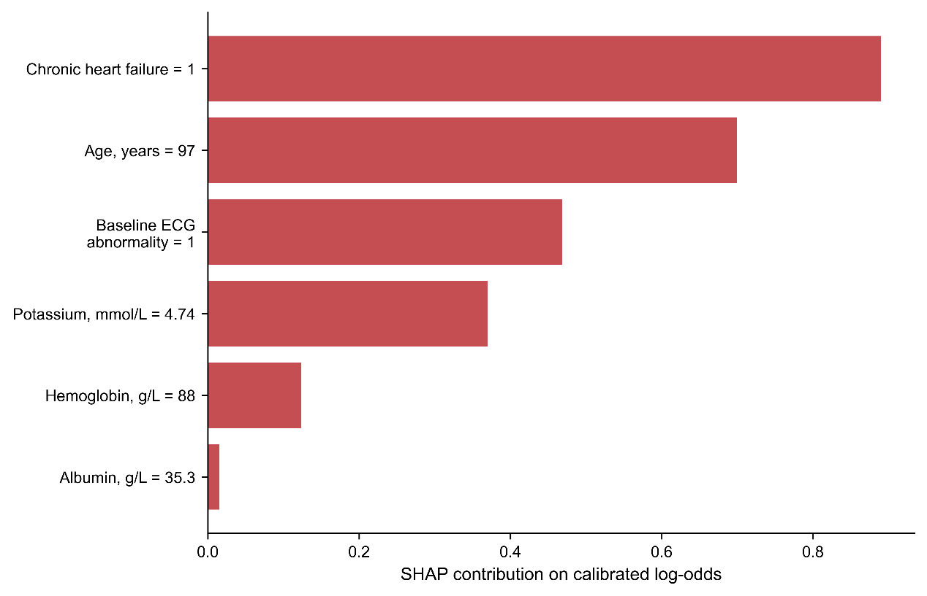
Panel a shows global feature importance ranked by mean absolute SHAP values on the calibrated log-odds scale in the internal test cohort. Panel b shows a representative individual-level SHAP waterfall plot for a high-risk patient. Positive SHAP values indicate contributions toward higher predicted postoperative in-hospital MACE risk, whereas negative values indicate contributions toward lower predicted risk. SHAP, Shapley additive explanations; MACE, major adverse cardiovascular events.
a
b

Supplementary Figure S3. SHAP dependence plots for selected continuous predictors.
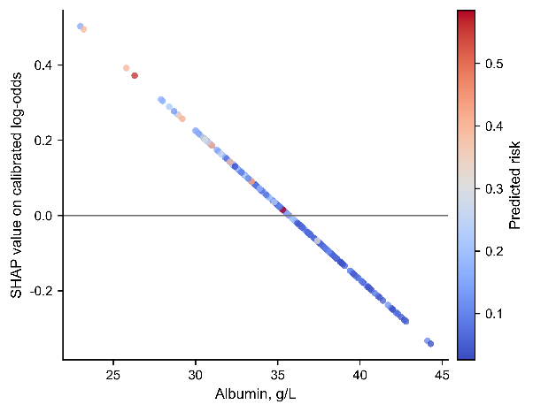
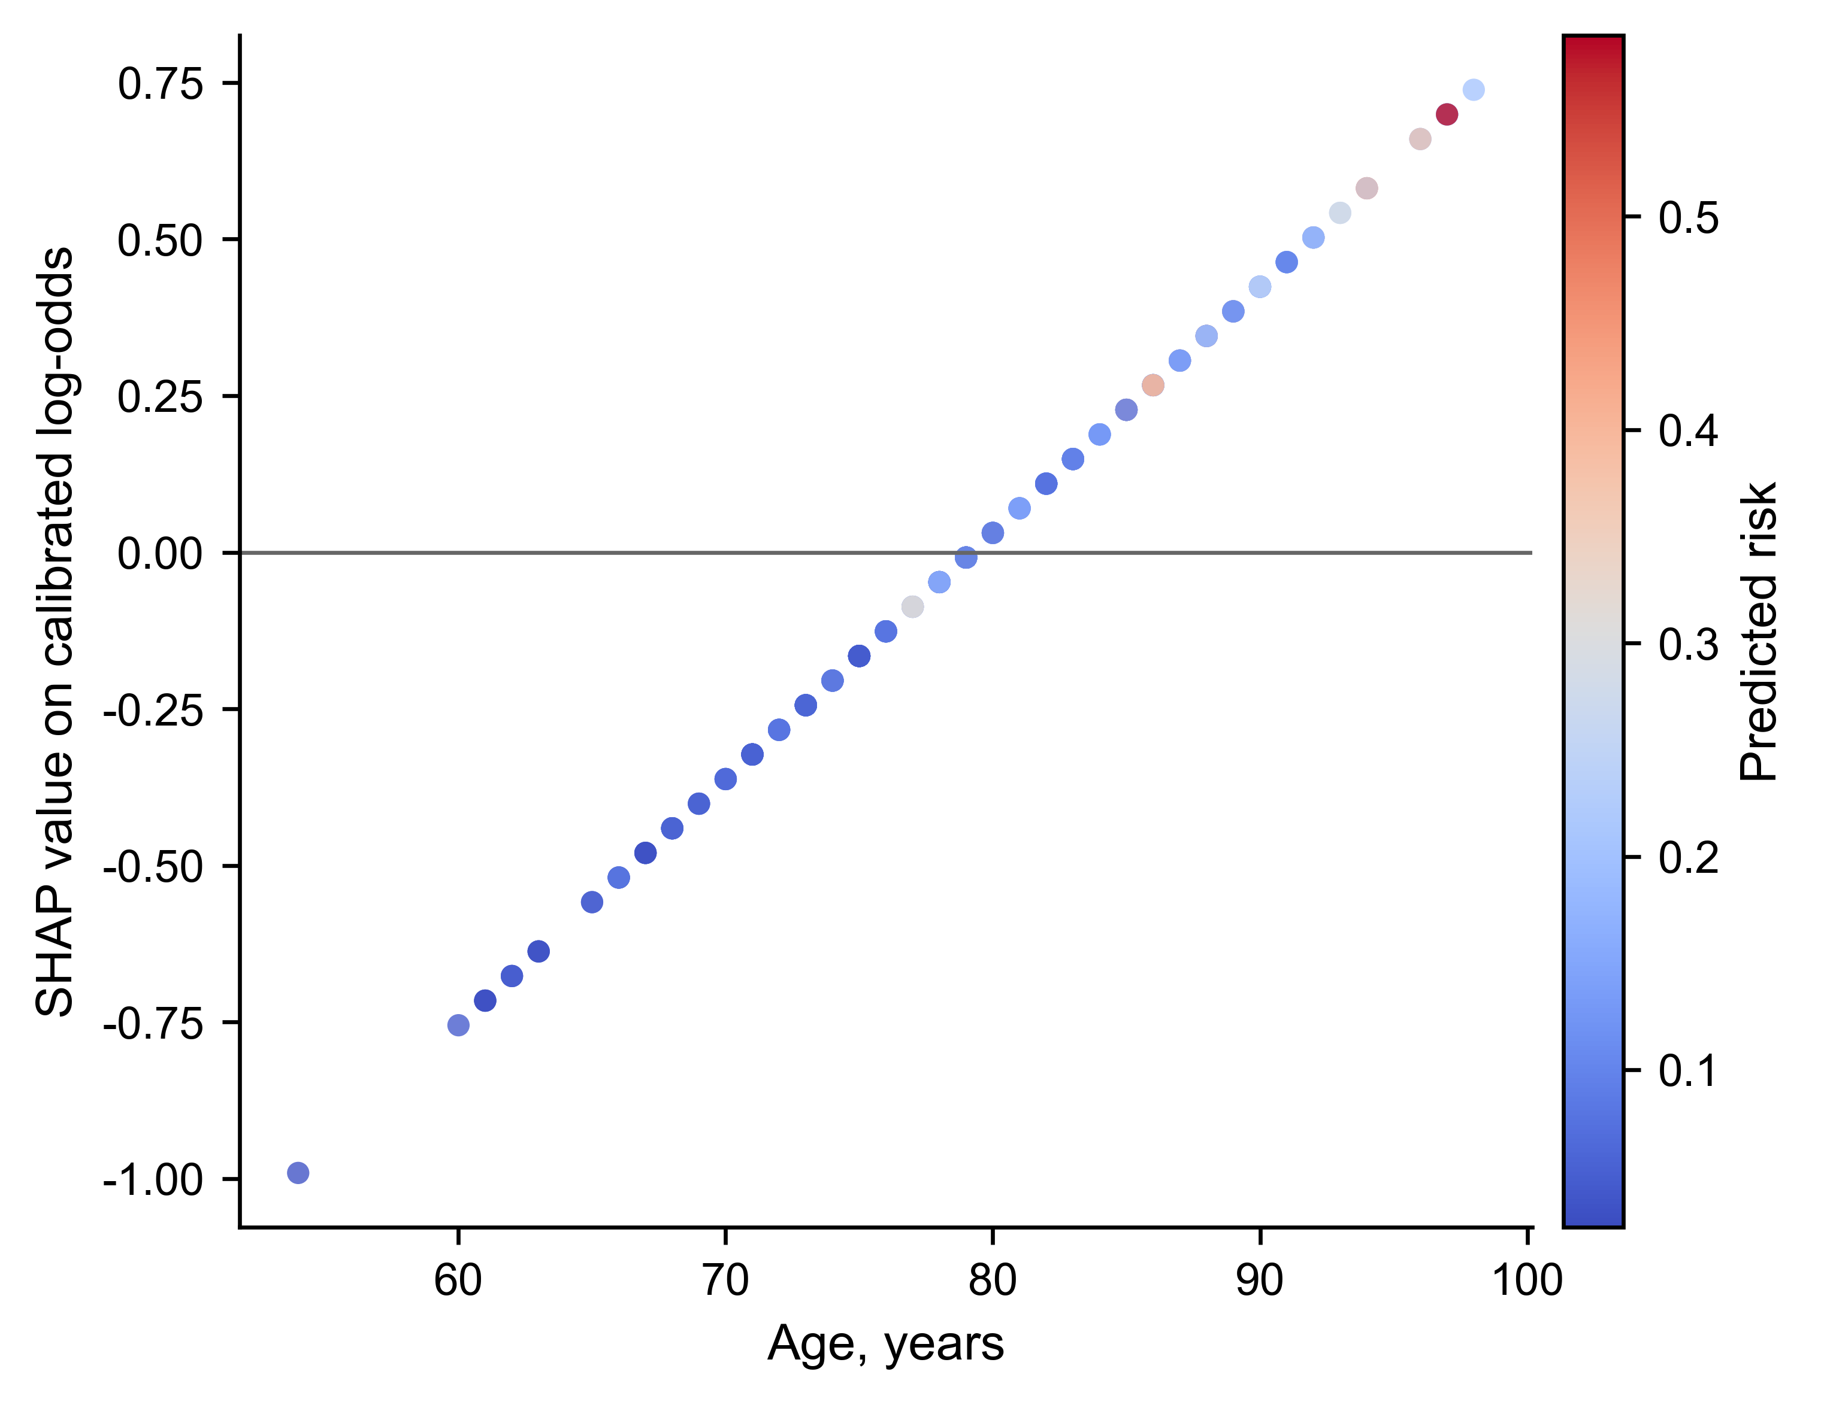
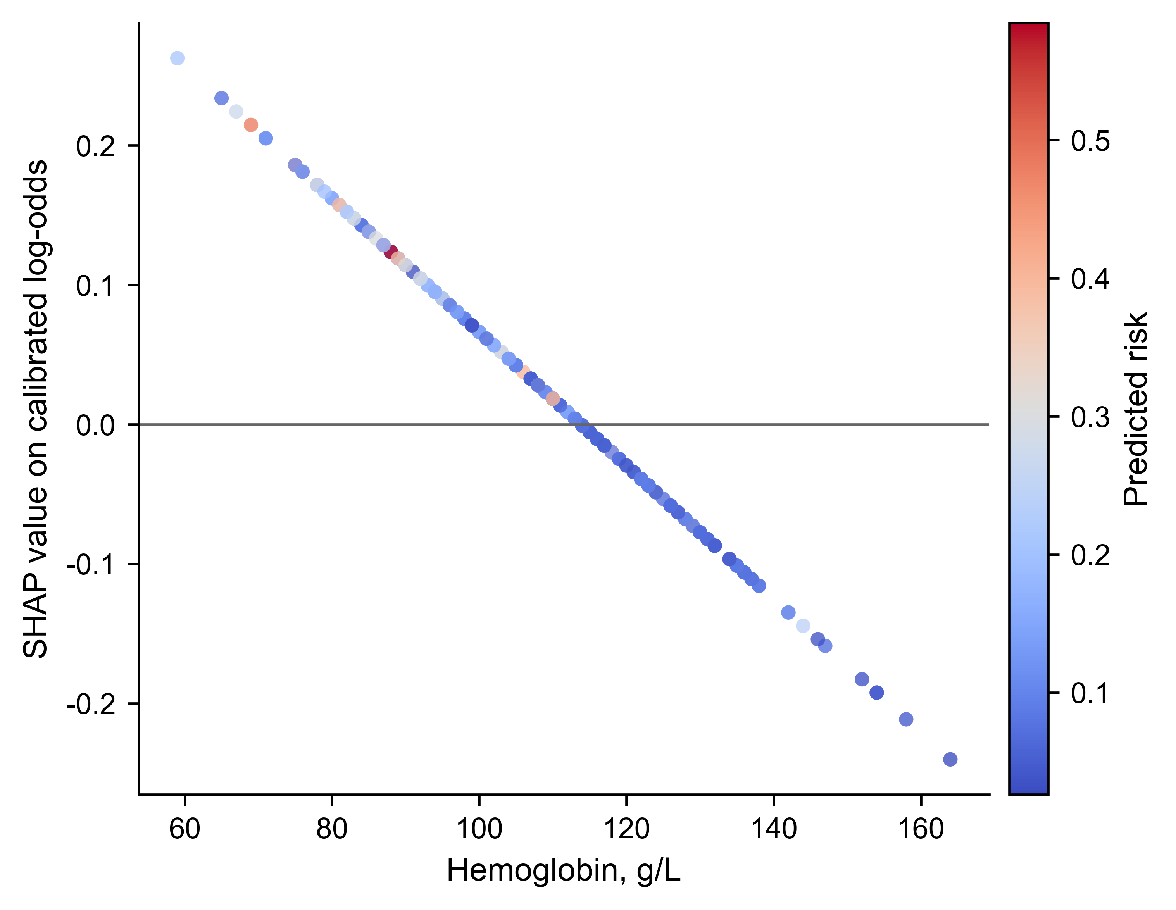
a
b
c
d
The plots show the relationships between selected continuous predictor values and their SHAP values on the calibrated log-odds scale in the internal test cohort. Positive SHAP values indicate contributions toward higher predicted postoperative in-hospital MACE risk, whereas negative values indicate contributions toward lower predicted risk. Panels show age (a), albumin (b), serum potassium (c), and hemoglobin (d). The color scale represents the predicted risk. SHAP, Shapley additive explanations; MACE, major adverse cardiovascular events.
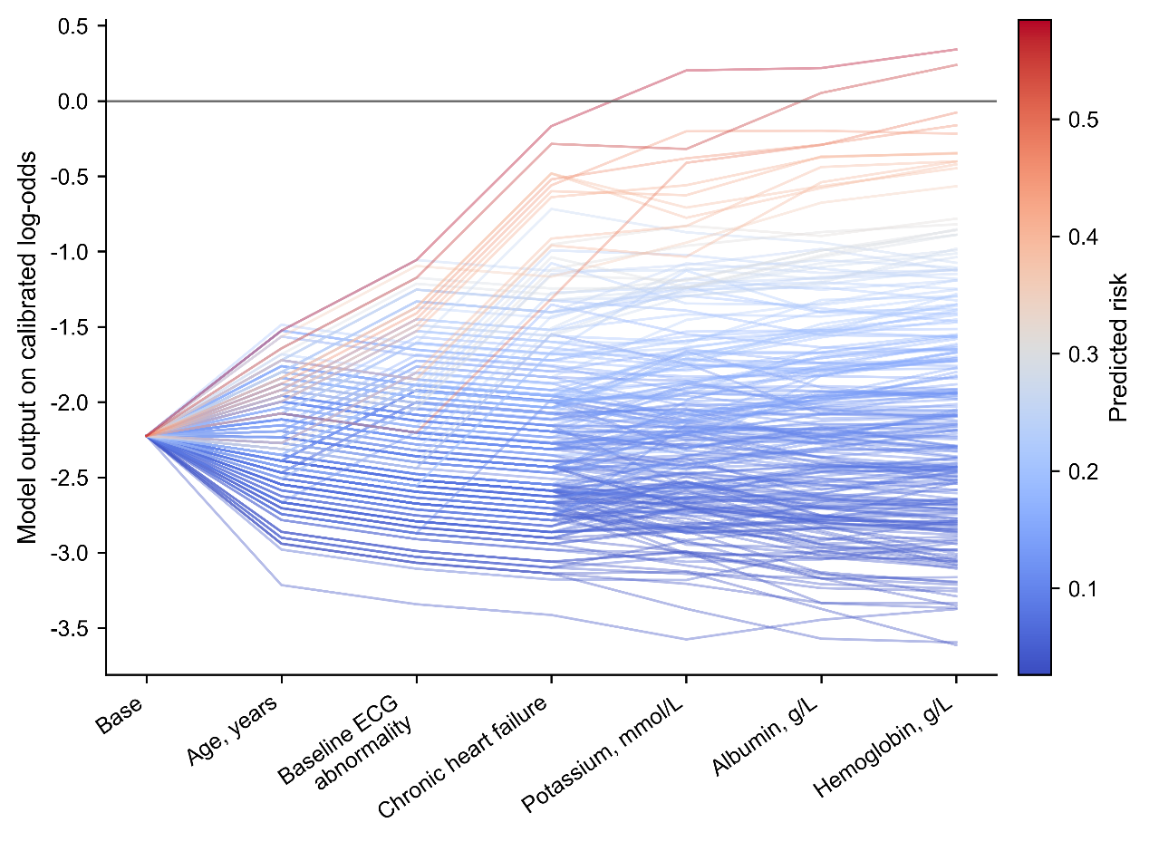
Supplementary Figure S4. SHAP decision plot in the internal test cohort.
The decision plot shows the cumulative contribution of predictors to the calibrated model output across patients in the internal test cohort. Each line represents one patient, starting from the base value and moving through sequential predictor contributions to the final model output on the calibrated log-odds scale. Lines are colored according to the predicted risk. SHAP, Shapley additive explanations.

Reference
[1] Thygesen K, Alpert JS, Jaffe AS, et al. Fourth Universal Definition of Myocardial Infarction (2018) [J]. Circulation, 2018, 138(20): e618-e51.10.1161/CIR.0000000000000617
[2] Ruetzler K, Smilowitz NR, Berger JS, et al. Diagnosis and Management of Patients With Myocardial Injury After Noncardiac Surgery: A Scientific Statement From the American Heart Association [J]. Circulation, 2021, 144(19): e287-e305.10.1161/CIR.0000000000001024
[3] Heidenreich PA, Bozkurt B, Aguilar D, et al. 2022 AHA/ACC/HFSA Guideline for the Management of Heart Failure: A Report of the American College of Cardiology/American Heart Association Joint Committee on Clinical Practice Guidelines [J]. Circulation, 2022, 145(18): e895-e1032.10.1161/CIR.0000000000001063
[4] Joglar JA, Chung MK, Armbruster AL, et al. 2023 ACC/AHA/ACCP/HRS Guideline for the Diagnosis and Management of Atrial Fibrillation: A Report of the American College of Cardiology/American Heart Association Joint Committee on Clinical Practice Guidelines [J]. Circulation, 2024, 149(1): e1-e156.10.1161/CIR.0000000000001193
[5] Kusumoto FM, Schoenfeld MH, Barrett C, et al. 2018 ACC/AHA/HRS Guideline on the Evaluation and Management of Patients With Bradycardia and Cardiac Conduction Delay: A Report of the American College of Cardiology/American Heart Association Task Force on Clinical Practice Guidelines and the Heart Rhythm Society [J]. Circulation, 2019, 140(8): e382-e482.10.1161/CIR.0000000000000628
[6] Greenberg SM, Ziai WC, Cordonnier C, et al. 2022 Guideline for the Management of Patients With Spontaneous Intracerebral Hemorrhage: A Guideline From the American Heart Association/American Stroke Association [J]. Stroke, 2022, 53(7): e282-e361.10.1161/STR.0000000000000407
[7] Kleindorfer DO, Towfighi A, Chaturvedi S, et al. 2021 Guideline for the Prevention of Stroke in Patients With Stroke and Transient Ischemic Attack: A Guideline From the American Heart Association/American Stroke Association [J]. Stroke, 2021, 52(7): e364-e467.10.1161/STR.0000000000000375

