Supplementary material for
Projecting maize yield in the North China Plain under climate extremes: A hybrid crop model-machine learning approach
Haonan Tan^{a,b,c,d}, Dengpan Xiao^{a,b,c,d,*}, Huizi Bai^{e,*}, Yang Lu^{a,b,c,d}, Lihua Lv^{f}, Peipei Pan^{a,b,c,d}, Dandan Ren^{g}, Man Zhang^{a,b,c,d}, Xiaomeng Yin^{a,b,c,d}, Yan Wang^{a,b,c,d}, Ying Li^{h,*}, Chen Wang^{a,b,c,d}, Maoyuan Sun^{a,b,c,d}
ª School of Geographical Sciences, Hebei Normal University, Shijiazhuang 050024, China
^{b} Hebei Key Laboratory of Environmental Change and Ecological Construction, Shijiazhuang 050024, China
^{c} Hebei Technology Innovation Center for Remote Sensing Identification of Environmental Change, Shijiazhuang 050024, China
^{d} Hebei Key Research Institute of Humanities and Social Sciences at Universities – Geographical Computing and Planning Research Center at Hebei Normal University, Shijiazhuang 050024, China
^{e} Engineering Technology Research Center, Geographic Information Development and Application of Hebei, Institute of Geographical Sciences, Hebei Academy of Sciences, Shijiazhuang 050011, China
^{f} Institute of Cereal and Oil Crops, Hebei Academy of Agricultural and Forestry Sciences, Shijiazhuang 050035, China
^{g} School of Resources and Environment, College of Carbon Neutrality, Linyi University, Linyi, China
^{h} CMA·Henan Agrometeorological Support and Applied Technique Key Laboratory, Zhengzhou 450003, China
*Corresponding authors.
E-mail addresses: xiaodp@hebtu.edu.cn (D. Xiao), baihz272@126.com (H. Bai), walnutclip@163.com (Y. Li)

- Standardized Precipitation Index (SPI)
The Standardized Precipitation Index (SPI) is a key indicator for meteorological drought monitoring. It quantifies the degree of drought or wetness across different time scales by fitting the precipitation time series to a probability distribution (most commonly the Gamma distribution) and then transforming the results to a standard normal distribution. The core formulas and calculation steps are as follows:
$γ\left(x\right)=\frac{1}{β^{α}Γ\left(α\right)}x^{α-1}e^{-x/β}, x>0$(1)
This formula is the probability density function of the gamma distribution, where $γ\left(x\right)$ represents the probability density when the precipitation is $x$, $x$ is the precipitation variable that must be greater than 0 with cases of no precipitation handled separately, $α$ is the shape parameter of the gamma distribution that determines the shape of the distribution curve and has a value greater than 0, $β$ is the scale parameter that determines the spread of the distribution curve and also has a value greater than 0, and $Γ\left(α\right)$ is the gamma function, a special normalization function that ensures the integral of the entire probability density distribution equals 1.
2. Standardized Precipitation Evapotranspiration Index (SPEI)
The Standardized Precipitation Evapotranspiration Index (SPEI) integrates the water balance relationship between precipitation and potential evapotranspiration. It quantifies drought conditions as a dimensionless index by calculating multi-timescale cumulative water surplus, fitting a probability distribution, and subsequently normalizing the results to a standard normal distribution. In this study, the SPEI was computed using a three-parameter distribution fitting approach based on sorted weighted moments combined with an approximate inverse normal transformation, with the detailed procedure and formulae presented below：
(1) Water surplus calculation
$X=P-PET$ (2)
$D=\sum_{i=1}^{scale}{X_{i}}$ (3)
Where $X$ denotes the monthly water surplus, $P$ is the monthly precipitation, $PET$ represents the monthly potential evapotranspiration, scale refers to the time scale of the SPEI (1, 3, 6, and 12 months), and $D$ is the cumulative water surplus at the corresponding time scale.
(2) Probability distribution fitting formula
$w_{i}=\frac{1}{n}\sum_{k=1}^{n}{{\left(1-\frac{k-0.35}{n}\right)}^{i-1}}⋅D_{s\left(k\right)} \left(i=1,2,3\right)$(4)
$β=\frac{2w_{2}-w_{1}}{6w_{2}-w_{1}-6w_{3}}$(5)
$α=\frac{\left(w_{1}-2w_{2}\right)⋅β}{Γ\left(1+\frac{1}{β}\right)⋅Γ\left(1-\frac{1}{β}\right)}$(6)
$γ=w_{1}-α⋅Γ\left(1+\frac{1}{β}\right)⋅Γ\left(1-\frac{1}{β}\right)$(7)
where $w_{1}$、$w_{2}$、$w_{3}$are the fitting weight coefficients, $α$、$β$、$γ$represent the scale, shape, and location parameters of the three-parameter distribution, respectively, and $Γ\left(⋅\right)$ denotes the gamma function.
(3) Cumulative probability and normal standardization
$F={\left[1+{\left(\frac{α}{D-γ}\right)}^{β}\right]}^{-1}, P=1-F$(8)
when P≤0.5:
$W=\sqrt{-2lnP}, SPEI=W-\frac{2.515517+0.802853W+0.010328W^{2}}{1+1.432788W+0.189269W^{2}+0.001308W^{3}}$(9)
when P>0.5:
$W=\sqrt{-2ln\left(1-P\right)}, SPEI=\frac{2.515517+0.802853W+0.010328W^{2}}{1+1.432788W+0.189269W^{2}+0.001308W^{3}}-W$(10)
where $F$ is the cumulative distribution function value; $P$ denotes the exceedance probability; $W$ is the intermediate variable for normal standardization; and $SPEI$ represents the final standardized index, with negative values indicating drought and positive values representing wetness.

Table S1 Information for the crop and climate data at 51 investigated stations.
 | ID | Station | Period | Prec (mm) | Temp (°C) | Yield (kg ha⁻¹) | FD (DOY) | MD (DOY)
Spring maize | 1 | Miyun | 1981–2009 | 627.9 | 11.8 | 5362 | 219 | 258
Spring maize | 2 | Chengde | 1990–2009 | 567.4 | 9.8 | 6817 | 195 | 249
Spring maize | 3 | Fengning | 1981–2009 | 492.3 | 7.4 | 7098 | 205 | 261
Spring maize | 4 | Qinglong | 1981–1989 | 774.6 | 9.9 | 3631 | 207 | 256
Spring maize | 5 | Anze | 1990–2009 | 609.3 | 10.2 | 6587 | 201 | 254
Spring maize | 6 | Hequ | 1990–2009 | 415.1 | 9.2 | 7161 | 203 | 258
Spring maize | 7 | Jincheng | 1990–2009 | 650.4 | 12.5 | 5944 | 196 | 238
Spring maize | 8 | Xiyang | 1981–2009 | 638.5 | 11.8 | 6178 | 210 | 271
Spring maize | 9 | Lingqiu | 1990–2009 | 422.7 | 8 | 5748 | 213 | 272
Spring maize | 10 | Taigu | 1990–2009 | 448.2 | 10.6 | 10114 | 199 | 257
Spring maize | 11 | Xixian | 1981–2009 | 548.4 | 10.1 | 6046 | 209 | 258
Spring maize | 12 | Xinzhou | 1981–2009 | 447.4 | 9.6 | 7996 | 195 | 253
Spring maize | 13 | Changzhi | 1985–2009 | 559.3 | 10 | 6495 | 198 | 262
Spring maize | 14 | Fenyang | 1981–1989 | 493.3 | 11.2 | 6242 | 196 | 248
Spring maize | 15 | Jiexiu | 1999–2009 | 536.5 | 11.5 | 7150 | 199 | 251
Summer maize | 16 | Tongxian | 1990–2019 | 532.1 | 13.2 | 6103 | 223 | 267
Summer maize | 17 | Bazhou | 1990–2009 | 482.2 | 13.3 | 5369 | 212 | 267
Summer maize | 18 | Changli | 1994–2009 | 600.4 | 11.5 | 5670 | 232 | 278
Summer maize | 19 | Dingzhou | 1990–2009 | 496.1 | 13.9 | 7284 | 223 | 263
Summer maize | 20 | Feixiang | 1981–2009 | 623.3 | 14.5 | 4396 | 223 | 266
Summer maize | 21 | Hejian | 1991–2009 | 505 | 13.4 | 6507 | 213 | 252
Summer maize | 22 | Huailai | 1981–2009 | 397.1 | 10.1 | 6940 | 202 | 258
Summer maize | 23 | Huanghua | 1981–2009 | 542.6 | 13 | 3755 | 217 | 233
Summer maize | 24 | Luancheng | 1981–2009 | 516.2 | 14.4 | 6507 | 216 | 262
Summer maize | 25 | Zunhua | 1981–2009 | 656.1 | 11.9 | 6430 | 210 | 259
Summer maize | 26 | Nangong | 1982–1993 | 461.5 | 14 | 3805 | 224 | 258
Summer maize | 27 | Fucheng | 1983–1993 | 576.1 | 13.1 | 3536 | 229 | 268
Summer maize | 28 | Lushi | 1981–2009 | 651.4 | 13.5 | 7388 | 225 | 275
Summer maize | 29 | Nanyang | 1981–2009 | 823.5 | 15.5 | 4707 | 217 | 250
Summer maize | 34 | Ruzhou | 1981–2009 | 784.7 | 15 | 6579 | 213 | 255
Summer maize | 30 | Huangfanqu | 1981–1993 | 798.1 | 15.3 | 3343 | 203 | 262
Summer maize | 31 | Fuyang | 1990–2009 | 963.4 | 16 | 6222 | 215 | 256
Summer maize | 32 | Neixiang | 1981–2009 | 898.4 | 15.9 | 5114 | 211 | 253
Summer maize | 33 | Qixian | 1990–2009 | 635 | 15.1 | 5994 | 214 | 257
Summer maize | 34 | Tangyin | 1990–2009 | 551.4 | 14.6 | 7562 | 215 | 260
Summer maize | 35 | Xinxiang | 1981–2009 | 554 | 15 | 6632 | 215 | 257
Summer maize | 36 | Zhengzhou | 1994–2009 | 640.8 | 15.2 | 6300 | 213 | 255
Summer maize | 37 | Zhumadian | 1990–2009 | 990.3 | 15.6 | 4639 | 218 | 258
Summer maize | 38 | Jiaozhou | 1986–2009 | 710.2 | 12.8 | 5168 | 227 | 270
Summer maize | 39 | Juxian | 1990–2009 | 739.7 | 13.2 | 6402 | 221 | 262
Summer maize | 40 | Laiyang | 1981–2009 | 828 | 12.5 | 5461 | 220 | 259
Summer maize | 42 | Baodi | 1981–2009 | 556.4 | 12.2 | 5368 | 216 | 266
Summer maize | 43 | Jinghai | 1990–2009 | 511.5 | 13.5 | 5400 | 225 | 268
Summer maize | 44 | Heze | 1981–2009 | 610.8 | 13.8 | 5655 | 217 | 260
Summer maize | 45 | Jining | 1981–2009 | 684.9 | 14.2 | 5872 | 215 | 256
Summer maize | 46 | Jiyang | 1990–2009 | 736.8 | 15 | 6655 | 224 | 266
Summer maize | 47 | Jiaozhou | 1986–2009 | 710.2 | 12.8 | 5168 | 227 | 270
Summer maize | 48 | Liaocheng | 1981–2009 | 503.1 | 14 | 5873 | 221 | 244
Summer maize | 49 | Taian | 1981–2009 | 658.35 | 13.7 | 6428 | 225 | 262
Summer maize | 50 | Weifang | 1983–2009 | 565.2 | 13.3 | 4971 | 215 | 256
Summer maize | 51 | Zibo | 1981–2009 | 736.8 | 15 | 6080 | 213 | 252

Table S2 List of the 27 GCMs for future climate projections used in this study.
Code | GCM name | Abbreviation | Institute ID | Country | Spatial resolution
1 | ACCESS-CM2 | ACC1 | CSIRO–ARCCSS | Australia | 1.9◦×1.3◦
2 | ACCESS-ESM1-5 | ACC2 | CSIRO–ARCCSS | Australia | 1.9◦×1.3◦
3 | BCC-CSM2-MR | BCC | BCC | China | 1.1◦×1.1◦
4 | CanESM5 | CAN1 | CCCMA | Canada | 2.8◦×2.8◦
5 | CanESM5-CanOE | CAN2 | CCCMA | Canada | 2.8◦×2.8◦
6 | CIESM | CIE | THU | China | 1.3◦×0.9◦
7 | CMCC-CM2-SR5 | CMC | CMCC | Italy | 1.3◦×0.9◦
8 | CNRM-ESM2-1 | CNR1 | CNRM | France | 1.4◦×1.4◦
9 | CNRM-CM6-1 | CNR2 | CNRM | France | 1.4◦×1.4◦
10 | CNRM-CM6-1-HR | CNR3 | CNRM | France | 0.5◦×0.5◦
11 | EC-Earth3 | ECE1 | EC–EARTH | Europe | 0.7◦×0.7◦
12 | EC-Earth3-Veg | ECE2 | EC–EARTH | Europe | 0.7◦×0.7◦
13 | FGOALS-g3 | FGO | FGOALS | China | 2.0◦×2.3◦
14 | GFDL-CM4 | GFD1 | NOAA–GFDL | America | 1.0◦×1.0◦
15 | GFDL-ESM4 | GFD2 | NOAA–GFDL | America | 1.0◦×1.0◦
16 | GISS-E2-1-G | GIS | NASA–GISS | America | 2.5◦×2.0◦
17 | HadGEM3-GC31-L | Had | MOHC | UK | 1.9◦×1.3◦
18 | INM-CM4-8 | INM1 | INM | Russia | 2.0°×1.5°
19 | INM-CM5-0 | INM2 | INM | Russia | 2.0°×1.5°
20 | IPSL-CM6A-LR | IPS | IPSL | France | 2.5°×1.3°
21 | MIROC6 | MIR1 | MIROC | Japan | 1.4◦×1.4◦
22 | MIROC-ES2L | MIR2 | MIROC | Japan | 2.8°×2.8°
23 | MPI-ESM1-2-HR | MPI1 | MPI-M | Germany | 0.9°×0.9°
24 | MPI-ESM1-2-LR | MPI2 | MPI-M | Germany | 1.9°×1.9°
25 | MRI-ESM2-0 | MRI | MRI | Japan | 1.9°×1.9°
26 | NESM3 | NES | NUIST | China | 1.9◦×1.9◦
27 | UKESM1-0-LL | UKE | MOHC | UK | 1.9°×1.9°

Table. S3 Extreme Climate Indicators (ECIs) screened by SR for spring maize and their statistical characteristics
Variable | Standardized coefficient β | Standard error (SE) | Significance | Variance inflation factor (VIF)
R20_FM | -0.273 | 0.042 | *** | 1.36
HD_FM | -0.191 | 0.051 | *** | 1.96
CWD_FM | -0.19 | 0.042 | *** | 1.34
HD_JF | -0.155 | 0.054 | ** | 2.20
CDD_JF | -0.148 | 0.041 | *** | 1.31
CDD_FM | -0.138 | 0.048 | ** | 1.76
HIS_FM | -0.142 | 0.053 | ** | 1.48
CDD_SJ | -0.137 | 0.041 | ** | 1.31
HD_SJ | -0.116 | 0.045 | * | 1.57
EDD_JF | 0.096 | 0.044 | * | 1.49
Note: *, ** and *** indicate significant at p < 0.05, p < 0.01, p < 0.001, respectively. VIF > 10 indicates severe multicollinearity. Same as Table S3–S5.

Table. S4 Extreme Climate Indicators (ECIs) screened by GA for spring maize and their statistical characteristics
Variable | Standardized coefficient β | Standard error (SE) | Significance | Variance inflation factor (VIF)
CDD_FM | 0.141 | 0.062 | * | 1.85
EDD_JF | 0.080 | 0.044 | * | 1.51
AHSD_JF | -0.078 | 0.041 | * | 1.30
EDD_FM | -0.105 | 0.0591 | ** | 1.74
HIS_FM | -0.127 | 0.0486 | ** | 1.87
HD_SJ | -0.134 | 0.0456 | ** | 1.63
HD_JF | -0.143 | 0.0538 | ** | 2.26
CDD_JF | -0.162 | 0.0421 | *** | 1.38
HD_FM | -0.171 | 0.052 | ** | 2.12
CDD_SJ | -0.176 | 0.044 | *** | 1.54
CWD_FM | -0.196 | 0.042 | *** | 1.38
R20_FM | -0.270 | 0.044 | *** | 1.50

Table. S5 Extreme Climate Indicators (ECIs) screened by SR for summer maize and their statistical characteristics
Variable | Standardized coefficient β | Standard error (SE) | Significance | Variance inflation factor (VIF)
HD_FM | -0.284 | 0.036 | *** | 2.22
CDD_JF | -0.243 | 0.027 | *** | 1.25
R20_JF | -0.225 | 0.028 | *** | 1.36
CWD_FM | -0.194 | 0.028 | *** | 1.33
AHSD_JF | 0.131 | 0.028 | *** | 1.35
HD_JF | -0.112 | 0.037 | ** | 2.34
HIS_FM | -0.11 | 0.028 | *** | 1.36
EDD_FM | -0.109 | 0.033 | *** | 1.83
EDD_JF | 0.102 | 0.035 | ** | 2.06
HCD_JF | 0.051 | 0.027 | * | 1.24

Table. S6 Extreme Climate Indicators (ECIs) screened by GA for summer maize and their statistical characteristics
Variable | Standardized coefficient β | Standard error (SE) | Significance | Variance inflation factor (VIF)
EDD_SJ | 0.178 | 0.050 | *** | 2.08
CDD_FM | 0.149 | 0.029 | *** | 1.43
R20_SJ | 0.094 | 0.035 | ** | 3.31
CWD_SJ | 0.056 | 0.027 | * | 2.37
R20_FM | -0.102 | 0.037 | ** | 1.27
HIS_FM | -0.104 | 0.028 | *** | 1.39
EDD_FM | -0.115 | 0.033 | *** | 1.85
HD_SJ | -0.190 | 0.053 | *** | 3.73
CWD_FM | -0.197 | 0.028 | *** | 1.33
R20_JF | -0.227 | 0.028 | *** | 1.37
CDD_JF | -0.235 | 0.027 | *** | 1.26
HD_FM | -0.282 | 0.036 | *** | 2.22

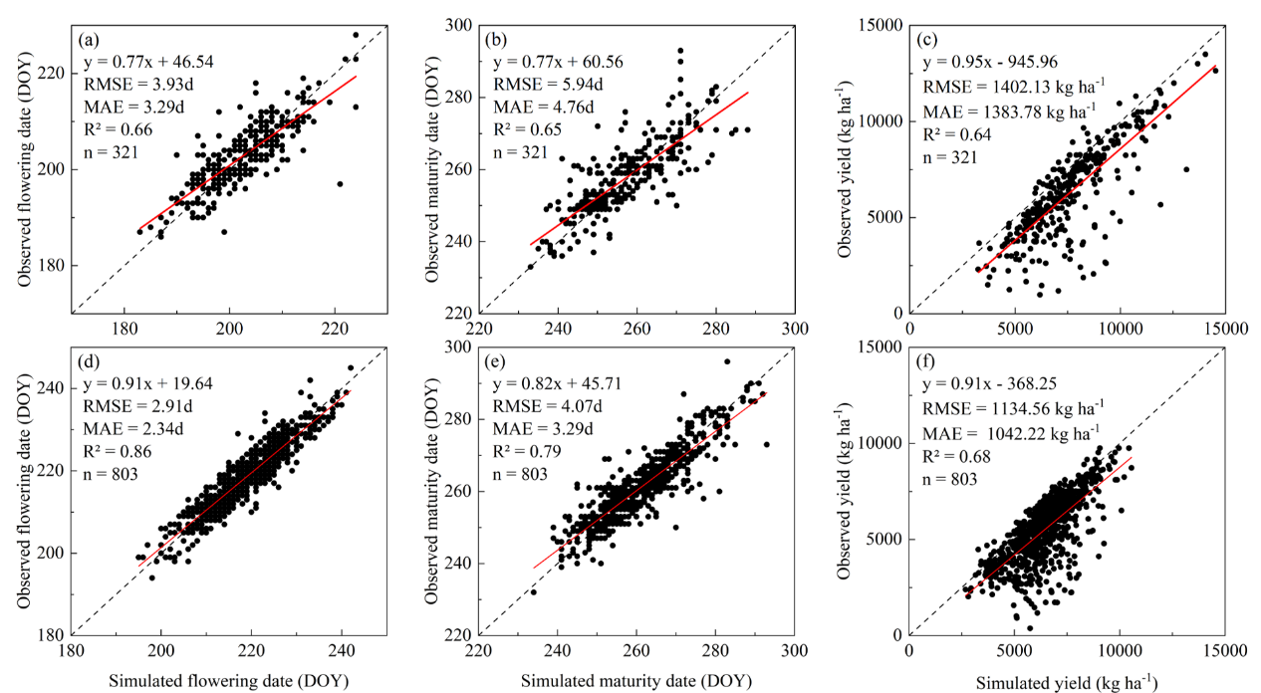
Fig. S1 Comparison of observed and APSIM-simulated values of flowering date (a, d), maturity date (b, e) and yield (c, f) at 51 stations for spring maize (a-c) and summer maize (d-f) in the North China Plain from 1981 to 2009.

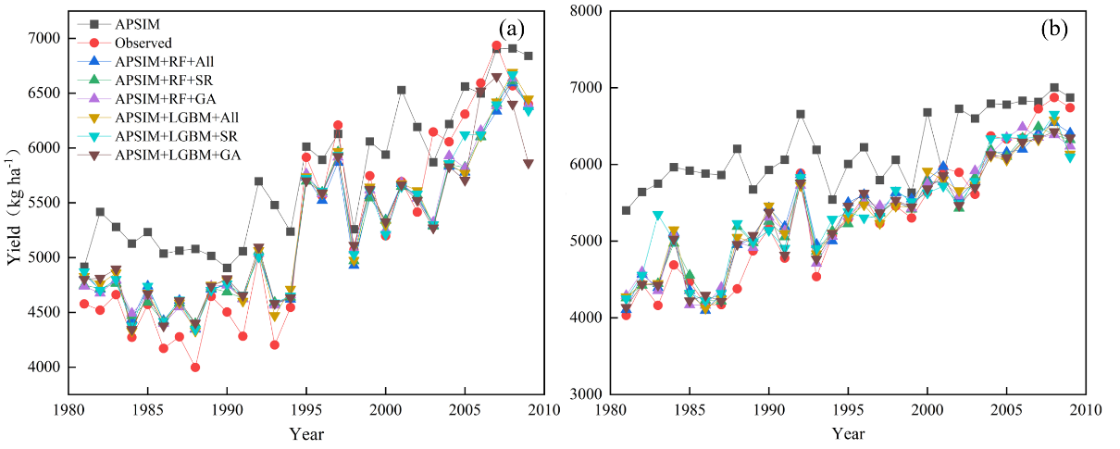
Fig. S2 Time series of observed and simulated maize yields across the North China Plain (NCP) using LGBM and RF with the different input selections (All: 22 predictors; SR: 10 out of 22 predictors selected by stepwise regression method; GA: 12 of 22 predictors selected by genetic algorithms, a and b indicate spring maize and summer maize, respectively).
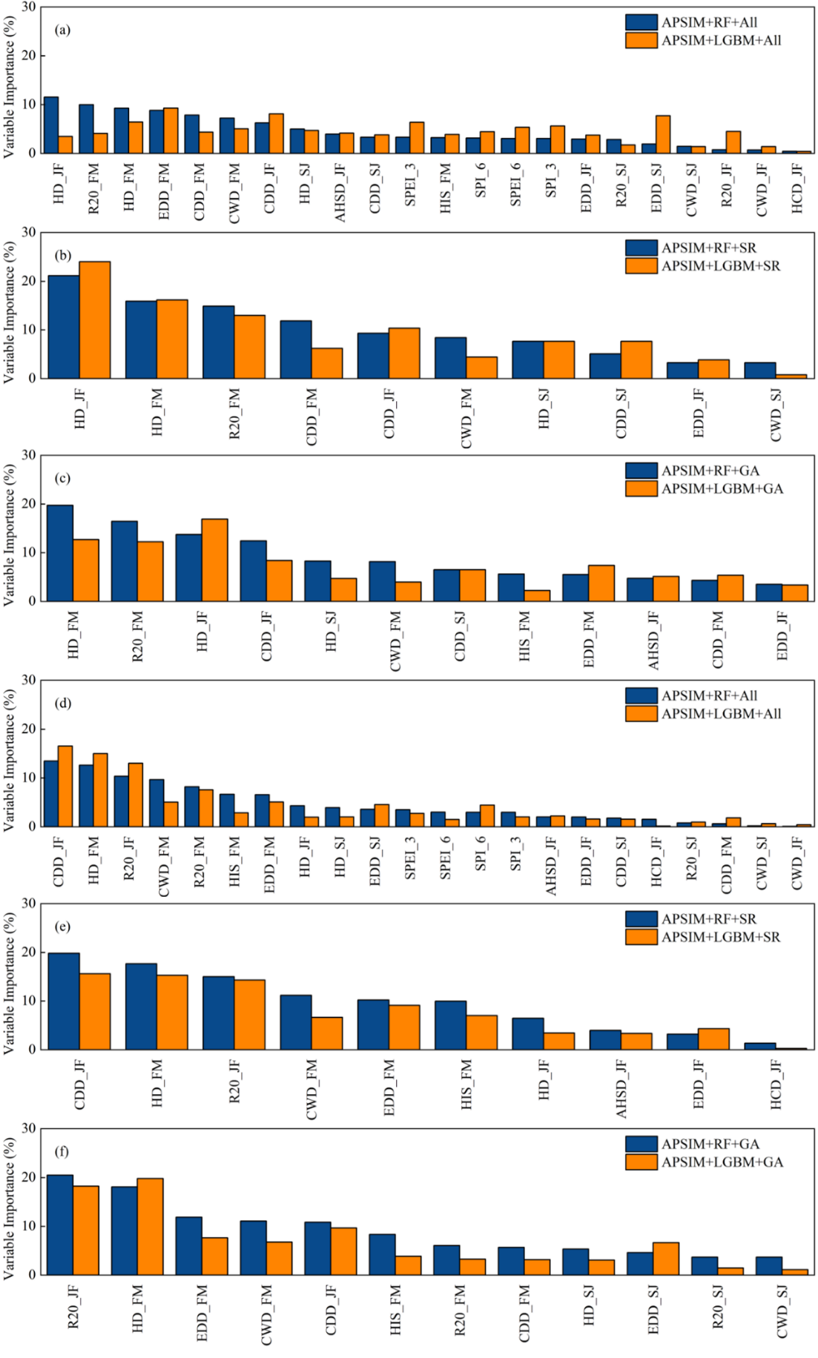
Fig. S3 Relative importance of each predictor variable used in RF and LGBM models to simulate spring (a-c) and summer (d-f) maize yield. All the 22 predictor variables (a, d); 10 out of 22 predictors selected by SR (b, e) and 12 out of 22 predictors selected by GA (c, f).

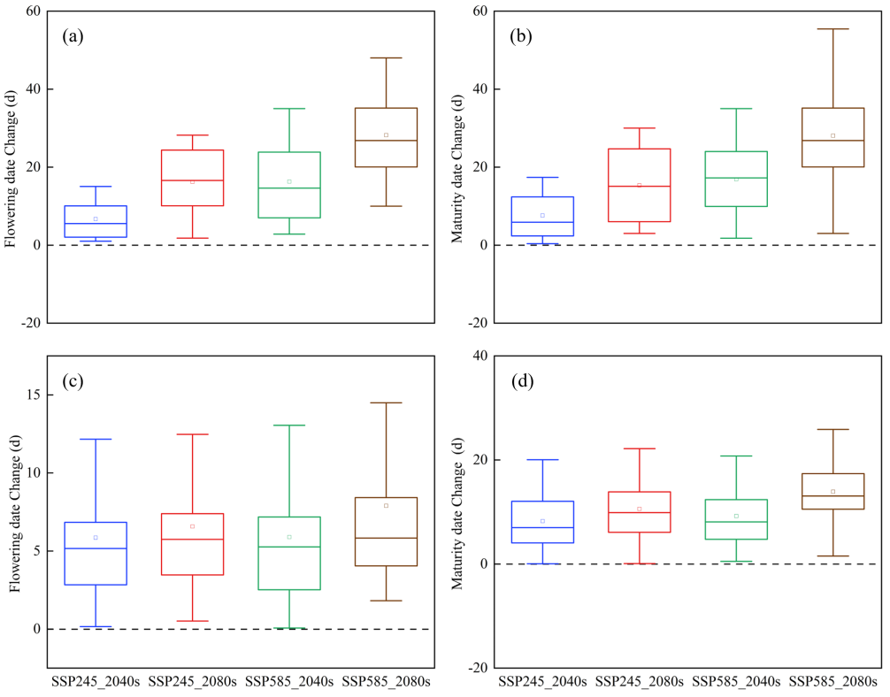
Fig. S4 Projected changes in flowering and maturity date in the 2040S and 2080S under SSP245 and SSP585 scenarios compared to the baseline period (a and b indicate spring maize, while c and d summer maize).
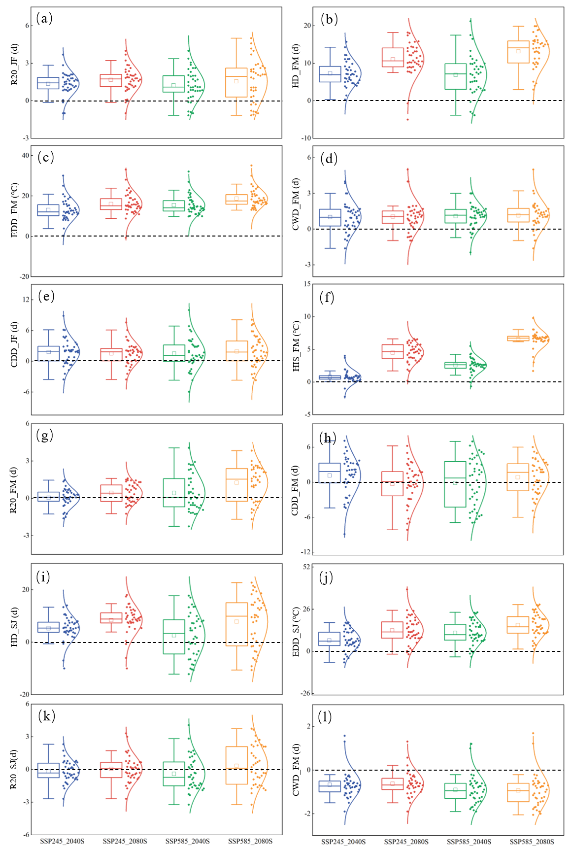
Fig. S5 Projected changes in 12 extreme climate indices (ECIs) selected by GA for summer maize in the 2040s and 2080s under SSP245 and SSP585 scenarios compared to the baseline period.

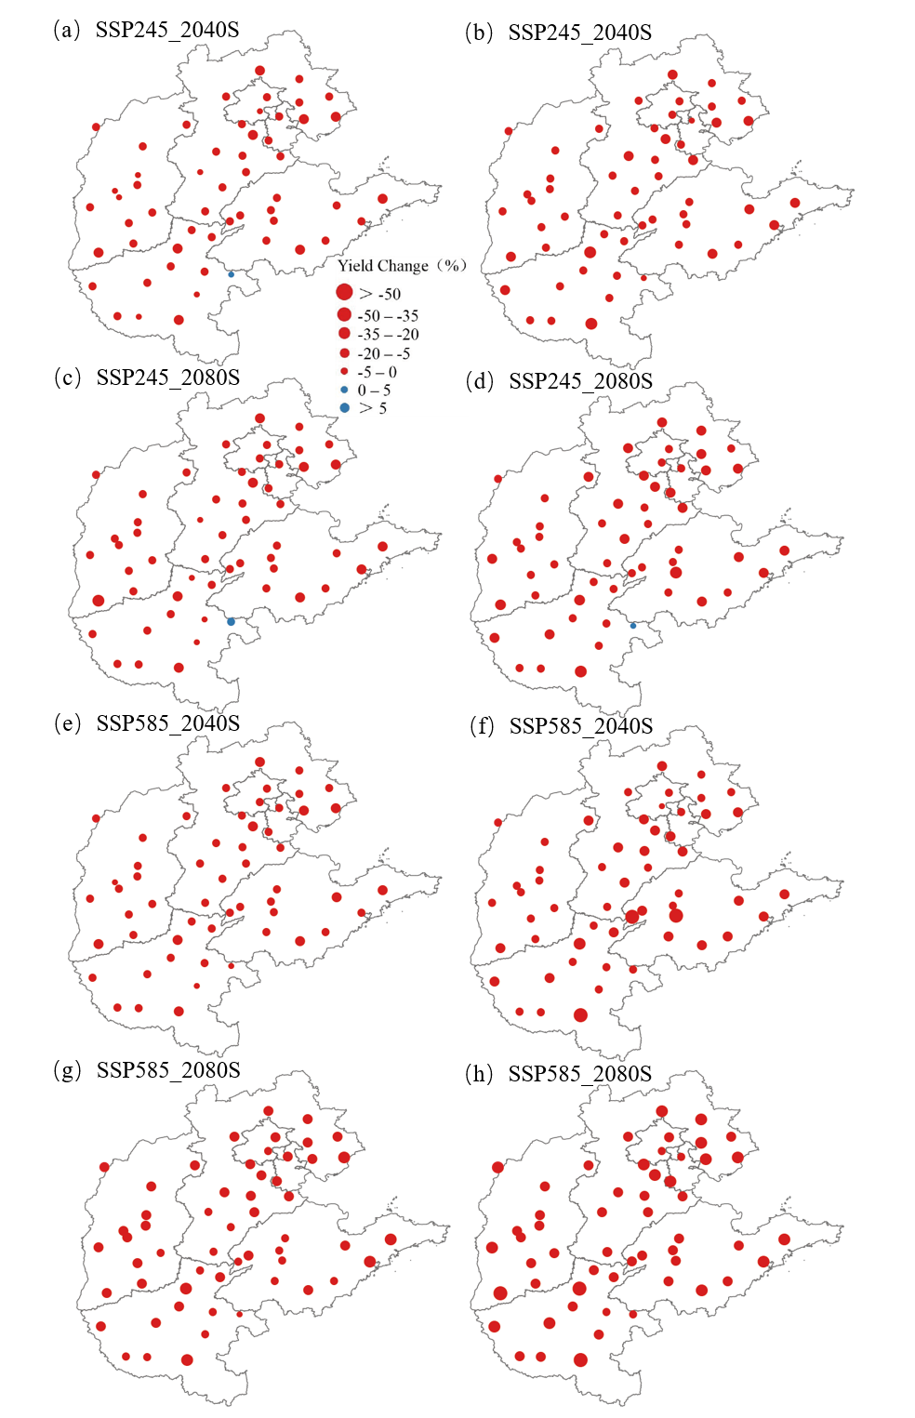
Fig. S6 Projected changes in simulated maize yield under future climate scenarios from APSIM model (a, c, e, g) and APSIM+RF+GA model (b, d, f, h) for 51 stations across the North China Plain.

