Supplementary information
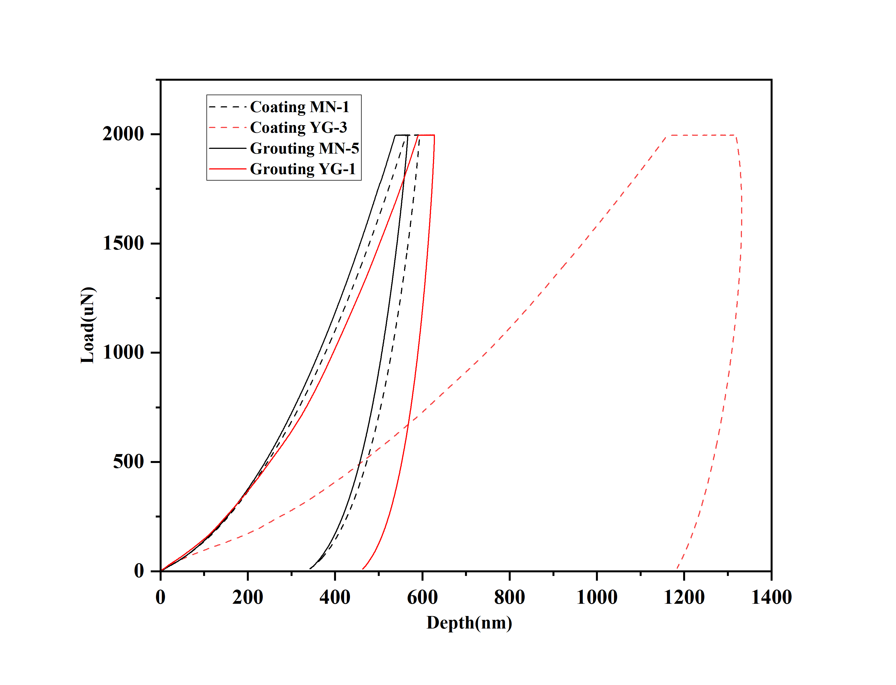
Fig. S1: Nanoindentation load-depth curves for all samples

