Table S2. Laboratory and Metabolic Characteristics of Participants by GI Disease Status at Baseline
Variable | GI Disease status |  |  |  |  |  | P value
Variable | Overall | n | No | n | Yes | n | P value
FBG(mg/dL) | 102.2 [94.3–112.9] | 9,268 | 102.4 [94.5–113.4] | 7,355 | 101.5 [93.8–111.6] | 1,913 | 0.006
CRP, (mg/L) | 1.0 [0.5–2.1] | 9,287 | 1.0 [0.6–2.1] | 7,369 | 0.9 [0.5–1.9] | 1,918 | <0.001
TG(mg/dL) | 104.4 [74.3–153.1] | 9,282 | 106.2 [75.2–154.0] | 7,364 | 99.1 [72.6–146.9] | 1,918 | <0.001
LDL-c (mg/dL) | 113.7 [93.0–136.9] | 9,271 | 114.0 [93.2–136.9] | 7,355 | 112.9 [92.4–136.2] | 1,916 | 0.322
HDL-c (mg/dL) | 49.5 [40.6–59.9] | 9,287 | 49.1 [40.2–59.9] | 7,369 | 51.0 [41.4–61.5] | 1,918 | <0.001
UA(mg/dL) | 4.3 [3.6–5.2] | 9,287 | 4.4 [3.6–5.2] | 7,369 | 4.1 [3.5–4.9] | 1,918 | <0.001
HbA1c (%) | 5.1 [4.9–5.4] | 9,326 | 5.1 [4.9–5.4] | 7,413 | 5.1 [4.9–5.4] | 1,913 | 0.786
CTI | 8.6 [8.1–9.2] | 8,360 | 8.7 [8.2–9.2] | 6,655 | 8.5 [8.0–9.1] | 1,705 | <0.001
Data are presented as median [interquartile range] with the number of non-missing participants (n) shown below each group. Group comparisons were performed using the Wilcoxon rank-sum test.
GI, gastrointestinal disease; FBG, fasting blood glucose; CRP, C-reactive protein; TG, triglycerides; LDL-c, low-density lipoprotein cholesterol; HDL-c, high-density lipoprotein cholesterol; UA, uric acid; HbA1c, glycated hemoglobin; CTI, C-reactive protein–glucose–triglyceride index.

Table S2. Laboratory and Metabolic Characteristics of Participants by CVD Status at Baseline
Variable | CVD status |  |  |  |  |  | P value
Variable | Overall | n | No | n | Yes | n | P value
FBG(mg/dL) | 102.6 [94.7–114.1] | 8,381 | 102.4 [94.5–113.4] | 7,342 | 105.1 [95.9–120.0] | 1,039 | <0.001
CRP, (mg/L) | 1.1[0.6–2.2] | 8,397 | 1.0 [0.6–2.1] | 7,356 | 1.4 [0.7–2.8] | 1,041 | <0.001
TG (mg/dL) | 107.1 [76.1–157.5] | 8,391 | 106.2 [75.2–154.0] | 7,351 | 118.6 [83.2–185.0] | 1,040 | <0.001
LDL-c (mg/dL) | 114.0 [93.2–137.2] | 8,380 | 114.0 [93.2–136.9] | 7,342 | 115.2 [92.4–137.9] | 1,038 | 0.342
HDL-c(mg/dL) | 48.7 [39.8–59.5] | 8,396 | 49.1 [40.2–59.9] | 7,356 | 45.2 [37.1–55.8] | 1,040 | <0.001
UA(mg/dL) | 4.4 [3.6–5.2] | 8,397 | 4.4 [3.6–5.2] | 7,356 | 4.5 [3.7–5.4] | 1,041 | <0.001
HbA1c (%) | 5.1 [4.9–5.4] | 8,451 | 5.1 [4.9–5.4] | 7,400 | 5.2 [4.9–5.5] | 1,051 | <0.001
CTI | 8.7 [8.2–9.3] | 7,582 | 8.7 [8.2–9.2] | 6,644 | 8.9 [8.4–9.6] | 938 | <0.001

Data are presented as median [interquartile range] with the number of non-missing participants (n) shown below each group. Group comparisons were performed using the Wilcoxon rank-sum test.
GI, gastrointestinal disease; FBG, fasting blood glucose; CRP, C-reactive protein; TG, triglycerides; LDL-c, low-density lipoprotein cholesterol; HDL-c, high-density lipoprotein cholesterol; UA, uric acid; HbA1c, glycated hemoglobin; CTI, C-reactive protein–glucose–triglyceride index.

Table S3. Missingness of baseline variables before multiple imputation
Variable | Missing values, n | Missingness, %
FBG | 5348 | 32.76
TG | 5332 | 32.67
CRP | 5325 | 32.62
HbA1c (%) | 5276 | 32.32
Time to GI event (years) | 4100 | 25.12
Incident GI event | 3873 | 23.73
BMI | 3548 | 21.74
Time to CVD event (years) | 2832 | 17.35
Incident CVD event | 2593 | 15.89
CESD-10 score | 1444 | 8.85
Drinking status | 127 | 0.78
Smoking status | 110 | 0.67
Education level | 43 | 0.26
Marital status | 21 | 0.13
GI | 0 | 0
CVD | 0 | 0
Age | 0 | 0
Sex | 0 | 0
Residence (urban/rural) | 0 | 0
Hypertension | 0 | 0
Diabetes | 0 | 0
BMI, body mass index; CESD-10, 10-item Center for Epidemiologic Studies Depression Scale; CRP, C-reactive protein; FBG, fasting blood glucose; GI, gastrointestinal disease; HbA1c, glycated hemoglobin; TG, triglycerides; CVD, cardiovascular disease. Missingness was assessed before multiple imputation.

Table S4. Mediation Analysis of CTI in the Bidirectional Association Between Gastrointestinal Disease and Cardiovascular Disease
Variables | Estimate (95%CI) |  | P
Variables | Estimate | 95% CI | P
GI disease and new-onset CVD risk (CESD-10 scores as mediator)
ACME (indirect effect) | 0.0129 | 0.0096 to 0.0162 | <0.05
ADE (direct effect) | 0.0498 | 0.0313 to 0.0683 | <0.05
Proportion mediated | 20.60% | 12.8% to 28.5% | <0.05
CVD and new-onset GI disease risk (CESD-10 scores as mediator)
ACME (indirect effect) | 0.0166 | 0.0126 to 0.0206 | <0.05
ADE (direct effect) | 0.0462 | 0.0220 to 0.0704 | <0.05
Proportion mediated | 26.50% | 14.9% to 38.1% | <0.05

Table S5. Mediation Analysis of CTI in the Bidirectional Association Between Gastrointestinal Disease and Cardiovascular Disease
Variables | Estimate (95%CI) |  | P
Variables | Estimate | 95% CI | P
GI disease and new-onset CVD risk (CTI as mediator)
ACME (indirect effect) | −0.0022 | −0.0037 to −0.0008 | <0.05
ADE (direct effect) | 0.0650 | 0.0466 to 0.0833 | <0.05
Proportion mediated | −3.56% | −6.12% to −1.01% | <0.05
CVD and new-onset GI disease risk (CTI as mediator)
ACME (indirect effect) | −0.0001 | −0.0016 to 0.0013 | -
ADE (direct effect) | 0.0629 | 0.0386 to 0.0872 | <0.05
Proportion mediated | −0.23% | −2.48% to 2.03% | -
Estimates were obtained using structural equation modeling with full-information maximum likelihood estimation (SEM-FIML), adjusted for age, sex, residence, education level, marital status, smoking status, drinking status, body mass index, hypertension, and diabetes. ACME, average causal mediation effect; ADE, average direct effect; CTI, C-reactive protein–glucose–triglyceride index; CI, confidence interval; GI, gastrointestinal; CVD, cardiovascular disease.

Table S6. E-values for Unmeasured Confounding in the Main Bidirectional Associations Between GI Disease and CVD.
Association | HR (95% CI) | E-value  (point estimate) | E_value_lower CI bound
GI disease and new onset CVD | 1.44 (1.32–1.57) | 2.24 | 1.97
CVD and new onset GI disease | 1.46 (1.30–1.64) | 2.28 | 1.92

HR, hazard ratio; CI, confidence interval; GI, gastrointestinal; CVD, cardiovascular disease.

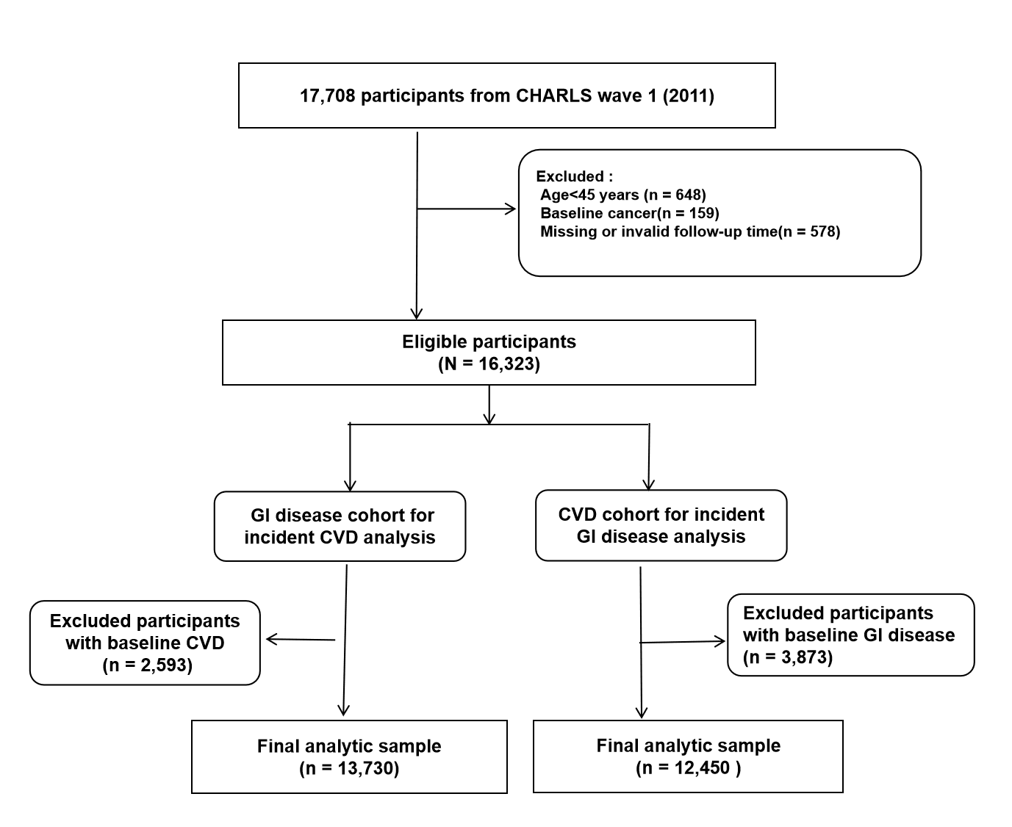

Figure S1. Flowchart of participant selection for the bidirectional association analyses between gastrointestinal (GI) disease and cardiovascular disease (CVD) based on the China Health and Retirement Longitudinal Study (CHARLS).

Figure S2. Restricted cubic spline analysis of age and risk of incident outcomes.
(A) GI disease with incident CVD; (B) CVD with incident GI disease. The solid lines represent hazard ratios (HRs) estimated from multivariable Cox models and the shaded areas indicate 95% confidence intervals.The horizontal dashed lineindicatesHR=1.0. The solid lines represent hazard ratios (HRs) estimated from fully adjusted Cox models, and the shaded areas indicate 95% confidence intervals. The horizontal dashed line indicates HR = 1.0. The vertical dotted line indicates the median age (58 years). Knots were placed at the 25th, 50th, and 75th percentiles of age.

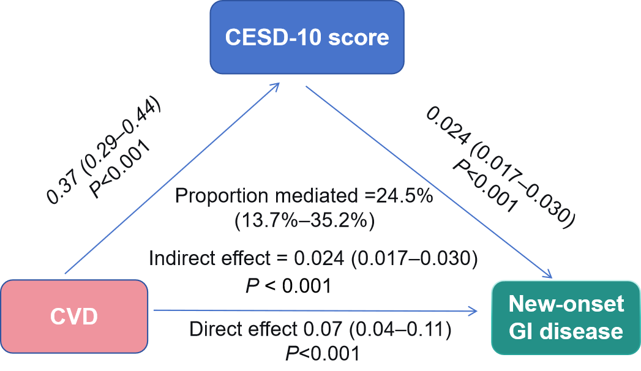
Figure S3. Mediation model of depressive symptoms (CESD-10 scores) in the association between CVD and new onset GI disease among female participants (exploratory analysis).
GI, gastrointestinal; CVD, cardiovascular disease. CESD-10, 10-item Center for Epidemiologic Studies Depression Scale

