Article title: Pan-cancer prevalence of microsatellite instability and Lynch syndrome in India
Journal name: Familial Cancer

Author names: Harsh Sheth¹*, Jyoti Sadhwani^{1,18}, Bhawna Sirohi², Senthilkumar Ramasamy², Yashwant Kashyap², Pankaj Shah³, Mithun Shah³, Suresh Advani⁴, Lidiya Thomas⁴, Vipul D. Yagnik⁵, Avinash Tank⁶, Chirag Shah⁷, Raja Pramanik⁸, Bhavesh Thakkar⁹, Darshan Bhansali⁹, Manish Gandhi⁹, Tarang Patel⁹, Natoo Patel⁹, Ashok Patel⁹, Ruchir Patel¹⁰, Ravindra Gaadhe¹¹, Chintan Shah¹², Bhavin Shah¹², Gaurang Modi¹³, Ankita Jakhar¹⁴, Ava Desai³, Chirantan Bose¹⁵, Amit Sehrawat¹⁶, Dipak Limbachiya¹⁷, Chandni Patel¹, Prachi Soni¹, Sunil Trivedi¹, Kshipra Chauhan¹⁸, Frenny Sheth¹, Jayesh Sheth¹, D Timothy Bishop¹⁹, John Burn²⁰, Abhinav Jain^{9,10}

Affiliations:
¹ Foundation for Research in Genetics and Endocrinology, Ahmedabad, Gujarat, India
² Vedanta Medical Research Foundation (BALCO Medical Centre), Raipur, Chhattisgarh, India
³ Zydus Cancer Hospital, Ahmedabad, Gujarat, India
⁴ Sushrut Hospital, Mumbai, Maharashtra, India
⁵ Nishtha Surgical Hospital & Research Centre, Patan, Gujarat, India
⁶ Dwarika Hospital, Ahmedabad, Gujarat, India
⁷ Mission Gastro Hospital, Ahmedabad, Gujarat, India
⁸ All India Institute of Medical Sciences, New Delhi, India
⁹ Marengo CIMS Hospital, Ahmedabad, Gujarat, India
¹⁰ Gastro1 Hospital, Ahmedabad, Gujarat, India
¹¹ Gastroplus Hospital, Ahmedabad, Gujarat, India
¹² HOC Vedanta, Ahmedabad, Gujarat, India
¹³ Oncowin Cancer Center, Ahmedabad, Gujarat, India
¹⁴ Gujarat Cancer & Research Institute, Ahmedabad, Gujarat, India
¹⁵ MOC Cancer Care & Research Centre, Mumbai, Maharashtra, India
¹⁶ All India Institute of Medical Sciences, Rishikesh, Uttarakhand, India
¹⁷ Eva Women’s Hospital, Ahmedabad, Gujarat, India
¹⁸ Gujarat Technological University, Ahmedabad, Gujarat, India
¹⁹ Leeds Institute of Medical Research, University of Leeds, Leeds, United Kingdom
²⁰ Translational and Clinical Research Institute, Newcastle University, Newcastle upon Tyne, United Kingdom
E-mail address of the corresponding author: harsh.sheth@frige.co.in

Supplementary File 2: Pedigree charts of 25 family members diagnosed with Lynch syndrome

MSI-RP-012-P 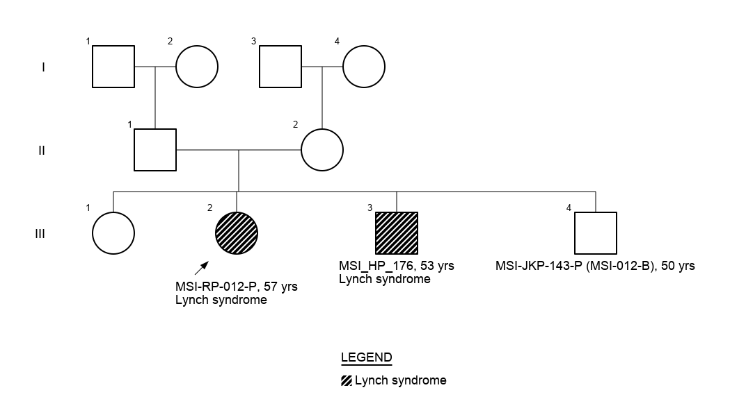 | MSI-ZSA-029-P  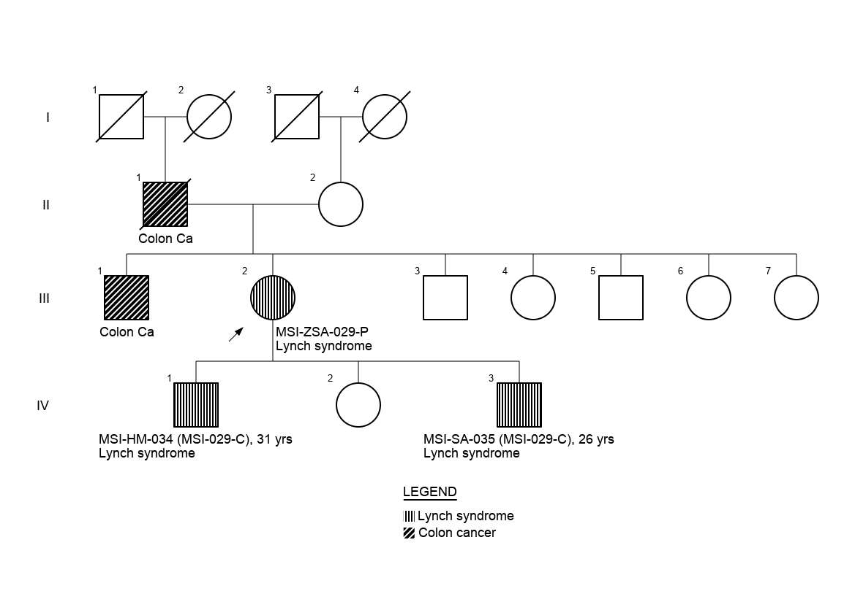
MSI-AAG-015-P  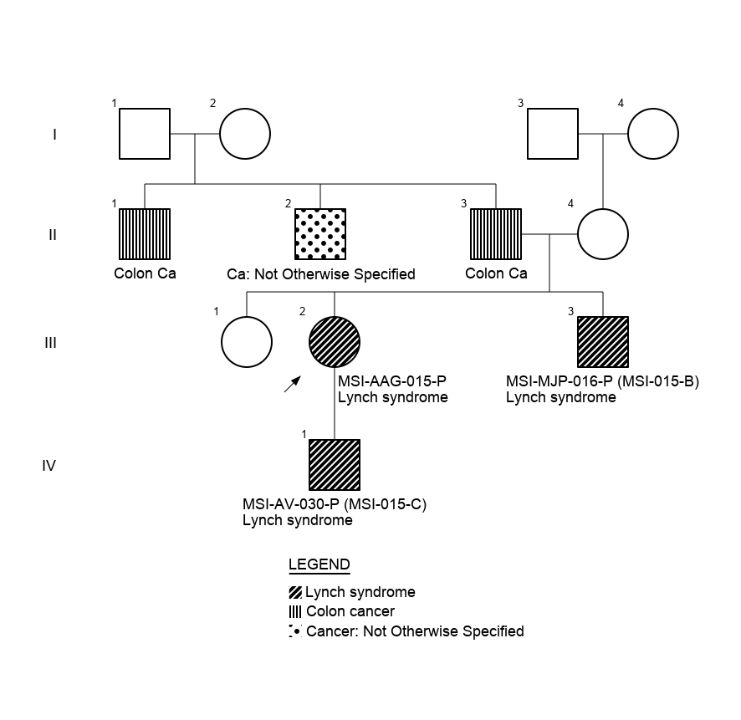 | MSI-SSR-194-P  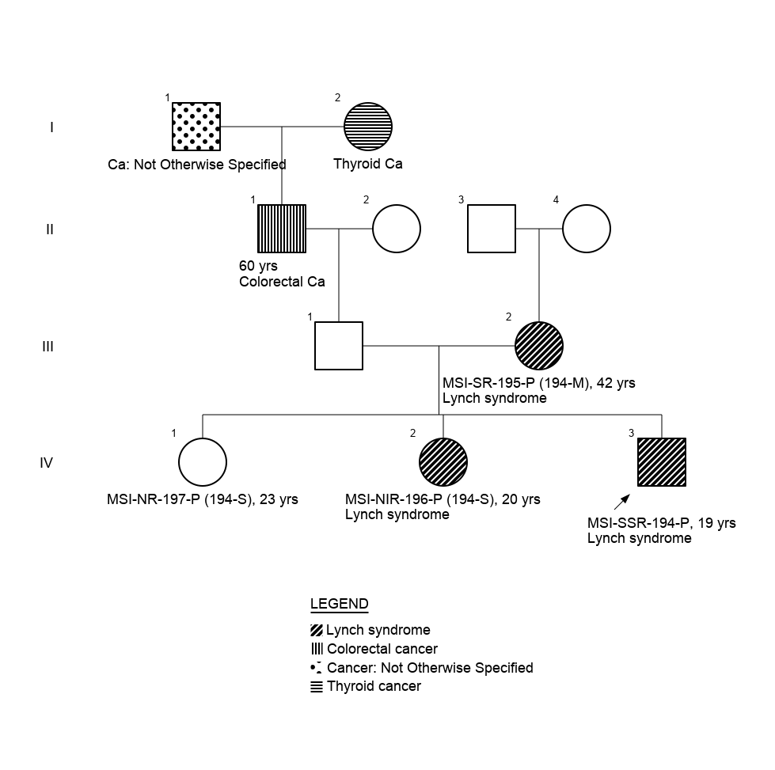
MSI-KMV-134-P
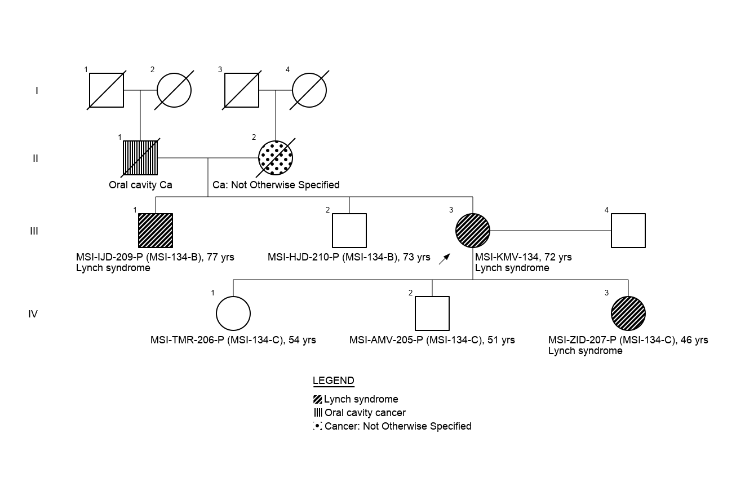

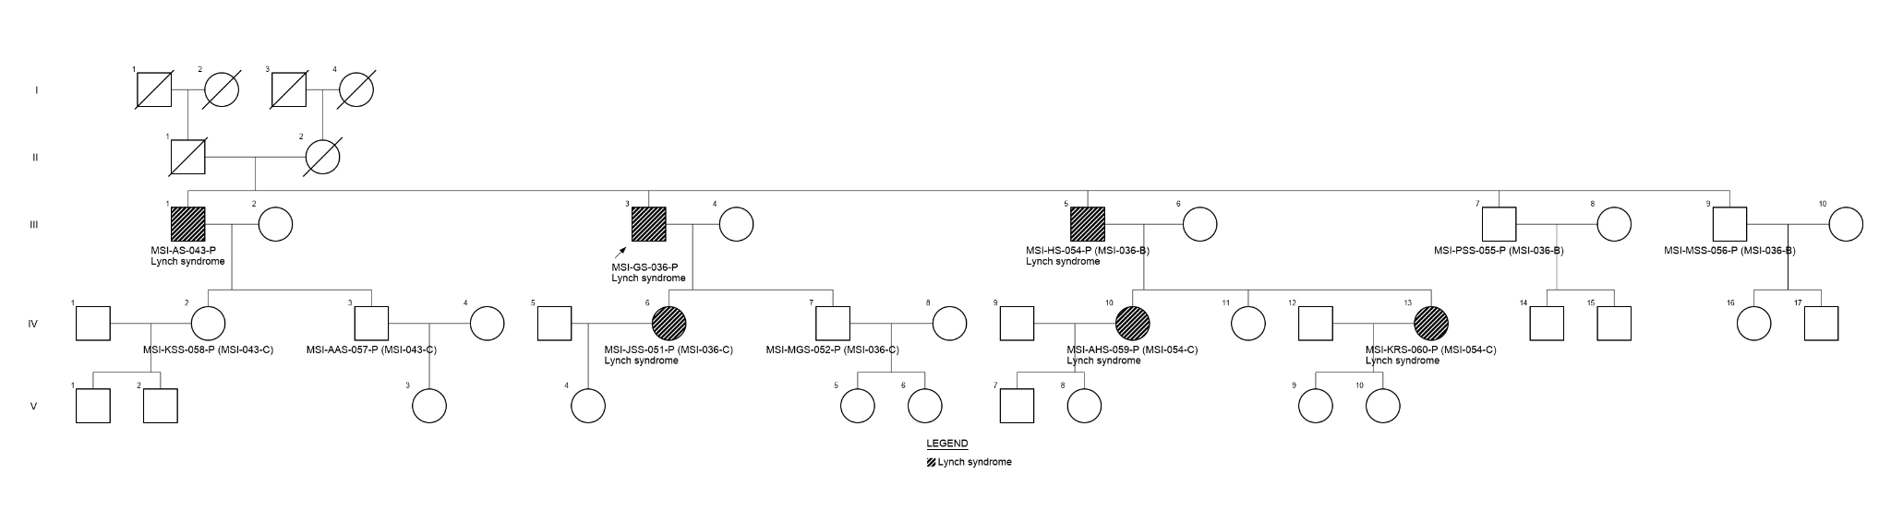 MSI-GS-036-P

MSI-HFA-144-P

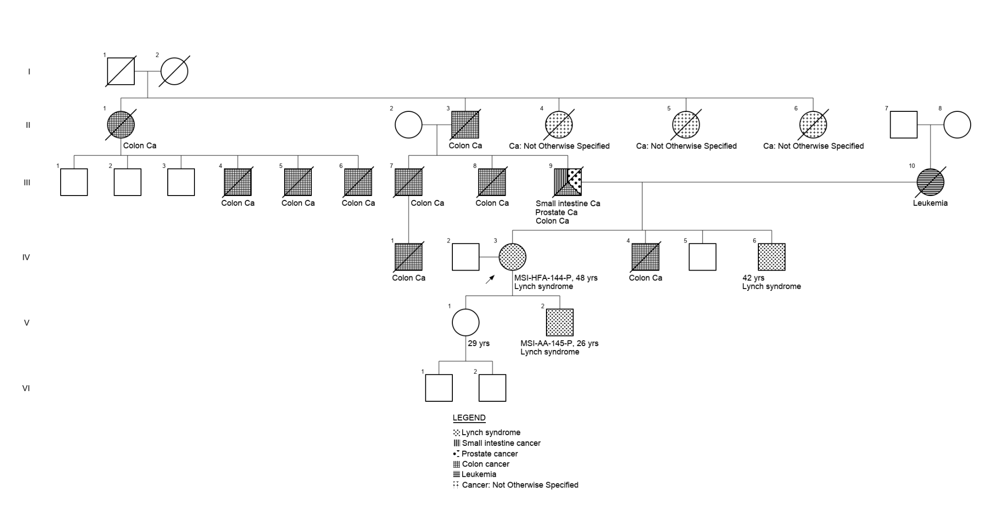
MSI-MSI/078/P-234-P

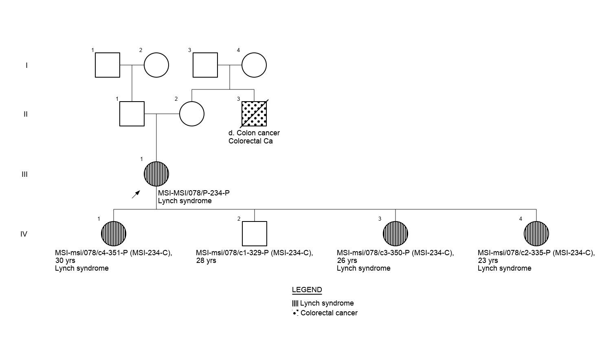
MSI-MSI/105/P-265-P

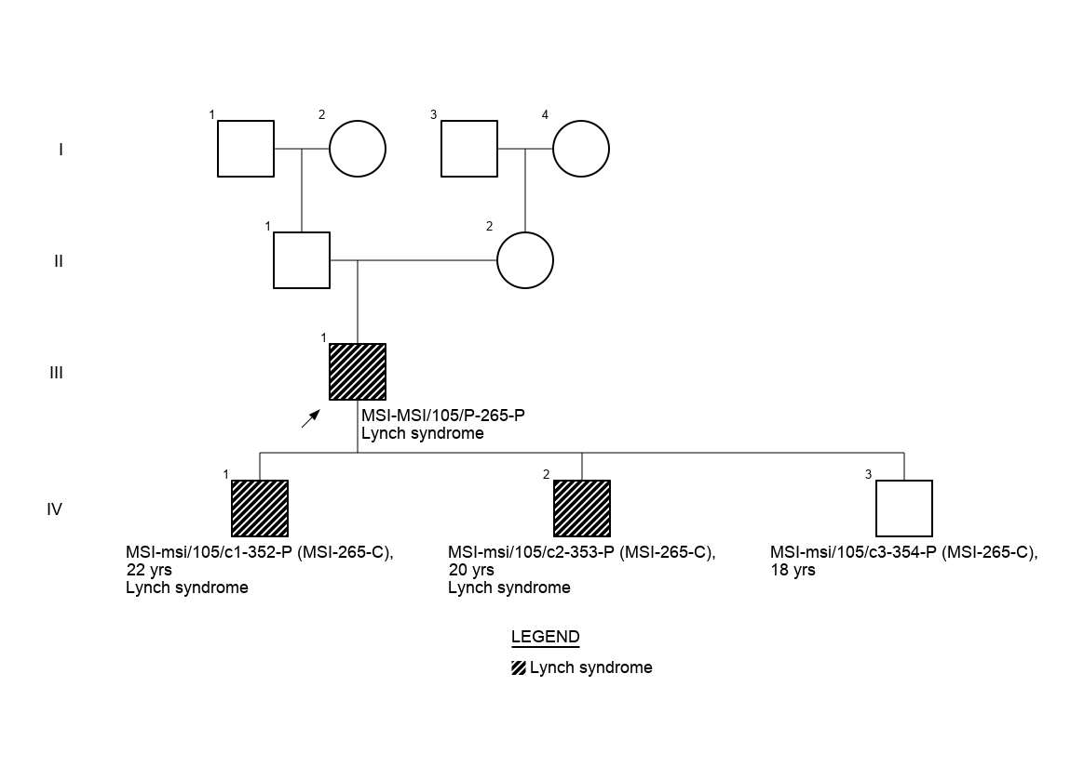
MSI-MSI/006/P-103-P

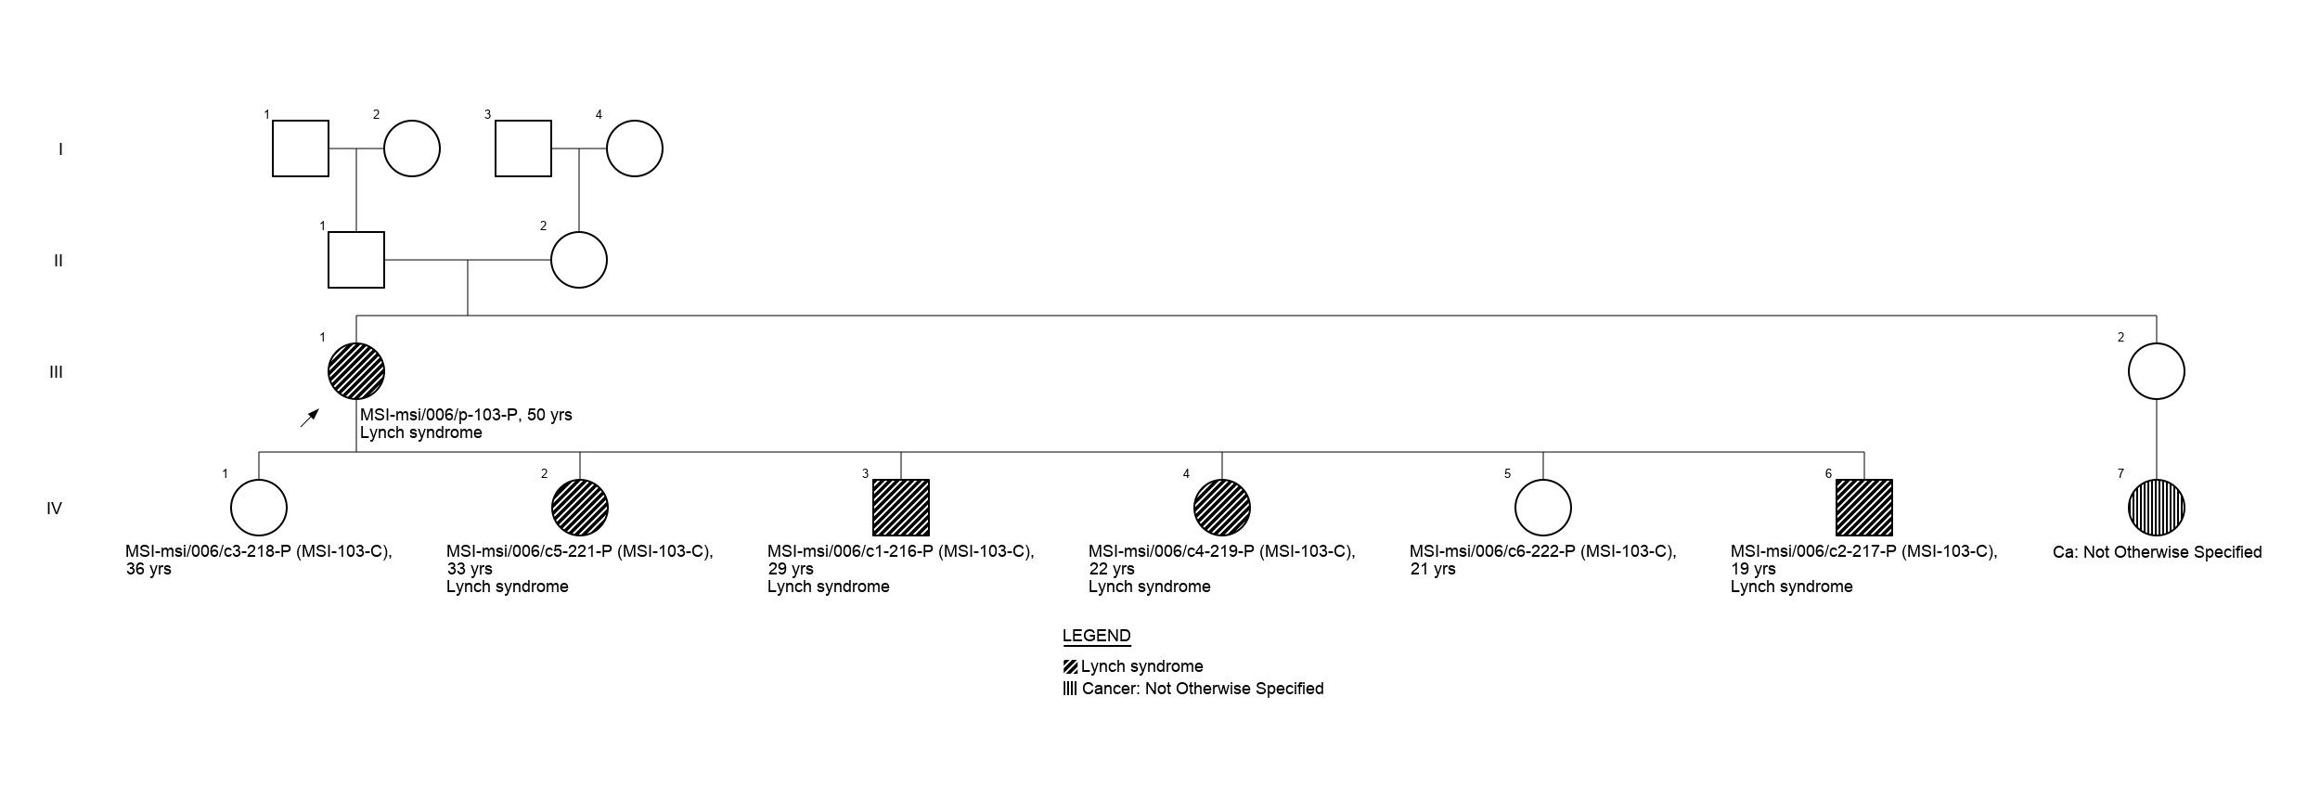
MSI-MSI/162/P-341-P  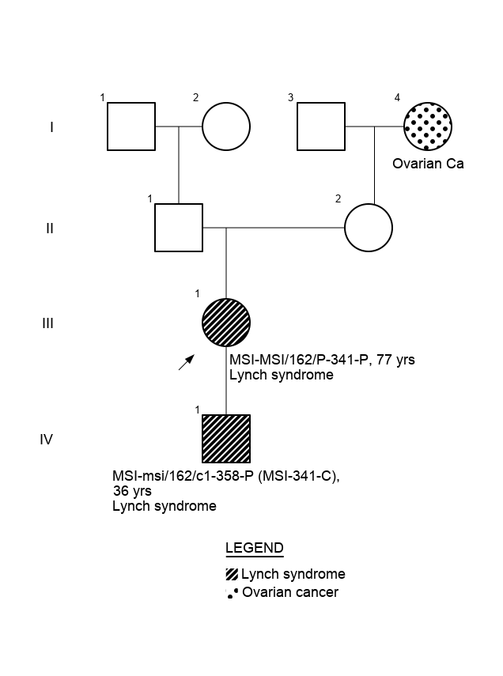 | MSI-MSI/155/P-331-P  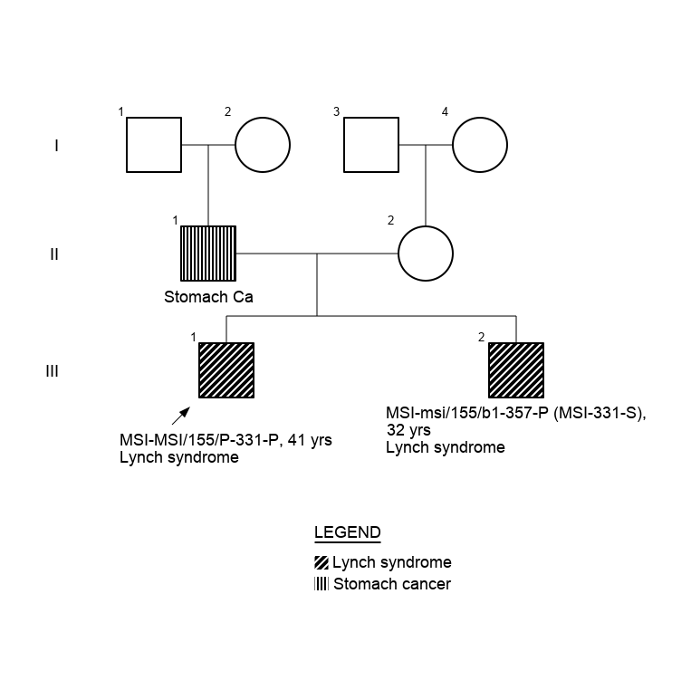
MSI-MSI/161/P-340-P

