Supplementary for “Targeted interventions can ensure environmental co-benefits from energy decarbonization”

This Supplementary Information includes the following sections

- SI-1: Comparison of REMIND scenarios
- SI-2: Detailed information on interventions
- SI-3: Detailed information on limitations and uncertainties
- SI-4: Sequencing of interventions for waterfall diagrams
- SI-5: Inventory changes for air pollutants

SI-1: Comparison of REMIND scenarios
Below, we display comparison of key scenario variables of the three REMIND scenarios CP, NZ, and NZ-SCI. The full scenario data can be accessed here: https://doi.org/10.5281/zenodo.20458541

Socioeconomic drivers
All three REMIND scenarios are following the SSP2 narrative and drivers^{1–4}. Thus, population is the same for all scenarios. GDP growth is slightly lower in the net zero scenarios.
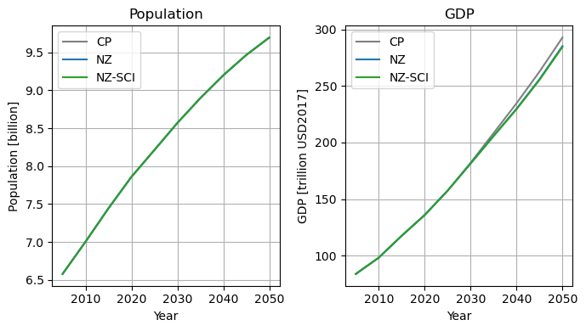
Figure SI.1: Socioeconomic drivers of IAM scenarios

CO2 emissions and global warming
Figure SI.2 shows the global CO2 emissions in the three scenarios and the resulting global warming, derived by the reduced-complexity climate model MAGICC⁵ based on the emission reported by REMIND.
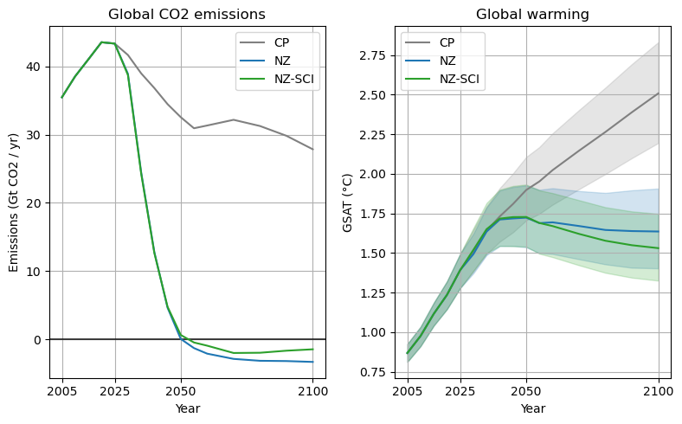
Figure SI.2: CO2 emissions and global warming by scenario
For global warming, lines show median temperature outcome, and error bands represent the 25-75th percentile range.

Final energy demand

While final energy demand continually increases until 2050 in the CP scenario, it decreases after 2030 in the net zero scenarios in part due to more efficient end use technology and electrification. The NZ and NZ-SCI scenario are very similar in their final energy demand.
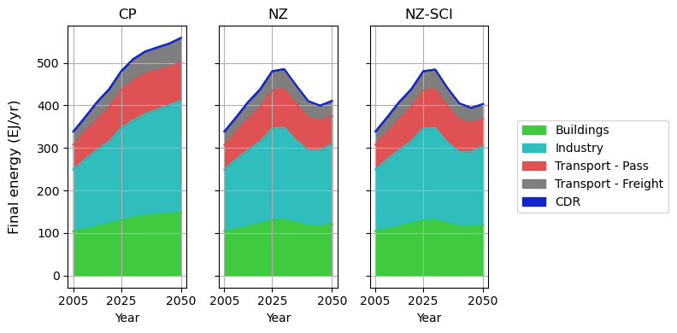
Figure SI.3: Global final energy demand in REMIND scenarios by end use sector

Primary energy production
Total primary energy production follows the scenario-specific trends above for final energy demand. The energy carrier shares show the decarbonization achieved through the respective climate targets: Large amounts of coal, gas, and oil remain in the CP scenario, whereas coal is fully phased out in the NZ and NZ-SCI scenarios before 2050, and oil and gas are strongly reduced. Solar and wind take up about half the primary energy production in the NZ and NZ-SCI scenarios, and biomass increases, mostly in the form of BECCS.
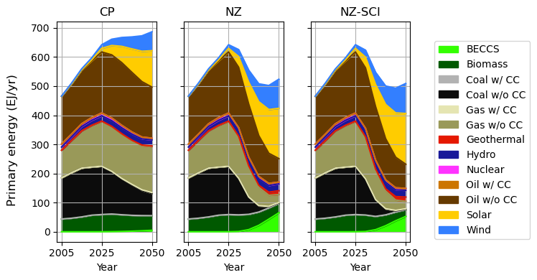
Figure SI.4: Primary energy production in REMIND scenarios, by energy carrier

Figure SI.5 below shows the difference in primary energy production between the NZ-SCI and NZ scenarios. The constrained biomass use in NZ-SCI is compensated by a slightly lower energy demand in total, and increased production in Geothermal, Solar, and Wind. Use of oil increases in NZ-SCI, but fossil gas decreases by an equivalent amount to balance GHG emissions.
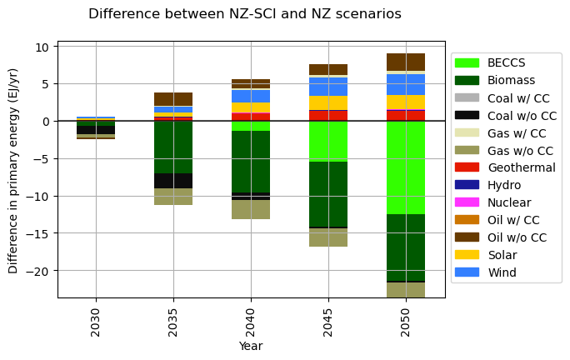
Figure SI.5: Difference in Primary Energy between NZ-SCI and NZ scenarios

Biomass production
Biomass production remains fairly stable in the CP scenario, but Energy Crop use strongly increases towards 2050 in the NZ scenario. The NZ-SCI phases out 1st Generation biomass and reduces the Energy Crops production increase.
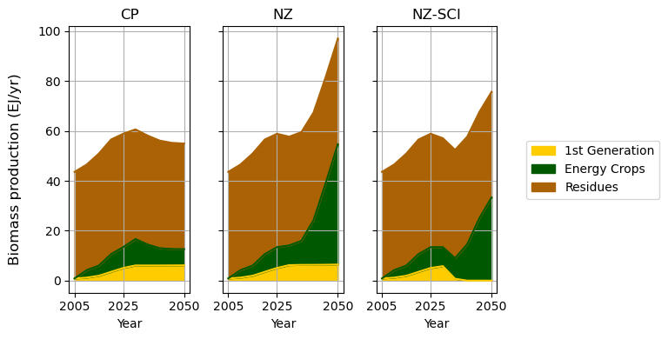
Figure SI.6: Primary biomass production in REMIND scenarios, by type

SI-2: Detailed information on interventions

Tailings treatment
Table SI.1 below shows the shares of the four tailings treatment technologies impoundment (ecoinvent default), backfilling, flocculation-flotation, and roasting and leaching by world region. For the CP and NZ scenarios, the 2020 shares are introduced and held constant. In the NZ-SCI scenario, shares are interpolated linearly between the 2020 and 2050 values shown below.

Table SI.1: Shares of tailings treatment technologies
 | Backfilling |  | Impoundment |  | Reference | Flocculation-Flotation |  | Roasting and leaching |  | Reference
Region | 2020 | 2050 | 2020 | 2050 | Reference | 2020 | 2050 | 2020 | 2050 | Reference
North America | 15% | 30% | 80% | 60% | ^{6,7} | 4% | 8% | 1% | 2% | ^{8–11}
LATAM | 5% | 25% | 90% | 65% | ^{7,12} | 4% | 8% | 1% | 2% | ^{8–11}
Europe | 15% | 35% | 80% | 55% | ^{8,13} | 4% | 8% | 1% | 2% | ^{8–11}
APAC | 10% | 20% | 85% | 70% | ^{14,15} | 4% | 8% | 1% | 2% | ^{8–11}
Africa | 5% | 10% | 90% | 70% | ^{9,16,17} | 4% | 8% | 1% | 2% | ^{8–11}
Global | 10% | 25% | 85% | 65% | ^{7,9,16} | 4% | 8% | 1% | 2% | ^{8–11}

Slags treatment
Table SI.2 and SI.3 below shows the shares by world region between landfilling and slag reuse for electric arc and basic oxygen furnace slag respectively. For the CP and NZ scenarios, the 2020 shares are introduced and held constant. In the NZ-SCI scenario, shares are interpolated linearly between the 2020 and 2050 values shown below.

Table SI.2: Market for electric arc furnace slag.
 | Landfilling |  | Reuse as SCM |  | Reference
Region | 2020 | 2050 | 2020 | 2050 | Reference
Europe w/out CH | 96% | 20,35,50% | 4% | 50,65,80% | ^{18,19}
CH | 100% | 20,50,70% | 0% | 30,50,80% | ^{19,20}
India | 100% | 20,50,70% | 0% | 30,50,80% | ^{21,22}
RoW | 96% | 20,50,70% | 4% | 30,50,80% | ^{21,22}

Table 2: Market for basic oxygen furnace slag.
 | Landfilling |  | Reuse as SCM |  | Reference
Region | 2020 | 2050 | 2020 | 2050 | Reference
RER | 79% | 13,23% | 21% | 77,87% | ^{23,24}
RoW | 79% | 15,23% | 21% | 77,85% | ^{24,25}

Metal recycling
Table SI.4 shows shares of secondary production for various metals, collected from the literature. For the CP and NZ scenarios, the 2020 shares are introduced and held constant. In the NZ-SCI scenario, shares are interpolated linearly between the 2020 and 2050 values shown below.

Table SI.4: Secondary share of input for selected metals
metal | share in 2020 | shares in 2050 (NZ-SCI) | source / note
copper | 0.32 | 0.52-0.58 | IEA²⁶; using share of demand as simplification
zinc | 0.30 | 0.32-0.42 | Rostek et al., ILZSG^{27,28}
zinc concentrate | 0 | 0 | Rostek et al., ILZSG^{27,28}; sourcing from slags already included is Rostek et al.
aluminium, cast alloy | 0.688 | 0.7-0.8 | van den Eynde et al.²⁹
aluminium, wrought alloy | 0.304 | 0.35-0.45 | van den Eynde et al.²⁹; adjusted for the fact that wrought alloy need higher purity (and therefore wrought-to-wrought alloy recycling needs better sorting)
lithium | 8.4e-04 | 0.2-0.3 | IEA²⁶
nickel, class 1 | 2.03e-03 | 0.2-0.3 | IEA²⁶
cobalt | 0.08 | 0.2-0.3 | IEA²⁶
lead | 0.65 | 0.7-0.75 | ILZSG³⁰
manganese | 2.48e-06 | 0.1-0.2 | Torres de Matos³¹

Smelting
Table SI.5 three copper smelter types we define to model pathways of improved smelting technology. The air emission factors of air pollutants and heavy metals per type is shown in Table SI.6. These are combined with an assumed pathway of shares per type and world region to calculate reduced emission factors per region and year. For the CP and NZ scenarios, the shares in 2020 are used and held constant. In the NZ-SCI scenario, shares are interpolated linearly between the 2020 and 2050 values shown below.

Table SI.5: Copper smelter type specification and data sources
smelter type | specification | data sources
legacy | limited control | ecoinvent³²
intermediate | modern flash smelters with acid plants, partial gas cleaning | EMEP³³
BAT | includes sulfuric acid plant, very good PM capture | Aurubis Hamburg site data³⁴

Table SI.6: Emission factors for different copper smelter types
substance | emission factor in kg/t Cu
substance | legacy | intermediate | BAT
Arsenic ion | 0.957 | 0.007 | 0.001
Cadmium II | 0.33 | 0.015 | 0.0007
Copper ion | 0.2 | 0.057 | 0.013
Lead II | 0.0035 | 0.016 | 0.0035
Sulfur dioxide | 460 | 6 | 1
Particulate Matter, < 2.5 um | 0.235 | 0.2 | 0.05
Particulate Matter, > 10 um | 0.00705 | 0.06 | 0.015
Particulate Matter, > 2.5 um and < 10 um | 0.00705 | 0.06 | 0.015

Table SI.7: Pathway of smelter type shares by world region
region | share in 2020 |  |  | share in 2050 (NZ-SCI)
region | legacy | intermediate | BAT | legacy | intermediate | BAT
AFR | 0.2 | 0.7 | 0.1 | 0-0.1 | 0.6-0.85 | 0.1-0.4
CAZ | 0.05 | 0.75 | 0.2 | 0 | 0.4-0.8 | 0.2-0.6
CHA | 0.15 | 0.7 | 0.15 | 0-0.05 | 0.45-0.8 | 0.15-0.55
EUR | 0.5 | 0.5 | 0.5 | 0 | 0-0.4 | 0.6-1
JAPAN | 0.5 | 0.5 | 0.5 | 0 | 0-0.4 | 0.6-1
NAM | 0.5 | 0.5 | 0.5 | 0 | 0-0.4 | 0.6-1
LATAM | 0.15 | 0.7 | 0.15 | 0-0.05 | 0.45-0.8 | 0.15-0.55
GLO | 0.2 | 0.7 | 0.1 | 0-0.1 | 0.6-0.8 | 0.1-0.4

SI-3: Detailed information on limitations and uncertainties

IAM modelling
IAMs are powerful tools for scenario analysis, but also carry their own limitations and assumptions, as laid out in the literature^{35–37}. For a critiques and recommendations in the context of prospective LCA, see de Bortoli et al.³⁸

prospective LCA

Limited feedbacks of interventions
Our modelling framework is limited in its ability to model feedbacks of the targeted interventions. Additional material or energy requirements are captured in the LCA analysis, but are not coupled back to REMIND. As mentioned in the main text, this could lead to inconsistencies e.g. in recycling rates or energy demands. Additionally, the cost of interventions does not enter the welfare optimization in REMIND. However, given their targeted nature, we expect costs of interventions to be small compared to the overall economic implications of transitioning to climate neutrality.

LCIA

Static LCIA methods
The characterization factors of the LCIA methods we use are static in time. However, the background IAM scenario and its associated earth system trajectory influences impact assessment, e.g. through altered background concentrations of GHGs and aerosols or global warming affecting water availability. Methods for such prospective impact assessment exist^{39,40}, but currently not across many impact pathways in one consistent framework (as needed for the analysis in this paper).

Global average characterization factors
As mentioned in the main text, we use LCIA methods with global average characterization factors. Regionalized methods exist^{40–42}, and have started to be used for case studies. For macro-scale prospective LCA, further work is needed to ensure that these regionalized methods yield sensible results:
- Source databases like ecoinvent have regional resolutions that strongly vary by sector. For comparative LCAs with few products and/or explicit foreground modelling, the practitioner can choose the production location explicitly. For macro-scale LCA, regional scopes of large parts of background databases need to be checked to avoid unwanted results.
- IAMs typically consider large world regions, which are adopted to create regionalized datasets with tools such as Premise. However, spread in characterization factors for some impact pathways is much more localized⁴¹. To make full use of regional detail in the LCIA method, and ensure that averaging characterization factors does not skew results⁴³, production patterns could be downscaled based on current production data or other proxies.
- However, current production patterns e.g. for mining or biomass production might change substantially into the future, posing a data gap for prospective modelling that is hard to overcome.
Through considering differentiated particulate matter intake fraction by emission sub-compartment, we implement an alternative to regionalization for the particulate matter formation impact pathway (see Methods).

Uncertainty in characterization factors
Beyond uncertainty originating from regional variation, the environmental fate and effect models that underlie characterization in LCA exhibit additional model parameter or assumption uncertainties. These often are not contained in characterization methods, including ReCiPe⁴⁴.

Long-term emissions
The same weighting (characterisation factors) is used for both long-term and short-term emissions, leading to an overestimation of long-term emissions, since they may have less severe impacts because they are spread over hundreds to thousands of years. However, excluding long-term emissions leads to an underestimation of impacts, and those that may occur after 100 years remain important to consider. Including long-term emissions can affect results by orders of magnitude, yet there is a lack of consensus among LCA practitioners on best practices for including long-term emissions⁴⁵. In our study, this is particularly important for toxic emissions from tailings and slag waste management. Thus, we calculate results both with and without long-term impacts and show the distribution by temporal scope as in Figure 2.

SI-4: Sequencing of interventions for waterfall diagrams

To calculate the reductions of interventions in the waterfall diagram in the main text (Fig. 3), we use the average between the following forward sequence and its reverse:

- 1st generation phaseout
- energy crop limit
- slags treatment
- tailings treatment
- copper recycling
- metal efficiency
- other recycling
- shipping
- woodstoves
- smelting

To fully remove the dependence on the specific intervention sequence, one would compute the Shapley values⁴⁶ based on all possible permutations of interventions. The approximation of just using a forward and backward sequence is then akin to the diagonal formulation of Shapley values developed by Aumann and Shapley⁴⁷.

In Figure SI.7 and Figure SI.8 below, we show waterfall diagrams for just the forward and the backward sequence. Contributions of interventions are very similar in both; there are only slight reallocations between the two biomass constraints and between waste treatment and recycling and efficiency. All other interventions are almost independent. Thus, we are confident that our approximation of averaging these two sequences is very close to the true Shapley values.

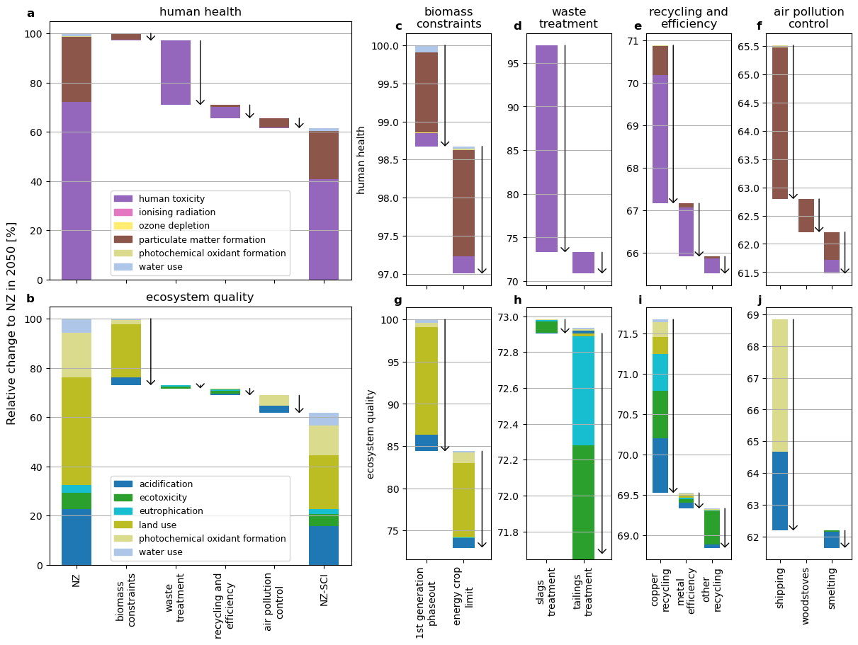
Figure SI.7: Non-climate impact reductions with forward sequence of interventions
Reductions of human health and ecosystem endpoint impacts by broad intervention (a, b) and detailed reductions by intervention category: (c, g) biomass limit (d, h) waste treatment (e, i) recycling and material-efficiency, (f, j) air pollution control. The reference scenario is the NZ scenario, all values in 2050. Arrows show the net change due to the intervention.
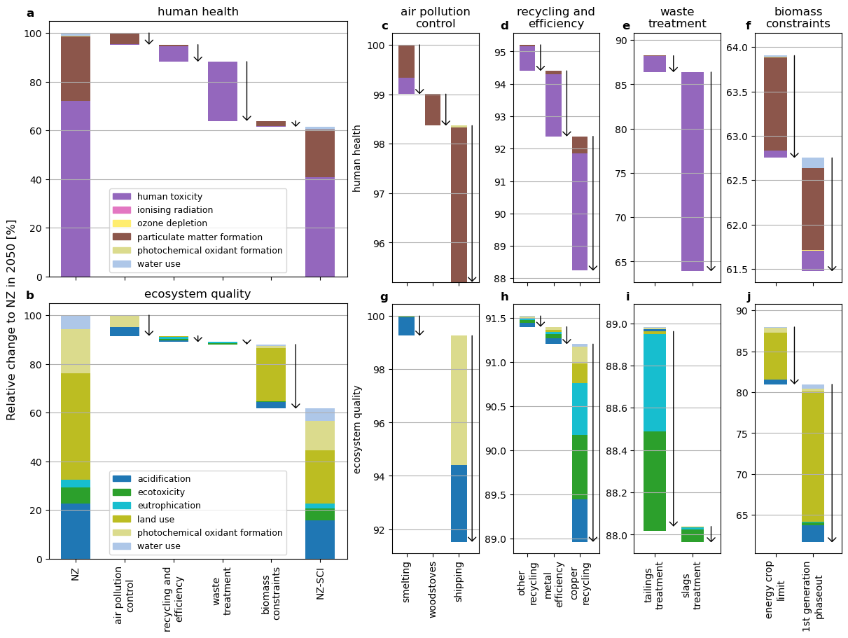
Figure SI.8: Non-climate impact reductions with backward sequence of interventions
Reductions of human health and ecosystem endpoint impacts by broad intervention (a, b) and detailed reductions by intervention category: (c, g) air pollution control (d, h) recycling and material-efficiency, (e, i) waste treatment, and (f, j) biomass constraints. The reference scenario is the NZ scenario, all values in 2050. Arrows show the net change due to the intervention.

SI-5: Inventory changes for air pollution

Adjusted base emission factors
Baseline emission factors for road transport final energy use datasets in Premise by default represent the technological standard of vehicle sold in the base year (2020), but the fleet-average emission factors. This can lead to underestimation of current air pollution impacts in macro-scale LCA assessments. We therefore adjust these baseline emission factors to the values shown in Table SI.8, which combined with activity data from REMIND scenarios for 2020 matches the emissions from the Community Emissions Data System (CEDS)⁴⁸.

Table SI.8: Baseline emission factors for road transport activities
vehicle type | fuel | emission factor (g/MJ fuel burned)
vehicle type | fuel | NOx | PM2.5
motorcycle | gasoline-like | 0.292 | 0.0343
passenger car | gasoline-like | 0.307 | 0.0502
passenger car | diesel-like | 0.136 | 0.0135
heavy-duty vehicle | diesel-like | 0.742 | 0.074

Adjustment of emission compartments
As we introduce differentiated intake fractions for various emission compartments for air pollutants, the air pollution impacts we calculate are sensitive to the emission compartments specified in the LCA datasets. We therefore double-checked key datasets and adjusted compartments where needed. The full table of adjustments is available here: https://github.com/dbantje/pathways/blob/interventionpaper/pathways/data/PM_compartments_change_v8p10.csv

References

1. Riahi, K. et al. The Shared Socioeconomic Pathways and their energy, land use, and greenhouse gas emissions implications: An overview. Glob. Environ. Change 42, 153–168 (2017).
2. KC, S. et al. Wittgenstein Center (WIC) Population and Human Capital Projections - 2023. Zenodo https://doi.org/10.5281/zenodo.14718294 (2024).
3. K. C., S. et al. Updating the Shared Socioeconomic Pathways (SSPs) Global Population and Human Capital Projections. https://pure.iiasa.ac.at/id/eprint/19487/ (2024).
4. Dellink, R., Chateau, J., Atarody, L., Bibas, R. & Lanzi, E. GDP projections by the OECD. (2025).
5. Meinshausen, M., Raper, S. C. B. & Wigley, T. M. L. Emulating coupled atmosphere-ocean and carbon cycle models with a simpler model, MAGICC6 – Part 1: Model description and calibration. Atmospheric Chem. Phys. 11, 1417–1456 (2011).
6. Hecla Mining Company. Tailings Management at Hecla. https://www.hecla.com/wp-content/uploads/Hecla-2021-TailingsMgmt_FactSheet.pdf (2021).
7. GlobalTailingsReview.org. Co-convened by ICMM, UNEP, PRI. Global Industry Standards on Tailings Management. https://globaltailingsreview.org/wp-content/uploads/2020/08/global-industry-standard-on-tailings-management.pdf (2020).
8. Adrianto, L. R., Ciacci, L., Pfister, S. & Hellweg, S. Toward sustainable reprocessing and valorization of sulfidic copper tailings: Scenarios and prospective LCA. Sci. Total Environ. 871, 162038 (2023).
9. Williams, D. Chapter VI: The Role of Technology and Innovation in Improving Tailings Management. Towards Zero Harm: A Compendium of Papers Prepared for the Global Tailings Review. https://globaltailingsreview. org/wpcontent/uploads/2020/09 (2020).
10. Franks, D. M. et al. Tailings facility disclosures reveal stability risks. Sci. Rep. 11, 5353 (2021).
11. Tunsu, C., Menard, Y., Eriksen, D. Ø., Ekberg, C. & Petranikova, M. Recovery of critical materials from mine tailings: A comparative study of the solvent extraction of rare earths using acidic, solvating and mixed extractant systems. J. Clean. Prod. 218, 425–437 (2019).
12. Cacciuttolo Vargas, C. & Marinovic Pulido, A. Sustainable Management of Thickened Tailings in Chile and Peru: A Review of Practical Experience and Socio-Environmental Acceptance. Sustainability 14, 10901 (2022).
13. Garbarino, E., Orveillon, G., Saveyn, H., Barthe, P. & Eder, P. Best Available Techniques (BAT) Reference Document for the Management of Waste from Extractive Industries. https://ec.europa.eu/environment/pdf/waste/mining/MWEI%20BREF.pdf (2018).
14. Lyu, J. et al. Extracting the Tailings Ponds from High Spatial Resolution Remote Sensing Images by Integrating a Deep Learning-Based Model. Remote Sens. 13, 743 (2021).
15. Chen, X., Jing, X., Chen, Y., Pan, C. & Wang, W. Tailings Dam Break: The Influence of Slurry with Different Concentrations Downstream. Front. Earth Sci. 9, 726336 (2021).
16. Baker, E., Davies, M., Fourie, A., Mudd, G. & Thygesen, K. Chapter II: Mine Tailings Facilities, Overview and Industry Trends. Towards Zero Harm-A Compendium of Papers Prepared for the Global Tailings Review. https://globaltailingsreview.org/wp-content/uploads/2020/09/Ch-II-Mine-Tailings-Facilities_Overview-and-Industry-Trends.pdf (2020).
17. Grant-Stuart, D. Your Tailings Dam. https://sancold.org.za/wp-content/uploads/2024/05/SANCOLD-Your-Tailings-Dam-2020.pdf (2020).
18. Falsafi, M. et al. Assessment of valorisation opportunities for secondary metallurgy slag through multi-criteria decision making. J. Clean. Prod. 402, 136838 (2023).
19. Piemonti, A. et al. Exploring the Potential for Steel Slags Valorisation in an Industrial Symbiosis Perspective at Meso-scale Level. Waste Biomass Valorization 14, 3355–3375 (2023).
20. Green Steel. SSG https://swisssteel-group.com/en/sustainability/green-steel.
21. Central Pollution Control Board. Guidelines on Management of Pyro-Metallurgical Slags. (2023).
22. Matsuura, H., Yang, X., Li, G., Yuan, Z. & Tsukihashi, F. Recycling of ironmaking and steelmaking slags in Japan and China. Int. J. Miner. Metall. Mater. 29, 739–749 (2022).
23. Slagreus – Reuse of slags from integrated steelmaking | BFI EN. BFI EN | VDEh-Betriebsforschungsinstitut GmbH https://www.bfi.de/en/projects/slagreus-reuse-of-slags-from-integrated-steelmaking/ (2019).
24. Ma, C. et al. Stainable Utilization Strategies for Basic Oxygen Furnace Slag: Properties, Processing, and Future Directions. Metals 15, 537 (2025).
25. Iron and Steel Technology Roadmap – Analysis. IEA https://www.iea.org/reports/iron-and-steel-technology-roadmap (2020).
26. Recycling of Critical Minerals – Analysis. IEA https://www.iea.org/reports/recycling-of-critical-minerals (2024).
27. Rostek, L., Pirard, E. & Loibl, A. The future availability of zinc: Potential contributions from recycling and necessary ones from mining. Resour. Conserv. Recycl. Adv. 19, 200166 (2023).
28. ILZSG. The World Zinc Factbook 2024. https://www.ilzsg.org/wp-content/uploads/SitePDFs/The%20World%20Zinc%20Factbook%202024.pdf (2024).
29. Van den Eynde, S. et al. Forecasting global aluminium flows to demonstrate the need for improved sorting and recycling methods. Waste Manag. 137, 231–240 (2022).
30. ILZSG. The World Lead Factbook 2023. https://www.ilzsg.org/wp-content/uploads/SitePDFs/1_ILZSG%20World%20Lead%20Factbook%202023.pdf (2023).
31. Torres De Matos, Cristina et al. Material System Analysis of Five Battery-Related Raw Materials: Cobalt, Lithium, Manganese, Natural Graphite, Nickel. (Publications Office of the European Union, 2020).
32. Classen, M. et al. Life Cycle Inventories of Metals. Final Report Ecoinvent Data v2.1, No 10. (2009).
33. EMEP/EEA. EMEP/EEA Air Pollutant Emission Inventory Guidebook 2023. (2023).
34. Aurubis. Hamburg Plant: Emission Facts & Figures. https://www.aurubis.com/dam/jcr:9f6f49e2-9350-48ce-8f04-bb846e3c7576/factsheet_emissionen_en.pdf (2019).
35. Wilson, C. et al. Evaluating process-based integrated assessment models of climate change mitigation. Clim. Change 166, 3 (2021).
36. Rubiano Rivadeneira, N. & Carton, W. (In)justice in modelled climate futures: A review of integrated assessment modelling critiques through a justice lens. Energy Res. Soc. Sci. 92, 102781 (2022).
37. Keppo, I. et al. Exploring the possibility space: taking stock of the diverse capabilities and gaps in integrated assessment models. Environ. Res. Lett. 16, 053006 (2021).
38. de Bortoli, A., Chanel, A., Chabas, C., Greffe, T. & Louineau, E. More rationality and inclusivity are imperative in reference transition scenarios based on IAMs and shared socioeconomic pathways - recommendations for prospective LCA. Renew. Sustain. Energy Rev. 222, 115924 (2025).
39. Baustert, P. et al. Integration of future water scarcity and electricity supply into prospective LCA: Application to the assessment of water desalination for the steel industry. J. Ind. Ecol. 26, 1182–1194 (2022).
40. Sacchi, R. et al. Contextual LCIA without the overhead: an exchange-based framework for flexible impact assessment. Int. J. Life Cycle Assess. 30, 3087–3101 (2025).
41. Bulle, C. et al. IMPACT World+: a globally regionalized life cycle impact assessment method. Int. J. Life Cycle Assess. 24, 1653–1674 (2019).
42. Verones, F. et al. LC-IMPACT: A regionalized life cycle damage assessment method. J. Ind. Ecol. 24, 1201–1219 (2020).
43. Mutel, C. et al. Overview and recommendations for regionalized life cycle impact assessment. Int. J. Life Cycle Assess. 24, 856–865 (2019).
44. Huijbregts, M. A. J. et al. ReCiPe2016: a harmonised life cycle impact assessment method at midpoint and endpoint level. Int. J. Life Cycle Assess. 22, 138–147 (2017).
45. Bakas, I., Hauschild, M. Z., Astrup, T. F. & Rosenbaum, R. K. Preparing the ground for an operational handling of long-term emissions in LCA. Int. J. Life Cycle Assess. 20, 1444–1455 (2015).
46. The Shapley Value: Essays in Honor of Lloyd S. Shapley. (Cambridge University Press, Cambridge, 1988). doi:10.1017/CBO9780511528446.
47. Aumann, R. J. & Shapley, L. S. Values of Non-Atomic Games. (Princeton University Press, 1974).
48. Hoesly, R. M. et al. Historical (1750–2014) anthropogenic emissions of reactive gases and aerosols from the Community Emissions Data System (CEDS). Geosci. Model Dev. 11, 369–408 (2018).

