Extended Data Figures
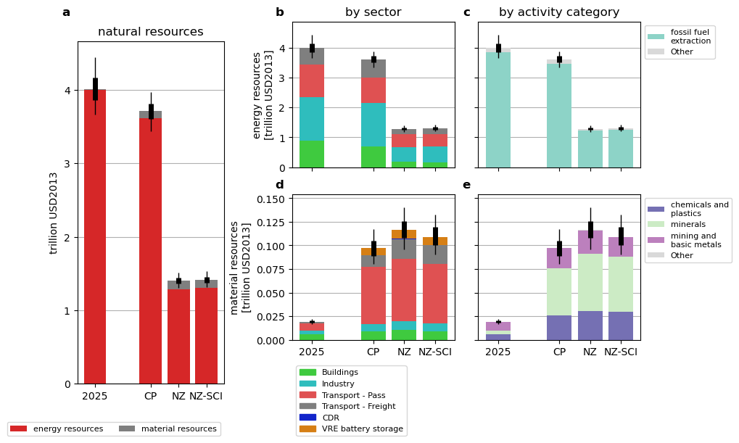
Extended Data Figure 1: Natural resource endpoint impacts by scenario
(a, b) global total natural resource indicator for 2025, and the three future scenarios in 2050. (b-d) energy resources and (e-g) material resources indicators by temporal scope, demand sector, supply chain activity. All impacts based on annual energy demand. The endpoint unit is USD2013, based on surplus cost potentials. Sector split is derived from grouping of energy demand variables, and activity category by inventory results of the pLCA analysis.
Boxplots show the variation due to uncertainty in LCA exchanges (see Methods for details), with boxes and whiskers representing the interquartile and 5-95th percentile range, respectively.
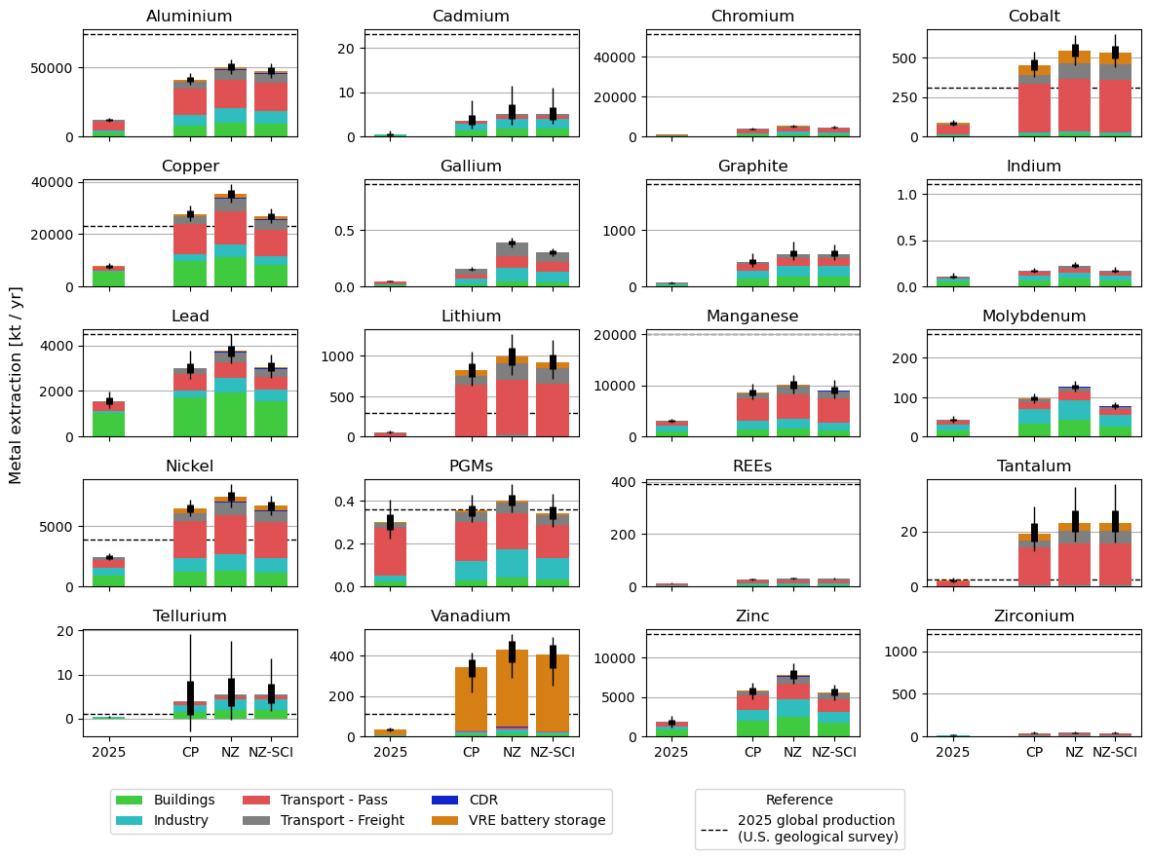
Extended Data Figure 2: Metal extraction by scenario, split by sector
Barplots show annual extraction demands (2025 and 2050) induced by global final energy demand, for 20 metals/metal groups (REEs = rare earth elements, PGMs = platinum group metals). Bars are stacked by demand sectors, showing which applications that contribute strongly to demand (e.g. Vanadium for stationary batteries). Dashed horizontal lines show global production level in 2025 as reported by the U.S. geological survey⁹².
Boxplots show the variation due to uncertainty in LCA exchanges (see Methods for details), with boxes and whiskers representing the interquartile and 5-95th percentile range, respectively.
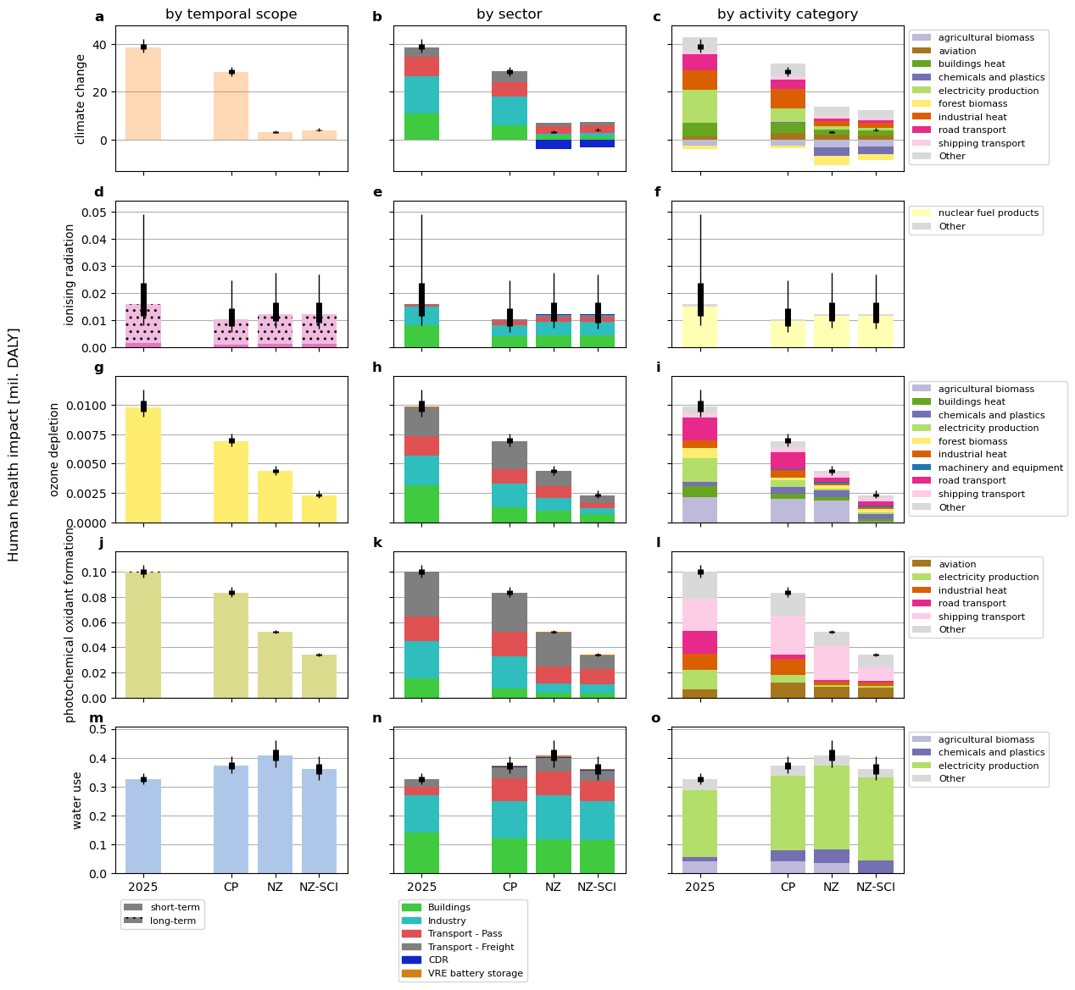
Extended Data Figure 3: Additional midpoints contributing to human health
Climate change, ionising radiation, ozone depletion, photochemical oxidant formation, and water use impacts in 2025 and 2050 shown by temporal scope, demand sector, supply chain activity. All impacts based on annual energy demand. The endpoint unit is DALY. Temporal scope of impacts is directly derived from the differentiation into short-term and long-term biosphere flows (e.g. emissions) within the LCA database, sector split by grouping of energy demand variables, and activity category by inventory results of the pLCA analysis.
Boxplots show the variation due to uncertainty in LCA exchanges (see Methods for details), with boxes and whiskers representing the interquartile and 5-95th percentile range, respectively.
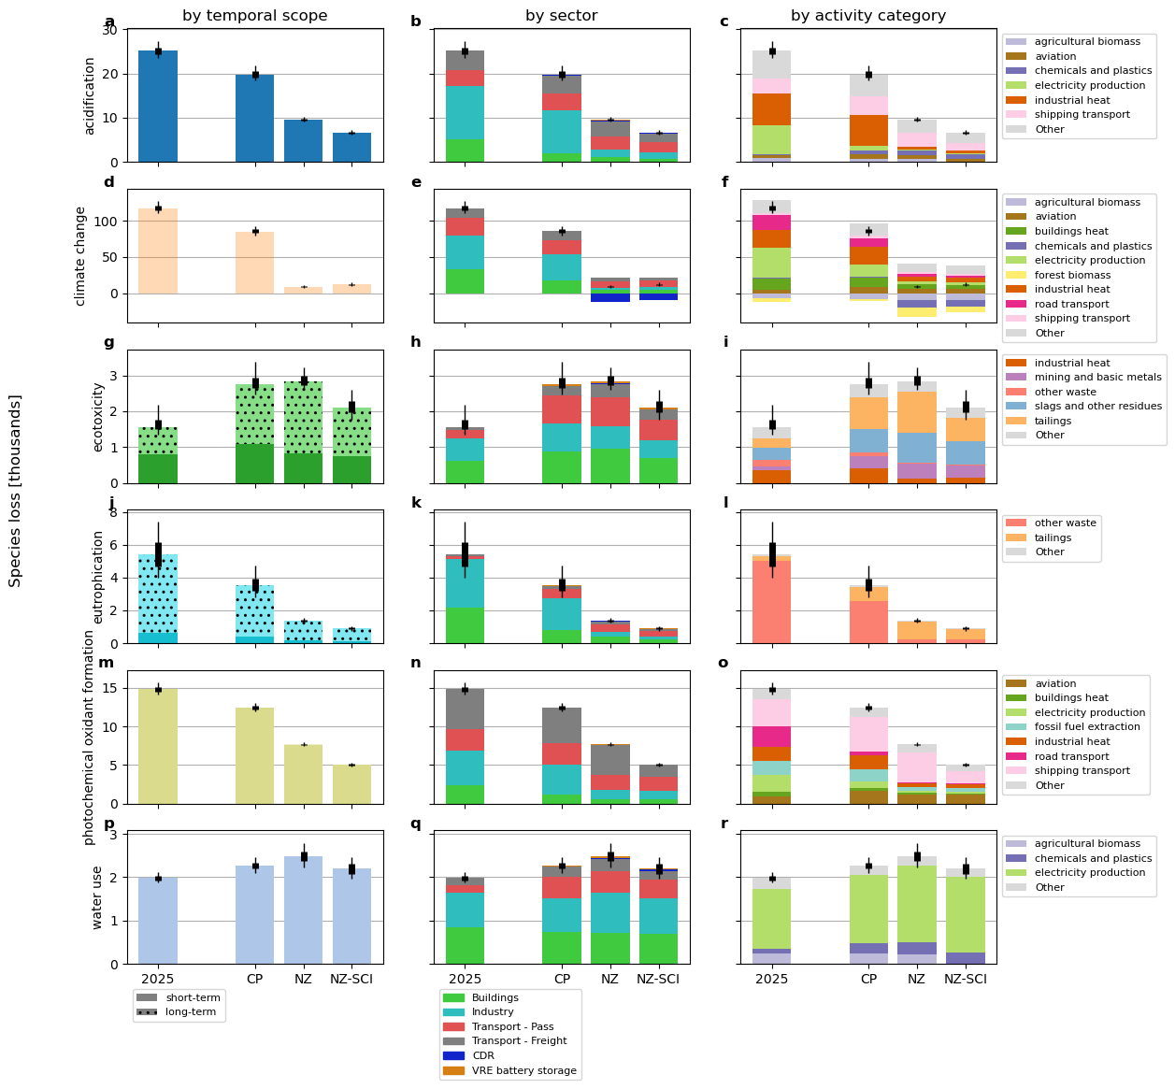
Extended Data Figure 4: Additional midpoints contributing to ecosystem quality
Acidification, climate change, ecotoxicity, eutrophication, photochemical oxidant formation, and water use impacts in 2025 and 2050 shown by temporal scope, demand sector, supply chain activity. All impacts based on annual energy demand. The endpoint unit is time-integrated species loss. Temporal scope of impacts is directly derived from the differentiation into short-term and long-term biosphere flows (e.g. emissions) within the LCA database, sector split by grouping of energy demand variables, and activity category by inventory results of the pLCA analysis.
Boxplots show the variation due to uncertainty in LCA exchanges (see Methods for details), with boxes and whiskers representing the interquartile and 5-95th percentile range, respectively.

