Supp. 1
A complete nucleotide sequence of Proteus sp. EKWG2I3 (Accession number, PV635194)
GGGGAATATTGCACAATGGGCGCAAGCCTGATGCAGCCATGCCGCGTGTATGAAGAAGGCCTTAGGGTTG
TAAAGTACTTTCAGCGGGGAGGAAGGTGATAAGGTTAATACCCTTGTCAATTGACGTTACCCGCAGAAGA
AGCACCGGCTAACTCCGTGCCAGCAGCCGCGGTAATACGGAGGGTGCAAGCGTTAATCGGAATTACTGGG
CGTAAAGCGCACGCAGGCGGTCAATTAAGTCAGATGTGAAAGCCCCGAGCTTAACTTGGGAATTGCATCT
GAAACTGGTTGGCTAGAGTCTTGTAGAGGGGGGTAGAATTCCATGTGTAGCGGTGAAATGCGTAGAGATG
TGGAGGAATACCGGTGGCGAAGGCGGCCCCCTGGACAAAGACTGACGCTCAGGTGCGAAAGCGTGGGGAG
CAAACAGGATTAGATACCCTGGTAGTCCACGCTGTAAACGATGTCGATTTAGAGGTTGTGGTCTTGAACC
GTGGCTTCTGGAGCTAACGCGTTAAATCGACCGCCTGGGGAGTACGGCCGCAAGGTTAAAACTCAAATGA
ATTGACGGGGGCCCGCACAAGCGGTGGAGCATGTGGTTTAATTCGATGCAACGCGAAGAACCTTACCTAC
TCTTGACATCCAGCGAATCCTTTAGAGATAGAGGAGTGCCTTCGGGAACGCTGAGACAGGTGCTGCATGG
CTGTCGTCAGCTCGTGTTGTGAAATGTTGGGTTAAGTCCCGCAACGAGCGCAACCCTTATCCTTTGTTGC
CAGCACGTAATGGTGGGAACTCAAAGGAGACTGCCGGTGATAAACCGGAGGAAGGTGGGGATGACGTCAA
GTCATCATGGCCCTTACGAGTAGGGCTACACACGTGCTACAATGGCAGATACAAAGAGAAGCGACCTCGC
GAGAGCAAGCGGAACTCATAAAGTCTGTCGTAGTCCGGATTGGAGTCTGCAACTCGACTCCATGAACTCG
GAATCGCTAGTAATCGTAGATCAGAATGCTACGGTGAATACGTTCCCGGGCCTTGTACACACCGCCCGTC
ACACCATGGGAGTGGGTTGCAAAAGAAGTAGGTAGCTTAACCTTCGGGAGGGCGCTACCA

Table A_{1:} GC-MS analysis of bioactive compounds detected in crude extracts of Proteus sp. EKWG2I3 isolate
RT | Compound Name | 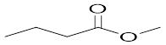  Structure | Molecular formula | Comp. (%) | Chemical nature | RI
3.24 | Butanoic acid, methyl ester |  | C₆H₁₀O₄ | 1.92 | ester | 2152
3.85 | 4-Ethynylcyclopentene | 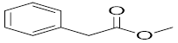 | C₁₄H₂₂O | 1.13 | alkyne | 1162
3.99 | Pentanoic acid, methyl ester | 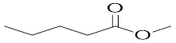 | C₆H₁₂O₂ | 12.71 | ester | -
5.04 | Pentanoic acid, 3-methyl- | 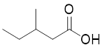 | C₈H₁₆O₂ | 0.39 | Carboxylic acid | 1095
5.22 | Butanoic acid, 2-methyl- | 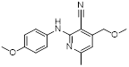 | C₁₃H₂₇O₃P | 0.29 | Carboclic acid | 1524
6.07 | 2-Pentene, 3-ethyl- | 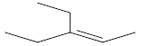 | C₇H₁₄ | 3.56 | alkenes
6.65 | Hexanoic acid, methyl ester | 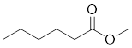 | C₇H₈ | 0.9 | ester | -
7.91 | 3-Pentanol, 2,2,4,4-tetramethyl- | 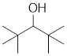 | C₁₀H₂₈O₄Si₃ | 1.05 | alcohol | 2875
8.01 | Methyl 2-hydroxy-3-methylpentanoate | 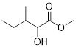 | C₁₂H₁₄O₂ | 0.45 | ester | 1804
8.08 | Azelaaldehydic acid, methyl ester | 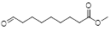 | C₁₁H₁₀O₃ | 0.54 | ester | 972
8.29 | Cyclohexane, 1,1-dimethoxy- | 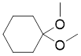 | C₁₀H₁₈O₃ | 0.41 | ether | -
8.63 | 3-(Methylthio)propanoic acid methyl ester | 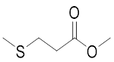 | C₉H₁₀O₂ | 2.18 | ester | 926
8.79 | Butanedioic acid, dimethyl ester | 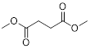 | C₆H₁₂O₂ | 2.1 | diester | 1387
10.38 | Benzene ethanol | 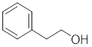 | C₈H₁₀O | 4.25 | alcohol
10.54 | Caprylic acid ME P302 | 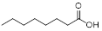 | C₁₁H₁₂O₅ | 0.27 | Carboclic acid | -
10.58 | 1-vinyl-13-Oxabicyclo[10.1.0]tridecane | 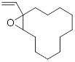 | C₁₀H₁₄O₂ | 0.25 | cycloalkane | 861
11.16 | 1,3-dimethyl-5-propan-2-yl-pyrazole | 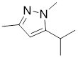 | C₈H₁₄N₂ | 2.9 | pyrazole | 1312
11.33 | Allo-Ocimene | 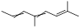 | C₁₁H₂₂O₃ | 0.25 | alkene | 1327
11.58 | Methyl phenylacetate | 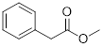 | C₉H₁₀O₂ | 38.49 | ester | 1437
12.41 | cis-4a-Methyl-decahydronaphthalene | 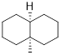 | C₁₀H₁₈O₄ | 0.37 | Fused cyclo Alkane | 1089
12.79 | Benzeneacetic acid | 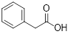 | C₁₇H₃₄O₂ | 0.23 | Carboxylic acid | 1404
13.31 | Benzene, 4-ethyl-1,2-dimethoxy- | 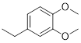 | C₉H₂₀O | 0.87 | S-Benzene | 2895
13.65 | 4-tert-Butylcyclohexyl methyl ethylphosphonate | 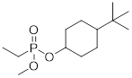 | C₁₁H₂₀ | 0.34 | cycloalkane | 2515
13.92 | 1,2,5-Trimethyl-8-oxabicyclo[3.2.1]oct-6-en-3-one | 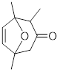 | C₉H₁₈O₂ | 0.27 | Cyclooxa ketone | 1787
14.99 |  | 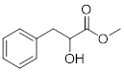 | C₁₀H₁₂O₃ | 2.5 | esters
  Benzenepropanoic acid, .alpha.-hydroxy-, methyl ester
16.13 | Octanedioic acid, dimethyl ester | 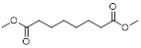 | C₇H₁₄O₃ | 0.4 | ester | -
16.39 | Decanoic acid, 3-hydroxy-, methyl ester | 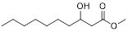 | C₁₁H₂₂O₃ | 0.26 | ester | -
17.14 | Phenol, 2,4-bis(1,1-dimethylethyl)- | 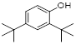 | C₁₁H₂₀O₄ | 1.23 | Phenol | 1147
17.63 | Azelaic acid, dimethyl ester |  | C₅H₁₀O₂S | 1.93 | diester | 3080
18.34 | 3-Phenylpropanoic acid, 1-adamantylmethyl ester | 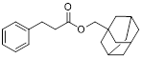 | C₁₄H₂₄O | 0.24 | ester | 1853
18.97 | Decanedioic acid, dimethyl ester | 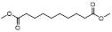 | C₁₂H₂₂O₄ | 2.88 | Esters | 3100
20.22 | 6-Methoxy-3-methyl-2-benzofurancarbaldehyde | 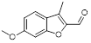 | C₇H₁₄O₂ | 0.68 | Aldehyde | -
20.33 | 1,4,4a,9a-Tetrahydro-3-methyl-9H-xanthen-9-one | 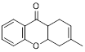 | C₆H₁₂O₂ | 0.35 | ketone | 1130
20.58 | Coumarin, 3,4-dihydro-4,5,7-trimethyl- | 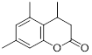 | C₁₀H₁₄O₂ | 0.55 | Lactone | 1080
21.11 | 1H-Indol-3-ylmethyl acetate | 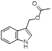 | C₁₁H₁₁NO₂ | 3.92 | Esters | 3100
22.1 | Palmitic acid ME P721 | 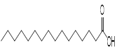 | C₁₀H₁₆ | 0.24 | Carboxylic acid | 2589
22.15 | 2,6,6-Trimethyl-5-(3-methyl-2-butenyl)-1-cyclohexene-1-carbaldehyde | 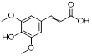  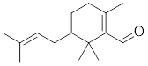 | C₂₀H₂₆O₂ | 0.23 | Cyclic aldehyde | 1312
24.13 | 3,5-Dimethoxy-4-hydroxycinnamic acid | 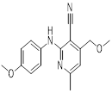 | C₁₄H₁₄O₂ | 0.3 | Carboclic acid | 848
26.65 | 3-Pyridinecarbonitrile, 4-(methoxymethyl)-2-[(4-methoxyphenyl)amino]-6-methyl- |  | C₁₆H₁₇N₃O₂ | 6.49 | pyridine derivatives | 900

