Supplementary material
Determining the ideal substrate for exposure experiments in ecotoxicology – A metabolomics approach

Georgia M. Sinclair ¹, Michela Di Giannantonio², Oliver A.H. Jones ¹, and Sara M. Long ³*
¹ Australian Centre for Research on Separation Science (ACROSS), School of Science, RMIT University, Bundoora West Campus, PO Box 71, Bundoora, VIC 3083, Australia
² Institute for the study of Anthropic Impacts and Sustainability in Marine Environment – National Research Council (CNR-IAS), Genova Italy
³ Aquatic Environmental Stress (AQUEST) Research Group School of Science, RMIT University, Bundoora, VIC 3083, Australia
* Correspondence: s3762567@student.rmit.edu.au

Table S1. Weekly water quality for adult and juvenile amphipods life stages substrates exposure.
 | Weekly Water Quality |  |  |  |  |  | Notes:
31.08.2020 |  | DO % | pH | Cond. | NH₄ | Temp. | Adults and juveniles
 | Water | 104.3 | 8.26 | 1436 | 3 | 19.7
 | Gauze | 100.6 | 8.06 | 1373 | 0 | 19.6
 | TP | 95.3 | 7.98 | 1414 | 0 | 20.8
 | Cel | 98.7 | 8 | 1436 | 0 | 20.7
7.09.2020 |  | DO % | pH | Cond. | NH₄ | Temp.
 | Water | 81.2 | 7.97 | 1487 | 4 | 20.5
 | Gauze | 63.1 | 7.44 | 1435 | 0.25 | 21
 | TP | 53.2 | 7.4 | 1466 | 0.25 | 20.4
 | Cel | 77.5 | 7.87 | 1543 | 0.25 | 20.6
14.09.2020 |  | DO % | pH | Cond. | NH₄ | Temp. | Juveniles only
 | Water | 96.4 | 8.24 | 1324 | 1 | 19.1 | Water exposure Ended
 | Gauze | 93.9 | 8.09 | 1286 | 0 | 19
 | TP | 93.5 | 8.16 | 1298 | 0 | 19.1
 | Cel | 95.9 | 8.18 | 1293 | 0 | 19
21.09.2020 |  | DO % | pH | Cond. | NH₄ | Temp.
 | Water
 | Gauze | 100.2 | 8.27 | 1345 | 0.25 | 19.4
 | TP | 93.6 | 8.07 | 1296 | 0.25 | 19.4
 | Cel | 98.9 | 8.32 | 1336 | 0.25 | 19.4
28.09.2020 |  | DO % | pH | Cond. | NH₄ | Temp.
 | Water
 | Gauze | 107.7 | 8.44 | 1311 | 0 | 18.9
 | TP | 101.4 | 8.11 | 1360 | 0 | 18.7
 | Cel | 96.4 | 8 | 1324 | 0 | 18.7

Table S2. Total Survival of post-gravid adults; initial count of juveniles before continuation of exposure and total survival following exposure.

Survival | 7.09.2020 |  |  |  | 5.10.2020
 | Adult (10) | Juvenile | Juv. A | Juv. B | Total
Water 1 | 6 | 5 | 0 | 0 | 0
Water 2 | 9 | 20 | 0 | 0 | 0
Water 3 | 7 | 30 | 0 | 0 | 0
Water 4 | 5 | 10 | 0 | 0 | 0
Water 5 | 5 | 25 | 0 | 0 | 0
Gauze 1 | 10 | 167 | 91 | 76 | 167
Gauze 2 | 8 | 115 | 35 | 35 | 70
Gauze 3 | 9 | 144 | 73 | 68 | 141
Gauze 4 | 9 | 106 | 40 | 48 | 88
Gauze 5 | 9 | 111 | 22 | 31 | 53
TP 1 | 10 | 128 | 22 | 25 | 47
TP 2 | 7 | 30 |  | 5 | 5
TP 3 | 10 | 116 | 50 | 17 | 67
TP 4 | 10 | 72 |  | 23 | 23
TP 5 | 9 | 66 |  | 8 | 8
Cel 1 | 10 | 44 | 7 | 16 | 23
Cel 2 | 10 | 156 | 22 | 53 | 75
Cel 3 | 9 | 144 | 54 | 47 | 101
Cel 4 | 9 | 76 | 44 | 25 | 69
Cel 5 | 10 | 97 | 45 | 40 | 85

Table S3. Water quality for copper – substrates exposure at 7 days and 14 days.
25.06.21 |  | DO % | pH | Cond. | NH₄ | Temp.
 | Gauze | 90.4 | 7.9 | 1373.0 | 0.0 | 19.7
 | Cellulose | 83.3 | 8.1 | 1381.0 | 0.0 | 20.5
 | Toilet Paper | 88.2 | 8.2 | 1392.0 | 0.0 | 20.9
 | Cu Gauze | 88.4 | 8.2 | 1387.0 | 0.0 | 19.9
 | Cu Cellulose | 88.0 | 8.2 | 1388.0 | 0.0 | 19.7
 | Cu Toilet Paper | 86.9 | 8.1 | 1373.0 | 0.0 | 19.5
2.07.21 |  | DO % | pH | Cond. | NH₄ | Temp.
 | Gauze | 84.2 | 8.1 | 1343.0 | 0.3 | 20.4
 | Cellulose | 83.5 | 8.2 | 1403.0 | 0.0 | 20.3
 | Toilet Paper | 86.9 | 8.3 | 1419.0 | 0.3 | 20.6
 | Cu Gauze | 86.8 | 8.3 | 1385.0 | 0.0 | 21.1
 | Cu Cellulose | 83.4 | 8.2 | 1364.0 | 0.0 | 21.2
 | Cu Toilet Paper | 87.2 | 8.3 | 1421.0 | 0.3 | 21.0

Table S4. Inductively Coupled Plasma Mass Spectrometry (ICP-MS). Water and substrates measurements.
Type | Group |  | Sample |  | Replicate | Conc. ppb
Water |  | Day 0 |  | Copper Stock |  | 11.390
 |  |  |  | Control |  | 4.854
 |  | Day 14 |  | Gauze | Copper | 8.164
 |  |  |  | Gauze | Control | 5.044
 |  |  |  | Cellulose | Copper | 10.648
 |  |  |  | Cellulose | Control | 4.668
 |  |  |  | Toilet Paper | Copper | 11.200
 |  |  |  | Toilet Paper | Control | 5.114
Substrates |  | Copper |  | Gauze | R1 | 120.108
 |  |  |  | Gauze | R2 | 116.327
 |  |  |  | Gauze | R3 | 107.789
 |  |  |  | Gauze | R4 | 108.124
 |  |  |  | Gauze | R5 | 136.361
 |  | Unspiked |  | Gauze | R1 | 51.130
 |  |  |  | Gauze | R2 | 28.829
 |  |  |  | Gauze | R3 | 41.826
 |  |  |  | Gauze | R4 | 23.882
 |  |  |  | Gauze | R5 | 20.549
 |  | Copper |  | Cellulose | R1 | 23.034
 |  |  |  | Cellulose | R2 | 39.304
 |  |  |  | Cellulose | R3 | 39.939
 |  |  |  | Cellulose | R4 | 53.161
 |  | Unspiked |  | Cellulose | R1 | 7.720
 |  |  |  | Cellulose | R2 | 19.710
 |  |  |  | Cellulose | R3 | 15.821
 |  |  |  | Cellulose | R4 | 20.407
 |  |  |  | Cellulose | R5 | 17.272
 |  | Copper |  | Toilet Paper | R1 | 310.772
 |  |  |  | Toilet Paper | R2 | 38.451
 |  |  |  | Toilet Paper | R3 | 95.378
 |  |  |  | Toilet Paper | R4 | 179.805
 |  |  |  | Toilet Paper | R5 | 139.301
 |  | Unspiked |  | Toilet Paper | R1 | 84.745
 |  |  |  | Toilet Paper | R2 | 6.991
 |  |  |  | Toilet Paper | R3 | 74.222
 |  |  |  | Toilet Paper | R4 | 39.574
 |  |  |  | Toilet Paper | R5 | 39.365

Raw area retention times (RT) from each peak for each treatment has been recorded.
Table S5. Adults unidentified metabolites.
m/z 113; RT:8.933 | m/z 147; RT:9.95 | m/z 133; RT:16.728
Unidentified 1 | Unidentified 2 | Unidentified 3

Table S6. Juveniles unidentified metabolites.
m/z 147; RT:6.487 | m/z 147; RT:8.67 | m/z 128; RT: 8.922 | m/z 147; RT:9.15 | m/z 147; RT:9.39 | m/z 173;  RT:9.939 | m/z 327; RT:11.756
Unidentified 1 | Unidentified 2 | Unidentified 3 | Unidentified 4 | Unidentified 5 | Unidentified 6 | Unidentified 7
m/z 147; RT:11.916 | m/z 147; RT:13.882 | m/z 133; RT:16.671
Unidentified 8 | Unidentified 9 | Unidentified 10

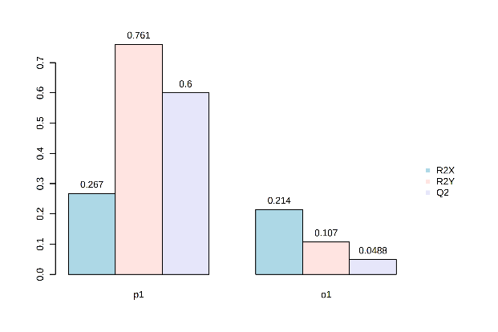
Fig. S1. Orthogonal PLS-DA – Adults separation across substrates model overview.
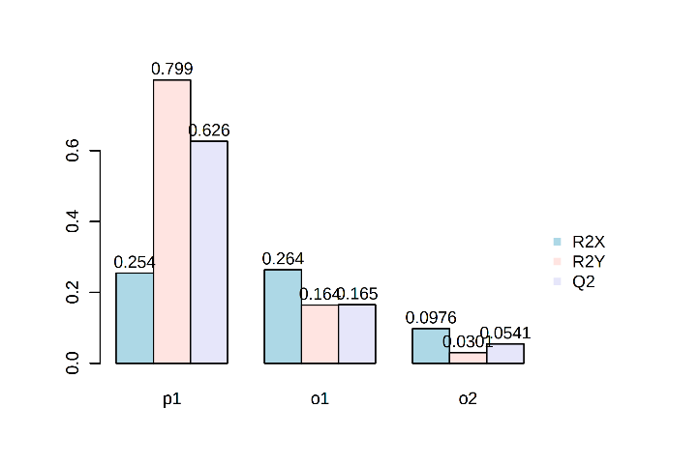
Fig. S2. Orthogonal PLS-DA – Juveniles separation across substrates model overview.

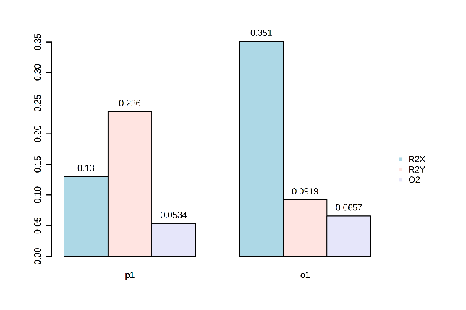
Fig. S3. Orthogonal PLS-DA – Amphipods exposed and unexposed to copper separation across substrates model overview.

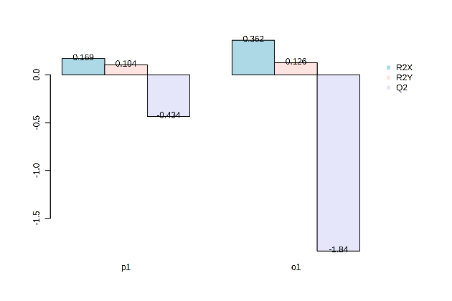
Fig. S4. Orthogonal PLS-DA – Amphipods exposed and unexposed to copper in cellulose separation across substrates model overview.

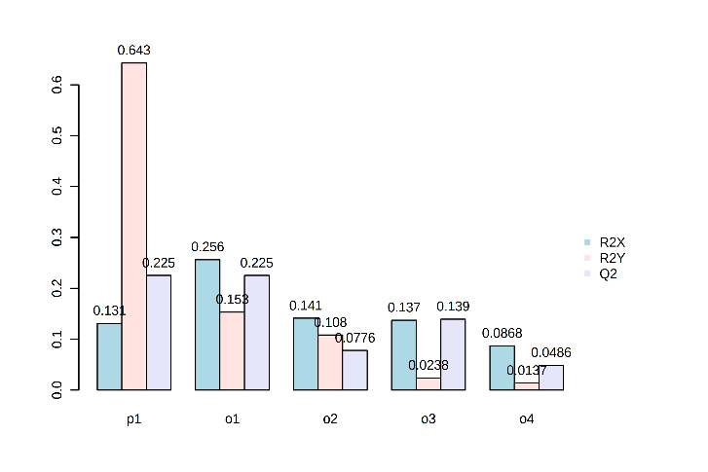
Fig. S5. Orthogonal PLS-DA – Amphipods exposed and unexposed to copper in toilet paper separation across substrates model overview.
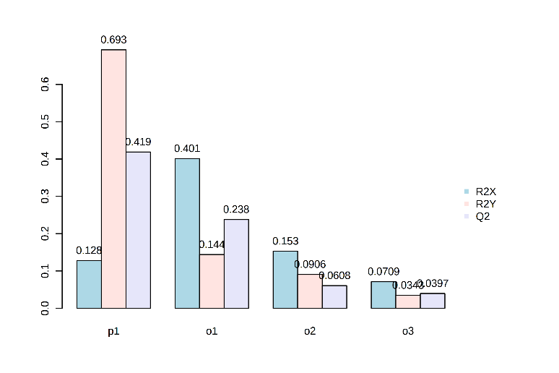
Fig. S6. Orthogonal PLS-DA – Amphipods exposed and unexposed to copper in gauze separation across substrates model overview.

