Supporting information:
Valorization of Petroleum coke into High-Quality Few-Layer Graphene through Liquid-Phase Exfoliation
- Masfer H. Alkahtani^{1*}, Yahya A. Alzahrani¹, Abdulmalik M Alessa¹, Abdulaziz Alromaeh², Majed M Aljomah², Faisal Alghannam³, Fahad H. Albaqami², Anas Almuqhim¹, Abdulaziz Aljuwair¹, Ramu Banavath⁴, Micah J. Green⁴ and Philip R. Hemmer^{5,6*}
¹Future energy technologies institute, King Abdulaziz city for science and technology (KACST), Riyadh 11442, Saudi Arabia.
²Microelectronics and Semiconductors Institute, King Abdulaziz City for Science and Technology (KACST), Riyadh 11442, Saudi Arabia.
³Next-Generation Connectivity and Wireless Sensors Institute, King Abdulaziz City for Science and Technology (KACST), Riyadh, Saudi Arabia.
⁴Artie McFerrin Department of Chemical Engineering, Texas A&M University, College Station,
TX 77843, USA
⁵Institute for Quantum Science and Engineering, Texas A&M University, College Station, Texas, 77843, USA.
⁶Department of Electrical and Computer Engineering, Texas A&M University, College Station, Texas, 77843, USA.

* Correspondence: mqhtani@kacst.gov.sa, and prhemmer@ece.tamu.edu.

S1: Solvent prewashing of raw petroleum coke
Prior to thermal activation and exfoliation, the as-received petroleum coke was mechanically ground to particles smaller than 90 µm and pre-cleaned in hot isopropanol (IPA) at 80 °C for 6 h as shown in Figure S1(a). This solvent pre-treatment was used to remove loosely attached surface contaminants, hydrocarbon residues, tar-like species, and other impurities that could interfere with subsequent graphitization and liquid-phase exfoliation. After IPA washing, the petroleum coke changed from a coarse gray powder to a more homogeneous black powder, indicating effective surface cleaning (Figure S1a).
This visual improvement was further supported by Raman spectroscopy as illustrated in Figure S1(b,c). The unwashed petroleum coke exhibited broad, poorly resolved Raman features, consistent with disordered carbon and surface contamination. After IPA pre-treatment, the Raman spectrum became clearer, with more defined features in the D- and G-band regions. These results suggest that hot IPA washing removes interfering surface residues and exposes the underlying carbon structure, thereby preparing the petroleum coke for efficient thermal activation and exfoliation into graphene.
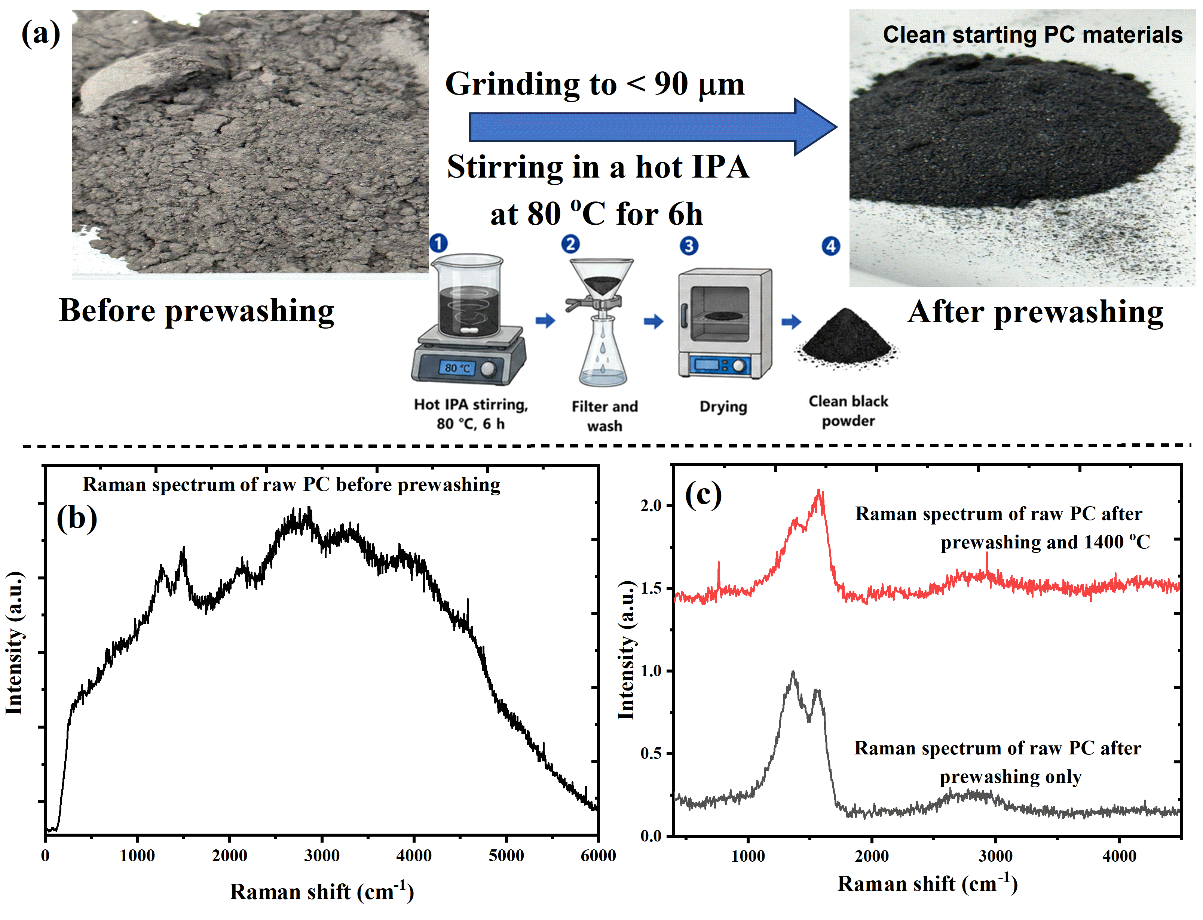
Figure S1: Solvent pre-treatment of raw petroleum coke prior to thermal activation.
(a) Raw petroleum coke was milled to particles below 90 µm and treated with hot isopropanol at 80 °C for 6 h to remove weakly bound hydrocarbons, tar-like residues, and surface contaminants. The optical images before and after treatment show a more uniform and cleaner appearance after IPA washing. (b,c) Raman spectra collected before and after solvent pre-treatment, as well as after high-temperature annealing, reveal a clear improvement in spectral quality. The untreated petroleum coke shows broad and poorly resolved features, whereas IPA washing produces sharper Raman bands, indicating removal of surface contamination prior to thermal activation and exfoliation. After thermal activation, the cleaned petroleum coke exhibits a more graphitic structure, making it more suitable for subsequent exfoliation into graphene.

S2: Mering-Maire Estimation of Graphitization Degree
The influence of the structural ordering of petroleum coke after thermal annealing was studied by determining interlayer spacing of d₀₀₂ from XRD data. As seen from Figure 1(b) in the main text, the position of (002) reflection for graphitic carbon gradually increased as a function of annealing temperature, suggesting a decrease in interlayer spacing and improvement in the packing order of carbon layers.
To calculate the interlayer spacing of graphite, Bragg equation was used:
d₀₀₂ = λ / (2 sin θ)
where λ is the wavelength of the used X-ray beam, while θ equals half of the 2θ value observed for (002) peak.
Graphitization of carbon materials can be assessed by Merin-Maire formula[1] as follows:
g (%) = [(0.3440 − d₀₀₂) / (0.3440 − 0.3354)] × 100
where 0.3440 nm is the distance between the graphite layers for non-graphitized carbon and 0.3354 nm is the distance between graphite layers for ideally graphitized carbon. In case the obtained value was less than zero, it should be reported as 0%.
As seen in Figure 1 (b and c) in the main text, the as-prepared petroleum coke showed broad (002) peak at 2θ ≈ 25.36°, corresponding to d₀₀₂ ≈ 0.3510 nm and graphitization degree equaling 0%. Annealing at 1000 °C slightly shifted (002) peak to 25.8°, corresponding to d₀₀₂ ≈ 0.3451 nm. As one can see, the d002 value is still larger than 0.3440 nm, and thus the obtained graphitization level is zero percent. At 1200 °C, the (002) reflection was shifted to about 26.1°, giving d₀₀₂ ≈ 0.3412 nm; the estimated graphitization level reaches 33%. The highest level of ordering (estimated graphitization of ~78%) is achieved at the highest annealing temperature (1400 °C). In this case, the (002) reflection is observed at 2θ ≈ 26.41° with d₀₀₂ ≈ 0.3373 nm.
Thus, one can conclude that the graphitic structure ordering of petroleum coke is significantly increased after the treatment by high temperatures. This result is confirmed by the Raman ratio (I_{2D}/I_{G}) enhancement and the prevalence of 3–5-layer few-layer graphene prepared through the CO₂-assisted liquid-phase exfoliation.

S3: Effect of exfoliation solvent on the quality of petcoke-derived graphene
The role of solvent composition for liquid-phase exfoliation of thermally activated petroleum coke was investigated via Raman spectroscopy. Four different solvent compositions were examined, including pure acetone, chloroform, isopropanol (IPA), and a specially optimized IPA:CO₂-saturated water solvent mixture. In Raman spectra, D, G, and 2D bands can be identified as indicative of graphitic carbon materials as shown in Figure S2. The I_{D}/I_{G} ratio has been used to describe disordered and defect levels. Meanwhile, I_{2D}/I_{G} ratio was used for evaluating exfoliation level and the presence of few-layer graphene. Based on the obtained data, it can be stated that a solvent mixture of IPA and CO₂-saturated water demonstrates the best performance in terms of Raman parameters. In particular, this combination leads to the minimum I_{D}/I_{G} ratio (0.40) and maximum I_{2D}/I_{G} ratio (0.73). In this case, one can state that this solvent mixture allows effectively performing delamination, while minimizing the formation of defects. IPA solvent provides a better wetting and stabilization of graphitic carbon surface, while CO₂-saturated water increases acoustic cavitation effects leading to liquid penetration into graphitic layer space. Thus, the quality of few-layer graphene becomes higher in comparison to other single-solvents.
Single-solvent IPA leads to exfoliation of graphene, but with higher I_{D}/I_{G} ratio (0.63) and lower I_{2D}/I_{G} ratio (0.50). This implies that while this solvent allows efficiently stabilizing exfoliated graphene sheets, lack of additional cavitation effect limits the exfoliation process. Acetone provides moderate I_{2D}/I_{G} (0.45) but high I_{D}/I_{G} (0.78) ratios, implying low exfoliation efficiency and higher levels of disorder.
Finally, chloroform solvent demonstrates the worst Raman response with the highest I_{D}/I_{G} (0.97) and lowest I_{2D}/I_{G} (0.35) ratios. This is caused by the unstable dispersion of graphene sheets extracted from petcoke in such solvent. Indeed, due to a lack of cavitation-assisted liquid penetration into graphite layers, a high number of graphene nanosheets restack, aggregate and precipitate out of solution. Due to this, fewer layers of graphene become exfoliated. Thus, the IPA:CO₂-saturated water solvent mixture demonstrates the optimal balance between graphitic carbon surface interaction, cavitation-assisted exfoliation, and dispersion stability. For this reason, it has been selected as the solvent of choice to produce few-layer graphene from thermally activated petcoke.

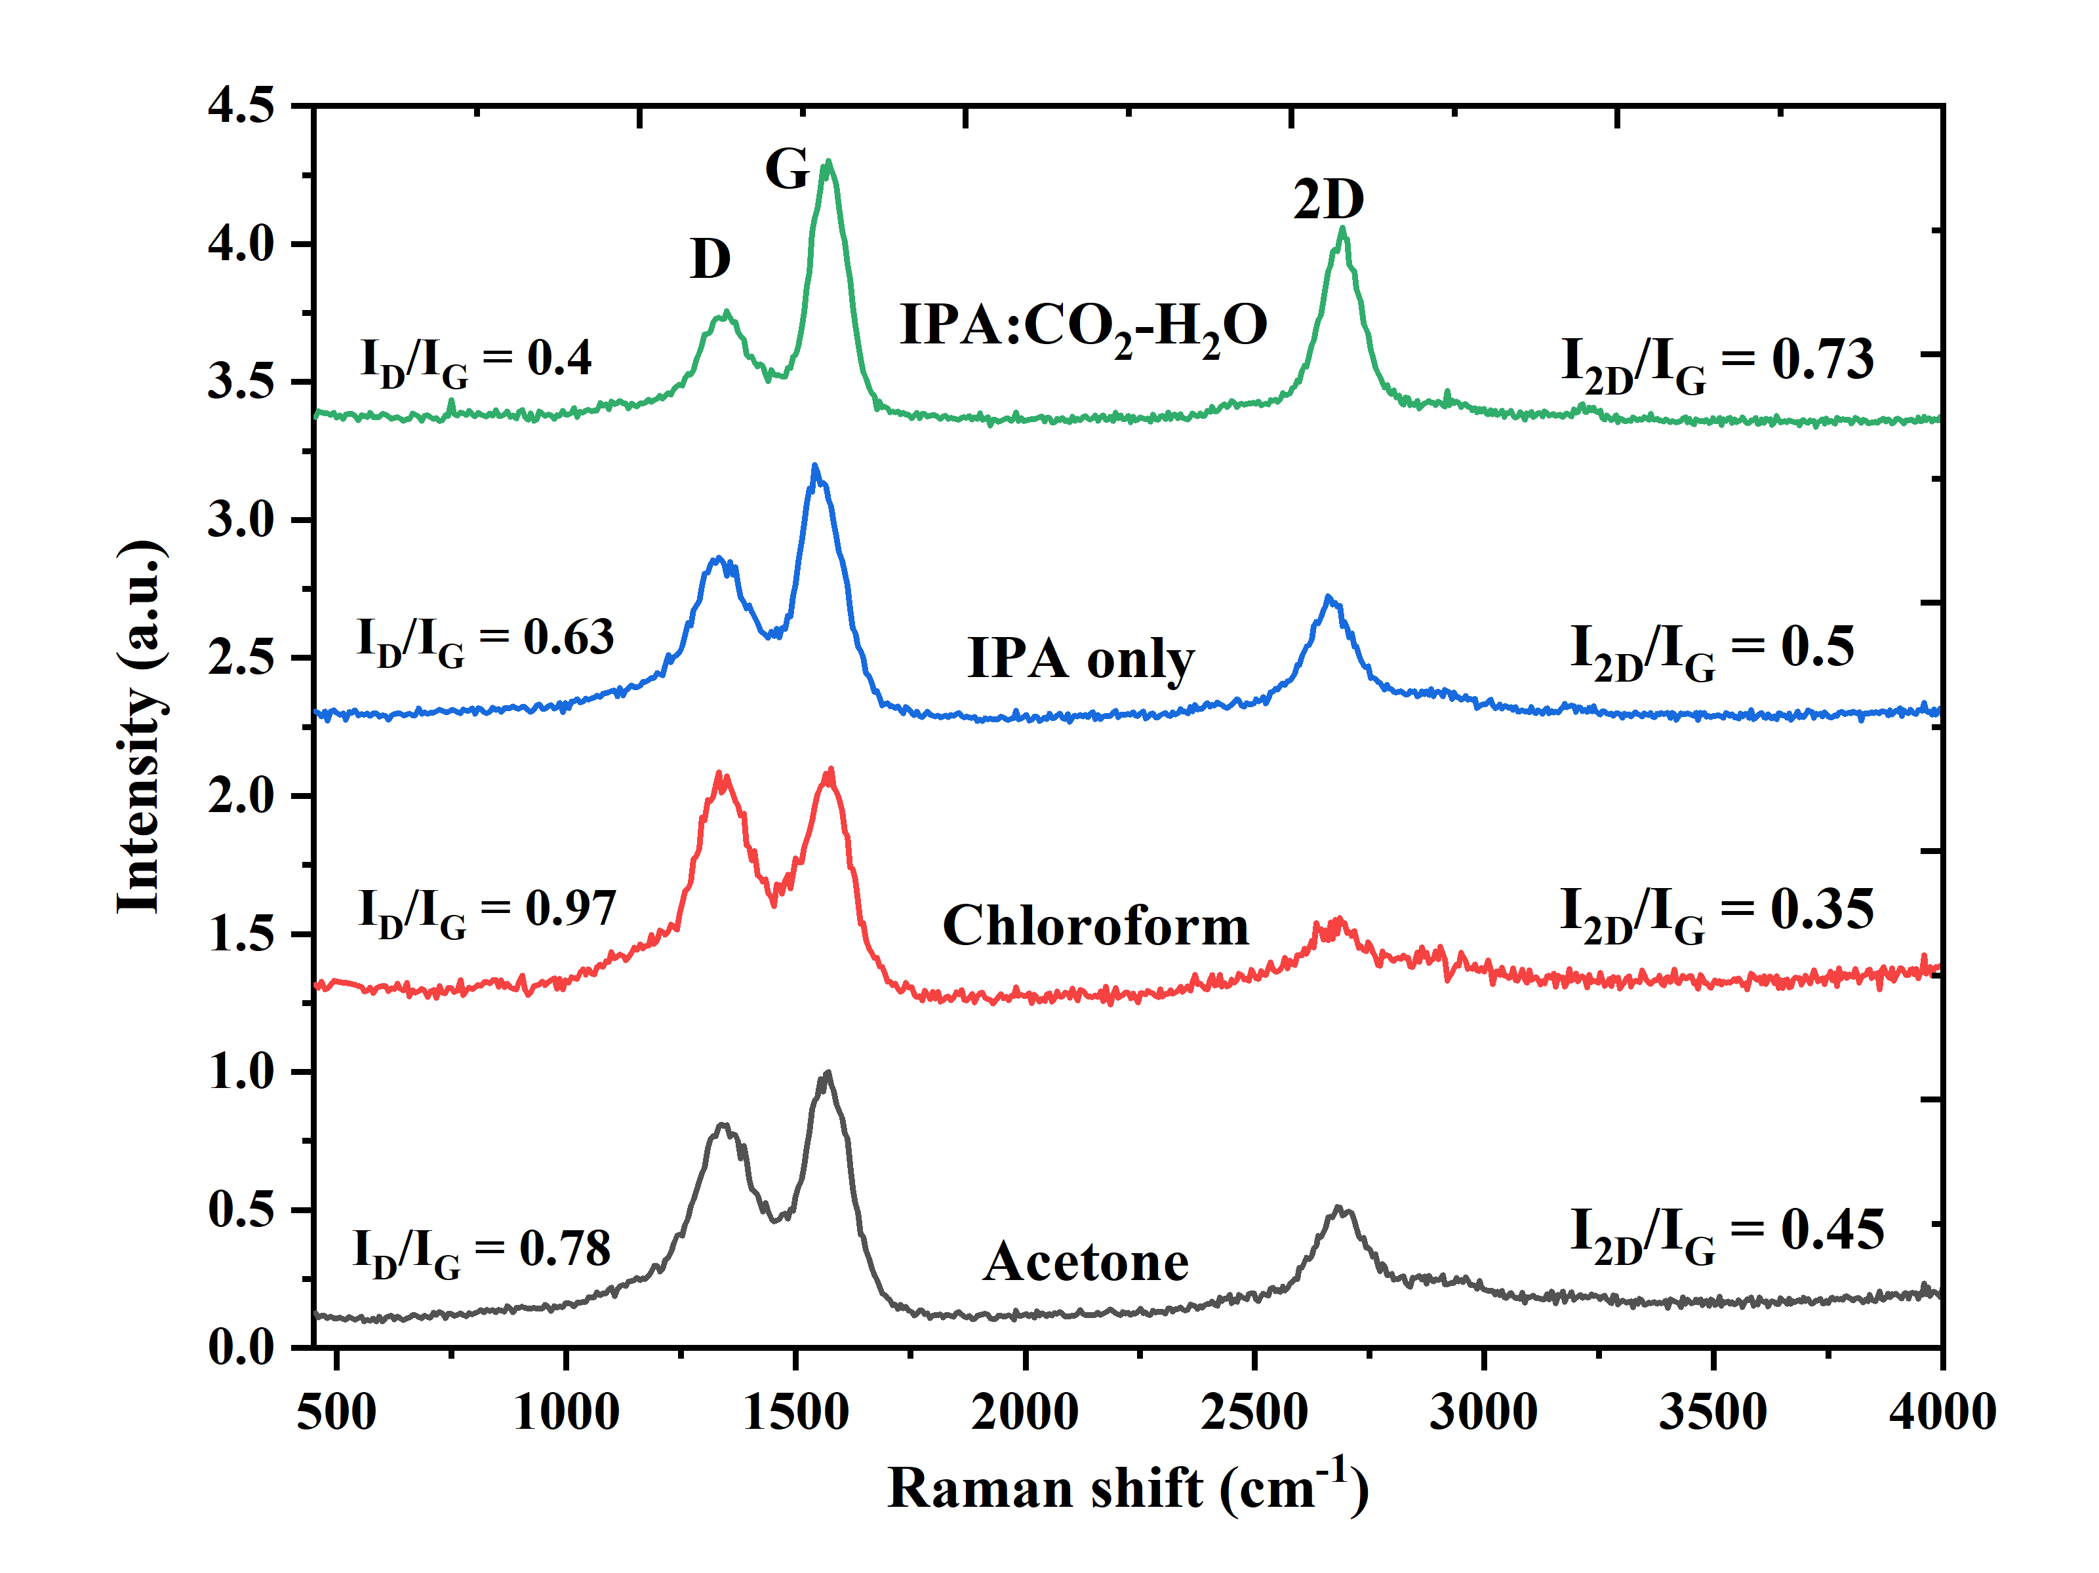
Figure S2: Raman spectra of graphene products obtained by liquid-phase exfoliation of thermally activated petroleum coke using acetone, chloroform, IPA, and an IPA:CO₂-saturated water mixture.

S4: Evolution of petcoke-derived graphene with thermal activation temperature.
Figure S3 illustrates the Raman spectra and corresponding TEM micrographs of graphene products obtained through exfoliation of as-received petcoke and petcoke samples subjected to thermal activation treatments at temperatures of 1000, 1200, and 1400 °C. From the analysis of the Raman spectrum of the product obtained through exfoliation of as-received petcoke sample, it can be observed that there are weak and poorly resolved D, G and 2D bands, indicative of poor exfoliation efficiency and weak graphitic ordering. This can be confirmed through TEM analysis where thick and dense carbon layers are seen rather than graphene nanosheets. Upon activation of the petcoke sample at 1000 °C, the Raman spectrum depicts distinct D and G peaks but with a broad and week 2D peak. This is an indication of partial graphitization but not sufficient delamination. TEM micrograph also shows thick carbon layers and sheet-like structures.
On further activation of the petcoke at 1200 °C, clear distinction in the 2D band is observed and the spectrum becomes sharp. This indicates efficient exfoliation and high degree of graphitization. From the TEM image, large and thin sheets are observed though still having some overlapping and restacking of the nanosheets. The best Raman and TEM images were obtained in the case of activation treatment at 1400 °C where sharp D, G and 2D peaks were recorded. From the TEM micrograph, thin crumpled nanosheets with electron transparency were found to exist with sizes ranging up to hundreds of nanometers. Therefore, the conclusion that is drawn is that activation treatments at elevated temperatures of petcoke are crucial for creating exfoliable graphitic structure.
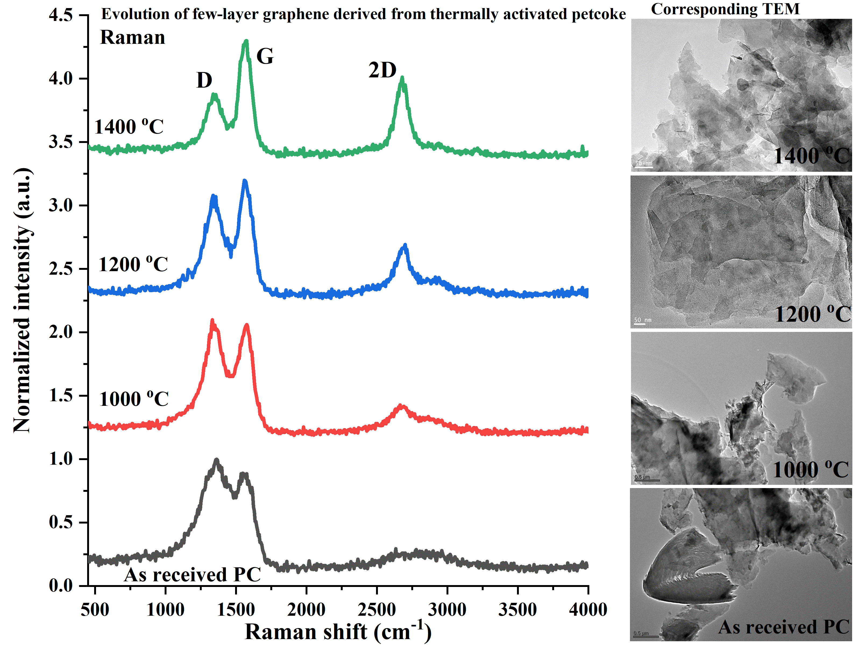
Figure S3: Evolution of few-layer graphene derived from thermally activated petcoke. Raman spectra and corresponding TEM images of exfoliated products obtained from as-received petcoke and petcoke thermally activated at 1000, 1200, and 1400 °C. Increasing the activation temperature progressively sharpens the Raman D, G, and 2D features and improves the formation of thin, electron-transparent graphene-like nanosheets. The 1400 °C-treated sample shows the clearest few-layer graphene morphology, confirming that thermal activation enhances graphitic ordering and promotes efficient CO₂-assisted liquid-phase exfoliation.

S5: Elemental purification and desulfurization during petcoke conversion
SEM-EDS analysis was used for studying the purity of elements in petroleum coke prior to their conversion to few-layer graphene. The SEM images of petroleum coke show that petroleum coke consists of tightly packed particles with heterogenous morphology, as depicted in Figure S4(a). From the elemental mapping data along with EDS analysis, the sample is observed to contain a large percentage of carbon along with a considerable amount of sulfur, oxygen, and minute amounts of iron, as displayed in Figure S4(b). As can be seen from the EDS analysis of raw petroleum coke shown in Figure S4(c), the elements present in the sample included approximately 81.4 wt% C, 7.0 wt% O, 8.78 wt% S, and 2.82 wt% Fe.
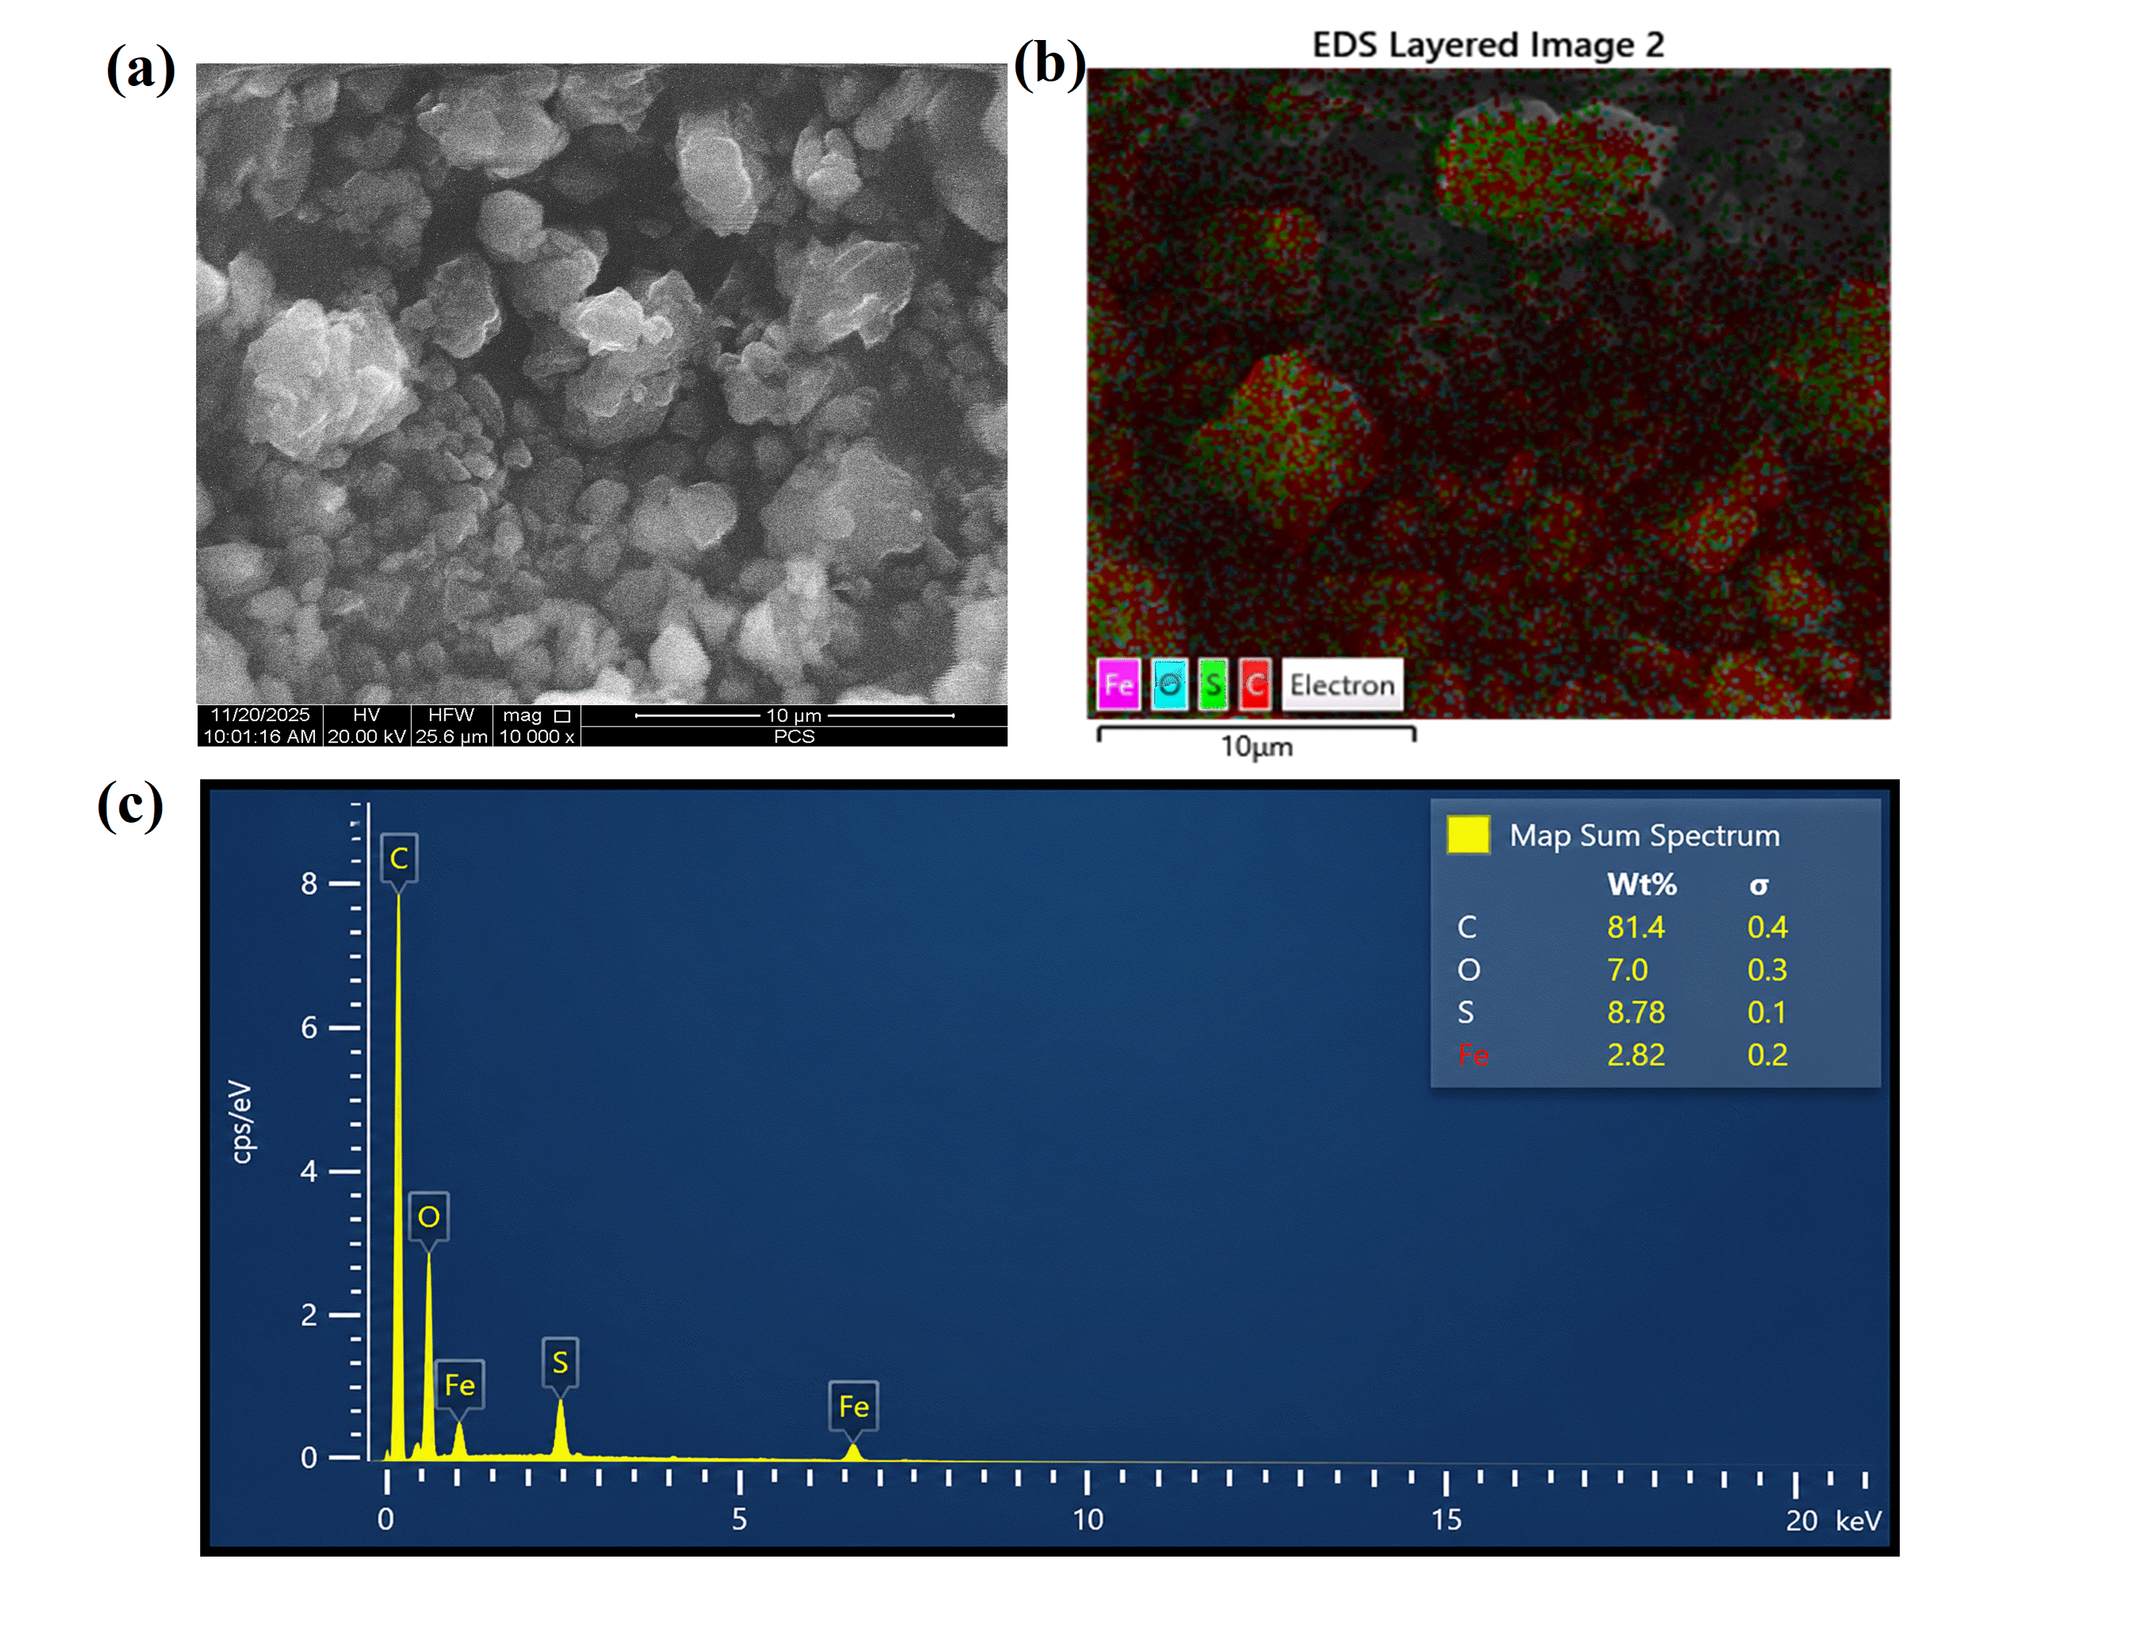
Figure S4: Characterization of the as-received petroleum coke before purification by means of SEM-EDS technique. (a) Image of raw petroleum coke obtained using scanning electron microscopy. (b) EDS analysis for mapping the elemental composition of carbon, oxygen, sulfur, and iron in space. (c) EDS spectrum for quantitative elemental analysis of the petroleum coke sample.

After IPA prewashing, high temperature thermal activation, and CO2-assisted liquid phase exfoliation process, the graphene product showed a remarkable change in morphology as well as in chemical composition. According to the results obtained from the SEM images of Figure S5(a-b), there is flaky and layered structure which is associated with exfoliated graphene layers. According to the EDS mapping of Figure S5(c), the main element detected in the analyzed region is carbon, with a considerable reduction in sulfur and oxygen intensities. As the EDS spectrum of Figure S5(d) shows, the percentage of elements is about 96.6 wt% C, 2.1 wt% S, and 1.4 wt% O with no iron intensity detected within the region. It means that the sulfur intensity has decreased to be:
Sulfur reduction (%) = [(8.78 - 2.1) / 8.78] x 100
Sulfur reduction (%) ≈ 76%
Oxygen reduction (%) = [(7.0 - 1.4) / 7.0] x 100
Oxygen reduction (%) ≈ 80%
Similarly, the oxygen level decreases from 7.0 wt% to 1.4 wt% for the treated petcoke compared to the raw petcoke, corresponding to an 80% removal of oxygen. Such results clearly show that the conversion method works in two ways as a structural modification and purification process of elements. First, the argon treatment at a high temperature aids the removal of sulfur along with volatile oxygen compounds; and subsequently, the process of exfoliation allows the isolation of graphitic layers in the form of few-layer graphene. It can be seen from the higher percentage of carbon from 81.4 wt% to 96.6 wt%.
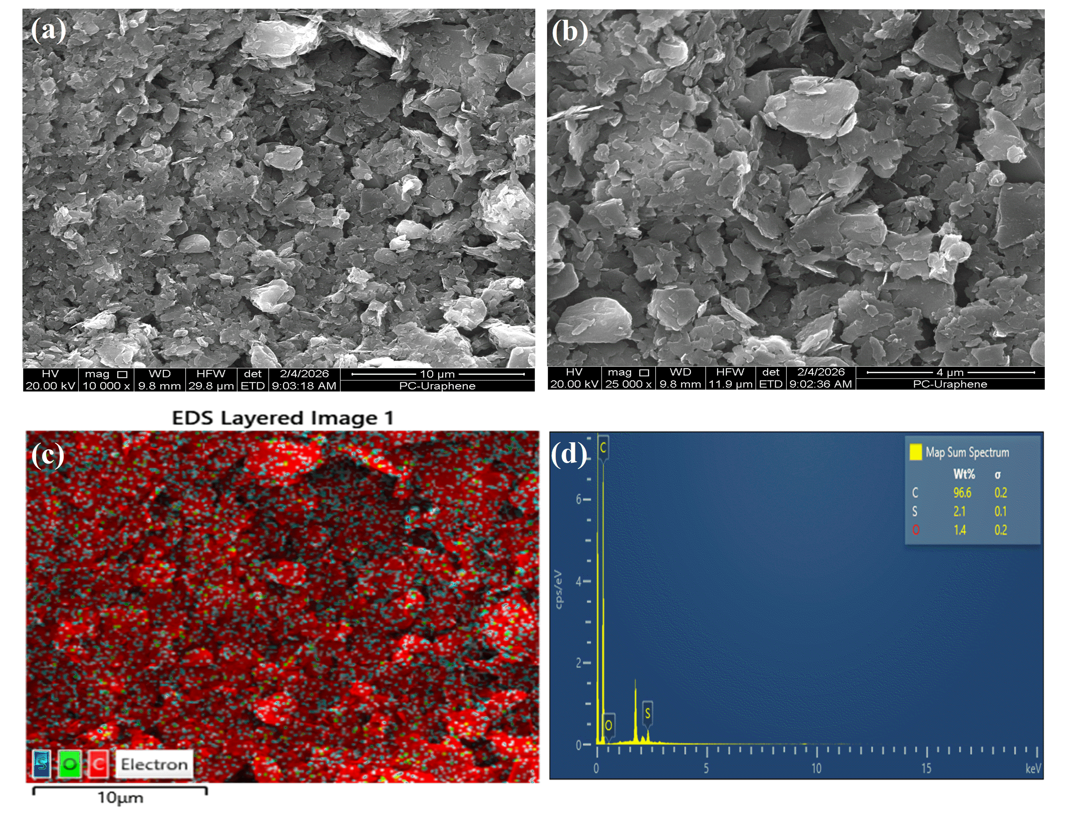
Figure S5: SEM-EDS analysis of graphene extracted from petcoke through purification and exfoliation process. (a,b) SEM micrographs show graphene flakes and layers after IPA treatment, thermal treatment, and CO2 exfoliation process. (c) EDS map shows that graphene consists mainly of carbon with reduced sulfur and oxygen content. (d) EDS plot and element percentage show 96.6 wt% carbon, 2.1 wt% sulfur, and 1.4 wt% oxygen.

Table S1: EDS-based elemental composition of petroleum coke before treatment and petcoke-derived graphene after IPA pretreatment, thermal desulfurization, and CO2-assisted exfoliation.
Sample | C (wt%) | O (wt%) | S (wt%) | Fe (wt%)
As-received petroleum coke | 81.4 | 7.0 | 8.78 | 2.82
Processed petcoke-derived graphene | 96.6 | 1.4 | 2.1 | Not detected in analyzed region

S6: CO₂-Assisted Exfoliation Optimization
The supporting information provides additional Raman, TEM, schematic, and visual evidence for the optimization of CO₂-assisted liquid-phase exfoliation of thermally activated petcoke into few-layer graphene. These figures support the main optimization trends shown in Figure 3 in the main text, where the Raman intensity ratios I_{D}/I_{G} ​ and I_{2D}/I_{G} ​ were used as indicators of defect formation and exfoliation efficiency, respectively. In general, a higher I_{2D}/I_{G} ​ ratio indicates more effective delamination into thinner graphene nanosheets, whereas a lower I_{D}/I_{G} ​ ratio reflects reduced defect generation during exfoliation. Therefore, the optimal condition is identified by maximizing I_{2D}/I_{G} ​ while minimizing I_{D}/I_{G} ​.
Figure S6 provides TEM and schematic evidence for the effect of sonication time on graphene exfoliation from petcoke. At short sonication times, only partial exfoliation occurs, producing relatively thick and stacked graphitic fragments with low I_{2D}/I_{G} ​ values. Increasing the sonication time improves delamination, and the optimum range is observed between 10 and 12 h, where thin, laterally extended few-layer graphene nanosheets are obtained. This condition corresponds to high I_{2D}/I_{G} ​ and low I_{D}/I_{G}​, confirming efficient exfoliation without excessive structural damage. However, prolonged sonication leads to fragmentation of the graphene sheets into smaller graphitic flakes with increased edge defects, consistent with the intermediate I_{2D}/I_{G} values observed at longer sonication times.

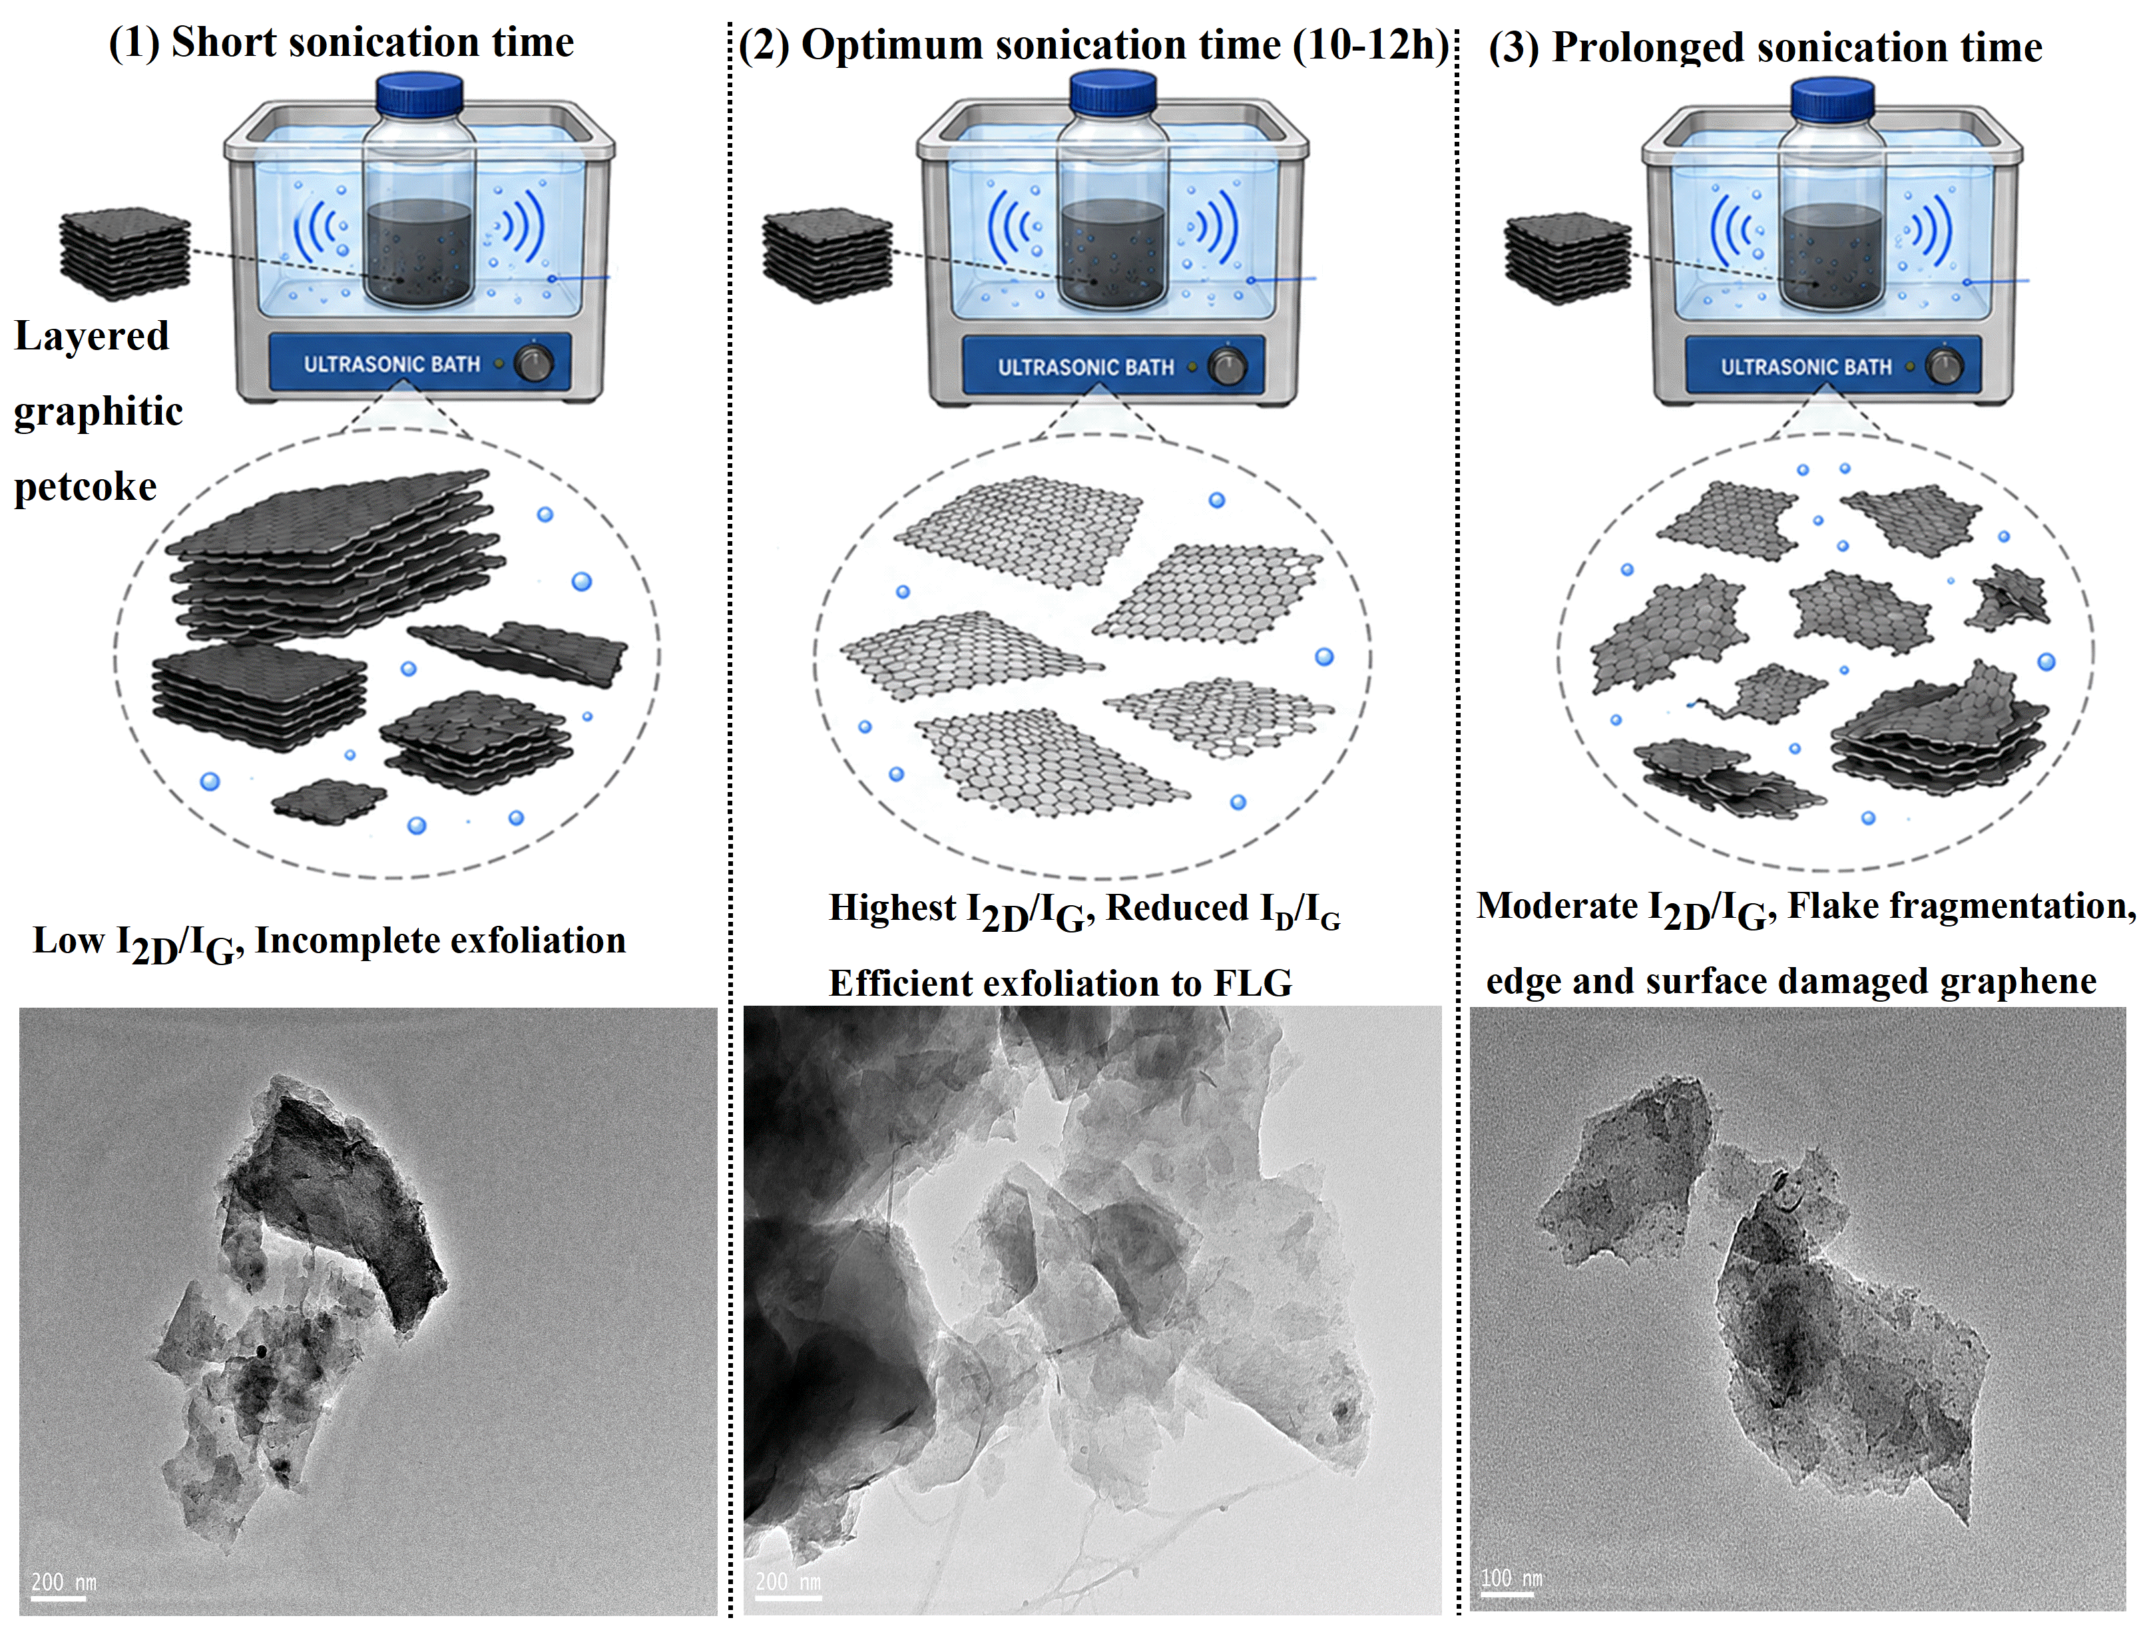
Figure S6: Results from TEM and Schematic imaging show how the duration of sonication affects the exfoliation of graphene from petcoke. Shorter sonication times lead to partial exfoliation of graphitic flakes that have a low value of I_{2D}/I_{G} ratio. A perfect duration of sonication time is between 10 and 12 hours where thin, laterally elongated few layers graphene is obtained, which correspond to high values of I_{2D}/I_{G} and low values of I_{D}/I_{G} ratio. Too long sonication leads to small graphitic flakes with defects, which agree with an intermediate value of I_{2D}/I_{G} ratio.

Figure S7 shows the normalized Raman spectra collected after different sonication durations of 1, 2, 4, 6, 8, 10, 12, 15, 17, 20, and 23 h. All spectra display the characteristic D, G, and 2D bands of graphitic carbon at approximately 1350, 1580, and 2700 cm⁻¹, respectively. The systematic evolution of these bands confirms that sonication time strongly controls the balance between delamination and damage. Short times are insufficient to fully separate graphitic layers, whereas the 10–12 h window provides the most favorable exfoliation condition. Beyond this window, extended acoustic exposure can induce flake fragmentation and defect formation.
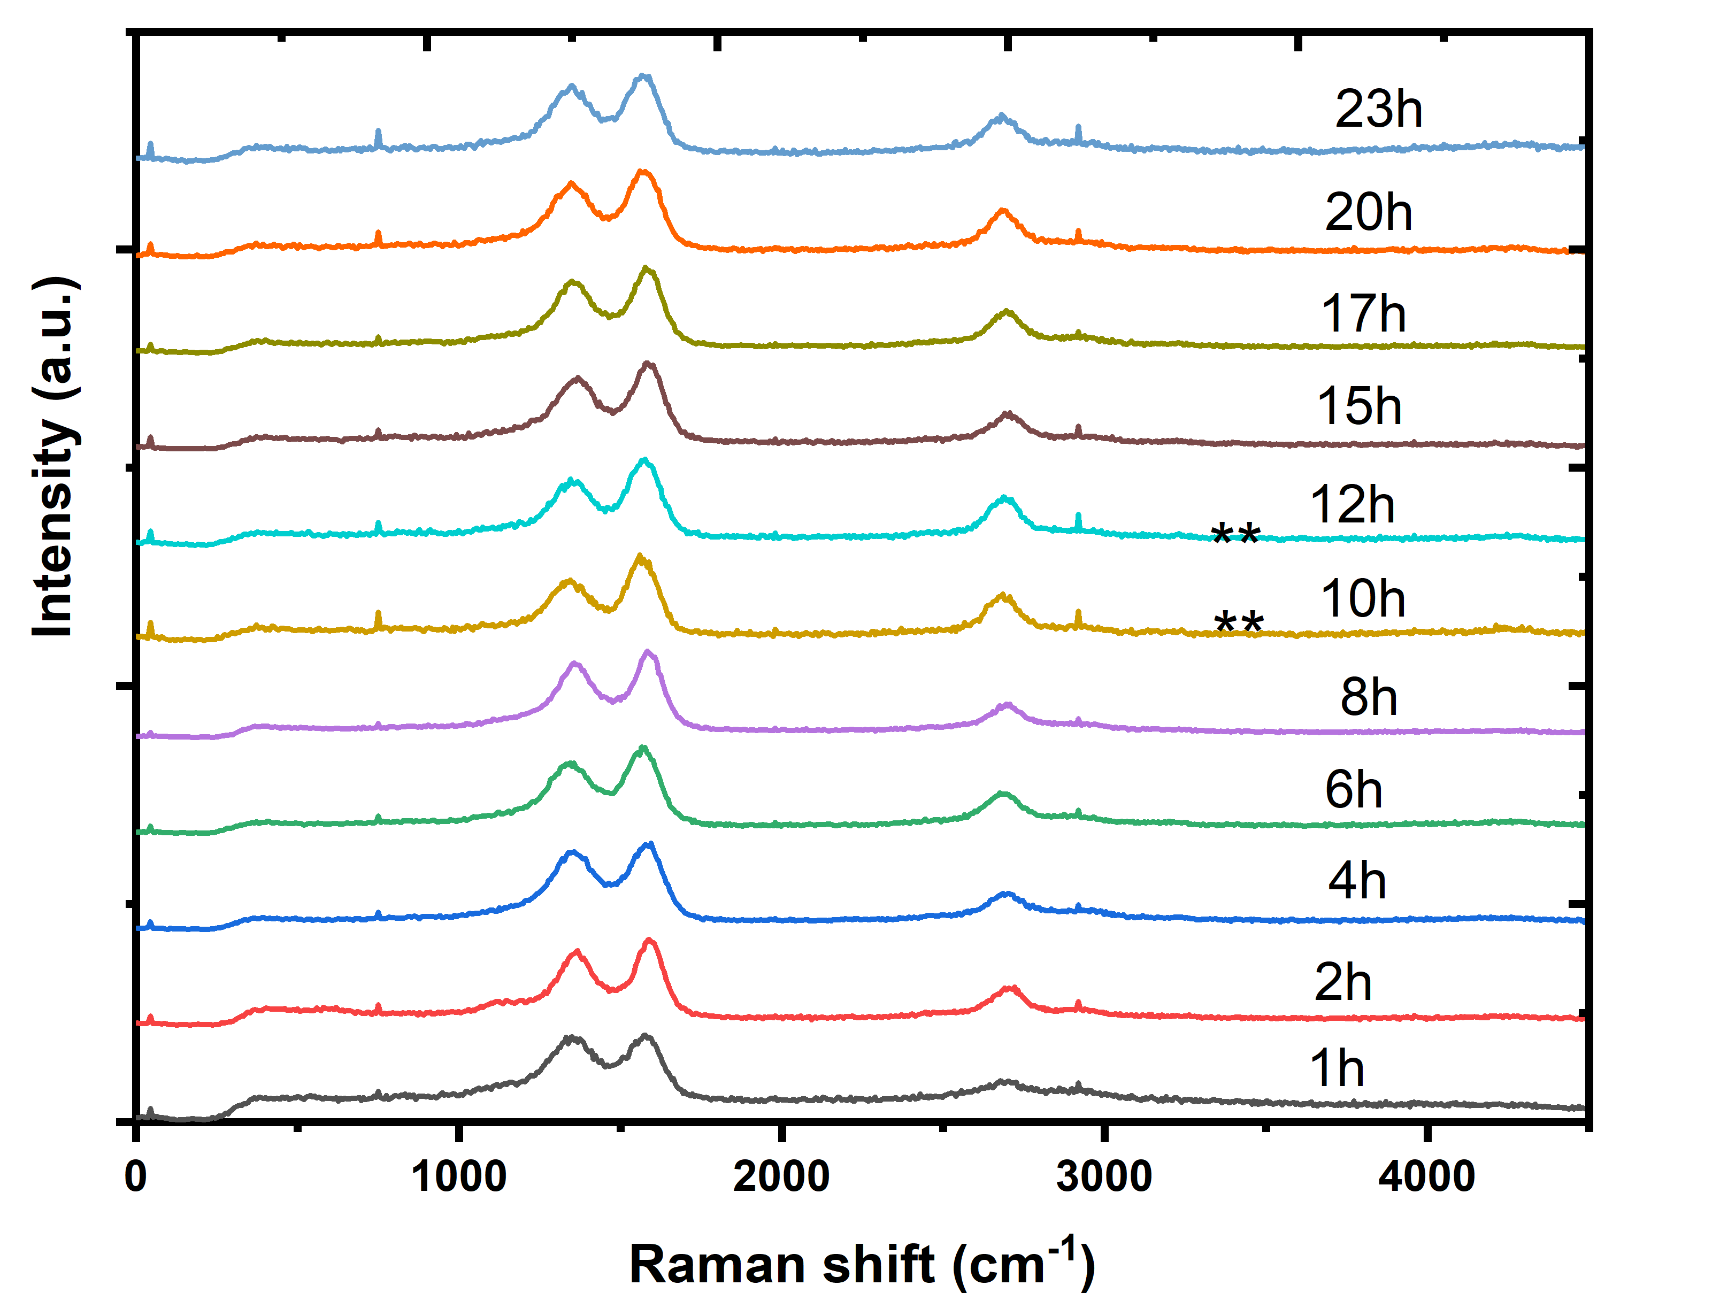
Figure S7: Raman spectra of normalized carbons obtained through sonication of petcoke were analyzed after sonication for (1-23) hours. These spectra contain characteristic peaks associated with carbon such as the D peak (approximately 1350 cm⁻¹), G peak (approximately 1580 cm⁻¹), and 2D peak (approximately 2700 cm⁻¹). A study of the shapes of the bands and the intensity ratios between them provides information on the structural changes due to increasing sonication times.

Figure S8 presents the effect of petcoke dispersion concentration on the Raman response of the exfoliated products. Suspensions prepared at 1, 3, 5, 7, 10, 13, 15, and 20 mg mL⁻¹ all show the characteristic graphitic D, G, and 2D bands. The calculated I_{D}/I_{G} and I_{2D}/I_{G} ​ ratios reveal that 10 mg mL⁻¹ gives the most favorable exfoliation behavior, with the lowest defect ratio and highest 2D-to-G intensity ratio. At lower concentrations, the amount of graphitic material available for exfoliation is limited, while at higher concentrations, increased suspension density can reduce acoustic energy transfer and promote nanosheet collision, aggregation, or incomplete exfoliation.
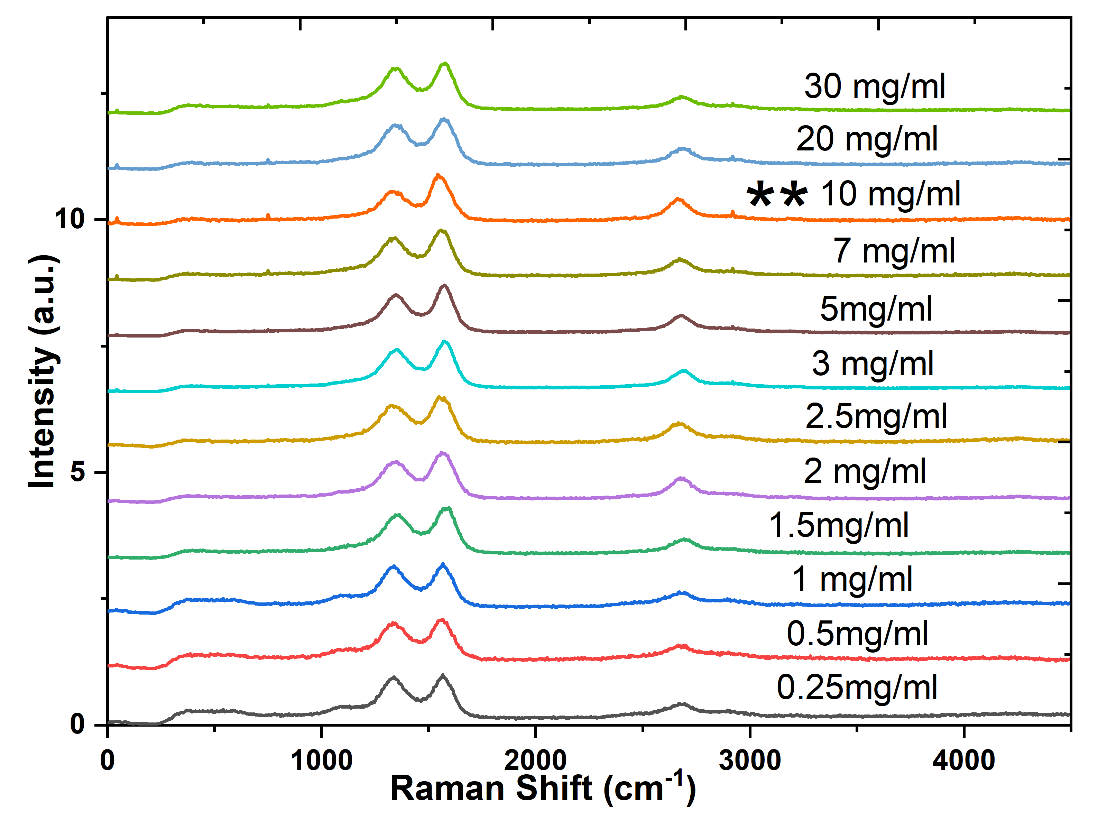
Figure S8: Normalized Raman spectra of graphene suspensions obtained from petcoke, fabricated at different concentrations of 1, 3, 5, 7, 10, 13, 15, and 20 mg mL⁻¹, are shown below. The spectrum shows the characteristic peaks of the D band at ~1350 cm⁻¹, the G band at ~1580 cm⁻¹, and the 2D band at ~2700 cm⁻¹ related to graphite carbon. Calculated ratios of the intensities, ID/IG and I2D/IG, of each spectrum are also listed, where the concentration dependence of defect concentration and graphite layers is observed. It can be noted that the dispersion fabricated at 10 mg mL⁻¹ possesses the smallest ID/IG ratio and the largest I2D/IG ratio.

Figure S9 further examines the effect of the IPA:CO₂-saturated water ratio on graphene formation. Raman spectra were collected for solvent ratios of 4:1, 3:2, 3:3, 2:3, and 1:4, each showing the typical D, G, and 2D bands. The extracted Raman ratios demonstrate that the 3:3 ratio, equivalent to a 1:1 IPA:CO₂-saturated water mixture, gives the lowest I_{D}/I_{G}​ value of 0.52 and the highest I_{2D}/I_{G} value of 0.68. This confirms that the equal-volume solvent mixture provides the best balance between IPA-assisted surface stabilization and CO₂-assisted cavitation-driven exfoliation.
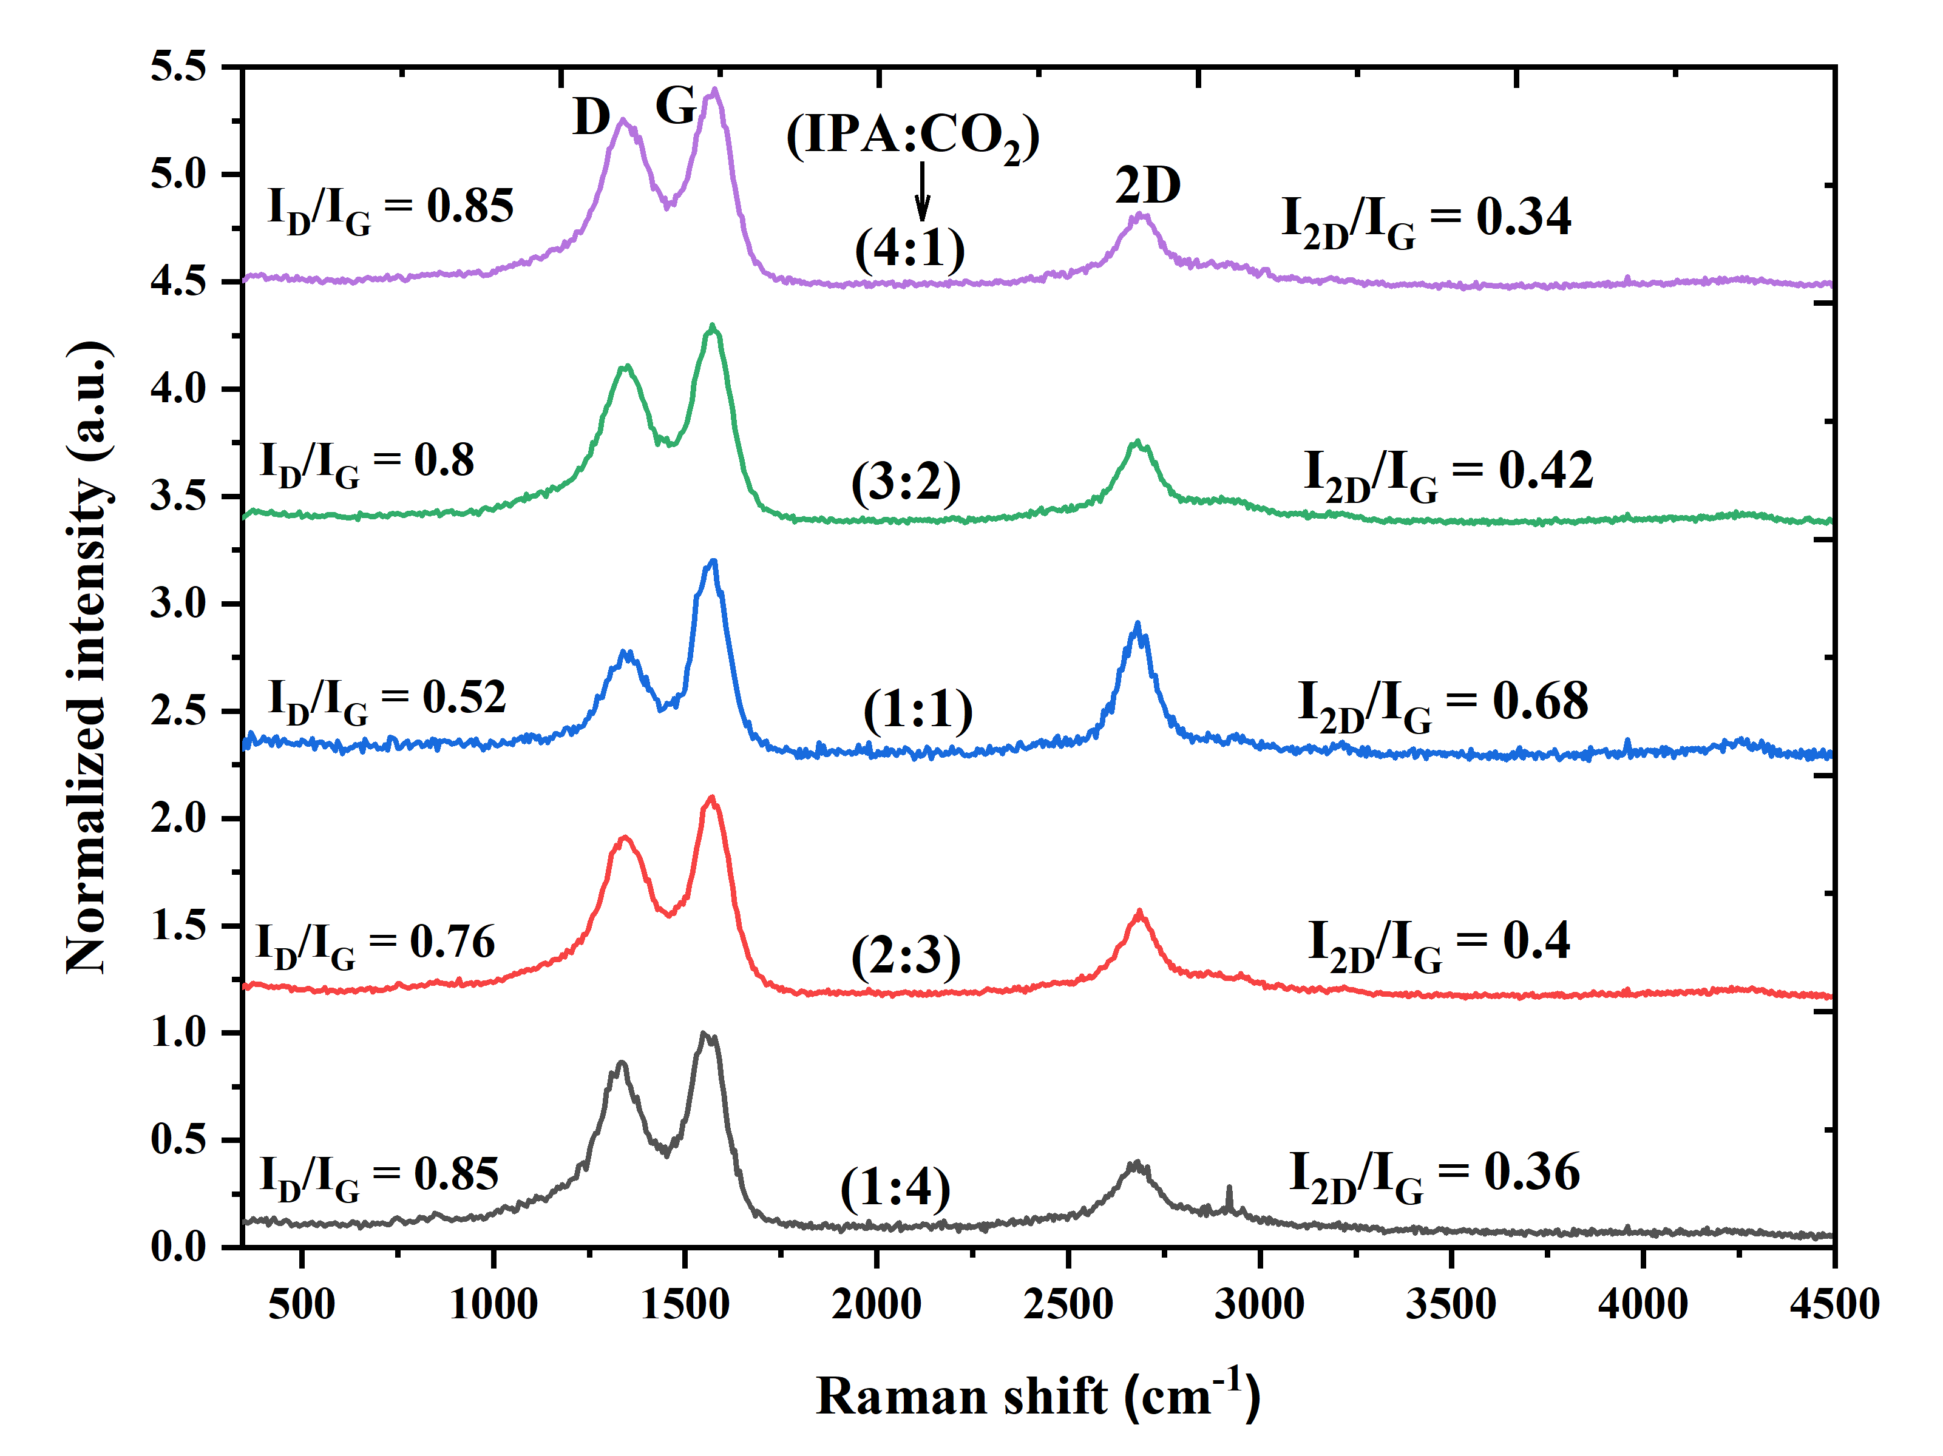
Figure S9: Graphene produced from petcoke Raman spectroscopy spectra have been presented for several IPA:CO₂ solvent concentrations under ultrasonication such as 4:1, 3:2, 1:1, 2:3, and 1:4. Spectra in all cases show prominent Raman bands at around 1350 cm⁻¹ (D band), 1580 cm⁻¹ (G band), and 2700 cm⁻¹ (2D band). ID/IG ratio and I2D/IG ratio for all solvent concentrations have been shown and clearly exhibit an important sensitivity of structural properties to solvent concentration. It has been observed that 1:1 IPA:CO₂ solvent concentration has the minimum value of ID/IG (0.52) and maximum value of I2D/IG (0.68).

Figure S10 visually and schematically explains the role of the IPA:CO₂-saturated water ratio. At high IPA content, graphitic surfaces are effectively wetted and stabilized, but the reduced amount of CO₂-saturated water limits cavitation and interlayer penetration, leading to incomplete exfoliation. In contrast, the 1:1 solvent ratio provides the most stable and homogeneous dispersion, indicating effective production of few-layer graphene. When the CO₂-saturated water fraction is increased beyond the optimum, solvent compatibility with graphene decreases, which promotes restacking, precipitation, and visible sedimentation. This observation confirms that excess aqueous content weakens dispersion stability despite potentially stronger cavitation.
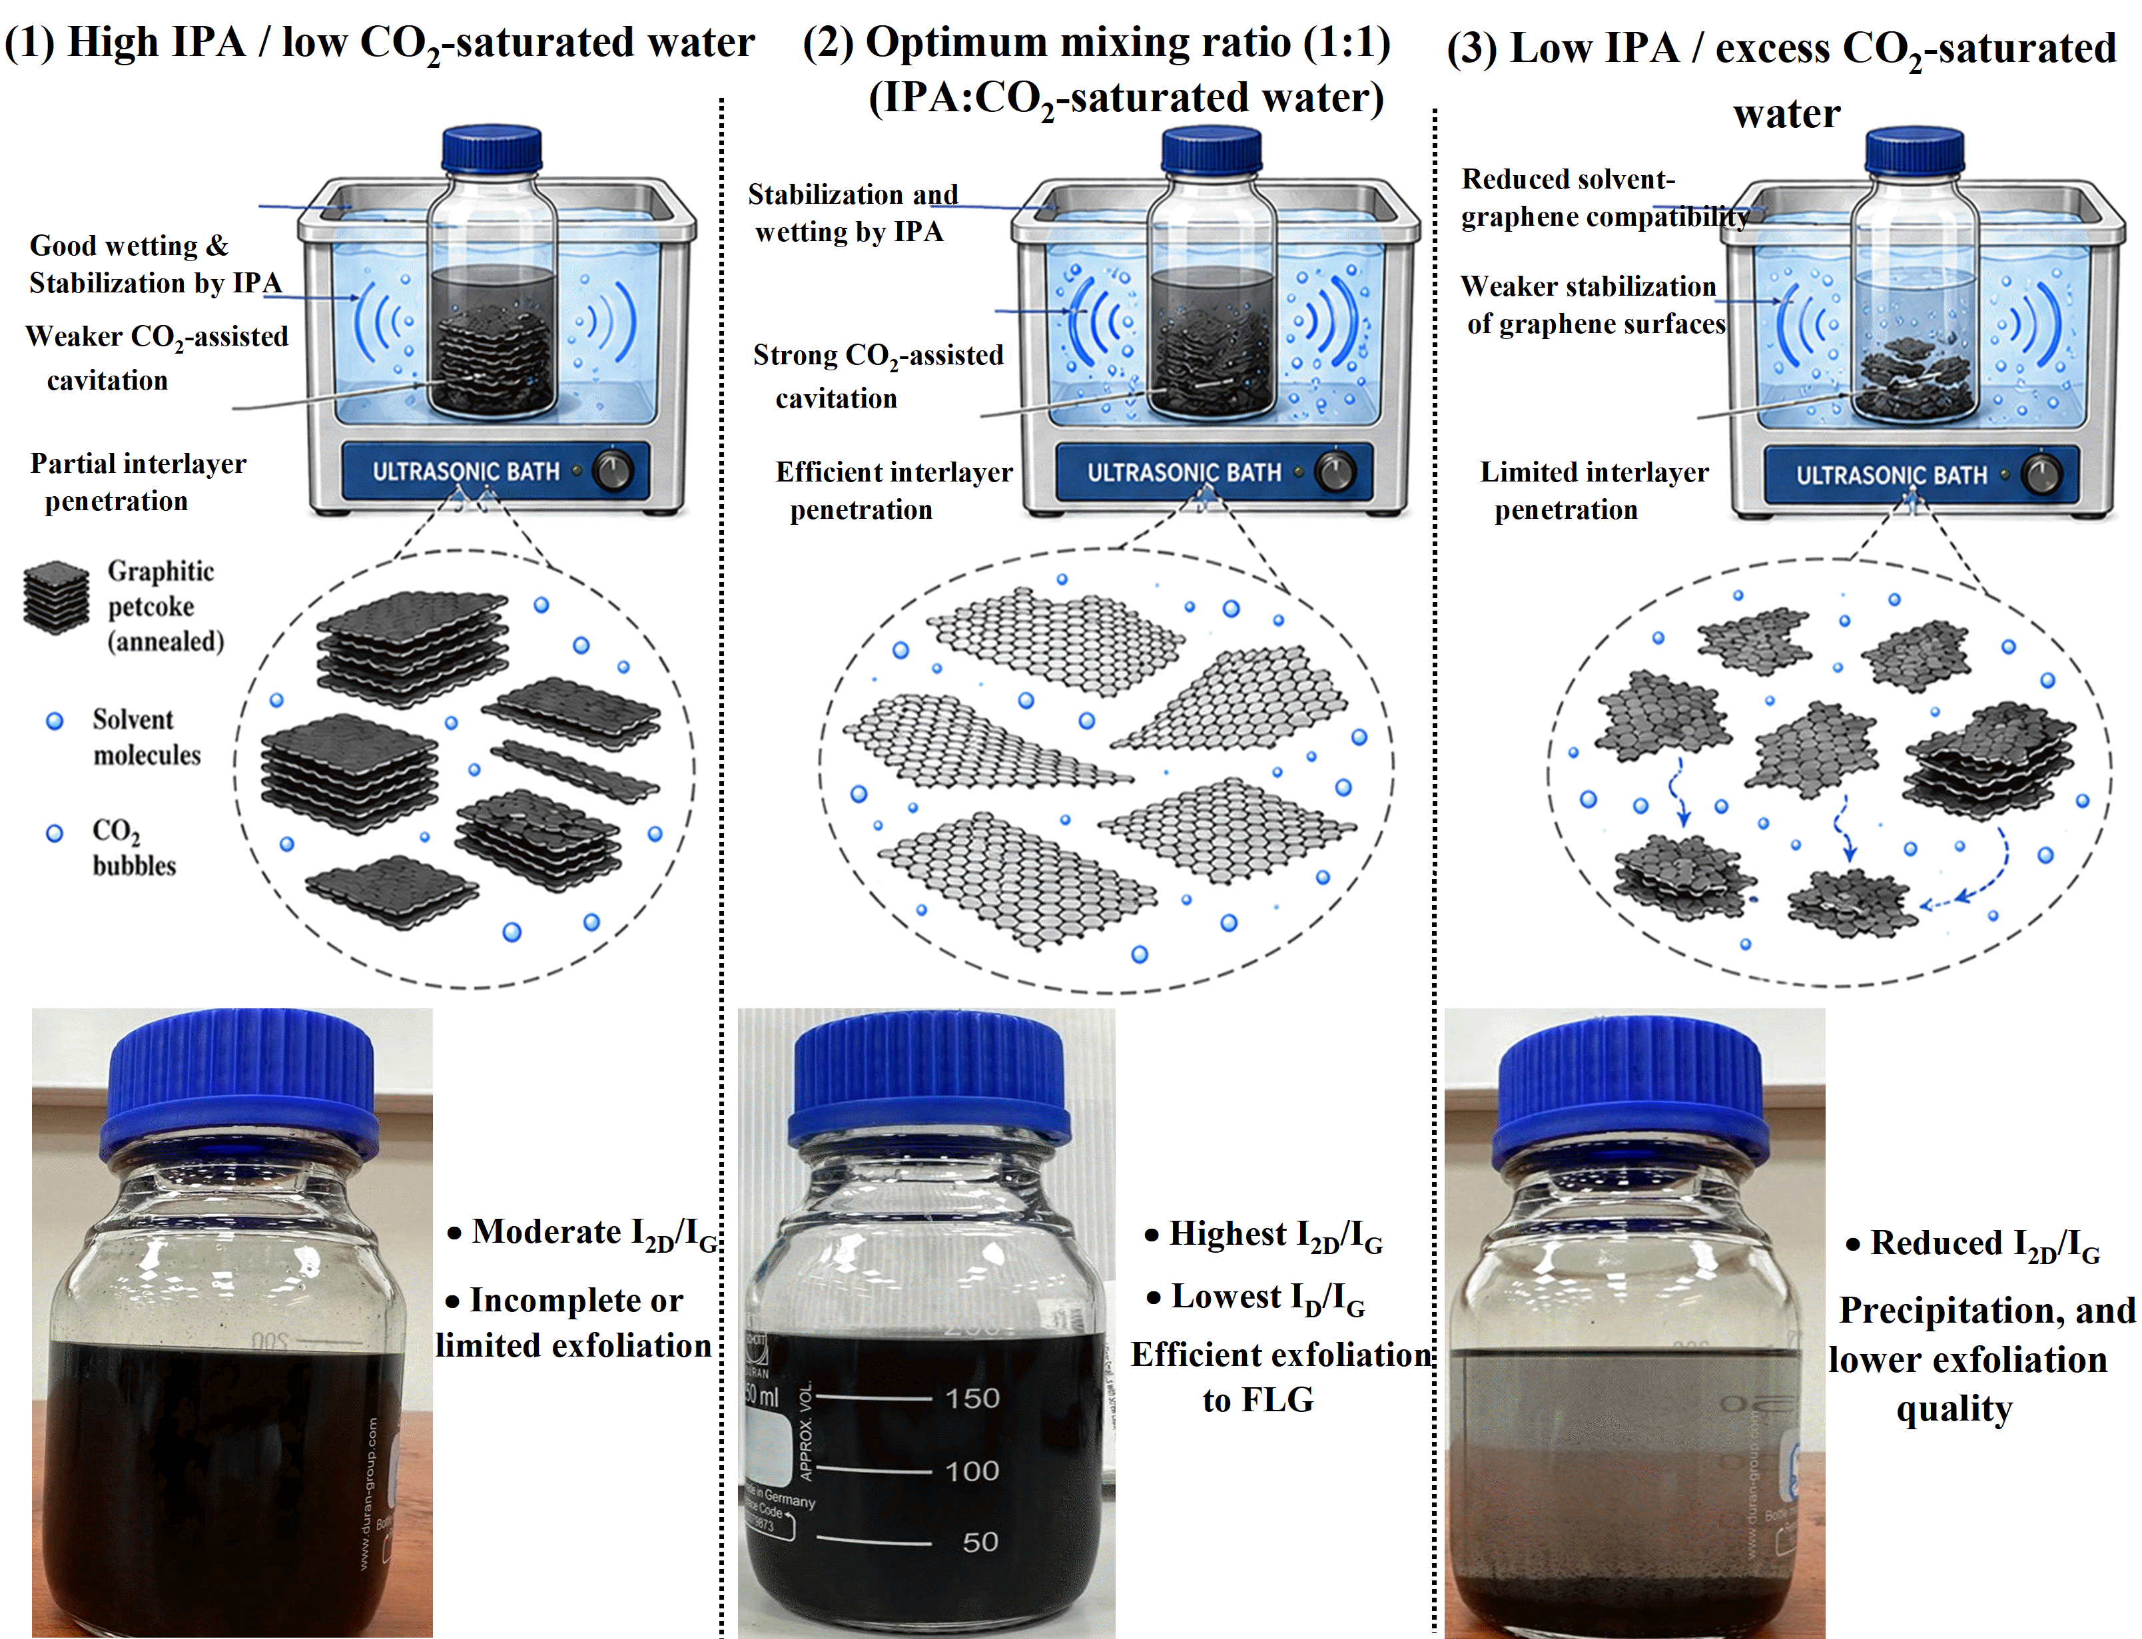
Figure S10: The schematic and vial images show the impact of varying the ratio of IPA to CO2-saturated water on the effectiveness of CO2-enhanced bath sonication for thermally activated petcoke. When there is a higher ratio of IPA to CO2-saturated water, the presence of IPA aids in wetting and stabilizing graphitic surfaces; however, due to the reduced CO2-assisted cavitation, there will be less intercalation, leading to partial or incomplete exfoliation. An equal ratio of 1:1 between IPA and CO2-saturated water will produce the best results in terms of exfoliation and dispersing the few-layer graphene. On the other hand, more CO2-saturated water will adversely affect the compatibility of the solvent with graphene.

Figure S11 shows the effect of sonication power on the Raman spectra of graphene produced from thermally activated petcoke. Spectra collected at 240, 300, 400, and 500 W display the same characteristic D, G, and 2D bands, confirming the preservation of graphitic carbon features across all power conditions. Increasing sonication power enhances acoustic cavitation and improves delamination, as reflected by changes in the I_{D}/I_{G} ​ and I_{2D}/I_{G} ​ ratios. Under the tested conditions, the highest exfoliation efficiency is obtained at 500 W, indicating that strong acoustic input improves the production of few-layer graphene without introducing excessive disorder.
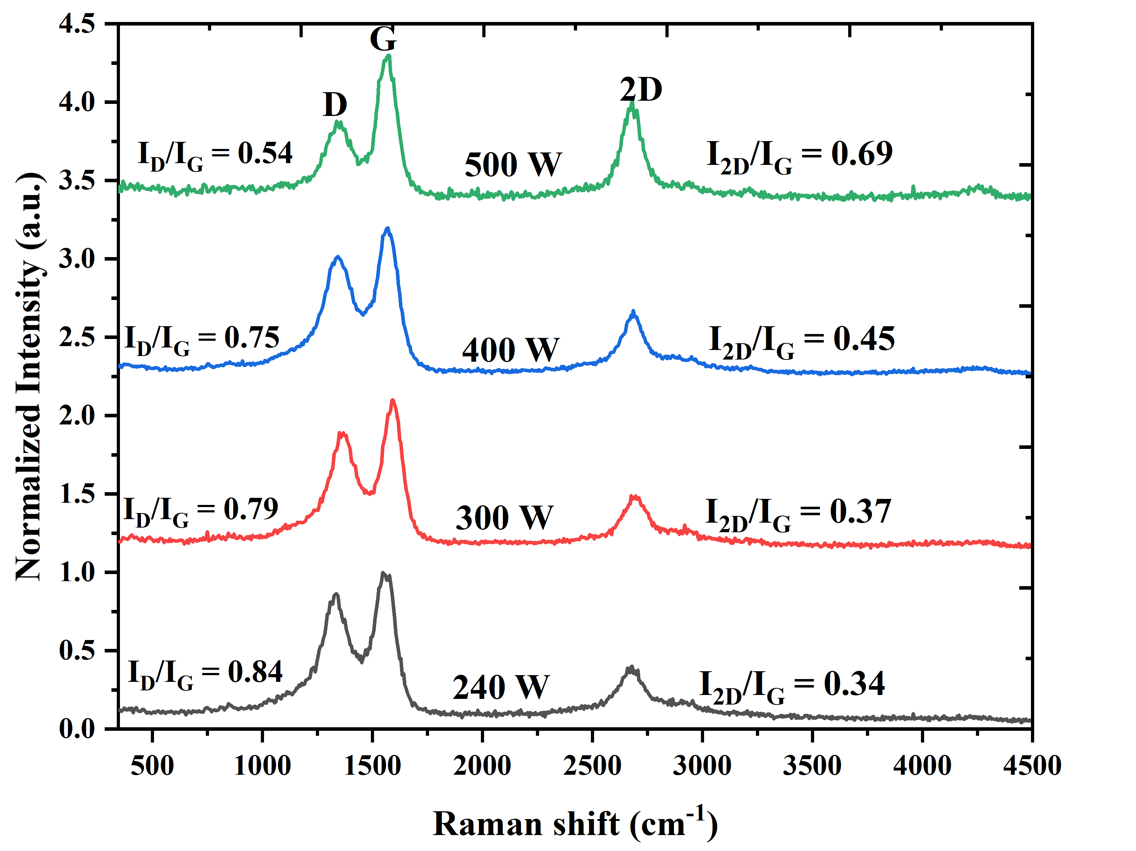
Figure S11: The normalized Raman spectra for graphene produced from petcoke have been obtained under different levels of sonication powers (240, 300, 400, and 500 W). All the obtained spectra show peaks corresponding to the D band (around 1350 cm⁻¹), G band (around 1580 cm⁻¹), and 2D band (around 2700 cm⁻¹). These three bands correspond to graphitic carbon, and the values of ID/IG and I2D/IG ratios for each sample are shown in the table below. As seen, the level of sonication power significantly affects the quality of the produced graphene structure because both ID/IG and I2D/IG ratios are changed with the increasing power value.

S7: Graphene yield estimation based on AFM analysis
The AFM spot-size determination was carried out using the calibrated scale bar from the image as illustrated in Figure S12. For example, a scale bar with a size of 5 µm in the AFM image corresponds to about 165 pixels, thus giving a calibration constant of 0.0303 µm/pixel. The bright flakes were then identified from the AFM image by image segmentation based on pixel intensities, with the scale bar and text regions being excluded from the analysis process in order to avoid erroneous counting. A pixel area was recorded for each individual flake, which was defined as an isolated bright spot, while the corresponding lateral spot size was defined as the diameter of a circle with the same area as that of the individual spots. This spot-detection overlay image is provided in the Supporting Information as evidence of the measurement procedure used for estimating the graphene flake-size distribution.
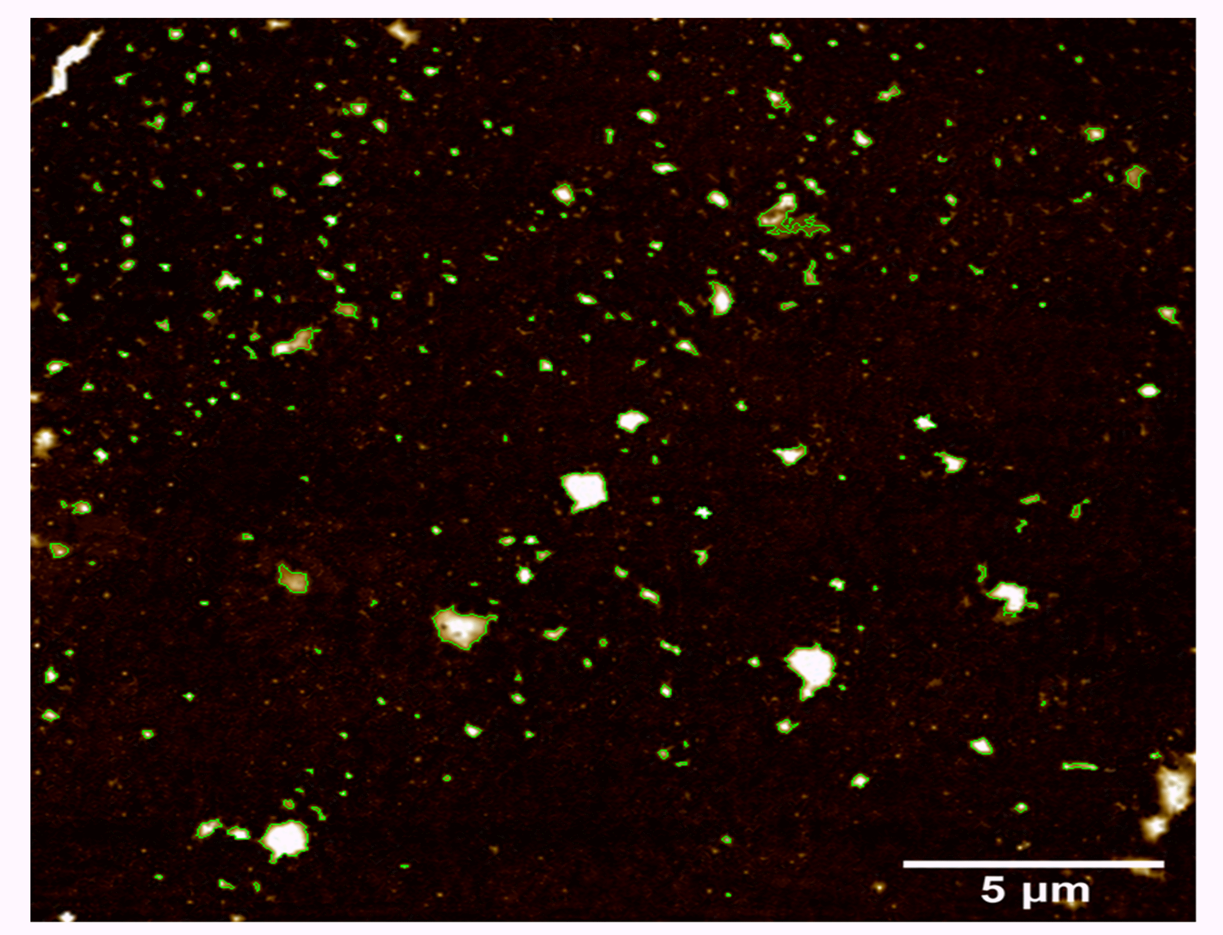
Figure S12: AFM spot-detection overlay to determine size of graphene flakes. AFM image of the graphene fraction isolated from the centrifuged petcoke via liquid phase exfoliation after desulfurization and drop-cast onto silicon substrate. Graphene flakes/ spots are highlighted using green outlines determined using image segmentation technique with 5 µm calibration. The text portion in the scale bar was ignored in the quantitative analysis to avoid erroneous detection. These flakes were used to determine lateral size distribution of flakes and the number fraction below 0.6 µm, considered as few-layer graphene as per our previous observations via TEM. Scale bar = 5 µm.

Table S2: AFM flake-count analysis of petcoke-derived graphene. Most detected flakes were below 0.6 µm and are assigned to few-layer graphene based on TEM evidence.
Total detected AFM spots/flakes | Detected spots/flakes below 0.6 µm | Number-based yield of sub-0.6 µm flakes | Interpretation
245 | 229 | 93.5% | Sub-0.6 µm flakes are assigned to few-layer graphene based on prior TEM evidence showing mainly 3–5 graphene layers.

References:

1. Hou, D., et al., Influence of order degree of coaly graphite on its structure change during preparation of graphene oxide. Journal of Materiomics, 2020. 6(3): p. 628-641.

