Supporting information

Electromigration-biased carbon transport and isotope fractionation in high-carbon-solubility metals
Alisher Sultangaziyev^{1,2}, Yongchul Kim¹, Yongqiang Meng^{1,2}, Liyuan Zhang⁵, Sun Hwa Lee^{1,2}, Rodney S. Ruoff^{1,2,3,4*}, and Won Kyung Seong^{1*}

¹ Center for Multidimensional Carbon Materials (CMCM), Institute for Basic Science (IBS), Ulsan, Republic of Korea
² Department of Chemistry, Ulsan National Institute of Science and Technology (UNIST), Ulsan, Republic of Korea
³ Department of Materials Science and Engineering, Ulsan National Institute of Science and Technology (UNIST), Ulsan, Republic of Korea
⁴ School of Energy and Chemical Engineering, Ulsan National Institute of Science and Technology (UNIST), Ulsan, Republic of Korea
⁵ School of Metallurgy and Environment, Central South University, Changsha, 410083, China.

*Correspondence and requests for materials should be addressed to ruofflab@gmail.com and one2rang@gmail.com

- Effective front diffusion coefficient calculation
During DC experiments, a reproducible boundary in reflected-light contrast was observed to propagate away from the carbon source pocket toward the cathode side (see Supplementary Movies S1 and S2, for Co and Ni). We refer to this feature as an optical-contrast front and use it as an operational marker to extract an effective transport timescale. Because optical contrast can reflect carbon uptake and surface-state changes prior to the appearance of thick graphite, the extracted effective front diffusion coefficient (D_{front}) is reported as an effective metric for transport under the experimental conditions, rather than as an intrinsic isothermal diffusion coefficient.
The front position $x_{f}(t)$was measured from the video by pausing at selected time points $t_{i}$ and recording the corresponding distance $x_{i}$ from the pocket edge along the bar axis. Pixel distances were converted to centimeters using the known bar geometry within the same field of view. The pocket edge served as the fixed spatial reference, and the front position was assigned using a consistent contrast threshold across frames.

To quantify the kinetics, we fit the linearized diffusion-type relation
$x_{f}^{2}=mt+b$ (S1)
where $b$accounts for a finite visibility threshold and/or an offset in the first observable position. We define an effective front diffusion coefficient
$D_{front}=\frac{m}{4}$ (S2)
This definition follows the standard scaling $x^{2}∼4Dt$ for diffusion-type front propagation ¹. The uncertainty in $D_{front}$is obtained from the standard error of the fitted slope $m$.

- Effective charge calculation.
We estimate an effective charge $Z^{*}$ for carbon in cobalt and nickel using a standard electrotransport framework in which the driving force on an interstitial species is written as F = $Z^{*}$eE ². Here e is the elementary charge, and E is the electric field. The effective charge $Z^{*}$is an operational parameter that can include contributions from both direct electrostatic forces and electron-wind forces. Because the inputs used here (electric field and drift velocity) are estimated under experimental constraints, the resulting $Z^{*}$ values are reported as lower-bound, order-of-magnitude estimates.

S2.1. Electric field estimate
The voltage drop across the bar during the DC experiments was taken from the furnace readout: $V_{Co}=$ 1.00V and $V_{Ni}=$ 1.08V. Using the full bar length as the gauge length, $L=7.0$cm, we estimate the maximum possible average field as
$E_{Co}^{max} ≈ \frac{1}{7}= 0.14\frac{V}{cm} { E}_{Ni}^{max} ≈ \frac{1.08}{7}= 0.15\frac{V}{cm}$ (S3)
This estimate is treated as an upper bound because it attributes the full measured voltage drop to the active bar segment and does not account for voltage losses outside the analyzed region (for example at contacts or in non-uniform current-carrying segments). If the true field within the analyzed region is smaller than $E^{max}$, then mobilities inferred using $E^{max}$ are underestimated, and the corresponding $∣Z^{*}∣$values are underestimated. Therefore, this procedure yields conservative lower bounds.

S2.2. Mobility from the optical diffusion-front displacement near the pocket
The electric field imparts an average drift velocity $v_{ }$ to interstitial carbon, related to the electric mobility U by:
$v=UE$ (S4)
We obtain $v_{ }$ from the measured displacement of an optical diffusion front tracked in situ in the graphite growth region. We define Δx as the distance the front travels along the bar axis over a measured time interval Δt. We then estimate the average drift velocity as:
$v= \frac{∆x}{∆t}$ (S5)
This velocity is an operational metric. The optical-contrast front can reflect carbon uptake and surface-state changes, and its motion can be influenced by diffusion and by the evolving segregation sink. We therefore use $v_{ }$ only to obtain an effective mobility estimate in a region where the temperature variation is small.
Using the upper-bound field, we define lower-bound mobility:
$U_{min}= \frac{v}{E^{max}}$ (S6)
Because E^{max} is an upper bound, U_{min} is a lower bound on the mobility.

S2.3. Conversion from mobility to effective charge
Under the electrotransport framework, the mobility is related to $Z^{*}$through an Einstein-type relation:
$U= \frac{DeZ^{*}}{k_{B}T}$ (S7)
where D is the chemical diffusivity of carbon in the host metal, k_{B} is the Boltzmann constant, and T is absolute temperature in K. Rearranging gives:
$Z^{*}= \frac{Uk_{B}T}{De}$ (S8)
To minimize ambiguity from the thermal gradient, we evaluate $Z^{*}$ using mobility extracted only from the graphite growth region. We conservatively set T = 950 °C and use the reported literature diffusivity D evaluated at the same temperature for cobalt and nickel ³⁻⁶. This choice also produces a low-bound estimate of $Z^{*}$ because D increases with temperature and using the upper end of the temperature window maximizes D, thereby reducing the inferred $Z^{*}$ for a given mobility. The sign of $Z^{*}$can be assigned from the observed drift direction relative to the defined field direction.

- Raman data analysis and isotope ratio extraction
Raman spectroscopy was used to quantify the isotopic composition of the graphite segregation via the mass dependence of the G-band phonon frequency, which to first order follows $ω∝m^{-1/2}$ ⁷. Raman maps were acquired over the graphite region using a 532 nm excitation laser. The spectrometer wavenumber axis was calibrated using the first-order Si peak at 520.7 cm⁻¹.
Each spectrum in a map was fitted in OriginPro using a single Lorentzian function to determine the G-peak position:
$I(ω)=I_{0}+\frac{A}{1+{\left(\frac{ω-ω_{G}}{Γ/2}\right)}^{2}}$ (S9)
where $I_{0}$is a constant baseline, $A$ is the peak amplitude, $ω_{G}$ is the fitted G-peak position, and $Γ$ is the full width at half maximum.
The fitted $ω_{G}$values were converted to the atomic fraction of ¹³C, denoted $x_{13}$ using an effective-mass relation for mixed-isotope graphite ⁸:
$ω_{G}= ω_{ref}\sqrt{\frac{m_{ref}}{m_{eff}}}$ (S10)
with
$m_{eff}=\left(1-x_{13}\right)m_{12}+ x_{13}m_{13}$ (S11)
Here, $m_{12}=$12.000000u and $m_{13}=$13.003355u are the isotopic masses of ¹²C and ¹³C, respectively. The reference mass is the natural-abundance atomic weight $m_{ref}≡m_{nat}=$ 12.011u, used only to define the natural-abundance reference spectrum. The reference G-peak position $ω_{ref}≡ω_{nat}$was determined from three independent Raman maps of a highly oriented pyrolytic graphite (HOPG, ZYA grade) standard acquired on the same instrument under the same measurement conditions as the samples. The mean value was 1579.91 cm⁻¹ with a standard deviation of 0.40 cm⁻¹. For reporting and for use in Eq. (S10), we use $ω_{ref}=$1580 cm⁻¹, which is within the measurement uncertainty and does not affect conclusions.
Eq. (S10) can be inverted to obtain $x_{13}$directly from a measured $ω_{G}$:
$m_{eff}=m_{ref}\left(\frac{ω_{ref}}{ω_{G}}\right)$ (S12)
$x_{13}= \frac{m_{eff} -{ m}_{12}}{m_{13} - m_{12}}$ (S13)
To ensure robust map-derived compositions, spectra were filtered by fit quality. Only pixels with $R^{2}>$ 0.90 were retained for isotope conversion. Excluded pixels appear as blank (white) points in the maps and primarily arise from spectra with low signal-to-noise, non-graphitic features due to exposed metal or contamination, strong topography or focus variation, or transient artifacts such as cosmic rays. The ¹³C fraction $x_{13}$was averaged over all retained pixels to obtain a single value for each Raman map. For each isotope mixture and each metal, three independent samples were measured. The reported Raman-derived isotope composition is the mean of the three sample-averaged values, with the dispersion reported in the main text.
- Computational method

S4.1. DFT and NEB calculations (neutral migration path)
Density functional theory (DFT) calculations were performed using the Vienna ab initio simulation package (VASP) with the PBE exchange-correlation functional and D3 dispersion correction ⁹⁻¹¹. The fcc Ni and fcc Co lattice parameter was fixed to a literature reference value ^{12,13}. K-point sampling was 9$×$9$×$9 with energy cutoff of 400 eV. To create carbon diffusion structure images, nudged elastic band (NEB) simulations were performed. During the NEB simulation, the climbing image method with tangent estimation was introduced to get the highest saddle point energy as a diffusion barrier ^{14,15}.

S4.2. NEGF-based evaluation of field-biased barriers
To evaluate electromigration-induced barrier asymmetry under bias, non-equilibrium Green’s function (NEGF) calculations were performed using SIESTA/TranSIESTA ¹⁶⁻¹⁸. The NEB image geometries from the neutral pathway were used as input structures for NEGF self-consistent calculations under an applied potential difference of 1 V, chosen to be comparable to the experimental voltage drop. For NEGF simulations, a double-Zeta Polarized basis set was employed, with an energy shift of 50 meV and a cutoff energy of 200 Ry. For each image, the current-induced force on the migrating carbon was obtained from the NEGF simulation. The field contribution to the migration energy profile was evaluated by integrating the NEGF force along the reaction coordinate and combining it with the neutral DFT energy profile to yield effective forward and backward barriers.
Because ¹²C and ¹³C have essentially identical electronic structure, the NEGF calculations provide the same barrier profile for both isotopes. Isotope dependence is introduced through the mass dependence of the attempt frequency.

S4.3. Kinetic Monte Carlo simulations and diffusion coefficients
Transport under bias-potential barriers was simulated by kinetic Monte Carlo (KMC) using an in-house Python code. Interstitial carbon was modeled as hopping between adjacent octahedral sites, as the tetrahedral sites are energetically unfavorable and serve only as transition states during the diffusion process in the fcc lattice. The diffusion probability ($P$) was calculated as follows,
$P=ν\sqrt{\frac{12}{m}}e^{-\frac{E_{b±}}{k_{B}T}}$ (S14)
where $ν$, $m$, $k_{B}$, and T are attempt frequency, atomic mass, Boltzmann constant and temperature, respectively. $E_{b,+}$and $E_{b,-}$are the forward and backward barriers under electric bias-potential. Attempt frequency was calculated from the force constant obtained from the energy variation near the octahedral site in the diffusion image with simple harmonic approximation. The temperature was 1600 K, the relevant diffusion distance was assumed to be twice that of carbon moving from an octahedral site (O_{h}) to a neighboring tetrahedral site (T_{d}) in the fcc Ni and fcc Co, and a single KMC simulation with 50 each of ¹²C and ¹³C atoms was conducted for 10 ns. Diffusion coefficients were extracted from the mean square displacement (MSD) slope using
$D=\frac{1}{6}\frac{dMSD(t)}{dt}$ (S15)
Independent trajectories were generated for each isotope to determine mean diffusivities and their statistical uncertainty.

S4.4. Uncertainty of the diffusivity ratio (Fieller confidence interval)
Isotope fractionation in the model is quantified through the ratio $R=D_{12}/D_{13}$. To estimate confidence intervals for $R$without relying on approximate ratio error propagation, Fieller’s theorem was applied to the KMC-derived diffusion coefficients and their uncertainties ¹⁹. The covariance between estimates was neglected because ¹²C and ¹³C trajectories were generated independently.

S4.5. Continuum model for composition-dependent fractionation
To connect isotope-dependent diffusivities to an experimentally comparable composition dependence, we used a diffusion description with a Gaussian concentration profile,
$C_{i}(x,t)∝C_{i,0}e^{(-\frac{x^{2}}{{4D}_{i}t})}$ (S16)
where $C_{i,0}$is the initial isotope fraction and $D_{i}$is the diffusivity from KMC. The local isotope composition was evaluated at a threshold total carbon concentration chosen near the relevant solubility limit under the modeled conditions, and the resulting predicted graphite ¹³C fraction and enrichment factor were compared to Raman and ToF-SIMS measurements.

S4.6. Concentration-dependent correction to ¹³C transport (α)
To account for non-ideal transport behavior at elevated local concentrations, a phenomenological correction parameter, $α$, is incorporated into the model. The effective diffusion coefficient for ¹³C is expressed as
$D_{13}^{eff}=\frac{D_{13}^{0}}{1+α{C_{13}}^{2}}$ (S17)
where $C_{13}$ represents the relative local concentration of ¹³C.
The introduction of this $1+αC_{13}^{2}$ term follows mean-field reasoning for pairwise interactions, analogous to the treatment of intermolecular forces in the van der Waals equation of state. In that framework, deviations from ideal behavior arise because the probability of interaction between two particles scales with the product of their number densities (i.e., proportional to $\left(n/V)^{2}\right.$). By extension, if interstitial carbon atoms exhibit weak attractive tendencies or transient clustering at high temperatures, the frequency of such interaction events scales with the square of the local concentration. Therefore, the lowest-order correction consistent with pairwise interaction statistics is proportional to $C_{13}^{2}$. Placing this term in the denominator reflects the expectation that attractive interactions or transient clustering impedes atomic mobility; increased local association renders diffusion more sluggish rather than enhancing it. Furthermore, the fitted values of α for both Ni and Co remained below 0.1 ($α$_{Ni} = 0.079; $α$_{Co} = 0.065).
We note that the magnitude of the correction term (1 + αC₁₃²) reaches up to ~5-6% at the highest local ¹³C concentration. We therefore do not present α as a small perturbation; rather, the α = 0 baseline (Table S7) establishes the direction of fractionation (E > 1) from the mass-dependent prefactor alone, while the nonzero α is introduced specifically to reproduce the rise toward the ¹³C-rich limit. The microscopic origin of this curvature is not uniquely identified by the present measurements and may include source supply, dissolution history, graphite nucleation timing, capture distance, or precipitation behavior in addition to any ¹³C-¹³C interaction effects. Accordingly, α should be regarded as a phenomenological closure parameter.

- Frequency domain thermoreflectance measurement

S5.1. FDTR measurement configuration
A 100 nm Au layer was deposited on the graphite samples to serve as an optical transducer. The Au surface was periodically heated using an intensity-modulated 488 nm pump beam (20 kHz to 40 MHz), while a 532 nm probe beam monitored temperature-induced reflectivity changes. The reflected probe signal was demodulated with a lock-in amplifier referenced to the pump modulation frequency, yielding the frequency-dependent phase response. Phase was used for parameter extraction due to its reduced sensitivity to absolute absorbed power and common-mode intensity drift.
Figure S1. Frequency-domain thermoreflectance measurement setup.
(a) Image of the FDTR setup. (b) Schematic of the FDTR setup.

S5.2. Thermal model and fitting procedure
Thermal parameters were extracted by fitting the measured phase response to a frequency-domain analytical solution of Fourier heat conduction for multilayer structures under Gaussian beam excitation, following the framework developed by Cahill and refined for FDTR by Schmidt and co-workers ²⁰⁻²². The complex temperature oscillation at the probe location is written as
$ΔT(ω)=2πQ_{ω}\int_{0}^{∞}{H(x,ω) exp⁡}\left[ − \frac{π^{2}(r_{\text{pump}}^{2}+r_{\text{probe}}^{2})}{2}x^{2}\right] x dx$ (S18)
where $ΔT(ω)$is the complex temperature response at angular frequency $ω$, $Q_{ω}$is the absorbed pump power per unit area, $r_{\text{pump}}$and $r_{\text{probe}}$are the 1/e² radii of the pump and probe beams, and $H(x,ω)$is the Hankel-transformed Green’s function describing heat propagation in the layered stack. Interfacial heat transfer is included through a thermal boundary resistance $R_{\text{int}}$at the Au/graphite interface.
Thermal conductivity and interfacial thermal resistance were obtained by nonlinear least-squares fitting of the phase-versus-frequency data. The primary fitted parameters were the in-plane thermal conductivity of graphite ($k_{\text{in}}$) and the Au/graphite interfacial thermal resistance ($R_{\text{int}}$). Au transducer thickness and layer heat capacities were fixed to measured and literature values. Fit uncertainties were obtained from the regression covariance of the nonlinear fit.
Figure S2. FDTR phase response of nickel-grown graphite for various source isotope mixtures.
(a-f) Frequency-dependent FDTR phase signals for graphite grown on Ni from source mixtures NC, 9C, 7C, 5C, 3C, and 1C, respectively. Open circles represent the experimental data, and solid lines represent the model fits. The good agreement across the full modulation-frequency range indicates that the thermal model captures the measured heat-transport response for all isotope compositions.

Supplementary figures
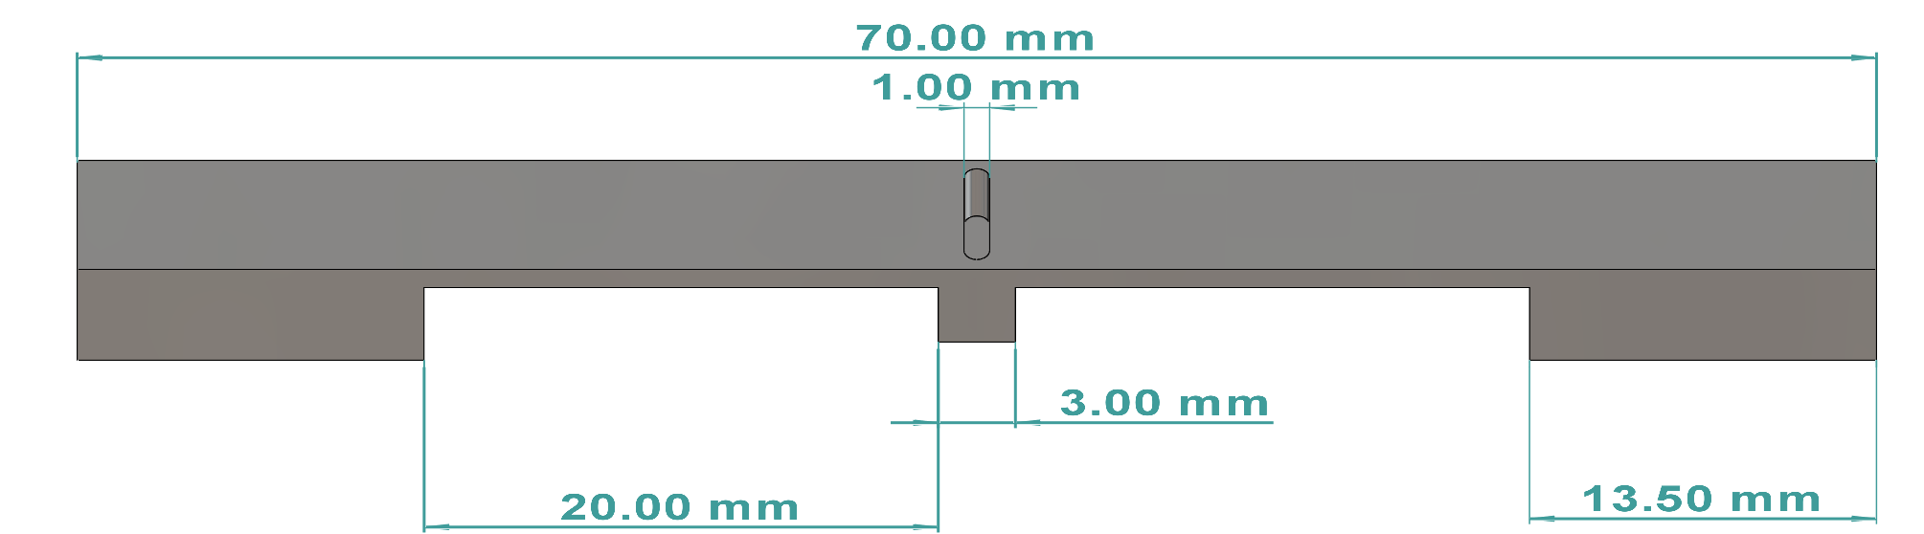
Figure S3. Symmetric bar design.
Schematic of the machined Co and Ni bar design showing the central carbon source pocket, electrode contacts, and the symmetric geometry used to generate a symmetric temperature profile under Joule heating.

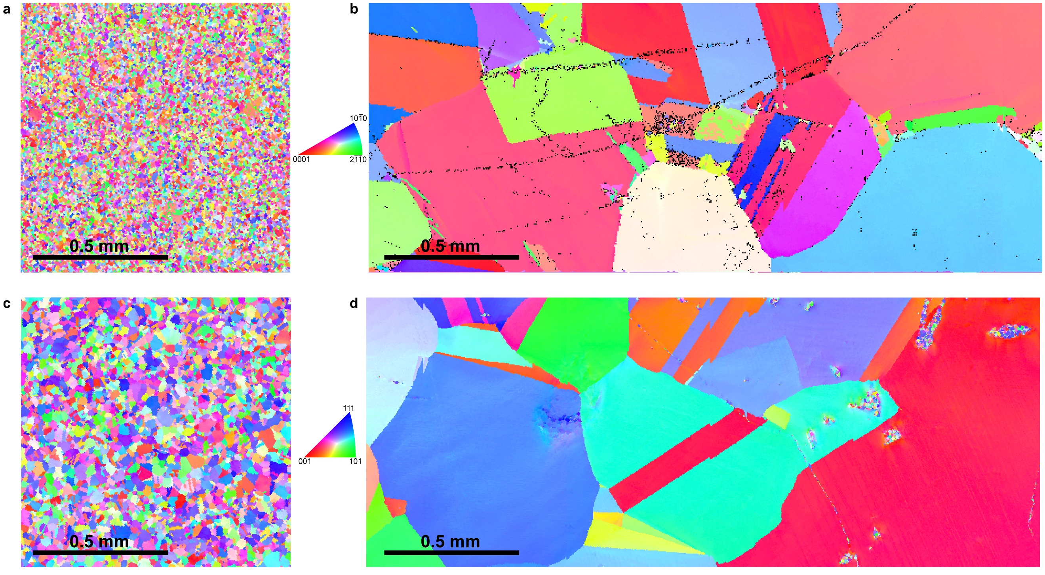
Figure S4. EBSD analysis of the raw and annealed Cobalt and Nickel bars.
(a, b) IPF maps from EBSD analysis of Co metal pieces before and after annealing. (c, d) IPF maps from EBSD analysis of Ni metal pieces before and after annealing.

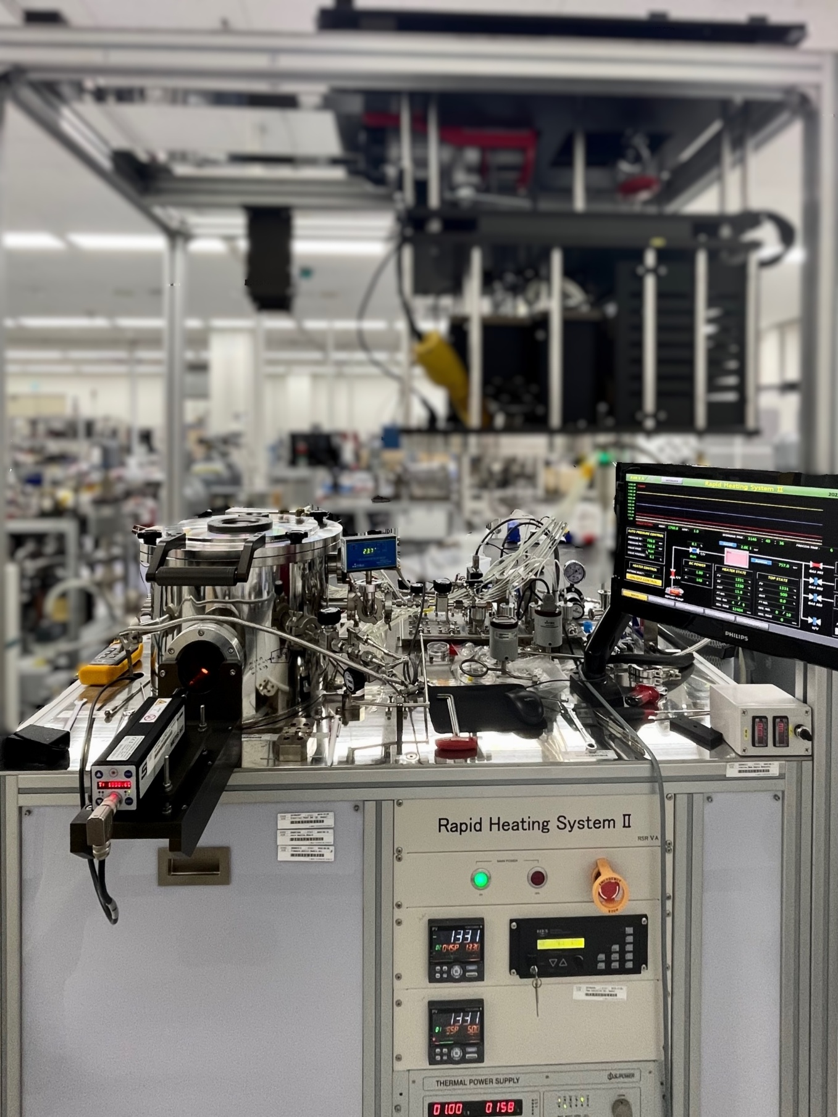
Figure S5. Image of the home-built cold-wall rapid Joule heating system.

Figure S6. Symmetrical thermal profile.
Results of spectropyrometer measurement of the temperature distribution in the symmetric Ni bar during the experiment, showing a mirrored profile about the central pocket. The spectropyrometer-reported tolerance was within ± 2 °C across the temperature range probed here, and the temperature difference between corresponding axial positions on the two halves of the bar lies within this tolerance (i.e., no statistically resolved left–right asymmetry).

Figure S7. X-ray diffraction patterns of cobalt and nickel substrates before and after electromigration experiments.
(a,b) Pristine Co and Ni substrates, respectively. (c,d) Co and Ni substrates after annealing. (e,f) Co and Ni substrates after the electromigration experiment. Indexed reflections are labeled for each pattern. The Co patterns are assigned to hcp Co reflections, while the Ni patterns are assigned to fcc Ni reflections.

Figure S8. In situ imaging of cobalt under DC bias versus AC bias.
Time-stamped optical snapshots from video recordings of Co bars during Joule heating under (a) direct current (DC) and (b) alternating current (AC, 60 Hz) using the same symmetric geometry. Under DC, a dark contrast front emerges and advances toward the cathode side with time, preceding the onset of cathode-localized graphite segregation at later stages. Under AC, the contrast remains centered near the source region and no comparable cathode-biased front or localized graphite segregation is observed over the same duration. Time points are indicated on each frame.

Figure S9. EBSD of the grown graphite.
(a) SEM image of the mapped region. (b) EBSD image quality (IQ) map. (c) Grain map highlighting large graphite domains with lateral dimensions on the order of hundreds of micrometers. (d) Inverse pole figure (IPF) map referenced to the sample normal, indicating that the graphite $c$-axis is predominantly aligned with the surface normal across the mapped area, with localized in-plane orientation variations. Black pixels denote non-indexed points (for example voids, contamination, or strong topography). (e) IPF key and pole figures for $\left\{0001\right\}$and $\left\{10\overset{ˉ}{1}1\right\}$. The $\left\{0001\right\}$ pole figure shows a strong central maximum consistent with basal planes parallel to the surface, while the $\left\{10\overset{ˉ}{1}1\right\}$ pole figure shows azimuthal spread consistent with in-plane rotational domains. RD and TD indicate the reference directions used for the EBSD map. Scale bars, 300 µm.

Figure S10. In-situ imaging of alternating current run on nickel.
Time-lapse images of a representative AC run on Ni and the corresponding post-run sample image. In contrast to DC operation, AC does not produce a clear cathode-biased transport front or thick cathode-localized graphite segregation. Scale bar, 1 mm.

Figure S11. Carbon concentration profiles measured from polished cut-out sections of Co and Ni bars after electromigration.
Carbon atomic percentage was measured along the transport direction from polished internal bar sections after removal of external graphite and surface deposits. Both Co and Ni show localized carbon enrichment within the metal, with maxima near the downstream graphite-collection region. The profiles provide semi-quantitative evidence for carbon redistribution inside the metal body after electromigration. Absolute carbon concentrations should be interpreted cautiously because light-element quantification by elemental analysis can be affected by polishing, residual surface carbon, and matrix effects. Error bars represent the standard deviation across n = 5 independent measurements.

Figure S12. Effective carbon transport rates extracted from in situ video analysis.
(a) Diffusion front position as a function of time for cobalt and nickel, determined from the recorded evolution of the visible transport front during Joule heating. (b) Squared diffusion front position, $x_{f}^{2}$, plotted against time. Linear fitting of $x_{f}^{2}$versus $t$ yields effective transport coefficients of 0.781 × 10⁻⁵ cm² s⁻¹ for cobalt and 0.805 × 10⁻⁵ cm² s⁻¹ for nickel.
Figure S13. Raman-derived isotope map of precipitated graphite in cobalt, natural-carbon source.
Figure S14. Raman-derived isotope map of precipitated graphite in cobalt, 90/10 source mixture.
Figure S15. Raman-derived isotope map of precipitated graphite in cobalt, 70/30 source mixture.
Figure S16. Raman-derived isotope map of precipitated graphite in cobalt, 50/50 source mixture.
Figure S17. Raman-derived isotope map of precipitated graphite in cobalt, 30/70 source mixture.
Figure S18. Raman-derived isotope map of precipitated graphite in cobalt, 10/90 source mixture.
Figure S19. Raman-derived isotope map of precipitated graphite in nickel, natural-carbon source.
Figure S20. Raman-derived isotope map of precipitated graphite in nickel, 90/10 source mixture.
Figure S21. Raman-derived isotope map of precipitated graphite in nickel, 70/30 source mixture.
Figure S22. Raman-derived isotope map of precipitated graphite in nickel, 50/50 source mixture.
Figure S23. Raman-derived isotope map of precipitated graphite in nickel, 30/70 source mixture.
Figure S24. Raman-derived isotope map of precipitated graphite in nickel, 10/90 source mixture.
Figure S25. ToF-SIMS depth profiling of transferred graphite, cobalt, natural-carbon source.
Figure S26. ToF-SIMS depth profiling of transferred graphite, cobalt, 90/10 source mixture.
Figure S27. ToF-SIMS depth profiling of transferred graphite, cobalt, 70/30 source mixture.
Figure S28. ToF-SIMS depth profiling of transferred graphite, cobalt, 50/50 source mixture.
Figure S29. ToF-SIMS depth profiling of transferred graphite, cobalt, 30/70 source mixture.
Figure S30. ToF-SIMS depth profiling of transferred graphite, cobalt, 10/90 source mixture.
Figure S31. ToF-SIMS depth profiling of transferred graphite, nickel, natural-carbon source.
Figure S32. ToF-SIMS depth profiling of transferred graphite, nickel, 90/10 source mixture.
Figure S33. ToF-SIMS depth profiling of transferred graphite, nickel, 70/30 source mixture.
Figure S34. ToF-SIMS depth profiling of transferred graphite, nickel, 50/50 source mixture.
Figure S35. ToF-SIMS depth profiling of transferred graphite, nickel, 30/70 source mixture.
Figure S36. ToF-SIMS depth profiling of transferred graphite, nickel, 10/90 source mixture.
Figure S37. Electromigration-biased diffusion barriers and fractionation modeling for cobalt.
(a) Schematic of interstitial carbon migration between neighboring sites in fcc Co obtained from nudged elastic band (NEB) calculations and used to define the diffusion pathway for barrier calculations. (b) Calculated migration barrier profiles along the diffusion path under different applied potentials, showing field-induced lowering/raising of forward/backward barriers (directional bias consistent with electromigration). (c) Kinetic Monte Carlo mean-square displacement (MSD) for ¹²C and ¹³C and extracted diffusion coefficients, demonstrating a reproducible mobility advantage of ¹²C

Figure S38. X-ray diffraction patterns of graphite recovered from Co samples with different source isotope compositions.
XRD patterns of graphite obtained from Co after electromigration experiments for (a) NC, (b) 9C, (c) 7C, (d) 5C, (e) 3C, and (f) 1C source compositions. The patterns are dominated by the hexagonal graphite (0002) peak, together with weaker (0004) and (0006) reflections, indicating strong preferred orientation of the graphitic basal planes. Additional weak non-basal reflections, such as (10-10), (10-11), (11-20), and (11-22), are observed in several samples. Peak labels are shown using four-index Miller-Bravais notation.

Figure S39. X-ray diffraction patterns of graphite recovered from Ni samples with different source isotope compositions.
XRD patterns of graphite segregated from Ni for (a) NC, (b) 9C, (c) 7C, (d) 5C, (e) 3C, and (f) 1C samples. All patterns are dominated by the hexagonal graphite (0002) reflection, with weaker higher-order (0004) and (0006) reflections also observed. Peak indexing is given in four-index Miller-Bravais notation for hexagonal graphite.

Supplementary tables
Table S1. ICP-OES impurity analysis of cobalt and nickel bars.
Element | Cobalt (ppm) |  | Nickel (ppm)
Element | Raw | Annealed | Raw | Annealed
Si | 23.2 | 9.03 | 34 | 17.8
Sb | 4.40 | 0.72 | 9.02 | 4.81
Sn | 2.3 | 1.1 | 3.17 | 0.673
Bi | 22.9 | 19.5 | 28.4 | N.D.
Fe | 3.22 | N.D. | 58.9 | N.D.
Cu | 1033 | 524 | 430 | 324
Mg | 0.111 | 0.059 | 7.05 | 1.62
Mn | N.D. | N.D. | 1.48 | 0.11
Ti | 430 | 254 | 0.366 | 0.166
Zn | 242 | 48.9 | 87.0 | N.D.
N.D. – not detected/below detection limit;
Table S2. Impurity analysis of ¹³C enriched carbon powder provided by Cambridge Isotope Laboratories.
Element | Concentration (ppm)
Sb | 0.1
As | 0.2
Bi | ≤0.1
Cd | ≤0.05
Cu | 11
Fe | 750
Pb | 2.3
Hg | 5.0
Mo | 41
Ag | 0.09
Sn | 1.6

Table S3. Measurement of starting carbon isotope mixtures by isotope ratio mass spectrometry (IRMS).
Isotope mix ratio ¹²C/¹³C (wt%) | IRMS ¹²C/¹³C (at%) | Standard deviation (at%)
Natural Carbon | 98.82/1.18 | ±0.0005
10/90 | 11.81/88.19 | ±0.0191
30/70 | 32.83/67.17 | ±0.0451
50/50 | 52.60/47.40 | ±0.0129
70/30 | 71.80/28.20 | ±0.0414
90/10 | 90.02/9.98 | ±0.0136
¹³C Source | 1.08/98.92 | ±0.1059

Target mixing ratios (by weight) and measured isotope compositions (¹²C/¹³C, at%) obtained by isotope ratio mass spectrometry (IRMS); reported uncertainties are the standard deviations from repeated measurements.
Table S4. Step sizes of Raman maps in this study.
Sample | Cobalt Raman map step size (µm) |  |  | Nickel Raman map step size (µm)
Sample | Map 1 | Map 2 | Map 3 | Map 1 | Map 2 | Map 3
NC | X:20  Y:60 | X:50  Y:100 | X:50  Y:50 | X:30  Y:60 | X:30  Y:200 | X:50  Y:50
9C | X:40  Y:40 | X:50  Y:50 | X:50  Y:50 | X:50  Y:70 | X:50  Y:100 | X:50  Y:100
7C | X:60  Y:70 | X:100  Y:50 | X:50  Y:50 | X:80  Y:75 | X:50  Y:100 | X:100  Y:50
5C | X:50  Y:50 | X:50  Y:50 | X:50  Y:50 | X:100  Y:50 | X:100  Y:50 | X:200  Y:400
3C | X:20  Y:50 | X:30  Y:80 | X:80  Y:80 | X:50  Y:80 | X:50  Y:50 | X:200  Y:500
1C | X:30  Y:60 | X:20  Y:60 | X:30  Y:70 | X:48  Y:56 | X:50  Y:70 | X:30  Y:60

Table S5. Effective charges for natural abundance carbon diffusion in Co and Ni under direct electric field.
Metal | E (V/cm) | U (cm²/V×sec) | D, (cm²/s) | Z*
Cobalt | 0.143 | 3.65×10⁻⁶ ± 9.67×10⁻⁷ | 4.03×10⁻⁸ | 9.56 ± 2.53
Nickel | 0.154 | 6.03×10⁻⁶ ± 2.09×10⁻⁶ | 1.67×10⁻⁷ | 3.81 ± 1.32
Reported uncertainties are the standard deviations from repeated measurements.

Table S6. Diffusion coefficients from kinetic Monte Carlo simulations.
Metal | Isotope | Diffusion Coefficient
Ni | ¹²C | 0.2648 ($±$0.004237) Å²/ps (2.648$×$10⁻⁵ cm²/s)
Ni | ¹³C | 0.2540 ($±$0.004220) Å²/ps (2.540$×$10⁻⁵ cm²/s)
Co | ¹²C | 0.1035 ($±$0.002420) Å²/ps (1.035$×$10⁻⁵ cm²/s)
Co | ¹³C | 0.09887 ($±$0.002330) Å²/ps (0.9887$×$10⁻⁵ cm²/s)
KMC-extracted diffusion coefficients for interstitial ¹²C and ¹³C in fcc Ni and fcc Co at the simulation temperature used in the main text; values are reported in Å² ps⁻¹ with the converted units in cm² s⁻¹ in parentheses.

Table S7. Raman, ToF-SIMS, and simulation results for isotope composition and enrichment of segregated graphite formed in cobalt and nickel.
Metal | Initial Isotope mix, ¹²C/¹³C | Mixing ratio ¹²C:¹³C, wt% | Raman |  |  | ToF-SIMS |  | Simulation with α |  | Simulation without α
Metal | Initial Isotope mix, ¹²C/¹³C | Mixing ratio ¹²C:¹³C, wt% | G Band position, cm⁻¹ | ¹³C content, at% | Enrichment factor E | ¹³C content, at% | Enrichment factor E | Predicted ¹³C content, at% | Enrichment factor E | Predicted ¹³C content, at% | Enrichment factor E
Cobalt | NC | Natural abundance | 1580.20 | 0.796 | 1.49 | 0.881 | 1.35 | 0.882 | 1.35 | 0.876 | 1.36
Cobalt | 9C | 90:10 | 1575.65 | 7.74 | 1.32 | 7.93 | 1.29 | 8.13 | 1.25 | 8.02 | 1.27
Cobalt | 7C | 70:30 | 1566.25 | 22.3 | 1.37 | 22.7 | 1.34 | 23.4 | 1.29 | 23.7 | 1.26
Cobalt | 5C | 50:50 | 1555.80 | 39.0 | 1.41 | 38.7 | 1.43 | 39.9 | 1.35 | 41.6 | 1.27
Cobalt | 3C | 30:70 | 1542.93 | 59.5 | 1.39 | 59.8 | 1.37 | 58.4 | 1.46 | 61.6 | 1.27
Cobalt | 1C | 10:90 | 1529.05 | 82.4 | 1.59 | 82.2 | 1.62 | 82.3 | 1.60 | 85.3 | 1.28
Nickel | NC | Natural abundance | 1580.21 | 0.786 | 1.51 | 0.895 | 1.33 | 0.899 | 1.32 | 0.896 | 1.33
Nickel | 9C | 90:10 | 1575.54 | 7.92 | 1.29 | 7.65 | 1.34 | 8.28 | 1.23 | 8.20 | 1.24
Nickel | 7C | 70:30 | 1566.25 | 22.3 | 1.37 | 22.3 | 1.37 | 23.7 | 1.27 | 24.2 | 1.23
Nickel | 5C | 50:50 | 1556.03 | 38.4 | 1.45 | 39.1 | 1.40 | 40.2 | 1.34 | 42.3 | 1.23
Nickel | 3C | 30:70 | 1543.26 | 59.0 | 1.42 | 59.2 | 1.41 | 58.3 | 1.46 | 62.3 | 1.24
Nickel | 1C | 10:90 | 1529.89 | 82.2 | 1.62 | 82.4 | 1.59 | 82.0 | 1.64 | 85.7 | 1.24

Table S8. I_{D}/I_{G} values of grown graphite as a function of initial isotope mix obtained from Raman maps.
Initial isotope mix | Cobalt I_{D}/I_{G} | Nickel I_{D}/I_{G}
NC | 0.061 ± 0.024 | 0.076 ± 0.020
9C | 0.109 ± 0.009 | 0.071 ± 0.037
7C | 0.110 ± 0.006 | 0.106 ± 0.002
5C | 0.128 ± 0.004 | 0.092 ± 0.019
3C | 0.094 ± 0.016 | 0.099 ± 0.005
1C | 0.070 ± 0.028 | 0.092 ± 0.025
Reported uncertainties are the standard deviations across three samples.

Table S9. XRD (0002) peak position and full width at half maximum (FWHM) for Ni-derived graphite across the isotope source composition series (Fig. S39).
Source composition | (002) 2θ position (°) | (002) FWHM (°)
NC | 26.57 | 0.207
9C | 26.57 | 0.208
7C | 26.56 | 0.218
5C | 26.58 | 0.205
3C | 26.56 | 0.217
1C | 26.57 | 0.208

Table S10. Results of FDTR measurements
Sample | Out-of-plane thermal conductivity (Wm⁻¹K⁻¹) | In-plane thermal conductivity (Wm⁻¹K⁻¹)
NC | 6.33 ± 0.25 | 2003 ± 24
9C | 6.19 ± 0.22 | 1924 ± 155
7C | 6.05 ± 0.37 | 1838 ± 112
5C | 5.78 ± 0.14 | 1750 ± 32
3C | 6.04 ± 0.24 | 1774 ± 89
1C | 6.10 ± 0.13 | 1814 ± 46
Reported uncertainties are the standard deviations across three samples.

References
1 Mehrer, H. Diffusion in Solids: Fundamentals, Methods, Materials, Diffusion-Controlled Processes. (Springer Berlin Heidelberg, 2007).
2 Okabe, T. & Guy, A. G. Steady-state electrotransport of carbon in iron. Metall. Trans. 1, 2705–2713 (1970).
3 Ishida, K. & Nishizawa, T. The C-Co(Carbon-Cobalt) system. J. Phase Equil. 12, 417–424 (1991).
4 Iijima, Y., Makuta, F., Agarwala, R. P. & Hirano, K. Diffusion of Carbon in Cobalt. Mater. Trans., JIM 30, 984–990 (1989).
5 Natesan, K. & Kassner, T. F. Thermodynamics of carbon in nickel, iron-nickel and iron-chromium-nickel alloys. Metall. Trans. 4, 2557–2566 (1973).
6 Singleton, M. & Nash, P. The C-Ni (Carbon-Nickel) system. Bull. Alloy. Phase. Diagr. 10, 121–126 (1989).
7 Li, X., Cai, W., Colombo, L. & Ruoff, R. S. Evolution of Graphene Growth on Ni and Cu by Carbon Isotope Labeling. Nano Lett. 9, 4268–4272 (2009).
8 Cai, W. et al. Synthesis of isotopically-labeled graphite films by cold-wall chemical vapor deposition and electronic properties of graphene obtained from such films. Nano Res. 2, 851–856 (2009).
9 Kresse, G. & Furthmüller, J. Efficient iterative schemes for ab initio total-energy calculations using a plane-wave basis set. Phys. Rev. B 54, 11169–11186 (1996).
10 Perdew, J. P., Burke, K. & Ernzerhof, M. Generalized Gradient Approximation Made Simple. Phys. Rev. Lett. 77, 3865–3868 (1996).
11 Grimme, S., Antony, J., Ehrlich, S. & Krieg, H. A consistent and accurate ab initio parametrization of density functional dispersion correction (DFT-D) for the 94 elements H-Pu. J. Chem. Phys. 132 (2010).
12 Rosenberg, S. J. Nickel and its alloys. (National Institute of Standards and Technology, Gaithersburg, MD, 1968).
13 Suturin, S. M. et al. A look inside epitaxial cobalt-on-fluorite nanoparticles with three-dimensional reciprocal space mapping using GIXD, RHEED and GISAXS. J. Appl. Crystallogr. 46, 874–881 (2013).
14 Henkelman, G., Uberuaga, B. P. & Jónsson, H. A climbing image nudged elastic band method for finding saddle points and minimum energy paths. J. Chem. Phys. 113, 9901–9904 (2000).
15 Henkelman, G. & Jónsson, H. Improved tangent estimate in the nudged elastic band method for finding minimum energy paths and saddle points. J. Chem. Phys. 113, 9978–9985 (2000).
16 José, M. S. et al. The SIESTA method for ab initio order-N materials simulation. J. Phys.: Condens. Matter 14, 2745 (2002).
17 Papior, N., Lorente, N., Frederiksen, T., García, A. & Brandbyge, M. Improvements on non-equilibrium and transport Green function techniques: The next-generation transiesta. Comput. Phys. Commun. 212, 8–24 (2017).
18 Brandbyge, M., Mozos, J.-L., Ordejón, P., Taylor, J. & Stokbro, K. Density-functional method for nonequilibrium electron transport. Phys. Rev. B 65, 165401 (2002).
19 Fieller, E. C. Some Problems in Interval Estimation. J. Roy. Stat. Soc. Ser. B. (Method.) 16, 175–185 (1954).
20 Cahill, D. G. Analysis of heat flow in layered structures for time-domain thermoreflectance. Rev. Sci. Instrum. 75, 5119–5122 (2004).
21 Schmidt, A. J., Chen, X. & Chen, G. Pulse accumulation, radial heat conduction, and anisotropic thermal conductivity in pump-probe transient thermoreflectance. Rev. Sci. Instrum. 79 (2008).
22 Schmidt, A. J., Cheaito, R. & Chiesa, M. A frequency-domain thermoreflectance method for the characterization of thermal properties. Rev. Sci. Instrum. 80 (2009).

