Supplementary Information:
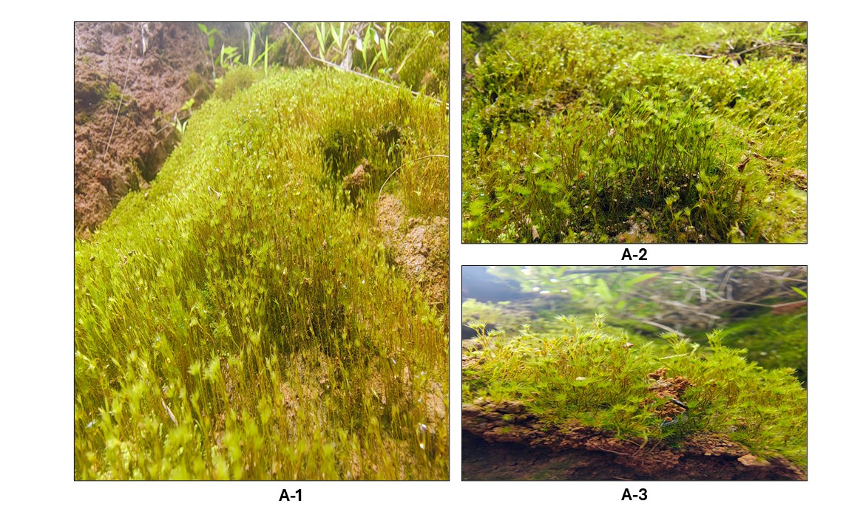

Figure-A: Photographs showing the habitat (A-1) and moss colony morphology (A-2, A-3) of Garckea phascoides

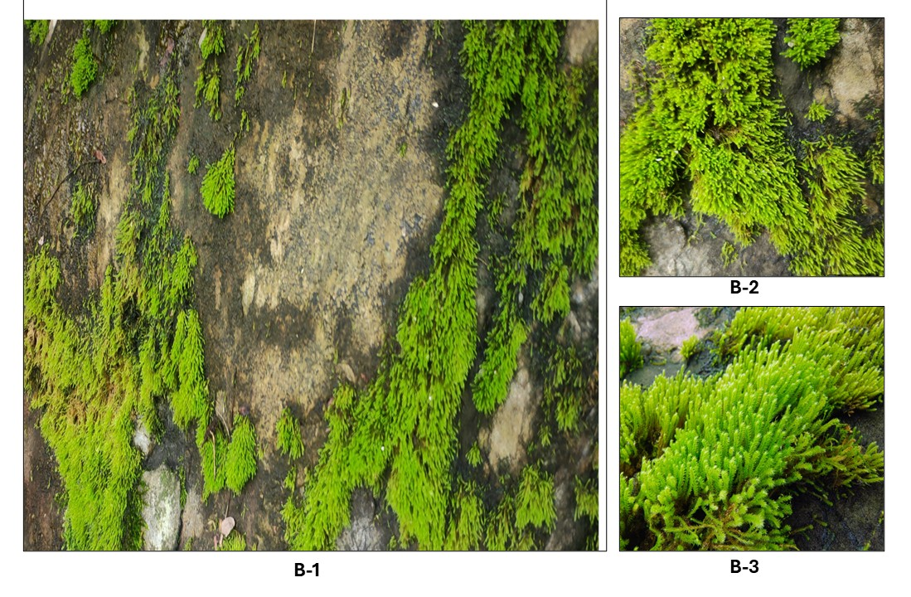

Figure-B: Photographs showing the habitat (B-1) and moss colony morphology (B-2, B-3) of Philonotis nitida.

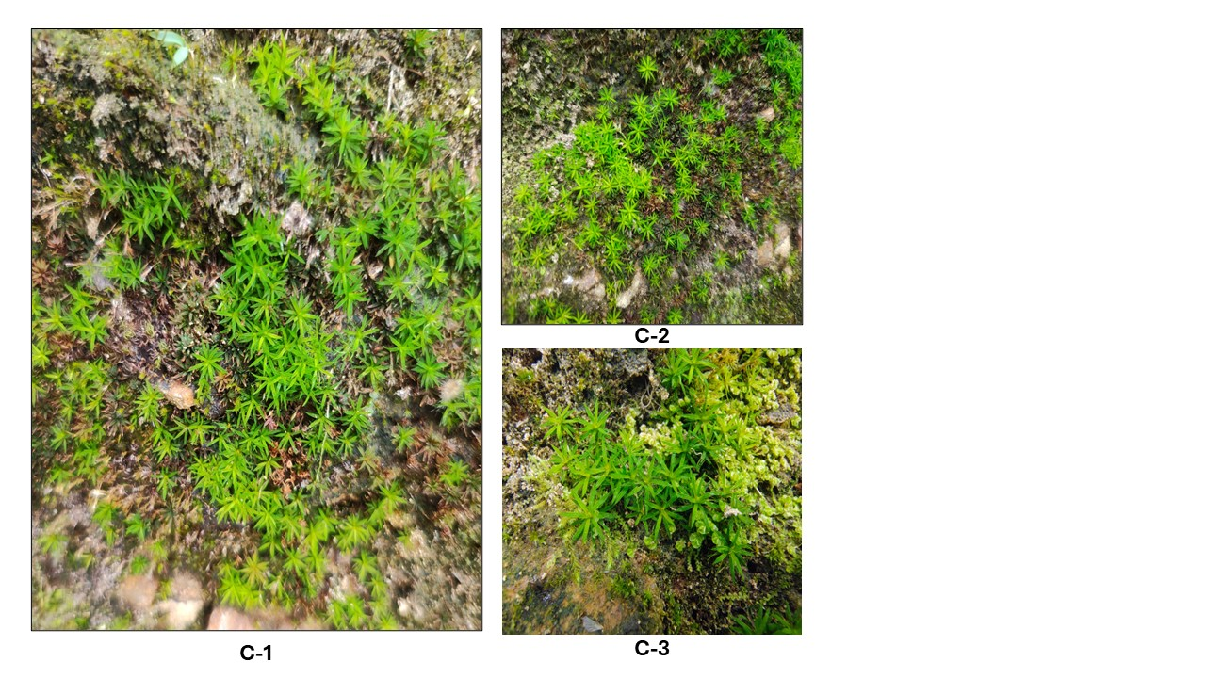

Figure-C: Photographs showing the habitat (C-1) and moss colony morphology (C-2, C-3) of Pogonatum aloides.

