Supplementary
Figures and Tables

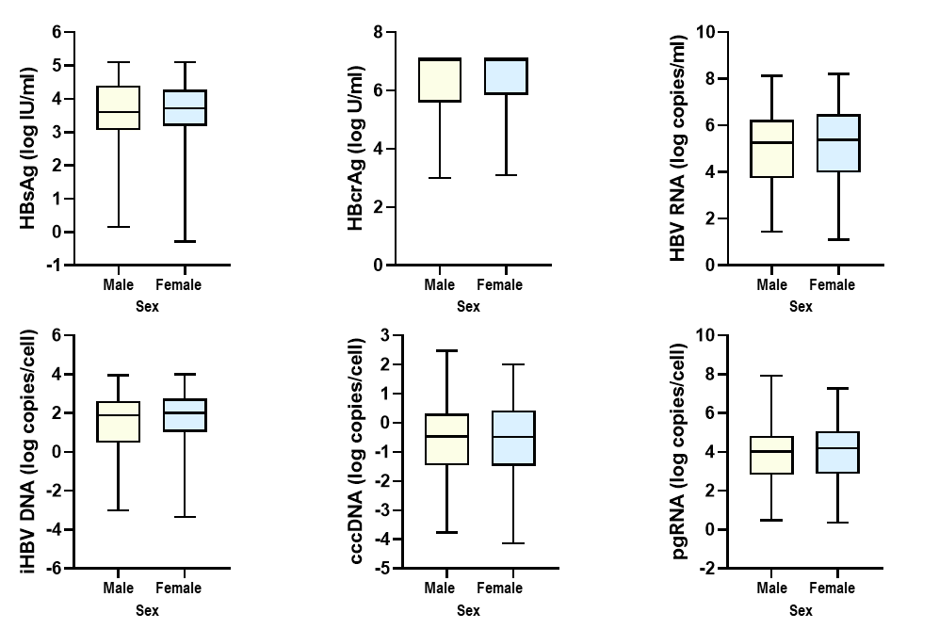
Supplementary Figure 1. Following adjustment for age, sex-dependent distribution of serum and intrahepatic HBV markers.
Comparison of Serum and Intrahepatic HBV Markers by sex

Supplementary Table 1. Primer and probe sequences for the amplification of HBV markers.
Name | Primer sequence (5’-3’)
iHBV DNA-F | CTCGTGGTGGACTTCTCTC
iHBV DNA-R | CTGCAGGATGAAGAGGAA
iHBV DNA-5’ R640 | TGTCCTGGTTATCGCTGGATGTGTCT
iHBV DNA-3’ FL | CACTCACCAACCTCCTGTCCTCCAA
cccDNA-F | CTCCCCGTCTGTGCCTTCT
cccDNA-R | GCCCCAAAGCCACCCAAG
cccDNA-5’ R640 | AGGTGAAGCGAAGTGCACACGGACC-p
cccDNA-3’ FL | GTTCACGGTGGTCTCCATGCAACGT
3.5kb RNAs-F | GGTCCCCTAGAAGAAGAACTCCCT
3.5kb RNAs-R | CATTGAGATTCCCGAGATTGAGAT
5’precore RNA-F | GGTCTGTTCACCAGCACC
5’precore RNA-R | TCAGAAGGCAAAAAAGAGAGTAACT
GAPDH-F | TTGGTATCGTGGAAGGACTCA
GAPDH-R | TGTCATCATATTTGGCAGGTTT

Supplementary Table 2. Correlation analysis between serum viral markers according to HBeAg status
 | Serum marker
 | HBV DNA
 | r | p
All
HBsAg | r = 0.713 | p < 0.001
HBcrAg | r = 0.787 | p < 0.001
HBV RNA | r = 0.851 | p < 0.001
HBeAg-positive patients
HBsAg | r = 0.711 | p < 0.001
HBcrAg | r = 0.532 | p < 0.001
HBV RNA | r = 0.799 | p < 0.001
HBeAg-negative patients
HBsAg | r = 0.428 | p < 0.001
HBcrAg | r = 0.605 | p < 0.001
HBV RNA | r = 0.720 | p < 0.001

Supplementary Table 3. After sex and age matching between HBeAg-positive and -negative patients, correlation analysis between serum and intrahepatic HBV markers according to HBeAg status
 | Intrahepatic markers
 | cccDNA |  | pgRNA
 | r | p | r | p
HBeAg-positive patients
HBsAg | r = 0.407 | p = 0.003 | r = 0.394 | p = 0.013
HBcrAg | r = 0.569 | p < 0.001 | r = 0.621 | p < 0.001
HBV RNA | r = 0.574 | p < 0.001 | r = 0.552 | p < 0.001
HBeAg-negative patients
HBsAg | r = 0.191 | p = 0.197 | r = 0.063 | p = 0.688
HBcrAg | r = 0.367 | p = 0.010 | r = 0.245 | p = 0.114
HBV RNA | r = 0.283 | p = 0.070 | r = 0.234 | p = 0.158

