Design, Synthesis And Cytotoxicity Of Pyrrolo[2,3-d]Pyrimidine Linked Diazospiro And Piperazine – Piperidine Libraries
Sridhar Guda,^{a,b} , Krishna Reddy.V ^{b}. Vishnu Thumma,^{c} Srilakshmi V Patri,ª* , Santosh Kumar Guru ^{d.}

ª Department of Chemistry, National Institute of Technology, Warangal - 5060004, Telangana, India.
^{b} Aragen Life Sciences Pvt Ltd., Medicinal Chemistry Laboratory Division, IDA Mallapur, Hyderabad – 500076, Telangana, India.
^{c} Department of Sciences and Humanities, Matrusri Engineering College, Hyderabad – 500059, Telangana, India.
^{d} National Institutes of Pharmaceutical Education and Research, Hyderabad-
500 037, Telangana, India

Correspond author email:

Spectral Copies
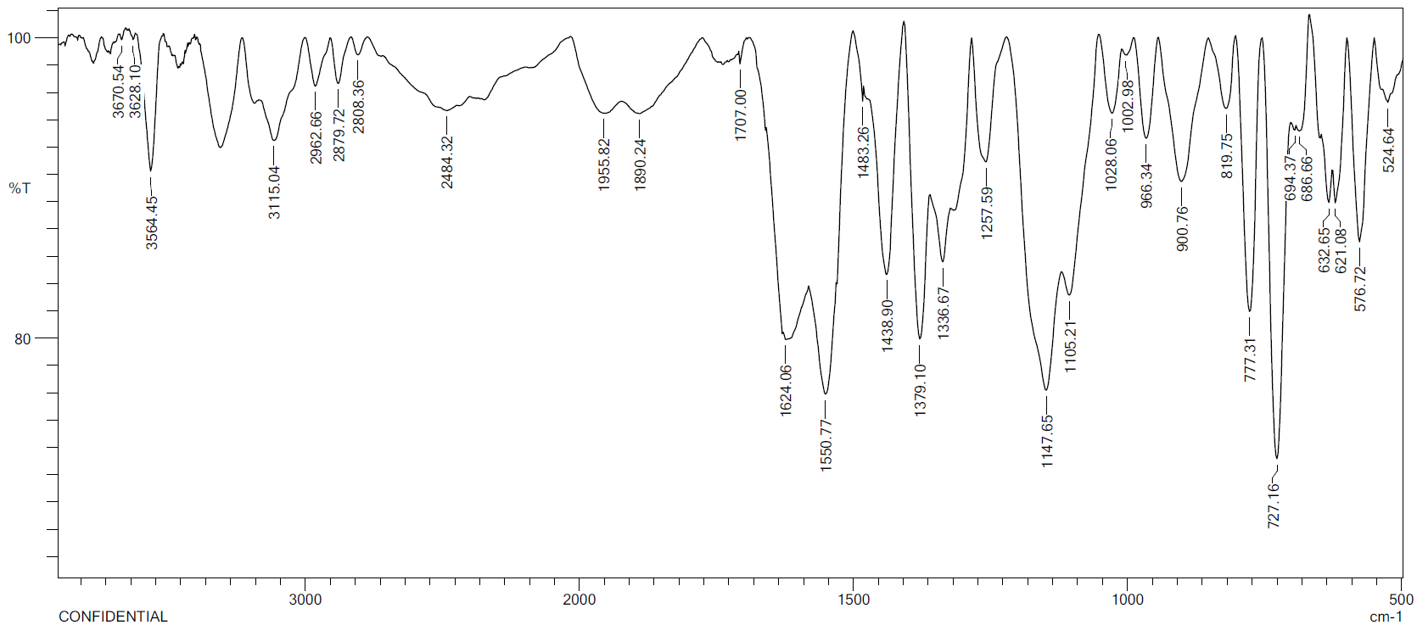
IR spectrum of 4-(2-((2-(trifluoromethyl)phenyl)sulfonyl)-2,7-diazaspiro[3.5]nonan-7-yl)-7H-pyrrolo[2,3-d]pyrimidine (7a)
¹H NMR spectrum of 4-(2-((2-(trifluoromethyl)phenyl)sulfonyl)-2,7-diazaspiro[3.5]nonan-7-yl)-7H-pyrrolo[2,3-d]pyrimidine (7a)
¹³C NMR spectrum of 4-(2-((2-(trifluoromethyl)phenyl)sulfonyl)-2,7-diazaspiro[3.5]nonan-7-yl)-7H-pyrrolo[2,3-d]pyrimidine (7a)
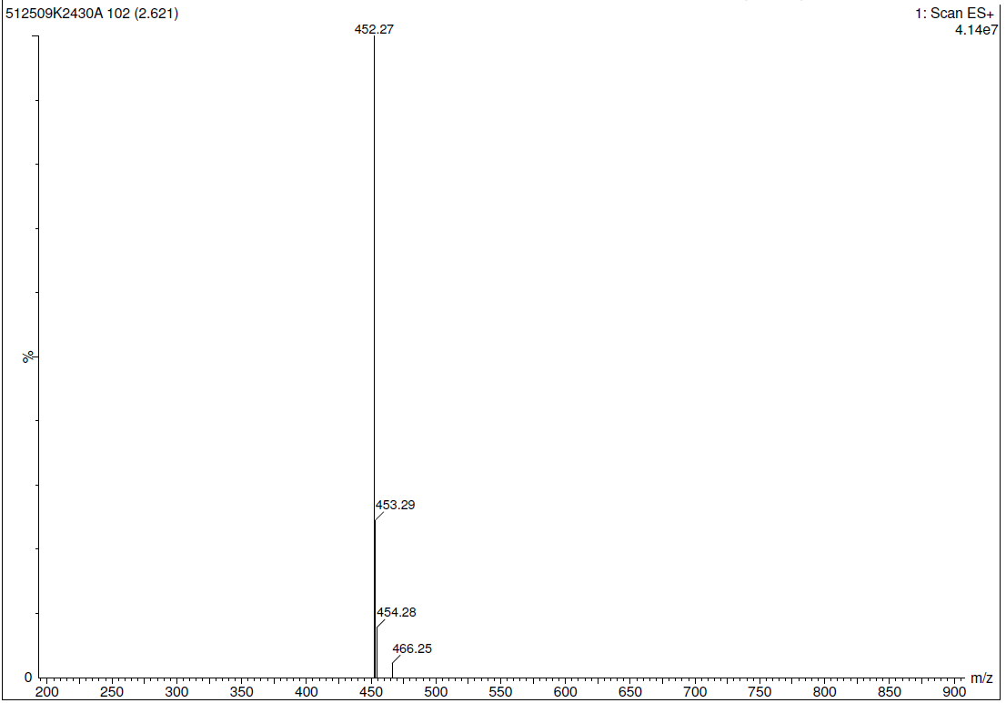
Mass spectrum of 4-(2-((2-(trifluoromethyl)phenyl)sulfonyl)-2,7-diazaspiro[3.5]nonan-7-yl)-7H-pyrrolo[2,3-d]pyrimidine (7a)
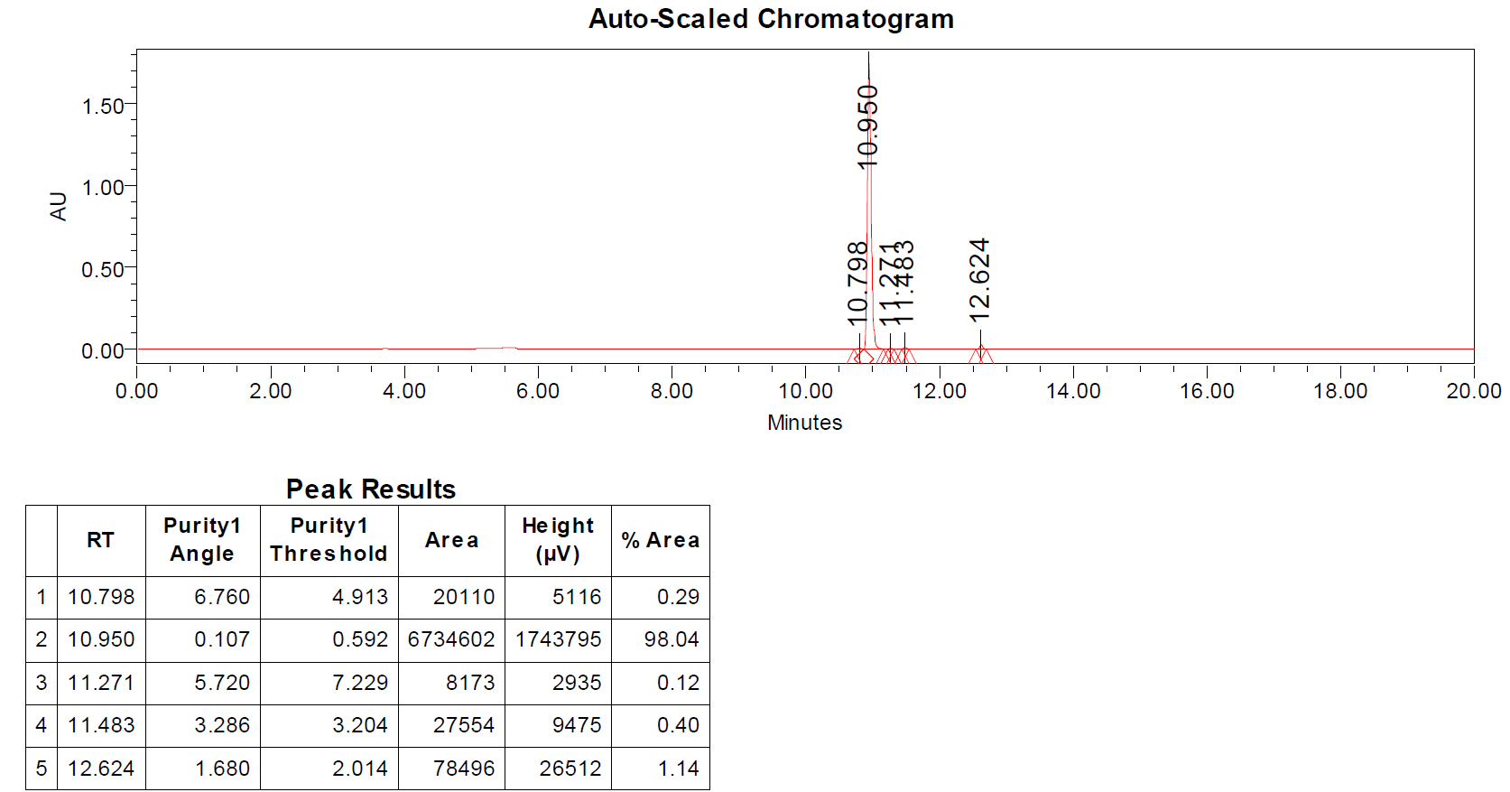
HPLC of 4-(2-((2-(trifluoromethyl)phenyl)sulfonyl)-2,7-diazaspiro[3.5]nonan-7-yl)-7H-pyrrolo[2,3-d]pyrimidine (7a)
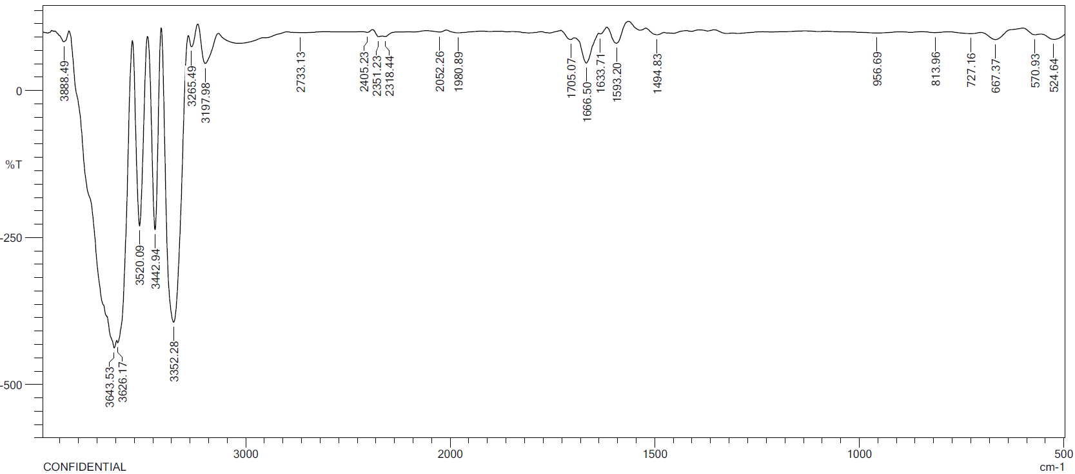
IR spectrum of 4-(2-((4-bromophenyl)sulfonyl)-2,7-diazaspiro[3.5]nonan-7-yl)-7H-pyrrolo[2,3-d]pyrimidine (7b)

¹H NMR spectrum of 4-(2-((4-bromophenyl)sulfonyl)-2,7-diazaspiro[3.5]nonan-7-yl)-7H-pyrrolo[2,3-d]pyrimidine (7b)

¹³C NMR spectrum of 4-(2-((4-bromophenyl)sulfonyl)-2,7-diazaspiro[3.5]nonan-7-yl)-7H-pyrrolo[2,3-d]pyrimidine (7b)
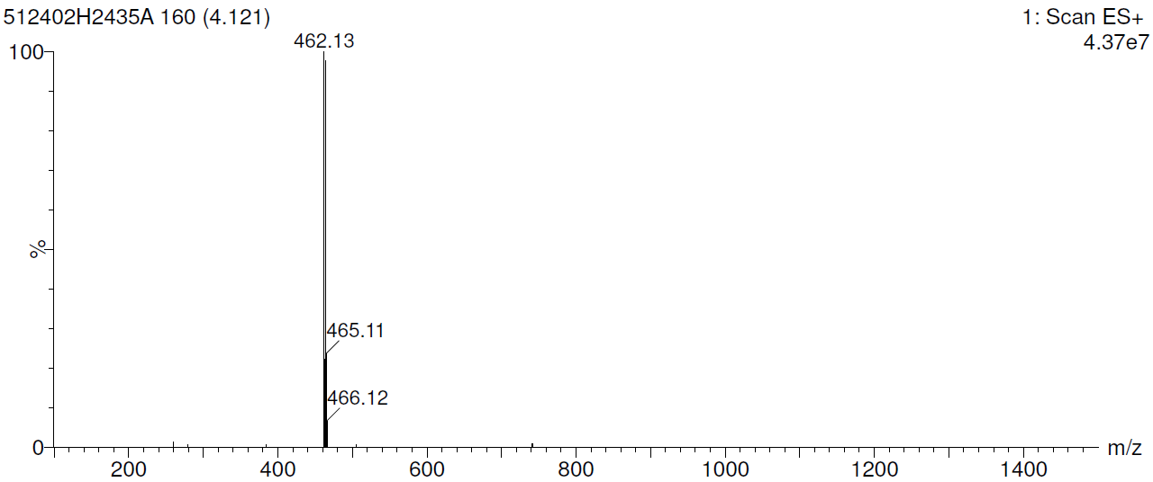
Mass spectrum of 4-(2-((4-bromophenyl)sulfonyl)-2,7-diazaspiro[3.5]nonan-7-yl)-7H-pyrrolo[2,3-d]pyrimidine (7b)
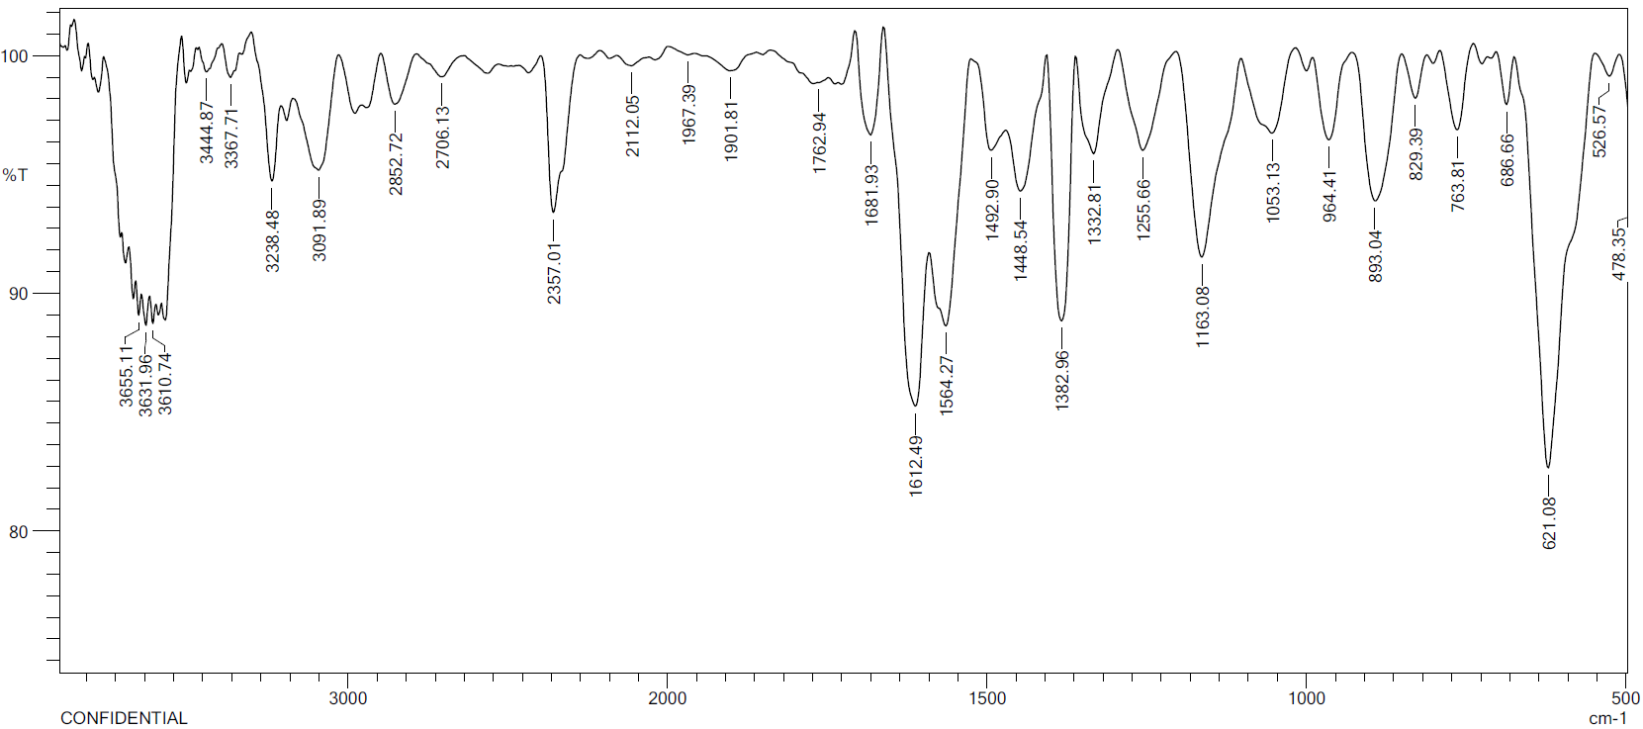
IR spectrum of 4-(2-((3-bromophenyl)sulfonyl)-2,7-diazaspiro[3.5]nonan-7-yl)-7H-pyrrolo[2,3-d]pyrimidine (7c)
¹H NMR spectrum of 4-(2-((3-bromophenyl)sulfonyl)-2,7-diazaspiro[3.5]nonan-7-yl)-7H-pyrrolo[2,3-d]pyrimidine (7c)
¹³C NMR spectrum of 4-(2-((3-bromophenyl)sulfonyl)-2,7-diazaspiro[3.5]nonan-7-yl)-7H-pyrrolo[2,3-d]pyrimidine (7c)
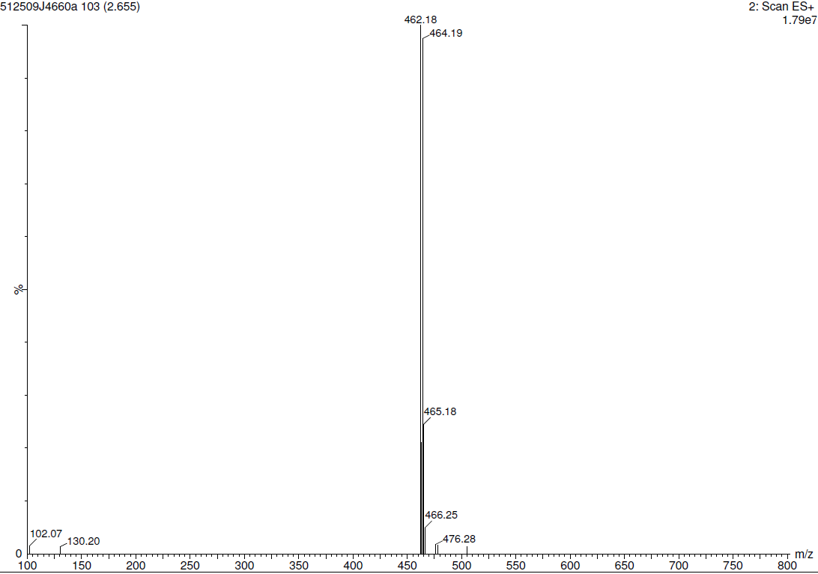
Mass spectrum of 4-(2-((3-bromophenyl)sulfonyl)-2,7-diazaspiro[3.5]nonan-7-yl)-7H-pyrrolo[2,3-d]pyrimidine (7c)

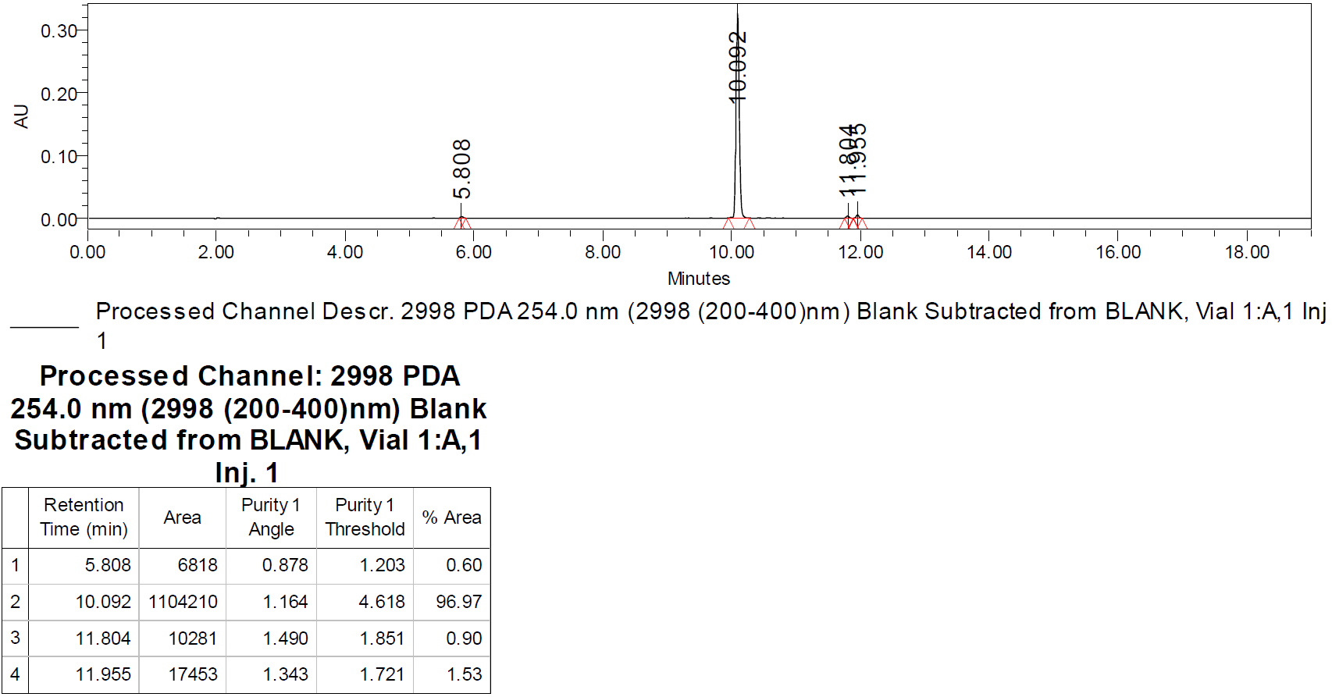
HPLC of 4-(2-((3-bromophenyl)sulfonyl)-2,7-diazaspiro[3.5]nonan-7-yl)-7H-pyrrolo[2,3-d]pyrimidine (7c)
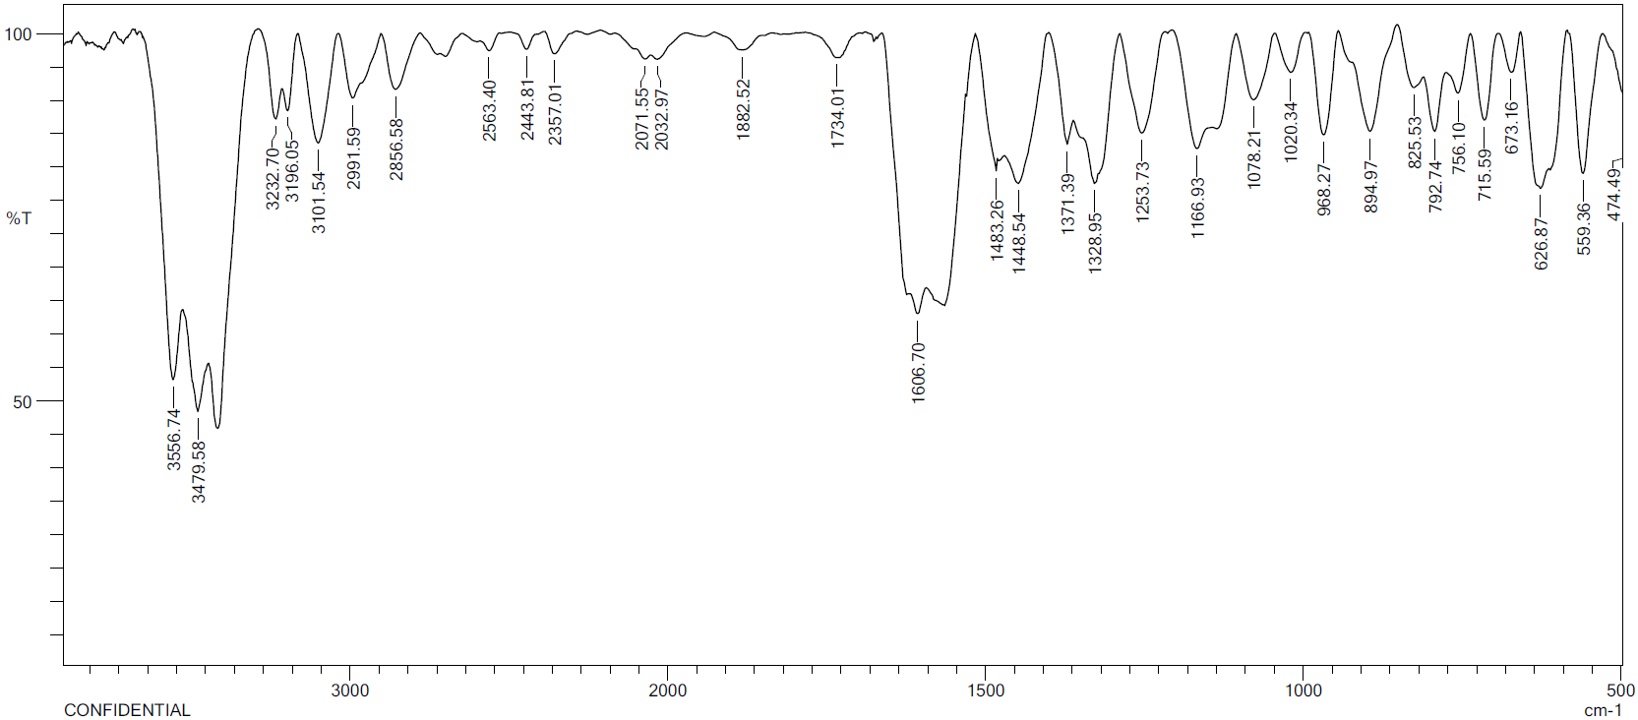
IR spectrum of 4-(2-((cyclopropylmethyl)sulfonyl)-2,7-diazaspiro[3.5]nonan-7-yl)-7H-pyrrolo[2,3-d]pyrimidine (7d)
¹H NMR spectrum of 4-(2-((cyclopropylmethyl)sulfonyl)-2,7-diazaspiro[3.5]nonan-7-yl)-7H-pyrrolo[2,3-d]pyrimidine (7d)
¹³C NMR spectrum of 4-(2-((cyclopropylmethyl)sulfonyl)-2,7-diazaspiro[3.5]nonan-7-yl)-7H-pyrrolo[2,3-d]pyrimidine (7d)
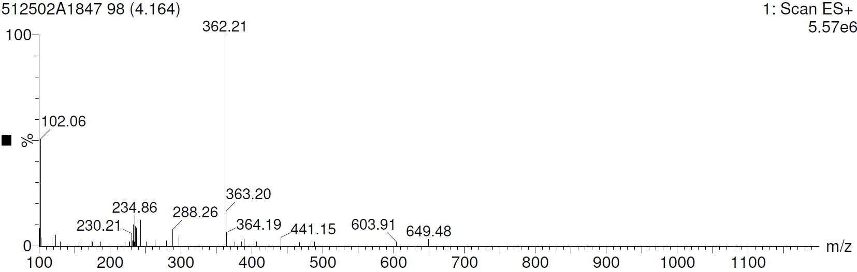
Mass spectrum of 4-(2-((cyclopropylmethyl)sulfonyl)-2,7-diazaspiro[3.5]nonan-7-yl)-7H-pyrrolo[2,3-d]pyrimidine (7d)
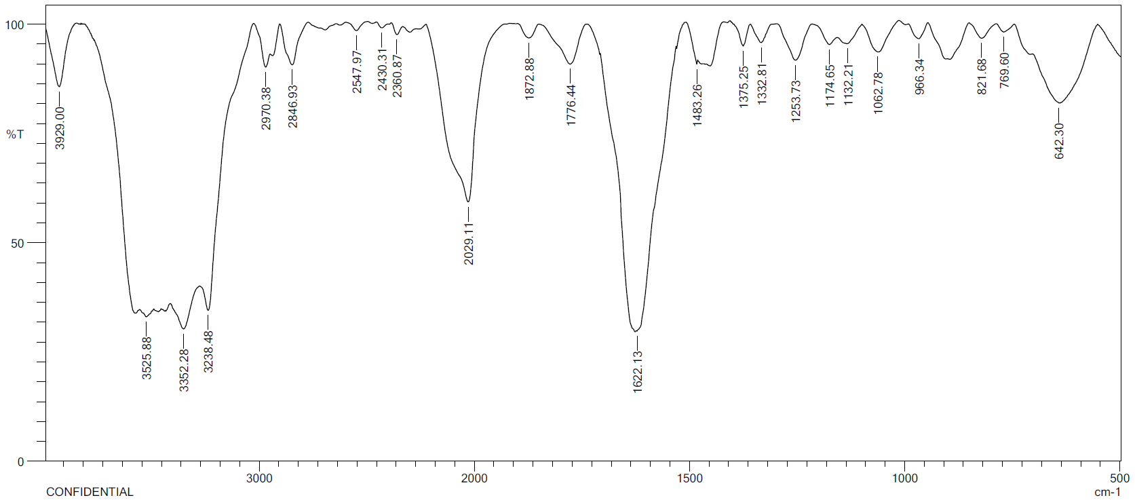
IR spectrum of 4-(2-(propylsulfonyl)-2,7-diazaspiro[3.5]nonan-7-yl)-7H-pyrrolo[2,3-d]pyrimidine (7e)
¹H NMR spectrum of 4-(2-(propylsulfonyl)-2,7-diazaspiro[3.5]nonan-7-yl)-7H-pyrrolo[2,3-d]pyrimidine (7e)
¹³C NMR spectrum of 4-(2-(propylsulfonyl)-2,7-diazaspiro[3.5]nonan-7-yl)-7H-pyrrolo[2,3-d]pyrimidine (7e)
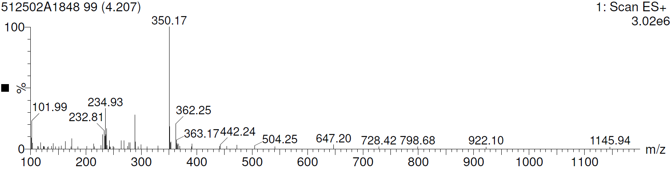
Mass spectrum of 4-(2-(propylsulfonyl)-2,7-diazaspiro[3.5]nonan-7-yl)-7H-pyrrolo[2,3-d]pyrimidine (7e)

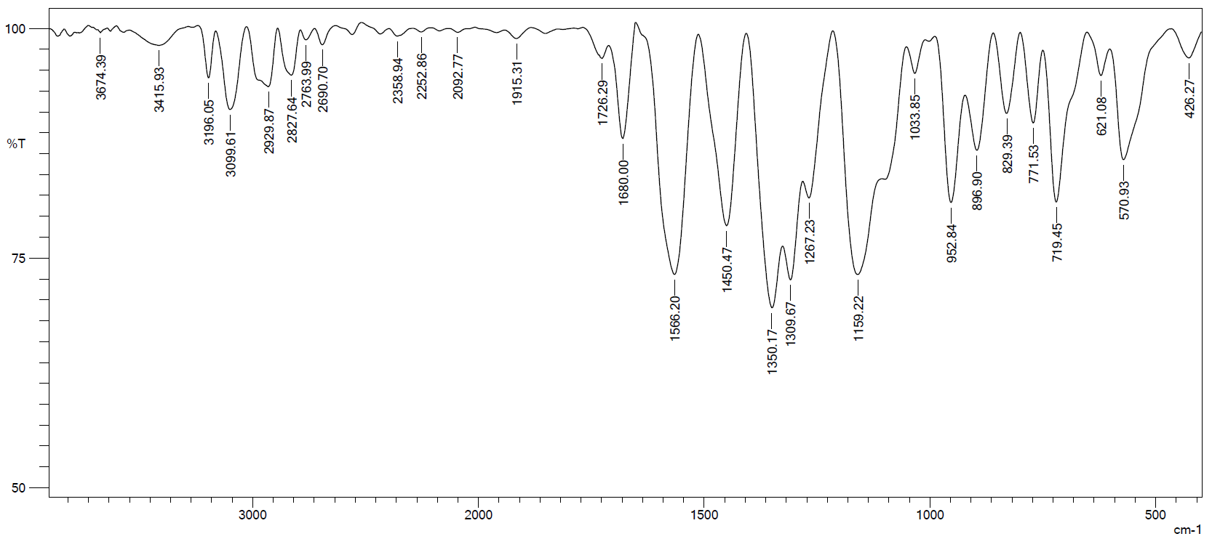
IR spectrum of 4-(4-((1-((2-(trifluoromethyl)phenyl)sulfonyl)piperidin-4-yl)methyl)piperazin-1-yl)-7H-pyrrolo[2,3-d]pyrimidine (12a)
¹H NMR spectrum of 4-(4-((1-((2-(trifluoromethyl)phenyl)sulfonyl)piperidin-4-yl)methyl)piperazin-1-yl)-7H-pyrrolo[2,3-d]pyrimidine (12a)
¹³C NMR spectrum of 4-(4-((1-((2-(trifluoromethyl)phenyl)sulfonyl)piperidin-4-yl)methyl)piperazin-1-yl)-7H-pyrrolo[2,3-d]pyrimidine (12a)

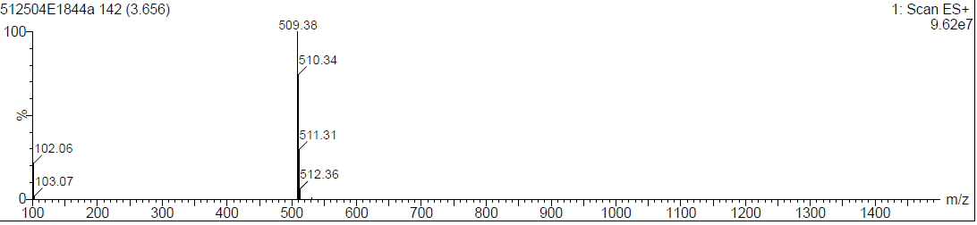
Mass spectrum of 4-(4-((1-((2-(trifluoromethyl)phenyl)sulfonyl)piperidin-4-yl)methyl)piperazin-1-yl)-7H-pyrrolo[2,3-d]pyrimidine (12a)
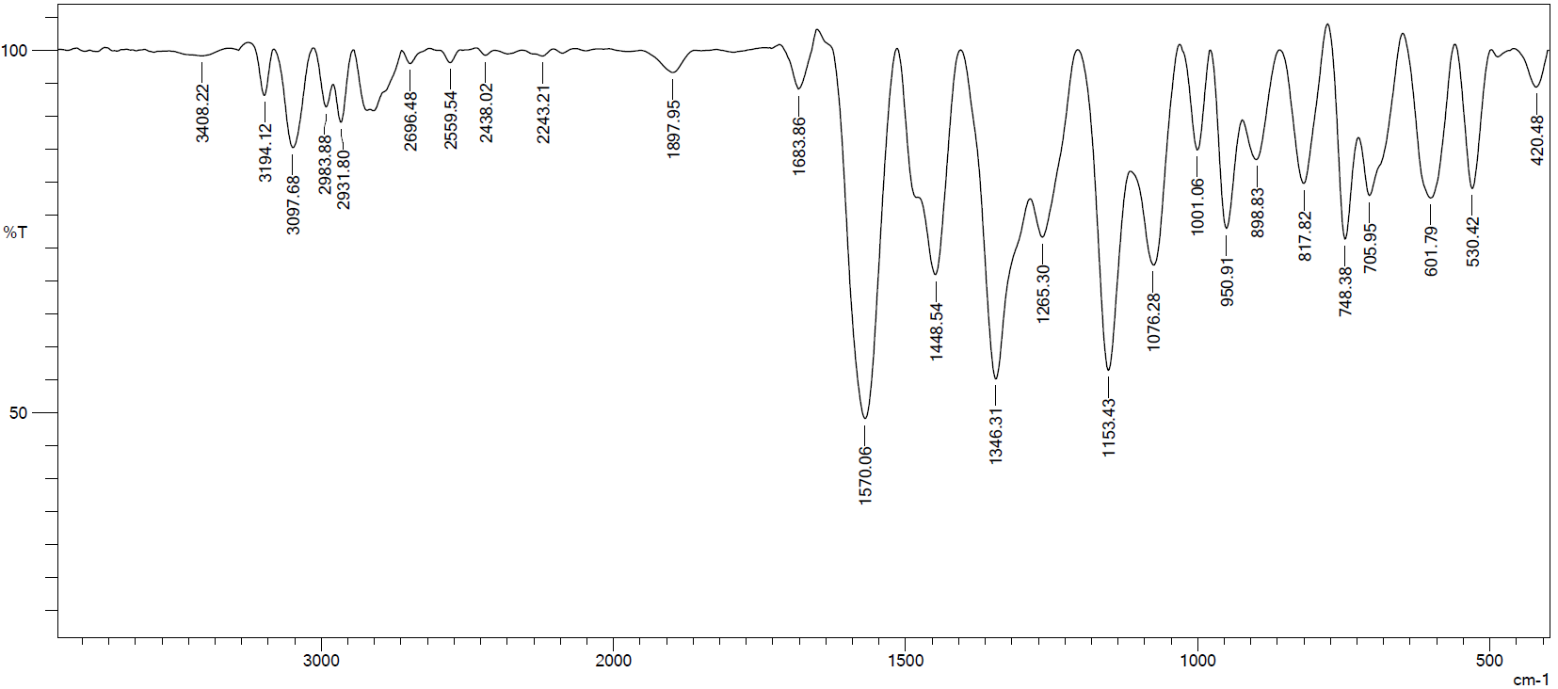
IR spectrum of 4-(4-((1-((4-bromophenyl)sulfonyl)piperidin-4-yl)methyl)piperazin-1-yl)-7H-pyrrolo[2,3-d]pyrimidine (12b)
¹H NMR spectrum of 4-(4-((1-((4-bromophenyl)sulfonyl)piperidin-4-yl)methyl)piperazin-1-yl)-7H-pyrrolo[2,3-d]pyrimidine (12b)
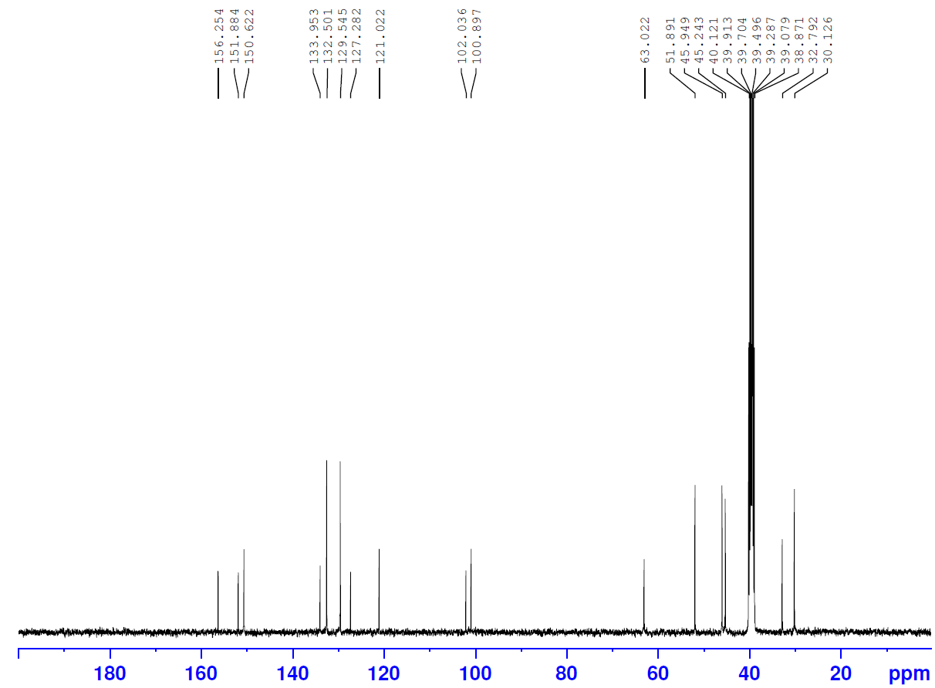
¹³C NMR spectrum of 4-(4-((1-((4-bromophenyl)sulfonyl)piperidin-4-yl)methyl)piperazin-1-yl)-7H-pyrrolo[2,3-d]pyrimidine (12b)
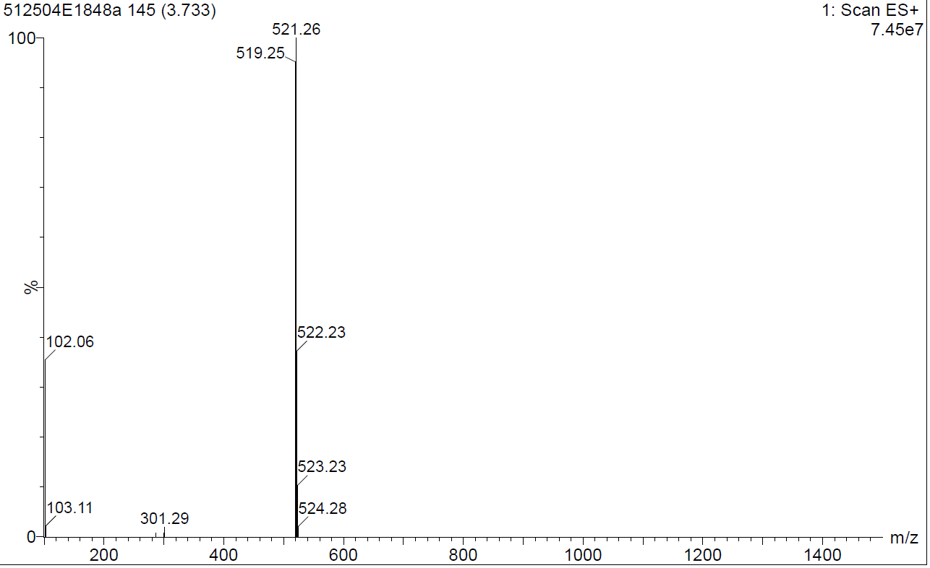
Mass spectrum of 4-(4-((1-((4-bromophenyl)sulfonyl)piperidin-4-yl)methyl)piperazin-1-yl)-7H-pyrrolo[2,3-d]pyrimidine (12b)
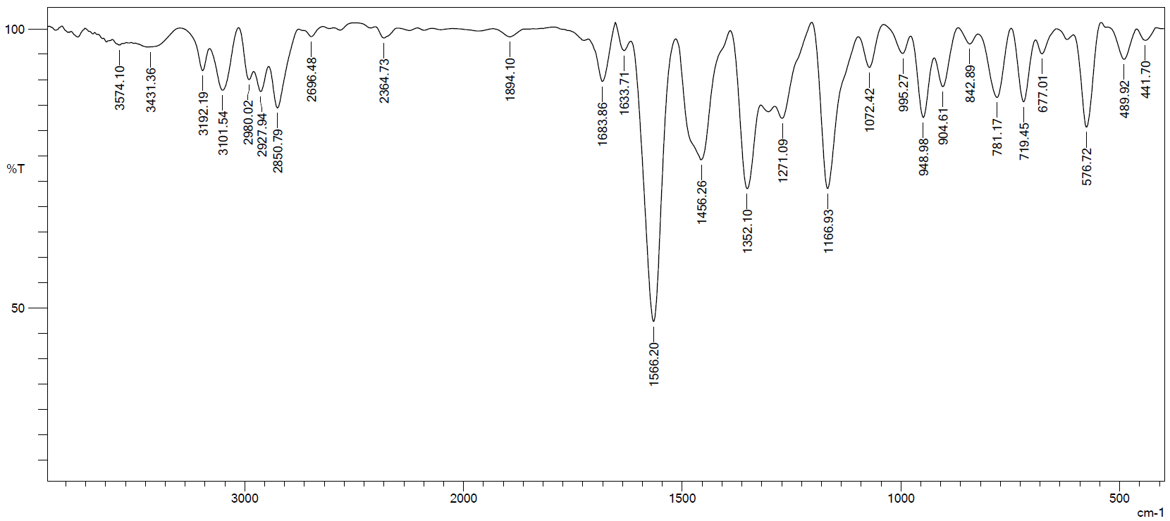
IR spectrum of 4-(4-((1-((2-bromophenyl)sulfonyl)piperidin-4-yl)methyl)piperazin-1-yl)-7H-pyrrolo[2,3-d]pyrimidine (12c)
¹H NMR spectrum of 4-(4-((1-((2-bromophenyl)sulfonyl)piperidin-4-yl)methyl)piperazin-1-yl)-7H-pyrrolo[2,3-d]pyrimidine (12c)
¹³C NMR spectrum of 4-(4-((1-((2-bromophenyl)sulfonyl)piperidin-4-yl)methyl)piperazin-1-yl)-7H-pyrrolo[2,3-d]pyrimidine (12c)
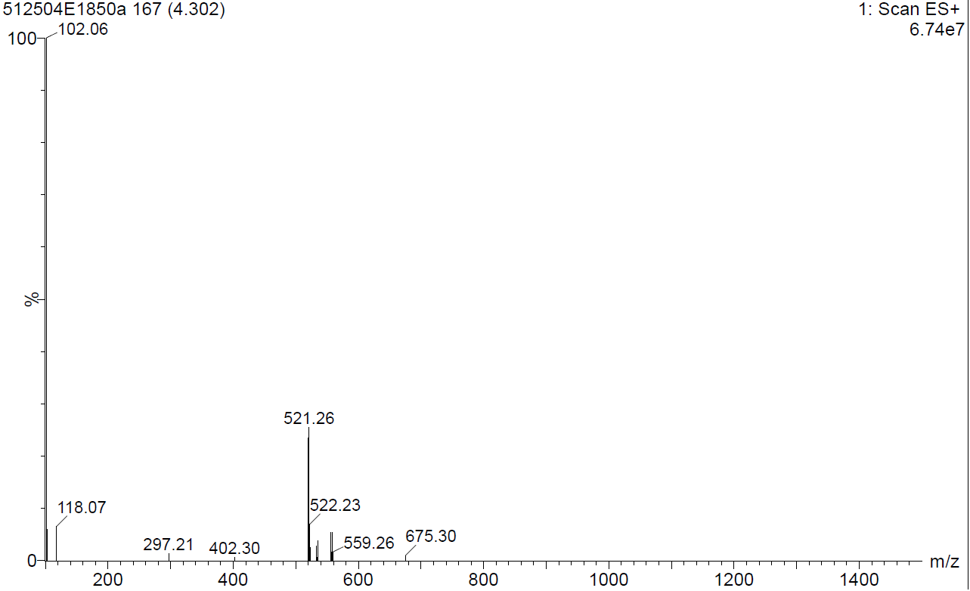
Mass spectrum of 4-(4-((1-((2-bromophenyl)sulfonyl)piperidin-4-yl)methyl)piperazin-1-yl)-7H-pyrrolo[2,3-d]pyrimidine (12c)
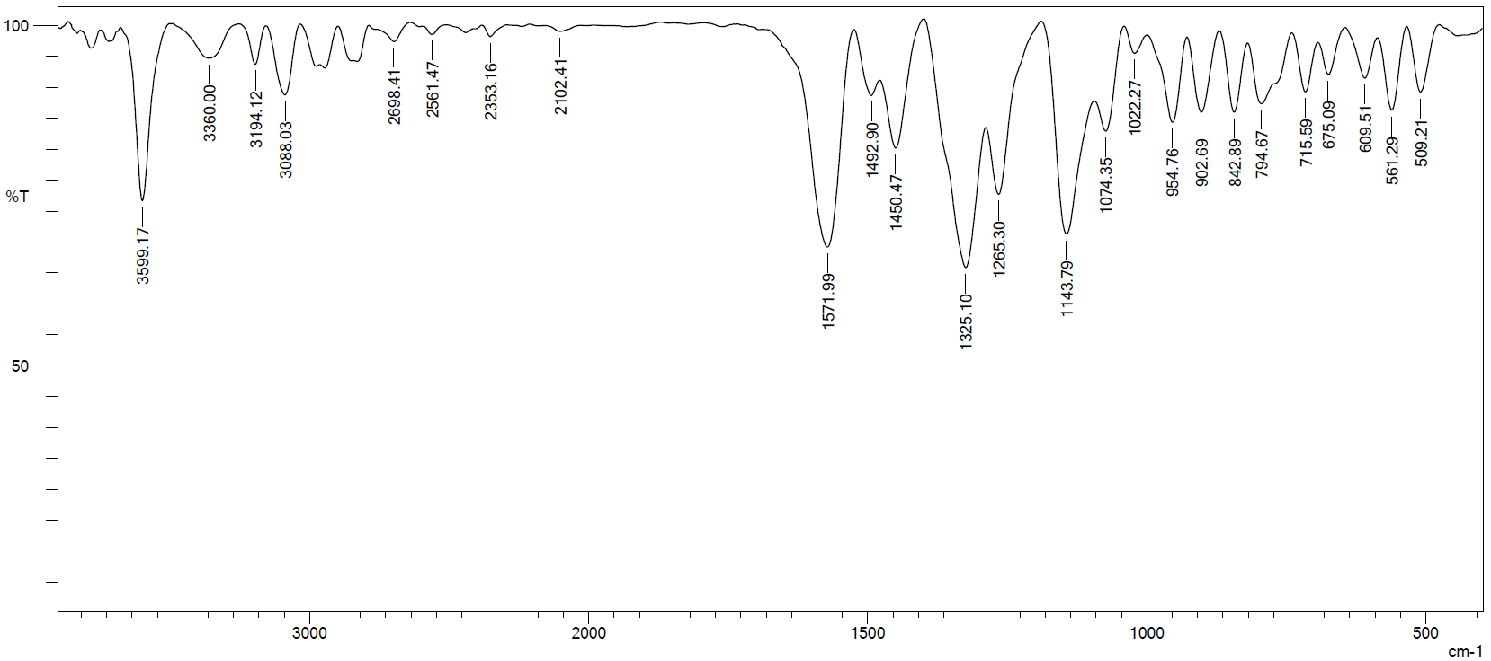
IR spectrum of4-(4-((1-((cyclopropylmethyl)sulfonyl)piperidin-4-yl)methyl)piperazin-1-yl)-7H-pyrrolo[2,3-d]pyrimidine (12d)
¹H NMR spectrum of4-(4-((1-((cyclopropylmethyl)sulfonyl)piperidin-4-yl)methyl)piperazin-1-yl)-7H-pyrrolo[2,3-d]pyrimidine (12d)
¹³C NMR spectrum of4-(4-((1-((cyclopropylmethyl)sulfonyl)piperidin-4-yl)methyl)piperazin-1-yl)-7H-pyrrolo[2,3-d]pyrimidine (12d)
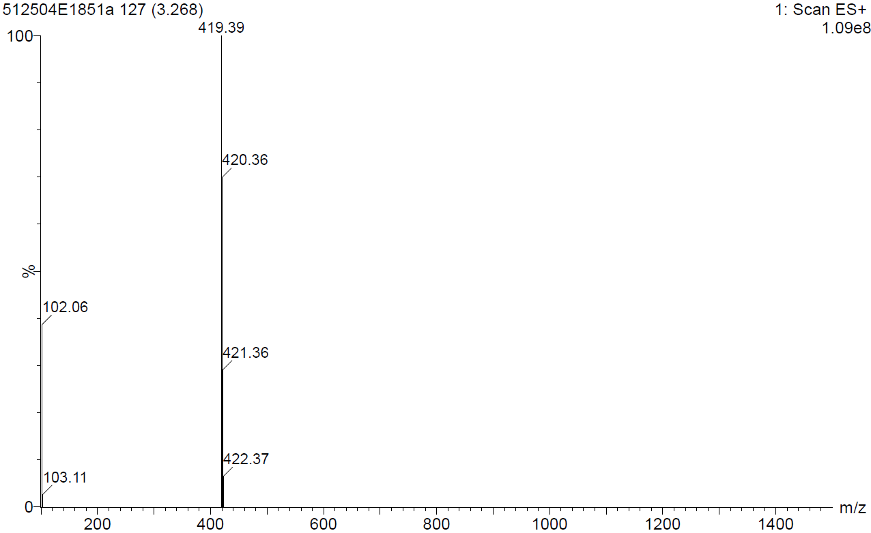
Mass spectrum of4-(4-((1-((cyclopropylmethyl)sulfonyl)piperidin-4-yl)methyl)piperazin-1-yl)-7H-pyrrolo[2,3-d]pyrimidine (12d)
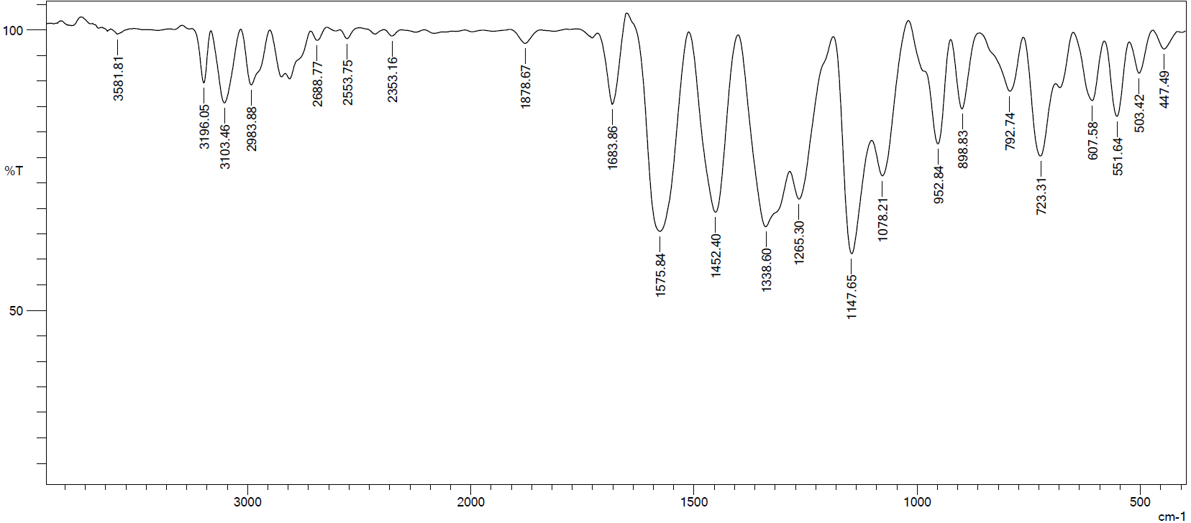
IR spectrum of 4-(4-((1-(propylsulfonyl)piperidin-4-yl)methyl)piperazin-1-yl)-7H-pyrrolo[2,3-d]pyrimidine (12e)
¹H NMR spectrum of 4-(4-((1-(propylsulfonyl)piperidin-4-yl)methyl)piperazin-1-yl)-7H-pyrrolo[2,3-d]pyrimidine (12e)
¹³C NMR spectrum of 4-(4-((1-(propylsulfonyl)piperidin-4-yl)methyl)piperazin-1-yl)-7H-pyrrolo[2,3-d]pyrimidine (12e)
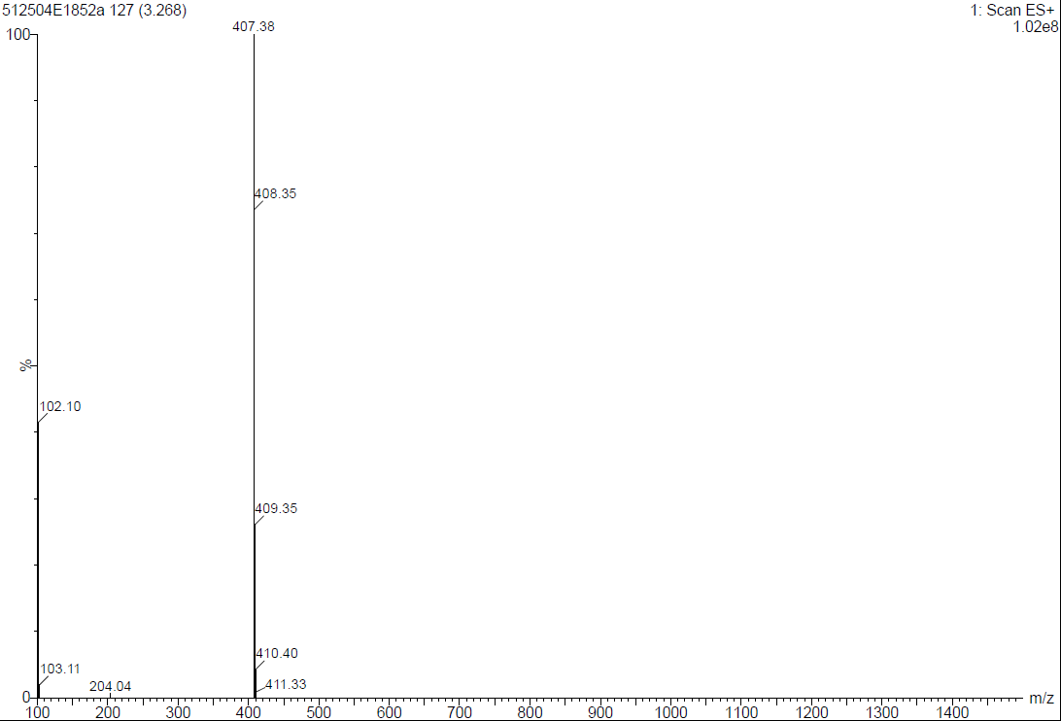
Mass spectrum of 4-(4-((1-(propylsulfonyl)piperidin-4-yl)methyl)piperazin-1-yl)-7H-pyrrolo[2,3-d]pyrimidine (12e)
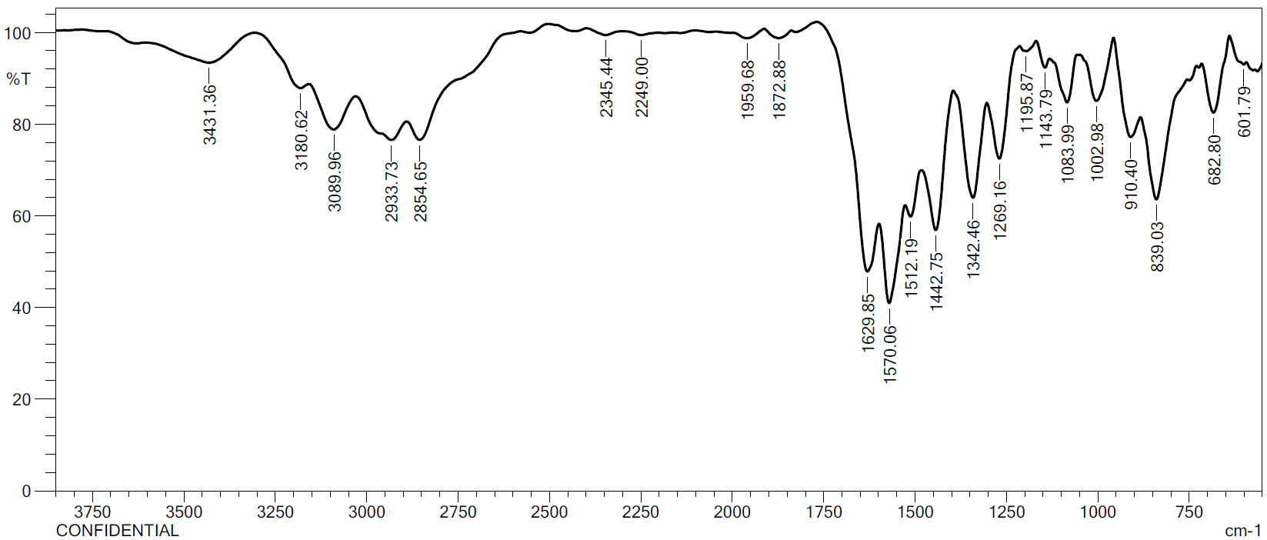
IR spectrum of (9-(7H-pyrrolo[2,3-d]pyrimidin-4-yl)-3,9-diazaspiro[5.5]undecan-3-yl)(4-methyl-3-nitrophenyl)methanone (18a)
¹H NMR spectrum of (9-(7H-pyrrolo[2,3-d]pyrimidin-4-yl)-3,9-diazaspiro[5.5]undecan-3-yl)(4-methyl-3-nitrophenyl)methanone (18a)
¹³C NMR spectrum of (9-(7H-pyrrolo[2,3-d]pyrimidin-4-yl)-3,9-diazaspiro[5.5]undecan-3-yl)(4-methyl-3-nitrophenyl)methanone (18a)
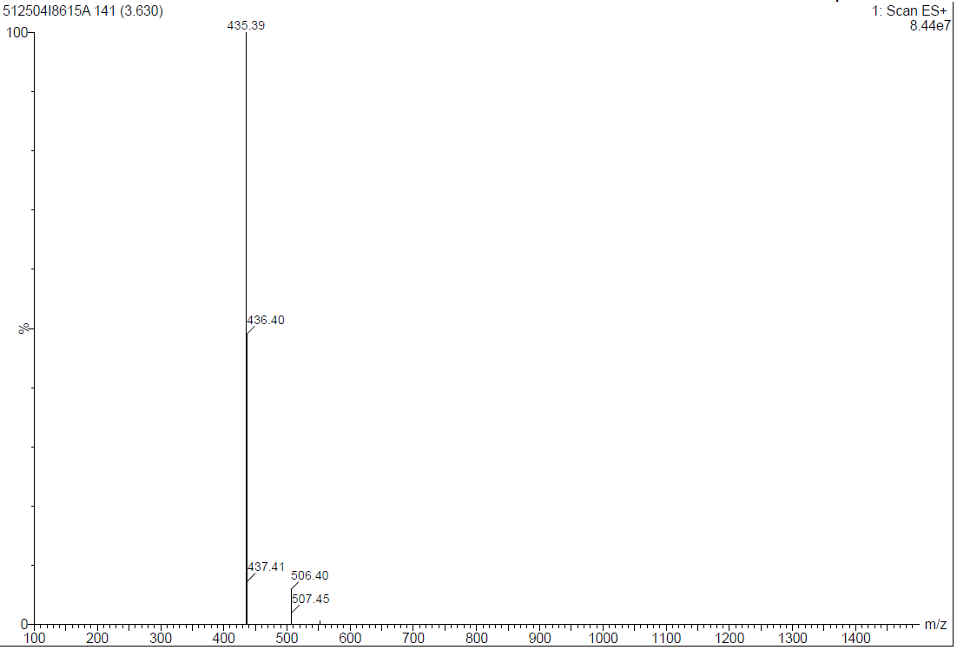
Mass spectrum of (9-(7H-pyrrolo[2,3-d]pyrimidin-4-yl)-3,9-diazaspiro[5.5]undecan-3-yl)(4-methyl-3-nitrophenyl)methanone (18a)
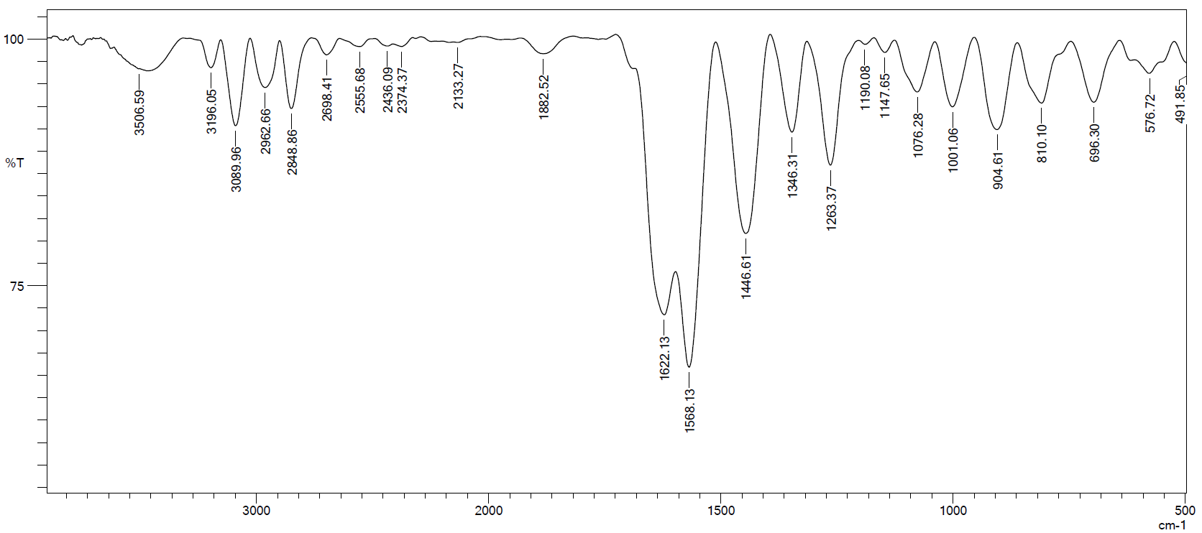
IR spectrum of (9-(7H-pyrrolo[2,3-d]pyrimidin-4-yl)-3,9-diazaspiro[5.5]undecan-3-yl)(4-bromo-2-chlorophenyl)methanone (18b)
¹H NMR spectrum of (9-(7H-pyrrolo[2,3-d]pyrimidin-4-yl)-3,9-diazaspiro[5.5]undecan-3-yl)(4-bromo-2-chlorophenyl)methanone (18b)

¹H NMR spectrum of (9-(7H-pyrrolo[2,3-d]pyrimidin-4-yl)-3,9-diazaspiro[5.5]undecan-3-yl)(4-bromo-2-chlorophenyl)methanone (18b)

¹³C NMR spectrum of (9-(7H-pyrrolo[2,3-d]pyrimidin-4-yl)-3,9-diazaspiro[5.5]undecan-3-yl)(4-bromo-2-chlorophenyl)methanone (18b)
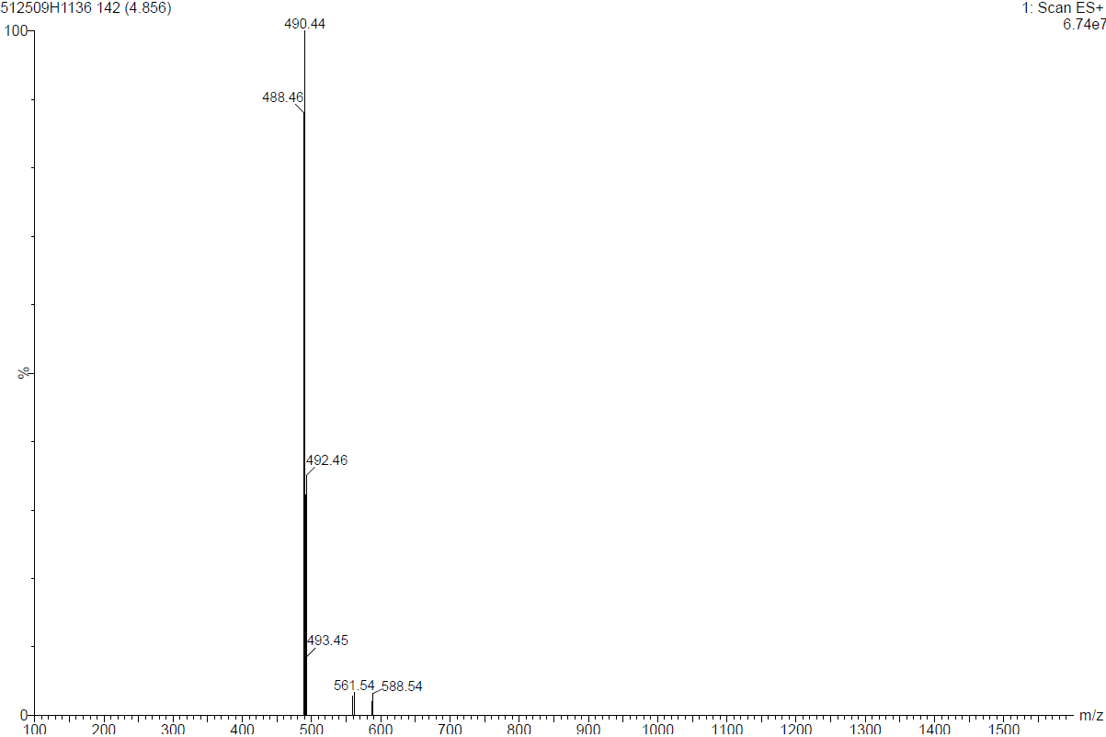
Mass spectrum of (9-(7H-pyrrolo[2,3-d]pyrimidin-4-yl)-3,9-diazaspiro[5.5]undecan-3-yl)(4-bromo-2-chlorophenyl)methanone (18b)
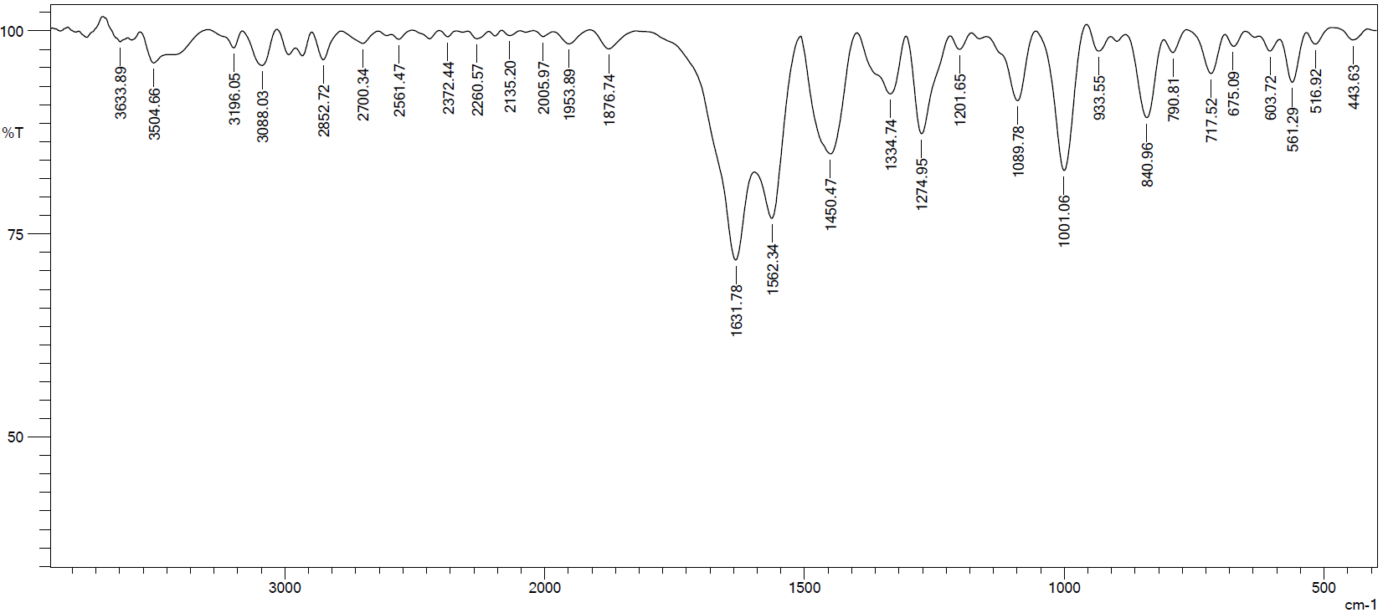
IR spectrum of (9-(7H-pyrrolo[2,3-d]pyrimidin-4-yl)-3,9-diazaspiro[5.5]undecan-3-yl)(2,6-difluorophenyl)methanone (18c)
¹H NMR spectrum of (9-(7H-pyrrolo[2,3-d]pyrimidin-4-yl)-3,9-diazaspiro[5.5]undecan-3-yl)(2,6-difluorophenyl)methanone (18c)
¹³C NMR spectrum of (9-(7H-pyrrolo[2,3-d]pyrimidin-4-yl)-3,9-diazaspiro[5.5]undecan-3-yl)(2,6-difluorophenyl)methanone (18c)

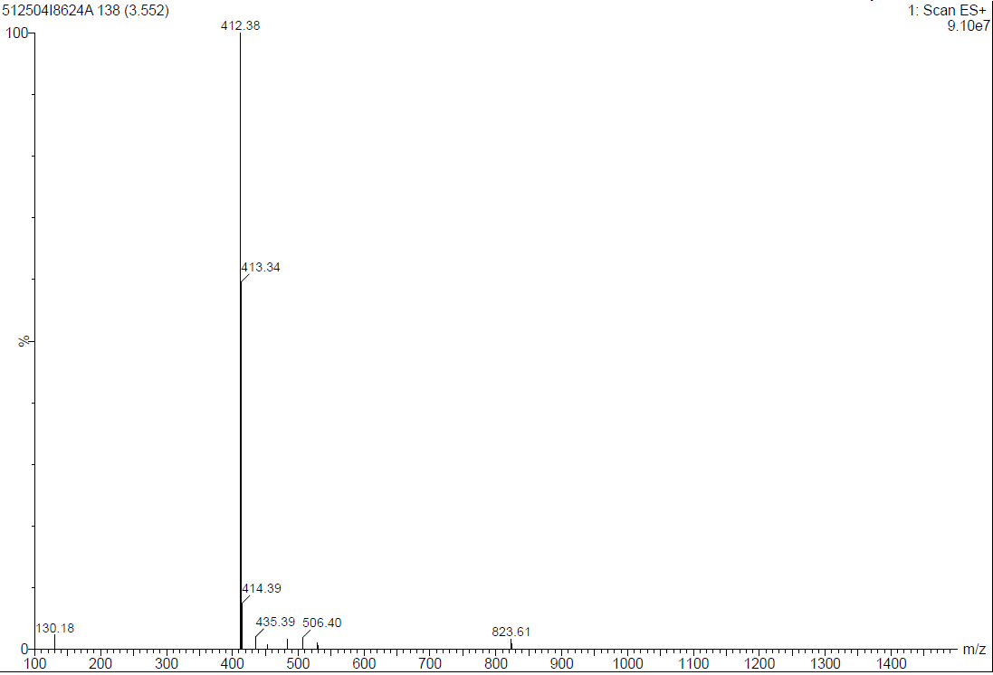
Mass spectrum of (9-(7H-pyrrolo[2,3-d]pyrimidin-4-yl)-3,9-diazaspiro[5.5]undecan-3-yl)(2,6-difluorophenyl)methanone (18c)
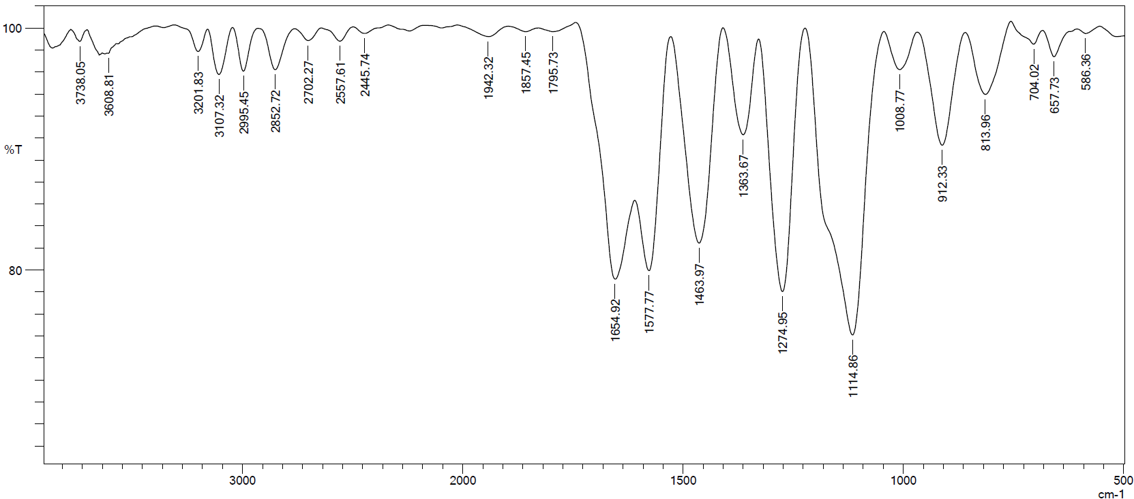
IR spectrum of (9-(7H-pyrrolo[2,3-d]pyrimidin-4-yl)-3,9-diazaspiro[5.5]undecan-3-yl)(2,6-bis(trifluoromethyl)phenyl)methanone (18d)
¹H NMR spectrum of (9-(7H-pyrrolo[2,3-d]pyrimidin-4-yl)-3,9-diazaspiro[5.5]undecan-3-yl)(2,6-bis(trifluoromethyl)phenyl)methanone (18d)
¹³C NMR spectrum of (9-(7H-pyrrolo[2,3-d]pyrimidin-4-yl)-3,9-diazaspiro[5.5]undecan-3-yl)(2,6-bis(trifluoromethyl)phenyl)methanone (18d)
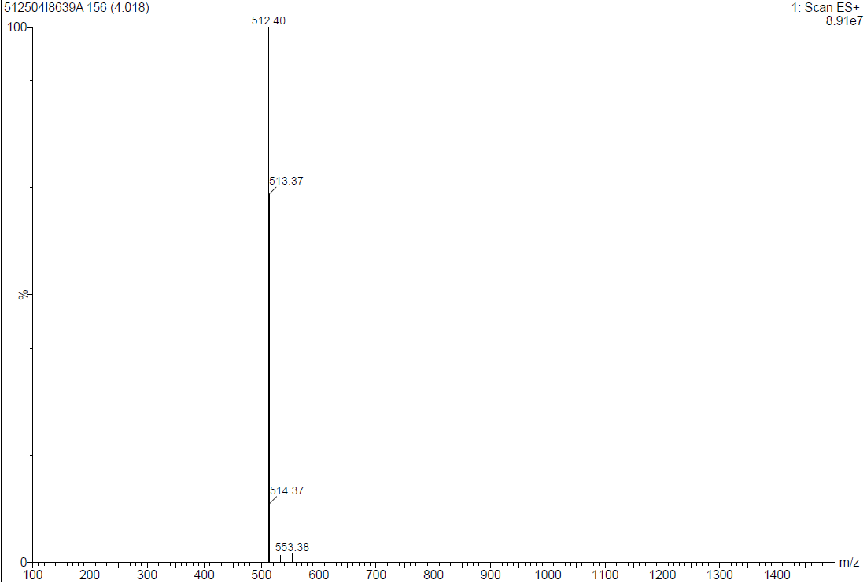
Mass spectrum of (9-(7H-pyrrolo[2,3-d]pyrimidin-4-yl)-3,9-diazaspiro[5.5]undecan-3-yl)(2,6-bis(trifluoromethyl)phenyl)methanone (18d)
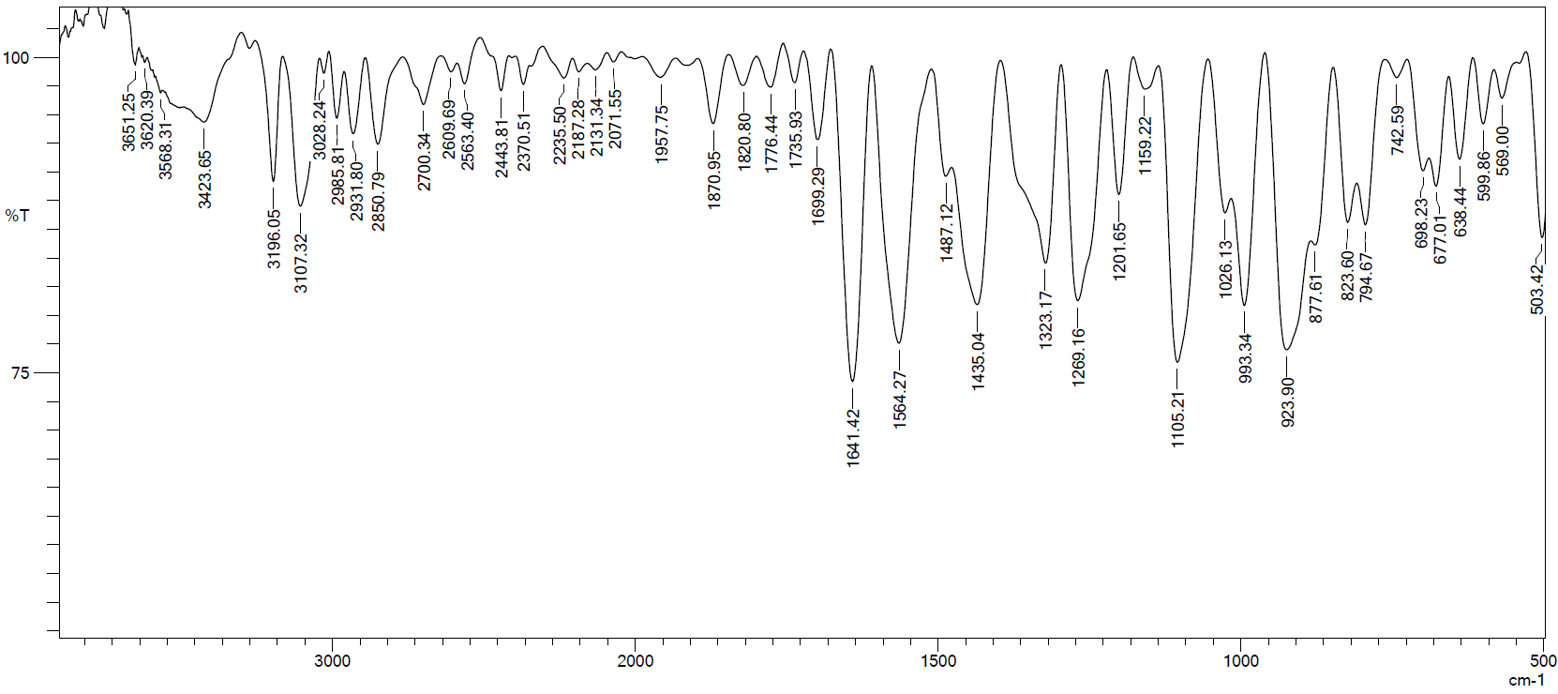
IR spectrum of (9-(7H-pyrrolo[2,3-d]pyrimidin-4-yl)-3,9-diazaspiro[5.5]undecan-3-yl)(2-chloropyridin-4-yl)methanone (18e)

¹H NMR spectrum of (9-(7H-pyrrolo[2,3-d]pyrimidin-4-yl)-3,9-diazaspiro[5.5]undecan-3-yl)(2-chloropyridin-4-yl)methanone (18e)
¹³C NMR spectrum of (9-(7H-pyrrolo[2,3-d]pyrimidin-4-yl)-3,9-diazaspiro[5.5]undecan-3-yl)(2-chloropyridin-4-yl)methanone (18e)
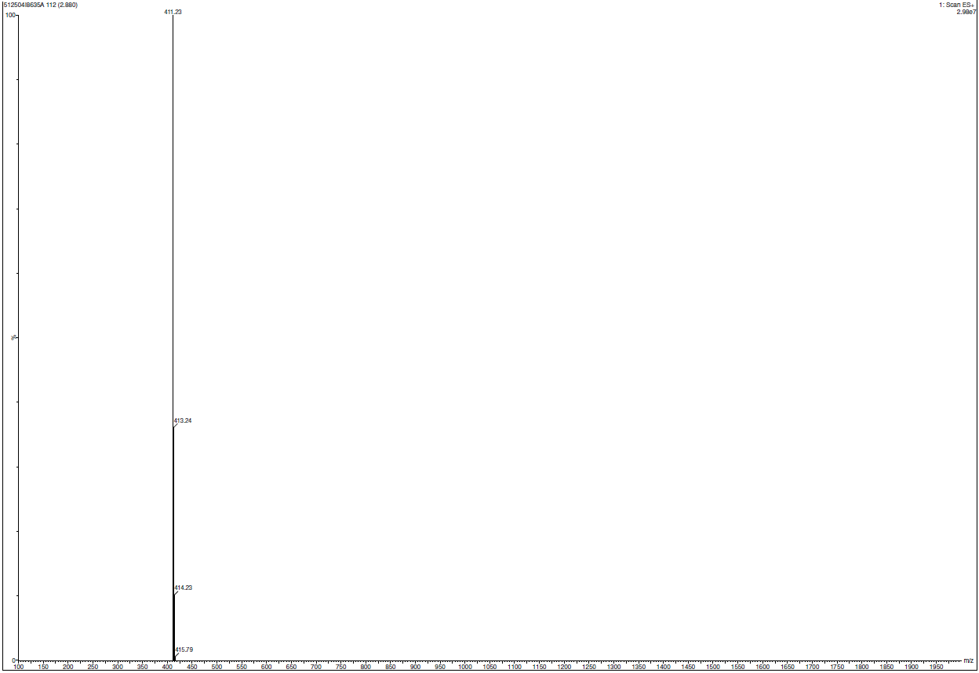
Mass spectrum of (9-(7H-pyrrolo[2,3-d]pyrimidin-4-yl)-3,9-diazaspiro[5.5]undecan-3-yl)(2-chloropyridin-4-yl)methanone (18e)
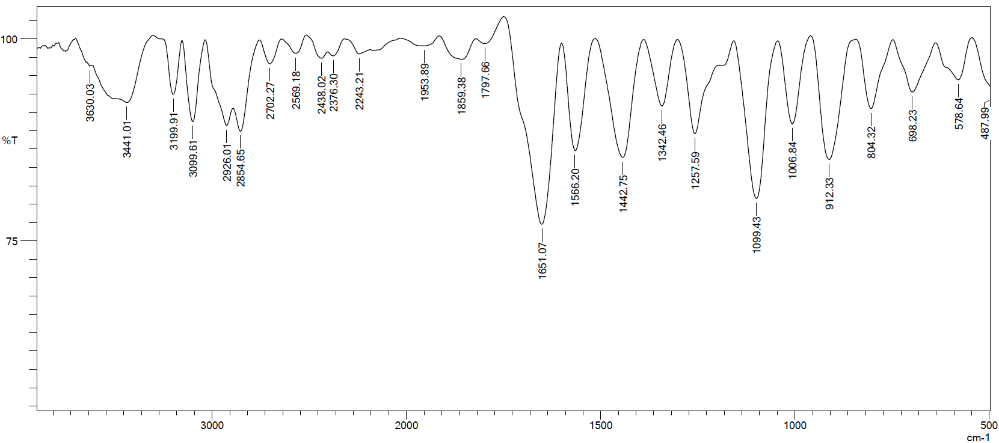
IR spectrum of (9-(7H-pyrrolo[2,3-d]pyrimidin-4-yl)-3,9-diazaspiro[5.5]undecan-3-yl)(5-bromo-2-chloropyridin-4-yl)methanone (18f)

¹H NMR spectrum of (9-(7H-pyrrolo[2,3-d]pyrimidin-4-yl)-3,9-diazaspiro[5.5]undecan-3-yl)(5-bromo-2-chloropyridin-4-yl)methanone (18f)
¹³C NMR spectrum of (9-(7H-pyrrolo[2,3-d]pyrimidin-4-yl)-3,9-diazaspiro[5.5]undecan-3-yl)(5-bromo-2-chloropyridin-4-yl)methanone (18f)
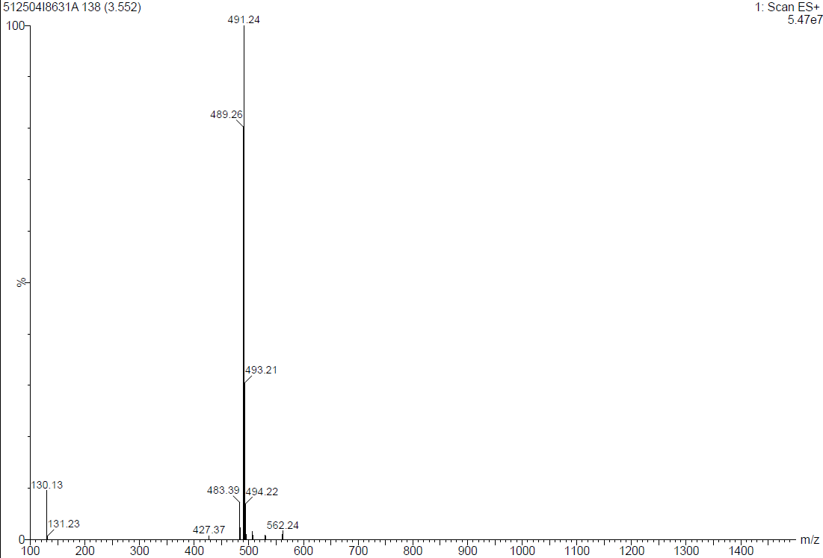
Mass spectrum of (9-(7H-pyrrolo[2,3-d]pyrimidin-4-yl)-3,9-diazaspiro[5.5]undecan-3-yl)(5-bromo-2-chloropyridin-4-yl)methanone (18f)
¹H NMR spectrum of tert-butyl 7-(7-tosyl-7H-pyrrolo[2,3-d]pyrimidin-4-yl)-2,7-diazaspiro[3.5]nonane-2-carboxylate (3)
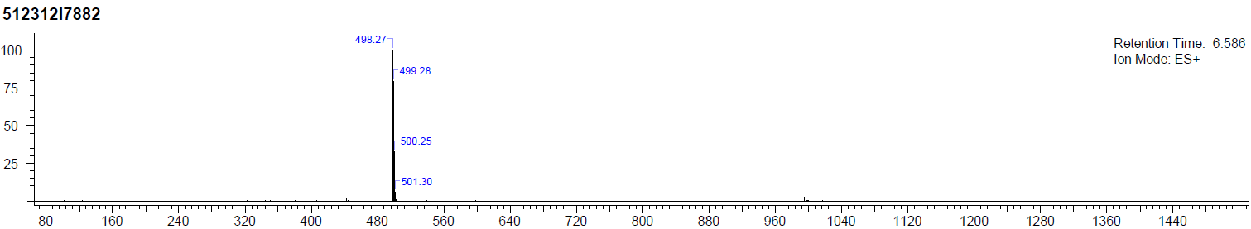
Mass spectrum of tert-butyl 7-(7-tosyl-7H-pyrrolo[2,3-d]pyrimidin-4-yl)-2,7-diazaspiro[3.5]nonane-2-carboxylate (3)
¹H NMR spectrum of 4-(2,7-diazaspiro[3.5]nonan-7-yl)-7-tosyl-7H-pyrrolo[2,3-d]pyrimidine (4)
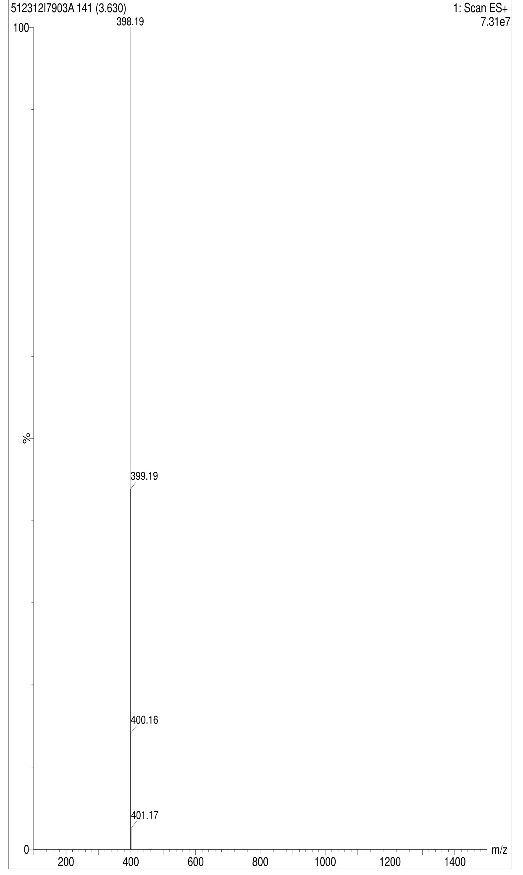
Mass spectrum of 4-(2,7-diazaspiro[3.5]nonan-7-yl)-7-tosyl-7H-pyrrolo[2,3-d]pyrimidine (4)
¹H NMR spectrum of 7-tosyl-4-(2-((2-(trifluoromethyl)phenyl)sulfonyl)-2,7-diazaspiro[3.5]nonan-7-yl)-7H-pyrrolo[2,3-d]pyrimidine (6a)
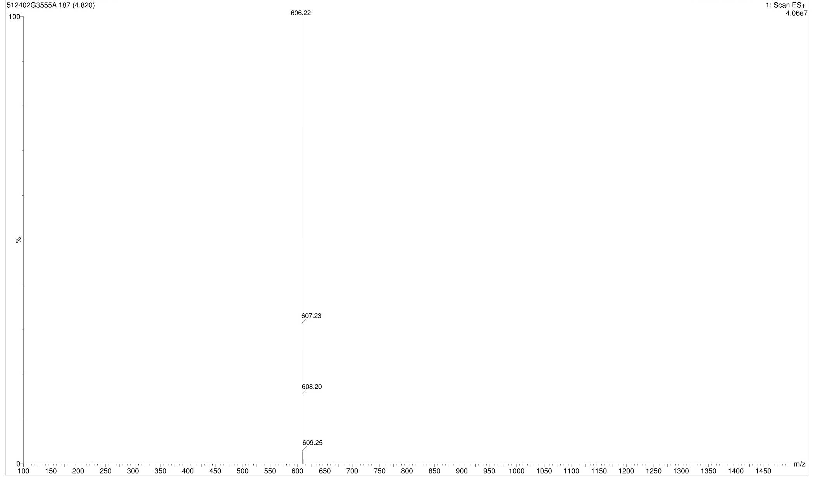
Mass spectrum of 7-tosyl-4-(2-((2-(trifluoromethyl)phenyl)sulfonyl)-2,7-diazaspiro[3.5]nonan-7-yl)-7H-pyrrolo[2,3-d]pyrimidine (6a)
¹H NMR spectrum of 4-(2-((4-bromophenyl)sulfonyl)-2,7-diazaspiro[3.5]nonan-7-yl)-7-tosyl-7H-pyrrolo[2,3-d]pyrimidine (6b)
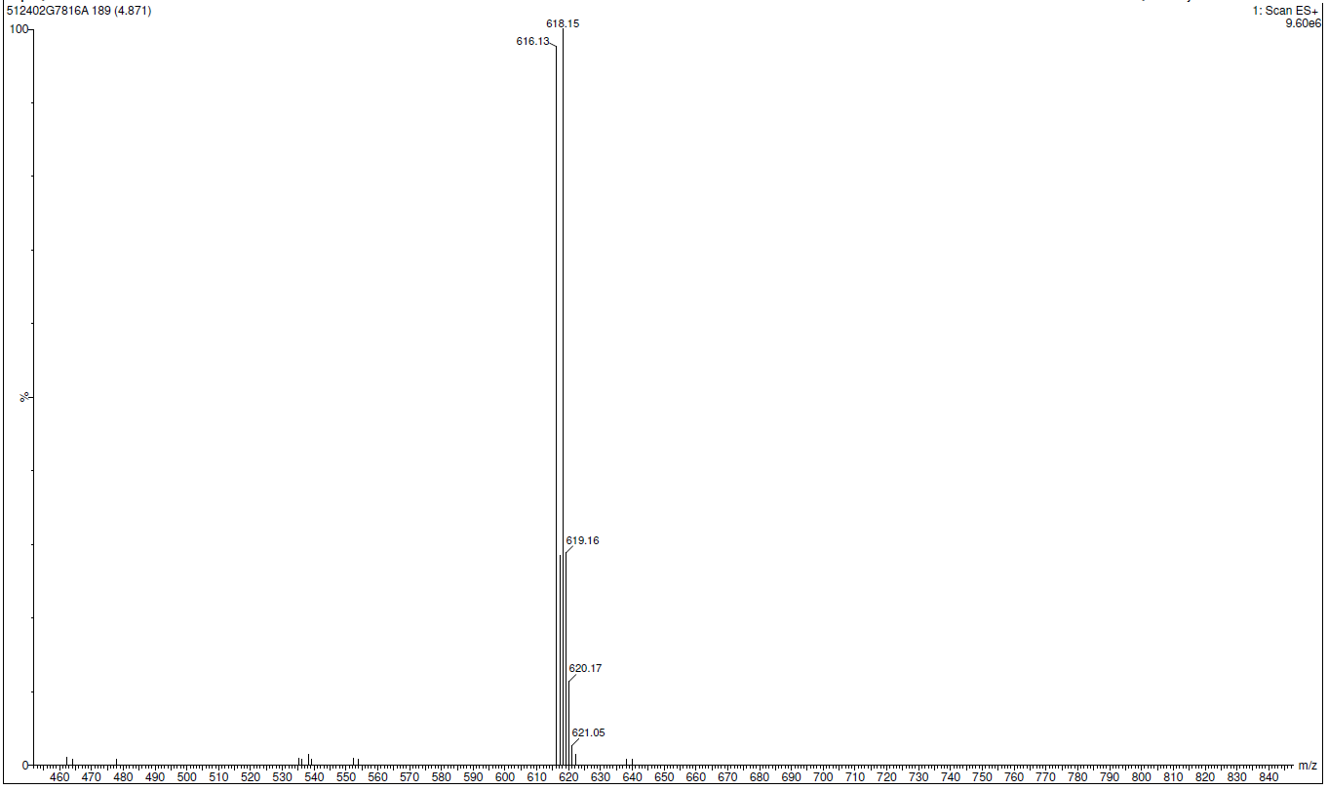
Mass spectrum of 4-(2-((4-bromophenyl)sulfonyl)-2,7-diazaspiro[3.5]nonan-7-yl)-7-tosyl-7H-pyrrolo[2,3-d]pyrimidine (6b)
¹H NMR spectrum of 4-(2-((3-bromophenyl)sulfonyl)-2,7-diazaspiro[3.5]nonan-7-yl)-7-tosyl-7H-pyrrolo[2,3-d]pyrimidine (6c)
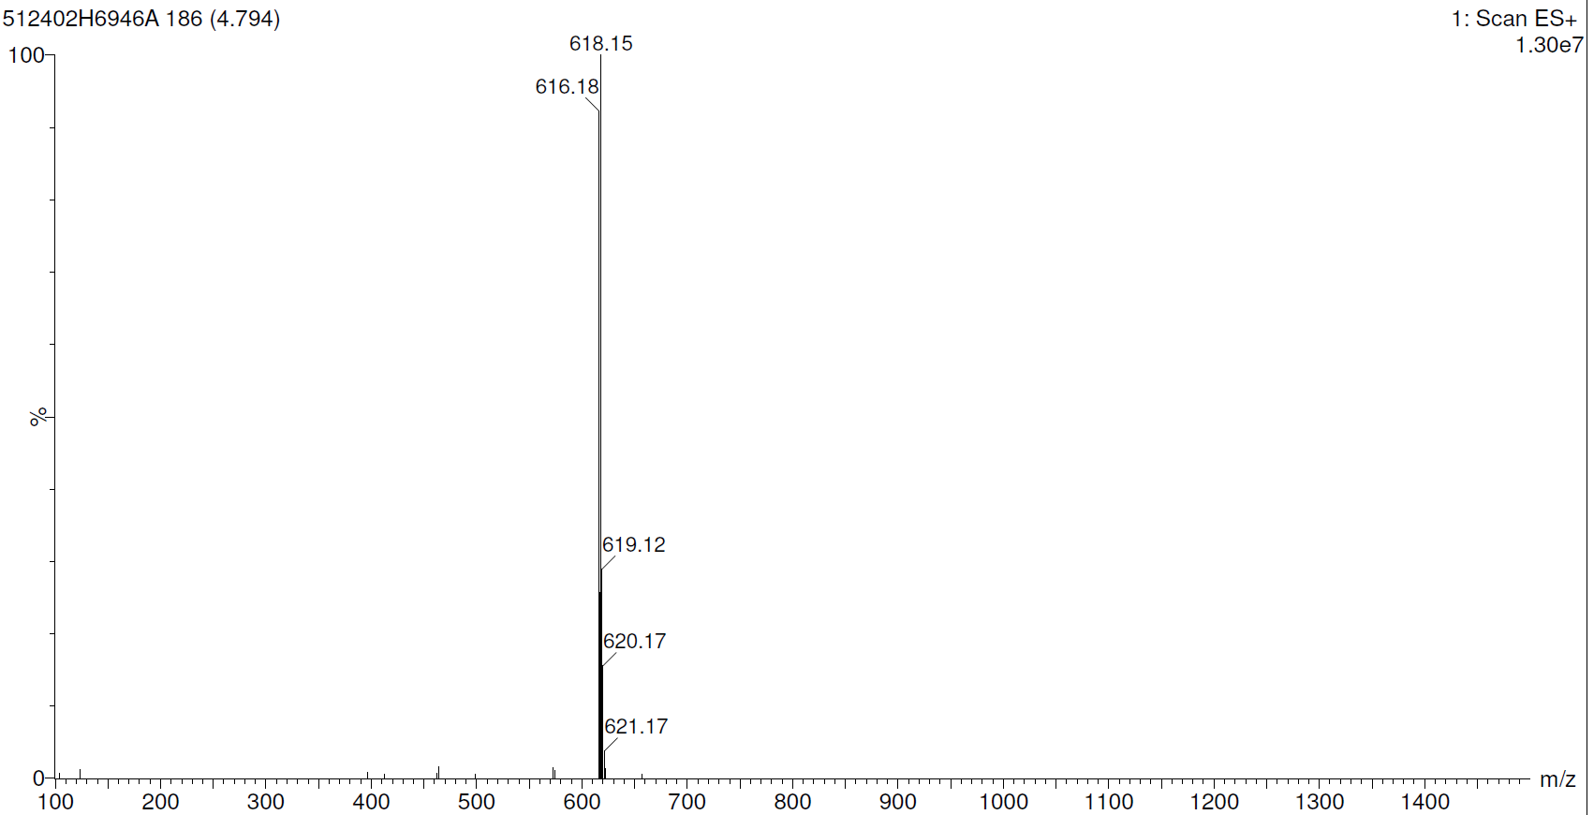
Mass spectrum of 4-(2-((3-bromophenyl)sulfonyl)-2,7-diazaspiro[3.5]nonan-7-yl)-7-tosyl-7H-pyrrolo[2,3-d]pyrimidine (6c)
¹H NMR spectrum of 4-(2-((cyclopropylmethyl)sulfonyl)-2,7-diazaspiro[3.5]nonan-7-yl)-7-tosyl-7H-pyrrolo[2,3-d]pyrimidine (6d)
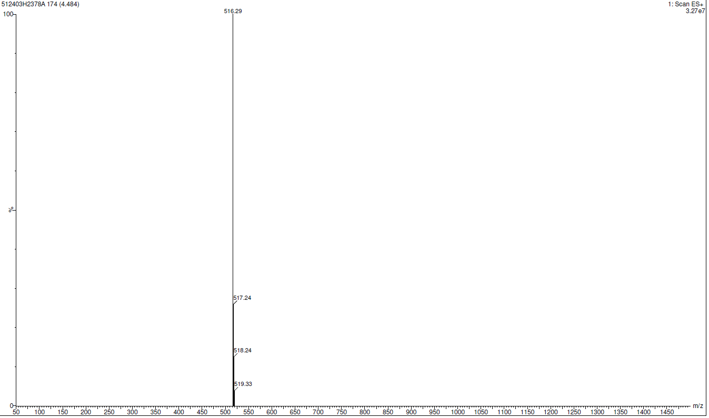
Mass spectrum of 4-(2-((cyclopropylmethyl)sulfonyl)-2,7-diazaspiro[3.5]nonan-7-yl)-7-tosyl-7H-pyrrolo[2,3-d]pyrimidine (6d)
¹H NMR spectrum of 4-(2-(propylsulfonyl)-2,7-diazaspiro[3.5]nonan-7-yl)-7-tosyl-7H-pyrrolo[2,3-d]pyrimidine (6e)
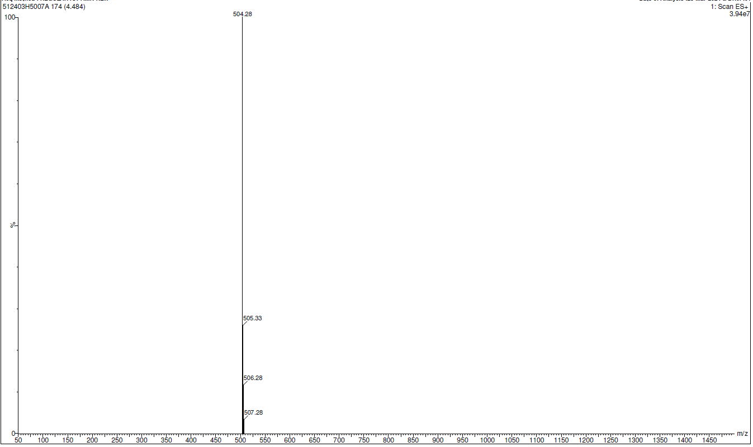
Mass spectrum of 4-(2-(propylsulfonyl)-2,7-diazaspiro[3.5]nonan-7-yl)-7-tosyl-7H-pyrrolo[2,3-d]pyrimidine (6e)
¹H NMR spectrum of tert-butyl 4-((4-(7-tosyl-7H-pyrrolo[2,3-d]pyrimidin-4-yl)piperazin-1-yl)methyl) piperidine-1-carboxylate (9)
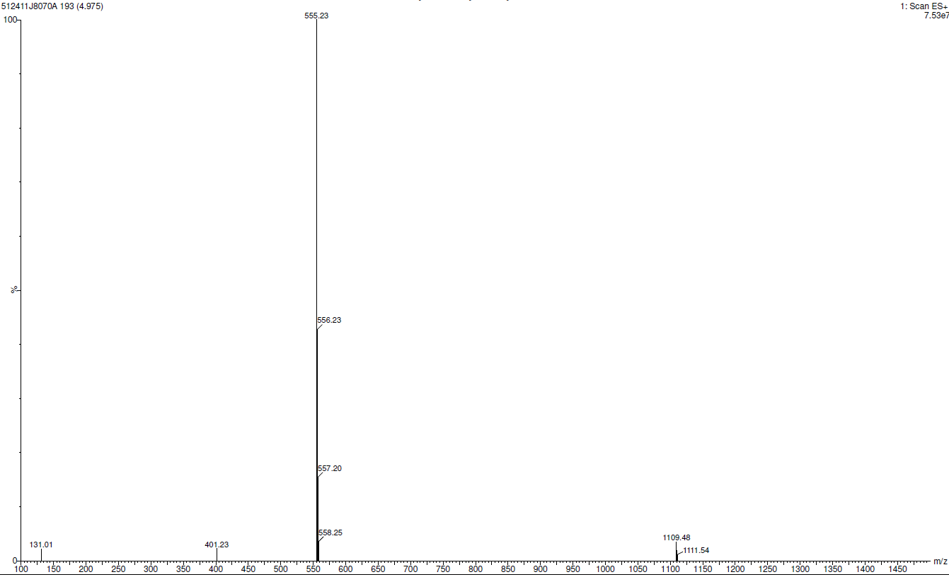
Mass spectrum of tert-butyl 4-((4-(7-tosyl-7H-pyrrolo[2,3-d]pyrimidin-4-yl)piperazin-1-yl)methyl) piperidine-1-carboxylate (9)
¹H NMR spectrum of 4-(4-(piperidin-4-ylmethyl)piperazin-1-yl)-7-tosyl-7H-pyrrolo[2,3-d]pyrimidine (10)
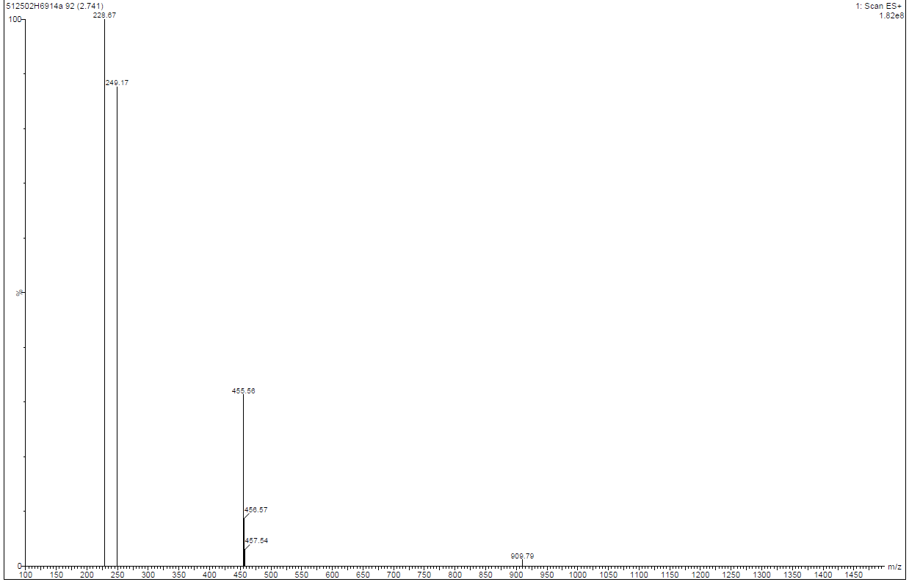
Mass spectrum of 4-(4-(piperidin-4-ylmethyl)piperazin-1-yl)-7-tosyl-7H-pyrrolo[2,3-d]pyrimidine (10)
¹H NMR spectrum of 7-tosyl-4-(4-((1-((2-(trifluoromethyl)phenyl)sulfonyl)piperidin-4-yl)methyl)piperazin-1-yl)-7H-pyrrolo[2,3-d]pyrimidine (11a)
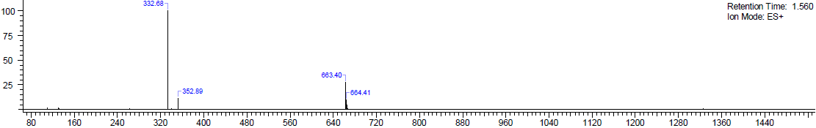
Mass spectrum of 7-tosyl-4-(4-((1-((2-(trifluoromethyl)phenyl)sulfonyl)piperidin-4-yl)methyl)piperazin-1-yl)-7H-pyrrolo[2,3-d]pyrimidine (11a)
¹H NMR spectrum of 4-(4-((1-((4-bromophenyl)sulfonyl)piperidin-4-yl)methyl)piperazin-1-yl)-7-tosyl-7H-pyrrolo[2,3-d]pyrimidine (11b)
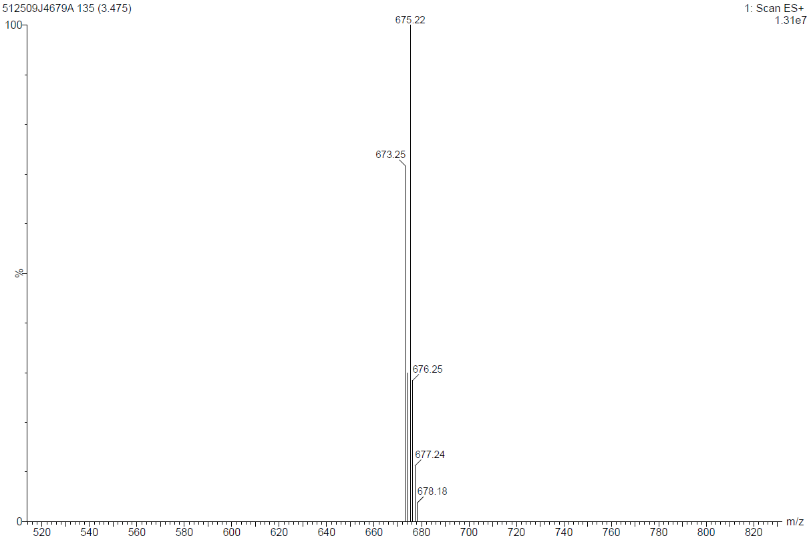
Mass spectrum of 4-(4-((1-((4-bromophenyl)sulfonyl)piperidin-4-yl)methyl)piperazin-1-yl)-7-tosyl-7H-pyrrolo[2,3-d]pyrimidine (11b)
¹H NMR spectrum of 4-(4-((1-((cyclopropylmethyl)sulfonyl)piperidin-4-yl)methyl)piperazin-1-yl)-7-tosyl-7H-pyrrolo[2,3-d]pyrimidine (11d)
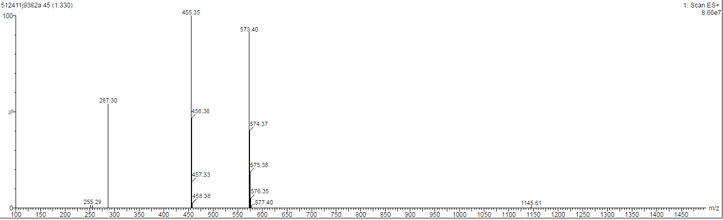
Mass spectrum of 4-(4-((1-((cyclopropylmethyl)sulfonyl)piperidin-4-yl)methyl)piperazin-1-yl)-7-tosyl-7H-pyrrolo[2,3-d]pyrimidine (11d)
¹H NMR spectrum of 4-(4-((1-(propylsulfonyl)piperidin-4-yl)methyl)piperazin-1-yl)-7-tosyl-7H-pyrrolo[2,3-d]pyrimidine (11e)
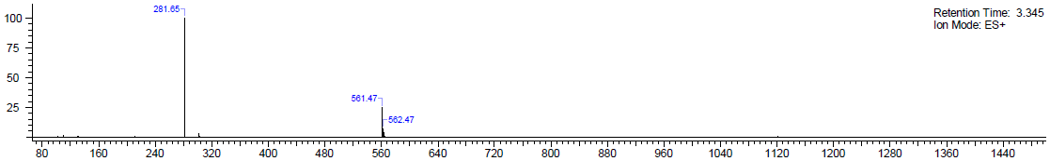
Mass spectrum of 4-(4-((1-(propylsulfonyl)piperidin-4-yl)methyl)piperazin-1-yl)-7-tosyl-7H-pyrrolo[2,3-d]pyrimidine (11e)
¹H NMR spectrum of tert-butyl 9-(7H-pyrrolo[2,3-d]pyrimidin-4-yl)-3,9-diazaspiro[5.5]undecane-3-carboxylate (15)
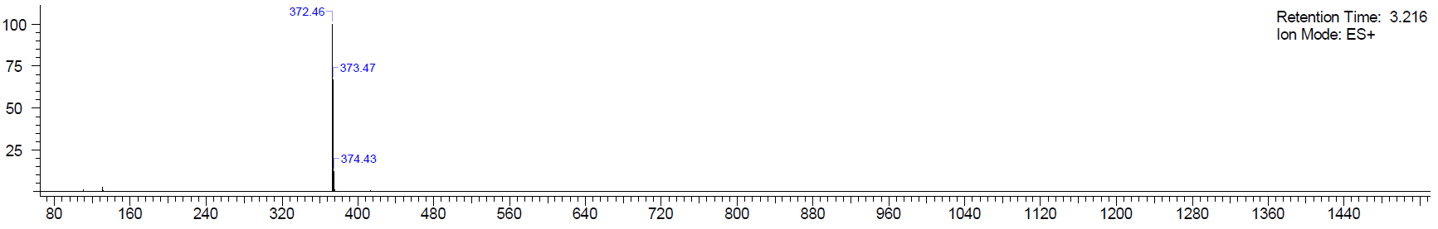
Mass spectrum of tert-butyl 9-(7H-pyrrolo[2,3-d]pyrimidin-4-yl)-3,9-diazaspiro[5.5]undecane-3-carboxylate (15)
¹H NMR spectrum of 3-(7H-pyrrolo[2,3-d]pyrimidin-4-yl)-3,9-diazaspiro[5.5]undecane (16)
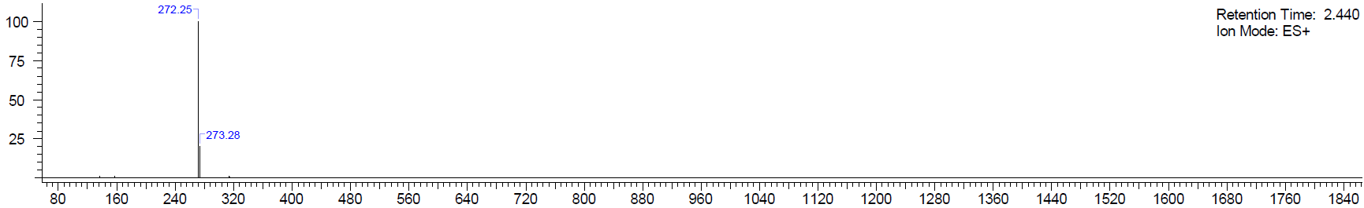
Mass spectrum of 3-(7H-pyrrolo[2,3-d]pyrimidin-4-yl)-3,9-diazaspiro[5.5]undecane (16)

