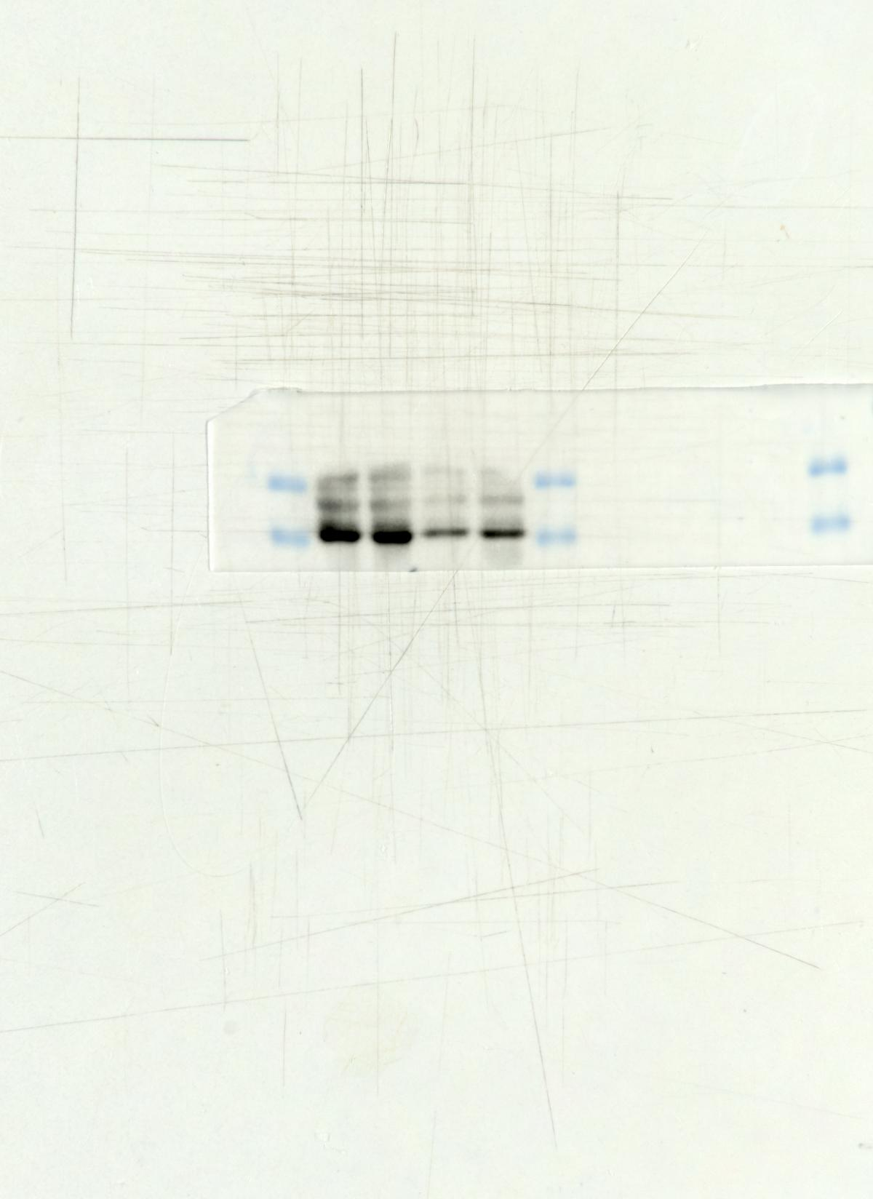Fig3 Bcl-2
35KD
25KD
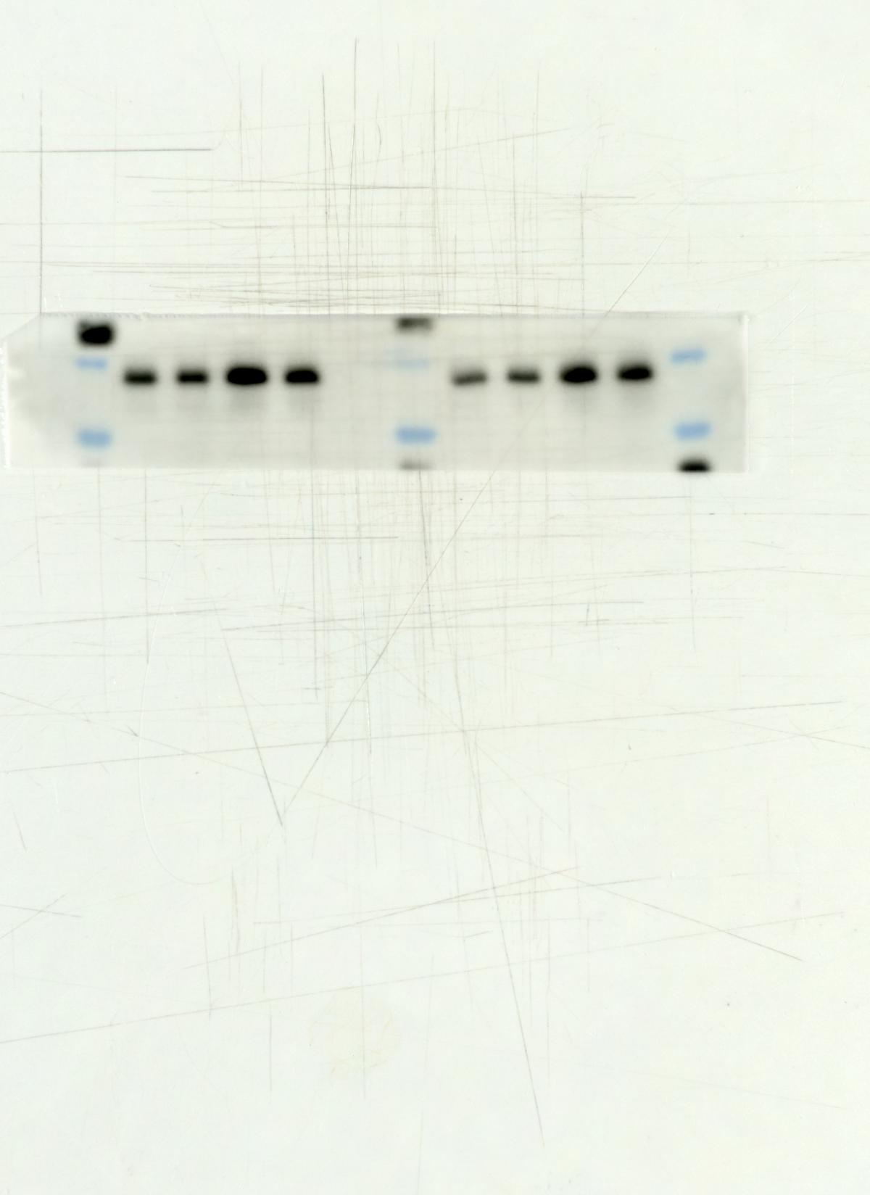 Fig3 Bax
10KD
15KD
25KD
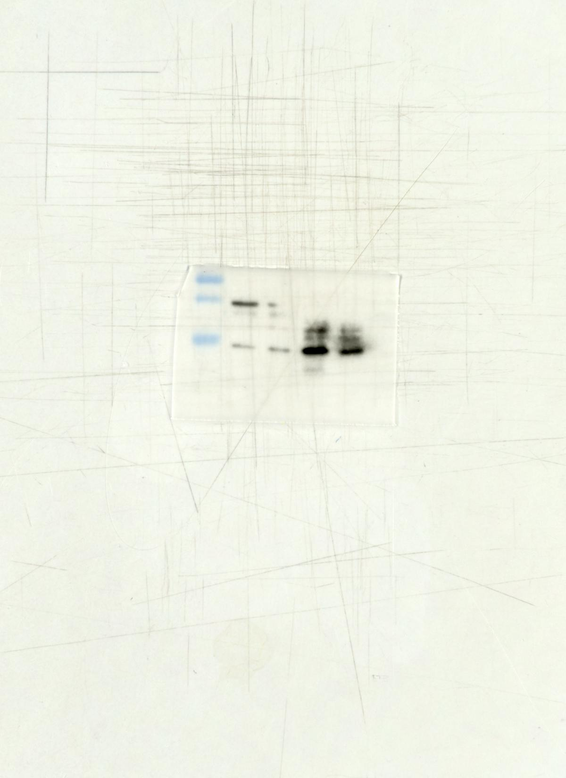Fig3 Cyt c
10KD
15KD
25KD
35KD
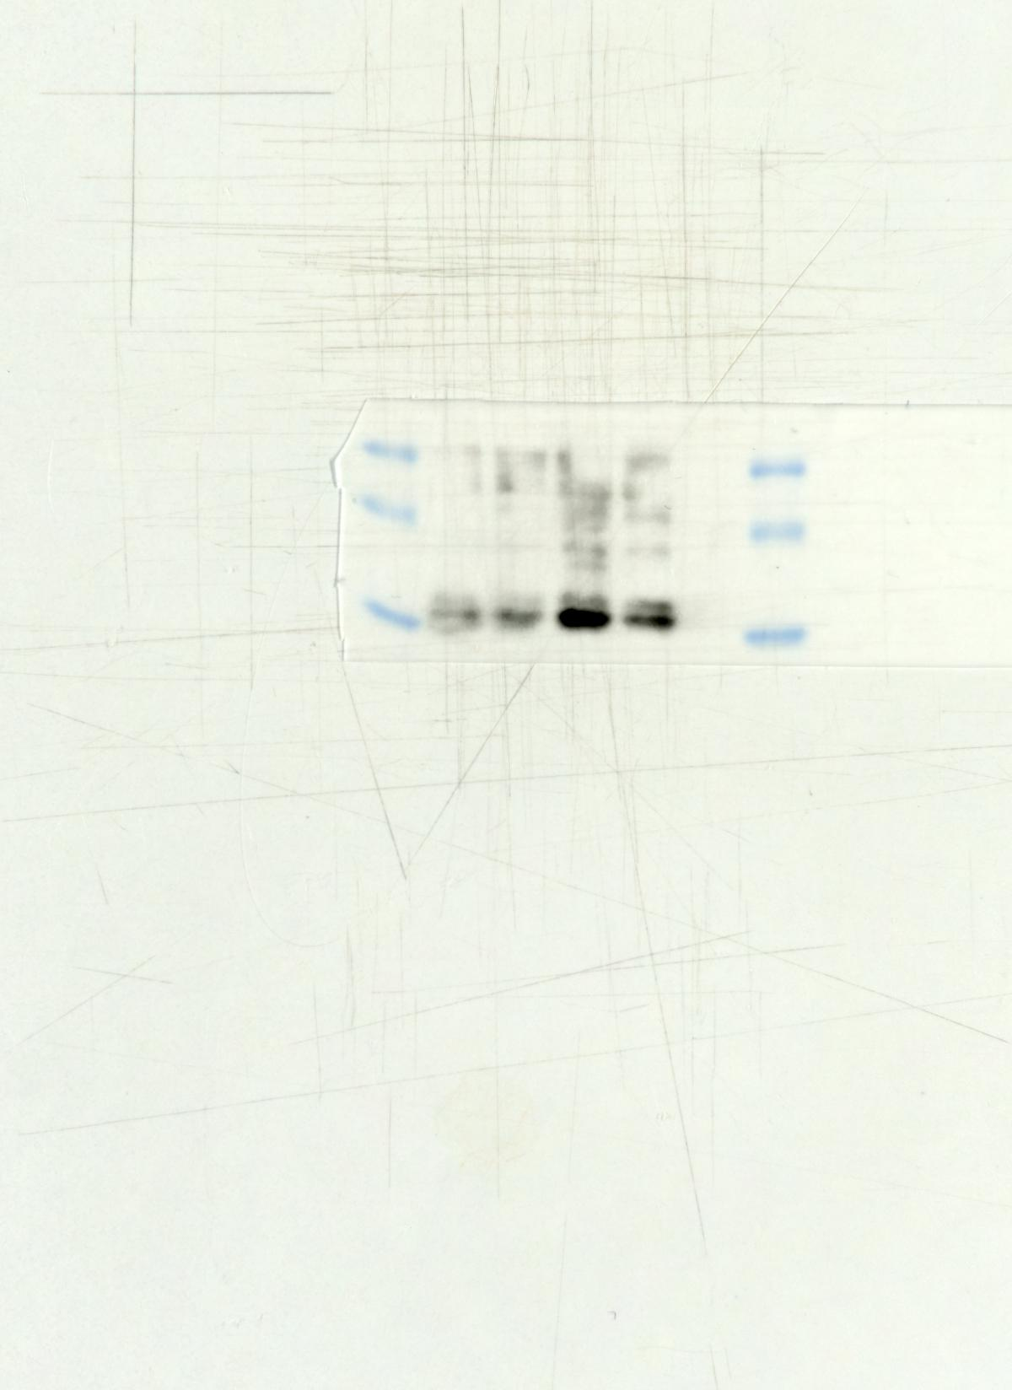Fig3 C-CASP3
15KD
25KD
35KD

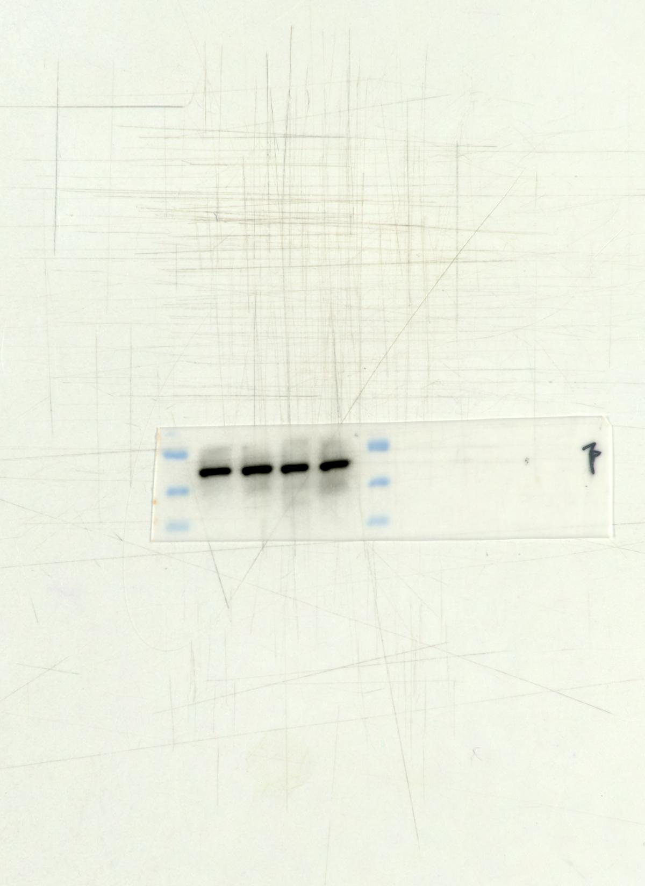Fig3 β-actin
35KD
40KD
55KD
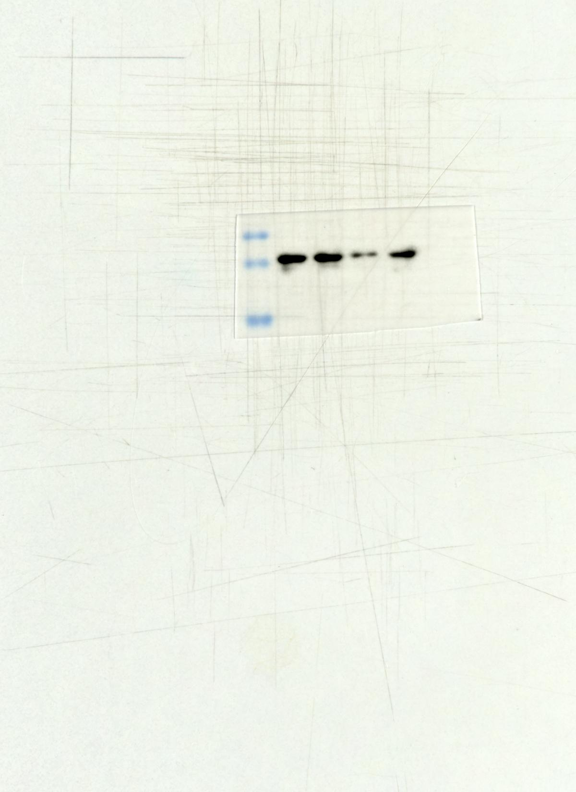Fig5 Bcl-2
15KD
25KD
35KD
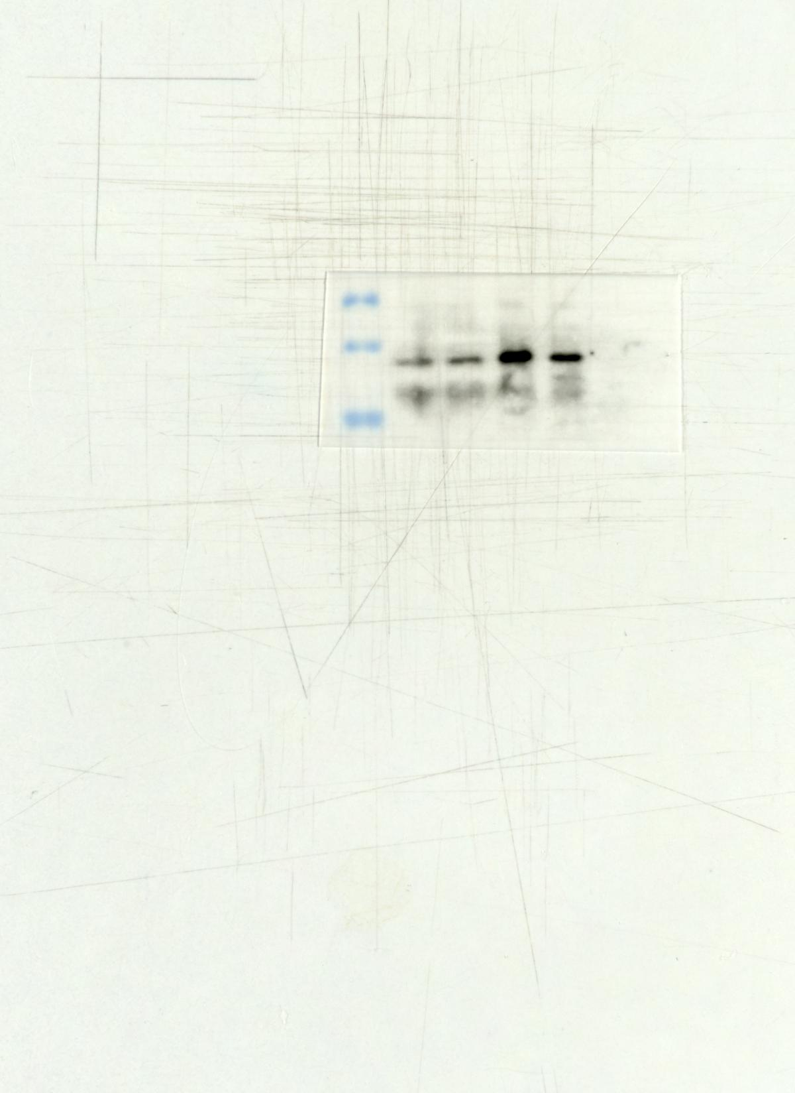Fig5 Bax
15KD
25KD
35KD
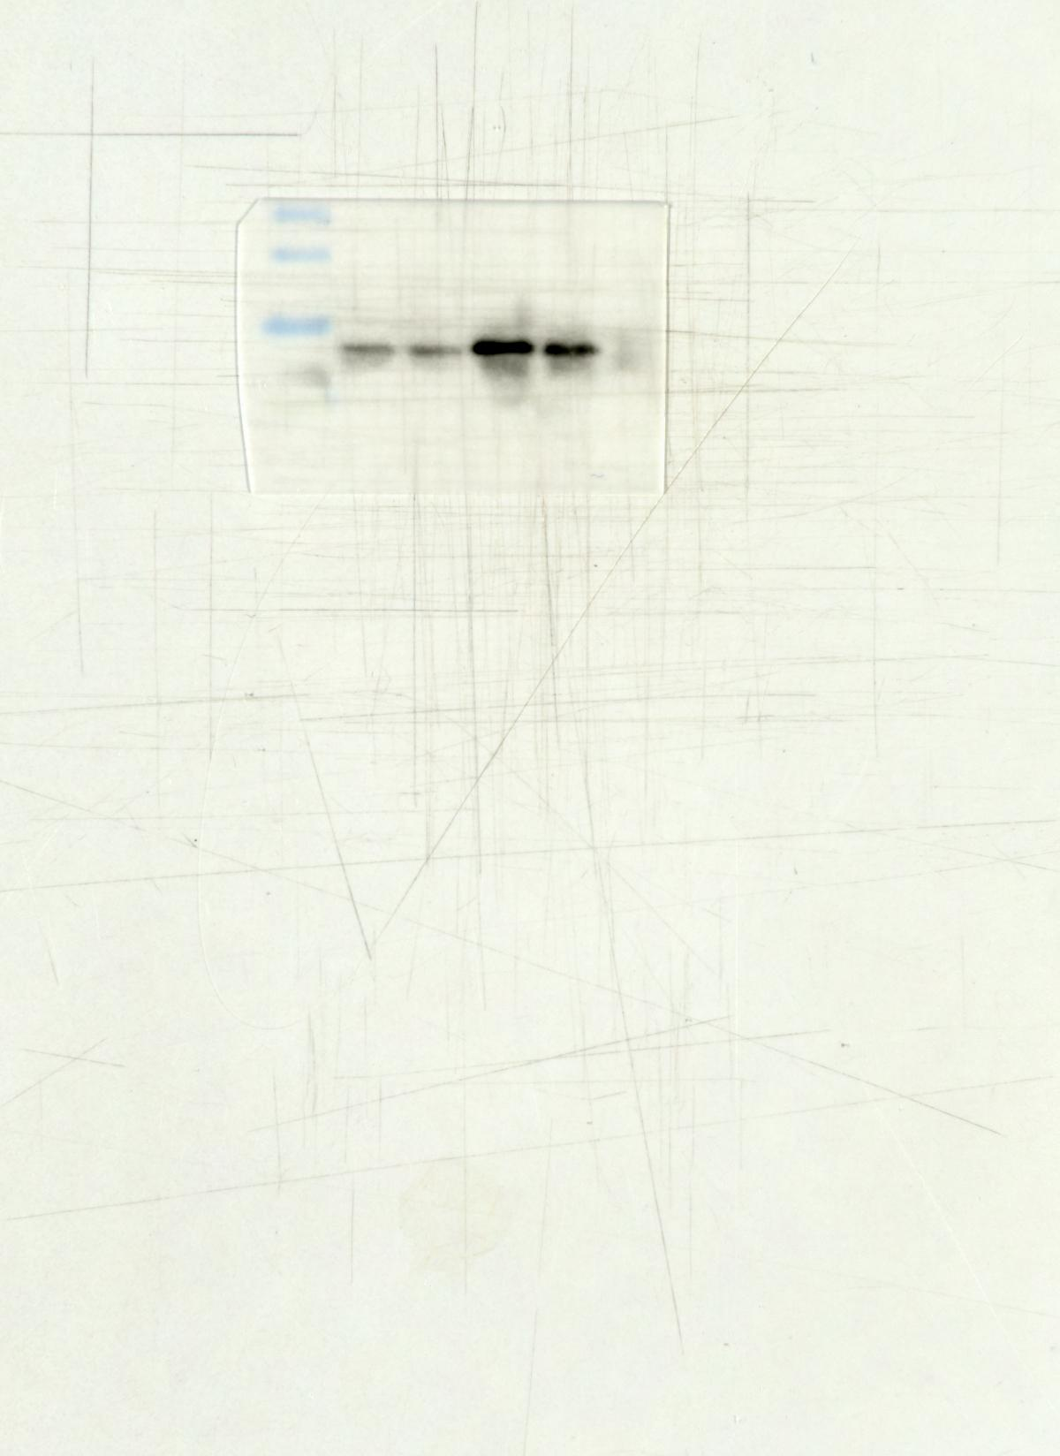Fig5 Cyt c
10KD
15KD
25KD
35KD

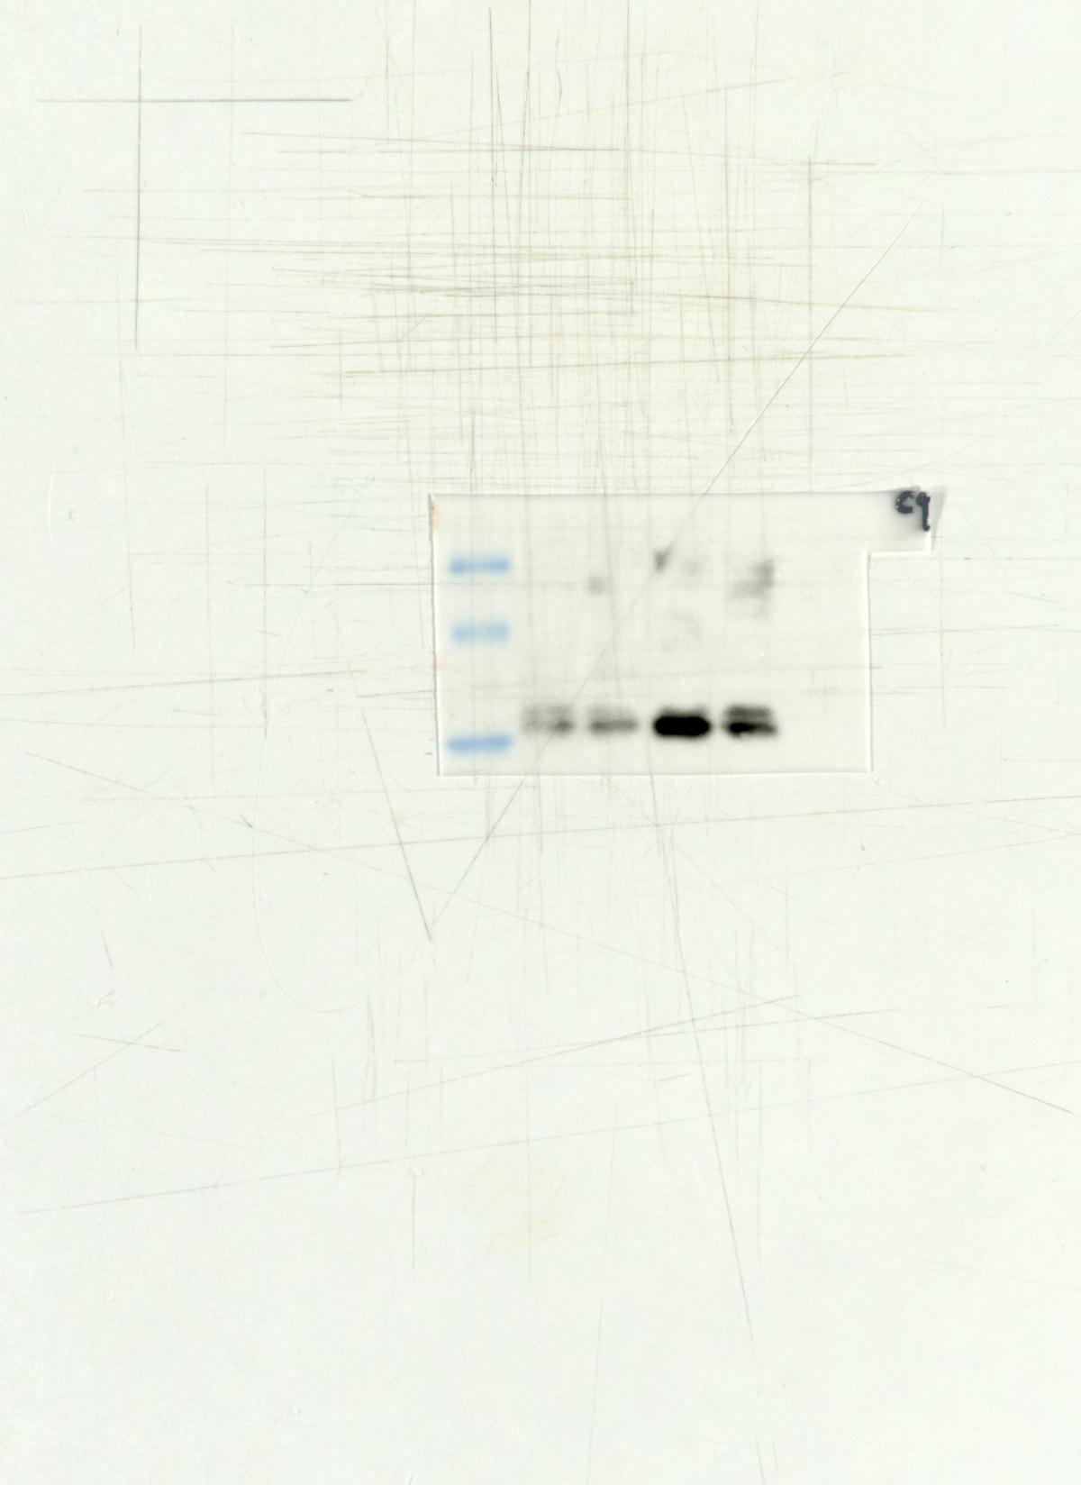Fig5 C-CASP3
15KD
25KD
35KD
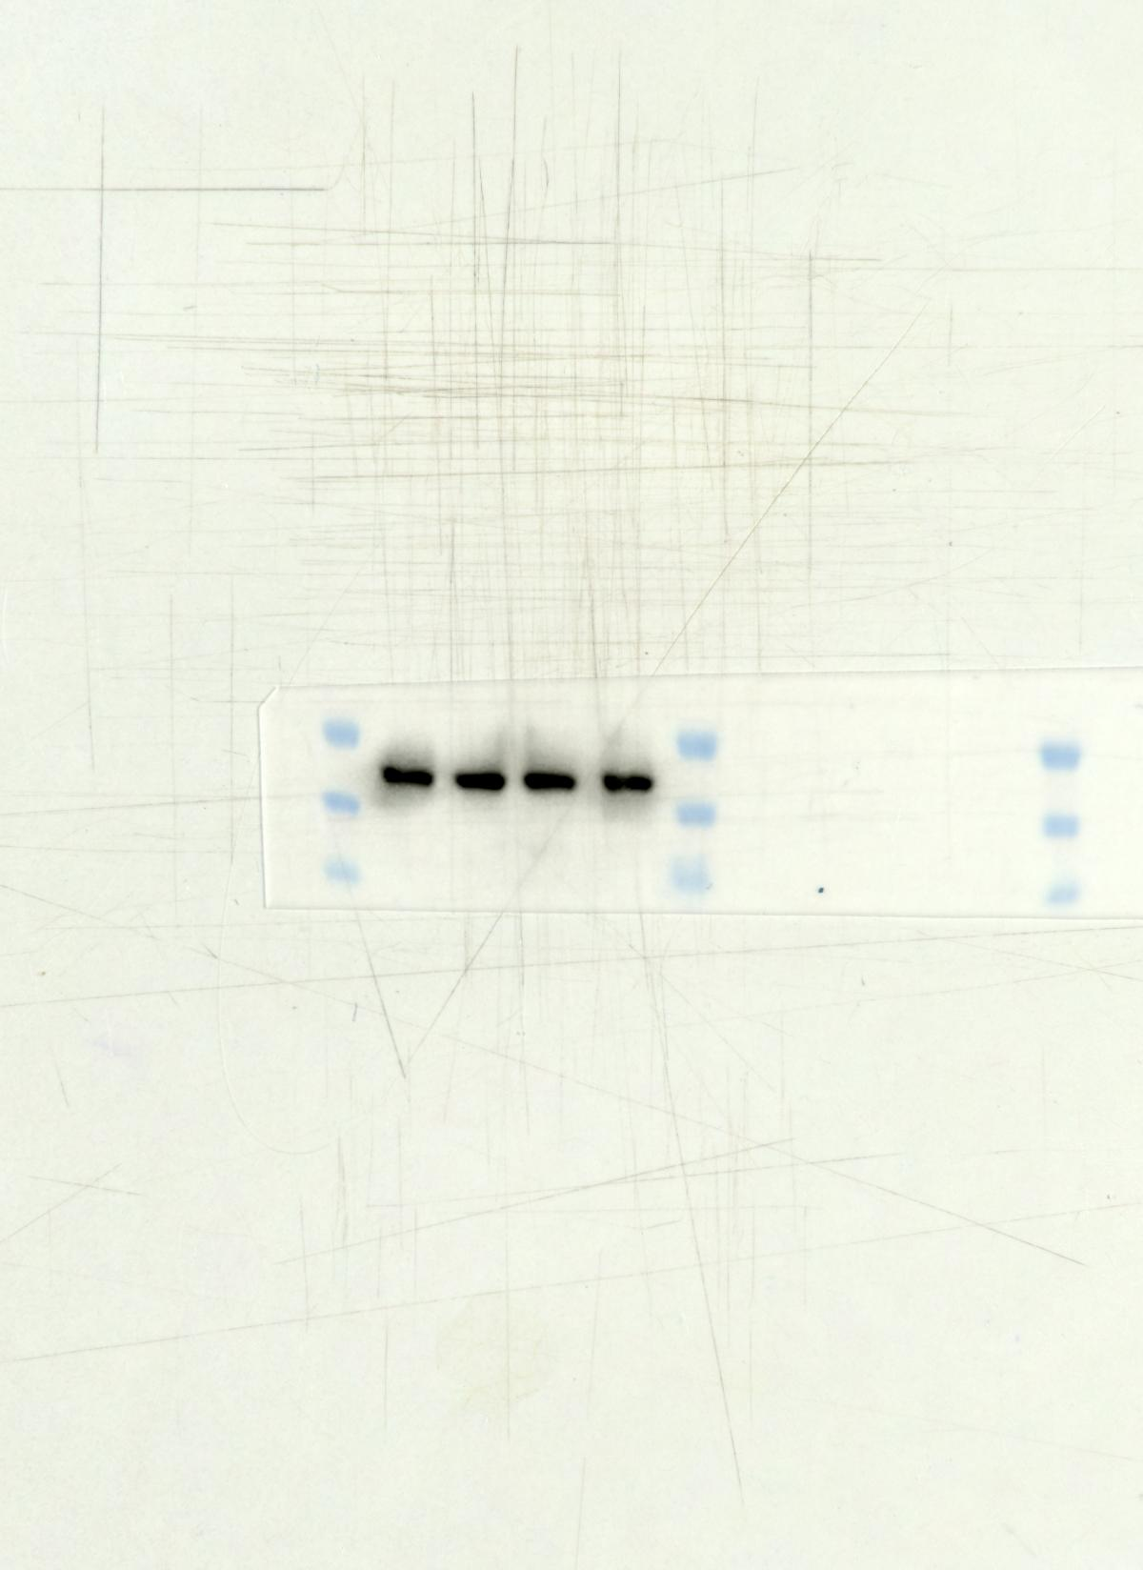 Fig5 β-actin
35KD
40KD
55KD
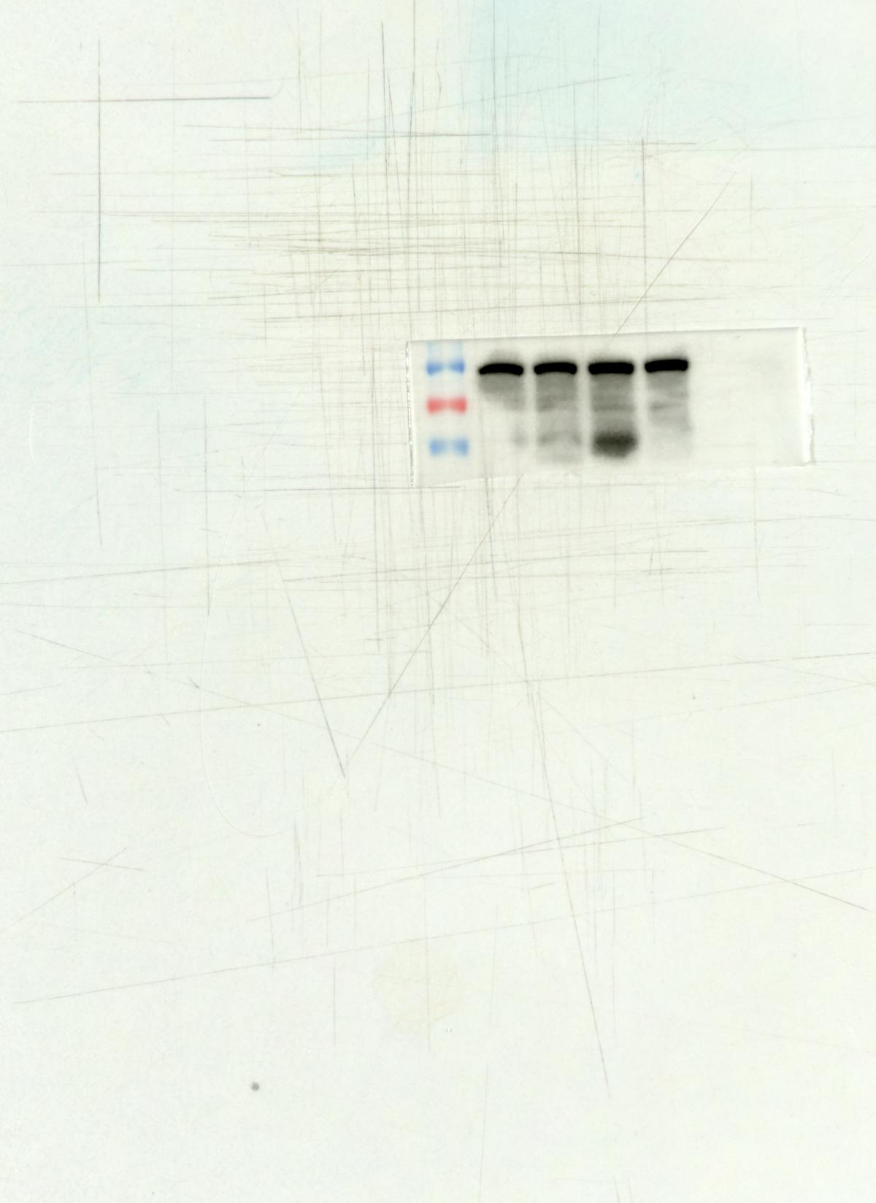 Fig6 PI3K
55KD
70KD
100KD
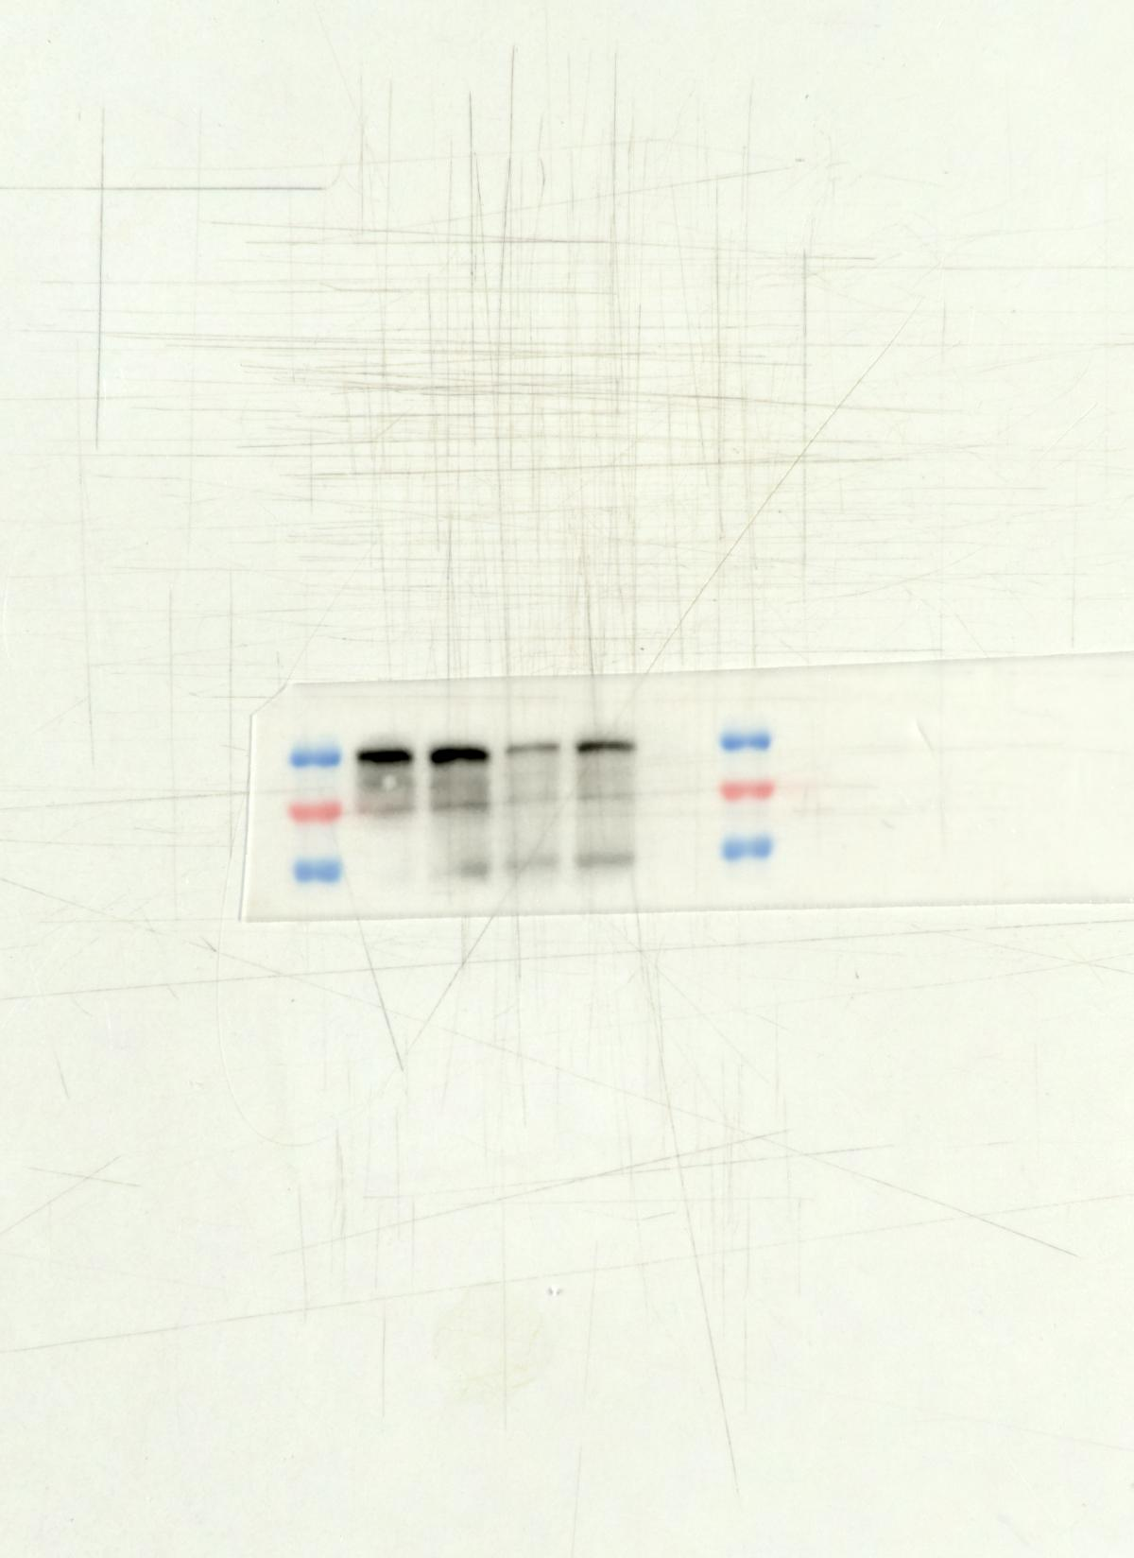 Fig6 P-PI3K
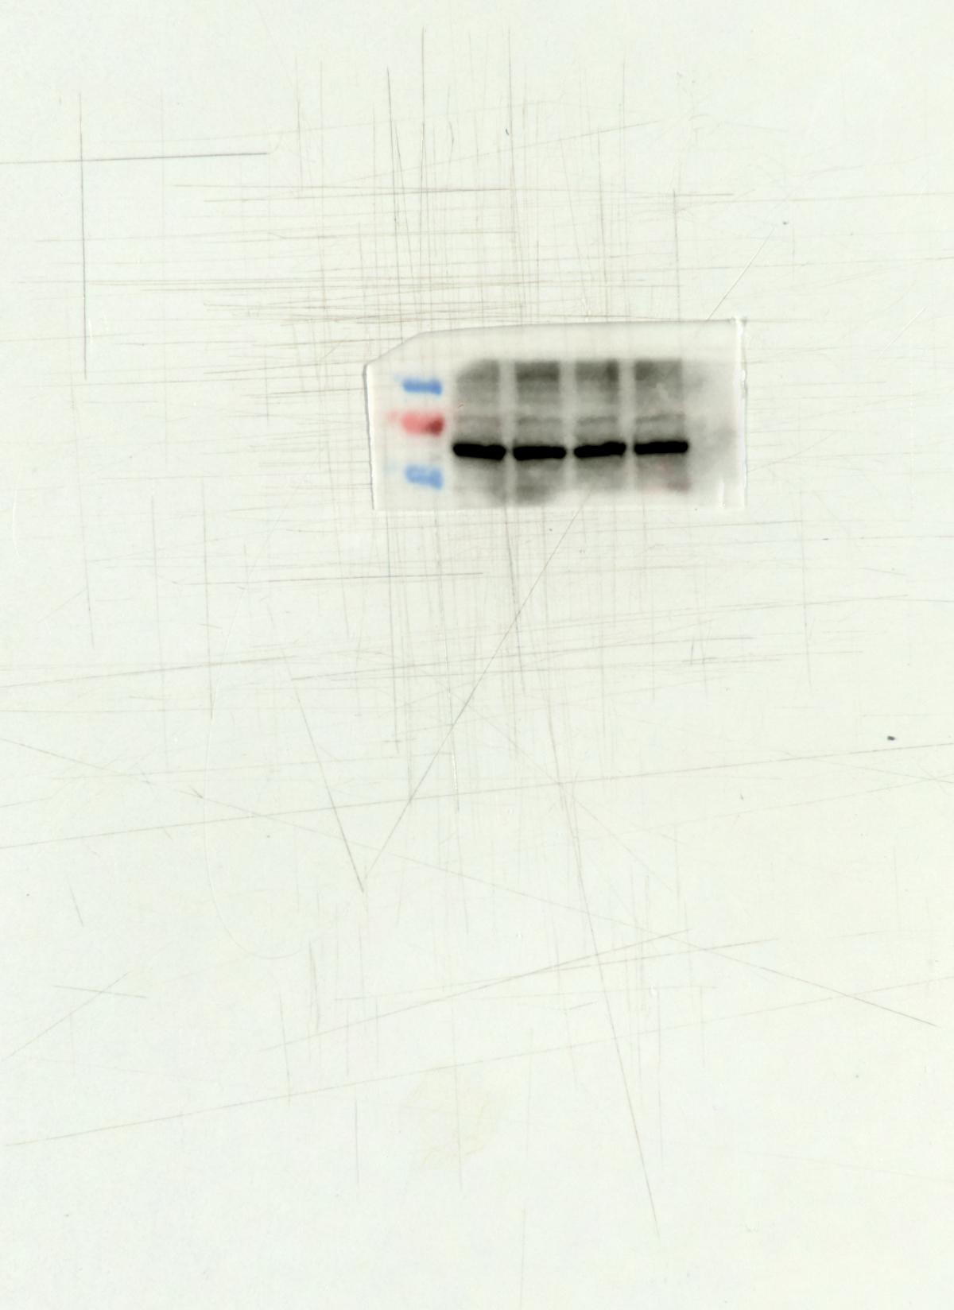Fig6 AKT
55KD
70KD
100KD
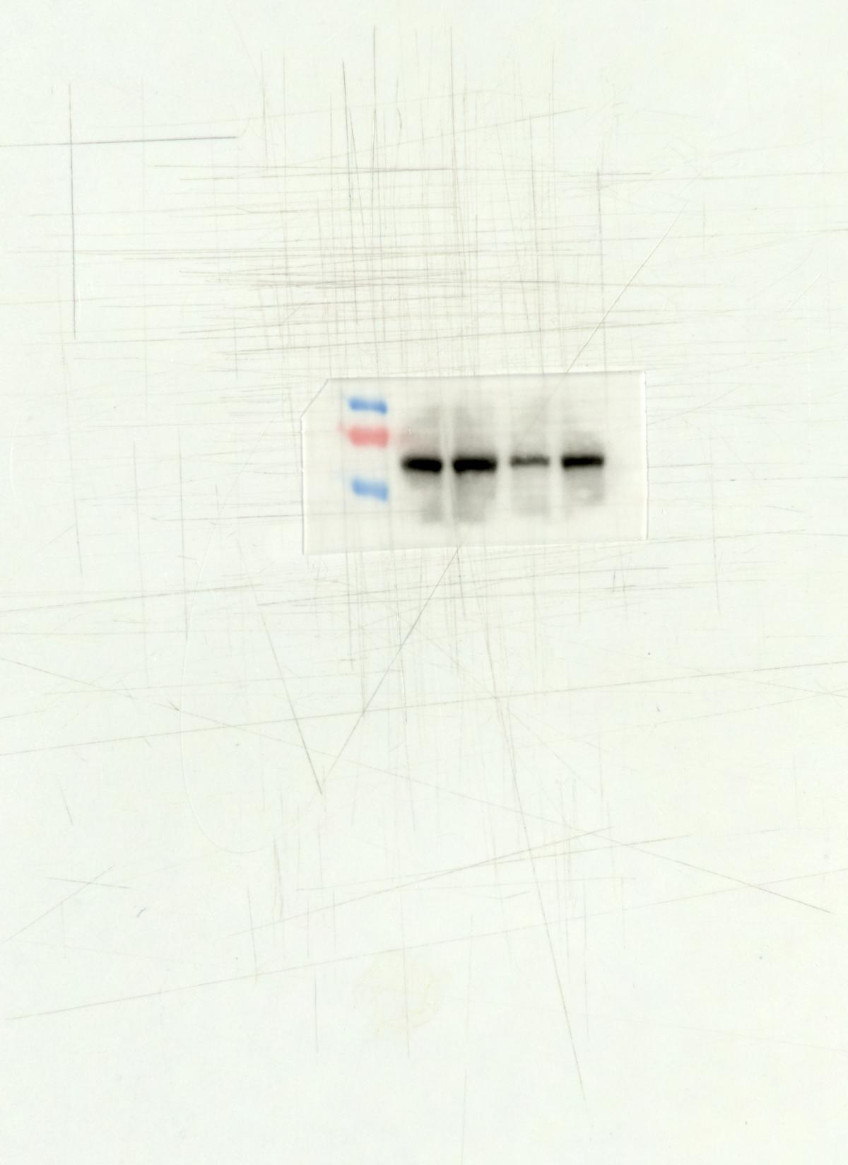 Fig6 P-AKT
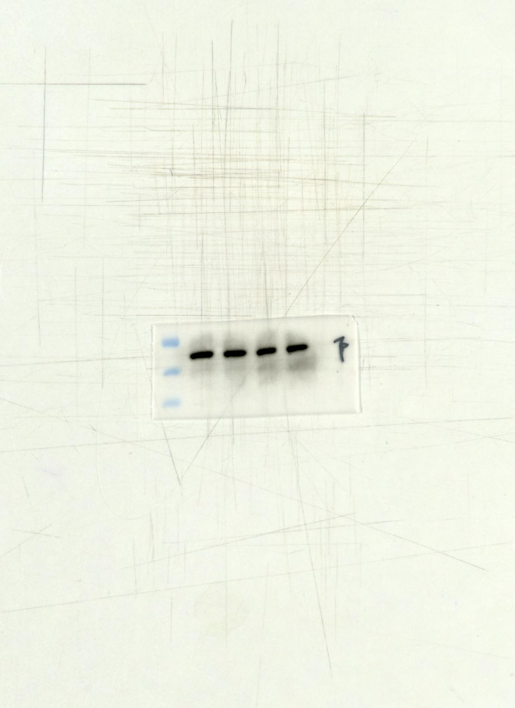 Fig6 β-actin
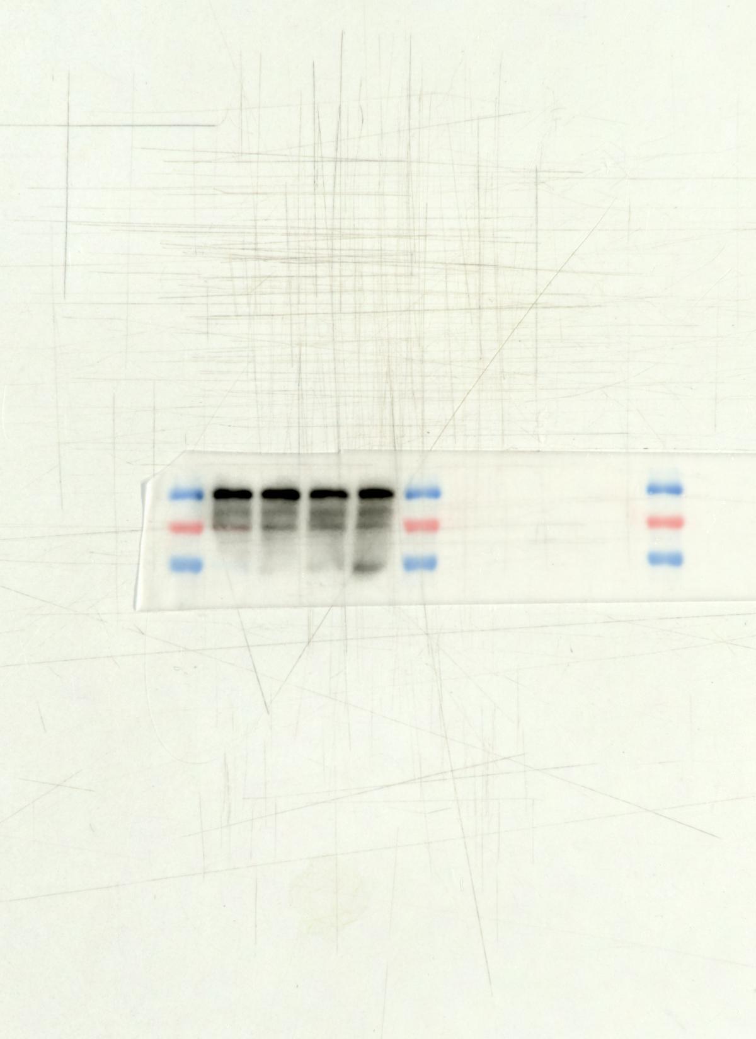 Fig6 PI3K （Cell）
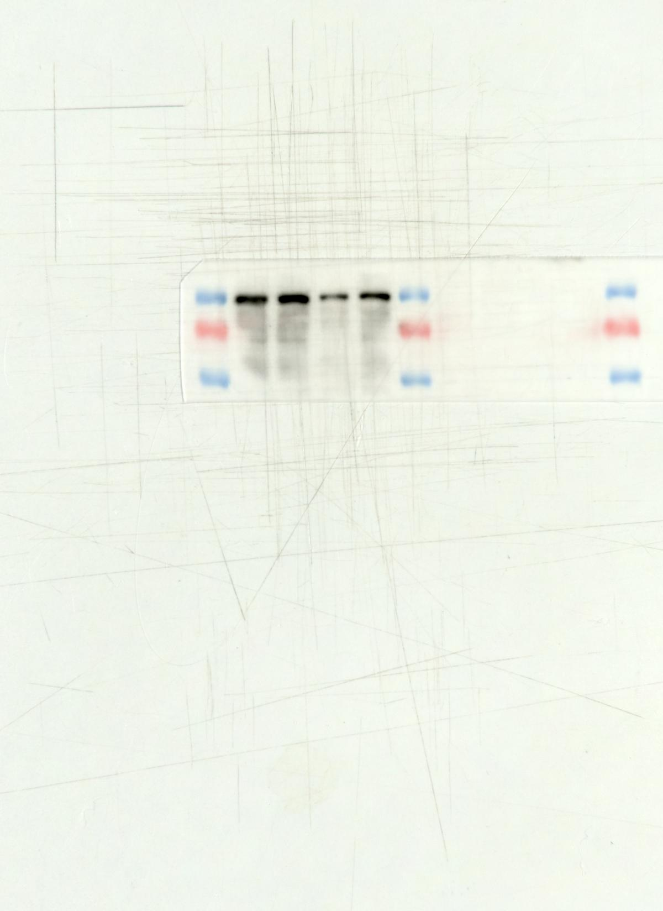 Fig6 P-PI3K
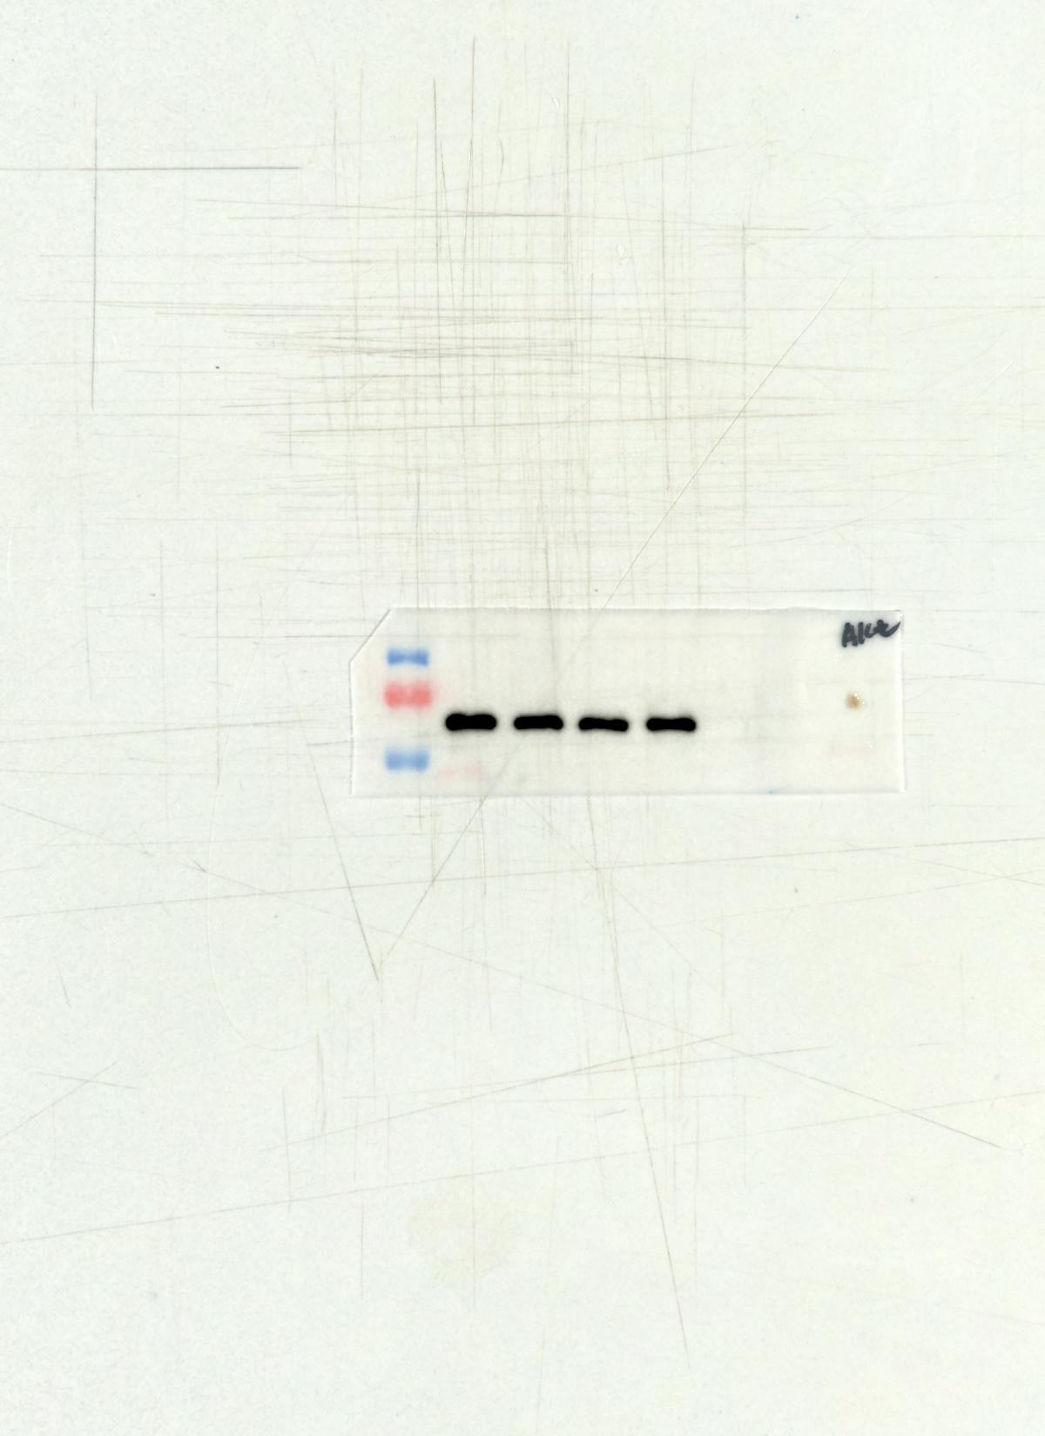 Fig6 AKT
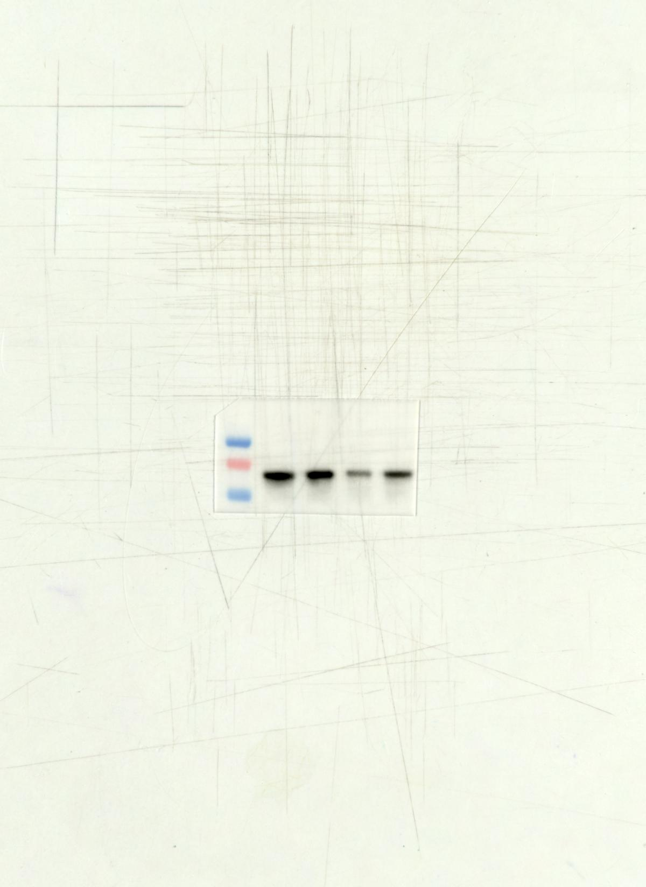 Fig6 P-AKT
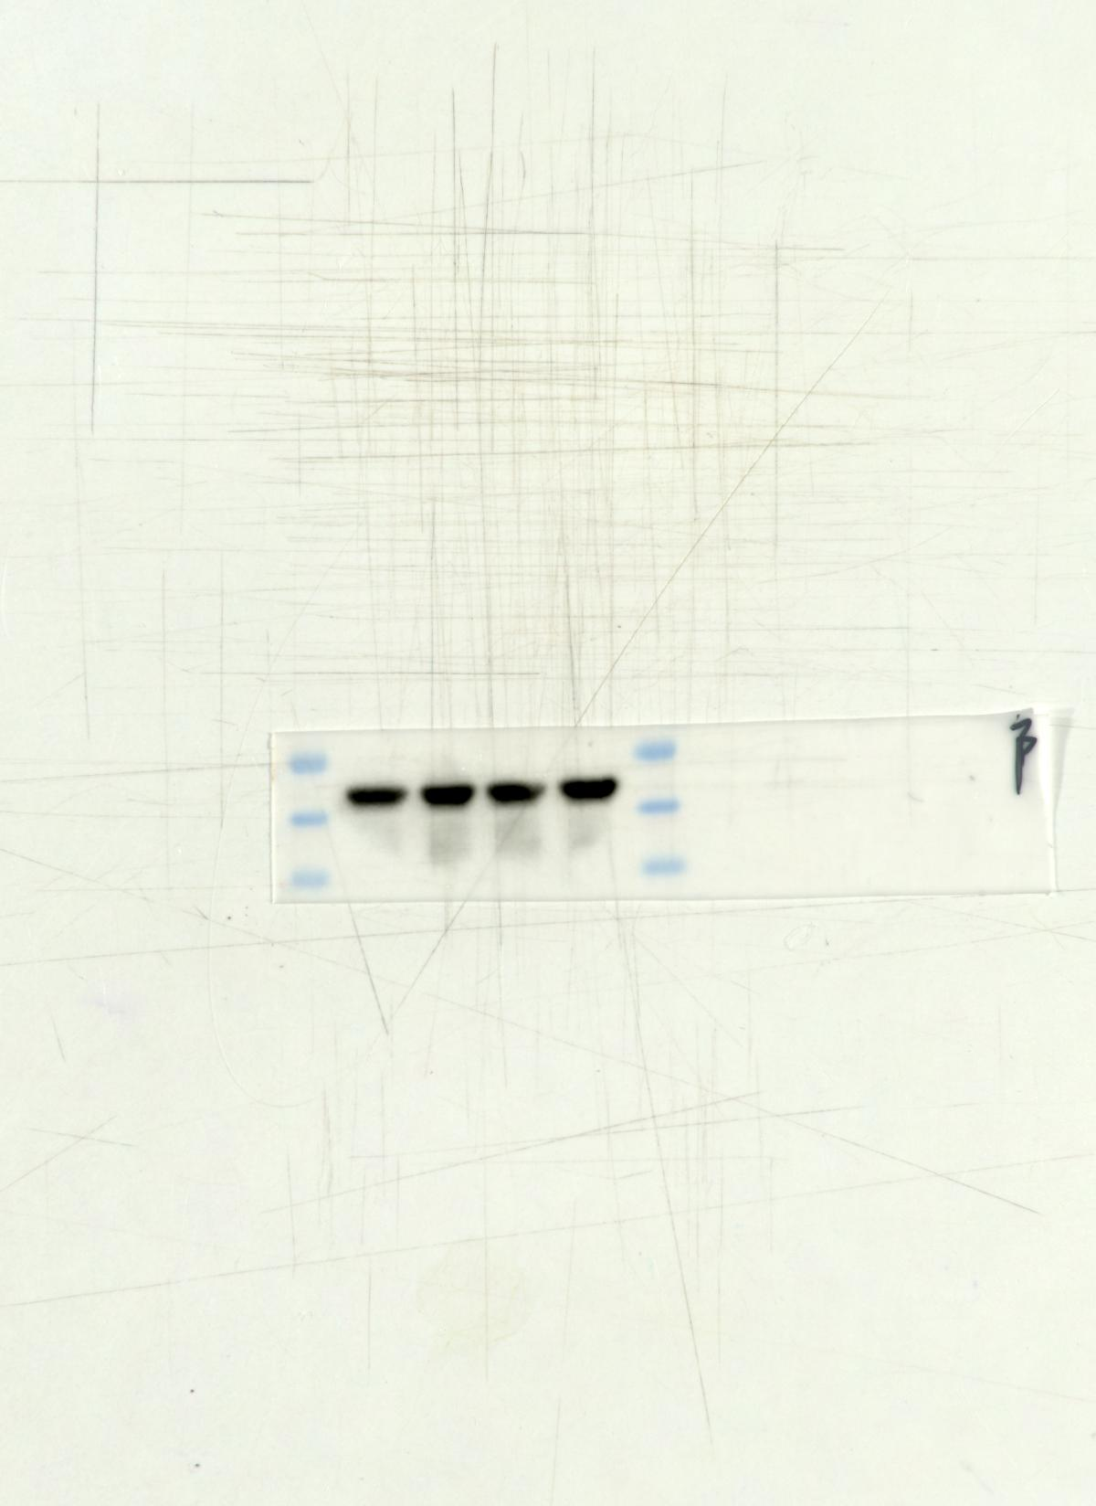 Fig6 β-actin
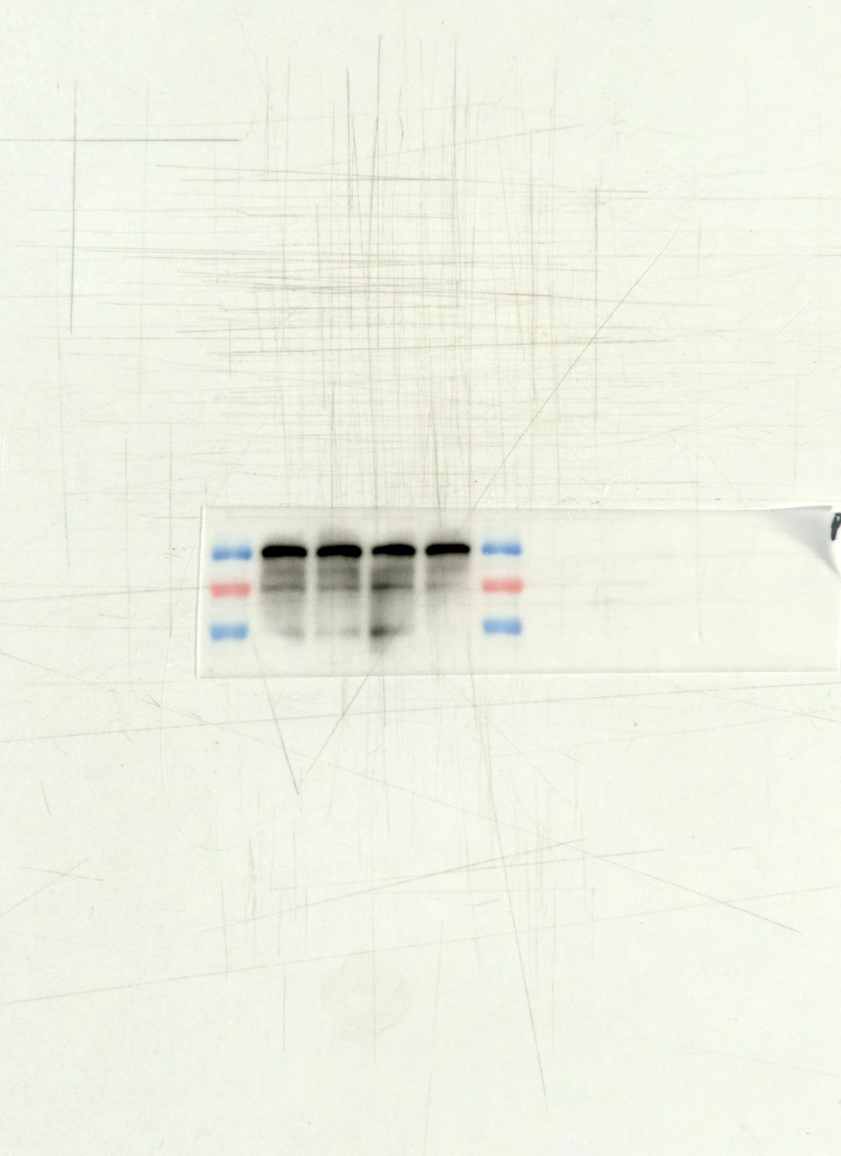 Fig8 PI3K
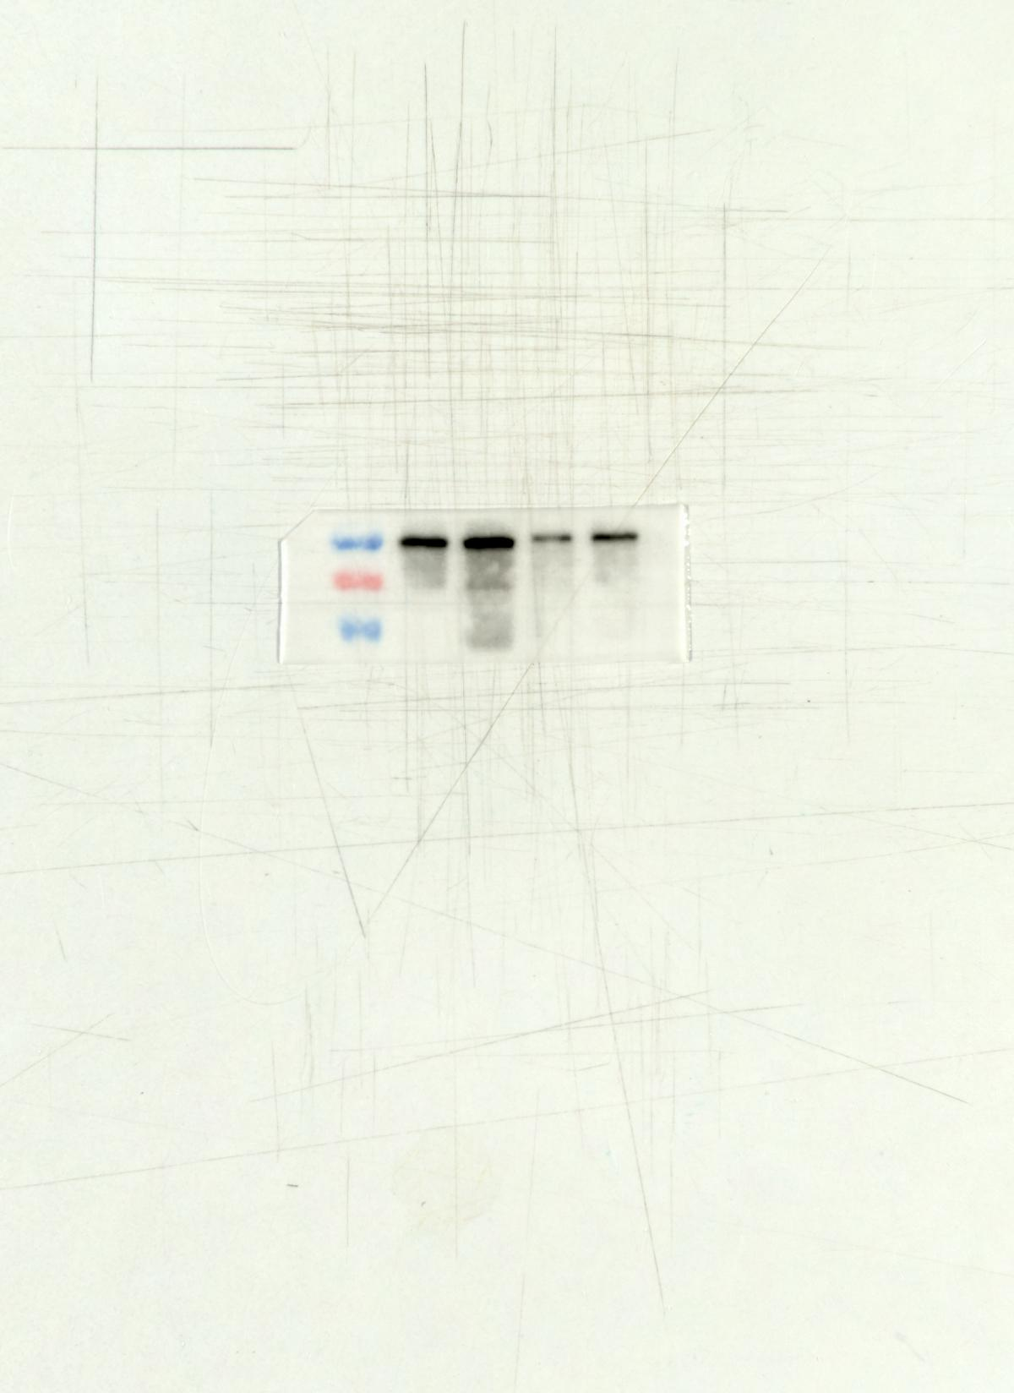 Fig8 P-PI3K
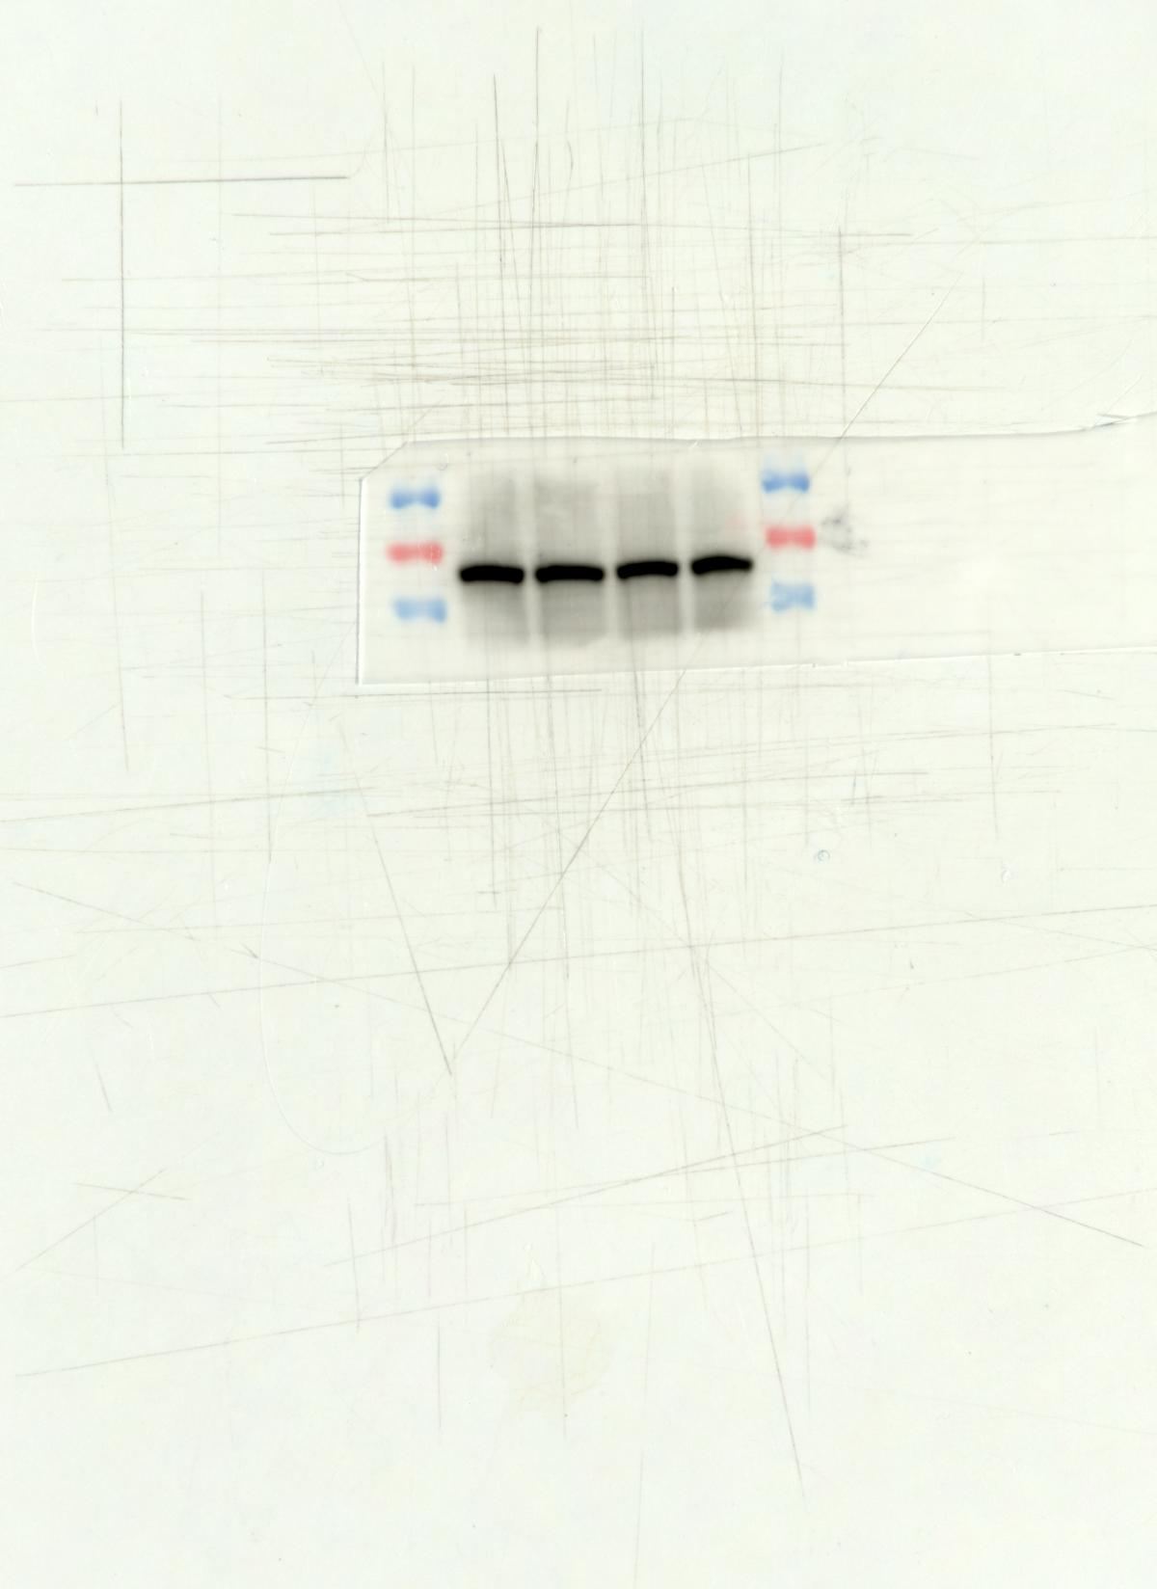 Fig8 AKT
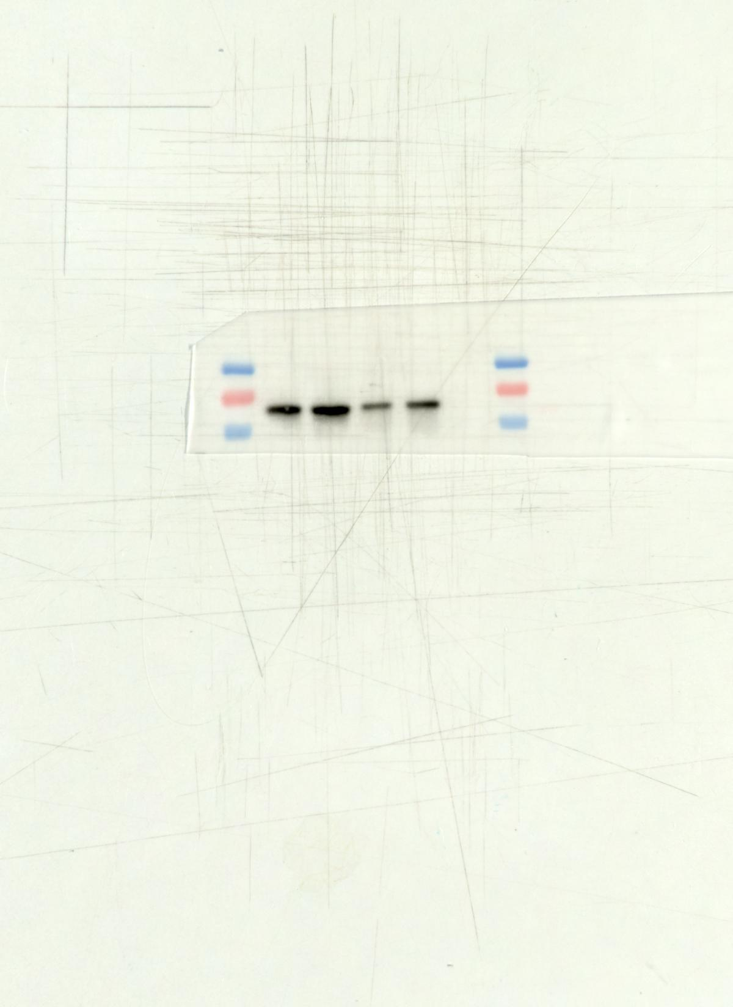 Fig8 P-AKT
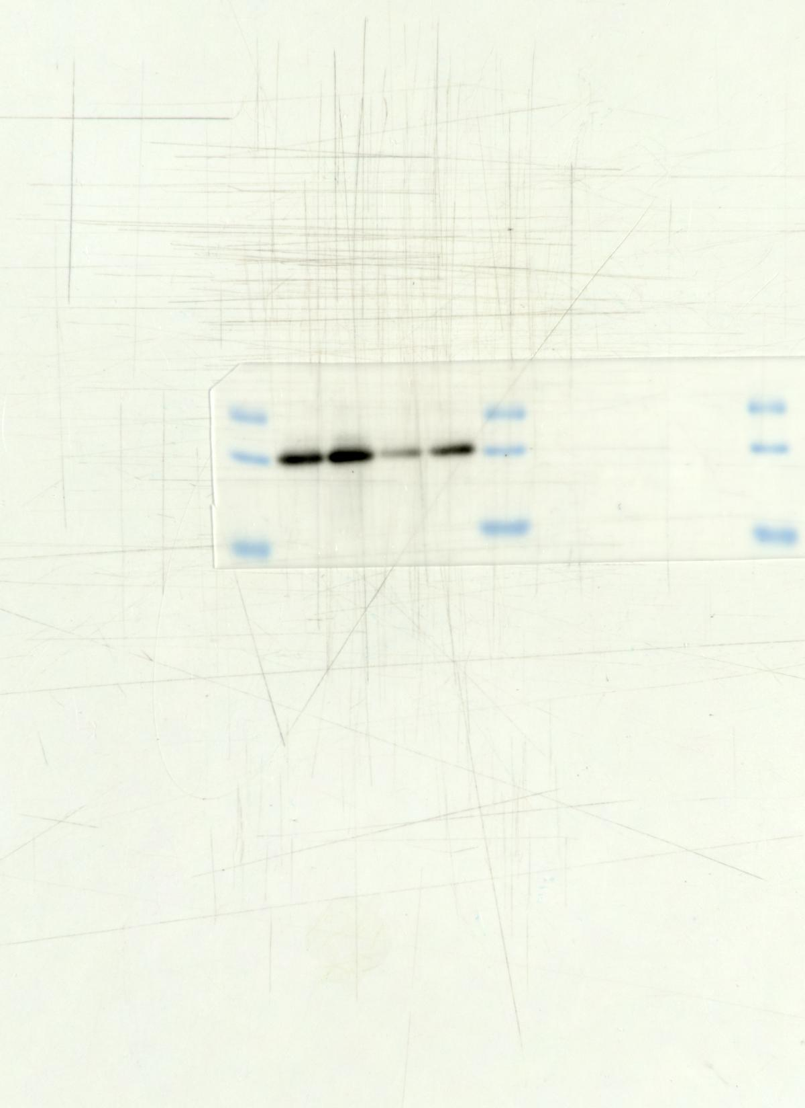 Fig8 Bcl-2
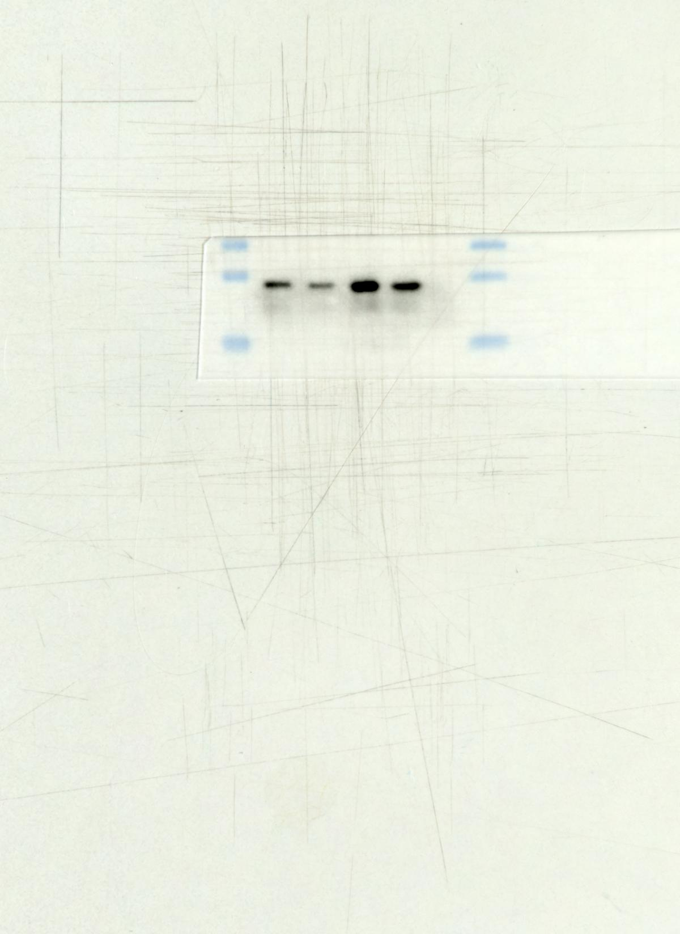 Fig8 Bax
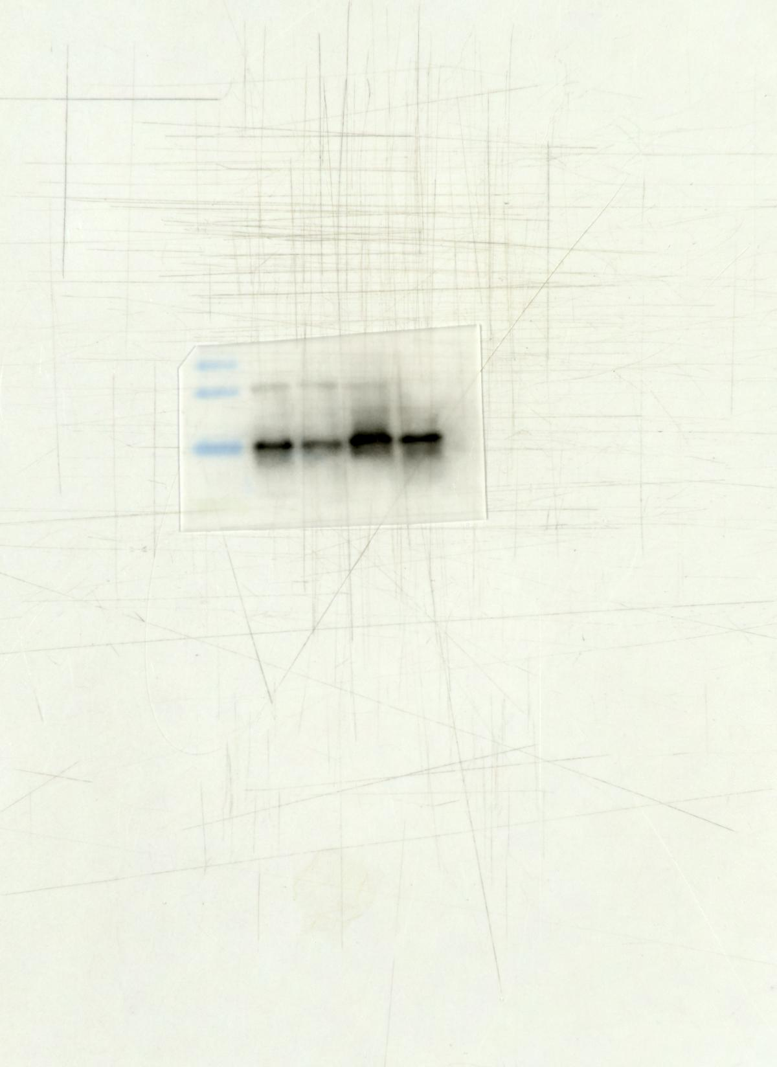 Fig8 Cyt c
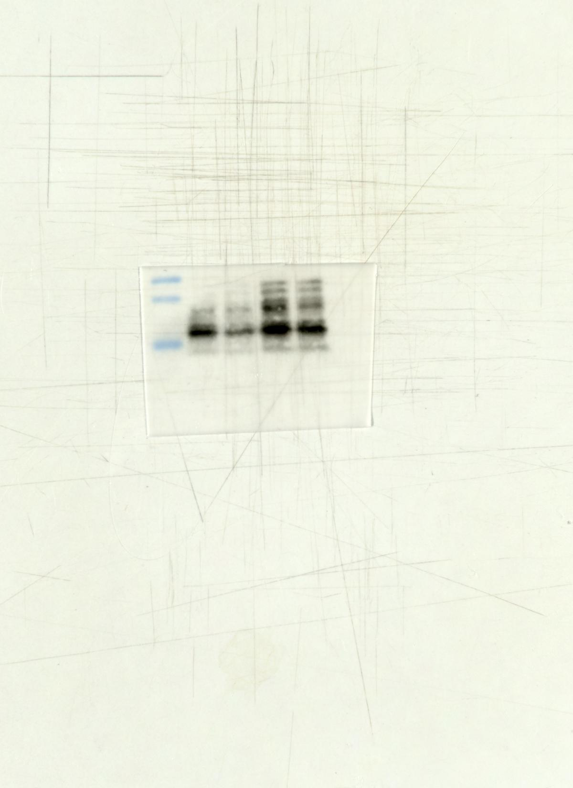 Fig8 C-CASP3
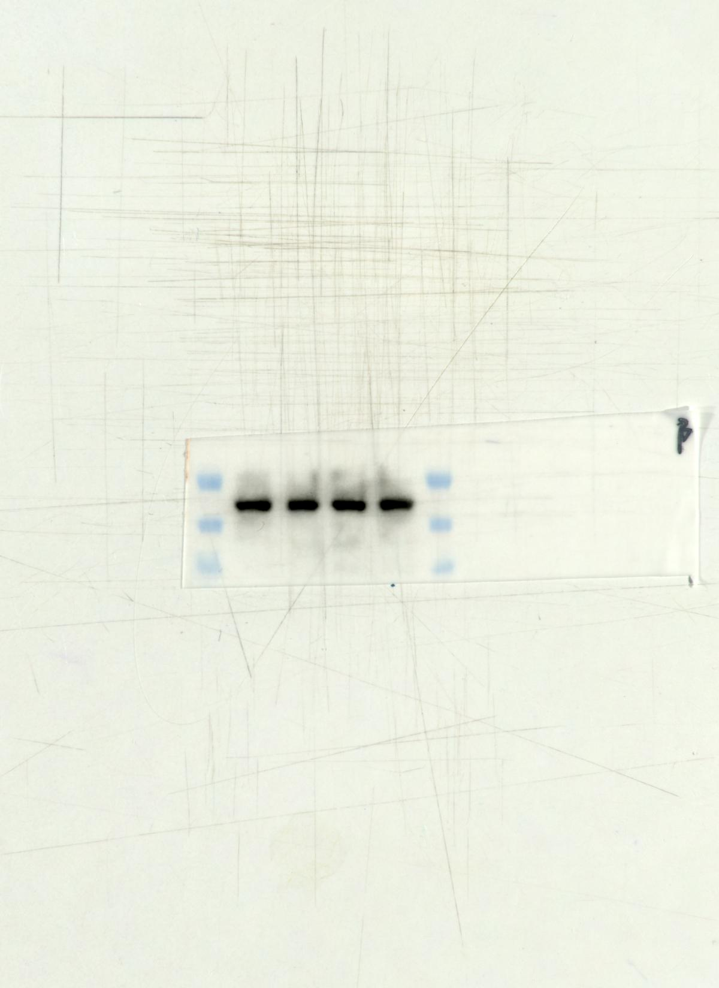 Fig8 β-actin

