Supplementary Table S1
Monoclonal antibodies produced at the Laboratory of Immunopathology in Neurocysticercosis, Universidad Peruana Cayetano Heredia

No. | Antibody Name | Internal Code | Immunizing Antigen | Isotype
1 | TsW1 | W1G12 | Whole cysticercus extract | IgG1
2 | TsW2 | W5D10 | Whole cysticercus extract | IgG1
3 | TsW3 | W2G10 | Whole cysticercus extract | IgM
4 | TsW4 | W4A4 | Whole cysticercus extract | IgM
5 | TsW5 | W2H7 | Whole cysticercus extract | IgG3
6 | TsW6 | W5H10 | Whole cysticercus extract | IgM
7 | TsW7 | W1G4 | Whole cysticercus extract | IgM
8 | TsW8 | W1H2 | Whole cysticercus extract | IgG1
9 | TsW9 | W6A7 | Whole cysticercus extract | IgM
10 | TsW10 | W2B11 | Whole cysticercus extract | IgG3
11 | TsW11 | W2D7 | Whole cysticercus extract | IgM
12 | TsV1 | V3C4 | Vesicular fluid | IgG1
13 | TsV2 | V2H1 | Vesicular fluid | IgG2a
14 | TsV3 | V4G1 | Vesicular fluid | IgG1
15 | TsV4 | V2H12 | Vesicular fluid | IgG1
16 | TsV5 | V1C12 | Vesicular fluid | IgG1
17 | TsE1 | E3G4 | Excretion/Secretion antigens | IgM
18 | TsE2 | E1G7 | Excretion/Secretion antigens | IgG3

Supplementary Table S2. Protein concentration of sequential supernatants obtained during dissolution of calcareous corpuscles.
Protein concentrations were determined in duplicate using the Bradford assay and calculated based on the BSA calibration curve (Fig. 3). Optical density values correspond to the mean absorbance of each fraction. Supernatants 8 and 9 showed the highest protein concentrations and were selected for subsequent electrophoretic analysis.
Fraction number | Mean absorbance (595 nm) | Protein concentration (μg/mL)
1 | 0,333 | 32,317
2 | 0,324 | 30,540
3 | 0,332 | 32,120
4 | 0,311 | 27,973
5 | 0,322 | 30,145
6 | 0,322 | 30,145
7 | 0,334 | 32,515
8 | 0,985 | 161,071
9 | 0,692 | 103,211
10 | 0,49 | 63,321
11 | 0,38 | 41,598
12 | 0,337 | 33,107
13 | 0,312 | 28,170
14 | 0,365 | 38,636
15 | 0,29 | 23,826

Supplementary Fig. S1

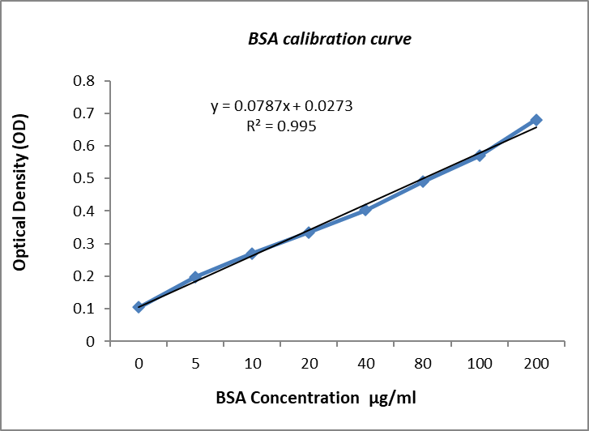
Fig. S1 Bradford assay calibration curve using bovine serum albumin (BSA). Standard curve generated using serial concentrations of BSA for protein quantification. Absorbance values were measured and fitted to the linear regression equation y = 0.0787x + 0.0273 (R² = 0.995), demonstrating high linearity within the working range.

