Supplementary material
Table captions
Table S1. The textural properties, including specific surface area, pore volume, and average pore diameter, were determined for CS, CS@UiO-66-NH₂, and CS@ UiO-66-NH₂@rGO.
Sample | Specific surface area  （m²·g⁻¹） | Pore volume  （cm³·g⁻¹） | Average pore  Diameter(nm)
CS | 17.45 | 0.132 | 25.12
UiO-66-NH₂ | 803 | 0.235 | 1.03
CS@UiO-66-NH₂ | 165.89 | 0.241 | 3.12
CS@UiO-66-NH₂@rGO | 298.76 | 0.338 | 3.00
CS@UiO-66-NH₂@rGO +TC | 96.4 | 0.21 | 28.6
CS@UiO-66-NH₂@rGO +NOR | 68.9 | 0.17 | 41.3

Figure captions
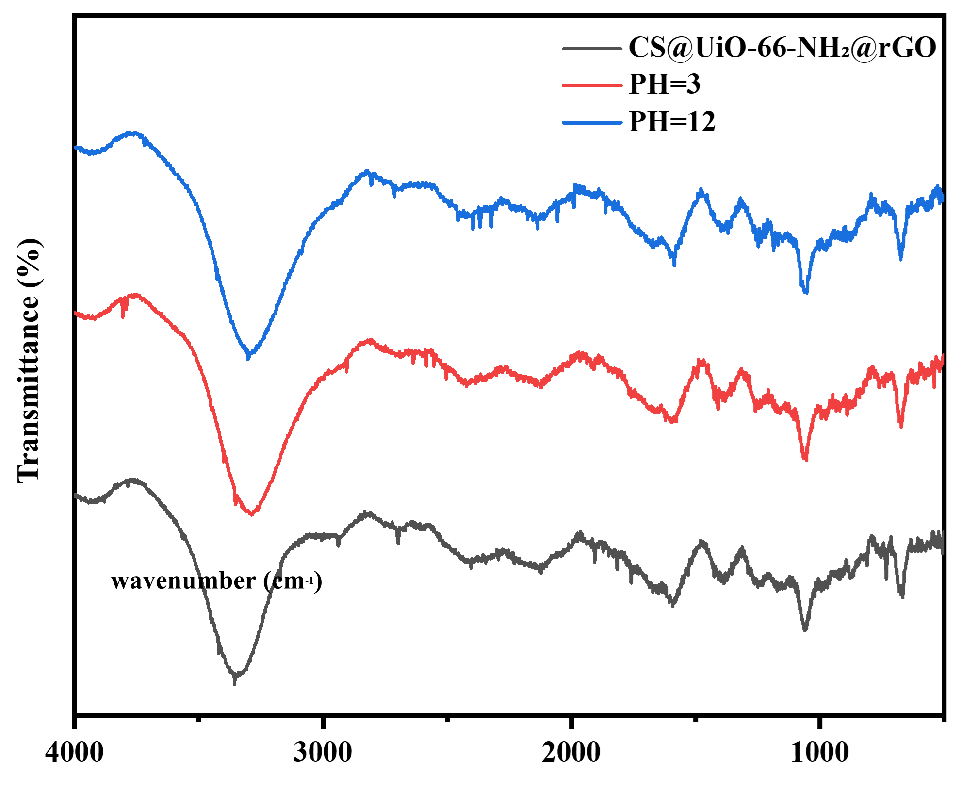
Fig. S1. FTIR spectra of CS@UiO-66-NH₂@rGO treated under pH=3 and pH=12.

