Supplementary Information

Supplementary Table S1. Primer sequences used in this study

Supplementary Table S2. GenBank accession numbers used in this study

Supplementary Table S3. Summary of RNA-Seq analysis

Supplementary Figure S1. Intestine of B. tabaci showing different parts of the digestive system: mouth (‘M’), foregut (‘FG’), filter chamber (‘FC’), caecum (‘CA’), connecting chamber (‘CC’), midgut (‘MG’), and rectal sac (‘RS’). The intestine was observed under a differential interference contrast (left photo) mode at 100x magnification. The scale bar represents 0.1 mm.

Supplementary Figure S2. Individual RNAi treatments targeting immune-related genes of Bemisia tabaci. Gene-specific dsRNAs (dsCath-F, dsKnottin, dsPGRP, dsCath-B, dsCath-L, and dsDefensin) were fed to adult whiteflies at a concentration of 500 µg/mL. A non-target gene, EGFP, was used as the control dsRNA (dsCON).

Supplementary Figure S3. Individual RNAi treatments specific to six viral genes in the viruliferous B. tabaci. The gene-specific dsRNAs (dsRNA^{V1}, dsRNA^{V2}, dsRNA^{C1}, dsRNA^{C2}, dsRNA^{C3}, and dsRNA^{C4}) were fed to the adults at a dose of 500 µg/mL to the adults. A non-target gene, EGFP, served as a control dsRNA (dsCON).

Supplementary Figure S4. Influence of individual RNAi treatment specific to a viral gene, C2, in the non-viruliferous B. tabaci. The gene-specific dsRNA (dsRNA^{C2}) was fed to the adults at a dose of 500 µg/mL to the adults. A non-target gene, EGFP, served as a control dsRNA (dsCON).

Supplementary Table S1. Primer sequences used in this study
Primer | Use | Orientation | Sequence (5’-3’) | Annealing temperature (ºC) | Amplicon (bp)
Bt-Dronc | qPCR | Forward | GAGGATCTCATCCAACGACTTC | 52 | 238
Bt-Dronc | qPCR | Reverse | GAACAGGTAGGTCACCAACTAAT | 52 | 238
T7-Bt-Dronc | RNAi | Forward | TAATACGACTCACTATAGGGAGAGAGGATCTCATCCAACGACTTC | 52 | 288
T7-Bt-Dronc | RNAi | Reverse | TAATACGACTCACTATAGGGAGAGAACAGGTAGGTCACCAACTAAT | 52 | 288
Bt-Cas1 | qPCR | Forward | ACTTACCTTGTTTCGGGAGATG | 52 | 358
Bt-Cas1 | qPCR | Reverse | GACGGCTAACTCGTGTCAATAA | 52 | 358
T7-Bt-Cas1 |  | Forward | TAATACGACTCACTATAGGGAGAACTTACCTTGTTTCGGGAGATG | 52 | 408
T7-Bt-Cas1 |  | Reverse | TAATACGACTCACTATAGGGAGAGACGGCTAACTCGTGTCAATAA | 52 | 408
Bt-Cath-B | qPCR | Forward | GGGTCGCTTACTCGTACATTAG | 54 | 285
Bt-Cath-B | qPCR | Reverse | CACTGGTCGCTTGATCTCTTTA | 54 | 285
T7-Bt-Cath-B | RNAi | Forward | TAATACGACTCACTATAGGGAGAGGGTCGCTTACTCGTACATTAG | 54 | 335
T7-Bt-Cath-B | RNAi | Reverse | TAATACGACTCACTATAGGGAGACACTGGTCGCTTGATCTCTTTA | 54 | 335
Bt-Cath-F | qPCR | Forward | ATGTCAGTCGGGCACATAAG | 54 | 210
Bt-Cath-F | qPCR | Reverse | CACGATCCCTGAGCTTTGAT | 54 | 210
T7-Bt-Cath-F | RNAi | Forward | TAATACGACTCACTATAGGGAGAATGTCAGTCGGGCACATAAG | 54 | 260
T7-Bt-Cath-F | RNAi | Reverse | TAATACGACTCACTATAGGGAGACACGATCCCTGAGCTTTGAT | 54 | 260
Bt-Cath-L | qPCR | Forward | ATCCTCAACAGGAGCCAAATC | 54 | 389
Bt-Cath-L | qPCR | Reverse | TCCGAGTCGTCATCATCATCTA | 54 | 389
T7-Bt-Cath-L | RNAi | Forward | TAATACGACTCACTATAGGGAGAATCCTCAACAGGAGCCAAATC | 54 | 439
T7-Bt-Cath-L | RNAi | Reverse | TAATACGACTCACTATAGGGAGATCCGAGTCGTCATCATCATCTA | 54 | 439
Bt-CYP5 | qPCR | Forward | GGATATTTACCGGGACAACAGA | 52 | 300
Bt-CYP5 | qPCR | Reverse | GCATAAATACGACAGCCCATTG | 52 | 300
T7-Bt-CYP5 | RNAi | Forward | TAATACGACTCACTATAGGGAGAGGATATTTACCGGGACAACAGA | 52 | 350
T7-Bt-CYP5 | RNAi | Reverse | TAATACGACTCACTATAGGGAGAGCATAAATACGACAGCCCATTG | 52 | 350
Bt-CYP6 | qPCR | Forward | TGGATACCTGCCTTGGATTG | 52 | 421
Bt-CYP6 | qPCR | Reverse | CGTGCCTACCGAATGAAAGA | 52 | 421
T7-Bt-CYP6 | RNAi | Forward | TAATACGACTCACTATAGGGAGATGGATACCTGCCTTGGATTG | 52 | 471
T7-Bt-CYP6 | RNAi | Reverse | TAATACGACTCACTATAGGGAGACGTGCCTACCGAATGAAAGA | 52 | 471
Bt-CYP7 | qPCR | Forward | GGTGCACTTGCTGAGAAATATG | 52 | 405
Bt-CYP7 | qPCR | Reverse | GGTGAAGTAGGAGGTGAAGATG | 52 | 405
T7-Bt-CYP7 | RNAi | Forward | TAATACGACTCACTATAGGGAGAGGTGCACTTGCTGAGAAATATG | 52 | 455
T7-Bt-CYP7 | RNAi | Reverse | TAATACGACTCACTATAGGGAGAGGTGAAGTAGGAGGTGAAGATG | 52 | 455
Bt-Defensin | qPCR | Forward | CCATTCTTCCGCACCTTCTA | 54 | 407
Bt-Defensin | qPCR | Reverse | GGTCTCGCACCAACAATTTAC | 54 | 407
T7-Bt-Defensin | RNAi | Forward | TAATACGACTCACTATAGGGAGACCATTCTTCCGCACCTTCTA | 54 | 457
T7-Bt-Defensin | RNAi | Reverse | TAATACGACTCACTATAGGGAGAGGTCTCGCACCAACAATTTAC | 54 | 457
Bt-PGES | qPCR | Forward | ACCTGGGAGCGGTATCTTAT | 56 | 274
Bt-PGES | qPCR | Reverse | GCTCCACCGATGATGAGTTATT | 56 | 274
T7-Bt-PGES | RNAi | Forward | TAATACGACTCACTATAGGGACCTGGGAGCGGTATCTTAT | 56 | 324
T7-Bt-PGES | RNAi | Reverse | TAATACGACTCACTATAGGGGCTCCACCGATGATGAGTTATT | 56 | 324
Bt-PGE₂R | qPCR | Forward | CCTTCCTTTGACTGTCGATTCT | 56 | 364
Bt-PGE₂R | qPCR | Reverse | GGAACAAGGACATCATCCCTATC | 56 | 364
T7-Bt-PGE₂R | RNAi | Forward | TAATACGACTCACTATAGGGCCTTCCTTTGACTGTCGATTCT | 56 | 414
T7-Bt-PGE₂R | RNAi | Reverse | TAATACGACTCACTATAGGGGGAACAAGGACATCATCCCTATC | 56 | 414
Bt-PGRP | qPCR | Forward | GGTGGCGATGGATCTGTTTAT | 54 | 233
Bt-PGRP | qPCR | Reverse | GGCAAACTCTACGGACATAGTT | 54 | 233
T7-Bt-PGRP | RNAi | Forward | TAATACGACTCACTATAGGGAGAGGTGGCGATGGATCTGTTTAT | 54 | 283
T7-Bt-PGRP | RNAi | Reverse | TAATACGACTCACTATAGGGAGAGGCAAACTCTACGGACATAGTT | 54 | 283
Bt-PLA₂-A | qPCR | Forward | TCTCCTCCTGCGAGTTCTAT | 52 | 321
Bt-PLA₂-A | qPCR | Reverse | CTGTGTTGCCACTGTTATTC | 52 | 321
T7-Bt-PLA₂-A | RNAi | Forward | TAATACGACTCACTATAGGGTCTCCTCCTGCGAGTTCTAT | 52 | 371
T7-Bt-PLA₂-A | RNAi | Reverse | TAATACGACTCACTATAGGGCTGTGTTGCCACTGTTATTC | 52 | 371
Bt-PLA₂-B | qPCR | Forward | ATCGACCACCTCAGGGAATA | 52 | 203
Bt-PLA₂-B | qPCR | Reverse | CTTATGCCTCCTCCGTCAATAC | 52 | 203
T7-Bt-PLA₂-B | RNAi | Forward | TAATACGACTCACTATAGGGATCGACCACCTCAGGGAATA | 52 | 253
T7-Bt-PLA₂-B | RNAi | Reverse | TAATACGACTCACTATAGGGCTTATGCCTCCTCCGTCAATAC | 52 | 253
Bt-PLA₂-C | qPCR | Forward | TGCATCGATGGAGTCTGTAATC | 52 | 239
Bt-PLA₂-C | qPCR | Reverse | TGATTTCCCTCTTCGGTATGT | 52 | 239
T7-Bt-PLA₂-C | RNAi | Forward | TAATACGACTCACTATAGGGTGCATCGATGGAGTCTGTAATC | 52 | 289
T7-Bt-PLA₂-C | RNAi | Reverse | TAATACGACTCACTATAGGGTGATTTCCCTCTTCGGTATGT | 52 | 289
Bt-PLA₂-D | qPCR | Forward | TTTAGATGAGTCGGGAGAAC | 52 | 313
Bt-PLA₂-D | qPCR | Reverse | AGCAGCTAGGTGACTGAAATAC | 52 | 313
T7-Bt-PLA₂-D | RNAi | Forward | TAATACGACTCACTATAGGGTTTAGATGAGTCGGGAGAAC | 52 | 363
T7-Bt-PLA₂-D | RNAi | Reverse | TAATACGACTCACTATAGGGAGCAGCTAGGTGACTGAAATAC | 52 | 363
Bt-JHEH | qPCR | Forward | GTACAACGATGGAGGGCTTTAT | 52 | 329
Bt-JHEH | qPCR | Reverse | GAGAGCGACTGCGCTATTT | 52 | 329
T7-Bt-JHEH | RNAi | Forward | TAATACGACTCACTATAGGGAGAGTACAACGATGGAGGGCTTTAT | 52 | 379
T7-Bt-JHEH | RNAi | Reverse | TAATACGACTCACTATAGGGAGAGAGAGCGACTGCGCTATTT | 52 | 379
Bt-sEH1 | qPCR | Forward | ATCTCTACTGGTCCTCCTTACC | 54 | 324
Bt-sEH1 | qPCR | Reverse | CTGTTTCTGGGTGCTCTTGA | 54 | 324
T7-Bt-sEH1 | RNAi | Forward | TAATACGACTCACTATAGGGAGAATCTCTACTGGTCCTCCTTACC | 54 | 374
T7-Bt-sEH1 | RNAi | Reverse | TAATACGACTCACTATAGGGAGACTGTTTCTGGGTGCTCTTGA | 54 | 374
Bt-sEH2 | qPCR | Forward | GTCCACACCCAAATCTCTACTG | 52 | 290
Bt-sEH2 | qPCR | Reverse | GACCTCAATCATCCCACTCTTATT | 52 | 290
T7-Bt-sEH2 | RNAi | Forward | TAATACGACTCACTATAGGGAGAGTCCACACCCAAATCTCTACTG | 52 | 340
T7-Bt-sEH2 | RNAi | Reverse | TAATACGACTCACTATAGGGAGAGACCTCAATCATCCCACTCTTATT | 52 | 340
Bt-sEH3 | qPCR | Forward | GTCCACACCCAAATCTCTACTG | 52 | 293
Bt-sEH3 | qPCR | Reverse | GACCTCAATCATCCCACTCTTATT | 52 | 293
T7-Bt-sEH3 | RNAi | Forward | TAATACGACTCACTATAGGGAGAGTCCACACCCAAATCTCTACTG | 52 | 343
T7-Bt-sEH3 | RNAi | Reverse | TAATACGACTCACTATAGGGAGAGACCTCAATCATCCCACTCTTATT | 52 | 343
TYLCV-CP | qPCR | Forward | GCGATATAATCATTTCCACGCCC |  | 530
TYLCV-CP | qPCR | Reverse | CCTCATCACTTGAAACCTATC |  | 530
T7-TYLCV-CP | RNAi | Forward | TAATACGACTCACTATAGGGAGAGCGATATAATCATTTCCACGCCC | 54 | 580
T7-TYLCV-CP | RNAi | Reverse | TAATACGACTCACTATAGGGAGACCTCATCACTTGAAACCTATC | 54 | 580
TYLCV-MP | qPCR | Forward | ATGGACGTACAGGCCCATGTA | 54 | 466
TYLCV-MP | qPCR | Reverse | TGCCTGTTCCTTCATTCCAGAG | 54 | 466
T7-TYLCV-MP | RNAi | Forward | TAATACGACTCACTATAGGGAGAATGGACGTACAGGCCCATGTA | 54 | 516
T7-TYLCV-MP | RNAi | Reverse | TAATACGACTCACTATAGGGAGATGCCTGTTCCTTCATTCCAGAG | 54 | 516
TYLCV-C1 | qPCR | Forward | CCTATATGAGGAGGTAGGTCCT | 54
TYLCV-C1 | qPCR | Reverse | TCTCTGGACCGGGTGTAACAA | 54
T7-TYLCV-C1 | RNAi | Forward | TAATACGACTCACTATAGGGAGACCTATATGAGGAGGTAGGTCCT | 54 | 700
T7-TYLCV-C1 | RNAi | Reverse | TAATACGACTCACTATAGGGAGAGCTCAACAGATGTCAAGACCTACG | 54 | 700
TYLCV-C2 | qPCR | Forward | ACGACCAGTCTGAGGCTGTAATG | 54 | 390
TYLCV-C2 | qPCR | Reverse | TGCAATCTTCGTCACCCTCTAC | 54 | 390
T7-TYLCV-C2 | RNAi | Forward | TAATACGACTCACTATAGGGAGAACGACCAGTCTGAGGCTGTAATG | 54 | 440
T7-TYLCV-C2 | RNAi | Reverse | TAATACGACTCACTATAGGGAGATGCAATCTTCGTCACCCTCTAC | 54 | 440
TYLCV-C3 | qPCR | Forward | CATCATACAATACATGATCAACTGC | 54 | 342
TYLCV-C3 | qPCR | Reverse | ATTCACGCACAGGGGAACTCAT | 54 | 342
T7-TYLCV-C3 | RNAi | Forward | TAATACGACTCACTATAGGGAGACATCATACAATACATGATCAACTGC | 54 | 392
T7-TYLCV-C3 | RNAi | Reverse | TAATACGACTCACTATAGGGAGAATTCACGCACAGGGGAACTCAT | 54 | 392
TYLCV-C4 | qPCR | Forward | TATTGAGGGCCTCGGATTTACTGC | 54 | 280
TYLCV-C4 | qPCR | Reverse | CCACATCTCCATGTGCTTATCC | 54 | 280
T7-TYLCV-C4 | RNAi | Forward | TAATACGACTCACTATAGGGAGATATTGAGGGCCTCGGATTTACTGC | 54 | 330
T7-TYLCV-C4 | RNAi | Reverse | TAATACGACTCACTATAGGGAGACCACATCTCCATGTGCTTATCC | 54 | 330

Supplementary Table S2. GenBank accession numbers used in this study
Abbreviation | Accession number | Species | Protein
Bt-CYP1 | WEY36949 | Bemisia tabaci | CYP
Bt-CYP2 | WEY36948 | B. tabaci | CYP
Bt-CYP3 | WEY36947 | B. tabaci | CYP
Bt-CYP4 | WEY36946 | B. tabaci | CYP
Bt-CYP5 | WEY36945 | B. tabaci | CYP
Bt-CYP6 | WEY36943 | B. tabaci | CYP
Bt-CYP7 | WEY36942 | B. tabaci | CYP
Bt-CYP8 | WEY36941 | B. tabaci | CYP
Bt-CYP9 | WEY36940 | B. tabaci | CYP
Bt-CYP10 | WEY36938 | B. tabaci | CYP
Bt-CYP11 | WEY36937 | B. tabaci | CYP
Bt-CYP12 | WEY36936 | B. tabaci | CYP
Bt-CYP13 | WEY36935 | B. tabaci | CYP
Bt-CYP14 | WEY36929 | B. tabaci | CYP
Bt-CYP15 | WEY36928 | B. tabaci | CYP
Bt-CYP16 | WEY36927 | B. tabaci | CYP
Bt-CYP17 | WEY36926 | B. tabaci | CYP
Bt-CYP18 | AEK21836 | B. tabaci | CYP
Bt-CYP19 | AEK21819 | B. tabaci | CYP
Bt-CYP20 | AEK21818 | B. tabaci | CYP
Bt-CYP21 | AEK21816 | B. tabaci | CYP
Bt-CYP22 | AEK21812 | B. tabaci | CYP
Bt-CYP23 | WYM63641 | B. tabaci | CYP
Bt-CYP24 | WJY55138 | B. tabaci | CYP
Bt-CYP25 | AFP49818 | B. tabaci | CYP
Bt-CYP26 | QZP43638 | B. tabaci | CYP
Bt-CYP27 | QZP43637 | B. tabaci | CYP
Bt-CYP28 | QZP43636 | B. tabaci | CYP
Bt-CYP29 | QZP43635 | B. tabaci | CYP
Bt-CYP30 | ASO75058 | B. tabaci | CYP
Bt-CYP31 | ACT78507 | B. tabaci | CYP
Bt-CYP32 | ACD84797 | B. tabaci | CYP
Bt-CYP33 | ACA51846 | B. tabaci | CYP
Bt-CYP34 | QHY21213 | B. tabaci | CYP
Bt-CYP35 | XHH83009 | B. tabaci | CYP
Bt-CYP36 | UCR17213 | B. tabaci | CYP
Bt-CYP37 | AYN79710 | B. tabaci | CYP
Bt-CYP38 | AYN79709 | B. tabaci | CYP
Bt-CYP39 | AYN79708 | B. tabaci | CYP
Bt-CYP40 | AYN79707 | B. tabaci | CYP
Bt-CYP41 | AYN79706 | B. tabaci | CYP
Bt-CYP42 | WFG82908 | B. tabaci | CYP
Bt-CYP43 | UZM07730 | B. tabaci | CYP
Bt-CYP44 | UZM07729 | B. tabaci | CYP
Bt-CYP1 | WEY36949 | B. tabaci | CYP
Hs-CYP1 | NP000766 | Homo sapiens | CYP
Hs-CYP2 | NP000752 | H. sapiens | CYP
Hs-CYP3 | NP000764 | H. sapiens | CYP
Hs-CYP4 | NP000762 | H. sapiens | CYP
Hs-CYP5 | NP000761 | H. sapiens | CYP
Mm-CYP1 | NP083255 | Mus musculus | CYP
Mm-CYP2 | NP067257 | M. musculus | CYP
Mm-CYP3 | NP034137 | M. musculus | CYP
Mm-CYP4 | NP034123 | M. musculus | CYP
Mm-CYP5 | NP034138 | M. musculus | CYP
Rn-CYP1 | NP786942 | Rattus norvegicus | CYP
Se-CYP32 | QWM97828 | Spodoptera exigua | CYP
Fo CYP24 | XP052129246 | Frankliniella occidentalis | sEH
Bt-JHEH | XP 018907454 | B. tabaci | sEH
Bt-EH1 | XP 018899417 | B. tabaci | sEH
Bt-EH2 | XP 018899416 | B. tabaci | sEH
Bt-EH3 | XP 018899415 | B. tabaci | sEH
Aaeg PA | AAEL006354 | Aedes aegypti | sEH
Aaeg PB | EAT42095 | A.aegypti | sEH
Aaeg1 | XP001651935 | A.aegypti | sEH
Agam1 | EAA10122 | Anopheles gambiae | sEH
Agam2 | EAL40266 | A. gambiae | sEH
Agam3 | EAL40265 | A. gambiae | sEH
mBmori | BAH97088 | Bombyx mori | sEH
Bm | XP004927786 | B. mori | sEH
Bmor X1 | XP004927786 | B. mori | sEH
Bmor X2 | XP021204834 | B. mori | sEH
Cele | CCD61875 | Caenorhabditis elegans | sEH
Dmel | BAD04047 | Drosophila melanogaster | sEH
Fo-EH2 | XP026280634 | F. occidentalis | sEH
Fo-JHEH | KAE8745912 | F. occidentalis | sEH
Ggal | AAZ38461 | Gallus | sEH
Harm | XP021183905 | Helicoverpa armigera | sEH
Hsap | AAC41694 | H. sapiens | sEH
Hsap Hs | NP775838 | H. sapiens | sEH
Mmus | AAA37555 | M. musculus domesticus | sEH
Pxyl | XP011556182 | Plutella xylostella | sEH
sRnor | CAA46211 | Rattus norvegicus | sEH
mRnor | AAA41585 | R. norvegicus | sEH
Se-JHEH | ABD85119 | S. exigua | sEH
Se-sEH | QWM97829 | S. exigua | sEH
Slit | XP022829648 | S. litura | sEH
Spur | NP001121538 | Strongylocentrotus urpuratus | sEH
Bt-III | NP_001074379 | Bos taurus | PLA₂
Cl-III | XP_025330373 | Canis lupus dingo | PLA₂
Cg-III | XP_003509348 | Cricetulus griseus | PLA₂
Dr-III | AAI08012 | Danio rerio | PLA₂
Fc-III | XP_023097342 | Felis catus | PLA₂
Hsa-III | NP_056530 | H. sapiens | PLA₂
It-III | XP_005339912 | Ictidomys tridecemlineatus | PLA₂
Mn-III | XP_011748880 | Macaca nemestrina | PLA₂
Ma-III | XP_005068966 | Mesocricetus auratus | PLA₂
Md-III | XP_008543925 | Microplitis demolitor | PLA₂
Mm-III | NP_766379 | M. musculus | PLA₂
Pp-III | XP_003826977 | Pan paniscus | PLA₂
Pa-III | XP_009215381 | Papio anubis | PLA₂
Rn-III | NP_001099485 | R. norvegicus | PLA₂
Se-III | AZL90156 | S. exigua | PLA₂
Hsa-IV | NP_077734 | H. sapiens | PLA₂
Pt-IV | XP_001165694 | Pan troglodytes | PLA₂
Ggg-IV | XP_004028114 | Gorilla gorilla gorilla | PLA₂
Rn-IV | NP_598235 | R. norvegicus | PLA₂
Mm-IV | NP_032895 | M. musculus | PLA₂
Hsa-VI | NP_001004426 | H. sapiens | PLA₂
Ggg-VI | XP_030861468 | G. gorilla gorilla | PLA₂
Poa-VI | XP_054325493 | Pongo pygmaeus | PLA₂
Mmu-VI | XP_028683552 | Macaca mulatta | PLA₂
Pit-VI | XP_023077806 | Piliocolobus tephrosceles | PLA₂
Rn-XV | NP_001004277 | R. norvegicus | PLA₂
Hsa-VIII | NP_001242939 | H. sapiens | PLA₂
Ggg-VIII | XP_030868607 | G. gorilla gorilla | PLA₂
Pat-VIII | XP_057158930 | P. paniscus | PLA₂
Mm-XV | NP_598553 | M. musculus | PLA₂
Hsa-XV | NP_036452 | H. sapiens | PLA₂
Op-XV | XP_004584230 | Ochotona princeps | PLA₂
FoPLA2-A | KAE8741843 | F. occidentalis | PLA₂
FoPLA2-B | XP_026293214 | F. occidentalis | PLA₂
FoPLA2-C | XP_026288906 | F. occidentalis | PLA₂
FoPLA2-D | XP_026285023 | F. occidentalis | PLA₂
BtPLA2-A | XP_018906397 | B. tabaci | PLA₂
BtPLA2-B | XP_018904671 | B. tabaci | PLA₂
BtPLA2-C | XP_018909500 | B. tabaci | PLA₂
BtPLA2-D | XP_018914736 | B. tabaci | PLA₂
Ag-PGES2 | XP_050055881 | Aphis gossypii | PGES2
Nl-PGES2 | XP_039285916 | Nilaparvata lugens | PGES2
Pc-PGES2 | XP_065205169 | Planococcus citri | PGES2
At-PGES2 | XP_013189219 | Amyelois transitella | PGES2
Bm-PGES2 | XP_012548985 | B. mori | PGES2
Gm-PGES2 | XP_026759547 | Galleria mellonella | PGES2
Sf-PGES2 | XP_035431091 | S. frugiperda | PGES2
Se-PGES2 | AYD37767 | S. exigua | PGES2
Tp-PGES2 | XP_034254866 | Thrips palmi | PGES2
Fo-PGES2 | XP_026276173 | F. occidentalis | PGES2
Ff-PGES2 | KAK3913179 | F. fusca | PGES2
Bt-PGES2 | XP_018915501 | B.tabaci | PGES2
Ac-PGES2 | XP_016920618 | Apis cerana | PGES2
Ln-PGES2 | KMQ94024 | Lasius niger | PGES2
Pl-PGES2 | BFW60122 | Polyrhachis lamellidens | PGES2
Px-PGES2 | XP_011568368 | P. xylostella | PGES2
Mp-PGES2 | XP_012527154 | Monomorium pharaonis | PGES2
Tl-PGES2 | XP_071647408 | Temnothorax longispinosus | PGES2
Pm-PGES2 | XP_070148944 | Polyergus mexicanus | PGES2
Hs-PGES2 | NP_079348 | H. sapiens | PGES2
Bt-PGE2R-EP3 | XP_018915501 | B. tabaci | PGE₂R
Hs-PGE2R-EP3 | XP_047279857 | H. sapiense | PGE₂R
Ac-PGE2R-EP3 | XP_016906572 | A. cerana | PGE₂R
Nm-PGE2R-EP3 | XP_031837582 | Nomia melanderi | PGE₂R
Mg-PGE2R-EP3 | XP_033328769 | Megalopta genalis | PGE₂R
Ol-PGE2R-EP3 | XP_034173340 | Osmia lignaria | PGE₂R
Vv-PGE2R-EP3 | XP_050850281 | Vespula vulgaris | PGE₂R
Ha-PGE2R-EP3 | XP_054006777 | Hylaeus anthracinus | PGE₂R
Pm-PGE2R-EP3 | XP_070168940 | Polyergus mexicanus | PGE₂R
Bf-PGE2R-EP3 | XP_071861962 | Bombus fervidus | PGE₂R
Hr-PGE2R-EP3 | XP_076658319 | Halictus rubicundus | PGE₂R
Ba-PGE2R-EP3 | XP_023935228 | Bicyclus anynana | PGE₂R
Ls-PGE2R-EP3 | XP_050681916 | Leptidea sinapis | PGE₂R
Cf-PGE2R-EP3 | XP_073959064 | Choristoneura fumiferana | PGE₂R
Cs-PGE2R-EP3 | XP_063624725 | Cydia splendana | PGE₂R
Cst-PGE2R-EP3 | XP_063536730 | C. strobilella | PGE₂R
Cfa-PGE2R-EP3 | XP_063379005 | C. fagiglandana | PGE₂R
Cp-PGE2R-EP3 | XP_061729590 | C. pomonella | PGE₂R
At-PGE2R-EP3 | AFM38201 | Anasa tristis | PGE₂R
Ti-PGE2R-EP3 | JAC16587 | Triatoma infestans | PGE₂R
Pc-PGE2R-EP3 | XP_065212420 | Planococcus citri | PGE₂R
Rp-PGE2R-EP3 | XP 073979352 | Rhodnius prolixus | PGE₂R
Hh-PGE2R-EP3 | XP 014283516 | Halyomorpha halys | PGE₂R
Supplementary Table S3. Summary of RNA-Seq analysis
Treatments | Total read bases (bp) | Total raw reads | # of clean reads | # of mapped reads
Non-viruliferous | 3,700,000,000 | 30,475,776 | 29,813,838 (97.83) | 24,387,996
Viruliferous | 3,900,000,000 | 32,076,630 | 31,266,388 (97.47) | 25,731,071

Supplementary Table S4. Genes assessed in KEGG analysis
Genes | Abbreviation | KO numbers
4-hydroxy-3-polyprenylbenzoate 5-hydroxylase | COQ6 | K06126
Secretory phospholipase A2 | PLA2G | K01047
Phospholipase D3/4 | PLD3_4 | K16860
Plasmanylethanolamine desaturase | TMEM189 | K20656
Fatty acid synthase, animal type | FASN | K00665
5-aminolevulinate synthase | E2.3.1.37 | K00643
Acetyl-CoA carboxylase | ACACA | K11262
3-hydroxybutyrate dehydrogenase | BDH1 | K00019
Ethanolamine-phosphate phospho-lyase | AGXT2L1 | K14286
Sphingomyelin phosphodiesterase | SMPD1 | K12350
Stearoyl-CoA desaturase | SCD | K00507
4-aminobutyrate aminotransferase | ABAT | K13524
Elongation of very long chain fatty acids protein 7 | ELOVL7 | K10250
Long-chain-fatty-acid-CoA ligase | ACSL | K01897
Glycerol kinase | glpK | K00864
Fructose-bisphosphate aldolase, class I | ALDO | K01623
Myo-inositol-1-phosphate synthase | INO1 | K01858
Alpha-1,4-N-acetylglucosaminyltransferase EXTL3 | EXTL3 | K02370
Trehalose 6-phosphate phosphatase | otsB | K01087
D-ribulokinase | rbtK | K00875
Glycerol-3-phosphate dehydrogenase | glpA | K00111
L-xylulose reductase | DCXR | K03331
1-phosphatidylinositol-5-phosphate 4-kinase | PIP4K2 | K00920
Dolichyl-phosphate-mannose-protein mannosyltransferase | POMT | K00728
Trehalose 6-phosphate phosphatase | otsB | K01087
Glycogenin | GYG | K00750
Glycerol-3-phosphate dehydrogenase (NAD+) | GPD1 | K00006
Xylosylprotein 4-beta-galactosyltransferase | B4GALT7 | K00733
Glycerol-3-phosphate O-acyltransferase 1/2 | GPAT1_2 | K00629
Chitinase | E3.2.1.14 | K01183
Cytidine deaminase | cdd | K01489
1-pyrroline-5-carboxylate dehydrogenase | E1.2.1.88 | K00294
AMP deaminase | AMPD | K01490
V-type H+-transporting ATPase subunit G | ATPeV1G | K02152
Succinyl-CoA synthetase alpha subunit | sucD | K01902
Cytochrome c oxidase subunit 5b | COX5B | K02265
Cytochrome c oxidase subunit 8 | COX8 | K02273
Succinate dehydrogenase iron-sulfur subunit | sdhB | K00240
F-type H+-transporting ATPase subunit g | ATPeFG | K02140
Succinate dehydrogenase flavoprotein subunit | sdhA | K00239
Ubiquinol-cytochrome c reductase subunit 8 | QCR8 | K00418
F-type H+-transporting ATPase subunit gamma | ATPeF1G | K02136
NADH dehydrogenase (ubiquinone) Fe-S protein 4 | NDUFS4 | K03937
Ornithine decarboxylase | E4.1.1.17 | K01581
NADH dehydrogenase (ubiquinone) Fe-S protein 1 | NDUFS1 | K03934
F-type H+/Na+-transporting ATPase subunit beta | ATPF1B | K02112
ATP citrate (pro-S)-lyase | ACLY | K01648
2-oxoglutarate dehydrogenase E1 component | OGDH | K00164
Ubiquinol-cytochrome c reductase cytochrome c1 subunit | CYC1 | K00413
NAD+ kinase | ppnK | K00858
cAMP-specific phosphodiesterase 4 | PDE4 | K13293
F-type H+-transporting ATPase subunit c | ATPeF0C | K02128
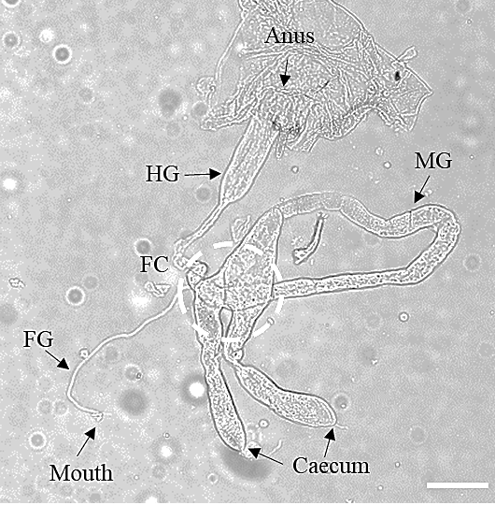

Supplementary Fig. S1

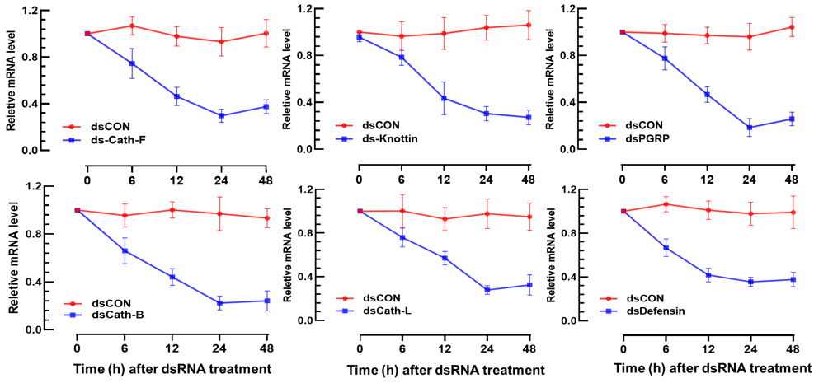

Supplementary Fig. S2

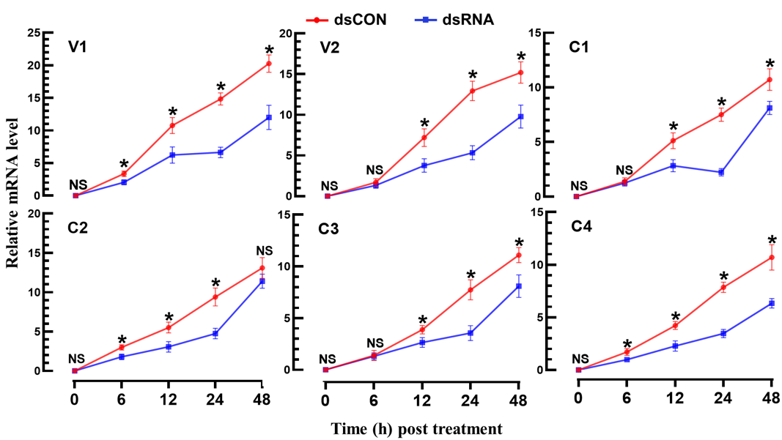

Supplementary Fig. S3

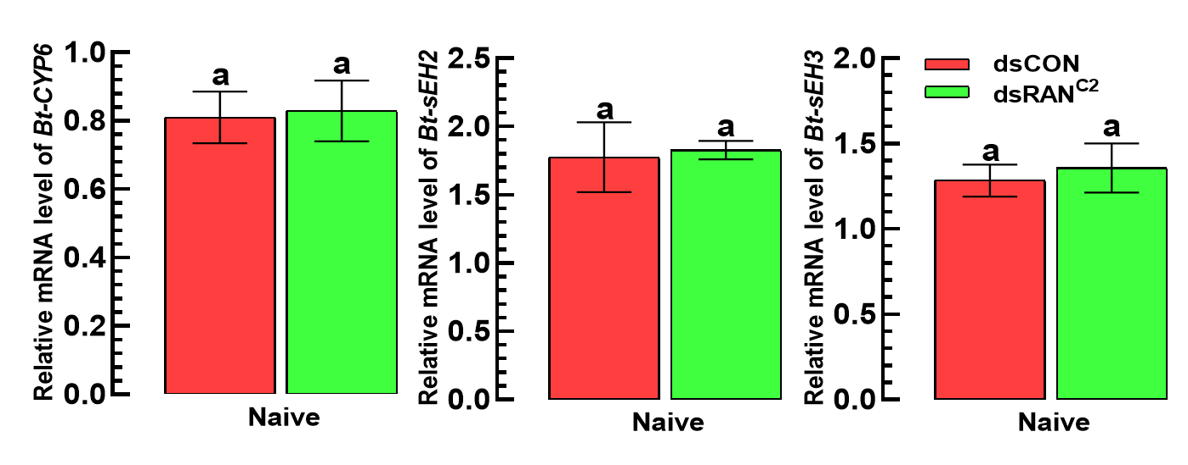

Supplementary Fig. S4

