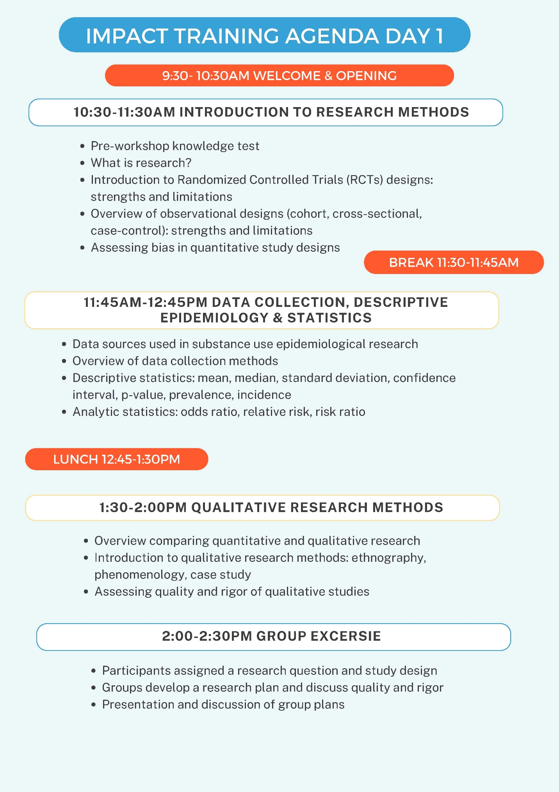
Supplementary Material 1. IMPACT 1 Workshop Agenda.

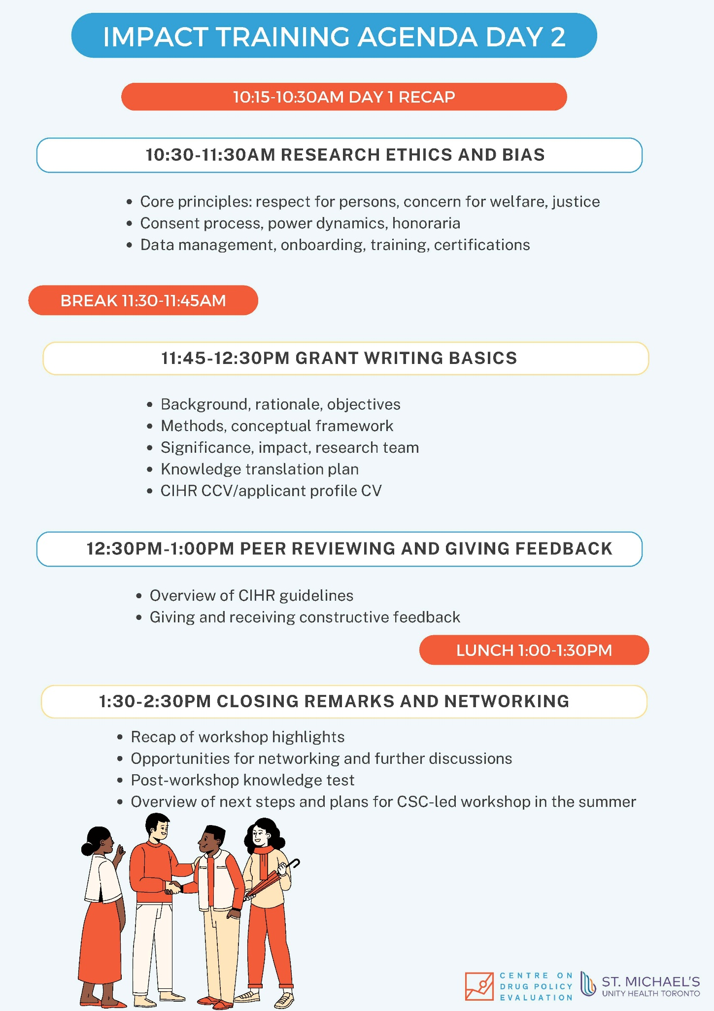
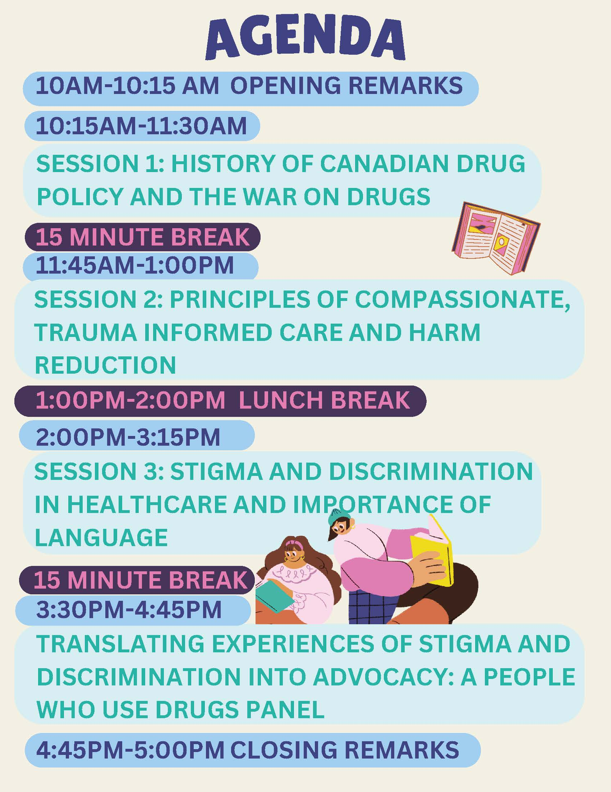
Supplementary Material 2. IMPACT 2 Workshop Agenda.

Supplementary Material 3. Community Steering Committee IMPACT 1 & 2 Interview Guide.

Introduction
SCRIPT: Welcome, and thank you for agreeing to participate in this interview. We're conducting interviews to understand your experiences participating in the two IMPACT workshops that took place in May and October 2024. Your insights will help improve future work with the CSC. Your responses will be kept confidential. This interview will be audio-recorded and take approximately one hour.
Do you have any questions before we begin?
Do you consent to participate in this interview?

--Start Recording on ZOOM--

Section 1: Background Information
Question | Probe
- Can you briefly describe your engagement with the Community Steering Committee (CSC)? | - How long have you been a member of the CSC?  - How has your overall experience been as a CSC member?

Section 2: Phase One - Research Methods Workshops
[Focus: Experiences during the two-day research methods training]
SCRIPT: Thank you for participating in this interview about the IMPACT research training workshop held in March 2024. We’re interested in understanding your experiences and perspectives on the training. I'll be asking you several questions, and there are no right or wrong answers. To start, could you take a moment to review the workshop agenda I've shared with you? This might help refresh your memory about the topics covered during the two-day training.
Question | Probe
Initial Expectations  - What did you expect before attending the research methods workshops? | - What topics or research skills were you eager to learn about?
Content and Learning:  - Which topics did you find most valuable or interesting and why? | - Were there any topics that were unclear or difficult to understand?  - Was there anything that you were hoping to learn that was missing?
Skills Development:  - Do you feel you gained any research skills during the workshop? If so, in what areas? | - Do you feel more confident in your ability to assist with research projects?  - If not, in what areas were you hoping to gain research skills?
Favorite Aspects:  - What did you like most about the research methods training? | - Any specific activities or teaching approaches that stood out?
Challenges Faced:  - Did you encounter any learning challenges or difficulties during the workshops? If so, what were they? | - How did you overcome these challenges?  - Were there any resources or support that could have helped?  - How could these challenges have been prevented?
Opportunities for Improvement - logistics:  - What are your thoughts on how the workshop was run? | - What was your experience working with the workshop facilitators and staff during this phase?  - Were your harm reduction and substance use needs met or supported over the workshop?  - Did you like the workshop setting? Did you feel comfortable being in a hospital research environment?  - Did you feel supported and heard?  - Did you have enough opportunities to ask questions  - Do you think the length of the workshop was sufficient?  - How was the quality of refreshment /service?  - Were there enough breaks?
Opportunities for Improvement - content:
- If you could change anything about the content of workshop, what would it be?
Applying Knowledge:  - How do you plan to use what you learned from the workshop in your current or future role in research? | - Have you already had opportunities to apply any of the skills or knowledge you gained from the workshop? If so, please provide some examples

Section 3: Phase Two - Collaborative Presentation Development
[Focus: Experiences working together and with the research team to develop presentations for healthcare providers in training]

SCRIPT: Thank you for participating in this interview about the IMPACT 2 workshop held in October 2024, where you presented lectures for medical and nursing students. We're interested in understanding your experiences developing and presenting the workshop. To start, could you take a moment to review the workshop agenda I've shared with you? This might help refresh your memory about the process of developing and presenting the sessions.

Question | Probe
Collaborative Experience:  - How was your experience collaborating with other CSC members to develop the presentations? | - What challenges did you face while working together?  - Were there any difficulties in communication, decision-making, or workload distribution?  - How did you deal with the challenges?  - Did you receive any support from staff to resolve any challenges that came up?  - What aspects did you find rewarding?  - What aspects of the collaborative process worked well?
Interaction with CDPE’s Team:  - How would you describe your experience working with CDPE staff and researchers during this phase? | - Did you feel that your ideas and contributions were valued?  - Did you feel that you had autonomy on the direction/focus of the presentations?  - Are there any areas for improvement?
The Presentation:  - On the day of the workshop, how was your experience of presenting? | - What aspects went well?  - What aspects didn’t go well? How could these aspects have been improved?  - Were you satisfied with the presentation?  - Is there anything you would have done differently regarding the content or delivery?
Personal/Professional Growth:  - Has participating in this collaborative process contributed to your personal or professional growth? If yes, in what ways? | - Would you be interested in participating in similar workshops or projects in the future?
Post-workshop Debrief:
- What was your experience with the post-workshop debrief session?
- Is there anything else about the participation in either workshop that you would like to add?
SCRIPT: Thank you for sharing your experiences and valuable insights. Your feedback will be instrumental in helping us improve future workshops and collaborations. If you have any additional thoughts or questions, please feel free to reach out to us.

Section 4: Understanding Non-Participation (for IMPACT 2)

Thank you for participating in this second interview on IMPACT 2. IMPACT 2 was a one-day workshop developed and presented by CSC members to medical and nursing students. We're interested in understanding your experience and reasons for not participating in this event. Again, there are no right or wrong answers.

Question | Probe
- Were you aware of IMPACT 2?
- When you first heard about the workshop, what were your initial thoughts or feelings? | - Were you interested in participating? Why or why not?
- What were some barriers that prevented you from participating in the workshop? | - Were there specific challenges or barriers that prevented you from attending (e.g., Timing conflicts, personal commitments, access issues, health concerns, lack of interest, etc.)?
- Were there logistical issues like transportation, scheduling, or technological barriers? | - Are there any supports or resources that could have made it easier for you participate in the workshops (e.g., accommodations in schedule, childcare support, technical assistance, or accessibility)?
- How would you describe the way staff communicated with you about the workshops? | - Did you receive sufficient information in a timely manner?  - How could we improve communication about future events?
- What suggestions do you have to make future workshops or events more accessible and appealing to you? | - Do you have any specific suggestions on timing, format, content, or accommodations?
- Is there anything else you'd like to share about your experience with the CSC or the workshops? | - Any concerns, feedback, or suggestions?

SCRIPT: Thank you for sharing your experiences and valuable insights. Your feedback will be instrumental in helping us improve future workshops and collaborations. If you have any additional thoughts or questions, please feel free to reach out to us.

--End Recording on ZOOM--

