Early postoperative microbiota transplant therapy is associated with coordinated microbial, metabolic, and immune recovery dynamics following intestinal surgery

SUPPLEMENTARY METHODS
Donor Screening and Eligibility Criteria
Donors were recruited and screened through the University of Minnesota Microbiota Therapeutics Program using established clinical and laboratory criteria.[35] Screening included a structured medical history questionnaire, physical examination, and serial laboratory testing to exclude gastrointestinal disease, metabolic disorders, autoimmune conditions, malignancy, recent antibiotic exposure, high-risk travel, and behaviors associated with infectious disease transmission. Laboratory screening included serologic, molecular, and culture-based testing for enteric pathogens, blood-borne viruses, and multidrug-resistant organisms, including extended-spectrum beta-lactamase–producing Enterobacterales, carbapenem-resistant organisms, vancomycin-resistant Enterococcus, and methicillin-resistant Staphylococcus aureus, consistent with prior standardized fecal microbiota donor screening protocols.[35]

Microbiota Product Manufacturing and Quality Control
The investigational microbiota product (MTP-101LR) was manufactured under current Good Manufacturing Practice conditions using previously described fecal microbiota processing workflows.[35] Donor stool was processed within a controlled laboratory environment using standardized homogenization, filtration, and cryopreservation procedures. Bacterial cell concentration was quantified using Petroff–Hausser chamber counting, and the final product was suspended in a cryoprotectant solution prior to aliquoting and storage at −80 °C.
Lot release criteria included visual inspection, bacterial concentration thresholds, endotoxin testing, and sterility testing, consistent with prior fecal microbiota manufacturing standards.[35] Each participant received microbiota derived from a single donor and a single manufacturing lot.

Sample Processing and Storage
Fecal samples were collected using sterile containers and immediately stored at −20 °C prior to transfer on ice to −80 °C storage, consistent with established microbiome preservation practices.[38] Peripheral blood samples were collected in EDTA tubes and stabilized immediately using a whole-blood stabilizing reagent validated for downstream immune profiling.[53] All samples were de-identified and processed in batch to minimize technical variability.

16S rRNA Gene Sequencing, Quality Control, and Source Attribution
Raw sequencing reads were processed using mothur (v.1.41) following a previously published pipeline.[41, 42] Briefly, paired-end reads were assembled, quality-filtered, and aligned to the SILVA reference database (ver. 138).[43] Sequences were subjected to a 2% preclustering step to reduce sequencing error,[44] screened for chimeras using UCHIME,[45] and classified taxonomically using the Ribosomal Database Project reference database (ver. 18).[47] Operational taxonomic units (OTUs) were assigned using the OptiClust algorithm at 99% similarity.[46]
A median of 25,043 (interquartile range 14,491–945,436) sequence reads per sample were obtained. For unbiased statistical comparisons,[95] samples were rarefied to 5,000 sequence reads by random subsampling, and samples with fewer sequence reads were removed from the data set. After rarefaction, the mean estimated Good’s coverage was 98.7 ± 1.3%, with a mean of 116 ± 48 OTUs observed per sample.
Negative extraction and amplification controls were included in all sequencing runs and did not yield detectable amplicons. Samples failing sequencing depth or quality control thresholds were excluded from downstream analyses, consistent with established microbiome quality control standards.[42]
Donor similarity and source attribution were assessed using SourceTracker, a Bayesian framework that estimates the proportion of microbial communities derived from predefined source environments.[52] Donor and recipient baseline stool samples were designated as source communities, and recipient fecal samples after baseline were treated as sinks. Analyses were performed on rarefied genus-level abundance tables using default SourceTracker parameters. Posterior distributions were estimated using Gibbs sampling, and donor contribution proportions were summarized across posterior samples. SourceTracker outputs were used to estimate longitudinal donor similarity following MTT.

Short-Chain and Branched-Chain Fatty Acid Quantification
Fecal short-chain and branched-chain fatty acids were quantified by gas chromatography–mass spectrometry using validated protocols.[39, 40] Samples were homogenized, acidified, and extracted prior to analysis. Calibration curves were generated using authentic standards, and internal standards were included to control for extraction efficiency and instrument variability. Quality control samples were analyzed at regular intervals throughout each analytical run. Metabolite concentrations were normalized to wet stool weight, as previously described. [39, 40]

Antibiotic Exposure During 6-month Follow up Period
Given the potential impact of antibiotics on microbial engraftment, postoperative antibiotic exposure was prospectively recorded during the six-month follow-up period. Five of twelve patients in the MTT group received antibiotics after surgery.
One patient received a 48-hour course of piperacillin–tazobactam initiated on POD 9 for postoperative leukocytosis in the absence of radiographic evidence of intra-abdominal infection. A second patient received a single dose of amoxicillin–clavulanate on POD9 for wound drainage subsequently confirmed to represent a seroma. Two patients with stage III colon cancer received a single prophylactic dose of cefazolin at 10 and 12 weeks postoperatively during chemotherapy port placement. One additional patient was treated with a two-week course of amoxicillin–clavulanate for pancreatitis occurring seven weeks after surgery. No prolonged or repeated antibiotic exposure overlapped with primary sampling windows.

Spectral Flow Cytometry Antibody Panels and Data Acquisition
Custom antibody panels were designed to profile innate and adaptive immune populations using spectral flow cytometry, following established best practices for high-dimensional immune phenotyping.[54, 55] Panel design was optimized using Cytek similarity and complexity indices to minimize spectral overlap and signal spread. Antibody clone, fluorophore, vendor, and catalog number information is provided in Supplementary Tables 2 and 3.
Data acquisition was performed on a five-laser Cytek Aurora system using standardized instrument settings. Spectral unmixing was performed using single-stain controls, and batch effects were assessed across acquisition days.[54]

Immune Data Preprocessing and Quality Control
Flow cytometry data were compensated, transformed using an arcsinh transformation, and quality-filtered to remove debris, doublets, and dead cells, consistent with established immune cytometry workflows.[55] Cell populations were gated using a hierarchical strategy prior to high-dimensional analysis. Samples failing predefined quality control thresholds were excluded from downstream analyses.

Unsupervised Immune Clustering and Dimensionality Reduction
High-dimensional immune data were analyzed using unsupervised clustering and dimensionality reduction approaches. Uniform Manifold Approximation and Projection (UMAP) was used for visualization of cellular phenotypes.[96] Clustering was performed using FlowSOM followed by metaclustering to identify phenotypically distinct cell populations.[97] Cluster identities were defined based on relative marker expression patterns rather than predefined functional labels, consistent with prior immune systems biology studies.[98]
Differential cluster abundance and marker expression were assessed using paired statistical tests with correction for multiple comparisons.

Multi-omics Integration and Latent Variable Modeling
To integrate microbiome composition and metabolite profiles, partial least squares regression was applied to genus-level microbial abundance data and fecal SCFA concentrations.[56-59] Data were centered and scaled prior to modeling. Latent axes were derived using stability selection to identify reproducible features contributing to shared variance across data types.[57, 58] Axis scores were calculated for each sample and used for downstream analyses.

Shared-Embedding Correlation Network (SECN) Construction
Shared-embedding correlation networks were constructed by embedding microbiome, metabolite, and immune features into a low-dimensional shared space, as previously described.[60-63] Sparse correlation matrices were estimated using partial Spearman correlations with false discovery rate correction. Network sparsification was performed to retain robust feature associations.
Connector nodes were defined as features with statistically significant edges linking all three data layers. Enrichment of immune versus non-immune features among connector nodes was assessed using Fisher’s exact test.[65]

Lead–Lag Analysis
Time-ordered associations between immune features were assessed using baseline-adjusted lead–lag analysis, as previously described.[61, 62, 64] Partial Spearman correlations were computed between features at sequential timepoints while controlling for baseline values. Associations were retained based on effect size thresholds and false discovery rate correction.

Statistical Analysis
Statistical analyses were performed using R (v.4.3). Paired comparisons were conducted using non-parametric tests where appropriate. Multiple-testing correction was applied using the Benjamini–Hochberg method.[62] Statistical significance was defined as adjusted P < 0.05 unless otherwise specified. Longitudinal sample completeness was high. Peripheral blood was available from all MTT recipients at all prespecified timepoints. For fecal sampling, one MTT recipient was missing stool samples at POD30 and POD90; all other fecal samples were available at prespecified collection timepoints. No imputation was performed, and analyses were conducted using available samples at each timepoint.

SUPPLEMENTARY FIGURES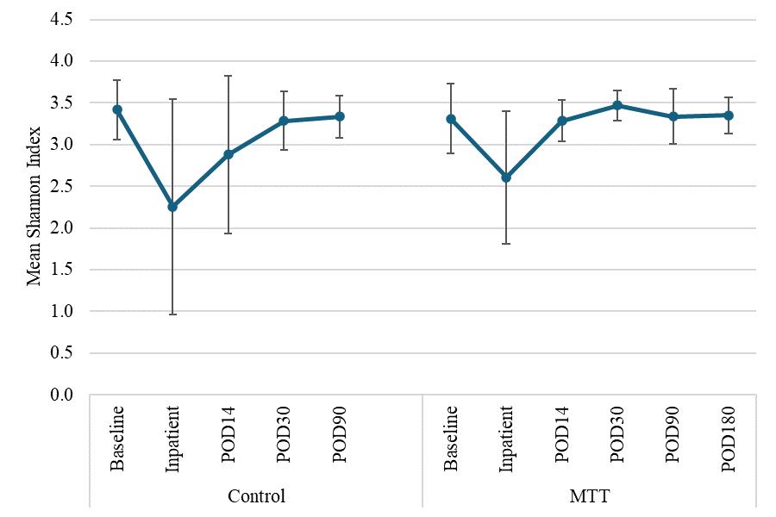
Fig. S1. Alpha Diversity Between Control and MTT Groups. Shannon indices (alpha diversity) for non-MTT control and MTT patients at baseline, inpatient, POD14, POD30, POD90, and POD180 timepoints.
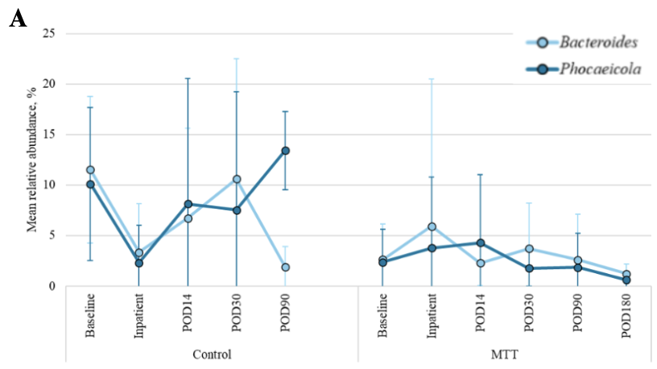

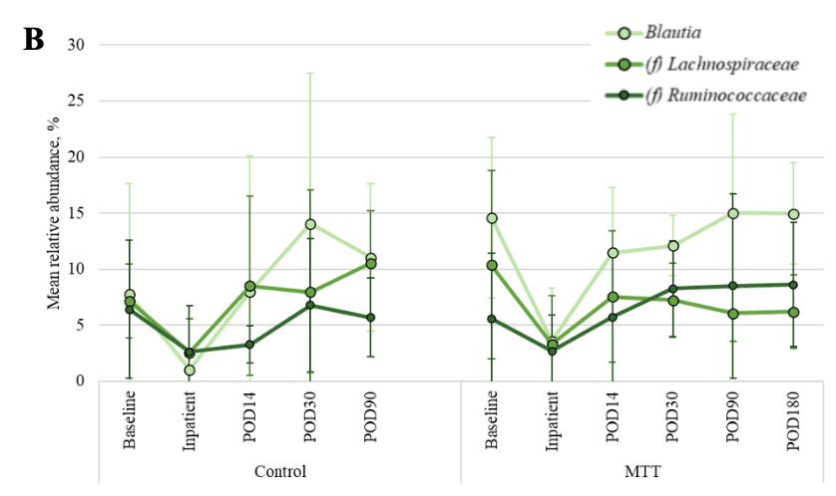

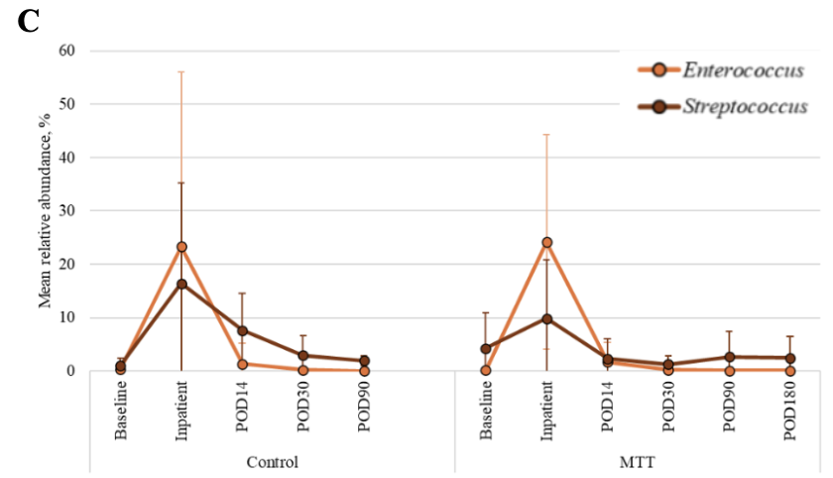

Fig. S2. MTT Modulates Key Commensal and Pathobiont Genera Over Time. Abundances of predominant genera (mean ± standard deviation) in non-MTT controls and MTT recipients at baseline, inpatient, POD14, POD30, POD90, and POD180; (A) Relative abundances of Bacteroides and Phocaeicola; (B) Relative abundances of Blautia, Ruminococcaceae, and Lachnospiraceae; (C) Relative abundances of Enterococcus spp. and Streptococcus spp.

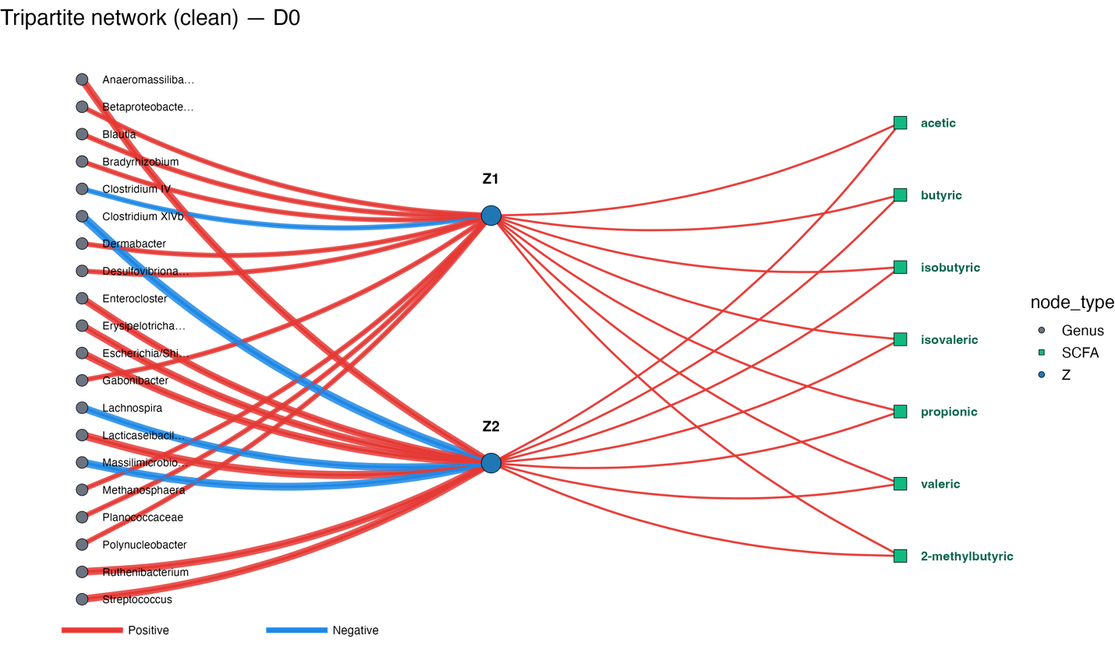Fig. S3. Baseline Tripartite Networks (POD0, pre-MTT). The network at baseline shows sparse and inconsistent links between microbes (left, gray nodes) and SCFA derivatives (right, green nodes), mediated by a central latent recovery axis (Z2, blue node) with no immune nodes present. Red edges indicate positive correlations and blue edges negative correlations. This pattern suggests weak microbiome–metabolite coupling prior to surgery.

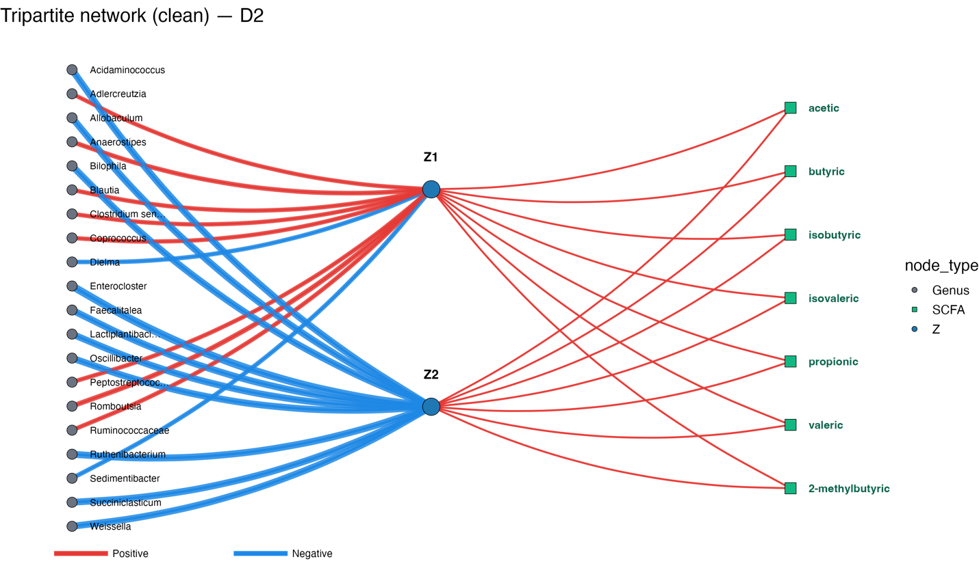Fig. S4. Early Recovery Tripartite Networks (POD2, post-surgery). The network at POD2 shows emerging links between microbes (left, gray nodes) and SCFA derivatives (right, green nodes), mediated by a central latent recovery axis (Z2, blue node) with no immune nodes present. Red edges indicate positive correlations and blue edges negative correlations. This pattern suggests improving microbiome–metabolite coupling early after surgery.

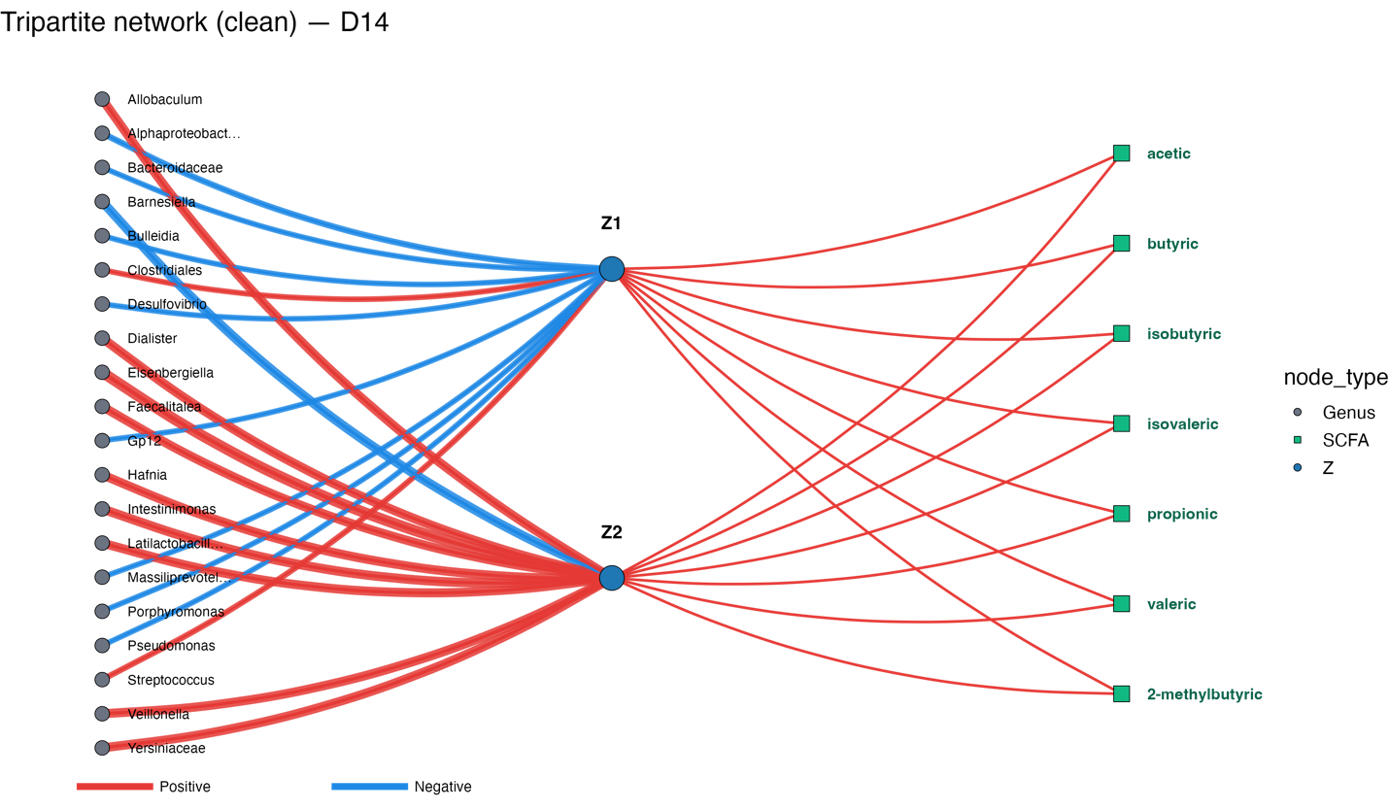Fig. S5. Late Recovery Tripartite Network (POD14). The network at POD14 shows robust and consistent links between microbes (left, gray nodes) and SCFA derivatives (right, green nodes), mediated by central latent recovery axes (Z2, blue nodes) with no immune nodes present. Red edges indicate positive correlations and blue edges negative correlations. This pattern suggests strong microbiome–metabolite coupling during late recovery.

Fig. S6. Gating Strategy for Identification of Innate Immune Subsets in MTT Samples.
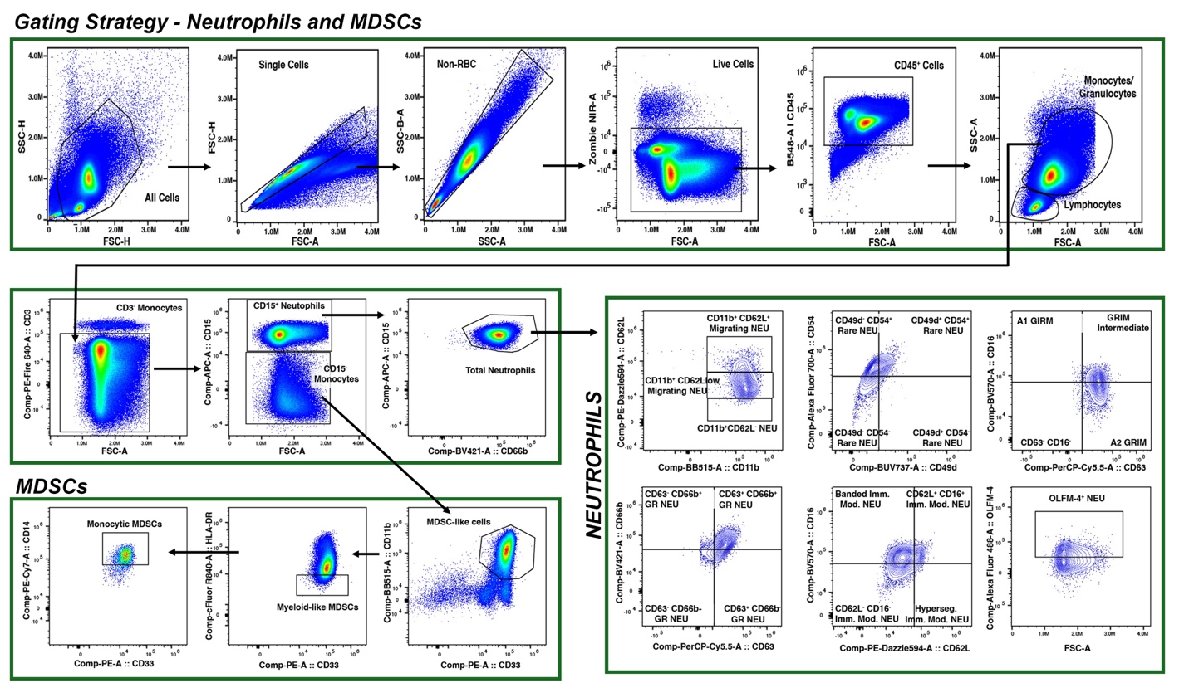
Density and contour plots illustrate the sequential gating strategy used to identify peripheral blood innate immune cell populations in MTT recipients.
Fig. S6A. Neutrophil and myeloid-derived suppressor cell (MDSC) panel.

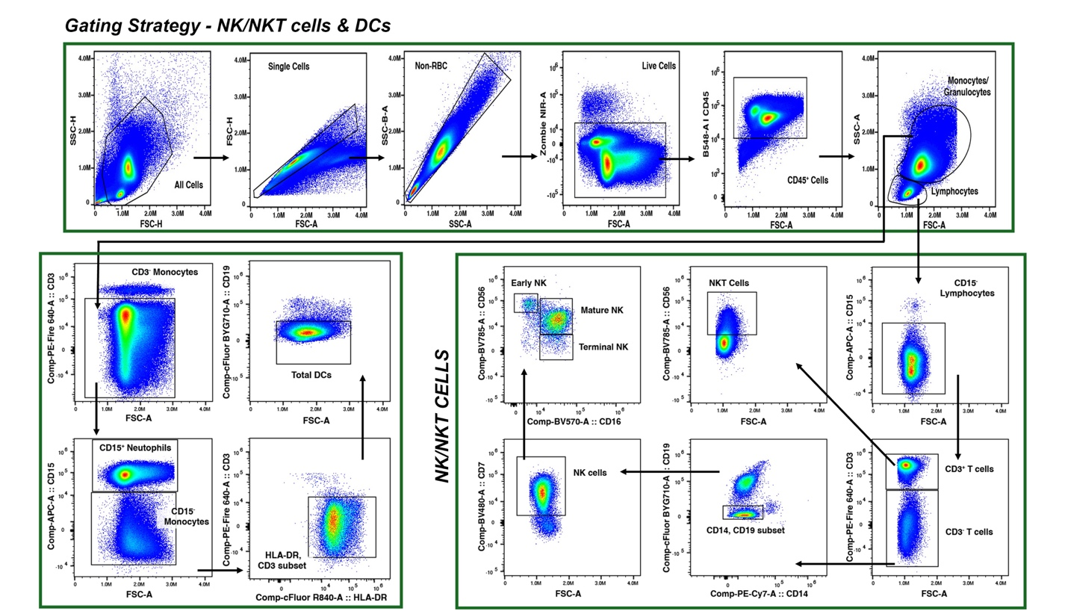
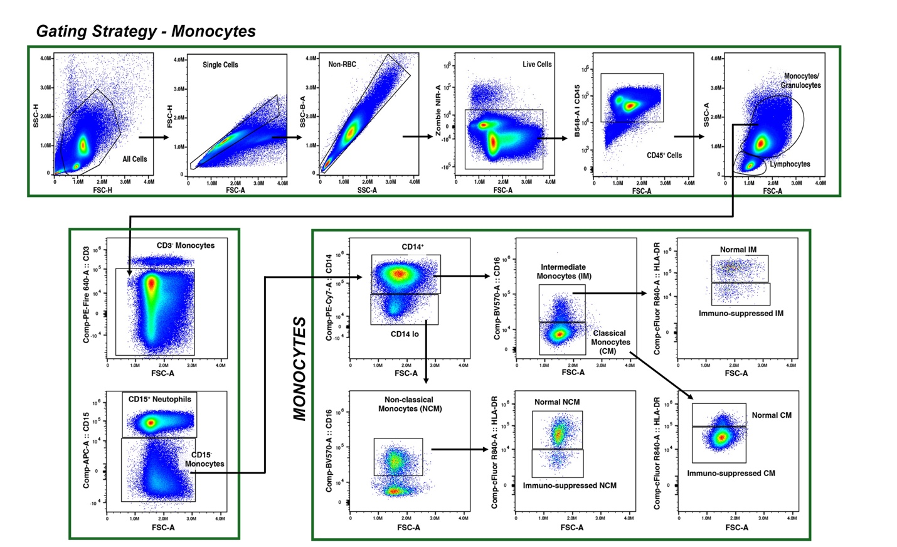
Fig. S6B. Monocyte Subsets.
Fig. S6C. NK, NKT, and dendritic cell (DC) populations.
Arrows indicate successive stages of the gating hierarchy, depicting the structured progression from CD45⁺ viable singlets to defined immune subsets. Density and contour plots were generated from a minimum of 100,000 CD45⁺ live singlet events per sample and are representative of pooled donor data (n = 6), ensuring robust representation of each immune population.

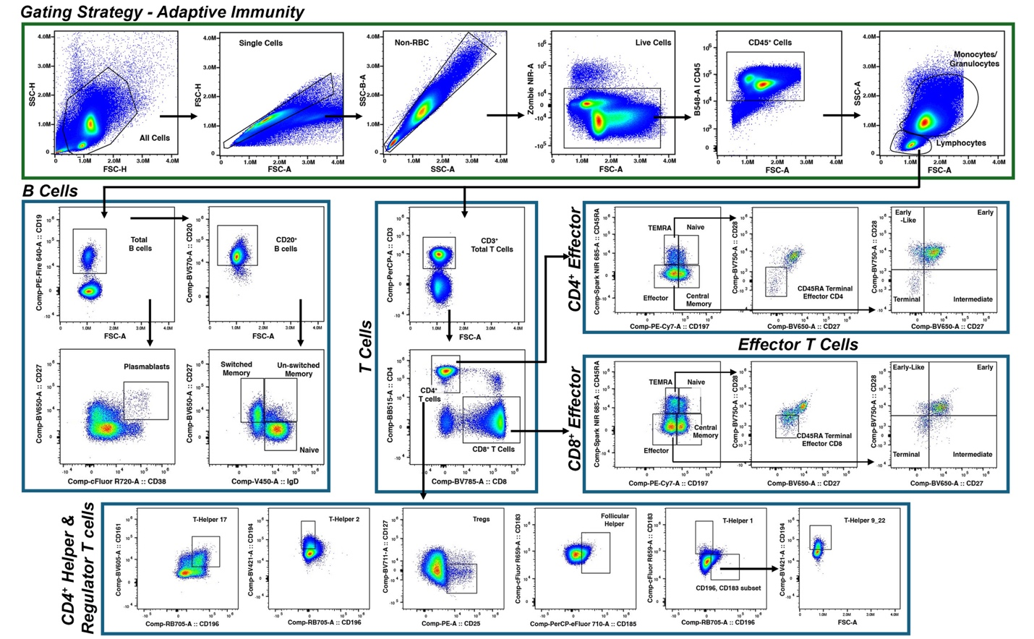
Fig. S7. Gating Strategy for Identification of Adaptive Immune Subsets in MTT Samples. Density plots depict the sequential gating strategy used to define T and B lymphocyte populations in peripheral blood samples from MTT recipients.
Arrows indicate each stage of the gating workflow, highlighting transitions between defined cell populations within the T and B cell panels. Plots were generated from a minimum of 100,000 CD45⁺ live singlet events per sample, concatenated across donors (n = 6), to ensure consistent representation of adaptive immune subsets.

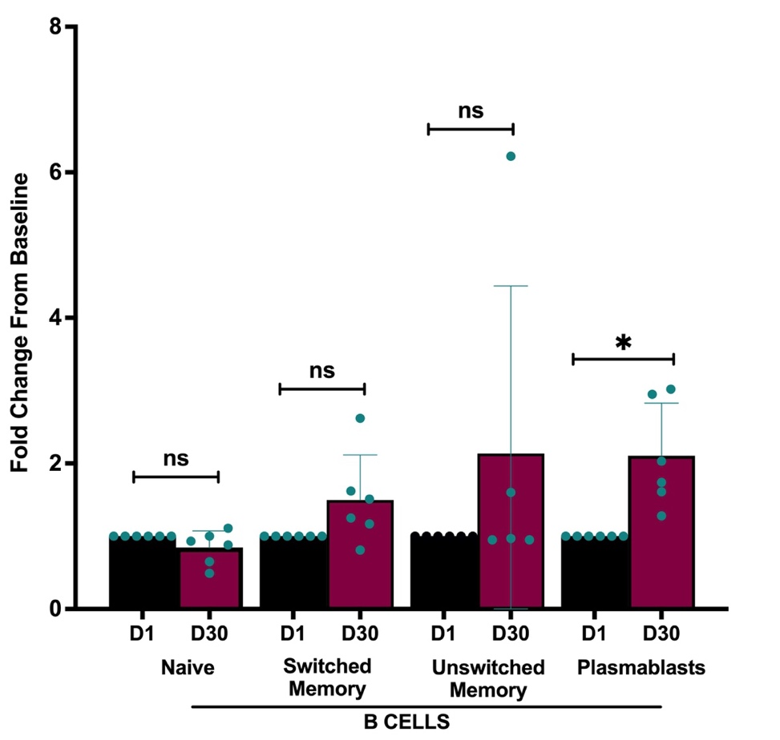

Fig. S8. MTT is Associated with Shifts in Memory B Cell and Plasmablast Populations. Quantification of B cell subsets following MTT is consistent with relative stability in naïve B cells alongside changes within antigen-experienced compartments. Switched and unswitched memory B cell populations exhibited increases relative to POD1 MTT baseline samples (not statistically significant). A statistically significant increase in plasmablast frequency was observed, consistent with differentiation of memory B cells into antibody-secreting cells. These findings align with adaptive immune remodeling observed at POD30 (Fig. 6) and support coordinated restructuring of humoral compartments during postoperative recovery.

SUPPLEMENTARY TABLES

Cohort | Time Point | Acetate | Propionate | Butyrate | Valerate
MTT | Baseline | 22.73 (14.03)ᵃ | 19.28 (17.33)ᵃ | 9.86 (6.86)ᵇ | 2.72 (2.04)ᵃ
MTT | Inpatient† | 8.21 (8.13)ᵇ | 1.60 (2.47)ᵇ | 0.44 (0.93)ᵇ | 0.06 (0.16)ᵇ
MTT | POD14 | 47.16 (50.01)ᶜ | 32.38 (26.35)ᶜ | 16.36 (18.33)ᶜ | 2.72 (3.70)ᵃ
MTT | Blanks | 0.15 (0.08) | 0.03 (<0.01) | 0.01 (<0.01) | 0.01 (<0.01)
Non-MTT Controls | Baseline | 26.41 (17.94)ᵃ | 25.68 (13.34)ᵃ | 18.89 (12.06)ᵃ | 3.70 (2.21)ᵃ
Non-MTT Controls | POD14 | 5.06 (4.90)ᵇ | 5.31 (8.41)ᵇ | 2.21 (4.23)ᵇ | 0.27 (0.54)ᵇ
Non-MTT Controls | Blanks | 1.25 (0.12) | 0.04 (0.01) | 0.01 (<0.01) | 0.01 (0.01)
Table S1. MTT is Associated With Higher SCFA Concentrations at POD14. Fecal short-chain fatty acid (SCFA) concentrations (µM/g) in patients who received MTT versus non-MTT controls at baseline, while inpatient (transplant patients only), and POD14. Values represent mean (standard deviation). Superscript letters denote statistical comparisons within each SCFA; values sharing a letter are not significantly different (P > 0.05, ANOVA with post hoc test). †Between 42-96 hours postoperatively.
Cohort | Time Point | 2-Methylbutyrate | Isobutyrate | Isovalerate
Microbial Transplant Therapy | Baseline | 1.21 (0.85)ᵃ | 2.27 (1.46)ᵃ | 1.68 (1.18)ᵃ
Microbial Transplant Therapy | Inpatient† | 0.12 (0.12)ᵇ | 0.41 (0.70)ᵇ | 0.36 (0.62)ᵇ
Microbial Transplant Therapy | POD14 | 1.28 (1.14)ᵃ | 2.70 (1.72)ᵃ | 1.74 (1.38)ᵃ
Microbial Transplant Therapy | Blanks | 0.03 (0.01) | 0.03 (0.03) | <0.01 (<0.01)
Non-MTT Controls | Baseline | 2.18 (0.79)ᶜ | 5.20 (3.54)ᶜ | 3.40 (1.76)ᶜ
Non-MTT Controls | POD14 | 0.39 (0.69)ᵇ | 0.78 (1.36)ᵇ | 0.68 (1.17)ᵇ
Non-MTT Controls | Blanks | 0.01 (<0.01) | 0.02 (<0.01) | 0.01 (<0.01)
Table S2. MTT is Associated With Higher BCFA Concentrations at POD14. Fecal branched-chain fatty acid (BCFA) concentrations (µM/g) in patients who received MTT versus non-MTT controls at baseline, while inpatient (transplant patients only), and POD14. Values represent mean (standard deviation). Superscript letters denote statistical comparisons within each BCFA; values sharing a letter are not significantly different (P > 0.05, ANOVA with post hoc test). †Between 42-96 hours postoperatively. Of 420 measurements among all measured fatty acids in Tables S1 and S2, 8 (2%) were greater than 2 standard deviations from the mean and excluded from the calculations.
Window | Positive Z2 Drivers (High Positive Loadings) | Negative Z2 Drivers (High Negative Loadings)
Overall | Parvimonas, Peptostreptococcus, Solobacterium, Intestinibacter, Butyricicoccus | Neglecta, Raoultibacter, Massiliimalia, Staphylococcus
POD0 | Blautia, Bulleidia, Campylobacter, Escherichia/Shigella, Lachnospira | Clostridium IV, Clostridium XlVa, Streptococcus, Treponema
POD2 | Lactiplantibacillus, Oscillibacter, Peptostreptococcus, Enterocloster, Dielma | Allobaculum, Anaerostipes, Romboutsia, Succiniclasticum, Acidaminococcus
POD14 | Veillonella, Intestinimonas, Lactobacillus, Massiliprevotella, Streptococcus | Clostridiales, Dialister, Eisenbergiella, Sutterellaceae, Tyzzerella

Table S3. Top Genus Drivers of Z2 by Time Window. Genera shown are the highest-magnitude (absolute) Z2 loading features from the 16S↔SCFA fusion PLS model within each time window. “Positive” and “Negative” indicate the sign of each genus’s Z2 loading. Positive Z2 loadings reflect taxa that covary with the Z2 latent axis in the same direction as SCFA rate patterns captured in that window, whereas negative loadings reflect taxa that covary in the opposite direction.

Sl.No | Antibody | Fluorophore | Vendor | Catalog # | Clone
1 | CD45 | B548 | Cytek | SKU R7-20292 | HI30
2 | CD56 | BV785 | BD Biosciences | 564058 | NCAM 16.2
3 | CD3 | PE-Fire640 | BioLegend | 344860 | SK7
4 | CD19 | BYG710 | Cytek | R7-20009 | HIB19
5 | CD14 | PECy7 | BD Biosciences | 557742 | 9095611
6 | CD7 | BV480 | BD Biosciences | 566119 | M – T701
7 | CD16 | BV570 | BioLegend | 302036 | 3G8
8 | HLA-DR | R840 | Cytek | SKU R7-20294 | L243
9 | CD33 | PE | BD Biosciences | 555450 | 1165676
10 | CD11b | B515 | BD Biosciences | 564517 | ICRF 44
11 | CD20 | B675 | Cytek | R7–20195 | 2H7
12 | CD5 | BV510 | Bio legend | 364018 | 017F12
13 | CD141 | BV750 | BD Biosciences | 747244 | 1A4
14 | CD1c | BV650 | BD Biosciences | 569617 | F 10/21A3
15 | CD123 | PECy7 | BD Biosciences | 551065 | 8250742
16 | Live/Dead | ViaDye™ Red Fixable Viability Dye | Cytek | SKU R7-60008 | -
17 | CD54 | BUV496 | Bio legend | 353126 | B297158
18 | CD184 | BUV395 | BD Biosciences | 740265 | 2B11/CXCR4
19 | CD49d | BUV737 | BD Biosciences | 748702 | L25
20 | CD63 | PerCP-Cy5.5 | Bio legend | 353020 | 85C6
21 | CD15 | APC | Bio legend | 323008 | B421788
22 | OLFM-4 | AF488 | Novus biotechne | 06415AF488 | D185256
23 | CD66b | BV421 | Bio legend | 392916 | 412789
24 | CD62L | PE-Dazzle594 | Bio legend | 304842 | B418094
25 | CD177 | BUV615 | BD Biosciences | 751453 | 507-3600

Table S4. Innate Immune Spectral Flow Cytometry Antibody Panel. Antibody panel used for spectral flow cytometric characterization of innate immune cell populations following MTT. This panel was designed to identify and quantify neutrophil, monocyte, dendritic cell, natural killer cell, and myeloid-derived suppressor cell (MDSC) subsets using marker combinations defining activation state, maturation, adhesion, migration, and immune-associated phenotypes. Fluorochrome selection and panel design were optimized for spectral uniqueness and minimal signal spread using Cytek similarity and complexity indices. All samples were acquired on a five-laser Cytek Aurora system. Antibody vendor, catalog number, clone, and fluorophore information are provided.

Sl.No. | Antibody | Fluorophore | Vendor | Catalog # | Clone
1 | CD 45 | B 548 | Cytek | R7-2029 | H130
2 | CD 19 | PE Fire 640 | BD Horizon | 302274 | HIB19
3 | CD 20 | BV570 | BioLegend | 302332 | 2H7
4 | CD 8 | BV 785 | BioLegend | 344740 | SK1
5 | CD 38 | R 720 | Cytek | R720061 | HIT2
6 | IgD | V450 | BD Horizon | 561309 | AI6-2
7 | TCR alpha/Beta | BV 510 | BioLegend | 306734 | IP26
8 | CD3 | PerCP | BD BioSciences | 552851 | SK7
9 | CD161 | V-605 | BD BioSciences | 748284 | HP3G10
10 | HLA DR | R840 | Cytek | R7-26293 | L243
11 | CD 45RA | R685 | BD BioSciences | 755990 | 5H9
12 | CD 28 | BV750 | BioLengend | 302970 | CD28.2
13 | CD 27 | BV650 | BioLegend | 302828 | 0323
14 | CD 4 | BB515 | BD Horizon | 566056 | L200
15 | CD 183 | R 659 | Cytek | RC-00049 | G025H7
16 | CD 185 | PerCP eFlour 710 | Invitrogen | 46918542 | MU5UBEE
17 | CD 197 | BYG781 | Cytek | RC-00048 | G043H7
18 | CD25 | BYG575 | Cytek | RC-00044 | BC96
19 | CD194 | BV421 | BioLegend | 359414 | L291H4
20 | CD127 | BV 711 | BioLegend | 351328 | A019D5
21 | TCR Gamma/Delta | BYG710 | Tonbo
22 | Live/Dead (ViaDye Red) | ViaDye™ Red Fixable Viability Dye | Cytek | SKU R7-60008 | -
23 | CD196 | RB705 | BD Biosciences | 566477 | 11A9

Table S5. Adaptive Immune Spectral Flow Cytometry Antibody Panel. Antibody panel used for spectral flow cytometric characterization of adaptive immune cell populations following MTT. This panel enables identification of CD4⁺ and CD8⁺ T cell subsets, regulatory T cells, γδ T cells, and B cell populations across differentiation and activation states using established surface marker combinations. The panel was optimized for spectral performance using Cytek similarity and complexity indices to minimize signal overlap. All samples were acquired on a five-laser Cytek Aurora system. Antibody vendor, catalog number, clone, and fluorophore information are listed.

