Supplementary Figures and Tables
Table S1. Number of non-missing SNPs present in each tissue-age group across different presence thresholds.
% Present in Sample | #2025 Leaf SNPs | #2024 Skin SNPs | #2024 Flesh SNPs | #2023 Skin SNPs | #2023 Flesh SNPs
≥0% | 2485 | 2485 | 2485 | 2485 | 2485
≥10% | 2468 | 2452 | 2443 | 2446 | 2452
≥20% | 2367 | 2358 | 2325 | 2332 | 2348
≥30% | 2264 | 2241 | 2216 | 2219 | 2241
≥40% | 2191 | 2162 | 2132 | 2132 | 2163
≥50% | 2191 | 2162 | 2132 | 2132 | 2163
≥60% | 2097 | 2058 | 2033 | 2032 | 2071
≥70% | 1983 | 1942 | 1916 | 1898 | 1952
≥80% | 1863 | 1802 | 1780 | 1702 | 1816
≥90% | 1617 | 1507 | 1476 | 1183 | 1568
100% | 1617 | 1507 | 1476 | 1183 | 1568

Table S2. Type III Analysis of Variance Table with Satterthwaite's method for the log10 of mean read depth from the linear mixed-effects model.
 | Sum Sq | Mean Sq | NumDF | DenDF | F value | Pr(>F)
RootAge | 0.000891 | 0.000891 | 1 | 21 | 0.0211 | 0.8858
RootTissue | 0.018638 | 0.018638 | 1 | 21 | 0.4421 | 0.5133
RootAge:RootTissue | 0.085016 | 0.085016 | 1 | 21 | 2.0168 | 0.1702

Table S3. Analysis of Deviance Table (Type III Wald chi-square tests) for the mean missing rate from the generalized linear model.
 | Chisq | Df | Pr(>X²)
(Intercept) | 261.0221 | 1 | < 2e-16
RootAge | 0.7509 | 1 | 0.38619
RootTissue | 2.8535 | 1 | 0.09118
RootAge:RootTissue | 2.6551 | 1 | 0.10322

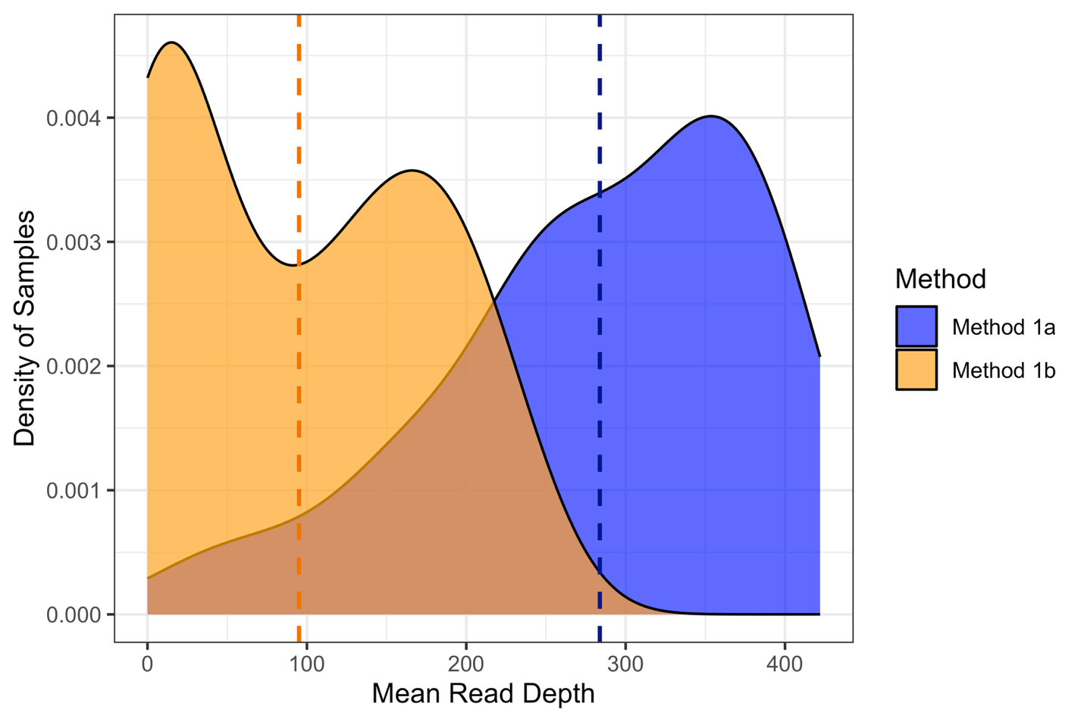
Figure S1. Mean read depth distributions for each DNA extraction method. The dashed vertical lines are the means for each extraction method (Method 1a mean = 283.8; Method 1b mean = 95.1)

