Supplementary material
Multilevel (mixed) logistic regression for the impact of cholera outbreaks on SRH outcomes:
For each binary SRH outcome $Y_{ij}$ (e.g., unprotected sex, multiple partners), for individual $i$in region $j$ a time $t$ :
$$logit\left(\operatorname{Pr}\left(Y_{ijt}​=1\right)\right)=β_{0}​+β_{1}​E_{j}​+β_{2}​T_{t}​+β_{3}​\left(​E_{j}​×T_{t}​\right)+X_{ij}γ+μ_{j}​$$
Where:
$Y_{ijt}$ is the SRH outcome for the individual $i$in region $j$a time $t$.
$E_{j}$ is the exposure binary indicator (cholera outbreak) for region $j$
$T_{t}$is the time indicator (0 for pre-exposure; 1 for post-exposure)
$E_{j}​×T_{t}$ is the interaction term that measures the effect of cholera exposure on $Y_{ijt}$, thus $β_{3}$ is the coefficient of interest; the log-odds change associated with cholera exposure in the post-outbreak period.
$X_{ij}$ is the vector of individual-level covariates, including all demographics.
$μ_{j}​∽N\left(0, σ_{μ}^{2}\right)$ is the random intercept for a region, capturing unobserved region-level heterogeneity.

Figure S1: Regional Trends in Adolescent SRH Indicators in Zambia (Pre vs. Post Cholera outbreak)
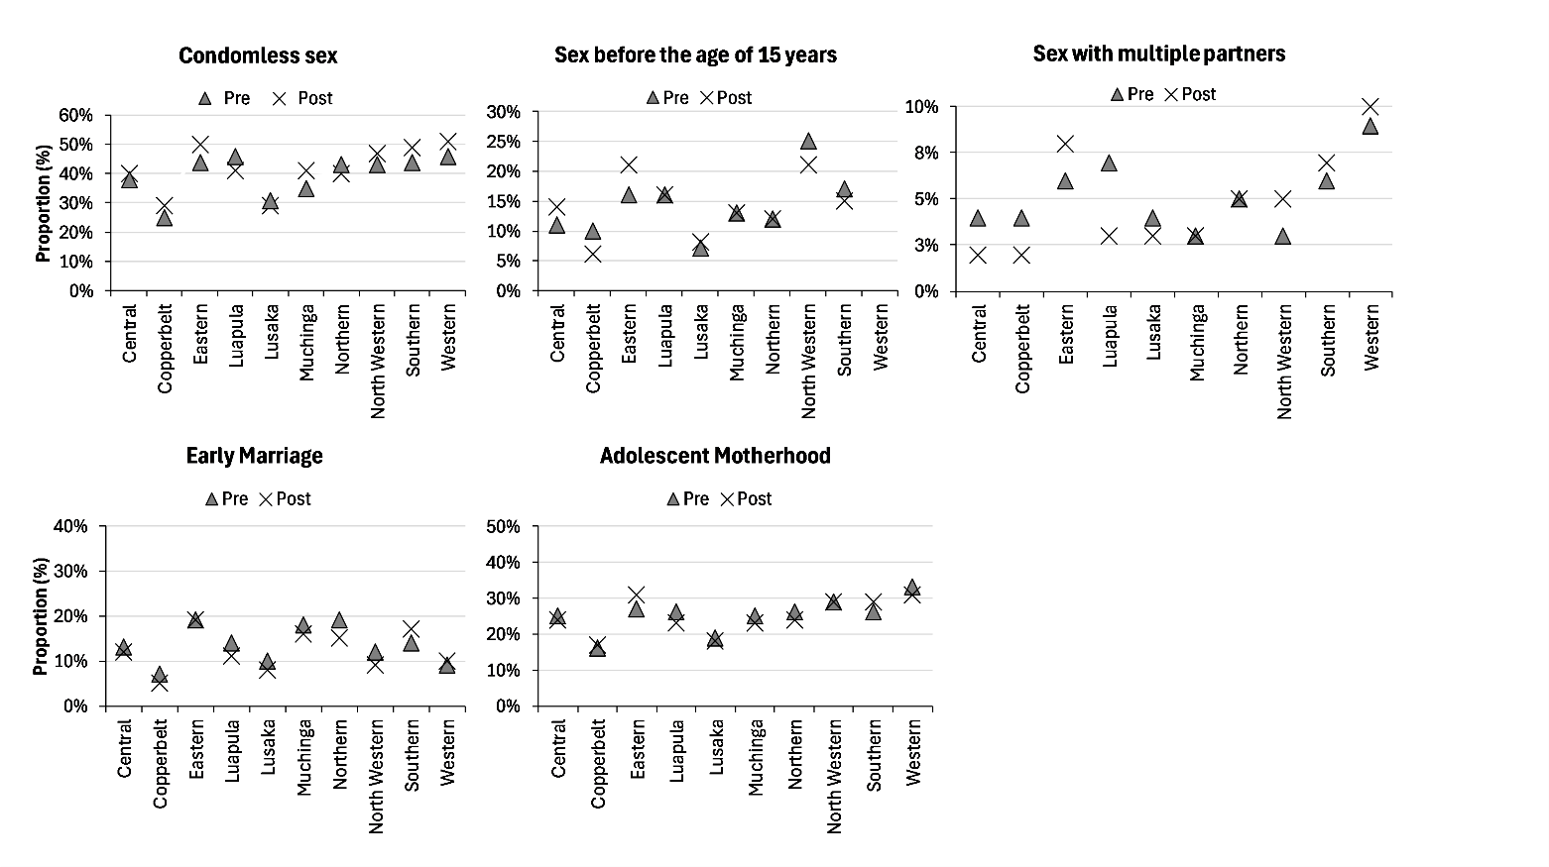
Figure S2: Regional Trends in Adolescent SRH Indicators in Uganda (Pre vs. Post Cholera outbreak)
