Title: Chemopreventive Effects of Ricinus communis Metabolites in Experimental Breast Carcinogenesis via Modulation of Inflammatory and Proliferative Signaling Pathways.
Mona A. Mohammed^{1*}, Bassant M.M. Ibrahim², , Noha E. Ibrahim³, Marwa E. Shabana⁴, Ahmed A. El-Rashedy^{5,6}
¹Medicinal and Aromatic Plants Research Department, Pharmaceutical and Drug Industries Research Institute, National Research Centre, Giza Egypt
²Pharmacology Department, Medical Research and Clinical Studies Institute, National Research Centre, Dokki Giza, PO:12622. Affiliation ID60014618
³Microbial Biotechnology Department, Genetic Engineering and Biotechnology Division, National Research Centre (NRC), Dokki, Cairo, 12622 Egypt
⁴Pathology Department, Medical Research and Clinical Studies Institute, National Research Centre, Giza, Egypt.
5Natural and Microbial Products Department, National Research Center (NRC),
⁶Egypt Department Organic and Medicinal Chemistry, Faculty of Pharmacy, University of Sadat City, Menoufia, 32897, Egypt
*Corresponding author
Mona A. Mohammed email: monaarafamohammed@yahoo.com,
on.ibrahim@nrc.sci.eg

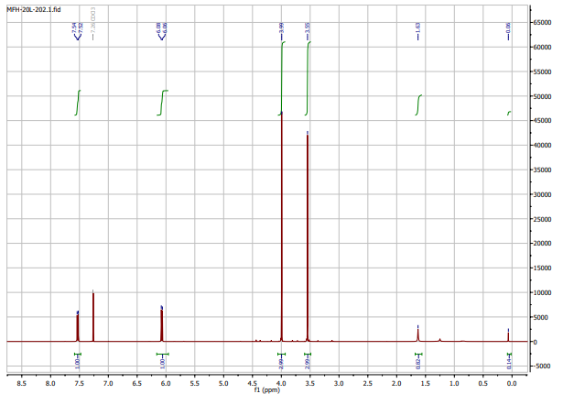
Figure S1: ¹H NMR spectrum of ricinine.
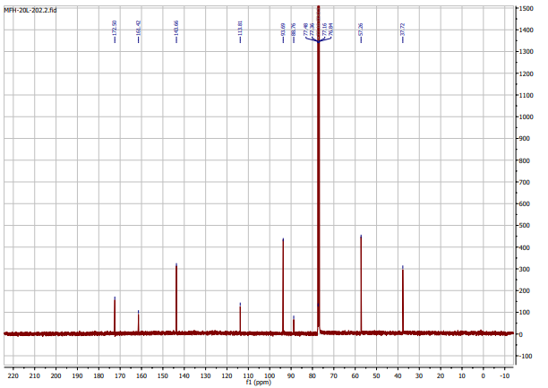
Figure S2: ¹³C NMR spectrum of ricinine.

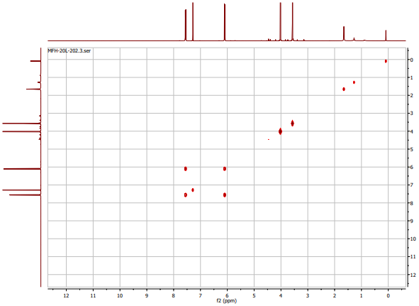
Figure S3: 2D HSQC-NMR spectrum (CDCl₃) showing ¹H–¹³C direct correlations of ricinine.
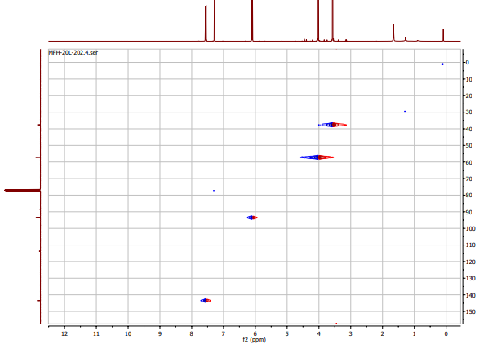
Figure 4: 2D HMBC-NMR spectrum (CDCl₃) showing long-range ¹H–¹³C correlations of ricinine.
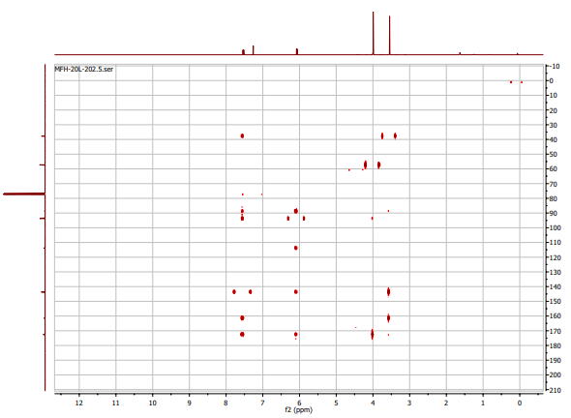
Figure S5: 2D COSY-NMR spectrum (CDCl3) showing ¹H–¹H coupling correlations of ricinine.

6-Nitroimidazo[1,2-a]pyridine

Ricinine

A
B
C
Figure S6: Total ion chromatograms (TICs) obtained by LC–HRMS analysis of (A) the total alkaloid extract, (B) the isolated ricinine compound, and (C) the total plant extract.

Raw Data: We are submitting this letter to provide access to the raw data supporting our manuscript. All raw datasets, including experimental measurements, LC-MS/MS spectra, and other relevant files, have been deposited in a public repository and can be accessed at the following link:
https://drive.google.com/drive/folders/1g5aK7HBNtB84bXuGpBBCU5x3EzOi_RQx?usp=drive_link

