Non-Destructive Evaluation of Plasticized PVC in Modern Design Heritage Objects: The Case of Libuše Niklová
Supplementary material

Simona KlempovÁ, Izabela LukaČoviČ-VajovÁ, Dominika RudinskÁ, Naďa KrivoŇÁkovÁ, and Katarína VizárovÁ

Table of Contents
S1. Photographic Documentation 3
S2. SEM-EDS and ATR-FTIR analysis of PVC-P model samples 9

S1. Photographic Documentation
Fig. S1.1. Photographic documentation of PVC-P model samples with different plasticizer concentrations (20, 30, and 40 wt%) exposed to thermal aging 90 °C (final aging time).
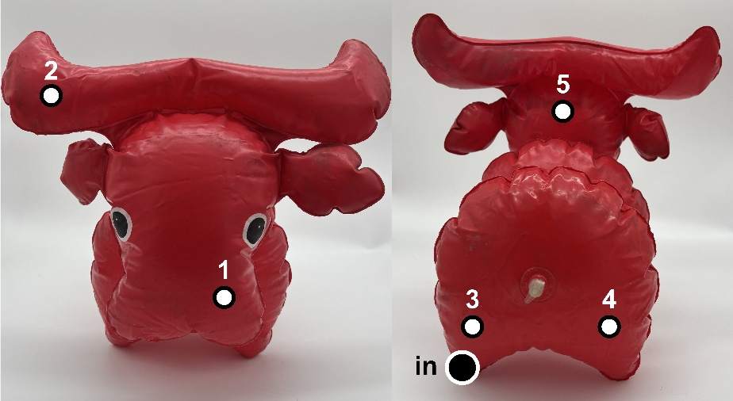
Fig. S1.2. Photographic documentation of a naturally aged PVC-P design object (Buvol, 1981) by Libuše Niklová, showing front and rear views with numbered measurement points. The label “in” indicates the SEM-EDS sampling point and the point where the interior of the sample was measured by ATR-FTIR.

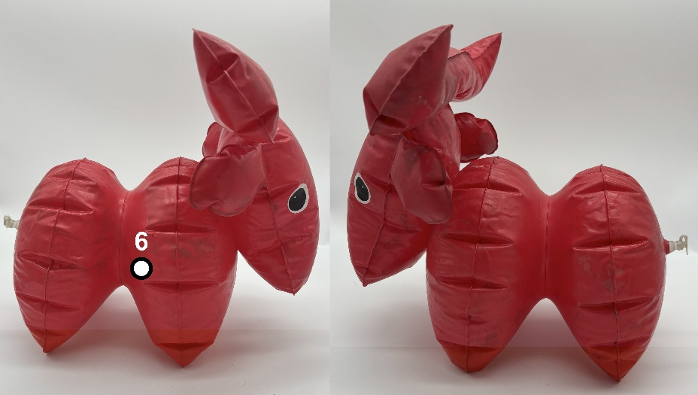
Fig. S1.3. Photographic documentation of a naturally aged PVC-P design object (Buvol, 1981) by Libuše Niklová, showing side views (right and left) with numbered measurement points.

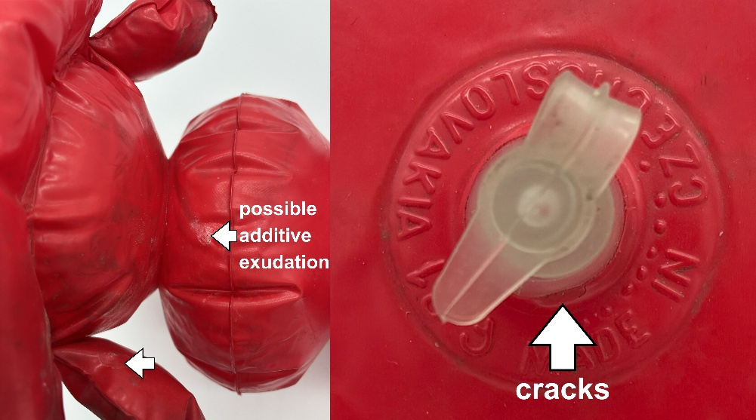
Fig. S1.4. Photographic documentation of a naturally aged PVC-P design object (Buvol, 1981) by Libuše Niklová, showing minor cracks around the valve (left), white powdered exudates (right), and dust deposits with insect frass (small black dots), or possible localized discoloration associated with degradation processes.

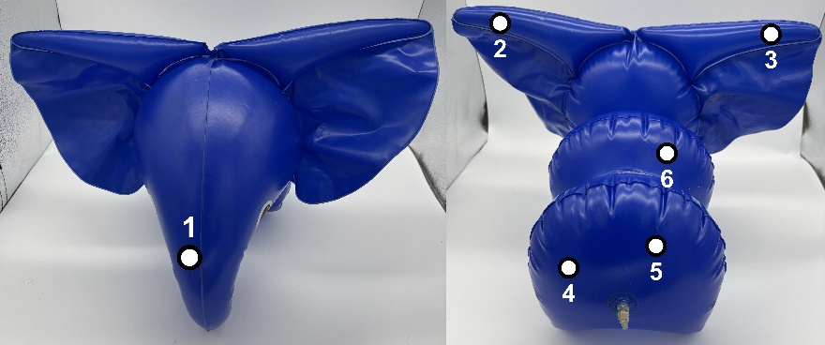
Fig. S1.5. Photographic documentation of a naturally aged PVC-P design object (Slon, 1980) by Libuše Niklová, showing front and rear views with numbered measurement points.
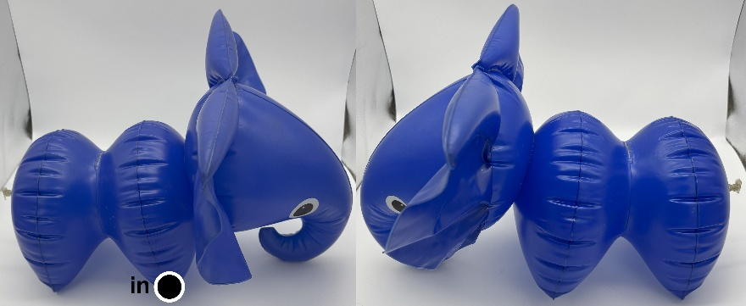
Fig. S1.6. Photographic documentation of a naturally aged PVC-P design object (Slon, 1980) by Libuše Niklová, showing side views (right and left). The label “in” indicates the SEM-EDS sampling point and the point where the interior of the sample was measured by ATR-FTIR.

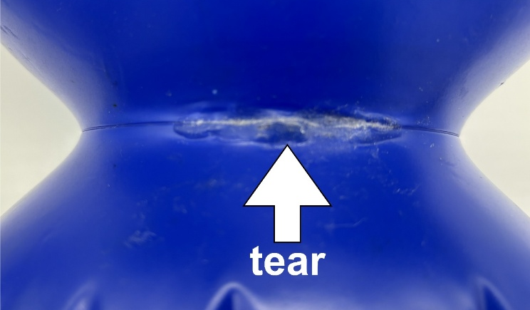
Fig. S1.7. Photographic documentation of a naturally aged PVC-P design object (Slon, 1980) by Libuše Niklová, showing a tear on the back (repaired), dust deposits with insect frass (small black dots), or possible localized discoloration associated with degradation processes.
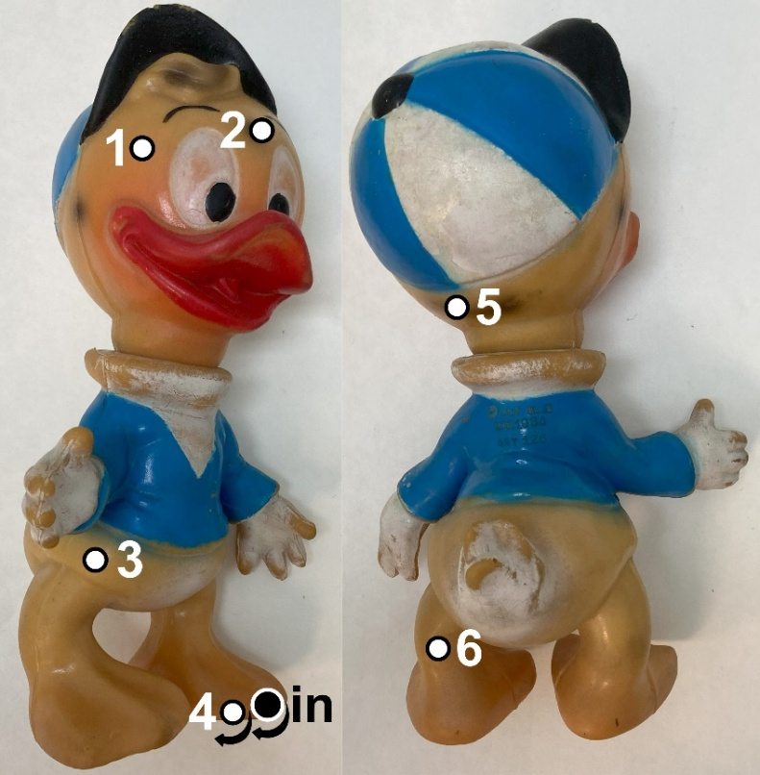
Fig. S1.8. Photographic documentation of a naturally aged PVC-P design object (Dewey, 1964) by The Walt Disney Company with numbered measurement points. Points 5 and “in” (indicated by arrows) are located on the bottom of the feet. The label “in” indicates the SEM-EDS sampling point and the point where the interior of the sample was measured by ATR-FTIR.

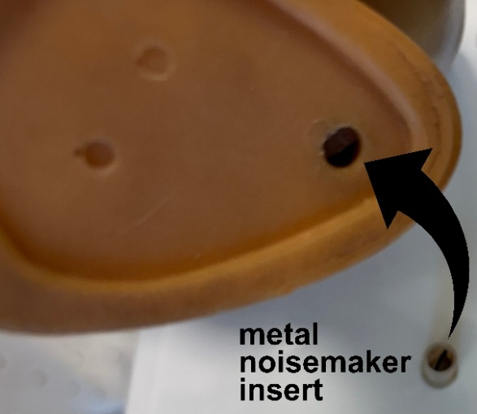
Fig. S1.9. Photographic documentation of a naturally aged PVC-P design object (Dewey, 1964) by The Walt Disney Company with detail view of the feet showing an opening containing a metal noisemaker insert with visible corrosion. The component is present in both feet.
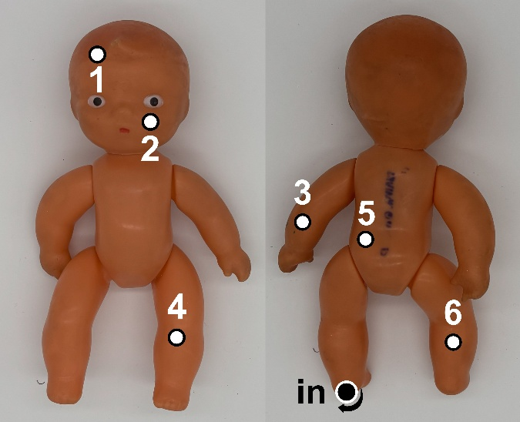
Fig. S1.10. Photographic documentation of a naturally aged PVC-P design object (Miminko František, 1961-1990) by Anna Vystydová, showing front and rear views with numbered measurement points. Point “in” (indicated by arrow) is located on the bottom of the feet. The label “in” indicates the SEM-EDS sampling point and the point where the interior of the sample was measured by ATR-FTIR.

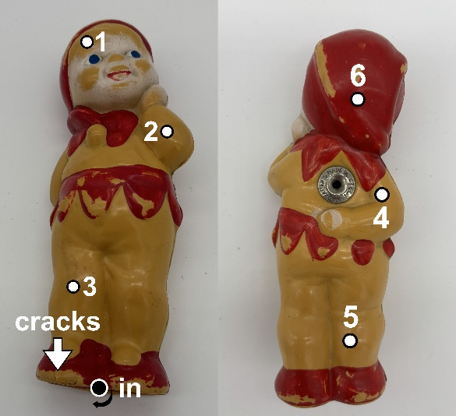
Fig. S1.11. Photographic documentation of a naturally aged PVC-P design object (Kašpárek, 1950s) by Libuše Niklová, showing front and rear views with numbered measurement points cracks around the feet. Point “in” (indicated by arrow) is located on the bottom of the feet. The label “in” indicates the SEM-EDS sampling point and the point where the interior of the sample was measured by ATR-FTIR.
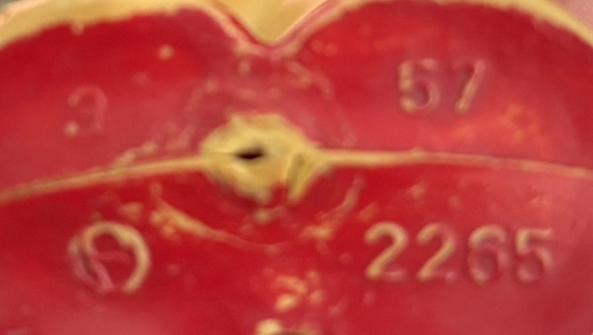
Fig. S1.12. Photographic documentation of a naturally aged PVC-P design object (Kašpárek, 1950s) by Libuše Niklová, showing the marking on the bottom with the manufacturer’s logo and the number 57.

S2. SEM-EDS and ATR-FTIR analysis of PVC-P model samples
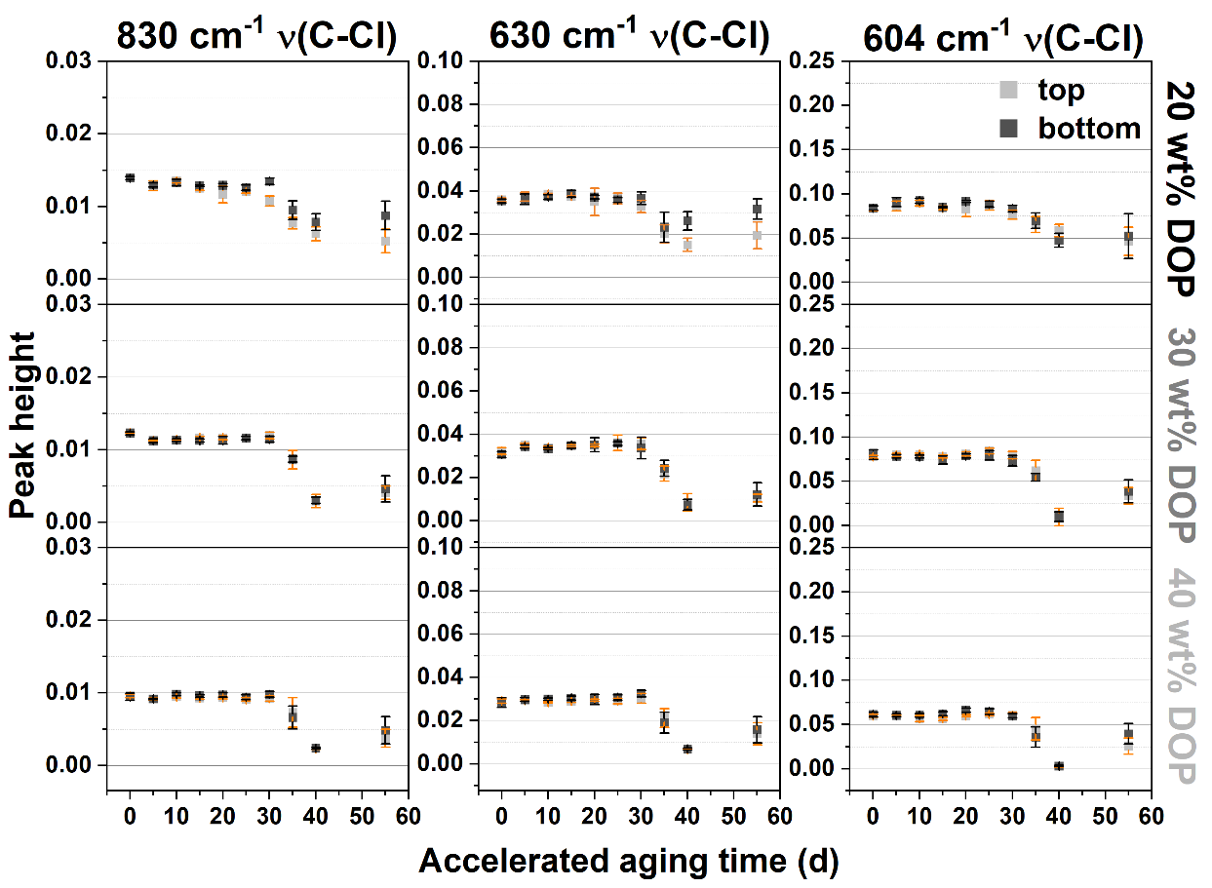
Fig. S2.1. Changes in the height of the C–Cl absorption bands at 830, 630, and 604 cm⁻¹ in ATR-FTIR spectra of PVC-P model samples with different plasticizer concentrations exposed to accelerated thermal aging.

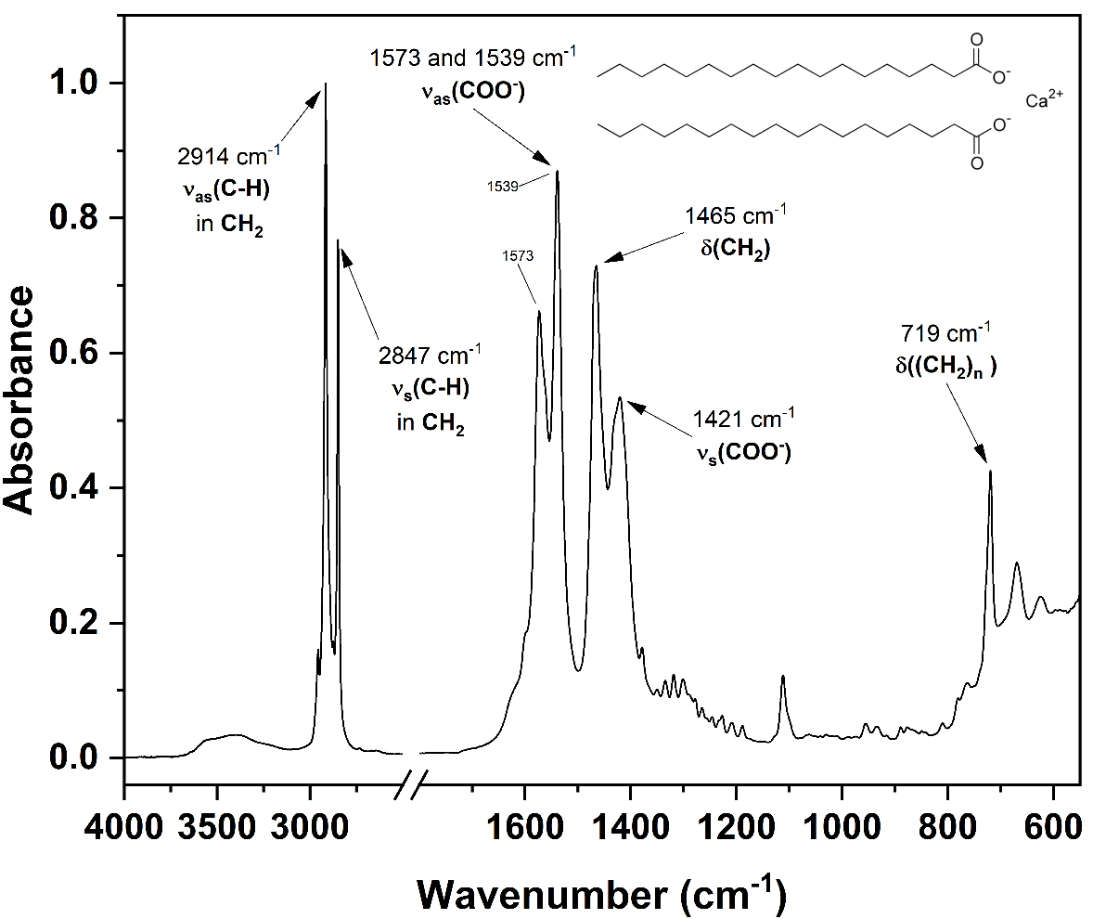
Fig. S2.2. ATR-FTIR spectrum of calcium stearate (thermal stabiliser) used for the preparation of PVC-P model samples. The spectrum was normalised to the [0,1] range.

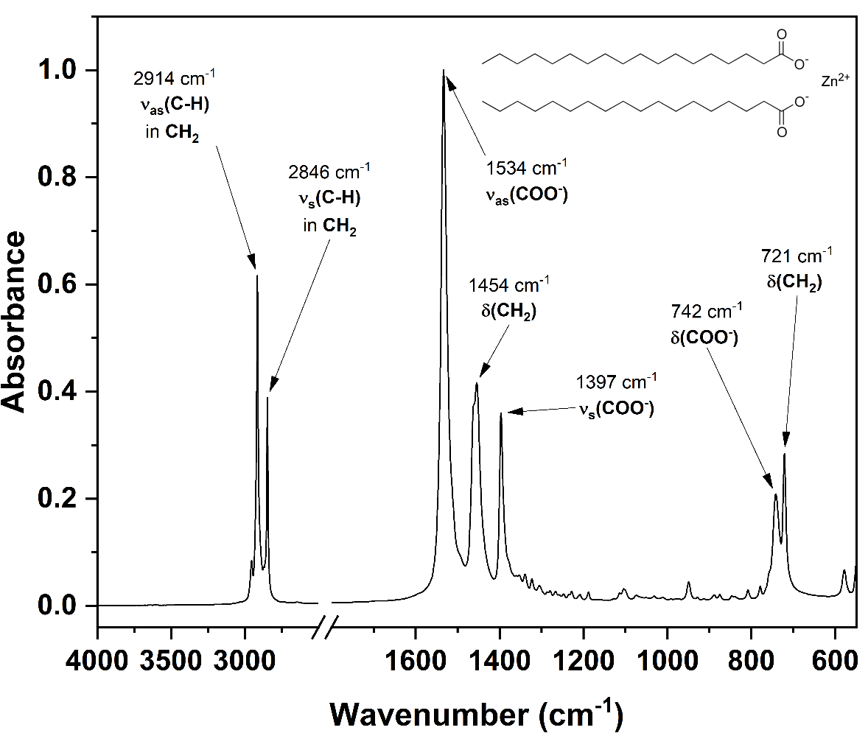
Fig. S2.3. ATR-FTIR spectrum of zinc stearate (thermal stabiliser) used for the preparation of PVC-P model samples.

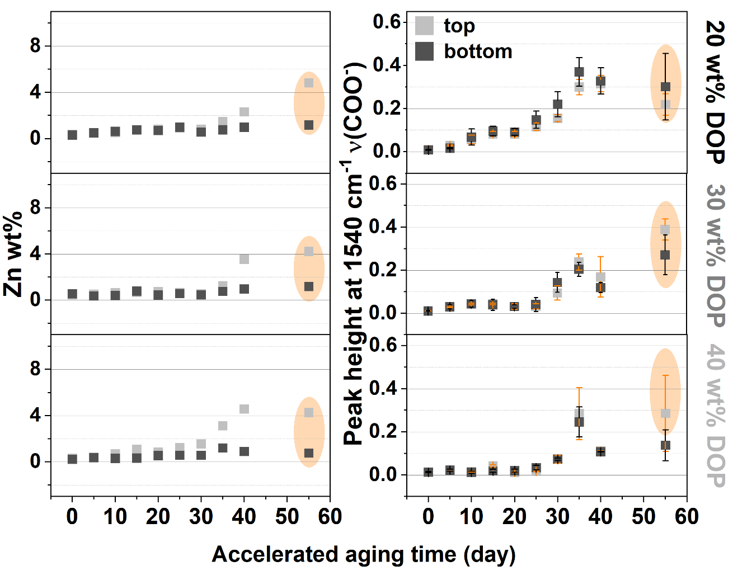
Fig. S2.4. Changes in elemental composition (Zn wt%) and height COO⁻ band associated with the thermal stabilizer (1540 cm⁻¹) in ATR-FTIR spectra of PVC-P model samples with different plasticizer concentrations exposed to accelerated thermal aging.

