Supplementary material for:

Blunted modulation of hierarchical brain organization in opioid use disorder

Dardo Tomasi^{1*}, Peter Manza^{1,2}, Şükrü Barış Demiral¹, Natasha Giddens^{1,3}, Annabelle Belcher⁴, Weizheng Yan^{1,5}, Kylee B. Miller¹, Faith N. Veenker¹, Christina Lildharrie¹, Michele-Vera Yonga¹, Sarah Abey¹, Leyla Brucar¹, Michaelene VanDine¹, Gene-Jack Wang¹, Nora D. Volkow¹

Figure S1. Principal and secondary functional gradients in control and OUD groups. Group-averaged principal (left) and secondary (right) functional gradients are shown for control and OUD participants on cortical surface renderings and corresponding subcortical slices. The principal gradient represents the dominant axis of functional organization, while the secondary gradient captures an orthogonal mode of variation. Overall gradient topology is broadly preserved across groups, with regional differences evident across cortical and subcortical structures.

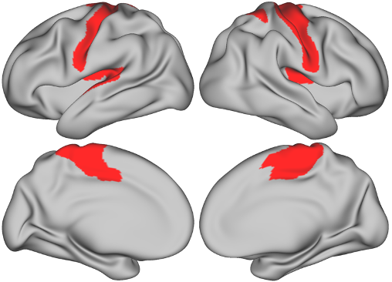
Figure S2. A priori MP-sensitive Network (MPsN) mask. Cortical regions comprising the a priori ROI mask used for hypothesis-driven analyses are shown on lateral and medial surface renderings. The mask was defined in an independent within-subject PET–MRI study of healthy adults (n = 20)¹ using the same 438-ROI parcellation and identifying ROIs exhibiting significant methylphenidate (MP)–related compression of the principal functional gradient (MP vs placebo, FDR-corrected). This predefined ROI set was used to restrict multiple-comparison correction for group-by-drug interaction tests and dopamine D2 receptor–gradient association analyses in the current study. No data from the present cohort were used in defining the mask.

Figure S3. Effects of methylphenidate on the secondary functional gradient. T-score maps for the main effect of drug (a), showing regions exhibiting significant differences between methylphenidate (MP) and placebo (PL) across participants, and group-by-drug interactions (b), highlighting regions where MP–PL effects differed between individuals with opioid use disorder (OUD; n=53) and healthy controls (HC; n=40). Cortical results are displayed on lateral and medial surface renderings, with corresponding subcortical effects shown on axial slices below. Associations were derived from linear mixed-effects models accounting for repeated measures and age, sex, race, BMI, IQ and FD covariates.

Figure S4. Preservation of functional gradient topology across drug conditions and groups. Scatterplots depict parcel-wise correspondence between placebo (PL) and methylphenidate (MP) sessions for the principal (top row) and secondary (bottom row) functional gradients in (a) healthy controls, (b) medicated individuals with OUD, and (c) unmedicated individuals with OUD. Solid lines indicate least-squares fits and dashed lines denote the identity line. Insets illustrate network topography on cortical surfaces. Each point represents a parcel (n=438), colored by canonical functional network affiliation²: Visual (VIS1, VIS2), Somatomotor (SMM), Cingulo-Opercular (CON), Dorsal Attention (DAN), Language (LAN), Frontoparietal (FPN), Auditory (AUD), Default-Mode (DMN), Posterior Multimodal (PMM), Ventral Multimodal (VMM), and Orbito-Affective (ORA).

Figure S5. Visual attention accuracy across groups. Box-and-whisker plots showing percentage accuracy for Control (n=36), Methadone (n=16), Buprenorphine (n=8), and unmedicated OUD (NoMeds; n=15) groups. Boxes represent the interquartile range (IQR), horizontal lines indicate medians, and whiskers denote the data range (excluding outliers). Individual data points are overlaid.

References
1. Tomasi D, Manza P, Demiral ŞB, Yan W, Miller KB, Veenker F et al. Methylphenidate reorganizes cortical hierarchy through dopaminergic modulation. Nat Commun 2026; 17: 791.

2. Ji J, Spronk M, Kulkarni K, Repovš G, Anticevic A, Cole M. Mapping the human brain's cortical-subcortical functional network organization. Neuroimage 2019; 185: 35-57.

