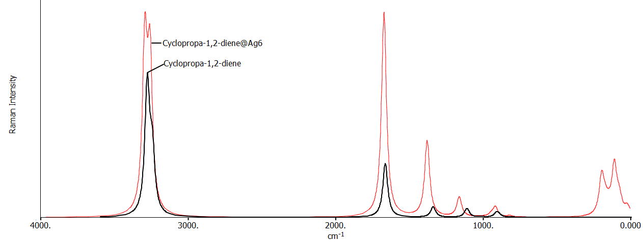

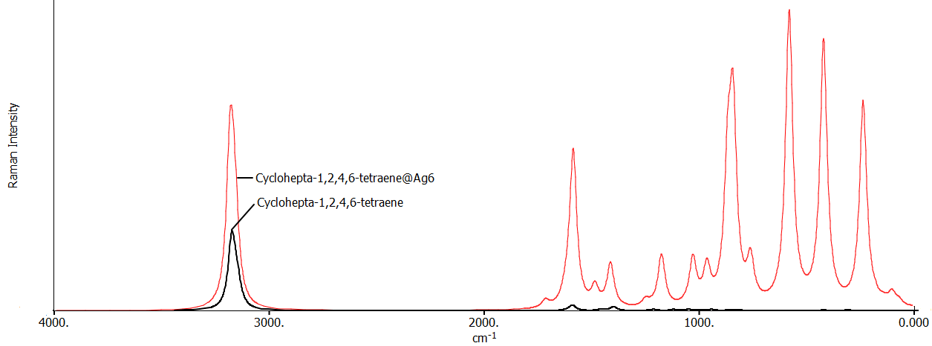

This graphical abstract illustrates how adsorption onto Ag₆ clusters enhances aromaticity in π-systems, leading to stronger aromatic stabilization and amplified surface-enhanced Raman scattering (SERS) signals.

