Supplementary figure 1
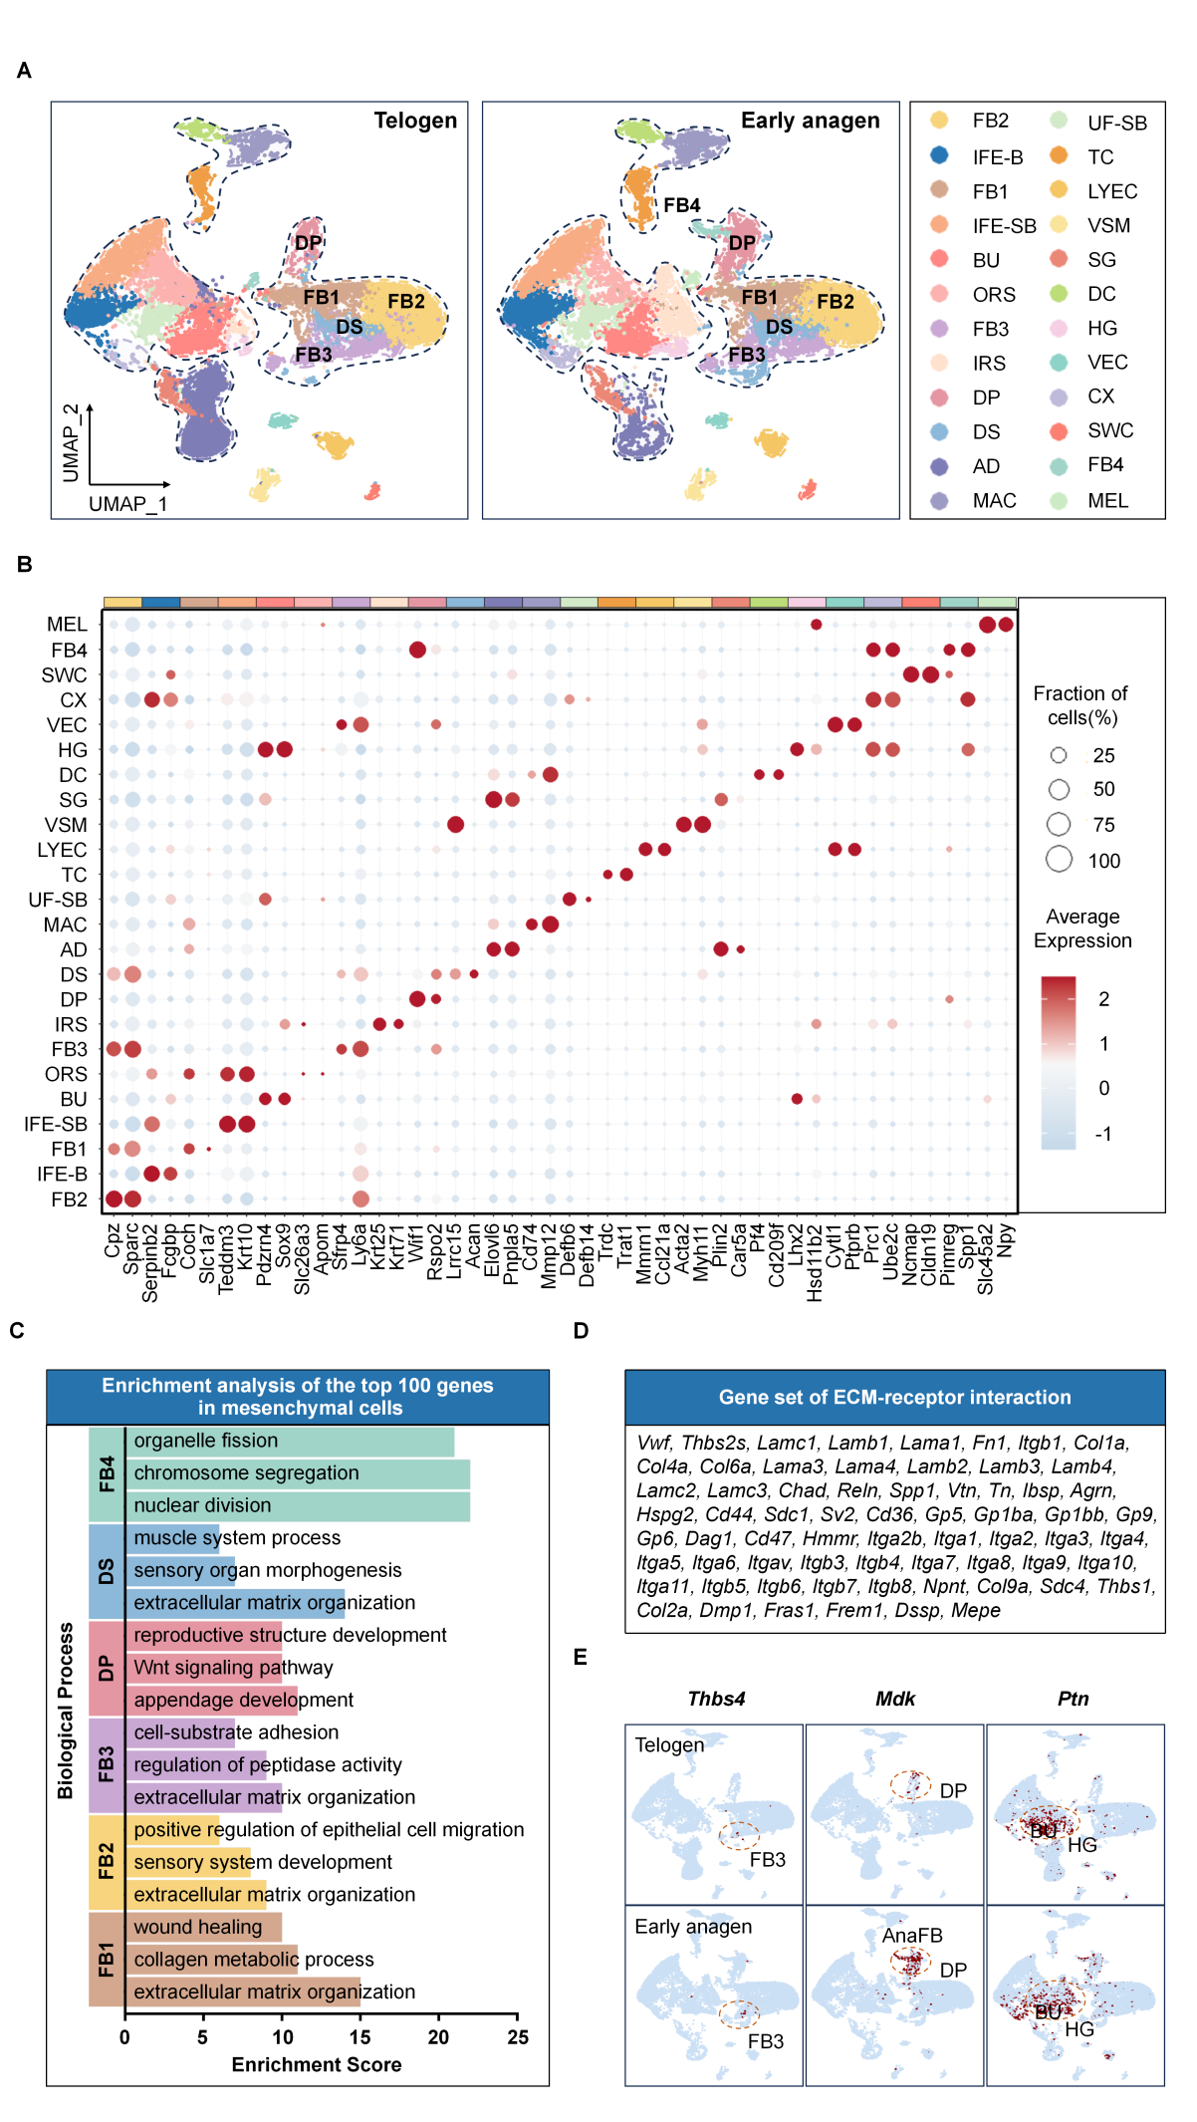
Figure S1
(A) UMAP of 24 skin cell clusters from telogen/early anagen skin.
(B) Heatmap showing the expression of representative marker genes across all 24 cell clusters.
(C) Enrichment analysis of top 100 genes odf mesenchymal cells.
(D) ECM-receptor interaction gene set used for pathway scoring of mesenchymal cells.
(E) FeaturePlots of Thbs4, Mdk, and Ptn showing their distinct expression patterns in skin cell clusters.

Supplementary figure 2

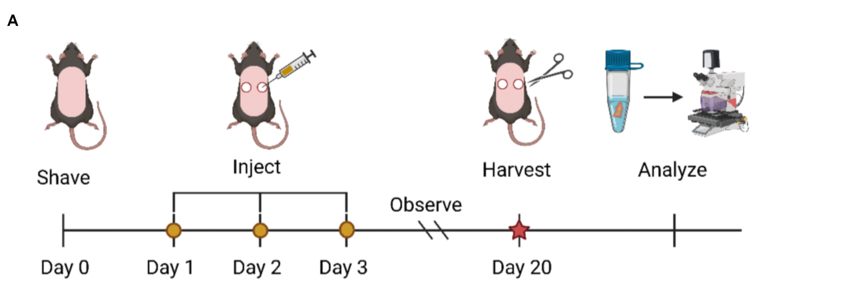
Figure S2
- Schematic of the in vivo assay: intradermal injection of THBS4 or BSA in telogen C57 mice, analyzed at day 20.

Supplementary figure 3

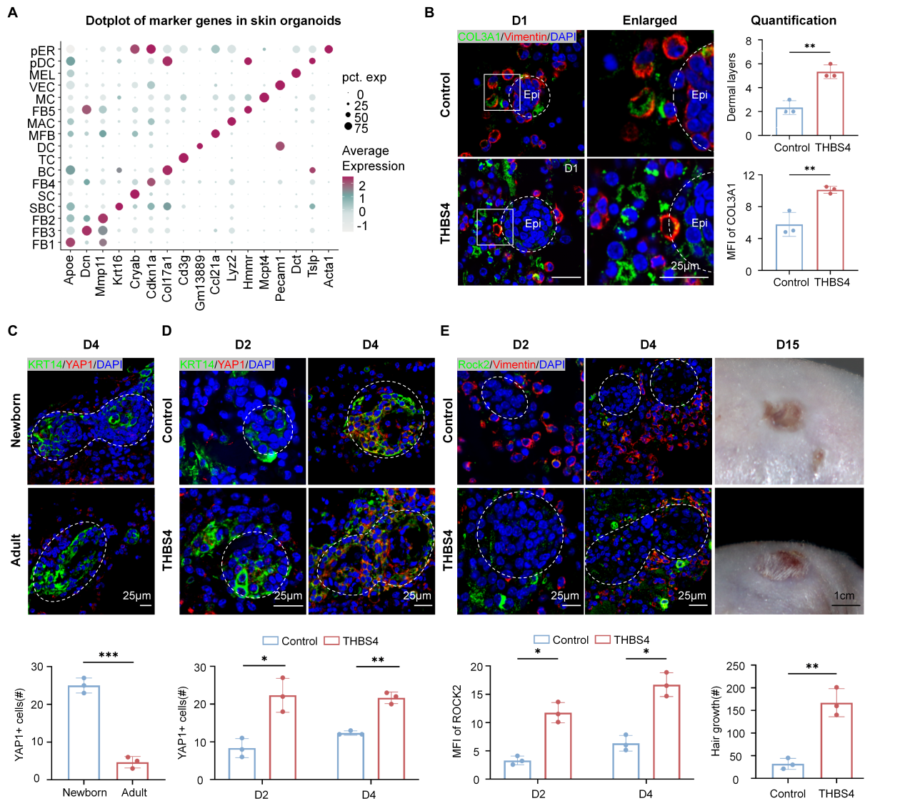
Figure S3
- Marker gene dot plot confirming cell identities in newborn/adult organoids at D4.
(B) COL3A1/Vimentin/DAPI immunofluorescence in control/THBS4-treated adult organoids at D1. Scale bar=25 μm. N=3, **P<0.01.
(C) YAP1/KRT14/DAPI immunofluorescence in newborn/adult organoids at D4. Scale bar=25 μm. N=3, ***P<0.001.
(D) YAP1 immunofluorescence in control/THBS4-treated adult organoids at D2 and D4. Scale bar=25 μm. N=3, **P<0.01, and *P<0.05.
(E) Representative images of Immunofluorescence labeling of ROCK2 in control/THBS4-treated adult organoids at D2 and D4. Images of nude mouse transplantation at D15 showing earlier hair growth in THBS4 group. Scale bar=25 μm.Scale bar=1 cm. N=3, *P<0.05.

Supplementary figure 4

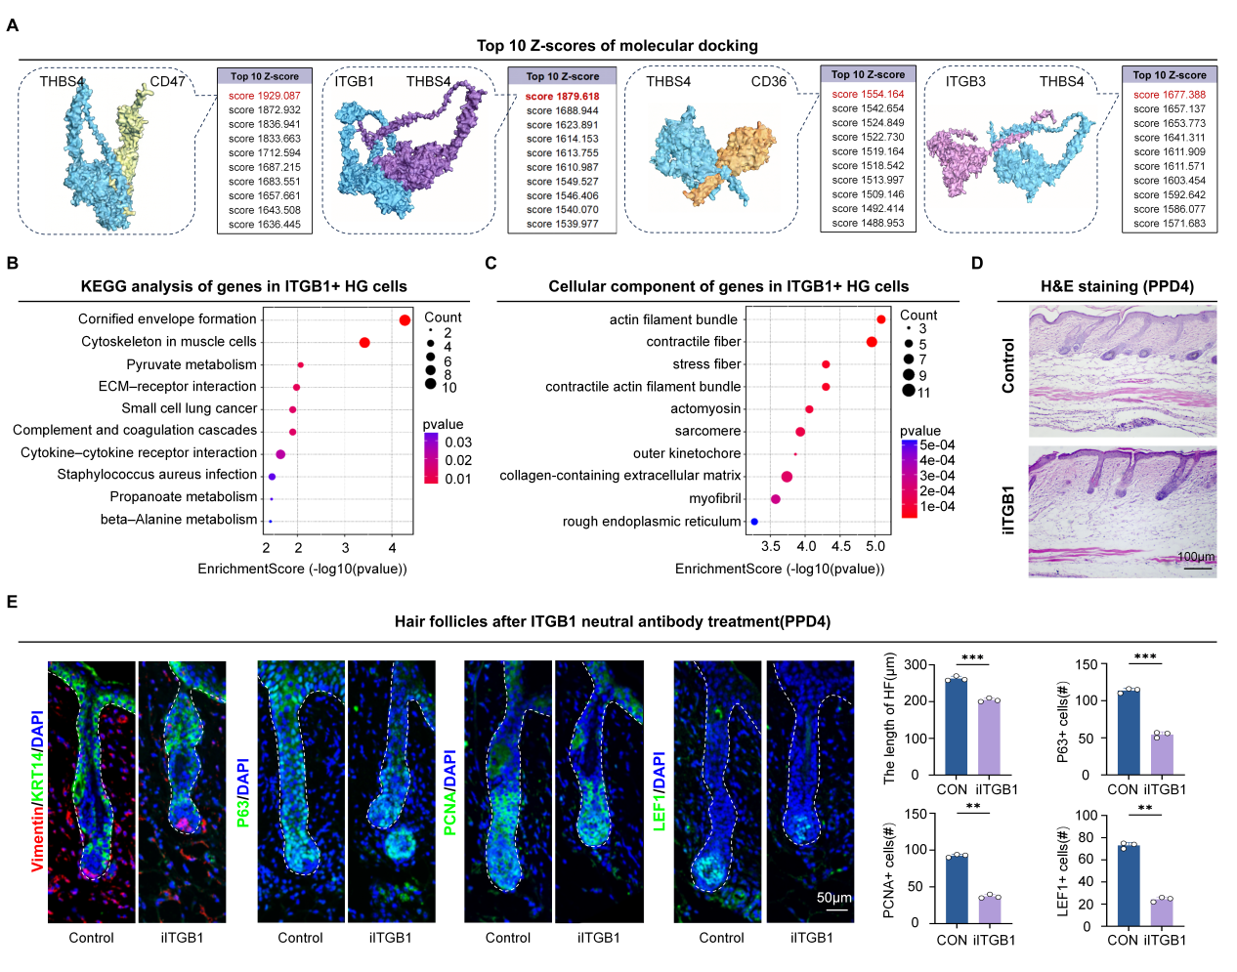

Figure S4
(A) Molecular docking top 10 z-scores for THBS4 binding to CD47, ITGB1, CD36, and ITGB3.
(B) Pathway analysis of ITGB1+ HG cell DEGs.
(C) GO cellular component analysis of ITGB1+ HG genes.
(D) H&E staining of hair follicles(PPD4).
(E) Immunofluorescence of PPD4 follicles (Vimentin/KRT14, P63, PCNA, LEF1) in control/anti-ITGB1 groups. Scale bar=50 μm.N=3, ***P<0.001, and **P<0.01.

Supplementary figure 5

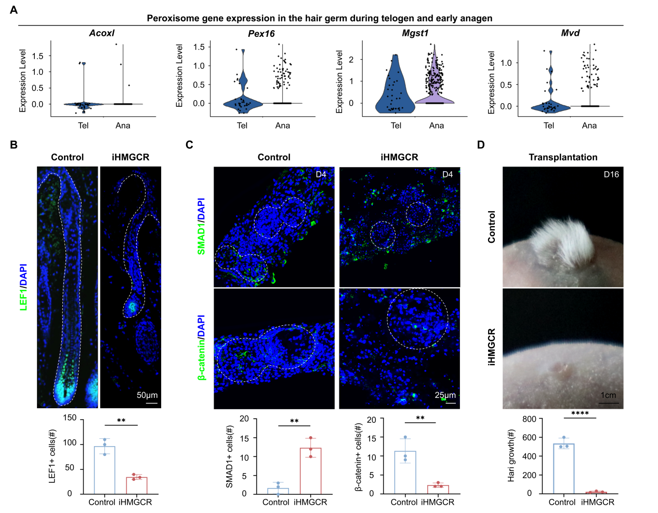
Figure S5
(A) Violin plots of peroxisome pathway genes in telogen/anagen HFSCs.
(B) LEF1 staining and quantification in control/iHMGCR follicles at PPD6. N=3, **P<0.01. Scale bar=20 μm.
(C) SMAD1/β-catenin staining and quantification in control/iHMGCR organoids. N=3, **P<0.01. Scale bar=25 μm.
(D) Tranplantation of organoids. N=3, **P<0.0001. Scale bar=1 cm.

Supplementary figure 6

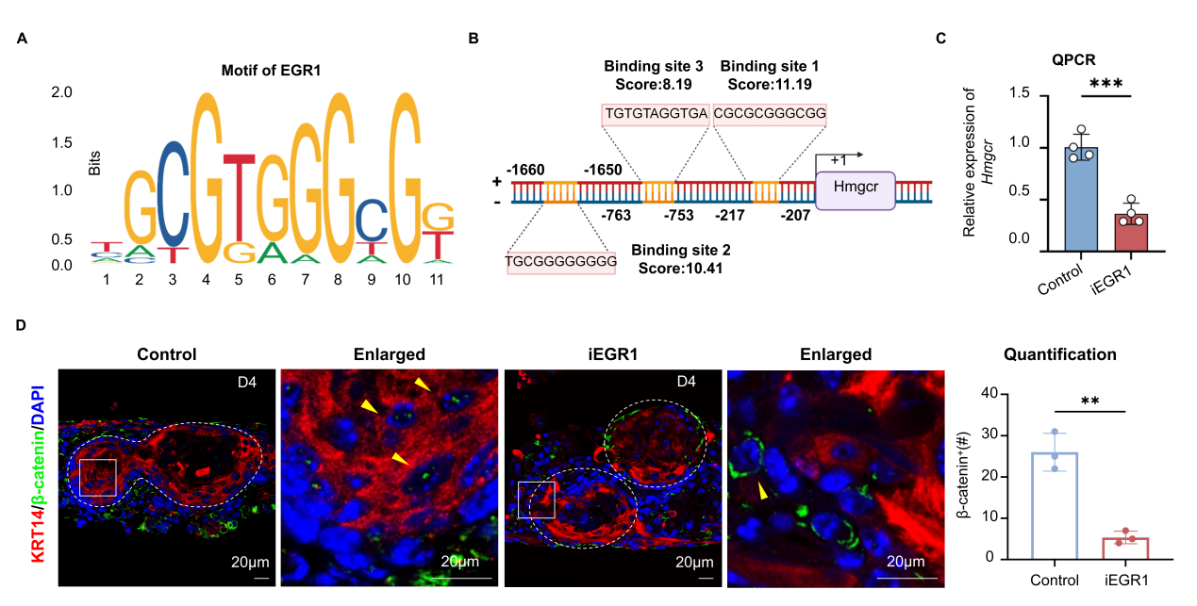
Figure S6
(A) EGR1 binding motif in Hmgcr promoter.
(B) Schematic of three high-score EGR1 binding sites in Hmgcr promoter.
(C) qPCR shows reduced HMGCR after Egr1 inhibition. N=3, ***P<0.001
(D) β-catenin/Vimentin/DAPI immunofluorescence in control/EGR1 inhibitor treated newborn mouse organoids at D4. N=3, **P<0.01. Scale bar=20 μm.

Supplementary Table 1. List of small molecule drugs in functional assays.
Name | Concentration | Company | Cat #
THBS4 recombinant protein | In vivo: 1mg/mL 50μL  In vitro: 500ng/mL | UscnLife Science | URPD824Mu01
ITGB1 neutralizing antibody | In vivo: 20μg/mL 50μL  In vitro: 5μg/mL | Sigma | MABT409
HMGCR inhibitor | In vivo: 200μM 50μL  In vitro: 50μM | MCE | HY-17504B
EGR1 inhibitor | In vitro: 100μM | MCE | HY-163731

Supplementary Table 2. List of primer sequences for Real-time qPCR.
qRT-PCR Primers
Gene Name | Forward (5’ to 3’ ) | Reverse (5’ to 3’ )
Gapdh | CTGGGCTACACTGAGCACC | AAGTGGTCGTTGAGGGCAATG
Hmgcr | AGCTTGCCCGAATTGTATGTG | TCTGTTGTGAACCATGTGACTTC
Egr1 | TCGGCTCCTTTCCTCACTCA | CTCATAGGGTTGTTCGCTCGG
Hoxa9 | CCCCGACTTCAGTCCTTGC | GATGCACGTAGGGGTGGTG
Zic3 | TGCTGCCAGTTCAGGCTATG | GCAGAAGGGGTTTTAGTGGTATC
Hic1 | GGCCATTCGAGGCAGCTAC | AGGTTTAGCAGGTTGTCATGC
Myc | ATGCCCCTCAACGTGAACTTC | CGCAACATAGGATGGAGAGCA
Mycn | CCTCACTCCTAATCCGGTCAT | GTGCTGTAGTTTTTCGTTCACTG

Supplementary Table 3. List of antibodies used in this study.
Antibody | Isotype | Company | Cat #
THBS4 | Rabbit | Abcam | ab263898
P63 | Rabbit | Genetex | GTX102425
LEF1 | Rabbit | Zenbio | 380956
Vimentin | Rabbit | Beyotime | AF1975
Vimentin | Mouse | Beyotime | AF0318
COL3A1 | Rabbit | Proteintech | 22734-1-AP
KRT14 | Rabbit | Beyotime | AF1987
KRT14 | Mouse | Boster | A01432
YAP1 | Mouse | Proteintech | 66900-1-Ig
ROCK2 | Rabbit | Boster | A01023-1
ITGB1 | Rabbit | Proteintech | 12594-1-AP
BMP4 | Rabbit | Beyotime | AF6312
β-catenin | Rabbit | Boster | A00004
PCNA | Mouse | Servicebio | GB12010-100
HMGCR | Rabbit | Beyotime | AF7119
SMAD1 | Rabbit | Beyotime | AF1504
EGR1 | Rabbit | Abcam | ab300449
DCN | Rabbit | Beyotime | AF6693
LY6A | Rabbit | Proteintech | 87403-1-RR
ACTA2 | Rabbit | Beyotime | AG0101
CAMK1D | Rabbit | Abcam | ab172618
SPP1 | Goat | R&D | AF808-SP

