Supplementary material of the manuscript titled: “High-resolution large ensemble for extreme precipitation forecasting with multiple AI weather models”
Yanbo Nie*¹, Agniv Sengupta¹, Daniel F. Steinhoff¹, Jorge Baño-Medina², and Luca Delle Monache¹
¹ Center for Western Weather and Water Extremes, Scripps Institution of Oceanography, University of California San Diego, La Jolla, CA, USA
² Instituto de Fisica de Cantabria (IFCA), CSIC-Universidad de Cantabria, Santander, Spain

Contents of this file

Figures S1 to S11
Table S1

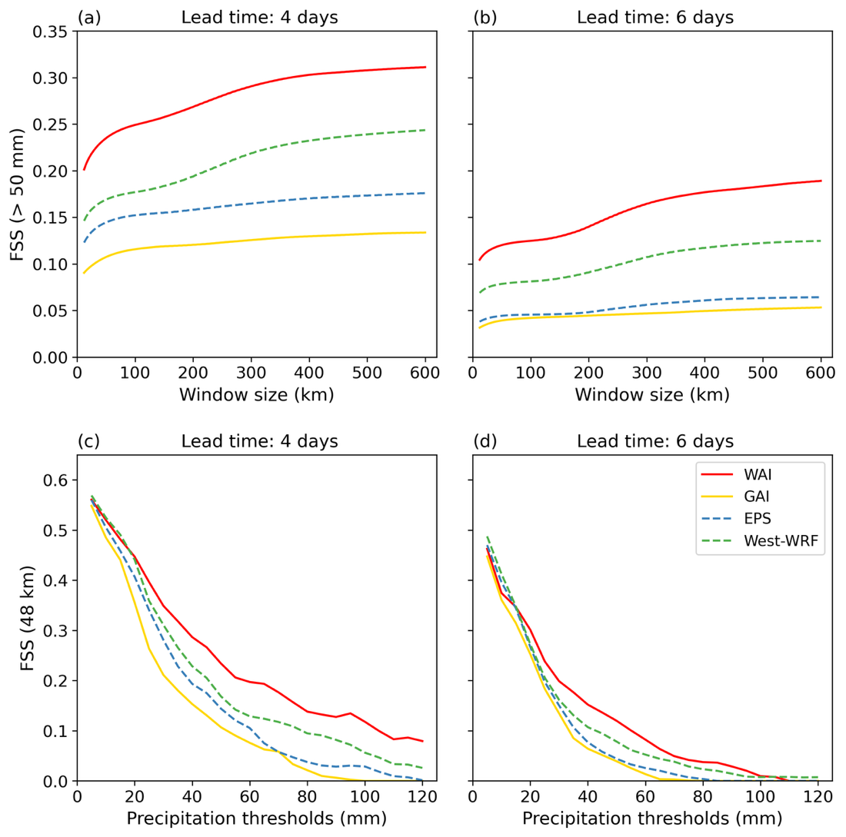
Fig. S1 | Comparison of fractions skill score (FSS) for ensemble mean precipitation. FSSs for a 50-mm precipitation threshold as a function of window size (km) at a 4-day and b 6-day lead times. FSS for a fixed window size (48 km × 48 km; equivalent to 12 × 12 grids) as a function of precipitation thresholds at c 4-day and d 6-day lead times. Results are shown for WAI-LE (solid red lines), GAI-LE (solid yellow lines), ECMWF EPS (dashed blue lines), and West-WRF (dashed green lines).

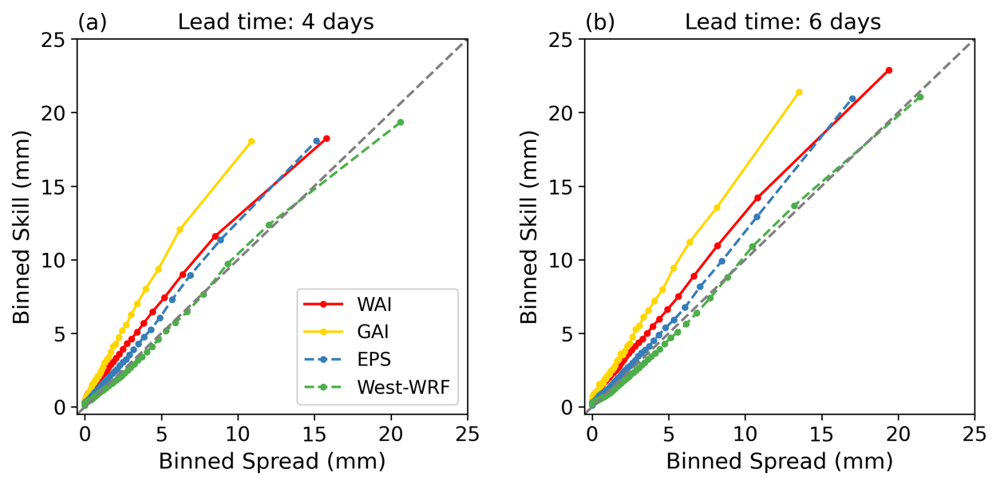
Fig. S2 | Comparison of spread-skill relationships. Spread–skill relationship at a 4-day and b 6-day lead times. The dashed diagonal represents the ideal 1:1 calibration. Results are shown for WAI-LE (solid red line), GAI-LE (solid yellow line), ECMWF EPS (dashed blue line), and West-WRF (dashed green line).

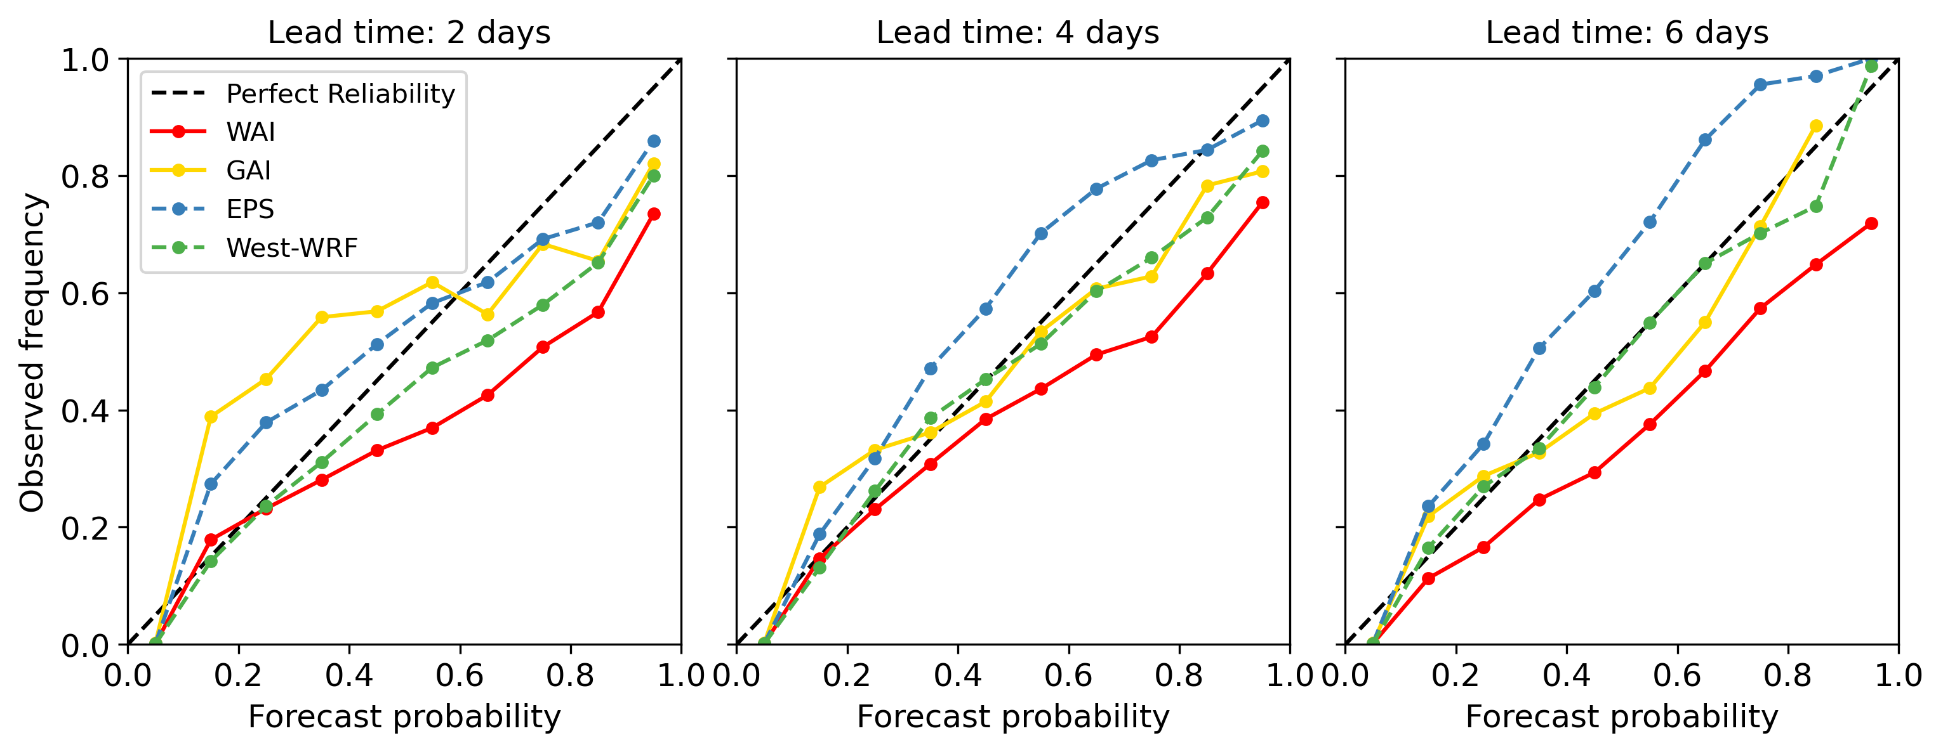
Fig. S3 | Comparison of reliability diagrams. Reliability diagrams at 2-day, 4-day, and 6-day lead times. Results are shown for WAI-LE (solid red line), GAI-LE (solid yellow line), ECMWF EPS (dashed blue line), and West-WRF (dashed green line).

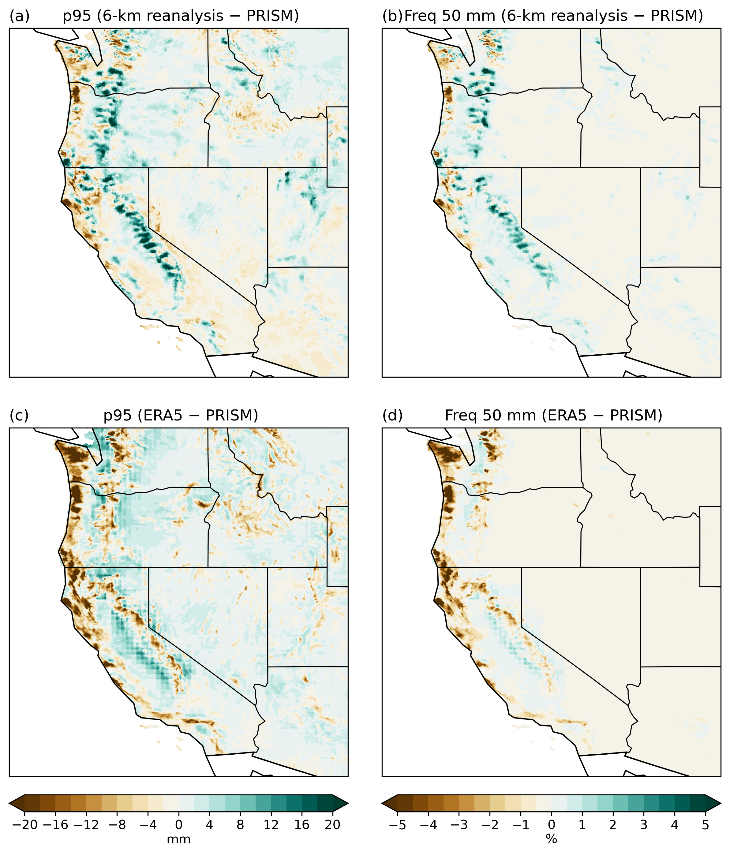
Fig. S4 | Differences in extreme precipitation statistics between reanalysis data and observations. Differences in a the 95th percentile (mm) and b the frequency of precipitation exceeding 50 mm (%) between the CW3E 6-km regional reanalysis and PRISM during winters (December–February) from 2012–13 to 2022–23. c, d As in a and b, but between ERA5 and PRISM.

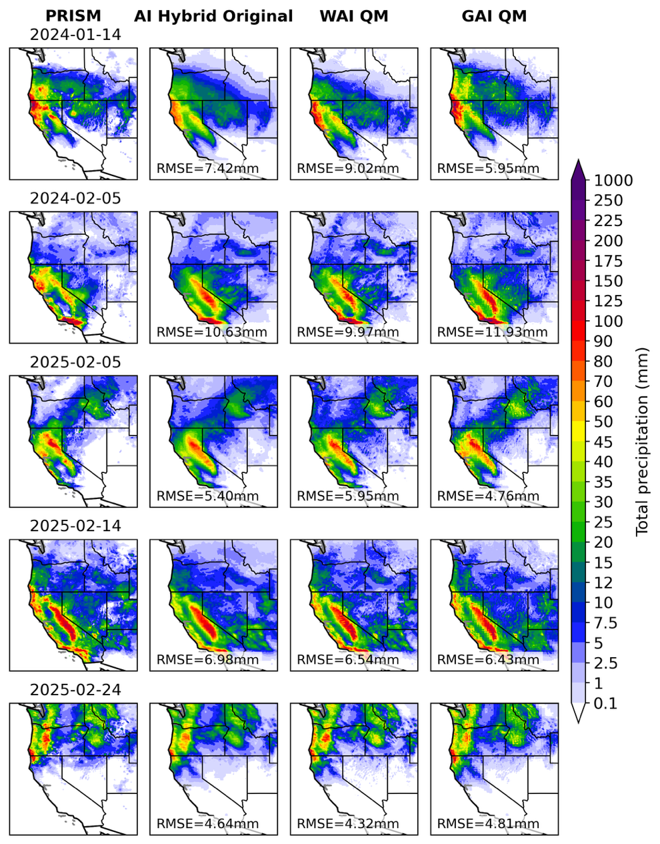
Fig. S5 | Comparison of observed precipitation and optimized AI precipitation forecasts for extreme events. As in Fig. 7 in the main manuscript, but for AI-based ensembles optimized by either distribution adjustment or hierarchical modeling.

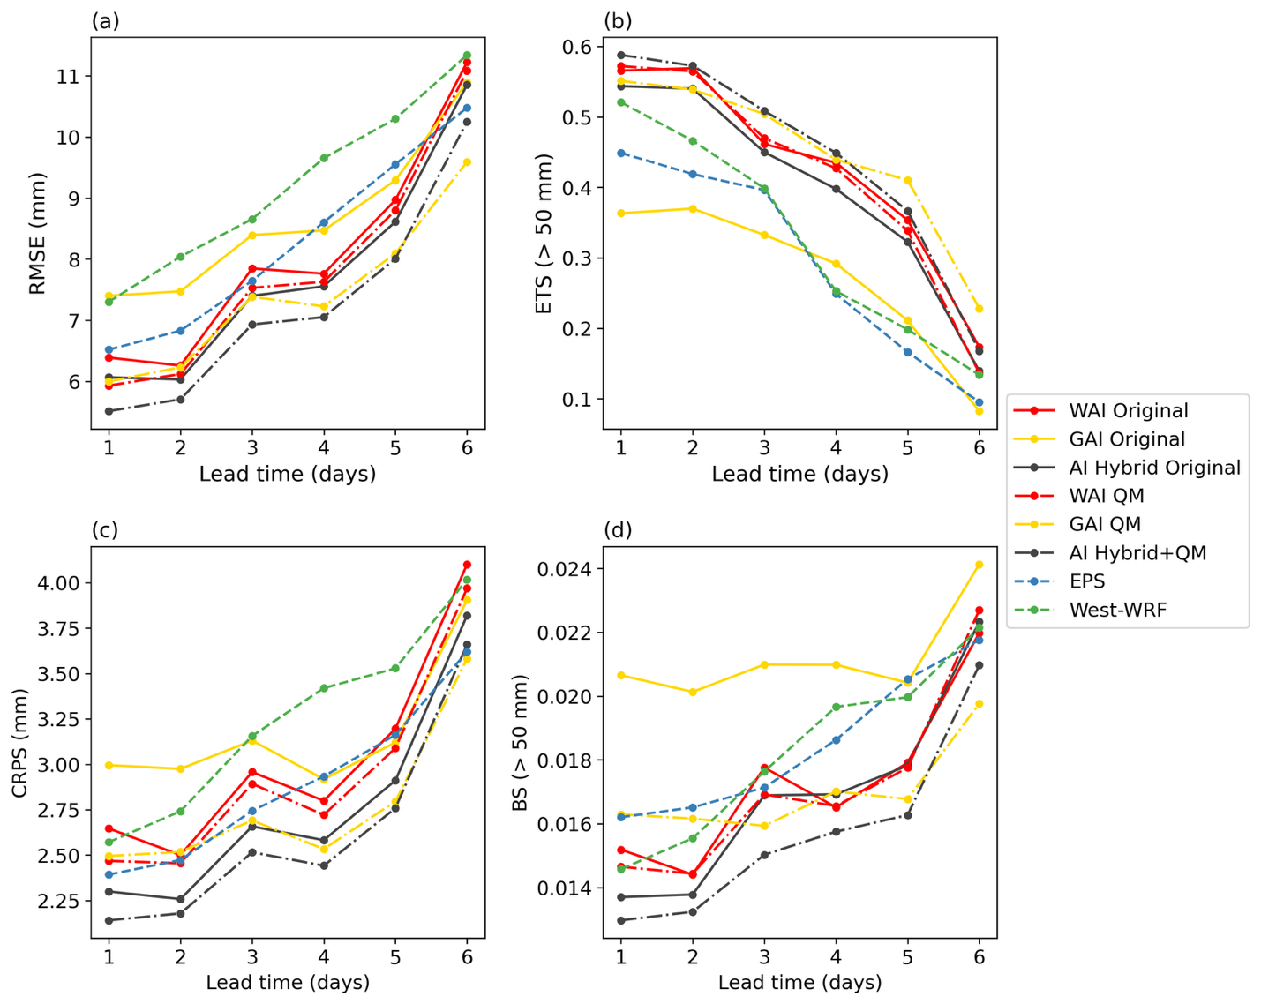
Fig. S6 | Average forecast skills for extreme events. a Root mean square error (RMSE, mm) for the ensemble means, b equitable threat score (ETS) for a 50-mm threshold for the ensemble means, c continuous ranked probabilistic score (CRPS, mm), and d Brier score (BS) for a 50-mm threshold valid on the five independent regional extreme precipitation days (REPDs) (see Methods in the main manuscript) as a function of lead times (days). Results are shown for the hybrid AI ensemble processed by quantile mapping (QM) (black dash-dot lines), the hybrid AI ensemble not processed by QM (black solid lines), QM-processed WAI-LE (red dash-dot lines), original WAI-LE (solid red lines), QM-processed GAI-LE (yellow dash-dot lines), original GAI-LE (solid yellow lines), ECMWF EPS (dashed blue line), and West-WRF (dashed green line).

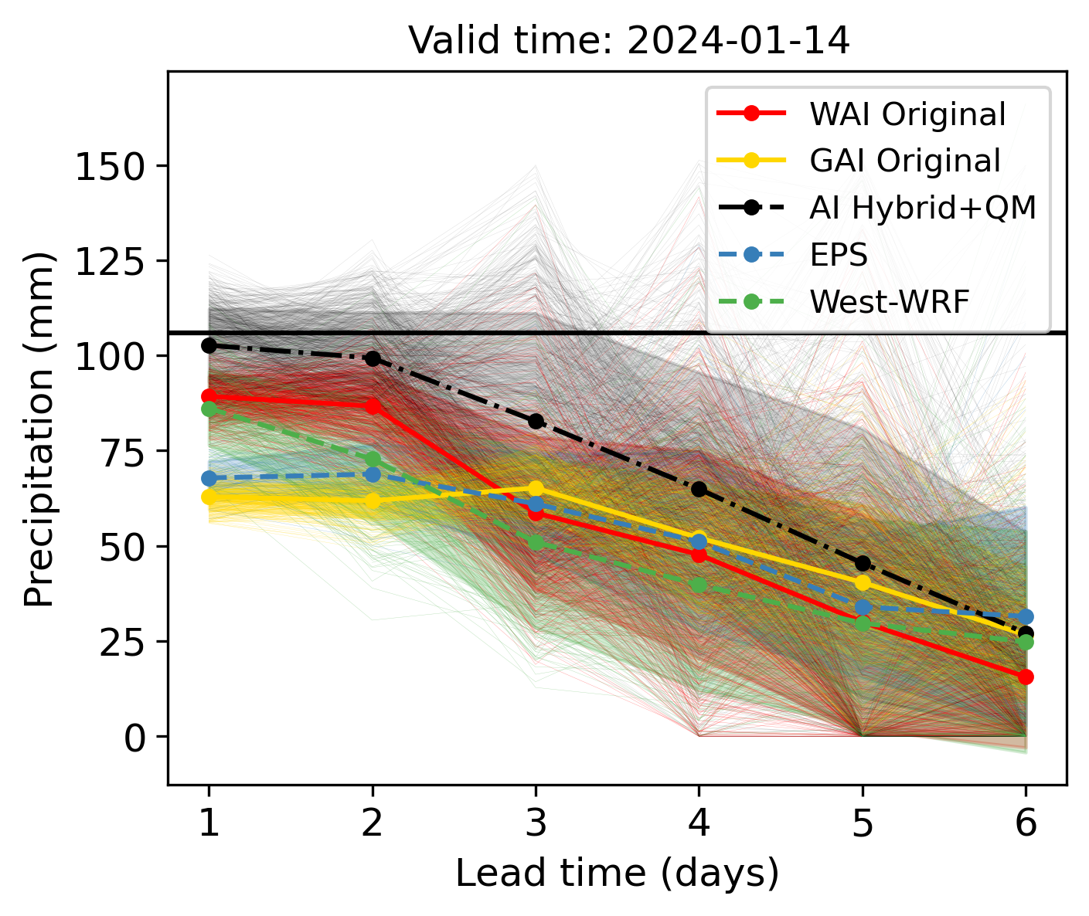
Fig. S7 | Forecasted precipitation averaged over 41°–42°N, 124.2°–123.2°W, valid on January 14, 2024, as a function of lead time. Results are shown for the hybrid AI ensemble processed by quantile mapping (QM) (black dash-dot lines), the hybrid AI ensemble not processed by QM (black solid lines), original WAI-LE (solid red lines), original GAI-LE (solid yellow lines), ECMWF EPS (dashed blue lines), and West-WRF (dashed green lines). The thick lines are ensemble means, and the thin lines represent individual members. The shadings represent the spreads (1.0 standard deviations). The horizontal black line represents the PRISM observation.

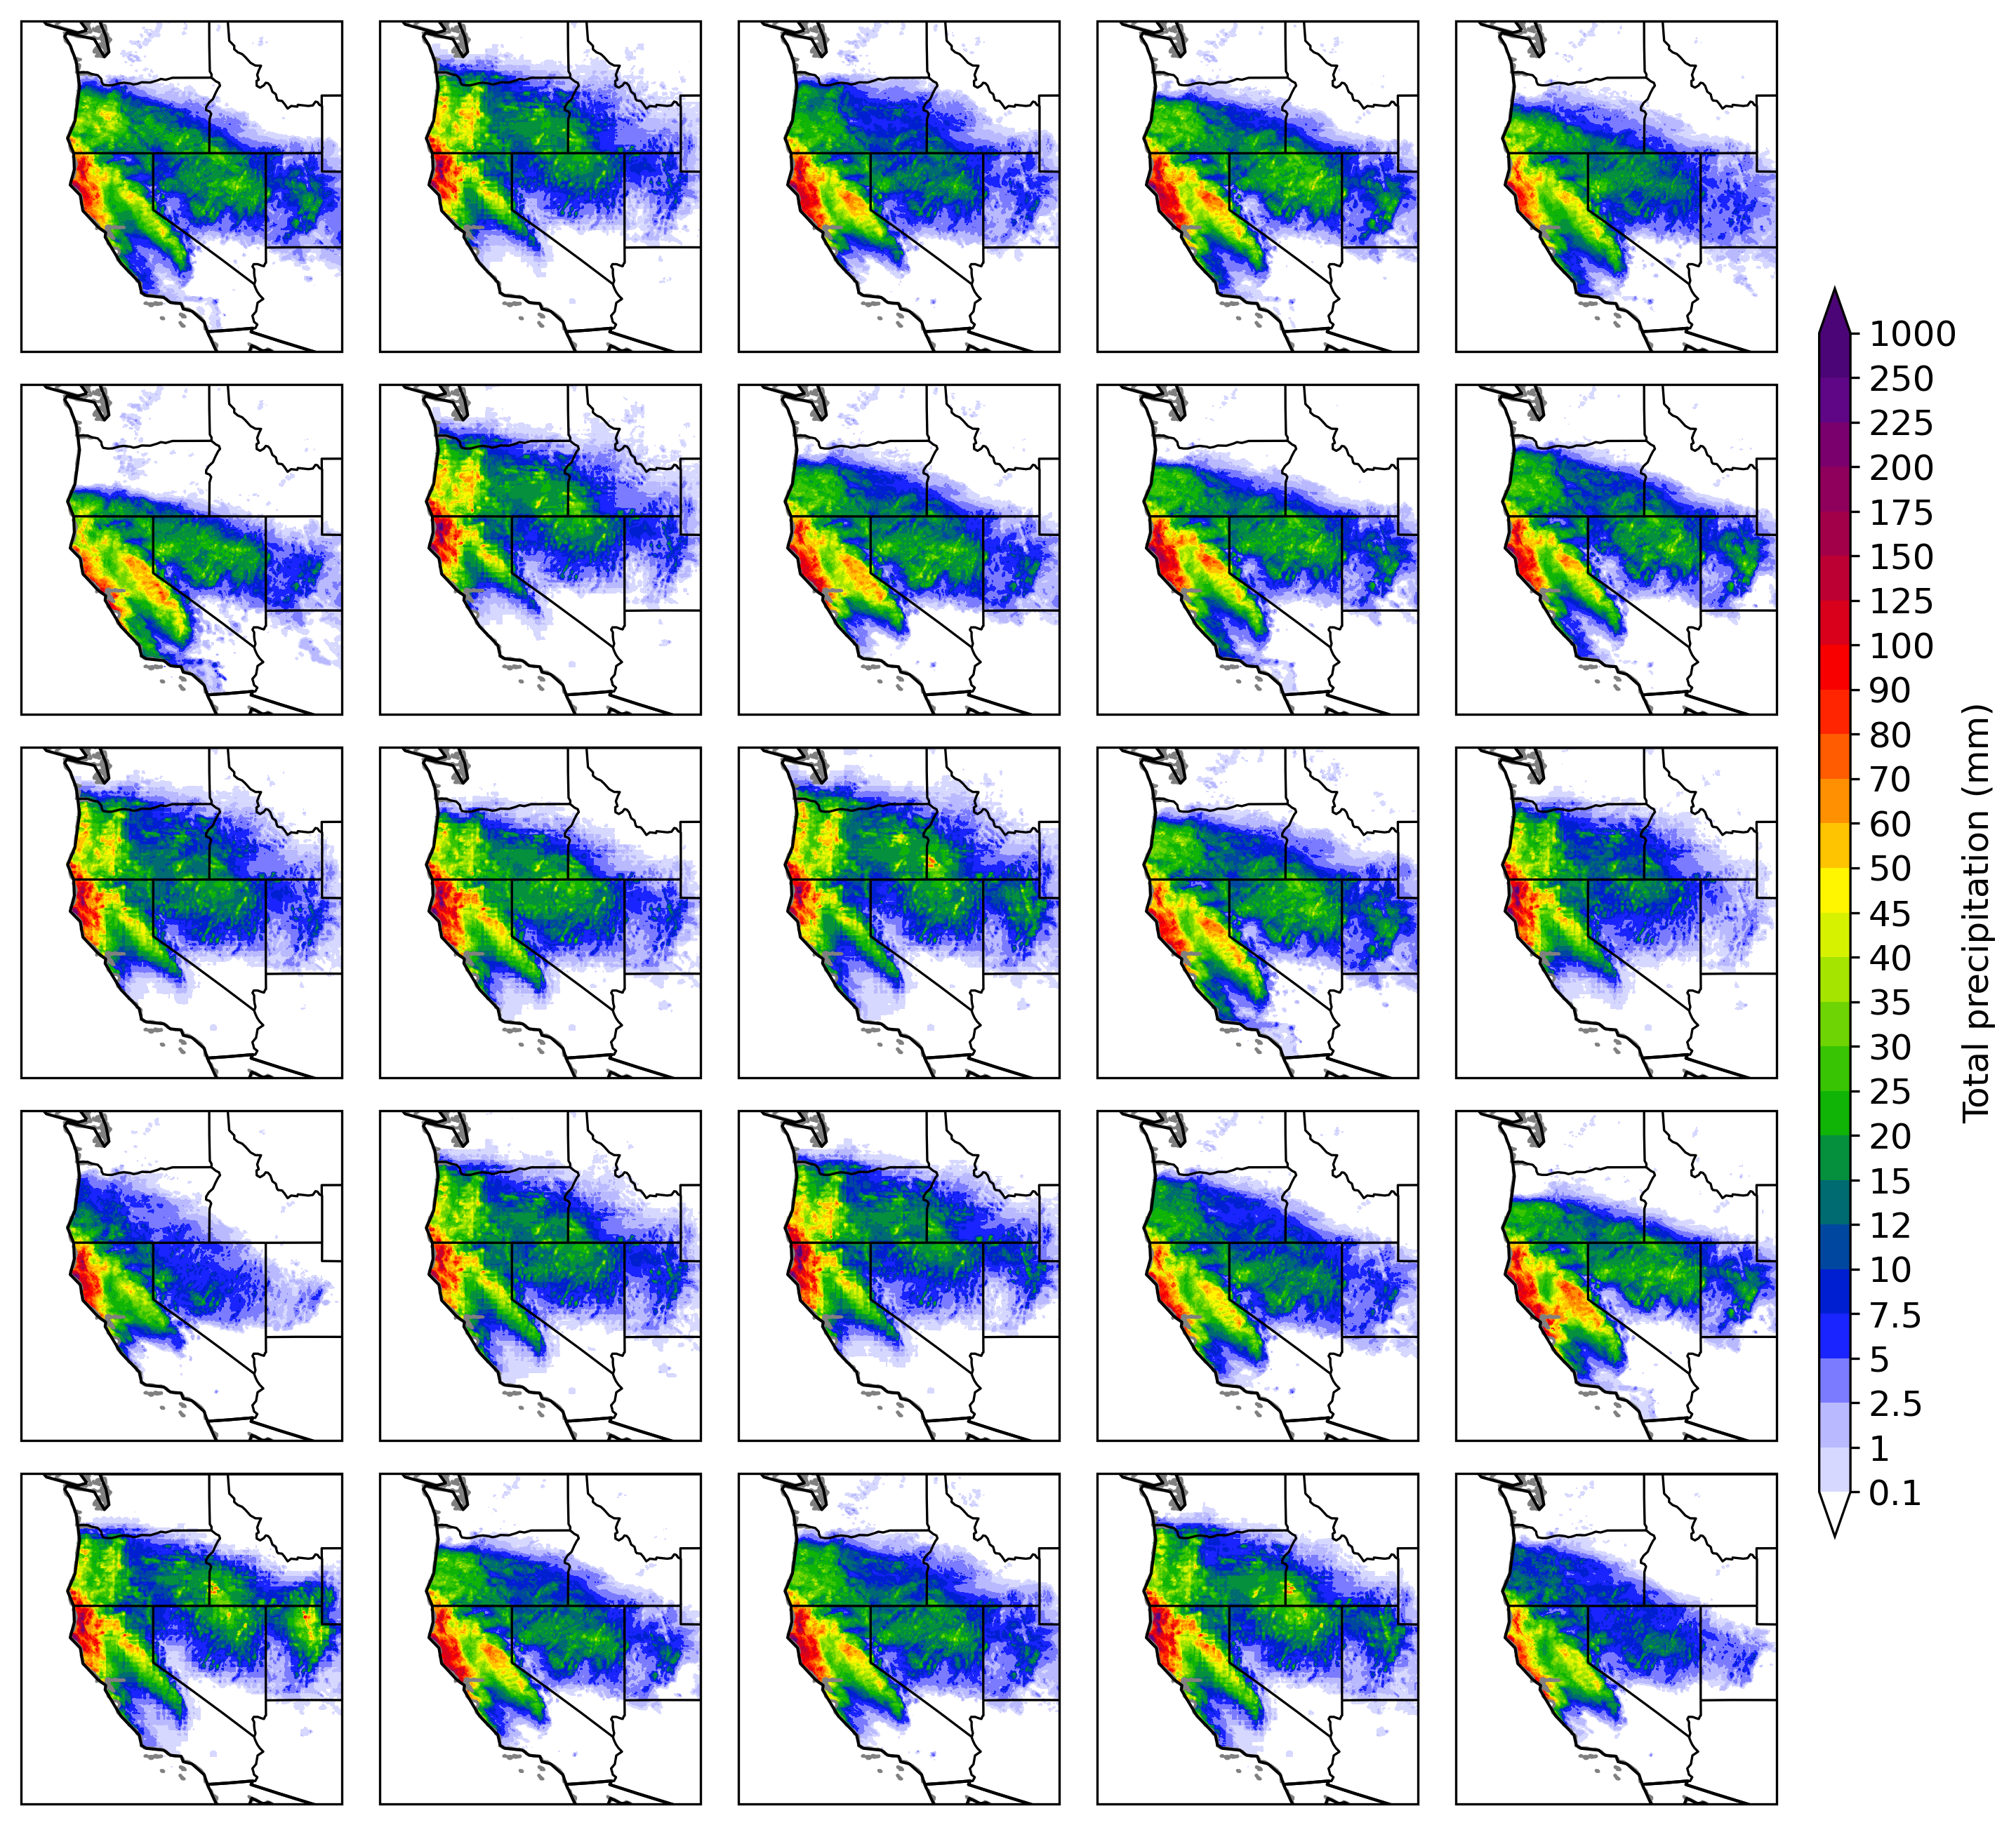
Fig. S8 | AI-based precipitation forecast maps valid on January 14, 2024. Results are shown for 25 randomly selected members of the HAI-LE ensemble processed by quantile mapping at a 3-day lead time.

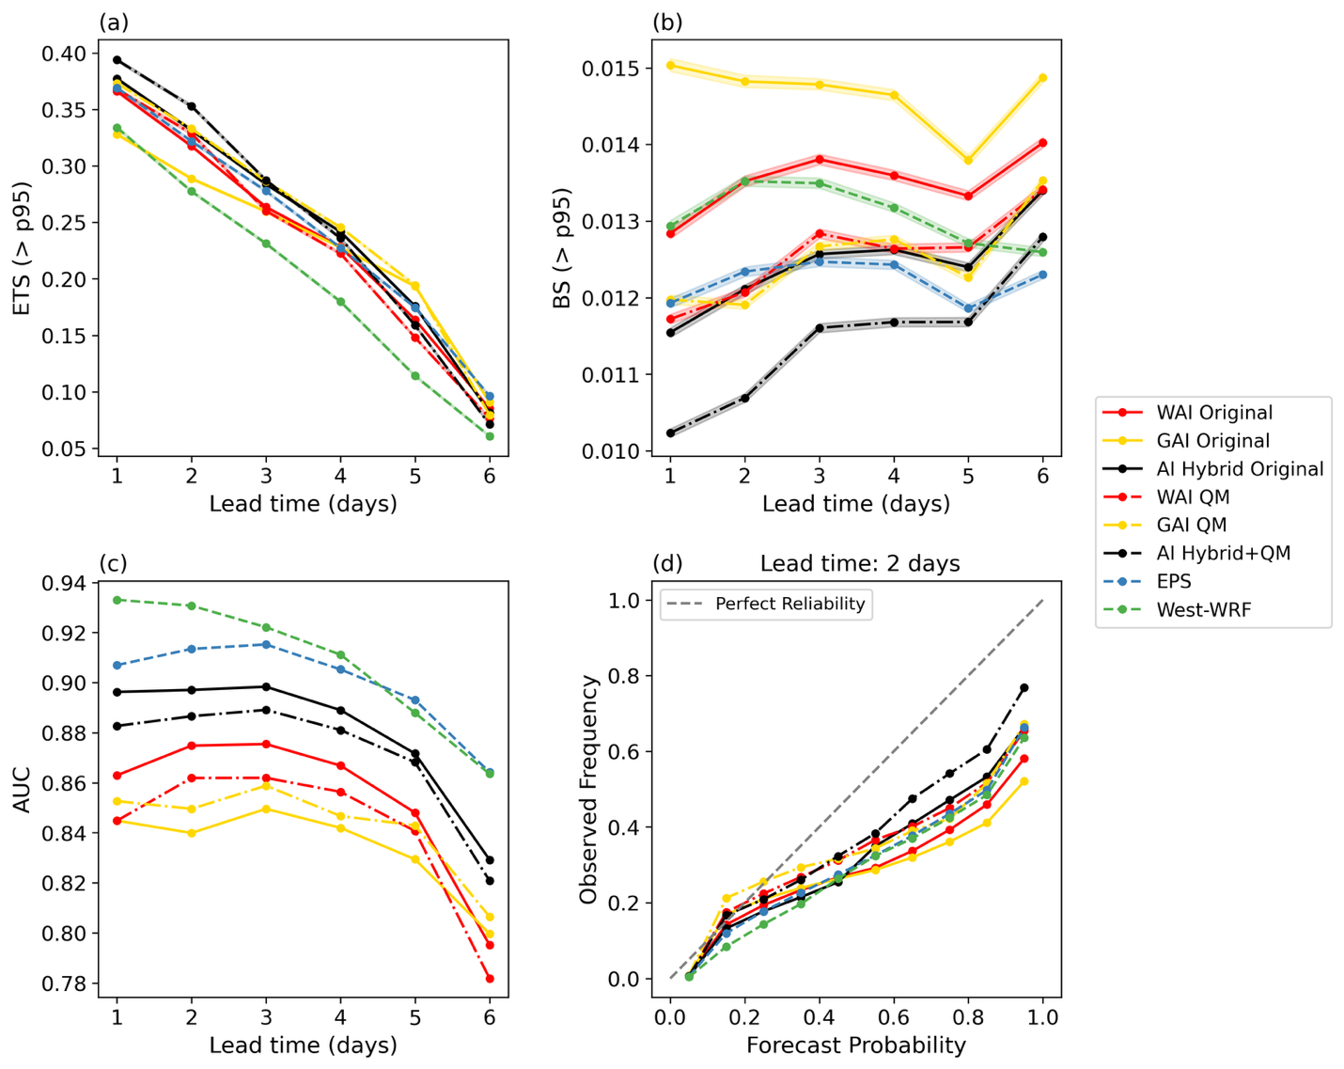
Fig. S9 | Comparison of evaluation metrics regarding the grid point-based 95th percentile of wet-day precipitation. a Equitable threat score (ETS), b Brier score (BS), and c Area under the relative operating characteristic curve (AUC) as a function of forecast lead time (days). d Reliability diagram at a 2-day lead time. Results are shown for the hybrid AI ensemble processed by quantile mapping (QM) (gray dash-dot lines), the hybrid AI ensemble not processed by QM (gray solid lines), QM-processed WAI-LE (red dash-dot lines), original WAI-LE (solid red lines), QM-processed GAI-LE (yellow dash-dot lines), original GAI-LE (solid yellow lines), ECMWF EPS (dashed blue line), and West-WRF (dashed green line).

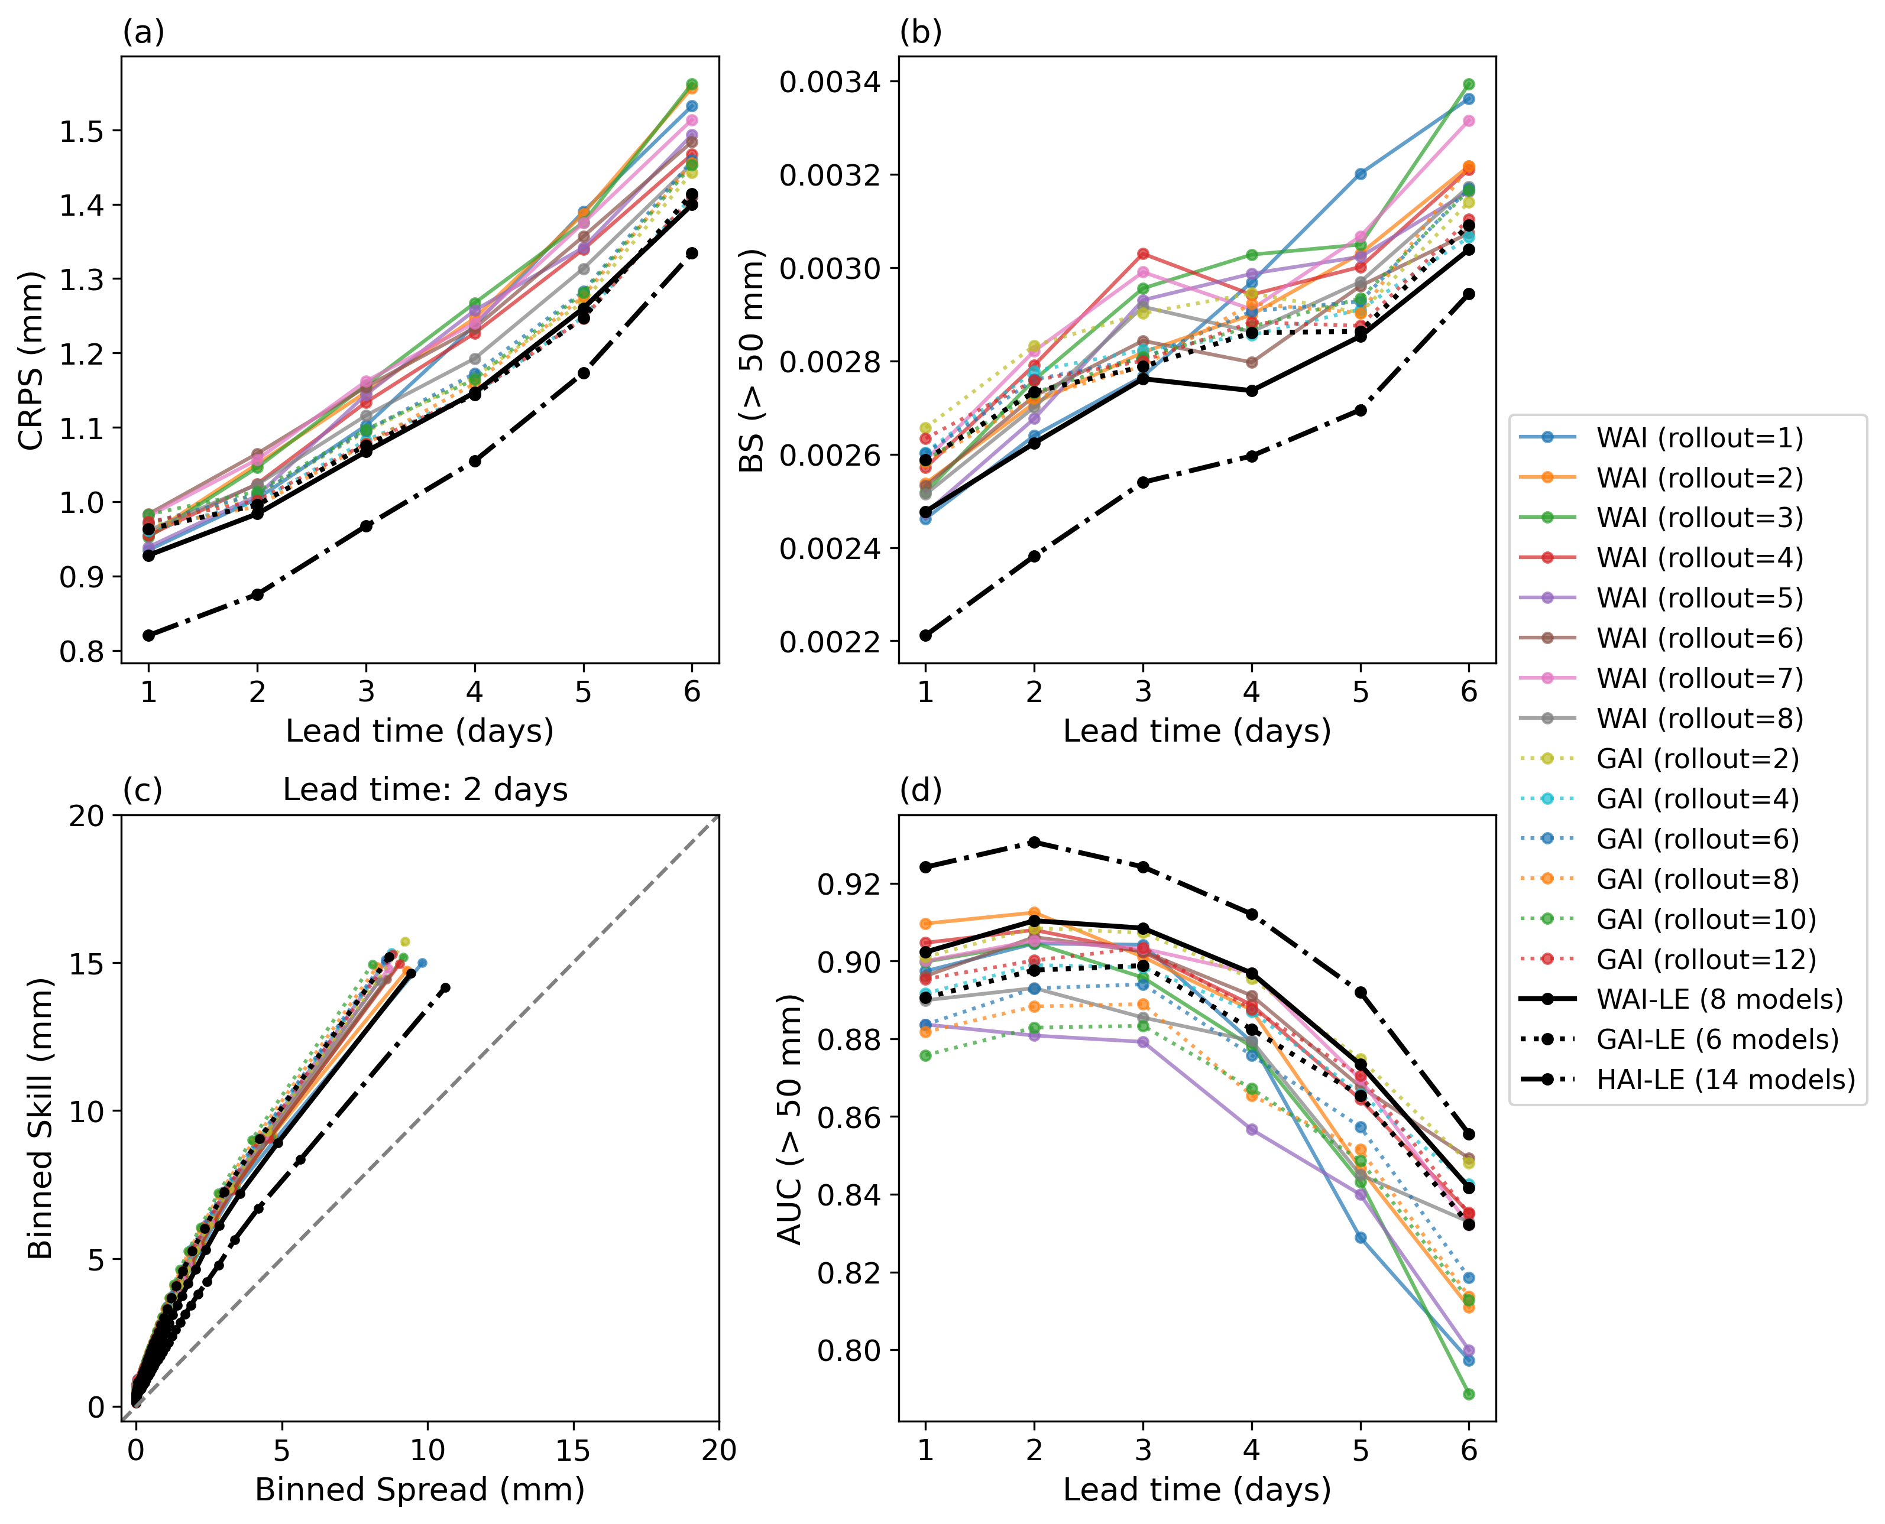
Fig. S10 | Comparison of probabilistic predictive skills for 1-model and 8-model WAI ensembles, 1-model and 6-model GAI ensembles, and 14-model hybrid AI ensemble. a continuous ranked probabilistic score (CRPS, mm) as a function of lead times (days), b Brier score (BS) for a 50-mm threshold as a function of lead times, c spread-skill relationships at a 2-day lead time, and d Area under the relative operating characteristic curve (AUC) for the 50-mm threshold as a function of lead time. The solid lines represent the ensembles of WAI models. The dot lines represent the ensembles of GAI models. The dash-dot lines represent the hybrid AI ensemble.

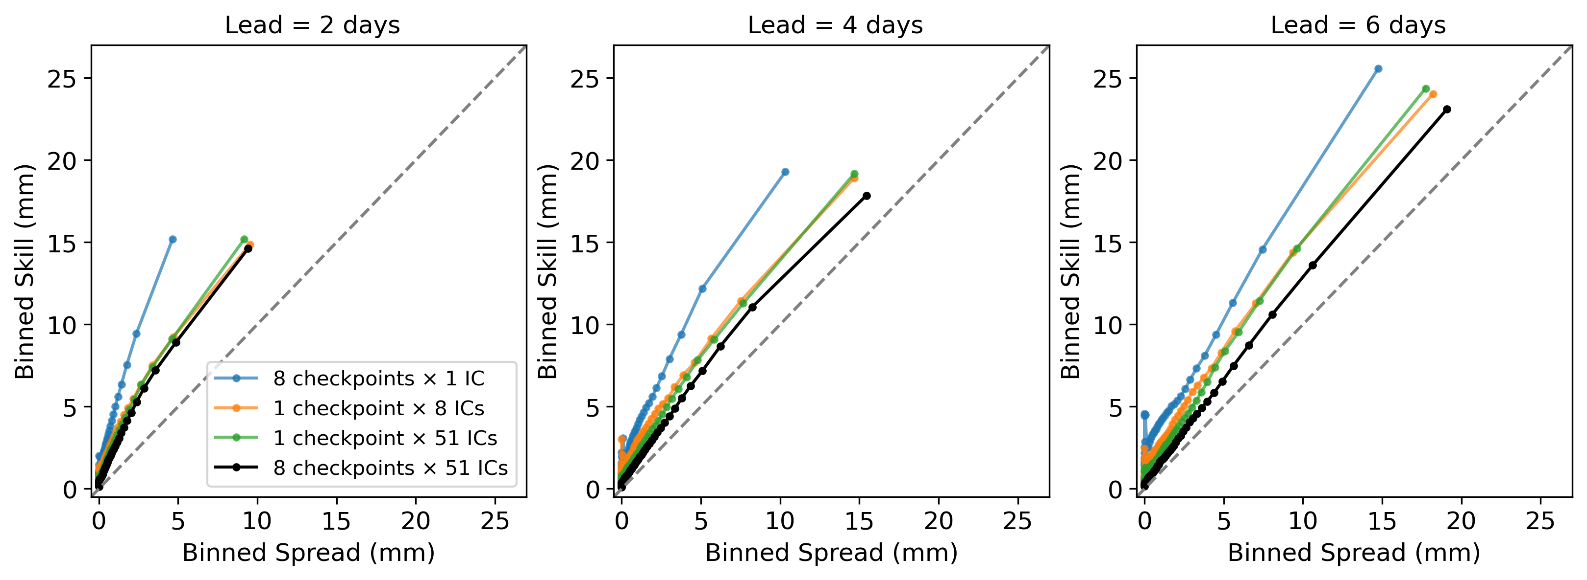
Fig. S11 | Binned spread–skill relationships for QM-adjusted AI ensembles generated using different combinations of checkpoint diversity and initial-condition (IC) perturbations. Blue, orange, green, and black lines denote ensembles generated from 8 checkpoints with 1 IC, 1 checkpoint with 8 ICs, 1 checkpoint with 51 ICs, and 8 checkpoints with 51 ICs, respectively. The dashed 1:1 diagonal line represents an ideal calibration.

Table 1. Computation resources required by AI and physics-based models.
Model | Resolution | Inference/running time for a single-member 6-day forecast | Hardware
West-WRF AI | 6 km | ~5 minutes | 1 Nvidia H100 GPU + 8 CPU cores + 96 GB memory
Global AI | 31 km | ~1.75 minutes | 1 Nvidia H100 GPU + 8 CPU cores + 96 GB memory
Physics-based West-WRF | 9 km | ~3–4 hours, varies based on parameterization scheme | 384 CPU cores + 448 GB memory

