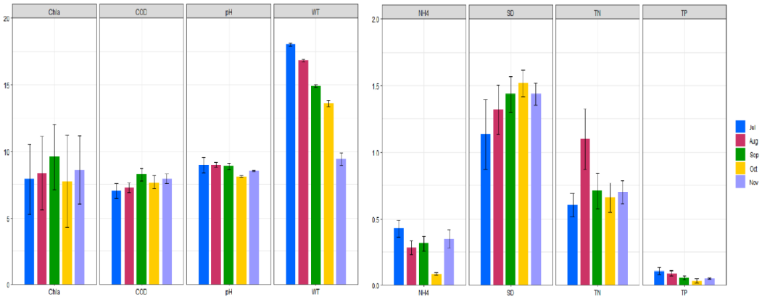
Fig.S1. Columnar chart of water physicochemical parameters from July to November.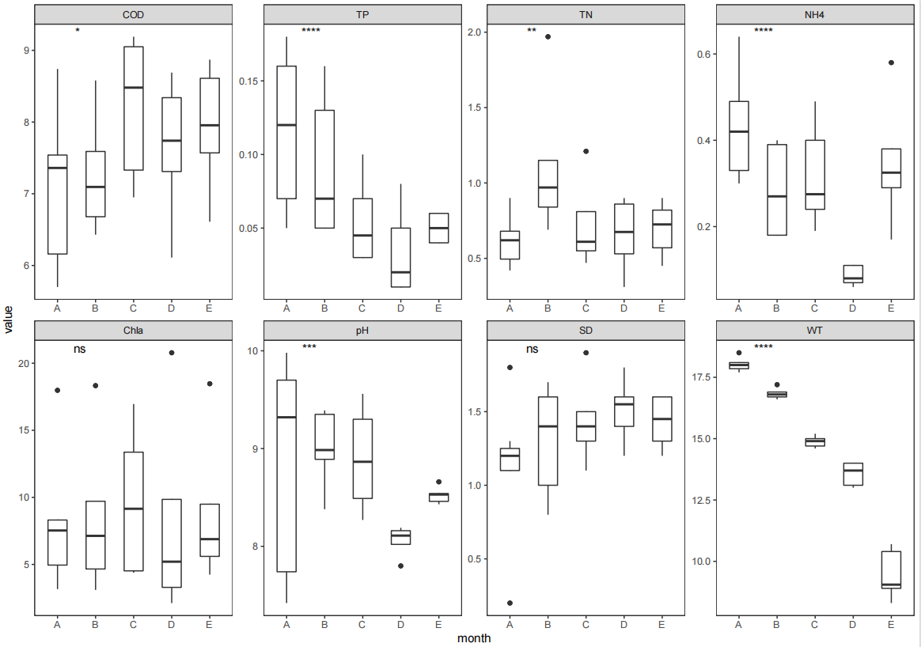 Fig.S2. Boxplot of water physicochemical parameters from July to November. Asterisks indicate a significant difference between JUL and NOV (Wilcoxon test); (* 0.01 < P ≤ 0.05; **0.001 < P ≤ 0.01; *** P ≤ 0.001, ns: not significant).
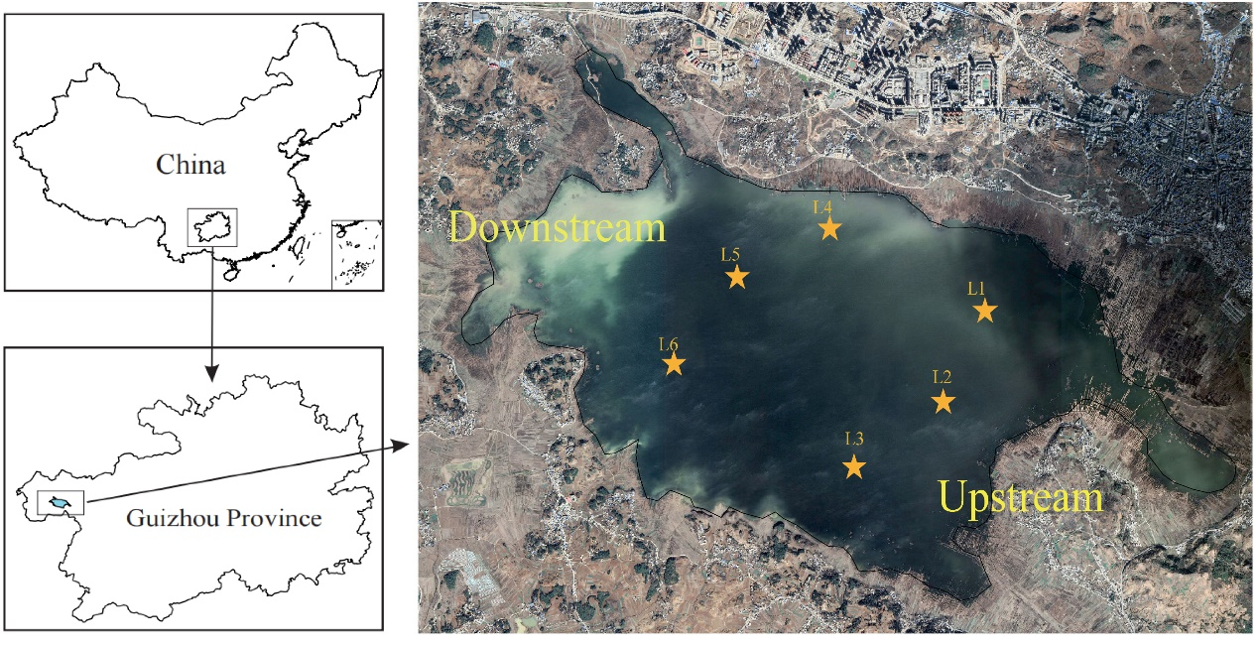
Fig.S3. Location of Caohai wetland, Guizhou Province, and distribution of sampling sites.
Fig.S4.Z_{i}-P_{i} plot showing the distribution of OTUs based on their topological roles in networks between bacteria. Zi and Pi are 2.5 and 0.62 respectively for OTUs classification. (A)July(B) August (C) September (D) October (E)

