Cascade Oxidation and Cation Exchange Reactions to Progressively Engineer High-entropy Metal Oxides
Liyan Zhao^{1,2§}, Zhiruo Zhao^{2§}, Wentong Zhang^{2§}, Yuhua Liu², Jiaying Jin², Mi Yan^{2,3,4}, and Shikuan Yang^{2,3,4}*
¹Department of Medical Oncology, The Second Affiliated Hospital, Zhejiang University School of Medicine, Hangzhou 310003, China
²School of Materials Science and Engineering, Zhejiang University, Hangzhou 310027, China
³State Key Laboratory of Baiyunobo Rare Earth Resource Researches and Comprehensive Utilization, Baotou Research Institution of Rare Earths, Baotou 014030, China
⁴Zhejiang Province Key Laboratory of Advanced Information Materials, Hangzhou 310027, China
§These authors contributed equally to this work
*Corresponding author. Email: shkyang@zju.edu.cn (S.K.)
Part I. Materials and Methods
1. Experimental section
1.1 Chemicals
Nickel nitrate (Ni(NO₃)₂·6H₂O), chromic nitrate (Cr(NO₃)₃·9H₂O), lead nitrate(Pb(NO₃)₂), zinc nitrate (Zn(NO₃)₂·6H₂O), ferric nitrate (Fe(NO₃)₃·9H₂O), ferrous sulfate (FeSO₄·7H₂O), silver nitrate (AgNO₃), boric acid (H₃BO₃), potassium chloride (KCl), and ethyl alcohol were purchased from Sinopharm Chemical Reagent Co., Ltd. Sodium sulphide (Na₂S·9H₂O) was purchased from Macklin. Manganous nitrate (Mn(NO₃)₂) and potassium iodide (KI) were purchased from Energy Chemical. Cobalt nitrate (Co(NO₃)₂·6H₂O) was purchased from Aladdin. Sodium borohydride (NaBH₄) was purchased from Sigma-Aldrich Co., Ltd. All chemical reagents were of analytical grade and used without further purification.
1.2 Electrodeposition of Ag₇O₈NO₃ microstructures
10 nm-thick titanium and 50 nm-thick gold film were thermally evaporated onto a piece of silicon wafer at a rate of 0.1 nm/s. The gold film-covered silicon wafer was cut into small pieces with an area of 1 cm×2 cm serving as the working electrode. The working electrode was washed with deionized water and then treated in a plasma cleaner for 10 min to obtain a hydrophilic surface. Electrodeposition was carried out using a three-electrode system. The reference electrode was Ag/AgCl. The counter electrode was a carbon rod (8 cm×Ф5 mm). The electrolyte solution was composed of AgNO₃ (0.06 M) and H₃BO₃ (0.16 M). All the electrodeposition processes were performed at room temperature. The Ag₇O₈NO₃ microarchitectures were deposited on the anode electrode surface. The potential waveform was generated by an electrochemical workstation (CHI 660D, CH Instruments Ins.).
1.3 Conversion of Ag₇O₈NO₃ to multicomponent metal oxides
The Ag₇O₈NO₃ microparticle powders were collected from the electrode surface by immersing it into water. The Ag₇O₈NO₃ microparticle powders were dispersed into 5 ml of 50 mM ion aqueous solutions (i.e., Co(NO₃)₂, Ni(NO₃)₂, Mn(NO₃)₂, Pb(NO₃)₂, FeSO₄) to finish the transformation to multicomponent metal oxides.
1.4 Synthesis of high-entropy metal oxides by COCE reactions
In a typical reaction, the Ag₇O₈NO₃ microarchitectures were placed in a square container containing 9 ml of 50 mM Ni(NO₃)₂ aqueous solutions. After 1 h reaction, AgNiO₂ microarchitectures were prepared. Next, the AgNiO₂ microarchitectures were cleaned with deionized water and then was immersed in 9 ml of 50 mM Co(NO₃)₂ aqueous solutions. The reaction proceeded for 3 min to replace Ni with Co in the lattice, generating Ag(Ni, Co)O₂ microarchitectures. Similarly, the Ag(Ni, Co)O₂ microarchitectures were immersed in 9 ml of 50 mM Mn(NO₃)₂ aqueous solutions for 1 min to introduce Mn, giving rise to the formation of Ag(Ni, Co, Mn)O₂. Next, the composition transformation was conducted by immersing the microarchitectures into 9 ml of 50 mM FeSO₄ aqueous solutions for 30 s to synthesize Ag(Ni, Co, Mn, Fe)O₂. As last, Ag(Ni, Co, Mn, Fe)O₂ microarchitectures were immersed into 9 ml of 50 mM Cr(NO₃)₃ ethanol solutions. The reaction was allowed to proceed for 2 min to create Ag(Ni, Co, Mn, Fe, Cr)O₂ microtructures.
2. Characterizations
2.1 Morphology and microstructure characterization
The morphology of the microarchitectures was observed by a transmission electron microscope (TEM, FEI Talos F200x, American) and a scanning electron microscope (SEM, GeminiSEM 300) equipped with an energy dispersive spectrometer (EDS). X-ray diffraction (XRD) patterns were collected on an X-ray diffractometer (GIXRD, Rigaku Ultima IV, Japan). X-ray photoelectron spectroscopy (XPS) was performed using a Thermo Scientific spectrometer (ESCALAB 250Xi).
To track the morphological evolution during the OCE process, quasi-in situ SEM characterization was performed. A cross-shaped marker was first created on the gold electrode substrate to serve as a positional reference. Subsequently, Ag₇O₈NO₃ micropyramids were electrodeposited onto the marked region at 2 V for 5 min. SEM images of the electrodeposited micropyramid were taken. Then, the Ag₇O₈NO₃ micropyramid was immersed into the polyvalent ion solutios to initiate the OCE reactions. The micropyramid after OCE reactions was characterized by SEM to monitor the structural evolution. The above procedure was repeated several times to monitor the COCE reactions.
2.2 OCP test
OCP measurements were conducted to monitor the OCE reaction process in real time. The as-electrodeposited Ag₇O₈NO₃ sample was used as the working electrode. A carbon plate with an area of 2 cm² served as the counter electrode, and an Ag/AgCl electrode was employed as the reference electrode. The electrolyte were composed of polyvalent cations. The measurements were performed on an electrochemical workstation (CHI 760e) under OCP test mode. The potential of the system was continuously recorded as a function of time until a stable value was reached, indicating the completion of the reaction. The corresponding overpotential–time curves were then recorded for further analysis.
2.3 In situ Raman spectroscopy measurements
In situ Raman spectroscopy was performed to monitor the composition evolution during the OCE reaction process. The Raman spectra of an as-electrodeposited Ag₇O₈NO₃ micropyramid were first collected. Subsequently, 100 μL of the polyvalent ion solutions were gently dropped onto the Ag₇O₈NO₃ micropyramid to initiate the OCE reaction. Raman spectra of the same micropyramid were recorded after OCE reactions proceeded for 400 s, 900 s, and 1000 s.
2.4 Oxygen evolution reaction measurements
The OER electrocatalytic performance was evaluated using a standard three-electrode system. A piece of nickel foam with an area of 2 cm × 3 cm was selected as the substrate to accormadate the catalysts.
Ag₇O₈NO₃ microtorpedoes were electrodeposited onto a piece of nickel foam. The as-prepared Ag₇O₈NO₃ microtorpedo-decorated nickel foam was subsequently immersed in 50 mM NiSO₄ solutions to initiate the OCE reactions. After 1000 s, the Ag₇O₈NO₃ microtorpedoes were converted into AgNiO₂ microtorpedoes. Further OCE reactions with Fe²⁺ ions in 50 mM FeSO₄ solutions yielded Ag(Ni, Fe)O₂ modified nickel foam. Complete OCE reactions between AgNiO₂ and Fe²⁺ ions gave rise to the formation of AgFeO₂ modified nickel foam. The obtained electrodes were then used as OER catalysts in 0.1 M KOH electrolyte. A piece of carbon plate with an area of 1.5 cm² served as the counter electrode, and an Ag/AgCl electrode was used as the reference electrode.
Linear sweep voltammetry (LSV) measurements were performed with a scan rate of 0.02 V s⁻¹. Electrochemical impedance spectroscopy (EIS) was conducted at the open-circuit potential with a frequency ranging from 10⁵ to 0.01 Hz. All LSV curves were corrected for iR compensation (90%). EIS data were fitted using ZView software to extract equivalent circuit parameters.

Part II. Supporting figures

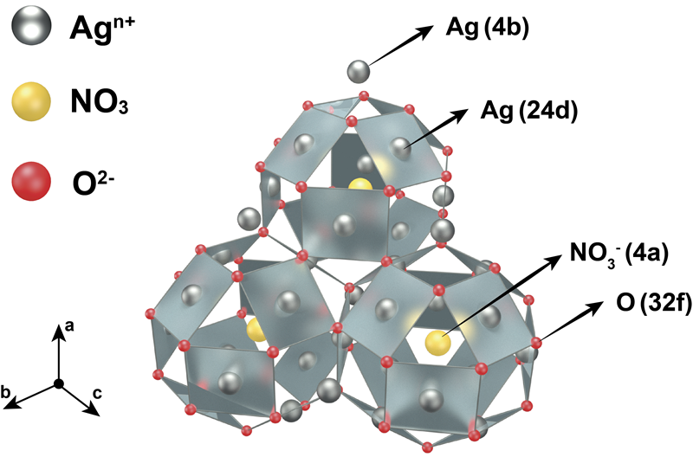
Figure S1. Schematic of the crystal structure of Ag₇O₈NO₃. The structure is composed of connected Ag₆O₈ cages in which silver atoms occupy the 24d Wyckoff positions and O atoms occupy the 32f positions via silver atom at the 4b Wyckoff position. The ${NO}_{3}^{−}$ anion is located at the center of the cage (4a site). The average oxidation state of Ag is +2.67, indicating a mixed-valence state of Ag²⁺and Ag³⁺.
Figure S2. Ag₇O₈NO₃ microtorpedoes gradually dissolved by electrochemical reactions in 0.1 M KNO₃ aqueous solutions. (A) Generation of current during the dissolution process. (B) Ag₇O₈NO₃ disappeared after storage for 6 h.

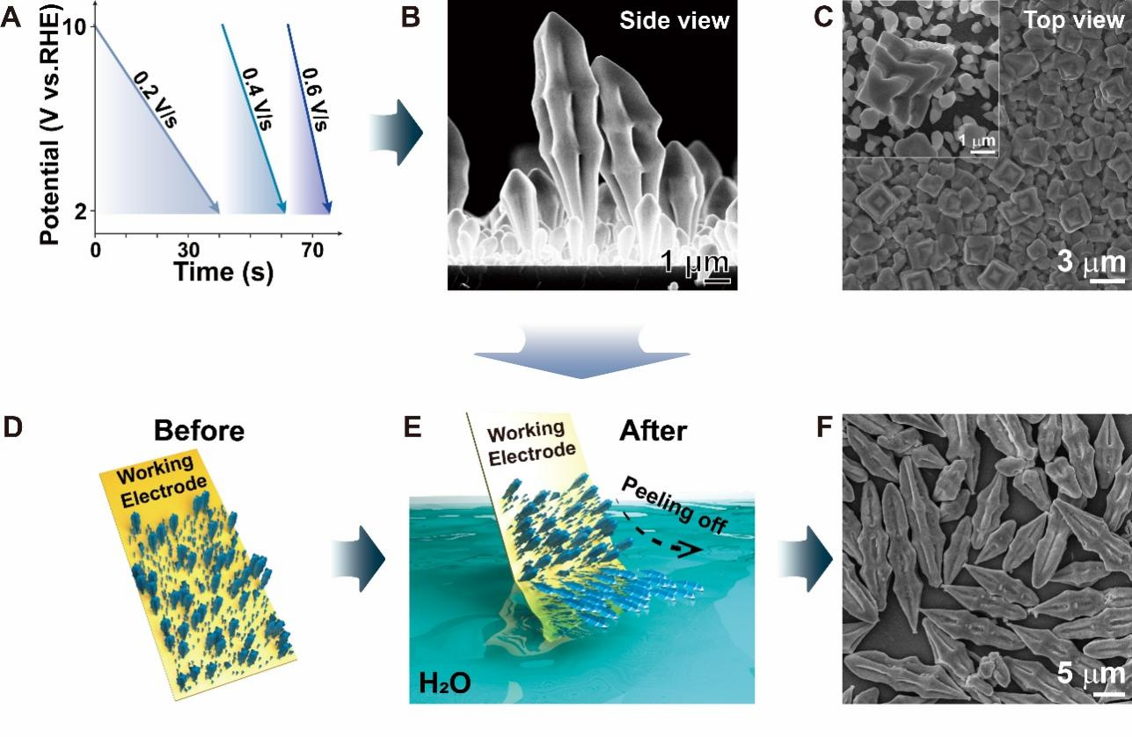
Figure S3. Electrodeposition and selective peeling-off of the electrodeposited Ag₇O₈NO₃ microtorpedoes from the electrode surface. (A) The potential waveform used to synthesize the Ag₇O₈NO₃ microtorpedoes. (B) Side-view of the microtorpedoes. (C) Top-view of the dense microtorpedoes. Inset: high-magnification view of a single microtorpedo. (D) Schematic of the as-electrodeposited Ag₇O₈NO₃ microtorpedoes. (E) Peeling off the microtorpedoes from the electrode surface by immersing it into water. (F) SEM image of the microtorpedoes collected from the electrode surface.
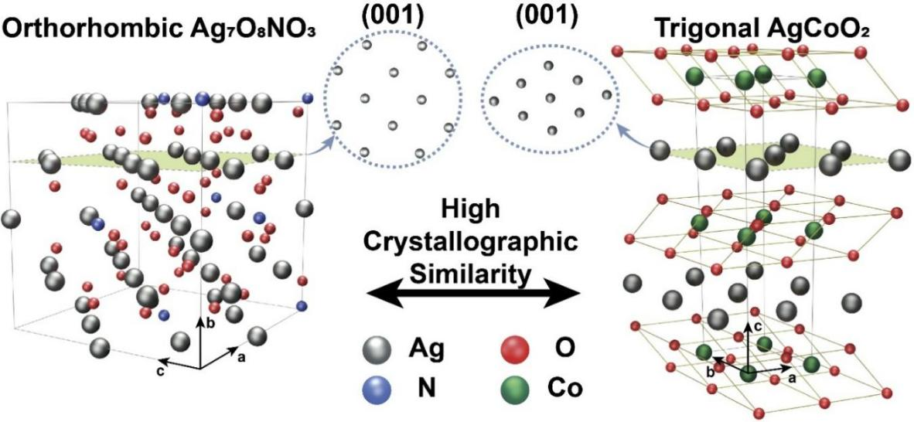
Figure S4. Structural similarity between orthorhombic Ag₇O₈NO₃ and trigonal AgCoO₂. Schematic of the crystal structure of (left) orthorhombic Ag₇O₈NO₃ and (right) trigonal AgCoO₂. The highlighted (001) planes in both structures demonstrate a high degree of crystallographic similarity. The circular insets provide a top-down view of the (001) atomic arrangement, highlighting the nearly identical quasi-hexagonal lattice of silver atoms (grey spheres). This structural match is the key factor in minimizing the lattice distortion and strain at the Ag₇O₈NO₃/AgCoO₂ core/shell interface.

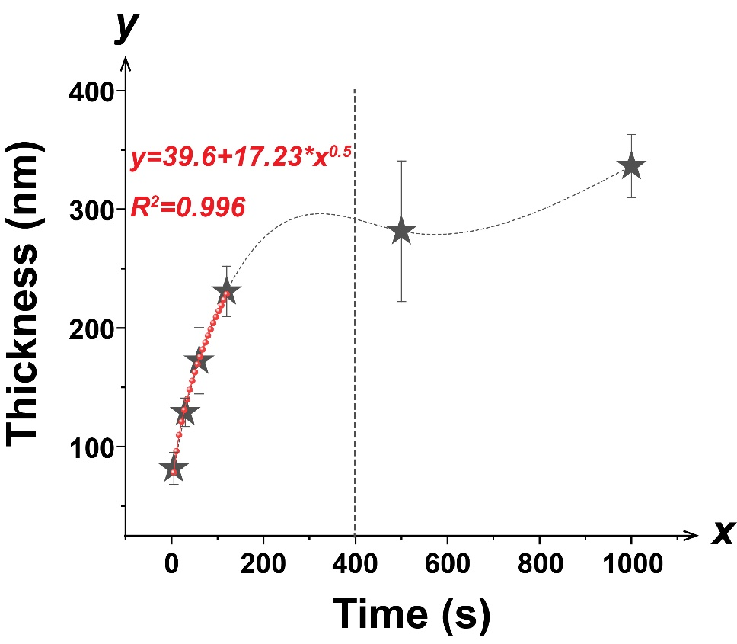
Figure S5. Evolution of the AgCoO₂ wall thickness as a function of the OCE reaction time. The experimental data (indicated by stars) show the time-dependent increase of the AgCoO₂ wall thickness. The thickness grow rapidly before 400 s. The red curve represents the numerical fitting of the growth Before 400 s, following a parabolic relationship. The early-stage formation of the AgCoO₂ wall is governed by a diffusion-controlled mechanism.

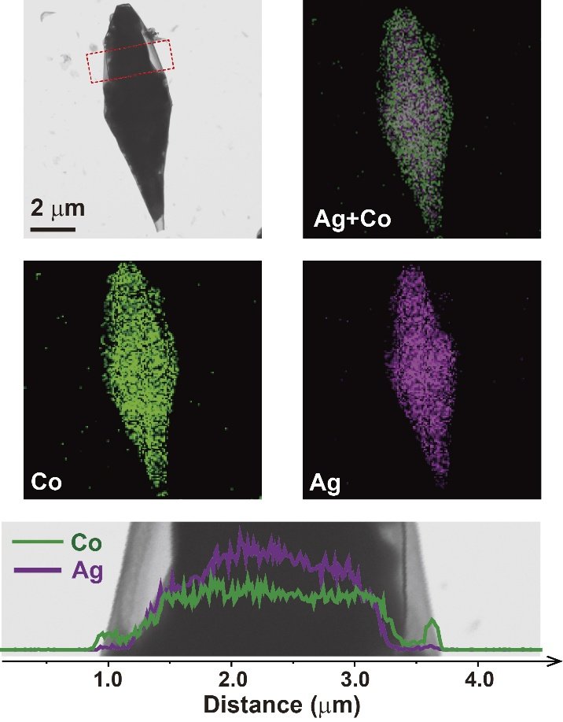
Figure S6. Morphological and element mapping of a single Ag₇O₈NO₃/AgCoO₂ core/shell microtorpedo. Top left: HAADF-STEM image of a representative microtorpedo. The red dashed rectangle indicates the region selected for the element line scan. Top right and Middle column: EDS elemental mapping results showing the spatial distribution of Co (green), Ag (purple), and the overlaid Ag and Co signals. Bottom: Element line scan profile across the microtorpedo. The profile confirms the core/shell structure with the Ag signal localized in the interior (core) and the Co signal extending across the whole structure, indicating the formation of an AgCoO₂ shell.

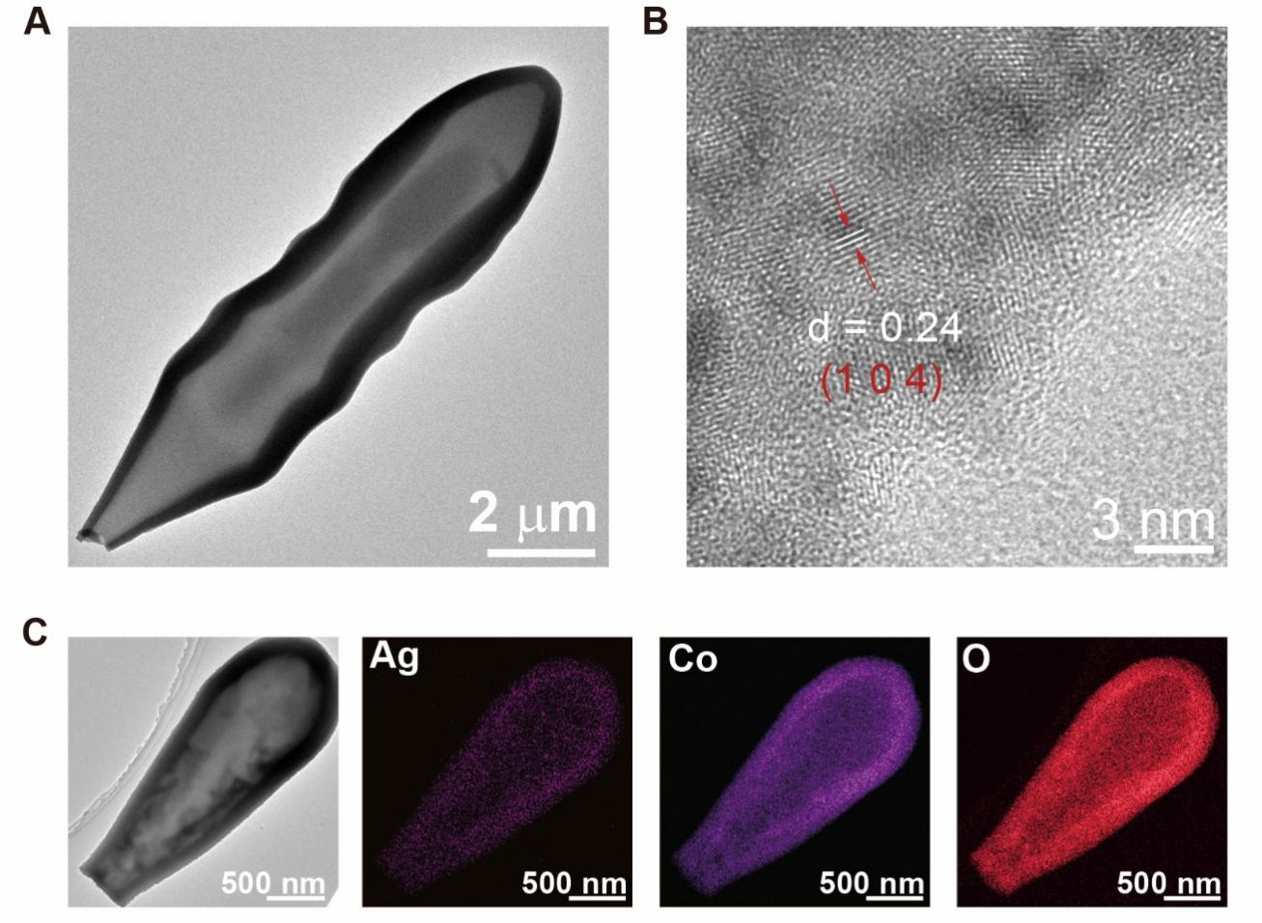
Figure S7. Characterization of an individual AgCoO₂ microtorpedo. (A) TEM image of the hollow AgCoO₂ microtorpedo. (B) High resolution TEM image of the hollow AgCoO₂ microtorpedo, indicating its polycrystalline structure. (C) TEM image and element mapping results of the hollow AgCoO₂ microtorpedo.

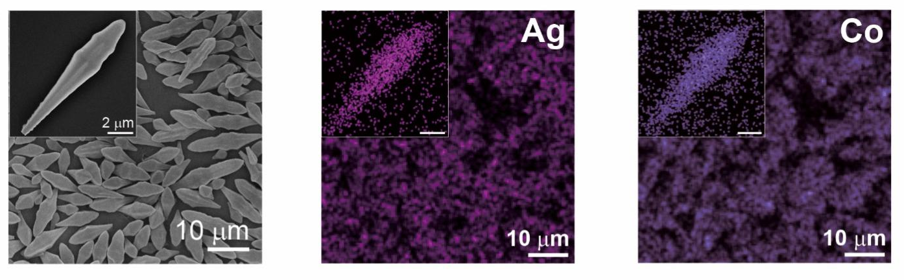
Figure S8. SEM image and element mapping results of AgCoO₂ microtorpedoes. The morphology of Ag₇O₈NO₃ microtorpedoes is well preserved after complete OCE transformation to AgCoO₂.
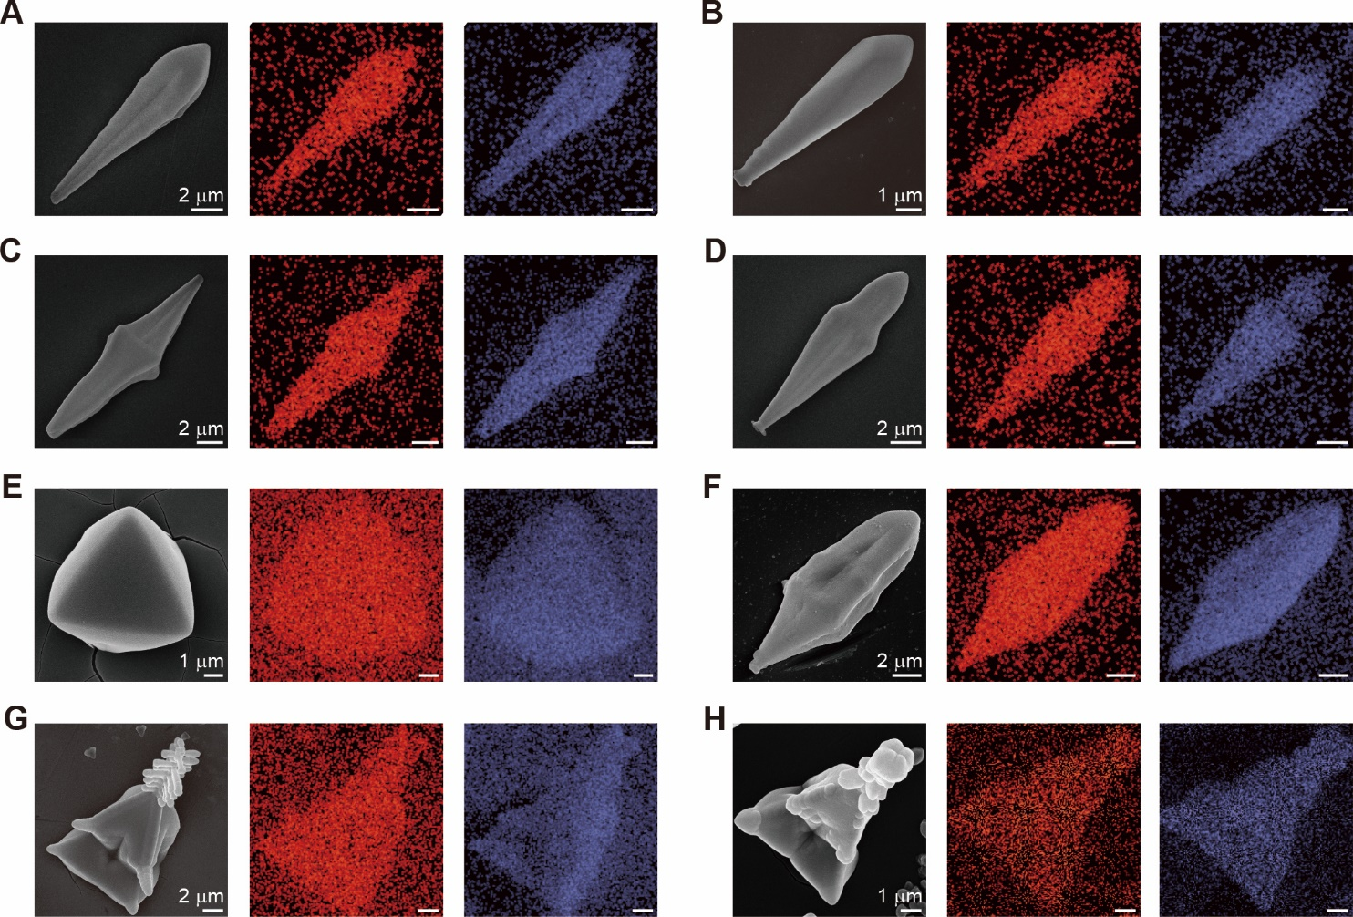
Figure S9. Various AgCoO₂ microarchitectures transformed from Ag₇O₈NO₃. (A-H) SEM image (left) and Ag (middle) and Co (right) element mapping results of AgCoO₂ microarchitectures.

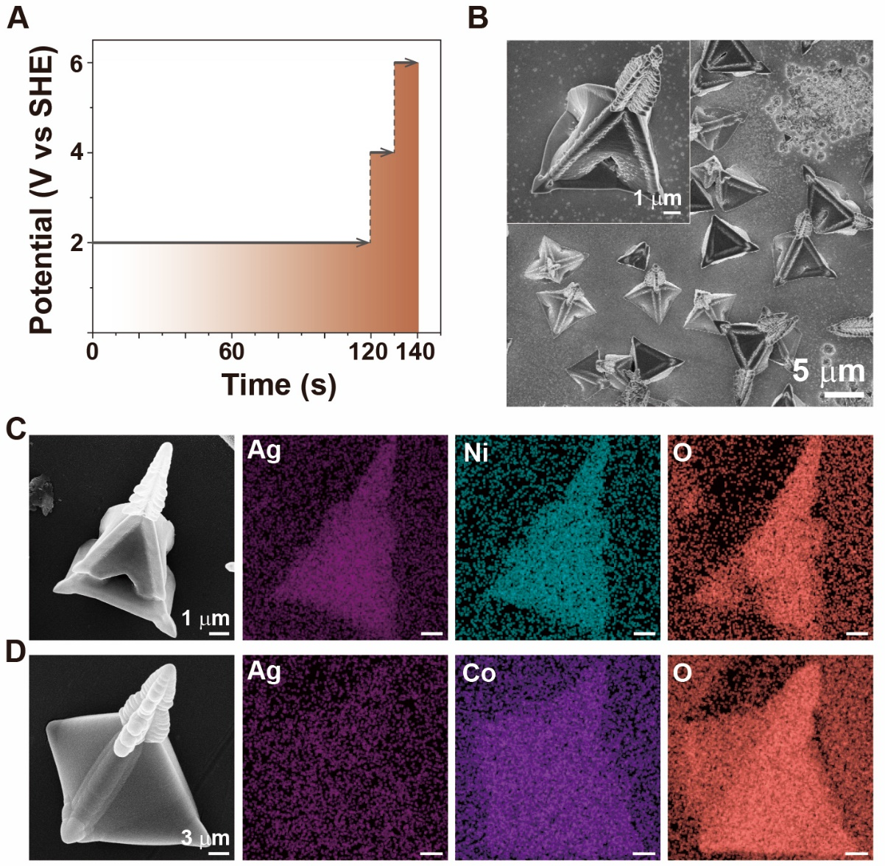
Figure S10. Conversion of Ag₇O₈NO₃ microarchitectures to AgNiO₂ and AgCoO₂ microarchitectures. (A) The potential waveform used to fabricate Ag₇O₈NO₃ microarchitectures. (B) SEM image of the complex Ag₇O₈NO₃ microarchitectures. Inset: magnified image. (C) SEM image and EDS mapping results of the AgNiO₂ microarchitectures coverted from the Ag₇O₈NO₃ microarchitectures. (D) SEM image and EDS mapping results of the AgCoO₂ microarchitectures.

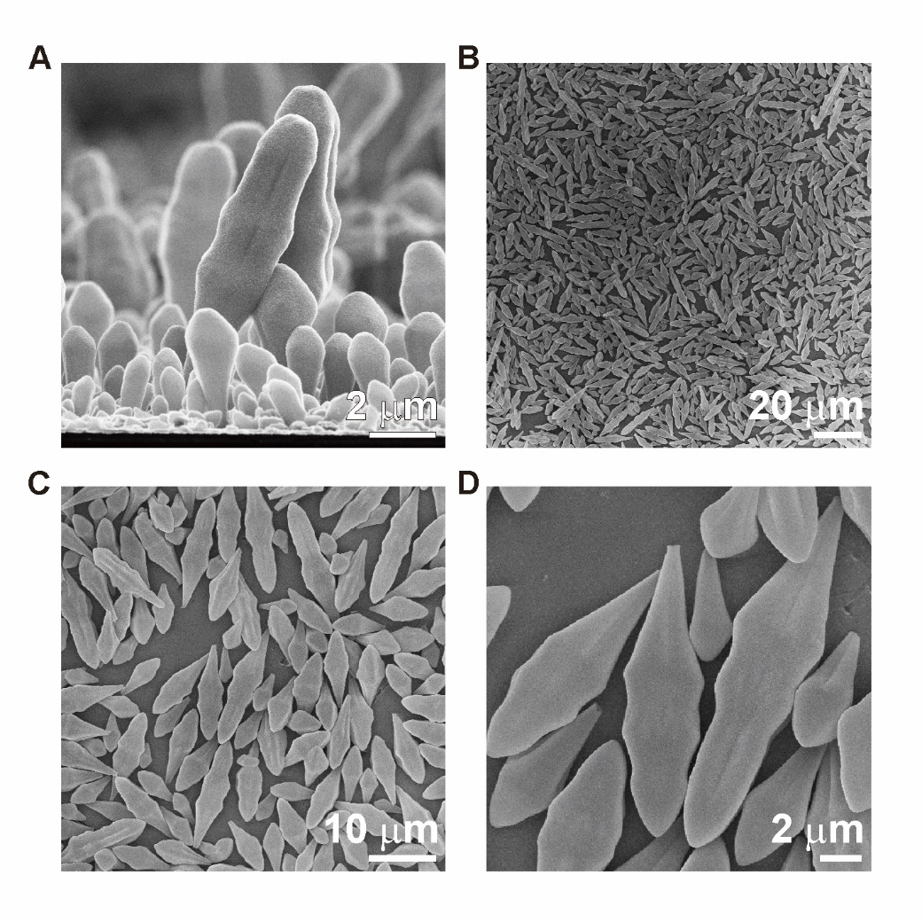
Figure S11. Selectively peeling off AgNiO₂ microtorpedoes from the electrode surface by immersing the electrode into water. (A) AgNiO₂ microtorpedoes on the anode electrode surface transformed from Ag₇O₈NO₃ microtorpedoes. (B-D) AgNiO₂ microtorpedoes selectively peeled off from the electrode surface.

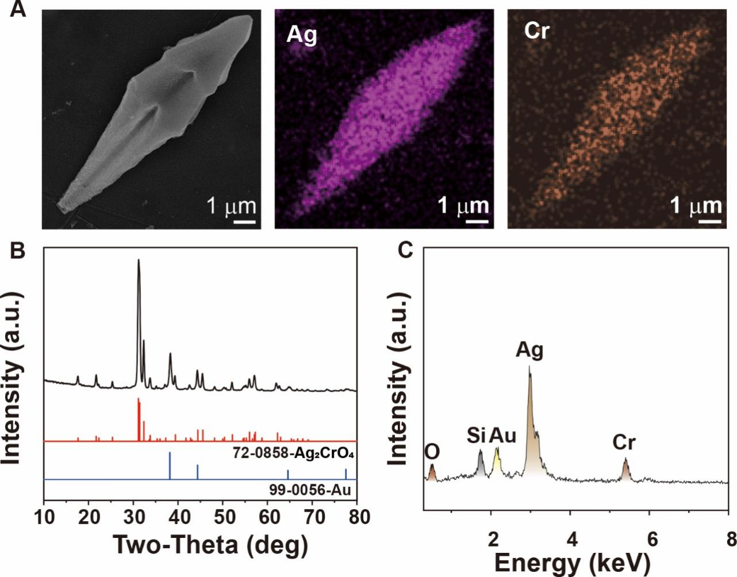
Figure S12. Preparation of Ag₂CrO₄ microtorpedoes. (A) SEM image (left) and element mapping results of Ag₂CrO₄ microtorpedoes. (B and C) XRD pattern and EDS spectrum of Ag₂CrO₄ microtorpedoes, respectively.

Figure S13. Converting Ag₇O₈NO₃ microstructures into Ag₂CrO₄ in Cr(NO₃)₃ aqueous solutions. (A) pH value of 50 mM Cr(NO₃)₃ aqueous solutions and Cr(NO₃)₃ solutions composed of equal volume of water and ethanol. (B) SEM image of the Ag₂CrO₄ structures transformed from the Ag₇O₈NO₃ micropyramids, indicating that the Ag₂CrO₄ structures were corroded in the low pH value solutions.

Figure S14. Transformation of Ag₇O₈NO₃ microtorpedoes in the mixture solution of Co(NO₃)₂ and Ni(NO₃)₂. (A) EDS spectra of the transformed products by placing Ag₇O₈NO₃ microtorpedoes in 10 ml of mixture solution of Ni(NO₃)₂ and Co(NO₃)₂ with different volume ratios (from top to bottom: only Ni(NO₃)₂; 50 : 1; 1:1; only Co(NO₃)₂). (B) The quantity ratio of the Ni and Co element in the EDS spectrum (from left to right corresponding to the EDS spectra from top to bottom in (A).

Figure S15. AgCoO₂ microtorpedoes could not react with Ni²⁺ ions. (A) SEM image of the AgCoO₂ microtorpedo after transferring into Ni(NO₃)₂ solutions for 1 h. (B) EDS spectrum confirmed the microtorpedo was still AgCoO₂.
Figure S16. Transformation of Ag₇O₈NO₃ microtorpedoes in the mixture solution of Mn(NO₃)₂ and Ni(NO₃)₂. (A) pH value of different reaction solutions. (B) Quantity ratio of Ni and Mn elements in the converted products after placing the Ag₇O₈NO₃ microstructures into 10 ml of the mixture solution of Mn(NO₃)₂ and Ni(NO₃)₂) with different volume ratios. The concentration of the Mn(NO₃)₂ and Ni(NO₃)₂ solutions was 10 mM. (C) The corresponding EDS spectra (from top to bottom) to B (from left to right). (D) EDS spectrum of the converted products in the mixture solution of Co (NO₃)₂, Mn (NO₃)₂, and Ni (NO₃)₂) with equal amount of Co²⁺, Mn²⁺, and Ni²⁺ ions. Ag₇O₈NO₃ sequentially reacted with Co²⁺ and Mn²⁺ ions.

Figure S17. No OCE reaction took place between Ag₇O₈NO₃ and Fe(NO₃)₃ aqueous solutions. (A) SEM image of Ag₇O₈NO₃ microstructure after immersing into Fe(NO₃)₃ aqueous solutions. (B) EDS spectrum indicated that the Ag₇O₈NO₃ microstructure did not react with the Fe³⁺ ions already at the highest valence.
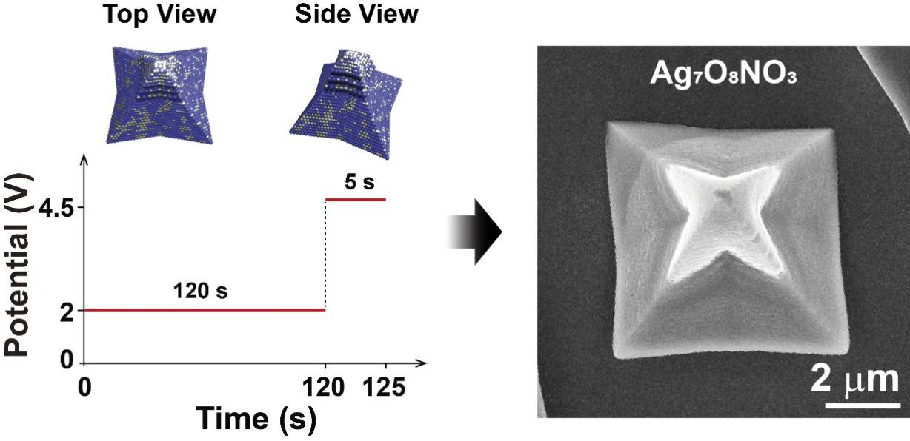
Figure S18. Electrodeposition of Ag₇O₈NO₃ micropyramids. Left: the potential waveform used to fabricate the micropyramid. Right: the corresponding SEM image of the micropyramid with a star-like apex. This unique fine structure was used to observe the morphology evolution during OCE reactions shown in Figure 3.

Figure S19. Characterization of the magnetic microtorpedoes. (A and B) SEM image and EDS spectrum of the magnetic microtorpedoes, respectively.

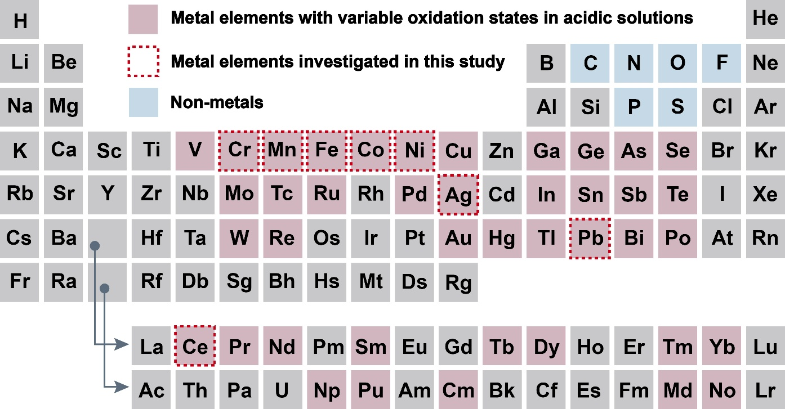
Figure S20. Polyvalent cations in the periodic table. Pink color marked elements have multiple valences, which are applicable to the OCE reactions. Elements in red dashed boxes (Cr, Mn, Fe, Co, Ni, Ag, Pb, and Ce) have been proven applicable to the OCE reactions and have been successfully introduced into the high-entropy metal oxides.

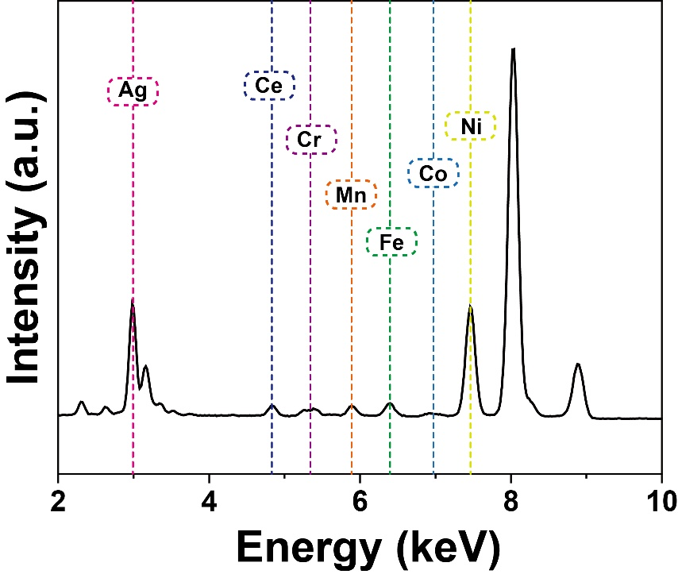
Figure S21. EDS spectrum of the G-6 Ag(Ni, Ce, Co, Mn, Cr, Fe)O₂ microtorpedo corresponding to Figure 4I .

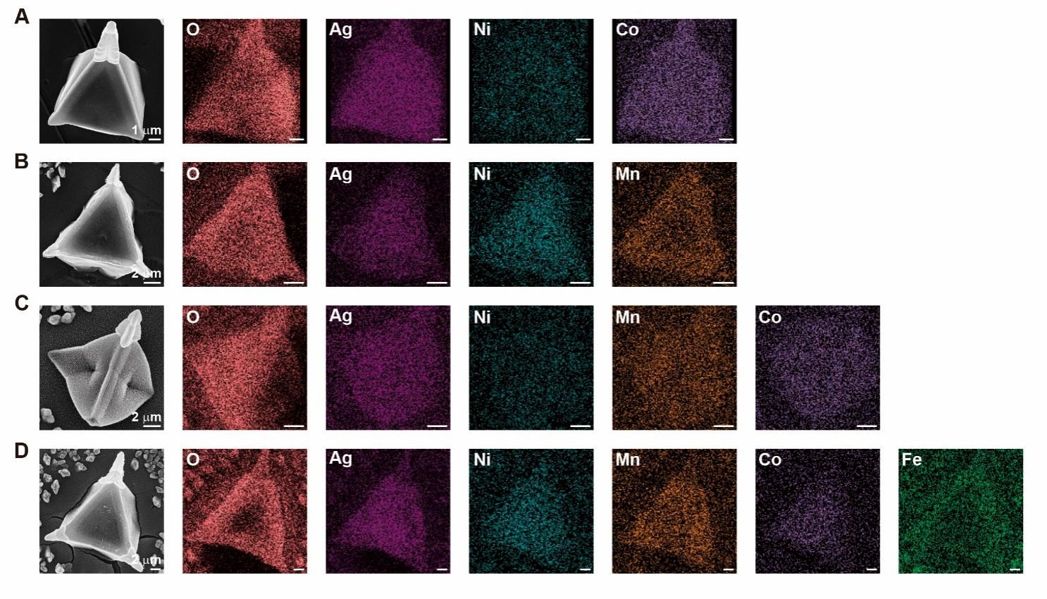
Figure S22. Characterization of the G-2, G-3, and G-4 microarchitectures. (A-D) SEM images (left) and element mapping results of G-2 Ag(Ni, Co)O₂, G-2 Ag(Ni, Mn)O₂, G-3 Ag(Ni, Mn, Co)O₂, and G-4 Ag(Ni, Mn, Co, Fe)O₂ microarchitectures, respectively.

