Table S1: Search string.
Database | Search string | Results
PubMed | (("Neoplasm, Rectal") OR ("Rectal Neoplasm") OR ("Neoplasms, Rectal") OR ("Rectum Neoplasms") OR ("Neoplasm, Rectum") OR ("Rectum Neoplasm") OR ("Rectal Tumors") OR ("Rectal Tumor") OR ("Tumor, Rectal") OR ("Cancer of Rectum") OR ("Rectum Cancers") OR ("Cancer of the Rectum") OR ("Rectal Cancer") OR ("Cancer, Rectal") OR ("Rectal Cancers") OR ("Rectum Cancer") OR ("Cancer, Rectum")  )  AND  (  ("Endoscopic Surgeries, Transanal") OR ("Endoscopic Surgery, Transanal") OR ("Surgeries, Transanal Endoscopic") OR ("Surgery, Transanal Endoscopic") OR ("Transanal Endoscopic Surgeries") OR ("Transanal Endoscopic Surgical Procedures") OR ("Transanal Minimally Invasive Surgery") OR ("TAMIS")  OR  ("Proctectomies") OR ("Rectum Excision") OR ("Excision, Rectum") OR ("Rectum Excisions") OR ("Rectum Resection") OR ("Rectum Resections") OR ("Resection, Rectum") OR ("Abdominoperineal Resection") OR ("Abdominoperineal Resections") OR ("Resection, Abdominoperineal") OR ("Resections, Abdominoperineal") OR ("Abdomino-perineal Excision") OR ("Abdomino perineal Excision") OR ("Abdomino-perineal Excisions") OR ("Excision, Abdomino-perineal") OR ("Abdomino-Perineal Rectum Excision") OR ("Abdomino Perineal Rectum Excision") OR ("Abdomino-Perineal Rectum Excisions") OR ("Excision, Abdomino-Perineal Rectum") OR ("Excisions, Abdomino-Perineal Rectum") OR ("Rectum Excision, Abdomino-Perineal") OR ("Abdomino-Perineal Resection") OR ("Abdomino Perineal Resection") OR ("Abdomino-Perineal Resections") OR ("Resection, Abdomino-Perineal") OR ("Abdominoperineal Excision") OR ("Abdominoperineal Excisions") OR ("Excision, Abdominoperineal") OR ("Abdominoperineal Rectum Excision") OR ("Abdominoperineal Rectum Excisions") OR ("Excision, Abdominoperineal Rectum") OR ("Rectum Excision, Abdominoperineal")  ) | 7,039
Cochrane library | (("Neoplasm, Rectal") OR ("Rectal Neoplasm") OR ("Neoplasms, Rectal") OR ("Rectum Neoplasms") OR ("Neoplasm, Rectum") OR ("Rectum Neoplasm") OR ("Rectal Tumors") OR ("Rectal Tumor") OR ("Tumor, Rectal") OR ("Cancer of Rectum") OR ("Rectum Cancers") OR ("Cancer of the Rectum") OR ("Rectal Cancer") OR ("Cancer, Rectal") OR ("Rectal Cancers") OR ("Rectum Cancer") OR ("Cancer, Rectum")) AND (("Endoscopic Surgeries, Transanal") OR ("Endoscopic Surgery, Transanal") OR ("Surgeries, Transanal Endoscopic") OR ("Surgery, Transanal Endoscopic") OR ("Transanal Endoscopic Surgeries") OR ("Transanal Endoscopic Surgical Procedures") OR ("Transanal Minimally Invasive Surgery") OR ("TAMIS") OR ("Proctectomies") OR ("Rectum Excision") OR ("Excision, Rectum") OR ("Rectum Excisions") OR ("Rectum Resection") OR ("Rectum Resections") OR ("Resection, Rectum") OR ("Abdominoperineal Resection") OR ("Abdominoperineal Resections") OR ("Resection, Abdominoperineal") OR ("Resections, Abdominoperineal") OR ("Abdomino-perineal Excision") OR ("Abdomino perineal Excision") OR ("Abdomino-perineal Excisions") OR ("Excision, Abdomino-perineal") OR ("Abdomino-Perineal Rectum Excision") OR ("Abdomino Perineal Rectum Excision") OR ("Abdomino-Perineal Rectum Excisions") OR ("Excision, Abdomino-Perineal Rectum") OR ("Excisions, Abdomino-Perineal Rectum") OR ("Rectum Excision, Abdomino-Perineal") OR ("Abdomino-Perineal Resection") OR ("Abdomino Perineal Resection") OR ("Abdomino-Perineal Resections") OR ("Resection, Abdomino-Perineal") OR ("Abdominoperineal Excision") OR ("Abdominoperineal Excisions") OR ("Excision, Abdominoperineal") OR ("Abdominoperineal Rectum Excision") OR ("Abdominoperineal Rectum Excisions") OR ("Excision, Abdominoperineal Rectum") OR ("Rectum Excision, Abdominoperineal")) | 3000
Embase | (("Neoplasm, Rectal") OR ("Rectal Neoplasm") OR ("Neoplasms, Rectal") OR ("Rectum Neoplasms") OR ("Neoplasm, Rectum") OR ("Rectum Neoplasm") OR ("Rectal Tumors") OR ("Rectal Tumor") OR ("Tumor, Rectal") OR ("Cancer of Rectum") OR ("Rectum Cancers") OR ("Cancer of the Rectum") OR ("Rectal Cancer") OR ("Cancer, Rectal") OR ("Rectal Cancers") OR ("Rectum Cancer") OR ("Cancer, Rectum")) AND (("Endoscopic Surgeries, Transanal") OR ("Endoscopic Surgery, Transanal") OR ("Surgeries, Transanal Endoscopic") OR ("Surgery, Transanal Endoscopic") OR ("Transanal Endoscopic Surgeries") OR ("Transanal Endoscopic Surgical Procedures") OR ("Transanal Minimally Invasive Surgery") OR ("TAMIS") OR ("Proctectomies") OR ("Rectum Excision") OR ("Excision, Rectum") OR ("Rectum Excisions") OR ("Rectum Resection") OR ("Rectum Resections") OR ("Resection, Rectum") OR ("Abdominoperineal Resection") OR ("Abdominoperineal Resections") OR ("Resection, Abdominoperineal") OR ("Resections, Abdominoperineal") OR ("Abdomino-perineal Excision") OR ("Abdomino perineal Excision") OR ("Abdomino-perineal Excisions") OR ("Excision, Abdomino-perineal") OR ("Abdomino-Perineal Rectum Excision") OR ("Abdomino Perineal Rectum Excision") OR ("Abdomino-Perineal Rectum Excisions") OR ("Excision, Abdomino-Perineal Rectum") OR ("Excisions, Abdomino-Perineal Rectum") OR ("Rectum Excision, Abdomino-Perineal") OR ("Abdomino-Perineal Resection") OR ("Abdomino Perineal Resection") OR ("Abdomino-Perineal Resections") OR ("Resection, Abdomino-Perineal") OR ("Abdominoperineal Excision") OR ("Abdominoperineal Excisions") OR ("Excision, Abdominoperineal") OR ("Abdominoperineal Rectum Excision") OR ("Abdominoperineal Rectum Excisions") OR ("Excision, Abdominoperineal Rectum") OR ("Rectum Excision, Abdominoperineal")) | 4300

Table S2: Meta-analysis and trial sequential analysis for primary outcomes
Outcomes (dichotomous) | Meta-analysis |  |  | Trial Sequential Analysis
 | RR (95% CI) | P value | I² (%) | IIA (%) | ICA (%) | RRR (%) | D² (%) | RIS (n) | RIS reached | Evidence
R0 resection rate | 1.02 (0.92–1.12) | 0.765 | 93.0 | 94.27 | 96.90 | 2.71 | 97.36 | 72,585* | No | AE
CRM positivity rate | 0.70 (0.22–2.25) | 0.551 | 38.5 | 0.99 | 1.62 | 38.89 | 50.26 | 20,484 | No | AE
Completeness of mesorectal excision | 1.05 (0.98–1.12) | 0.181 | 51.6 | 85.29 | 83.92 | −1.63 | 67.38 | 66,799* | No | AE

TaTME and LaTME were considered the intervention and control groups respectively. The α and 1-β were defined as 5% and 80%, respectively.
IIA: incidence in intervention arm; ICA: incidence in control arm; RRR: relative risk reduction; D²: diversity; RIS: required information size; AE: absent evidence.
*RIS was not displayed on the TSA graph due to insufficient information size (R0 resection rate: 3.1%; completeness of mesorectal excision: 3.53%). The RIS value was calculated by the TSA software but the alpha-spending boundary could not be plotted.

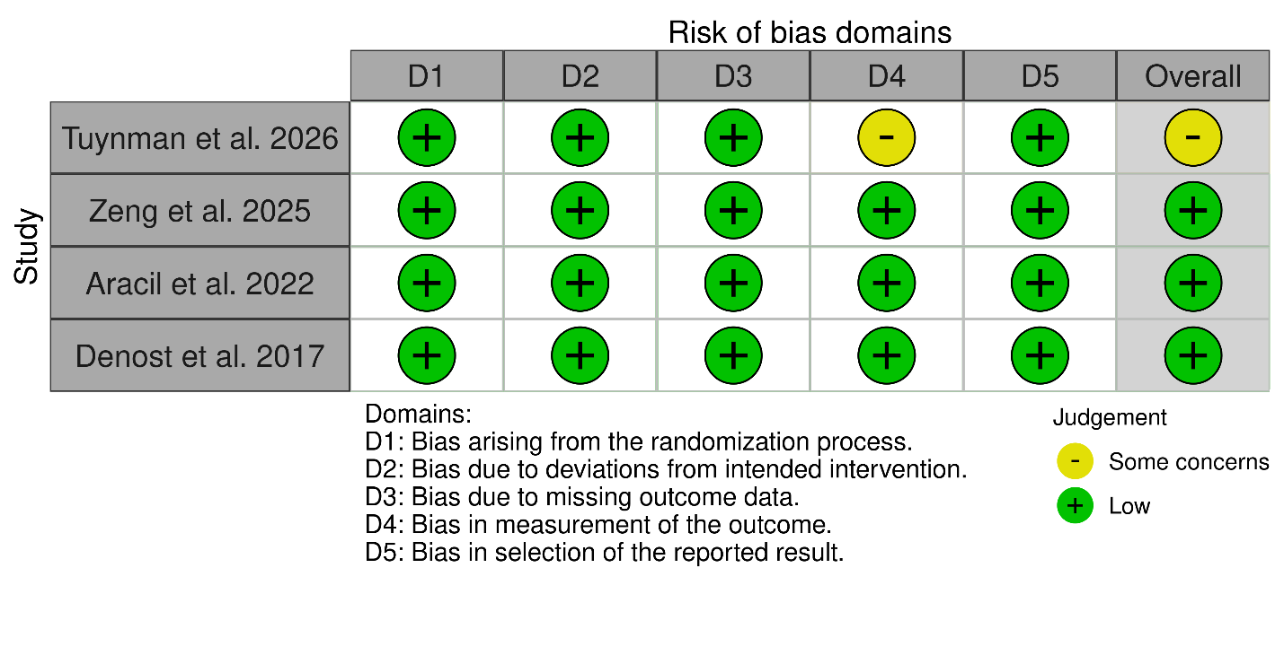
Figure S1: Traffic plot of included studies.
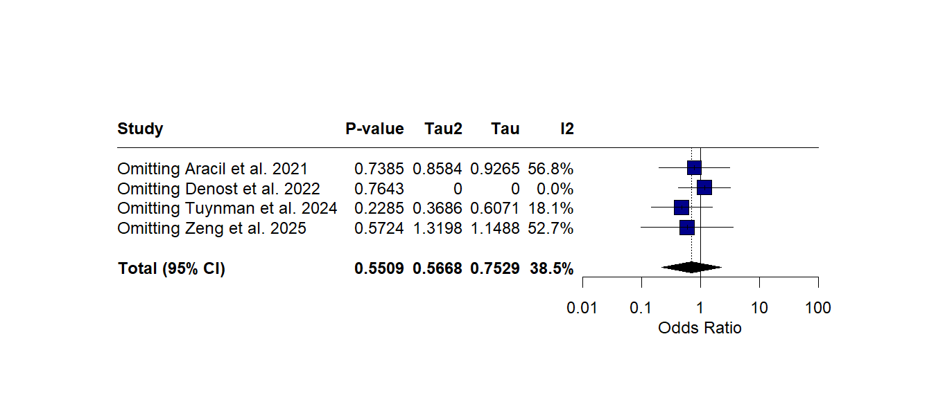
Figure S2a: Influencial plot of Circumferential resection margin (CRM) positivity
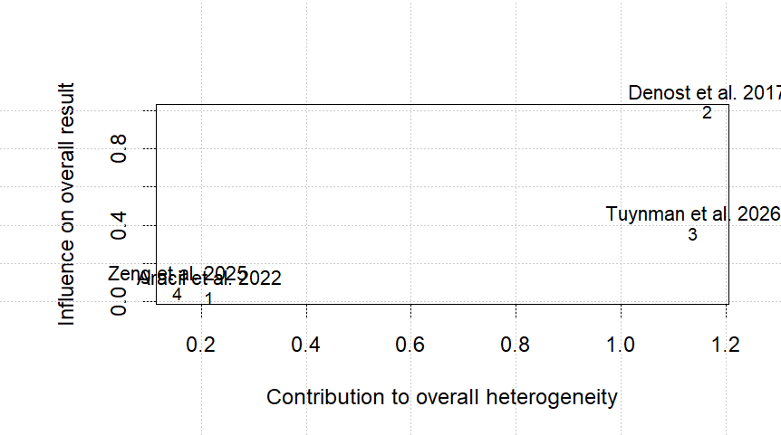
Figure S2b: Baujat plot of CRM positivity.
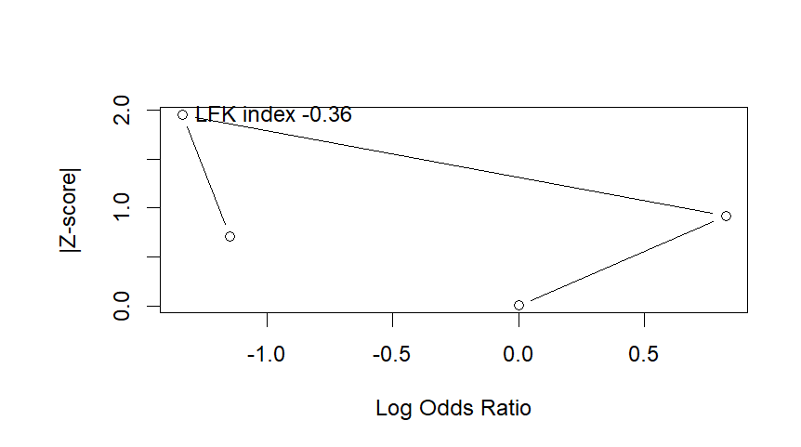
Figure S2c: DOI plot of CRM positivity.
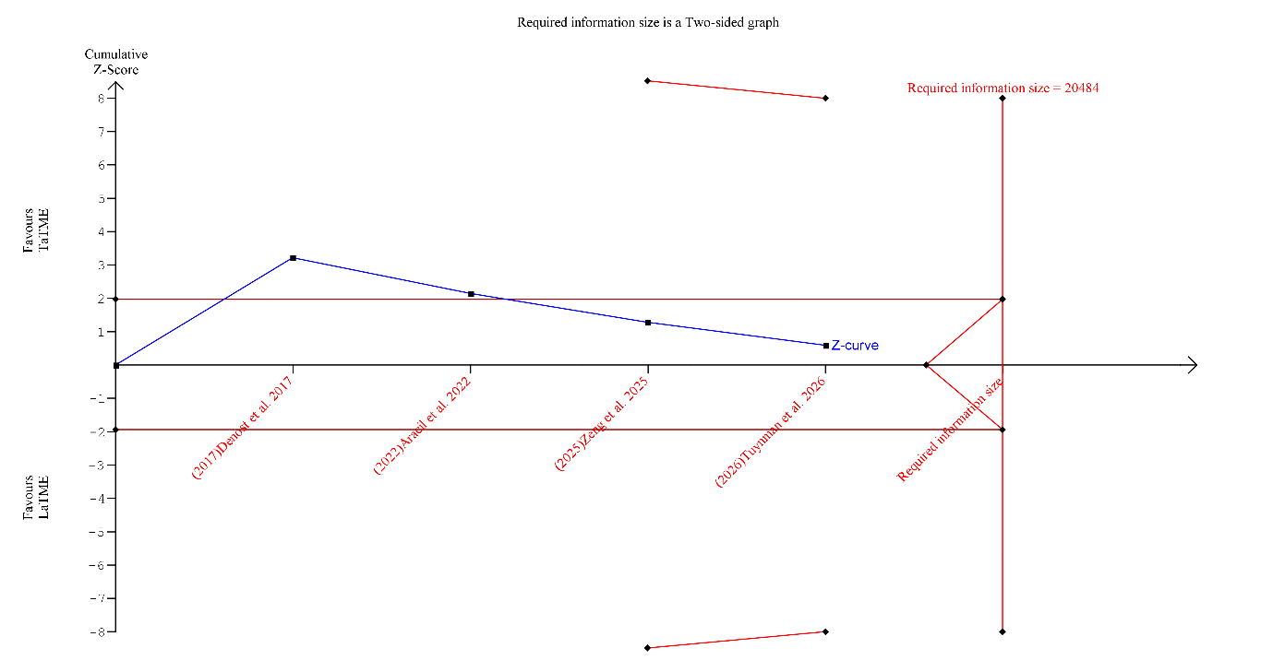
Figure S2d: TSA of CRM positivity.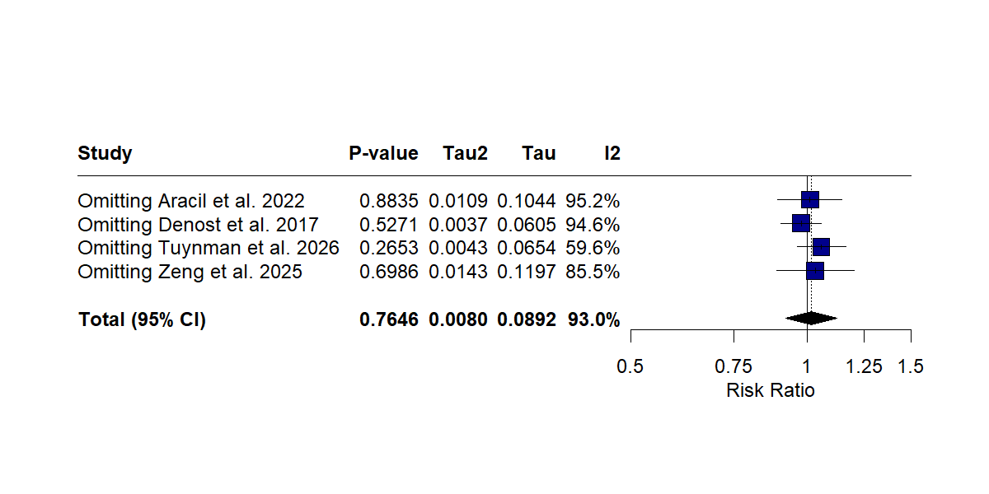
Figure S3a: Influencial plot of R0 resection rate
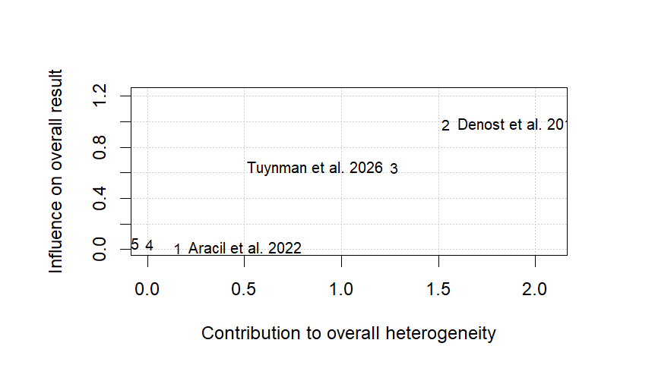
Figure S3b: Baujat Plot of R0 resection rate
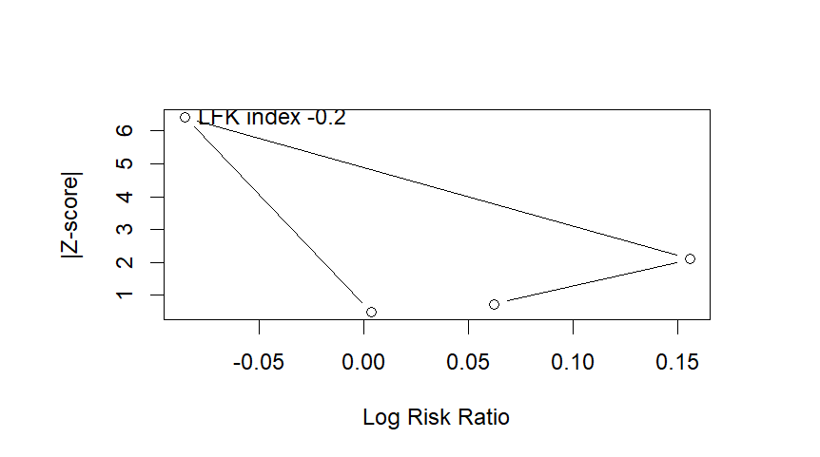
Figure S3c: DOI plot of R0 resection rate
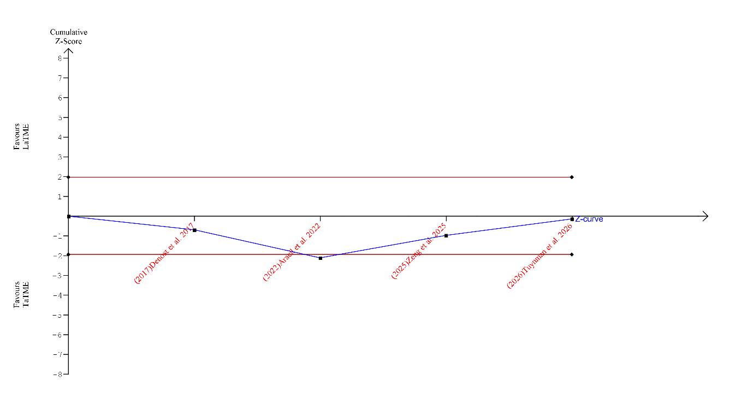
Figure S3d: TSA of R0 resection rate.
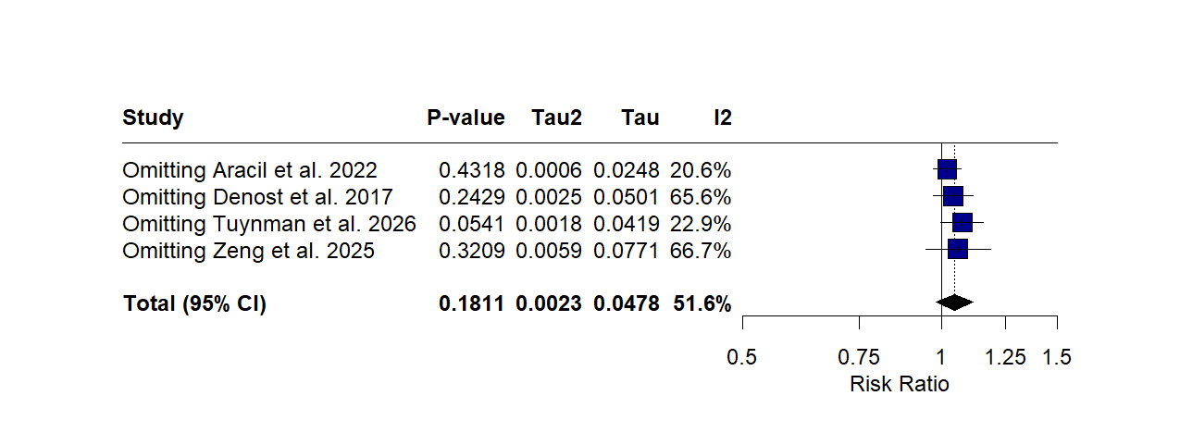
Figure S4a: Influencial plot of completeness of mesorectal excision.
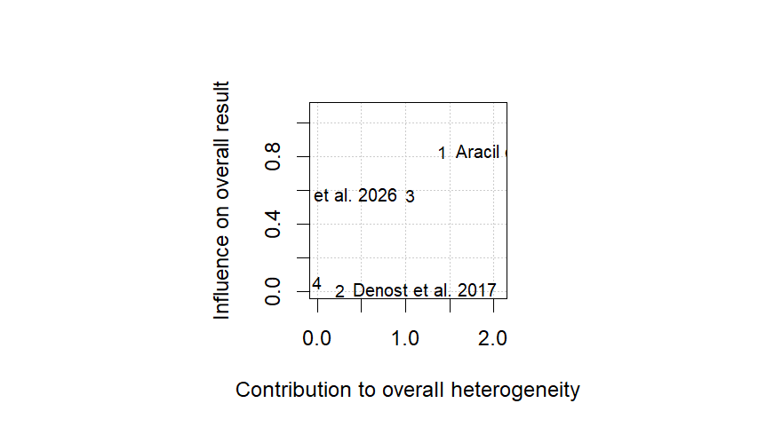
Figure S4b: Baujat Plot of completeness of mesorectal excision
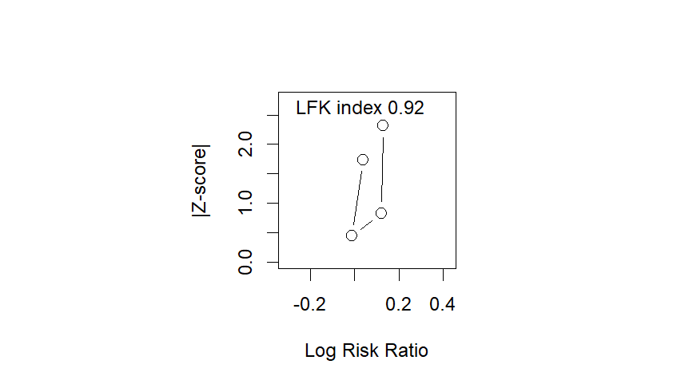
Figure S4c: DOI plot of completeness of mesorectal excision
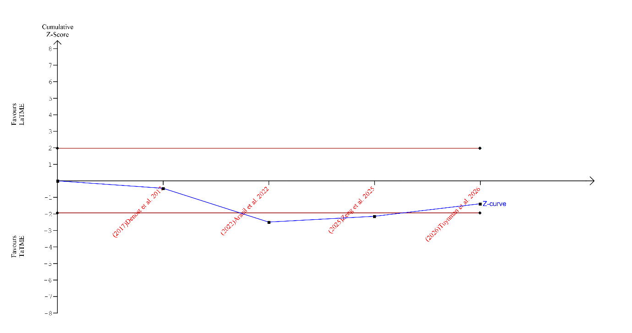
Figure S4d: TSA of completeness of mesorectal excision
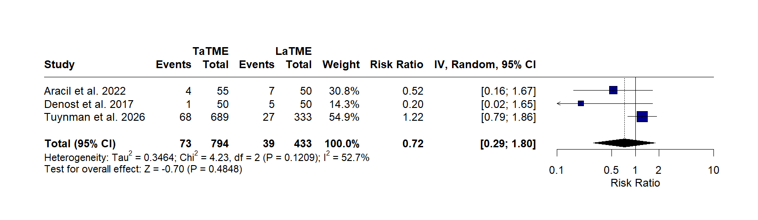
Figure S5a: Forest plot of anastomotic leakage.
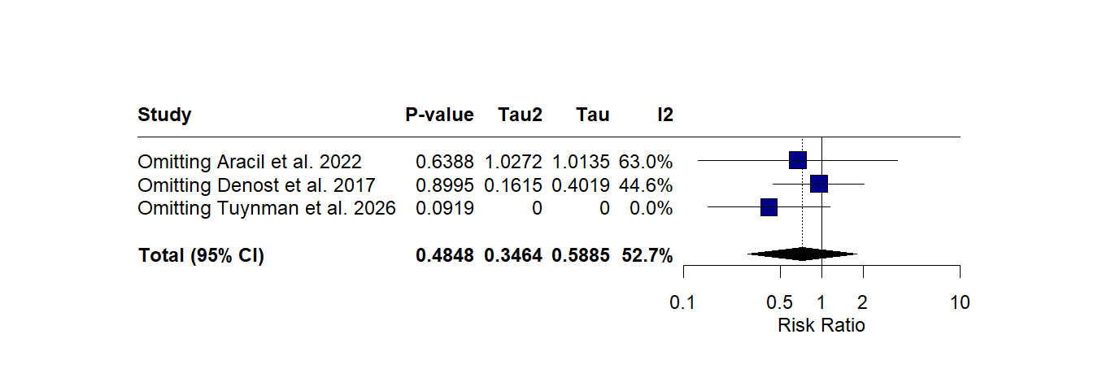
Figure S5b: Influencial plot of anastomotic leakage.
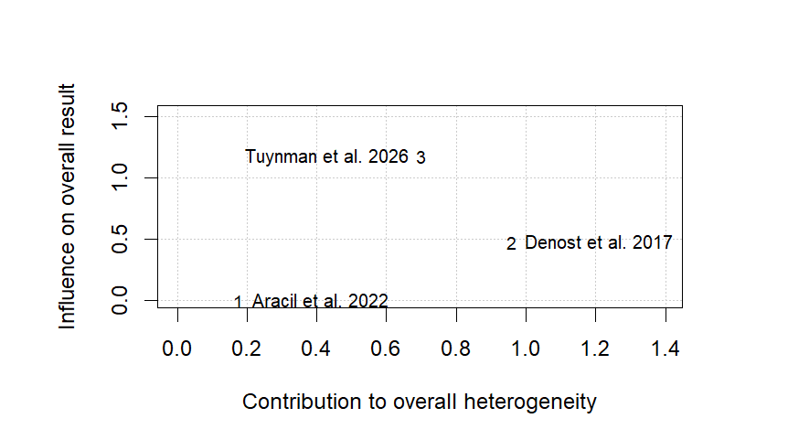
Figure S5c: Baujat Plot of anastomotic leakage.
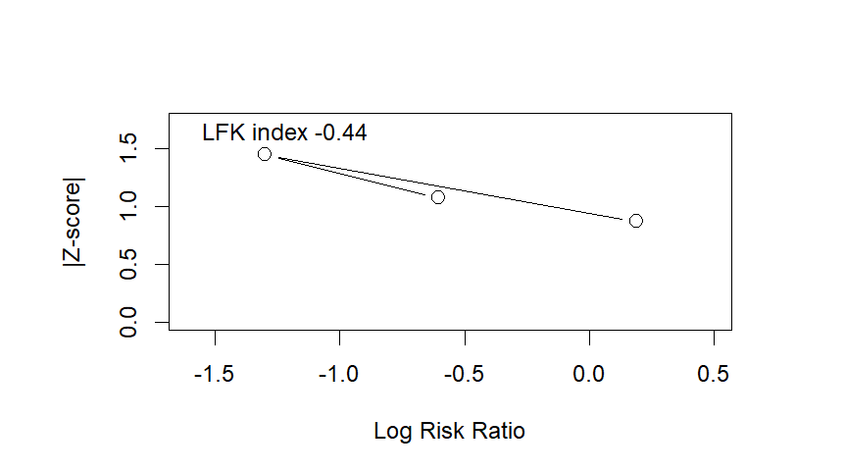
Figure S5d: DOI plot of anastomotic leakage.
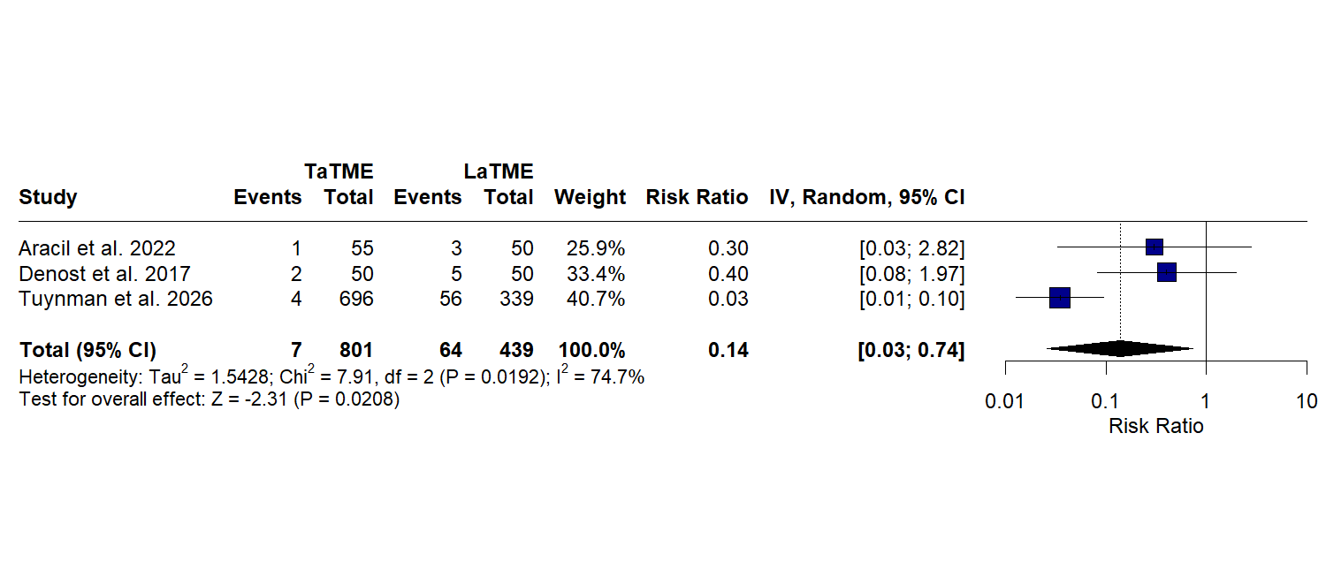
Figure S6a: Forest plot of conversion to open surgery
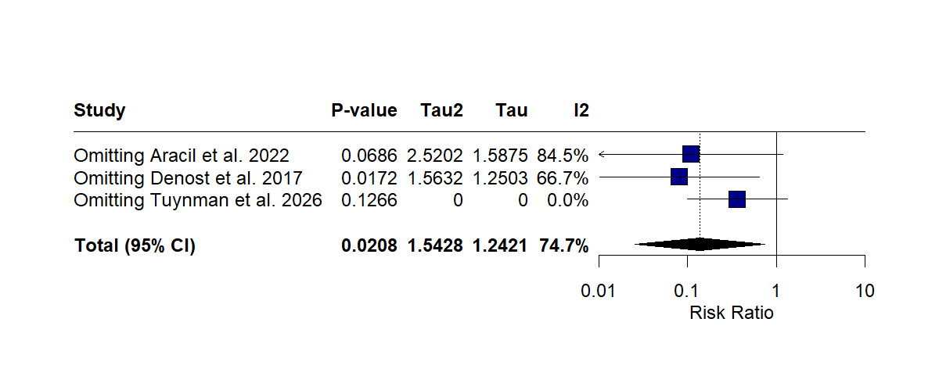
Figure S6b: Influencial plot of conversion to open surgery
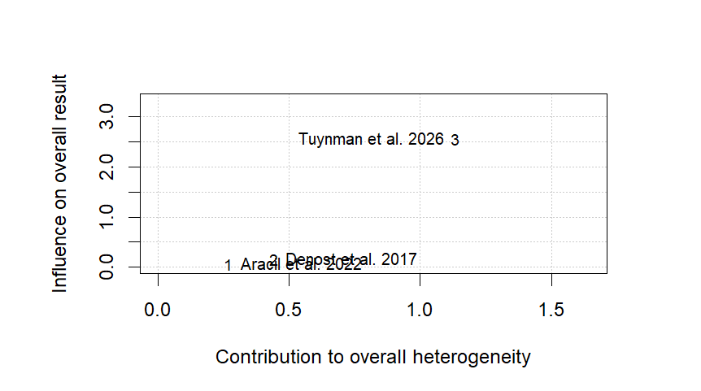
Figure S6c: Baujat Plot of conversion to open surgery
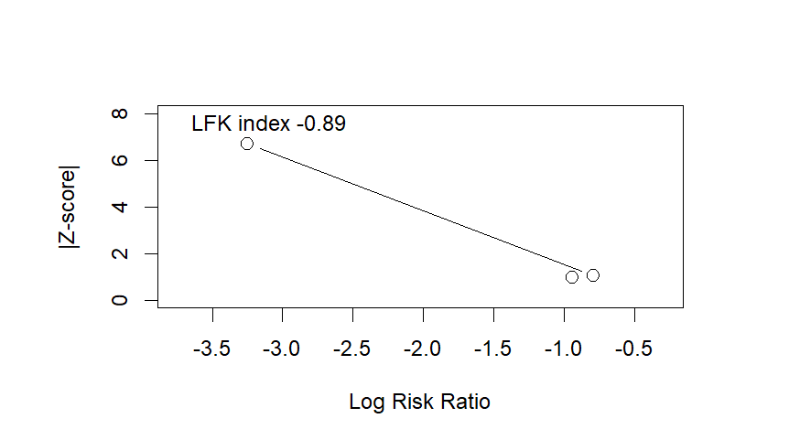
Figure S6d: DOI plot of conversion to open surgery

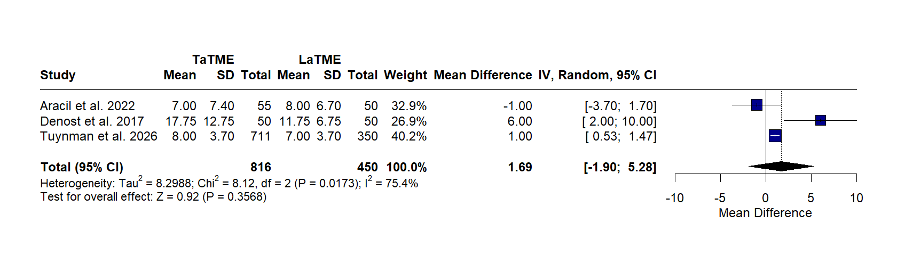
Figure S7a: Forest plot of Hospital Stay
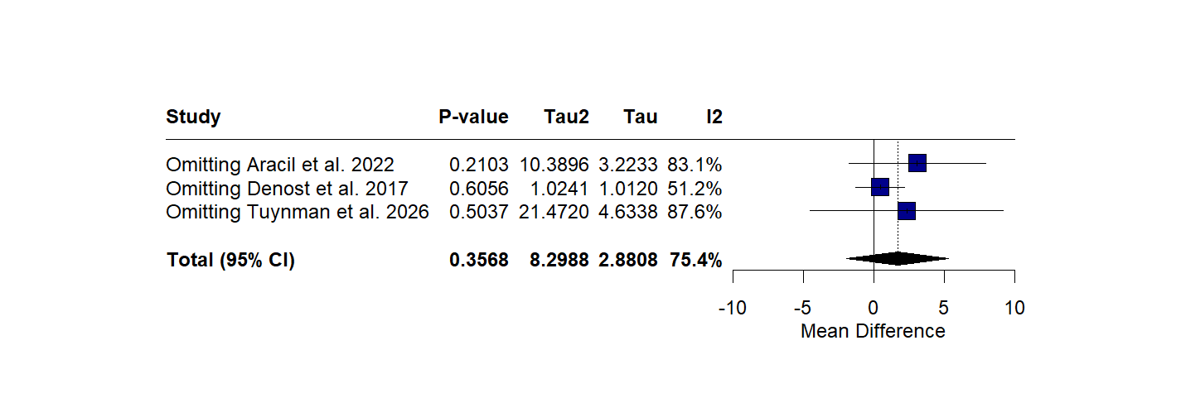
Figure S7b: Influencial plot of Hospital Stay
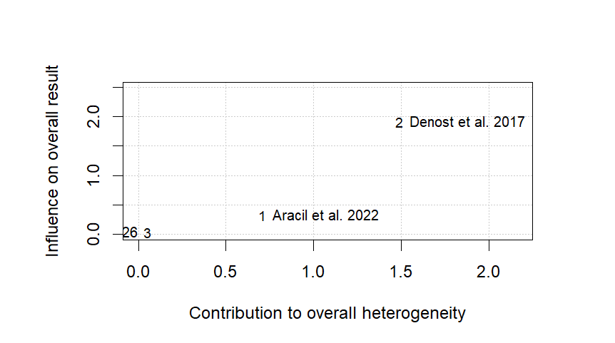
Figure S7c: Baujat Plot of Hospital Stay
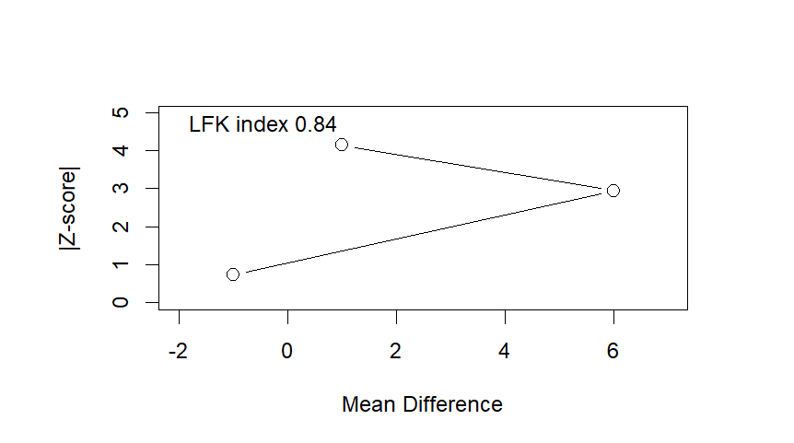
Figure S7d: DOI plot of Hospital Stay

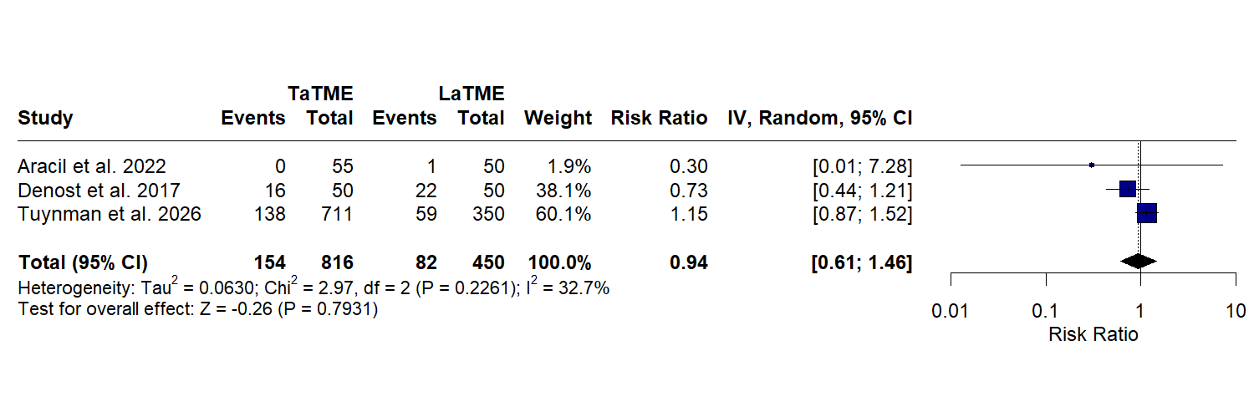
Figure S8a: Forest plot of Overall Morbidity
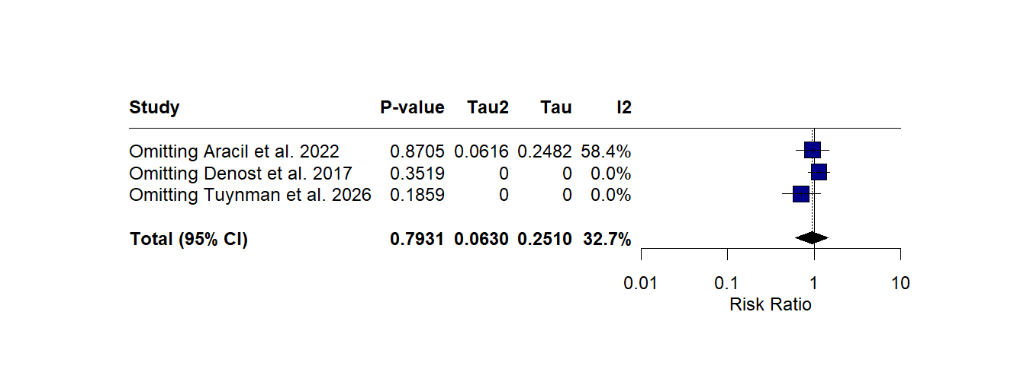
Figure S8b: Influencial Plot of Overall Morbidity
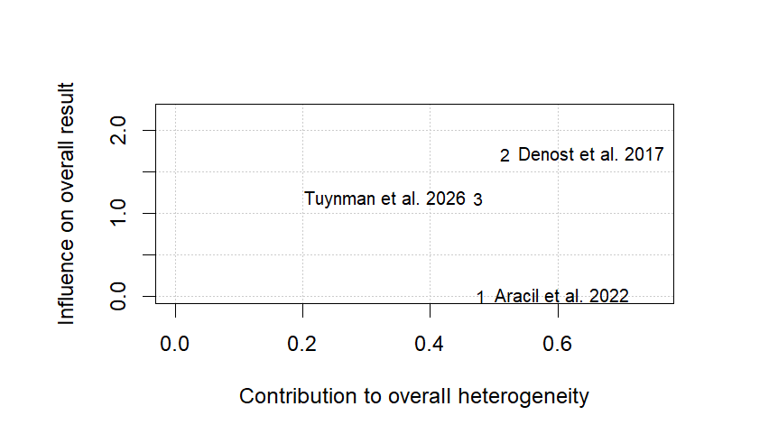
Figure S8c: Baujat plot of Overall Morbidity
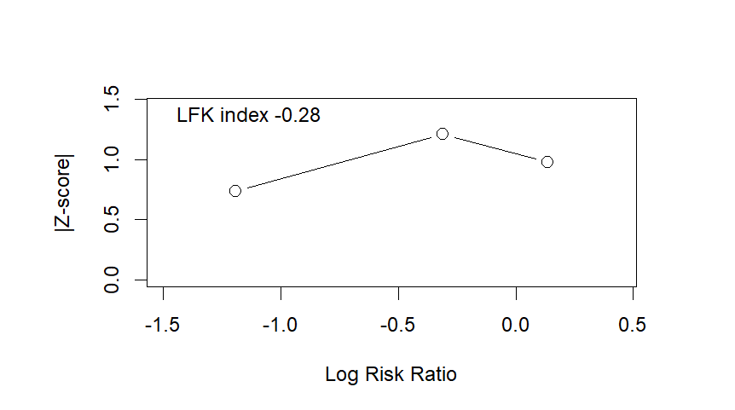
Figure S8d: DOI plot of Overall Morbidity
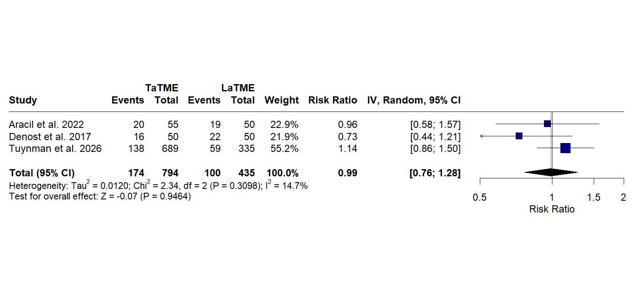
Figure S9a: Forest plot of post-operative complications
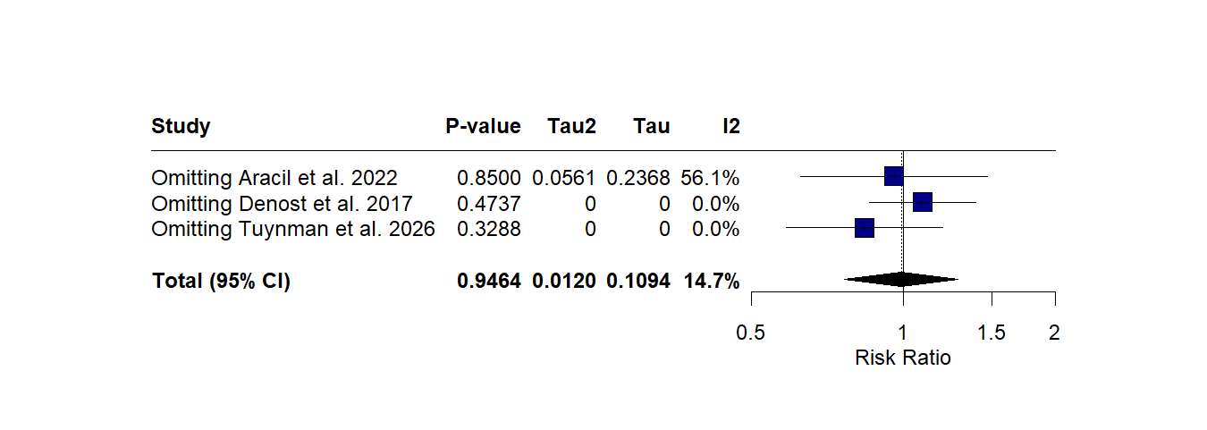
Figure S9b: Influencial Plot of Post-operative complications
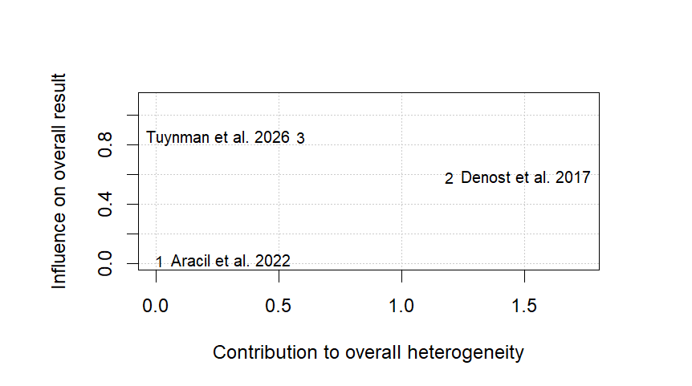
Figure S9c: Baujat plot of post-operative complications
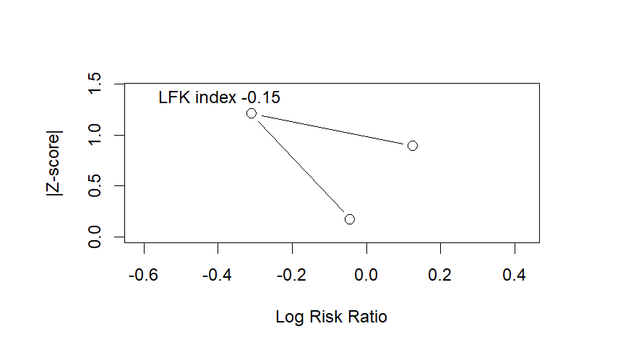
Figure S9d: DOI of post-operative complications
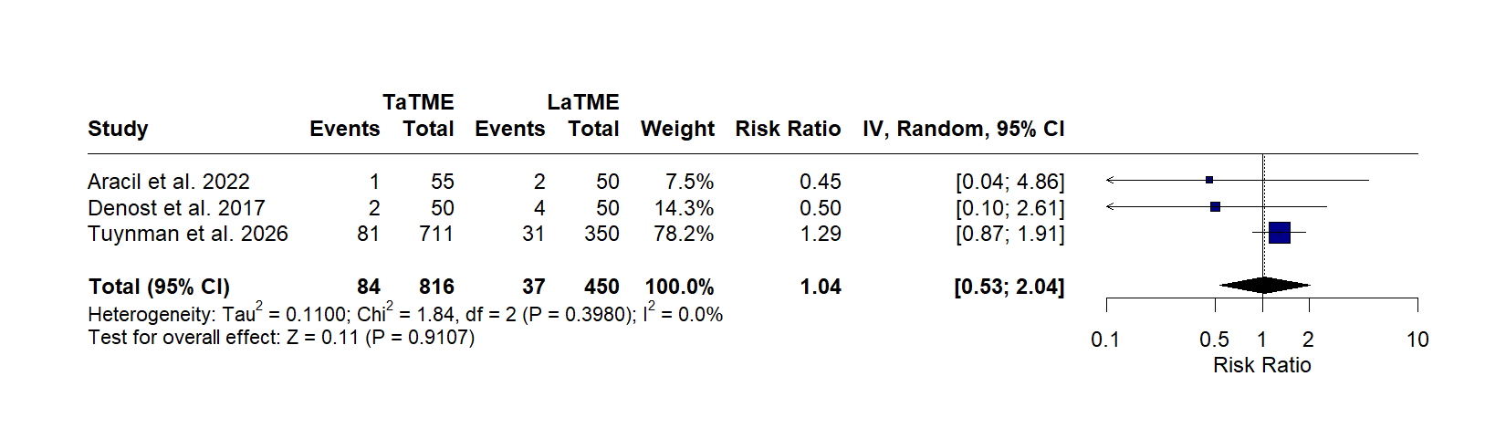
Figure S10a: Forest plot of Reoperation rate
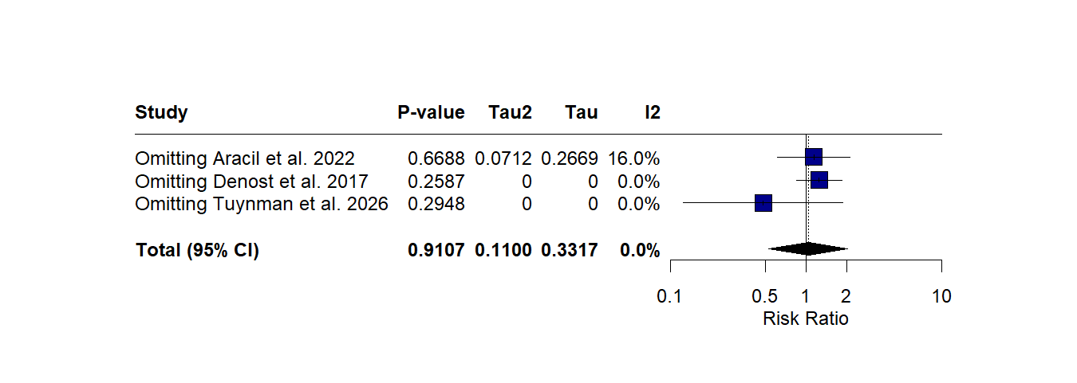
Figure S10b: Influencial Plot of Reoperation rate
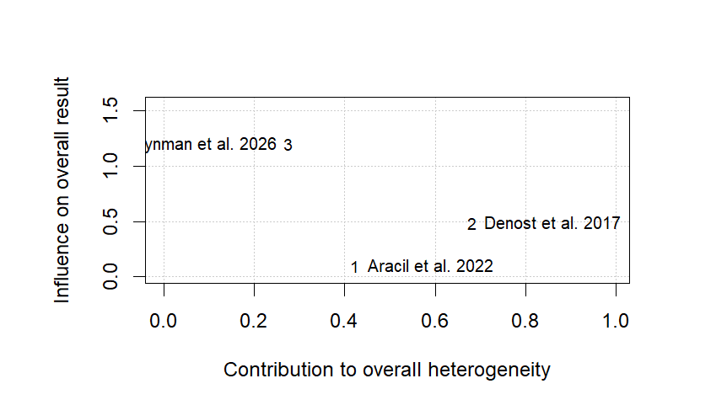
Figure S10c: Baujat plot of Reoperation rate
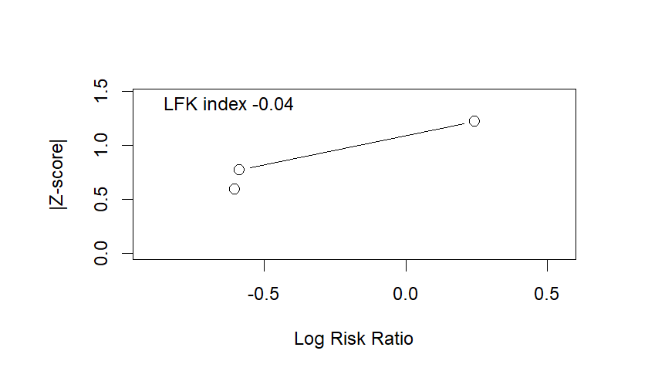
Figure S10d: DOI of Reoperation rate
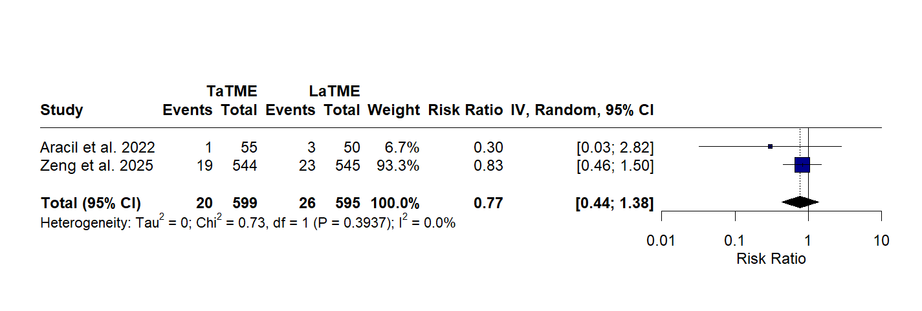
Figure S11a: Forest plot of 3-Year Local Recurrence
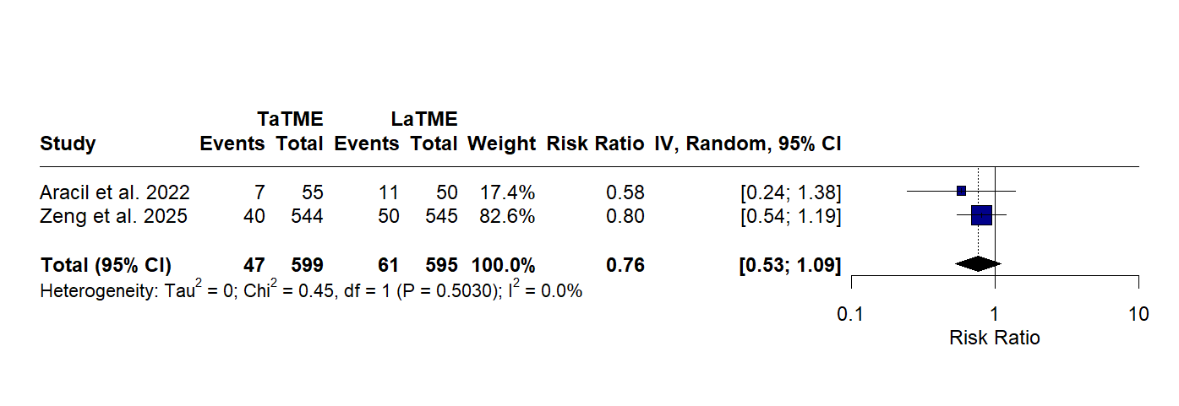
Figure S11b: Forest plot of 3-Year overall survival
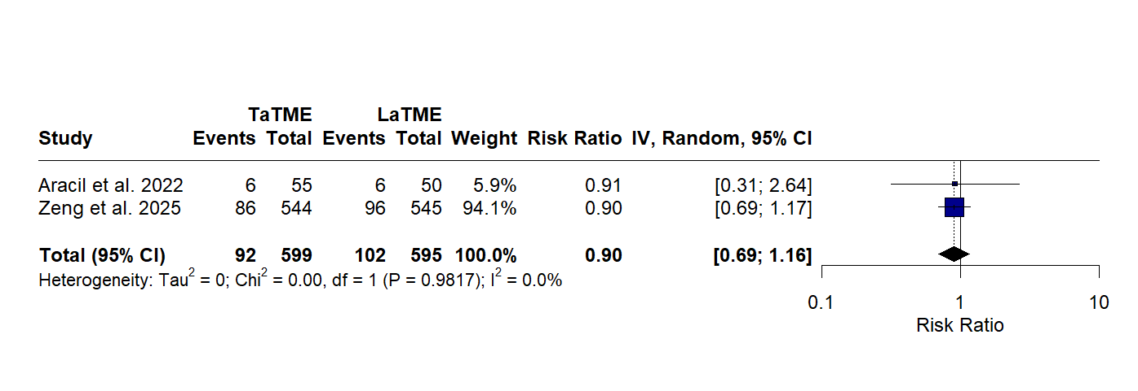
Figure S11c: Forest plot of 3-Year Disease-Free Survival

